KALASALINGAM ACADEMY OF RESEARCH AND EDUCATION
LAWBOT
Production-Grade Indian Legal AI Assistant
& Knowledge Platform
PROJECT DOCUMENTATION

PROJECT INFORMATION
Field | Details
Project Title | LAWBOT – Know Your Rights: Legal Awareness Bot
Project Domain | Artificial Intelligence, Legal Technology, RAG and Full-Stack Development
Project ID | PRJ032
Team ID | TO32
Project Guide / Trainer | Mr. SHIRWIN PRINCE I
Team GitHub Repository | https://github.com/praveen-grande/law-bot-ai

Student Name | Registration Number | Individual GitHub Link
GRANDE PRAVEEN | 99230040558 | https://github.com/praveen-grande/GenAI-Assessment-Practice
GUDIBANDI NITIN REDDY | 99230040559 | https://github.com/nitin-reddy123/GEN-AI
SEELAM ROHIT REDDY | 99230040756 | https://github.com/Rohithreddy2911/GEN_AI
PROJECT TEAM
TABLE OF CONTENTS
Section | Title
1 | Introduction
2 | Problem Statement & Objectives
3 | System Architecture (RAG Pipeline)
4 | Implementation Details & Technology Stack
5 | Results and Testing
6 | Conclusion & Future Scope

1. INTRODUCTION

1.1 Overview
LAWBOT is a full-stack, AI-powered Indian Legal Intelligence and Knowledge Platform designed to make Indian legal information more accessible, understandable and reliable. It uses Retrieval-Augmented Generation (RAG) to retrieve relevant legal material before generating context-aware answers to users’ questions.
The platform is designed to work with Indian statutory laws, constitutional provisions and landmark Supreme Court and High Court judgments. Its knowledge coverage includes the newer criminal law framework—Bharatiya Nyaya Sanhita (BNS), Bharatiya Nagarik Suraksha Sanhita (BNSS) and Bharatiya Sakshya Adhiniyam (BSA), 2023—as well as legacy legislation such as IPC, CrPC and the Indian Evidence Act.
LAWBOT combines a legal chatbot, structured legal knowledge, research utilities, document analysis and secure user management. Unlike a basic conversational AI interface, it retrieves relevant information first and uses that material as context for response generation.

1.2 Purpose and Scope
Indian legal information is distributed across statutes, amendments, constitutional provisions and judicial decisions. This can make it difficult for citizens, students, researchers and advocates to locate and understand relevant information. General-purpose language models may also produce inaccurate statutory references or fabricated case citations.
- Grounded legal chatbot: answers Indian legal questions using retrieved statutory provisions and case-law information.
- Legal research suite: supports statutory searches, legacy-to-new law cross-referencing and landmark case exploration.
- Document analysis: processes supported PDF, DOCX and TXT files to identify clauses, statutory references, potential risks and missing safeguards.
- Emergency legal guidance: provides an Emergency Legal Distress / SOS guidance module.
- Secure user management: includes password hashing, session security, email verification, password reset and user-data isolation.

2. PROBLEM STATEMENT & OBJECTIVES

2.1 Problem Statement
The project addresses the following challenges in accessing and using Indian legal information:
- Complexity of Indian legal systems: legal information is spread across many statutes and judgments. The transition from IPC, CrPC and the Indian Evidence Act to BNS, BNSS and BSA can create confusion about section numbering and legal provisions.
- Hallucinations in general-purpose AI: language models may produce incorrect legal information, fabricated case citations or apply legal principles from other jurisdictions.
- Limited contextual retrieval: traditional keyword searches may not capture the meaning or context of a natural-language legal question.
- Dependence on one AI provider: a single provider can become unavailable due to outages, quota limits or server errors.
- Data privacy concerns: weak authentication and ownership checks can expose private conversations or uploaded documents.

2.2 Project Objectives
- Develop a grounded Indian legal RAG pipeline that classifies questions, retrieves relevant legal information and generates context-aware responses.
- Implement multi-LLM failover from the configured primary provider to Groq Cloud using Llama 3.3 70B when supported failure conditions occur.
- Maintain authentic conversation records, creating conversations when users start chatting rather than pre-populating dummy data.
- Implement secure authentication using scrypt password hashing, HMAC-SHA256 signed session tokens, single-use verification/reset tokens and brute-force protection.
- Provide a unified legal research platform for statutory research, IPC-to-BNS and CrPC-to-BNSS mapping, landmark judgments and document analysis.

2.3 Scope of the System
The documented scope includes a legal chatbot, statutory knowledge base, case-law research, legal document analysis, emergency guidance, user profile and security settings, and an administrative control panel. The platform is intended as a legal information and research aid; users should consult qualified legal professionals for advice on specific cases.

3. SYSTEM ARCHITECTURE (RAG PIPELINE)

3.1 High-Level System Architecture
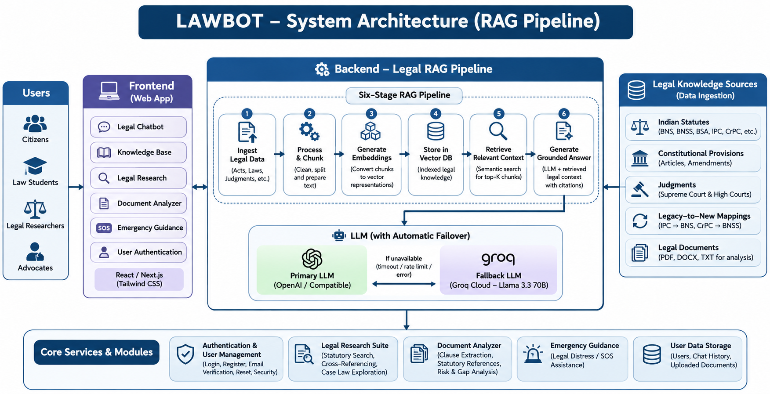
LAWBOT follows a modular three-tier architecture. The presentation tier handles user interaction, the application and security tier manages APIs and user data, and the RAG and multi-LLM intelligence tier retrieves legal context and generates grounded responses.
Layer | Main Responsibilities
Presentation Layer | React 19 single-page application; legal chatbot; knowledge explorer; statutory mapper; case-law finder; document analyzer; SOS portal; profile and admin interfaces.
Application & Security Layer | Node.js and Express APIs; registration and login; authentication middleware; session management; rate limiting; ownership verification; conversation management; document parsing.
RAG & Multi-LLM Intelligence Layer | Query understanding; legal intent classification; query rewriting; hybrid retrieval; relevance scoring; grounded prompt construction; LLM routing; citation attachment.

High-Level Processing Flow
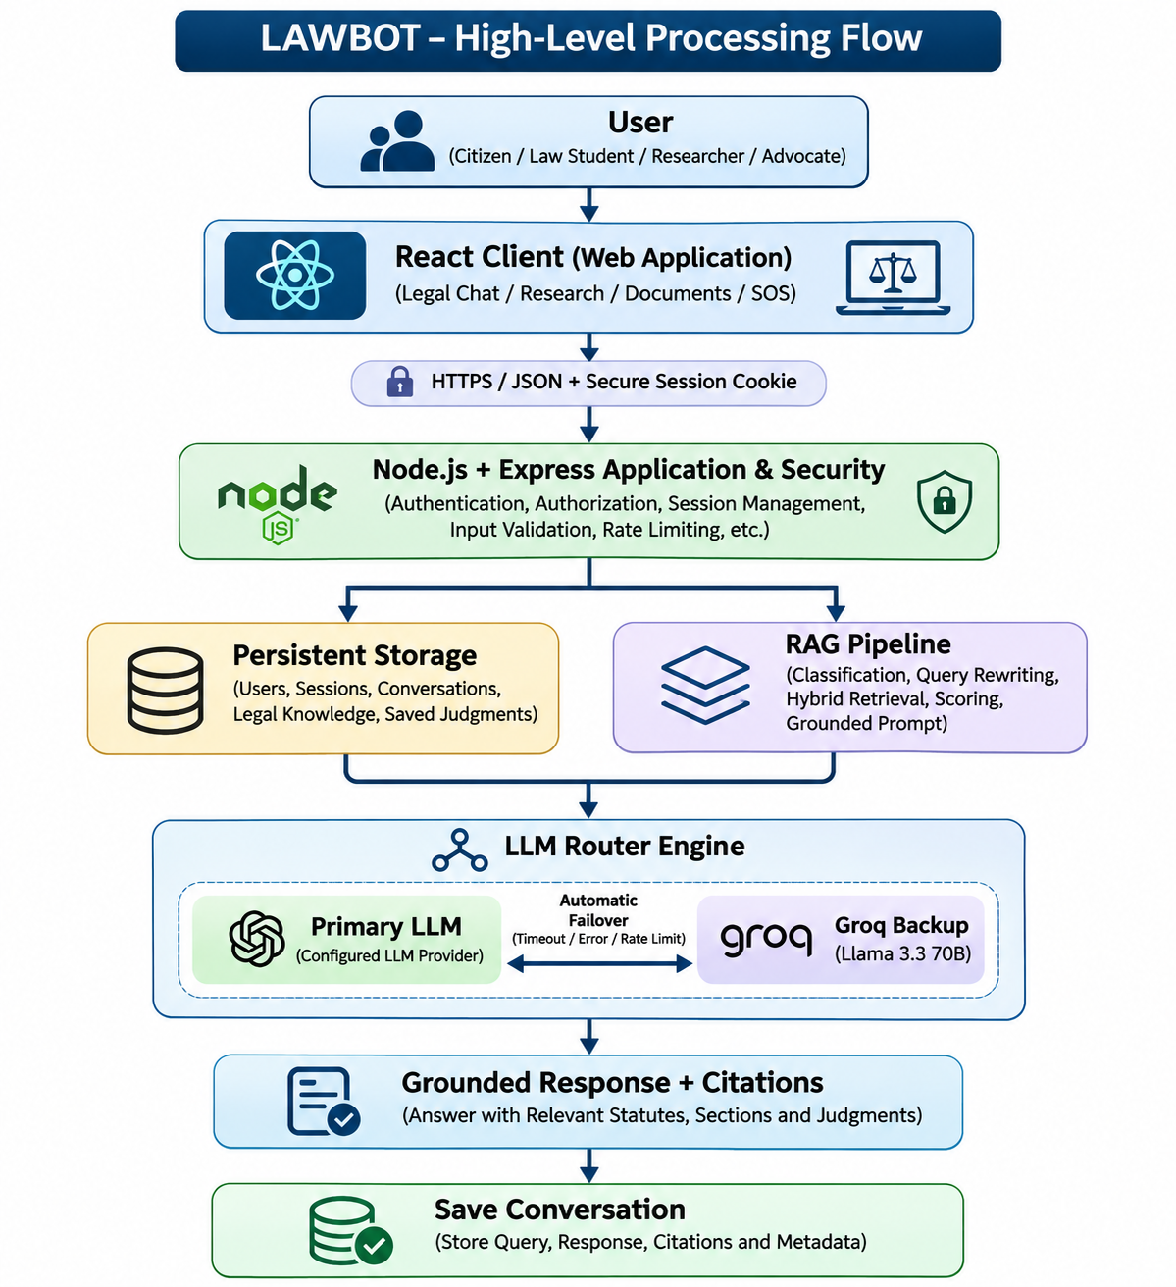

3.2 Six-Stage Legal RAG Pipeline
Stage 1 – Query understanding and classification: Analyzes the question to identify intent, legal domain, ambiguity and jurisdiction. Supported intent types include statutory lookup, case explanation, case comparison, procedural guidance, document questions and ambiguous or non-Indian-jurisdiction queries.
Stage 2 – Conversation-aware query rewriting: Uses recent conversation history to convert follow-up questions into self-contained queries. For example, a follow-up asking which judgment expanded Article 21 to privacy is interpreted in the context of the earlier Article 21 question.
Stage 3 – Hybrid legal corpus retrieval: Retrieves relevant material from statutory provisions, landmark judicial decisions and uploaded user documents. The documented corpus includes the Constitution, BNS, BNSS, BSA, legacy criminal laws, Contract Act, Consumer Protection Act, RTI Act, POSH Act and Information Technology Act.
Stage 4 – Relevance scoring and guardrails: Evaluates retrieved material using keyword, statutory citation, section-number and legal-domain matching. If adequate supporting information is unavailable, the system is instructed not to invent statutory sections or judicial citations.
Stage 5 – Grounded prompt construction: Combines retrieved provisions, case summaries, citations, conversation history and relevant uploaded-document context, with instructions to distinguish statutory text from legal interpretation.
Stage 6 – LLM generation and failover: Sends the prompt to the configured primary provider. When supported failure conditions occur, the router attempts Groq Cloud with Llama 3.3 70B. Retrieved citations are attached and the response is saved to the authenticated user’s conversation.

4. IMPLEMENTATION DETAILS & TECHNOLOGY STACK

4.1 Technology Stack
Component | Technology | Purpose
Frontend | React 19, TypeScript | User interface and component-based application.
Styling | Tailwind CSS v4 | Responsive interface styling.
Icons / Animation / Charts | Lucide React; Motion; Recharts | Icons, UI transitions and analytics visualizations.
Backend | Node.js, Express | Server-side execution, REST APIs and middleware.
Primary AI | Configured primary LLM provider | Legal response generation.
Backup AI | Groq API – Llama 3.3 70B | Backup generation through automatic failover.
Authentication | Node.js Crypto, scrypt, HMAC-SHA256 | Password hashing and signed session tokens.
Document Processing | pdf-parse, mammoth | PDF and DOCX text extraction; TXT processing is also supported.
Testing | node:test, node:assert/strict, Playwright | Automated tests and browser-based verification.

4.2 Core Backend Modules

1. Authentication and User Database – src/utils/auth.ts
- Uses schema version 3 with automatic database migrations.
- Hashes passwords using scrypt with a unique 16-byte random salt and a 64-byte derived hash; compares hashes in constant time.
- Supports single-use email-verification and password-reset tokens, with SHA-256 hashing of stored tokens and expiry/usage validation.
- Uses HMAC-SHA256 signed session tokens, HttpOnly and SameSite=Lax cookies, brute-force protection and session invalidation after password reset.
The documented brute-force policy allows six failed login attempts within a 15-minute window before the next attempt receives HTTP 429 Too Many Requests.

2. Conversation and User Isolation Engine – src/utils/chatStore.ts
- Creates conversations when users begin chatting; new accounts do not receive dummy conversations or messages.
- Supports persistent conversations, renaming, deletion and message management.
- Verifies ownership using authenticated user identity and returns HTTP 403 Forbidden for unauthorized cross-user access.

3. RAG and Multi-LLM Failover – src/utils/ragPipeline.ts and src/utils/llmRouter.ts
- Performs legal intent classification, domain identification, query rewriting, hybrid retrieval and relevance scoring.
- Builds grounded prompts, calls the primary LLM and attempts automatic Groq failover when configured failure conditions are met.
- Tracks provider usage, failover status and retrieved citations.

4. Legal Knowledge Base and Document Analyzer – src/utils/legalKnowledgeStore.ts
- Maintains structured statutory information, criminal-law transition mappings and landmark judgment information.
- Extracts text from PDF, DOCX and TXT documents and identifies important clauses, legal references, potential risks and missing safeguards.
- Keeps uploaded documents isolated by user.

5. RESULTS AND TESTING

5.1 Automated Test Suite Summary
According to the supplied project overview, LAWBOT was tested using Node.js built-in testing tools and Playwright for browser-based verification. The overview reports 73 passing assertions and zero failures.
Test Category | Scenarios Verified | Result
User Registration | UUID generation, email normalization, duplicate rejection and password validation. | PASS
Email Verification | Token generation and SHA-256 hashing. | PASS
Login Security | Valid login, invalid credentials and generic error responses. | PASS
Brute-Force Protection | Rate limiting after six failed attempts. | PASS
Password Security | scrypt hashing, salt validation and plaintext leakage checks. | PASS
Password Reset | Single-use tokens and session invalidation. | PASS
Cross-User Isolation | Unauthorized access to conversations and saved resources. | PASS
Conversation Lifecycle | Persistence and conversation management. | PASS
RAG Query Processing | Legal classification, query rewriting and case-law retrieval. | PASS
Jurisdiction / Failover | Foreign legal reference detection and Groq backup activation. | PASS

Reported Test Metric | Value
Total assertions | 73
Passed | 73
Failed | 0

5.2 Key Performance and Quality Outcomes
- Grounded responses: retrieval of relevant legal material before generation is intended to reduce unsupported answers and citations.
- Criminal-law transition support: the overview lists IPC Section 302 to BNS Section 103 and IPC Section 420 to BNS Section 318 as example mappings; CrPC-to-BNSS cross-referencing is also supported.
- Service resilience: the LLM router provides a backup generation path through Groq when the primary provider encounters supported failures.
- Secure data isolation: backend sessions establish authenticated identity, and ownership checks protect conversations and saved resources.
- Authentic records: new accounts begin without artificial conversations or pre-populated bookmarks.
- Security validation: automated tests cover password handling, session management, token lifecycle, brute-force protection and cross-user ownership.
Note: The figures and test outcomes in this section are reproduced from the supplied project overview. They should be retained in a final submission only if they match the test results produced by the current project build.

6. CONCLUSION & FUTURE SCOPE

6.1 Conclusion
LAWBOT demonstrates an AI-powered Indian Legal Intelligence and Knowledge Platform that combines Retrieval-Augmented Generation, full-stack web development, secure user management and multi-provider LLM integration. The project addresses challenges in accessing complex Indian legal information, understanding the transition from legacy criminal laws to the newer legal framework, and reducing unsupported AI-generated legal references.
Its six-stage RAG pipeline classifies user questions, rewrites conversational follow-ups, retrieves relevant legal material, scores the retrieved context, constructs a grounded prompt and generates a response through an LLM router. The primary-provider and Groq backup arrangement improves resilience, while cryptographic authentication and ownership validation strengthen the protection of user data.
The platform also brings together statutory research, landmark case-law exploration, legal document analysis and emergency legal guidance. The supplied project overview reports 73 passing automated assertions with zero failures.
Overall, LAWBOT illustrates how Artificial Intelligence, Natural Language Processing, Retrieval-Augmented Generation and modern web technologies can support a more accessible Indian legal information platform.

6.2 Future Scope
1. Live eCourts and Indian Kanoon Integration: Integrate supported legal information sources and APIs to retrieve updated Supreme Court and High Court judgments, daily orders, cause lists and case-status information through CNR lookup.
2. Multilingual Voice-Based Legal Assistance: Extend language support to English, Hindi, Telugu and Tamil with speech-to-text and text-to-speech capabilities.
3. Automated Legal Drafting Studio: Introduce guided drafting for RTI applications, consumer forum complaints, legal notices, rent recovery notices and bail petition drafts.
4. OCR for Scanned Legal Documents: Add Optical Character Recognition to extract text from scanned FIRs, court orders and land records, including regional-language documents.
5. Advanced Vector Retrieval and Hybrid Reranking: Improve hybrid lexical and semantic retrieval using legal-domain embeddings and reranking techniques.
6. Continuous Knowledge Base Updates: Create automated workflows to incorporate legislation, amendments and judicial decisions from verified official sources.
7. Enhanced Legal Analytics: Develop analytics for legal research activity, frequently asked questions, knowledge-base coverage and system performance.
REFERENCES
[1] Government of India. (2023). The Bharatiya Nyaya Sanhita, 2023. India Code.
https://www.indiacode.nic.in/indiacode/handle/123456789/20062
[2] Government of India. (2023). The Bharatiya Nagarik Suraksha Sanhita, 2023. India Code.
https://www.indiacode.nic.in/indiacode/handle/123456789/20099
[3] Government of India. (2023). The Bharatiya Sakshya Adhiniyam, 2023. India Code.
https://www.indiacode.nic.in/indiacode/handle/123456789/20063
[4] Bureau of Police Research and Development. New Criminal Laws: BNS, BNSS and BSA.
https://bprd.nic.in/page/new_criminal_laws
[5] Lewis, P., et al. (2020). Retrieval-Augmented Generation for Knowledge-Intensive NLP Tasks. NeurIPS.
https://papers.nips.cc/paper/2020/file/6b493230205f780e1bc26945df7481e5-Paper.pdf
[6] Supreme Court of India. Judgments and Orders Search Portal.
https://verdictfinder.sci.gov.in/elk_frontend/index.php
[7] e-Committee, Supreme Court of India. eCourts Services Portal.
https://ecommitteesci.gov.in/service/ecourts-services-portal/
[8] OWASP Foundation. OWASP Top 10: Web Application Security Risks.
https://owasp.org/projects/top-ten/
[9] React Team. React Official Documentation – Learn React.
https://react.dev/learn
[10] OpenJS Foundation. Node.js Official Documentation.
https://nodejs.org/docs/latest/api/
[11] OpenJS Foundation. Express.js Official Documentation.
https://expressjs.com/en/guide/

