**SUMMARY**

## USC ID/s: 1733072222, 5549510111, 9084470206

| M+N | Time in MS (Basic) | Time in MS (Efficient) | Memory in KB (Basic) | Memory in KB (Efficient) |
| --- | --- | --- | --- | --- |
| 16 | 0.04887580871582031 | 0.1270771026611328 | 13068 | 13492 |
| 64 | 0.48542022705078125 | 1.0993480682373047 | 13348 | 13324 |
| 128 | 1.9197463989257812 | 3.9033889770507812 | 13380 | 13608 |
| 256 | 7.677793502807617 | 13.79537582397461 | 13580 | 13604 |
| 384 | 15.489339828491211 | 30.308008193969727 | 14320 | 13308 |
| 512 | 27.685880661010742 | 55.26399612426758 | 14636 | 13504 |
| 768 | 61.42687797546387 | 124.50313568115234 | 14676 | 13480 |
| 1024 | 116.17064476013184 | 219.82693672180176 | 15392 | 13572 |
| 1280 | 202.622652053833 | 331.03156089782715 | 16168 | 13472 |
| 1536 | 292.6208972930908 | 491.49489402770996 | 19268 | 13840 |
| 2048 | 568.9995288848877 | 876.6806125640869 | 22896 | 13860 |
| 2560 | 883.0194473266602 | 1404.207706451416 | 27984 | 13716 |
| 3072 | 1343.4312343597412 | 2109.680414199829 | 33112 | 13800 |
| 3584 | 1499.337911605835 | 2812.703847885132 | 42432 | 13644 |
| 3968 | 2161.1313819885254 | 3413.3551120758057 | 45616 | 13572 |

## Datapoints

## Insights

### Graph1 – Memory vs Problem Size (M+N)

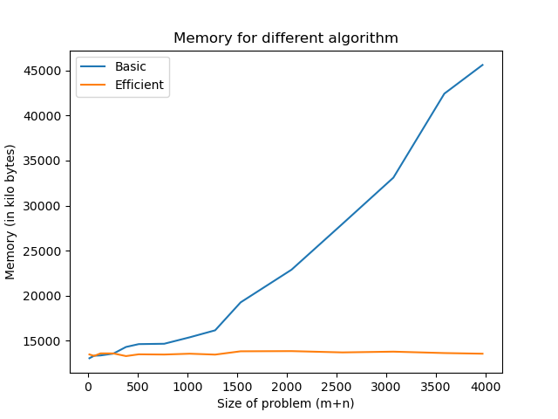

#### Nature of the Graph (Logarithmic/ Linear/ Polynomial/ Exponential)

Basic: Linear

Efficient: Linear

Explanation:

### Graph2 – Time vs Problem Size (M+N)

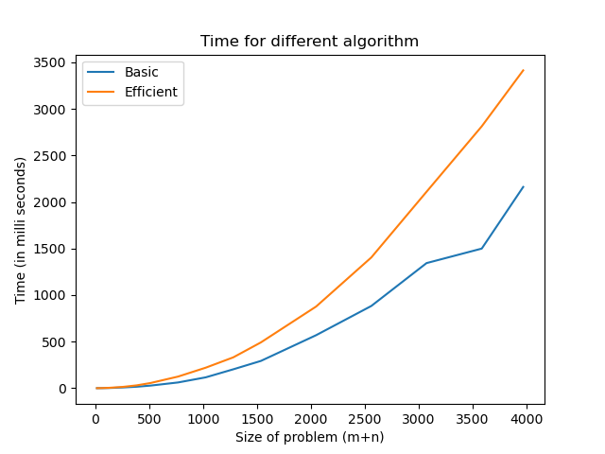

#### Nature of the Graph (Logarithmic/ Linear/ Polynomial/ Exponential)

Basic:

Efficient:

#### Explanation:

## Contribution

(Please mention what each member did if you think everyone in the group does not have an equal contribution, otherwise, write “Equal Contribution”)

<USC ID/s>: <Equal Contribution>

## 1733072222: Equal Contribution

## 5549510111 : Equal Contribution

## 9084470206: Equal Contribution