# Goal:

## Functional Goal:

Build a system that gives appropriate views and actions to manage expiry. System should be easy to use, fast, stable and accurate. System should specifically provide quick action interfaces for rapid handling in rush hours or when there are multiple items but insignificant quantity of purchase or sale.

## Design goals:

1. Conceptual design should be readily available in easy to re-create formats. E.g. DB design should have ER diagrams, DB scripts, and master data capable of getting imported and exported.
2. There should be clear separation of concerns
3. MVC should be used. Design should be presentation and server technology agnostic. It should be easy to plug & play different DB vendor, conversion to a web based system, change the presentation technology.

# Overview of business scenario:

The system will serve retail medical shop.

## Use cases

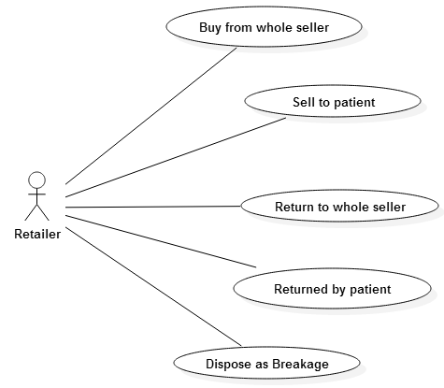

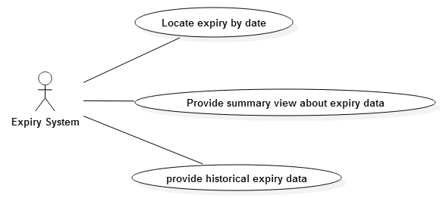

## Activity diagram

### Buy from whole seller

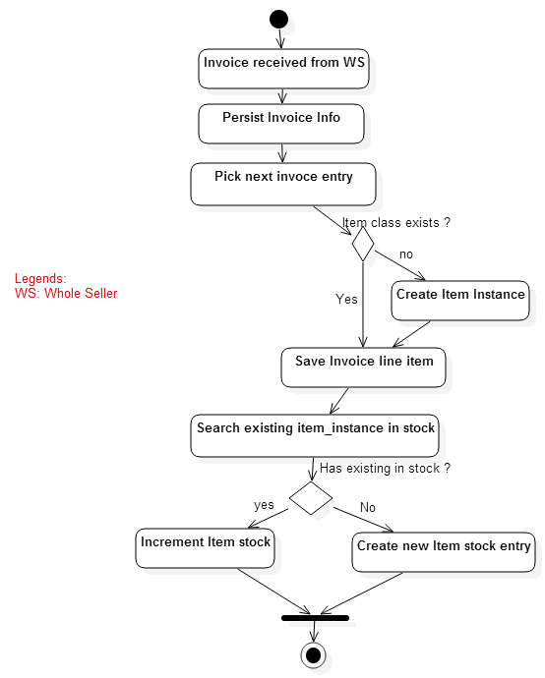

### Sell to patient

<TODO>

### Return to whole seller

<TODO>

### Returned by patient

<TODO>

### Dispose as Breakage

<TODO>

### Locate expiry by date

<TODO>

### Provide summary view about expiry data

<TODO>

### Provide historical expiry data

<TODO>

## Entities in the system

## Other requirements

Entry of existing stock in system