Steps to create and run a spring mvc project.

1. In eclipse go to , File 🡪 new 🡪 maven project 🡪 click Next button to select maven templates

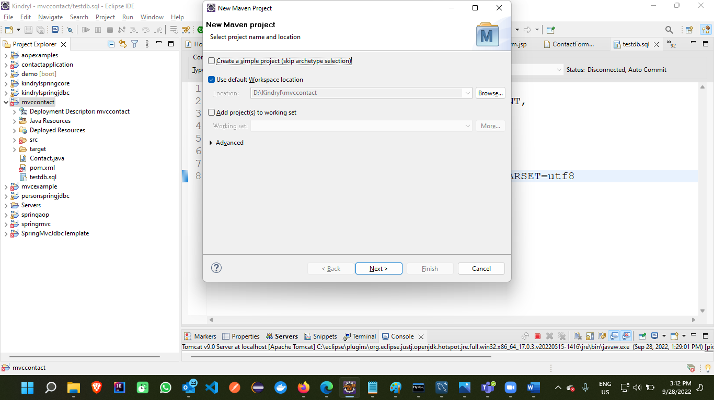

1. Search for **mvc** in filters text box and select spring-mvc-archetype 1.0.2 version and click on next button

1. Provide the groupId and artifactId for the maven project and click on finish

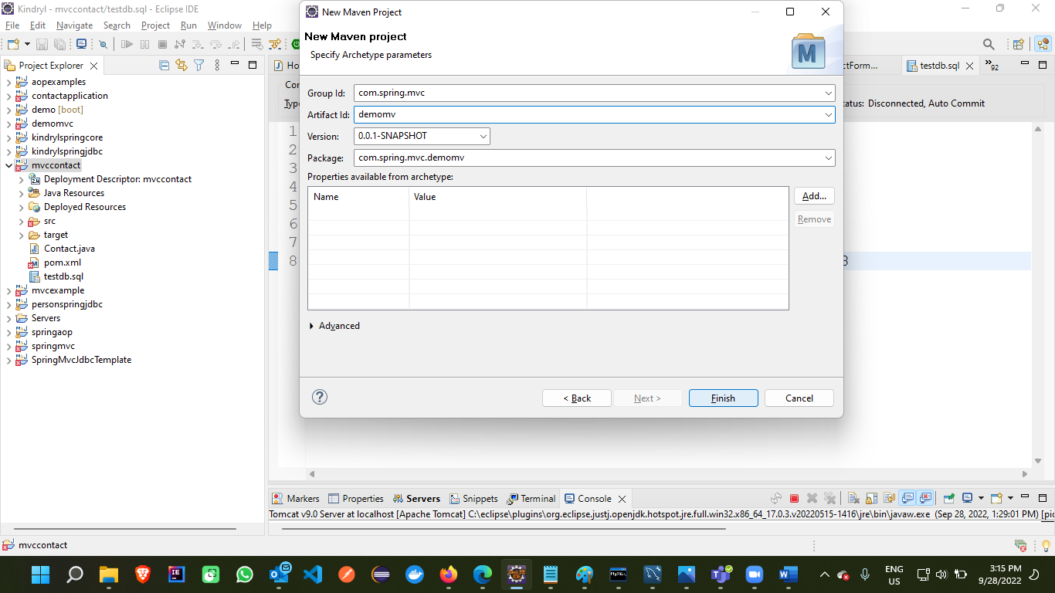

1. After maven project is created, expand the folders you should see the below kind of project structure:

1. Right click on project 🡪 Run as 🡪 Run on Server 🡪 from the local host select the version of tomcat and click on next button.

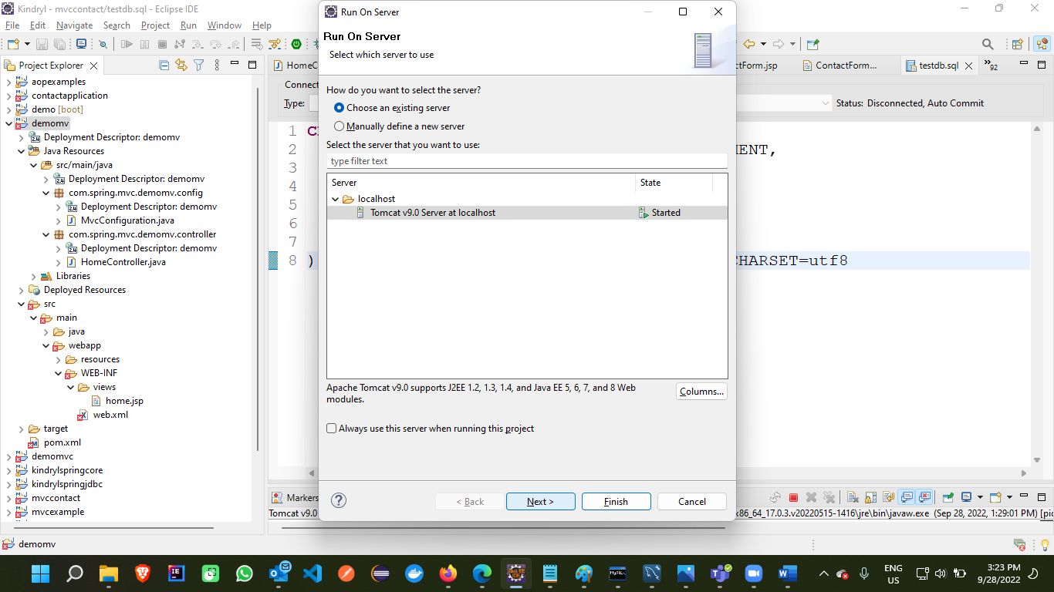

1. Click on the projects to be deployed on tomcat on left window and click on **Add** button or you want to delete any from tomcat, select that from right pane window and click on **remove**
2. 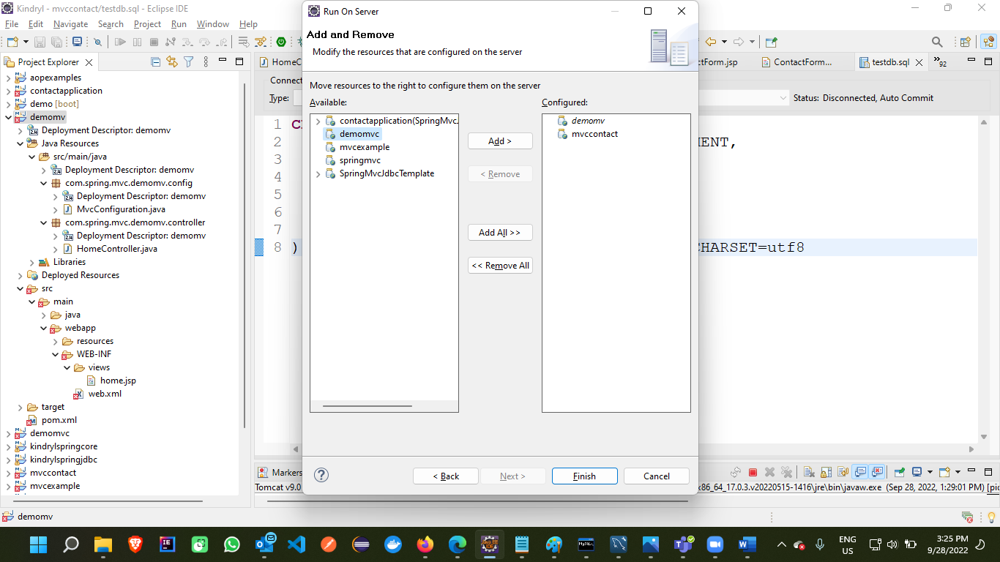
3. Once the projects are deployed on tomcat, click on Finish button

1. Upon successful deployment, and tomcat is started access the url:

[http://localhost:9090/<applicationName>/urlpatter](http://localhost:9090/%3capplicationName%3e/urlpatter)

eg> <http://localhost:9090/demomv/>

1. You should see the home page output on the browser.