Oracle Joins
Join is a query that is used to combine rows from two or more tables, views, or materialized views. It retrieves data from multiple tables and creates a new table.

Join Conditions
There may be at least one join condition either in the FROM clause or in the WHERE clause for joining two tables. It compares two columns from different tables and combines pair of rows, each containing one row from each table, for which join condition is true.

Types of Joins
- Inner Joins (Simple Join)
- Outer Joins
  - Left Outer Join (Left Join)
  - Right Outer Join (Right Join)
  - Full Outer Join (Full Join)
- Equijoins
- Self Joins
- Cross Joins (Cartesian Products)
- Antijoins
- Semijoins

Oracle INNER JOIN
Inner Join is the simplest and most common type of join. It is also known as simple join. It returns all rows from multiple tables where the join condition is met.
Syntax
- SELECT columns
- FROM table1
- INNER JOIN table2
- ON table1.column = table2.column;
Image representation of Inner Join
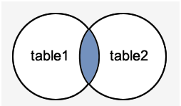

- SELECT suppliers.supplier_id, suppliers.supplier_name, order1.order_number
- FROM suppliers
- INNER JOIN order1
- ON suppliers.supplier_id = order1.supplier_id;

Oracle INNER JOIN Example
Let's take an example to perform Inner Join on two tables "Suppliers" and "Order1".
Suppliers
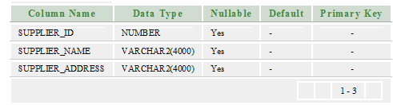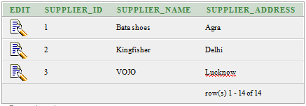
Order1
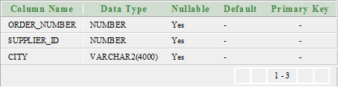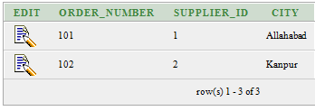

Oracle OUTER JOIN
An outer join is similar to equijoin but it gets also the non-matched rows from the table. It is categorized in Left Outer Join, Right Outer Join and Full Outer Join by Oracle 9i ANSI/ISO 1999 standard.

Left Outer Join
Left Outer Join returns all rows from the left (first) table specified in the ON condition and only those rows from the right (second) table where the join condition is met.
Syntax
- SELECT columns
- FROM table1
- LEFT [OUTER] JOIN table2
- ON table1.column = table2.column;

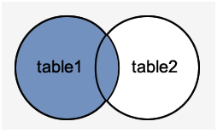

Execute this query
- SELECT suppliers.supplier_id, suppliers.supplier_name, order1.order_number
- FROM suppliers
- LEFT OUTER JOIN order1
- ON suppliers.supplier_id = order1.supplier_id;
Output
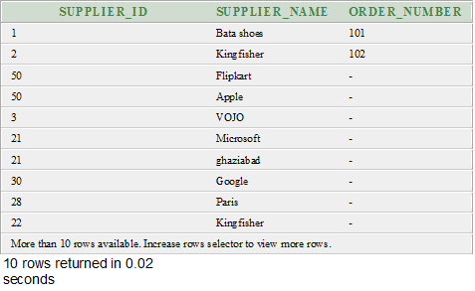

Right Outer Join
The Right Outer Join returns all rows from the right-hand table specified in the ON condition and only those rows from the other table where the join condition is met.
Syntax
- SELECT columns
- FROM table1
- RIGHT [OUTER] JOIN table2
- ON table1.column = table2.column;

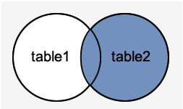

SELECT order1.order_number, order1.city, suppliers.supplier_name
- FROM suppliers
- RIGHT OUTER JOIN order1
- ON suppliers.supplier_id = order1.supplier_id;

Output
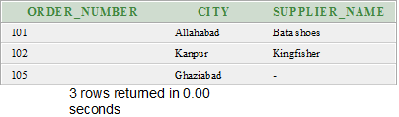

Full Outer Join
The Full Outer Join returns all rows from the left hand table and right hand table. It places NULL where the join condition is not met.
Syntax
- SELECT columns
- FROM table1
- FULL [OUTER] JOIN table2
- ON table1.column = table2.column;

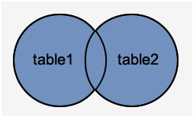

- SELECT suppliers.supplier_id, suppliers.supplier_name, order1.order_number
- FROM suppliers
- FULL OUTER JOIN order1
- ON suppliers.supplier_id = order1.supplier_id;
Output

Oracle EQUI JOIN
Oracle Equi join returns the matching column values of the associated tables. It uses a comparison operator in the WHERE clause to refer equality.
Syntax
- SELECT column_list
- FROM table1, table2....
- WHERE table1.column_name =
- table2.column_name;
Equijoin also can be performed by using JOIN keyword followed by ON keyword and then specifying names of the columns along with their associated tables to check equality.
Syntax
- SELECT *
- FROM table1
- JOIN table2
- [ON (join_condition)]

Oracle EQUI JOIN Example
Let' take two tables "agents" and "customer".
Agents table
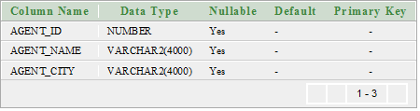
Agent data
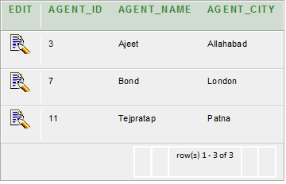

Oracle SELF JOIN
Self Join is a specific type of Join. In Self Join, a table is joined with itself (Unary relationship). A self join simply specifies that each rows of a table is combined with itself and every other row of the table.
Syntax
- SELECT a.column_name, b.column_name...
- FROM table1 a, table1 b
- WHERE a.common_filed = b.common_field;

Oracle SELF JOIN Example
Let's take a table "customers".
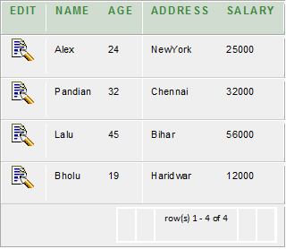

- SELECT a.name, b.age, a.SALARY
- FROM CUSTOMERS a, CUSTOMERS b
- WHERE a.SALARY < b.SALARY;

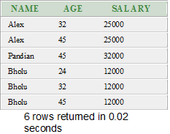

Oracle Cross Join (Cartesian Products)
The CROSS JOIN specifies that all rows from first table join with all of the rows of second table. If there are "x" rows in table1 and "y" rows in table2 then the cross join result set have x*y rows. It normally happens when no matching join columns are specified.
In simple words you can say that if two tables in a join query have no join condition, then the Oracle returns their Cartesian product.
Syntax
- SELECT *
- FROM table1
- CROSS JOIN table2;
Or
- SELECT * FROM table1, table2
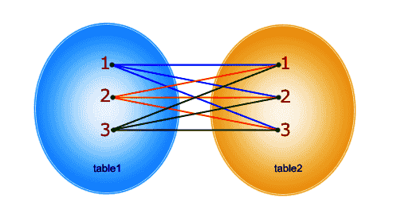

- CREATE TABLE "CUSTOMER"
- ( "CUSTOMER_ID" NUMBER,
- "FIRST_NAME" VARCHAR2(4000),
- "LAST_NAME" VARCHAR2(4000)
- )

- CREATE TABLE "SUPPLIER"
- ( "SUPPLIER_ID" NUMBER,
- "FIRST_NAME" VARCHAR2(4000),
- "LAST_NAME" VARCHAR2(4000)
- )
Execute this query
- SELECT * FROM customer,supplier

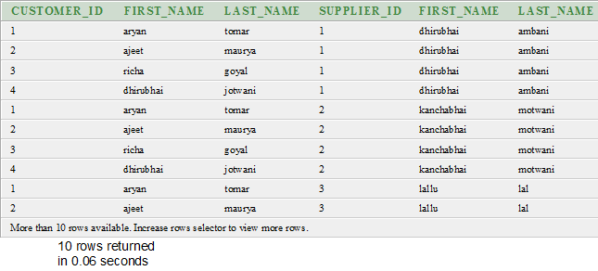

Oracle Anti Join
Anti-join is used to make the queries run faster. It is a very powerful SQL construct Oracle offers for faster queries.
Anti-join between two tables returns rows from the first table where no matches are found in the second table. It is opposite of a semi-join. An anti-join returns one copy of each row in the first table for which no match is found.
Anti-joins are written using the NOT EXISTS or NOT IN constructs.

CREATE TABLE "DEPARTMENTS"
- ( "DEPARTMENT_ID" NUMBER(10,0) NOT NULL ENABLE,
- "DEPARTMENT_NAME" VARCHAR2(50) NOT NULL ENABLE,
- CONSTRAINT "DEPARTMENTS_PK" PRIMARY KEY ("DEPARTMENT_ID") ENABLE
- )
- /

CREATE TABLE "CUSTOMER"
- ( "CUSTOMER_ID" NUMBER,
- "FIRST_NAME" VARCHAR2(4000),
- "LAST_NAME" VARCHAR2(4000),
- "DEPARTMENT_ID" NUMBER
- )

SELECT departments.department_id, departments.department_name
- FROM departments
- WHERE NOT EXISTS
- (
- SELECT 1
- FROM customer
- WHERE customer.department_id = departments.department_id
- )
- ORDER BY departments.department_id;

Oracle Semi Join
Semi-join is introduced in Oracle 8.0. It provides an efficient method of performing a WHERE EXISTS sub-query.
A semi-join returns one copy of each row in first table for which at least one match is found.
Semi-joins are written using the EXISTS construct.

Oracle Semi Join Example
Let's take two tables "departments" and "customer"
Departments table
- CREATE TABLE "DEPARTMENTS"
- ( "DEPARTMENT_ID" NUMBER(10,0) NOT NULL ENABLE,
- "DEPARTMENT_NAME" VARCHAR2(50) NOT NULL ENABLE,
- CONSTRAINT "DEPARTMENTS_PK" PRIMARY KEY ("DEPARTMENT_ID") ENABLE
- )
- /

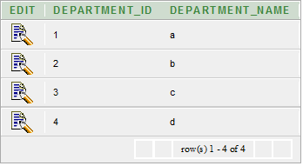
Customer table
- CREATE TABLE "CUSTOMER"
- ( "CUSTOMER_ID" NUMBER,
- "FIRST_NAME" VARCHAR2(4000),
- "LAST_NAME" VARCHAR2(4000),
- "DEPARTMENT_ID" NUMBER
- )
- /
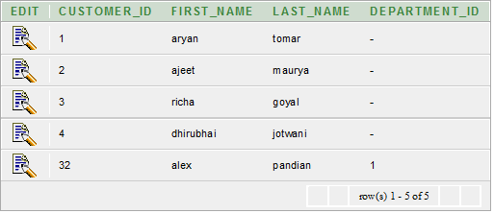
Execute this query
- SELECT departments.department_id, departments.department_name
- FROM departments
- WHERE EXISTS
- (
- SELECT 1
- FROM customer
- WHERE customer.department_id = departments.department_id
- )
- ORDER BY departments.department_id;
Output
