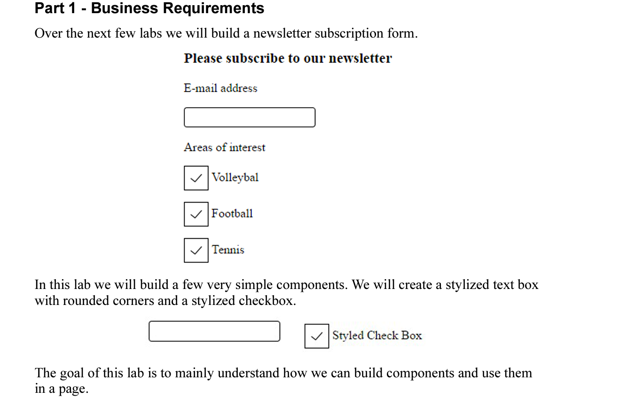

Step 1 : Create a TextBox Component

Step 2: Use the component

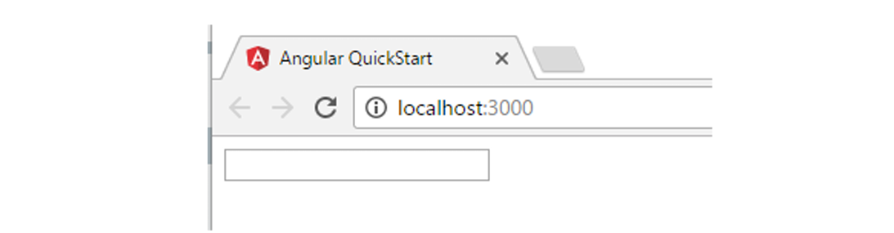

Step 3: Apply styles to TextBox

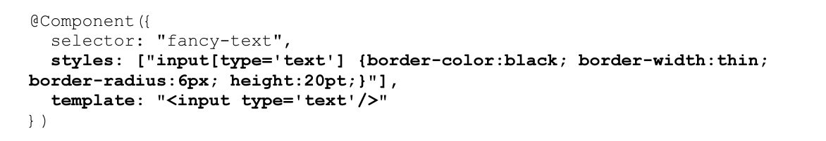

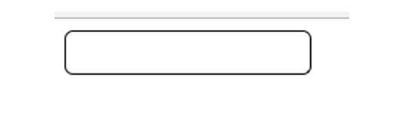

Move the Style to separate CSS file – fancyText.component.css file

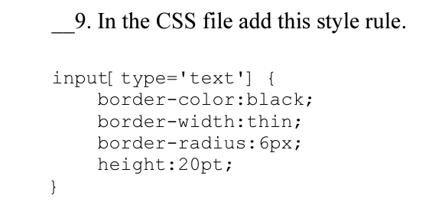

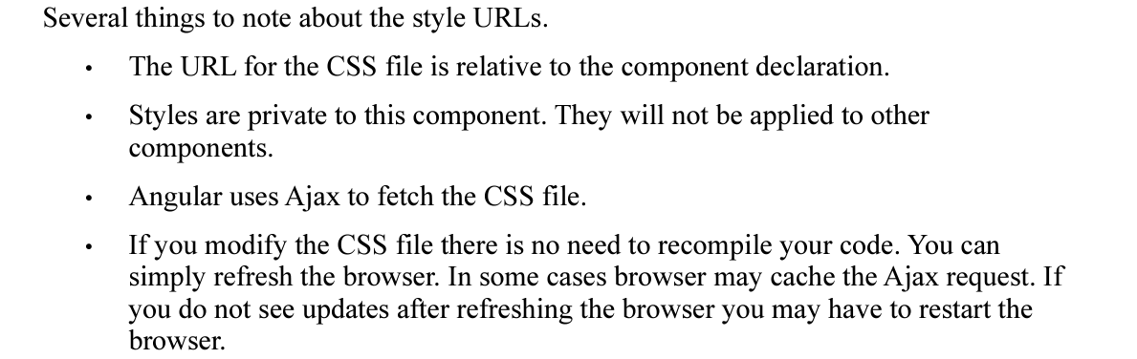

Step 4: Create a fancyCheckBox component

fancyCheckBox.component.css

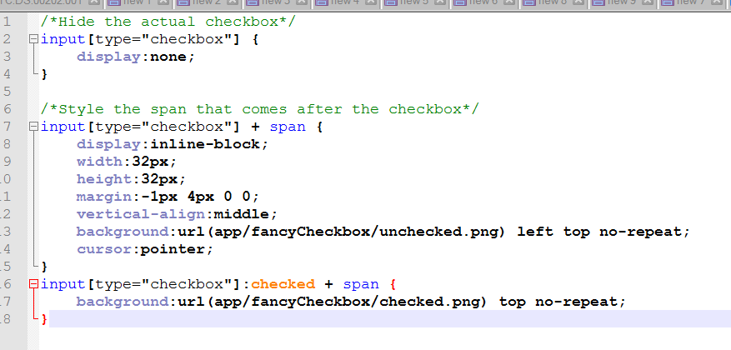

fancyCheckBox.component.ts

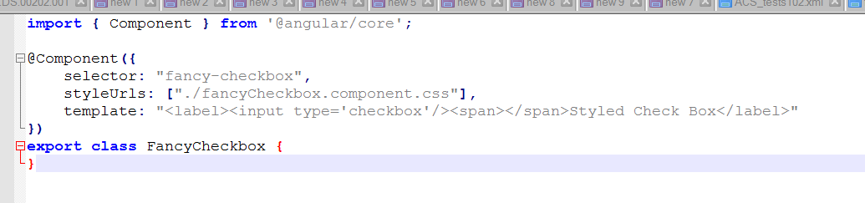

Step 5: Create a subscription form component

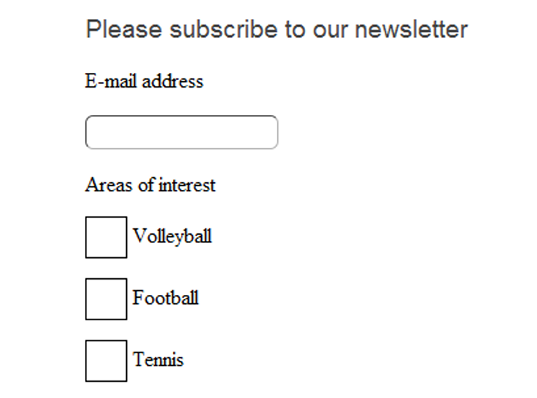

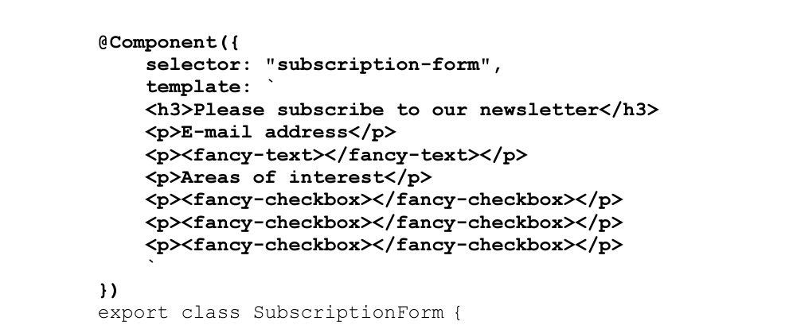

Step 6:Use the Form component

Step 7: Provide Input to the component

HINT: In fancy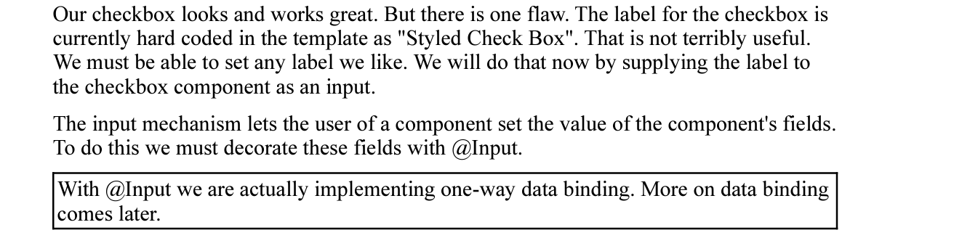CheckBox.component.ts,

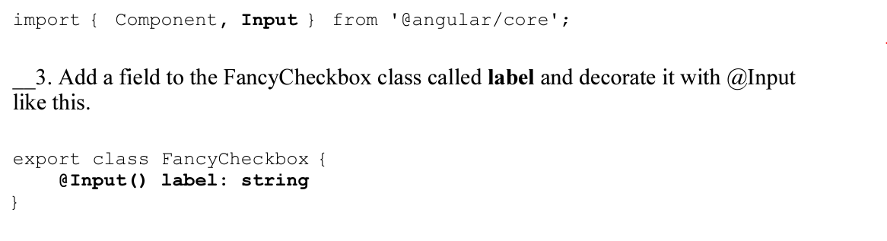

Show the value of label field in template

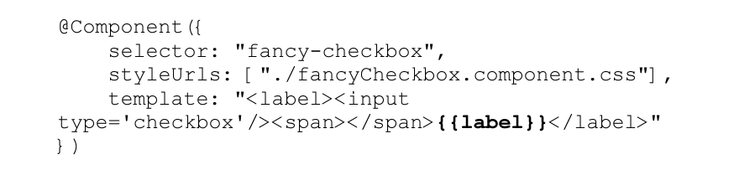

In subscriptionForm.component.ts

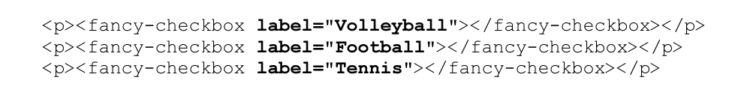

Step 8: Externalize Template HTML

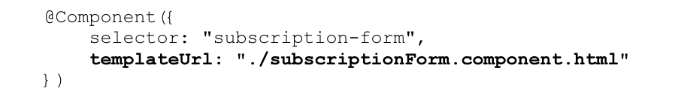

In this lab, we created three components and used one high level component which included two low level components.