Deepfake Video Detection Using CNN and XAI

Christy Maria Joseph
Technological University Dublin
Dublin, Ireland
X00230958@mytudublin.ie

Praveen Sivakumar
Technological University Dublin
Dublin, Ireland
X00230952@mytudublin.ie

Neetha Mariam Sam
Technological University Dublin
Dublin, Ireland
X00230954@mytudublin.ie

Vibhooshan Gunasekaran
Technological University Dublin
Dublin, Ireland
X00231082@mytudublin.ie

ABSTRACT
With the rapid advancement in AI and deep learning techniques, various tools have been developed for multimedia manipulation for use in fields such as entertainment, education etc. Although the invention of these technologies was for legitimate purposes, over the years, its usage has been exploited for unlawful and malicious purposes. Deep-fake media, which is AI-generated media produced using advanced deep learning techniques, poses information integrity, privacy, and trust in digital communication threats increasingly [1]. Although most of the detection research to date has been conducted at detecting deepfake videos [2], the increasing prevalence of both manipulated videos and synthetic images highlights the urgent need for robust detection systems. In this research, we propose an interpretable deep learning model to classify media as either authentic or AI-generated. Using a large-scale dataset containing labeled samples of 364 real videos and 3000 manipulated videos, we implement a convolutional neural network (CNN) with LSTM to distinguish real from fake visual content. Preprocessing of the image includes frame extraction (from videos), resizing and normalization to ensure efficient training. To break the "black-box" nature of CNNs, Explainable AI (XAI) method, Grad-CAM is used to provide visualizations of spatial features informing model predictions, enabling improved interpretability and compliance with transparency obligations under the EU AI Act and GDPR.
Keywords
Deep-fake, CNNs, Explainable AI (XAI), EU AI Act and GDPR.

1. INTRODUCTION
With the advancement of advanced generative artificial intelligence (AI) technologies, there has been a new era in synthetic media creation. The most notable amongst these are the deepfakes, a highly realistic media content produced using deep learning models, typically Generative Adversarial Networks (GANs) or similar architecture. Deepfakes can change or produce visual and audio data to construct convincing situations that never occurred. While the name originally applied to face-swapped videos posted by an anonymous Reddit user in 2017, over time the technology encompasses a variety of media modalities, including video and still images [3].
Deepfakes have been the focus of most of the early studies since they can go viral and mimic individuals in motion, and thus they have a high potential as a tool for disinformation, political propaganda, and reputation attacks [4]. Deepfake images, the static photos created or altered by AI, are no less of a concern. These pictures can be easily produced in large numbers, posted on social media, and utilized for applications ranging from fake profile creation to manipulation of photographic evidence. Deepfakes pictures typically require less computational power to generate, as compared to videos, lowering the entrance cost to malicious actors [5].
The increased availability of sophisticated image-generating programs such as StyleGAN, DALL·E, Midjourney, and Stable Diffusion has reinforced the spread of manipulated images. While peaceful uses involve digital art or filmmaking, the same technology is accessible to produce convincingly realistic-looking portraits or to subtly alter already existing images in a misleading way. The resulting social risks are multi-faceted: loss of faith in online information, threat of identity theft, spread of misinformation, and legal consequences of defamation and privacy invasion [6].
Technically, it is hard to identify whether media is deepfake because there is an ongoing arms race between generation and detection techniques. Early detection mechanisms relied on handcrafted features such as facial landmark inconsistencies, unusual eye blinking rates, or compression artifact features [7]. However, as generation techniques have evolved, such types of anomalies are becoming increasingly difficult to identify for both humans and for traditional detection algorithms. Existing approaches leverage deep convolutional neural networks (CNNs) to learn discriminative features automatically, enabling better real and synthetic media classification.
Our work aims to build an interpretable deepfake detection model using a convolutional neural network architecture. By focusing on real and manipulated videos, this work covers a relatively understudied but critical domain of deepfake detection. It is particularly integrated with Explainable AI (XAI) method, Gradient-weighted Class Activation Mapping (Grad-CAM), to chart the decision-making process of the model. This increases interpretability to both technical and non-technical stakeholders, allows for auditability under regulatory frameworks such as the EU AI Act and General Data Protection Regulation (GDPR), and makes it possible to ascertain whether the model relies on prominent facial features or dataset-specific biases.
Through this research, the following research questions are aimed at being answered:
- RQ1: How effectively can a CNN+LSTM architecture distinguish real from deepfake images?
- RQ2: Which XAI techniques (GradCAM, Saliency Map (Blackbox-model), feature coefficients (Glassbox model)) best reveal the spatial features driving the model’s decisions?
- RQ3: To what extent do these explanations satisfy EU AI Act transparency obligations and GDPR auditability standards, thereby enhancing stakeholder trust?
This work contributes to the further development of open, trusted, and ethical AI systems capable of maintaining information authenticity when the difference between real and fake visual media is getting harder to tell apart.

Literature Review
Deepfake generation has rapidly advanced, enabling highly realistic synthetic images and videos that pose growing threats on social media platforms, undermining trust and privacy. To mitigate this, deep learning methods, particularly Convolutional Neural Networks (CNNs), are widely employed for deepfake image detection.
Recent research has focused on CNN architectures such as ResNet, VGG, Inception, and Xception for deepfake detection. Mansoor and Iliev [8] trained ResNet-50, Inception-V3, and VGG-16 on forged versus real faces and achieved F1-scores 0.8–0.9.
CNN-Based Deepfake Detection
Research by P. Sharma use ensembles by combining different models. One approach mixed a GAN and CNN and added a “memory” system so the model wouldn’t forget older deepfake types. This improved the accuracy 98.7% and maintained stable performance on social-media-style images [9]. Others combined CNNs with transformers. Data-Efficient Image Transformer (DeiT), which are good at looking at the bigger picture in an image [10]. In general, modern detectors fuse local CNN and global transformer features - ResNet/Xception capture local textures, while transformers or attention modules capture global inconsistencies [11]. New datasets like DF40 give researchers a wide variety of deepfake examples for testing.
Explainable AI (XAI) Techniques for Deepfake Detection
However, the black-box nature of CNNs raises concerns about transparency and accountability. So explainability (XAI) has become a focus. XAI tools illuminate why an image was flagged. Grad-CAM is widely used: it generates heatmaps on face images showing regions that most influence the CNN’s decision [12]. LIME and SHAP provide local feature importance by perturbing inputs and measuring output changes. For instance, Tsigo’s research evaluated five XAI methods on a CNN trained on FaceForensics++, finding that LIME provided the clearest explanations for identifying tampered regions across test cases [13]. Other researchers use network dissection, Mansoor and Iliev used a “face dictionary” of segmented facial parts. Their network-dissection step analyzed units in ResNet, VGG, etc., revealing which facial features each neuron responds to. This makes the detector’s reasoning more transparent (“this neuron signals a warped eyebrow, suggesting tampering”) [9].
Some works layer XAI into the pipeline. Tariq et al. (2025) propose a multimodal explanation framework (DF-P2E): first, a CNN classifier produces a Grad-CAM map, then an image captioning model turns that map into a plain-language summary of suspicious regions, and finally a fine-tuned LLM refines it into a user-friendly narrative [12].
Emerging Tools and Techniques
Several new methods have been introduced recently, specifically to deepfake forensics. Continual learning and robustness, where GAN-CNN ensemble with generative replay is an example: it synthesizes past deepfake samples via a GAN and replays them during training to prevent catastrophic forgetting of earlier deepfake types [9]. This is important for social-media applications, where attackers rapidly adapt.
Transformer-based models: In addition to DeiT above, multi-head and cross-modal transformers (like CLIP or ViT) have been used. For instance, models pretrained on image-text data (CLIP) outperform pure CNNs on heterogeneous deepfake sets. Interactivity: A few recent pipelines consider human-in-the-loop or user studies. Tariq performed user trials rating the usefulness of their explanations [12]. New datasets and metrics: DF40 is a new benchmark with 40 deepfake generation methods (face swap, reenactment, full synthesis) from diverse sources. Models are now compared on cross-dataset generalization - train on one source and test on unseen deepfakes.

Methodology
This research adopts a structured methodology to develop and evaluate an explainable deep learning model for detecting deepfake videos. The process includes dataset selection, initial data analysis and dataset preparation, preprocessing, model design, training and evaluation, and explainability analysis. The following sections explain each of these methodologies and how they were implemented in detail.

Dataset and Exploration
In this project we have used the Deep Fake Detection (DFD) Entire Original Dataset, sourced from Kaggle. It contains authentic and manipulated video clips where synthetic faces have been superimposed onto real actors using advanced face-swapping techniques. The dataset contains over 364 original videos, featuring 28 actors performing in 16 different scenes. Additionally, the dataset contains another folder containing 3000 manipulated videos generated using DeepFakes method. These real and manipulated videos are important for training models to accurately detect fake content.
Dataset size and composition:
The size of the dataset is 24 GB containing the following features
- Original Sequences: 364 videos
- Manipulated Sequences: 3068 videos
Before proceeding with preprocessing and model development, a thorough investigation of the dataset was done to discover its composition and structure. The dataset consisted of 364 authentic videos and 3,068 synthetic videos. A bar plot was created to visualize the proportion of real and fake videos in the dataset. As expected, fake videos were much higher in quantity than real ones. This imbalance indicated the need for careful sampling or balancing strategies during training to prevent model bias towards the majority class.
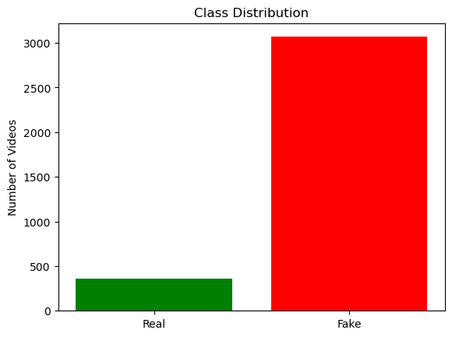
Figure 1: Class Distribution (Real vs Fake)
Frame count of each video was pulled out for analyzing lengths of videos. The histogram showed that most videos were 400 to 1,000 frames in length, with a few extending over 1,500 frames in length. The variation in frame lengths revealed the need to sample a constant number of frames (i.e., 10 equally spaced-out frames per video) for consistent input representation across the dataset.
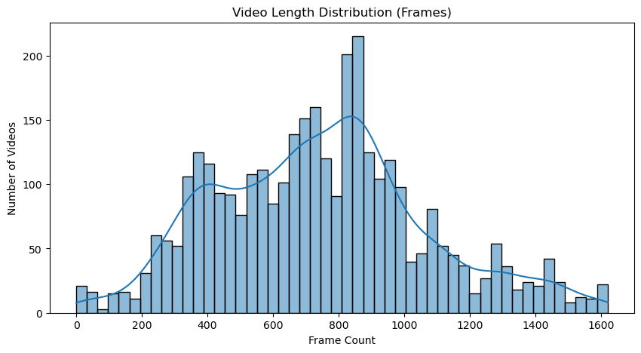
Figure 2 : Video Length Distribution
A random sample of 100 videos (50 fake and 50 real) was analyzed for resolution. The scatter plot of widths vs. heights revealed all the videos with resolution 1920 X 1080, which is a very large resolution for model development. Preprocessing steps such as resizing frames to a particular size (128×128) are therefore necessary to standardize the input format for the neural networks.
The dataset requires additional preprocessing steps to extract relevant frames and reduce the computational overhead.

Preprocessing
Deepfake video datasets are typically very large and contain thousands of frames per clip. Raw videos are not directly usable for model training because they are computationally expensive and not so feasible on standard hardware. Therefore, a controlled preprocessing pipeline was implemented to reduce the data size without compromising critical spatial and temporal features important for deepfake detection. The major preprocessing steps involved are:

Frame Extraction
Each video was reduced to a fixed number of representative frames. Instead of analyzing all frames, which would lead to redundancy and excessive storage requirements, 10 evenly spaced frames were selected from each video. The process was achieved through:
- Determining the total number of frames within a video.
- Determining evenly distributed indices across the video timeline.
- Selecting frames at such indices.
This method ensured that every video was covered by a set of frames containing all possible time moments, as well as spatial and temporal variations, without unnecessary duplication.

Frame resizing and Color Conversion
The extracted frames were preprocessed further to make it fit for modelling. These include:
- Resizing: Frames were resized to 128 × 128 pixels. This resolution was selected as a balance between the computational complexity of processing it and having enough facial detail to use for deepfake detection.
- Color Conversion: Frames were converted from their default OpenCV BGR format to RGB, which is compatible with deep learning models that accept RGB input.
This normalization process reduced input dimension and format variation across the dataset.

Frame Storage
The extracted and processed frames (images) were stored as individual JPEG images in separate folders for real and fake classes. For each frame, a naming convention (real_videoIndex_frameIndex.jpg,fake_videoIndex_frameIndex.jpg) was used to maintain traceability between frames and their source videos. This enabled reusing preprocessed frames without re-extracting them.

Dataset Limiting
Due to computational constraints, the dataset was limited to a maximum of 300 videos per class (300 real and 300 fake). 10 frames were extracted from each video, resulting in 3,000 frames per class and 6,000 frames total.
This constant dataset provided an experimentally tractable yet representative subset while ensuring balanced class distribution.

Label Encoding
Each frame sequence extracted was assigned a binary label: 0: Real, 1: Fake.
These labels were stored in an array (y) alongside the frame data retrieved (X). This binary encoding was necessary for downstream supervised learning with binary classification models.

Train-Validation-Test Split
To enable model training, hyperparameter tuning, and unbiased evaluation, the dataset was split into three sets through stratified sampling:
- Training Set (70%): Used to learn model parameters.
- Validation Set (15%): Used for hyperparameter tuning and early stopping.
- Test Set (15%): Hold-out set for final testing.
Stratification maintained both the real and fake classes at an equal proportion across all splits.
This methodology significantly reduced dataset size while maintaining representative spatial and temporal information. It provided a clean, balanced, and well-structured dataset suitable for deepfake video detection using deep learning models.

Model Architecture
Deepfake video detection is the capture of both spatial details (frame-wise) and temporal dynamics (between consecutive frames). The requirement has been fulfilled through a hybrid Convolutional Neural Network (CNN) + Long Short-Term Memory (LSTM) architecture. The CNN component captures spatial features from each frame of a video, and the LSTM component captures sequential relationships between frames.
To ensure frame-wise feature extraction, all CNN layers are wrapped inside TimeDistributed wrappers, which allows the same convolutional operations to be applied independently to each frame in the sequence. For each of the layers there is:
- Conv2D (filters, 3×3 kernel, ReLU)
- Batch Normalization
- MaxPooling (2×2)
- Dropout (0.25)
Each block progressively increases the number of filters (32, 64, 128), enabling the model to learn hierarchical spatial representations such as edges, textures, and higher-level patterns characteristic of deepfake artifacts. Batch Normalization accelerates training convergence and stabilizes gradients, while Dropout regularizes the model and reduces overfitting.
After convolutional layers, in each time step, a Global Average Pooling (GAP) operation was applied. GAP reduces each feature map to a scalar through the averaging operation, hence producing compact representations without losing discriminative information. This also reduces the parameters, improving computational efficiency.
The frame-level feature sequence was then passed through stacked LSTM layers for encoding temporal relations:
- LSTM (256 units, return_sequences=True)
- Dropout (0.3)
- LSTM (128 units)
- Dropout (0.3)
The first LSTM layer extracts temporal dynamics of features across frames, while the second LSTM layer summarizes these relations into a compact representation. The dropout regularization prevents overfitting by preventing co-adaptation of recurrent units.
The final layer was done with a Dense layer with sigmoid activation, outputting a single probability score: 0: Real ; 1: Fake. This is a binary setup that perfectly corresponds to each of the target classes (fake/real) associated with the task of deepfake detection.
Compilation was performed with the following configurations:
- Optimizer: Adam (learning rate = 1e-4)
- Loss Function: Binary Cross-Entropy (suited for two-class problems)
- Evaluation Metric: Accuracy
Adam was selected due to its support for handling big data and adaptive learning rates. A 1e-4 learning rate was selected to ensure stable convergence with no overshooting. Binary Cross-Entropy is suitable for binary classification (Real or Fake). Accuracy was used as the main measure since the dataset is nicely balanced, hence a good performance benchmark.

Model Training
The CNN + LSTM hybrid architecture was trained using the preprocessed data. The training settings and strategy were selected to balance computational cost with optimal performance.
Training Configurations are as follows:
- Epochs: 20
Up to 20 training epochs were allowed. This offered sufficient opportunity for convergence without running into excessive computation.
- Batch Size: 8
Low batch size was chosen for memory constraints while training with video frame sequences. Although smaller batches will be required to increase training time, they provide the ability to train models on limited hardware with improved generalization
- Validation Split: A separate validation set (15%) was used for hyperparameter tuning purposes and to monitor generalization performance.
As a precaution against overfitting and to achieve optimal training, the following callbacks were employed:
- EarlyStopping: Training was stopped when validation loss did not improve for consecutive 5 epochs. This avoided computation waste and reduced overfitting.
- ModelCheckpoint: The best model according to validation loss was automatically saved as best_model.h5. This ensured that the last test was performed on the best-learned weights rather than on the last epoch.

Evaluation and Results

Training and Validation performance
The training curve shows that the model gradually learned to identify real from fake videos with time. Training accuracy continuously rose, reaching around 73% in the final epoch, whereas training loss decreased permanently. Validation accuracy, however, remained inconsistent, fluctuating between 55%–75%, showing that the model encountered some overfitting, as reflected in the divergence of training and validation loss curves in later epochs. This divergence indicated that the model was overfitting to the training data and struggled to generalize well to unseen videos.

Test set Evaluation and Confusion Matrix
The model was evaluated on a test set of 90 video samples (45 real and 45 fake). The performance results are, Accuracy: 73%, Precision (Real): 0.68, Recall (Real): 0.87, F1-Score (Real): 0.76, Precision (Fake): 0.82, Recall (Fake): 0.60, F1-Score (Fake): 0.69. These results indicate that the model is not so good at distinguishing real and fake videos in general, with average precision for both classes.
The model performed better on real videos, with 87% recall meaning that it tagged most real samples correctly. It performed poorly on fake video detection, with a recall of only 44%, wrongly marking more than half of the fake videos as real.
Overall accuracy of 73% means that the CNN–LSTM approach with custom convolutional feature extraction was not robust enough to identify the subtle, high-quality manipulations found in present deepfakes. The poor accuracy illustrated the need for stronger feature extraction. Specifically, low recall for fake samples indicated that the model was not discriminative enough to accommodate visual imprecision caused by generative mechanisms.
To address this issue, a second approach relying on transfer learning was explored. Specifically, MobileNetV2 was employed as the spatial feature extractor, and an LSTM for modeling temporal dependencies. This approach was employed to leverage pre-trained knowledge on large-scale natural image datasets (ImageNet) to improve fake content detection and generalize more.
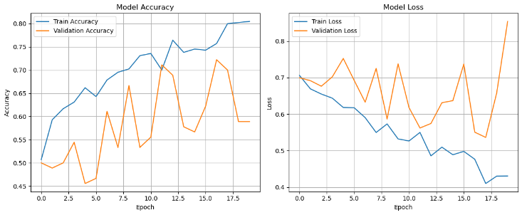
Figure 3: CNN+LSTM- Model Accuracy
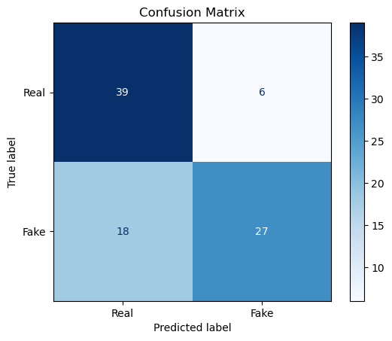
Figure 4: Confusion matrix

MobileNetV2 + LSTM Model
Since the baseline model (CNN+LSTM) struggled to generalize effectively to fake videos, showing lower recall to fake classes, a transfer-learning approach was implemented. MobileNetV2, a lightweight convolutional neural network that was pretrained on the ImageNet dataset, was used as the feature extractor. By leveraging rich pretrained spatial features, the model was expected to learn subtle visual artifacts in deepfakes better. The temporal modeling module was preserved with an LSTM to model sequential dependencies between frames.

Model Architecture and Training
Our proposed model integrates MobileNetV2 for spatial feature learning with LSTMs for learning temporal sequences:
- MobileNetV2 Backbone: Pretrained on ImageNet to learn high-level spatial patterns. Parameters froze during early training to avoid overfitting and save computational time.
- TimeDistributed Wrapping: The backbone CNN was wrapped in TimeDistributed, ensuring frame-by-frame feature extraction across 10 sampled frames per video.
- Global Average Pooling: A TimeDistributed(GlobalAveragePooling2D()) layer condensed spatial features into compact embeddings for each frame.
- The LSTM and output layers are of the same architecture as that of the base model.
The training setup was same as that of the base model, with Adam optimizer, Binary cross-entropy loss function, batch size of 8 (limited by video frame memory size), Epochs: 30 (with EarlyStopping), EarlyStopping: Ended training if validation loss didn't improve after 5 epochs, ModelCheckpoint: Saved best model with mobilenet_lstm_best.h5.

Results
The training vs validation accuracy plots indicate that both plots converge to greater than 96%, with no significant signs of overfitting. Validation accuracy plateaued early (epoch 2–3), suggesting efficient convergence. For the test set, the model performed with accuracy: 96% and loss: 0.1883. The classification report is as follows:
Table 1. Classification Report for MobileNetV2
Class | Precision | Recall |  | Support
  F1-score
Real | 1.00 | 0.91 | 0.95 | 45
Fake | 0.92 | 1.00 | 0.96 | 45

- Real videos were detected with perfect precision and good recall (91%).
- Fake videos were detected with perfect recall (100%) and satisfactory precision (92%).
- The balanced performance on both classes is a significant improvement over the baseline CNN–LSTM.
The confusion matrix confirms that the model correctly classified nearly all videos: 41/45 Real videos correctly classified (4 misclassified as Fake) and 45/45 Fake videos correctly classified.
The MobileNetV2 + LSTM hybrid performed much better than the CNN–LSTM baseline. By leveraging the pretrained features, the model generalized better and had better balanced class performance with an especially strong capability in detecting fake content (100% recall). This demonstrates the effectiveness of transfer learning for deepfake detection and makes MobileNetV2 as an effective feature extractor for video classification tasks.
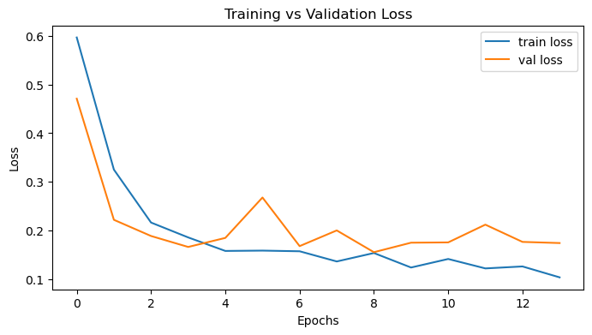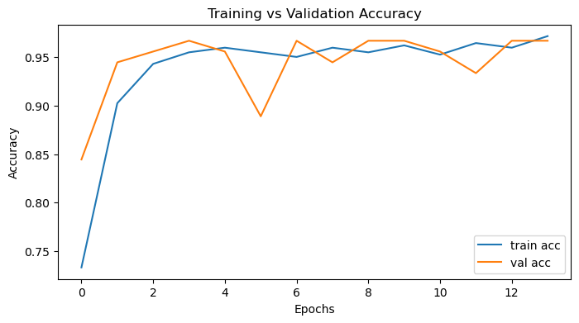
Figure 5: Transfer Learning- Accuracy and Loss
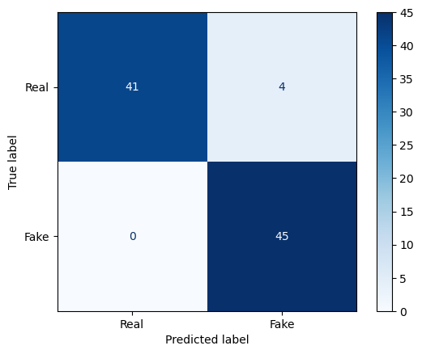
Figure 6: Confusion Matrix- Transfer Learning

Glassbox Model- Logistic Regression
Though deep models such as CNN–LSTM and MobileNetV2–LSTM produce good performance in detecting deepfakes, they have been opposed as black-box models because they are not highly interpretable. To address this, two glassbox model based on Logistic Regression and decision tree was implemented for the comparison. Logistic regression is transparent in decision-making because it produces interpretable coefficients that measure feature importance directly, making it suitable for affirming findings consistent with Explainable AI (XAI) principles and even regulatory policies such as the EU AI Act.
Instead of training raw frames directly, features were first extracted from a video using the MobileNetV2 CNN pre-trained as a feature extractor. Frames were passed into MobileNetV2 through to the Global Average Pooling layer to produce a dense feature vector for each frame.
The Decision Tree classifier was also trained on the same CNN-based video embeddings. Decision trees partition the feature space into understandable decision rules, allowing direct visualizing of classification process.

Training and Evaluation
A Logistic Regression and decision tree was trained on the extracted features. The results on the test set (90 videos) were as follows:
Table 2. Classification Report on logistic regression
Class | Precision | Recall
  F1-score
Real | 1.00 | 0.91 | 0.95
Fake | 0.92 | 1.00 | 0.96
Accuracy: 96%
Table 3. Classification Report on decision tree
Class | Precision | Recall
  F1-score
Real | 0.94 | 0.69 | 0.79
Fake | 0.75 | 0.96 | 0.84
Accuracy: 82%

The logistic regression model performed equally well (96% accuracy) as the MobileNetV2–LSTM deep model but with full interpretability. This result shows the strength of transfer learning: even simple linear models like logistic regression can perform quite well if they are powered by good CNN-extracted features. Decision trees allow visualization of splits and thresholds. However, due to high dimension CNN features, the tree became very complex, reducing interpretability compared to simple tabular space. However, it signals non-linear feature interactions which cannot be detected by Logistic Regression.
Both glass-box models provided valuable interpretability, but Logistic Regression emerging as the better-performing and more interpretable model.

Best Model Selection
To figure out the optimal method for detecting deepfakes in videos, four models were implemented and experimented with
- Baseline CNN–LSTM
- Accuracy: 73%
- Advantages: Simplicity of architecture to integrate spatial and temporal data.
- Disadvantages: Lower generalization, especially for fake videos (Recall = 0.60), that indicate lack of ability to identify subtle manipulations.
- MobileNetV2–LSTM (Transfer Learning)
- Accuracy: 95.6%
- Strengths: Employed pretrained ImageNet weights to ensure stable spatial feature learning and LSTM for temporal sequence modeling. Achieved well-balanced performance on real and fake videos with satisfactory precision and recall.
- Weaknesses: Computationally more expensive than simple models.
- Glassbox Logistic Regression (MobileNetV2 features)
- Accuracy: 95.6%
- Strengths: Achieved performance comparable to the MobileNetV2–LSTM but with interpretability. The model's linearity provides coefficient analysis and transparency, which is very important for explainability-driven scenarios (e.g., compliance with EU AI Act).
- Weaknesses: Unlike LSTM-based models, it does not learn temporal dynamics among frames but instead utilizes aggregated frame-level features.
- Glassbox Decision Tree
- Accuracy: 82%
- Strengths: Derives non-linear relationships and provides clear, rule-based explanations of decisions. Particularly excellent at detecting deepfakes (Recall = 0.96).
- Weaknesses: Lower overall accuracy but with a bias to classify genuine videos as fake (Recall = 0.69 for Real). The model is complex when handling high-dimensional CNN features, reducing interpretability compared to Logistic Regression.
Final Selection:
Considering both accuracy and practical applicability, the MobileNetV2–LSTM was considered the best-performing model for this research. It struck a proper balance between detection capability, generalization, and immunity to temporal artifacts in videos.

Explainable AI (XAI) Implementation
To better understand how the MobileNetV2–LSTM model makes its predictions, two XAI methods were applied: Grad-CAM++ and Saliency Maps. Both methods offer insights that are complementary to each other by visualizing areas of the video frames that had the highest impact on the predictions made by the model.
- Grad-CAM++:
Grad-CAM++ was applied on single frames by computing class-discriminative heatmaps from the last convolutional layer of the base MobileNet model..
Result:
On right cases, Grad-CAM++ paid attention to steady and pertinent body regions, such as the upper body and gestures.
In incorrect cases, the attention was weaker, with the model highlighting background objects like desks or walls, which is indicative of possible overfitting or failure to distinguish between features.
- Saliency Maps:
Saliency maps compute the gradient of the model output with respect to input pixels and aid in deciding which pixels have the most influence on the prediction.
Result:
- For proper predictions, saliency maps showed high activation around the subject's hands, face, and body posture, indicating prominent model activity.

- In wrong predictions, attention was spread across the frame, such as the background, which shows the model may have been confused by irrelevant features.
Comparing both the techniques, Grad-CAM++ was stronger for explaining the model's spatial attention over certain sequences of frames and Saliency Map showed better results for some other frames. Hence, a solid conclusion cannot be made regarding which method is better interpretable, rather, both the methods are useful for interpreting different types of frames.
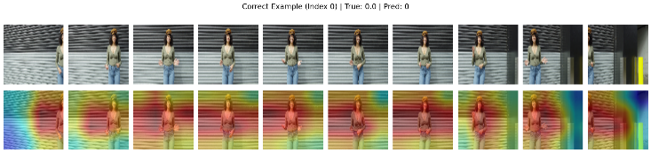
Figure 7: Grad-CAM++ of fake images
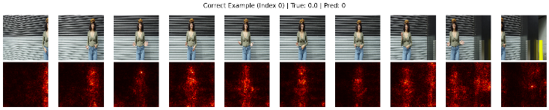
Figure 8: Saliency Map of fake images
To further apply interpretability to Grad-CAM++ and Saliency Maps, we also looked at the feature coefficients from the glass-box Logistic Regression model. The features contributing to the results were selected and analyzed to see which features most contributed to detecting whether a frame is fake/real. This approach highlights that conclusions can be traced back to single features. However, these lacks interpretability because we can’t identify what these features are. Hence in our case, the black-box models are more interpretable using Grad-CAM++ and Saliency maps.

GDPR, EU AI Act Compliance
The proposed deepfake detection framework has been designed with regulatory compliance in mind, particularly the EU AI Act and the General Data Protection Regulation (GDPR). These frameworks emphasize transparency, accountability, fairness, and protection of personal data when deploying AI systems.

GDPR Compliance
- Data Minimization (Art. 5(1)(c)): Only essential video frames are extracted (10 frames per video), reducing the amount of personal data processed while maintaining model performance.
- Lawful Basis & Purpose Limitation (Art. 6, 5(1)(b)): All data used is sourced from publicly available, research-licensed datasets (Kaggle DFD). The model is trained solely for the purpose of research into deepfake detection.
- Data Protection by Design (Art. 25): Preprocessing removes metadata and standardizes frames, ensuring no unnecessary identifiers are retained.
- Right to Explanation (Art. 22): By integrating Explainable AI techniques (Grad-CAM++, Saliency Maps), individuals impacted by model decisions can receive human-interpretable explanations of how predictions were made. This aligns with GDPR obligations for meaningful information about automated decision-making.

EU AI Act compliance:
Under the EU AI Act, deepfake detection systems may qualify as high-risk AI applications when used for authentication, misinformation control, or identity verification. To meet the obligations:
- Transparency (Art. 13): Grad-CAM++ and Saliency Maps provide visual evidence of the features driving decisions, ensuring that outputs are explainable to both technical and non-technical stakeholders.
- Human Oversight (Art. 14): The system is intended as a decision-support tool, not as an autonomous decision-maker. Human operators retain responsibility for final judgments, reducing the risks of false positives/negatives.
- Accuracy, Robustness, and Cybersecurity (Art. 15): The use of transfer learning (MobileNetV2–LSTM) improves generalization across real/fake samples, while model evaluation includes confusion matrices, F1-scores, and stress tests to ensure reliability.
- Documentation & Record-Keeping (Arts. 16–18): The experimental pipeline (dataset composition, preprocessing steps, model architecture, training settings, and evaluation metrics) is fully documented, ensuring reproducibility and regulatory auditability.

Alignment with UN Sustainable Development Goals (SDGs)

- SDG 9: Industry, Innovation, and Infrastructure
By developing an innovative AI-based system for detecting synthetic media, this research fosters innovation in trustworthy AI systems. The use of explainable AI techniques ensures that technological innovation is not only state-of-the-art but also responsible and transparent.
- SDG 16: Peace, Justice, and Strong Institutions
Deepfakes can compromise democratic processes, social trust, and justice by enabling misinformation, fraud, and identity manipulation. This project is contributing directly to the strengthening of institutions and promoting justice by providing technologies that are resilient to disinformation, protecting individuals from malicious media manipulation, and enhancing digital trust
- SDG 17: Partnerships for the Goals
The use of open research datasets (Kaggle DFD) and transparent reporting enables the framework to be built upon by the broader research community. Openness will facilitate collaboration between academia, industry, and policymakers to combine forces to combat the global issue of disinformation and media manipulation.

Conclusion and Future Work
This research investigated deepfake video detection using both deep learning and explainable machine learning approaches. A baseline CNN–LSTM model achieved decent performance (73% accuracy), with challenges in identifying subtle manipulations. In contrast, MobileNetV2–LSTM transfer learning model achieved outstanding accuracy gains of 96%, with the merits of pretraining spatial features as well as temporal sequence modeling.
As an added measure of transparency, glass-box models (Logistic Regression and Decision Tree) were implemented as well. Logistic Regression behaved just like the deep learning model (96% accuracy) but with the additional interpretable coefficients, while Decision Tree offered simple-to-interpret decision rules at slightly less accuracy (82%). Finally, XAI methods (Grad-CAM++, Saliency Maps, and feature coefficients) provided explanations regarding why models make predictions and confirming models will focus on semantically salient regions but get confused where attention is diffused or are misleading. In conclusion, the study demonstrates that accuracy and explainability can both be guaranteed by combining high-performing transfer learning models with glass-box interpretable models.

Future Work:
The work can be extended in numerous ways:
- Larger and More Diverse Datasets: Scaling up the dataset size to include multi-context videos (e.g., low-light, occluded faces) would improve generalizability.
- Advanced Architectures: Incorporating attention mechanisms, transformers, or 3D CNNs can augment spatiotemporal feature learning.
- Ethical and Regulatory Alignment: Greater explainable AI adoption guarantees compliance while fostering end-user trust.
In summary, this research contributes the balanced perspective: glass-box models and XAI deliver interpretability, while deep learning models give the state-of-the-art accuracy, a combination that is essential towards creating reliable, ethical, and deployable deepfake detection system

References

[1] | S. R. MD, N. N. MOHAMMAD, M. BEDDHU and A. H. SUNG, "Deepfake Detection: A Systematic Literature Review," 2022.
[2] | D. Guera and E. J. Delp, "Deepfake Video Detection Using Recurrent Neural Networks," 2018.
[3] | R. Tolosana, R. Vera-Rodriguez, J. Fierrez, A. Morales and J. Ortega-Garcia, "Deepfakes and beyond: A Survey of face manipulation and fake detection," 2020.
[4] | B. Chesney and D. Citron, "Deep Fakes: A Looming Challenge for Privacy, Democracy, and National Security," 2019.
[5] | M. Marie-Helen and A. Alexandrou, "Determining authenticity of video evidence in the age of artificial intelligence and in the wake of Deepfake videos," 2018.
[6] | C. Vaccari and A. Chadwick, "Deepfakes and Disinformation: Exploring the Impact of Synthetic Political Video on Deception, Uncertainty, and Trust in News," 2020.
[7] | L. Yuezun, C. Ming-Ching and L. Siwei, "In Ictu Oculi: Exposing AI Created Fake Videos by Detecting Eye Blinking," 2018.
[8] | M. N and I. A. I., "Explainable AI for DeepFake Detection," 2025.
[9] | S. P. Sharma, K. M and H. K. Sharma, "GAN-CNN Ensemble: A Robust Deepfake Detection Model of Social Media Images Using Minimized Catastrophic Forgetting and Generative Replay Technique," 2024.
[10] | A. H. Soudy, "Deepfake detection using convolutional vision transformers and convolutional neural networks," 2024.
[11] | A. Kafi , A. Bhattacharjee, A. Intesher, K. Islam , A. Fuad, Abrar, U. Saha and H. Imtiaz, "Hybrid Deepfake Image Detection: A Comprehensive Dataset-Driven Approach Integrating Convolutional and Attention Mechanisms with Frequency Domain Features," 2025.
[12] | T. S , W. S. S, S. P, I. I and G. S, "From Prediction to Explanation: Multimodal, Explainable, and Interactive Deepfake Detection Framework for Non-Expert Users," 2025.
[13] | T. K, A. E, B. S and P. S, "Towards Quantitative Evaluation of Explainable AI Methods for Deepfake Detection," 2024.

Appendix

Data Card
https://www.kaggle.com/datasets/sanikatiwarekar/deep-fake-detection-dfd-entire-original-dataset

Individual Contributions
In this project I was involved in every stage together with my colleagues. I specifically contributed my time working on the black-box models and Explainable AI (XAI) techniques, thus combining my technical competence with insight into how to build systems that are accurate yet interpretable.
My main role entailed building, training, and testing the two black-box models. First, I designed and implemented a hybrid CNN + LSTM to extract spatial features from frames and temporal dynamics from sequences of frames. While this baseline achieved about 73% accuracy, I started seeing its weaknesses, especially in fake detection, with low recall. That made me realize the limitations of training such models from scratch. To resolve this, I designed the MobileNetV2 + LSTM based on transfer learning. Pretrained MobileNetV2 weights were used as a spatial feature extraction module coupled with LSTM for temporal modeling, thus delivering substantially better performance. Because of careful tuning through early stopping, checkpointing, and freezing layers, this model gave 96% accuracy with balanced precision and recall.
Apart from building models, I also focused on Explainable AI (XAI). Black-box models often labelled as hard to interpret. I wanted to make sure we would be able to explain the decisions made by our models. I contributed in implementing Grad-CAM++ and Saliency Maps to understand which parts of the video frames were most influential to the predictions. Developing an intuition about these heatmaps was an enriching experience: correct predictions usually focused on the face, limbs or gestures.
Also, I collaborated with colleagues working on glass-box models, connecting my results from black-box explainability with their approaches based on interpretable features. The comparison gave me a better idea of how both types of models can complement one another. I also contributed in the XAI for the glass-box model as well, where we did the analysis on the contributions of the feature coefficients. Black-box models give you better performance while glass-box models give you better interpretability. But looking at the end results of interpreting the model, in our particular case, black-box model was better.
Writing portions of the Black-Box Models and XAI sections in the report gave me the chance to clearly present these results and reflect on how they relate to regulatory requirements. Apart from this I contributed on other parts of the document as well, like references, methodologies, future work and all.
To conclude, my contributions to the project were developing the black-box models CNN+LSTM and MobileNetV2+LSTM and applying XAI techniques for interpreting their predictions. I deepened my technical skillset on deep learning and transfer learning and, simultaneously, saw the need for explaining and holding AI systems subject to accountability. Experience in balancing performance with explainability came from this project, a skill of utmost importance in implementation of trusted AI systems.

