SwiftShip Tracker: Project Report
Salesforce Developer project | Team lead: Praveen P | Submission deadline: Saturday, 3 October 2026
GitHub: https://github.com/praveen0-100/-swiftship-tracker

1. Introduction
Overview. SwiftShip Tracker is a Salesforce CRM solution for parcel booking, shipment tracking and delivery management. It covers the full lifecycle: booking, dispatch, in-transit tracking, out for delivery, and delivery confirmation. Customers see shipment information; delivery agents update parcel status.
Purpose.
- Centralize parcel and delivery information
- Simplify booking and tracking
- Give real-time shipment visibility
- Automate delivery updates and notifications
- Enable conversational tracking with Agentforce and Prompt Builder
- Provide role-based access for customers, agents, support staff and admins

2. Ideation Phase

2.1 Problem statements
PS | I am | I'm trying to | But | Because | Which makes me feel
PS-1 | Customer / Sender | book a parcel easily | booking requires support or multiple apps | parcel operations are not centralized | frustrated
PS-2 | Customer / Sender | track my parcel | there is no simple real-time tracking | shipment information is hard to access | confused
PS-3 | Delivery Agent | update parcel status | updates are manual | there is no centralized operational tracking | concerned
PS-4 | Customer | receive delivery updates | notifications are not sent at every stage | communication is not automated | uncertain
PS-5 | Admin | monitor parcel operations | flow and performance are hard to see | data is not centrally reported | concerned

2.2 Empathy map (Customer / Sender)
- Think & feel: wants to book and track without repeatedly contacting support
- Hear: delivery information and status updates from the parcel service
- See: parcel details, tracking status, estimated delivery date
- Say & do: books parcels, checks tracking, asks for updates
- Pain: delays, confusion, no easy tracking, dependence on support
- Gain: real-time visibility, self-service tracking, timely notifications

2.3 Brainstorming
Ideas considered: manual registers, spreadsheet tracking, a standalone parcel portal, Salesforce CRM with Agentforce. Selected: Salesforce CRM with Agentforce for centralized management, Flow automation, real-time visibility, conversational AI, role-based security, and reports.

3. Requirement Analysis

3.1 Customer journey
Parcel Booking > Parcel Record Creation > Dispatch & Shipment > In-Transit Tracking > Out for Delivery > Delivery Confirmation > Customer Notification > Feedback / Support

3.2 Requirements
FR | Requirement | Implemented by
FR-1 | Parcel booking and record creation | Parcel__c, SwiftShip Tracker app
FR-2 | Parcel status tracking | Parcel__c.Status__c
FR-3 | Weight management | Parcel__c.Weight__c, trigger validation
FR-4 | Estimated delivery date | Estimated_Delivery_Date__c, trigger validation
FR-5 | Sender information | Sender__c
FR-6 | Receiver information | Receiver__c
FR-7 | Delivery and location tracking | Delivery__c.Current_Location__c
FR-8 | Agent status updates | Swift_Ship permission set, Parcel record edit
FR-9 | Automated notifications | ParcelTriggerHandler status-change emails, OverdueParcelBatch
FR-10 | AI-powered tracking | Agentforce + Parcel_Details flow
FR-11 | Reports and dashboards | see docs/manual-steps.md
FR-12 | Customer access | Experience Cloud (future scope in this prototype)

NFR | Description
Usability | Intuitive Lightning app and tabs
Security | Permission sets, field-level access
Reliability | Validation keeps status and dates accurate
Performance | Bulkified trigger and batch (200 per scope)
Availability | Cloud-based Salesforce
Scalability | Batch Apex, lookup relationships
Data integrity | Required fields, relationship-based data
Maintainability | Handler pattern, configurable flow

3.3 Data flow
Customer/Sender > Parcel Booking > Parcel Record > Sender + Receiver > Delivery Record > Status Update > Location & ETA > Notifications > Tracking / Agentforce > Reports & Dashboards
AI flow: Customer query > Agentforce > Parcel_Details flow / Prompt Builder > Parcel record > Status, weight, ETA > conversational response

3.4 Technology stack
Layer | Technology
Platform | Salesforce Developer Edition
UI | Lightning App, Lightning record pages
Database | Custom objects
Logic | Flow, Apex trigger, Batch Apex
AI | Agentforce, Prompt Builder
Notifications | Apex email
Security | Permission sets, field-level security
Reporting | Reports and dashboards

4. Project Design

4.1 Problem-solution fit
Problem | Solution | Benefit
Booking is difficult | Parcel management in Salesforce | Centralized booking
Tracking needs support | Agentforce + Prompt Builder | Self-service tracking
Manual status updates | Flow and Apex | Automated processes
Communication gaps | Email on every status change | Timely notifications
Scattered data | Parcel, Delivery, Sender, Receiver objects | Structured data
Hard to monitor | Reports and dashboards | Better visibility
Different access needs | Permission sets | Secure access

4.2 Proposed solution
Problem: inefficient parcel booking and tracking. Solution: Salesforce parcel management system. Innovation: conversational tracking through Agentforce with automated Flow and Apex. Impact: centralized booking, real-time visibility, timely notifications. Scalability: supports growth and external logistics integration.

4.3 Architecture
Users (Customer, Delivery Agent, Support, Admin) > Salesforce Lightning > SwiftShip Tracker platform: Data (Parcel, Delivery, Sender, Receiver) | Automation (Flow, Apex, Batch Apex, email) | AI (Agentforce, Prompt Builder, Parcel Tracking Agent) | Security (permission sets, FLS) > Reports & Dashboards

5. Project Planning
Agile, sprint-based, epics > stories > story points.
Sprint | Epic | Story | Points | Priority | Member
1 | Developer setup | USN-1 Create and configure the Salesforce environment | 3 | High | Praveen P
2 | Data modeling | USN-2 Create Parcel, Delivery, Sender, Receiver objects and relationships | 5 | High | Priyan K
2 | Data modeling | USN-3 Tabs and Lightning app | 5 | High | Nishanth S
3 | Automation | USN-4 Validate parcel details and mandatory fields | 3 | High | Nandhakumar A
3 | Automation | USN-5 Flows to update parcel status and delivery info | 3 | High | Nandhakumar A
4 | Apex | USN-6 Triggers and classes for parcel actions | 5 | High | Praveen P
4 | Apex | USN-7 Batch Apex for overdue parcels | 5 | High | Priyan K
5 | Reports | USN-8 Status and delivery performance reports | 4 | High | Nishanth S
6 | Dashboards & AI | USN-9 Dashboards and Agentforce tracking | 4 | Medium | Nandhakumar A

Project tracker, velocity and burndown
Sprint dates follow the actual build log (all work done 30 Sep to 1 Oct 2026, ahead of the 3 Oct deadline).
Sprint | Total story points | Duration | Start | End (planned) | Points completed | Release date (actual)
Sprint-1 | 3 | 1 day | 30 Sep 2026 | 30 Sep 2026 | 3 | 30 Sep 2026
Sprint-2 | 10 | 1 day | 30 Sep 2026 | 30 Sep 2026 | 10 | 30 Sep 2026
Sprint-3 | 6 | 1 day | 30 Sep 2026 | 30 Sep 2026 | 6 | 30 Sep 2026
Sprint-4 | 10 | 1 day | 30 Sep 2026 | 30 Sep 2026 | 10 | 30 Sep 2026
Sprint-5 | 4 | 1 day | 1 Oct 2026 | 1 Oct 2026 | 4 | 1 Oct 2026
Sprint-6 | 4 | 1 day | 1 Oct 2026 | 1 Oct 2026 | 4 | 1 Oct 2026

Total: 37 story points over 6 sprints, average velocity about 6.2 points per sprint.

Team
Name | Role
Praveen P | Team Lead (Member1 in the backlog above)
Priyan K | Team Member (Member2)
Nishanth S | Team Member (Member3)
Nandhakumar A | Team Member (Member4)
Prakash V | Team Member

6. Development Phases
Phase 1: Requirement analysis. Personas (Customer, Agent, Support, Admin), data model, use cases, tool selection.
Phase 2: Backend. Objects and fields (force-app/main/default/objects), tabs, app, Parcel_Details flow.
Phase 3: UI and Agentforce. Swift_Ship permission set, Agentforce default agent, "Parcel Updates" subagent, flow action, agent renamed SwiftShip Tracker.
Phase 4: Testing. Verify the agent lists, subagent and flow are active; preview "Track parcel P-001"; confirm data on the Parcel record. Apex tests: 5/5 pass (SwiftShipTests).
Phase 5: Deployment and maintenance. Validated and deployed to a Developer Org with sf project deploy start. Sandbox/UAT and CI/CD are out of scope for this prototype. Maintenance: monitor flow failures, refine prompts and subagent topics, keep parcel data current.

7. Functional and Performance Testing
Evidence is in docs/test-evidence.md (5/5 Apex tests passing, validation errors for weight 0 and past dates, flow output for P-001, org records) and docs/screenshots/:
- 01-parcel-object-fields.jpg: Parcel object fields
- 02-parcel-record-P-001.jpg: Parcel record with auto-number ID
- 03-parcel-details.png: Parcel Details flow in Flow Builder (Active)
- 04-retrieve-parcel-details.png: Retrieve Parcel Details prompt template
- 10-retrieve-parcel-details-book-box.png: Prompt Builder preview - the resolved prompt is filled with P-001 (Books Box) data
- 04-report-parcels-by-status.jpg and 05-report-overdue-parcels.jpg: the two reports
- 06-validation-error-weight-zero.jpg: red validation error when saving Weight = 0
- 07-dashboard-swiftship-operations.jpg: SwiftShip Operations dashboard
- 08-agent-preview-track-P-001.jpg: agent answering "Track parcel P-001" (subagent, action and grounded output in the trace)
- 09-agent-active.jpg: agent SwiftShip Tracker, Version 1 (Active)
The Retrieve Parcel Details prompt template is Published in the org. The agent definition is stored in the repo under force-app/main/default/aiAuthoringBundles/SwiftShip_Tracker.

8. Advantages and Disadvantages
Advantages: centralized data, real-time visibility, automated processes, conversational tracking, less manual effort, timely notifications, scalable.
Disadvantages: needs accurate data, depends on configuration, Agentforce quality depends on prompts, integrations add complexity, flows need upkeep, users need access.

9. Conclusion
SwiftShip Tracker shows how Salesforce objects, Flow, Apex and Agentforce combine into a centralized parcel management and tracking solution, letting customers get shipment information without manual support.

10. Future Scope
Broader Agentforce queries, richer real-time tracking, Experience Cloud self-service, delivery analytics, external logistics integration, better prompts, sandbox and CI/CD.

11. Appendix
A. Custom objects: Parcel, Delivery, Sender, Receiver | B. Automation: Flow, Apex trigger, email | C. Apex: ParcelTriggerHandler, OverdueParcelBatch, SwiftShipTests | D. AI: Agentforce, Prompt Builder | E. UI: Lightning app, tabs | F. Security: permission set | G. Analytics: reports and dashboards

12. Screenshots
Figure 1: Parcel object: fields and relationships
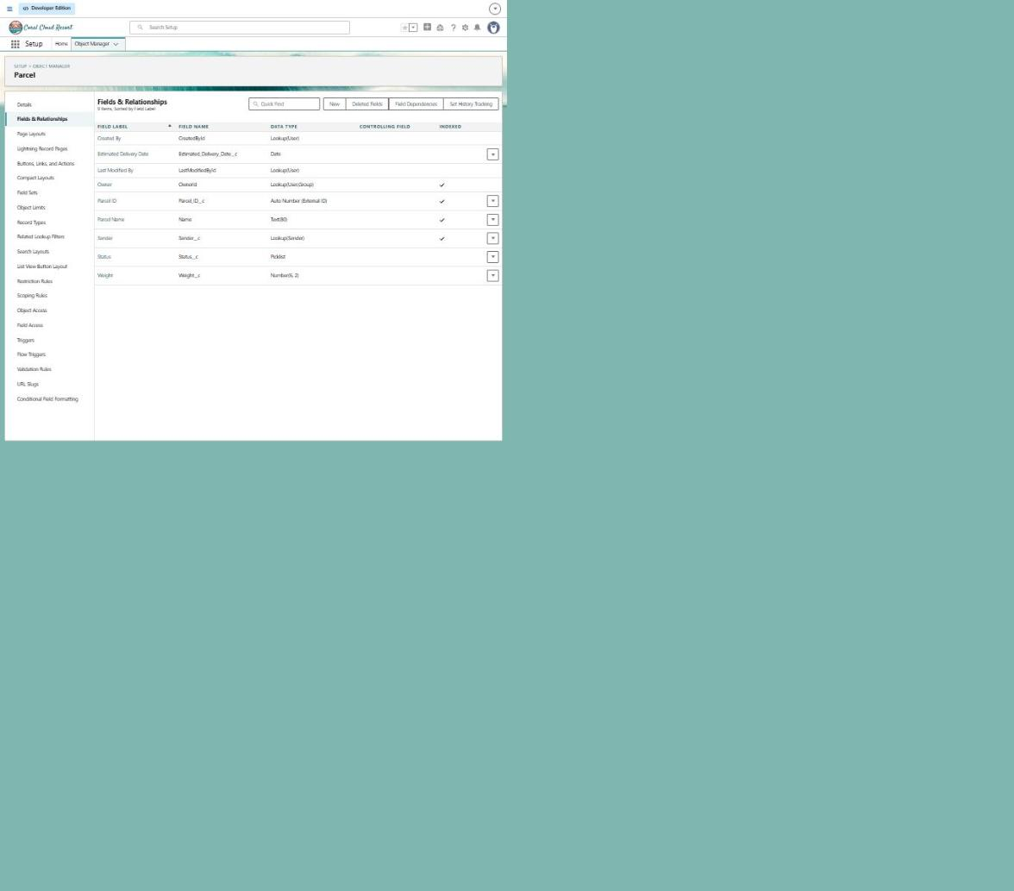
Figure 2: Parcel record P-001 with all fields
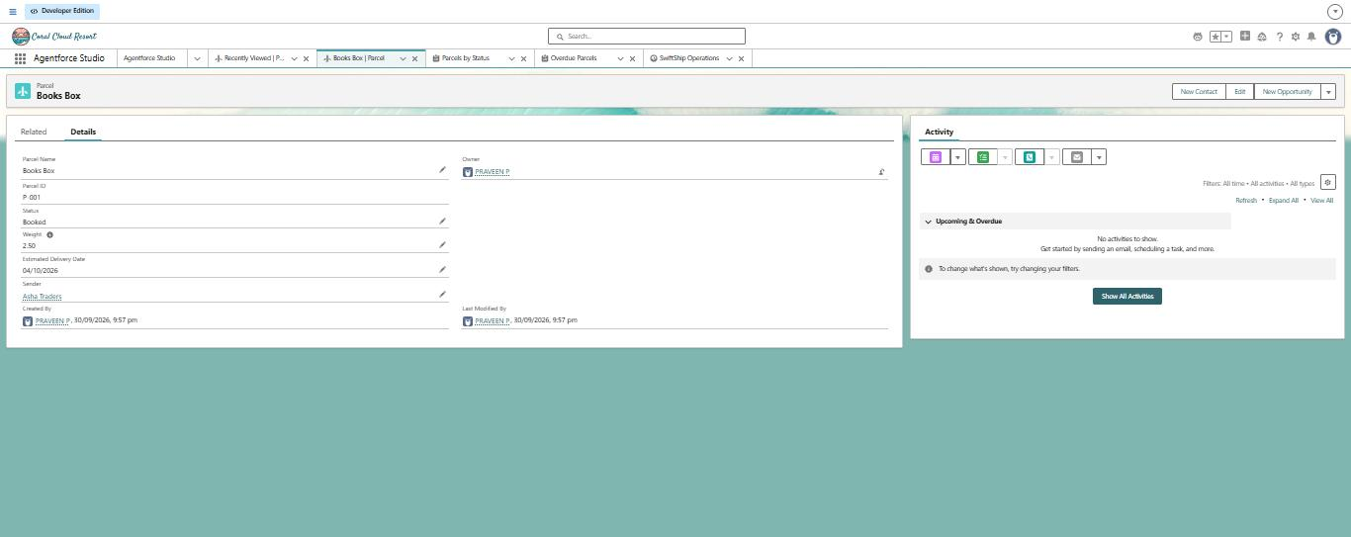
Figure 3: Parcel Details flow in Flow Builder (Active)
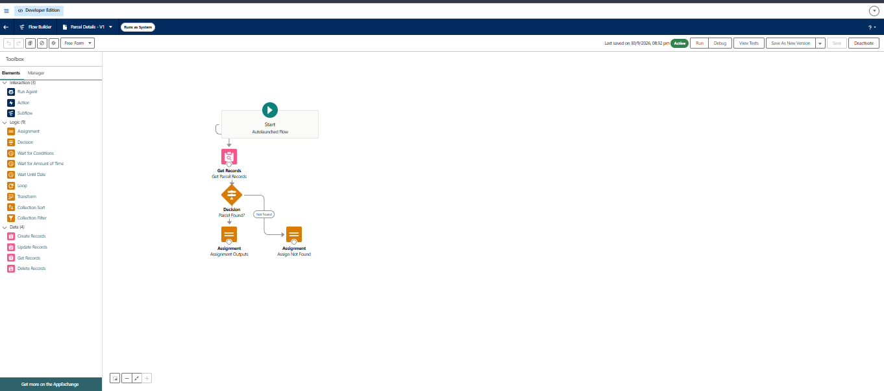
Figure 4: Retrieve Parcel Details prompt template
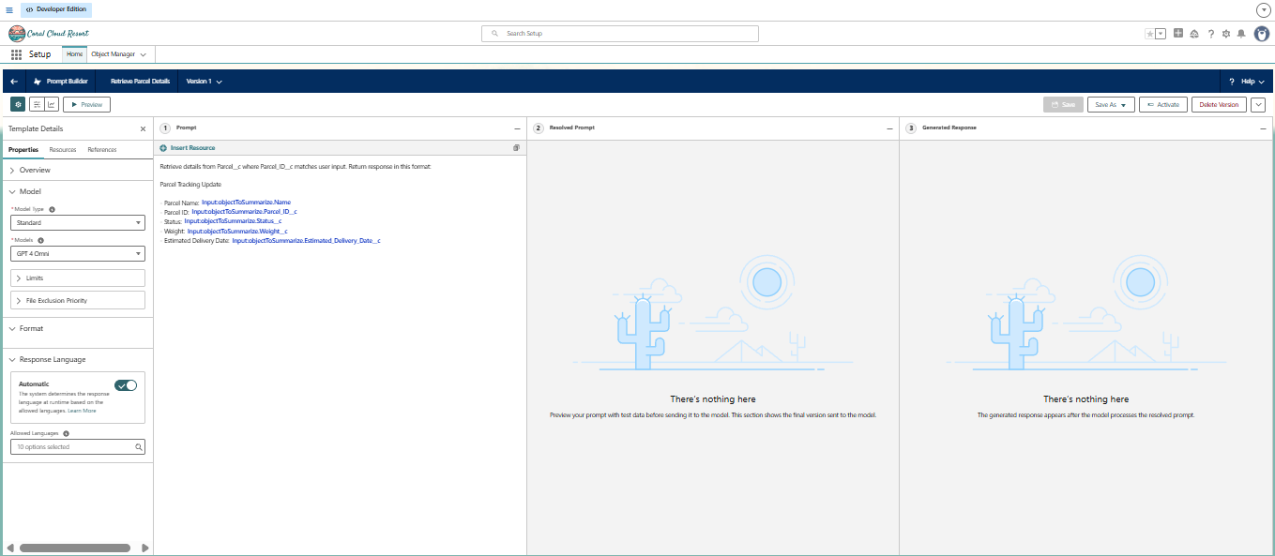
Figure 5: Report: Parcels by Status

Figure 6: Report: Overdue Parcels
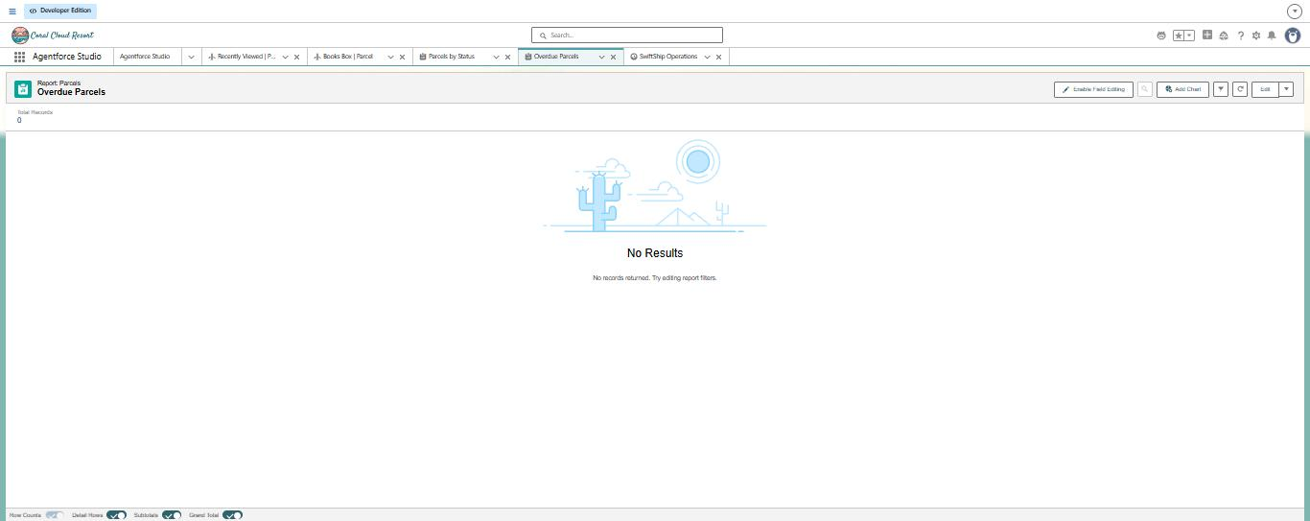
Figure 7: Validation error when saving Weight = 0
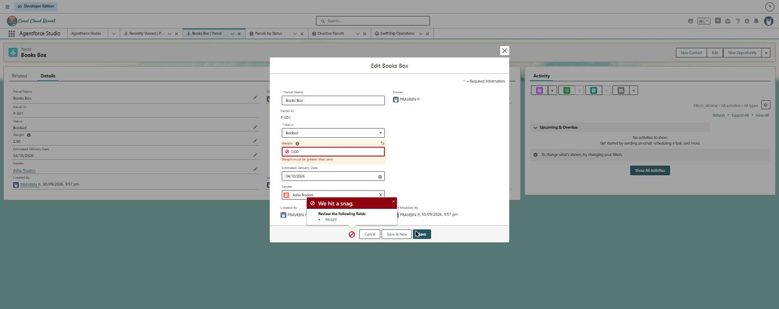
Figure 8: Dashboard: SwiftShip Operations

Figure 9: Agent preview: "Track parcel P-001"
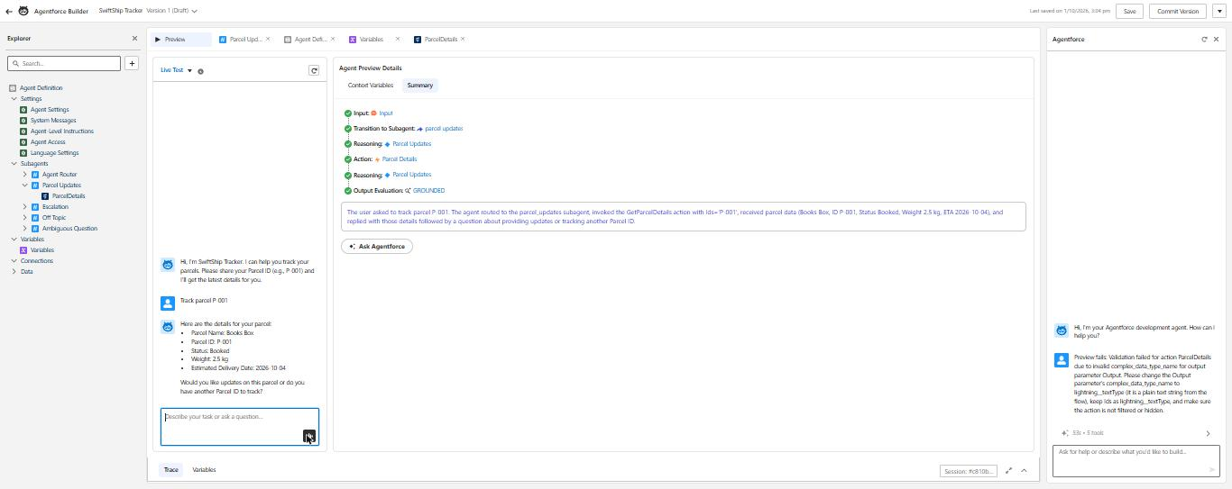
Figure 10: Agent SwiftShip Tracker, Version 1 (Active)
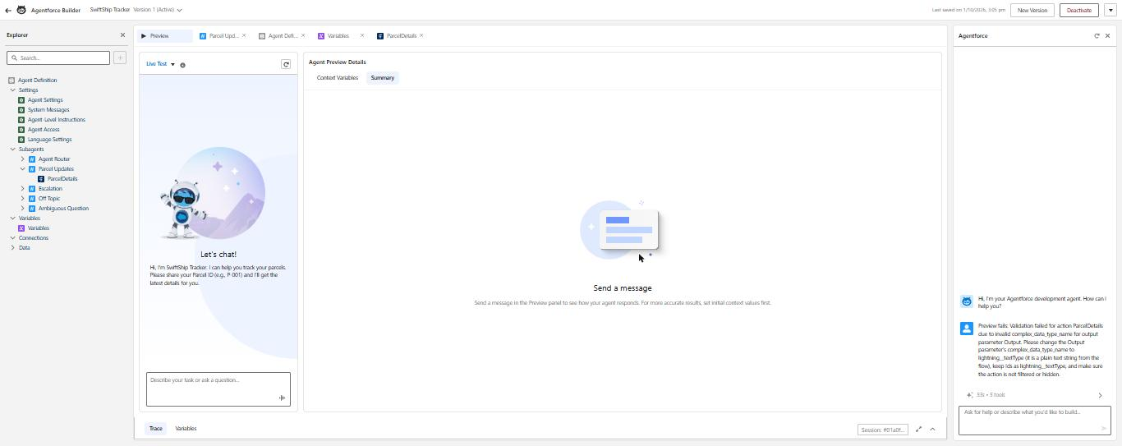
Figure 11: Prompt Builder preview: resolved prompt filled with P-001 data
