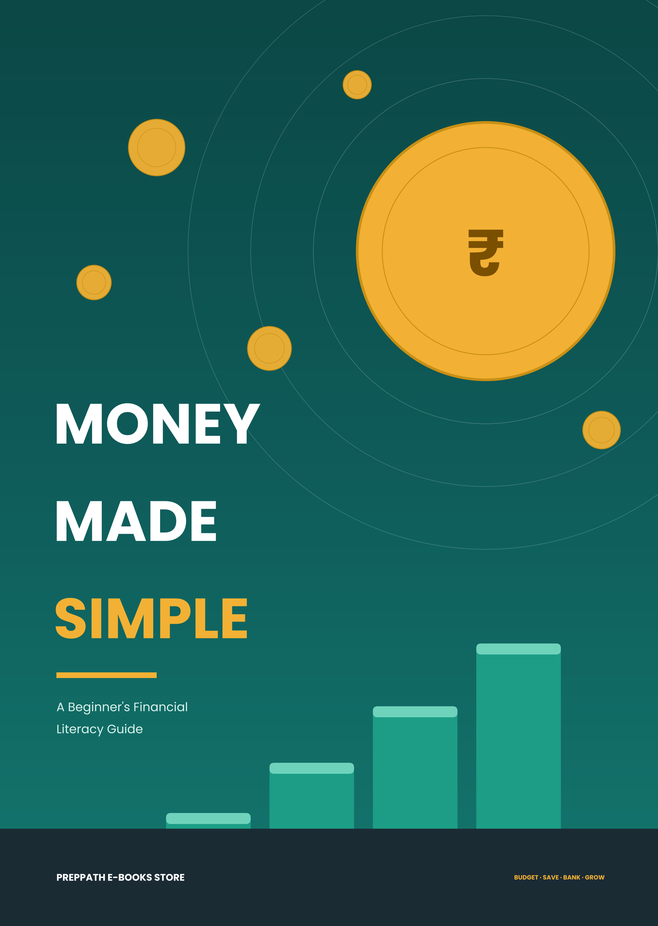

Contents

◆ Welcome and how to use this book 3
01 Your Money Mindset 4
02 Needs versus Wants 7
03 Budgeting That Works 11
04 Saving Made Simple 15
05 Understanding Banking 18
06 Interest: Friend or Foe? 22
07 Inflation: The Silent Thief 26
08 Credit, Loans and Debt 29
09 Financial Planning Basics 32
10 Staying Safe with Money 36
◆ Toolkit: 90-Day Plan and Worksheets 39
◆ Glossary 43
◆ A Final Word 45
Welcome

Nobody is born knowing how to handle money, and school rarely teaches it. Most of us learn by making mistakes — an overdrawn account, a credit card bill that grows faster than expected, a month that ends ten days before the salary arrives. This book is here to help you skip as many of those lessons as possible.
Money Made Simple covers the five ideas that sit under almost every money decision: budgeting and saving, banking, needs versus wants, financial planning, and interest and inflation. Each chapter uses everyday rupee examples, plain language and short exercises. You do not need a finance background, a high income or a calculator — only a pen and an honest look at your own numbers.
How to use this book
1 Read one chapter at a time. Each one ends with a short Check yourself box and a Do this week action.
2 Do the exercises. Reading about a budget does not build a budget. The worksheets in the Toolkit at the back are there to be written on.
3 Use your own numbers. The examples use a monthly income of ₹30,000 because it is easy to scale. Replace it with yours — even a pocket allowance works.
4 Go slowly on purpose. One new habit a week beats ten abandoned resolutions.
WATCH OUT This is education, not personalised advice
Everything here is general information for beginners. Interest rates, tax rules, fees and limits change often and differ between banks and products — always check current details with your bank or an official source. For decisions about investments, insurance, loans or tax, consider talking to a qualified, registered professional. Figures in charts are illustrations, not predictions or promises.

Quick money snapshot
Before you begin, tick whatever is true today. Revisit this list after Chapter 10 and see how many more boxes you can tick.
☐ I know roughly how much money comes in each month.
☐ I know where most of it goes.
☐ I save something every month before spending the rest.
☐ I have an emergency fund that covers at least one month of essentials.
☐ I understand the difference between a need and a want.
☐ I know what interest rate I earn on my savings — and what I pay on any loan.
☐ I can explain why ₹100 today is worth more than ₹100 in twenty years.
☐ I never share my UPI PIN, OTP or card details with anyone.
CHAPTER  01 | Your Money Mindset  Why money skills matter — and where to start

Financial literacy is not about being rich. It is about having choices.

IN THIS CHAPTER YOU WILL LEARN
✓ Why money habits matter more than income
✓ How money flows through your life
✓ The three money personalities
✓ The three building blocks you will use all book

Why money skills matter
Two people can earn the same salary and end up in completely different places ten years later. One has savings, a plan and the freedom to say no to a bad job. The other is living month to month and worried about every unexpected bill. The difference is rarely intelligence or luck. It is habits — small decisions repeated until they become a lifestyle.
Money skills give you three things that no salary can buy on its own:
Safety  a cushion when life surprises you | Choices  freedom to change jobs, study or relocate | Calm  less stress about the next bill

The good news is that these skills are learnable, and they start working the moment you use them. Saving your first ₹500 a month is not about ₹500. It is about becoming a person who saves.
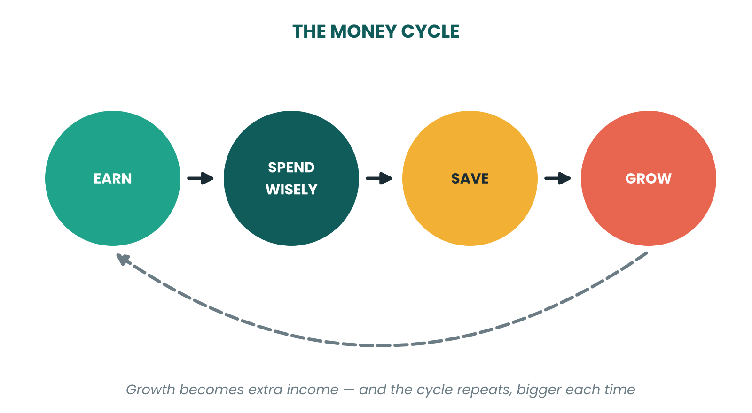
Figure 1.1 — Healthy money is a loop: what you earn, you spend wisely, save from, and grow.
Where does money actually go?
Money comes in through income — salary, stipend, pocket money, freelance work, gifts. It leaves through expenses. What is left over is either saved or, if you are not careful, simply disappears. The big idea of this book fits in one line:
Income − Expenses = Savings. If you do not decide where the difference goes, your spending will decide for you.

Most beginners try to fix the right-hand side of this equation by earning more. Earning more helps, but it works best after you have mastered the left side. A person who cannot manage ₹30,000 usually cannot manage ₹60,000 either — the spending simply rises to meet the income. Economists call this lifestyle creep.
Three money personalities
Most people lean toward one of these styles. None is wrong; each has a blind spot to manage.
Style | Strength | Blind spot | Fix
The Spender | Enjoys life, generous with others | Little or no savings; surprised by bills | Automate savings on payday
The Saver | Disciplined, builds a cushion | Guilt about spending; may miss life's moments | Create a planned 'fun money' budget
The Avoider | Relaxed, rarely stressed about money | Does not check balances or bills | Set one weekly 10-minute money check

Three building blocks
Everything in this book is built from three simple ingredients. Keep them in mind as you read.
• Awareness — knowing your real numbers: what you earn, owe, own and spend.
• Intention — giving every rupee a job before the month begins.
• Consistency — repeating small actions long enough for them to compound.
MONEY MOVE Your first number
Open your bank or UPI app and add up what you spent last month. Do not judge it, do not fix it — just write it down. That single number is the starting line for every chapter that follows.

TRY IT Check yourself
• What are the three money personalities, and which one are you?
• Why does earning more not automatically mean saving more?
• What does 'lifestyle creep' mean?

MONEY MOVE Do this week
Write down your monthly income and last month's total spending. Subtract. Is the answer positive, zero or negative? You now know where you stand.

CHAPTER  02 | Needs versus Wants  The skill that makes every budget work

A need keeps your life running. A want makes it more enjoyable. Confusing the two is the most expensive mistake in personal finance.

IN THIS CHAPTER YOU WILL LEARN
✓ How to tell a need from a want
✓ Why the line moves
✓ The 24-hour and 30-day rules
✓ How marketing turns wants into 'needs'

The simplest test
Ask one question: 'What happens if I do not buy this?' If the answer is that your health, safety, job or education would suffer, it is a need. If life simply goes on — perhaps a little less fun — it is a want.
Category | Needs (essential) | Wants (optional)
Food | Groceries, basic home-cooked meals | Daily café coffee, delivery, restaurant meals
Housing | Rent or hostel fees, electricity, water | Premium room upgrade, expensive décor
Transport | Bus pass, fuel for commuting to work or college | Cab rides for convenience, a bike upgrade
Clothing | Basic clothes that fit the season and job | Branded sneakers, fast-fashion hauls
Communication | A basic phone plan, internet for study or work | Latest flagship phone, extra data packs
Health | Medicines, insurance premiums, check-ups | Supplements you cannot explain, trendy diets
Fun | — | Movies, OTT subscriptions, gaming, trips

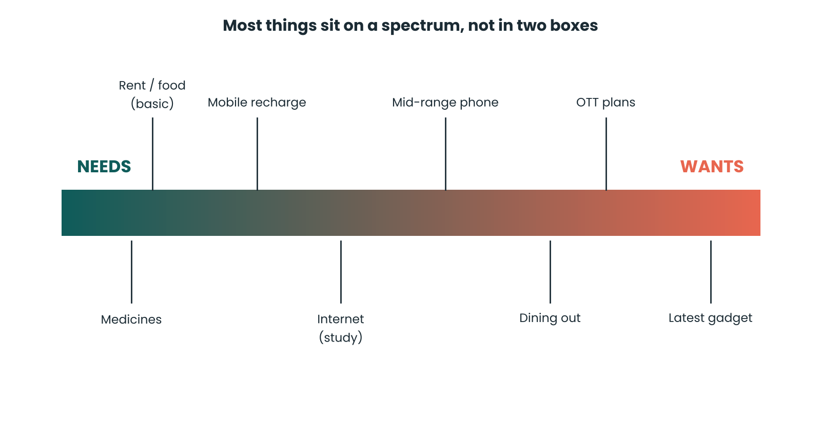
Figure 2.1 — Most spending sits somewhere between pure need and pure want.
Why the line moves
The same item can be a need for one person and a want for another. A laptop is a need for a student who codes or a freelancer who edits videos; it is a want if you already own a working one and just fancy the newest model. A two-wheeler is a need if there is no public transport to your workplace; it is a want if you live next to a metro station.
Even within a need, there is a choice of level. Food is a need, but the ₹80 home-cooked lunch and the ₹350 restaurant lunch both satisfy it. The first covers the need; the second adds a want on top. Seeing these layers is a superpower: you can keep the need and trim the extra without feeling deprived.
EXAMPLE Splitting a phone purchase
Priya needs a phone for college and freelancing. A reliable ₹15,000 phone covers the need. The ₹70,000 flagship adds ₹55,000 of want — features she may never use. She buys the ₹15,000 phone and puts ₹3,000 a month into a goal fund. In a year, the saved difference becomes a laptop upgrade.

How marketing blurs the line
Advertisements are very good at making wants feel like needs. Watch for these phrases:
• 'Limited-time offer' — urgency stops you from thinking.
• 'Everyone is buying it' — social proof makes you feel left out.
• 'Just ₹999 a month' — splitting the price hides the total cost.
• 'Buy now, pay later' — removes the pain of paying, so you spend more.
DID YOU KNOW The pain of paying
Researchers have found that people tend to spend more when paying by card or app than with cash, because handing over notes feels more real. Tap-and-go payments make spending painless — which is exactly why you should review it deliberately.

Three rules that beat impulse
Rule | How it works | Best for
The 24-hour rule | Add the item to your cart. Wait a full day before paying. | Small impulse buys under ₹2,000
The 30-day rule | Write it on a list. If you still want it in 30 days, consider it. | Gadgets, clothes, big wants
The cost-per-use rule | Divide the price by the number of times you will use it. | Shoes, bags, equipment

Example: a ₹3,000 pair of shoes worn 300 times costs ₹10 per wear. A ₹1,500 pair worn 30 times costs ₹50 per wear. The 'cheaper' pair is more expensive in real terms.
Wants are not the enemy
A budget with no wants lasts about three weeks. The aim is not to eliminate wants but to choose them on purpose and pay for them from planned money. A good want leaves you glad you spent. A bad want leaves you wondering where the money went. Ask: 'Will I still be glad about this a month from now?'
Practice: need, want or both?
Decide for each item, then read the suggested answer. There is often a need hidden inside a want — and the reverse.
Situation | Suggested thinking
A ₹600 monthly gym membership | Want, unless a doctor advised exercise. Free alternatives (walking, home workouts) meet the health need.
A ₹2,000 course that leads to a certificate for your job | Need-like: it builds income. Compare prices first.
A ₹4,500 pair of headphones when yours still work | Want. Wait 30 days and see if the urge fades.
A ₹350 pizza for the third time this week | Want layered on the need to eat. Cook at home twice and keep the treat.
A ₹12,000 insurance premium | Need. Protects savings from a large risk.
A ₹800 monthly OTT bundle you barely watch | Want you can cancel. Cancel today, re-subscribe later if you miss it.

A worked audit: Ravi's month
Ravi, a junior developer, takes home ₹30,000. He sorted last month's spending into N, W and ? and added up each group:
Group | What was in it | Amount | Share
Needs (N) | Rent share, groceries, transport, phone, electricity | ₹16,200 | 54%
Wants (W) | Eating out, shopping, OTT, games, weekend trips | ₹11,800 | 39%
Not sure (?) | Gym fee, a course he never started, gifts | ₹2,000 | 7%
Savings | Nothing moved to savings | ₹0 | 0%

The surprise was not the wants — it was the savings. By trimming the wants by ₹3,000 and cancelling the unused course and gym (₹1,500), Ravi freed ₹4,500 a month. Sent to an emergency fund, that is ₹54,000 in a year without any extra income. The point of the audit is not guilt; it is visibility.
TRY IT Check yourself
• Name three things that are needs for you and three that are wants.
• Why can the same item be a need for one person and a want for another?
• What is the cost-per-use of a ₹2,400 jacket worn 40 times?

MONEY MOVE Do this week
Go through last month's spending and mark each item N (need), W (want) or ? (not sure). Add up each total. Most people are surprised by the size of the '?' column.

CHAPTER  03 | Budgeting That Works  A plan for every rupee — without the misery

A budget is not a cage. It is permission to spend without guilt, because you already know the essentials are covered.

IN THIS CHAPTER YOU WILL LEARN
✓ Why budgets fail — and how to make one that survives
✓ The 50/30/20 method with a worked example
✓ Zero-based budgeting and the envelope method
✓ How to track spending in five minutes a day

What a budget really is
A budget is a simple plan: before the month starts, you decide what each rupee will do. That is all. It is not a record of the past and it is not a punishment. Done well, a budget removes daily money worries because the big decisions are already made.
Budgets fail for three reasons: they are too strict, too complicated, or never reviewed. The fix is the same for all three — keep it simple, leave room for fun, and check in weekly.
Method 1: the 50/30/20 rule
Popularised by US senator Elizabeth Warren, this is the easiest budget to start with. Split your take-home income (after tax and deductions) into three parts:
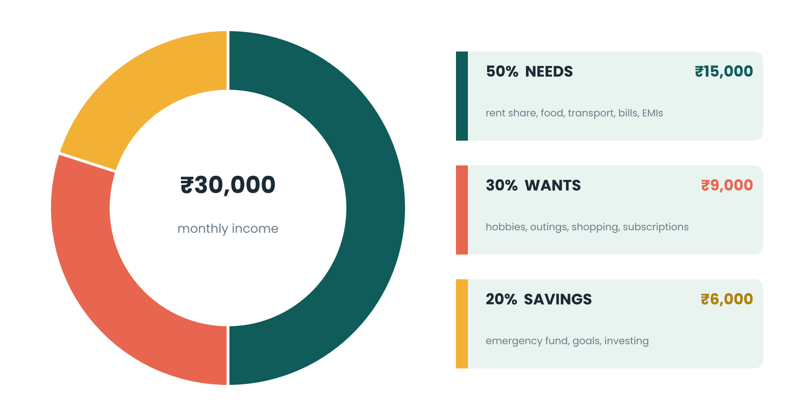
Figure 3.1 — The 50/30/20 split applied to ₹30,000 a month.
If rent alone eats 60% of your income, the ratios will not fit — and that is okay. Treat them as a starting point. Many beginners begin at 60/25/15 and shift toward more savings as their income grows or their needs shrink.
Item (monthly) | Amount | Group
Rent share / hostel | ₹7,000 | Need
Groceries and meals at home | ₹4,500 | Need
Transport | ₹1,500 | Need
Phone, internet, electricity | ₹1,500 | Need
Eating out and fun | ₹4,000 | Want
Shopping and subscriptions | ₹3,000 | Want
Hobbies and outings | ₹2,000 | Want
Emergency fund | ₹3,000 | Savings
Goal fund (laptop, course) | ₹2,000 | Savings
Long-term investing | ₹1,000 | Savings
Total | ₹30,000 | 100%

Method 2: zero-based budgeting
Here, income minus every planned expense equals zero. Every rupee is assigned a job — including savings and fun — until nothing is left unassigned. This method suits people with irregular income or who like precision.
1 Write down your expected income for the month.
2 List fixed costs first (rent, EMIs, phone).
3 List variable needs (food, transport, medicines).
4 Assign money to savings and goals.
5 Give the remaining rupees to wants.
6 Check that income − all of the above = ₹0.
Method 3: the envelope method
Withdraw cash for flexible categories — say food, fun and shopping — and put it into labelled envelopes. When an envelope is empty, spending in that category stops until next month. Today you can do the same digitally: keep separate sub-accounts or wallets, or move a fixed sum to a second account used only for spending.
MONEY MOVE Pay yourself first
Do not save what is left after spending — spend what is left after saving. On payday, transfer your savings amount to a separate account immediately. Set up an automatic standing instruction so it happens without willpower.

Tracking in five minutes a day
A budget only works if you compare it with reality. You do not need a fancy app:
• Notes app or notebook: write each spend as it happens — amount and category.
• UPI app history: most apps show monthly spending by category.
• Spreadsheet: one row per spend; totals by category using a simple pivot or SUMIF.
• Weekly review: every Sunday, spend ten minutes comparing planned and actual.
WATCH OUT Small leaks sink big ships
Five daily ₹100 'tiny' purchases add up to ₹15,000 in a month — half of the ₹30,000 income in our example. Track small spends for two weeks and see which ones you would not miss.

A student budget on ₹8,000 a month
You do not need a salary to budget. Here is how the same ideas look for a student living at home with a monthly allowance of ₹8,000. Because family covers rent and food, the 'needs' slice is small, so more can go to saving and skills.
Item (monthly) | Amount | Group
Bus pass and commuting | ₹1,000 | Need
Phone recharge and internet | ₹500 | Need
Books, printouts, stationery | ₹700 | Need
Snacks and outings with friends | ₹1,500 | Want
Subscriptions and gaming | ₹500 | Want
Clothes and personal care | ₹800 | Want
Emergency fund | ₹1,000 | Savings
Laptop / course fund | ₹1,500 | Savings
Gifts and surprises buffer | ₹500 | Buffer
Total | ₹8,000 | 100%

Budgeting with irregular income
Freelancers, part-time workers and gig workers often earn unevenly: ₹40,000 one month, ₹12,000 the next. The solution is to budget from your lowest realistic month, not your best one.
1 Look at your last six months and find the lowest income. Use it as your 'base' income.
2 Cover essentials and a minimum saving amount from the base income only.
3 When a month earns more than the base, split the extra: half to savings or debt, a quarter to a 'buffer' account, a quarter to wants.
4 Keep one month of expenses in the buffer. Pay yourself a steady 'salary' from it, so your lifestyle does not swing with your income.
MONEY MOVE Give the buffer a name
Create a separate account called 'Salary Buffer'. Client payments land there first; you transfer your fixed monthly 'salary' to your spending account on the same day each month.

TRY IT Check yourself
• What does 'pay yourself first' mean?
• In a ₹40,000 income, how much does 50/30/20 allocate to savings?
• Name one reason budgets fail and one way to fix it.

MONEY MOVE Do this week
Build your first budget on the worksheet in the Toolkit using the 50/30/20 method. Track every spend for seven days.

CHAPTER  04 | Saving Made Simple  Build a cushion, fund your goals, and make it automatic

You do not need to save a lot. You need to save regularly.

IN THIS CHAPTER YOU WILL LEARN
✓ Why saving comes before spending
✓ How big an emergency fund should be
✓ Goal-based saving and sinking funds
✓ Ten habits and challenges that make saving easier

Why save at all?
Saving gives your money three jobs, each with its own time frame:
Time frame | Purpose | Examples | Where it usually lives
Now (0–1 year) | Emergencies and short goals | Medical bill, phone repair, exam fees | Savings account, liquid or sweep-in options
Soon (1–5 years) | Planned goals | Laptop, course, bike, wedding gift, move-out deposit | Recurring deposit, fixed deposit, conservative options
Later (5+ years) | Long-term goals | Home, retirement, children's education | Long-term investments (Chapter 9)

The emergency fund
An emergency fund is money set aside only for genuine surprises: a sudden medical cost, a job loss, an urgent repair, an unplanned trip home. It is not for sales, shopping or a friend's birthday trip. Its purpose is to stop a bad event from becoming a debt spiral.
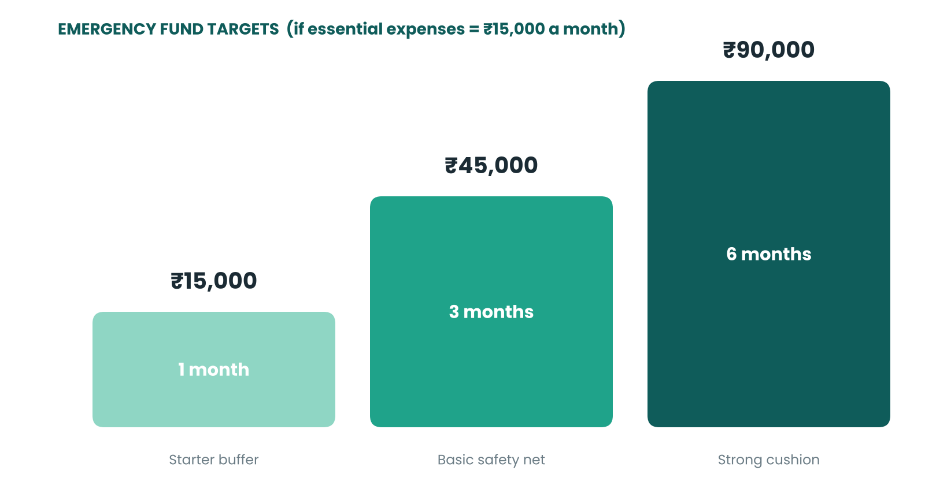
Figure 4.1 — Build the fund in steps. Start with one month, then climb.
How to size it: add up your essential monthly expenses (rent, food, transport, bills, EMIs, insurance) and multiply by three to six. Students and people with stable family support can start nearer three months; freelancers and those with irregular income should aim for six or more.
MONEY MOVE Start with ₹1,000
Waiting until you can save ₹15,000 at once means waiting forever. Open a separate savings account, label it 'Emergency', and send even ₹500 on payday. The goal is to build the habit while the amounts are small.

Where to keep it
Emergency money should be safe, accessible and boring. A savings account is usually the first home; later you might spread it across a savings account and a short-term deposit that can be broken without much penalty. Do not put emergency money into volatile investments — the day you need it may be a day when markets are down.
Goal-based saving
Vague saving ('I should save more') rarely survives the month. A goal with an amount and a date does. Use this formula:
Monthly saving = Goal amount ÷ Number of months

Goal | Amount | Time | Monthly saving
Laptop upgrade | ₹48,000 | 12 months | ₹4,000
Online course and certification | ₹15,000 | 6 months | ₹2,500
Trip with family | ₹30,000 | 10 months | ₹3,000
Emergency fund (3 months) | ₹45,000 | 15 months | ₹3,000

Interest earned along the way will shorten these timelines slightly; ignore it for planning and treat it as a bonus.
Sinking funds: beating predictable surprises
Some 'surprises' are not surprises at all — annual insurance premiums, festival shopping, exam fees, a phone that will need replacing. A sinking fund spreads such a cost across the year. If your insurance premium is ₹12,000 a year, put ₹1,000 aside every month and the bill no longer ambushes you.
Ten habits that make saving easier
1 Automate it. A standing instruction on payday beats willpower.
2 Separate accounts. Money you cannot see is money you will not spend.
3 Save raises. Every time income grows, raise your saving amount first.
4 Round up. Treat ₹470 expenses as ₹500 and move the difference to savings.
5 52-week challenge. Save ₹10 in week 1, ₹20 in week 2 and so on — about ₹13,780 in a year.
6 No-spend days. Pick two days a week with zero non-essential spending.
7 Unsubscribe. Cancel subscriptions you have not used in 30 days.
8 Cash-back to savings. Move rewards and refunds straight into your fund.
9 Visual goals. Put the target on your phone wallpaper.
10 Celebrate milestones. A small planned treat at each milestone keeps you going.
DID YOU KNOW The 52-week challenge maths
Adding ₹10 + ₹20 + ₹30 … up to ₹520 gives 10 × (1 + 2 + … + 52) = 10 × 1,378 = ₹13,780. Starting with ₹10 and stepping by ₹10 each week feels small at first and surprisingly large at the end.

TRY IT Check yourself
• Why is an emergency fund kept separate from other savings?
• If essential costs are ₹20,000, what is a six-month fund?
• How much must you save monthly to buy a ₹36,000 phone in 9 months?

MONEY MOVE Do this week
Open a separate 'Emergency' account and set an automatic transfer for the day after your income arrives, even if it is only ₹500.

CHAPTER  05 | Understanding Banking  Accounts, cards, UPI and staying in control

A bank is not just a place to keep money. It is a toolbox — and the tools are free if you know how to use them.

IN THIS CHAPTER YOU WILL LEARN
✓ How banks work and why they exist
✓ Types of accounts and which you need
✓ Debit cards, credit cards, UPI and net banking
✓ How to read a statement and avoid fees

How banks work
Banks are middlemen. They collect money from people who have extra (depositors) and lend it to people who need it (borrowers). The bank pays depositors a small interest rate and charges borrowers a higher rate; the gap pays the bank's costs and profit.
In India, banks are regulated by the Reserve Bank of India (RBI). Bank deposits are protected by deposit insurance through the DICGC, which currently covers up to ₹5 lakh per depositor per bank (principal and interest combined) if a bank fails. Check the latest limit on official sources.
Types of accounts
Account | What it is for | Key points
Savings account | Everyday money, emergency fund | Earns interest; limited free transactions in some cases; most people start here
Current account | Businesses and freelancers with many transactions | Usually no interest; may need a minimum balance
Basic / zero-balance account | First-time bank customers, students | No minimum balance; basic services; good first account
Fixed deposit (FD) | Money you will not need for a set period | Fixed interest; penalty if broken early
Recurring deposit (RD) | Saving a fixed amount every month | Disciplined habit; rate fixed at opening
Joint account | Shared household expenses | Two or more holders; clear rules needed

MONEY MOVE Opening an account
You usually need identity and address proof (such as Aadhaar and PAN) for KYC (Know Your Customer), a passport photo and an initial deposit if required. Many banks let you open accounts digitally, but only on the bank's official app or website.

Cards: debit versus credit
 | Debit card | Credit card
Whose money? | Your own, straight from your account | The bank's — you borrow and repay later
Interest | None, if you have balance | High if you do not pay the full bill by the due date
Risk | Overspending drains your account | Overspending creates debt
Benefit | Simple, cannot spend what you lack | Rewards, grace period, builds credit history
Best for | Everyday spending, beginners | Disciplined users who pay in full, every month

WATCH OUT Credit cards charge heavily for delay
Many cards charge around 3–4% per month on unpaid balances — roughly 36–48% a year — plus late fees. Paying only the 'minimum due' keeps you in debt for years. If you use a card, treat it like a debit card: spend only what you can pay in full by the due date.

Moving money: UPI, IMPS, NEFT and RTGS
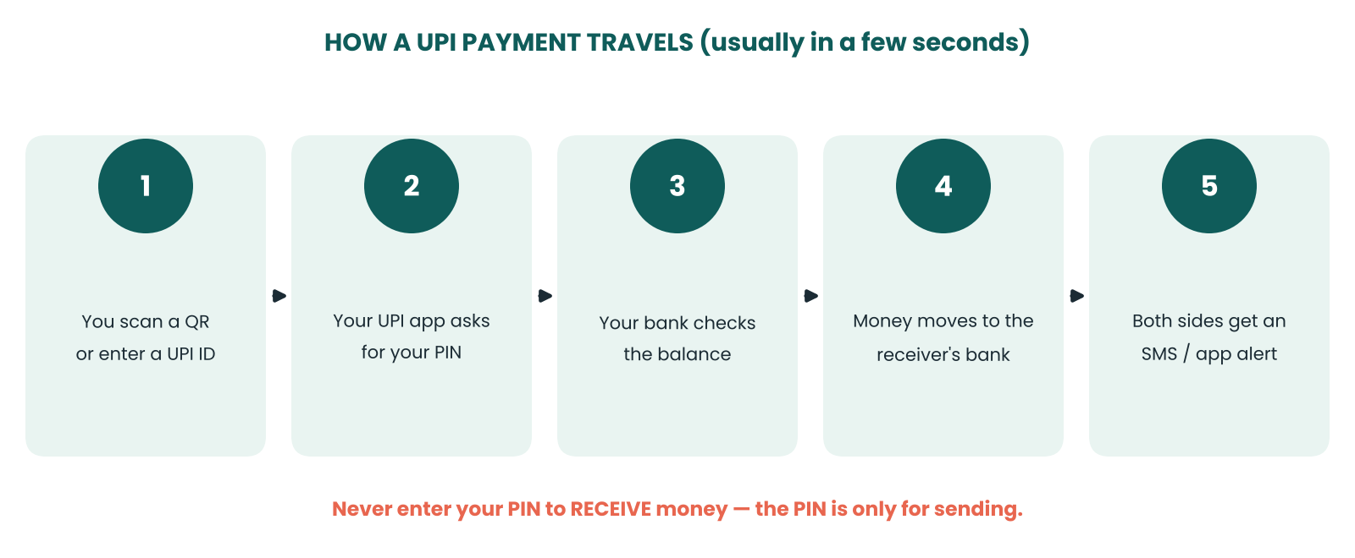
Figure 5.1 — A UPI payment moves in seconds, but only your PIN authorises it.
Method | Speed | Typically used for
UPI | Instant, 24×7 | Everyday payments, shops, friends and family
IMPS | Instant, 24×7 | Instant account-to-account transfers
NEFT | Settled in batches through the day | Regular transfers of any amount
RTGS | Real-time | Large-value transfers (there is a minimum, currently ₹2 lakh)

Limits and charges vary by bank and method, and they change over time, so check your bank's current rules before large transfers.
Reading your statement
Download your statement once a month and look for four things:
1 Opening and closing balance — do they match your records?
2 Unknown debits — small unfamiliar charges are a classic fraud sign.
3 Fees — SMS charges, minimum-balance penalties, annual card fees.
4 Interest credited — is it what you expected?
Avoiding bank fees
• Choose an account type that matches your usage (zero-balance if you cannot keep a minimum).
• Know the free transaction and ATM limits on your account.
• Pay card bills on time — set an auto-pay for at least the total due.
• Opt for UPI or net banking instead of paying for demand drafts or cheques.
• Read the fee schedule once, when you open the account.
Digital banking essentials
• Mobile banking app: check balances, pay bills, set alerts, block a lost card. Use only the official app and keep it updated.
• Net banking: a full-featured website login. Log out after use and never save passwords on shared computers.
• Nominee: name a nominee on every account and deposit so your family can claim the money without delays.
• Passbook and e-statements: your proof of transactions; keep them for tax and loan applications.
• Auto-pay and standing instructions: set them up for rent, EMIs, card bills and savings transfers so they cannot be forgotten.
Choosing a bank
Compare two or three options on the points below, rather than choosing only on a gift or a friend's recommendation.
Check | Why it matters
Minimum balance rule | A penalty for falling below it quietly drains your account.
Free transactions and ATM use | Extra withdrawals and transfers may cost money.
Interest on savings | Rates differ; small gaps add up over years.
App quality and support | You will use the app daily and need help when something goes wrong.
Branch and ATM access | Matters if you handle cash or live outside a big city.

TRY IT Check yourself
• What is the difference between a savings account and a current account?
• Why should you never enter your UPI PIN to receive money?
• What happens if you pay only the minimum due on a credit card?

MONEY MOVE Do this week
Download last month's statement. Circle every fee and every transaction you do not recognise. Call your bank about anything suspicious.

CHAPTER  06 | Interest: Friend or Foe?  How money grows when you save — and how debt grows when you borrow

Interest is the price of money. Earn it, and it works for you. Owe it, and it works against you.

IN THIS CHAPTER YOU WILL LEARN
✓ What interest is and how it is quoted
✓ Simple interest versus compound interest
✓ The rule of 72
✓ Why starting early beats saving more

What is interest?
Interest is the fee for using someone else's money. When you deposit money, the bank is borrowing from you and pays interest. When you take a loan, you borrow from the bank and pay interest. The same mechanism produces opposite results, depending on which side of it you stand on.
Two terms to know: principal is the original amount, and rate is the percentage charged per year (written p.a., 'per annum') unless stated otherwise.
Simple interest
With simple interest, you earn only on the original principal.
Simple interest = Principal × Rate × Time

Example: ₹10,000 at 8% for 3 years → 10,000 × 0.08 × 3 = ₹2,400. After 3 years you have ₹12,400.
Compound interest
With compound interest, you earn interest on the principal and on the interest already earned. Each year the base grows, so each year's interest is larger.
Future value = Principal × (1 + Rate)^Years

Year | Opening | Interest at 8% | Closing
1 | ₹10,000 | ₹800 | ₹10,800
2 | ₹10,800 | ₹864 | ₹11,664
3 | ₹11,664 | ₹933 | ₹12,597
4 | ₹12,597 | ₹1,008 | ₹13,605
5 | ₹13,605 | ₹1,088 | ₹14,693

The first year's interest is ₹800. By year five it is about ₹1,088, simply because the base has grown. Over short periods the difference looks small. Over long periods it becomes enormous.
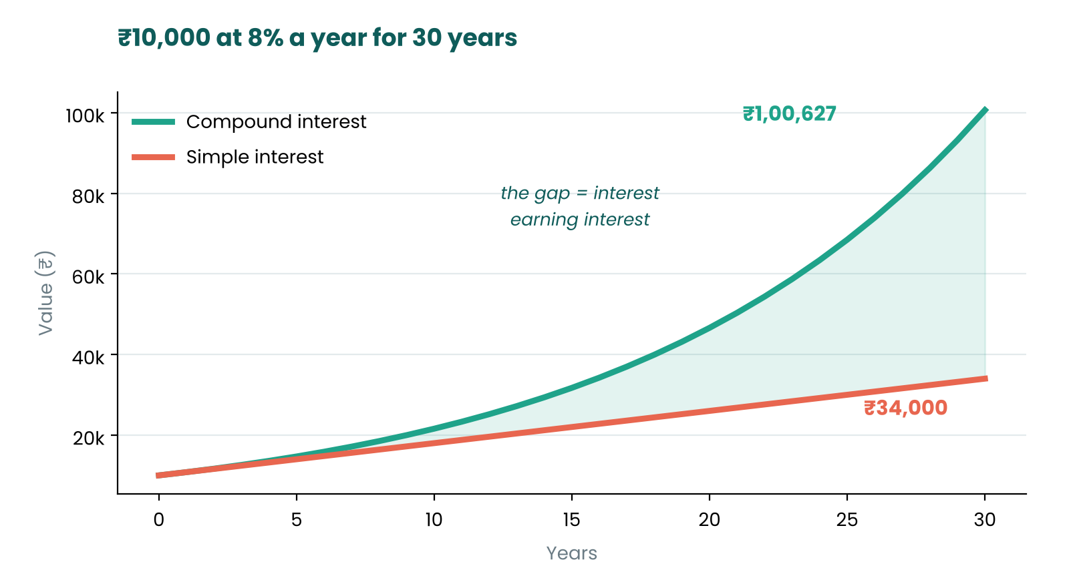
Figure 6.1 — Same money, same rate, 30 years: compounding earns almost three times as much as simple interest.
DID YOU KNOW A famous quote, a doubtful origin
Compound interest is often called 'the eighth wonder of the world' and credited to Einstein. There is no reliable evidence he said it — but the idea behind the quote is real and powerful.

The rule of 72
A handy shortcut: divide 72 by the annual rate to estimate how many years it takes for money to double.
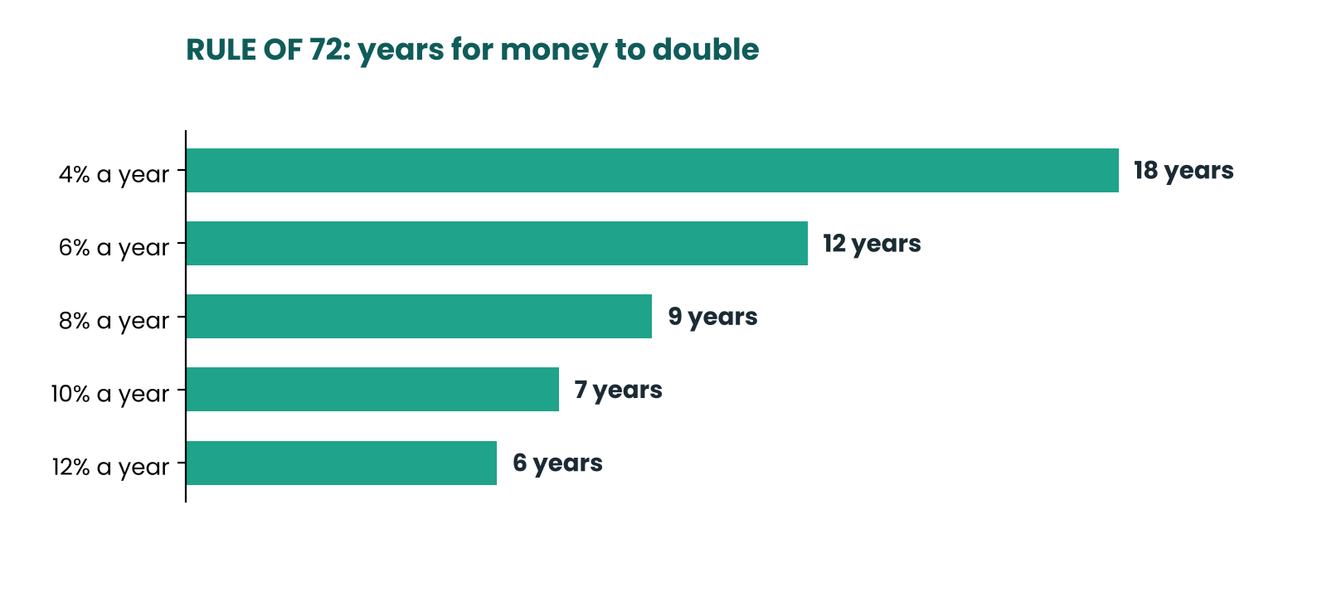
Figure 6.2 — At 8% your money doubles roughly every nine years.
The rule works in reverse too. A credit card charging 36% a year doubles what you owe in about two years if you never repay — a painful way to experience compounding.
Time beats amount
Saving a little for a long time can beat saving a lot for a short time. Saving ₹2,000 every month and earning 8% a year (an illustrative rate, not a promise) gives:
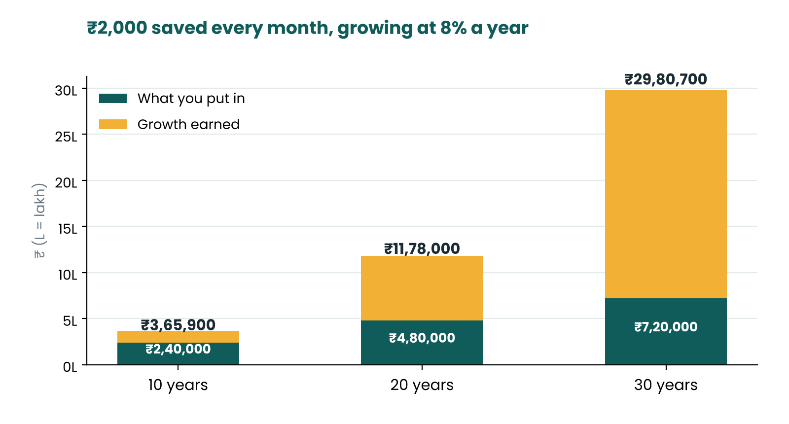
Figure 6.3 — The longer the time, the more of the final amount is growth rather than your own money.
₹3,65,900  after 10 years | ₹11,78,000  after 20 years | ₹29,80,700  after 30 years

Notice that going from 20 to 30 years adds about ₹18,02,700 — more than the first 20 years combined, even though the monthly saving never changed. This is why starting early matters more than starting big.
EXAMPLE Early Esha versus late Lara
Esha saves ₹2,000 a month from age 22 to 32 (10 years, ₹2,40,000 in total), then stops and lets it grow until 62. Lara waits until 32 and saves ₹2,000 a month for the next 30 years (₹7,20,000 in total). At the same illustrative 8% return, Esha ends with about ₹40,01,000 and Lara with about ₹29,81,000. Esha put in one-third of the money — her extra 10 years of compounding did the rest.

Reading the rate: nominal, effective and APR
• Nominal rate: the headline rate before considering how often interest is added.
• Effective rate: what you really earn or pay once compounding is included. A 8% rate compounded quarterly is effectively a little above 8%.
• APR (annual percentage rate): for loans, it tries to include fees along with interest to show the true yearly cost. Always compare APRs, not just headline rates.
WATCH OUT Flat rate versus reducing balance
Some loans quote a 'flat' rate calculated on the original loan amount for the whole period, even though you repay part of it every month. A 10% flat rate can work out to nearly double that on a reducing-balance basis. Always ask for the effective annual rate.

Where does your money earn interest?
Here is how ₹50,000 might grow over three years in different places. The rates are illustrations only — look up current rates before deciding.
Where | Illustrative rate | After 3 years | Gain
Savings account | 3% | ₹54,636 | ₹4,636
Fixed deposit (quarterly compounding) | 7% | ₹61,572 | ₹11,572
Idle cash | 0% | ₹50,000 | ₹0

The extra return from moving idle money to a suitable deposit is not dramatic in three years — but it costs nothing but a little attention, and the gap widens with time and with larger amounts.
TRY IT Check yourself
• What is the difference between simple and compound interest?
• Using the rule of 72, how long does money take to double at 6%?
• Why is saving ₹1,000 a month at 22 often better than ₹2,000 a month at 32?

MONEY MOVE Do this week
Find the interest rate on your savings account and on any loan or card you have. Write both down. Are you earning more than you pay, or paying more than you earn?

CHAPTER  07 | Inflation: The Silent Thief  Why prices rise and what it means for your savings

Inflation never sends a bill. It just makes the same rupee buy a little less every year.

IN THIS CHAPTER YOU WILL LEARN
✓ What inflation is and how it is measured
✓ How it erodes the value of idle cash
✓ Real versus nominal returns
✓ How to protect your money

What is inflation?
Inflation is the general rise in prices over time. If a tea costs ₹10 today and ₹11 next year, inflation is 10% for that item. Economists track a whole basket of goods — food, fuel, housing, clothing, transport, education, health — in an index such as India's Consumer Price Index (CPI). The RBI works with an inflation target of 4%, with a tolerance band of 2% either side.
Prices rise for many reasons: higher production costs, strong demand, supply shortages, currency changes. You cannot control any of them. What you can control is whether your money keeps up.
The shrinking rupee
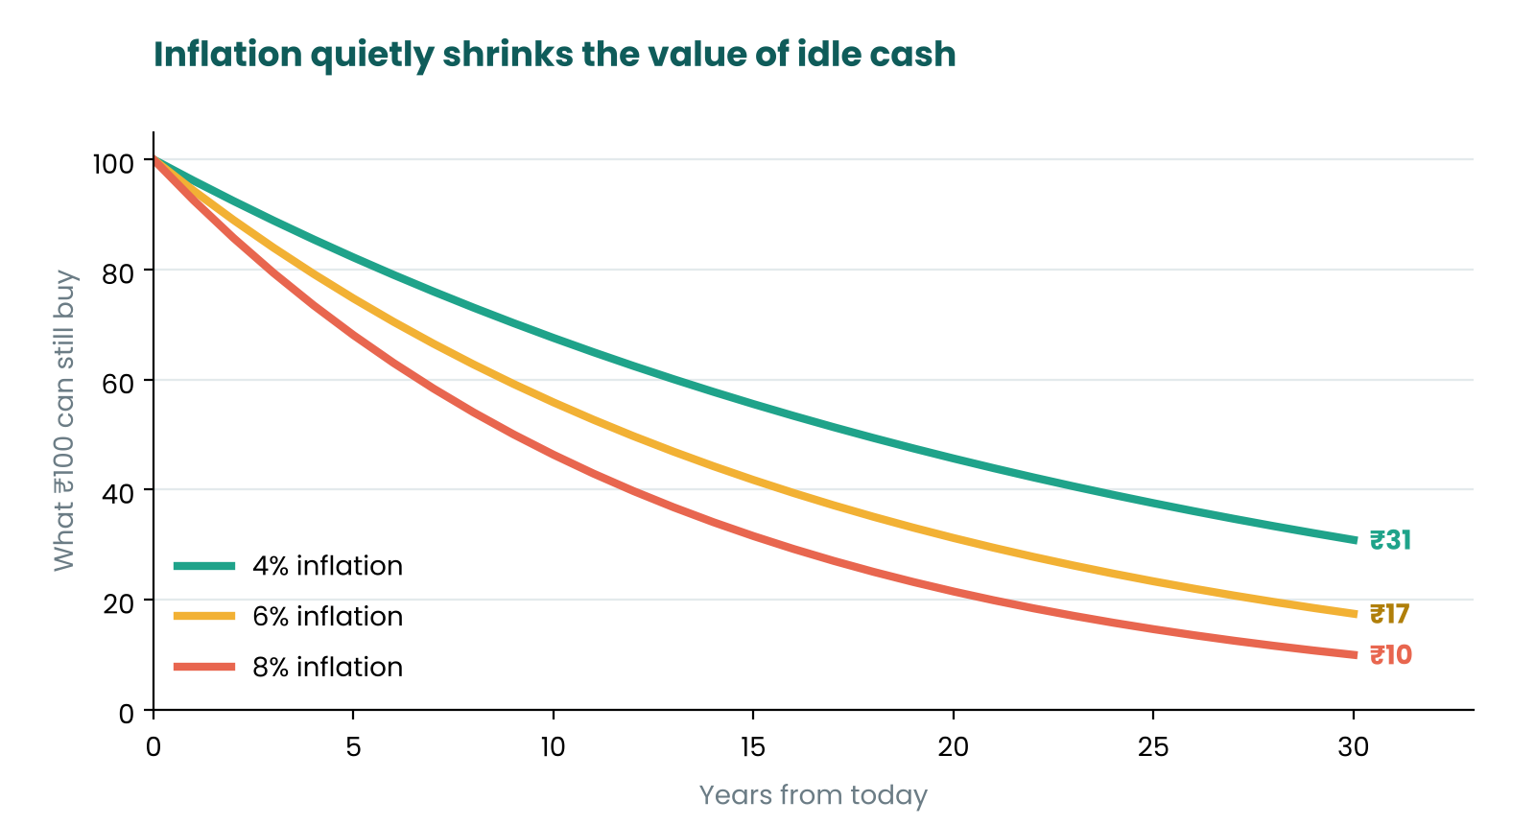
Figure 7.1 — What ₹100 can still buy after 30 years at different inflation rates.
₹56  buying power of ₹100 after 10 years at 6% | ₹31  after 20 years | ₹17  after 30 years

The other side of the coin: something that costs ₹100 today would cost about ₹179 in ten years, ₹321 in twenty and ₹574 in thirty years at 6% inflation. Cash in a cupboard feels safe, but it quietly loses value.
Real versus nominal returns
The interest rate printed on your deposit is the nominal return. What matters is the real return — what is left after inflation.
Real return ≈ Nominal return − Inflation rate

Where the money sits | Nominal return | Inflation | Real return
Cash at home | 0% | 6% | −6%
Savings account (illustrative) | 3% | 6% | −3%
Fixed deposit (illustrative) | 7% | 6% | +1%
Long-term growth assets (illustrative, not guaranteed) | 10% | 6% | +4%

These rates are for illustration only. Actual rates vary by time, bank and product. The lesson is general: money you will not need for many years usually needs to earn more than inflation, otherwise your purchasing power shrinks.
Who gains and who loses?
• Savers in cash lose purchasing power if their interest is below inflation.
• Borrowers with fixed-rate loans gain — they repay with rupees that are worth less than when they borrowed.
• People with rising incomes stay ahead if raises match or beat inflation. Ask yourself: did your pay go up by more than prices this year?
• Fixed-income retirees feel it most, which is why long-term planning must account for inflation.
EXAMPLE The ₹20,000 monthly budget
If your essential expenses are ₹20,000 today and inflation is 6%, the same lifestyle will cost about ₹35,800 a month in ten years and about ₹64,100 in twenty. Any plan that ignores this will fall short.

How to protect yourself
1 Grow your income. Skills, certifications and promotions are your best inflation hedge.
2 Keep only what you need in cash. Emergency money stays liquid; long-term money should aim to grow faster than inflation.
3 Review your rates. If your savings account pays far below inflation, move surplus into better — but still suitable — options.
4 Invest for long-term goals. Diversified investments over long periods have historically tended to outpace inflation, though with ups and downs and no guarantees.
5 Avoid expensive debt. High interest plus inflation pressure is a double hit.
TRY IT Check yourself
• Why is a 3% savings rate a loss when inflation is 6%?
• What is the difference between nominal and real return?
• Who benefits from inflation: a borrower with a fixed-rate loan or a saver in cash?

MONEY MOVE Do this week
Ask an older family member what a haircut, a movie ticket or a litre of milk cost 20 years ago. Compare with today. You have just measured real-life inflation.

CHAPTER  08 | Credit, Loans and Debt  Borrowing smartly — and recognising the danger zones

Debt is a tool. Used on purpose it can build your future; used carelessly it can bury it.

IN THIS CHAPTER YOU WILL LEARN
✓ Good debt versus bad debt
✓ How EMIs and loan interest work
✓ What a credit score is and how to build one
✓ How to get out of debt

Good debt, bad debt
 | Good debt (usually) | Bad debt (usually)
Purpose | Builds earning power or lasting value | Pays for things that lose value fast
Examples | Education loan, a carefully planned home loan, a business loan with a clear plan | Credit card balance for shopping, loan apps for parties, 'buy now pay later' for gadgets
Interest | Relatively low | Often very high
Test | Will this increase my income or net worth? | Will I still be paying for this after I stop using it?

Even 'good' debt becomes dangerous if the repayment is too large for your income. A common guide is to keep total monthly EMIs below roughly one-third of your take-home income.
How an EMI works
An EMI (Equated Monthly Instalment) is a fixed payment each month that covers both principal and interest. In early months, most of the EMI goes to interest; later, more goes to principal.
EXAMPLE A ₹1,00,000 loan at 12% for 12 months
EMI ≈ ₹8,885 a month. Total repaid ≈ ₹1,06,619, so the interest cost is about ₹6,619. Stretch the same loan to 24 months and the EMI falls to about ₹4,707, but the total interest rises to about ₹12,976. A lower EMI usually means a higher total cost.

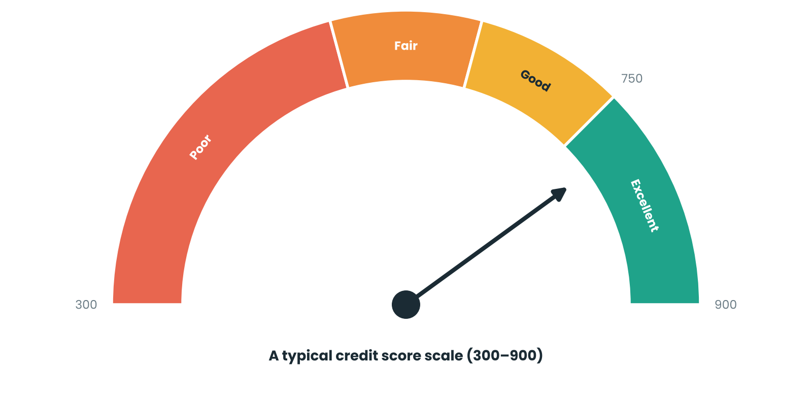
Figure 8.1 — Credit scores in India typically run from 300 to 900. Higher is better.
Your credit score
A credit score is a three-digit number summarising how reliably you have repaid borrowed money. Credit bureaus such as CIBIL, Experian, Equifax and CRIF High Mark calculate it. Lenders use it to decide whether to lend to you and at what interest rate. A score of 750 or above is generally considered good.
Factor | What helps | What hurts
Payment history (biggest factor) | Paying every EMI and card bill on time | Late or missed payments
Credit utilisation | Using well below your card limit (aim under about 30%) | Maxing out cards
Credit age and mix | A long history and a sensible mix of loans | Many new accounts opened quickly
Enquiries | Applying only when you need credit | Many loan applications in a short time

MONEY MOVE Build credit from zero
Start with a small credit card or a secured card against a fixed deposit, use it for one regular bill, and pay the full amount before the due date every month. In 6–12 months you will have a credit history. You are allowed to check your own score from time to time — it does not lower it.

Getting out of debt
If you already have debt, two popular strategies work well:
Method | How it works | Best for
Avalanche | Pay minimums on all debts; send extra money to the one with the highest interest rate first. | Saving the most money
Snowball | Pay minimums on all; send extra to the smallest balance first, then roll the freed-up money to the next. | Staying motivated with quick wins

WATCH OUT Instant loan apps
Quick-approval loan apps can charge extremely high fees and some misuse contact lists and photos to harass borrowers. Borrow only from regulated lenders. If an app asks for broad access to your phone, walk away.

TRY IT Check yourself
• Name one example of good debt and one of bad debt.
• Why does a longer loan term lower the EMI but raise the total cost?
• What is the single biggest factor in a credit score?

MONEY MOVE Do this week
List every debt: lender, balance, interest rate, EMI and due date. Circle the one with the highest interest — it gets any spare money first.

CHAPTER  09 | Financial Planning Basics  Turning today's habits into tomorrow's security

A goal without a plan is just a wish. A plan without action is just a hobby.

IN THIS CHAPTER YOU WILL LEARN
✓ The financial planning pyramid
✓ Net worth: your financial scoreboard
✓ Insurance and protecting what you build
✓ A gentle introduction to investing

The planning pyramid
Financial planning is doing things in the right order. A common mistake is jumping to the top (investing in exciting options) before the base is solid.
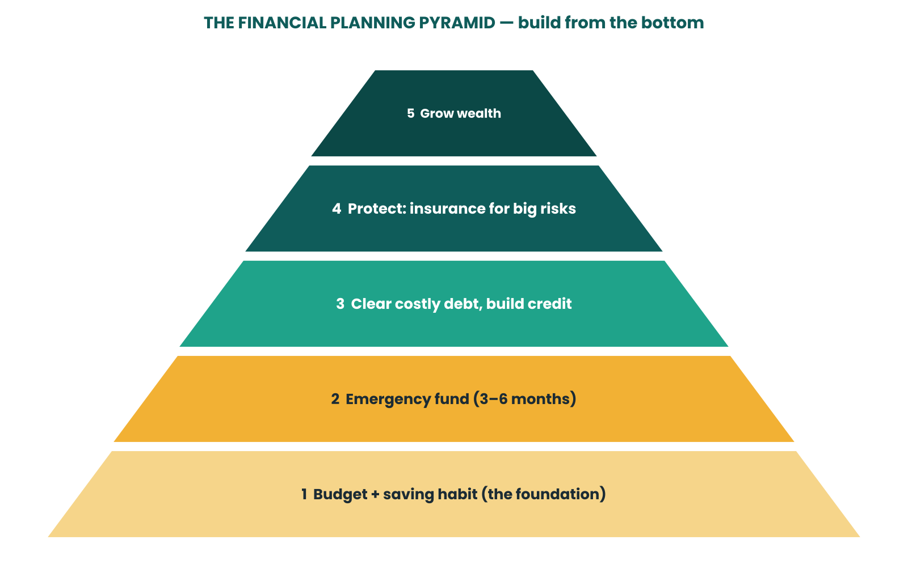
Figure 9.1 — Build from the bottom: do not invest until the layers beneath are in place.
Know your net worth
Net worth = What you own (assets) − What you owe (liabilities)

Assets (own) | Example | Liabilities (owe) | Example
Cash and bank balance | ₹35,000 | Credit card balance | ₹5,000
Fixed deposit | ₹50,000 | Education loan | ₹1,20,000
Gold and jewellery | ₹40,000 | Friend / family loan | ₹10,000
Laptop and phone (current value) | ₹30,000
Total assets | ₹1,55,000 | Total liabilities | ₹1,35,000

In this example, net worth = ₹1,55,000 − ₹1,35,000 = ₹20,000. It is small, but it is a true starting point. Recalculate every six months and watch it rise. Net worth can be negative at the start, especially with a student loan — that is normal, and the direction matters more than the number.
Setting SMART goals
Letter | Meaning | Example
S | Specific | Save for a ₹48,000 laptop
M | Measurable | ₹4,000 a month
A | Achievable | Fits within the 20% savings slice
R | Relevant | Needed for freelancing income
T | Time-bound | By the end of 12 months

Protect what you build: insurance
Insurance is not an investment — it is a shield against big, unlikely losses that could wipe out your savings. For most beginners, two types matter first:
• Health insurance: one hospital stay can cost more than a year of savings. If your employer provides cover, check what it excludes; consider adding your own.
• Term life insurance: only if others depend on your income. It pays a lump sum if you die during the term, and is usually inexpensive compared with endowment or money-back plans.
• Be careful with mixed products that bundle insurance and investment — the combined cost is often higher than keeping them separate.
A gentle introduction to investing
Investing means putting money into assets that can grow over time. Higher potential growth comes with higher risk — they travel together. Before you invest, make sure your emergency fund is in place and you have cleared costly debt.
Option | How it works | Risk | Liquidity
Savings account | Stores money, pays small interest | Very low | High
Fixed / recurring deposit | Fixed interest for a fixed term | Low | Medium (penalty to break)
PPF and similar government schemes | Long lock-in, government-backed | Low | Low
Mutual funds via SIP | Small regular investments pooled into stocks or bonds | Varies by fund | Medium
Gold | Held as jewellery, coins, bonds or funds | Medium | Medium
Direct stocks | Part-ownership in companies | High | High (but prices swing)

MONEY MOVE Three investing rules for beginners
Diversify — do not put everything in one place. Think long term — money needed within three years should not be in volatile assets. Understand before you buy — if you cannot explain it simply, skip it. Use SEBI-registered intermediaries and avoid anyone promising guaranteed high returns.

WATCH OUT Past returns are not future results
Ads love to show last year's best performer. Markets go up and down, and no one can reliably predict short-term moves. This book does not recommend any specific product.

Priorities change with age and stage
Stage | Typical focus | Watch out for
Student / first job (18–25) | Habits, emergency fund, skills, avoiding bad debt | Credit card traps, lifestyle creep
Early career (25–35) | Higher savings rate, insurance, starting long-term investing | Big EMIs for wants, delaying investing
Family years (35–50) | Home, education fund, adequate insurance | Under-insurance, neglecting retirement
Pre-retirement (50+) | Reduce risk gradually, plan income, clear debts | Taking too much risk late, outliving savings

Seven common money mistakes
1 Not tracking spending at all.
2 Saving only 'what is left'.
3 Having no emergency fund and borrowing for every surprise.
4 Paying only the minimum on credit cards.
5 Investing in something nobody can explain to you.
6 Ignoring inflation and keeping everything in cash.
7 Waiting for the 'perfect time' to start instead of starting small.
TRY IT Check yourself
• Calculate your approximate net worth using the table above.
• Why should the emergency fund come before investing?
• Why is insurance not considered an investment?

MONEY MOVE Do this week
Write three SMART goals — one for under a year, one for 1–5 years, one for 5+ years. Next to each, write the monthly amount needed.

CHAPTER  10 | Staying Safe with Money  Scams, fraud and the habits that protect you

Scammers do not need to hack your bank. They only need to convince you to hand over the keys.

IN THIS CHAPTER YOU WILL LEARN
✓ The most common money scams
✓ The golden rules of digital safety
✓ What to do if something goes wrong

Common scams
Scam | How it works | Red flag
Fake bank / KYC call | 'We are from your bank — update KYC or your account will be blocked.' | Urgency + asks for OTP, PIN or app install
UPI collect request | You are asked to 'approve' a request so you can 'receive' money. | Receiving never needs a PIN
Fake QR code | A QR code from a stranger or a sticker over a shop's QR | Scanning a QR to receive money
Phishing links | SMS or email with a link to a copy of your bank's site | Misspelt web address, odd sender
Fake job or task scam | Pay a 'registration fee' or do 'tasks' for rewards | Asks you to pay before you earn
Fake officials | Callers claim to be police or customs and threaten arrest | Demands money or video calls to 'clear' your name
Investment 'guaranteed returns' | Promised high, fixed returns through chat groups | 'Risk-free', 'double your money'

The golden rules
1 Never share your OTP, PIN, CVV or passwords — not with the bank, police, friends or 'customer care'. Real banks never ask.
2 You enter a PIN only to send money, never to receive it.
3 Hang up and call back on the number printed on your card or the bank's official site.
4 Download apps only from official stores and check the publisher.
5 Use strong, unique passwords and turn on two-factor authentication.
6 Set transaction limits and alerts on your accounts.
7 Keep your phone updated and avoid public Wi-Fi for banking.
8 If it sounds too good to be true, it is.
WATCH OUT Pressure is the weapon
Every scam depends on three things: urgency, fear and secrecy. If someone tells you to act immediately, not to tell anyone, or that something terrible will happen — stop. Talk to a trusted person before doing anything.

If something goes wrong
1 Act within minutes. Call your bank to freeze the card or account.
2 Report on the national cyber-crime helpline 1930 and file a complaint at cybercrime.gov.in.
3 Change passwords and UPI PINs from a safe device.
4 Keep evidence: screenshots, call numbers, transaction IDs.
5 File a complaint at your nearest police station and follow up with the bank in writing.
Ten money myths, busted
Myth | Reality
'I will start saving when I earn more.' | Habits form at any income. Starting with ₹500 beats waiting.
'Budgeting means no fun.' | A good budget includes planned fun money.
'Credit cards are free money.' | They are loans with very high interest if not paid in full.
'Checking my own credit score lowers it.' | Checking your own score is a soft enquiry and does not hurt it.
'Savings accounts are enough for everything.' | They are good for safety; long-term goals need more growth.
'Insurance is a waste if I do not claim.' | It is protection, like a helmet; you hope not to use it.
'Investing is gambling.' | Informed, diversified, long-term investing differs from speculation.
'Cash at home is the safest.' | Inflation erodes it, and theft or loss can wipe it out.
'A higher interest rate is always better.' | Higher return usually means higher risk; compare safety too.
'Only rich people need a financial plan.' | A plan matters most when money is tight.

Your safety checklist
☐ Two-factor authentication is on for email and banking apps.
☐ Transaction alerts reach my phone for every account and card.
☐ My UPI daily limit is set to a level I am comfortable with.
☐ My phone has a screen lock and the latest updates.
☐ I use different passwords for email and banking.
☐ I know the official helpline numbers printed on my cards.
☐ A trusted family member knows how to reach my bank in an emergency.
☐ I have never shared an OTP, PIN or CVV — and never will.
TRY IT Check yourself
• Who is allowed to ask for your OTP?
• Why does receiving money never need your UPI PIN?
• What is the first thing to do if you suspect fraud?

MONEY MOVE Do this week
Turn on transaction alerts for all accounts, set a UPI daily limit you are comfortable with, and enable two-factor authentication on your email.

TOOLKIT  T | Toolkit  90-day plan and worksheets

Knowing is not enough. Doing is where the change happens.

IN THIS CHAPTER YOU WILL LEARN
✓ A simple 90-day plan to put the book into action
✓ Worksheets you can write on
✓ Blank templates for monthly reviews

Your 90-day money plan
Month | Focus | Actions
Days 1–30 | Awareness | Track every rupee • Sort spending into needs and wants • Open a separate savings account • Start with ₹500 emergency saving
Days 31–60 | Control | Build a 50/30/20 budget • Automate savings • Cancel unused subscriptions • Check statements and fees
Days 61–90 | Growth | Set SMART goals • Calculate net worth • Review loan and card rates • Learn one investment option properly

Quick formulas cheat sheet
What | Formula | Example
Savings | Income − Expenses | ₹30,000 − ₹24,000 = ₹6,000
Savings rate | Savings ÷ Income × 100 | 6,000 ÷ 30,000 = 20%
Emergency fund | Monthly essentials × 3 to 6 | ₹15,000 × 6 = ₹90,000
Simple interest | P × R × T | ₹10,000 × 8% × 3 = ₹2,400
Compound value | P × (1 + R)^T | ₹10,000 × 1.08^30 ≈ ₹1,00,627
Rule of 72 | 72 ÷ rate = years to double | 72 ÷ 8 = 9 years
Net worth | Assets − liabilities | ₹1,55,000 − ₹1,35,000 = ₹20,000

Worksheet 1 — My monthly budget
Fill 'Planned' at the start of the month and 'Actual' at the end. Planned total should equal income.
Item | Planned (₹) | Actual (₹) | Need / Want / Save
Income (take-home)
Rent / hostel
Groceries
Transport
Phone and internet
Fun and eating out
Shopping
Emergency fund
Goal fund
Investing
Total

Worksheet 2 — Needs versus wants audit
What I bought | ₹ | N, W or ? | Glad I bought it? (Y/N)

Worksheet 3 — Savings goals
Goal | Target (₹) | Date | Monthly saving (₹)

Worksheet 4 — Net worth snapshot
Assets | ₹ | Liabilities | ₹

Worksheet 5 — Debt tracker
Lender | Balance (₹) | Rate (%) | EMI (₹) | Due date

Worksheet 6 — Weekly money check-in (10 minutes)
Week | Spent vs plan | One win | One fix

Worksheet 7 — 12-month savings tracker
Month | Planned (₹) | Saved (₹) | Running total (₹)
Month 1
Month 2
Month 3
Month 4
Month 5
Month 6
Month 7
Month 8
Month 9
Month 10
Month 11
Month 12

My reflections
Three things I learned | One habit I will start this week

MONEY MOVE Monthly review checklist

☐ Compare planned and actual spending.
☐ Move the savings amount first — before anything else.
☐ Download and scan the bank statement.
☐ Check card balances and due dates.
☐ Update net worth.
☐ Choose one small improvement for next month.
TOOLKIT  G | Glossary  Money words made simple

Words are less scary once you know what they mean.

IN THIS CHAPTER YOU WILL LEARN
✓ Everyday finance terms used in this book

Term | Meaning
APR | Annual percentage rate; the yearly cost of a loan, including fees.
Asset | Anything you own that has value.
Budget | A plan for how to use your income.
Compound interest | Interest earned on both the principal and previously earned interest.
Credit score | A number showing how reliably you repay borrowed money.
Credit utilisation | The share of your card limit that you use.
Debit card | A card that spends money straight from your bank account.
Deposit insurance | Protection for bank deposits up to a limit if a bank fails.
Diversification | Spreading money across different places to reduce risk.
Emergency fund | Money kept only for unexpected essential costs.
EMI | Equated Monthly Instalment; the fixed monthly loan repayment.
FD | Fixed deposit; money locked with a bank for a set time at a fixed rate.
Inflation | The general rise in prices over time.
Interest | The fee for using someone else's money.
KYC | Know Your Customer; identity verification for financial accounts.
Liability | Anything you owe.
Liquidity | How quickly something can be turned into cash.
Net worth | Assets minus liabilities.
Nominal return | A return before adjusting for inflation.
Principal | The original amount borrowed or invested.
RD | Recurring deposit; fixed monthly deposits with a bank.
Real return | A return after subtracting inflation.
Sinking fund | Money set aside regularly for a predictable future cost.
SIP | Systematic Investment Plan; investing a fixed amount at regular intervals.
UPI | Unified Payments Interface; instant phone-based bank payments.

TOOLKIT  ★ | A Final Word  You have already started

Progress, not perfection.

IN THIS CHAPTER YOU WILL LEARN
✓ What to remember
✓ Where to go from here

You now know more about money than many adults do. You can tell a need from a want, build a budget that bends without breaking, save automatically, use banking tools safely, understand how interest and inflation work, and plan toward goals.
You will still make mistakes. Everyone does. The difference is that now you can see them, learn from them and adjust. Small steps, repeated, are what create financial freedom.
Five things to remember
1 Spend less than you earn; decide where the difference goes.
2 Pay yourself first, and automate it.
3 Keep an emergency fund before you chase growth.
4 Borrow only for things that build your future, and never for things that vanish.
5 Start early, stay consistent, and let time do the heavy lifting.
MONEY MOVE Your next step
Pick the one action from this book that feels easiest and do it today. Tomorrow, pick another.

This book is for educational purposes only and is not financial, legal or tax advice. Rates, rules and limits change; verify with official sources and consult a qualified professional for decisions about your own situation.

