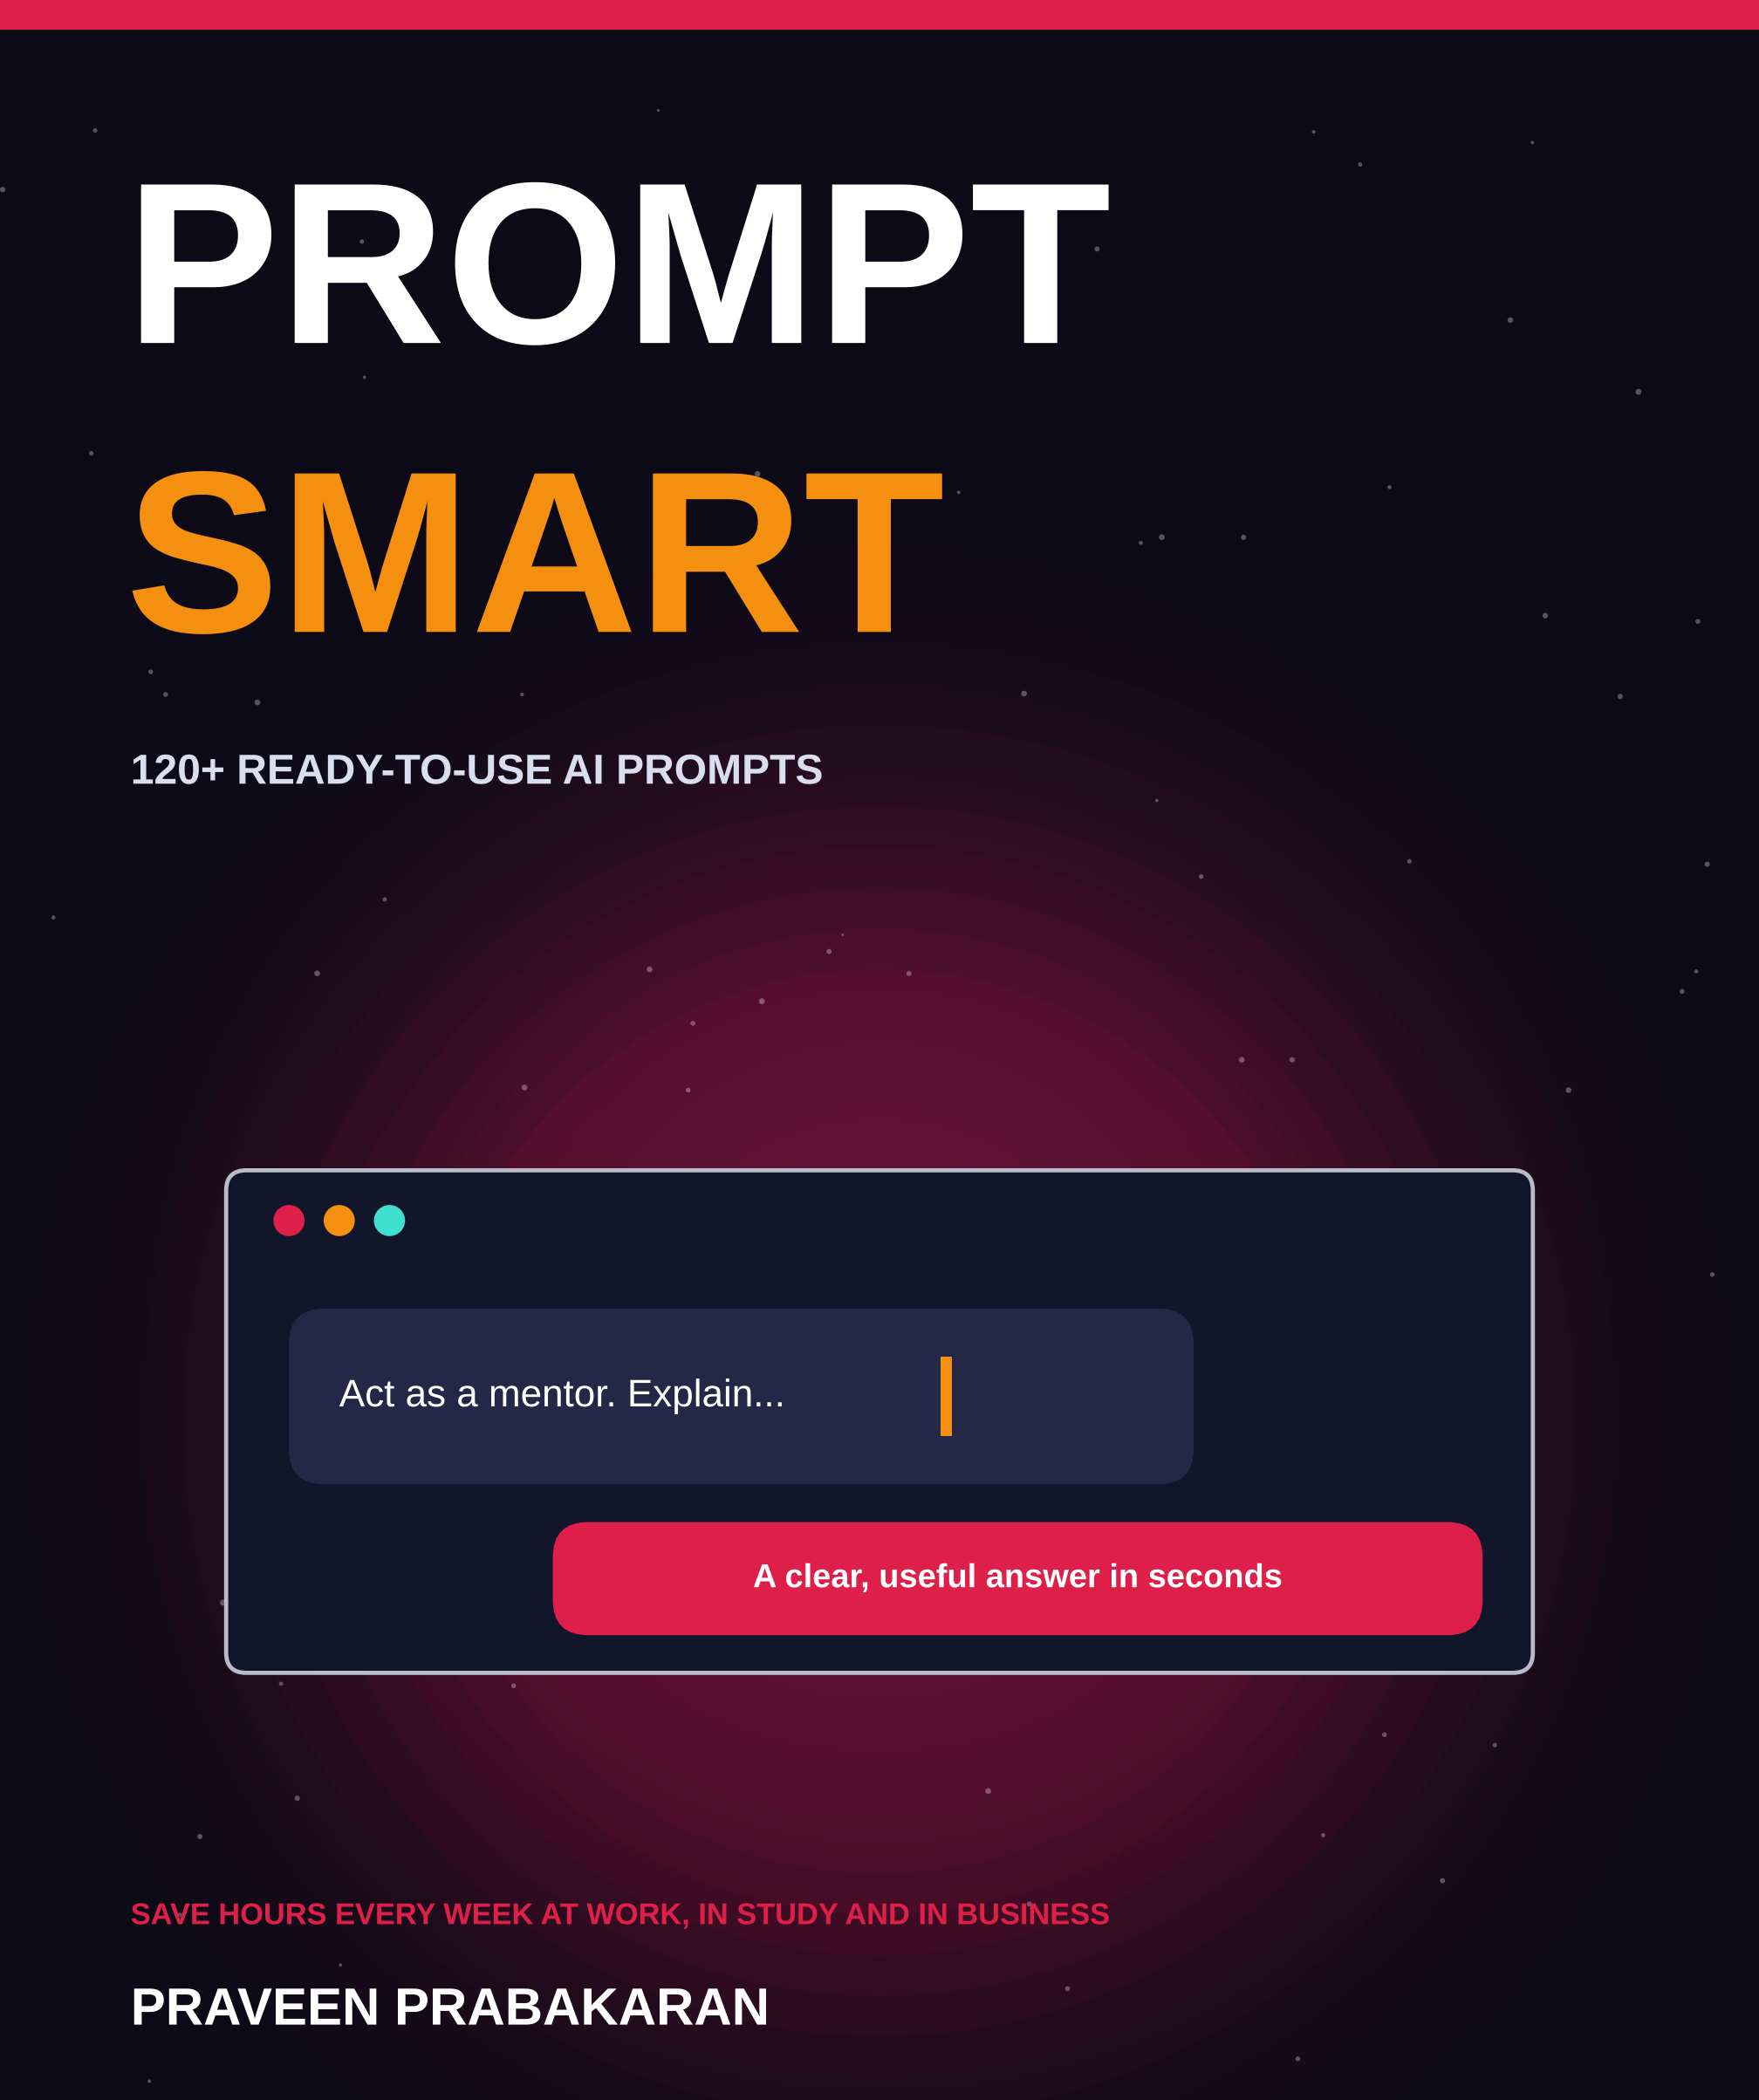

ABOUT THIS EDITION
Prompt Smart
The Visual Edition
A picture-led guide to writing AI prompts that save hours every week at work, in study and in business.
Written and designed by Praveen Prabakaran
© Praveen Prabakaran. All rights reserved.
This visual edition condenses the book: the foundations in full, plus the eight most useful prompts from each of the eight prompt chapters. The chapter menus list every prompt in the complete library. All illustrations were created for this book.
AI tools change quickly. The prompts are written to work across assistants, but results vary from tool to tool. Always check AI output before you rely on it.

CONTENTS
What is inside
01 How AI Works 4
Why your prompt decides the result
02 The TRACE Formula 5
Five questions that fix most weak prompts
03 Power Techniques 6
Seven moves that turn good answers into great ones
04 Email and Messages 7
Say it clearly, kindly and faster
05 Writing and Content 8
Beat the blank page and polish your drafts
06 Meetings and Planning 9
Minutes, plans, priorities and decisions
07 Research and Learning 10
Tutors, quizzes and summaries on demand
08 Data and Spreadsheets 11
Formulas, clean-up, insights and SQL
09 Coding and Tech 12
Write, explain, debug and review code
10 Jobs and Careers 13
Resumes, interviews, offers and growth
11 Business and Marketing 14
Customers, copy, sales and freelancing
12 Use AI Safely 15
Five habits that keep you trusted and protected
13 Your Prompt Library 16
A 30-day plan to make it a habit
A–Z Glossary 17
Fifteen key terms in one line each
→ A Last Word 18
Start small, then keep going

CHAPTER 1
How AI Works
AI assistants such as ChatGPT, Claude, Gemini and Copilot do not read your mind. They respond to exactly what you write. A vague prompt gets a vague answer; a clear, detailed prompt gets one you can use.
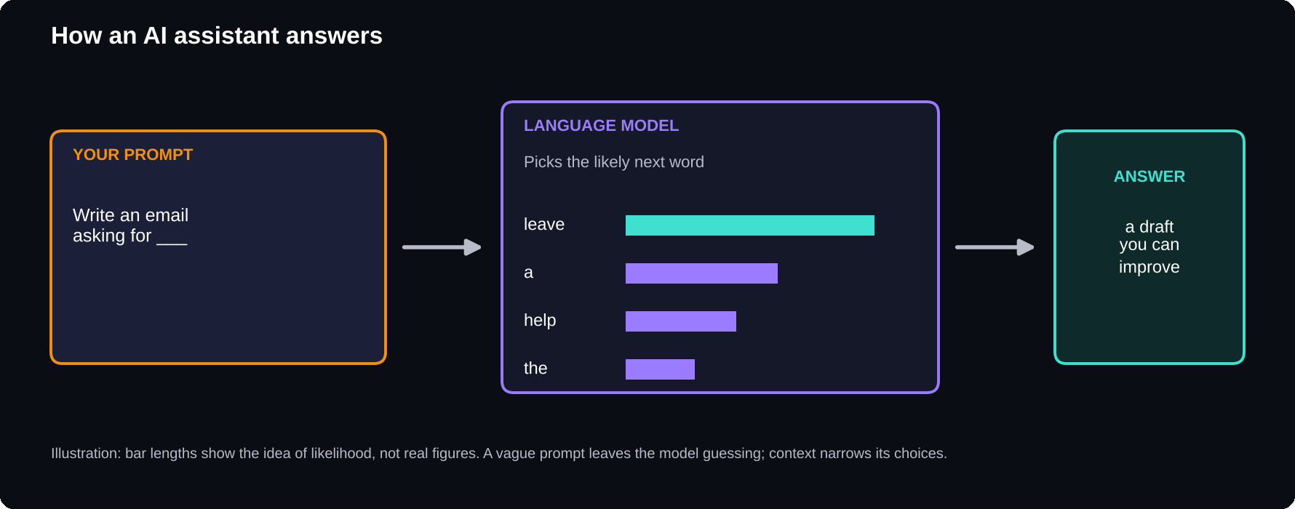
From prompt to answer
A language model generates its reply one small piece at a time, choosing what is most likely to come next given everything in the chat.

What is happening behind the screen
These tools are built on large language models. A language model learns patterns from huge amounts of text, then writes a response piece by piece. That one idea explains most of their strengths and weaknesses.
GOOD AT
Drafting, rewriting and summarising text in seconds · Explaining ideas at any level · Generating many options quickly · Writing and explaining code · Changing tone, length and format on request

STRUGGLES WITH
Facts they were not trained on or cannot look up · Exact numbers and long calculations, unless they can run code · Knowing your situation unless you tell them · Admitting uncertainty · Remembering earlier chats, unless memory is on

4
things to remember every time you use an AI assistant
Four rules to remember
1 The AI only knows what you tell it. Context is your job.
2 It can make things up. A confident false fact is called a hallucination, so check names, numbers, dates and quotes.
3 Every answer is a draft. Ask it to change anything, as many times as you like.
4 Answers vary. If one is weak, try again or add more detail.
Same task, two prompts
Weak prompt: “Write an email asking for leave.” Result: a generic, stiff email you would need to rewrite.
STRONG PROMPT
You're helping me write to my manager, Priya. Write a short, polite email asking for leave on 18 and 19 December for my cousin's wedding in Madurai. Mention that I'll finish the client report by 16 December and that Arun has agreed to cover urgent requests. Keep it under 100 words, friendly but professional.

The second prompt took 30 seconds longer to write and saved 10 minutes of editing. That trade-off is the whole idea of this book.
PRO TIP
If you wouldn't understand the task from your prompt alone, neither will the AI. Imagine handing your prompt to a smart new colleague on their first day: what would they need to know?

CHAPTER 2
The TRACE Formula
Every strong prompt answers five questions. Remember them with the word TRACE: Task, Role, Audience, Context and Expected format. You will not need all five every time, but checking against them fixes most weak prompts.
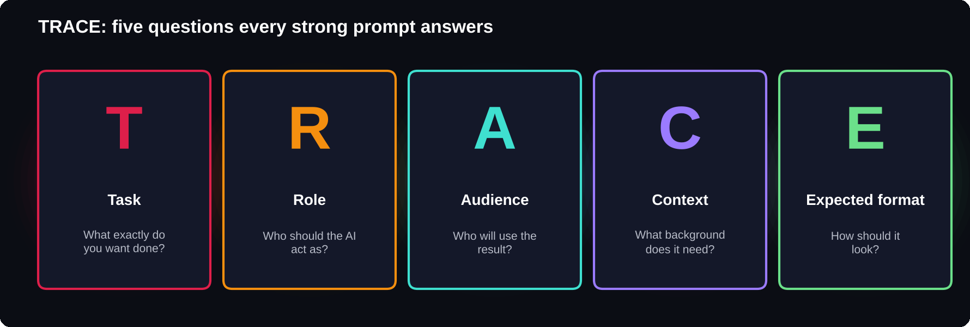
The five parts of a strong prompt
Context is usually the missing piece in a weak prompt.

5
parts in the TRACE formula: Task, Role, Audience, Context, Expected format
The fill-in template
COPY AND REUSE
Act as [role]. [Task: what you want, using a clear action verb]. This is for [audience]. Here's the background: [context, including any facts, constraints or goals]. Give me the result as [format: length, structure, tone].

Before and after: a presentation
Before: “Make a presentation on cybersecurity.”
AFTER
Act as a cybersecurity trainer. Create a 10-slide outline for a presentation on basic online safety for non-technical office staff at a mid-sized bank. Focus on phishing emails, strong passwords and safe use of public Wi-Fi. For each slide, give a title and 3 short bullet points.

Before and after: a study explanation
Before: “Explain normalisation.”
AFTER
Act as a patient DBMS tutor. Explain database normalisation to a second-year IT student preparing for a semester exam. Use one simple example table of student marks and show how it changes in 1NF, 2NF and 3NF. Keep it under 400 words and end with 3 likely exam questions.

Words that improve any prompt
1 Action verbs: summarise, compare, rewrite, list, draft, explain, critique, translate, outline.
2 Precise limits: “under 150 words”, “exactly 5 bullet points”.
3 Tone words: formal, friendly, persuasive, neutral, encouraging, concise.
4 Format words: table, checklist, numbered steps, email, script, FAQ.
PRO TIP
Put the most important instruction first or last. In long prompts, the beginning and end tend to get the most attention, so don't bury the key request in the middle.

CHAPTER 3
Power Techniques
The TRACE formula gets you good answers. These seven techniques get you great ones. Each is simple, and together they cover almost every situation where an AI answer falls short.
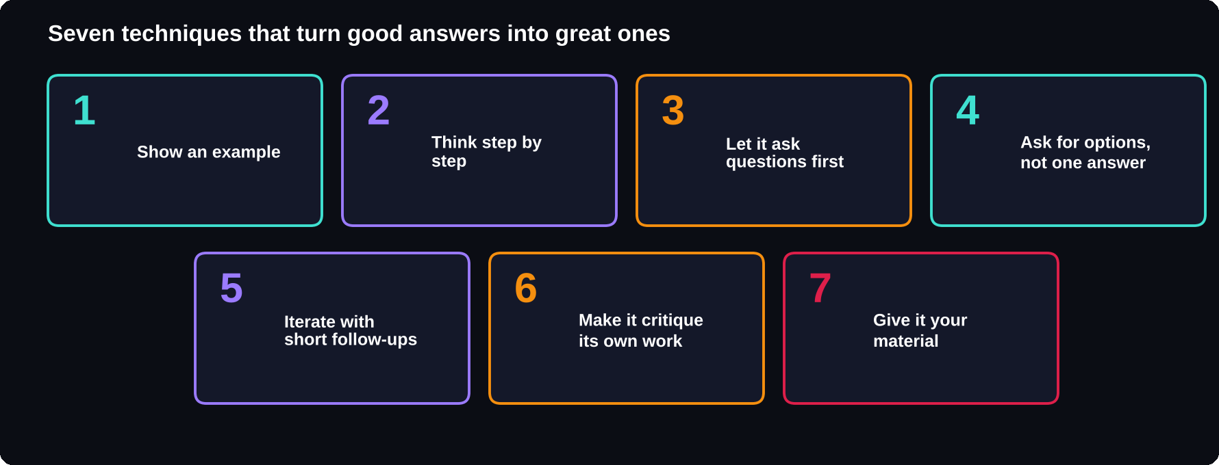
The seven techniques
Examples and “ask me questions first” are the two most powerful.

1. Show an example
AI copies patterns very well. Paste a sample of the style you want, then ask for more in exactly that style.
2. Think step by step
For logic, maths or planning, ask the AI to work through the reasoning before it gives the final answer.
3. Let it ask you questions first
THE MOST USEFUL PROMPT IN THE BOOK
I want to [goal]. Before you start, ask me up to 5 questions that would help you do this well. Wait for my answers.

5
questions are enough to turn a vague idea into a precise brief
4. Ask for options
Request 5 versions, each with a different approach and a one-line note on who it suits. You will often combine parts of two or three.
5. Iterate with short follow-ups
You rarely need to rewrite your prompt. Just steer: “Shorter, under 80 words.” “More formal.” “Turn this into a table.”
6. Make it critique its own work
SELF-REVIEW
Review your answer above as a strict [editor / senior engineer / examiner]. List its 3 biggest weaknesses, then write an improved version that fixes them.

7. Give it the material
USE ONLY MY TEXT
Using only the text below, [task]. If something isn't covered in the text, say “not mentioned” rather than guessing. [Paste text]

This is the best way to reduce made-up facts.
Quick fixes
1 Too long: “Cut this to half the length without losing the key points.”
2 Too generic: add who, where, why, numbers and names.
3 Wrong tone: name the tone and give an example sentence.
4 Made-up facts: paste your source and say “use only this”.
5 Wrong format: show an example of the exact format.
PRO TIP
Start a new chat when you change topics. Long conversations about many different things can confuse the AI, because it keeps trying to connect your new request to everything earlier in the chat.

CHAPTER 4
Email and Messages
Email and messages eat hours of most working weeks. These 15 prompts help you write faster, say difficult things kindly and reply to anything in the right tone.
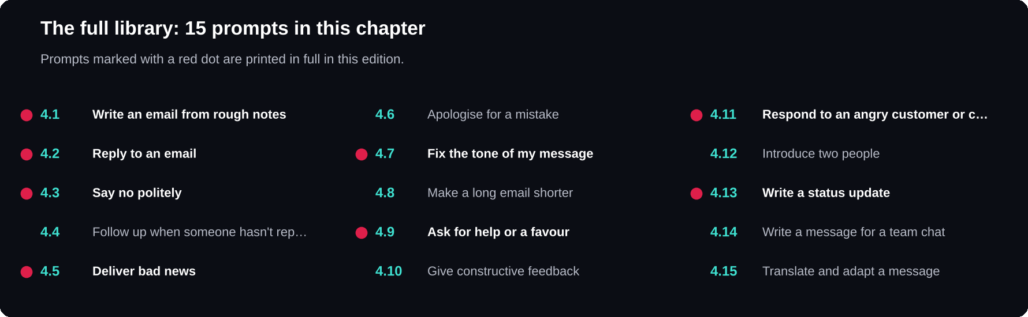
Chapter 4 at a glance
All 15 prompts are listed; the eight picked for this edition are printed in full on the page.

15
email and workplace prompts in the full chapter
4.1 WRITE AN EMAIL FROM ROUGH NOTES
Turn these rough notes into a clear, professional email to [recipient and their role]. Keep it under [number] words, with a clear subject line and one specific request at the end. Notes: [paste notes].

4.2 REPLY TO AN EMAIL
Here's an email I received: [paste email]. Draft a reply that [agrees / politely declines / asks for more time / asks for clarification]. Keep the tone [friendly / formal] and under 120 words.

4.3 SAY NO POLITELY
Help me decline [request] from [person and relationship] without damaging the relationship. My reason is [reason]. Offer [an alternative, if any]. Give me 2 versions: one warm, one brief.

4.5 DELIVER BAD NEWS
I need to tell [audience] that [bad news]. The reason is [reason], and the next step is [next step]. Write a message that is honest, takes responsibility where appropriate, and stays calm and clear. Under 150 words.

4.7 FIX THE TONE OF MY MESSAGE
Rewrite this message so it sounds [more polite / more confident / less blunt / more professional], without changing the meaning: [paste message].

4.9 ASK FOR HELP OR A FAVOUR
Write a short message asking [person] for help with [task]. Explain why I'm asking them specifically, exactly what I need, and how much of their time it will take. Make it easy to say yes or no.

4.11 RESPOND TO AN ANGRY CUSTOMER OR CLIENT
A customer sent this complaint: [paste message]. Write a reply that acknowledges their frustration, explains [what happened, if known], and offers [solution]. Calm, respectful, no blame, under 150 words.

4.13 WRITE A STATUS UPDATE
Write a weekly status update for [audience] on [project]. Done: [list]. In progress: [list]. Blocked: [list and what's needed]. Use 3 short headed sections and bullet points.

PRO TIP
Before you send anything sensitive, ask: "Read this as the recipient. How might it come across, and is there anything that could be misunderstood?"

CHAPTER 5
Writing and Content
AI is a tireless writing partner: it can beat the blank page, suggest structure and polish your drafts. These 15 prompts work best when you keep your own ideas and voice at the centre.
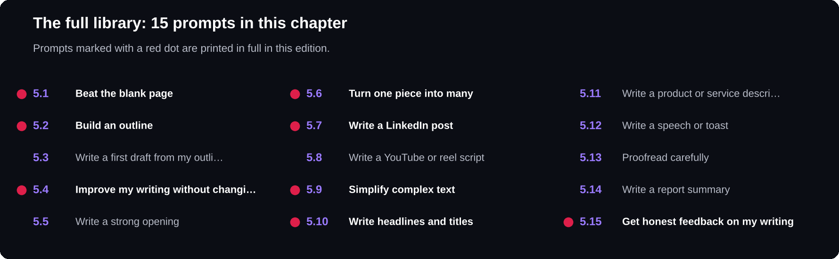
Chapter 5 at a glance
All 15 prompts are listed; the eight picked for this edition are printed in full on the page.

15
writing and content prompts in the full chapter
5.1 BEAT THE BLANK PAGE
I need to write [type of piece] about [topic] for [audience]. Give me 10 possible angles or headlines, each with one line explaining why it would interest this audience.

5.2 BUILD AN OUTLINE
Create a detailed outline for a [length]-word [blog post / article / report] on [topic] for [audience]. Include a hook, 4 to 6 section headings with key points under each, and a conclusion with a clear takeaway.

5.4 IMPROVE MY WRITING WITHOUT CHANGING MY VOICE
Edit this text for clarity, grammar and flow. Keep my voice and style; don't make it sound like a template. Show the edited version, then list the main changes you made: [paste text].

5.6 TURN ONE PIECE INTO MANY
Turn this article into: 1) a LinkedIn post under 150 words, 2) 3 tweets or X posts, 3) an Instagram caption with 5 hashtags, and 4) a 3-sentence email newsletter teaser: [paste article].

5.7 WRITE A LINKEDIN POST
Write a LinkedIn post about [achievement / lesson / project]. Start with a strong first line, tell a short story, share one lesson, and end with a question for readers. Under 200 words, genuine, not boastful.

5.9 SIMPLIFY COMPLEX TEXT
Rewrite this for [audience, e.g. a 14-year-old / a non-technical manager]. Keep all the important points, remove jargon and use one everyday example: [paste text].

5.10 WRITE HEADLINES AND TITLES
Suggest 10 titles for [piece] about [topic]. Mix styles: how-to, list, question, curiosity and benefit-led. Keep each under 60 characters.

5.15 GET HONEST FEEDBACK ON MY WRITING
Act as a demanding editor. Rate this draft from 1 to 10 for clarity, structure and persuasiveness, explain each score, and give the 3 changes that would improve it most: [paste draft].

PRO TIP
Write the first rough draft yourself, even badly, and use AI to improve it. Your ideas and experiences are what make writing worth reading; AI is best at polishing them.

CHAPTER 6
Meetings and Planning
The biggest time savings from AI often come from organising work rather than doing it: turning messy notes into decisions, big goals into small steps and long to-do lists into a realistic plan. These 15 prompts handle exactly that.
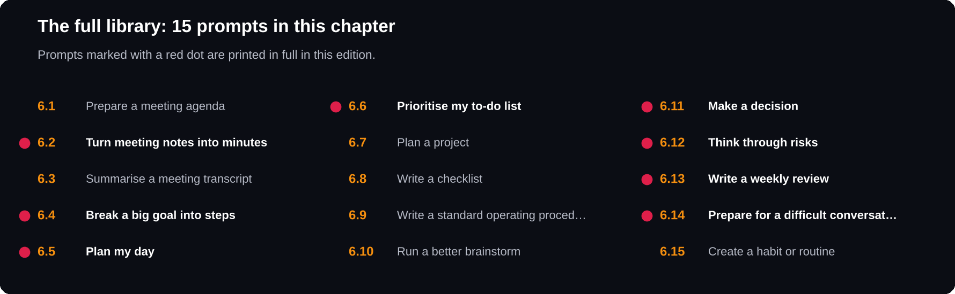
Chapter 6 at a glance
All 15 prompts are listed; the eight picked for this edition are printed in full on the page.

15
planning and productivity prompts in the full chapter
6.2 TURN MEETING NOTES INTO MINUTES
Turn these rough meeting notes into clear minutes with 3 sections: decisions made, action items (with owner and deadline) and open questions. Don't add anything not in the notes: [paste notes].

6.4 BREAK A BIG GOAL INTO STEPS
I want to [goal] by [date]. I can spend about [hours] per week on it. Break this into weekly milestones and specific tasks, starting with what I should do in the first 30 minutes.

6.5 PLAN MY DAY
Here are my tasks for today with rough time estimates: [list]. I have meetings at [times] and I'm most focused in the [morning / afternoon]. Create a realistic schedule, put the hardest work in my best hours and flag anything that won't fit.

6.6 PRIORITISE MY TO-DO LIST
Sort these tasks using the urgent-important matrix: do now, schedule, delegate, drop. Explain your reasoning in one line each, and tell me the single task to start with: [paste list].

6.11 MAKE A DECISION
I'm deciding between [option A] and [option B] for [situation]. What matters most to me: [criteria]. Compare the options in a table against these criteria, list the risks of each and tell me what information would make the decision clearer.

6.12 THINK THROUGH RISKS
Imagine it's 6 months from now and [project] has failed. List the 7 most likely reasons why, then suggest one action I can take now to prevent each.

6.13 WRITE A WEEKLY REVIEW
Help me do a weekly review. Here's what I planned: [list]. Here's what I actually did: [list]. Identify what went well, what slipped and why, and suggest my top 3 priorities for next week.

6.14 PREPARE FOR A DIFFICULT CONVERSATION
I need to talk to [person] about [issue]. Help me prepare: the main message in one sentence, how to open the conversation, 3 reactions they might have and how I could respond to each.

PRO TIP
For recurring tasks like weekly reports or meeting minutes, save your best prompt as a template. Next time, you only paste in the new notes.

CHAPTER 7
Research and Learning
AI can be the most patient tutor you've ever had: it explains things at your level, quizzes you and never gets tired of questions. For research, treat it as a starting point and always check important facts against reliable sources.
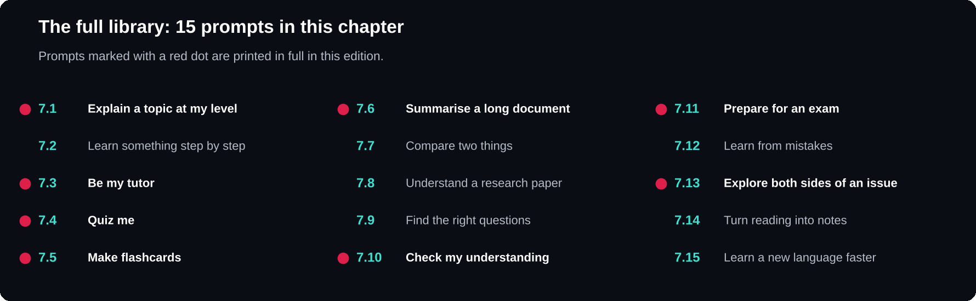
Chapter 7 at a glance
All 15 prompts are listed; the eight picked for this edition are printed in full on the page.

15
study and research prompts in the full chapter
7.1 EXPLAIN A TOPIC AT MY LEVEL
Explain [topic] to me as if I'm [a complete beginner / a 2nd-year engineering student / a manager with no technical background]. Use one real-world analogy and one example, then check my understanding with 2 questions.

7.3 BE MY TUTOR
Act as my tutor for [subject]. Teach me [topic] one small idea at a time. After each idea, ask me a question and wait for my answer before moving on. Correct me kindly if I'm wrong.

7.4 QUIZ ME
Give me 10 multiple-choice questions on [topic] at [difficulty] level. Don't show the answers yet. After I reply with my choices, mark them and explain each wrong answer.

7.5 MAKE FLASHCARDS
Turn these notes into 20 flashcards in a table with "Question" and "Answer" columns. Keep answers short and focus on things likely to be tested: [paste notes].

7.6 SUMMARISE A LONG DOCUMENT
Summarise this document in 3 levels: a one-sentence summary, a 5-bullet summary, and a 1-paragraph summary of the key evidence. Use only what's in the text: [paste document].

7.10 CHECK MY UNDERSTANDING
Here's my explanation of [concept]: [your explanation]. Tell me what I got right, what's wrong or missing, and how an expert would explain it more precisely.

7.11 PREPARE FOR AN EXAM
My exam on [subject] is in [days]. Topics: [list]. I'm weakest at [topics]. Create a day-by-day revision plan, with the most likely exam questions for each topic and time for practice tests.

7.13 EXPLORE BOTH SIDES OF AN ISSUE
Give me the strongest arguments for and against [position or decision], presented fairly. Then list the key facts I'd need to check to decide for myself.

PRO TIP
When accuracy matters, ask: "Which parts of your answer are you least certain about?" Then check those parts in a textbook or reliable website first.

CHAPTER 8
Data and Spreadsheets
You don't need to be a data analyst to get answers from your numbers. AI can write spreadsheet formulas, explain what your data shows and suggest the right chart. For calculations that matter, use a tool that can actually run code or check the formula in the spreadsheet yourself.
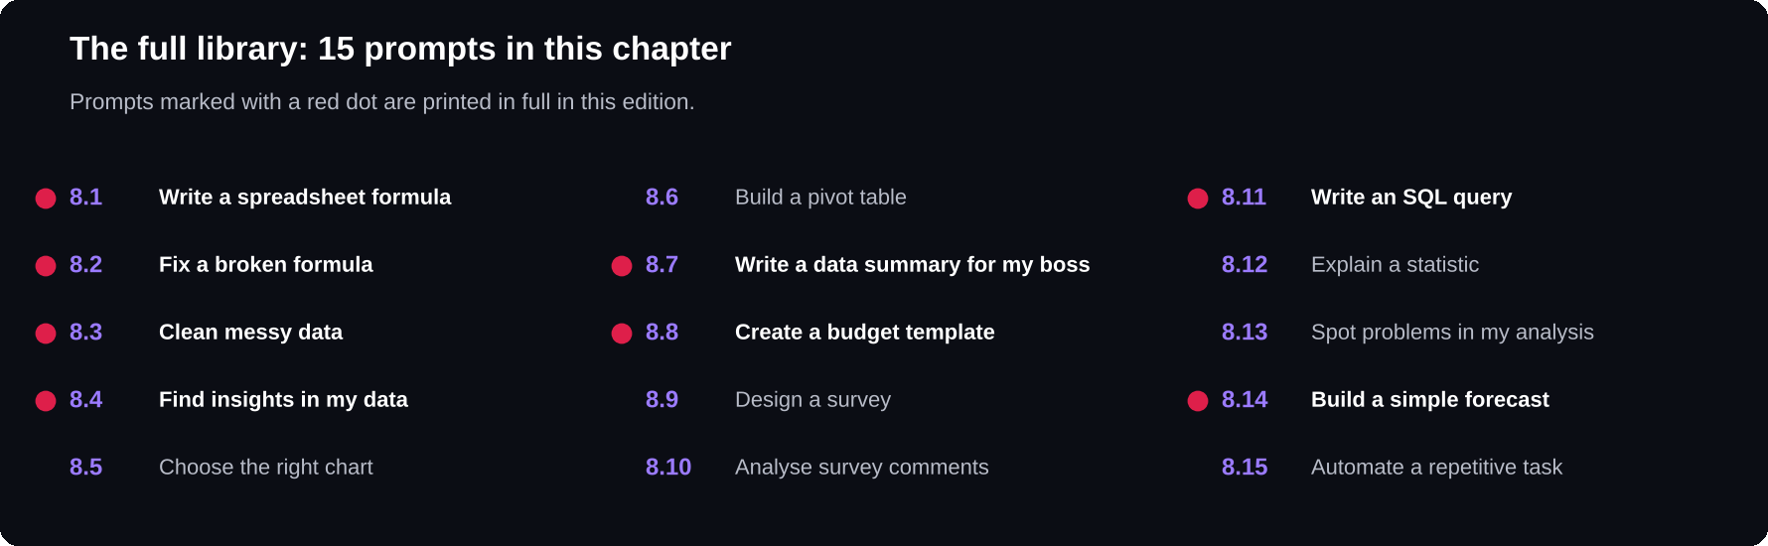
Chapter 8 at a glance
All 15 prompts are listed; the eight picked for this edition are printed in full on the page.

15
data and spreadsheet prompts in the full chapter
8.1 WRITE A SPREADSHEET FORMULA
I'm using [Excel / Google Sheets]. My data has [describe columns, e.g. A = date, B = product, C = sales]. Write a formula that [what you want, e.g. totals sales for "Product X" in March]. Explain how it works in plain words.

8.2 FIX A BROKEN FORMULA
This formula gives [error or wrong result]: [paste formula]. My data looks like this: [describe or paste a few rows]. Explain what's wrong and give the corrected formula.

8.3 CLEAN MESSY DATA
Here's a sample of messy data: [paste rows]. List the problems you see (duplicates, inconsistent spelling, wrong formats, missing values) and give me step-by-step instructions or formulas to clean them in [tool].

8.4 FIND INSIGHTS IN MY DATA
Here's my data: [paste table or summary]. What are the 5 most important patterns or changes? For each, say what it might mean and what I should check before drawing conclusions.

8.7 WRITE A DATA SUMMARY FOR MY BOSS
Turn these numbers into a short summary for a manager who has 2 minutes: [paste numbers]. Start with the headline, then 3 supporting points, then one recommendation. No jargon.

8.8 CREATE A BUDGET TEMPLATE
Design a monthly budget template for [personal use / a small team / an event]. List the columns, categories, formulas for totals and variance, and how to highlight overspending automatically.

8.11 WRITE AN SQL QUERY
Write an SQL query for a table called [table] with columns [list]. I want to [goal, e.g. find the top 5 customers by total order value in 2026]. Explain each part of the query.

8.14 BUILD A SIMPLE FORECAST
Here are my monthly figures for the past [number] months: [paste]. Explain a simple, sensible way to forecast the next 3 months in a spreadsheet, and the main reasons the forecast could be wrong.

PRO TIP
Never paste confidential data, such as customer details or salary information, into an AI tool unless your organisation has approved that tool for it. Replace real names with labels like Customer A and Customer B.

CHAPTER 9
Coding and Tech
AI coding help is most powerful when you stay in charge: you understand the problem, you review the code and you test it. These 15 prompts help you write, fix, understand and improve code faster without losing that control.
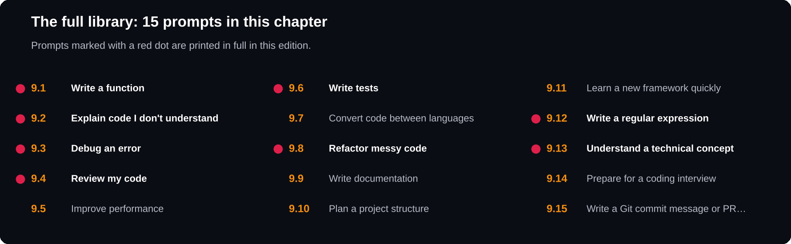
Chapter 9 at a glance
All 15 prompts are listed; the eight picked for this edition are printed in full on the page.

15
coding prompts in the full chapter
9.1 WRITE A FUNCTION
Write a [language] function that [what it does]. Inputs: [describe]. Output: [describe]. Handle these edge cases: [list]. Add short comments and 3 example test cases.

9.2 EXPLAIN CODE I DON'T UNDERSTAND
Explain this code line by line for someone who knows basic [language]. Then summarise what it does overall in 2 sentences and point out anything risky or unusual: [paste code].

9.3 DEBUG AN ERROR
I'm getting this error: [paste full error message]. Here's the relevant code: [paste code]. I expected [expected behaviour] but got [actual behaviour]. Explain the likely cause and the fix, and how to avoid it in future.

9.4 REVIEW MY CODE
Act as a senior [language] developer doing a code review. Check this code for bugs, security issues, readability and performance. List issues by severity, with a suggested fix for each: [paste code].

9.6 WRITE TESTS
Write unit tests for this function using [testing framework]. Cover normal cases, edge cases and invalid inputs. Explain what each test checks: [paste code].

9.8 REFACTOR MESSY CODE
Refactor this code to be cleaner and easier to maintain without changing its behaviour. Use clear names, smaller functions and remove duplication. Explain each change: [paste code].

9.12 WRITE A REGULAR EXPRESSION
Write a regex that matches [description, e.g. Indian mobile numbers with an optional +91]. Give 5 examples that should match and 5 that shouldn't, and explain each part of the pattern.

9.13 UNDERSTAND A TECHNICAL CONCEPT
Explain [concept, e.g. REST APIs / Docker / recursion] with a real-world analogy, a minimal code example and the 3 mistakes beginners make most often.

PRO TIP
Never run code you don't understand, especially code that deletes files, changes databases or handles passwords. Ask the AI to explain anything unclear, and test changes on a copy first.

CHAPTER 10
Jobs and Careers
Whether you're looking for your first job or your next promotion, AI can help you present your real strengths clearly. The golden rule: everything on your resume and in your interviews must be true. Use AI to express your experience better, never to invent it.
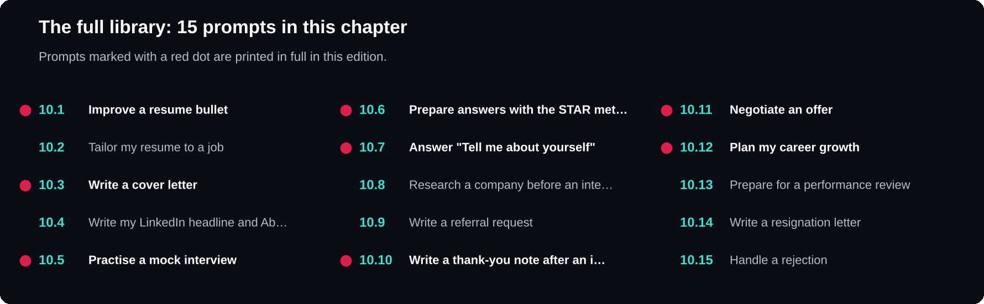
Chapter 10 at a glance
All 15 prompts are listed; the eight picked for this edition are printed in full on the page.

15
career prompts in the full chapter
10.1 IMPROVE A RESUME BULLET
Rewrite this resume bullet to start with a strong action verb and show the result or impact. Give 3 versions, and don't add any numbers I haven't provided: [paste bullet]. Context: [what you actually did].

10.3 WRITE A COVER LETTER
Write a cover letter for the [role] position at [company]. My key experience: [3 points]. Why I want this role: [reason]. Keep it under 250 words, specific to this company, and avoid clichés like "I am a hard-working team player".

10.5 PRACTISE A MOCK INTERVIEW
Act as an interviewer for a [role] position at a [type of company]. Ask me one question at a time, mixing technical and behavioural questions. After each answer, give brief feedback and a better way to phrase it. Ask 8 questions in total.

10.6 PREPARE ANSWERS WITH THE STAR METHOD
Help me turn this experience into a STAR answer (Situation, Task, Action, Result) for the question "[interview question]": [describe what happened]. Keep it under 2 minutes when spoken.

10.7 ANSWER "TELL ME ABOUT YOURSELF"
Write a 60 to 90-second "Tell me about yourself" answer for a [role] interview. Present: [current situation]. Past: [relevant experience]. Future: [what you want next]. Natural, not memorised-sounding.

10.10 WRITE A THANK-YOU NOTE AFTER AN INTERVIEW
Write a short thank-you email to [interviewer] after my interview for [role]. Mention [one topic we discussed] and briefly restate why I'm a good fit. Under 120 words.

10.11 NEGOTIATE AN OFFER
I received an offer for [role] at [salary or package]. Based on [reasons, e.g. my skills, another offer, market research], I'd like to ask for [request]. Write a polite, confident email that keeps a positive relationship.

10.12 PLAN MY CAREER GROWTH
I'm currently a [role] and want to become a [target role] in [years]. Create a development plan: skills to build, experiences to seek, certifications worth considering and how to show progress to my manager.

PRO TIP
Recruiters can often spot AI-written applications that sound generic. Always add a specific detail only you could know: a project you built, a problem you solved or a real reason you want to work there.

CHAPTER 11
Business and Marketing
For small business owners and freelancers, AI can act like a marketing assistant, a sales coach and a business adviser rolled into one. These 15 prompts help you find customers, communicate value and run your business more smoothly.
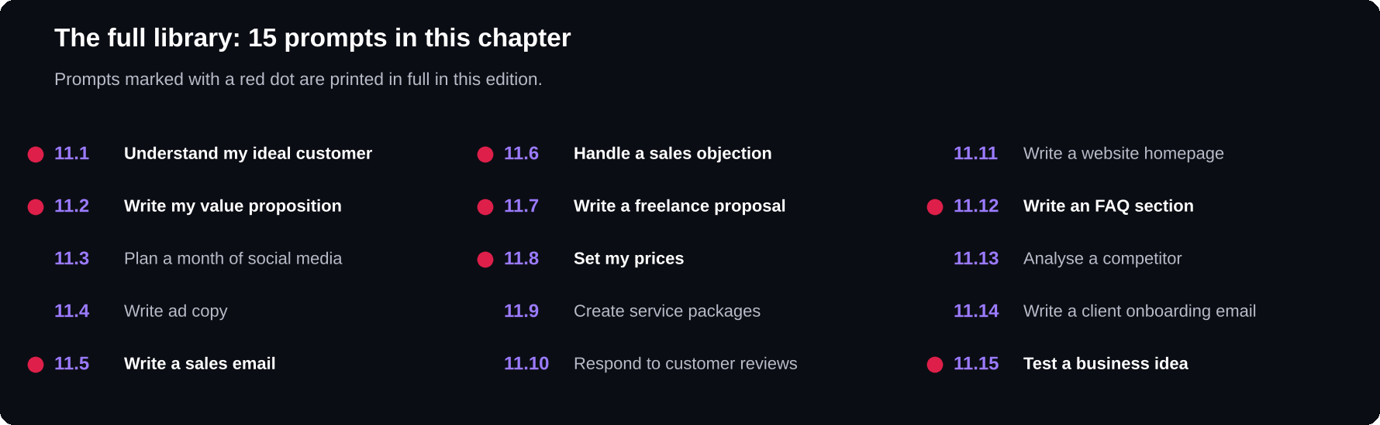
Chapter 11 at a glance
All 15 prompts are listed; the eight picked for this edition are printed in full on the page.

15
business prompts in the full chapter
11.1 UNDERSTAND MY IDEAL CUSTOMER
I sell [product or service] in [location or market]. Describe 3 types of ideal customer: who they are, the problem they want solved, what stops them from buying and where they spend time online.

11.2 WRITE MY VALUE PROPOSITION
Write 5 one-sentence value propositions for [business]. We help [customer] to [result] by [how], unlike [alternative]. Make each one clear enough for a stranger to understand in 5 seconds.

11.5 WRITE A SALES EMAIL
Write a short cold email to [type of prospect] offering [product or service]. Mention a specific problem they likely face, one result we've delivered [real example], and ask for a 15-minute call. Under 120 words, no hype.

11.6 HANDLE A SALES OBJECTION
A potential customer says: "[objection, e.g. it's too expensive]". Give me 3 honest, respectful ways to respond that address their concern without pressure.

11.7 WRITE A FREELANCE PROPOSAL
Write a proposal for this freelance job: [paste job post]. My relevant experience: [list]. Start by showing I understand their problem, explain my approach in 3 steps, give a timeline and end with a question. Under 200 words.

11.8 SET MY PRICES
I offer [service] to [type of client]. My costs and time per project: [details]. Explain 3 pricing models (hourly, per project, packages) for my situation, with pros and cons, and questions I should research about market rates.

11.12 WRITE AN FAQ SECTION
Write 10 frequently asked questions and clear answers for [business or product], covering pricing, delivery, refunds, how it works and common concerns. Use these facts: [list facts]. Mark anything you're unsure of with [CHECK].

11.15 TEST A BUSINESS IDEA
I'm thinking about starting [business idea] for [audience]. Act as a practical business mentor. Ask me 5 hard questions about the idea, then suggest the cheapest way to test whether people will actually pay for it.

PRO TIP
Never use AI to create fake reviews, testimonials or invented results. It misleads customers, can break consumer laws and platform rules, and destroys trust when discovered. Use AI to present your real results well instead.

CHAPTER 12
Use AI Safely
AI saves time only if you can trust what you do with it. Five habits keep you safe: protect private information, check facts, keep your own judgement, be honest about AI use, and respect other people's work.
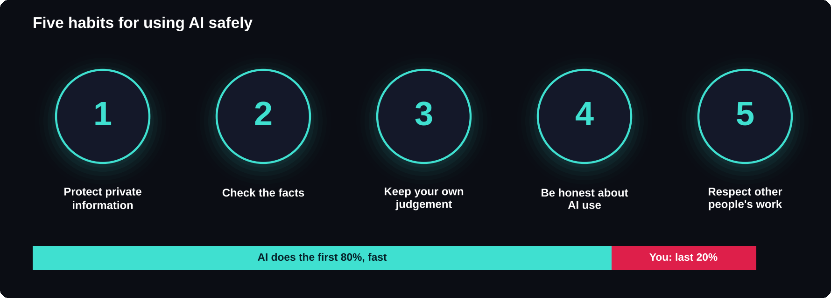
Five habits and the 80/20 rule
Let AI do the first 80% quickly, then spend your time on the last 20%: checking, personalising and deciding.

1. Protect private information
What you type into an AI tool may be stored and, depending on the tool and settings, used to improve the service. Before you paste anything, ask: would I be comfortable if this appeared outside my organisation?
DO NOT PASTE WITHOUT PERMISSION
Customer or patient personal details · Passwords, API keys or access codes · Confidential plans, contracts or financial results · Unpublished code or data belonging to your employer

Safer habit: replace real names and numbers with placeholders like Client A or ₹X.
2023
year of India's Digital Personal Data Protection Act, which sets rules for handling personal data
2. Check the facts
1 Are names, dates and numbers correct? Check an original source.
2 Do quotes, books, papers or links actually exist? AI sometimes invents references.
3 Is the information current?
4 Did you check the calculation yourself or in a spreadsheet?
5 Would an expert agree?
3. Keep your own judgement
Use AI to inform decisions, not make them. For health, law, money or someone's job, talk to a qualified person. AI can also reflect biases from its training text, so check results for unfair assumptions.
4. Be honest about AI use
At college, follow your institution's rules on AI. At work, be open with your team. In published content, you are responsible for every word.
5. Respect other people's work
Do not ask AI to copy someone else's article, book, design or code. Use it to create original work and to build on ideas, with credit where it is due.
THREE SAFER PROMPTS
Before answering, tell me which parts of this you're confident about and which I should verify.
Answer using only the information I've provided. If it's not there, say so instead of guessing.
Review this text for any personal or confidential information I should remove before sharing it: [paste text].

PRO TIP
A good rule of thumb: let AI do the first 80% quickly, then spend your own time on the last 20%: checking, personalising and deciding.

CHAPTER 13
Your Prompt Library
The people who get the most out of AI are not the ones who know the most prompts. They save their best prompts, improve them over time and reuse them every week.
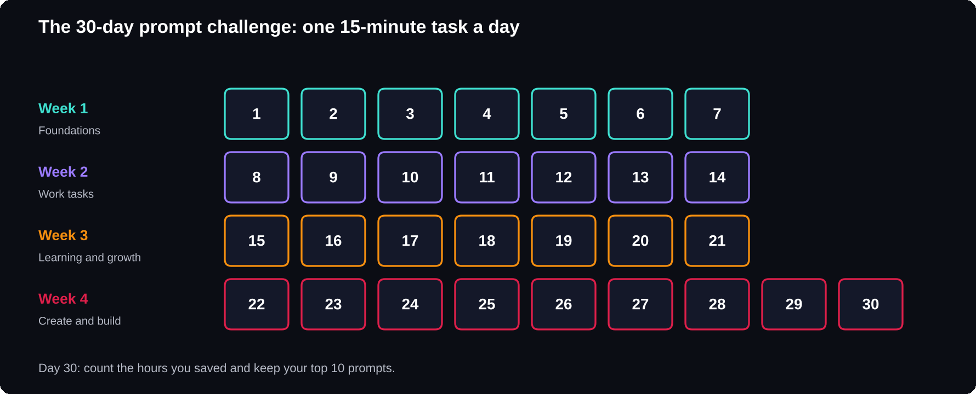
The 30-day prompt challenge
One small task a day, about 15 minutes each.

Set up your library
Use any tool you already open every day: a notes app, a document or a spreadsheet. For each prompt, save five fields.
1 Name: for example, Weekly status update.
2 Use it when: every Friday before 5 pm.
3 The prompt itself.
4 Best follow-ups: “Shorter”, “Add a risks section”.
5 Notes: works best with last week's update as an example.
10
prompts from this book are enough to start; add your own as you go
Improve a prompt over time
1 Too generic? Add the context line you always end up typing.
2 Wrong format? Add an example of the format you want.
3 Same follow-up every time? Put it into the prompt.
4 Made things up? Add “use only the information I've provided”.
After three or four rounds, most prompts become reliable enough to use without editing.
YOUR ABOUT-ME BLOCK
About me: I'm a [role] at [type of organisation] in [city]. I usually write for [audience]. I prefer [clear, concise, friendly] language, British/Indian English spelling and answers with headings and bullet points. Avoid jargon unless I ask for it.

Week 1: foundations
Rewrite a real email with TRACE. Try “ask me 5 questions first”. Ask for 5 options. Make the AI critique itself. Summarise a long document (7.6). Plan tomorrow (6.5). Save your 5 favourites.
Week 2: work tasks
Turn notes into minutes (6.2). Write a status update (4.13). Write or fix a formula (8.1, 8.2). Fix the tone of a hard message (4.7). Break a big goal into steps (6.4). Spot project risks (6.12). Improve 3 saved prompts.
Week 3: learning and growth
Learn a topic with the tutor prompt (7.3) and quiz yourself (7.4). Improve 3 resume bullets (10.1). Do a mock interview (10.5). Write your LinkedIn About (10.4). Explain a hard idea back to the AI (7.10). Write your about-me block.
Week 4: create and build
Write a LinkedIn post (5.7) and turn it into 3 formats (5.6). Write or debug code (9.1, 9.3). Write an SOP (6.9). Test a side-business idea (11.15). Get editor feedback (5.15). Write 3 prompts of your own. Teach a friend TRACE. On day 30, count the hours saved.
PRO TIP
Share your best prompts with your team. A shared prompt library is one of the easiest ways to raise the quality of everyone's work at once.

A TO Z
Glossary
Fifteen words that unlock the rest of the book.

AI assistant
A chat tool built on a language model, such as ChatGPT, Claude, Gemini or Copilot.
About-me block
A short profile pasted at the start of a chat so answers fit your role and style.
Context
The background facts an AI needs but cannot know unless you say them.
Custom instructions
A saved profile some tools apply to every chat.
Expected format
The E in TRACE: the length, structure and tone you want back.
Follow-up
A short reply that steers the answer, such as “shorter” or “more formal”.
Hallucination
A confident answer that is false or invented.
Iteration
Improving an answer step by step instead of rewriting the prompt.
Language model
Software that learns patterns from huge amounts of text and writes one piece at a time.
Placeholder
A [square bracket] you replace with your own details.
Prompt
The instruction or question you give an AI.
Prompt library
Your saved collection of tested prompts.
Role
The R in TRACE: who the AI should act as.
TRACE
Task, Role, Audience, Context, Expected format.
Verify
Check names, numbers, dates and references against an original source.

THE LAST WORD
Start small
AI is a tool, and like any tool, the results depend on the person using it. The prompts in this book will save you time, but the real change comes from the habit: pause, add context, ask for what you actually need, check the result and improve it.

Start small. Pick one prompt today, use it on a real task, and notice how much time you saved. Then pick another.
Thank you for reading. If this book helped you, please leave a review on the store where you bought it. It helps other readers find it.
ABOUT THE AUTHOR
Praveen Prabakaran is a final-year B.Tech Information Technology student from Tamil Nadu, India, with a strong interest in AI/ML, competitive programming and hackathons. He writes practical, beginner-friendly guides that turn new technology into clear steps anyone can follow.

