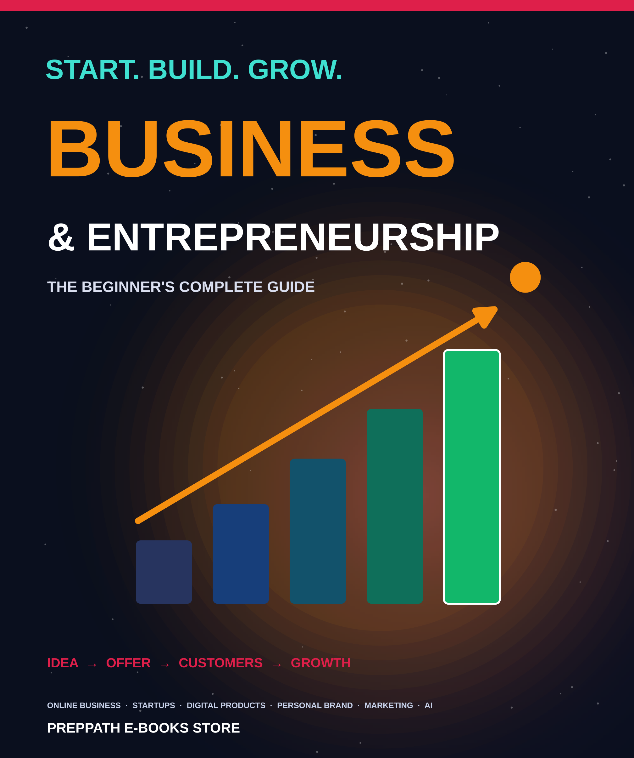

ABOUT THIS EDITION
Business & Entrepreneurship
The Beginner's Complete Guide
A picture-led guide that takes you from first idea to first customers: online business, startup planning, digital products, personal brand, marketing and AI.
Published by PrepPath E-books Store
© 2026 PrepPath E-books Store. All rights reserved.
Six chapters, each a complete guide you can read on its own or in order. All illustrations were created for this book. Examples use made-up details.
Business rules differ between countries and change over time. Treat this guide as a starting point, not legal, tax or financial advice.

CONTENTS
What is inside
01 Start Your First Online Business 4
From a rough idea to your first sale
02 The Beginner's Startup Blueprint 5
One page that turns an idea into a plan
03 Digital Product Business Guide 6
Make once, sell many times
04 Building a Personal Brand 7
Be known for something, and be trusted for it
05 Small Business Marketing Strategies 8
Get noticed, earn trust, win customers
06 How to Build a Business with AI 9
Use AI as your assistant, not your replacement
A–Z Glossary 10
Fifteen key terms in one line each
→ A Last Word 11
Start small, and a few notes

CHAPTER 1
Start Your First Online Business
You do not need a big idea, a team or a lot of money to begin. You need a real problem, a simple offer and the courage to show it to a few people. This chapter walks you from idea to first sale.
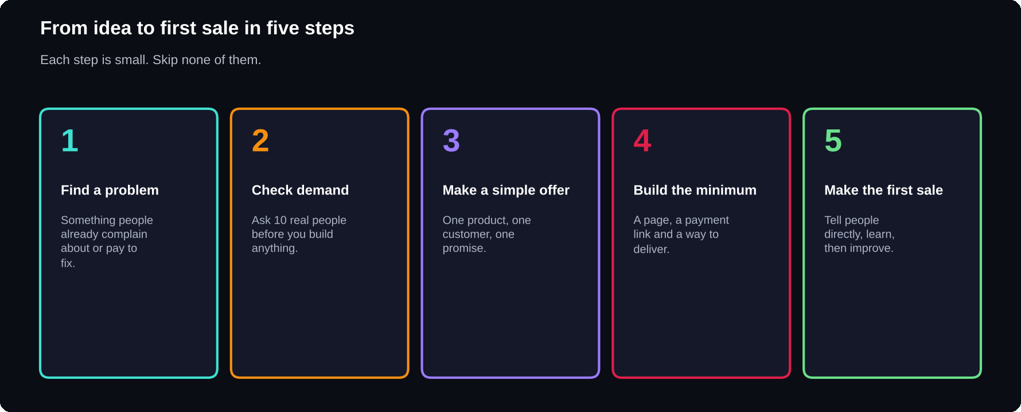
Five steps to a first sale
Small, ordered steps beat a perfect plan that never launches.

Choose what kind of business
Most first online businesses fall into four groups: selling services (writing, design, tutoring, coding), selling digital products (e-books, templates, courses), selling physical products (made, sourced or dropshipped), and earning from content (a channel, a newsletter or a community). Pick the group where you already have a skill, because skills shorten the road to a first customer.
1
problem, 1 customer type and 1 clear promise are enough to begin
Find a problem worth solving
Good ideas start from irritation. Look at your own work, study and daily life, and write down what wastes time, confuses people or feels too hard. Then listen: what do friends, classmates and online groups keep asking for help with? A problem people already talk about is a problem they may pay to fix.
1 List 10 things you are good at or have learned the hard way
2 List 10 problems people around you complain about
3 Circle the overlaps. These are your idea candidates
4 Pick one that you can explain in a single sentence
Check demand before you build
Talk to 10 people who could be your customer. Do not pitch. Ask how they handle the problem now, what annoys them, and what they have tried. If most describe the same pain, you have found something. If nobody cares, change the idea, not the customer.
THE SIMPLE TEST
Describe your offer in one sentence and ask: “Would you want this?” Then ask: “What would stop you?” The second answer is the useful one.

Make a simple offer
An offer says who it is for, what result they get and how. Example: “A one-page resume checklist for final-year students who want to get shortlisted.” Keep it narrow. A narrow offer is easier to explain, easier to find customers for, and easier to build.
Build the minimum
Use free or low-cost tools. You need a way to describe the offer (a simple page or a social profile), a way to accept payment (a payment link or UPI), and a way to deliver (a file, a message or a call). Do not wait for a logo, a website or a company name to be perfect.
1 Describe the offer on one page or one post
2 Add a payment link or UPI option
3 Prepare the delivery: file, email or call
4 Add a way to contact you, such as a DM or email
Get the first sale
Your first customers come from people, not algorithms. Message the people you talked to. Share in communities where the problem is discussed. Offer to help the first few customers personally and ask for honest feedback. One real sale teaches more than a month of planning.

CHAPTER 2
The Beginner's Startup Blueprint
A startup is a young business that is still searching for a model that works. The blueprint in this chapter fits on one page, and it forces you to answer the questions that matter before you spend money.
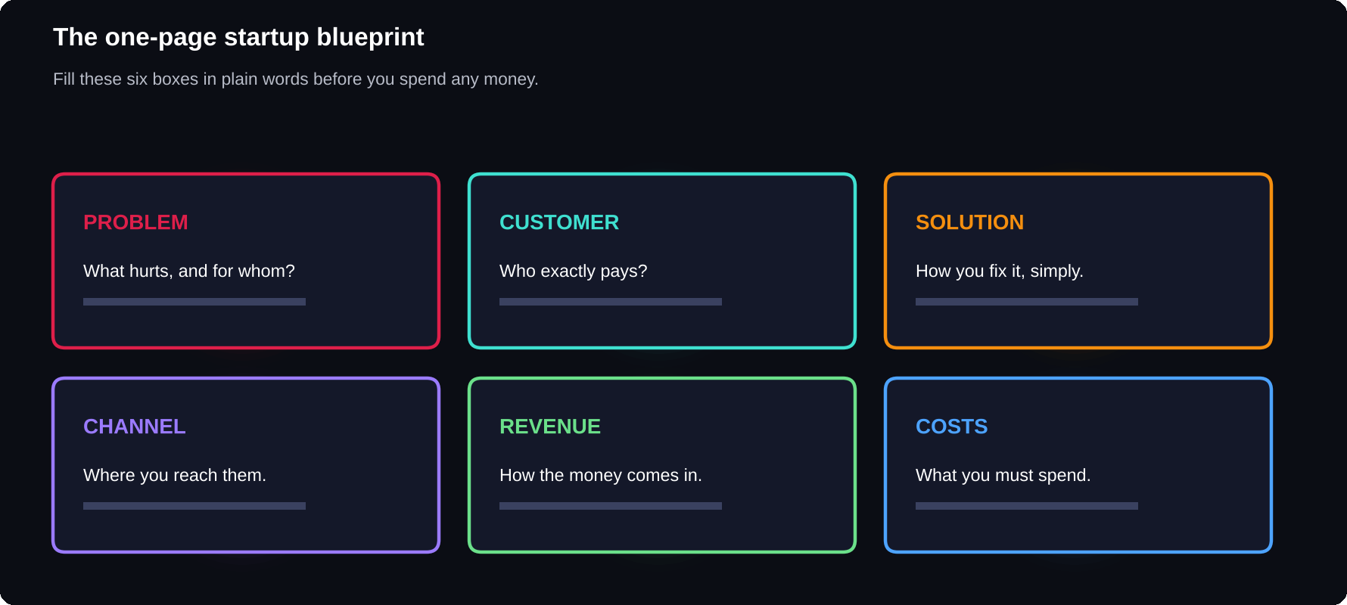
The one-page blueprint
Six boxes, written in plain words. If a box is empty, that is your next task.

6
boxes make a complete first blueprint: problem, customer, solution, channel, revenue, costs
Problem and customer
Write the problem as your customer would say it, not as you would. Then describe the customer: age, situation, what they already use and what they care about. “Everyone” is not a customer. If you cannot picture one person, you cannot find them.
Solution and unique angle
Describe how you solve the problem in two or three sentences. Then add what makes it different: faster, simpler, local, in their language, or built for one specific group. If your answer is “the same but a bit better”, look for a sharper angle.
Channel: how you reach customers
Pick one or two places where your customers already spend time, such as Instagram, WhatsApp groups, YouTube, college communities or search. Doing one channel well beats being thin on five.
Revenue and costs
List how money will come in: one-time sales, subscriptions, commissions or services. Then list what you must spend: tools, ads, time and delivery. Your aim at first is simple: earn more from each customer than it costs to win and serve them.
EXAMPLE (MADE UP)
Problem: final-year students cannot write a good resume. Customer: Indian engineering students. Solution: a step-by-step visual guide. Channel: Instagram and college groups. Revenue: digital product sales. Costs: design tools and ad tests.

Build the smallest version: the MVP
An MVP, or minimum viable product, is the smallest version that lets a real customer get the result. For a service it may be a free pilot with three people. For a product it may be a simple page, a prototype or a first chapter. Ship it, watch how people use it, and improve.
1 Define the one result the MVP must deliver
2 Cut every feature that is not needed for that result
3 Give it to 5 to 10 real users
4 Watch and ask what confused them
5 Fix the top problem, then repeat
Numbers that matter early
You do not need a finance degree. Track three things each week: how many people you spoke to, how many tried your offer, and how many paid. If the numbers do not move, change something small and test again.

CHAPTER 3
Digital Product Business Guide
A digital product is made once and can be delivered again and again at almost no extra cost. That makes it a good first business for students and beginners with a skill to share.
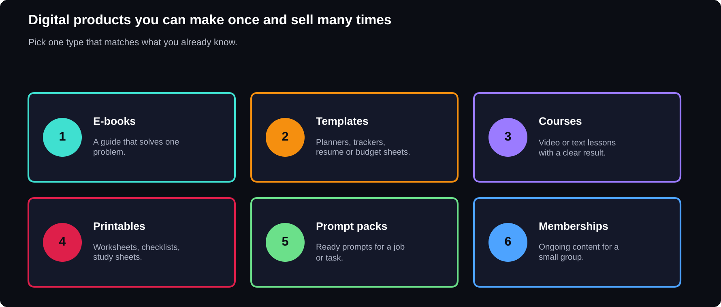
Six kinds of digital products
Start with the one that matches what you already know.

Why digital products suit beginners
There is no stock to store, no shipping to manage and no minimum order. You create the product, set up delivery and spend your time on improving it and finding customers. The trade-off is that many people sell similar products, so clear focus and quality matter.
1
product, made well, beats a store full of weak ones
Pick a topic people need
Choose a topic with a real, repeating need: exam preparation, job skills, productivity, a hobby, a language or a tool. Search the topic on marketplaces and social media. If similar products sell, there is demand. Then find an angle: a narrower audience, a clearer format or a more practical approach.
Create the product
1 Write the result: what can the buyer do after using it?
2 Outline the product in 8 to 12 parts
3 Draft quickly, then edit twice
4 Add visuals, examples and a checklist
5 Export as a clean PDF or file
6 Test it with 3 people and fix what they stumble on
QUALITY RULE
Do the work that makes it feel complete: consistent fonts, clear headings, no typos, and real examples. Buyers cannot touch a digital product, so the care shows in the pages.

Package and describe it
Give it a clear title that says who it is for and what it gives. Make a cover that is readable at thumbnail size. Write a short description: the problem, what is inside, who it suits and how it is delivered. Use honest words, and do not promise results you cannot control.
Where to sell
You can sell through a marketplace, through your own store or page, or directly through social media and messages. Marketplaces bring ready traffic but have their own rules. Your own page gives more control but needs you to bring the visitors. Many creators begin on a marketplace and add their own page later.
Deliver and support
Deliver instantly where you can: a download link after payment. Add a short “how to use this” note, and a contact for questions. Fast, friendly replies earn reviews, and reviews bring the next customers.
RESPECT OTHERS' WORK
Only sell what you created or have the right to sell. Do not copy other authors' text, images or templates. Original work protects you and your reputation.

Grow with a product ladder
Once one product sells, build around it: a free sample to attract readers, the main product, a companion template or checklist, and later a bundle or course. Each step serves the same customer a little further.

CHAPTER 4
Building a Personal Brand
Your personal brand is what people think of when they hear your name. You already have one, whether you plan it or not. Building it on purpose means choosing what you want to be known for, and showing it consistently.
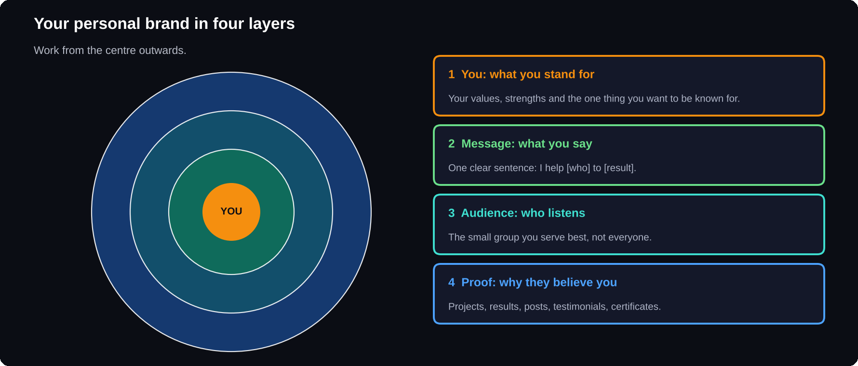
Four layers of a brand
Start from you, then message, audience and proof.

What a personal brand is
A personal brand is a clear promise plus the proof that you keep it. It helps a recruiter remember you, a customer trust you and a collaborator choose you. It is not fame, and it is not pretending. It is being clear about who you are and what you offer.
1
sentence can hold your brand: “I help [who] to [result].”
Start with you
List your strengths, values and interests. Ask three people who know you what they would come to you for. Look for the overlap between what you enjoy, what you are good at and what others need. That overlap is where a brand can grow.
Write your message
FORMULA
I help [specific people] to [get a specific result] by [your way of doing it].

EXAMPLE (MADE UP)
I help final-year students write resumes that get shortlisted, using simple step-by-step guides.

Pick your audience
Speak to one group first. A brand that tries to please everyone is remembered by no one. Describe your reader in a sentence, and write each post as if for that person.
Show proof
Proof is what turns claims into trust: projects you built, results you achieved, certificates that matter, testimonials, screenshots and honest lessons from mistakes. Show your work in progress. People like to follow someone who is learning in public.
Choose your platforms
1 LinkedIn: for jobs, professional credibility and B2B
2 Instagram and YouTube: for reach and showing personality
3 GitHub or a portfolio: for technical and creative work
4 A newsletter or blog: for depth and a direct audience
Pick one main platform, and use the others to point back to it. Use the same photo, name and bio everywhere so that people can recognise you.
A simple weekly routine
1 Share one useful post: a tip, a lesson or a small win
2 Comment thoughtfully on three other people's posts
3 Reply to every message and comment you receive
4 Once a month, review what people reacted to and do more of it
DID YOU KNOW?
Consistency matters more than perfect posts. Showing up weekly for six months builds more trust than a burst of posts followed by silence.

Protect your reputation
Be honest, credit others, and avoid arguments you cannot win. Remember that what you post stays visible. Check your public profiles as an employer or customer would, and tidy anything that does not fit the person you want to be known as.

CHAPTER 5
Small Business Marketing Strategies
Marketing is not shouting louder. It is helping the right people find you, understand you and feel safe choosing you. A small business wins by being specific and consistent, not by copying big brands.
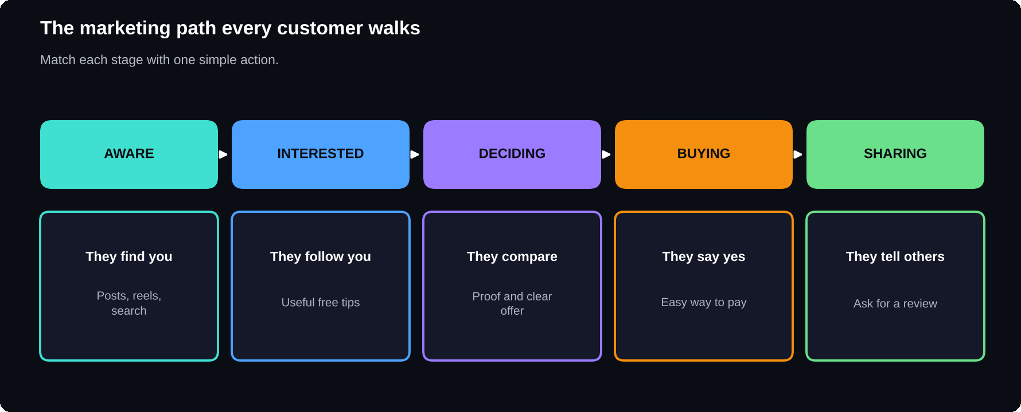
The customer path
Know where each person is, and give them the next helpful step.

Know your customer first
Write a short customer profile: who they are, what they want, what worries them and where they spend time online. Use their own words in your posts and pages. The better you understand one customer, the easier every marketing choice becomes.
5
stages from stranger to fan: aware, interested, deciding, buying, sharing
Say what you offer in one line
Your positioning is the clear sentence about what you do, for whom, and why you are the right choice. Put it at the top of your profile, page and product description. If a stranger cannot repeat it after five seconds, simplify it.
Content that attracts
Share what your customers find useful: how-to tips, short guides, checklists, behind-the-scenes, before-and-after examples and answers to common questions. Aim for roughly three parts helpful for every one part promotional.
1 Pick 3 topics your customers care about
2 Make short posts or reels on each, every week
3 End with one clear next step: follow, save, message or visit
4 Repeat what works. Drop what does not
Social media and search
Social platforms help people discover you. Search helps people who already want a solution. Use clear titles and descriptions with the words customers actually type. Add a profile link and a clear call to action to everything.
Email and messages
An email list or a WhatsApp or Telegram community is an audience you own. Offer something useful in exchange for a sign-up, such as a checklist or a short guide, and then send helpful updates. Keep promotions occasional and honest.
PERMISSION FIRST
Only message people who agreed to hear from you. Follow the rules of each platform and your country's rules on marketing messages.

Paid ads: only after it works
Paid ads multiply what already works, and they also multiply what does not. Start with a small test budget, a single clear offer and one audience. Track what each sale costs you. If the numbers are healthy, increase slowly.
Offers, reviews and referrals
Happy customers are your best marketing. Ask for a review right after a good result. Share real testimonials, with permission. A simple referral thank-you can turn one customer into three.
Measure and improve
Each week, note four numbers: how many saw it, how many reacted, how many clicked and how many bought. Do more of what moves them.

CHAPTER 6
How to Build a Business with AI
AI tools can draft, summarise, brainstorm and answer questions in seconds. Used well, they let one person do the work of a small team. Used carelessly, they produce generic, wrong or risky output. This chapter shows how to stay in charge.
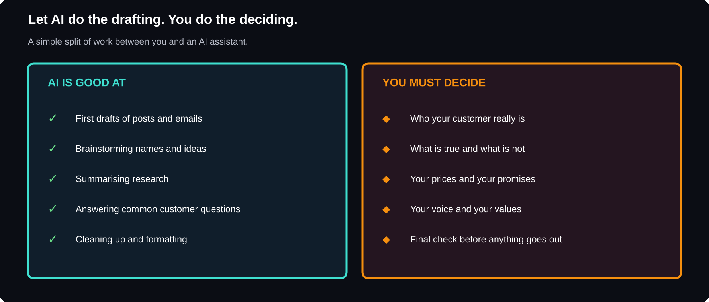
AI drafts, you decide
Hand over the repeatable work. Keep the judgment, the facts and the final check.

Where AI helps most
AI works best on tasks that are repeated, wordy or need a first draft. In a small business that means research summaries, content ideas, product descriptions, customer replies, simple spreadsheets and code snippets. It saves time on the first 70% so that you can spend your attention on the final 30%.
5
areas to start: research, content, customer support, operations and learning
Step by step: use AI to start a business
1 Brainstorm: ask for 20 problems in your niche, then pick 3 to check with real people
2 Research: ask for a summary of how others solve it, then verify the facts yourself
3 Plan: ask for a draft of the one-page blueprint and edit it
4 Create: draft your product or offer, then rewrite it in your voice
5 Market: draft posts, emails and replies, then check tone and facts
6 Improve: paste customer feedback and ask for patterns
A GOOD PROMPT HAS FIVE PARTS
Task, role, audience, context and format. Example: “Act as a marketing coach. Write 5 Instagram post ideas for final-year students who need resume help. Short, friendly, with a call to action.”

Keep the human parts human
Your customers pick you for your judgment, honesty and care. Decide your prices, promises and values yourself. Add real stories and examples that only you have. Read every output aloud, and rewrite anything that does not sound like you.
Check before you trust
AI can state wrong facts with confidence, invent sources and repeat old information. Check names, numbers, dates, laws and claims against an original source before you publish or act on them. Never paste private customer data or passwords into an AI tool unless you know how that tool handles data.
SAFE USE RULES
1. Verify facts. 2. Protect private data. 3. Do not pass off AI text as expert advice. 4. Respect copyright and platform rules. 5. Tell customers when AI is part of a service if it matters to them.

Automate the boring work
Once a task repeats, ask whether it can be automated: auto-replies to common questions, a form that sends orders to a sheet, scheduled posts, or templates for quotes. Start with one small automation and keep a person ready to step in.
Stand out when everyone has AI
Because anyone can generate text, generic content is cheap. What stays valuable is a clear point of view, real experience, original examples, speed in replying and honest care for the customer. Use AI to create more time for those things.

A TO Z
Glossary
Fifteen words every new founder meets.

Audience
The group of people you want to reach and serve.
Brand
What people think of when they hear your name, and the promise you keep.
Call to action
A clear next step you ask people to take, such as follow or buy.
Channel
A place where you reach customers, such as Instagram or email.
Customer profile
A short description of your ideal customer and their needs.
Digital product
A product delivered as a file or online access, such as an e-book.
Funnel
The path from stranger to customer.
MVP
Minimum viable product: the smallest version that delivers the result.
Niche
A narrow, specific part of a market that you serve well.
Positioning
The clear sentence about what you do and why you are different.
Prompt
The instruction you give an AI tool.
Revenue
The money that comes in from sales.
Startup
A young business searching for a model that works.
Testimonial
A real customer's words about their result.
Value proposition
The promise of what the customer gets and why it matters.

THE LAST WORD
Start small
Every business you admire began with one idea, one customer and one small step. Pick the chapter you need today, do the first action and keep going.

Good luck with your first launch. If this book helped you, please leave a review on the store where you bought it.
NOTES
General guidance, not professional advice
Rules on registration, tax, consumer protection and advertising differ by country and change over time. Check current local rules or ask a qualified adviser before you launch.
Examples are made up
The sample ideas, customers and numbers in this book are illustrations. Test your own idea with real people.

