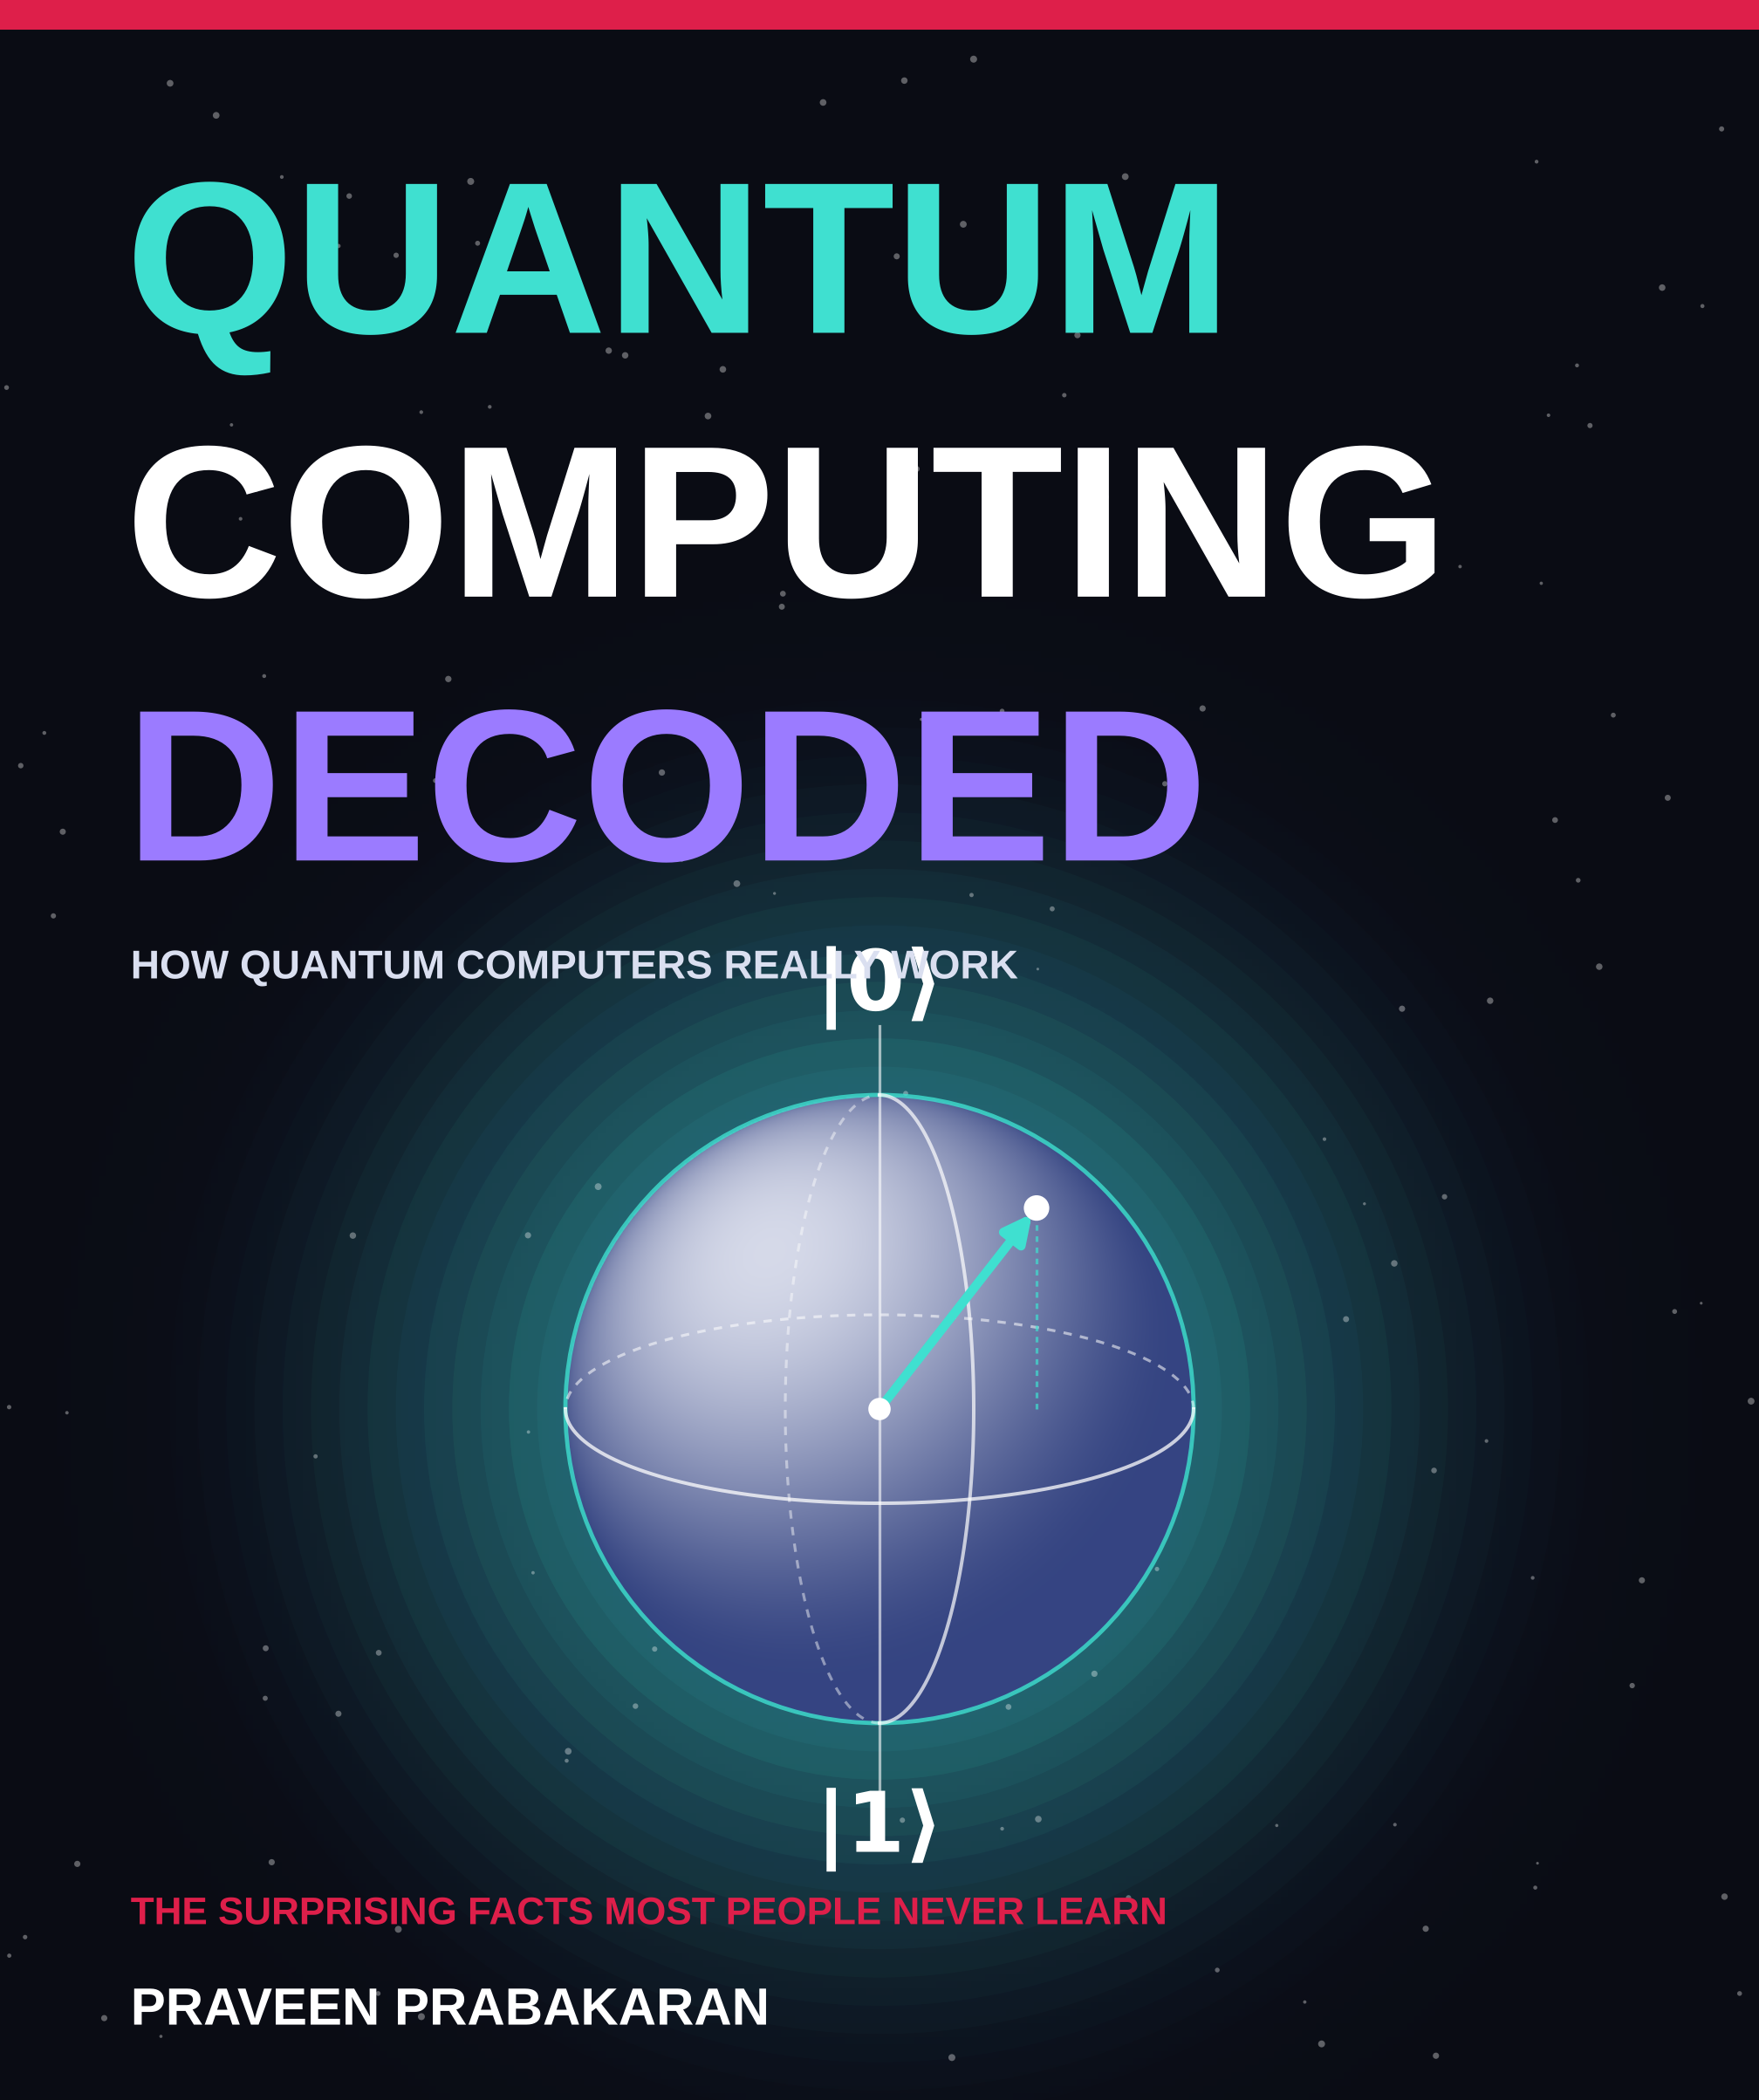

ABOUT THIS EDITION
Quantum Computing Decoded
The Visual Edition
A picture-led guide to the strange physics, real machines and surprising facts of quantum computing.
Written and designed by Praveen Prabakaran
© Praveen Prabakaran. All rights reserved.
All illustrations were created for this book. The layout follows the clean, image-led encyclopedia style of a red running header, three text columns, captioned pictures and big-number facts; no text or artwork from any other publication is used.
Facts, figures and dates are current to mid-2026. Quantum computing moves fast; check the sources at the back of the book for the latest news. Charts marked as illustrations show a trend, not measured data.

CONTENTS
What is inside
01 Why It Matters 4
What a quantum computer is, and what it is not
02 A Short History 5
From Feynman's 1981 idea to cloud quantum computers
03 Qubits 6
Superposition, measurement and the Bloch sphere
04 Entanglement 7
Spooky links and wave interference
05 Gates and Circuits 8
The building blocks of every quantum program
06 Building Qubits 9
Six technologies, one race, and a very cold fridge
07 Algorithms 10
Shor, Grover, simulation and hybrid methods
08 Noise and Errors 11
Why qubits fail, and how error correction fights back
09 Quantum in 2026 12
Milestones, claims and the race to fault tolerance
10 Cryptography 13
Why the internet is switching to quantum-safe encryption
11 India's Quantum Push 14
The National Quantum Mission and India's quantum machines
12 30 Surprising Facts 15
Strange physics, remarkable machines and surprising history
13 Start Learning 16
Your first quantum program and a 4-week plan
A–Z Glossary 17
Twenty key terms in one line each
→ Sources 18
Where the facts come from

CHAPTER 1
Why It Matters
A quantum computer is not a faster laptop. It is a different kind of machine that uses the rules of quantum physics to tackle problems that would keep an ordinary computer busy for longer than the age of the universe.
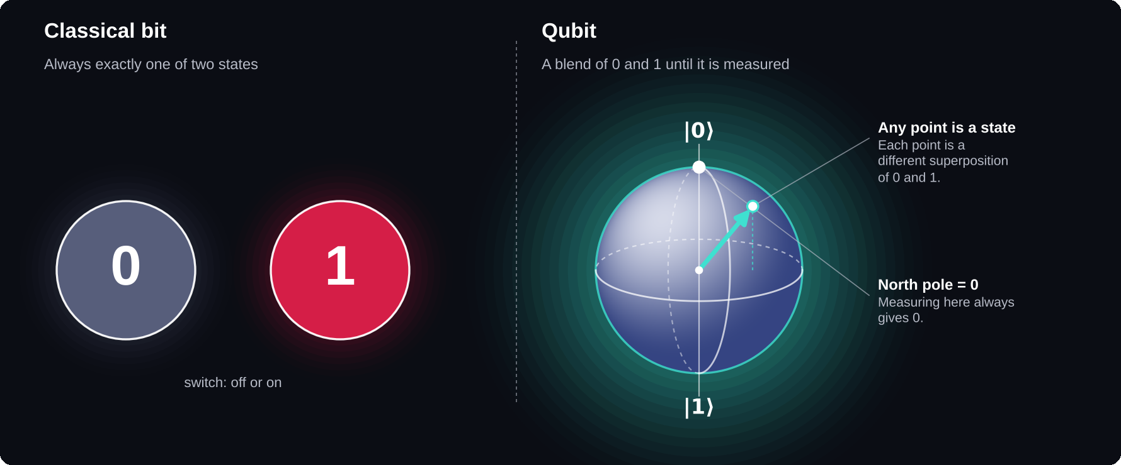
Bit versus qubit
A bit is one of two states. A qubit can sit anywhere on a sphere of blends of 0 and 1 until it is measured.

The limits of ordinary computers
Every computer you have used stores information in bits that are either 0 or 1. That works brilliantly for most jobs. But some problems grow so fast that no classical machine can keep up: simulating molecules, breaking certain codes and searching vast numbers of possibilities. Tracking just 50 interacting electrons exactly would need more numbers than any classical computer could store.
1981
the year Richard Feynman proposed using a quantum machine to simulate nature
Three strange ingredients
Superposition lets a qubit hold a blend of 0 and 1. Entanglement links qubits into one shared system. Interference makes wrong answers cancel and right answers grow. Take away any one of them, and the quantum advantage disappears.
Myth: it tries every answer at once
A quantum computer works with many possibilities together, but a measurement returns just one answer. The art of quantum programming is arranging interference so that the right answer is the likely one.
DID YOU KNOW?
The word “quantum” means “how much” in Latin. Physicists chose it because energy in the tiny world comes in fixed little packets, called quanta, rather than flowing smoothly.

Myth: it will replace your laptop
For most everyday tasks a quantum computer would be slower and far more expensive than the phone in your pocket. These are specialist machines, usually reached over the cloud and used alongside classical computers.

CHAPTER 2
A Short History
In 1981 it was a thought experiment. By 2016 anyone with a browser could run a real quantum program. The story is a handful of big ideas, followed by a long engineering struggle that is still going on.
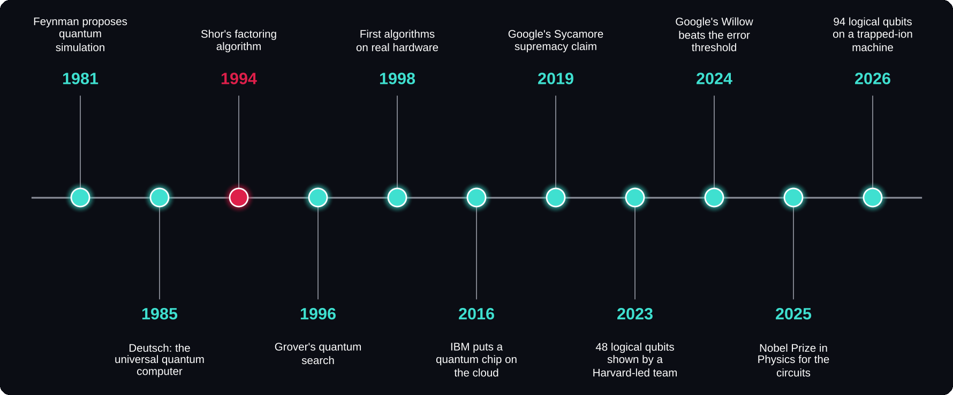
Quantum computing, 1981 to 2026
The 1994 breakthrough, Peter Shor's factoring algorithm, is marked in red because it turned a curiosity into a race.

1981–1996: the ideas
Richard Feynman argued in 1981 that simulating quantum systems on ordinary computers gets exponentially harder as the systems grow. In 1985 David Deutsch described a universal quantum computer. In 1994 Peter Shor found an algorithm that could factor huge numbers efficiently, and governments suddenly paid attention. In 1996 Lov Grover added a fast quantum search.
1998–2016: the first real qubits
The first quantum algorithms on real hardware ran in 1998 on tiny two-qubit machines made from molecules, controlled with the same physics as hospital MRI scanners. In 2016 IBM put a small quantum processor on the cloud, so anyone could run real quantum experiments for free.
40
years between the experiments of 1984–85 and the 2025 Nobel Prize that honoured them
2019–2026: the race
Google's 53-qubit Sycamore claimed quantum supremacy in 2019, a claim rivals challenged within weeks. In 2023 a Harvard-led team demonstrated 48 logical qubits. In 2024 Google's Willow chip showed error correction improving as it scaled up. In 2026 Quantinuum ran computations with up to 94 error-protected logical qubits.
DID YOU KNOW?
The 2025 Nobel Prize in Physics went to John Clarke, Michel Devoret and John Martinis for experiments from 1984 and 1985. They showed that an electrical circuit big enough to hold in your hand can behave like a single quantum particle. That discovery underpins the superconducting qubits used by Google and IBM.

Supremacy claims get challenged
IBM disputed Google's 2019 estimate within weeks, and in 2022 researchers showed the task could be done in hours on classical hardware. Classical computers keep getting better at fighting back, so the real goal is now reliability, not record-breaking.

CHAPTER 3
Qubits
A bit is 0 or 1. A qubit can be a precise blend of both, until you look. Measuring forces it to choose, and the blend is gone.
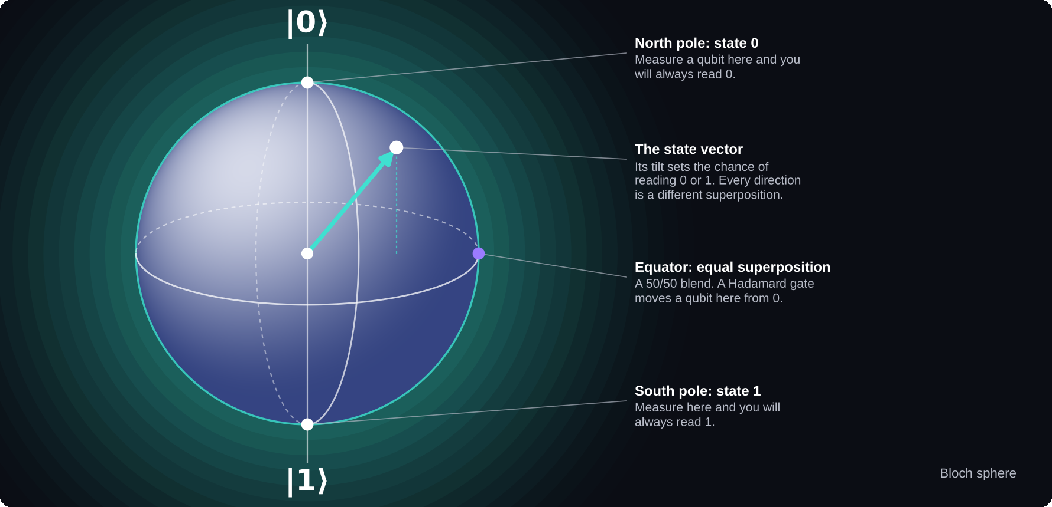
The Bloch sphere
Physicists picture one qubit as a point on a globe. Its position sets the chance of reading 0 or 1.

Amplitudes, not coin flips
A qubit holds two numbers called amplitudes, one for 0 and one for 1. Measuring gives each result with a probability equal to the square of its amplitude. Unlike probabilities, amplitudes can be negative, so they can cancel each other out. That cancelling is where quantum power comes from.
2ⁿ
amplitudes needed to describe n qubits: every extra qubit doubles the space
The Bloch sphere
The North Pole is 0, the South Pole is 1, and every other point on the surface is a different superposition. One qubit has infinitely many possible states, yet measuring it still gives just one bit of information.
Measurement is final
Measuring is not peeking at a hidden value. The superposition collapses to 0 or 1 and is gone. So you cannot read out everything a quantum computer holds; algorithms must be designed so the right answer is very likely.
≈ 1 quadrillion
amplitudes needed to describe just 50 qubits, enough to strain the largest supercomputers
THE NO-CLONING RULE
Proved in 1982, it says an unknown quantum state can never be copied perfectly. It sounds like a limitation, but it is why quantum messages can reveal an eavesdropper: anyone who tries to copy the message disturbs it.

CHAPTER 4
Entanglement
Two ideas turn fragile qubits into a powerful machine: entanglement, which links them into one system, and interference, which steers them towards the right answer.
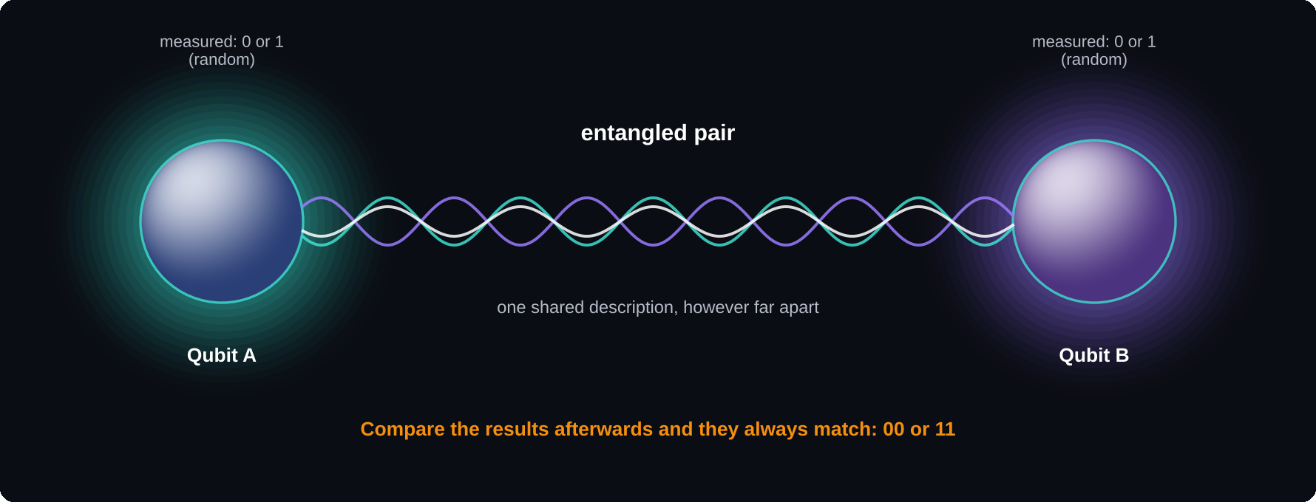
An entangled pair
Measured alone, each qubit gives a random result. Compared afterwards, the two always agree.

Entanglement: one shared story
Entangled qubits have no separate descriptions, only a shared one. Measure a Bell pair and each qubit alone gives a random 0 or 1, but the two results always match, even if the qubits were carried to opposite sides of the Earth first.
No faster-than-light messages
Each side's result is random, so neither can control what the other sees. The matching pattern appears only when both sides compare notes over an ordinary channel, such as a phone call.
DID YOU KNOW?
Albert Einstein disliked entanglement so much that he called it “spooky action at a distance”. Experiments proved him wrong, and the 2022 Nobel Prize in Physics went to Alain Aspect, John Clauser and Anton Zeilinger for them.

1,200+ km
separation between the ground stations that received entangled photons from China's Micius satellite in 2017
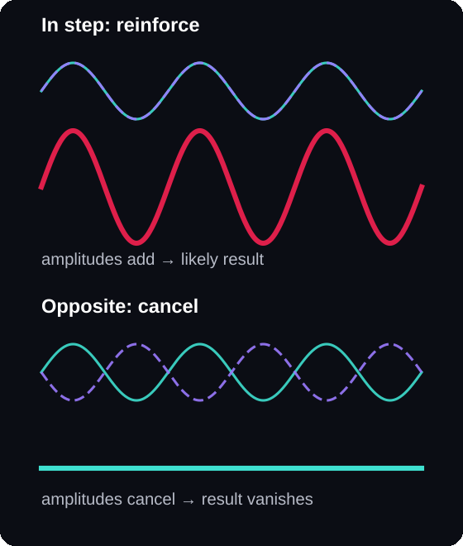
Interference
Waves in step add up. Waves in opposite step cancel, as in noise-cancelling headphones.
Interference: cancelling wrong answers
When two paths lead to the same result, their amplitudes add. Positive with positive reinforces; positive with negative cancels. Every useful quantum algorithm is a designed pattern of interference that cancels the paths to wrong answers and strengthens the path to the right one.
The three ideas together
Superposition spreads the computation across many possibilities. Entanglement connects the qubits so they explore them as one system. Interference focuses the result onto the correct answer before you measure.

CHAPTER 5
Gates and Circuits
A quantum program is a circuit: a sequence of gates applied to qubits, followed by a measurement. Gates rotate amplitudes instead of flipping fixed values.
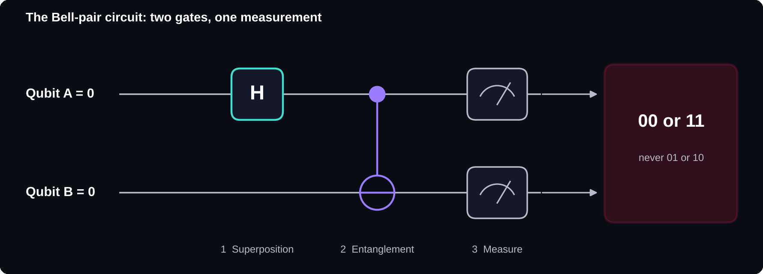
Your first circuit
A Hadamard gate and a CNOT gate turn two qubits that start at 0 into an entangled pair.

The gates to know
The X gate swaps 0 and 1, like a classical NOT. The Hadamard (H) gate turns 0 or 1 into an equal superposition. The Z gate flips the sign of the 1 amplitude. The CNOT gate flips a target qubit only if the control qubit is 1, and it is what creates entanglement.
2
gates are all it takes to entangle two qubits: H, then CNOT
Making a Bell pair
Apply H to the first qubit, apply CNOT with the first as control and the second as target, then measure both. The result is always 00 or 11, each about half the time, and never 01 or 10.
Reading a circuit diagram
Each horizontal line is one qubit and time flows left to right. A dot joined by a vertical line to a ⊕ symbol is a CNOT: the dot is the control, the ⊕ the target. A meter symbol at the end is a measurement.
DID YOU KNOW?
Just three gates, H, T and CNOT, are enough to build any quantum computation to any accuracy you want. Every gate is also reversible; only measurement cannot be undone.

CHAPTER 6
Building Qubits
There is no single way to build a qubit. At least six technologies are in the race, and nobody knows yet which will win. Each trades speed, accuracy and ease of scaling in a different way.
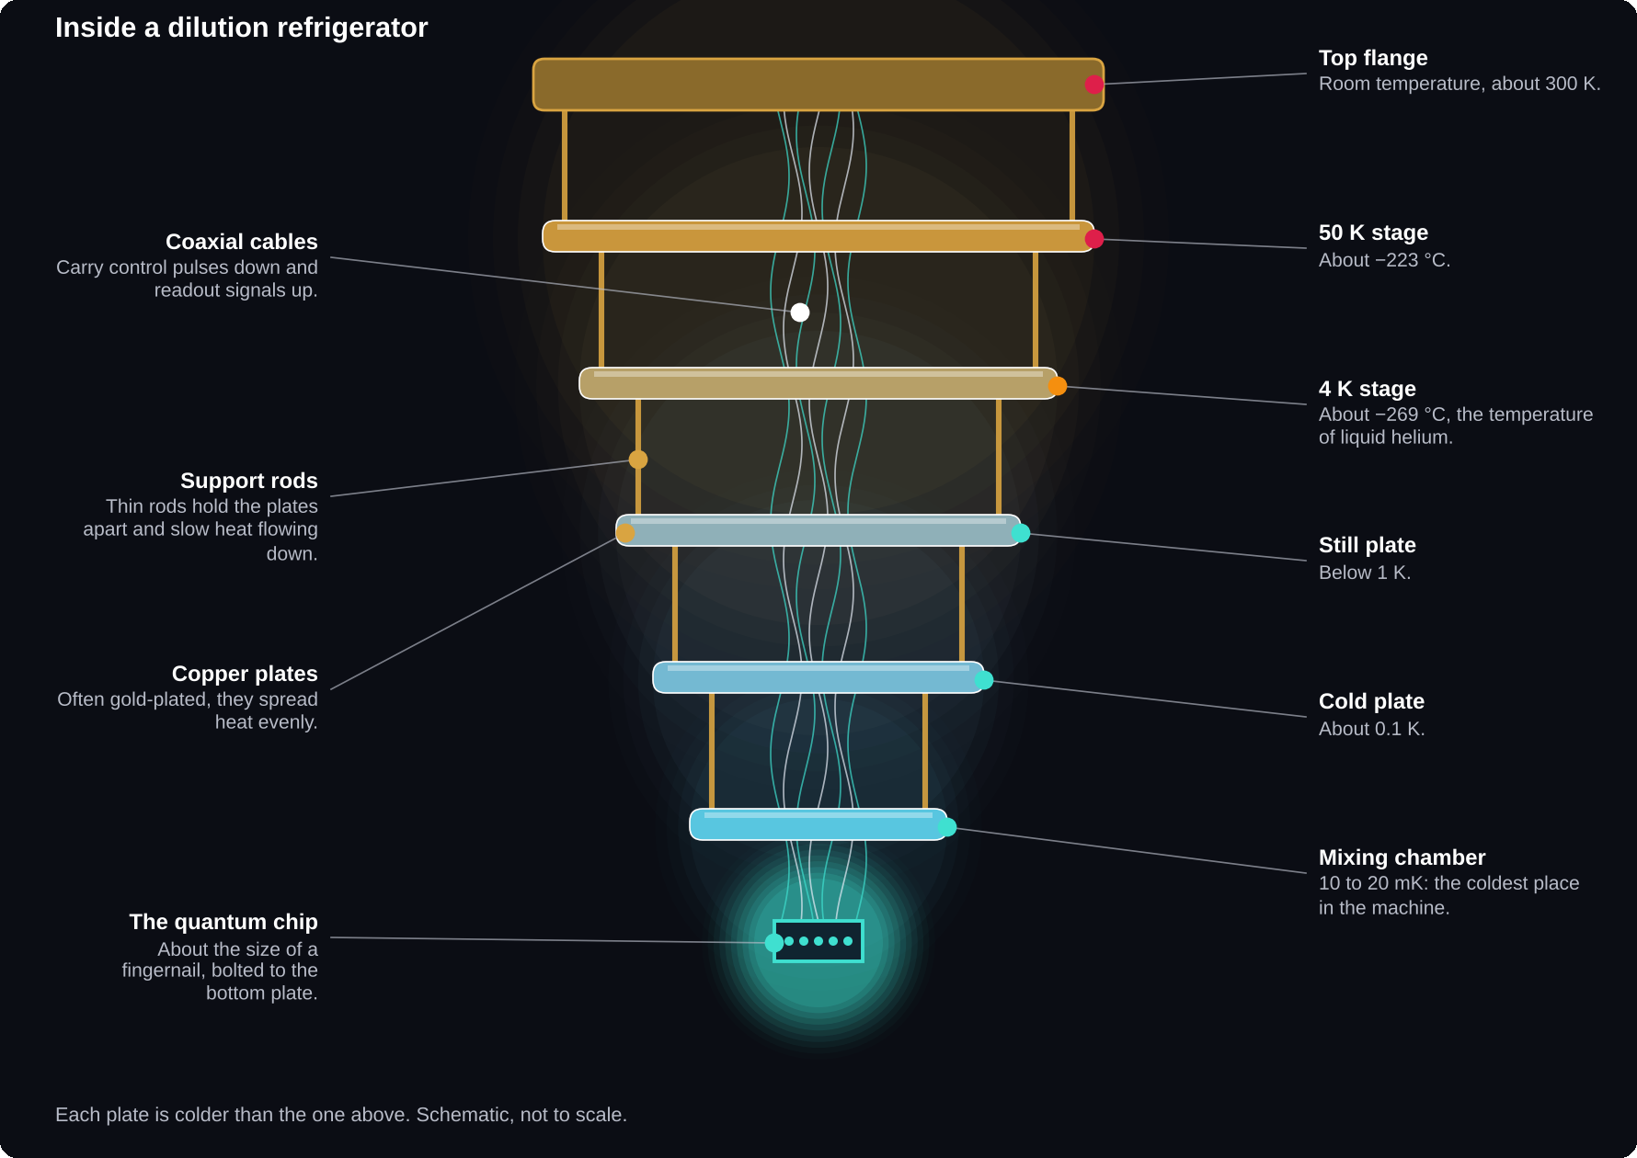
Inside a dilution refrigerator
The famous golden “chandelier” is the cooling system, not the computer. The chip sits at the very bottom.

Superconducting circuits
Tiny loops of metal cooled until they have zero electrical resistance. Gates are very fast and the chips are made with chip-factory methods, but the qubits are noisy and must be kept near absolute zero. Used by IBM, Google, Rigetti and India's QpiAI.
Trapped ions
Single charged atoms held in place by electric fields. They are extremely accurate and any qubit can talk to any other, but gates are slower. Quantinuum's Helios, launched in November 2025, holds 98 barium-ion qubits. IonQ also uses ions.
10–20 mK
operating temperature of a superconducting chip, colder than outer space at 2.7 K
Neutral atoms and photons
Neutral-atom machines hold uncharged atoms with laser beams called optical tweezers, so hundreds can be arranged in flexible patterns (QuEra, Pasqal, Atom Computing). Photonic machines use particles of light on optical chips, which travel far without heating anything but rarely interact (PsiQuantum, Xanadu).
Spin and topological qubits
Silicon spin qubits store information in the spin of a single electron and could reuse today's chip factories. Topological qubits, pursued by Microsoft, promise built-in protection from errors but have not yet been clearly demonstrated.
DID YOU KNOW?
The coldest stages of these fridges rely on helium-3, a rare form of helium that barely exists naturally. Much of it comes from the decay of tritium used in nuclear weapons programmes, so supply is limited and expensive.

COLOUR OF LIGHT, COST OF A COMPUTER
Quantinuum switched from ytterbium to barium ions partly because barium works with visible-light lasers instead of expensive ultraviolet ones.

CHAPTER 7
Algorithms
Only a few kinds of problems have a proven big quantum speed-up. Knowing which ones is the best defence against hype.
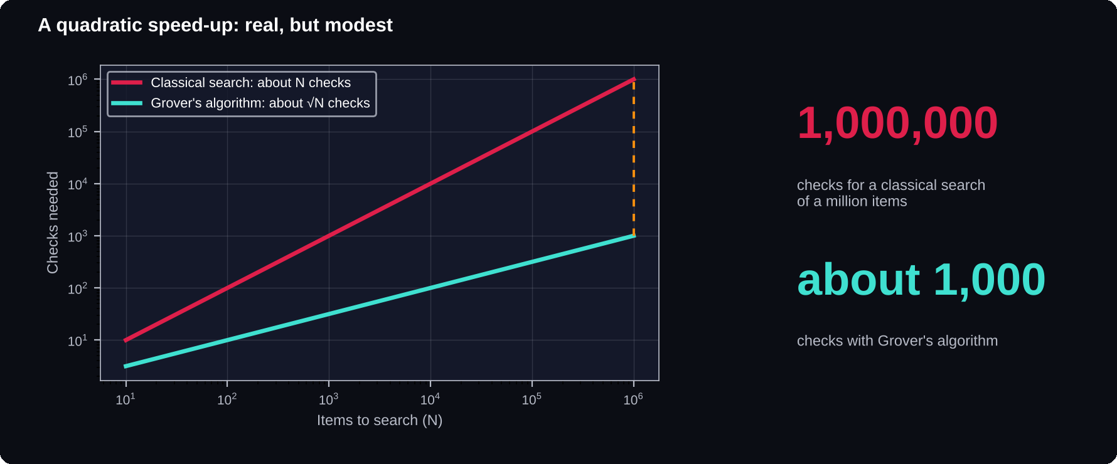
Grover's quadratic speed-up
Searching a million unsorted items needs about a million checks classically, but only about a thousand with Grover's algorithm.

Shor's algorithm (1994)
Shor's trick turns factoring into finding a hidden repeating pattern, which a quantum computer can do using interference in a step called the quantum Fourier transform. It would break RSA encryption, but only on large, error-corrected machines that do not exist yet.
< 1 million
noisy qubits that could break RSA-2048 in under a week, according to a 2025 estimate by Google's Craig Gidney: about 20 times fewer than his 2019 estimate
Grover's algorithm (1996)
A search that takes N steps classically takes about √N steps with Grover's algorithm. That is a quadratic speed-up, real but modest, and it is proven to be the best possible. Because today's quantum operations are slow and error-prone, it only wins on very large problems run on very good machines.
Quantum simulation
Feynman's dream, and the most promising early use. Simulating how electrons behave in molecules could lead to better fertilisers (making ammonia uses an estimated 1–2% of the world's energy), new medicines, and better batteries and solar cells.
Hybrid algorithms
Today's machines are too noisy for long circuits. Hybrid methods such as VQE and QAOA let a quantum chip run short circuits while a classical computer tunes the settings in a loop. Researchers are still testing whether they beat the best classical methods on real problems.
DID YOU KNOW?
In 2001, IBM researchers factored the number 15 using Shor's algorithm on a 7-qubit machine built from molecules. The algorithm works; the machines just are not big and reliable enough yet.

CHAPTER 8
Noise and Errors
The biggest obstacle in quantum computing is not building qubits. It is keeping them from making mistakes. The answer, quantum error correction, finally began to work in 2024.
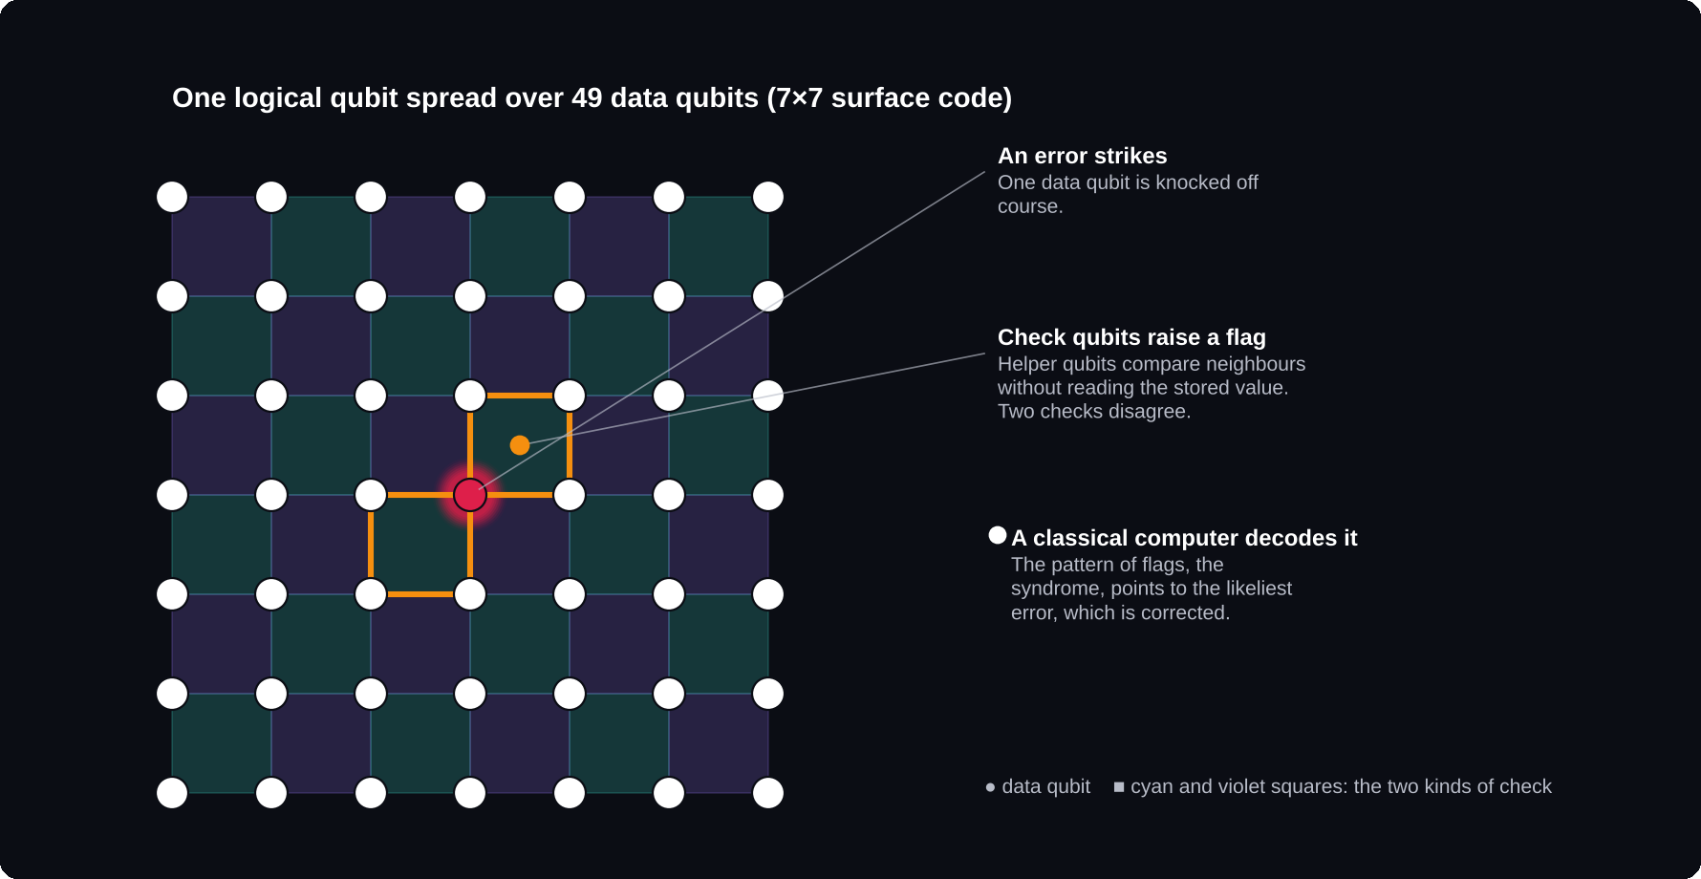
Catching an error
One logical qubit is spread across many physical qubits, and helper qubits flag mistakes without reading the stored value.

Decoherence
A qubit's superposition survives only while nothing in the environment “notices” it. Heat, vibration or a stray electromagnetic wave can destroy it. Today's best two-qubit gates succeed about 99.9% of the time, yet a useful algorithm may need billions of steps.
The NISQ era
In 2018 John Preskill named today's period the NISQ era: Noisy Intermediate-Scale Quantum. It describes machines with tens to hundreds of qubits that are too noisy for full error correction. Most quantum computers you can use today are NISQ machines.
Check without looking
Quantum data cannot be copied or read directly. So one logical qubit is spread across many physical qubits. Helper qubits measure relationships between them, such as “are these two the same?”, and a classical computer decodes the pattern, called the syndrome, and corrects the error, thousands of times a second.
÷ 2
roughly how much Google's logical error rate fell each time its code grew from 3×3 to 5×5 to 7×7 (December 2024)
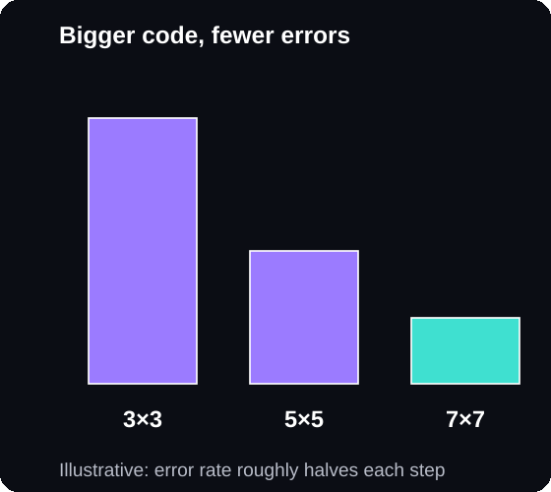
Below the threshold
Bigger codes mean fewer errors, but only when the physical qubits are good enough.
The threshold
Error correction only helps if the physical qubits are already good enough. Above a critical error rate, adding qubits adds more mistakes than it fixes. Below it, every increase in code size makes the logical qubit more reliable. Willow was the first convincing demonstration of crossing below it.
Physical versus logical
A logical qubit may need dozens to thousands of physical qubits, depending on the code and target accuracy. So a machine with 1,000 physical qubits might offer only a handful of high-quality logical ones.
DID YOU KNOW?
In 2021, Google researchers found that cosmic rays and natural radioactivity can hit a superconducting chip and cause bursts of errors across many qubits at once. Some future machines may need shielding, or even to be built underground.

CHAPTER 9
Quantum in 2026
In 2026 quantum computers are real, improving fast and available over the cloud, but they do not yet beat classical computers on everyday commercial problems. The yardstick has shifted from physical qubits to reliable logical qubits.
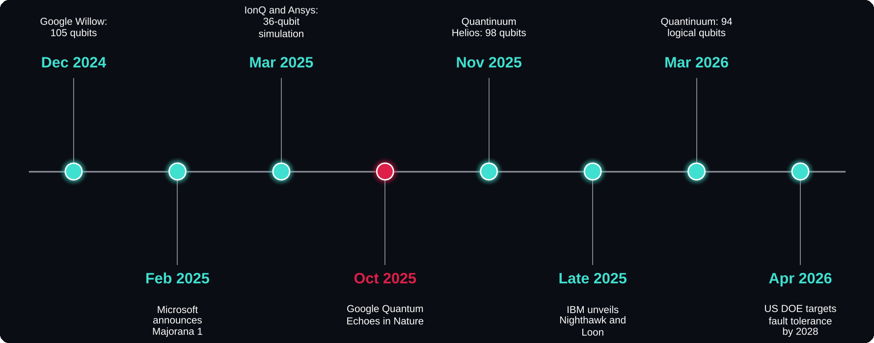
Milestones, December 2024 to April 2026
Google's October 2025 “Quantum Echoes” result is marked in red as the first widely discussed verifiable speed-up.

Dec 2024 · Google Willow
A 105-qubit chip that showed error correction improving as the code grew, a long-awaited milestone.
Feb 2025 · Microsoft Majorana 1
Announced as the first chip with topological qubits. Many physicists remain unconvinced that it has shown a working topological qubit.
Mar 2025 · IonQ and Ansys
A 36-qubit fluid-flow simulation for a medical device ran about 12% faster than classical computing, according to the companies.
Oct 2025 · Google Quantum Echoes
Published in Nature. Using 65 of Willow's qubits, a calculation ran about 13,000 times faster than on the Frontier supercomputer, and another quantum computer can check the result.
13,000×
the speed-up Google claimed for Quantum Echoes on 65 of Willow's 105 qubits
Nov 2025 · Quantinuum Helios
98 barium-ion qubits, 99.921% two-qubit accuracy and 48 fully error-corrected logical qubits.
Late 2025 · IBM Nighthawk and Loon
A 120-qubit Nighthawk chip and an experimental Loon chip testing the parts needed for fault tolerance. IBM targets fault-tolerant processors in 2029.
Mar 2026 · Quantinuum
Computations with up to 94 error-protected logical qubits. The method is only partly fault-tolerant: it detects errors and discards runs where they occur.
Apr 2026 · US Department of Energy
Announced a Grand Challenge aiming for a first fault-tolerant quantum computer by 2028.
WHAT IS QUANTUM ADVANTAGE?
It means a quantum computer doing something useful faster, cheaper or better than the best classical method. Every claim is challenged: classical computers fight back, many tasks are chosen only to show off the hardware, and “faster” depends on what you compare against. IBM aims for advantage on at least one practical problem by the end of 2026, so check the latest news.

DID YOU KNOW?
The United Nations declared 2025 the International Year of Quantum Science and Technology, marking 100 years since the birth of quantum mechanics.

CHAPTER 10
Cryptography
A large error-corrected quantum computer could break the encryption that protects most of the internet. None exists yet, but the world is already switching to post-quantum cryptography.
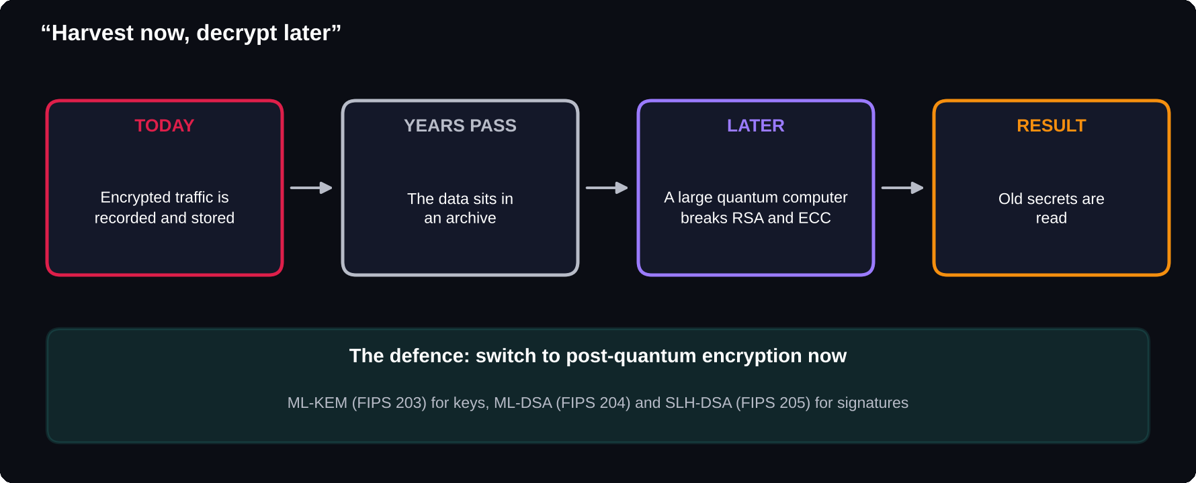
Harvest now, decrypt later
Data encrypted today can be recorded and stored until a quantum computer is ready, so long-lived secrets need protecting now.

What is at risk, and what is not
RSA and elliptic-curve encryption, used for secure websites, digital signatures and crypto wallets, would be broken by Shor's algorithm. Symmetric ciphers such as AES-256 are only weakened and remain safe. Hash functions such as SHA-256 are only mildly affected.
The new standards
In August 2024 the US National Institute of Standards and Technology published three standards: FIPS 203 (ML-KEM) for agreeing secret keys, and FIPS 204 (ML-DSA) and FIPS 205 (SLH-DSA) for digital signatures. HQC and FN-DSA are being developed as extra options.
2030 / 2035
NIST's plan deprecates RSA and ECC after 2030 and disallows them after 2035
Lattices
The new methods mostly rely on lattice problems: finding the nearest point in a grid with hundreds of dimensions. Nobody knows an efficient way to solve them on classical or quantum computers.
Quantum key distribution
QKD uses quantum physics itself to share keys. Because measuring a quantum state disturbs it, an eavesdropper leaves detectable traces. It needs special hardware and dedicated fibre or satellite links, while post-quantum cryptography works on ordinary devices.
Q-DAY
The nickname for the day a quantum computer can break RSA-2048. Nobody knows when it will arrive. That uncertainty is exactly why the switch is happening now.

What developers should do
Do not write your own encryption; use maintained libraries that support the new standards. Learn the names ML-KEM and ML-DSA. And design systems so encryption methods can be swapped easily, an idea called crypto-agility.

CHAPTER 11
India's Quantum Push
India is investing seriously in quantum technology through its National Quantum Mission, and Indian startups have already built working quantum computers. For students, that means a growing number of research and job opportunities at home.
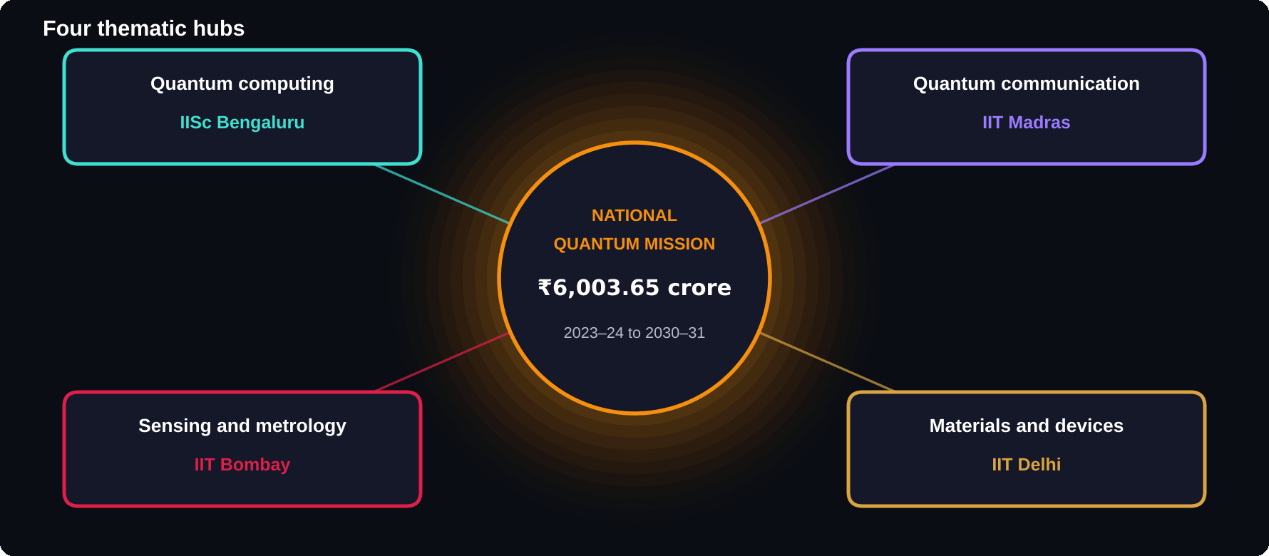
The National Quantum Mission
Four thematic hubs, each led by a leading institute, cover computing, communication, sensing and materials.

The mission
Approved on 19 April 2023 with a budget of ₹6,003.65 crore for 2023–24 to 2030–31. Ajai Chowdhry, co-founder of HCL, chairs the Mission Governing Board. Goals include quantum computers growing from 20–50 qubits towards 50–1,000 qubits, secure quantum communication, quantum sensors and new quantum materials.
₹6,003.65 crore
budget of the National Quantum Mission, 2023–24 to 2030–31
India's machines
In April 2025 QpiAI launched QpiAI-Indus, a 25-qubit superconducting system described as India's first full-stack quantum computer. In August 2024 TIFR Mumbai, with DRDO and TCS, completed testing of a 6-qubit processor. In November 2025 QpiAI announced Kaveri 64, a 64-qubit processor expected to be commercially available in late 2026.
Quantum communication
Also in November 2025, QNu Labs showed a quantum key distribution network tested over a 500 km fibre link with the Indian Army's Southern Command. In May 2025 IBM, TCS and the Andhra Pradesh government announced a partnership for a large quantum computer at the Quantum Valley Tech Park in Amaravati.
DID YOU KNOW?
India's link to quantum physics goes back a century. In 1924 Satyendra Nath Bose sent Albert Einstein a paper on the statistics of light particles, and every particle of the type called a boson is named after him.

Opportunities for students
Research projects and internships at the four hubs and institutes such as TIFR, IISER and C-DAC. Jobs in hardware, software and cryptography at startups like QpiAI and QNu Labs. Most quantum software roles need strong Python, linear algebra and problem-solving, not a physics PhD.
WORLD QUANTUM DAY
It falls on 14 April because 4.14 matches the first digits of Planck's constant, the most famous number in quantum physics.

CHAPTER 12
30 Surprising Facts
These are the facts that surprise people most, from strange physics to the engineering behind real machines.
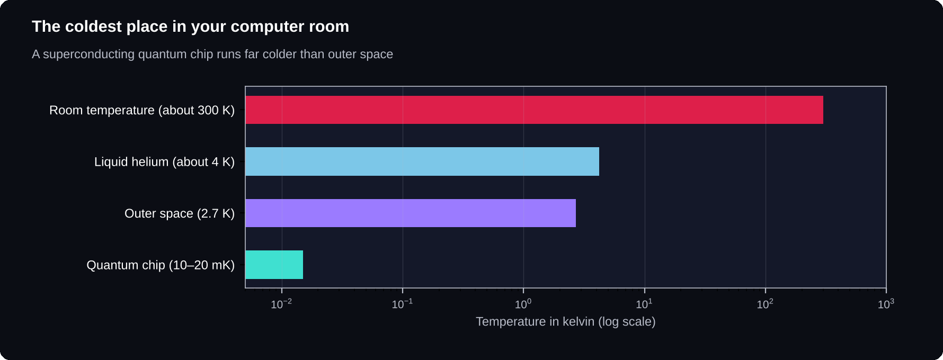
Colder than space
A superconducting quantum chip runs far colder than outer space, which sits at about 2.7 kelvin.

The strange basics
1 One qubit has infinitely many possible states, yet measuring it always gives just one bit.
2 n qubits can deliver at most n ordinary bits when read out, a limit called the Holevo bound.
3 Quantum mechanics needs complex numbers: experiments in 2021 and 2022 showed a version using only real numbers cannot match nature.
4 Quantum teleportation, first shown in 1997, moves a qubit's state, not matter, and needs an ordinary message too.
5 Schrödinger's cat (1935) was meant as a joke against quantum theory, to show how absurd superposition seems for big objects.
6 Quantum programs run thousands of times. Each run, a “shot”, gives one random result; the answer comes from counting.
7 Quantum computers can produce truly random numbers. Classical ones use formulas.
8 Most experts believe quantum computers cannot efficiently solve the hardest puzzle problems, the NP-complete ones.
The machines
9 The golden “chandelier” is a fridge. The chip at the bottom is about the size of a fingernail.
10 Superconducting qubits run at about 10 to 20 thousandths of a degree above absolute zero.
11 Cooling a dilution refrigerator can take a day or more.
12 Camera images of ion-trap computers show each atom as a tiny glowing dot.
13 Neutral-atom machines move atoms with optical tweezers; their inventor, Arthur Ashkin, won the 2018 Nobel Prize in Physics.
14 Cosmic rays can hit a chip and cause bursts of errors.
15 One reliable logical qubit may need hundreds of physical qubits or more.
16 Anyone can use a real quantum computer for free over the cloud; IBM opened access in 2016.
The history
17 Heisenberg's breakthrough paper appeared in 1925, which is why 2025 was the International Year of Quantum.
18 The word “qubit” was coined by Benjamin Schumacher in the early 1990s.
19 John Preskill introduced the term “quantum supremacy” in 2012.
20 The first quantum algorithms on real hardware (1998) used molecules in a liquid, with the same physics as an MRI scan.
21 The 2025 Nobel Prize rewarded experiments from 1984 and 1985, about 40 years earlier.
22 Google's Willow finished a benchmark in under five minutes that Google estimated would take a top supercomputer 10 septillion years. The task has no practical use.
23 Grover's √N speed-up is proven to be the best possible.
Security and the wider world
24 Your phone already depends on quantum physics: flash memory stores data by letting electrons tunnel through a barrier.
25 Bitcoin's signatures could be broken by Shor's algorithm, but its mining is much less affected.
26 Attackers may be saving your encrypted data today to decrypt it later.
27 In 2017 Austria and China held a video call secured with quantum keys sent via the Micius satellite.
28 Atomic clocks, a quantum technology, keep GPS in time; the best would lose less than a second in billions of years.
29 Every boson in the universe is named after the Indian physicist Satyendra Nath Bose.
30 World Quantum Day is 14 April because 4.14 matches the first digits of Planck's constant.

CHAPTER 13
Start Learning
You can write and run a real quantum program today, on a laptop, in about a dozen lines of Python. Then follow a four-week plan to keep going.

What you need first
Basic Python (variables, loops, functions). Linear algebra: vectors and matrices, because qubit states are vectors and gates are matrices. Complex numbers, because amplitudes are complex. And basic probability, because measurement results are probabilistic. You do not need a physics degree.
Your first quantum program
Install Qiskit, IBM's free, open-source toolkit, with pip install qiskit. Then run this program. It builds the Bell-pair circuit from Chapter 5, simulates it 1,000 times and counts the results.
from qiskit import QuantumCircuit
from qiskit.primitives import StatevectorSampler

qc = QuantumCircuit(2)
qc.h(0) # superposition
qc.cx(0, 1) # entangle
qc.measure_all()

sampler = StatevectorSampler()
run = sampler.run([qc], shots=1000)
print(run.result()[0].data.meas.get_counts())

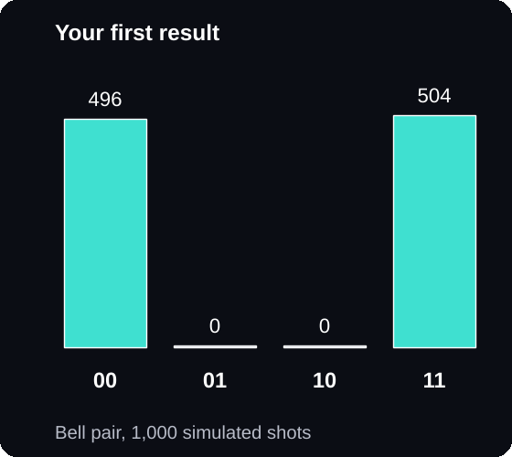
Your first result
The counts change slightly each run, but you will only ever see 00 and 11, never 01 or 10.
Try removing the qc.cx line: all four results appear, because the qubits are no longer linked. Then create a free IBM Quantum account and run the same circuit on real hardware; a few “wrong” answers will appear, which is noise.
Popular tools
Qiskit (IBM) is best for beginners and for IBM's real hardware. Cirq (Google) suits research-style circuits. PennyLane (Xanadu) is built for quantum machine learning. Q# and Azure Quantum (Microsoft) offer guided coding exercises.
Free resources
IBM Quantum Learning offers free courses using Qiskit and real hardware. NPTEL has quantum computing courses taught by IIT faculty. The classic textbook is Quantum Computation and Quantum Information by Michael Nielsen and Isaac Chuang, best read once you know the basics.
A 4-week starter plan
Week 1, the maths: vectors, matrices and complex numbers. Week 2, single qubits: X, H and Z gates as matrices, checked against Qiskit results. Week 3, entanglement: Bell pairs, a 3-qubit state and the Deutsch–Jozsa algorithm. Week 4, real algorithms: Grover's search on 2 or 3 qubits, run once on real hardware.
DID YOU KNOW?
Quantum computing makes a great final-year project or hackathon idea. Even a small Grover search, a quantum random number generator, or a comparison of simulator and real-hardware results will stand out on a résumé.

A TO Z
Glossary
Twenty words that unlock the rest of the book.

Amplitude
A number, possibly negative or complex, that sets a qubit's chance of giving each result.
Bell pair
Two qubits entangled so their measurement results always match.
Bloch sphere
A globe on which every point is a possible state of one qubit.
CNOT gate
A two-qubit gate that flips the target qubit only if the control qubit is 1.
Decoherence
The loss of quantum behaviour as a qubit interacts with its surroundings.
Entanglement
A link that gives qubits one shared description, however far apart they are.
Fault-tolerant
Able to run any algorithm reliably, because errors are corrected faster than they build up.
Hadamard gate
A gate that turns 0 or 1 into an equal superposition.
Interference
The adding or cancelling of amplitudes, used to boost right answers.
Logical qubit
A reliable qubit built from many physical qubits using error correction.
NISQ
Noisy Intermediate-Scale Quantum: today's imperfect machines.
Physical qubit
One real piece of quantum hardware.
Post-quantum cryptography
Encryption designed to stay safe against quantum computers.
Q-Day
The day a quantum computer can break RSA-2048.
Quantum advantage
A quantum computer beating the best classical method at a useful task.
Qubit
A quantum bit that can hold a blend of 0 and 1.
Superposition
A blend of 0 and 1 that holds until the qubit is measured.
Surface code
A popular error-correcting code that arranges qubits in a grid.
Syndrome
The pattern of check results that reveals where an error occurred.
Threshold
The error rate below which bigger codes give fewer errors.

SOURCES
Where the facts come from
Dates and numbers were checked against these pages in 2026. Frontier research moves quickly, so look for newer results too.
Clarke, Devoret and Martinis win 2025 Nobel Prize in Physics
thequantuminsider.com/2025/10/07/clarke-devoret-and-martinis-win-2025-nobel-prize-in-physics-for-revealing-quantum-effects-in-macroscopic-circuits/
The evolution of quantum computing technology
thequantuminsider.com/2026/04/24/history-of-quantum-computing/
Quantum computing milestones 2025–2026, Technerdo
technerdo.com/blog/quantum-computing-milestones-2026
Quantum “echoes” reveal the potential of Google's quantum computer, Science News
sciencenews.org/?p=3161421
Physicists are mostly unconvinced by Microsoft's topological quantum chip, Science News
sciencenews.org/article/microsoft-topological-quantum-majorana
Introducing Helios, Quantinuum
quantinuum.com/blog/introducing-helios-the-most-accurate-quantum-computer-in-the-world
NIST IR 8547 transition timeline, Quantum Computing Report
quantumcomputingreport.com/nist-releases-final-ir-8547-establishing-definitive-post-quantum-cryptography-transition-timeline-and-deprecation-schedules/
India's quantum computer, Wikipedia
en.wikipedia.org/wiki/India%27s_quantum_computer
India's startups unveil 64-qubit processor and quantum network, Quantum Zeitgeist
quantumzeitgeist.com/indias-startups-quantum-quantum-network/
Facts about quantum error correction, cryptography and India's National Quantum Mission are also drawn from official announcements by Google Quantum AI, Quantinuum, IBM, NIST and India's Department of Science and Technology.

