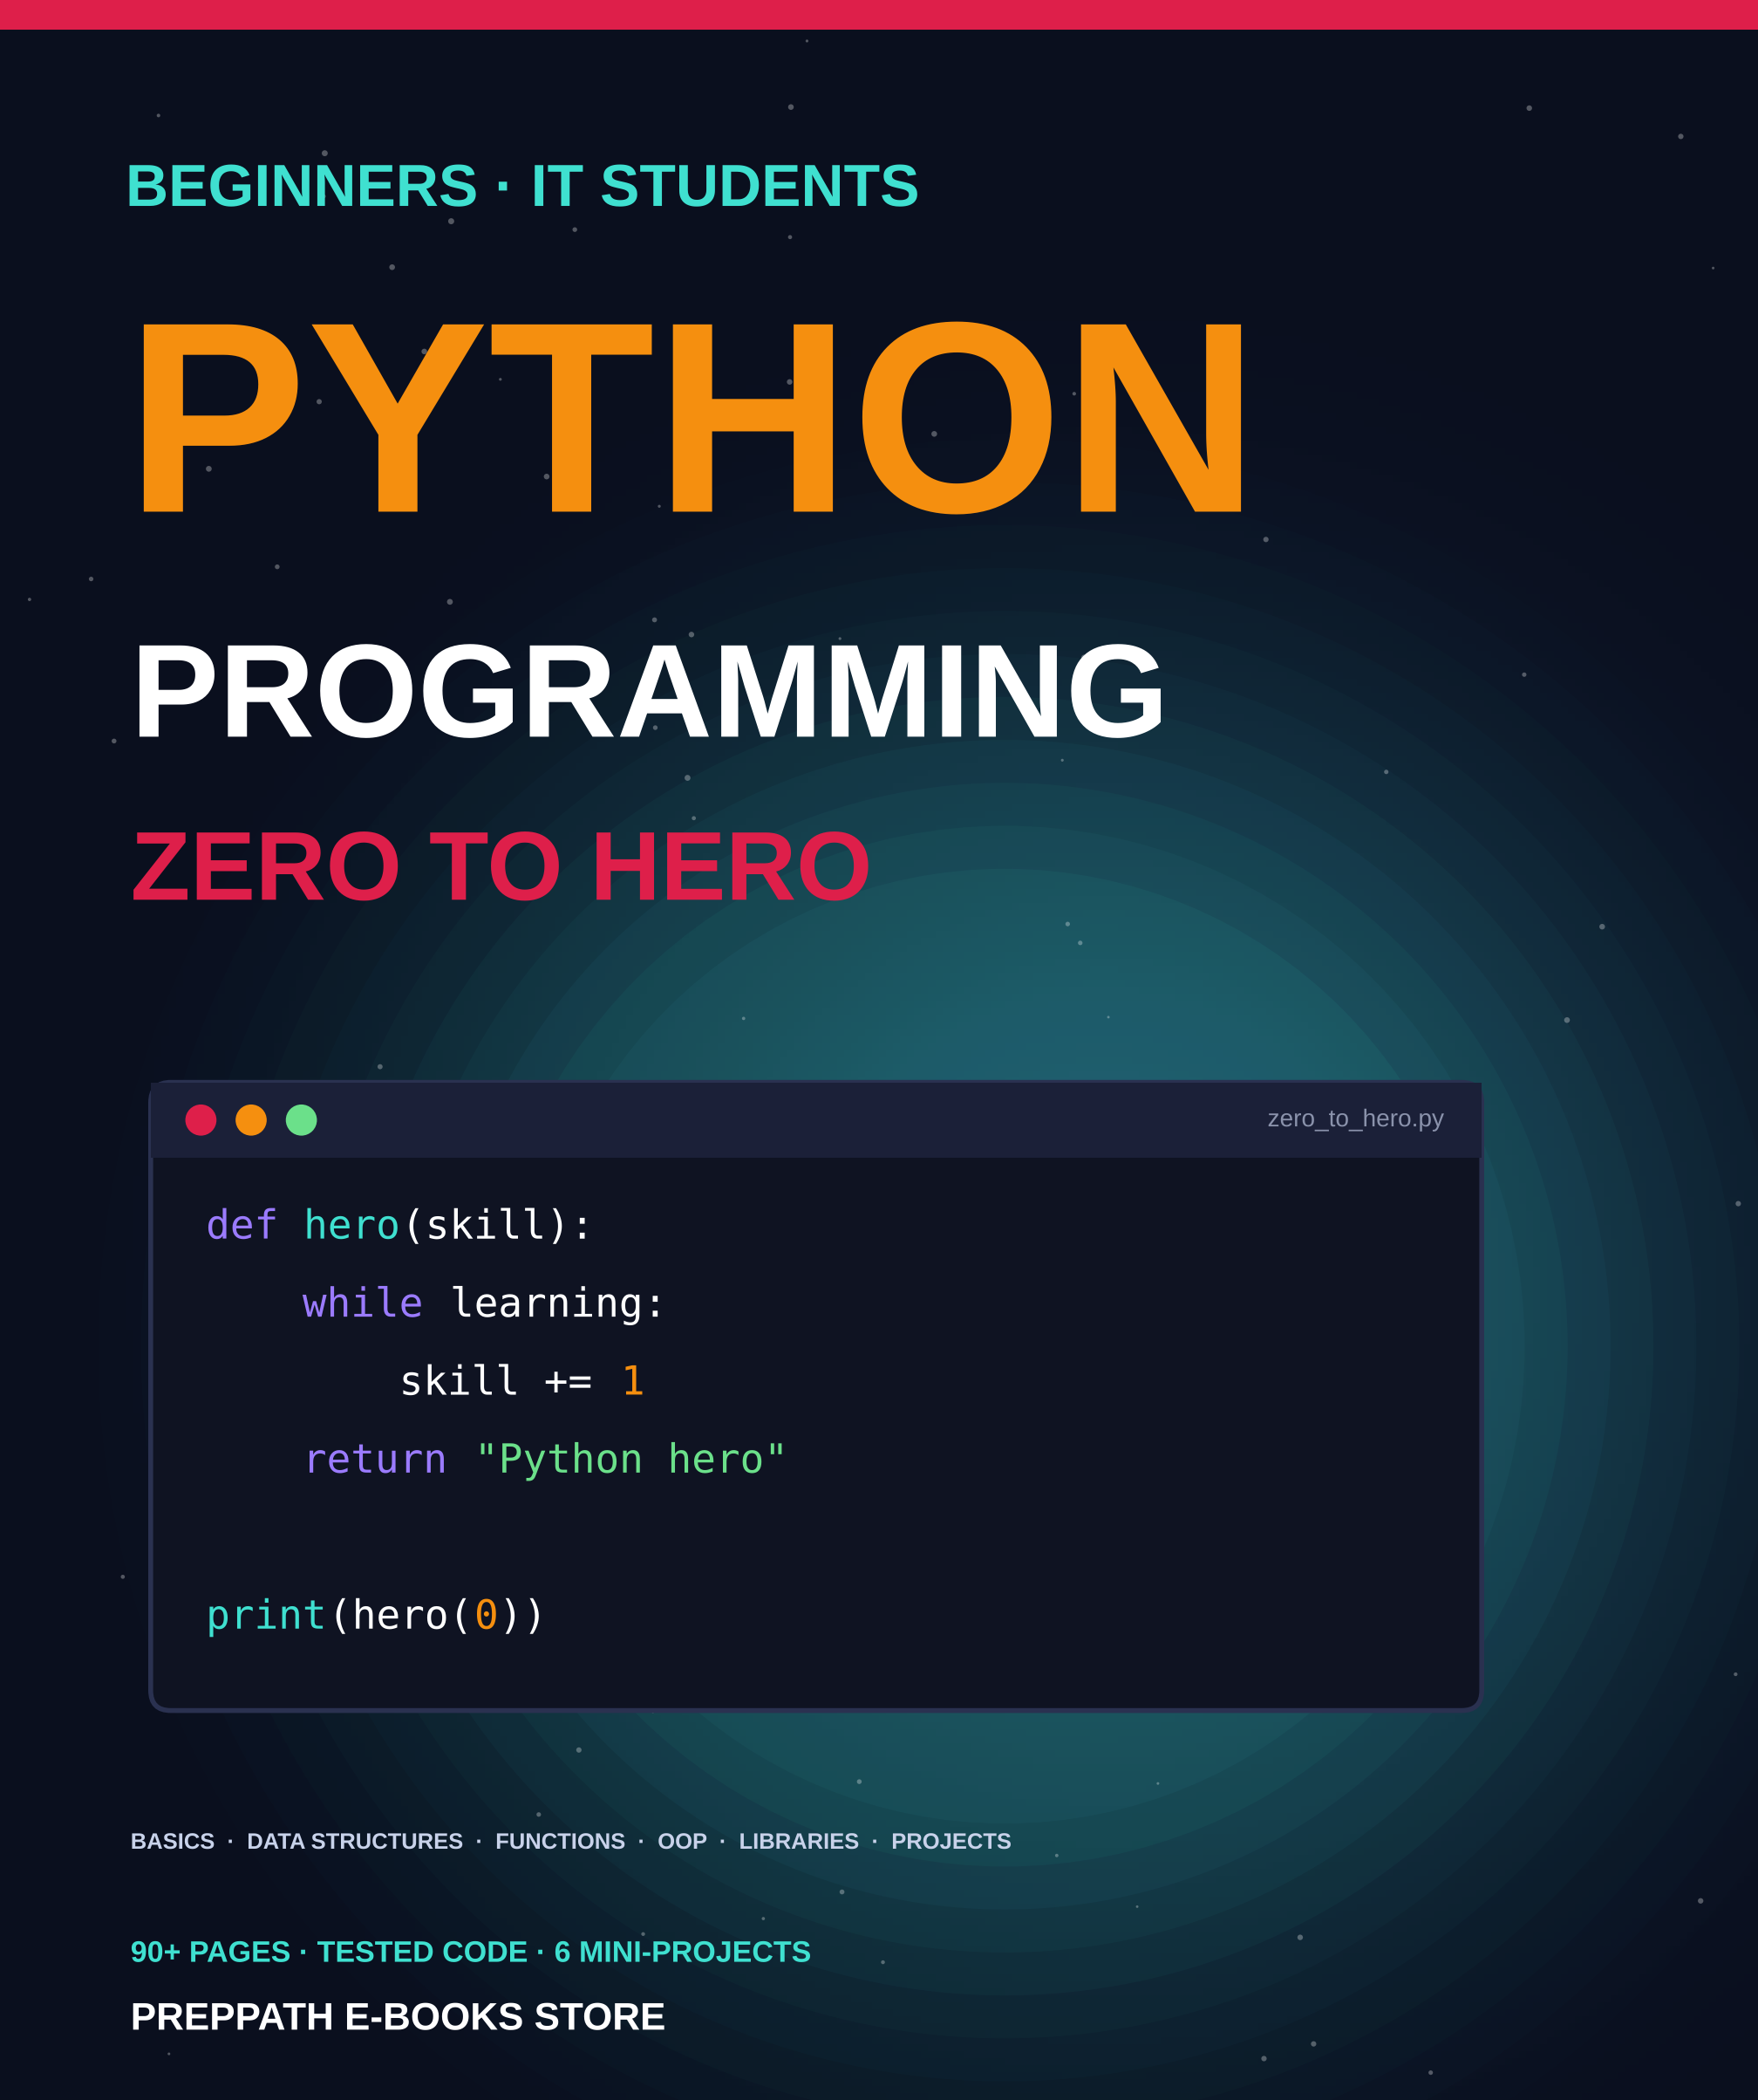

ABOUT THIS EDITION
Python Programming
Zero to Hero
A picture-led, hands-on guide that takes you from your first line of code to real programs: fundamentals, data structures, functions, object-oriented programming, libraries and mini-projects.
Published by PrepPath E-books Store
© 2026 PrepPath E-books Store. All rights reserved.
Sixteen chapters build one skill on top of another. Every code example in this book was run, and the output shown is the real output (Python 3.12 or later). Type the examples yourself, change them and break them. That is how programming is learned.
Python changes over time. Check the official documentation for the latest details, and always test code before using it for anything important.

CONTENTS
What is inside

01 Meet Python 4
What Python is, how to install it and your first program
02 Variables and Data Types 7
Storing and naming information
03 Operators and Expressions 10
Calculating, comparing and combining
04 Strings in Depth 13
Indexing, slicing, methods and formatting
05 Making Decisions 16
if, elif, else and match
06 Loops 19
Repeating work with for and while
07 Lists 22
Ordered, changeable collections
08 Tuples and Sets 25
Fixed groups and unique collections
09 Dictionaries 28
Labelled data: keys and values
10 Functions 31
Reusable blocks of code
11 Functions: Going Further 34
Flexible arguments, lambda, recursion and decorators
12 Working with Files 37
Reading, writing, CSV and JSON
13 Errors and Debugging 40
Handling the unexpected and finding bugs
14 Modules and the Standard Library 43
Reuse code from Python and from others
15 Object-Oriented Programming I 46
Classes, objects, attributes and methods
16 Object-Oriented Programming II 49
Inheritance, polymorphism and special methods
17 Libraries for Data and the Web 52
NumPy, pandas, Matplotlib and requests
18 Algorithms and Problem Solving 55
Searching, sorting and thinking about speed
19 Databases with SQL and SQLite 59
Store and query data with SQL
20 Text Processing and Regular Expressions 62
Find, extract and clean text with patterns
21 Data Analysis in Practice 65
A complete pandas workflow from raw data to insight
22 Six Mini-Projects 68
Put everything together in real programs
23 Better Code and Next Steps 71
Style, testing, Git and your learning roadmap
A Python Cheat Sheet 74
Syntax, methods and formats on one set of pages
B Common Errors and Fixes 77
Messages decoded, with the usual cure
C Fifty Practice Problems 79
Three levels, from warm-up to challenge
D Python Interview Questions 81
Thirty questions every IT student should answer
E Quiz Answers 84
Answers to every chapter quiz
F Syntax Tables 87
Syntax you will look up every week
G Setup and Troubleshooting 89
Install Python and fix the errors every beginner meets
A–Z Glossary 91
Key terms in one line each
→ A Last Word 92
Start small, and a few notes

CHAPTER 1
Meet Python
Python is one of the most popular programming languages in the world, and one of the easiest to start with. In this chapter you will install it, run your first program and learn how to read the messages Python gives you when something goes wrong.
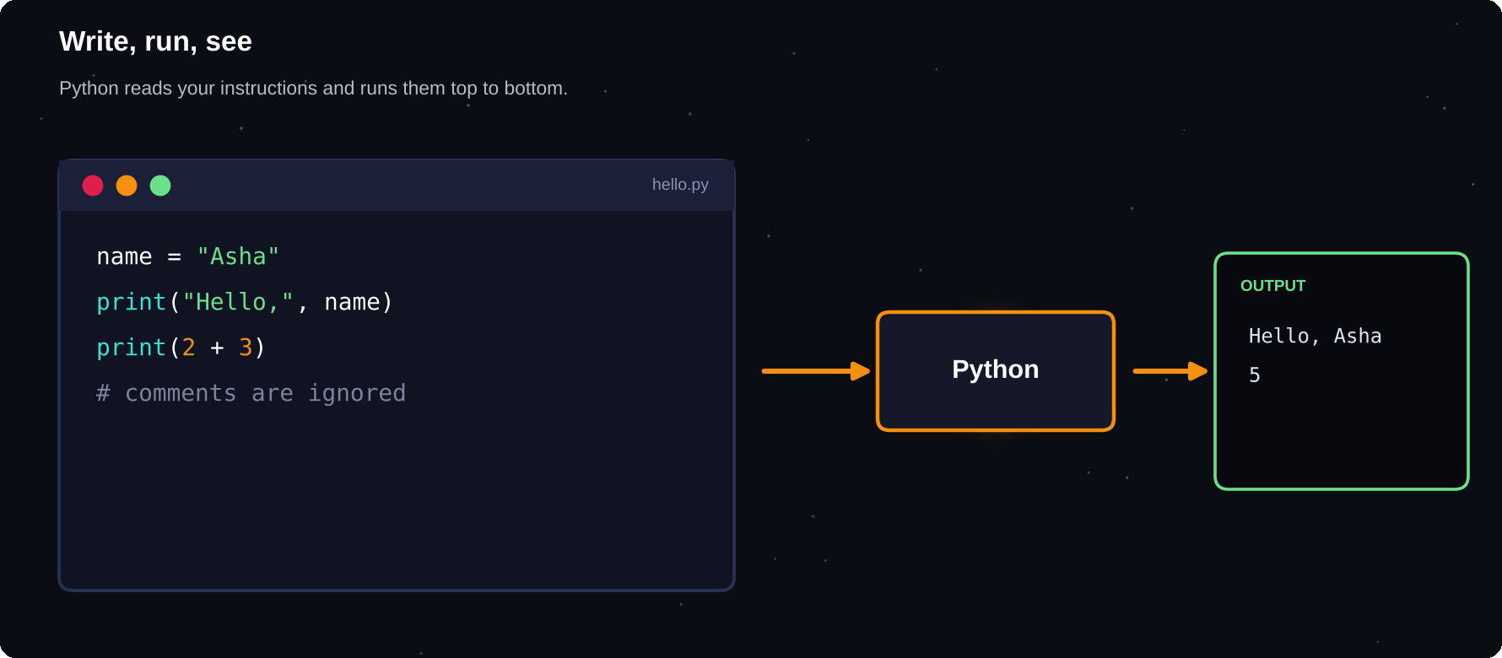
Write, run, see
Programming is a loop: write a little code, run it, look at the result, then improve it.
IN THIS CHAPTER
01 What is Python?  02 What can you build with Python?  03 Install Python  04 Your first program | 05 Four places to write code  06 Python is case-sensitive  07 Comments: notes for humans  08 Reading error messages | 09 The Zen of Python  10 Debugging corner  11 Quick quiz

What is Python?
Python is a general-purpose programming language: a way of giving clear instructions to a computer. Its code reads almost like English, which makes it friendly for beginners, yet it is powerful enough to run websites, analyse data, control robots and train artificial intelligence.
1991
the year Python was first released. It has been improved steadily for more than three decades
Python is interpreted: a program called the interpreter reads your code line by line and carries it out straight away. You do not need a separate step to build your program before running it, so experiments are quick.
What can you build with Python?
Area | Examples
Web | Websites, APIs, dashboards
Data | Reports, analysis, charts
AI / ML | Models, text, images
Automation | Rename files, send emails
Games | Quizzes, simple 2D games
Science | Simulations, lab data

Install Python
Download the latest Python 3 from python.org and run the installer. On Windows, tick the box “Add Python to PATH” before you click Install. On macOS and most Linux systems Python may already be present, but install a current version anyway. Then open a terminal (Command Prompt, PowerShell or Terminal) and check it worked.
$ python --version
» Python 3.12.4
$ python
» >>> 2 + 3
» 5

PYTHON OR PYTHON3?
On some macOS and Linux systems the command is python3, not python. If python is not found, try python3 (and pip3 in place of pip) everywhere in this book.

Your first program
The tradition is to start by printing a greeting. The print() function shows text on the screen. The text goes inside quotation marks, and the whole thing goes inside parentheses.
print("Hello, World!")
print("I am learning Python.")
» Hello, World!
» I am learning Python.

Each line is a statement, an instruction that Python runs from top to bottom. Try changing the words and running it again. You cannot break your computer by experimenting.
Four places to write code
Where | Best for
Terminal (REPL) | Trying one line quickly
Script file (.py) | Programs you want to keep
IDLE | Simple, comes with Python
VS Code / PyCharm | Real projects
Jupyter / Colab | Notes, data, teaching

The interactive prompt, called the REPL (read, evaluate, print, loop), shows the answer to every line you type. Save longer programs in a file ending in .py and run them with python filename.py.
$ python hello.py
» Hello, World!

Python is case-sensitive
print and Print are different words to Python. Only the first one works. Spaces at the start of a line also matter, and you will meet them again in chapter 5. For now, begin every line at the left edge.
Comments: notes for humans
A comment starts with # and runs to the end of the line. Python ignores it. Use comments to explain why you did something, not to repeat what the code already says.
# This line is ignored by Python
print("Comments are free") # so is this
» Comments are free

Reading error messages
Everyone makes errors, so learn to read them calmly. Python tells you the kind of error on the last line, and the lines above show where it happened. Read from the bottom up.
print(nmae)
» NameError: name 'nmae' is not defined

print(10 / 0)
» ZeroDivisionError: division by zero

Error | Usually means
SyntaxError | Typo: missing quote or bracket
NameError | Name misspelt or not created
TypeError | Wrong kind of value used
IndentationError | Spaces at line start are off
ZeroDivisionError | Dividing by zero

COMMON MISTAKES
Forgetting a closing quote or bracket. Using curly “smart” quotes from a word processor instead of straight quotes. Mixing up upper and lower case.

The Zen of Python
Python has a short list of guiding ideas. Type import this in the REPL to read them. Three worth remembering from day one: “Readability counts.” “Simple is better than complex.” “Errors should never pass silently.”
35
reserved keywords in Python, such as if, for and def. You will meet each one in this book
Debugging corner
This program has a typo. Can you spot it before reading the error?
print("Hello)
» SyntaxError: unterminated string literal
» (detected at line 1)

The closing quotation mark is missing. Close the string and the error disappears.
Try it yourself
1 Print your name and your city on two lines
2 Print a short poem with 4 print() calls
3 Add a comment above each line
4 Break one line on purpose and read the error
5 Fix it and run the program again
Chapter checkpoint
1 Python reads your code top to bottom
2 print() shows text on the screen
3 # starts a comment
4 Error messages are clues, so read the last line first
5 Save programs in .py files and run them from a terminal
Quick quiz
Answer from memory, then check Appendix E.
1 Which function shows text on the screen?
2 Which symbol starts a comment?
3 Which file extension do Python scripts use?
4 Which line of an error message should you read first?
5 Are print and Print the same to Python?
6 What does REPL stand for?

CHAPTER 2
Variables and Data Types
A program is mostly about handling information: names, ages, prices, scores. Variables are labelled boxes where you keep it, and data types describe what kind of information each box holds.
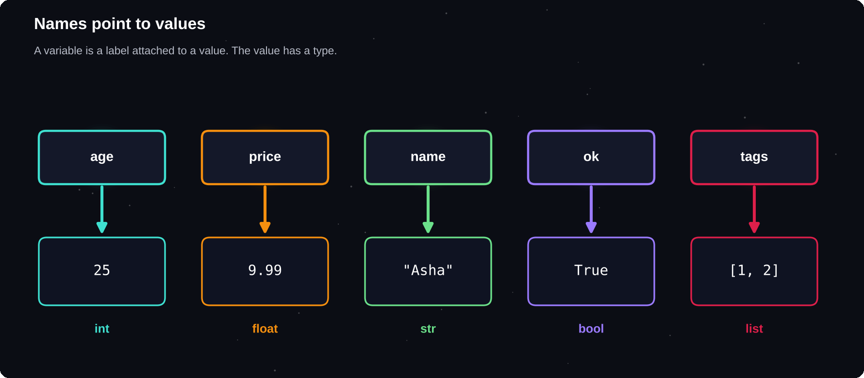
Names point to values
A variable is a name attached to a value. Every value has a type.
IN THIS CHAPTER
01 Variables  02 Naming rules  03 The basic data types  04 Integers and floats  05 Strings | 06 Booleans and None  07 Converting between types  08 Getting input from the user  09 Nice output with f-strings  10 Multiple assignment | 11 Constants and good style  12 Debugging corner  13 Quick quiz

Variables
A variable is a name that refers to a value. You create one by writing the name, an equals sign and the value. The equals sign here means “store”, not “is equal to”. You can then use the name anywhere you would use the value.
name = "Asha"
age = 21
print(name)
print(age)
print(name, "is", age, "years old")
» Asha
» 21
» Asha is 21 years old

A variable can be changed at any time. Python simply points the name at a new value, and the old value is forgotten if nothing else uses it.
score = 10
score = score + 5
print(score)
» 15

Naming rules
Rule | Example
Letters, digits, _ | total_1
Cannot start with a digit | 1st` is invalid
No spaces or symbols | my-name` is invalid
Case-sensitive | Age` and `age` differ
Not a keyword | for = 3` is invalid

Use lowercase words joined by underscores, such as first_name or total_price. This style is called snake_case, and almost all Python code uses it. Choose names that explain themselves: price is better than p.
The basic data types
Type | Holds | Example
int | Whole numbers | 42
float | Decimal numbers | 3.14
str | Text | "Hi"
bool | True or False | True
NoneType | “Nothing” | None

print(type(42))
print(type(3.14))
print(type("Hi"))
print(type(True))
print(type(None))
» <class 'int'>
» <class 'float'>
» <class 'str'>
» <class 'bool'>
» <class 'NoneType'>

The type() function tells you the type of any value. Python works it out for you, so you never have to declare a type in advance. This is called dynamic typing.
Integers and floats
Integers are whole numbers of any size. Floats are numbers with a decimal point. Python can handle very large integers exactly, which many languages cannot.
big = 2 ** 100
print(big)
price = 19.99
print(price * 3)
» 1267650600228229401496703205376
» 59.97

FLOATS ARE APPROXIMATE
Computers store floats in binary, so some decimals cannot be stored exactly. 0.1 + 0.2 gives 0.30000000000000004. For money, use the decimal module or whole paise and cents.

print(0.1 + 0.2)
print(round(0.1 + 0.2, 2))
» 0.30000000000000004
» 0.3

Strings
A string is text inside single or double quotes. Both work the same. Use triple quotes for text that spans several lines. You can join strings with + and repeat them with *.
a = "Py"
b = 'thon'
print(a + b)
print("ha" * 3)
poem = """Roses are red,
Python is fun."""
print(poem)
» Python
» hahaha
» Roses are red,
» Python is fun.

Booleans and None
A bool is either True or False, with a capital first letter. Booleans come from comparisons and control decisions. None is a special value meaning “no value yet”.
is_student = True
print(5 > 3)
result = None
print(result)
» True
» None

Converting between types
Use int(), float(), str() and bool() to convert. A very common job is turning text, which is what input() always returns, into a number.
print(int("25") + 5)
print(float("2.5") * 2)
print(str(100) + " marks")
print(int(9.99))
print(bool(0), bool("hi"))
» 30
» 5.0
» 100 marks
» 9
» False True

print(int("abc"))
» ValueError: invalid literal for int()
» with base 10: 'abc'

Getting input from the user
The input() function pauses the program, shows a prompt and waits for the user to type and press Enter. It always gives you a string.
name = input("Your name? ")
age = int(input("Your age? "))
print("Next year", name, "is", age + 1)
» Your name? Your age? Next year Ravi is 21

Nice output with f-strings
An f-string starts with the letter f before the opening quote. Anything inside curly braces is replaced by its value, and you can add formatting after a colon.
item, cost = "Notebook", 45.5
print(f"{item} costs Rs {cost}")
print(f"Two cost Rs {cost * 2:.2f}")
print(f"{1234567:,}")
» Notebook costs Rs 45.5
» Two cost Rs 91.00
» 1,234,567

Multiple assignment
x, y, z = 1, 2, 3
a = b = 0
x, y = y, x
print(x, y, z, a, b)
» 2 1 3 0 0

COMMON MISTAKES
Using a variable before it exists (NameError). Forgetting to convert input() text to a number, so that “5” + “5” gives “55”. Confusing = (store) with == (compare).

Constants and good style
Python has no true constants, but by convention names in CAPITALS mean “do not change this”, such as TAX_RATE = 0.18. Use blank lines and spaces around = to keep code readable.
Debugging corner
Why does adding 1 to the age fail?
age = "20"
print(age + 1)
» TypeError: can only concatenate str (not
» "int") to str

age is text, not a number. Convert it first: int(age) + 1.
Try it yourself
1 Store your name, age and height in variables and print a sentence about them
2 Ask for two numbers and print their sum
3 Convert a temperature from Celsius to Fahrenheit: f = c * 9 / 5 + 32
4 Swap two variables without a third one
5 Print the type of five different values
Chapter checkpoint
1 A variable is a name pointing at a value
2 Basic types: int, float, str, bool and None
3 type() shows a type, and int() float() str() convert
4 input() always returns text
5 f-strings make output easy to read
Quick quiz
Answer from memory, then check Appendix E.
1 What type is 3.0?
2 What is int("7") + 3?
3 What does input() always return?
4 Which is a valid name: 2nd, my-var, total_1, for?
5 What does "ab" * 3 give?
6 What type does None have?

CHAPTER 3
Operators and Expressions
Operators are the symbols that do things with values: add, compare, combine. An expression is any piece of code that produces a value. Together they turn data into answers.
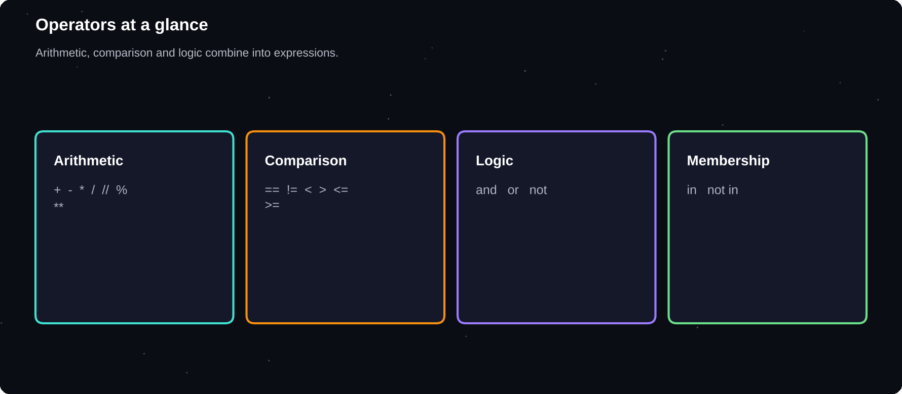
Operators at a glance
Arithmetic gives numbers. Comparison and logic give True or False.
IN THIS CHAPTER
01 Arithmetic operators  02 Order of operations  03 Assignment shortcuts  04 Comparison operators | 05 Logical operators  06 Truthiness  07 Membership and identity  08 Useful built-in functions | 09 Worked example: a bill splitter  10 Worked example: even or odd  11 Debugging corner  12 Quick quiz

Arithmetic operators
Op | Meaning | Example
+ | Add | 7 + 2 = 9
- | Subtract | 7 - 2 = 5
* | Multiply | 7 * 2 = 14
/ | Divide (float) | 7 / 2 = 3.5
// | Floor divide | 7 // 2 = 3
% | Remainder | 7 % 2 = 1
** | Power | 7 ** 2 = 49

print(7 + 2, 7 - 2, 7 * 2)
print(7 / 2, 7 // 2, 7 % 2)
print(7 ** 2)
print(-7 // 2)
» 9 5 14
» 3.5 3 1
» 49
» -4

Note that / always gives a float, even when the answer is whole. Floor division rounds down toward negative infinity, which is why -7 // 2 is -4.
%
the remainder operator. It is perfect for tests such as “is this number even?” (n % 2 == 0)
Order of operations
Python follows the same order as school maths: brackets first, then powers, then multiplication and division, then addition and subtraction. When unsure, add brackets. They cost nothing and make your intention clear.
print(2 + 3 * 4)
print((2 + 3) * 4)
print(2 ** 3 ** 2)
print(10 - 4 - 3)
» 14
» 20
» 512
» 3

Assignment shortcuts
n = 10
n += 5
n -= 3
n *= 2
n //= 5
print(n)
» 4

The pattern x += 5 means x = x + 5. Every arithmetic operator has such a shortcut.
Comparison operators
Op | Meaning
== | Equal to
!= | Not equal to
> < | Greater, less
>= <= | Greater or equal, less or equal

age = 18
print(age == 18)
print(age != 18)
print(age >= 21)
print(10 < age < 20)
» True
» False
» False
» True

Comparisons always return True or False. Python lets you chain them, so 10 < age < 20 reads exactly as in maths.
= VERSUS ==
A single = stores a value. A double == asks a question. Writing if x = 5 is an error, and mixing them up is one of the most common beginner mistakes.

Logical operators
and gives True only if both sides are True. or gives True if at least one is True. not flips a value.
age, has_id = 20, True
print(age >= 18 and has_id)
print(age < 13 or age > 60)
print(not has_id)
» True
» False
» False

A | B | A and B | A or B
True | True | True | True
True | False | False | True
False | True | False | True
False | False | False | False

Truthiness
Every value in Python can be treated as True or False. Empty or zero values are “falsy”: 0, 0.0, an empty string, an empty list and None. Almost everything else is “truthy”.
print(bool(0), bool(""), bool([]))
print(bool(1), bool("a"), bool([0]))
» False False False
» True True True

Membership and identity
print("a" in "banana")
print("z" not in "banana")
x = None
print(x is None)
» True
» True
» True

in checks whether something is inside a string or collection. is checks whether two names refer to the very same object, and is mostly used with None. Use == to compare values.
Useful built-in functions
Function | Does
abs(x) | Distance from zero
round(x, n) | Round to n places
min(a, b, ...) | Smallest value
max(a, b, ...) | Largest value
pow(a, b) | a to the power b
divmod(a, b) | Quotient and remainder

print(abs(-8), round(3.14159, 2))
print(min(4, 9, 2), max(4, 9, 2))
print(divmod(17, 5))
» 8 3.14
» 2 9
» (3, 2)

Worked example: a bill splitter
bill = 1250.0
people = 4
tip = bill * 0.10
total = bill + tip
share = total / people
print(f"Total: {total:.2f}")
print(f"Each pays: {share:.2f}")
» Total: 1375.00
» Each pays: 343.75

Worked example: even or odd
n = 17
print(n, "is even:", n % 2 == 0)
» 17 is even: False

Debugging corner
Why is this False when the maths looks right?
print(0.1 + 0.2 == 0.3)
import math
print(math.isclose(0.1 + 0.2, 0.3))
» False
» True

Floats are approximate. Compare them with math.isclose() instead of ==.
Try it yourself
1 Convert 5000 seconds into hours, minutes and seconds with // and %
2 Check whether a year is a leap year using % and logical operators
3 Compute the area and perimeter of a rectangle
4 Predict the result of 3 + 4 * 2 ** 2 before running it
5 Find the average of three numbers and round it to 1 decimal place
Chapter checkpoint
1 Arithmetic: + - * / // % **
2 Comparison and logic give True or False
3 Use brackets when order is unclear
4 Empty and zero values are falsy
5 == compares values, is compares identity
Quick quiz
Answer from memory, then check Appendix E.
1 7 // 2
2 7 % 3
3 2 ** 5
4 5 == 5.0
5 not (True and False)
6 10 / 4

CHAPTER 4
Strings in Depth
Text is everywhere: names, messages, web pages, files. Python treats text as a sequence of characters that you can slice, search, clean and reshape with a rich set of built-in tools.
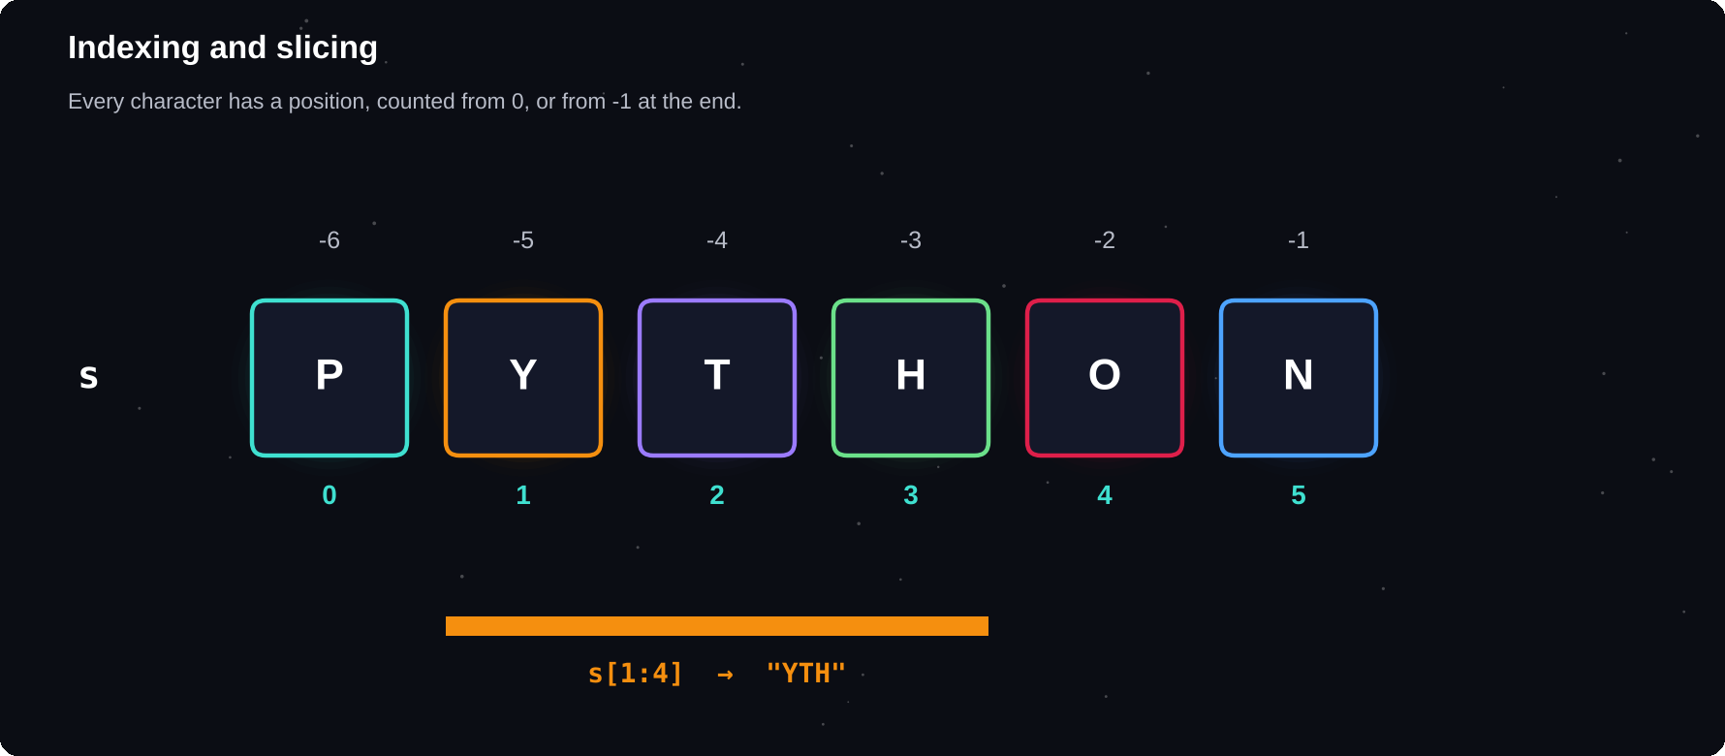
Indexing and slicing
Every character has a position. Counting starts at 0, and negative numbers count from the end.
IN THIS CHAPTER
01 A string is a sequence  02 Slicing  03 Strings cannot be changed  04 Case and cleaning methods  05 Searching | 06 Split and join  07 Testing the content  08 Escape characters  09 Formatting numbers and text  10 Strings and numbers: ord and chr | 11 Worked example: palindrome checker  12 Worked example: count the vowels  13 Worked example: Caesar cipher  14 Debugging corner  15 Quick quiz

A string is a sequence
A string is an ordered row of characters. You can ask how long it is, loop over it, and pick out characters by position. The position is called the index, and the first character is at index 0, not 1.
word = "Python"
print(len(word))
print(word[0], word[5])
print(word[-1], word[-2])
for ch in word:
print(ch, end=" ")
» 6
» P n
» n o
» P y t h o n

word = "Python"
print(word[10])
» IndexError: string index out of range

Slicing
A slice takes a piece of a string: text[start:stop:step]. The slice includes start but stops just before stop. Leave a part out to mean “from the beginning” or “to the end”.
s = "Programming"
print(s[0:3])
print(s[3:])
print(s[:3])
print(s[-4:])
print(s[::2])
print(s[::-1])
» Pro
» gramming
» Pro
» ming
» Pormig
» gnimmargorP

[::-1]
the famous slice that reverses any sequence. Step -1 walks backwards from the end
Strings cannot be changed
Strings are immutable: once created, they cannot be edited in place. Methods that appear to change a string actually return a new one, so you must store the result.
s = "cat"
s[0] = "b"
» TypeError: 'str' object does not support
» item assignment

s = "cat"
s = "b" + s[1:]
print(s)
» bat

Case and cleaning methods
Method | Result
upper() | ALL CAPITALS
lower() | all small letters
title() | Each Word Capitalised
strip() | Remove spaces at both ends
replace(a, b) | Swap a for b

raw = " hELLo wORLD "
print(raw.strip())
print(raw.strip().title())
print(raw.upper().strip())
print("a-b-c".replace("-", "+"))
» hELLo wORLD
» Hello World
» HELLO WORLD
» a+b+c

Searching
text = "the cat sat on the mat"
print(text.find("cat"))
print(text.find("dog"))
print(text.count("at"))
print(text.startswith("the"))
print(text.endswith("mat"))
print("sat" in text)
» 4
» -1
» 3
» True
» True
» True

find() returns the index of the first match, or -1 if there is none. Use in when you only need a yes or no answer.
Split and join
split() breaks a string into a list of pieces, and join() glues a list of strings back together using the string you call it on as the separator.
line = "red,green,blue"
colors = line.split(",")
print(colors)
print(" | ".join(colors))
words = "to be or not".split()
print(len(words))
» ['red', 'green', 'blue']
» red | green | blue
» 4

Testing the content
Method | True when
isdigit() | Only digits 0-9
isalpha() | Only letters
isalnum() | Letters or digits
isspace() | Only whitespace
isupper() | All capitals

print("2024".isdigit())
print("abc".isalpha())
print("abc123".isalnum())
print("12.5".isdigit())
» True
» True
» True
» False

Escape characters
A backslash gives special meaning to the next character. \n is a new line, \t is a tab, \\ is a backslash itself, and \" is a quote inside a string. A raw string (r"...") switches this off, which is handy for file paths and patterns.
print("Line1\nLine2")
print("Name:\tAsha")
print('It\'s fine')
print(r"C:\new\table")
» Line1
» Line2
» Name: Asha
» It's fine
» C:\new\table

Formatting numbers and text
After a colon inside an f-string you can control width, alignment, decimals and separators. This is how you produce neat tables.
name, price = "Pen", 7.5
print(f"{name:<8}|{price:>8.2f}|")
print(f"{name:^8}|{price:08.3f}|")
print(f"{0.256:.1%}")
print(f"{255:b} {255:x} {1e6:,.0f}")
» Pen | 7.50|
» Pen |0007.500|
» 25.6%
» 11111111 ff 1,000,000

Strings and numbers: ord and chr
print(ord("A"), ord("a"))
print(chr(72), chr(105))
print("apple" < "banana")
» 65 97
» H i
» True

Every character has a numeric code. Python compares strings by these codes, which is why all capitals come before lowercase letters in sorting.
Worked example: palindrome checker
def is_palindrome(text):
t = [c.lower() for c in text
if c.isalnum()]
return t == t[::-1]

print(is_palindrome("Madam"))
print(is_palindrome("Never odd or even"))
print(is_palindrome("Python"))
» True
» True
» False

Worked example: count the vowels
sentence = "Learning Python is fun"
vowels = "aeiou"
text = sentence.lower()
n = sum(1 for c in text if c in vowels)
print("Vowels:", n)
» Vowels: 6

Worked example: Caesar cipher
def shift(text, k):
out = ""
for c in text:
if c.isalpha():
b = 97 if c.islower() else 65
n = (ord(c) - b + k) % 26
out += chr(n + b)
else:
out += c
return out

secret = shift("Hello, World!", 3)
print(secret)
print(shift(secret, -3))
» Khoor, Zruog!
» Hello, World!

COMMON MISTAKES
Forgetting that string methods return a new string. Using index 1 for the first character. Mixing text and numbers in + (use str() or an f-string). Comparing strings with different capitalisation.

Debugging corner
What is wrong here?
print("5" * "2")
» TypeError: can't multiply sequence by
» non-int of type 'str'

A string can only be repeated by an integer. Convert with int() if you meant to multiply numbers.
Try it yourself
1 Ask for a full name and print the initials
2 Count how many words are in a sentence
3 Check whether a password has at least 8 characters, one digit and one capital letter
4 Reverse each word in a sentence but keep the word order
5 Print a left-aligned table of three items and prices
Chapter checkpoint
1 Strings are indexed from 0 and sliced with [start:stop:step]
2 Strings are immutable. Methods return new strings
3 split() and join() convert between strings and lists
4 f-strings control width, alignment and decimals
5 Characters have numeric codes: ord() and chr()
Quick quiz
Answer from memory, then check Appendix E.
1 "Python"[1:4]
2 "hello".upper()
3 "a,b,c".split(",")
4 len("Hi there")
5 "abc"[::-1]
6 Can you change one character of a string in place?

CHAPTER 5
Making Decisions
Programs become useful when they can choose. With conditions, your code can react to different situations: grant or refuse access, give a grade, pick a message. This chapter teaches the tools for making decisions.
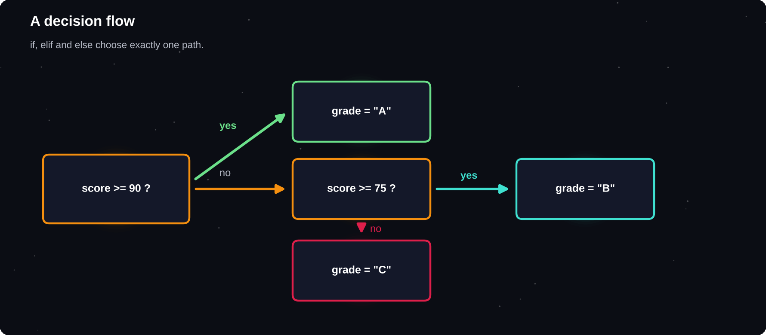
A decision flow
A condition is a question with a True or False answer. The answer decides which path the program takes.
IN THIS CHAPTER
01 The if statement  02 if and else  03 elif: more than two choices  04 Combining conditions  05 Nested decisions | 06 Truthiness in conditions  07 The one-line conditional  08 Checking a range and membership  09 match: choosing among many cases  10 Worked example: leap year | 11 Worked example: simple login check  12 Worked example: BMI category  13 pass: a placeholder  14 Debugging corner  15 Quick quiz

The if statement
An if statement runs a block of code only when a condition is True. The line ends with a colon, and the code that belongs to the if is indented by four spaces. Indentation is not decoration in Python. It is how Python knows which lines belong together.
temperature = 34
if temperature > 30:
print("It is hot.")
print("Drink water.")
print("Done.")
» It is hot.
» Drink water.
» Done.

The last line has no indent, so it runs every time. The first two lines run only when the temperature is above 30.
if and else
age = 16
if age >= 18:
print("You can vote.")
else:
print("Too young to vote.")
» Too young to vote.

elif: more than two choices
Use elif (short for else if) to test several conditions in order. Python stops at the first one that is True, so put the most specific test first.
marks = 82
if marks >= 90:
grade = "A+"
elif marks >= 75:
grade = "A"
elif marks >= 60:
grade = "B"
else:
grade = "C"
print("Grade:", grade)
» Grade: A

4
spaces per indentation level is the standard. Never mix tabs and spaces in the same file
x = 5
if x > 3:
print("big")
» IndentationError: expected an indented
» block after 'if' statement on line 2

Combining conditions
age, member = 25, True
if age >= 18 and member:
print("Welcome in")
if age < 12 or age > 65:
print("Discount")
if not member:
print("Please join")
» Welcome in

Nested decisions
user, pw = "admin", "1234"
if user == "admin":
if pw == "1234":
print("Access granted")
else:
print("Wrong password")
else:
print("Unknown user")
» Access granted

Nesting works, but deep nesting is hard to read. Often you can flatten it with and, or an early exit.
Truthiness in conditions
You do not need to compare with True. Any value works as a condition: empty strings, empty lists, zero and None count as False.
items = []
if items:
print("Has items")
else:
print("Empty list")
name = ""
if not name:
print("Please enter a name")
» Empty list
» Please enter a name

The one-line conditional
When a decision only picks between two values, a conditional expression keeps it short: value_if_true if condition else value_if_false.
n = 7
kind = "even" if n % 2 == 0 else "odd"
print(n, "is", kind)
» 7 is odd

Checking a range and membership
score = 55
if 40 <= score < 60:
print("Pass")
day = "Sat"
if day in ("Sat", "Sun"):
print("Weekend")
» Pass
» Weekend

match: choosing among many cases
From Python 3.10, match compares a value with several patterns. It reads more clearly than a long chain of elif when you are checking one variable against many possible values. The underscore is the default case.
cmd = "stop"
match cmd:
case "go":
print("Moving")
case "stop" | "halt":
print("Stopping")
case _:
print("Unknown command")
» Stopping

Worked example: leap year
year = 2024
if year % 400 == 0:
leap = True
elif year % 100 == 0:
leap = False
else:
leap = year % 4 == 0
print(year, "leap year?", leap)
» 2024 leap year? True

Worked example: simple login check
users = {"asha": "py123"}
name, pw = "asha", "py123"
if name in users and users[name] == pw:
print("Login OK")
else:
print("Invalid login")
» Login OK

Worked example: BMI category
weight, height = 68, 1.72
bmi = weight / height ** 2
if bmi < 18.5:
cat = "Underweight"
elif bmi < 25:
cat = "Normal"
else:
cat = "Above normal"
print(f"BMI {bmi:.1f}: {cat}")
» BMI 23.0: Normal

pass: a placeholder
Python does not allow an empty block. When you want to leave a block for later, write pass. It does nothing, but it keeps the program valid.
COMMON MISTAKES
Using = instead of == in a condition. Forgetting the colon. Wrong indentation. Testing conditions in the wrong order, so that an easy test catches everything. Comparing a number with a string, such as “5” == 5, which is always False.

Debugging corner
The programmer wanted to compare, but wrote the wrong operator.
x = 5
if x = 5:
print("five")
» SyntaxError: invalid syntax. Maybe you
» meant '==' or ':=' instead of '='?

Use == to compare. A single = stores a value.
Try it yourself
1 Print whether a number is positive, negative or zero
2 Find the largest of three numbers without using max()
3 Write a ticket-price program based on age groups
4 Convert a mark to a grade with at least five bands
5 Use match to turn a number 1-7 into a day name
Chapter checkpoint
1 if, elif and else choose between paths
2 Indentation marks the block. Use 4 spaces
3 and, or, not combine conditions
4 match handles many cases for one value
5 Empty and zero values count as False
Quick quiz
Answer from memory, then check Appendix E.
1 Which symbol ends the line of an if statement?
2 How many spaces is the standard indent?
3 bool([])
4 "yes" if 3 > 2 else "no"
5 Which keyword means “else if”?
6 What does case _ mean in a match statement?

CHAPTER 6
Loops
Computers are good at repeating things without getting bored. Loops let you run the same code many times: once for every item in a list, or again and again until something happens.
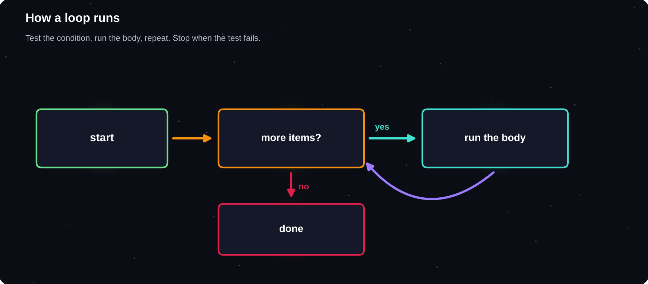
How a loop runs
Check, run the body, go back to the top. Repeat until the check fails.
IN THIS CHAPTER
01 The for loop  02 range(): counting  03 The while loop  04 break and continue  05 The else clause on a loop | 06 while True with break  07 Nested loops  08 enumerate and zip  09 Accumulator patterns  10 Worked example: FizzBuzz | 11 Worked example: prime numbers  12 Worked example: digits and factorials  13 Worked example: Fibonacci  14 Debugging corner  15 Quick quiz

The for loop
A for loop takes each item from a sequence in turn and runs the indented block once for each. The loop variable holds the current item.
for fruit in ["apple", "mango", "kiwi"]:
print("I like", fruit)
» I like apple
» I like mango
» I like kiwi

for ch in "Hi!":
print(ch)
» H
» i
» !

range(): counting
range() makes a sequence of numbers. With one number, it counts from 0 up to but not including that number. With two, you set the start. With three, you also set the step.
print(list(range(5)))
print(list(range(2, 8)))
print(list(range(10, 0, -3)))
for i in range(1, 4):
print("Round", i)
» [0, 1, 2, 3, 4]
» [2, 3, 4, 5, 6, 7]
» [10, 7, 4, 1]
» Round 1
» Round 2
» Round 3

0
is where range(n) starts, and n itself is never included. range(5) gives 0, 1, 2, 3, 4
The while loop
A while loop repeats as long as its condition stays True. Use it when you do not know in advance how many times to repeat. Make sure something inside the loop eventually makes the condition False, or the loop runs forever.
count = 3
while count > 0:
print(count)
count -= 1
print("Lift off!")
» 3
» 2
» 1
» Lift off!

break and continue
break leaves the loop immediately. continue skips the rest of the current round and jumps to the next one.
for n in range(1, 10):
if n == 3:
continue
if n == 6:
break
print(n)
» 1
» 2
» 4
» 5

The else clause on a loop
A loop can have an else block that runs only if the loop finished without hitting break. It is useful for searches.
for n in [4, 8, 15, 16]:
if n % 5 == 0:
print("Found", n)
break
else:
print("No multiple of 5")
» Found 15

while True with break
A common pattern is an intentional endless loop that exits from inside when a condition is met, for example when the user types a valid answer.
inputs = iter(["abc", "", "42"])
while True:
text = next(inputs)
if text.isdigit():
print("Got number", text)
break
print("Invalid, try again")
» Invalid, try again
» Invalid, try again
» Got number 42

Nested loops
A loop inside a loop runs the inner loop completely for every round of the outer one. It is the key to tables and grids.
for row in range(1, 4):
for col in range(1, 4):
print(row * col, end="\t")
print()
» 1 2 3
» 2 4 6
» 3 6 9

for i in range(1, 5):
print("*" * i)
» *
» **
» ***
» ****

enumerate and zip
enumerate() gives you the position and the item together. zip() walks through two or more sequences side by side.
names = ["Asha", "Ravi", "Mei"]
for i, n in enumerate(names, start=1):
print(i, n)
marks = [88, 92, 79]
for n, m in zip(names, marks):
print(n, m)
» 1 Asha
» 2 Ravi
» 3 Mei
» Asha 88
» Ravi 92
» Mei 79

Accumulator patterns
Most loops build up an answer: start with an empty total, then update it each round.
nums = [4, 9, 2, 7]
total, biggest, count = 0, nums[0], 0
for n in nums:
total += n
count += 1
if n > biggest:
biggest = n
print(total, biggest, total / count)
» 22 9 5.5

Worked example: FizzBuzz
for n in range(1, 16):
if n % 15 == 0:
print("FizzBuzz")
elif n % 3 == 0:
print("Fizz")
elif n % 5 == 0:
print("Buzz")
else:
print(n)
» 1
» 2
» Fizz
» 4
» Buzz
» Fizz
» 7
» 8
» Fizz
» Buzz
» 11
» Fizz
» 13
» 14
» FizzBuzz

Worked example: prime numbers
def is_prime(n):
if n < 2:
return False
for d in range(2, int(n ** 0.5) + 1):
if n % d == 0:
return False
return True

primes = [n for n in range(30)
if is_prime(n)]
print(primes)
» [2, 3, 5, 7, 11, 13, 17, 19, 23, 29]

Worked example: digits and factorials
n, total = 4729, 0
while n > 0:
total += n % 10
n //= 10
print("Digit sum:", total)
f = 1
for k in range(1, 6):
f *= k
print("5! =", f)
» Digit sum: 22
» 5! = 120

Worked example: Fibonacci
a, b = 0, 1
for _ in range(10):
print(a, end=" ")
a, b = b, a + b
» 0 1 1 2 3 5 8 13 21 34

COMMON MISTAKES
Forgetting to change the variable in a while loop, which gives an endless loop (press Ctrl+C to stop it). Off-by-one errors with range. Changing a list while looping over it.

Debugging corner
This loop never ends because nothing changes i. The fixed version below counts to 3.
i = 0
while i < 3:
print(i)
i += 1
» 0
» 1
» 2

Try it yourself
1 Print the multiplication table of any number
2 Sum all even numbers from 1 to 100
3 Count the vowels in a sentence with a loop
4 Print a pyramid of stars with 5 rows
5 Guess-the-number: loop until a stored number is found
Chapter checkpoint
1 for walks through a sequence. while repeats on a condition
2 range(start, stop, step) creates numbers
3 break exits and continue skips a round
4 enumerate gives index and item, zip pairs sequences
5 Build answers with an accumulator
Quick quiz
Answer from memory, then check Appendix E.
1 list(range(3))
2 list(range(2, 10, 3))
3 What does break do?
4 What does continue do?
5 sum(range(1, 5))
6 When does a loop's else block run?

CHAPTER 7
Lists
So far each variable held one value. A list holds many, in order. Lists are the most used data structure in Python, and almost every real program depends on them.
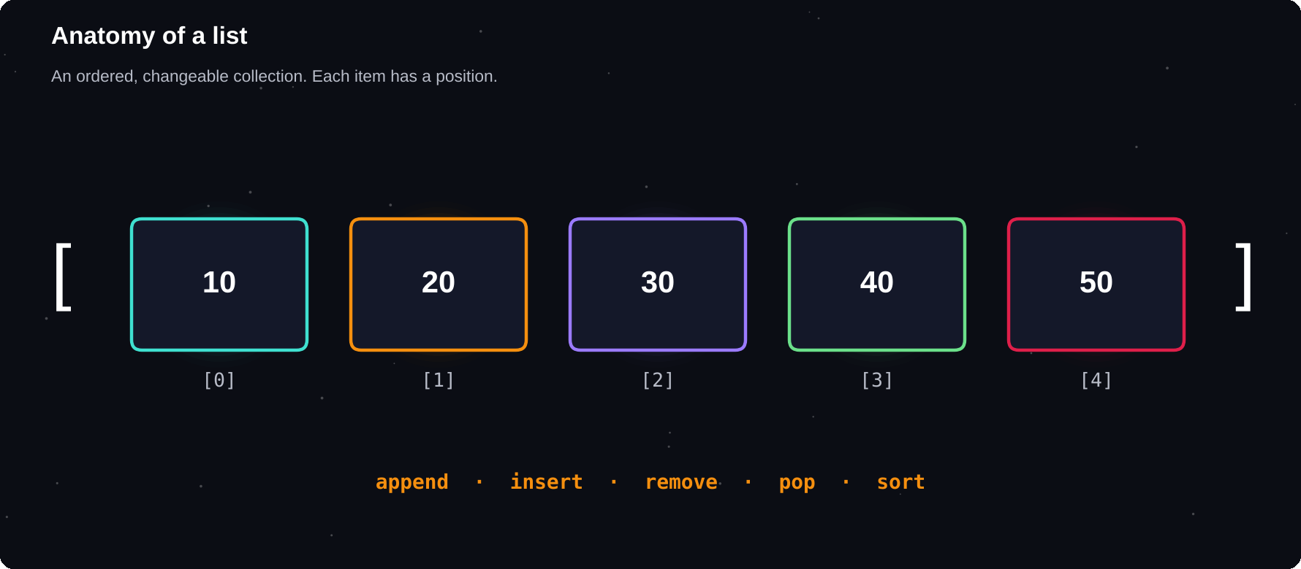
Anatomy of a list
A list is a row of boxes. Each box has an index, and you can add, remove or change items.
IN THIS CHAPTER
01 Creating and reading lists  02 Lists can be changed  03 Adding and removing items  04 Searching and counting  05 Sorting | 06 Copying lists: a classic trap  07 Looping over lists  08 List comprehensions  09 Nested lists  10 Unpacking and useful tricks | 11 Worked example: average and top scores  12 Worked example: remove duplicates  13 Worked example: a stack  14 Debugging corner  15 Quick quiz

Creating and reading lists
A list is written with square brackets, with items separated by commas. Items can be of any type, and you can mix types. Indexing and slicing work exactly as they do for strings.
nums = [10, 20, 30, 40, 50]
mixed = ["Asha", 21, True, 3.5]
print(nums[0], nums[-1])
print(nums[1:4])
print(len(mixed))
» 10 50
» [20, 30, 40]
» 4

Lists can be changed
Unlike strings, lists are mutable: you can replace items in place.
fruits = ["apple", "banana", "cherry"]
fruits[1] = "blueberry"
print(fruits)
» ['apple', 'blueberry', 'cherry']

Adding and removing items
Method | Does
append(x) | Add x at the end
insert(i, x) | Add x at position i
extend(list) | Add many items
remove(x) | Remove first x
pop() | Remove and return last
pop(i) | Remove item at i

todo = ["study"]
todo.append("code")
todo.insert(0, "wake up")
todo.extend(["sleep", "repeat"])
print(todo)
todo.remove("repeat")
last = todo.pop()
print(last, todo)
» ['wake up', 'study', 'code', 'sleep',
» 'repeat']
» sleep ['wake up', 'study', 'code']

Searching and counting
marks = [70, 85, 90, 85, 60]
print(85 in marks)
print(marks.index(90))
print(marks.count(85))
print(len(marks), sum(marks))
print(min(marks), max(marks))
» True
» 2
» 2
» 5 390
» 60 90

Sorting
sort() sorts the list itself and returns nothing. sorted() leaves the original untouched and returns a new sorted list. Add reverse=True for descending order, and key= to choose what to sort by.
data = [5, 2, 9, 1]
print(sorted(data))
print(sorted(data, reverse=True))
print(data)
data.sort()
print(data)
words = ["pear", "fig", "banana"]
print(sorted(words, key=len))
» [1, 2, 5, 9]
» [9, 5, 2, 1]
» [5, 2, 9, 1]
» [1, 2, 5, 9]
» ['fig', 'pear', 'banana']

Copying lists: a classic trap
Assigning one list to another name does not copy it. Both names point to the same list, so a change through one shows up in the other. Make a real copy with copy() or a slice.
a = [1, 2, 3]
b = a
b.append(4)
print(a)
c = a.copy()
c.append(5)
print(a, c)
» [1, 2, 3, 4]
» [1, 2, 3, 4] [1, 2, 3, 4, 5]

2
names can point to one list. Use .copy() or [:] when you need an independent copy
Looping over lists
prices = [120, 80, 45]
for p in prices:
print(p * 2, end=" ")
print()
for i in range(len(prices)):
print(i, prices[i])
» 240 160 90
» 0 120
» 1 80
» 2 45

List comprehensions
A list comprehension builds a new list in one readable line: [expression for item in sequence if condition]. It replaces a common loop-and-append pattern.
squares = [n * n for n in range(1, 6)]
evens = [n for n in range(10) if n%2==0]
upper = [w.upper() for w in ["a", "b"]]
print(squares, evens, upper)
» [1, 4, 9, 16, 25] [0, 2, 4, 6, 8] ['A',
» 'B']

Nested lists
A list can contain other lists. This is how you store a grid or a table: the first index picks the row, and the second picks the column.
grid = [[1, 2, 3],
[4, 5, 6],
[7, 8, 9]]
print(grid[1][2])
for row in grid:
print(sum(row))
print([row[0] for row in grid])
» 6
» 6
» 15
» 24
» [1, 4, 7]

Unpacking and useful tricks
first, second, *rest = [10, 20, 30, 40]
print(first, second, rest)
print(list("abc"))
print(["x"] * 3)
print([1, 2] + [3])
» 10 20 [30, 40]
» ['a', 'b', 'c']
» ['x', 'x', 'x']
» [1, 2, 3]

Worked example: average and top scores
scores = [72, 88, 95, 60, 83]
avg = sum(scores) / len(scores)
top3 = sorted(scores, reverse=True)[:3]
above = [s for s in scores if s > avg]
print(f"Average {avg:.1f}")
print(top3, above)
» Average 79.6
» [95, 88, 83] [88, 95, 83]

Worked example: remove duplicates
items = [3, 1, 3, 2, 1, 5]
seen, result = [], []
for x in items:
if x not in seen:
seen.append(x)
result.append(x)
print(result)
» [3, 1, 2, 5]

Worked example: a stack
A stack follows “last in, first out”, like a pile of plates. A list does this naturally with append() and pop().
stack = []
for ch in "abc":
stack.append(ch)
print(stack.pop(), stack.pop(), stack)
» c b ['a']

COMMON MISTAKES
Index out of range. Expecting sort() to return a list. Modifying a list while looping over it. Believing b = a makes a copy. Using list as a variable name, which hides the built-in list().

Debugging corner
Why does the last line fail?
nums = [10, 20, 30]
print(nums[len(nums)])
» IndexError: list index out of range

The last valid index is len(nums) - 1. Use nums[-1] for the last item.
Try it yourself
1 Make a list of 5 numbers and print the sum and the average
2 Find the second-largest number in a list
3 Remove all negative numbers from a list
4 Rotate a list by one position
5 Flatten [[1, 2], [3], [4, 5]] into one list
Chapter checkpoint
1 Lists are ordered and changeable
2 append, insert, extend, remove and pop change a list
3 sort() changes in place. sorted() returns a new list
4 b = a shares the same list. Use copy() for a copy
5 Comprehensions build lists in one line
Quick quiz
Answer from memory, then check Appendix E.
1 [1, 2, 3][-1]
2 sorted([5, 3, 1])
3 len([[1, 2], [3]])
4 After b = a (a list), are a and b separate lists?
5 [x * 2 for x in range(3)]
6 Difference between sort() and sorted()?

CHAPTER 8
Tuples and Sets
Lists are not the only way to group data. A tuple is a list that cannot change, which makes it safe and fast. A set is an unordered pile of unique items, perfect for removing duplicates and comparing groups.
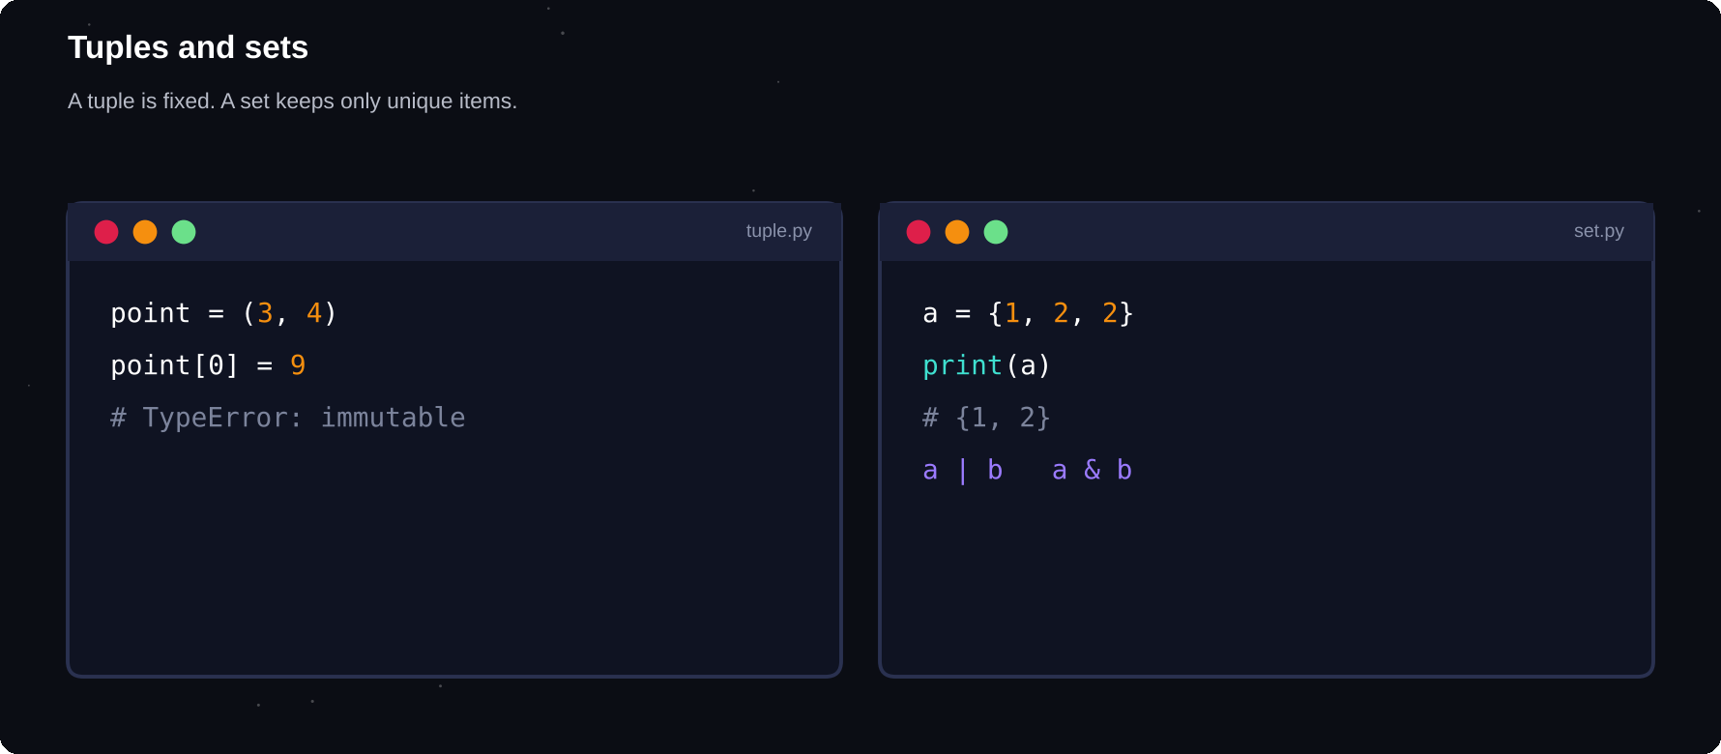
Tuples and sets
A tuple keeps its order and never changes. A set keeps only unique items and supports maths-style operations.
IN THIS CHAPTER
01 Tuples  02 The one-item tuple trap  03 Unpacking  04 When to use a tuple  05 Sets | 06 Adding and removing  07 Set operations  08 Worked example: remove duplicates  09 Worked example: who knows both?  10 Set comprehensions and speed | 11 Choosing the right container  12 Debugging corner  13 Quick quiz

Tuples
A tuple is written with round brackets. It works like a list for reading: indexing, slicing, looping, len(), in. The difference is that a tuple cannot be changed after it is created.
point = (3, 7)
colors = ("red", "green", "blue")
print(point[0], colors[-1])
print(len(colors), "red" in colors)
for c in colors:
print(c, end=" ")
» 3 blue
» 3 True
» red green blue

point = (3, 7)
point[0] = 9
» TypeError: 'tuple' object does not
» support item assignment

The one-item tuple trap
Brackets alone do not make a tuple. The comma does. A tuple with one item needs a trailing comma.
a = (5)
b = (5,)
print(type(a), type(b))
c = 1, 2, 3
print(type(c))
» <class 'int'> <class 'tuple'>
» <class 'tuple'>

Unpacking
You can spread a tuple across several variables in one line. This is how swapping works, and how a function can return several values at once.
lat, lon = (13.08, 80.27)
print(lat, lon)
def min_max(nums):
return min(nums), max(nums)

low, high = min_max([4, 9, 1, 7])
print(low, high)
» 13.08 80.27
» 1 9

When to use a tuple
Use a | When
tuple | Fixed record: (x, y), (day, month)
tuple | Dictionary keys, set members
list | A collection that grows or changes

0
changes allowed. A tuple is immutable, so it can safely be used as a dictionary key
Sets
A set is written with curly brackets. It stores unique items only, and in no particular order, so you cannot index it. Adding something that is already there does nothing.
nums = {3, 1, 3, 2, 1}
print(nums)
print(2 in nums)
print(len(nums))
empty = set()
print(type(empty))
» {1, 2, 3}
» True
» 3
» <class 'set'>

EMPTY SET
{} makes an empty dictionary, not an empty set. To create an empty set, write set().

Adding and removing
tags = {"python", "code"}
tags.add("fun")
tags.add("code")
tags.discard("zzz")
tags.remove("python")
print(sorted(tags))
» ['code', 'fun']

remove() raises an error if the item is missing, while discard() stays quiet.
Set operations
Operation | Meaning
a | b | Union: all items
a & b | Intersection: in both
a - b | Difference: in a only
a ^ b | In one but not both
a <= b | a is a subset of b

a = {1, 2, 3, 4}
b = {3, 4, 5}
print(a | b)
print(a & b)
print(a - b)
print(a ^ b)
print({3, 4} <= a)
» {1, 2, 3, 4, 5}
» {3, 4}
» {1, 2}
» {1, 2, 5}
» True

Worked example: remove duplicates
names = ["Asha", "Ravi", "Asha", "Mei"]
unique = set(names)
print(len(names), len(unique))
print(sorted(unique))
» 4 3
» ['Asha', 'Mei', 'Ravi']

Worked example: who knows both?
python = {"Asha", "Ravi", "Mei"}
java = {"Ravi", "Joe", "Mei"}
print("Both:", sorted(python & java))
print("Only Py:", sorted(python - java))
print("Either:", len(python | java))
» Both: ['Mei', 'Ravi']
» Only Py: ['Asha']
» Either: 4

Set comprehensions and speed
squares = {n * n for n in range(-3, 4)}
print(sorted(squares))
» [0, 1, 4, 9]

Checking whether something is in a set is very fast, even with millions of items, because sets use a technique called hashing. Looking through a list is slower the longer the list gets.
Choosing the right container
Type | Ordered | Changeable | Duplicates
list | Yes | Yes | Yes
tuple | Yes | No | Yes
set | No | Yes | No

COMMON MISTAKES
Trying to index a set. Writing (5) when you mean (5,). Using {} for an empty set. Putting a list inside a set: only unchangeable items such as numbers, strings and tuples can be set members.

Debugging corner
Why can a list not go inside a set?
s = {[1, 2], [3]}
» TypeError: unhashable type: 'list'

Set members must be unchangeable. Use tuples such as (1, 2) instead.
Try it yourself
1 Store a date as a tuple and unpack it into day, month and year
2 Write a function that returns the sum and the average of a list as a tuple
3 Find the unique words in a sentence
4 Given two lists, print the items that appear in both
5 Check whether two words are anagrams using sorted()
6 Find the numbers that appear only once in a list
Chapter checkpoint
1 A tuple is an ordered, unchangeable group
2 Unpacking assigns tuple items to names
3 A set holds unique, unordered items
4 Sets support union, intersection and difference
5 Use set() for an empty set
Quick quiz
Answer from memory, then check Appendix E.
1 len({1, 1, 2})
2 What is type((5))?
3 {1, 2} | {2, 3}
4 {1, 2, 3} & {2, 3, 4}
5 Can you change an item of a tuple?
6 How do you create an empty set?

CHAPTER 9
Dictionaries
A dictionary stores information under labels. Instead of remembering that index 2 is a phone number, you ask for the “phone”. Dictionaries are the backbone of Python, and they model real-world records very naturally.
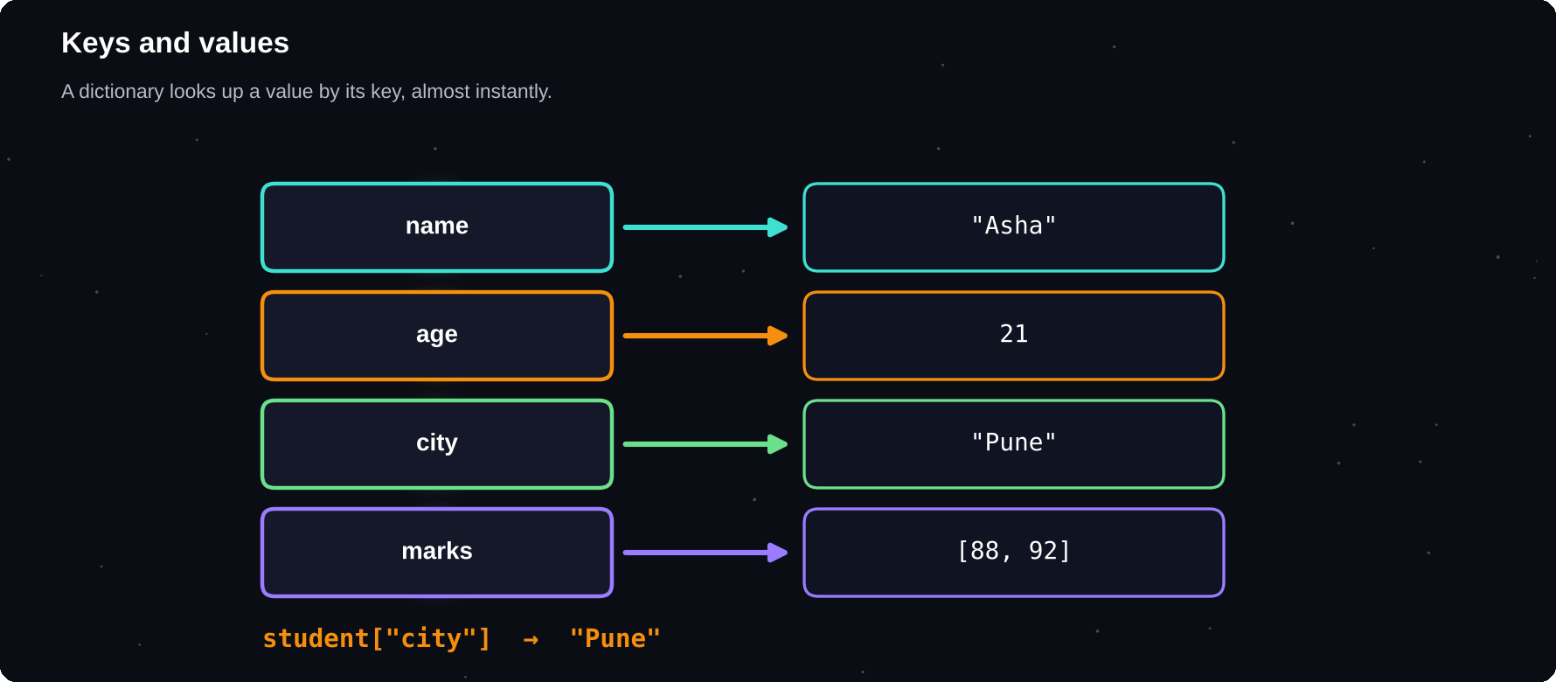
Keys and values
Each key points to one value. Looking up a key is fast, however large the dictionary is.
IN THIS CHAPTER
01 Creating a dictionary  02 Reading safely with get()  03 Adding, changing and removing  04 Keys, values and items  05 Looping over a dictionary | 06 Nested dictionaries  07 Dictionary comprehensions  08 Counting with a dictionary  09 Sorting a dictionary  10 Merging dictionaries | 11 Worked example: phone book  12 Worked example: grouping words  13 Worked example: inventory total  14 Debugging corner  15 Quick quiz

Creating a dictionary
A dictionary is written with curly brackets and pairs of key: value, separated by commas. Keys must be unique and unchangeable (strings, numbers or tuples). Values can be anything.
student = {
"name": "Asha",
"age": 21,
"skills": ["Python", "SQL"],
}
print(student["name"])
print(student["skills"][0])
print(len(student))
» Asha
» Python
» 3

Reading safely with get()
Asking for a key that does not exist raises a KeyError. The get() method returns None, or a default you choose, instead.
d = {"a": 1}
print(d["b"])
» KeyError: 'b'

d = {"a": 1}
print(d.get("b"))
print(d.get("b", 0))
» None
» 0

Adding, changing and removing
stock = {"pen": 10}
stock["book"] = 4
stock["pen"] += 5
stock.update({"ink": 2, "pen": 20})
print(stock)
del stock["ink"]
print(stock.pop("book"))
print(stock)
» {'pen': 20, 'book': 4, 'ink': 2}
» 4
» {'pen': 20}

Keys, values and items
marks = {"Asha": 88, "Ravi": 92, "Li": 79}
print(list(marks.keys()))
print(list(marks.values()))
print(list(marks.items()))
print("Ravi" in marks)
» ['Asha', 'Ravi', 'Li']
» [88, 92, 79]
» [('Asha', 88), ('Ravi', 92), ('Li', 79)]
» True

O(1)
roughly constant time to find a key. A dictionary is dramatically faster than scanning a list
Looping over a dictionary
marks = {"Asha": 88, "Ravi": 92, "Li": 79}
for name in marks:
print(name, end=" ")
print()
for name, m in marks.items():
print(f"{name:<6}{m}")
» Asha Ravi Li
» Asha 88
» Ravi 92
» Li 79

Nested dictionaries
A dictionary value can be another dictionary. This is how you represent tables of records, and it is also the shape of the JSON data you will meet in chapter 12.
people = {
"asha": {"age": 21, "city": "Goa"},
"ravi": {"age": 23, "city": "Pune"},
}
print(people["ravi"]["city"])
for k, info in people.items():
print(k, info["age"])
» Pune
» asha 21
» ravi 23

Dictionary comprehensions
squares = {n: n * n for n in range(1, 6)}
print(squares)
names = ["asha", "ravi"]
lengths = {n: len(n) for n in names}
print(lengths)
» {1: 1, 2: 4, 3: 9, 4: 16, 5: 25}
» {'asha': 4, 'ravi': 4}

Counting with a dictionary
One of the most common jobs is counting how often each item appears. Start with an empty dictionary and update it as you loop.
text = "to be or not to be"
count = {}
for w in text.split():
count[w] = count.get(w, 0) + 1
print(count)
» {'to': 2, 'be': 2, 'or': 1, 'not': 1}

Sorting a dictionary
marks = {"Asha": 88, "Ravi": 92, "Li": 79}
by_mark = sorted(marks.items(),
key=lambda p: p[1],
reverse=True)
print(by_mark)
print(max(marks, key=marks.get))
» [('Ravi', 92), ('Asha', 88), ('Li', 79)]
» Ravi

Merging dictionaries
a = {"x": 1, "y": 2}
b = {"y": 99, "z": 3}
print(a | b)
print({**a, **b})
» {'x': 1, 'y': 99, 'z': 3}
» {'x': 1, 'y': 99, 'z': 3}

When both dictionaries share a key, the value from the right-hand one wins. The | operator needs Python 3.9 or later.
Worked example: phone book
book = {"Asha": "98400", "Ravi": "98410"}
book["Mei"] = "98420"
name = "Ravi"
if name in book:
print(name, "->", book[name])
for n in sorted(book):
print(n, book[n])
» Ravi -> 98410
» Asha 98400
» Mei 98420
» Ravi 98410

Worked example: grouping words
words = ["apple", "bat", "ant", "ball"]
groups = {}
for w in words:
groups.setdefault(w[0], []).append(w)
print(groups)
» {'a': ['apple', 'ant'], 'b': ['bat',
» 'ball']}

Worked example: inventory total
items = {
"pen": {"qty": 10, "price": 7},
"book": {"qty": 4, "price": 120},
}
total = 0
for name, d in items.items():
total += d["qty"] * d["price"]
print("Stock value:", total)
» Stock value: 550

COMMON MISTAKES
Using a list as a key (use a tuple). Expecting a KeyError not to happen: use get() or in. Changing a dictionary while looping over it. Forgetting that updating an existing key replaces its old value.

Debugging corner
Deleting from a dictionary while looping over it causes an error.
d = {"a": 1, "b": 2}
for k in d:
del d[k]
» RuntimeError: dictionary changed size
» during iteration

Loop over a copy instead: for k in list(d).
Try it yourself
1 Store your own details in a dictionary and print them neatly
2 Count the letters in a word with a dictionary
3 Build a dictionary that maps numbers 1 to 5 to their cubes
4 Find the student with the highest marks from a dictionary
5 Invert a dictionary so values become keys
6 Write a program that stores and looks up phone numbers
Chapter checkpoint
1 A dictionary maps unique keys to values
2 get() reads safely. in checks for a key
3 items() gives key and value together in loops
4 Values can be lists or dictionaries
5 Use dictionaries for counting and grouping
Quick quiz
Answer from memory, then check Appendix E.
1 {"a": 1}.get("b", 0)
2 list({"x": 1, "y": 2})
3 len({"a": 1, "a": 2})
4 Which can be a key: a list or a tuple?
5 What error does d["missing"] raise?
6 {k: k * 2 for k in range(3)}

CHAPTER 10
Functions
A function is a named recipe. Write it once, then use it whenever you need it. Functions are how programmers avoid repeating themselves, and how large programs are broken into small, understandable pieces.
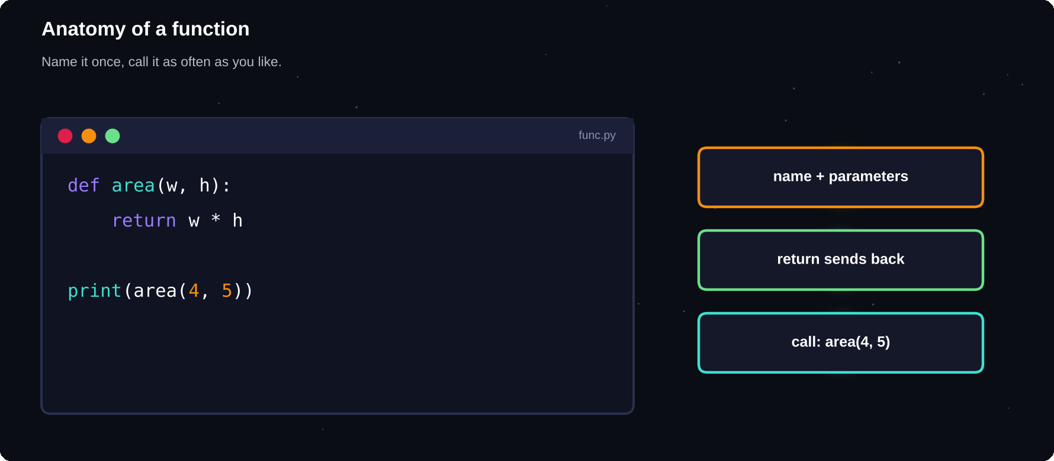
Anatomy of a function
Inputs go in as parameters. The body does the work. A result comes out with return.
IN THIS CHAPTER
01 Defining and calling  02 Parameters and arguments  03 Returning a value  04 Several parameters  05 Default values | 06 Returning several values  07 Docstrings  08 Variable scope  09 Functions calling functions  10 Worked example: temperature converter | 11 Worked example: grade function  12 Worked example: a tiny calculator  13 Why use functions?  14 Debugging corner  15 Quick quiz

Defining and calling
You define a function with def, a name, brackets and a colon. The indented body runs only when the function is called. Choose verbs for names, such as calculate_tax or print_report.
def greet():
print("Hello!")
print("Welcome to Python.")

greet()
greet()
» Hello!
» Welcome to Python.
» Hello!
» Welcome to Python.

Parameters and arguments
Parameters are the names in the definition. Arguments are the actual values you pass in when you call it.
def greet(name):
print("Hello,", name)

greet("Asha")
greet("Ravi")
» Hello, Asha
» Hello, Ravi

Returning a value
return sends a result back to the caller and ends the function. A function without return gives back None.
def square(n):
return n * n

result = square(7)
print(result)
print(square(3) + square(4))
» 49
» 25

PRINT OR RETURN?
print() shows something on the screen for a human. return hands a value back to the program so it can be stored or used in a calculation. Most functions should return their result, not print it.

Several parameters
def area(length, width):
return length * width

print(area(5, 3))
print(area(width=2, length=10))
» 15
» 20

Arguments can be given by position or by name. Naming them makes calls easier to read and lets you change the order.
Default values
Give a parameter a default and callers may leave it out. Parameters with defaults must come after those without.
def power(base, exp=2):
return base ** exp

print(power(5))
print(power(2, 10))
» 25
» 1024

Returning several values
def stats(nums):
return min(nums), max(nums), sum(nums)

lo, hi, total = stats([3, 8, 1, 6])
print(lo, hi, total)
» 1 8 18

3
values returned above, but Python is really returning one tuple that gets unpacked
Docstrings
A string placed as the first line of a function explains what it does. Tools and the help() function read it, so write one for every function you share.
def bmi(kg, m):
"""Return body mass index."""
return kg / m ** 2

print(round(bmi(68, 1.72), 1))
print(bmi.__doc__)
» 23.0
» Return body mass index.

Variable scope
Variables created inside a function are local: they exist only while the function runs. Code outside cannot see them. A function can read variables from outside, but it should normally receive them as parameters.
rate = 0.1
def tax(amount):
fee = amount * rate
return fee

print(tax(500))
» 50.0

def f():
secret = 42
f()
print(secret)
» NameError: name 'secret' is not defined

Functions calling functions
def is_even(n):
return n % 2 == 0

def describe(n):
kind = "even" if is_even(n) else "odd"
return f"{n} is {kind}"

print(describe(4))
print(describe(7))
» 4 is even
» 7 is odd

Worked example: temperature converter
def c_to_f(c):
return c * 9 / 5 + 32

def f_to_c(f):
return (f - 32) * 5 / 9

print(c_to_f(100))
print(round(f_to_c(98.6), 1))
» 212.0
» 37.0

Worked example: grade function
def grade(marks):
if marks >= 90:
return "A+"
if marks >= 75:
return "A"
if marks >= 60:
return "B"
return "C"

for m in (95, 80, 65, 40):
print(m, grade(m))
» 95 A+
» 80 A
» 65 B
» 40 C

Worked example: a tiny calculator
def calc(a, op, b):
if op == "+":
return a + b
if op == "-":
return a - b
if op == "*":
return a * b
if op == "/":
return a / b
return "Unknown operator"

print(calc(8, "*", 4))
print(calc(9, "/", 2))
print(calc(1, "^", 2))
» 32
» 4.5
» Unknown operator

Why use functions?
1 Reuse: write once, use many times
2 Clarity: a good name explains the step
3 Testing: small pieces are easy to check
4 Teamwork: people can work on separate functions
COMMON MISTAKES
Forgetting the brackets when calling (greet instead of greet()). Printing instead of returning. Using the same name for a function and a variable. Calling a function before it is defined.

Debugging corner
The function runs, but the answer is None. Why?
def add(a, b):
a + b

print(add(2, 3))
» None

The result was calculated but never returned. Write return a + b.
Try it yourself
1 Write is_prime(n) and use it to list primes under 50
2 Write a function that returns the longest word in a sentence
3 Write count_vowels(text)
4 Write a function with a default argument for a greeting
5 Write celsius_table(start, stop, step) that prints a table
6 Write a function that checks whether a password is strong
Chapter checkpoint
1 def defines a function. Calling runs it
2 Parameters receive arguments
3 return gives a value back. No return means None
4 Default values make parameters optional
5 Local variables live only inside the function
Quick quiz
Answer from memory, then check Appendix E.
1 Which keyword defines a function?
2 What does a function without return give back?
3 def f(a, b=2): return a * b. What is f(3)?
4 What is the difference between a parameter and an argument?
5 Where does a local variable exist?
6 print or return: which hands a value back to the program?

CHAPTER 11
Functions: Going Further
Once the basics feel natural, functions have more tricks to offer: take any number of arguments, pass functions around like data, call themselves, and wrap each other. These ideas appear in almost every real Python project.
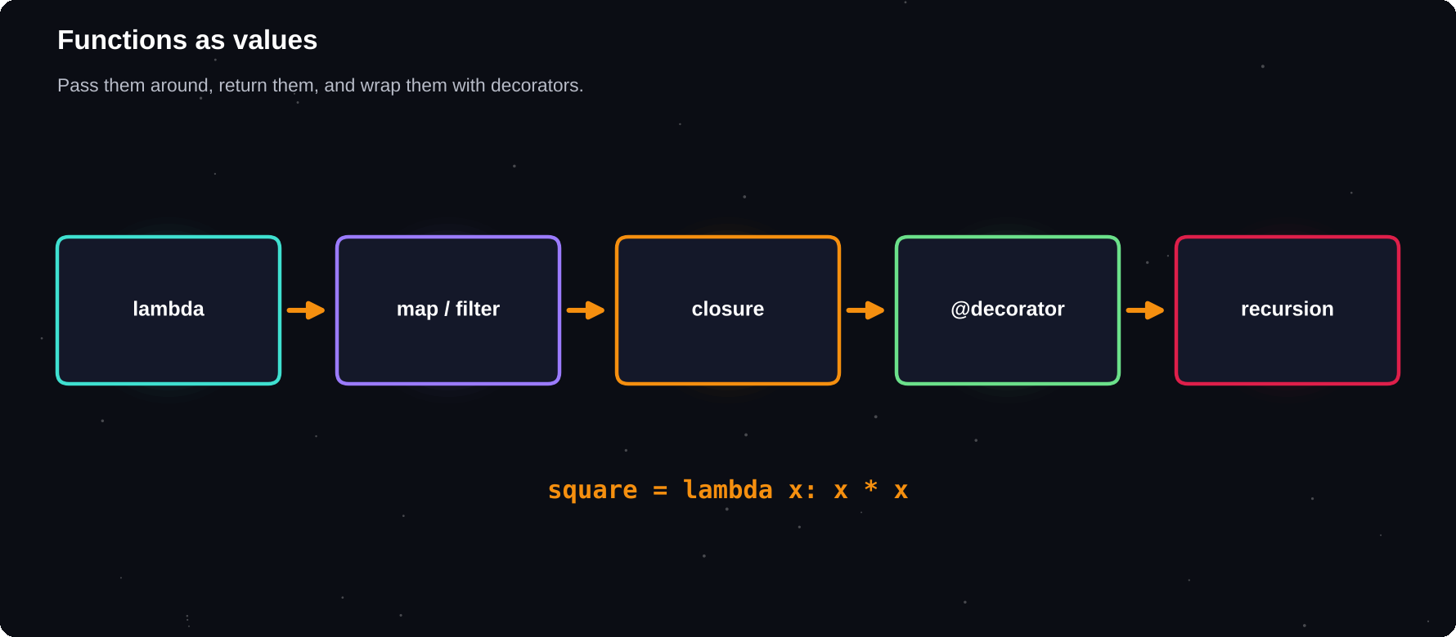
Functions as values
A function is an object. You can store it, pass it to another function and return it.
IN THIS CHAPTER
01 *args: any number of arguments  02 **kwargs: named extras  03 Unpacking when you call  04 Scope rules: LEGB  05 Lambda: tiny anonymous functions | 06 map, filter and friends  07 Recursion  08 Default argument trap  09 Type hints  10 Generators | 11 Decorators  12 Worked example: apply a function twice  13 Debugging corner  14 Quick quiz

*args: any number of arguments
A parameter starting with * collects extra positional arguments into a tuple. By convention it is called args.
def total(*nums):
return sum(nums)

print(total(1, 2))
print(total(4, 5, 6, 7))
print(total())
» 3
» 22
» 0

**kwargs: named extras
A parameter starting with ** collects extra named arguments into a dictionary.
def profile(name, **info):
print(name)
for k, v in info.items():
print(" ", k, "=", v)

profile("Asha", age=21, city="Chennai")
» Asha
» age = 21
» city = Chennai

Unpacking when you call
def add3(a, b, c):
return a + b + c

nums = [1, 2, 3]
print(add3(*nums))
data = {"a": 5, "b": 6, "c": 7}
print(add3(**data))
» 6
» 18

Scope rules: LEGB
Python looks for a name in this order: Local (inside the function), Enclosing (an outer function), Global (the file) and Built-in (like len). To change a global variable from inside a function you must declare it with global. In most cases it is cleaner to return a value instead.
count = 0
def bump():
global count
count += 1

bump()
bump()
print(count)
» 2

Lambda: tiny anonymous functions
A lambda is a one-line function without a name: lambda parameters: expression. It is handy as a short helper for sorting and filtering.
double = lambda x: x * 2
print(double(21))
pairs = [(1, "b"), (2, "a"), (3, "c")]
print(sorted(pairs, key=lambda p: p[1]))
» 42
» [(2, 'a'), (1, 'b'), (3, 'c')]

map, filter and friends
nums = [1, 2, 3, 4, 5, 6]
sq = list(map(lambda n: n * n, nums))
isev = lambda n: n % 2 == 0
ev = list(filter(isev, nums))
print(sq)
print(ev)
print(any(n > 5 for n in nums))
print(all(n > 0 for n in nums))
» [1, 4, 9, 16, 25, 36]
» [2, 4, 6]
» True
» True

Comprehensions usually read better than map and filter, but you will see both in other people's code.
Recursion
A recursive function calls itself on a smaller version of the problem. It needs a base case that stops the calls, or it would run forever. Python stops runaway recursion with an error after about a thousand calls.
def factorial(n):
if n <= 1:
return 1
return n * factorial(n - 1)

print(factorial(5))
print(factorial(10))
» 120
» 3628800

def fib(n):
if n < 2:
return n
return fib(n - 1) + fib(n - 2)

print([fib(i) for i in range(10)])
» [0, 1, 1, 2, 3, 5, 8, 13, 21, 34]

def count_down(n):
if n == 0:
print("Go!")
return
print(n)
count_down(n - 1)

count_down(3)
» 3
» 2
» 1
» Go!

Default argument trap
A default value is created once, when the function is defined. If it is a list or a dictionary, every call shares the same one. Use None as the default and create the list inside.
def add_bad(x, items=[]):
items.append(x)
return items

print(add_bad(1))
print(add_bad(2))

def add_ok(x, items=None):
if items is None:
items = []
items.append(x)
return items

print(add_ok(1), add_ok(2))
» [1]
» [1, 2]
» [1] [2]

Type hints
Type hints say what types a function expects and returns. Python does not enforce them, but editors and tools use them to catch mistakes and to document your code.
def full_name(a: str, b: str) -> str:
return a + " " + b

print(full_name("Asha", "Rao"))
» Asha Rao

Generators
A function that uses yield produces its values one at a time instead of building the whole list. This saves memory when the data is large.
def evens(limit):
n = 0
while n < limit:
yield n
n += 2

for v in evens(9):
print(v, end=" ")
print()
print(sum(evens(100)))
» 0 2 4 6 8
» 2450

Decorators
A decorator wraps a function to add behaviour without changing its code. It is written with @ above the function.
def shout(fn):
def wrapper(*a):
return fn(*a).upper() + "!"
return wrapper

@shout
def greet(name):
return "hello " + name

print(greet("asha"))
» HELLO ASHA!

Worked example: apply a function twice
def twice(fn, value):
return fn(fn(value))

print(twice(lambda x: x + 3, 10))
print(twice(str.upper, "py"))
» 16
» PY

COMMON MISTAKES
Recursion with no base case. Using a list as a default value. Forgetting that lambdas can hold only one expression. Using global for everything instead of passing values in.

Debugging corner
A recursive function without a base case never stops.
def loop(n):
return loop(n + 1)

loop(0)
» RecursionError: maximum recursion depth
» exceeded

Add a condition that returns a value without calling the function again.
Try it yourself
1 Write a function that multiplies any number of arguments
2 Sort a list of names by their last letter using a lambda
3 Write a recursive function that sums the digits of a number
4 Write a generator that yields the first n squares
5 Write a decorator that prints “start” and “end” around a function
6 Reverse a string using recursion
Chapter checkpoint
1 *args and **kwargs accept flexible arguments
2 Scope order is Local, Enclosing, Global, Built-in
3 lambda makes a tiny function. map and filter apply it
4 Recursion needs a base case
5 Never use a list as a default value
Quick quiz
Answer from memory, then check Appendix E.
1 What does *args collect?
2 What does **kwargs collect?
3 (lambda x: x + 1)(4)
4 What stops a recursive function?
5 Why avoid [] as a default value?
6 Which keyword turns a function into a generator?

CHAPTER 12
Working with Files
Variables vanish when a program ends. Files keep data safe on disk. In this chapter you will read and write text files, handle CSV tables and JSON data, and manage paths the modern way.
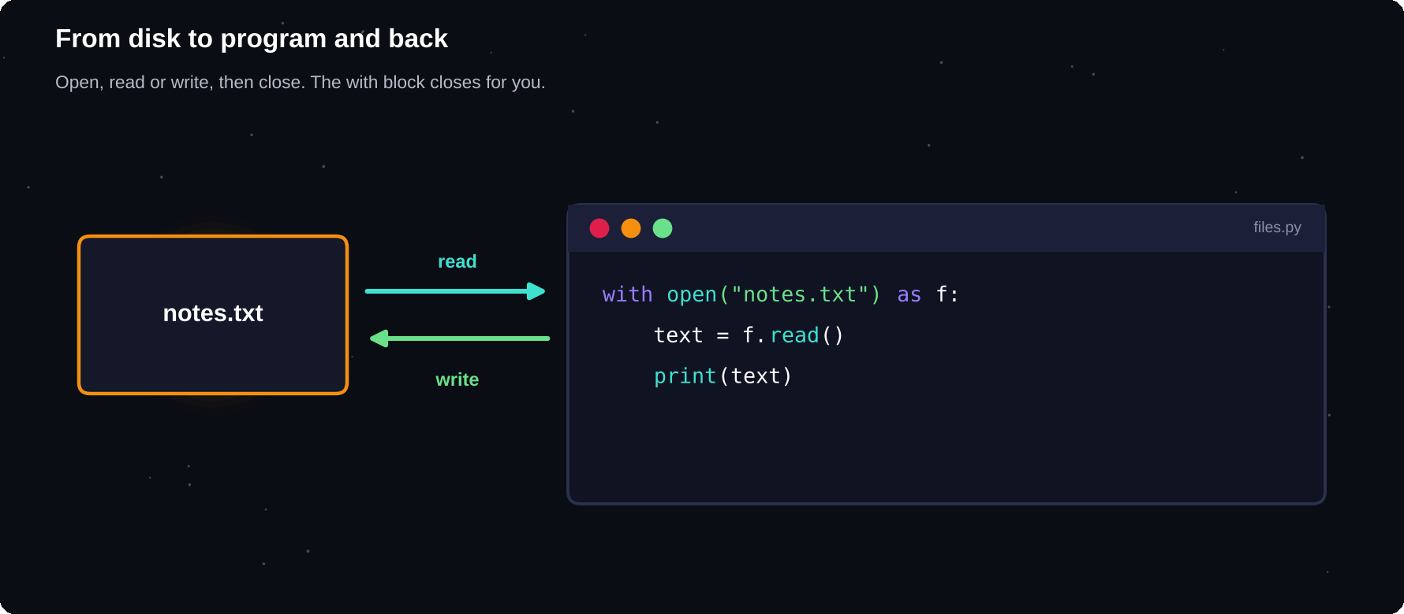
From disk to program and back
Open a file, read or write, then close it. The with statement closes it for you.
IN THIS CHAPTER
01 Writing a text file  02 Reading a text file  03 Appending  04 File not found | 05 Encoding  06 CSV files  07 JSON: the data language of the web  08 Paths with pathlib | 09 Worked example: word counter  10 Worked example: a simple note saver  11 Debugging corner  12 Quick quiz

Writing a text file
open() connects your program to a file. The first argument is the file name and the second is the mode: “w” to write (this erases anything already there), “a” to append and “r” to read. The with statement closes the file automatically, even if an error occurs.
with open("notes.txt", "w") as f:
f.write("Line one\n")
f.write("Line two\n")
print("saved")
» saved

Mode | Meaning
"r" | Read (default). File must exist
"w" | Write. Creates or erases
"a" | Append to the end
"x" | Create. Fails if it exists
"rb" | Read bytes (images, PDFs)

Reading a text file
with open("notes.txt", "w") as f:
f.write("alpha\nbeta\ngamma\n")

with open("notes.txt") as f:
text = f.read()
print(repr(text))
with open("notes.txt") as f:
for line in f:
print(line.strip())
with open("notes.txt") as f:
lines = f.readlines()
print(len(lines))
» 'alpha\nbeta\ngamma\n'
» alpha
» beta
» gamma
» 3

Looping directly over the file reads one line at a time, which is best for large files because it does not load everything into memory.
Appending
with open("log.txt", "w") as f:
f.write("start\n")
with open("log.txt", "a") as f:
f.write("more\n")
print(open("log.txt").read())
» start
» more

File not found
open("missing.txt")
» FileNotFoundError: [Errno 2] No such file
» or directory: 'missing.txt'

Encoding
Text files store characters as bytes using an encoding. Use encoding="utf-8" so that names and symbols from any language are saved correctly, especially on Windows.
enc, name = "utf-8", "h.txt"
with open(name, "w", encoding=enc) as f:
f.write("café €5\n")
with open(name, encoding=enc) as f:
print(f.read().strip())
» café €5

CSV files
CSV (comma-separated values) is the simplest table format. Spreadsheets and databases can export it. The csv module reads and writes it safely, including values that contain commas.
import csv
rows = [["name", "marks"], ["Asha", 88],
["Ravi", 92]]
with open("m.csv", "w", newline="") as f:
csv.writer(f).writerows(rows)

with open("m.csv", newline="") as f:
for row in csv.DictReader(f):
print(row["name"], row["marks"])
» Asha 88
» Ravi 92

JSON: the data language of the web
JSON stores dictionaries, lists, strings, numbers and booleans as text. It is used by almost every web service. The json module converts between Python objects and JSON text.
import json
user = {"name": "Asha", "age": 21,
"skills": ["Python", "SQL"]}
text = json.dumps(user, indent=2)
print(text)
back = json.loads(text)
print(back["skills"][1])
» {
» "name": "Asha",
» "age": 21,
» "skills": [
» "Python",
» "SQL"
» ]
» }
» SQL

import json
data = {"scores": [70, 85]}
with open("d.json", "w") as f:
json.dump(data, f)
with open("d.json") as f:
print(json.load(f))
» {'scores': [70, 85]}

2
pairs to remember: dump/load work with files, dumps/loads work with strings
Paths with pathlib
The pathlib module treats paths as objects, so the same code works on Windows, macOS and Linux. Use it instead of gluing strings together.
from pathlib import Path
p = Path("data") / "report.txt"
print(p.name, p.suffix, p.stem)
print(p.parent)
Path("data").mkdir(exist_ok=True)
p.write_text("hello")
print(p.exists(), p.read_text())
» report.txt .txt report
» data
» True hello

from pathlib import Path
Path("a.txt").write_text("x")
Path("b.txt").write_text("y")
for f in sorted(Path(".").glob("*.txt")):
print(f.name)
» a.txt
» b.txt

Worked example: word counter
from pathlib import Path
Path("story.txt").write_text(
"the cat and the hat and the bat")
text = Path("story.txt").read_text()
words = text.split()
freq = {}
for w in words:
freq[w] = freq.get(w, 0) + 1
print(freq)
» {'the': 3, 'cat': 1, 'and': 2, 'hat': 1,
» 'bat': 1}

Worked example: a simple note saver
def save_note(text):
with open("notes.log", "a") as f:
f.write(text + "\n")

def show_notes():
with open("notes.log") as f:
return f.read().splitlines()

save_note("buy milk")
save_note("call mom")
print(show_notes())
» ['buy milk', 'call mom']

COMMON MISTAKES
Opening with “w” and erasing a file you meant to keep. Forgetting that read() returns a string, not a list. Forgetting newline characters. Using a wrong relative path: the file must be in the folder the program runs from.

Debugging corner
Where did the first line go?
with open("a.txt", "w") as f:
f.write("first\n")
with open("a.txt", "w") as f:
f.write("second\n")
print(open("a.txt").read())
» second

Mode “w” erases the file each time. Use “a” to add to the end.
Try it yourself
1 Save five names to a file, one per line, and read them back
2 Count the lines and words in a text file
3 Read a CSV of marks and print the class average
4 Save a dictionary to JSON and load it again
5 Write a program that appends a timestamp-free log of user actions
6 List all .txt files in a folder with pathlib
Chapter checkpoint
1 with open() closes files automatically
2 Modes: r read, w write, a append
3 csv handles tables. json handles nested data
4 Specify encoding="utf-8" for text
5 pathlib makes paths portable
Quick quiz
Answer from memory, then check Appendix E.
1 Which mode appends to a file?
2 Why use with open(...)?
3 Which module reads and writes CSV?
4 json.load or json.loads reads from a string?
5 What does open("x.txt", "w") do to an existing file?
6 Which module treats paths as objects?

CHAPTER 13
Errors and Debugging
Real programs meet bad input, missing files and surprises. Good programmers expect trouble and handle it gracefully. They also have a method for tracking down bugs. This chapter gives you both skills.
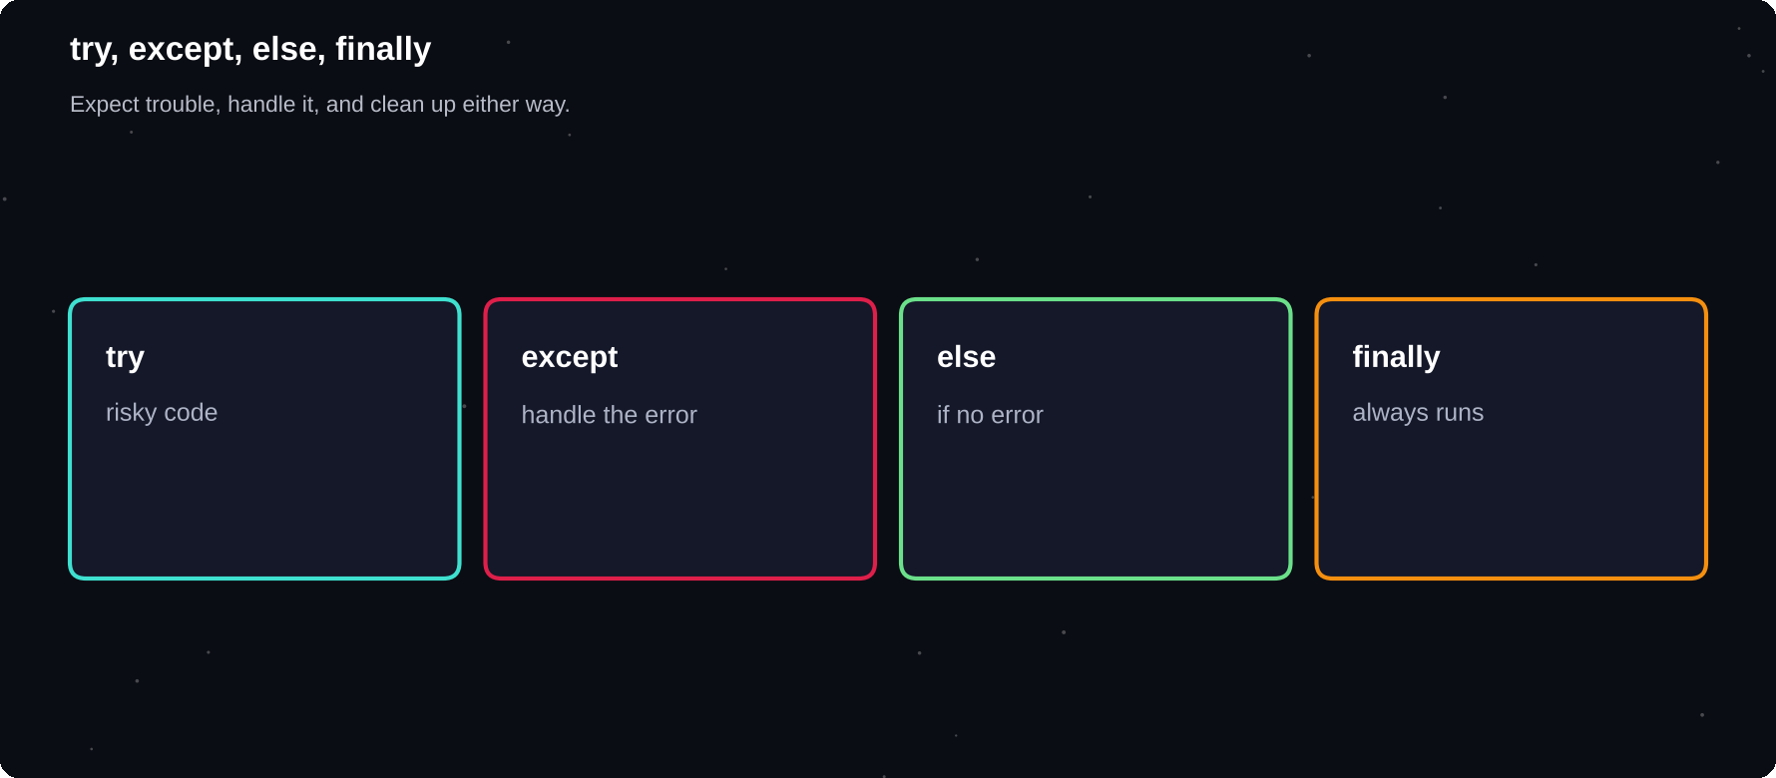
try, except, else, finally
Code that might fail goes in try. Each except catches one kind of problem. finally always runs.
IN THIS CHAPTER
01 Exceptions  02 Catching specific errors  03 else and finally  04 Getting the error message  05 Common exceptions | 06 Raising your own errors  07 Custom exceptions  08 Asking again: input validation loop  09 assert: checking your assumptions  10 Reading a traceback | 11 A debugging method  12 Logging instead of print  13 Debugger tools  14 Debugging corner  15 Quick quiz

Exceptions
When Python cannot continue, it raises an exception. If nobody handles it, the program stops and prints a traceback. You can catch an exception with try and except and decide what to do instead.
try:
n = int("abc")
print("never reached")
except ValueError:
print("That is not a number")
print("program continues")
» That is not a number
» program continues

Catching specific errors
def safe_div(a, b):
try:
return a / b
except ZeroDivisionError:
return "cannot divide by zero"
except TypeError:
return "numbers only"

print(safe_div(8, 2))
print(safe_div(8, 0))
print(safe_div(8, "x"))
» 4.0
» cannot divide by zero
» numbers only

Catch the specific exceptions you expect. A bare except: hides real bugs, because it also catches things you never intended to handle.
else and finally
def read_num(text):
try:
n = int(text)
except ValueError:
print("bad input")
else:
print("ok:", n)
finally:
print("done with", repr(text))

read_num("12")
read_num("x1")
» ok: 12
» done with '12'
» bad input
» done with 'x1'

else runs only when no exception occurred. finally runs no matter what, which makes it the right place for clean-up.
Getting the error message
try:
[1, 2, 3][5]
except IndexError as e:
print("Problem:", e)
» Problem: list index out of range

Common exceptions
Exception | Cause
ValueError | Right type, wrong value
TypeError | Wrong type for the operation
KeyError | Dictionary key missing
IndexError | List index out of range
FileNotFoundError | File does not exist
ZeroDivisionError | Divided by zero
AttributeError | Object lacks that attribute

Raising your own errors
Use raise to signal a problem when your function receives something it cannot work with. Calling code can then decide what to do.
def set_age(age):
if age < 0:
raise ValueError("negative age")
return age

try:
set_age(-5)
except ValueError as e:
print("Error:", e)
» Error: negative age

Custom exceptions
class LowBalance(Exception):
pass

def withdraw(bal, amt):
if amt > bal:
raise LowBalance("too low")
return bal - amt

try:
withdraw(100, 500)
except LowBalance as e:
print("Denied:", e)
» Denied: too low

Asking again: input validation loop
answers = iter(["abc", "-3", "25"])
while True:
try:
age = int(next(answers))
if age < 0:
raise ValueError
break
except ValueError:
print("Enter a valid age")
print("Age:", age)
» Enter a valid age
» Enter a valid age
» Age: 25

EAFP
Easier to Ask Forgiveness than Permission. Python style is to try the action and handle the failure
assert: checking your assumptions
def average(nums):
assert len(nums) > 0, "empty list"
return sum(nums) / len(nums)

print(average([2, 4, 6]))
» 4.0

def average(nums):
assert len(nums) > 0, "empty list"
return sum(nums) / len(nums)

average([])
» AssertionError: empty list

Reading a traceback
A traceback lists the calls that led to the error, with the most recent last. Start at the bottom: it names the error and the line. Then read upward to see how the program got there.
A debugging method
1 Reproduce the bug. Find the smallest input that fails
2 Read the error message and the line number
3 Print the values of variables around that line
4 Form a guess, change one thing, test again
5 Explain the code aloud, line by line, to a friend or a rubber duck
6 Fix it, then add a test so it stays fixed
def total(items):
t = 0
for p, q in items:
print("DEBUG", p, q, t)
t += p * q
return t

print(total([(10, 2), (5, 3)]))
» DEBUG 10 2 0
» DEBUG 5 3 20
» 35

Logging instead of print
The logging module lets you keep debug messages in your code and switch them on or off with a single setting, rather than deleting print calls.
import logging
fmt = "%(levelname)s: %(message)s"
logging.basicConfig(level=logging.INFO,
format=fmt)
logging.info("starting")
logging.debug("hidden detail")
logging.warning("low disk")

Debugger tools
Editors such as VS Code and PyCharm have a built-in debugger. Set a breakpoint on a line, run in debug mode and step through the code one line at a time while watching variables change. Python also has breakpoint() built in.
COMMON MISTAKES
Catching everything with a bare except. Printing nothing in the except block, so errors vanish silently. Wrapping huge blocks of code in one try. Fixing symptoms instead of the cause.

Debugging corner
A bare except hides the real problem. Which mistake is it hiding?
try:
print(totl)
except:
print("something went wrong")
» something went wrong

The variable name is misspelt, which is a NameError. Catch specific exceptions so you see real bugs.
Try it yourself
1 Write a safe number-reading function that keeps asking until valid
2 Open a file and handle FileNotFoundError politely
3 Write a function that raises ValueError for an empty name
4 Add logging to one of your earlier programs
5 Create a custom exception for an invalid password
6 Take a broken program from a friend and fix it using the debugging steps
Chapter checkpoint
1 try/except handles errors. Catch specific ones
2 else runs on success, finally always runs
3 raise signals your own problems
4 Read tracebacks from the bottom up
5 Debug by reproducing, printing, guessing and testing
Quick quiz
Answer from memory, then check Appendix E.
1 Which block always runs?
2 Which exception does int("x") raise?
3 Which keyword signals your own error?
4 Which part of a traceback do you read first?
5 Why avoid a bare except?
6 When does the else block of a try run?

CHAPTER 14
Modules and the Standard Library
You do not have to write everything yourself. Python ships with a huge standard library, and a world of packages is only one command away. This chapter shows how to import, how to tour the most useful modules and how to install more.
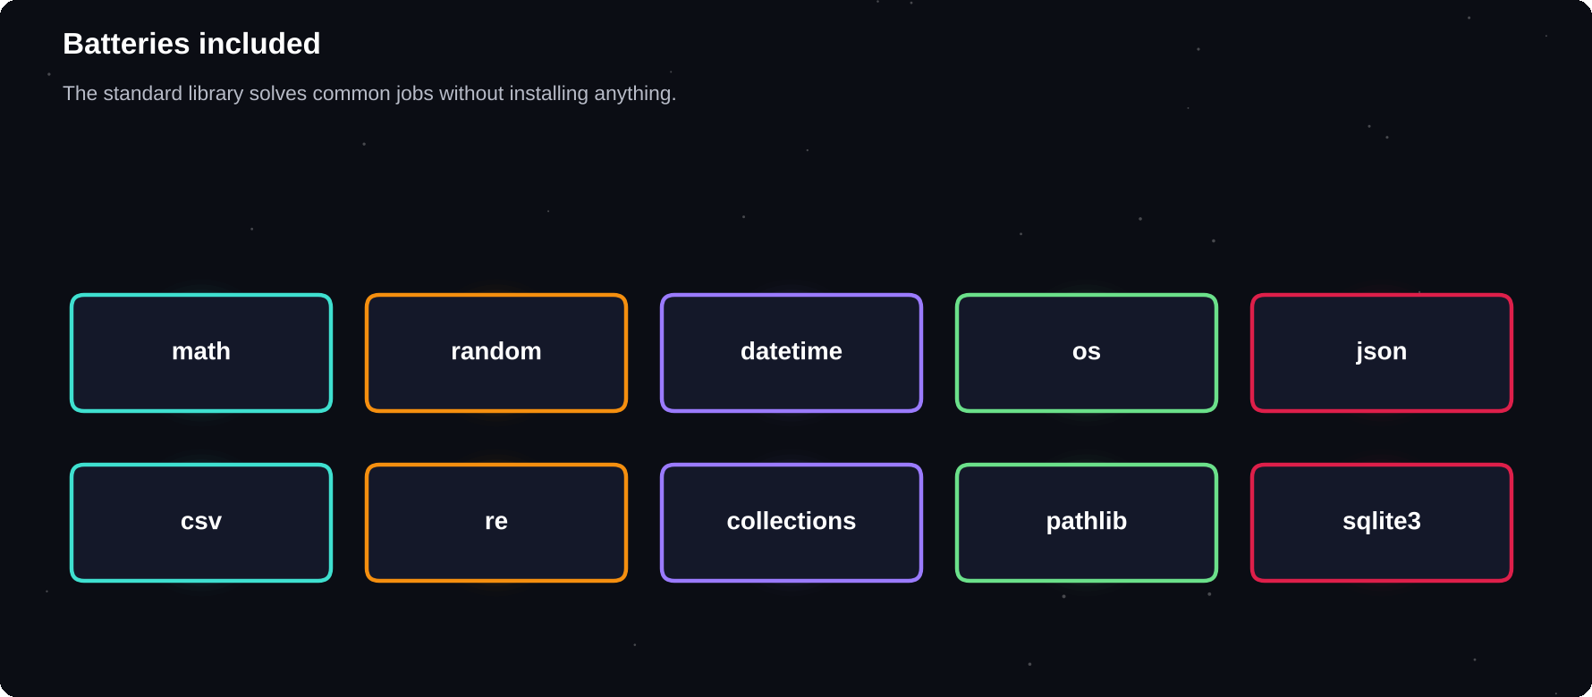
Batteries included
Standard library, your own modules, and third-party packages from PyPI.
IN THIS CHAPTER
01 What is a module?  02 Ways to import  03 Your own module  04 random  05 datetime | 06 collections  07 itertools and functools  08 os, sys and shutil  09 Installing packages with pip  10 Choosing a package safely | 11 Worked example: password generator  12 Debugging corner  13 Quick quiz

What is a module?
A module is simply a Python file full of definitions you can reuse. A package is a folder of modules. You load one with import, and then use its contents with a dot.
import math
print(math.sqrt(49))
print(math.pi)
print(math.ceil(4.1), math.floor(4.9))
» 7.0
» 3.141592653589793
» 5 4

Ways to import
Style | Use
import math | Then write math.sqrt
from math import sqrt | Then write sqrt
import numpy as np | Short alias
from math import * | Avoid: floods your names

from math import sqrt, pi as PI
import statistics as st
print(sqrt(16), round(PI, 3))
print(st.mean([2, 4, 9]))
print(st.median([2, 4, 9]))
» 4.0 3.142
» 5
» 4

Your own module
Save functions in a file such as tools.py, then import it from another file in the same folder. Code that should only run when the file is executed directly, not when it is imported, goes under an if __name__ check.
# tools.py
def double(x):
return x * 2

if __name__ == "__main__":
print(double(21)) # direct run only

# main.py
import tools
print(tools.double(5))

random
import random
random.seed(7)
print(random.randint(1, 6))
print(random.choice(["a", "b", "c"]))
cards = [1, 2, 3, 4, 5]
random.shuffle(cards)
print(len(cards), sorted(cards))
» 3
» a
» 5 [1, 2, 3, 4, 5]

Setting a seed makes random numbers repeatable, which is useful for testing. Never use random for passwords. The secrets module is made for that.
datetime
from datetime import date, datetime
from datetime import timedelta
d = date(2026, 8, 15)
print(d, d.strftime("%d %B %Y"))
print(d + timedelta(days=30))
print((date(2026, 12, 25) - d).days)
t = datetime(2026, 1, 1, 9, 30)
print(t.strftime("%H:%M on %A"))
» 2026-08-15 15 August 2026
» 2026-09-14
» 132
» 09:30 on Thursday

collections
from collections import Counter, deque
c = Counter("mississippi")
print(c.most_common(2))
q = deque([1, 2, 3])
q.append(4)
print(q.popleft(), list(q))
» [('i', 4), ('s', 4)]
» 1 [2, 3, 4]

from collections import defaultdict
from collections import namedtuple
groups = defaultdict(list)
for w in ["ant", "bee", "ape"]:
groups[w[0]].append(w)
print(dict(groups))
Point = namedtuple("Point", "x y")
p = Point(3, 4)
print(p.x, p.y, p)
» {'a': ['ant', 'ape'], 'b': ['bee']}
» 3 4 Point(x=3, y=4)

itertools and functools
from itertools import permutations
from itertools import product
print(list(permutations("abc", 2))[:3])
combos = list(product([0, 1], repeat=3))
print(len(combos))
from functools import reduce
mul = lambda a, b: a * b
print(reduce(mul, [1, 2, 3, 4]))
» [('a', 'b'), ('a', 'c'), ('b', 'a')]
» 8
» 24

os, sys and shutil
import os, sys
print(os.path.join("a", "b.txt"))
print(os.path.splitext("photo.jpg"))
print(sys.version_info.major)
print(type(os.listdir(".")))
» a/b.txt
» ('photo', '.jpg')
» 3
» <class 'list'>

Installing packages with pip
pip downloads packages from PyPI, the Python Package Index. Always install into a virtual environment so that each project keeps its own set of libraries and versions.
$ python -m venv venv
$ source venv/bin/activate # Mac/Linux
$ venv\Scripts\activate # Windows
$ pip install requests pandas
$ pip freeze > requirements.txt
$ pip install -r requirements.txt

500k+
projects on PyPI, covering almost any task you can imagine
Choosing a package safely
1 Prefer well-known packages with active maintenance
2 Read the documentation and the licence
3 Check recent releases and how many people use it
4 Install from the official index only
5 Pin versions in requirements.txt
Worked example: password generator
import secrets, string
chars = string.ascii_letters
chars += string.digits
pw = "".join(secrets.choice(chars)
for _ in range(12))
print(len(pw), pw.isalnum())
» 12 True

COMMON MISTAKES
Naming your own file the same as a module (for example random.py), which shadows the real one. Installing packages globally. Using from x import * everywhere. Forgetting to activate the virtual environment.

Debugging corner
The import fails. What are the two usual causes?
import requestz
» ModuleNotFoundError: No module named
» 'requestz'

Either the name is misspelt or the package is not installed. Check the spelling, then run pip install in the right environment.
Try it yourself
1 Use math to compute the hypotenuse of a right triangle
2 Print how many days remain until your next birthday
3 Count the most common letters in a paragraph with Counter
4 Create tools.py with three helpers and import it
5 Make a virtual environment and install one package
6 Simulate rolling two dice 1000 times and count the sums
Chapter checkpoint
1 import loads a module. from x import y loads one name
2 The standard library has math, random, datetime, collections and more
3 if __name__ == "__main__" guards script code
4 pip installs packages. Use a virtual environment
5 Never name your file like a standard module
Quick quiz
Answer from memory, then check Appendix E.
1 import math; math.sqrt(81)
2 Which command installs a package?
3 What does if __name__ == "__main__" do?
4 Why use a virtual environment?
5 Counter("aab").most_common(1)
6 Which module creates secure random values?

CHAPTER 15
Object-Oriented Programming I
Real things have data and behaviour: a car has a colour and a speed, and it can accelerate. Object-oriented programming (OOP) lets you model that in code. A class is the blueprint, and an object is one thing built from it.
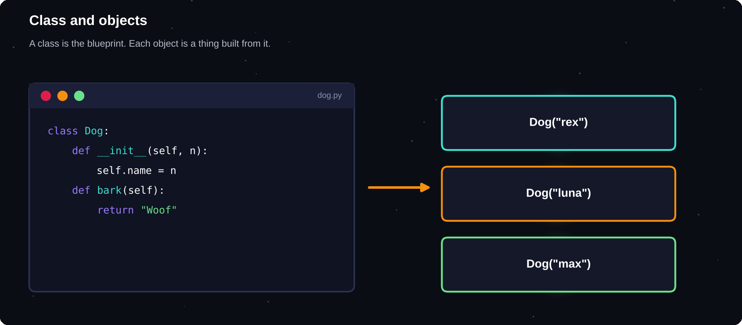
Class and objects
One class describes the pattern. Each object holds its own data.
IN THIS CHAPTER
01 Why classes?  02 Your first class  03 Attributes: data on the object  04 Methods: behaviour  05 Class attributes versus instance attributes | 06 A readable printout: __str__  07 Encapsulation: protecting data  08 Properties  09 Static and class methods  10 Worked example: a bank account | 11 Worked example: a rectangle  12 Objects in lists  13 Debugging corner  14 Quick quiz

Why classes?
So far you have kept related data in separate variables or in dictionaries. A class bundles the data and the functions that work on it into a single unit. Large programs become easier to organise, reuse and extend.
Your first class
class Dog:
def __init__(self, name, age):
self.name = name
self.age = age

def bark(self):
return f"{self.name} says Woof!"

rex = Dog("Rex", 3)
tina = Dog("Tina", 5)
print(rex.bark())
print(tina.name, tina.age)
» Rex says Woof!
» Tina 5

__init__ is the constructor. Python calls it automatically when you create an object. self is the object itself, which Python passes in as the first parameter of every method. Attributes created on self belong to that one object.
self
always the first parameter of an instance method. You never pass it yourself, Python does
Attributes: data on the object
class Car:
def __init__(self, color):
self.color = color
self.speed = 0

c = Car("red")
print(c.color, c.speed)
c.speed = 40
c.owner = "Asha"
print(c.speed, c.owner)
» red 0
» 40 Asha

Methods: behaviour
class Counter:
def __init__(self):
self.value = 0

def up(self):
self.value += 1
return self.value

def reset(self):
self.value = 0

c = Counter()
c.up(); c.up()
print(c.value)
c.reset()
print(c.value)
» 2
» 0

Class attributes versus instance attributes
An attribute written directly in the class body is shared by all objects. An attribute set on self belongs to one object.
class Student:
school = "NIT"
count = 0

def __init__(self, name):
self.name = name
Student.count += 1

a = Student("Asha")
b = Student("Ravi")
print(a.school, b.school)
print(Student.count)
» NIT NIT
» 2

A readable printout: __str__
By default, printing an object shows an unhelpful address. Define __str__ to control what print() displays and __repr__ for debugging output.
class Book:
def __init__(self, title, pages):
self.title = title
self.pages = pages

def __str__(self):
return f"{self.title} {self.pages}p"

print(Book("Python 101", 220))
» Python 101 220p

Encapsulation: protecting data
Some data should not be changed carelessly. By convention, a name starting with an underscore means “internal, please do not touch”. Methods can check values before changing them.
class Account:
def __init__(self, owner, balance=0):
self.owner = owner
self._balance = balance

def deposit(self, amt):
if amt <= 0:
raise ValueError("bad amount")
self._balance += amt

def balance(self):
return self._balance

acc = Account("Asha", 100)
acc.deposit(50)
print(acc.balance())
» 150

Properties
A property lets you use a method as if it were an attribute, with validation behind the scenes.
class Circle:
def __init__(self, r):
self.r = r

@property
def area(self):
return round(3.14 * self.r ** 2, 2)

c = Circle(2)
print(c.area)
c.r = 3
print(c.area)
» 12.56
» 28.26

Static and class methods
class Temp:
@staticmethod
def c_to_f(c):
return c * 9 / 5 + 32

@classmethod
def boiling(cls):
return cls.c_to_f(100)

print(Temp.c_to_f(37))
print(Temp.boiling())
» 98.6
» 212.0

Worked example: a bank account
class BankAccount:
def __init__(self, owner, balance=0):
self.owner = owner
self.balance = balance

def deposit(self, amt):
self.balance += amt

def withdraw(self, amt):
if amt > self.balance:
return "Insufficient funds"
self.balance -= amt
return self.balance

a = BankAccount("Asha", 500)
a.deposit(250)
print(a.withdraw(100))
print(a.withdraw(9999))
» 650
» Insufficient funds

Worked example: a rectangle
class Rect:
def __init__(self, w, h):
self.w, self.h = w, h

def area(self):
return self.w * self.h

def perimeter(self):
return 2 * (self.w + self.h)

r = Rect(4, 3)
print(r.area(), r.perimeter())
» 12 14

Objects in lists
class Item:
def __init__(self, name, price):
self.name, self.price = name, price

cart = [Item("pen", 7), Item("book", 120)]
total = sum(i.price for i in cart)
print(total)
print([i.name for i in cart])
» 127
» ['pen', 'book']

COMMON MISTAKES
Forgetting self in a method definition or when using an attribute. Writing __init__ with the wrong number of underscores. Using a mutable class attribute, such as a list, when each object needs its own. Forgetting to call the method with brackets.

Debugging corner
Every method needs self as its first parameter.
class A:
def hi():
return "hi"

A().hi()
» TypeError: A.hi() takes 0 positional
» arguments but 1 was given

Write def hi(self). Python passes the object in automatically.
Try it yourself
1 Create a Person class with a name, age and a greet() method
2 Create a Student class with a list of marks and an average() method
3 Make a Counter class with up, down and reset
4 Make a Product class and a Cart that holds several products
5 Add validation so a negative age raises ValueError
6 Add __str__ to every class you write
Chapter checkpoint
1 A class is a blueprint. An object is one instance
2 __init__ sets up a new object. self refers to it
3 Attributes hold data. Methods define behaviour
4 __str__ controls how an object prints
5 A leading underscore marks internal data
Quick quiz
Answer from memory, then check Appendix E.
1 When does __init__ run?
2 What is self?
3 What is the difference between a class and an object?
4 What does __str__ control?
5 What does a leading underscore on a name mean?
6 What does @property allow?

CHAPTER 16
Object-Oriented Programming II
Classes become really powerful when they work together. Inheritance lets one class build on another, polymorphism lets different objects respond to the same call in their own way, and special methods make your objects behave like built-in types.
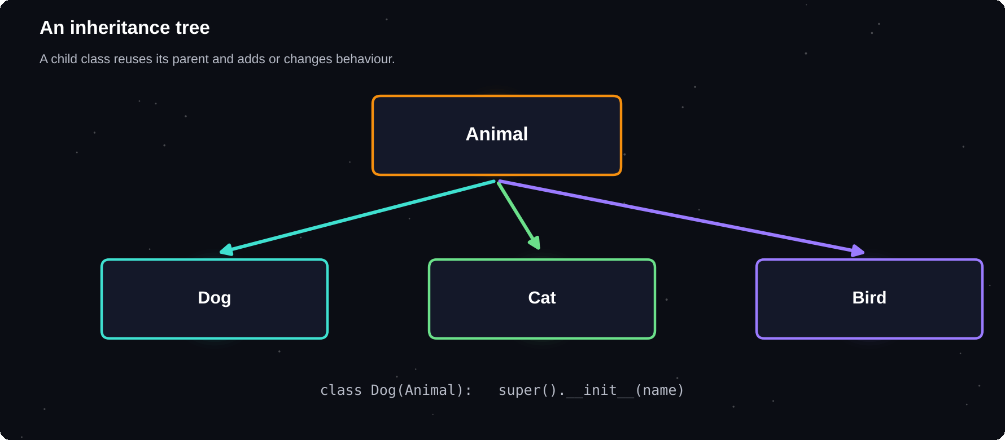
An inheritance tree
Children inherit everything from their parent, then add or replace what they need.
IN THIS CHAPTER
01 Inheritance  02 super(): reuse the parent  03 Method overriding and extending  04 Polymorphism | 05 isinstance and issubclass  06 Special (dunder) methods  07 Composition: has-a  08 Abstract base classes | 09 Dataclasses: less boilerplate  10 Worked example: shapes with inheritance  11 Debugging corner  12 Quick quiz

Inheritance
A subclass inherits the attributes and methods of its parent class. Put the common parts in the parent, and only the differences in the children. You name the parent in brackets after the class name.
class Animal:
def __init__(self, name):
self.name = name

def speak(self):
return "..."

class Dog(Animal):
def speak(self):
return "Woof"

class Cat(Animal):
def speak(self):
return "Meow"

d = Dog("Rex")
print(d.name, d.speak())
print(Cat("Tina").speak())
» Rex Woof
» Meow

super(): reuse the parent
class Person:
def __init__(self, name):
self.name = name

class Student(Person):
def __init__(self, name, roll):
super().__init__(name)
self.roll = roll

s = Student("Asha", 101)
print(s.name, s.roll)
» Asha 101

Method overriding and extending
class Employee:
def __init__(self, name, base):
self.name, self.base = name, base

def pay(self):
return self.base

class Manager(Employee):
def pay(self):
return super().pay() + 5000

print(Employee("Ravi", 30000).pay())
print(Manager("Asha", 30000).pay())
» 30000
» 35000

Polymorphism
Polymorphism means “many forms”. Different classes provide the same method name, so calling code can treat them alike and each object does the right thing.
class Circle:
def __init__(self, r): self.r = r
def area(self): return 3.14 * self.r ** 2

class Square:
def __init__(self, s): self.s = s
def area(self): return self.s ** 2

for shape in [Circle(1), Square(2)]:
print(round(shape.area(), 2))
» 3.14
» 4

is-a
inheritance should describe an “is a” relationship: a Dog is an Animal
isinstance and issubclass
class A: pass
class B(A): pass
b = B()
print(isinstance(b, B), isinstance(b, A))
print(issubclass(B, A), isinstance(5, int))
» True True
» True True

Special (dunder) methods
Methods with double underscores on both sides let your objects work with Python's operators and functions.
Method | Used by
__str__ | print(obj), str(obj)
__repr__ | Debug display
__len__ | len(obj)
__eq__ | obj1 == obj2
__add__ | obj1 + obj2
__lt__ | obj1 < obj2, sorting
__getitem__ | obj[i]

class Vec:
def __init__(self, x, y):
self.x, self.y = x, y

def __add__(self, o):
return Vec(self.x+o.x, self.y+o.y)

def __eq__(self, o):
return (self.x, self.y) == (o.x, o.y)

def __str__(self):
return f"Vec({self.x}, {self.y})"

print(Vec(1, 2) + Vec(3, 4))
print(Vec(1, 1) == Vec(1, 1))
» Vec(4, 6)
» True

class Playlist:
def __init__(self, songs):
self.songs = songs
def __len__(self):
return len(self.songs)
def __getitem__(self, i):
return self.songs[i]

p = Playlist(["a", "b", "c"])
print(len(p), p[1])
for s in p:
print(s, end=" ")
» 3 b
» a b c

Composition: has-a
Inheritance is not always the answer. Often it is better for one object to contain another. A Car has an Engine. It is not an Engine.
class Engine:
def start(self):
return "Engine on"

class Car:
def __init__(self):
self.engine = Engine()

def start(self):
return self.engine.start() + ", go!"

print(Car().start())
» Engine on, go!

Abstract base classes
An abstract class defines methods that every subclass must provide. Python refuses to create an object of a class that has missing abstract methods.
from abc import ABC, abstractmethod

class Shape(ABC):
@abstractmethod
def area(self): ...

class Sq(Shape):
def __init__(self, s): self.s = s
def area(self): return self.s ** 2

print(Sq(3).area())
try:
Shape()
except TypeError:
print("cannot create Shape")
» 9
» cannot create Shape

Dataclasses: less boilerplate
A dataclass writes __init__, __repr__ and __eq__ for you, based on the fields you list. It is perfect for classes that mostly hold data.
from dataclasses import dataclass

@dataclass
class Point:
x: int
y: int = 0

p = Point(3)
print(p)
print(p == Point(3, 0))
» Point(x=3, y=0)
» True

Worked example: shapes with inheritance
class Shape:
def __init__(self, name):
self.name = name
def describe(self):
a = self.area()
return f"{self.name}: {a:.1f}"

class Rect(Shape):
def __init__(self, w, h):
super().__init__("Rect")
self.w, self.h = w, h
def area(self):
return self.w * self.h

print(Rect(4, 2.5).describe())
» Rect: 10.0

COMMON MISTAKES
Forgetting super().__init__() so the parent never sets its attributes. Using inheritance when composition is clearer. Making deep chains of subclasses that nobody can follow. Overriding a method with different parameters.

Debugging corner
The child class forgot to call the parent's __init__.
class P:
def __init__(self, n):
self.name = n

class S(P):
def __init__(self, n, r):
self.roll = r

print(S("a", 1).name)
» AttributeError: 'S' object has no
» attribute 'name'

Add super().__init__(n) as the first line of the child's __init__.
Try it yourself
1 Build Vehicle, Car and Bike classes with a describe() method
2 Make a Library that holds Book objects and can search by title
3 Add __lt__ to Student so a list of students sorts by marks
4 Create a dataclass for a Movie with title, year and rating
5 Write an abstract Payment class with Card and UPI subclasses
6 Overload + for a Money class that has an amount
Chapter checkpoint
1 class Child(Parent) inherits from Parent
2 super() calls the parent's version
3 Polymorphism: same method name, different behaviour
4 Dunder methods connect objects to operators
5 Use composition for has-a relationships
Quick quiz
Answer from memory, then check Appendix E.
1 How do you make Dog inherit from Animal?
2 What does super() do?
3 What is polymorphism?
4 Which dunder method lets objects use +?
5 What is a has-a relationship called?
6 Which methods does @dataclass write for you?

CHAPTER 17
Libraries for Data and the Web
Python's greatest strength is its ecosystem. With a few lines you can crunch numbers, analyse a spreadsheet, draw a chart or fetch data from the internet. This chapter is a guided tour of the libraries you are most likely to use first.
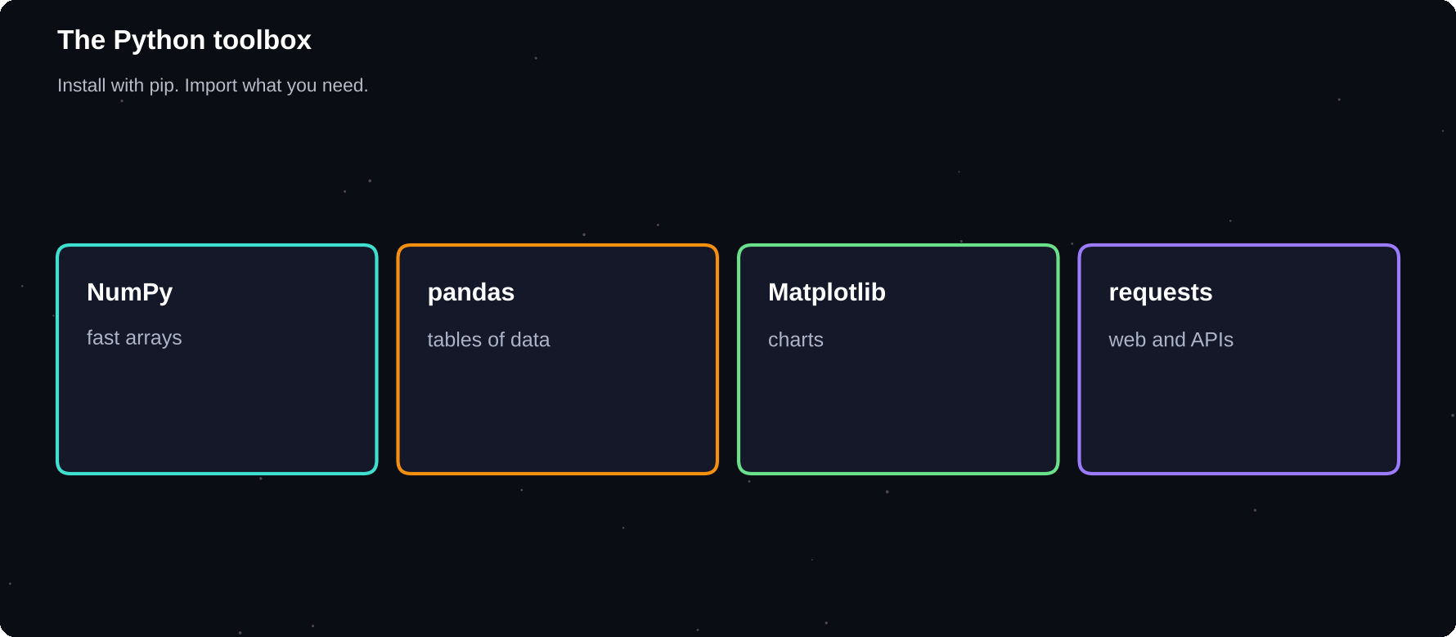
The Python toolbox
Each library does one job well. Together they cover data, charts and the web.
IN THIS CHAPTER
01 Installing the tools  02 NumPy: fast numbers  03 pandas: tables of data  04 Matplotlib: charts | 05 requests: talking to the web  06 Other libraries to know  07 A built-in database: sqlite3  08 Worked example: analyse a small dataset | 09 Debugging corner  10 Quick quiz

Installing the tools
$ pip install numpy pandas matplotlib
$ pip install requests

Install into a virtual environment, as shown in chapter 14. Then import each library with its usual short alias.
NumPy: fast numbers
NumPy gives you arrays: grids of numbers stored compactly, with operations that apply to every item at once. This is far faster than looping, and it is the foundation of scientific Python.
import numpy as np
a = np.array([1, 2, 3, 4])
print(a * 10)
print(a.mean(), a.sum(), a.max())
print(a[a > 2])
print(np.arange(0, 10, 3))
» [10 20 30 40]
» 2.5 10 4
» [3 4]
» [0 3 6 9]

import numpy as np
m = np.array([[1, 2], [3, 4]])
print(m.shape)
print(m.T)
print(m @ m)
print(np.zeros((2, 3)))
» (2, 2)
» [[1 3]
» [2 4]]
» [[ 7 10]
» [15 22]]
» [[0. 0. 0.]
» [0. 0. 0.]]

100x
typical speed-up from replacing a Python loop with a NumPy array operation on large data
pandas: tables of data
pandas works with DataFrames, which are like spreadsheets in code. You can load files, filter rows, add columns and compute summaries in a few lines.
import pandas as pd
df = pd.DataFrame({
"name": ["Asha", "Ravi", "Mei", "Joe"],
"dept": ["IT", "IT", "CS", "CS"],
"marks": [88, 92, 79, 85]})
print(df)
print(df["marks"].mean())
» name dept marks
» 0 Asha IT 88
» 1 Ravi IT 92
» 2 Mei CS 79
» 3 Joe CS 85
» 86.0

import pandas as pd
df = pd.DataFrame({
"dept": ["IT", "IT", "CS", "CS"],
"marks": [88, 92, 79, 85]})
print(df[df["marks"] > 84])
print(df.groupby("dept")["marks"].mean())
df["pass"] = df["marks"] >= 80
print(df)
» dept marks
» 0 IT 88
» 1 IT 92
» 3 CS 85
» dept
» CS 82.0
» IT 90.0
» Name: marks, dtype: float64
» dept marks pass
» 0 IT 88 True
» 1 IT 92 True
» 2 CS 79 False
» 3 CS 85 True

Task | pandas
Read a CSV | pd.read_csv("f.csv")
First rows | df.head()
Summary | df.describe()
Sort | df.sort_values("col")
Missing values | df.dropna()
Save | df.to_csv("o.csv")

Matplotlib: charts
Matplotlib draws line charts, bar charts, histograms and more. Create a figure, plot your data, label it and save or show it.
import matplotlib.pyplot as plt
days = ["Mon", "Tue", "Wed", "Thu"]
hours = [2, 3.5, 1, 4]
plt.bar(days, hours, color="teal")
plt.title("Study hours")
plt.ylabel("Hours")
plt.savefig("study.png") # or plt.show()

import matplotlib
matplotlib.use("Agg")
import matplotlib.pyplot as plt
plt.plot([1, 2, 3], [2, 4, 9])
plt.savefig("line.png")
import os
print(os.path.exists("line.png"))
» True

requests: talking to the web
The requests library fetches web pages and APIs. An API is a web address that returns data, usually as JSON. Always check the status code and handle errors.
import requests
url = "https://api.example.com/users/1"
r = requests.get(url, timeout=10)
if r.status_code == 200:
data = r.json()
print(data["name"])
else:
print("Failed:", r.status_code)

BE POLITE ONLINE
Read a site's terms and robots rules before collecting data. Use timeouts, do not send requests too quickly, and never publish private data you collect.

Other libraries to know
Library | Use it for
Flask / FastAPI | Websites and APIs
Django | Large web applications
scikit-learn | Machine learning
Pillow | Images
BeautifulSoup | Reading web pages
pytest | Testing
Tkinter / PyGame | Windows and games
SQLite3 | Databases (built in)

A built-in database: sqlite3
import sqlite3
db = sqlite3.connect(":memory:")
db.execute("CREATE TABLE t (n TEXT, m INT)")
db.executemany("INSERT INTO t VALUES (?, ?)",
[("Asha", 88), ("Ravi", 92)])
for row in db.execute("SELECT * FROM t"):
print(row)
q = "SELECT AVG(m) FROM t"
print(db.execute(q).fetchone())
» ('Asha', 88)
» ('Ravi', 92)
» (90.0,)

Worked example: analyse a small dataset
import pandas as pd
df = pd.DataFrame({
"month": ["Jan", "Feb", "Mar"],
"sales": [120, 150, 135]})
best = df.loc[df["sales"].idxmax(), "month"]
print("Best month:", best)
print("Total:", df["sales"].sum())
g = df["sales"].pct_change()
df["growth"] = g.round(2)
print(df)
» Best month: Feb
» Total: 405
» month sales growth
» 0 Jan 120 NaN
» 1 Feb 150 0.25
» 2 Mar 135 -0.10

COMMON MISTAKES
Looping over a DataFrame row by row when a column operation would do. Forgetting that a library must be installed before you import it. Calling plt.show() on a server with no screen. Not handling missing data.

Debugging corner
A column name must match exactly, including capitals.
import pandas as pd
df = pd.DataFrame({"marks": [80, 90]})
print(df["Marks"])
» KeyError: 'Marks'

Use df["marks"], or print df.columns to see the real names.
Try it yourself
1 Use NumPy to compute the mean and standard deviation of 10 numbers
2 Create a DataFrame of five students and find who has the top marks
3 Plot a line chart of the squares from 1 to 10
4 Read a CSV file with pandas and print its first 3 rows
5 Group a DataFrame by a column and plot the averages
6 Use sqlite3 to store and query three records
Chapter checkpoint
1 NumPy arrays calculate on whole columns of numbers at once
2 pandas DataFrames are tables you can filter and group
3 Matplotlib draws charts
4 requests fetches web data. Always check the status
5 Install packages with pip in a virtual environment
Quick quiz
Answer from memory, then check Appendix E.
1 Which library provides fast arrays?
2 What is the main pandas table type?
3 Which library draws charts?
4 Which HTTP status code means success?
5 np.array([1, 2, 3]).sum()
6 Which built-in module works with SQLite databases?

CHAPTER 18
Algorithms and Problem Solving
An algorithm is a step-by-step method for solving a problem. Choosing a good one can make a program a thousand times faster. This chapter teaches the classic algorithms every IT student should know, and the habits of mind behind them.
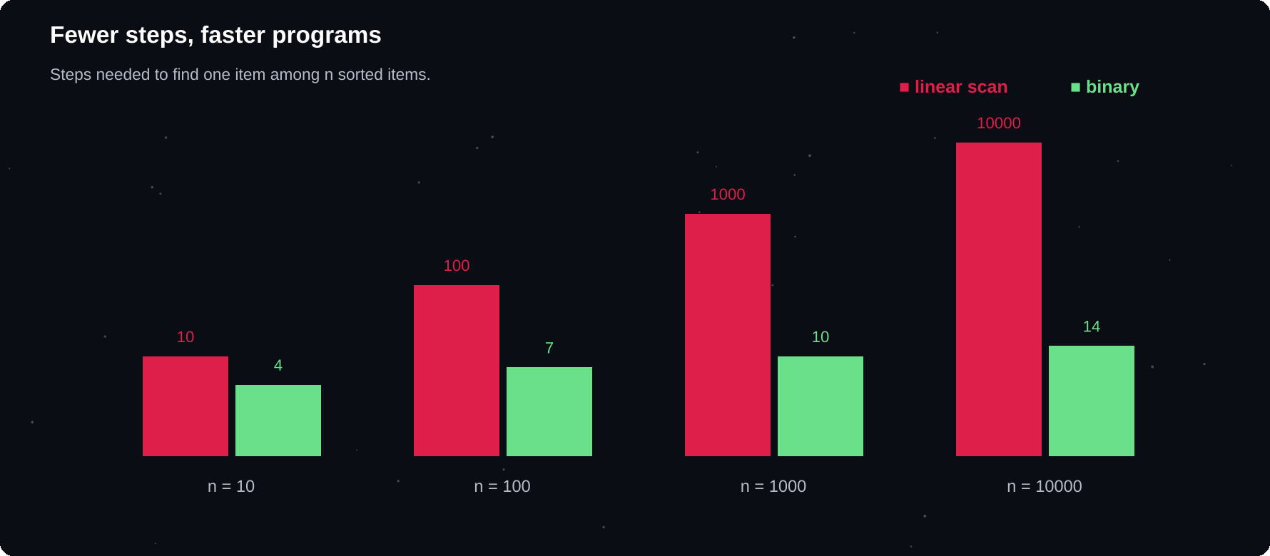
Fewer steps, faster programs
Binary search needs only a handful of steps where a simple scan would need thousands.
IN THIS CHAPTER
01 How to solve a problem  02 Linear search  03 Binary search  04 Big-O: describing growth  05 Bubble sort | 06 Selection and insertion sort  07 Merge sort: divide and conquer  08 Trade memory for speed: hashing  09 Stacks: last in, first out  10 Queues: first in, first out | 11 Dynamic programming: remember results  12 Greedy choices  13 Worked example: find the missing number  14 Debugging corner  15 Quick quiz

How to solve a problem
1 Understand: restate the problem and try a small example by hand
2 Plan: write the steps in plain words or pseudo-code
3 Code: translate one step at a time
4 Test: normal input, empty input, and awkward input
5 Improve: can it be simpler or faster?
Most beginners jump straight to step 3. Slowing down for steps 1 and 2 saves far more time than it costs.
Linear search
Look at every item in turn until you find the target. It works on any list, sorted or not.
def linear(items, target):
for i, x in enumerate(items):
if x == target:
return i
return -1

print(linear([4, 8, 15, 16], 15))
print(linear([4, 8, 15, 16], 99))
» 2
» -1

Binary search
On a sorted list you can do much better. Look at the middle item. If it is too big, discard the right half. If it is too small, discard the left half. Each step halves the problem.
def binary(items, t):
lo, hi, steps = 0, len(items) - 1, 0
while lo <= hi:
steps += 1
mid = (lo + hi) // 2
if items[mid] == t:
return mid, steps
if items[mid] < t:
lo = mid + 1
else:
hi = mid - 1
return -1, steps

data = list(range(0, 2000, 2))
print(binary(data, 1234))
print(binary(data, 7))
» (617, 10)
» (-1, 10)

10
steps or fewer to find any item among 1,000 sorted values. A linear scan may need all 1,000
Big-O: describing growth
Big-O notation says how the work grows as the input size n grows. It ignores small details and keeps the shape of the growth.
Big-O | Name | Example
O(1) | Constant | Dict lookup
O(log n) | Logarithmic | Binary search
O(n) | Linear | Scan a list
O(n log n) | Log-linear | Good sorts
O(n²) | Quadratic | Nested loops
O(2ⁿ) | Exponential | Naive fib(n)

Bubble sort
Compare neighbours and swap them if they are in the wrong order. Repeat until a pass makes no swaps. It is easy to understand, but slow for large lists: O(n²).
def bubble(a):
a = a[:]
n = len(a)
for i in range(n - 1):
swapped = False
for j in range(n - 1 - i):
if a[j] > a[j + 1]:
a[j], a[j+1] = a[j+1], a[j]
swapped = True
if not swapped:
break
return a

print(bubble([5, 2, 9, 1, 7]))
» [1, 2, 5, 7, 9]

Selection and insertion sort
def selection(a):
a = a[:]
for i in range(len(a)):
m = min(range(i, len(a)),
key=lambda k: a[k])
a[i], a[m] = a[m], a[i]
return a

def insertion(a):
a = a[:]
for i in range(1, len(a)):
key, j = a[i], i - 1
while j >= 0 and a[j] > key:
a[j + 1] = a[j]
j -= 1
a[j + 1] = key
return a

print(selection([29, 10, 14, 37, 13]))
print(insertion([29, 10, 14, 37, 13]))
» [10, 13, 14, 29, 37]
» [10, 13, 14, 29, 37]

Merge sort: divide and conquer
Split the list in half, sort each half by recursion, then merge the two sorted halves. It runs in O(n log n), which is why it is a model for how fast sorting can be.
def merge_sort(a):
if len(a) <= 1:
return a
mid = len(a) // 2
left = merge_sort(a[:mid])
right = merge_sort(a[mid:])
out = []
while left and right:
if left[0] <= right[0]:
out.append(left.pop(0))
else:
out.append(right.pop(0))
return out + left + right

print(merge_sort([38, 27, 43, 3, 9, 82, 10]))
» [3, 9, 10, 27, 38, 43, 82]

IN REAL CODE
Use the built-in sorted() and list.sort(). They use Timsort, a fast hybrid algorithm, and they are far quicker than anything you would write by hand. Writing sorts yourself is for learning.

Trade memory for speed: hashing
A dictionary lookup takes about the same time whatever its size. Remembering what you have seen in a dictionary can turn a slow nested loop into a single pass.
def two_sum(nums, target):
seen = {}
for i, n in enumerate(nums):
if target - n in seen:
return seen[target - n], i
seen[n] = i
return None

print(two_sum([2, 7, 11, 15], 9))
print(two_sum([3, 2, 4], 6))
» (0, 1)
» (1, 2)

Stacks: last in, first out
A stack suits problems where the most recent item must be dealt with first, such as matching brackets or undoing actions.
def balanced(s):
pairs = {")": "(", "]": "[", "}": "{"}
stack = []
for ch in s:
if ch in "([{":
stack.append(ch)
elif ch in pairs:
top = stack and stack.pop()
if top != pairs[ch]:
return False
return not stack

print(balanced("{[()]}"))
print(balanced("([)]"))
print(balanced("(("))
» True
» False
» False

Queues: first in, first out
from collections import deque
line = deque(["Asha", "Ravi"])
line.append("Mei")
print(line.popleft())
print(list(line))
» Asha
» ['Ravi', 'Mei']

Dynamic programming: remember results
If a problem keeps solving the same small questions again and again, store the answers. The naive Fibonacci recursion from chapter 11 repeats work exponentially. A cache makes it instant.
from functools import cache

@cache
def fib(n):
if n < 2:
return n
return fib(n - 1) + fib(n - 2)

print(fib(50))
» 12586269025

def stairs(n):
a, b = 1, 1
for _ in range(n - 1):
a, b = b, a + b
return b

print([stairs(n) for n in range(1, 8)])
» [1, 2, 3, 5, 8, 13, 21]

Greedy choices
def change(amount, coins=(50, 20, 10, 5, 1)):
out = []
for c in coins:
while amount >= c:
amount -= c
out.append(c)
return out

print(change(87))
» [50, 20, 10, 5, 1, 1]

A greedy algorithm always takes the best-looking choice right now. It works for this set of coins, but greedy methods do not always give the best answer, so test them carefully.
Worked example: find the missing number
nums = [0, 1, 2, 4, 5, 6]
n = len(nums)
missing = n * (n + 1) // 2 - sum(nums)
print(missing)
» 3

COMMON MISTAKES
Binary search on an unsorted list. Off-by-one errors in loop limits. Optimising before the program is correct. Forgetting that a recursive solution needs a base case. Using list.pop(0) in a long loop, which is slow. Use deque instead.

Debugging corner
What goes wrong with binary search on unsorted data?
def has(items, t):
lo, hi = 0, len(items) - 1
while lo <= hi:
mid = (lo + hi) // 2
if items[mid] == t:
return True
if items[mid] < t:
lo = mid + 1
else:
hi = mid - 1
return False

print(has([3, 1, 2, 5, 4], 1))
» False

The list is not sorted, so the answer is wrong. Sort first, or use a scan.
Try it yourself
1 Write a function that returns the position where a value should be inserted in a sorted list
2 Count how many comparisons bubble sort makes on a reversed list of 10 items
3 Find the first repeated item in a list using a set
4 Check whether two strings are anagrams in O(n) using a dictionary
5 Implement a queue with two stacks
6 Compute the nth Fibonacci number with a loop and with a cache
Chapter checkpoint
1 An algorithm is a step-by-step method
2 Binary search needs a sorted list and halves the work each step
3 Big-O describes how work grows with input size
4 Dictionaries and sets give fast lookups
5 Stacks, queues and caching solve whole families of problems
Quick quiz
Answer from memory, then check Appendix E.
1 What must be true of a list before binary search?
2 What is the Big-O of a simple scan of a list?
3 What does Big-O describe?
4 Which data structure matches brackets?
5 Which collection gives fast removal from the front?
6 What does @cache do for fib(n)?

CHAPTER 19
Databases with SQL and SQLite
Files are fine for small data, but real applications keep their data in databases. SQL is the language every database understands. Python includes SQLite, a complete database that lives in a single file, so you can practise without installing anything.
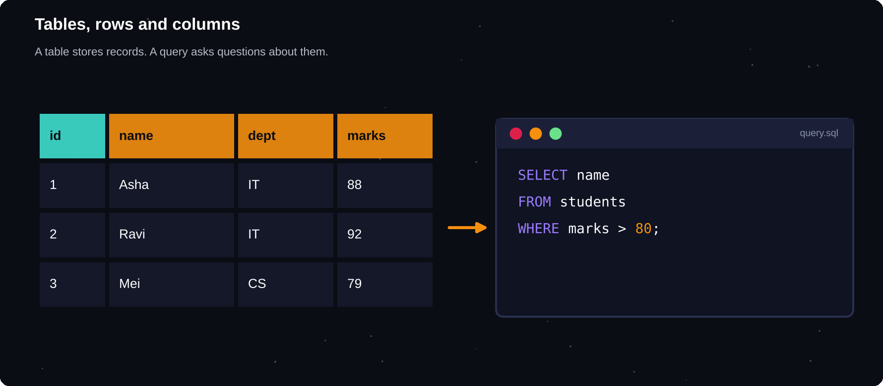
Tables, rows and columns
A table stores records. A query asks questions about them.
IN THIS CHAPTER
01 What is a relational database?  02 Connect and create a table  03 Insert rows safely  04 SELECT: asking questions | 05 UPDATE and DELETE  06 Reading rows by column name  07 Joining two tables  08 Transactions | 09 Worked example: a contact book  10 pandas and SQL together  11 Debugging corner  12 Quick quiz

What is a relational database?
A relational database stores data in tables. Each row is one record, and each column is one field. A primary key is a column whose value is unique for every row. Tables are linked together using keys.
SQL
Structured Query Language: the standard language for creating, reading, changing and deleting data
Connect and create a table
sqlite3 is built into Python. Using ":memory:" keeps the database in memory so nothing is saved. Give a file name such as "school.db" to keep it on disk.
import sqlite3
db = sqlite3.connect(":memory:")
db.execute("""
CREATE TABLE students (
id INTEGER PRIMARY KEY,
name TEXT NOT NULL,
dept TEXT,
marks INTEGER
)""")
print("table created")
» table created

Insert rows safely
Always pass values using ? placeholders, never by pasting them into the SQL string. Placeholders stop SQL injection, a classic attack in which a user types SQL into an input box.
import sqlite3
db = sqlite3.connect(":memory:")
db.execute("CREATE TABLE s (name, dept, m)")
rows = [("Asha", "IT", 88),
("Ravi", "IT", 92),
("Mei", "CS", 79)]
sql = "INSERT INTO s VALUES (?, ?, ?)"
db.executemany(sql, rows)
db.commit()
q = "SELECT COUNT(*) FROM s"
print(db.execute(q).fetchone())
» (3,)

SELECT: asking questions
SQL | Meaning
SELECT * FROM t | All columns, all rows
SELECT a, b FROM t | Chosen columns
WHERE marks > 80 | Filter rows
ORDER BY marks DESC | Sort
LIMIT 3 | First 3 rows
COUNT, SUM, AVG | Summaries
GROUP BY dept | One result per group

import sqlite3
db = sqlite3.connect(":memory:")
T = "CREATE TABLE s (name, dept, marks)"
db.execute(T)
I = "INSERT INTO s VALUES (?, ?, ?)"
db.executemany(I, [
("Asha", "IT", 88), ("Ravi", "IT", 92),
("Mei", "CS", 79), ("Joe", "CS", 85)])
q = """SELECT name, marks FROM s
WHERE marks > 80
ORDER BY marks DESC"""
for row in db.execute(q):
print(row)
» ('Ravi', 92)
» ('Asha', 88)
» ('Joe', 85)

import sqlite3
db = sqlite3.connect(":memory:")
T = "CREATE TABLE s (name, dept, marks)"
db.execute(T)
I = "INSERT INTO s VALUES (?, ?, ?)"
db.executemany(I, [
("Asha", "IT", 88), ("Ravi", "IT", 92),
("Mei", "CS", 79), ("Joe", "CS", 85)])
q = """SELECT dept, COUNT(*), AVG(marks)
FROM s GROUP BY dept"""
for dept, n, avg in db.execute(q):
print(dept, n, avg)
» CS 2 82.0
» IT 2 90.0

UPDATE and DELETE
import sqlite3
db = sqlite3.connect(":memory:")
db.execute("CREATE TABLE s (n, m)")
db.execute("INSERT INTO s VALUES (?, ?)",
("Asha", 88))
db.execute("INSERT INTO s VALUES (?, ?)",
("Mei", 79))
u = "UPDATE s SET m = ? WHERE n = ?"
db.execute(u, (82, "Mei"))
d = "DELETE FROM s WHERE n = ?"
db.execute(d, ("Asha",))
q = "SELECT * FROM s"
print(db.execute(q).fetchall())
» [('Mei', 82)]

ALWAYS USE WHERE
UPDATE or DELETE without a WHERE clause changes every row in the table. Check the condition twice before you run it.

Reading rows by column name
import sqlite3
db = sqlite3.connect(":memory:")
db.row_factory = sqlite3.Row
db.execute("CREATE TABLE s (name, marks)")
db.execute("INSERT INTO s VALUES ('A', 88)")
q = "SELECT * FROM s"
row = db.execute(q).fetchone()
print(row["name"], row["marks"])
print(dict(row))
» A 88
» {'name': 'A', 'marks': 88}

Joining two tables
A foreign key links a row in one table to a row in another. JOIN puts the related data back together in one result.
import sqlite3
db = sqlite3.connect(":memory:")
db.executescript("""
CREATE TABLE dept (id INT, name TEXT);
CREATE TABLE emp (name TEXT, dept_id INT);
INSERT INTO dept VALUES (1, 'IT'), (2, 'CS');
INSERT INTO emp VALUES ('Asha', 1);
INSERT INTO emp VALUES ('Mei', 2);
""")
q = """SELECT emp.name, dept.name FROM emp
JOIN dept ON emp.dept_id = dept.id"""
print(db.execute(q).fetchall())
» [('Asha', 'IT'), ('Mei', 'CS')]

Transactions
A transaction groups several changes so that they all happen or none do. Call commit() to save them, or rollback() to cancel after a problem.
import sqlite3
db = sqlite3.connect(":memory:")
db.execute("CREATE TABLE a (bal INT)")
db.execute("INSERT INTO a VALUES (100)")
db.commit()
try:
db.execute("UPDATE a SET bal = bal-30")
raise RuntimeError("it failed")
except RuntimeError:
db.rollback()
q = "SELECT bal FROM a"
print(db.execute(q).fetchone())
» (100,)

Worked example: a contact book
import sqlite3

db = sqlite3.connect(":memory:")
db.execute("CREATE TABLE c (name, phone)")

def add(name, phone):
sql = "INSERT INTO c VALUES (?, ?)"
db.execute(sql, (name, phone))

def find(part):
sql = "SELECT * FROM c WHERE name LIKE ?"
like = f"%{part}%"
cur = db.execute(sql, (like,))
return cur.fetchall()

add("Asha Rao", "98400")
add("Ravi Kumar", "98410")
add("Asha Menon", "98420")
print(find("asha"))
» [('Asha Rao', '98400'), ('Asha Menon',
» '98420')]

pandas and SQL together
import sqlite3
import pandas as pd
db = sqlite3.connect(":memory:")
db.execute("CREATE TABLE s (name, marks)")
db.execute("INSERT INTO s VALUES (?, ?)",
("Asha", 88))
db.execute("INSERT INTO s VALUES (?, ?)",
("Ravi", 92))
df = pd.read_sql("SELECT * FROM s", db)
print(df)
» name marks
» 0 Asha 88
» 1 Ravi 92

COMMON MISTAKES
Building SQL with f-strings and user input. Forgetting commit() so that changes are lost. Forgetting WHERE in UPDATE or DELETE. Not closing the connection. Storing several values in one column instead of using another table.

Debugging corner
The row disappeared after the program ended.
import sqlite3
db = sqlite3.connect("t.db")
db.execute("CREATE TABLE IF NOT EXISTS x(n)")
db.execute("INSERT INTO x VALUES (1)")
db.close()
db = sqlite3.connect("t.db")
q = "SELECT COUNT(*) FROM x"
print(db.execute(q).fetchone())
» (0,)

The insert was never committed, so it was lost. Call db.commit() before closing.
Try it yourself
1 Create a books table and insert five books
2 List books published after 2015, newest first
3 Count the books by author with GROUP BY
4 Add a members table and a loans table and JOIN them
5 Write a function that updates a price safely with placeholders
6 Save the database to a file and read it again from a new program
Chapter checkpoint
1 Databases store data in related tables
2 SQL: SELECT, INSERT, UPDATE, DELETE, JOIN, GROUP BY
3 sqlite3 is built into Python
4 Use ? placeholders, never string pasting
5 commit() saves. rollback() cancels
Quick quiz
Answer from memory, then check Appendix E.
1 What does SQL stand for?
2 Which symbol should values use in sqlite3 queries?
3 Which command saves changes?
4 What does GROUP BY do?
5 What does JOIN do?
6 What happens if UPDATE has no WHERE?

CHAPTER 20
Text Processing and Regular Expressions
A huge amount of real data is text: logs, emails, web pages, survey answers. Python's string tools handle simple jobs. For flexible pattern matching, regular expressions give you a compact language for describing text.
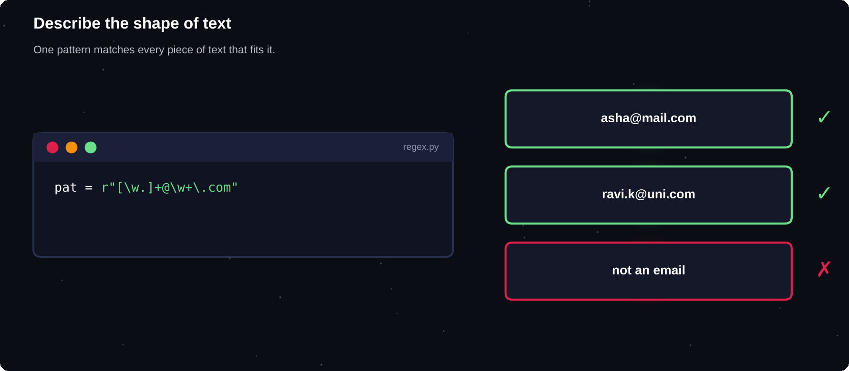
Describe the shape of text
A pattern matches every piece of text that fits its shape.
IN THIS CHAPTER
01 Your first pattern  02 Pattern building blocks  03 The main functions  04 Groups: pull out the parts  05 Greedy versus lazy | 06 Flags and compiling  07 Worked example: extract emails  08 Worked example: parse a log  09 Worked example: password rules  10 Cleaning text for analysis | 11 Useful string tools  12 Text in other languages  13 Debugging corner  14 Quick quiz

Your first pattern
The re module searches text with patterns. Write patterns as raw strings, with an r in front, so that backslashes are kept as they are.
import re
text = "Call 98400 12345 or 98410 54321"
print(re.findall(r"\d{5}", text))
print(re.search(r"\d+", text).group())
print(bool(re.search(r"Call", text)))
» ['98400', '12345', '98410', '54321']
» 98400
» True

Pattern building blocks
Pattern | Matches
. | Any one character
\d \w \s | Digit, word char, space
\D \W \S | The opposites
[abc] [a-z] | One of a set or range
* + ? | 0+, 1+, 0 or 1 times
{3} {2,4} | Exact or range of times
^ $ | Start, end of text
\b | Edge of a word
( ) | | Group, or

The main functions
Function | Does
re.search(p, s) | First match anywhere
re.match(p, s) | Match at the start
re.fullmatch(p, s) | Whole string must match
re.findall(p, s) | List of all matches
re.sub(p, new, s) | Replace matches
re.split(p, s) | Split on a pattern

import re
print(re.sub(r"\s+", " ", "a b \t c"))
print(re.split(r"[,;]\s*", "x, y;z"))
pat = r"[A-Z]{3}\d{4}"
print(re.fullmatch(pat, "ABC1234"))
» a b c
» ['x', 'y', 'z']
» <re.Match object; span=(0, 7),
» match='ABC1234'>

Groups: pull out the parts
Brackets capture part of a match. You can name each group with (?P<name>...) so that your code explains itself.
import re
p = r"(\d{4})-(\d{2})-(\d{2})"
m = re.search(p, "Due 2026-08-15.")
print(m.groups())
p = r"(?P<h>\d+):(?P<m>\d+)"
n = re.search(p, "at 14:35")
print(n["h"], n["m"])
» ('2026', '08', '15')
» 14 35

Greedy versus lazy
import re
html = "<b>bold</b> and <i>italic</i>"
print(re.findall(r"<.+>", html))
print(re.findall(r"<.+?>", html))
» ['<b>bold</b> and <i>italic</i>']
» ['<b>', '</b>', '<i>', '</i>']

Quantifiers are greedy: they match as much as possible. Add a ? after them to match as little as possible.
Flags and compiling
import re
pat = re.compile(r"python", re.IGNORECASE)
txt = "Python and PYTHON and py"
print(pat.findall(txt))
print(len(pat.sub("***", "I like Python")))
» ['Python', 'PYTHON']
» 10

Worked example: extract emails
import re
text = "Mail asha@a.com or ravi.k@u.edu.in"
pat = r"[\w.]+@[\w.]+\.\w+"
print(re.findall(pat, text))
» ['asha@a.com', 'ravi.k@u.edu.in']

KEEP PATTERNS SIMPLE
Regular expressions cannot fully validate things like email addresses. Use them to find or clean text, and use proper libraries or confirmation emails for real validation.

Worked example: parse a log
import re
from collections import Counter
log = """ERROR 2026-08-01 disk full
INFO 2026-08-01 started
ERROR 2026-08-02 timeout
WARN 2026-08-02 slow"""
levels = re.findall(r"^(\w+)", log, re.M)
print(Counter(levels))
errs = re.findall(r"ERROR \S+ (.+)", log)
print(errs)
» Counter({'ERROR': 2, 'INFO': 1, 'WARN': 1})
» ['disk full', 'timeout']

Worked example: password rules
import re
def strong(pw):
rules = [r".{8,}", r"[A-Z]", r"[a-z]",
r"\d", r"[^\w\s]"]
return all(re.search(r, pw)
for r in rules)

print(strong("python"))
print(strong("Py!thon#2026"))
» False
» True

Cleaning text for analysis
import string
from collections import Counter
text = "The cat sat. The CAT ran! A cat?"
p = string.punctuation
table = str.maketrans("", "", p)
low = text.lower()
words = low.translate(table).split()
print(words)
print(Counter(words).most_common(2))
» ['the', 'cat', 'sat', 'the', 'cat',
» 'ran', 'a', 'cat']
» [('cat', 3), ('the', 2)]

Useful string tools
s = " Hello, World "
print(s.strip().casefold())
x = "a-b_c".replace("-", " ")
print(x.replace("_", " "))
print("abc".center(9, "*"))
print("python".capitalize(), "x".zfill(4))
print("one two".partition(" "))
» hello, world
» a b c
» ***abc***
» Python 000x
» ('one', ' ', 'two')

Text in other languages
Python 3 strings are Unicode, so they can hold any language and emoji. Read and write files with encoding="utf-8". Be aware that one visible character can be built from several code points.
t = "caf\u00e9"
print(len(t), t.upper())
print(t.encode("utf-8"))
print(len("\u0baa\u0bc8"))
» 4 CAFÉ
» b'caf\xc3\xa9'
» 2

COMMON MISTAKES
Forgetting the r before a pattern. Using match when you meant search. Writing patterns too clever to read. Forgetting that . does not match a new line unless you use re.S. Trying to parse full HTML with regular expressions.

Debugging corner
The pattern grabs far more than the programmer wanted.
import re
t = 'a "x" and "y"'
print(re.findall(r"\".+\"", t))
print(re.findall(r"\".+?\"", t))
» ['"x" and "y"']
» ['"x"', '"y"']

Greedy .+ runs to the last quotation mark. Use the lazy .+? form.
Try it yourself
1 Extract all hashtags from a tweet-like string
2 Find every date in the form dd/mm/yyyy in a paragraph
3 Replace every run of spaces with one space
4 Check whether a phone number has exactly 10 digits
5 Count the most common words in a text file, ignoring punctuation
6 Mask all but the last 4 digits of a long number
Chapter checkpoint
1 Use raw strings for patterns
2 search finds, findall lists, sub replaces, split splits
3 Groups capture parts of a match
4 Quantifiers are greedy. Add ? for lazy
5 Keep patterns readable, and test them
Quick quiz
Answer from memory, then check Appendix E.
1 Why write patterns as raw strings?
2 Which function lists all matches?
3 What does \d match?
4 What makes a quantifier lazy?
5 Which function replaces matches?
6 What does a capturing group do?

CHAPTER 21
Data Analysis in Practice
Data analysis follows a pattern: load, inspect, clean, transform, summarise and communicate. This chapter walks through that workflow on a small dataset, so you can repeat the steps on any data of your own.
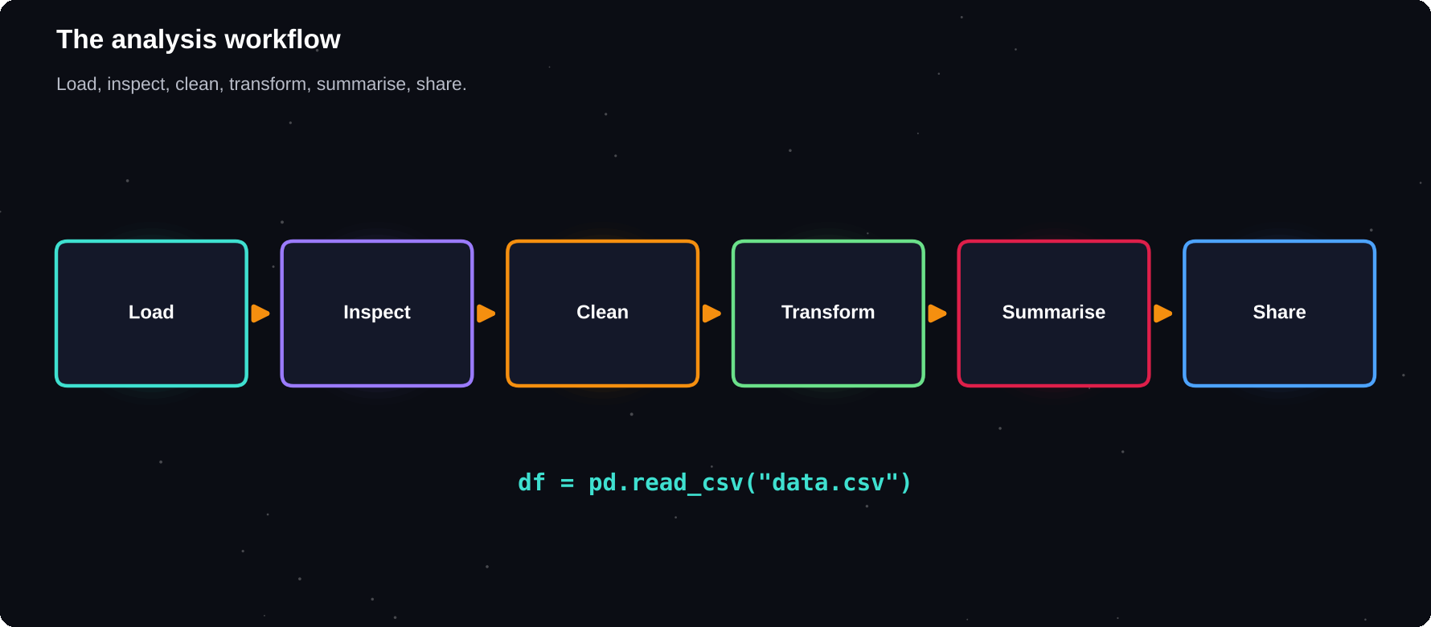
The analysis workflow
Load, inspect, clean, transform, summarise, share.
IN THIS CHAPTER
01 Step 1: load the data  02 Step 2: inspect  03 Step 3: clean  04 Step 4: transform | 05 Step 5: summarise  06 Combining tables with merge  07 Step 6: communicate  08 Worked example: a sales report | 09 Good habits  10 Debugging corner  11 Quick quiz

Step 1: load the data
pandas reads CSV, Excel, JSON and SQL. Here the CSV text is held in a string, so the example is self-contained. With a real file, pass its path to read_csv instead.
import io
import pandas as pd
raw = """name,dept,marks,city
Asha,IT,88,Chennai
Ravi,IT,92,Pune
Mei,CS,,Chennai
Joe,CS,85,Delhi
Zara,IT,79,Pune
"""
df = pd.read_csv(io.StringIO(raw))
print(df)
» name dept marks city
» 0 Asha IT 88.0 Chennai
» 1 Ravi IT 92.0 Pune
» 2 Mei CS NaN Chennai
» 3 Joe CS 85.0 Delhi
» 4 Zara IT 79.0 Pune

Step 2: inspect
import io
import pandas as pd
raw = "a,b\n1,x\n2,y\n,z\n"
df = pd.read_csv(io.StringIO(raw))
print(df.shape)
print(df.dtypes)
print(df.isna().sum())
print(df["b"].value_counts())
» (3, 2)
» a float64
» b str
» dtype: object
» a 1
» b 0
» dtype: int64
» b
» x 1
» y 1
» z 1
» Name: count, dtype: int64

Check | Code
Size | df.shape
Types | df.dtypes
First rows | df.head()
Summary stats | df.describe()
Missing | df.isna().sum()
Unique values | df[c].nunique()

Step 3: clean
Real data is messy. Decide how to treat missing values: remove the row, fill with a typical value, or leave a note. Also fix types and strip stray spaces.
import pandas as pd
df = pd.DataFrame({
"name": [" Asha", "Ravi ", "Mei"],
"marks": [88, None, 79]})
df["name"] = df["name"].str.strip()
avg = df["marks"].mean()
df["marks"] = df["marks"].fillna(avg)
print(df)
» name marks
» 0 Asha 88.0
» 1 Ravi 83.5
» 2 Mei 79.0

Step 4: transform
import pandas as pd
df = pd.DataFrame({
"name": ["Asha", "Ravi", "Mei", "Joe"],
"marks": [88, 92, 79, 85]})
df["grade"] = pd.cut(df["marks"],
[0, 79, 89, 100], labels=["C", "B", "A"])
df["pass"] = df["marks"] >= 80
print(df)
» name marks grade pass
» 0 Asha 88 B True
» 1 Ravi 92 A True
» 2 Mei 79 C False
» 3 Joe 85 B True

Step 5: summarise
import pandas as pd
df = pd.DataFrame({
"dept": ["IT", "IT", "CS", "CS", "IT"],
"marks": [88, 92, 79, 85, 79]})
g = df.groupby("dept")["marks"]
print(g.agg(["count", "mean", "max"]))
top = df.sort_values("marks",
ascending=False)
print(top.head(2))
» count mean max
» dept
» CS 2 82.000000 85
» IT 3 86.333333 92
» dept marks
» 1 IT 92
» 0 IT 88

import pandas as pd
df = pd.DataFrame({
"dept": ["IT", "IT", "CS", "CS"],
"term": ["T1", "T2", "T1", "T2"],
"marks": [88, 92, 79, 85]})
p = df.pivot_table(index="dept",
columns="term",
values="marks")
print(p)
» term T1 T2
» dept
» CS 79.0 85.0
» IT 88.0 92.0

80%
of a data analyst's time is often spent on cleaning and preparing data, not on fancy models
Combining tables with merge
import pandas as pd
s = pd.DataFrame({"name": ["Asha", "Ravi"],
"dept": ["IT", "CS"]})
d = pd.DataFrame({"dept": ["IT", "CS"],
"head": ["Rao", "Iyer"]})
print(s.merge(d, on="dept"))
» name dept head
» 0 Asha IT Rao
» 1 Ravi CS Iyer

Step 6: communicate
A chart often says more than a table. Keep it simple: a clear title, labelled axes and one message.
import matplotlib.pyplot as plt
avg = df.groupby("dept")["marks"].mean()
avg.plot(kind="bar", color="teal")
plt.title("Average marks by department")
plt.ylabel("Marks")
plt.tight_layout()
plt.savefig("avg_marks.png")

Worked example: a sales report
import pandas as pd
df = pd.DataFrame({
"month": ["Jan", "Feb", "Mar", "Apr"],
"units": [120, 150, 135, 180],
"price": [10, 10, 12, 12]})
df["revenue"] = df["units"] * df["price"]
best = df.loc[df["revenue"].idxmax()]
print(df)
print("Best:", best["month"],
best["revenue"])
print("Total:", df["revenue"].sum())
» month units price revenue
» 0 Jan 120 10 1200
» 1 Feb 150 10 1500
» 2 Mar 135 12 1620
» 3 Apr 180 12 2160
» Best: Apr 2160
» Total: 6480

Good habits
1 Keep the raw file untouched. Clean a copy
2 Write each step as code so it can be repeated
3 Check the result after every step
4 Document your assumptions
5 Look at the data, not only the numbers
COMMON MISTAKES
Looping over rows when a column operation would do. Ignoring missing values. Chained indexing such as df[a][b] = x, which may not change the data. Drawing conclusions from a tiny sample. Publishing charts without labels.

Debugging corner
Why does this analysis give NaN?
import pandas as pd
s = pd.Series([80, None, 90])
print(s.sum(), s.mean())
print(s.fillna(0).mean())
» 170.0 85.0
» 56.666666666666664

Missing values are skipped by sum and mean, which can mislead you. Decide how to treat them on purpose.
Try it yourself
1 Download a small public CSV and print its shape and column types
2 Count the missing values per column and decide how to handle them
3 Find the top three rows by one numeric column
4 Group by a category and plot the averages
5 Merge two small tables on a shared key
6 Write a function that takes a CSV path and prints a summary report
Chapter checkpoint
1 Workflow: load, inspect, clean, transform, summarise, share
2 isna(), fillna() and dropna() handle missing data
3 groupby() and pivot_table() summarise
4 merge() joins tables on a key
5 Plot with a clear title and labelled axes
Quick quiz
Answer from memory, then check Appendix E.
1 What is the first step of the analysis workflow?
2 Which method shows missing values per column?
3 Which method fills missing values?
4 Which method summarises by category?
5 Which method joins two tables?
6 What must every chart have?

CHAPTER 22
Six Mini-Projects
Reading about code teaches you little. Building teaches you almost everything. These six mini-projects use the skills from every earlier chapter. Type them in, run them, then make them your own.
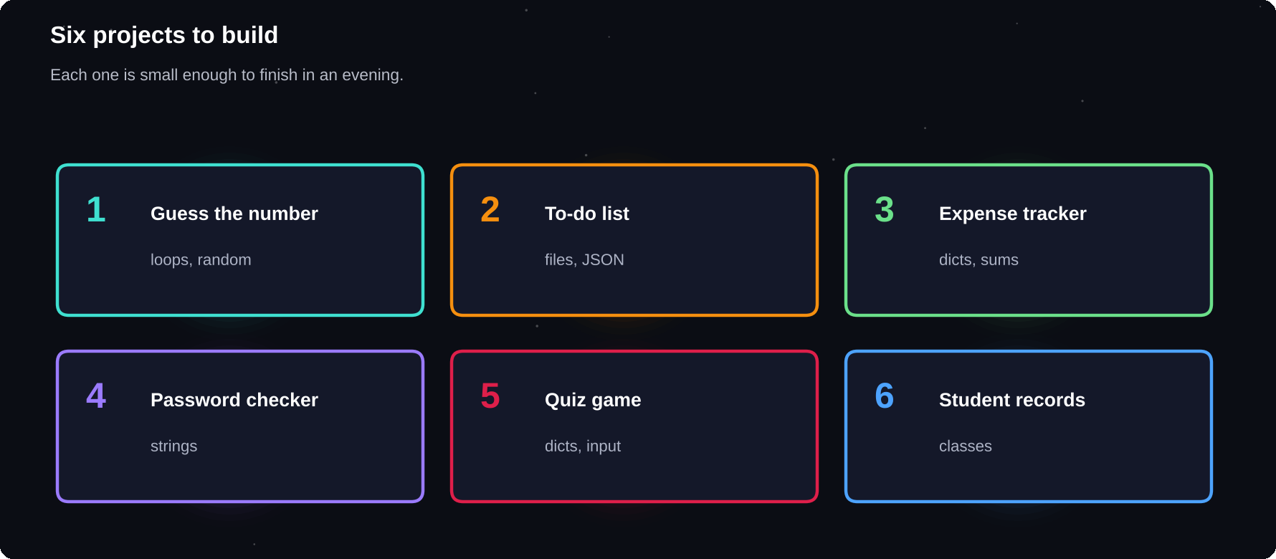
Six projects to build
Each project is small enough to finish in an evening and useful enough to keep.
IN THIS CHAPTER
01 How to build a project  02 Project 1: Guess the number  03 Project 2: To-do list that remembers  04 Project 3: Expense tracker | 05 Project 4: Password checker  06 Project 5: Quiz game  07 Project 6: Student records with classes  08 Where to go from here | 09 Debugging corner  10 Quick quiz

How to build a project
1 State the problem in one sentence
2 List the steps a person would follow by hand
3 Write each step as a comment or pseudo-code
4 Build the smallest working version first
5 Test with normal, empty and wrong input
6 Improve one feature at a time
The programs below read from input(). To make the output repeatable in this book, the keyboard answers were supplied by a script. When you run them yourself, type your own.
Project 1: Guess the number
The computer picks a secret number and gives hints until you find it. Skills: random, while, if, counting.
import random
random.seed(3)
secret = random.randint(1, 20)
tries = 0
while True:
guess = int(input("Guess 1-20: "))
tries += 1
if guess < secret:
print("Too low")
elif guess > secret:
print("Too high")
else:
print(f"Got it in {tries} tries!")
break
» Guess 1-20: Too low
» Guess 1-20: Too high
» Guess 1-20: Got it in 3 tries!

EXTEND IT
Limit the player to 5 tries. Ask for the range at the start. Handle text input with try/except. Keep a best score in a file.

Project 2: To-do list that remembers
A command-line to-do manager that saves tasks in a JSON file. Skills: functions, lists, dictionaries, files.
import json, os
FILE = "todo.json"

def load():
if os.path.exists(FILE):
with open(FILE) as f:
return json.load(f)
return []

def save(tasks):
with open(FILE, "w") as f:
json.dump(tasks, f)

tasks = load()
while True:
cmd = input("> ").strip()
if cmd.startswith("add "):
tasks.append({"t": cmd[4:], "ok": 0})
elif cmd.startswith("done "):
tasks[int(cmd[5:]) - 1]["ok"] = 1
elif cmd == "list":
for i, t in enumerate(tasks, 1):
m = "x" if t["ok"] else " "
print(f"{i}. [{m}] {t['t']}")
elif cmd == "quit":
break
save(tasks)
print("Saved", len(tasks), "tasks")
» > > > > 1. [x] buy milk
» 2. [ ] study python
» > Saved 2 tasks

EXTEND IT
Add a delete command. Show only unfinished tasks. Add due dates with the datetime module. Sort tasks by priority.

Project 3: Expense tracker
Record spending by category and print a summary with simple bars. Skills: dictionaries, loops, formatting.
spend = {}
data = [("food", 250), ("travel", 400),
("food", 180), ("books", 320),
("travel", 150)]
for cat, amt in data:
spend[cat] = spend.get(cat, 0) + amt

total = sum(spend.values())
for cat, amt in sorted(spend.items(),
key=lambda p: -p[1]):
bar = "#" * round(amt / total * 20)
print(f"{cat:<7}{amt:>5} {bar}")
print("Total:", total)
» travel 550 ########
» food 430 #######
» books 320 #####
» Total: 1300

EXTEND IT
Read the expenses from a CSV file. Add a monthly budget and warn when it is crossed. Chart the result with Matplotlib.

Project 4: Password checker
Score a password for length and variety, then give advice. Skills: strings, functions, sets, conditions.
def check(pw):
tips = []
if len(pw) < 10:
tips.append("use 10+ characters")
if not any(c.isdigit() for c in pw):
tips.append("add a digit")
if not any(c.isupper() for c in pw):
tips.append("add a capital")
if not any(not c.isalnum() for c in pw):
tips.append("add a symbol")
return tips

for pw in ["python", "Tr0ub4dor&3x!"]:
tips = check(pw)
print(pw, "->", tips or "strong")
» python -> ['use 10+ characters', 'add a
» digit', 'add a capital', 'add a
» symbol']
» Tr0ub4dor&3x! -> strong

EXTEND IT
Reject common passwords from a file. Generate a strong random password with the secrets module. Show a strength score from 0 to 4.

Project 5: Quiz game
Ask questions from a dictionary and score the answers. Skills: dictionaries, loops, strings, input.
quiz = {
"Capital of France?": "paris",
"2 + 3 * 4 = ?": "14",
"Language of this book?": "python",
}
score = 0
for q, a in quiz.items():
ans = input(q + " ").strip().lower()
if ans == a:
print("Correct!")
score += 1
else:
print("Answer:", a)
print(f"Score: {score}/{len(quiz)}")
» Capital of France? Correct!
» 2 + 3 * 4 = ? Answer: 14
» Language of this book? Correct!
» Score: 2/3

EXTEND IT
Shuffle the questions. Load questions from a JSON file. Add multiple-choice options and a timer.

Project 6: Student records with classes
A small school system built with objects. Skills: classes, lists, sorting, formatting.
class Student:
def __init__(self, name, marks):
self.name, self.marks = name, marks

def avg(self):
m = self.marks
return sum(m) / len(m)

class School:
def __init__(self):
self.students = []

def add(self, s):
self.students.append(s)

def ranking(self):
return sorted(self.students,
key=Student.avg,
reverse=True)

sc = School()
sc.add(Student("Asha", [88, 92, 95]))
sc.add(Student("Ravi", [70, 85, 80]))
sc.add(Student("Mei", [91, 89, 94]))
for i, s in enumerate(sc.ranking(), 1):
print(i, s.name, round(s.avg(), 1))
» 1 Asha 91.7
» 2 Mei 91.3
» 3 Ravi 78.3

EXTEND IT
Save students to a JSON file. Add subjects and grades. Build a menu so the user can add and search students.

Where to go from here
Pick one project and double its size. Publish it on GitHub with a clear README. A small project that works and is explained well says more about you than a long list of tutorials.
Debugging corner
An off-by-one error: this should add the numbers 1 to 5.
total = 0
for n in range(1, 5):
total += n
print(total)
total = sum(range(1, 6))
print(total)
» 10
» 15

range stops before its end value. Use range(1, 6) to include 5.
Chapter checkpoint
1 Plan the steps before writing code
2 Build the smallest working version first
3 Test with unusual input
4 Extend one feature at a time
5 Share your work on GitHub
Quick quiz
Answer from memory, then check Appendix E.
1 What is the first step of building a project?
2 Why build the smallest working version first?
3 Which project saved its data in a JSON file?
4 What does random.seed(3) achieve?
5 Name one way to extend the quiz game.
6 Where should you publish finished projects?

CHAPTER 23
Better Code and Next Steps
Working code is the start. Good code is clear, tested and shared. This last chapter teaches the habits that separate beginners from professionals, and then points you to the next stage of your journey.
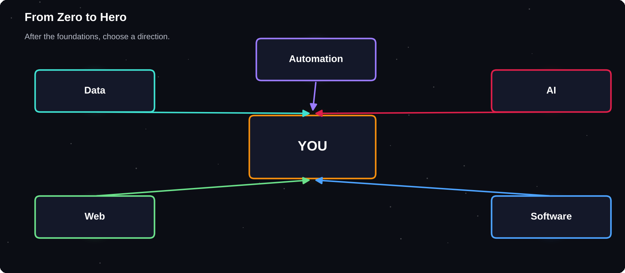
From Zero to Hero
Choose a direction after the foundations: data, web, automation, AI or software engineering.
IN THIS CHAPTER
01 PEP 8: the style guide  02 Write for humans  03 Refactoring example  04 Testing your code  05 Project structure | 06 Git and GitHub basics  07 Reading documentation  08 Choose your path  09 A 12-week plan  10 Practice, projects and community | 11 You made it  12 Debugging corner  13 Quick quiz

PEP 8: the style guide
PEP 8 is the community's style guide. Following it makes your code look familiar to every other Python programmer. The main rules are simple.
Rule | Example
4 spaces per indent | no tabs
snake_case names | total_price
CapWords for classes | BankAccount
UPPER_CASE constants | MAX_TRIES
Lines under 79 chars | wrap long lines
Spaces around = | x = 5
Imports at the top | one per line

# Hard to read
def f(a,b):return a*b+a

# Clear
def area_plus(width, height):
return width * height + width

print(f(2,3), area_plus(2, 3))
» 8 8

Write for humans
1 Use meaningful names: days_left, not d
2 Keep each function small and focused
3 Do not repeat yourself: make a function
4 Comment the why, not the what
5 Write docstrings for functions and classes
6 Delete dead code and unused imports
Refactoring example
# Before
prices = [100, 250, 80]
t = 0
for p in prices:
t = t + p * 1.18

# After
GST = 1.18

def with_tax(amount):
return amount * GST

total = sum(with_tax(p) for p in prices)
print(round(total, 2))
» 507.4

Testing your code
A test is a small program that checks that your code gives the right answer. Tests catch bugs early and let you change code with confidence. The simplest start is assert, and the professional tool is pytest.
def is_even(n):
return n % 2 == 0

assert is_even(4)
assert not is_even(7)
assert is_even(0)
print("All tests passed")
» All tests passed

# test_calc.py (run with: pytest)
from calc import add

def test_add():
assert add(2, 3) == 5

def test_add_negative():
assert add(-1, 1) == 0

def add(a, b):
"""
>>> add(2, 3)
5
>>> add(-1, 1)
0
"""
return a + b

import doctest
print(doctest.testmod())
» TestResults(failed=0, attempted=2)

3
kinds of input to test: normal, empty or zero, and wrong. Most bugs live at the edges
Project structure
my_project/
README.md
requirements.txt
main.py
tools/
__init__.py
helpers.py
tests/
test_helpers.py

Git and GitHub basics
Git records the history of your code so you can undo mistakes and work with others. GitHub is a website that stores Git projects online. For a student, a good GitHub profile is a portfolio.
$ git init
$ git add .
$ git commit -m "First version"
$ git branch -M main
$ git remote add origin <repo-url>
$ git push -u origin main

Reading documentation
Professionals read documentation constantly. Start with docs.python.org for the standard library. Use help() and dir() inside Python to explore objects.
print(dir("")[-3:])
print(len(dir(list)) > 40)
print("abc".upper.__doc__)
» ['translate', 'upper', 'zfill']
» True
» Return a copy of the string converted to
» uppercase.

Choose your path
Goal | Learn next
Data analysis | pandas, SQL, statistics
Machine learning | NumPy, scikit-learn, maths
Web development | Flask or Django, HTML, SQL
Automation | files, APIs, scheduling
Software jobs | DSA, Git, testing, OOP
Competitions | algorithms, problem solving

A 12-week plan
Weeks | Focus
1-2 | Chapters 1-6, daily practice
3-4 | Data structures, functions
5-6 | Files, errors, modules
7-8 | OOP and a first project
9-10 | A library path of your choice
11-12 | Portfolio project on GitHub

HABITS THAT WORK
Code every day, even for 30 minutes. Type code, do not copy and paste. Read other people's code. Build things you care about. Ask questions, and explain what you learn to someone else.

Practice, projects and community
1 Solve small problems on coding practice sites regularly
2 Contribute one small fix to an open-source project
3 Join a local or online Python community
4 Enter hackathons and coding contests
5 Keep a learning journal of what you built each week
You made it
You now know the foundations that every Python programmer uses: variables, control flow, data structures, functions, files, errors, modules, objects and libraries. The rest is practice, curiosity and projects. Keep building.
Debugging corner
== compares values. is asks whether two names are the very same object.
a = [1]
b = [1]
print(a == b, a is b)
» True False

Chapter checkpoint
1 Follow PEP 8 and write for humans
2 Test your code, starting with assert
3 Use Git and share projects on GitHub
4 Read the documentation
5 Choose a path and build a portfolio project
Quick quiz
Answer from memory, then check Appendix E.
1 How many spaces does PEP 8 use for one indent?
2 Which naming style do class names use?
3 Which keyword gives you the simplest test?
4 Which Git command records a snapshot?
5 Which file lists a project's dependencies?
6 Why keep functions small?

APPENDIX A
Python Cheat Sheet
Keep this appendix open while you code. It collects the most used types, operators, methods, built-in functions and formats in compact tables.
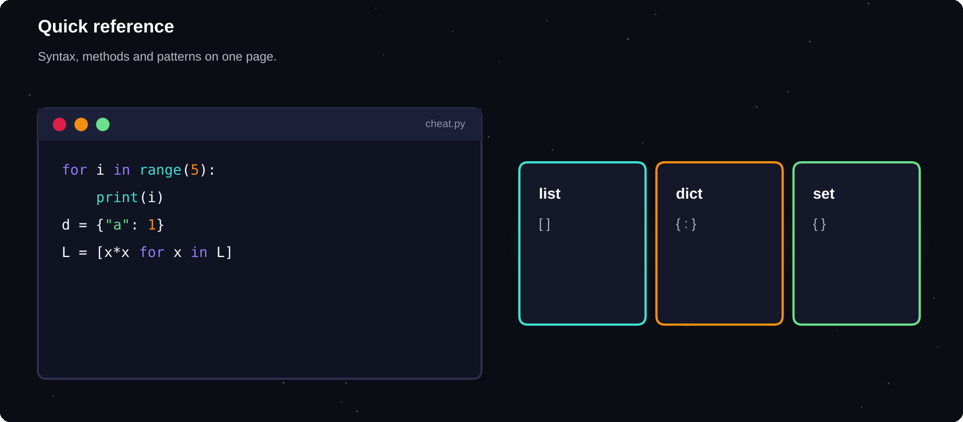
Quick reference
Tables you will come back to again and again.
IN THIS CHAPTER
01 Data types  02 Operators  03 String methods  04 List methods | 05 Dictionary methods  06 Set methods  07 Built-in functions  08 Format specifiers | 09 Slicing  10 Syntax patterns  11 Escape sequences  12 Handy modules

Data types
Type | Example | Changeable?
int | 42 | No
float | 3.14 | No
str | "hi" | No
bool | True | No
list | [1, 2] | Yes
tuple | (1, 2) | No
set | {1, 2} | Yes
dict | {"a": 1} | Yes
NoneType | None | No

Operators
Group | Operators
Arithmetic | + - * / // % **
Comparison | == != < > <= >=
Logical | and or not
Assignment | = += -= *= /= //= %=
Membership | in not in
Identity | is is not

String methods
Method | Result
s.upper() / lower() | Change case
s.title() | Capitalise words
s.strip() | Trim spaces
s.split(sep) | String to list
sep.join(list) | List to string
s.replace(a, b) | Swap text
s.find(x) | Index or -1
s.count(x) | Occurrences
s.startswith(x) | True or False
s.isdigit() | Only digits?
s.zfill(n) | Pad with zeros
s.center(n) | Centre in width n

List methods
Method | Result
l.append(x) | Add at end
l.insert(i, x) | Add at index
l.extend(m) | Add many
l.remove(x) | Remove first x
l.pop(i) | Remove and return
l.index(x) | Position of x
l.count(x) | Occurrences
l.sort() | Sort in place
l.reverse() | Reverse in place
l.copy() | Shallow copy
l.clear() | Empty the list

Dictionary methods
Method | Result
d[k] | Value or KeyError
d.get(k, v) | Value or default
d.keys() | All keys
d.values() | All values
d.items() | Key-value pairs
d.update(e) | Merge in e
d.pop(k) | Remove and return
d.setdefault(k, v) | Get or create

Set methods
Method | Result
s.add(x) | Add item
s.remove(x) | Remove, error if absent
s.discard(x) | Remove if present
a | b | Union
a & b | Intersection
a - b | Difference
a ^ b | Symmetric difference
a <= b | Subset

Built-in functions
Function | Does
len(x) | Number of items
type(x) | Type of x
sum(it) | Total
min() / max() | Smallest / largest
sorted(it) | New sorted list
reversed(it) | Reverse iterator
range(a, b, s) | Number sequence
enumerate(it) | Index and item
zip(a, b) | Pair items
map(f, it) | Apply f to each
filter(f, it) | Keep where f is true
any() / all() | Some / every true
abs() round() | Absolute, rounded
int() float() str() | Convert types
input(prompt) | Read text
isinstance(x, T) | Type check

Format specifiers
Spec | Effect
{x:.2f} | 2 decimals
{x:>8} | Right-align, width 8
{x:<8} | Left-align
{x:^8} | Centre
{x:08.2f} | Zero-pad
{x:,} | Thousands commas
{x:.1%} | Percent
{x:b} {x:x} | Binary, hex

Slicing
Slice | Meaning
s[a:b] | From a up to b-1
s[:b] | First b items
s[a:] | From a to the end
s[-n:] | Last n items
s[::2] | Every second item
s[::-1] | Reversed

Syntax patterns
if cond:
...
elif other:
...
else:
...

for item in items:
...
while cond:
...

def name(a, b=1):
return a + b

class Name(Parent):
def __init__(self, x):
self.x = x

try:
...
except ValueError as e:
...
finally:
...

with open("f.txt") as f:
...

Escape sequences
Code | Meaning
\n | New line
\t | Tab
\\ | Backslash
\" | Double quote
\' | Single quote

Handy modules
Module | Use
math | sqrt, ceil, pi
random | randint, choice, shuffle
datetime | Dates and times
collections | Counter, deque, defaultdict
json / csv | Data files
pathlib / os | Files and paths
re | Regular expressions
statistics | mean, median
itertools | Combinations, products
logging | Messages and debug
unittest | Testing
sqlite3 | Small database

APPENDIX B
Common Errors and Fixes
Every programmer sees these messages every week. This appendix explains what each one means and what to try first.
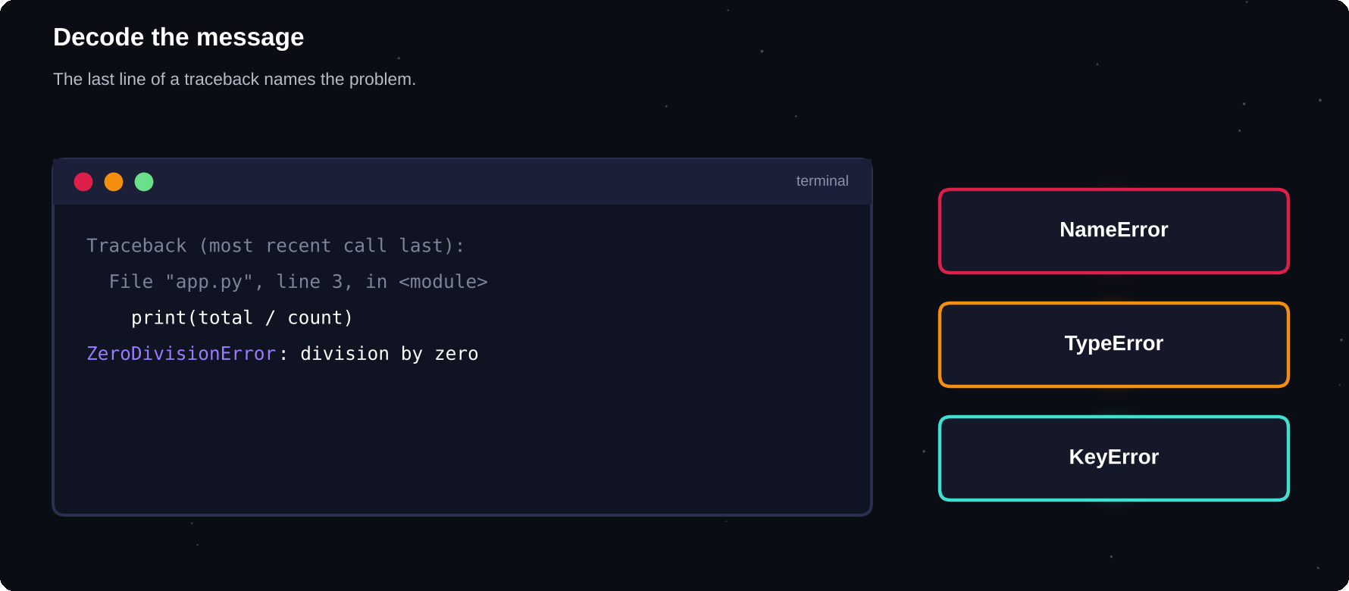
Decode the message
The error name tells you the kind of problem. The last line tells you the detail.
IN THIS CHAPTER
01 Quick lookup  02 TypeError: wrong kinds of values  03 AttributeError | 04 UnboundLocalError  05 IndentationError  06 ValueError and friends | 07 A method for any error

Quick lookup
Message | Usual cause and fix
SyntaxError | Missing colon, quote or bracket. Check the line shown
IndentationError | Wrong spaces. Use 4 per level
NameError | Typo, or used before created
TypeError | Wrong type: convert with int() or str()
ValueError | Right type, bad value: validate input
IndexError | Index past the end: check len()
KeyError | Missing key: use get() or in
AttributeError | No such attribute: check spelling and type
ModuleNotFoundError | Not installed: pip install it
FileNotFoundError | Wrong path or folder
ZeroDivisionError | Check the divisor first
RecursionError | Missing base case
UnboundLocalError | Assigned in a function before reading
KeyboardInterrupt | You pressed Ctrl+C

TypeError: wrong kinds of values
print("Total: " + 50)
» TypeError: can only concatenate str (not
» "int") to str

Fix: print("Total: " + str(50)) or print(f"Total: {50}").
print(len(5))
» TypeError: object of type 'int' has no
» len()

Fix: len() needs something with a length, such as a string or list.
AttributeError
nums = [1, 2]
nums.push(3)
» AttributeError: 'list' object has no
» attribute 'push'

Lists use append(), not push(). Use dir(nums) to list what an object offers.
UnboundLocalError
count = 0
def bump():
count += 1

bump()
» UnboundLocalError: cannot access local
» variable 'count' where it is not
» associated with a value

A name assigned inside a function is local. Pass the value in and return the new one, or declare global.
IndentationError
for i in range(2):
print(i)
» IndentationError: expected an indented
» block after 'for' statement on line 1

The body of a for, if, def or class must be indented.
ValueError and friends
print(int("12.5"))
» ValueError: invalid literal for int()
» with base 10: '12.5'

int() cannot parse a decimal string. Use int(float(text)).
a, b = [1, 2, 3]
» ValueError: too many values to unpack
» (expected 2)

The number of names must match the number of items, unless you use *rest.
A method for any error
1 Read the last line. It names the error
2 Read the line number above it
3 Look at the variable values on that line
4 Search the exact message in your documentation or a search engine
5 Reduce the program to the smallest version that still fails
6 Fix one thing at a time, then run again

APPENDIX C
Fifty Practice Problems
Skill comes from solving many small problems. Try each one on your own before looking anything up. Start at Level 1 and move up when it feels easy.
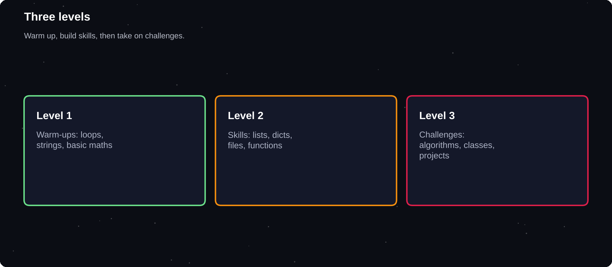
Three levels
Warm up, build confidence, then stretch yourself.
IN THIS CHAPTER
01 Level 1: Warm-up | 02 Level 2: Building skills | 03 Level 3: Challenges

Level 1: Warm-up
1 Print your name 5 times using a loop
2 Swap two variables without using a third
3 Check whether a number is odd or even
4 Find the largest of three numbers
5 Calculate simple interest from principal, rate and time
6 Print the multiplication table of any number
7 Count the vowels in a string
8 Reverse a string
9 Sum all digits of an integer
10 Convert minutes to hours and minutes
11 Check whether a year is a leap year
12 Print the first 10 even numbers
13 Find the area of a circle from its radius
14 Print a right-angled triangle of stars
15 Compute the factorial of n with a loop
Level 2: Building skills
16 Find the second-largest number in a list
17 Remove duplicates from a list, keeping the order
18 Check whether a string is a palindrome
19 Count the frequency of each word in a sentence
20 Check whether two strings are anagrams
21 Print all primes up to 100
22 Generate the first n Fibonacci numbers
23 Find the common items of two lists
24 Merge two sorted lists into one sorted list
25 Flatten a nested list
26 Convert a decimal number to binary without bin()
27 Rotate a list by k positions
28 Write a function that checks a strong password
29 Find the most frequent character in a string
30 Read a file and print the longest line
31 Create a dictionary of squares for 1 to n
32 Sort a list of dictionaries by one key
33 Count the lines, words and characters of a file
34 Write a function to validate an email address shape
35 Build a simple calculator with functions
Level 3: Challenges
36 Implement binary search
37 Write bubble sort and selection sort yourself
38 Build a Stack and a Queue class
39 Create a Bank class with deposit, withdraw and history
40 Write a recursive function to generate all permutations of a string
41 Solve the Tower of Hanoi for n discs
42 Parse a CSV file and report the average of each numeric column
43 Build a text-based hangman game
44 Write a function that finds the longest common prefix
45 Implement a simple LRU cache using a dictionary
46 Create a contact book that saves to JSON
47 Write a decorator that times a function
48 Detect balanced brackets in a string using a stack
49 Build a tic-tac-toe game for two players
50 Scrape the titles of a web page politely using requests
HOW TO PRACTISE
Set a timer for 20 minutes. If you are stuck, write down what you tried, then take a hint. When your solution works, improve it: make it shorter, clearer or faster. Save every solution in a Git repository.

APPENDIX D
Python Interview Questions
Interviewers ask the same Python questions again and again. Practise answering these aloud in your own words, then add an example for each.
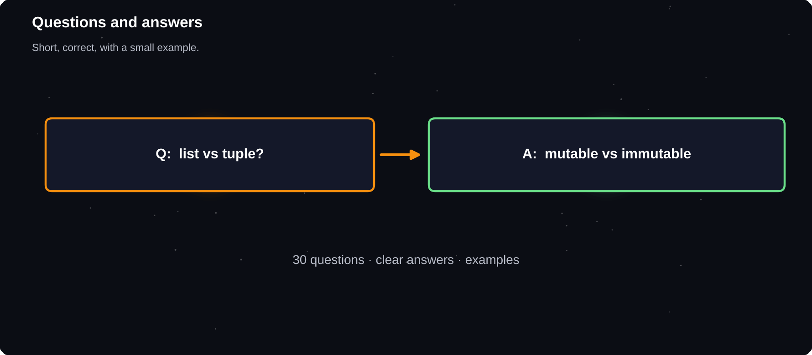
Questions and answers
A clear answer is short, correct and backed by a small example.
IN THIS CHAPTER
01 1. What is Python?  02 2. What is the difference between a list and a tuple?  03 3. What does mutable mean?  04 4. What is the difference between == and is?  05 5. How is memory managed in Python? | 06 6. What is a shallow copy versus a deep copy?  07 7. What are *args and **kwargs?  08 8. What is a lambda?  09 9. What is a decorator?  10 10. What is a generator? | 11 11. What is the difference between an iterable and an iterator?  12 12. What is a list comprehension?  13 13. What does the LEGB rule describe?  14 14. What is the difference between a module and a package?  15 15. What does if __name__ == "__main__" do?

1. What is Python?
Python is a high-level, interpreted, general-purpose language with readable syntax and a large ecosystem of libraries.
2. What is the difference between a list and a tuple?
A list is mutable and a tuple is immutable. Tuples are slightly lighter and can be dictionary keys, provided their contents are hashable.
3. What does mutable mean?
A mutable object can be changed after creation, such as a list, dict or set. Immutable objects such as int, str and tuple cannot.
4. What is the difference between == and is?
== compares values. is checks whether two names refer to the same object in memory.
5. How is memory managed in Python?
Python uses reference counting plus a garbage collector that cleans up objects that refer to each other in cycles.
6. What is a shallow copy versus a deep copy?
A shallow copy copies the outer container but shares the inner objects. A deep copy (copy.deepcopy) copies everything recursively.
7. What are *args and **kwargs?
*args collects extra positional arguments into a tuple. **kwargs collects extra keyword arguments into a dictionary.
8. What is a lambda?
A small anonymous function written in one expression, such as lambda x: x * 2.
9. What is a decorator?
A function that takes another function and returns a modified version of it, applied with the @ syntax.
10. What is a generator?
A function that uses yield to produce values lazily, one at a time, instead of building a whole list in memory.
11. What is the difference between an iterable and an iterator?
An iterable can be looped over, such as a list. An iterator is the object that produces items one by one using next().
12. What is a list comprehension?
A compact way to build a list from a loop and an optional condition: [x * x for x in nums if x > 0].
13. What does the LEGB rule describe?
The order in which Python looks up names: Local, Enclosing, Global, Built-in.
14. What is the difference between a module and a package?
A module is a single Python file. A package is a folder of modules, usually with an __init__.py file.
15. What does if __name__ == "__main__" do?
It runs the code beneath it only when the file is executed directly, not when it is imported.
16. Is Python call by value or call by reference?
Neither exactly. Python passes object references, often called call by assignment. Mutating a mutable argument is visible to the caller, while rebinding the name is not.
17. What is the mutable default argument problem?
A default list or dict is created once and shared by all calls. Use None as the default and create the object inside the function.
18. What are @staticmethod and @classmethod?
A static method receives no automatic first argument. A class method receives the class (cls) and can create or configure instances.
19. What is inheritance and what is polymorphism?
Inheritance lets a class reuse another class's behaviour. Polymorphism lets different classes provide the same method name with their own behaviour.
20. What is encapsulation in Python?
Keeping an object's data and the methods that use it together, and limiting direct access by convention (a leading underscore) and properties.
21. What are dunder methods?
Special methods with double underscores, such as __init__, __str__ and __len__, that let objects work with built-in syntax.
22. How do you handle exceptions?
With try, except, else and finally. Catch specific exceptions, and use raise to signal your own.
23. What does the with statement do?
It manages a resource through a context manager, so clean-up such as closing a file happens automatically.
24. What is a virtual environment?
An isolated folder with its own Python packages for one project, created with python -m venv.
25. What is PEP 8?
The official style guide for Python code: naming, indentation, line length and layout.
26. What is the GIL?
The Global Interpreter Lock in the standard CPython interpreter lets only one thread run Python bytecode at a time. It matters for CPU-bound threads. Use multiprocessing for parallel CPU work.
27. How are dictionaries ordered?
Since Python 3.7, a dictionary remembers the order in which keys were inserted.
28. Why is a set lookup fast?
Sets and dictionaries use hashing, so membership tests take about constant time on average.
29. What is the difference between pass, continue and break?
pass does nothing. continue skips to the next loop round. break leaves the loop.
30. What are type hints?
Optional annotations such as def f(x: int) -> str that describe expected types. Python does not enforce them, but tools and editors use them.

APPENDIX E
Quiz Answers
Mark yourself honestly. If you missed a question, return to that chapter, find the section and try its examples again.
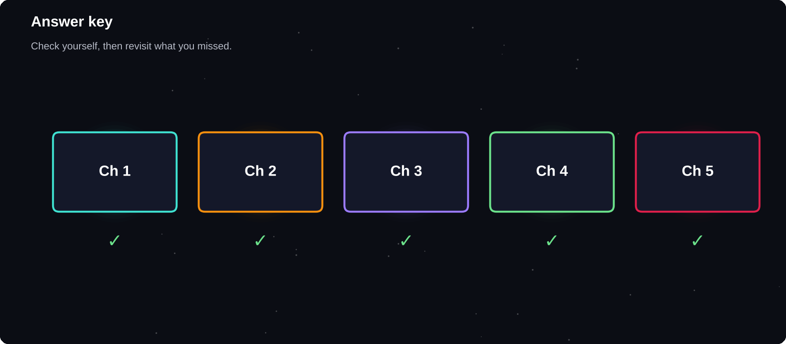
Answer key
Every question, with its answer.
IN THIS CHAPTER
01 Chapter 1  02 Chapter 2  03 Chapter 3  04 Chapter 4  05 Chapter 5 | 06 Chapter 6  07 Chapter 7  08 Chapter 8  09 Chapter 9  10 Chapter 10 | 11 Chapter 11  12 Chapter 12  13 Chapter 13  14 Chapter 14  15 Chapter 15

Check your answers here. Each list matches the numbered questions at the end of the chapter.
Chapter 1
1 print()
2 #
3 .py
4 The last line
5 No. Python is case-sensitive
6 Read, Evaluate, Print, Loop
Chapter 2
1 float
2 10
3 A string
4 total_1
5 'ababab'
6 NoneType
Chapter 3
1 3
2 1
3 32
4 True
5 True
6 2.5
Chapter 4
1 'yth'
2 'HELLO'
3 ['a', 'b', 'c']
4 8
5 'cba'
6 No. Strings are immutable
Chapter 5
1 A colon (:)
2 4
3 False
4 'yes'
5 elif
6 The default case
Chapter 6
1 [0, 1, 2]
2 [2, 5, 8]
3 Leaves the loop immediately
4 Skips to the next round
5 10
6 When the loop ends without break
Chapter 7
1 3
2 [1, 3, 5]
3 2
4 No. Both names point to one list
5 [0, 2, 4]
6 sort() changes the list. sorted() returns a new one
Chapter 8
1 2
2 int
3 {1, 2, 3}
4 {2, 3}
5 No
6 set()
Chapter 9
1 0
2 ['x', 'y']
3 1
4 A tuple
5 KeyError
6 {0: 0, 1: 2, 2: 4}
Chapter 10
1 def
2 None
3 6
4 A parameter is the name in the definition. An argument is the value passed in
5 Only inside the function
6 return
Chapter 11
1 Extra positional arguments, as a tuple
2 Extra named arguments, as a dictionary
3 5
4 A base case
5 It is created once and shared by every call
6 yield
Chapter 12
1 "a"
2 It closes the file automatically
3 csv
4 json.loads
5 Erases its content
6 pathlib
Chapter 13
1 finally
2 ValueError
3 raise
4 The bottom line
5 It hides real bugs
6 When no exception occurred
Chapter 14
1 9.0
2 pip install name
3 Runs the code only when the file is executed directly
4 To keep each project's packages separate
5 [('a', 2)]
6 secrets
Chapter 15
1 When a new object is created
2 The object the method is working on
3 A class is the blueprint. An object is one instance of it
4 What print() shows for the object
5 Internal use, by convention
6 Using a method like an attribute
Chapter 16
1 class Dog(Animal):
2 Gives access to the parent class
3 Different classes responding to the same method name in their own way
4 __add__
5 Composition
6 __init__, __repr__ and __eq__
Chapter 17
1 NumPy
2 DataFrame
3 Matplotlib
4 200
5 6
6 sqlite3
Chapter 18
1 It must be sorted
2 O(n)
3 How work grows as the input grows
4 A stack
5 deque
6 Remembers results so they are not recomputed
Chapter 19
1 Structured Query Language
2 ? placeholders
3 commit()
4 Gives one result row per group
5 Combines related rows from two tables
6 Every row is changed
Chapter 20
1 So backslashes are kept as they are
2 re.findall()
3 A digit
4 A ? after it
5 re.sub()
6 Saves part of the match
Chapter 21
1 Load the data
2 df.isna().sum()
3 fillna()
4 groupby()
5 merge()
6 A clear title and labelled axes
Chapter 22
1 State the problem in one sentence
2 You learn quickly and always have something that works
3 The to-do list
4 The same random numbers every run
5 For example: shuffle questions, load from JSON, add a timer
6 GitHub
Chapter 23
1 4
2 CapWords
3 assert
4 git commit
5 requirements.txt
6 They are easier to read, test and reuse

APPENDIX F
Syntax Tables
Keep this page open while you code. It collects the syntax, methods and patterns from the whole book in one place.
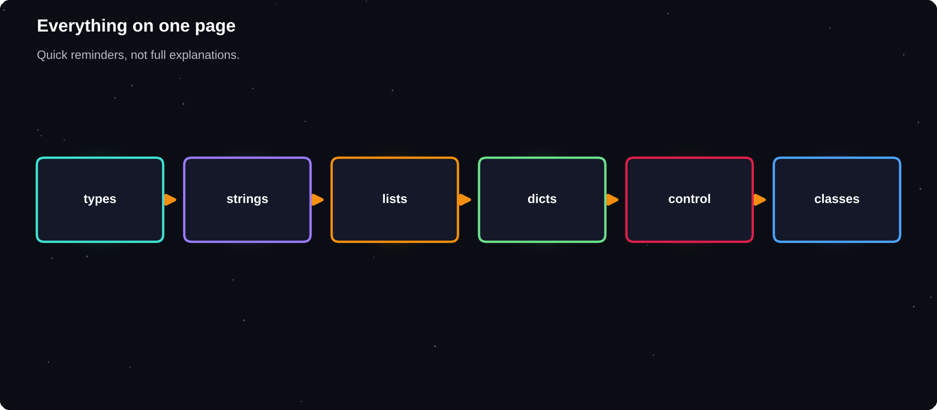
Everything on one page
Quick reminders, not full explanations. Each topic has a chapter behind it.
IN THIS CHAPTER
01 Types and conversion  02 Operators  03 String methods  04 List methods | 05 Dictionary and set methods  06 Control flow patterns  07 Functions and classes  08 Errors and files | 09 Comprehensions  10 Handy built-ins  11 Terminal commands

Types and conversion
Type | Example | Convert
int | 42 | int("42")
float | 3.14 | float("3.14")
str | "hi" | str(42)
bool | True | bool(0)
list | [1, 2] | list("ab")
tuple | (1, 2) | tuple([1])
dict | {"a": 1} | dict(a=1)
set | {1, 2} | set([1])

Operators
Group | Operators
Arithmetic | + - * / // % **
Compare | == != < > <= >=
Logic | and or not
Identity | is is not
Membership | in not in
Assign | = += -= *= /=

String methods
Method | Does
s.upper() / lower() | Change case
s.strip() | Trim spaces
s.split(",") | Make a list
",".join(L) | Join a list
s.replace(a, b) | Replace text
s.find(x) | Index or -1
s.startswith(x) | Prefix test
f"{x:.2f}" | Format a number

List methods
Method | Does
L.append(x) | Add at the end
L.insert(i, x) | Add at index
L.remove(x) | Remove first x
L.pop(i) | Remove and return
L.sort() | Sort in place
sorted(L) | New sorted list
L.reverse() | Reverse in place
L.index(x) | Position of x

Dictionary and set methods
Method | Does
d[k] | Value or KeyError
d.get(k, 0) | Value or default
d.items() | Key-value pairs
d.keys() / values() | Keys, values
d.pop(k) | Remove a key
d.update(e) | Merge another dict
a | b` `a & b | Set union, overlap
a - b | In a but not b

Control flow patterns
if x > 0:
...
elif x == 0:
...
else:
...

for i in range(5): ...
while cond: ...
for k, v in d.items(): ...
for i, x in enumerate(L, 1): ...

Functions and classes
def f(a, b=2, *args, **kw):
return a + b

sq = lambda x: x * x

class Dog:
def __init__(self, name):
self.name = name
def __str__(self):
return self.name

Errors and files
try:
risky()
except ValueError as e:
print(e)
else:
ok()
finally:
cleanup()

with open("a.txt") as f:
text = f.read()

Comprehensions
nums = [1, 2, 3, 4, 5, 6]
print([n * n for n in nums if n % 2 == 0])
print({n: n % 3 for n in nums[:4]})
print({n % 3 for n in nums})
print(sum(n for n in nums))
» [4, 16, 36]
» {1: 1, 2: 2, 3: 0, 4: 1}
» {0, 1, 2}
» 21

Handy built-ins
Function | Does
len min max sum | Size and totals
range(a, b, s) | Number sequence
zip(a, b) | Pair items
map filter | Apply, select
any all | True if any, all
round(x, 2) | Round a number
type isinstance | Inspect types
help dir | Explore objects

Terminal commands
$ python --version
$ python script.py
$ python -m venv .venv
$ pip install requests
$ pip list
$ python -m pytest

APPENDIX G
Setup and Troubleshooting
Most beginners lose their first hour to setup problems, not to code. This appendix gets Python running on your computer and explains the error messages you are most likely to see.
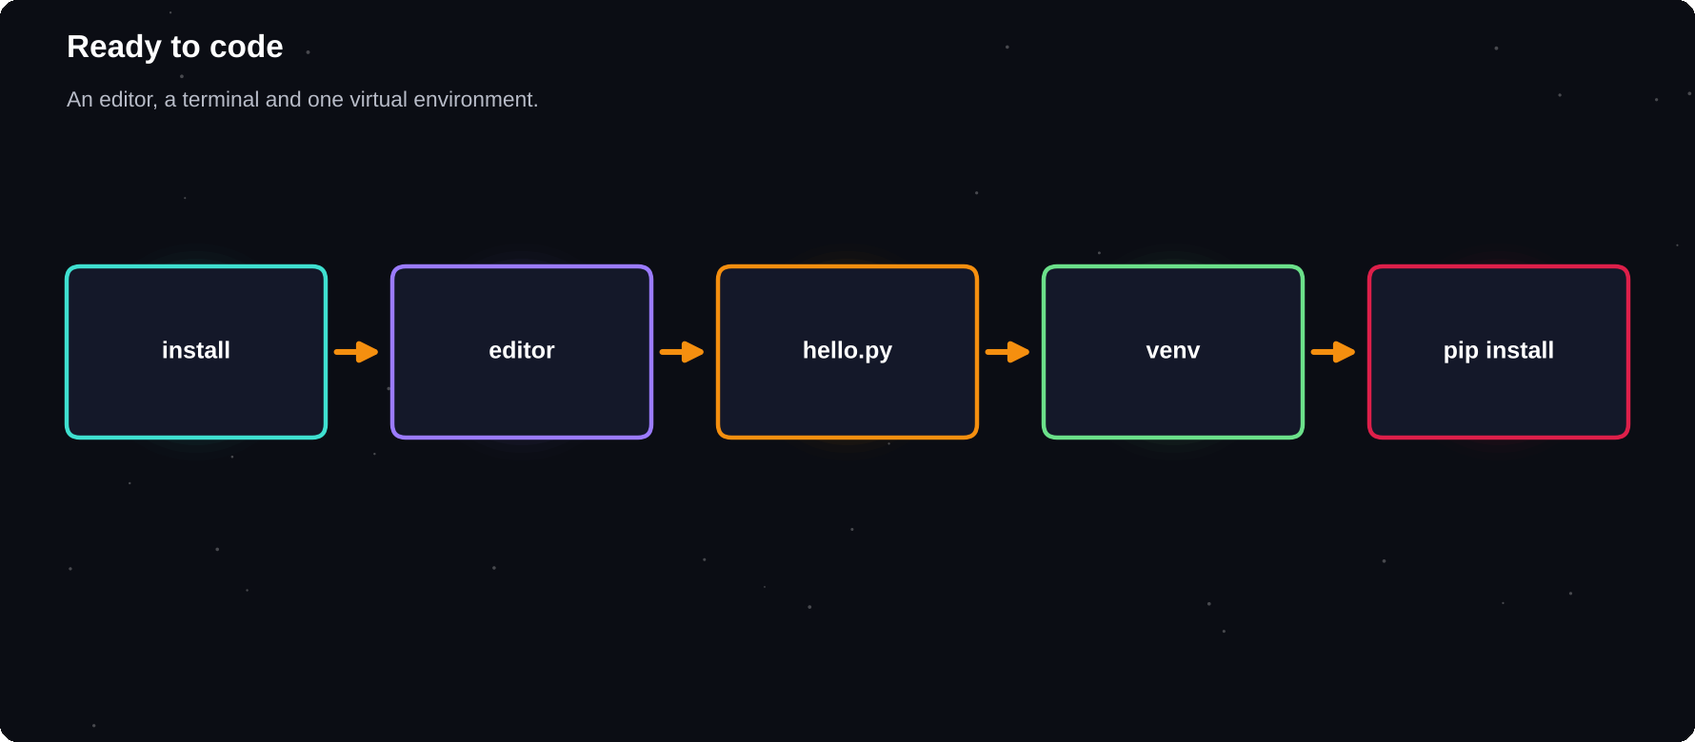
Ready to code
A working editor, a terminal and one virtual environment are all you need.
IN THIS CHAPTER
01 Step 1: install Python  02 Step 2: choose an editor  03 Step 3: run your first file | 04 Step 4: a virtual environment  05 The interactive shell  06 Common error messages | 07 How to read a traceback  08 A debugging routine  09 Common setup problems

Step 1: install Python
1 Go to python.org and open the Downloads page
2 Download the latest stable Python 3 for your system
3 On Windows, tick Add Python to PATH on the first screen
4 Finish the installer
5 Open a terminal and check the version
$ python --version
$ python3 --version

On macOS and Linux the command is often python3. On Windows it can also be py. Any of these printing Python 3.12 or newer means the install worked.
Step 2: choose an editor
Editor | Best for
VS Code | Free, popular, many extensions
PyCharm Community | Full Python IDE, strong tools
Thonny | Simplest start for beginners
Jupyter Notebook | Data work and experiments
IDLE | Comes with Python, basic

Step 3: run your first file
1 Create a folder called python-practice
2 Make a file hello.py containing print("Hello")
3 Open a terminal in that folder
4 Run python hello.py
5 Change the message and run it again
Step 4: a virtual environment
$ python -m venv .venv
$ source .venv/bin/activate
> .venv\Scripts\activate
$ pip install requests
$ deactivate

The first activate line is for macOS and Linux. The second, starting with >, is for Windows. Activate the environment each time you open a new terminal for the project.
The interactive shell
Type python on its own to open the REPL, a prompt where each line runs at once. It is perfect for testing a single idea. Press Ctrl+D (or Ctrl+Z then Enter on Windows) to leave.
Common error messages
Error | Usual cause
SyntaxError | Missing colon, bracket or quote
IndentationError | Mixed or wrong spacing
NameError | Name not defined yet, or typo
TypeError | Wrong type, such as str + int
ValueError | Right type, wrong value
IndexError | Position outside the list
KeyError | Missing dictionary key
AttributeError | Object has no such method
ImportError | Module not installed or misnamed
ZeroDivisionError | Divided by zero
FileNotFoundError | Wrong path or folder

How to read a traceback
print("start")
nums = []
print(sum(nums) / 1)
» start
» 0.0

def avg(nums):
return sum(nums) / len(nums)

print(avg([]))
» ZeroDivisionError: division by zero

Read a traceback from the bottom up. The last line names the error and explains it. The lines above show the path your program took, ending at the line that failed.
A debugging routine
1 Read the last line of the error carefully
2 Go to the line number it names
3 Print the values of the variables nearby
4 Test a smaller version of the problem
5 Search the exact error message online
6 Take a break, then explain the code aloud
Common setup problems
Problem | Fix
python not recognised | Reinstall with Add to PATH ticked
pip not found | Use python -m pip install name
Wrong Python version | Check which python, use python3
Package not found after install | Activate the right virtual env
Permission denied | Do not use sudo. Use a venv
Editor shows import errors | Select the venv interpreter

ASKING FOR HELP
Share the full error message, the smallest code that shows the problem, what you expected and what happened instead. Good questions get good answers quickly.

A TO Z
Glossary
Every term you meet on the way to Hero.

Argument
A value you pass to a function when you call it.
Attribute
A variable that belongs to an object.
Boolean
A value that is True or False.
Bug
A mistake in a program that makes it behave wrongly.
Class
A blueprint for creating objects.
Comment
A note for humans that Python ignores.
Comprehension
A short way to build a list, set or dictionary in one line.
Condition
An expression that is True or False and controls a decision.
Constructor
The __init__ method that sets up a new object.
Data structure
A way of organising data, such as a list or dictionary.
Debugging
Finding and fixing bugs.
Decorator
A function that wraps another function to add behaviour.
Dictionary
A collection of key-value pairs.
DataFrame
A table of data in pandas.
Exception
An error that Python raises when it cannot continue.
Expression
Code that produces a value.
Float
A number with a decimal point.
Function
A named, reusable block of code.
Generator
A function that yields values one at a time.
IDE
An editor with tools for coding, such as VS Code or PyCharm.
Immutable
Cannot be changed after creation.
Import
Loading a module so you can use it.
Index
The position of an item, counting from 0.
Inheritance
A class reusing the behaviour of a parent class.
Integer
A whole number.
Interpreter
The program that reads and runs Python code.
Iterable
Anything you can loop over.
JSON
A text format for nested data used across the web.
Keyword
A reserved word such as if, for or def.
Lambda
A small unnamed function written in one line.
Library
A collection of ready-made code for a particular job.
List
An ordered, changeable collection.
Loop
Code that repeats.
Method
A function that belongs to an object or class.
Module
A Python file you can import.
Mutable
Can be changed after creation.
Object
A thing created from a class, with data and behaviour.
Package
A folder of modules.
Parameter
A name in a function definition that receives an argument.
PEP 8
The official style guide for Python code.
pip
The tool that installs Python packages.
Recursion
A function calling itself on a smaller problem.
REPL
The interactive prompt: read, evaluate, print, loop.
Scope
The part of a program where a name can be used.
Set
An unordered collection of unique items.
Slice
A piece of a sequence, such as text[1:4].
String
Text inside quotes.
Syntax
The rules for writing valid code.
Traceback
The report Python prints when an error stops a program.
Tuple
An ordered, unchangeable collection.
Variable
A name that points at a value.
Virtual environment
An isolated set of packages for one project.

THE LAST WORD
Keep building
You started at zero. You now know how to read, write, test and organise real Python programs. The path from here is practice: pick a project that excites you and build it.

Thank you for reading. If this book helped you, please leave a review on the store where you bought it. It helps other learners find it.
NOTES
The Python Tutorial and Standard Library reference
docs.python.org/3/
PEP 8: Style Guide for Python Code
peps.python.org/pep-0008/
Python version and examples
All code in this book was run with Python 3.12 or later. Syntax such as match needs 3.10+ and the | dictionary merge needs 3.9+.

