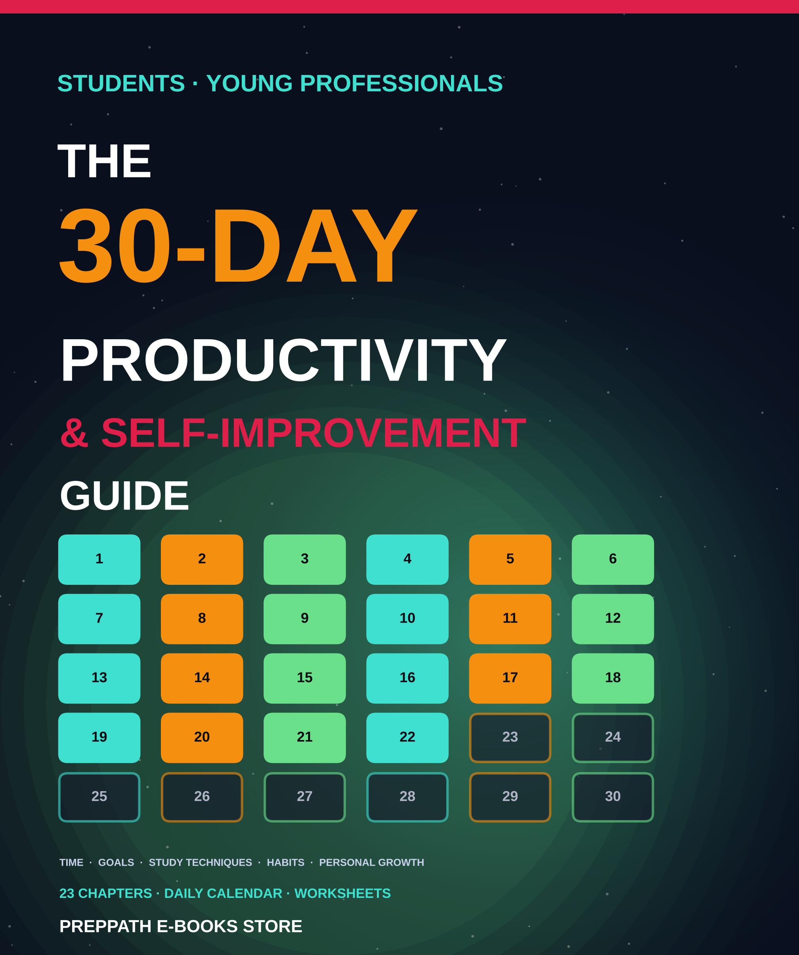

ABOUT THIS EDITION
The 30-Day Productivity & Self-Improvement Guide
For students and young professionals
A picture-led, practical guide to one month of change: time management, goal setting, study techniques, habit tracking and personal development, with a small daily action for every day.
Published by PrepPath E-books Store
© 2026 PrepPath E-books Store. All rights reserved.
Twenty-three chapters take you through four weeks: time and focus, goals and systems, learning and study, then habits and balance. Each chapter ends with actions to try and a short checkpoint. The calendar in Appendix A sets one small action for each day.
This guide gives general information and is not medical, psychological or financial advice. Results vary from person to person. If you are struggling, please speak to a qualified professional.

CONTENTS
What is inside

01 Why 30 Days Works 4
How to use this guide and what to expect
02 Know Your Starting Point 6
Values, priorities and an honest look at your week
03 Sleep, Energy and Body 8
The base layer that every other habit stands on
04 How Your Time Really Works 10
Audit your hours and sort tasks by what matters
05 Plan Your Day and Week 12
Time blocking, top tasks and a weekly plan
06 Beat Procrastination 14
Why we delay and how to start anyway
07 Focus and Deep Work 16
Work without distraction, for short periods, on purpose
08 Goal Setting That Works 18
Clear, specific goals with a reason behind them
09 From Goals to Systems 20
Daily actions, weekly reviews and tracking progress
10 Motivation and Mindset 22
Keep going when excitement fades
11 How Learning Really Works 24
Memory, forgetting and why re-reading fails
12 Study Techniques That Work 26
Feynman, Cornell, mind maps and a weekly study plan
13 Reading, Notes and Exams 28
Read faster, note better and walk into exams ready
14 Digital Tools for Study 30
Apps and systems that help, without becoming distractions
15 The Science of Habits 32
Cues, routines, rewards and the two-minute rule
16 Build a Habit Tracker 34
Track your streaks and learn from the data
17 Break Bad Habits 36
Understand triggers and replace the routine
18 Stress, Wellbeing and Balance 38
Rest, recovery and staying well while you work hard
19 Money and Career Basics 40
Budgeting, saving and early career habits
20 Communication and Relationships 42
Listening, speaking and working well with others
21 Thinking Clearly and Deciding Well 44
Better decisions, fewer regrets
22 Confidence, Creativity and Growth 46
Build self-belief and keep learning for life
23 Review and Your Next 30 Days 48
Measure progress and plan what comes next
A The 30-Day Calendar 50
One small action for each day of the month
B Worksheets and Templates 52
Copy these into your notebook or notes app
C Technique Quick Reference 55
Every method in the book on one page
D Troubleshooting 57
When things go wrong, try these fixes
A–Z Glossary 59
Key terms in one line each
→ A Last Word 60
Start small, and a few notes

CHAPTER 1
Why 30 Days Works
Big change feels impossible, but a month is short enough to commit to and long enough to notice results. This guide gives you one clear focus for each stretch of the month, with small daily actions that fit around study and work.
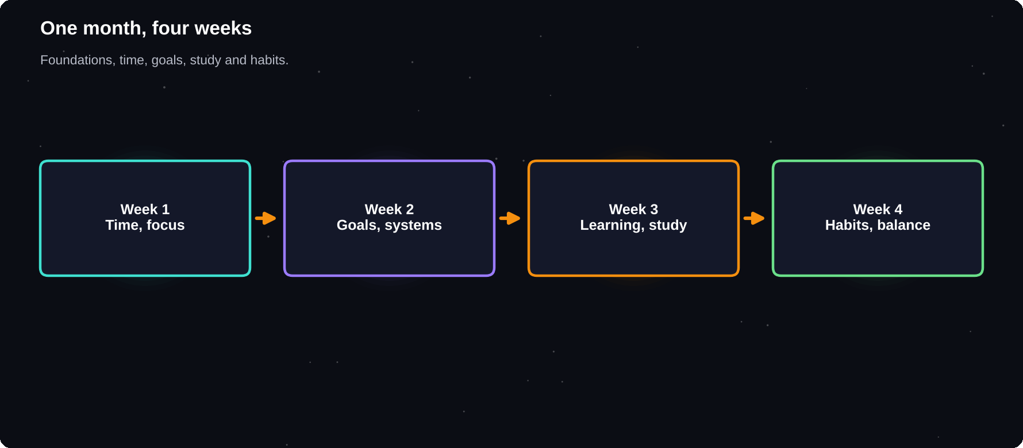
One month, four weeks
Foundations, time, goals and study, habits: each week builds on the last.
IN THIS CHAPTER
01 The idea in one minute  02 How the month is laid out  03 How to use each chapter | 04 What you need  05 Set your rules  06 Take your starting snapshot | 07 Common mistakes to avoid

The idea in one minute
Most self-improvement fails because people try to change everything at once, rely on motivation and quit after a bad day. This guide does the opposite. It picks a small number of skills, teaches them in order and asks for twenty to forty minutes a day.
30
days is a trial period, not a finish line. Research on habits suggests many behaviours take longer than a month to become automatic, so think of this as a strong start
How the month is laid out
Week | Focus
Week 1 | Time and focus
Week 2 | Goals and systems
Week 3 | Learning and study
Week 4 | Habits and balance
Days 29–30 | Review and next plan

How to use each chapter
1 Read the chapter once, with a pen in hand
2 Do the Try it yourself actions the same day
3 Choose one technique to practise tomorrow
4 Note what worked in a daily log
5 Review everything at the end of each week
What you need
Item | Why
A notebook or notes app | Daily log
A calendar | Plan your time
A timer | Focus sessions
20–40 minutes a day | Practice
Honesty | Real progress

Set your rules
1 Never miss twice: if you skip a day, restart the next day
2 Start small: a tiny action done daily beats a big one skipped
3 Track, do not judge: record what happened without guilt
4 Change one thing at a time
5 Stay flexible: adjust the plan, not your goal
A NOTE ON HEALTH
This guide offers general study and productivity advice. It is not medical or mental health advice. If you feel persistently low, anxious or overwhelmed, speak to a doctor, counsellor or someone you trust.

Take your starting snapshot
Before you begin, rate yourself from 1 to 10 on each area below. You will rate yourself again on day thirty. Numbers are not a grade. They simply show you where you started.
Area | Your score
Time control | __ / 10
Focus | __ / 10
Goal clarity | __ / 10
Study results | __ / 10
Daily habits | __ / 10
Energy and sleep | __ / 10
Stress level | __ / 10

Common mistakes to avoid
1 Starting five new habits on day one
2 Waiting for the perfect moment
3 Copying someone else's routine exactly
4 Treating one missed day as total failure
5 Reading about change instead of practising it
Try it yourself
1 Write down why you picked this month
2 Fill in your starting snapshot
3 Block 30 minutes in your calendar every day
4 Choose where you will keep your daily log
5 Tell one friend about your plan
Chapter checkpoint
1 Small daily actions beat big bursts
2 Each week has one clear focus
3 A month is a strong start, not the end
4 Never miss twice
5 Record your starting point

CHAPTER 2
Know Your Starting Point
You cannot improve what you have not looked at. Before you learn any technique, spend one session understanding where your time, energy and attention go now, and what you actually want from this month.
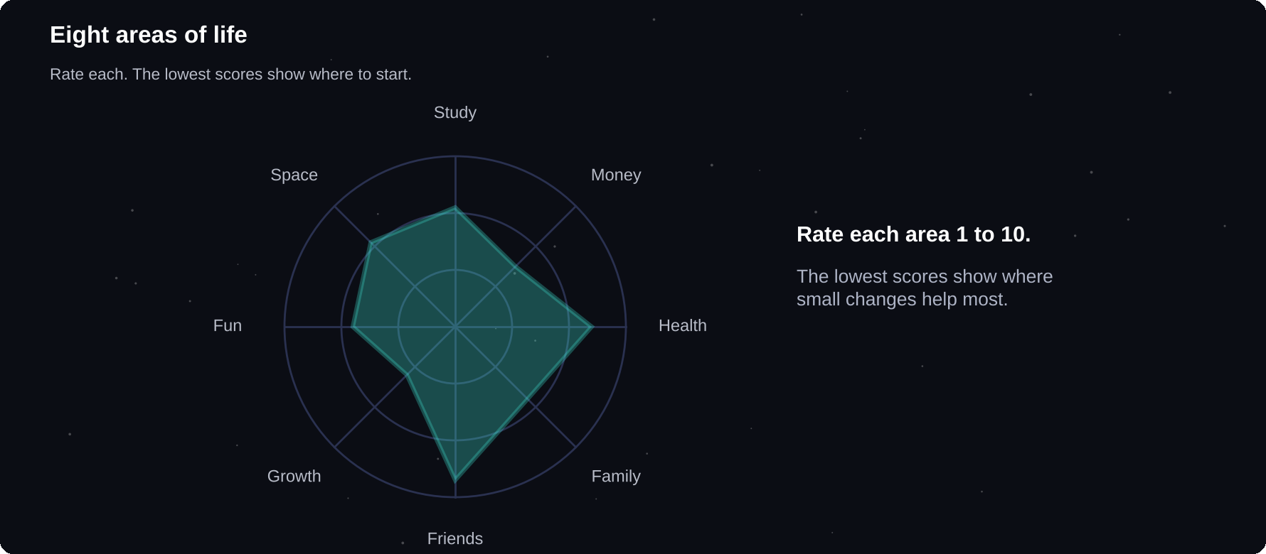
Eight areas of life
Rate each area. The lowest scores point to where small changes help most.
IN THIS CHAPTER
01 Why self-assessment first  02 The life wheel  03 Find your values | 04 Do a quick time snapshot  05 Strengths and obstacles  06 Pick your three focus areas | 07 Write your month statement

Why self-assessment first
Advice that ignores your situation rarely sticks. A student with three exams, a young professional with a long commute and a part-time worker with a family all need different plans. Understanding your starting point lets you choose the right techniques from this guide.
The life wheel
Draw a circle and divide it into eight slices. Rate each area from 1 (very unhappy) to 10 (very happy). Join the points to see the shape of your life right now.
Area | Ask yourself
Study or work | Am I making progress?
Money | Do I feel in control?
Health | Do I move, eat, sleep well?
Family | Are the bonds healthy?
Friends | Do I have support?
Growth | Am I learning?
Fun | Do I rest and enjoy?
Environment | Is my space helpful?

Find your values
Values are what matter most to you, such as honesty, learning, family, creativity, health or independence. Goals that match your values feel meaningful. Goals that do not tend to fade.
1 List ten things you care about
2 Circle the five that matter most
3 Choose your top three
4 Write one sentence for each: what it means to you
5 Check this month's plan against them
Do a quick time snapshot
For the next two days, write down what you do each hour. You will use this in chapter 4. Be honest. The aim is to learn, not to impress anyone.
Strengths and obstacles
List | Examples
Strengths | Curious, organised, friendly
Weak spots | Phone, late nights, delaying
Helpers | Friend, mentor, quiet room
Blockers | Noisy home, long commute

Pick your three focus areas
From the life wheel, choose the three areas where a small improvement would make the biggest difference. For many students these are study, health and time. For young professionals they are often work, money and energy.
EXAMPLE
Ravi is in his third year. His lowest scores: Study 4, Health 5, Fun 5. His three focus areas for the month: a steady study routine, seven hours of sleep and one hobby evening a week.

Write your month statement
A month statement is one or two sentences that describe how you want things to be in thirty days. It should be specific and kind to yourself.
TEMPLATE
In 30 days I want to [result] because [value]. I will do this by [two or three daily actions]. I will know it is working when [evidence].

Try it yourself
1 Draw and score your life wheel
2 List your top three values
3 Start your two-day time snapshot
4 Choose three focus areas
5 Write your month statement
Chapter checkpoint
1 Assess before you plan
2 The life wheel shows balance
3 Values keep goals meaningful
4 Choose three focus areas only
5 Write a clear month statement

CHAPTER 3
Sleep, Energy and Body
No planner, app or technique can fully rescue a tired brain. Sleep, food, movement and daylight shape your attention, memory and mood. A few simple changes here make every later chapter easier.
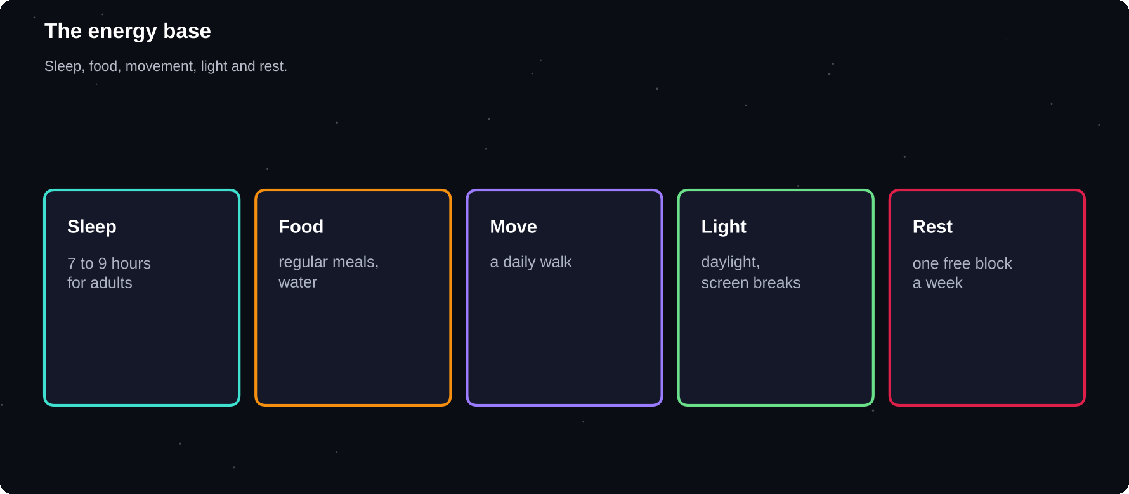
The energy base
Sleep, food, movement and breaks support focus, memory and mood.
IN THIS CHAPTER
01 Energy, not only time  02 Sleep  03 Simple sleep habits | 04 Food and water  05 Move your body  06 Light and breaks | 07 Digital habits and rest  08 Listen to your body

Energy, not only time
People often try to squeeze more hours out of the day. A better question is how to bring more energy to the hours you already have. One focused hour with a rested brain can beat three tired ones.
Sleep
Sleep helps your brain store what you learned and recover for the next day. Health organisations generally advise about 7 to 9 hours for adults and more for teenagers. Individual needs vary, so notice how you feel.
7–9
hours is the commonly recommended sleep range for adults. Teenagers usually need more
Simple sleep habits
1 Keep a regular bedtime and wake time, even at weekends
2 Dim lights and put screens away 30–60 minutes before bed
3 Keep the room cool, dark and quiet
4 Avoid caffeine in the afternoon and evening
5 Do not study in bed, so that your brain links bed with sleep
6 Write tomorrow's top three tasks to clear your mind
SKIP THE ALL-NIGHTER
Late-night cramming usually costs more than it gains. Memory and concentration drop when you are short of sleep. Plan study earlier and protect your sleep before exams.

Food and water
Habit | Why it helps
Eat regular meals | Stable energy
Include protein, fibre | Fuller for longer
Drink water | Even mild thirst hurts focus
Limit sugary drinks | Fewer energy crashes
Do not skip breakfast if you feel weak | Better morning focus

Move your body
Regular movement improves mood and focus for many people. You do not need a gym. A brisk 20-minute walk, a few stretches between study sessions or a short bodyweight routine all help.
1 Walk 20 minutes a day
2 Stand and stretch every hour
3 Choose an activity you enjoy
4 Move a little before hard study sessions
5 Start small and build slowly
Light and breaks
Morning daylight helps regulate your body clock. Short breaks away from screens rest your eyes and mind. The 20-20-20 habit is a simple reminder: every 20 minutes, look at something 20 feet away for 20 seconds.
Digital habits and rest
Habit | Try
Phone in another room | While studying
Night mode | After sunset
Screen-free meal | One a day
Weekly rest block | A few offline hours

Listen to your body
If you have ongoing sleep problems, constant fatigue or health worries, speak to a doctor. Productivity advice cannot replace medical care.
Try it yourself
1 Set a bedtime and a wake-up time
2 Plan tomorrow's first meal and your water
3 Schedule a 20-minute walk
4 Choose a screen cut-off time
5 Track how you feel for a week
Chapter checkpoint
1 Energy matters as much as time
2 Protect your sleep
3 Eat, drink and move regularly
4 Take screen and rest breaks
5 See a doctor for health concerns

CHAPTER 4
How Your Time Really Works
Week one is about time. Everyone has the same 168 hours, yet some people feel in control and others feel behind all the time. The difference is awareness. You will find out where your hours really go, then decide what deserves them.
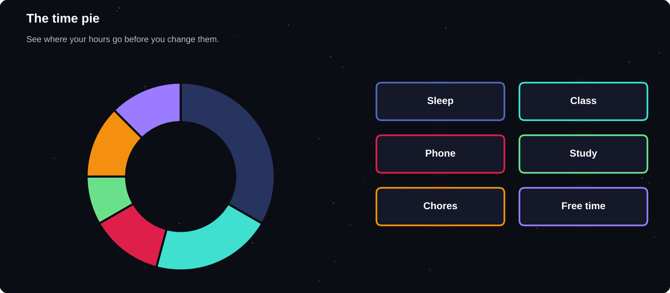
The time pie
Study, sleep, meals, travel, phone and free time: seeing the pie changes the plan.
IN THIS CHAPTER
01 The 168-hour week  02 Run a time audit  03 Urgent and important | 04 Examples  05 The 80/20 idea  06 Time wasters and time stealers | 07 Worked example: a student's week  08 Your fixed and flexible time

The 168-hour week
A week has 168 hours. Sleep may take around 50 to 60 of them, meals and personal care another 15 to 20. Classes or work, travel and chores take a large share. What remains is your flexible time. Knowing that number is the start of real planning.
Block | Hours per week
Sleep | 50–60
Meals, hygiene | 15–20
Class or work | Varies
Travel | Varies
Chores, errands | Varies
Flexible time | What remains

Run a time audit
1 For three days, write what you do in each hour
2 Use categories: study, class, rest, phone, social, travel, chores
3 Add the totals for each category
4 Circle surprises: time you did not know was lost
5 Decide what you would like to change
MOST PEOPLE ARE SURPRISED
Short stretches of phone, video and messaging add up quickly. Many students find hours a day hiding in places they never noticed. The point is awareness, not guilt.

Urgent and important
Not all tasks are equal. The Eisenhower matrix sorts tasks by two questions: is it important, and is it urgent? It helps you stop reacting to every demand.
 | Urgent | Not urgent
Important | Do now | Schedule
Not important | Delegate or limit | Drop

Examples
Quadrant | Examples
Do now | Assignment due tomorrow
Schedule | Exam revision, exercise, skills
Delegate or limit | Most messages, some calls
Drop | Endless scrolling

Most growth lives in the schedule box: important but not urgent. If you never plan it, urgent tasks will push it out forever.
The 80/20 idea
Often a small share of your actions produces most of your results. A few study methods, a few key tasks or a few relationships matter more than the rest. Look for your vital few.
Time wasters and time stealers
Waster | Fix
Endless social media | App limits, scheduled time
Messages all day | Batch checking
Saying yes to everything | Pause before agreeing
Unclear tasks | Write the next action
Perfectionism | Set a good-enough standard

Worked example: a student's week
Asha is a second-year student. Her audit showed she believed she studied three hours a day. The record said otherwise.
Activity | Hours per day
Classes | 5.0
Travel | 1.5
Phone, social | 3.0
Real study | 1.2
Meals, chores | 2.5
Rest, other | 2.8

The surprise was three hours of phone time spread through the day. She did not need to delete everything. She set app limits and moved most phone use to a fixed half-hour after dinner, which freed nearly two hours.
Your fixed and flexible time
1 Mark fixed time: classes, work, sleep, meals, travel
2 Count what is left in the week
3 Choose how many flexible hours go to study, health and fun
4 Protect those blocks like appointments
5 Review the numbers after one week
Try it yourself
1 Run your three-day time audit
2 Sort tomorrow's tasks into the four boxes
3 Find your top two time stealers
4 Pick one to reduce this week
5 List three important but not urgent tasks to schedule
Chapter checkpoint
1 You have 168 hours a week
2 Audit before you change
3 Separate urgent from important
4 Protect the important and not urgent
5 Reduce time stealers

CHAPTER 5
Plan Your Day and Week
A plan turns good intentions into scheduled actions. You do not need a complicated system. A short list of priorities, a few time blocks and a weekly review are enough to put you ahead of most people.
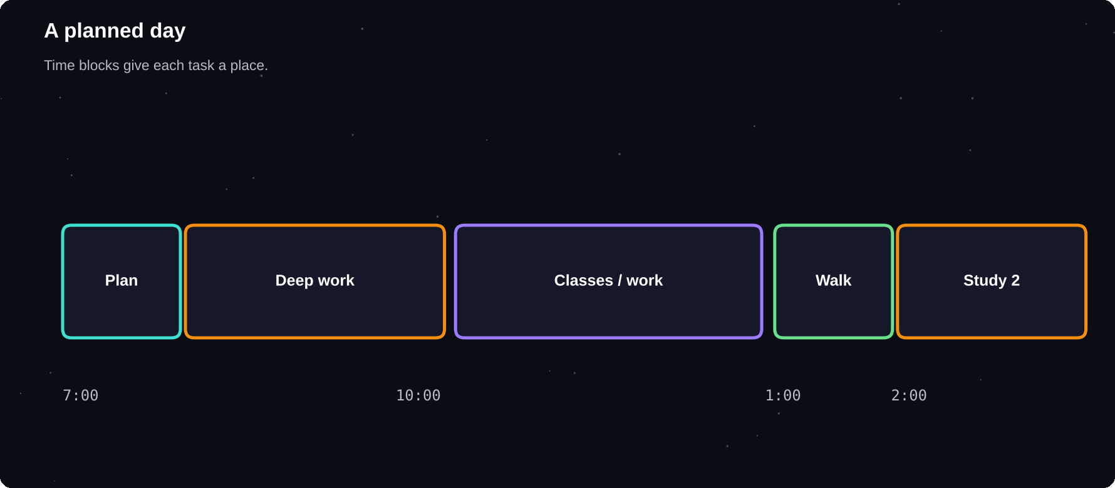
A planned day
Time blocks give each task a place, so you decide once instead of all day.
IN THIS CHAPTER
01 Plan the night before  02 Three top tasks  03 Time blocking  04 Rules for good blocks | 05 Find your peak time  06 The weekly plan  07 Handle interruptions  08 Paper, app or both | 09 A sample day for a student  10 A sample day for a young professional

Plan the night before
Spend five minutes each evening to decide tomorrow. Your brain can rest knowing there is a plan, and you start the day with a clear first action instead of a blank page.
Three top tasks
Choose the three most important tasks for the day, your MITs (most important tasks). Do the first one early, before messages and distractions grow.
EXAMPLE
Tomorrow: 1) Finish chapter 5 notes, 2) Submit lab report, 3) 20-minute walk. Everything else is a bonus.

Time blocking
Time blocking means giving each task a specific slot in your calendar. A task with a time is much more likely to happen than a task on a vague list.
Time | Block
7:00 | Wake, water, plan
8:00 | Top task 1, deep study
10:30 | Classes or work
1:00 | Lunch, short walk
2:00 | Top task 2
5:00 | Exercise, chores
7:30 | Light study, review
9:30 | Plan tomorrow, wind down

Rules for good blocks
1 Match hard work to your best energy time
2 Leave gaps: plan for 70 per cent of the day
3 Add buffer time between tasks
4 Group similar tasks, such as all emails together
5 Put breaks and meals in the calendar too
Find your peak time
Some people think best in the morning and some at night. Track your energy for a week and note when you focus most easily. Put your hardest tasks there.
The weekly plan
Once a week, ideally on Sunday, look at the coming seven days.
1 Check deadlines, exams and events
2 Choose three weekly priorities
3 Block study and exercise first
4 Add social time and rest
5 Decide what you will say no to
Handle interruptions
Interruption | Response
Friend drops by | Agree a time to talk
New task appears | Add to the list, decide later
Urgent request | Ask when it is due
Notification | Mute during blocks

Paper, app or both
Use the tool you will actually open. A paper planner is simple and distraction-free. A calendar app sends reminders and syncs across devices. Many people use an app for events and paper for daily priorities.
A sample day for a student
Time | Plan
6:45 | Wake, water, stretch
7:15 | Breakfast, read the plan
8:00 | Travel: flashcard review
9:00–1:00 | Classes
1:30 | Lunch and a short walk
2:30 | Study block 1: hardest subject
4:00 | Break, exercise
5:00 | Study block 2: practice problems
7:30 | Dinner, free time
9:30 | Plan tomorrow, wind down

A sample day for a young professional
Time | Plan
6:30 | Wake, light movement
8:00 | Commute: listen or read
9:00 | Deep work on the top task
11:30 | Messages and meetings
1:00 | Lunch away from the desk
2:00 | Collaboration and admin
5:30 | Review, plan tomorrow
7:00 | Exercise, dinner, personal time
9:30 | Learning for 20 minutes, sleep

Use these as patterns, not rules. Change the times to fit your classes, shifts and commute.
Try it yourself
1 Plan tomorrow tonight with three top tasks
2 Block your hardest task at your best time
3 Leave one hour free for surprises
4 Do a weekly plan this Sunday
5 Review at the end of the day: what worked?
Chapter checkpoint
1 Plan the night before
2 Pick three top tasks
3 Time block the day, but leave gaps
4 Do a weekly plan
5 Choose tools you will actually use

CHAPTER 6
Beat Procrastination
Procrastination is not laziness. It is usually a way of avoiding an uncomfortable feeling such as boredom, fear of failure or confusion about where to begin. Once you know the cause, you can pick a fix that fits.
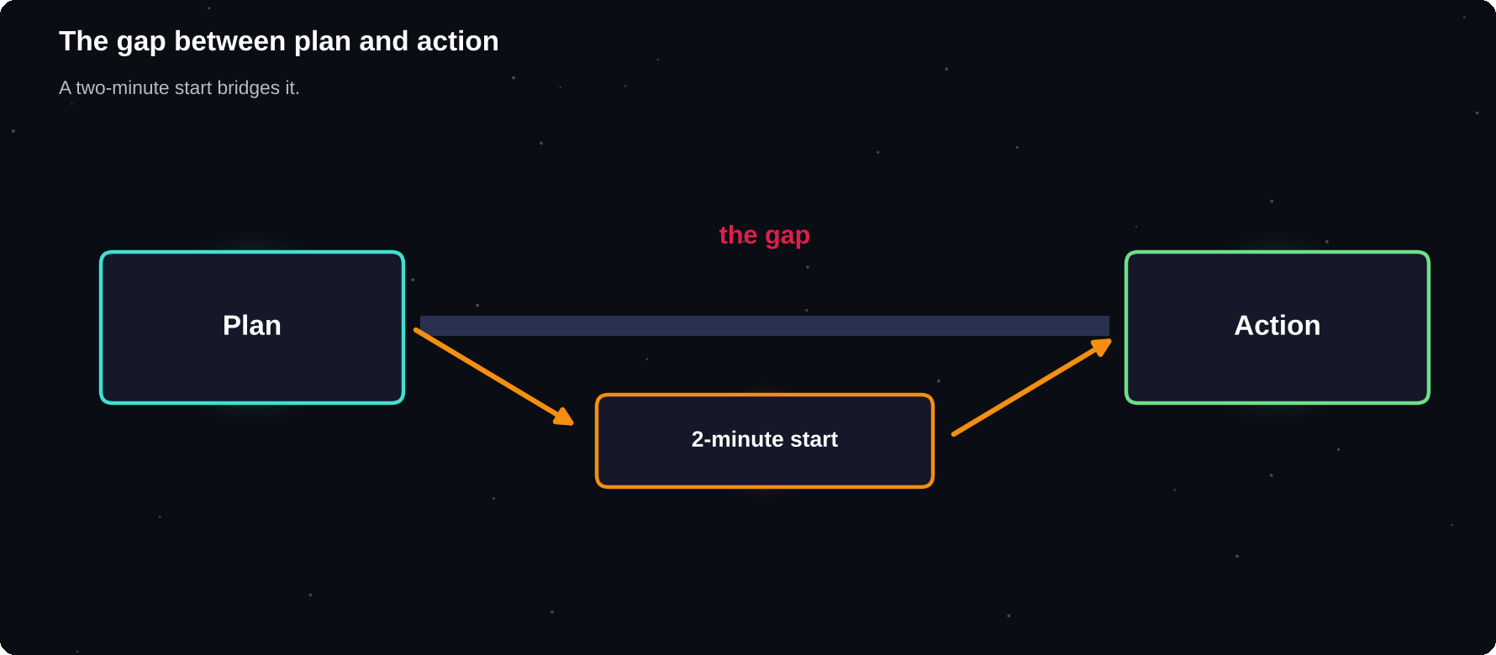
The gap between plan and action
Small starts bridge the gap.
IN THIS CHAPTER
01 What is procrastination?  02 Why we delay  03 Fixes that work | 04 Break big tasks into steps  05 Implementation intentions  06 Eat the frog | 07 Dealing with guilt  08 Procrastination scripts  09 The five-minute reset

What is procrastination?
Procrastination means delaying something you intend to do, even though you know the delay will probably cost you. It is common and human. Almost everyone does it sometimes.
Why we delay
Cause | What it feels like
Fear of failing | “What if it is not good?”
Perfectionism | “I must start perfectly”
Unclear task | “Where do I begin?”
Boredom | “This is dull”
Overwhelm | “It is too big”
Low energy | “I am too tired”
Distraction | “Just five minutes of phone”

Notice that most of these are feelings, not time problems. A calendar will not fix fear. A smaller first step often will.
Fixes that work
1 The two-minute start: commit to only two minutes. Starting is the hard part
2 Shrink the task: “open the document and write one sentence”
3 Make the next action obvious: write exactly what to do first
4 Remove friction: set out books, close tabs, charge your laptop
5 Add friction to distractions: log out, move the phone
6 Use a deadline: decide today when it will be done
7 Reward yourself after the work, not before
PERFECT IS THE ENEMY
Give yourself permission to write a bad first draft. Editing is much easier than creating. A rough start moves you past the fear.

Break big tasks into steps
A task like “write the report” is too vague to start. Break it into small, concrete actions.
Vague | Concrete steps
Write the report | 1. List headings 2. Write intro 3. Add data
Study for the exam | 1. List topics 2. Do topic one for 25 minutes
Apply for jobs | 1. Update CV 2. Find three roles 3. Send one

Implementation intentions
Research on planning suggests that deciding exactly when and where you will act makes action more likely. Use the format: “When X happens, I will do Y.”
EXAMPLES
When I finish dinner, I will study for 30 minutes at my desk. When I get on the bus, I will review flashcards instead of scrolling.

Eat the frog
The phrase means doing your hardest or most dreaded task first. Once it is done, the rest of the day feels lighter. If your frog is a big one, shrink it into steps first.
Dealing with guilt
Beating yourself up makes procrastination worse, because you now want to avoid the bad feeling as well. Treat a slip with kindness: notice it, note what triggered it and restart with a small action.
Procrastination scripts
When the urge to delay appears, a ready answer helps you act before you think yourself out of it.
The thought | Your script
I will do it later | I will do two minutes now
I am not in the mood | Mood follows action. Start small
It must be perfect | A rough draft is a good start
I work better under pressure | Pressure is stress. Plan buffers
One scroll will not hurt | Scroll after this session

The five-minute reset
1 Stand up and drink some water
2 Take three slow breaths
3 Write the very next action on a card
4 Set a timer for five minutes
5 Start, and decide what to do when it rings
Try it yourself
1 Name your most delayed task
2 Write why you avoid it, in one sentence
3 Break it into five tiny steps
4 Do the first step for two minutes now
5 Write a when-then plan for the next step
Chapter checkpoint
1 Procrastination is avoidance of feelings
2 Shrink the first step
3 Remove friction from good tasks
4 Use when-then plans
5 Treat slips with kindness

CHAPTER 7
Focus and Deep Work
Real progress comes from focused, uninterrupted effort. In a world of notifications, focus is a skill you must train and protect. This chapter gives you practical tools for working deeply in short, well-planned sessions.
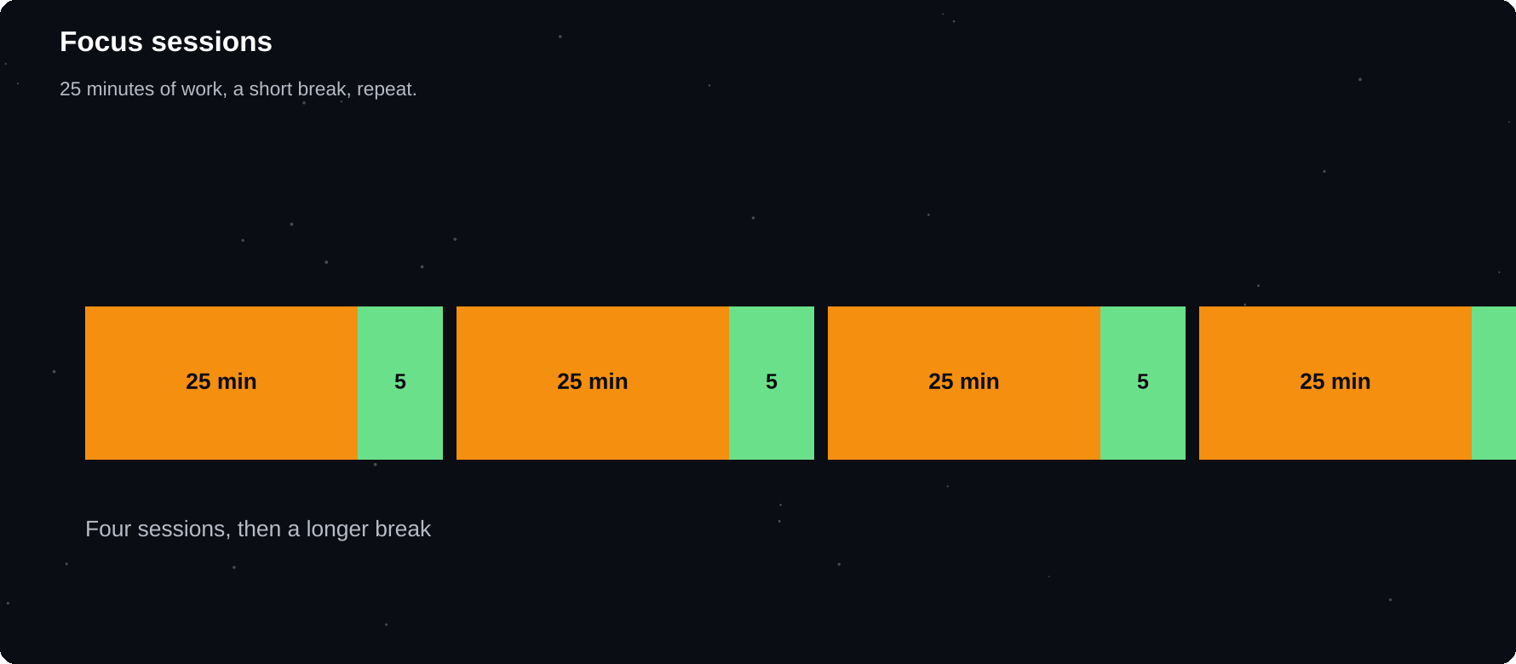
Focus sessions
25 minutes of work, 5 minutes of rest, repeated four times, then a longer break.
IN THIS CHAPTER
01 Why multitasking fails  02 The Pomodoro method  03 Build a focus space | 04 Handling distractions  05 Single-tasking  06 Use deep and shallow time | 07 Phone habits

Why multitasking fails
When you switch between tasks, your brain pays a cost each time. You lose track of where you were, and mistakes rise. What feels like doing two things at once is really rapid switching, and it usually makes both tasks slower.
The Pomodoro method
The Pomodoro Technique, created by Francesco Cirillo, uses a timer to split work into short sessions. It is simple and works well for beginners.
1 Choose one task
2 Set a timer for 25 minutes
3 Work with full focus until it rings
4 Take a 5-minute break away from your screen
5 After four sessions, take a longer break of 15 to 30 minutes
Round | Work | Break
1 | 25 min | 5 min
2 | 25 min | 5 min
3 | 25 min | 5 min
4 | 25 min | 15–30 min

ADJUST THE TIMES
25 minutes is a starting point. Some people prefer 40 or 50 minutes of work with 10-minute breaks. Choose what suits the task and your attention.

Build a focus space
1 Clear your desk of everything except what you need
2 Put your phone in another room or in a drawer
3 Close extra browser tabs and mute notifications
4 Use headphones or a quiet place
5 Keep water and a notebook nearby
Handling distractions
Distraction | Response
Random thought | Write it on a pad, return
Urge to check phone | Wait until the break
Noise | Headphones, a different room
Hunger, thirst | Prepare before you start
Boredom | Shorten the session

Single-tasking
Pick one thing and give it your full attention. Close everything else. When the session ends, you can move on. Over time, your ability to hold focus grows, like a muscle.
Use deep and shallow time
Deep work | Shallow work
Studying hard topics | Replying to messages
Writing, coding | Filing, admin
Problem solving | Routine errands
Needs full focus | Can be done tired

Schedule deep work at your peak energy time. Put shallow work in lower-energy gaps.
Phone habits
1 Turn off non-essential notifications
2 Remove social apps from your home screen
3 Use do-not-disturb during study blocks
4 Charge your phone away from your bed
5 Set app limits for the biggest time stealers
Try it yourself
1 Do two Pomodoro sessions today
2 Create your focus space checklist
3 Move your phone out of reach for one session
4 Keep a distraction pad beside you
5 Note how your focus felt at the end of the day
Chapter checkpoint
1 Switching tasks costs focus
2 Pomodoro uses timed work and breaks
3 Design your space for focus
4 Write distractions down and carry on
5 Control your phone, do not let it control you

CHAPTER 8
Goal Setting That Works
Week two moves from time to direction. Goals give your effort a destination. Research on goal setting has long found that specific, challenging goals tend to lead to better performance than vague ones such as “do my best”.
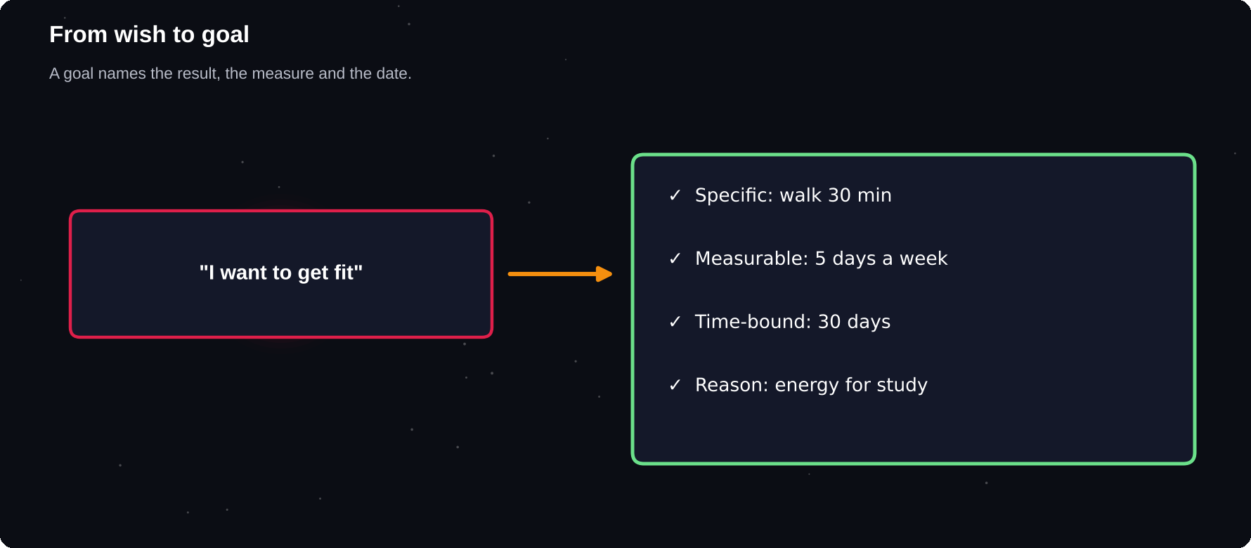
From wish to goal
A goal names the result, the measure and the date.
IN THIS CHAPTER
01 Wishes versus goals  02 SMART goals  03 Outcome, process and performance goals  04 Know your why | 05 Limit your goals  06 Write your goals  07 Stretch without breaking  08 Goals can change | 09 Visualise the process  10 Worked example: three goals  11 Check your goals

Wishes versus goals
Wish | Goal
I want to get fit | Walk 30 minutes, 5 days a week for 30 days
I want better grades | Raise my maths score to 75 by the end of term
I want to read more | Read 20 pages a day
I want a job | Send five applications a week

SMART goals
Letter | Question
Specific | What exactly will I do?
Measurable | How will I know?
Achievable | Is it realistic for me?
Relevant | Does it matter to me?
Time-bound | By when?

SMART EXAMPLE
I will complete 20 practice questions in maths every weekday evening for the next four weeks, so that I feel confident for my exam on 15 December.

Outcome, process and performance goals
Type | Example
Outcome | Score 80 per cent
Performance | Finish past papers in 90 minutes
Process | Study 1 hour daily

Outcome goals are inspiring but partly out of your control. Process goals are fully in your hands. Set both, and focus your daily energy on the process.
Know your why
A goal with a strong reason lasts longer than one without. Ask “why does this matter?” until you reach a value you care about. Write the answer where you will see it.
Limit your goals
Too many goals spread your energy thin. For this month, choose a maximum of three: one for each focus area you chose in chapter 2.
Write your goals
1 Write each goal in one sentence
2 Make it specific and measurable
3 Add a start and end date
4 Write your reason
5 List the first three actions
Stretch without breaking
A goal that is too easy is boring. One that is far too hard is discouraging. Aim for a stretch: a little beyond what you do now, but still believable.
Goals can change
If your situation changes, you can adjust. Changing a goal because it no longer fits is wise. Quitting because it is uncomfortable is different. Review honestly every week.
Visualise the process
Picturing success can feel good, but it works better when you also picture the obstacles and plan for them. Ask “what is most likely to get in my way, and what will I do then?”
Worked example: three goals
Area | SMART goal
Study | Do 25 practice questions in maths on weekdays, for four weeks
Health | Walk 30 minutes on five days a week for 30 days
Skills | Complete one Excel lesson daily and finish a mini-project by day 30

Notice that each goal has a number, a time frame and a daily or weekly action. That clarity removes the daily question “what should I do now?”
Check your goals
1 Could a stranger tell whether I did it?
2 Is the first step small enough to start today?
3 Does it match a value I care about?
4 Is the deadline realistic with my other work?
5 What would make me quit, and what is my plan?
Try it yourself
1 Write three SMART goals for the month
2 Write the reason behind each
3 Mark one process goal for each
4 Display them where you see them daily
5 List one obstacle for each and your response
Chapter checkpoint
1 Goals are specific and measurable
2 SMART gives a clear checklist
3 Focus on process as well as outcome
4 Know your reason
5 Choose no more than three goals

CHAPTER 9
From Goals to Systems
A goal tells you where you want to go. A system is the repeatable set of actions that carries you there. People who succeed over time tend to focus on their systems: the routines they follow regardless of mood.
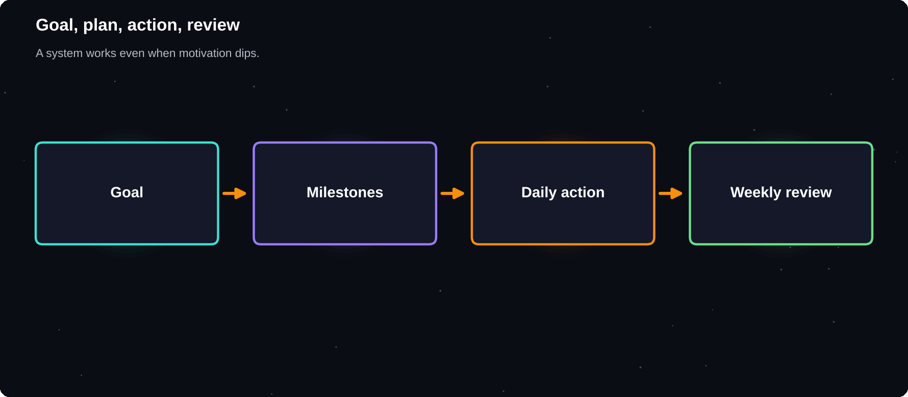
Goal, plan, action, review
A system keeps you moving even when motivation dips.
IN THIS CHAPTER
01 Goals and systems  02 Break goals into milestones  03 Example: learn basic Excel in 30 days | 04 The weekly review  05 Measure progress  06 The 1 per cent mindset | 07 Plan for bad days  08 Accountability

Goals and systems
Goal | System
Pass the exam | Study 90 minutes daily, weekly past paper
Get fit | Walk after dinner, gym on Tue and Sat
Learn to code | One lesson daily, one project monthly
Save money | Auto-transfer on salary day

A goal can be reached once. A system keeps working. If you only watch the result, you may feel stuck while the process is quietly paying off.
Break goals into milestones
1 Write the final goal
2 Divide the time into four equal parts
3 Set one milestone at the end of each part
4 List the weekly actions that lead to each milestone
5 Turn each weekly action into a daily task
Example: learn basic Excel in 30 days
Week | Milestone
1 | Basic formulas, formatting
2 | Sorting, filters, tables
3 | Charts, pivot tables
4 | Mini-project and review

The weekly review
The weekly review is the habit that keeps everything else on track. Spend 20 to 30 minutes once a week.
1 What did I complete this week?
2 What did not go well, and why?
3 What did I learn?
4 What are my three priorities for next week?
5 What will I change?
Measure progress
Method | Example
Count | Pages read, questions done
Time | Minutes of focused study
Check | Done or not done each day
Score | Practice test results

Choose measures you control. “Hours of focused study” is more useful than “marks”, because you can control the first one directly.
The 1 per cent mindset
Tiny improvements compound over time. Getting slightly better each day looks small in a week but can be large in a year. Do not wait for dramatic changes.
Plan for bad days
1 Define a minimum version of each habit: five minutes counts
2 Decide in advance what you will do when you are ill or busy
3 Keep the chain unbroken in the smallest possible way
4 Never miss twice
5 Return to the plan after a break without guilt
Accountability
Telling someone your plan makes you more likely to follow through. A friend, mentor or study partner can check in weekly. Choose someone supportive, not harsh.
Try it yourself
1 Turn one goal into four weekly milestones
2 List daily actions for week one
3 Schedule your weekly review in the calendar
4 Write a minimum version for each action
5 Choose an accountability partner
Chapter checkpoint
1 Systems carry you towards goals
2 Milestones make big goals manageable
3 Weekly reviews keep you on track
4 Measure what you control
5 Plan for bad days

CHAPTER 10
Motivation and Mindset
Motivation comes and goes. Mindset, the way you think about effort, mistakes and ability, shapes whether you continue when things get hard. This chapter shows how to build steady drive without depending on mood.
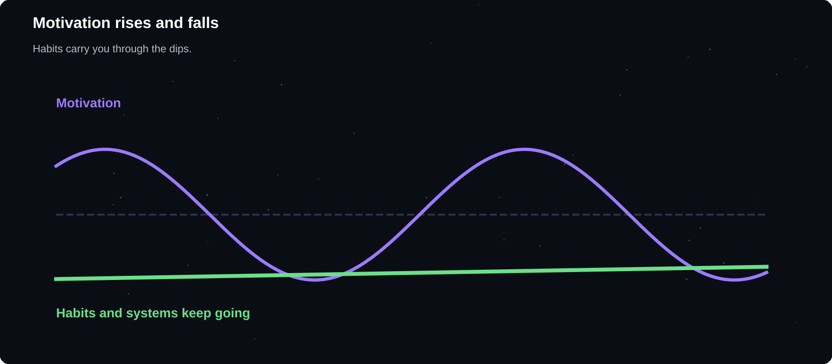
Motivation rises and falls
Habits and systems carry you through the dips.
IN THIS CHAPTER
01 Motivation is a feeling  02 Two kinds of motivation  03 Growth and fixed mindset | 04 Self-talk  05 Use rewards well  06 Use your environment | 07 When motivation is low

Motivation is a feeling
Feelings change daily. If you wait to feel ready, you will often wait a long time. Action usually comes first, and motivation follows. Starting a small task often creates the energy to continue.
Two kinds of motivation
Type | Source
Intrinsic | Interest, enjoyment, meaning
Extrinsic | Rewards, grades, praise

Both help, but intrinsic motivation is usually more lasting. Connect your tasks to something you care about, such as learning, independence or helping others.
Growth and fixed mindset
Psychologist Carol Dweck described two ways of thinking about ability. In a fixed mindset, ability is seen as set. In a growth mindset, ability is seen as something you can develop through effort and good strategies. Evidence on how strongly mindset affects results is mixed, but the habit of treating setbacks as information is useful.
Fixed thought | Growth thought
I am bad at maths | I have not learned this yet
I failed | I learned what to change
It is too hard | It needs a different method
They are just talented | They practised

Self-talk
The way you talk to yourself matters. Harsh self-criticism drains energy. Speak to yourself as you would to a friend: honest, but kind and constructive.
1 Notice the thought
2 Ask: is this fact or judgement?
3 Replace with a balanced version
4 Focus on the next small action
Use rewards well
1 Reward effort and process, not only results
2 Make rewards small and quick, such as a favourite drink or a walk
3 Give the reward only after the work
4 Celebrate milestones with something meaningful
Use your environment
Do | Effect
Put books on your desk | Study feels natural
Hide snacks and games | Less temptation
Study with others | Social support
Display your goals | Constant reminder

When motivation is low
1 Lower the bar to the smallest version
2 Remember why you started
3 Look at your progress log
4 Rest if you are really tired, then restart
5 Talk to someone
PERSISTENT LOW MOOD
Ongoing low mood, loss of interest or hopelessness is not a motivation problem. Please speak to a doctor, counsellor or someone you trust. Support is available and asking for help is a strength.

Try it yourself
1 Write your why for this month on a card
2 Rewrite three negative thoughts in a balanced way
3 Choose a small reward for completing week one
4 Rearrange your desk for focus
5 Write a letter to yourself for day 30
Chapter checkpoint
1 Action creates motivation
2 Connect tasks to meaning
3 See setbacks as information
4 Speak to yourself kindly
5 Seek help for persistent low mood

CHAPTER 11
How Learning Really Works
Week three is about learning. Many students spend hours re-reading notes and highlighting, methods that feel productive but often give weak results. Understanding how memory works lets you study less, and remember more.
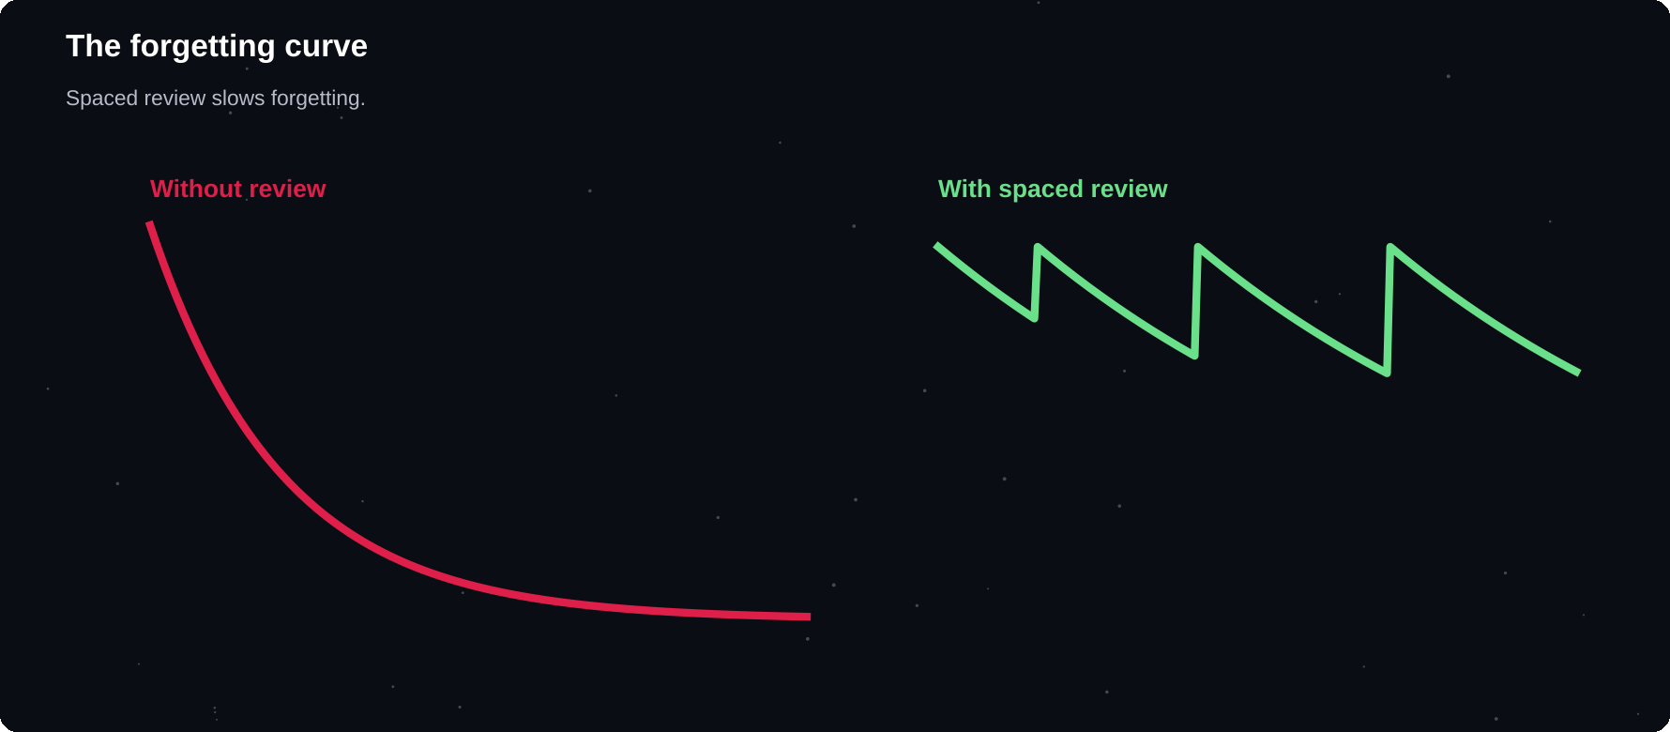
The forgetting curve
Without review, memory fades quickly. Spaced review flattens the curve.
IN THIS CHAPTER
01 How memory works  02 The forgetting curve  03 Methods that work and methods that do not | 04 Active recall  05 Spaced repetition  06 Interleaving | 07 Understand, do not memorise  08 Why re-reading feels good  09 A spaced revision calendar

How memory works
Learning involves taking in information, storing it and retrieving it later. Weak links between ideas mean you forget quickly. Strong, repeated, meaningful links mean you remember.
The forgetting curve
Hermann Ebbinghaus studied memory in the nineteenth century and showed that we forget new material fast, especially without review. The curve is steep at first, then levels out. Each review slows the forgetting.
Review
at increasing gaps flattens the curve. This idea is called spaced repetition
Methods that work and methods that do not
A well-known review of study techniques by Dunlosky and colleagues compared ten common methods. Practice testing and distributed practice (spacing) received high ratings for usefulness. Highlighting and re-reading were rated low.
Technique | Usefulness
Practice testing | High
Spaced practice | High
Explaining ideas | Moderate
Mixing problem types | Moderate
Highlighting | Low
Re-reading | Low
Summarising | Low to moderate

Active recall
Active recall means closing the book and trying to remember. It feels harder than re-reading, and that effort is exactly what builds memory. After reading a section, ask yourself questions and answer them without looking.
1 Read a section
2 Close the book
3 Write what you remember
4 Check against the text
5 Mark gaps and repeat
Spaced repetition
Review | When
First | The same day
Second | After 1 day
Third | After 3 days
Fourth | After 1 week
Fifth | After 2–4 weeks

Flashcard apps and paper boxes can schedule reviews for you. Even a simple calendar reminder works.
Interleaving
Mixing different topics or problem types in one session, rather than finishing one topic completely, helps you learn to choose the right method. It feels harder, yet it can improve later performance.
Understand, do not memorise
1 Ask why and how, not only what
2 Link new ideas to things you already know
3 Use examples from your own life
4 Teach the idea to someone else
5 Draw diagrams of relationships
Why re-reading feels good
Re-reading makes text feel familiar, and familiarity feels like knowledge. This is the fluency illusion. Recognising a page is not the same as being able to recall or use its ideas without it. Testing yourself exposes the difference early, while there is time to fix it.
A spaced revision calendar
Day | Do this
Day 1 | Learn topic A, recall at the end
Day 2 | Learn topic B, recall topic A
Day 4 | Recall topics A and B, learn C
Day 8 | Recall A, B and C
Day 15 | Recall everything, past paper

SLEEP HELPS MEMORY
Sleep supports memory storage. A good night after studying is one of the easiest and cheapest study techniques.

Try it yourself
1 Pick one topic and close your notes
2 Write everything you remember in five minutes
3 Check and fill the gaps
4 Schedule your first spaced review
5 Make ten flashcards for a topic
Chapter checkpoint
1 Forgetting is fast without review
2 Test yourself instead of re-reading
3 Space your reviews
4 Mix topics
5 Understand ideas deeply

CHAPTER 12
Study Techniques That Work
You now know the principles: test yourself, space your reviews and understand deeply. This chapter turns them into techniques you can apply tonight, whatever your subject.
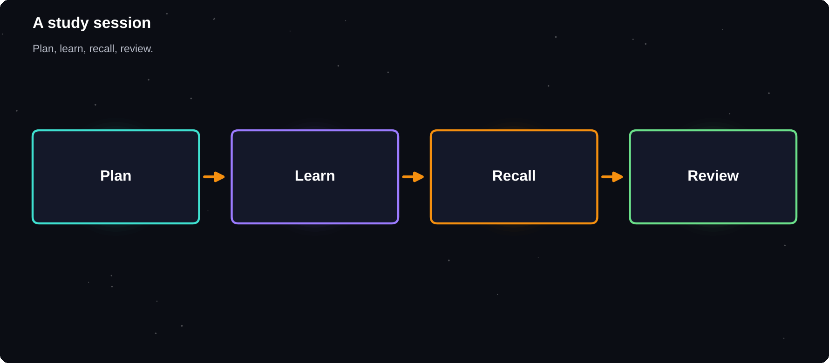
A study session
Plan, learn, recall, review: four steps for every session.
IN THIS CHAPTER
01 A four-step study session  02 The Feynman technique  03 Cornell notes  04 Mind maps | 05 Flashcards  06 Practice problems and past papers  07 Study groups  08 A weekly study plan | 09 Choose the right technique  10 Study session mistakes

A four-step study session
1 Plan: choose one topic and a clear target
2 Learn: read or watch with full focus for 25 minutes
3 Recall: close the notes and write what you remember
4 Review: check gaps, fix them and schedule a repeat
The Feynman technique
Named after physicist Richard Feynman, this method tests whether you truly understand something by explaining it simply.
1 Pick a concept and write its name at the top of a page
2 Explain it in plain words, as if to a younger student
3 Find the places where you got stuck or used jargon
4 Go back to your notes and fill the gaps
5 Simplify your explanation again
Cornell notes
Divide your page into three areas: a narrow left column for cues and questions, a wide right column for notes and a bottom box for a summary.
Area | Use
Cue column | Questions, keywords
Notes column | Main points in your words
Summary | Two sentences after class

Later, cover the notes column and answer the cue questions. This turns notes into a self-test.
Mind maps
A mind map puts a central idea in the middle with branches for sub-topics. It shows relationships at a glance and suits subjects with many connected ideas, such as history or biology. Use colour and short keywords.
Flashcards
1 One idea per card
2 Write the question on the front, the answer on the back
3 Use your own words
4 Add a picture or example when useful
5 Review in short, frequent rounds and sort cards by difficulty
Practice problems and past papers
For subjects like maths, science and coding, doing problems is the most important study method. Attempt a problem before looking at the solution. If you get stuck, note exactly where, then study that step.
Stage | Action
Attempt | Try without help for 10 minutes
Check | Compare with the solution
Analyse | Why was it wrong?
Redo | Solve again a day later

Study groups
A good study group of three to five people helps you explain ideas and fill gaps. Agree a goal and an agenda before each meeting, and keep chat to the breaks.
A weekly study plan
Day | Focus
Mon | Subject A, new material
Tue | Subject B, new material
Wed | Subject A recall and problems
Thu | Subject B recall and problems
Fri | Mixed review, weak topics
Sat | Past paper or project
Sun | Light review, weekly plan

Choose the right technique
Subject type | Best methods
Facts, vocabulary | Flashcards, spaced recall
Concepts, theory | Feynman, mind maps
Maths, science | Practice problems
Essays, humanities | Outlines, practice questions
Coding, skills | Build small projects
Languages | Daily short speaking, listening

Study session mistakes
1 Studying for hours without a plan
2 Passive re-reading and highlighting only
3 Checking the answer before trying
4 Studying with notifications on
5 Skipping breaks and sleep
Try it yourself
1 Explain one concept using the Feynman steps
2 Take your next notes in Cornell format
3 Make a mind map of one chapter
4 Create ten flashcards
5 Plan a weekly study schedule
Chapter checkpoint
1 Use a four-step study session
2 Explain ideas in simple words
3 Turn notes into questions
4 Practise problems actively
5 Plan study across the week

CHAPTER 13
Reading, Notes and Exams
Reading and note-taking feed your study sessions, and exams test the result. With a few smart habits you can read with purpose, take notes you can use and handle exam pressure calmly.
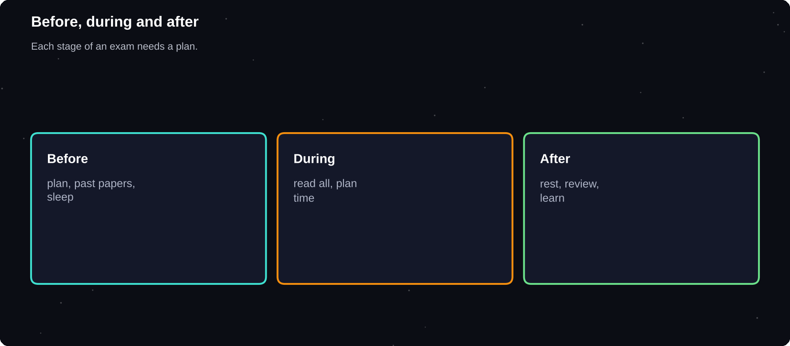
Before, during and after
Preparation, exam day and review each need a plan.
IN THIS CHAPTER
01 SQ3R: read with purpose  02 Take better notes  03 Highlight less | 04 Start exam preparation early  05 Past papers  06 Exam day | 07 Handle exam anxiety  08 After the exam

SQ3R: read with purpose
Step | What to do
Survey | Skim headings, summaries
Question | Turn headings into questions
Read | Read to answer them
Recite | Say the answers aloud
Review | Revisit key points later

This method, created by Francis Robinson, turns passive reading into active study.
Take better notes
1 Listen for ideas, do not copy every word
2 Use your own words and short forms
3 Leave space to add details later
4 Mark questions you want to ask
5 Review notes within 24 hours
Highlight less
Heavy highlighting makes pages colourful but not memorable. If you highlight, mark only key terms, then write a question in the margin.
Start exam preparation early
When | Action
6 weeks before | List topics, get past papers
4 weeks before | Cover each topic once
2 weeks before | Past papers, weak topics
1 week before | Timed practice, short review
Day before | Light review, sleep

Past papers
1 Do one under exam conditions with a timer
2 Mark it honestly using the mark scheme
3 List every mistake and its cause
4 Study the weak areas
5 Try another paper a week later
Exam day
1 Sleep well and eat a normal breakfast
2 Arrive early with everything you need
3 Read the whole paper first
4 Plan your time by marks per question
5 Answer easier questions first, then return to harder ones
6 Leave a few minutes to check
Handle exam anxiety
Some nerves are normal and can even help. If anxiety feels overwhelming, try slow breathing: breathe in for four counts, out for six. Remind yourself that you prepared, and focus on the next question only.
TALK TO SOMEONE
If exam stress affects your sleep, health or daily life, talk to a teacher, counsellor or doctor. Many colleges offer free support.

After the exam
Do not replay every question. Rest, then review your result when it arrives. Treat marks as feedback about your methods, and note what to keep and what to change.
Try it yourself
1 Read one chapter with SQ3R
2 Make an exam countdown plan
3 Do one past paper with a timer
4 Write your own exam-day checklist
5 Practise a breathing exercise for two minutes
Chapter checkpoint
1 Read with questions in mind
2 Take notes in your own words
3 Begin exam prep weeks ahead
4 Practise past papers under time
5 Look after sleep and stress

CHAPTER 14
Digital Tools for Study
Tools can save time, but too many apps become a new form of procrastination. Choose a small set that does a clear job, learn it well and ignore the rest.
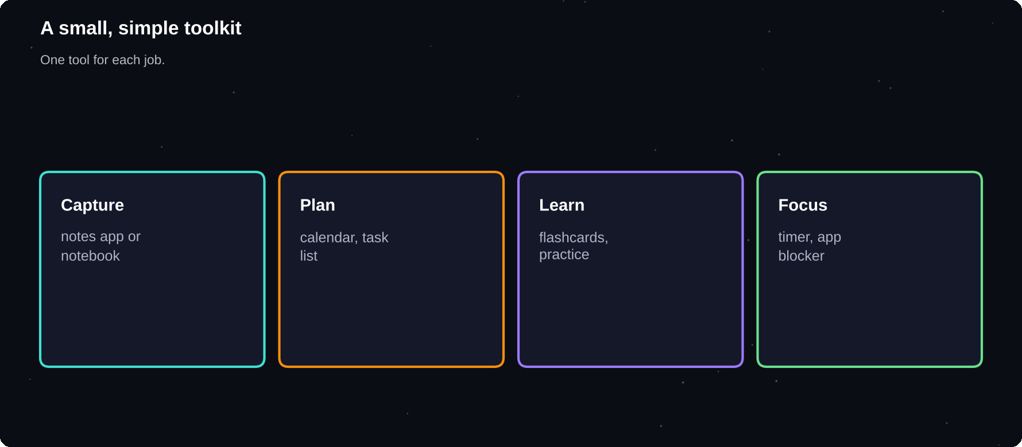
A small, simple toolkit
Capture, plan, learn and focus: one tool for each job.
IN THIS CHAPTER
01 The four jobs of a toolkit  02 Notes and knowledge  03 Calendar and tasks | 04 Flashcards and spaced repetition  05 Focus tools  06 Writing and research | 07 Using AI tools wisely  08 Digital hygiene  09 The toolkit trap

The four jobs of a toolkit
Job | Tool type
Capture | Notes app, notebook
Plan | Calendar, task list
Learn | Flashcards, practice sites
Focus | Timer, website blocker

Notes and knowledge
Pick one place for all notes: a notes app or a notebook. Organise by subject and date, and use simple tags. The best system is the one you will keep using.
1 Create one folder per subject
2 Date every note
3 Add a summary at the top
4 Link related notes together
5 Back up your notes
Calendar and tasks
Tool | Use for
Calendar | Classes, deadlines, time blocks
Task list | Next actions and projects
Reminders | Recurring habits

Flashcards and spaced repetition
Digital flashcard apps schedule reviews for you using spaced repetition. They are handy for vocabulary, definitions, formulas and facts. Keep cards short and review a little every day.
Focus tools
1 A simple timer for Pomodoro sessions
2 A website or app blocker for distracting sites
3 Do-not-disturb mode on your phone
4 Noise-cancelling headphones or instrumental music if it helps
Writing and research
Need | Idea
Drafting | A plain document editor
References | A reference manager
Grammar | A grammar checker as a second look
Sources | Library databases, scholar search

Using AI tools wisely
1 Check your institution's rules on AI use
2 Use AI to explain ideas or quiz you, not to do your thinking
3 Verify facts with trusted sources
4 Never submit AI-written work as your own where it is not allowed
5 Keep practising the skill yourself
Digital hygiene
Back up files in the cloud and on a drive. Use strong, unique passwords and a password manager. Keep your desktop tidy, and name files clearly, for example: Maths_Notes_Ch5_2026-11-06.
The toolkit trap
Spending hours choosing the perfect app is a classic procrastination. Pick simple tools, use them for a month, and only then consider switching.
Try it yourself
1 Choose one notes tool and one planner
2 Install a focus timer
3 Set up one flashcard deck
4 Remove three apps you do not use
5 Create a backup of your key files
Chapter checkpoint
1 Capture, plan, learn, focus
2 Keep your toolkit small
3 Use spaced repetition tools
4 Use AI honestly and within the rules
5 Do not let tools become distractions

CHAPTER 15
The Science of Habits
Week four is about making progress automatic. A habit is a behaviour you do with little effort or decision. Once something becomes a habit, it no longer drains your willpower, so you can spend that energy on new challenges.
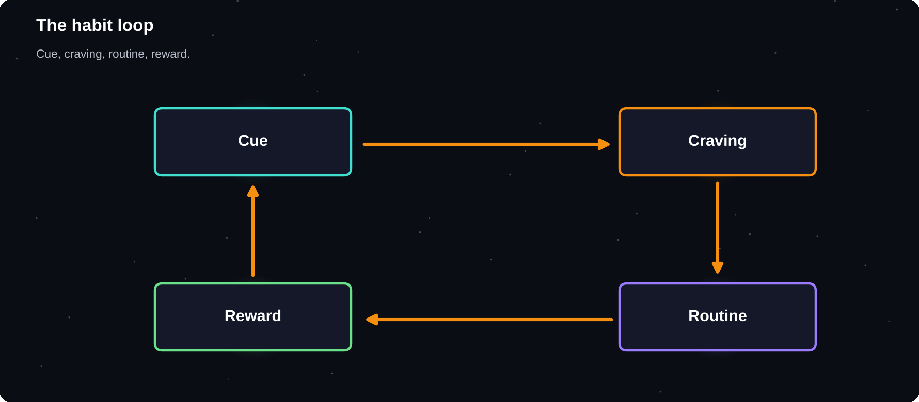
The habit loop
Cue, craving, routine, reward: the loop that makes behaviour automatic.
IN THIS CHAPTER
01 What is a habit?  02 The habit loop  03 How long does it take?  04 Four rules of building a habit | 05 Habit stacking  06 The two-minute rule  07 Design your environment  08 Choose your first habits | 09 Habit examples that fit a busy day  10 Let habits grow

What is a habit?
Habits are actions repeated in the same situation until they feel automatic. Brushing your teeth, making tea or checking your phone when you wake up are all habits. You can design good ones on purpose.
The habit loop
Part | Example
Cue | You sit at your desk
Craving | You want to feel prepared
Routine | You open your notes
Reward | A sense of progress, a tick

How long does it take?
A study by Phillippa Lally and colleagues at University College London followed people forming a new habit. Reaching automaticity took 66 days on average, with a wide range from 18 to 254 days. Missing one day did not stop the process.
66
days was the average time to form a habit in one well-known study, and it varied widely. Thirty days is a start, not the finish
Four rules of building a habit
1 Make it obvious: attach it to a clear cue
2 Make it attractive: link it to something you enjoy
3 Make it easy: shrink it until it is almost effortless
4 Make it satisfying: track it and reward yourself
Habit stacking
Attach a new habit to an existing one. Use the formula: after I [current habit], I will [new habit].
EXAMPLES
After I pour my morning tea, I will write my three top tasks. After I close my laptop, I will plan tomorrow. After I brush my teeth, I will read two pages.

The two-minute rule
When you start a new habit, it should take less than two minutes. Read one page. Put on your running shoes. Open your notes. The aim is to make starting so easy that you cannot say no. You can always do more, but the minimum counts.
Design your environment
Want to do more | Make it visible
Read | Book on your pillow
Study | Notes open on the desk
Drink water | Bottle beside you
Exercise | Shoes by the door

Choose your first habits
Start with one to three. For example: a daily plan, thirty minutes of study and a short walk. Do these for two weeks before adding anything new.
Habit | Cue | Minimum
Plan the day | After breakfast | 3 tasks
Study | After class | 10 minutes
Walk | After dinner | 5 minutes

Habit examples that fit a busy day
Area | Tiny habit
Study | After class, review notes for 5 minutes
Health | After brushing teeth, 10 squats
Sleep | At 10:00, charge the phone outside the room
Reading | After dinner, read two pages
Planning | After closing the laptop, write tomorrow's three tasks
Money | After payday, move savings first

Let habits grow
When the tiny version feels automatic, usually after a couple of weeks, add a little: five minutes becomes ten, ten squats become twenty. Grow slowly and stay consistent.
Try it yourself
1 Choose one to three habits for the month
2 Write the cue for each
3 Write the two-minute version
4 Place the visual cue in your environment
5 Start today and tick it off
Chapter checkpoint
1 Habits are cue, routine and reward
2 Habits take weeks to months to form
3 Make the habit easy to start
4 Stack new habits on existing ones
5 Start with only a few

CHAPTER 16
Build a Habit Tracker
What gets measured gets managed. A habit tracker makes progress visible, gives a small reward for every tick and shows patterns you cannot see otherwise. A simple tracker is far better than a perfect one you never use.
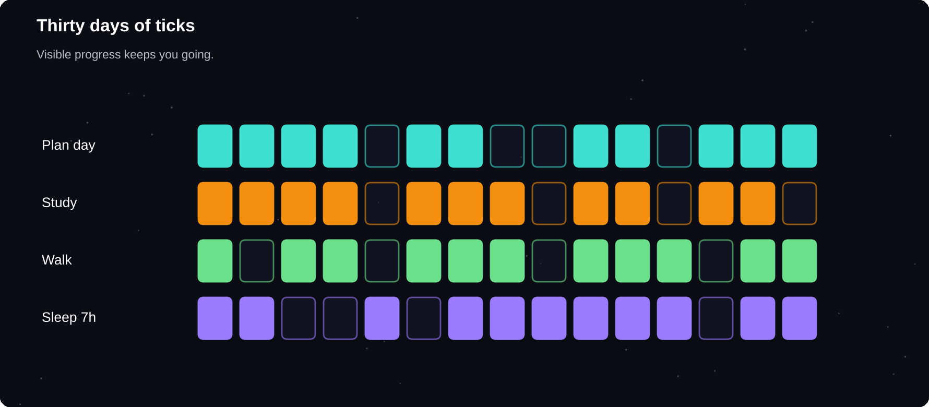
Thirty days, thirty ticks
A grid of ticks turns invisible effort into visible progress.
IN THIS CHAPTER
01 Why track habits?  02 A simple 30-day grid  03 Ways to track | 04 Count what matters  05 Streaks and the never-miss-twice rule  06 Rate your day | 07 Reading your data  08 Reward milestones

Why track habits?
1 It reminds you to act
2 It gives a small win each time
3 It shows streaks and gaps
4 It reveals what helps or hurts
5 It makes weekly reviews easy
A simple 30-day grid
Draw a grid with your habits down the side and the days of the month across the top. Each day, tick the habits you completed.
Habit | M | T | W | T | F | S | S
Plan day | ✓ | ✓ |  | ✓ | ✓
Study 30m | ✓ | ✓ | ✓ |  | ✓ | ✓
Walk |  | ✓ | ✓ | ✓ |  | ✓ | ✓
Sleep 7h | ✓ |  | ✓ | ✓ | ✓ |  | ✓

Ways to track
Method | Good for
Paper grid | Simple, visual
Wall calendar | Streaks you can see
Notes app | Quick daily check-in
Habit app | Reminders, statistics
Spreadsheet | Charts and totals

Count what matters
1 Track actions you control
2 Track no more than five habits
3 Define each habit precisely: “Study 30 minutes” not “study more”
4 Record the minimum version as success
5 Add a quick note on bad days
Streaks and the never-miss-twice rule
Streaks are motivating, but a broken streak should not break you. If you miss a day, mark it and restart. Missing once is a slip. Missing twice starts a new habit, the wrong one.
Rate your day
Add a quick score from 1 to 5 for energy, mood or focus. After a few weeks, patterns often appear: perhaps focus is best after exercise, or worst after late nights.
Reading your data
Pattern | Possible action
Missed all Mondays | Prepare on Sunday
Low scores after late nights | Move bedtime earlier
Great focus after walks | Walk before study
Skipped habit often | Shrink it, change the cue

Reward milestones
Celebrate seven, fourteen and thirty days with something small and healthy: a favourite meal, a film or a day out. Rewards strengthen the habit loop.
Try it yourself
1 Draw your 30-day grid today
2 Write your habits with precise definitions
3 Place the tracker where you see it daily
4 Tick today's habits
5 Plan your first reward at day seven
Chapter checkpoint
1 Tracking makes progress visible
2 Keep your tracker simple
3 Never miss twice
4 Look for patterns in your data
5 Celebrate milestones

CHAPTER 17
Break Bad Habits
Bad habits are not a sign of weak character. They exist because they give you something: relief, comfort, escape or fun. To change them, you need to understand what they do for you and offer your brain a better alternative.
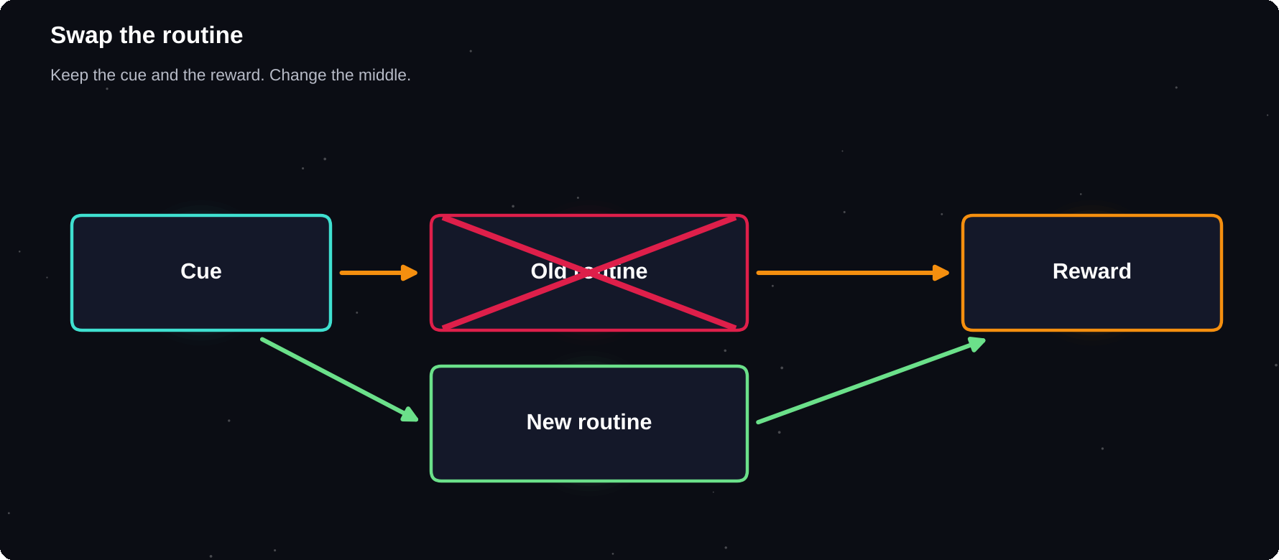
Swap the routine
Keep the cue and the reward. Change the routine in the middle.
IN THIS CHAPTER
01 Why bad habits stick  02 The habit audit  03 Four ways to weaken a habit | 04 Replace, do not only remove  05 Urge surfing  06 Plan for slips | 07 Common bad habits and fixes

Why bad habits stick
A habit repeats because it is rewarded. Scrolling relieves boredom. Snacking relieves stress. Staying up late gives you free time that you feel the day denied. If you only try to stop, the need remains. You must meet it another way.
The habit audit
Question | Example
What is the habit? | Checking my phone in study blocks
What triggers it? | A hard question, boredom
What do I get? | Relief from discomfort
When and where? | At my desk, evenings
Who is around? | Roommates, group chats

Four ways to weaken a habit
1 Make it invisible: remove cues, such as deleting apps or hiding snacks
2 Make it unattractive: remind yourself of the cost
3 Make it difficult: add steps, such as logging out
4 Make it unsatisfying: tell a friend or pay a small penalty
Replace, do not only remove
Trigger | Old routine | New routine
Boredom | Scroll | Read a page
Stress | Snack | Walk, breathe
Late night | Videos | Wind-down routine
Hard task | Check phone | Two-minute start

Urge surfing
Cravings rise, peak and fade, usually within minutes. Instead of acting at once, notice the urge, breathe and wait. Observe it like a wave. Many people find the urge passes more quickly than expected.
Plan for slips
1 Expect them. Change is rarely a straight line
2 Ask what triggered the slip
3 Adjust the plan, such as the environment
4 Return at the next opportunity
5 Count the days you succeeded, not only the slips
Common bad habits and fixes
Habit | Idea
Late-night phone use | Charger outside the bedroom
Skipping breakfast | Prepare the night before
Endless social media | App limits, scheduled time
Procrastinating | Two-minute starts
Negative self-talk | Balanced rewrites
Junk snacking | Keep fruit visible, snacks hidden

WHEN IT IS MORE THAN A HABIT
Behaviours such as substance use, gambling or constant online use that harm your life and feel out of control may need professional support. Please speak to a doctor or a qualified counsellor.

Try it yourself
1 Choose one habit to weaken this month
2 Fill in the habit audit
3 Write a replacement routine
4 Change your environment today
5 Tell a friend your plan
Chapter checkpoint
1 Every habit gives you a reward
2 Find the trigger and the need
3 Replace the routine
4 Make bad habits harder
5 Plan for slips and seek help if needed

CHAPTER 18
Stress, Wellbeing and Balance
Productivity is not about doing more at any cost. People who keep going for years know how to rest. Stress is normal, and a certain amount helps you perform, but too much for too long harms your health and your results.
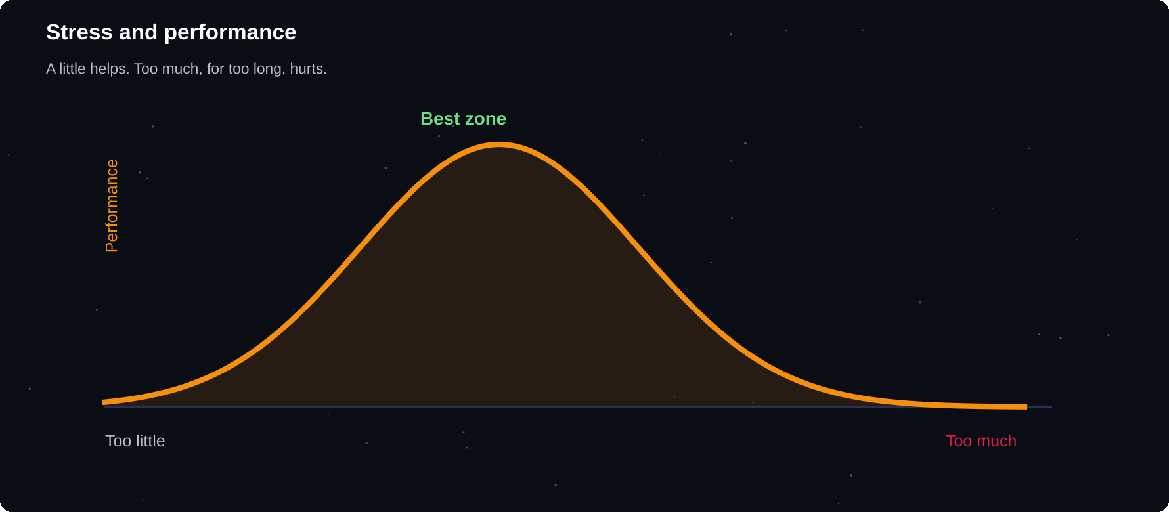
Stress and performance
A little pressure helps. Too much, for too long, hurts.
IN THIS CHAPTER
01 Understand stress  02 Warning signs  03 Quick tools to calm down | 04 Regular recovery  05 Avoid burnout  06 Mindfulness basics | 07 Keep your relationships  08 Balance across your life wheel

Understand stress
Stress is your body's response to demands. In short bursts it can sharpen focus. When it is constant and you do not recover, it can affect sleep, mood, concentration and health.
Warning signs
Area | Possible signs
Body | Headaches, tiredness, tension
Mind | Racing thoughts, poor focus
Mood | Irritable, anxious, flat
Behaviour | Withdrawing, poor sleep

Quick tools to calm down
1 Slow breathing: in for 4, out for 6, for two minutes
2 A short walk, preferably outside
3 Write down what is worrying you
4 Stretch your neck and shoulders
5 Talk with a friend
6 Splash cool water on your face
Regular recovery
Habit | How often
Sleep | Every night
Movement | Most days
Social time | Several times a week
Hobby, fun | Weekly
A full rest day | Weekly if possible
Time in nature | When you can

Avoid burnout
Burnout is a state of long-term exhaustion and reduced motivation caused by prolonged stress. Prevent it by setting limits, taking real breaks and not treating rest as a reward you must earn.
1 Set a stop time for study and work
2 Take your breaks, away from screens
3 Say no to some requests
4 Ask for help earlier
5 Reduce your plan when life gets heavy
Mindfulness basics
Mindfulness means paying attention to the present without judgement. Even three minutes of watching your breath can help you reset. If you try it, start small and see how you feel.
Keep your relationships
Time with family and friends supports wellbeing and gives perspective. Do not drop your social life when you get busy. A short call or meal together helps you recharge.
Balance across your life wheel
Revisit your life wheel from chapter 2. Which areas are low? Choose one small action for each low area, such as a walk for health, a call for friends or a hobby evening for fun.
PLEASE GET HELP
If you feel hopeless, have thoughts of harming yourself, or cannot cope, contact a doctor, a local helpline or someone you trust right now. You do not have to manage alone.

Try it yourself
1 Practise two minutes of slow breathing
2 Schedule one fun activity this week
3 Set a daily stop time
4 Plan one full rest block
5 Call or meet a friend
Chapter checkpoint
1 Stress is normal, chronic stress is harmful
2 Use quick calming tools
3 Plan regular recovery
4 Prevent burnout with limits
5 Reach out for help when needed

CHAPTER 19
Money and Career Basics
Personal development includes your finances and your career. Simple money habits and early career choices have large effects over time. This chapter gives practical basics for students and young professionals, in general terms.
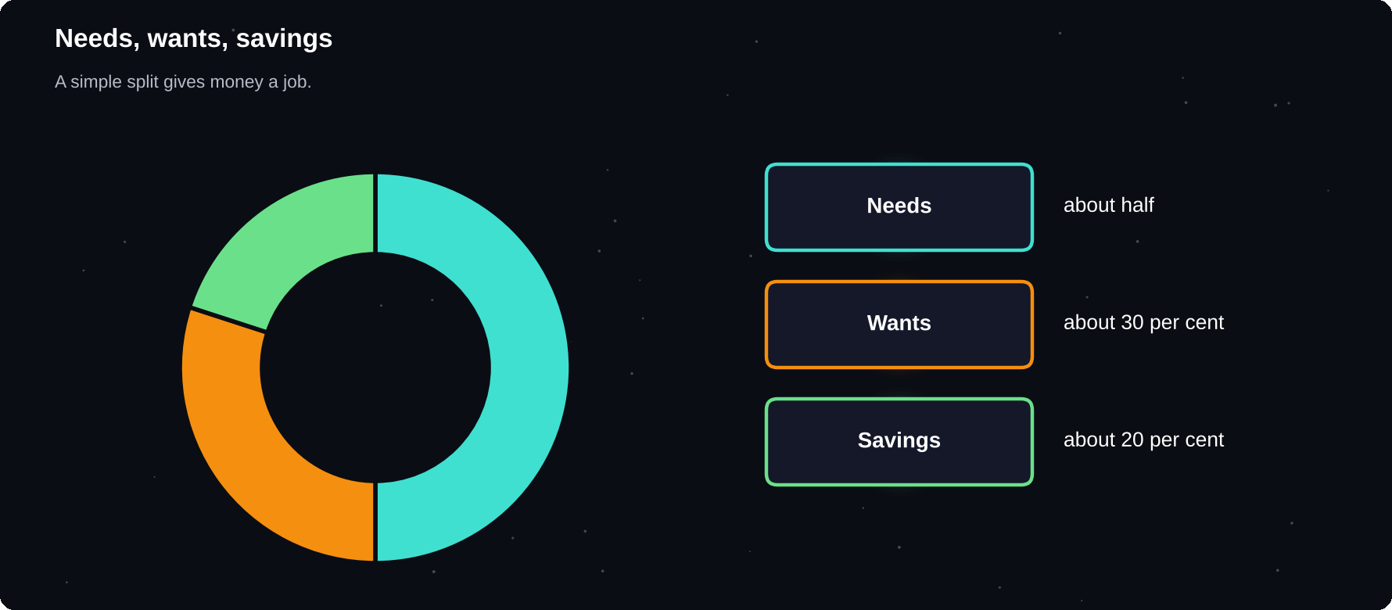
Needs, wants, savings
A simple split gives every unit of money a job.
IN THIS CHAPTER
01 Money habits that last  02 A simple budget  03 Track your spending | 04 Save for goals  05 Build career skills early  06 Experience counts | 07 Resume and online presence  08 Networking

Money habits that last
1 Know what comes in and goes out
2 Pay yourself first: save before you spend
3 Separate needs from wants
4 Avoid expensive debt
5 Build a small emergency fund
A simple budget
The 50/30/20 idea is a common starting point: about half of your income to needs, thirty per cent to wants and twenty per cent to savings or debt repayment. Adjust the split to your situation. A student with little income may start with a smaller share.
Category | Examples
Needs | Food, rent, travel, fees
Wants | Eating out, games, shopping
Savings | Emergency fund, goals

Track your spending
1 Record every expense for one month
2 Group them into categories
3 Find the three biggest categories
4 Cut one or two things you do not value
5 Set a monthly limit for wants
Save for goals
Give each saving goal a name, an amount and a date. Automating a small transfer each month works better than relying on willpower.
NOT FINANCIAL ADVICE
This is general information, not financial advice. Rules, products and risks vary by country. For investing, loans or taxes, learn from reliable sources and consider a qualified adviser.

Build career skills early
Skill | How to build it
Communication | Present, write, listen
Digital skills | Spreadsheets, tools
Problem solving | Projects, case studies
Teamwork | Group work, clubs
Learning | Courses, reading

Experience counts
1 Look for internships and part-time work
2 Join clubs and take on small leadership roles
3 Build a project you can show
4 Volunteer for things you care about
5 Collect examples of what you achieved
Resume and online presence
Keep a clean, honest one-page resume. List results, not just duties. Keep your professional profile up to date and your public posts respectful, because employers often look.
Networking
Networking is simply building genuine relationships. Be curious, ask questions, thank people and offer help where you can. A short, polite message to someone whose work you admire can open doors.
Try it yourself
1 Track your spending for one week
2 Set up one small monthly saving
3 Update your resume
4 List three skills to build this year
5 Message one person you would like to learn from
Chapter checkpoint
1 Know your money flows
2 Pay yourself first
3 Build skills and experience early
4 Keep your resume current
5 Network with kindness

CHAPTER 20
Communication and Relationships
Almost everything you want to achieve involves other people: teachers, classmates, managers, friends and family. Clear communication and good relationships are skills, and like any skill they improve with practice.
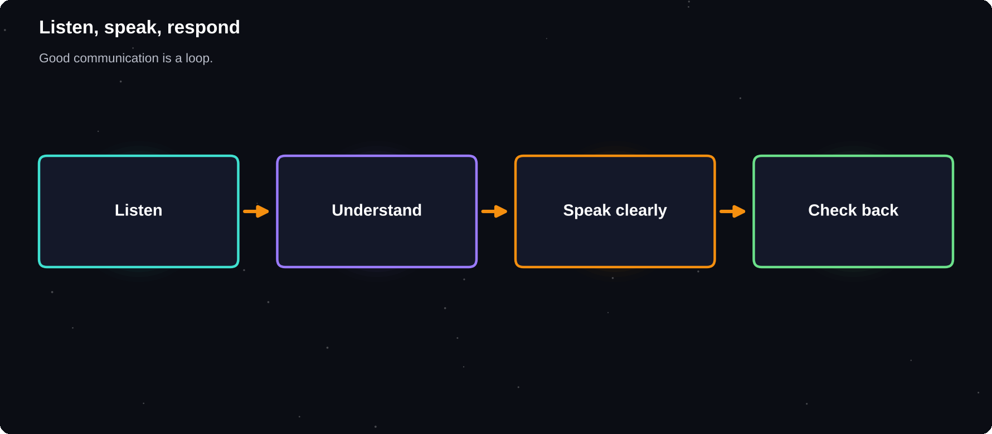
Listen, speak, respond
Good communication is a loop, not a broadcast.
IN THIS CHAPTER
01 Listening first  02 Speaking clearly  03 Ask for what you need | 04 Healthy boundaries  05 Handle conflict  06 Feedback | 07 Build your support network

Listening first
1 Give your full attention and put the phone away
2 Let the other person finish
3 Ask open questions
4 Repeat back what you heard
5 Notice feelings as well as facts
Speaking clearly
Say the main point first, then give the reason, then the details. Short sentences work well in speech and in writing. If you are unsure, ask: “Did that make sense?”
Format | Tip
Email | Clear subject, short paragraphs
Chat | One topic per message
Meeting | Prepare two points
Presentation | Start with the main idea

Ask for what you need
A SIMPLE FORMULA
When [situation], I feel [feeling], because [reason]. Could we [request]? Example: When deadlines change late, I find it hard to plan. Could we agree on dates a week ahead?

Healthy boundaries
Boundaries are limits that protect your time, energy and wellbeing. Saying no is not rude. A calm, clear no with a short reason or an alternative keeps relationships healthy.
Situation | Response
Too many requests | I cannot take that on this week
Late-night messages | I will reply tomorrow morning
Pressure to skip study | I will join after I finish

Handle conflict
1 Pause when you feel angry
2 Talk privately, not in public chats
3 Focus on the issue, not the person
4 Look for a shared goal
5 Agree on next steps
Feedback
Receiving feedback is uncomfortable but valuable. Listen without defending, ask for examples and thank the person. When you give feedback, be specific, kind and focus on behaviour and improvements.
Build your support network
Role | Gives you
Mentor | Guidance, experience
Peers | Support, shared learning
Friends, family | Care, perspective
Experts | Specific advice

Try it yourself
1 Practise active listening in one conversation
2 Write one clear request using the formula
3 Decide one boundary and say it kindly
4 Ask someone for feedback
5 Thank someone who has helped you
Chapter checkpoint
1 Listen before you speak
2 State your main point first
3 Set kind, clear boundaries
4 Handle conflict calmly
5 Build a support network

CHAPTER 21
Thinking Clearly and Deciding Well
Every day you make dozens of decisions, from small choices about food to big ones about courses and careers. Good decisions are not about being a genius. They come from a clear process, honest thinking and a little patience.
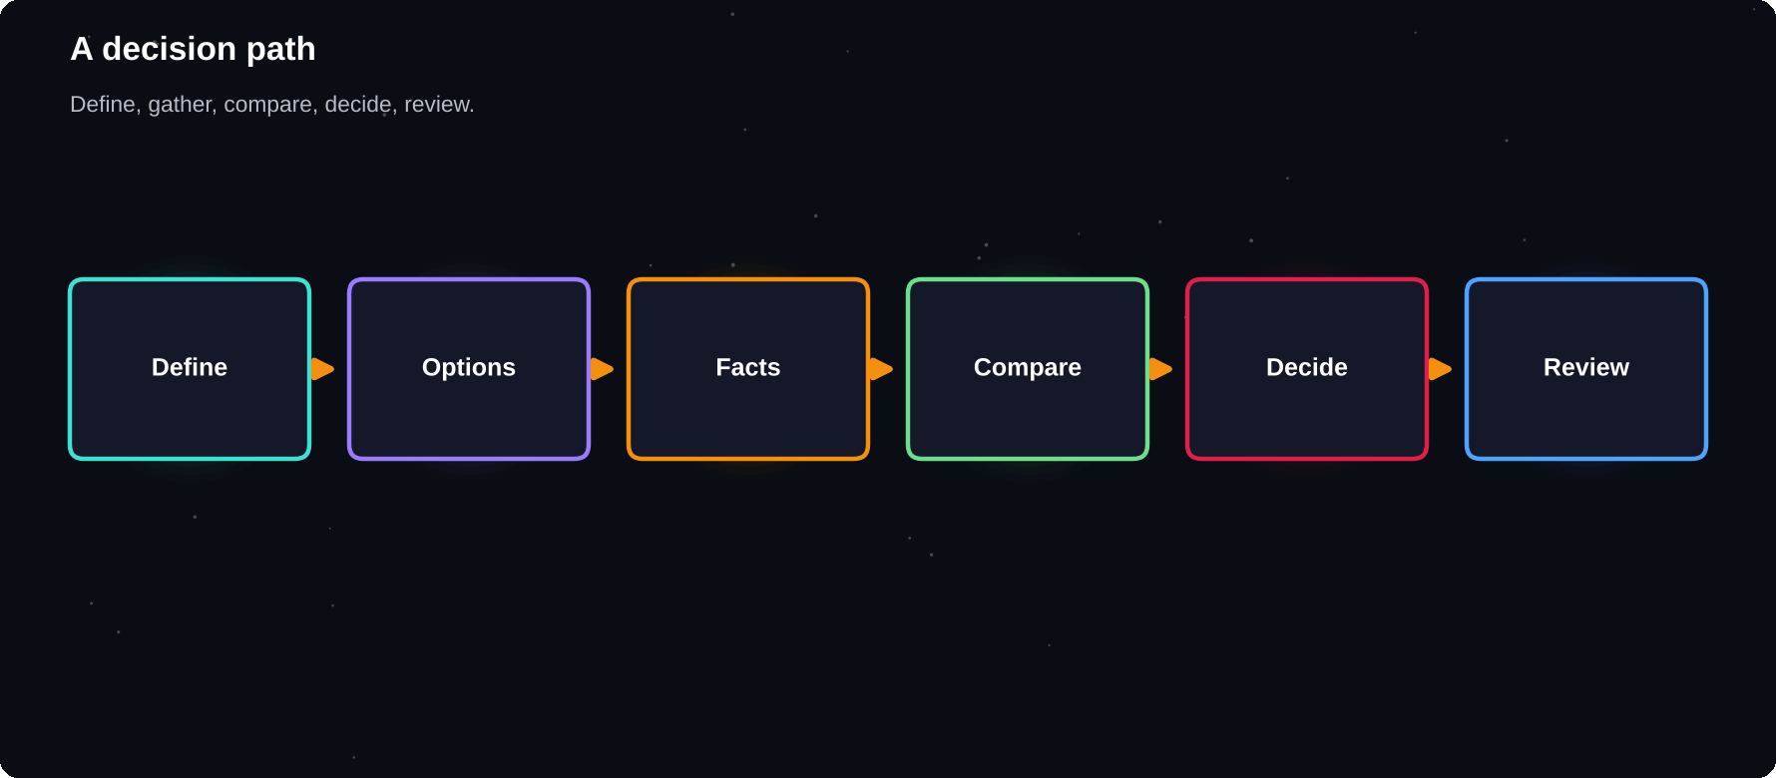
A decision path
Define, gather, compare, decide, review.
IN THIS CHAPTER
01 Decision fatigue  02 A five-step decision process  03 Pros, cons and weights | 04 Reversible and irreversible choices  05 Common thinking traps  06 Ways to think better | 07 Ask good questions  08 The 10-10-10 check  09 Learn from decisions

Decision fatigue
Making many choices drains mental energy, and later decisions tend to get worse. You can protect your best thinking by automating small choices: plan your meals, lay out clothes, and keep routines for the morning.
A five-step decision process
1 Define the decision and what you want to achieve
2 List realistic options, including doing nothing
3 Gather facts and ask people who know
4 Compare pros, cons and your values
5 Decide, act and set a date to review
Pros, cons and weights
A plain pros and cons list is a good start. Improve it by scoring each factor from 1 to 5 by how much it matters, and then comparing totals.
Factor | Weight | Option A | Option B
Cost | 4 | 3 | 5
Learning | 5 | 5 | 3
Time | 3 | 2 | 4
Interest | 4 | 5 | 3

Do not follow the maths blindly. If the result surprises you, ask why. Your feelings may be telling you about a value the table missed.
Reversible and irreversible choices
Type | Approach
Reversible, small | Decide quickly, adjust
Reversible, medium | Short research, test
Hard to reverse | Take time, seek advice

Common thinking traps
Trap | What happens
Confirmation bias | We favour facts that agree with us
Sunk cost | We continue because we already invested
Anchoring | The first number shapes our view
Overconfidence | We guess we are more right than we are
Herd thinking | We copy what everyone else does
Present bias | Short-term rewards beat long-term ones

Ways to think better
1 Ask: what would change my mind?
2 Look for evidence against your view
3 Imagine advising a friend in the same position
4 Sleep on big decisions
5 Write down your reasoning, so you can learn from the outcome
Ask good questions
Better questions lead to better answers. Instead of “what should I do?”, ask “what am I trying to achieve?”, “what are the risks?” and “what would I regret in a year?”
The 10-10-10 check
TRY THIS
How will I feel about this decision in 10 minutes, 10 months and 10 years? Often the short-term feeling is loud and the long-term view is quiet but more important.

Learn from decisions
Keep a simple decision journal. Write the decision, your reasons and what you expect. Review after a few weeks or months. Judge the quality of your thinking, not only the outcome, since good decisions sometimes have bad results.
Try it yourself
1 Choose one real decision you are facing
2 Write your options and a weighted comparison
3 Name one thinking trap that might affect you
4 Ask one person for a different view
5 Decide and set a review date
Chapter checkpoint
1 Reduce small decisions with routines
2 Use a clear process for bigger ones
3 Watch for thinking traps
4 Match effort to how reversible a choice is
5 Review and learn from outcomes

CHAPTER 22
Confidence, Creativity and Growth
Habits and systems are the structure. Confidence, curiosity and creativity are the energy that make a life feel full. These qualities can be built through small, repeated experiences, much like the other skills in this book.
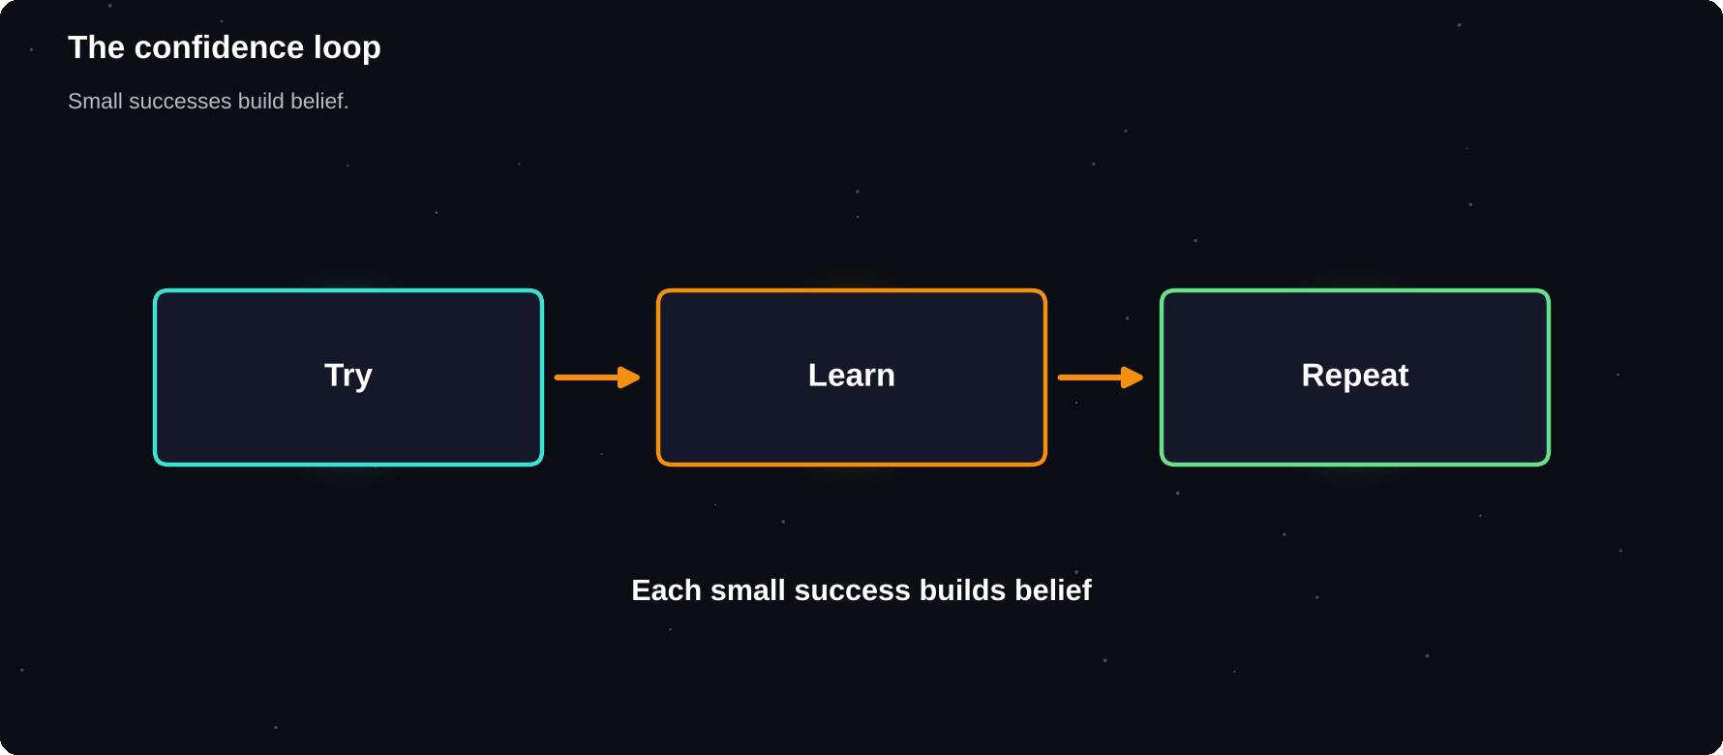
The confidence loop
Try, learn, repeat. Each small success builds belief.
IN THIS CHAPTER
01 What is confidence?  02 The confidence loop  03 Build evidence  04 Handle fear and awkwardness | 05 Speaking up and presenting  06 Curiosity  07 Creativity  08 Keep a reflection habit | 09 Lifelong learning  10 Your personal development plan  11 Quarterly questions  12 Be patient with growth

What is confidence?
Confidence is trust in your ability to cope and learn. It is not the absence of fear. It grows through doing things, especially small things that stretch you slightly and end well enough.
The confidence loop
1 Set a small, doable challenge
2 Do it, even imperfectly
3 Notice what went well
4 Learn one thing to improve
5 Take a slightly bigger step next time
Build evidence
Habit | Why it helps
Keep a wins list | Fights the memory of failures
Keep your promises to yourself | Builds self-trust
Learn new skills | Shows that you can improve
Prepare well | Reduces fear
Ask for feedback | Replaces guessing with facts

Handle fear and awkwardness
Most people are too busy thinking about themselves to judge you as harshly as you imagine. Expect some discomfort when trying something new, and treat it as a sign that you are growing.
Speaking up and presenting
1 Prepare your first sentence and your main point
2 Practise aloud, ideally with a friend
3 Slow down and pause
4 Look at friendly faces
5 Use a short story or example
6 Finish with a clear takeaway
Curiosity
Curious people learn faster, enjoy more and find opportunities others miss. Ask “why?” and “how?” more often. Follow a question into a book, a video or a conversation.
Habit | Try
Read daily | 10 pages of a book
Learn from others | Ask one question per day
Try new things | One new activity a month
Reflect | Write for five minutes

Creativity
Creativity is not a gift for a few. It is a habit of making connections and trying ideas. Give yourself time, allow bad ideas and make things regularly, even small ones.
1 Keep an ideas notebook
2 Set a daily or weekly creative practice
3 Combine two unrelated ideas
4 Change your environment, for example take a walk
5 Make first, judge later
Keep a reflection habit
EVENING PROMPTS
What went well today? What did I learn? What will I do differently tomorrow? Who am I grateful for?

Lifelong learning
Skills change quickly. The ability to learn, unlearn and relearn is one of the most useful you can build. Choose one skill each quarter, learn it through projects and share what you make.
Your personal development plan
Pull the threads together in a one-page plan that you review each quarter.
Area | Question | Next step
Skills | What will I learn? | One course
Health | How will I care for myself? | A routine
Money | What will I save? | A monthly amount
People | Who will I connect with? | Two meetings
Purpose | What matters to me? | A weekly hour

Quarterly questions
1 What did I learn in the last three months?
2 Which habits stayed, and which faded?
3 Where do I feel stuck?
4 Who can help me with that?
5 What is my focus for the next three months?
Be patient with growth
Personal growth is slow, uneven and mostly invisible from day to day. Look back over months, not days, and you will usually see how far you have come.
Try it yourself
1 Start a wins list today
2 Choose one small challenge that stretches you
3 Practise a 60-second talk on a topic you know
4 Read ten pages of a book
5 Write your evening reflection for a week
Chapter checkpoint
1 Confidence grows from small successes
2 Fear is normal when trying new things
3 Curiosity speeds learning
4 Creativity is a habit
5 Reflect and keep learning

CHAPTER 23
Review and Your Next 30 Days
You have reached the end of the month. Now you pause, look back and decide what to keep. The review is where the real learning happens. It turns a month of effort into a plan that continues.
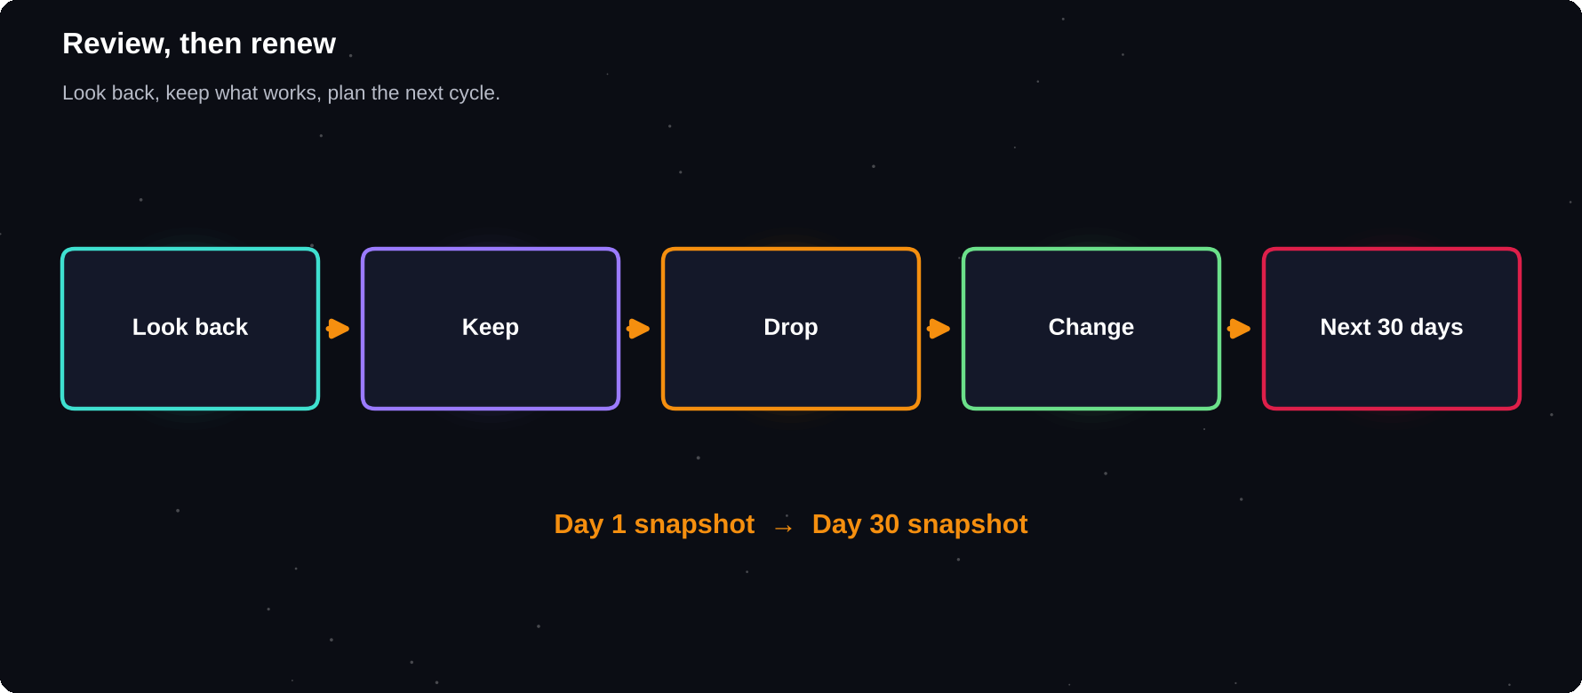
Review, then renew
Look back, keep what worked, drop what did not, plan the next cycle.
IN THIS CHAPTER
01 Re-take your snapshot  02 Review your tracker  03 Ask the review questions | 04 Keep, drop, change  05 Celebrate  06 Plan your next 30 days | 07 Keep growing  08 A letter to yourself

Re-take your snapshot
Go back to the scores from chapter 1. Rate each area from 1 to 10 again, and compare. Whatever the numbers, look for direction, not perfection.
Area | Day 1 | Day 30
Time control | __ | __
Focus | __ | __
Goal clarity | __ | __
Study results | __ | __
Daily habits | __ | __
Energy, sleep | __ | __
Stress | __ | __

Review your tracker
1 Count the ticks for each habit
2 Find your best and worst days
3 Look for patterns: what helped, what hurt?
4 Check which habits felt effortless by now
5 Note which habits still need work
Ask the review questions
1 What went well, and why?
2 What did not, and why?
3 What surprised me?
4 Which technique helped most?
5 What will I keep, drop and change?
Keep, drop, change
Keep | Drop | Change
Daily plan | Late scrolling | Study time to morning
Pomodoro | Too many apps | Shorter breaks
Weekly review | Perfectionism | Sleep earlier

Celebrate
Acknowledge what you did, whatever the result. Finishing a month of effort is an achievement in itself. Share it with someone who supports you, and give yourself a proper reward.
Plan your next 30 days
1 Pick one new focus area
2 Keep your two or three strongest habits
3 Set three new SMART goals
4 Schedule your next weekly reviews
5 Choose a start date and begin
Keep growing
Cycle | Possible focus
Month 2 | Deepen study habits
Month 3 | Health and fitness
Month 4 | A skill or project
Month 5 | Money and career
Month 6 | Review the half year

A LONG GAME
Real change is slow and uneven. Expect plateaus and setbacks. If you keep returning to your system, you are already ahead of where you started.

A letter to yourself
Open the letter you wrote on day twenty-eight. What would you say to yourself a month ago? What would you say to yourself a month from now? Write a short note, and keep it.
Try it yourself
1 Re-rate your snapshot
2 Analyse your tracker
3 Answer the five review questions
4 Write your keep, drop and change list
5 Plan day one of your next month
Chapter checkpoint
1 Review is where learning happens
2 Compare day 1 with day 30
3 Keep what works, change what does not
4 Celebrate progress
5 Start your next cycle

APPENDIX A
The 30-Day Calendar
Use this plan to run the month. Each day lists one reading or action. Adjust the order if you need to, but keep the daily habit of a short review.
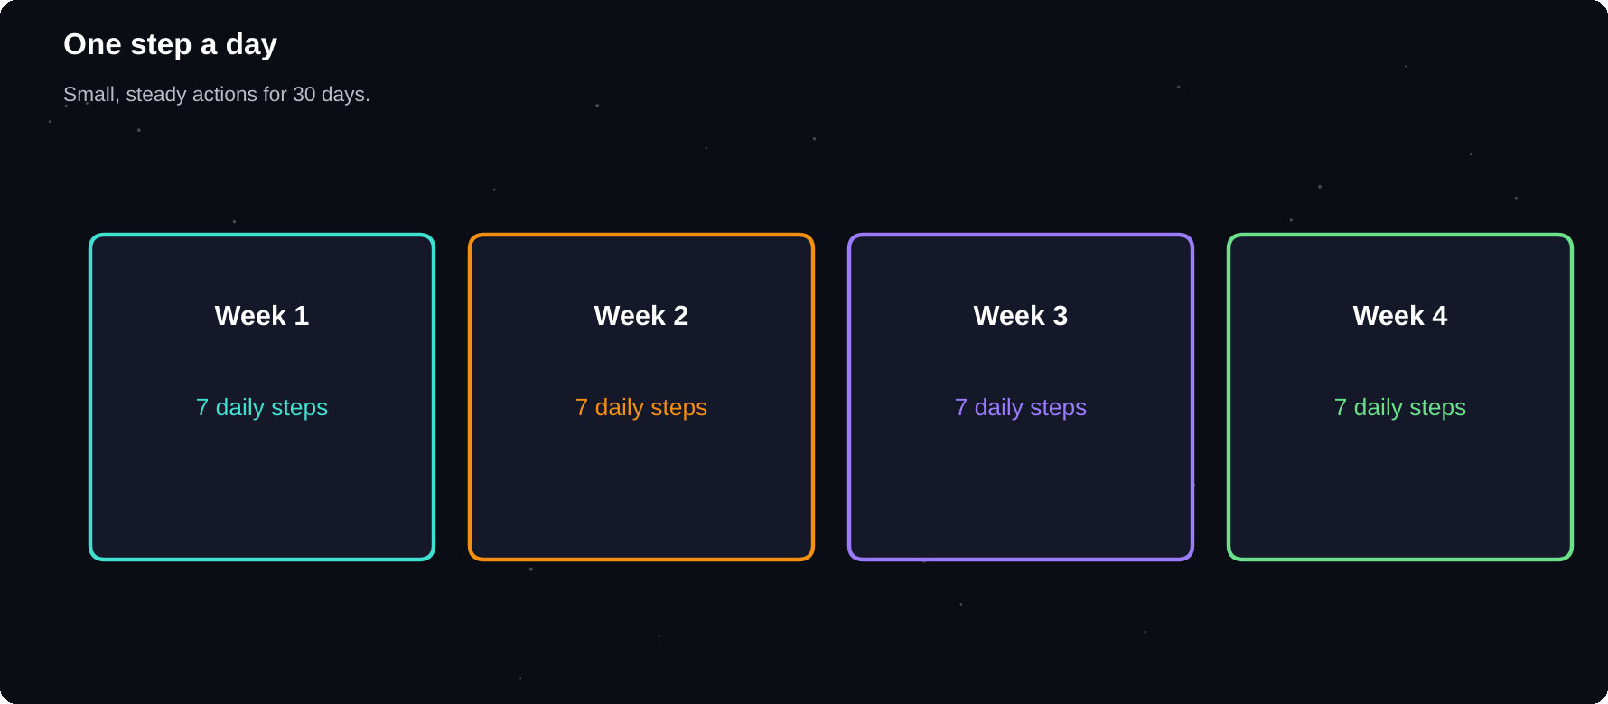
One step a day
Small, steady actions for 30 days.
IN THIS CHAPTER
01 Week 1: Time and focus  02 Week 2: Goals and systems | 03 Week 3: Learning and study  04 Week 4: Habits and balance | 05 Days 29–30: Review

Week 1: Time and focus
Day | Action
1 | Read ch. 1, take your snapshot
2 | Life wheel and values (ch. 2)
3 | Set sleep and energy habits (ch. 3)
4 | Time audit (ch. 4)
5 | Urgent and important sort
6 | Plan tomorrow, time block (ch. 5)
7 | Weekly plan and review

Week 2: Goals and systems
Day | Action
8 | Beat procrastination (ch. 6)
9 | Two Pomodoro sessions (ch. 7)
10 | Focus space and phone rules
11 | Write SMART goals (ch. 8)
12 | Break goals into milestones (ch. 9)
13 | Mindset and self-talk (ch. 10)
14 | Weekly review

Week 3: Learning and study
Day | Action
15 | Active recall practice (ch. 11)
16 | Set up spaced review
17 | Feynman technique (ch. 12)
18 | Cornell notes, flashcards
19 | SQ3R reading, exam plan (ch. 13)
20 | Tool toolkit setup (ch. 14)
21 | Weekly review

Week 4: Habits and balance
Day | Action
22 | Choose habits and cues (ch. 15)
23 | Start your tracker (ch. 16)
24 | Habit audit for a bad habit (ch. 17)
25 | Stress tools (ch. 18)
26 | Money and career basics (ch. 19)
27 | Communication practice (ch. 20)
28 | Weekly review, write a letter

Days 29–30: Review
Day | Action
29 | Re-take snapshot, tracker (ch. 23)
30 | Plan the next 30 days (ch. 23)

IF YOU FALL BEHIND
Do not try to catch up on everything. Skip to today's step, and return to missed chapters when you have time. The plan serves you, not the reverse.

APPENDIX B
Worksheets and Templates
These simple templates support the exercises in the book. Rewrite them in your notebook, or copy them into a notes app, and use them as often as you like.
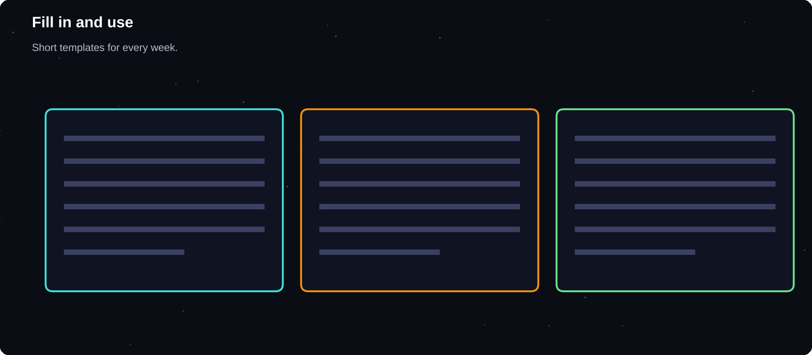
Fill in and use
Short templates you will use every week.
IN THIS CHAPTER
01 Daily plan  02 Weekly review  03 Goal sheet  04 Study session log  05 Habit audit | 06 Time audit  07 Exam countdown  08 Monthly review  09 30 journal prompts, one per day  10 Decision worksheet | 11 Energy log  12 Reading and learning log  13 Wins and gratitude list  14 Exam-week plan

Daily plan
TEMPLATE
Date: ___. Top 3 tasks: 1) ___ 2) ___ 3) ___. Time blocks: ___. Habits to tick: ___. One thing I am grateful for: ___. Tomorrow's first action: ___.

Weekly review
TEMPLATE
Week of: ___. Wins: ___. Problems: ___. Lessons: ___. Habit score: ___/__. Three priorities for next week: 1) ___ 2) ___ 3) ___. One change I will make: ___.

Goal sheet
TEMPLATE
Goal: ___. Why it matters: ___. Measure: ___. Deadline: ___. Milestones: ___. Weekly actions: ___. Obstacle and plan: When ___ happens, I will ___.

Study session log
Date | Topic | Method | Rating
 |  | Recall | 1–5
 |  | Practice | 1–5
 |  | Flashcards | 1–5

Habit audit
TEMPLATE
Habit: ___. Trigger: ___. What I get from it: ___. A better way to get the same reward: ___. Change to my environment: ___.

Time audit
Hour | Activity | Category
7–8
8–9
9–10
10–11

Exam countdown
TEMPLATE
Exam: ___. Date: ___. Topics: ___. Weak topics: ___. Past papers to do: ___. Daily plan: ___. Exam-day checklist: ___.

Monthly review
TEMPLATE
Month: ___. Biggest win: ___. Biggest challenge: ___. Keep: ___. Drop: ___. Change: ___. Focus for next month: ___.

30 journal prompts, one per day
Spend two or three minutes each evening writing a few lines in answer to the day's prompt.
1 Why did I start this month?
2 What does a great day look like for me?
3 What gives me energy? What drains it?
4 Which of my values matter most?
5 Where does my time really go?
6 What is one task I am avoiding, and why?
7 What went well this week?
8 What distracts me most, and what can I change?
9 What is my most important goal and why?
10 When do I focus best?
11 What would I do if I were not afraid?
12 What is one thing I learned today?
13 Who supports me? How can I thank them?
14 What did I do this week that I am proud of?
15 Which study method worked best so far?
16 Which topic do I find hardest, and what is my plan?
17 What would I tell a friend in my position?
18 What habit feels easiest now?
19 What habit still feels hard?
20 Where did I say yes when I meant no?
21 How did I rest this week?
22 What am I grateful for?
23 What is stressing me, and what is in my control?
24 What small risk can I take this week?
25 Which of my habits has changed my days?
26 What skill do I want to learn next?
27 Who do I want to become this year?
28 What do I want to keep from this month?
29 What did my numbers show on day 30?
30 What is my plan for the next 30 days?
Decision worksheet
TEMPLATE
Decision: ___. What I want to achieve: ___. Options: A) ___ B) ___ C) do nothing. Facts I need: ___. Who can advise: ___. Pros and cons: ___. 10-10-10 check: ___. My choice: ___. Review date: ___.

Energy log
Time | Energy 1–5 | What I was doing
Morning
Midday
Afternoon
Evening

Reading and learning log
Date | Source | Key idea | Action

Wins and gratitude list
TEMPLATE
Three wins this week: 1) ___ 2) ___ 3) ___. Three things I am grateful for: 1) ___ 2) ___ 3) ___. One person to thank: ___.

Exam-week plan
Day | Subjects | Sleep by | Break
Mon |  | 10:30 | Walk
Tue |  | 10:30 | Walk
Wed |  | 10:30 | Walk
Thu |  | 10:30 | Walk

APPENDIX C
Technique Quick Reference
A quick reminder of the main techniques, when to use them and where they appear in the book.
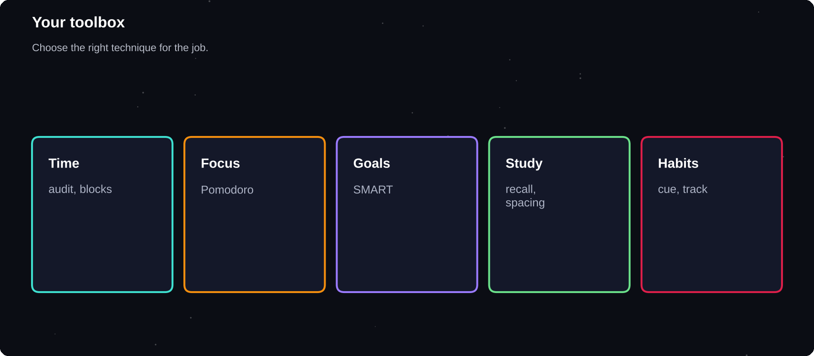
Your toolbox
Choose the right technique for the job.
IN THIS CHAPTER
01 Time and focus  02 Goals | 03 Study  04 Habits and wellbeing

Time and focus
Technique | Use it to
Time audit | See where hours go (ch. 4)
Eisenhower matrix | Sort by importance (ch. 4)
Time blocking | Give tasks a slot (ch. 5)
Top three tasks | Daily priorities (ch. 5)
Two-minute start | Beat delay (ch. 6)
Pomodoro | Focus in sessions (ch. 7)

Goals
Technique | Use it to
SMART goals | Make goals clear (ch. 8)
Milestones | Break goals down (ch. 9)
Weekly review | Stay on course (ch. 9)
When-then plans | Act on cue (ch. 6)
Self-talk rewrite | Keep going (ch. 10)

Study
Technique | Use it to
Active recall | Strengthen memory (ch. 11)
Spaced repetition | Fight forgetting (ch. 11)
Interleaving | Mix topics (ch. 11)
Feynman | Test understanding (ch. 12)
Cornell notes | Turn notes into tests (ch. 12)
SQ3R | Read with purpose (ch. 13)
Past papers | Practise exams (ch. 13)

Habits and wellbeing
Technique | Use it to
Habit stacking | Add new habits (ch. 15)
Two-minute rule | Start small (ch. 15)
Habit tracker | See progress (ch. 16)
Habit swap | Replace bad habits (ch. 17)
Slow breathing | Calm down (ch. 18)
Boundaries | Protect time (ch. 20)

APPENDIX D
Troubleshooting
Every plan meets problems. Find yours in the list below, try the fix for a few days and adjust. Treat each problem as information about what your plan needs.
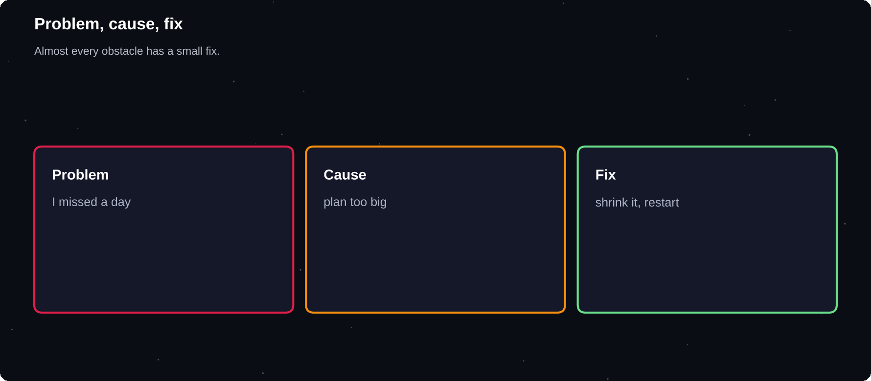
Problem, cause, fix
Almost every obstacle has a small fix.
IN THIS CHAPTER
01 I missed a day  02 I have no time  03 I get distracted | 04 I forget to track  05 I feel overwhelmed  06 My motivation has faded | 07 I study but forget  08 My routine breaks during exams or travel

I missed a day
Do not try to double up. Restart the next day with the smallest version of the habit. One missed day does not undo your progress, but two in a row can start a new pattern.
I have no time
1 Run the time audit again
2 Shrink the habits to five minutes
3 Move them to a fixed cue, such as after breakfast
4 Drop a low-value commitment
5 Ask for support from family or friends
I get distracted
1 Move your phone out of reach
2 Use shorter focus sessions
3 Write distractions on a pad
4 Study in a library or another place
5 Block apps during sessions
I forget to track
1 Put the tracker where you will see it, such as on your desk or pillow
2 Set a daily reminder
3 Attach tracking to an existing habit
4 Make it quicker, such as one tick per habit
I feel overwhelmed
1 Cut the plan to one focus area
2 Choose the smallest version of every task
3 Take a rest day without guilt
4 Talk to someone
5 Return gradually
My motivation has faded
1 Re-read your why
2 Review your progress so far
3 Change the routine to make it fresh
4 Study with a partner
5 Set a short, easy goal
I study but forget
1 Replace re-reading with recall
2 Use spaced review
3 Sleep enough
4 Teach the topic aloud
5 Mix practice problems
My routine breaks during exams or travel
Use the minimum version during busy times. For example: two minutes of planning and a ten-minute walk. Resume the full plan afterwards.
WHEN TO GET HELP
If problems are linked to persistent stress, sadness, anxiety or health, talk to a doctor, counsellor or trusted person. A plan cannot replace support.

A TO Z
Glossary
Every term you meet during your 30 days.

80/20 rule
The idea that a small share of effort often gives most of the results.
Active recall
Trying to remember information without looking at it.
Burnout
Long-term exhaustion and loss of motivation from prolonged stress.
Cue
A trigger that starts a habit.
Deep work
Focused work with no distractions on a demanding task.
Eisenhower matrix
A grid that sorts tasks by urgency and importance.
Feynman technique
Learning by explaining an idea in simple words.
Fixed mindset
The belief that ability cannot change.
Forgetting curve
The pattern of how memory fades over time without review.
Growth mindset
The belief that ability can grow with effort and good strategies.
Habit stacking
Linking a new habit to an existing one.
Implementation intention
A when-then plan for acting at a set time and place.
Interleaving
Mixing different topics or problem types while studying.
Intrinsic motivation
Drive that comes from interest or meaning.
Milestone
A checkpoint on the way to a larger goal.
MIT
Most important task of the day.
Pomodoro
A timed focus session, often 25 minutes, followed by a short break.
Procrastination
Delaying a task you intend to do.
SMART goal
Specific, measurable, achievable, relevant and time-bound.
Spaced repetition
Reviewing information at increasing intervals.
SQ3R
Survey, question, read, recite, review: a method for reading.
System
A repeatable routine that produces progress.
Time blocking
Giving each task a set slot in your calendar.
Time audit
A record of how you actually spend your time.
Trigger
Anything that sets off a habit or an urge.

THE LAST WORD
Keep going
Thirty days will not change everything, but it can change how you work, study and think about yourself. The next step is to repeat what worked and keep your system alive.

Thank you for reading. If this guide helped you, please leave a review on the store where you bought it. It helps other students and young professionals find it.
NOTES
How are habits formed
Lally, van Jaarsveld, Potts and Wardle, European Journal of Social Psychology, 2009
Improving students' learning with effective learning techniques
Dunlosky and colleagues, Psychological Science in the Public Interest, 2013
Goal-setting theory
Locke and Latham, work on specific, challenging goals
The Pomodoro Technique
Francesco Cirillo
Important
This guide gives general information on study, time and habits. It is not medical, psychological or financial advice. Individual results vary. If you are struggling, speak to a qualified professional.

