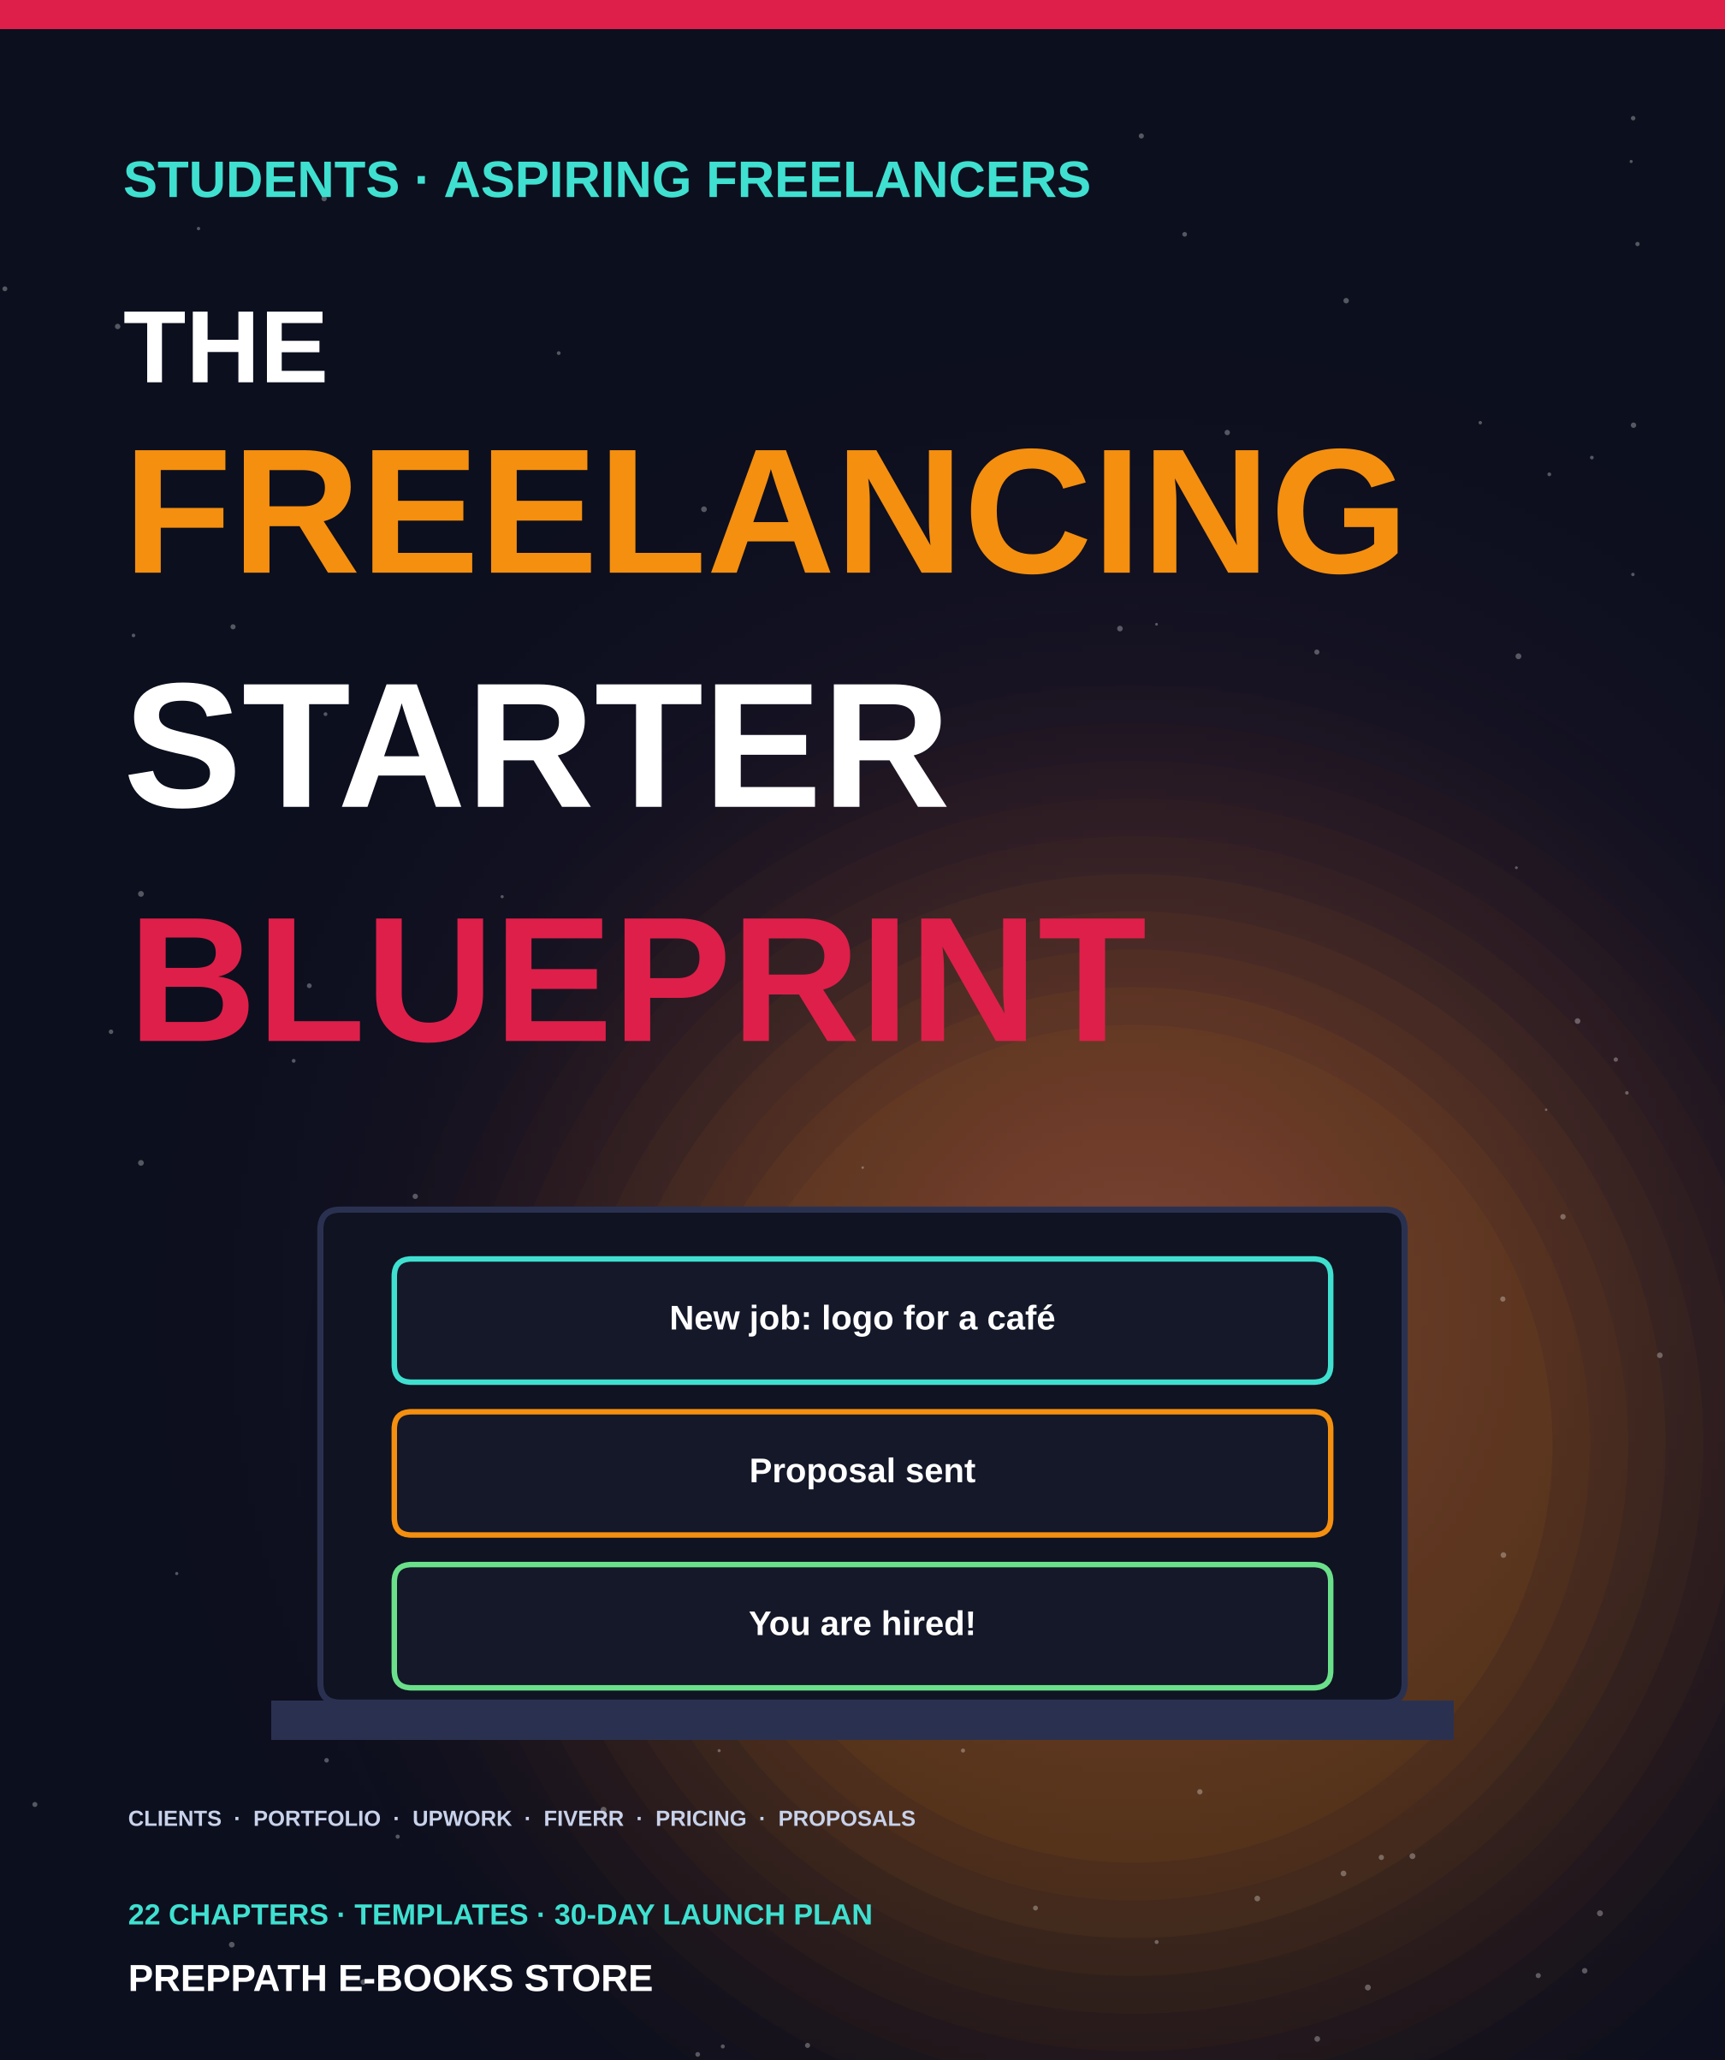

ABOUT THIS EDITION
The Freelancing Starter Blueprint
For students and aspiring freelancers
A picture-led, practical guide to starting as a freelancer: finding clients, building a portfolio, working on Upwork and Fiverr, pricing, proposals and client communication.
Published by PrepPath E-books Store
© 2026 PrepPath E-books Store. All rights reserved.
Twenty-two chapters take you step by step from choosing a skill to growing a steady client base. Each chapter ends with actions to try and a short checkpoint. Do the actions, and you will have a profile, a portfolio and your first proposals by the end of the month.
Platform rules, fees and tax laws change and differ by country. This book is general guidance, not legal, tax or financial advice, and it does not promise any level of income.

CONTENTS
What is inside

01 What Freelancing Really Is 4
The idea, the myths and the student advantage
02 Choose Your Skill and Niche 6
Pick a service people already pay for
03 Set Up Your Freelance Business 8
Tools, workspace, payments and good habits
04 Build Your Professional Profile 10
Photo, headline and bio that make people click
05 Create a Portfolio from Zero 12
Prove your skill before you have a single client
06 Getting Started on Upwork 14
Create a profile and understand how the platform works
07 Winning Your First Upwork Job 17
Find the right jobs and stand out from the crowd
08 Fiverr: Gigs That Sell 20
Turn your skill into a clear, searchable product
09 Find Clients Beyond Marketplaces 23
LinkedIn, outreach, communities and referrals
10 Pricing Your Services 25
Charge fairly without undervaluing yourself
11 Writing Proposals That Win 28
A simple structure and a personal first line
12 Client Communication 31
Be clear, quick and calm in every message
13 Scope, Contracts and Agreements 33
Agree the details before the work begins
14 Doing the Work and Delivering 35
Plan, produce, check and hand over great work
15 Getting Paid and Earning Reviews 37
Invoices, payments and building your reputation
16 Scams, Safety and Legal Basics 39
Protect your money, your data and yourself
17 Service Playbooks 41
Five beginner services, step by step
18 Using AI Tools Responsibly 43
Work faster without losing trust
19 Working with International Clients 45
Time zones, culture, language and payments
20 Productivity and Mindset 47
Stay consistent through rejection and busy weeks
21 Three Illustrative Journeys 49
How the method can look in practice
22 Grow Your Freelance Career 51
Repeat clients, higher rates and a sustainable business
A Message Templates 53
Ready-to-adapt messages for every stage
B Your 30-Day Launch Plan 55
A step-by-step plan from zero to first proposal
C Service Ideas for Students 57
Fifty starting ideas, sorted by skill
D Checklists 59
Quick checks before you publish, pitch and deliver
A–Z Glossary 61
Key terms in one line each
→ A Last Word 62
Start small, and a few notes

CHAPTER 1
What Freelancing Really Is
Freelancing means selling a skill directly to clients instead of working for one employer. You choose the work, set the terms and build your own reputation. It is also real business: no clients, no income. This chapter shows you the honest picture before you begin.
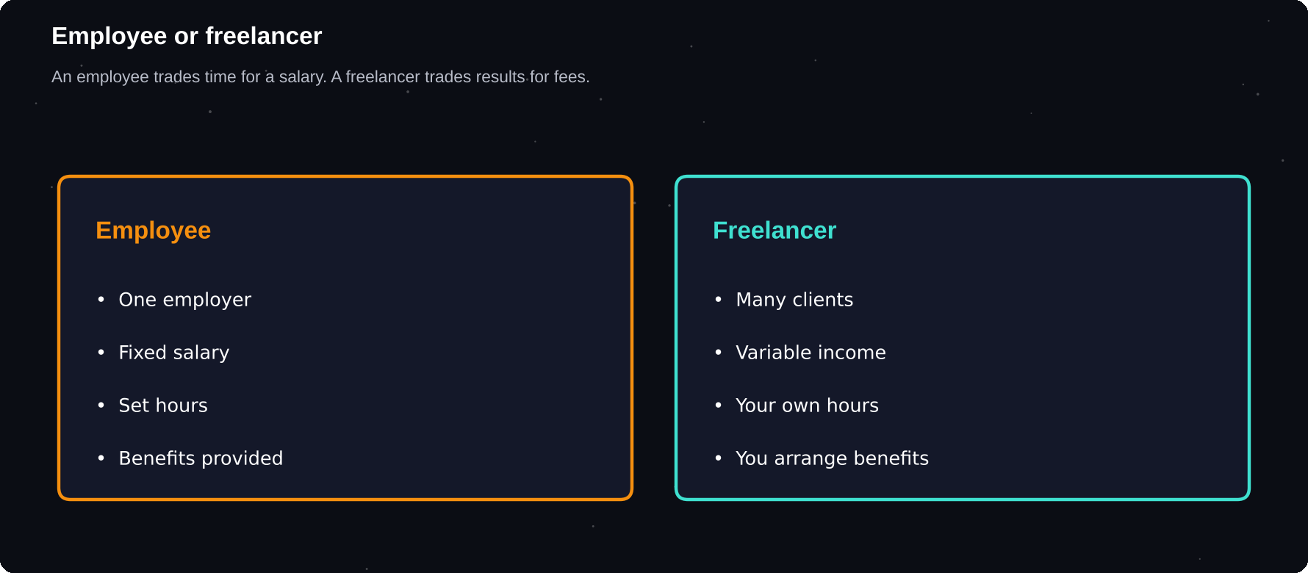
Employee or freelancer
An employee trades time for a salary. A freelancer trades results for fees, and carries more of the risk.
IN THIS CHAPTER
01 What is a freelancer?  02 Freelancer versus employee  03 Where freelance work comes from | 04 Myths worth dropping  05 The student advantage  06 The honest downsides | 07 Your freelance journey

What is a freelancer?
A freelancer is a self-employed person who sells services to several clients, usually project by project. A student who designs a logo for a local shop, a graduate who writes blog posts for a start-up and a developer who fixes a website for a client abroad are all freelancers.
You are not hired for a job title. You are hired to solve one specific problem, and you are paid when you solve it.
Freelancer versus employee
 | Employee | Freelancer
Income | Fixed salary | Varies by month
Clients | One employer | Several clients
Hours | Set by company | Set by you
Benefits | Leave, insurance | You arrange them
Tax | Deducted for you | You manage it
Growth | Promotions | Skills, reputation

Where freelance work comes from
Businesses of every size need work done without hiring a full-time person. They have a one-off project, a busy season or a skill they do not have in-house. Online marketplaces and social networks now connect them with freelancers across the world in a few clicks.
Field | Typical services
Writing | Blogs, product text, editing
Design | Logos, posts, presentations
Tech | Websites, apps, bug fixes
Data | Cleaning, charts, reports
Marketing | Social media, ads, SEO
Support | Virtual assistance, research
Media | Video editing, voice-over
Language | Translation, transcription

Myths worth dropping
1 “I will earn a lot in my first week.” Most beginners need weeks to land a first client
2 “I need years of experience.” You need proof you can do the job, not a long CV
3 “The cheapest freelancer wins.” Clear, confident communication wins far more often
4 “Freelancing means freedom from bosses.” You now answer to every client
5 “I can do everything.” People hire specialists
BE REALISTIC
Earnings differ widely. Many freelancers start part-time, alongside study or a job, and grow slowly over months. Treat this book as a method, not a promise of income.

The student advantage
Students have things experienced freelancers envy: time, energy and fresh skills. You also learn fast, you can start small without risk and you often understand what other young founders and small shops need.
1 Free evenings and weekends to build a first portfolio
2 No need to give up a salary while you test the idea
3 Current knowledge of new tools and platforms
4 A built-in network of classmates, teachers and alumni
5 Freedom to choose low-risk first projects
The honest downsides
Income is uneven. Some clients pay late or not at all. You will lose proposals, face rude messages and have slow weeks. There is no paid leave. Knowing this early lets you plan for it, and most problems in this book have a practical fix.
3
things freelancers must run at once: the work itself, finding the next client and the business admin
Your freelance journey
Stage | Goal
1. Choose | A skill and a service
2. Prepare | Profile and portfolio
3. Find | Leads on platforms, networks
4. Pitch | Proposals that win
5. Deliver | Great work, clear talk
6. Grow | Reviews, repeat clients

Try it yourself
1 List five skills you already have, even small ones
2 Write which of them someone might pay for
3 Decide how many hours per week you can honestly give
4 Set a first goal: one paid project in 60 days
5 Tell one trusted person your plan
Chapter checkpoint
1 Freelancers sell skills to several clients
2 Income is uneven, so plan for it
3 Students have time, energy and fresh skills
4 A first goal should be small and clear
5 The rest of this book is a step-by-step method

CHAPTER 2
Choose Your Skill and Niche
The most common beginner mistake is offering everything to everyone. Clients search for a specific solution. A clear skill aimed at a clear customer is far easier to sell than a vague promise to do anything.
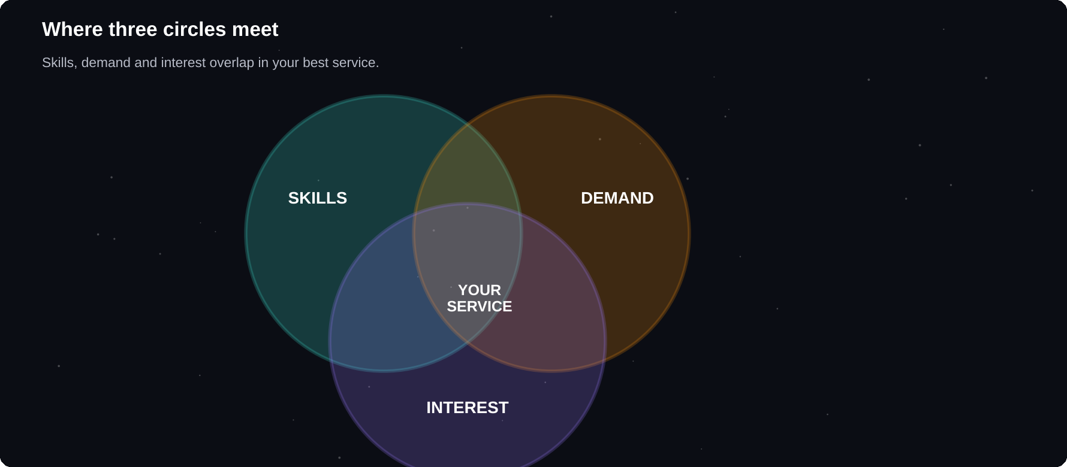
Where three circles meet
Your best service sits where your skills, market demand and your interest overlap.
IN THIS CHAPTER
01 Skill, service, niche  02 The three-circle test  03 Take a skills inventory | 04 Beginner-friendly services  05 Check the demand  06 Narrow into a niche | 07 Skills to learn next

Skill, service, niche
A skill is something you can do, such as writing. A service is a skill packaged for a buyer, such as “product descriptions for online shops”. A niche is a service aimed at a specific group, such as “product descriptions for handmade jewellery sellers”.
1
clear sentence should explain what you do and for whom. If you cannot say it simply, clients cannot remember it
The three-circle test
1 Skills: what can you do well, or learn quickly?
2 Demand: do people already pay for this?
3 Interest: could you enjoy doing it for months?
The sweet spot is where all three overlap. Skills without demand make a hobby. Demand without interest brings burnout. Interest without skill needs practice first.
Take a skills inventory
Source | Ask yourself
Studies | Which subjects do I do well in?
Projects | What have I built or made?
Hobbies | What do I do for free?
Friends | What do they ask me to help with?
Tools | Which software do I know well?
Languages | Which do I speak or write?

Beginner-friendly services
Service | Good first skill if you...
Content writing | Write clearly
Social media posts | Use Canva well
Data entry, research | Are accurate, careful
Video editing | Edit reels or videos
Web fixes | Know HTML, CSS
Presentation design | Like clean slides
Transcription | Type fast
Translation | Know two languages
Virtual assistance | Are organised
Basic data cleaning | Use Excel, Sheets

Check the demand
Before you commit, spend an hour on the platforms you plan to use. Search for your service. Are there many jobs and gigs? Do buyers leave reviews? A busy category means demand. An empty one may mean no demand, or no competition, so look carefully.
1 Search your service on Upwork and Fiverr
2 Note how many jobs and sellers appear
3 Read ten job posts and highlight repeated needs
4 Read client reviews for what buyers praise and complain about
5 Write down the problem each buyer is really trying to solve
Narrow into a niche
A niche can be an industry, a type of client, a tool or a result. Narrow gently: start broad enough to find work, then specialise as you learn what sells.
Broad | Niche
Graphic design | Logos for cafés
Writing | Blog posts for fitness coaches
Video editing | Short reels for creators
Data entry | Product catalogue clean-up
Web design | One-page sites for clinics

DO NOT OVERTHINK IT
Your first niche is a starting point, not a life sentence. Pick one, test it for 60 days, and change it if the market tells you to.

Skills to learn next
If your first choice needs a stronger skill, do not wait years. Learn the one skill that unlocks paid work, build three practice projects and begin. Free courses, official documentation and video tutorials are enough to start.
Try it yourself
1 Fill in: “I help ___ with ___ so they can ___”
2 Pick one main service and one backup service
3 Check demand on two platforms
4 List three skills you must improve
5 Choose one course or tutorial to start this week
Chapter checkpoint
1 Clients buy solutions, not skills
2 Use the three-circle test
3 Check real demand before you commit
4 A niche makes you easier to remember
5 Start narrow and refine as you learn

CHAPTER 3
Set Up Your Freelance Business
You do not need an office or expensive equipment. You need a reliable device, a good connection, a few free tools and some simple habits. This chapter helps you set up properly, so that you look professional from your first message.
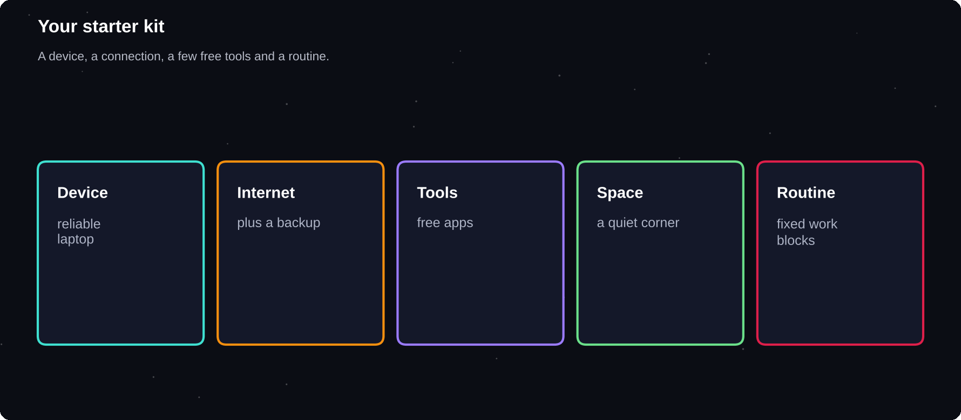
Your starter kit
A device, a connection, a few free tools and a routine are enough to begin.
IN THIS CHAPTER
01 The basics  02 A professional email  03 Free and low-cost tools | 04 Organise your files  05 Your workspace  06 Time and routine | 07 Getting ready to be paid  08 Separate your money  09 Record everything

The basics
1 A laptop or computer that is reliable
2 A stable internet connection, plus a backup such as a mobile hotspot
3 A quiet place to work and take calls
4 A professional email address
5 A bank account that can receive payments
A professional email
Use a simple, serious address such as firstname.lastname@gmail.com. Avoid nicknames, numbers or jokes. Clients notice small details like this. Use the same name on every platform so that people can recognise you.
Free and low-cost tools
Need | Tool ideas
Documents | Google Docs, Word
Spreadsheets | Google Sheets, Excel
Design | Canva, Figma
Meetings | Google Meet, Zoom
Chat | WhatsApp, Slack, Email
Tasks | Trello, Notion
Files | Google Drive, Dropbox
Time | Toggl, a simple sheet
Invoices | Free invoice templates

Organise your files
Create one main folder called Freelance. Inside it, make a folder for each client, and inside that: Brief, Drafts, Final and Invoices. Name files clearly, for example: Logo_ClientName_v2_2026-11-06.
Your workspace
1 Choose a fixed spot, even a corner of a table
2 Keep your phone out of reach during deep work
3 Use headphones for calls
4 Check lighting and background before video calls
5 Back up your work in the cloud
Time and routine
Working from home blurs the line between study, rest and work. Set work blocks and protect them. A simple routine of two focused hours a day beats a burst of effort once a month.
Time block | Use for
Morning | Deep work on client tasks
Midday | Messages and emails
Afternoon | Learning, study
Evening | Finding new leads
Weekly | Review income, admin

Getting ready to be paid
Most online platforms pay into a bank account or a payment service. Rules for receiving money from abroad, such as bank requirements and documents, differ by country and bank. Ask your bank which documents it needs for incoming international payments, and keep records of every payment.
TAXES AND RULES
Freelance income is usually taxable, and rules differ by country. Ask a qualified accountant or your tax office about registration, tax and invoices. If you are a minor, check the age rules of each platform and involve a parent or guardian.

Separate your money
Open or use a separate account for freelance income if you can. It keeps records tidy, makes taxes easier and helps you see how the business is really doing.
Record everything
Keep a record of | Why
Client names, dates | Follow-ups
Agreements | Avoid disputes
Invoices | Proof of work
Payments | Taxes, history
Expenses | Reduce tax, plan

Try it yourself
1 Create a professional email address
2 Build your Freelance folder structure
3 Set up a free Trello or Notion board
4 Choose your weekly work blocks
5 Ask your bank how it handles international payments
Chapter checkpoint
1 Reliable device and internet come first
2 Free tools are enough at the start
3 Organise files and routines early
4 Know the payment and tax rules where you live
5 Keep clear records from day one

CHAPTER 4
Build Your Professional Profile
Your profile is your shop window. A client who finds you will decide in seconds whether you look trustworthy. A clear photo, a sharp headline and a short, benefit-led bio can make that decision easy.
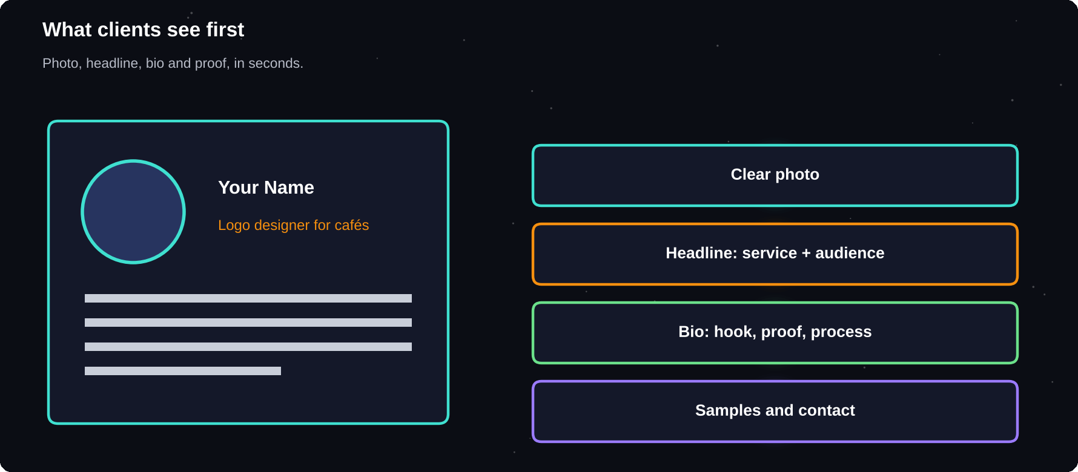
What clients see first
Photo, headline, skills and proof, all in a few seconds.
IN THIS CHAPTER
01 What a profile must do  02 Your photo  03 Write a headline that sells | 04 Write your bio in four parts  05 Skills and keywords  06 Show your education honestly | 07 Languages and availability  08 Profile mistakes to avoid  09 One name everywhere

What a profile must do
1 Say clearly what you do
2 Show who you help
3 Prove you can do it
4 Make it easy to contact you
Your photo
Use a clear, friendly headshot with good light and a plain background. Look at the camera and smile naturally. A phone photo by a window works well. Avoid sunglasses, group photos, filters and logos in place of a face.
Write a headline that sells
The headline sits beside your name. It should say what you do and for whom, not only your job title.
Weak | Stronger
Student | Blog writer for tech start-ups
Designer | Logo and social media designer
Developer | Web developer for small businesses
Freelancer | Excel report cleaner for sellers

Write your bio in four parts
1 Hook: the problem you solve, in one sentence
2 Proof: what you have done, even in practice projects
3 Process: how you work and what the client can expect
4 Call to action: invite a message
EXAMPLE BIO
Small businesses lose customers to unclear websites. I build clean one-page sites that load fast and look right on phones. I have built six practice sites for local shops and clubs. You get a clear plan, regular updates and one round of changes. Send me a message with your idea and I will reply within a day.

Skills and keywords
Clients and platforms search by keywords. Use the words buyers use. If you offer “product descriptions”, write that phrase, not only “creative writing”. List your top skills and tools, and keep them honest.
Show your education honestly
Student status is not a weakness. State your degree, the courses that matter and projects you have completed. Always be honest about your experience. Overstating it leads to unhappy clients, bad reviews and lost trust.
Languages and availability
Detail | Tip
Languages | List levels honestly
Hours | State when you reply
Time zone | Show your overlap
Response time | Promise what you keep

Profile mistakes to avoid
1 Copying another freelancer's text
2 Spelling and grammar errors
3 Vague claims such as “best in the world”
4 Writing only about yourself, not the client
5 Leaving sections empty
One name everywhere
Use the same photo, name and short bio across Upwork, Fiverr, LinkedIn and your portfolio. When a client searches for you, everything should match and reinforce your message.
Try it yourself
1 Take a new profile photo this week
2 Write three headline options and pick one
3 Draft your bio using the four parts
4 Ask a friend to read it aloud and tell you what you do
5 Fix every error before you publish
Chapter checkpoint
1 Your profile is a shop window
2 Headline: what you do, for whom
3 Bio: hook, proof, process, call to action
4 Be honest about your experience
5 Stay consistent across platforms

CHAPTER 5
Create a Portfolio from Zero
Clients do not believe claims. They believe samples. The good news is that you do not need clients to create samples. You can make a strong portfolio from practice projects, volunteer work and imagined briefs.
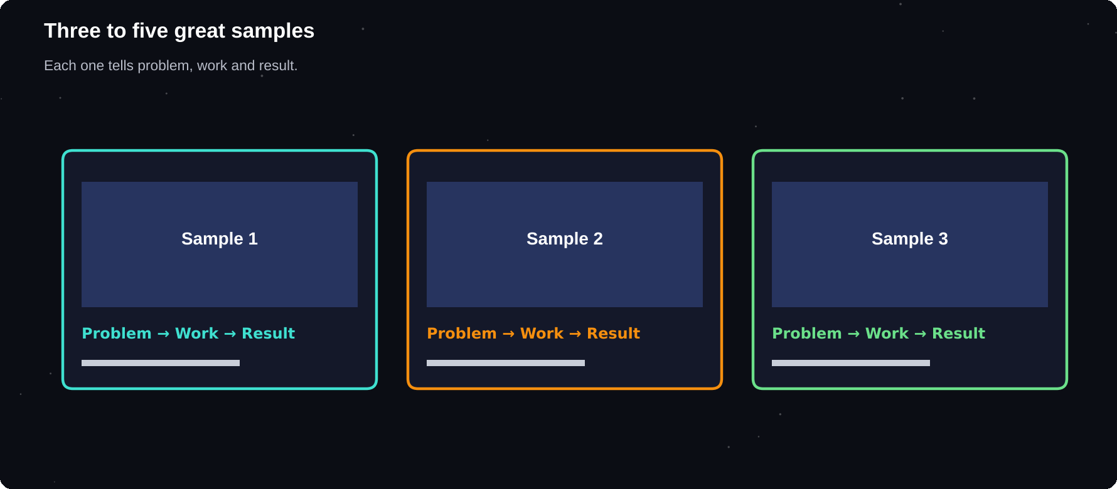
Three to five great samples
A small set of strong, relevant samples beats a long list of weak ones.
IN THIS CHAPTER
01 What is a portfolio?  02 Six ways to get samples with no clients  03 Choose what to include | 04 Present each sample like a case study  05 Where to host your portfolio  06 Make it easy to review | 07 Ask for testimonials early  08 Update regularly

What is a portfolio?
A portfolio is a small collection of your best work, shown with a short explanation of each piece. It answers the buyer's biggest question: can this person really do it?
3–5
strong samples are usually enough to begin. Quality and relevance matter more than quantity
Six ways to get samples with no clients
1 Practice projects: create work for a made-up business
2 Redesigns or rewrites of a real brand's page, labelled clearly as practice
3 Volunteer work for a club, charity or college event
4 Course projects and assignments you are allowed to share
5 Work for friends and family, with their permission
6 Personal projects that solve a real problem
Choose what to include
Skill | Sample ideas
Writing | 3 blogs, 1 product page
Design | Logo set, 3 social posts
Web | 2 sites with live links
Video | 3 short edited clips
Data | A cleaned sheet, a chart
Assistant | Sample schedule, research

Present each sample like a case study
A picture or a file alone says little. Add three short lines to every sample so the viewer sees your thinking.
1 The problem: what the project needed
2 What you did: steps and tools
3 The result: the finished work or its benefit
LABEL PRACTICE WORK
If a sample is a practice project, say so. Never present practice work as a paying client's, and never use a brand's logo to suggest a relationship that does not exist. Honesty protects your reputation.

Where to host your portfolio
Option | Good for
Platform profile | Quick start
Google Drive folder | Simple sharing
Notion page | Clean, free page
Canva website | Designers
GitHub Pages | Developers
Behance, Dribbble | Visual work
Personal website | Long-term brand

Make it easy to review
1 Put your best sample first
2 Use clear titles and short captions
3 Compress large files so they open fast
4 Test every link on a phone
5 Add your contact details at the end
Ask for testimonials early
Even a short message from a teacher, a club leader or a friend whose project you helped with adds trust. Ask politely: “Could you write two sentences about working with me? I would like to add it to my portfolio.”
Update regularly
Once a quarter, replace weaker samples with newer, better ones. When you finish a real client project, ask permission to add it. Remove anything you no longer feel proud of.
Try it yourself
1 Pick three practice briefs this week
2 Create the first sample in two days
3 Write the three-line case study for it
4 Upload it to one hosting option
5 Share the link with someone and ask for honest feedback
Chapter checkpoint
1 You can build a portfolio without clients
2 Choose three to five relevant samples
3 Explain the problem, work and result
4 Label practice work honestly
5 Make it easy to open and review

CHAPTER 6
Getting Started on Upwork
Upwork is a large marketplace where clients post jobs and freelancers send proposals. It rewards complete profiles, clear proposals and good reviews. This chapter explains how it works, so that you can set up properly and avoid common beginner mistakes.
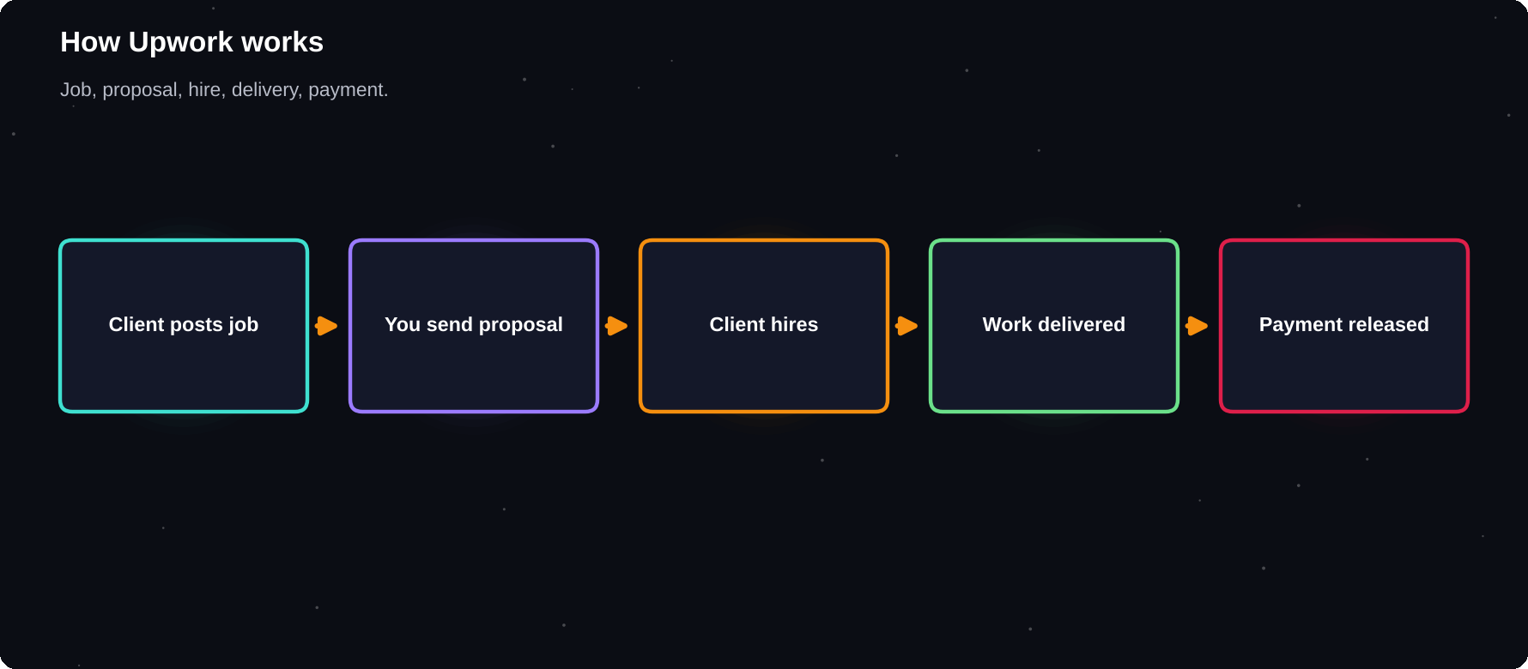
How Upwork works
Clients post jobs, freelancers apply, the client hires, the work is delivered and payment is released.
IN THIS CHAPTER
01 How the marketplace works  02 Two kinds of contract  03 Create your account  04 Complete your profile | 05 Understand Connects  06 Fees  07 Job Success and ratings  08 Platform rules to respect | 09 Your first week on Upwork  10 The proposal screen  11 Saved searches and alerts  12 Keep your profile alive

How the marketplace works
1 A client posts a job with a budget and details
2 Freelancers send proposals, using Connects
3 The client reviews, chats and hires one
4 A contract starts, fixed-price or hourly
5 The freelancer delivers, the client pays, both leave reviews
Two kinds of contract
Type | How it works
Fixed-price | One price per project or milestone
Hourly | Paid per tracked hour

Fixed-price suits a clear, defined deliverable. Hourly suits ongoing or uncertain work. Beginners often find fixed-price easier to win and manage.
Create your account
1 Sign up with your professional email
2 Use your real name and a clear photo
3 Verify your identity when asked
4 Choose a main category and your services
5 Fill in every section of the profile
ONE ACCOUNT ONLY
Platforms usually allow one account per person. Duplicate accounts or false identities can lead to permanent suspension. Read the current terms of service and follow them.

Complete your profile
Section | What to write
Title | Service plus audience
Overview | Hook, proof, process, call
Skills | Up to the allowed number
Portfolio | Your best 3–5 samples
Education | Degree, courses
Rate | Realistic, explained in ch. 10

Understand Connects
Sending a proposal usually costs Connects, a virtual currency that you receive monthly or can buy. Each job shows how many it needs. Because Connects are limited, apply only to jobs you can do well. Check Upwork's help pages for the current number and cost, because both change.
Fit
matters more than volume. Ten targeted proposals beat fifty copied ones
Fees
Upwork charges freelancers a service fee on earnings, and the percentage and structure have changed over time. Clients may also pay fees. Always check the current fee page before you set your price, and make sure your rate still leaves you a fair income after fees.
Job Success and ratings
Upwork tracks how happy clients are through reviews, completed contracts and other signals, and it may show a badge or score. You build them with good work, clear communication and finished contracts. Never ask clients to inflate a rating, and never try to cheat the system.
Platform rules to respect
1 Keep communication and payment on the platform for contracts you found there
2 Do not share contact details to avoid fees
3 Do not sell or buy accounts
4 Do not submit work you did not create
5 Disclose use of tools such as AI if the client requires it
Your first week on Upwork
Day | Action
1 | Create account, photo
2 | Write title, overview
3 | Add portfolio, skills
4 | Study 20 job posts
5 | Save a search for your niche
6 | Draft proposal templates
7 | Send 3 careful proposals

The proposal screen
When you apply, Upwork shows a form with a cover letter, your rate or bid, a timeline and sometimes screening questions. Treat the questions as part of the test: clients use them to filter quickly, so answer each one directly.
Field | Tip
Cover letter | Short, specific, no template
Rate or bid | Match your pricing sheet
Timeline | Realistic, with buffer
Questions | Answer each one briefly
Attachments | One relevant sample

Saved searches and alerts
Save searches for your exact service and for a few related keywords. Check them at set times each day. Early, relevant proposals are more likely to be read, and the saved search stops you from wasting time scrolling.
1 Create one search per service keyword
2 Add filters for budget and experience
3 Review matches every morning and evening
4 Move good jobs to a tracking sheet
5 Delete searches that bring only poor matches
Keep your profile alive
Review your profile monthly. Add new samples, update the overview with what you learned, and remove weak items. A profile that grows with you looks active and trustworthy.
Try it yourself
1 Create and complete your profile
2 Read the current fee and Connects pages
3 Search for jobs in your niche and save the search
4 Pick five jobs you could do well
5 Note which words clients use again and again
Chapter checkpoint
1 Upwork connects clients and freelancers through jobs and proposals
2 Complete your profile fully
3 Connects are limited, so apply selectively
4 Check current fees and rules
5 Follow the platform's terms

CHAPTER 7
Winning Your First Upwork Job
Your first job is the hardest. You have no reviews, so the client must trust your proposal and your profile instead. The method is simple: choose jobs carefully, answer the client's real problem and show that you are reliable.
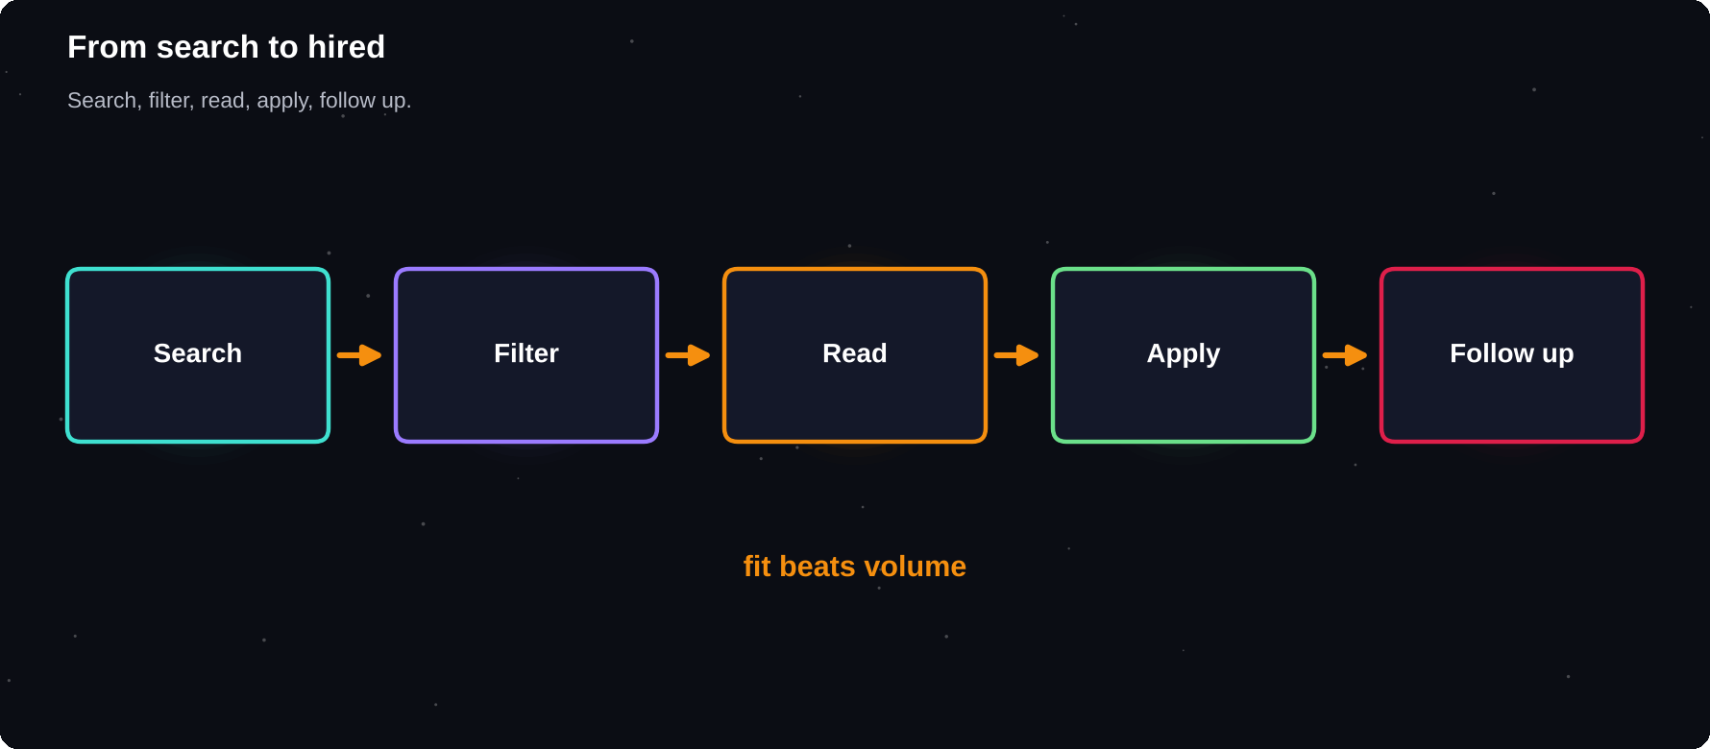
From search to hired
Search, filter, read carefully, apply with care, follow up.
IN THIS CHAPTER
01 Find the right jobs  02 Reading a job post  03 Red flags  04 The jobs to target first | 05 Apply quickly, but carefully  06 What goes in a proposal  07 When the client replies  08 If you are not getting replies | 09 Learn from every proposal  10 Worked example: reading a job  11 Turning clues into a first line  12 Decide whether to apply

Find the right jobs
1 Search with specific keywords for your service
2 Filter by experience level, budget and project type
3 Prefer clients with a verified payment method
4 Check how many proposals a job already has
5 Read the client's history and past reviews
Reading a job post
Read twice. First for the task, then for clues about the client: how clearly they write, what they care about and what worries them. Highlight keywords you can mirror in your proposal.
Look for | Meaning
Clear brief | Client knows the goal
Budget stated | They have thought it through
Payment verified | Lower payment risk
Past reviews | Reliable to work with?
Hire rate | Do they actually hire?

Red flags
1 No clear task or constantly changing scope
2 Requests free work or a free test project
3 Wants to move to private chat or off-platform payment immediately
4 Unrealistic budget for the work
5 Bad reviews from many previous freelancers
6 Asks for your login details or personal documents
SKIP BAD JOBS
A bad client costs more than the fee you earn. Protect your time. A small sample can be reasonable. Complete, unpaid project work is not.

The jobs to target first
As a beginner, look for small, well-defined jobs with a clear result, such as fixing a page, writing five posts or cleaning a spreadsheet. Clients with a small trial task often welcome new freelancers. Jobs asking for “entry level” suit you best.
Apply quickly, but carefully
Early proposals tend to be seen first. Check new jobs at set times each day and reply fast, but never send a rushed copy-and-paste message. Quality still wins.
What goes in a proposal
1 A first line about the client's problem
2 Proof you can solve it: one relevant sample
3 A short plan of how you will do it
4 Timeline and price
5 A question that shows you read the post
Chapter 11 explains proposals in detail. Use a template as a skeleton, but rewrite the opening for every job.
When the client replies
1 Reply within hours, not days
2 Answer questions directly and politely
3 Offer a short call only if the client asks
4 Confirm the scope, price and deadline in writing
5 Do not start before the contract is active
If you are not getting replies
Possible cause | Fix
Generic proposals | Personalise the first lines
Weak profile | Improve photo, title
Wrong jobs | Aim at smaller, clear tasks
Too slow | Check new jobs daily
Unclear value | Add a relevant sample

Learn from every proposal
Keep a simple sheet: job link, date, Connects used, reply, result. After twenty proposals, patterns will show which kinds of jobs and openings work for you.
Worked example: reading a job
THE POST
“Need 5 product descriptions for my handmade candle shop. Friendly tone, about 80 words each. Budget flexible. Start this week.”

Clue | What it tells you
Handmade candles | A small, creative brand
Friendly tone | Match voice, not jargon
80 words each | Short, clear scope
Budget flexible | Quality matters to them
Start this week | Reply quickly

Turning clues into a first line
FIRST LINE
Candle shoppers are buying a feeling, so each description should smell and glow on the page. I recently wrote a set for a handmade soap shop (link). Here is how I would approach yours.

Notice that the opening is about the client's customers, not about the freelancer. This is what makes a client keep reading.
Decide whether to apply
1 Can I deliver this well within their timeline?
2 Is the scope clear and the budget fair?
3 Is the payment method verified?
4 Do I have one relevant sample?
5 Would I be happy to work for this client again?
If you answer no to two or more, skip the job and use your Connects on a better match.
Try it yourself
1 Collect ten suitable jobs in a sheet
2 Mark any red flags
3 Write a custom first line for three jobs
4 Send your three best proposals
5 Record every result, then refine
Chapter checkpoint
1 Choose clear, small, well-matched jobs
2 Read the client's history for red flags
3 Never do large free work
4 Reply fast and personally
5 Track results and improve

CHAPTER 8
Fiverr: Gigs That Sell
On Fiverr, the process is reversed. You do not chase jobs; you create gigs, which are ready-made services with a clear price and promise, and buyers come to you. A well-made gig works while you sleep.
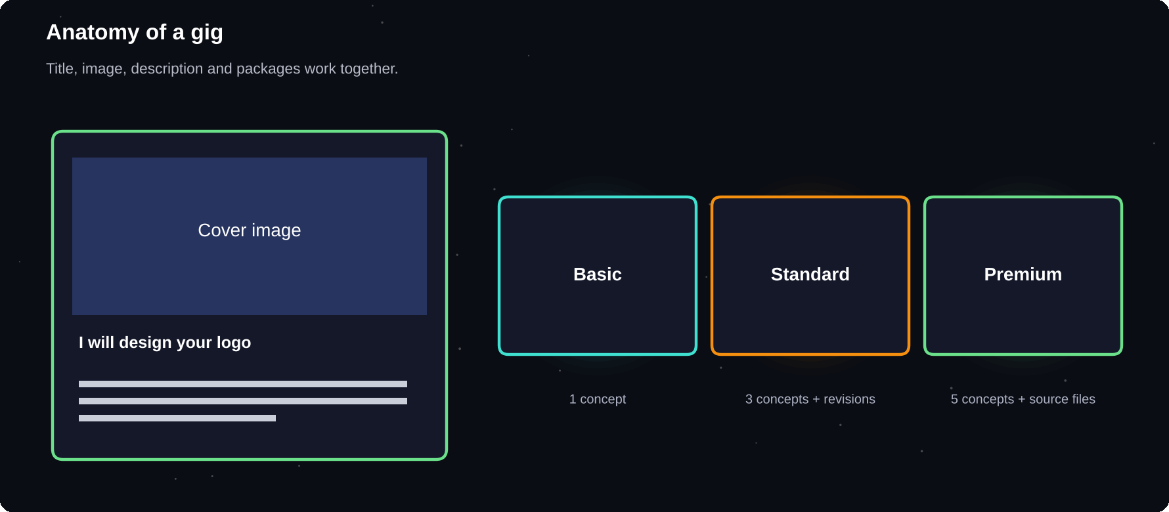
Anatomy of a gig
Title, images, description and packages all work together.
IN THIS CHAPTER
01 How Fiverr works  02 Upwork versus Fiverr  03 Pick a gig idea  04 The gig title  05 Images and video | 06 Write the description  07 Packages  08 Add extras  09 Answer buyers well  10 Your first orders | 11 Gig search words  12 Requirements and FAQ  13 Improve a gig with data

How Fiverr works
1 You create a gig describing one specific service
2 Buyers find it through search or browsing
3 They order a package or message you first
4 You deliver by the deadline
5 They accept, pay and leave a review
Upwork versus Fiverr
 | Upwork | Fiverr
Style | Apply to jobs | Sell gigs
Start | Proposals | Gig page
Pricing | Set per job | Fixed packages
Best for | Custom projects | Defined services
Effort | Active pitching | Optimise once

Pick a gig idea
Choose one specific service and one buyer. “Logo design” is crowded. “Minimal logo for a new bakery” is clearer. Study the top gigs in your category for what they include, then offer something simpler or more focused.
The gig title
Titles usually begin with “I will”. Include the service, the buyer's benefit and the main keyword.
Weak | Better
I will do design | I will design a clean logo for your small business
I will write | I will write SEO blog posts for your website

Images and video
1 Use clear, bright cover images of your best sample
2 Show before and after if possible
3 Keep text on images short and readable
4 Add a short video if you are comfortable on camera
5 Never use other people's work
Write the description
1 Start with the buyer's problem
2 Say what the buyer will get
3 Explain your process in three steps
4 List what is not included
5 End with an invitation to message you
Packages
Most gigs offer three packages: Basic, Standard and Premium. They differ in quantity, speed or extras. The middle package should look like the best value. Start with prices you can deliver profitably, and raise them as reviews arrive.
Package | Example: social posts
Basic | 3 designs
Standard | 6 designs, 2 revisions
Premium | 12 designs, source files

Add extras
Extras let buyers customise: fast delivery, extra revisions, source files. They increase the order value without changing the main gig.
Answer buyers well
1 Reply quickly, ideally within hours
2 Ask for the details you need before you start
3 Confirm the package and delivery date
4 Stay inside the platform for communication
5 Deliver a little early when you can
Your first orders
The first reviews are the hardest to win. Make the first orders excellent. Communicate clearly, deliver on time and politely ask satisfied buyers to leave a review. Never offer money for reviews or fake orders. Doing so breaks the rules and can end your account.
CHECK THE CURRENT RULES
Platform fees, levels and policies change. Read Fiverr's current seller guidelines and fee information before you publish your first gig.

Gig search words
Buyers find gigs by searching. Use the words they type, such as “logo design for small business”, in your title, description and tags. Study the suggestions that appear as you type a search on the platform. They reveal what real buyers look for.
1 Pick one main keyword for the gig
2 Add related words as tags
3 Use plain language, not clever names
4 Check the competition for the same phrase
5 Refine after a few weeks of data
Requirements and FAQ
Use the requirements section to ask buyers for what you need before you start: brand name, colours, examples, text. A short FAQ answers common questions, such as file formats and delivery, and reduces back-and-forth messages.
Ask in requirements | Why
Business name, topic | Start immediately
Examples they like | Match taste
Text or files | Avoid delays
Deadline | Plan delivery

Improve a gig with data
The platform shows impressions, clicks and orders. If many people see the gig but few click, improve the title and cover image. If many click but few order, improve the description, packages or price.
Try it yourself
1 Find five top gigs in your category and note why they work
2 Write three gig title options
3 Design your cover image
4 Create three packages with clear differences
5 Publish, then share the link with friends
Chapter checkpoint
1 Fiverr sells ready-made services as gigs
2 Focus on one clear service and buyer
3 Title, images and packages all matter
4 Great first orders create reviews
5 Follow the current rules

CHAPTER 9
Find Clients Beyond Marketplaces
Marketplaces are a good start, but they are crowded and take a fee. Many freelancers find their best clients elsewhere: through people they know, direct messages and useful content. This chapter shows you how to find them politely and without spam.
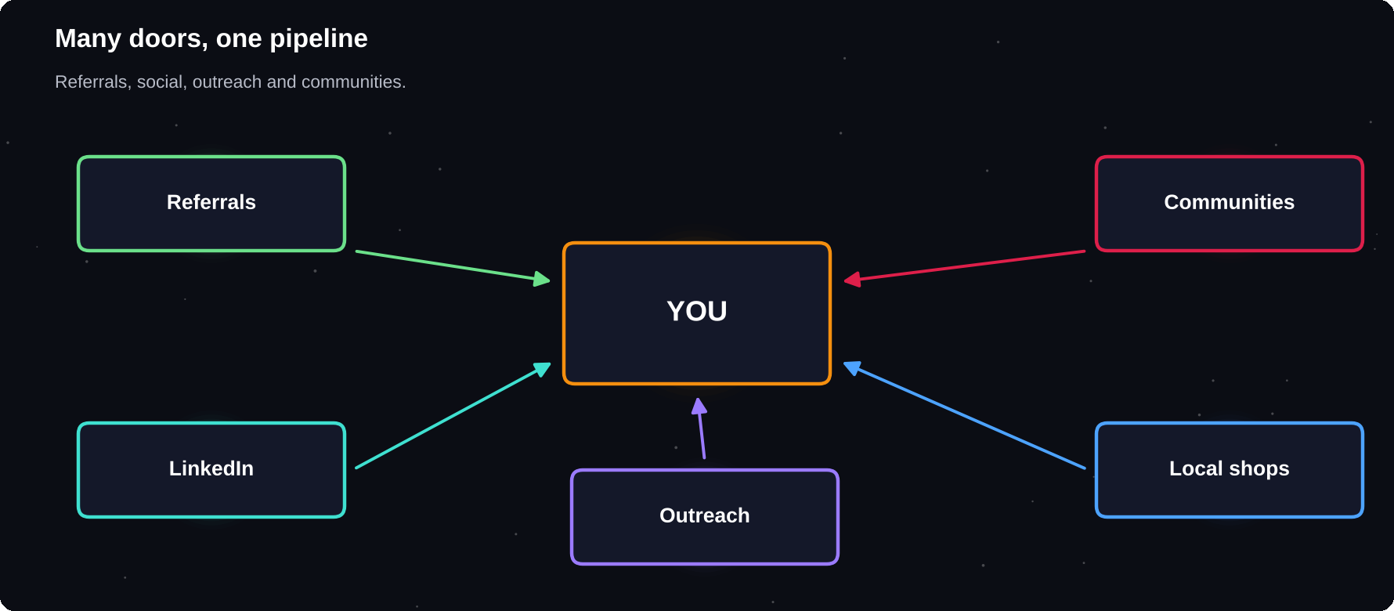
Many doors, one pipeline
Referrals, social media, outreach and communities all feed your pipeline.
IN THIS CHAPTER
01 Start with the people you know  02 Referrals  03 LinkedIn | 04 Direct outreach  05 A simple outreach message  06 Communities and groups | 07 Local businesses  08 Content that attracts clients  09 Build a simple pipeline

Start with the people you know
Your first client often comes from your own network. Tell friends, family, teachers and seniors what you offer in one simple sentence. Ask: “Do you know anyone who needs help with ___?”
1 message
to ten people costs nothing and often leads to your first paid project
Referrals
1 Finish every project well
2 Ask happy clients: “Who else might need this?”
3 Thank people who refer you
4 Keep in touch with past clients
5 Make referrals easy with a short, forwardable description
LinkedIn
LinkedIn is a professional network where business owners and managers spend time. Optimise your profile like you did in chapter 4, then share useful posts and connect with people who might need your service.
1 Write a headline with service plus audience
2 Post once or twice a week about problems you solve
3 Comment helpfully on posts from your target clients
4 Send personal connection notes, not sales pitches
5 Share finished work and lessons learned
Direct outreach
Cold outreach means contacting people who do not know you. Done well, it is respectful and specific. Done badly, it is spam. Always research first, mention something real about their business and offer one clear idea.
Do | Do not
Personalise every message | Copy and paste to hundreds
Offer value first | Lead with a hard sell
Keep it short | Write long essays
Follow up once or twice | Pester daily
Respect a “no” | Argue or keep writing

A simple outreach message
TEMPLATE
Hi [Name], I noticed [specific thing about their business]. I help [type of business] with [your service]. For example, I could [one concrete idea]. Would you like me to send a short sample? Thanks for your time. [Your name]

Communities and groups
Joining communities where your clients gather lets you learn their problems. Answer questions without selling. Over time, people remember the helpful person and message them when they need help.
Where | What to do
Facebook, WhatsApp groups | Help, then share work
Reddit, forums | Answer questions
Slack, Discord | Join niche servers
College clubs | Offer help to events
Local business groups | Meet shop owners

Local businesses
Small shops, clinics, coaching centres and restaurants near you often have weak websites and social pages. Walk in or write with a specific, friendly suggestion. Local clients are often easier to trust and talk to.
Content that attracts clients
1 Write short posts about common mistakes in your field
2 Share before and after examples
3 Explain one tip per post
4 Record a short video for beginners
5 Always add a simple way to contact you
Build a simple pipeline
Stage | Meaning
Lead | Someone who might need you
Contacted | You have messaged them
Talking | They replied
Proposal | You sent a quote
Won or lost | Decision made

Track these in a sheet. Aim to add five new leads a week. Every lead you contact is practice.
Try it yourself
1 Message ten people you know with your one-sentence offer
2 Update your LinkedIn headline
3 Join two communities where your clients spend time
4 List ten local businesses you could help
5 Send three personal outreach messages this week
Chapter checkpoint
1 Start with your own network
2 Referrals are your best source
3 LinkedIn and communities build trust over time
4 Personalise outreach and respect refusals
5 Track leads in a simple pipeline

CHAPTER 10
Pricing Your Services
Pricing is where many beginners struggle. Too low and you burn out or attract bad clients. Too high and you get no replies. The answer is to calculate a rate that covers your needs, test it in the market, and raise it as your proof grows.
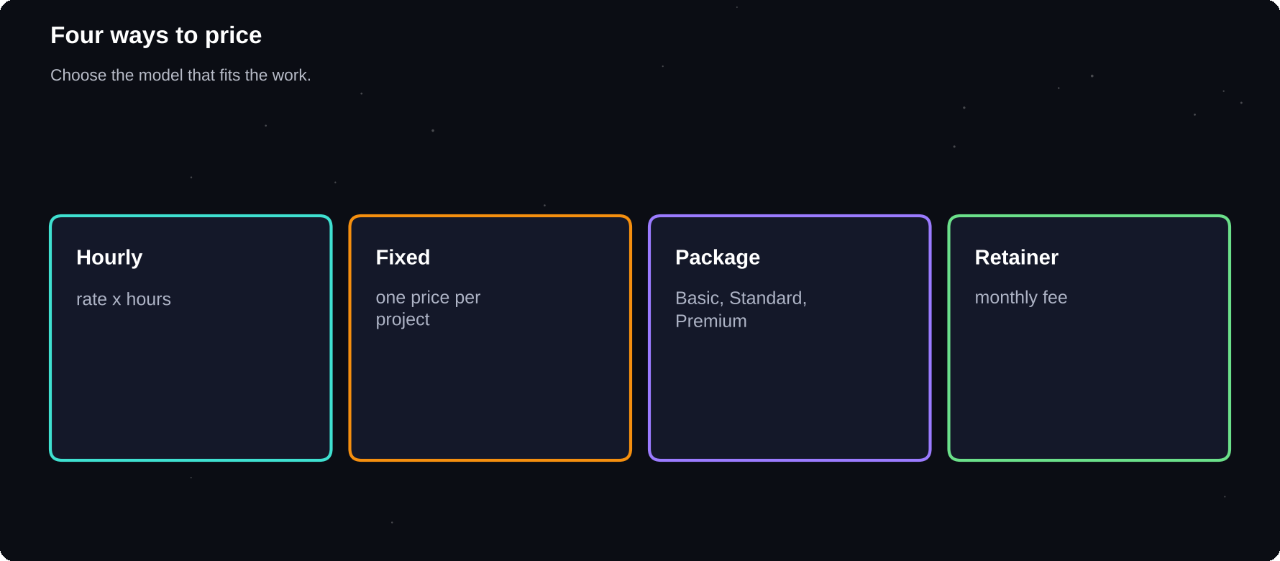
Three ways to price
Hourly, per project and value-based pricing suit different work.
IN THIS CHAPTER
01 Three pricing models  02 Work out a minimum rate  03 Research the market  04 Fixed price: estimate carefully | 05 Value-based pricing  06 Why very low prices hurt  07 Starting prices for beginners  08 Scope and extras | 09 Talking about price  10 Raise your rates  11 Worked pricing example

Three pricing models
Model | How it works
Hourly | Rate times hours worked
Fixed | One price per project
Package | Set bundles, such as Basic
Retainer | Monthly fee for ongoing work

Work out a minimum rate
1 Decide the monthly income you want
2 Add costs: internet, tools, platform fees, taxes
3 Estimate the hours you can realistically bill
4 Divide total needed by billable hours
5 That is your minimum hourly rate
Billable hours are fewer than hours worked. Time spent finding clients, replying to messages and doing admin is not paid. Many freelancers can bill only half to two-thirds of their working time.
EXAMPLE FORMULA
Rate = (monthly income goal + monthly costs) / billable hours. Use your own currency and numbers. The aim is a rate that works, not a number copied from someone else.

Research the market
1 Look at gigs and profiles in your niche and experience level
2 Note the lower, middle and upper ranges
3 Check what the higher-priced sellers include
4 Place yourself near the lower-middle range at first
5 Plan increases as reviews arrive
Fixed price: estimate carefully
Estimate the hours the project will take, add time for revisions and messages, and then add a buffer, usually 20–30 per cent, because tasks take longer than planned. Multiply by your rate.
Step | Example
Work time | 10 hours
Revisions, calls | +3 hours
Buffer 20% | +2.6 hours
Total | 15.6 hours
Price | Total times your rate

Value-based pricing
Sometimes the value to the client is far higher than your hours. A page that brings the client new customers is worth more than the time it took to write. When the client can name the benefit, price part of your fee on that result.
Why very low prices hurt
1 You cannot afford to do good work
2 You attract clients who care only about price
3 You signal low quality
4 Raising prices later feels hard
5 You burn out quickly
Starting prices for beginners
A beginner price should be a little lower than experienced freelancers, never free. A modest introductory price for your first few projects is fine, as long as it is fair, you say why it is introductory, and you plan to raise it.
Scope and extras
Always write what is included: number of revisions, file formats, length, deadline. Anything outside that scope is an extra with a separate price. This protects you from scope creep, where a project slowly grows without more pay.
Included | Extra
2 revision rounds | More rounds
Final files | Source files
Standard delivery | Rush delivery
Agreed length | Extra pages

Talking about price
1 State your price calmly, with no apology
2 Explain what is included
3 Offer options instead of discounts
4 Do not lower the price. Reduce the scope instead
5 Ask for a deposit on larger projects
Raise your rates
Review prices every quarter. Raise them after good reviews, when you are busy, or when you gain a new skill. Tell existing clients in advance, politely, and give a date.
Worked pricing example
Meera wants a monthly income of 20,000 from freelancing. Her monthly costs are 2,000 for internet, tools and fees. She can work about 60 hours a month, but only 40 of them are billable, as the rest goes on finding clients and admin.
Step | Calculation
Needed | 20,000 + 2,000 = 22,000
Billable hours | 40
Minimum rate | 22,000 / 40 = 550 per hour

Now she prices a project of five product descriptions. She estimates two hours for each, ten in all, plus two for revisions and messages, plus a 20 per cent buffer.
Step | Calculation
Work and revisions | 10 + 2 = 12 hours
Buffer 20% | 12 x 1.2 = 14.4 hours
Price | 14.4 x 550 = 7,920

The numbers are only an illustration, in a currency of her choice. The method works for any currency. She then checks the market: if local or platform prices are far below, she lowers the scope or improves her speed, not her self-respect.
TEST AND ADJUST
If you get many replies at your price, you may be too low. If you get none after many careful proposals, check your samples first, then your price.

Try it yourself
1 Calculate your minimum hourly rate
2 Research five competitors' prices
3 Create three packages for your main service
4 Write the included and extra items for each
5 Practise saying your price aloud
Chapter checkpoint
1 Know your minimum rate before you quote
2 Estimate hours, add a buffer
3 Avoid extreme low pricing
4 Define scope and extras
5 Review and raise prices regularly

CHAPTER 11
Writing Proposals That Win
A proposal is a short sales message. It does not need clever words. It needs to show the client you understood their problem, can solve it and are easy to work with. A good proposal is short, specific and about the client, not about you.
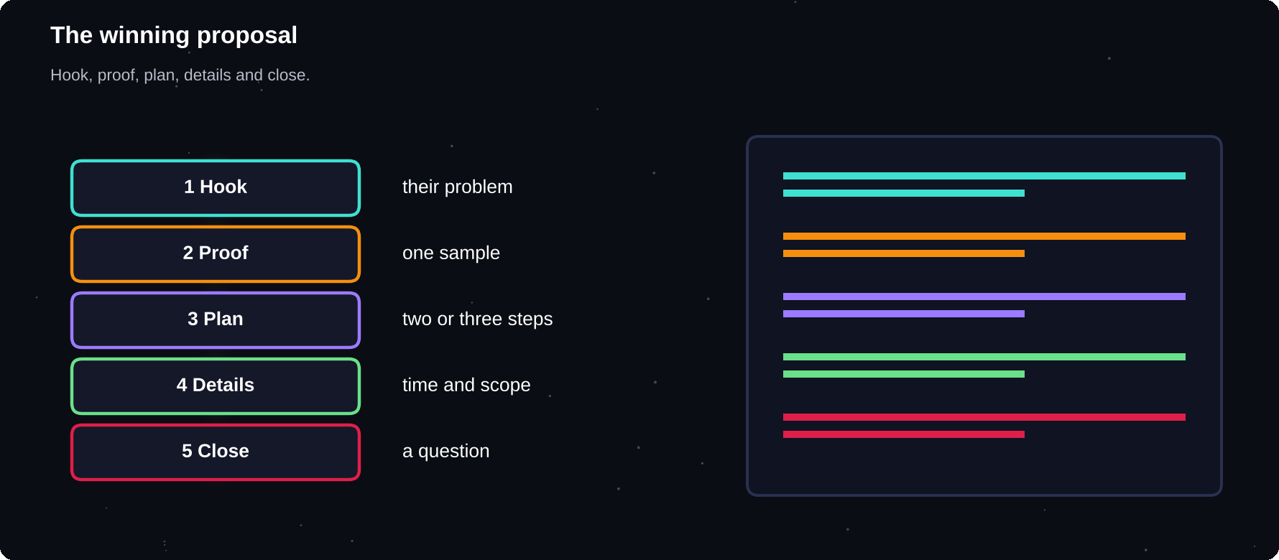
The winning proposal
Hook, proof, plan, price and a closing question.
IN THIS CHAPTER
01 The goal of a proposal  02 Five parts, one page or less  03 The first line  04 Prove it with one sample  05 Show a plan | 06 A full proposal template  07 Answer every question  08 Keep it short and clear  09 What not to write  10 Following up | 11 Be honest about being new  12 Two sample proposals  13 Why these work

The goal of a proposal
A client may read dozens of proposals, usually only the first two lines at first. Your job is to earn the next ten seconds of attention. Everything else follows from that.
Five parts, one page or less
1 Hook: show you understood their problem
2 Proof: one relevant sample or result
3 Plan: how you will do it, in two or three steps
4 Details: timeline, price, what is included
5 Close: a question or simple next step
The first line
Weak | Strong
Hello, I am a hard-working student. | You need five product descriptions that sound friendly, not technical.
I can do this job. | Your shop sells handmade soap. Here is how I would make the pages match that feel.

Prove it with one sample
Pick the most relevant piece in your portfolio and link it. One strong, relevant sample beats five random ones. If you have no relevant sample, make a quick one for the client's niche.
Show a plan
EXAMPLE
1. I will review your current pages and note the tone. 2. I will write a draft for two products to confirm the style. 3. After your feedback I will complete the rest and send them in your preferred format.

A full proposal template
SKELETON
Hi [Name], you want [their goal] for [their business]. That reminds me of [your relevant sample, with link]. My plan: step one, step two, step three. I can deliver in [time] for [price], including [revisions]. Quick question: [specific question about the job]. Happy to start as soon as you confirm. Thanks, [Name]

Answer every question
If the job post asks for something specific, such as a keyword or a time zone, answer it clearly. Clients often use these as a quick test to see who read the post.
Keep it short and clear
1 Use short sentences and simple words
2 Break text into small paragraphs
3 Avoid long lists of your skills
4 Check spelling and grammar
5 Read it aloud before sending
What not to write
Avoid | Why
Copy-paste greetings | Looks automated
Begging for a chance | Weakens trust
Lying about experience | Harms reputation
Promising impossible results | Creates disputes
Negative talk about others | Looks unprofessional

Following up
If the client has not replied after a few days, send one short, polite follow-up that adds value, such as a quick idea or a relevant link. Then let go and move on. Do not send many reminders.
Be honest about being new
You can mention you are a student or new freelancer without apologising. Frame it positively: you are motivated, careful, quick to reply and careful with detail. Then prove it with a sample and a clear plan.
Two sample proposals
Study how the first line speaks to the client, how one relevant sample is used and how the plan is simple.
EXAMPLE: WRITING
Hi Priya, a candle buyer cannot smell your product online, so every word has to do the work. I wrote a similar set for a soap shop (link). My plan: first, I draft two descriptions to match your tone. Second, you comment. Third, I finish all five. I can deliver in four days for [price], with two revision rounds. Which scent is your best seller?

EXAMPLE: DESIGN
Hi Daniel, a clean menu helps customers order faster. I redesigned a café menu last month (link). My plan: first, three layout options. Second, you pick one and give feedback. Third, I send print-ready files. I can deliver in five days for [price]. Do you already have a brand colour?

Why these work
1 They start with the client's customer or problem
2 They link one relevant sample
3 They show a simple plan
4 They give time, price and revisions
5 They end with a specific question
Try it yourself
1 Write your proposal skeleton
2 Create three versions of the first line
3 Write a plan section for your main service
4 Send one proposal this week and note the result
5 Ask a friend to rate the first two lines
Chapter checkpoint
1 The first two lines decide the outcome
2 Use hook, proof, plan, details, close
3 Make every proposal personal
4 Be honest and clear about experience
5 Follow up politely, once

CHAPTER 12
Client Communication
Most client problems are communication problems. Clients rarely leave a freelancer because the work was a little late. They leave because they felt ignored or confused. Clear, friendly and regular communication is a skill you can learn quickly.
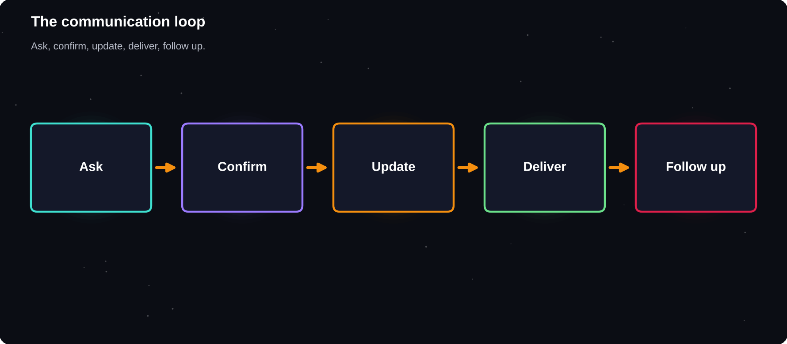
The communication loop
Ask, confirm, update, deliver, follow up.
IN THIS CHAPTER
01 Why communication wins work  02 Message basics  03 The first call or chat  04 Confirm in writing | 05 Regular updates  06 Time zones and availability  07 Handling feedback  08 Difficult messages | 09 Saying no politely  10 Written tone

Why communication wins work
Two freelancers with the same skill and price are not equal if one replies in an hour and writes clearly, and the other disappears for days. Reliability is a service you sell.
24h
is a sensible maximum time to reply to a client. Say in advance when you are unavailable
Message basics
1 Greet the client by name
2 Answer the question first, then add detail
3 Use short paragraphs and simple words
4 End with the next step
5 Re-read before you send
The first call or chat
Before a project, find out what the client really needs. Do not assume. Ask open questions and write down the answers, then send them back as a summary for confirmation.
Question | Why ask
What is the goal? | Aim at the real result
Who is it for? | Choose style, tone
Any examples you like? | Align taste early
What is the deadline? | Plan your time
Who approves the work? | Avoid surprises
What is the budget? | Match scope to money

Confirm in writing
SUMMARY MESSAGE
Thanks for the call. To confirm: you need [deliverable] by [date] for [price]. It includes [items] and [number] rounds of revisions. I will start once the contract is active. Please reply if anything is missing.

Regular updates
Send a short update at agreed points, even when there is nothing dramatic to report. Clients relax when they know progress is happening. A two-line message saves a worried one later.
Time zones and availability
1 State your time zone and working hours in your profile
2 Suggest meeting times in the client's time zone
3 Set clear expectations for weekends and holidays
4 Tell clients early if you will be offline
5 Use a shared calendar link for calls
Handling feedback
Feedback is not criticism of you. It helps you match the client's vision. Listen, ask what they want to change and why, and then confirm the action.
1 Thank the client for the feedback
2 Ask questions if anything is unclear
3 Repeat the changes you will make
4 Give a realistic time
5 Deliver and ask if it now fits
Difficult messages
Situation | Response idea
Client is angry | Stay calm, thank, solve
Scope keeps growing | Quote the extra work
Late reply from client | Remind, adjust the deadline
Unclear feedback | Ask for examples
Client wants free extras | Offer a paid option

Saying no politely
You can decline work, extras or unrealistic deadlines. Say it kindly and offer an alternative: “I cannot do that by Friday, but I can deliver by Tuesday. Would that work?”
Written tone
Text cannot show a smile. Keep a warm, positive tone. Avoid sarcasm, capital letters and long, angry replies. If you feel upset, wait before you answer. A calm reply an hour later is better than a quick one you regret.
Try it yourself
1 Write your standard reply to a new enquiry
2 Draft the confirmation message for a project
3 Practise rewriting an angry message into a calm one
4 Set your reply-time promise and keep it
5 Create a one-page questionnaire for new clients
Chapter checkpoint
1 Fast, clear replies build trust
2 Confirm every agreement in writing
3 Send regular updates
4 Handle feedback calmly
5 Say no politely, with an alternative

CHAPTER 13
Scope, Contracts and Agreements
Most disputes happen because two people imagined different things. A written agreement removes the guesswork. It does not need to be long or legal-sounding. It needs to say what you will do, by when and for how much.
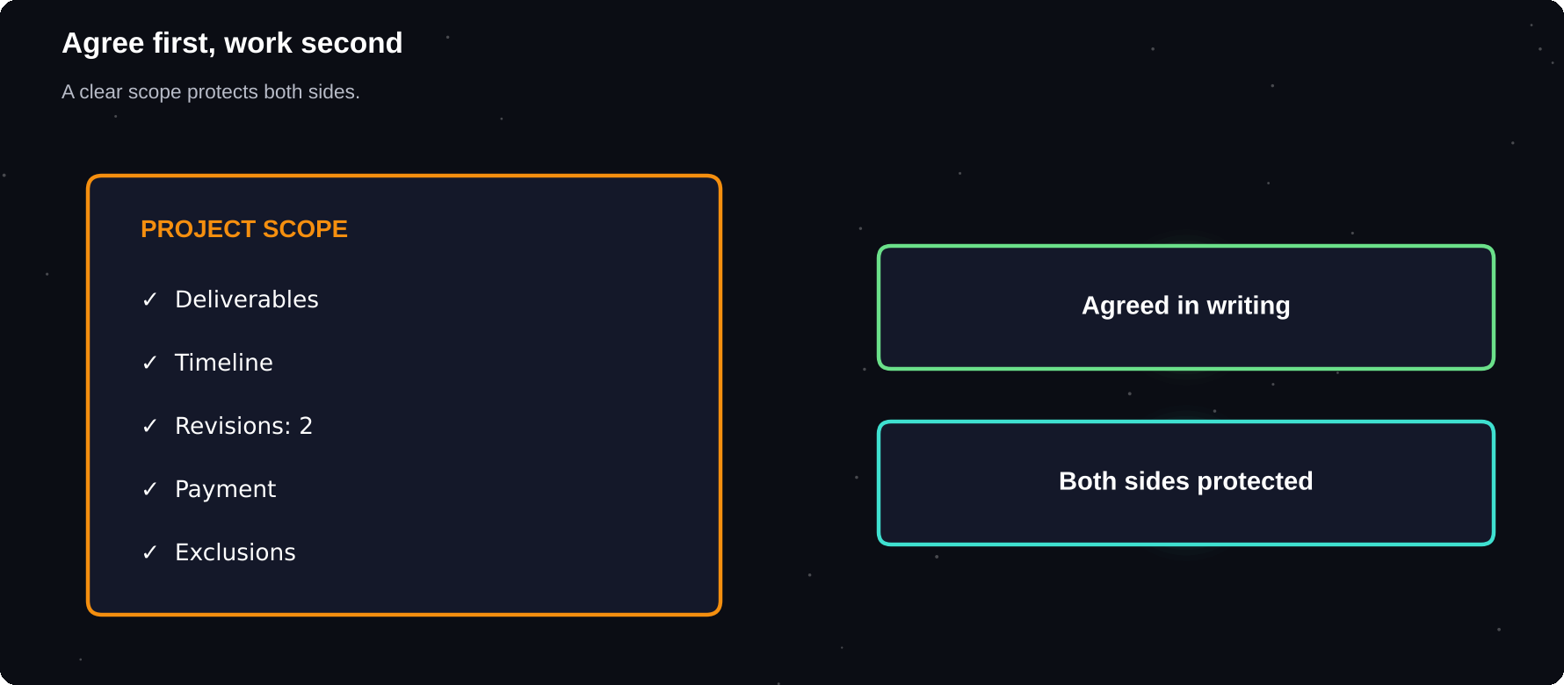
Agree first, work second
A clear scope protects both you and the client.
IN THIS CHAPTER
01 Why you need a written scope  02 What to put in a scope  03 Break work into milestones  04 Marketplace contracts | 05 Direct clients: a simple agreement  06 Key clauses in a simple agreement  07 Ownership and credit  08 Deposits | 09 Handle changes  10 A worked scope example

Why you need a written scope
1 It prevents misunderstandings
2 It protects you from endless extras
3 It gives the client confidence
4 It is evidence if a dispute arises
5 It makes your business look professional
What to put in a scope
Item | Example
Deliverables | 5 blog posts, 800 words
Format | Google Doc, PDF
Revisions | 2 rounds
Deadline | Date for each stage
Price | Total, milestones
Client duties | Give logos, feedback
Exclusions | No stock photo licences

Break work into milestones
For bigger projects, split the work into stages with a payment for each. The client sees progress, and you are not working for weeks before any payment. Marketplaces have milestone tools that hold funds safely.
Milestone | Share
Start / brief approved | 30%
Draft delivered | 40%
Final delivered | 30%

Marketplace contracts
On Upwork and Fiverr, the platform contract and payment protection form the basis of the agreement. Still describe the details in your messages and the contract description. Rely on the platform's own tools for work found there.
Direct clients: a simple agreement
For clients you find outside platforms, use a short written agreement signed or accepted by email. Free templates exist, but the rules differ by country, so for large or complicated work get advice from a lawyer.
NOT LEGAL ADVICE
This book explains good practice, not law. For significant projects, long contracts or anything involving intellectual property, ask a qualified professional in your country.

Key clauses in a simple agreement
1 Parties: who is the client and who is the freelancer
2 Scope: exactly what you will deliver
3 Timeline: dates and stages
4 Payment: amount, schedule, deposits and late fees
5 Revisions: how many and how they are requested
6 Ownership: who owns the final work and when
7 Confidentiality: protect private information
8 Ending: how either side can stop the work
Ownership and credit
Clarify who owns the final work and whether you may show it in your portfolio. Many clients take ownership after full payment. Ask permission to display the project, and respect any confidentiality request.
Deposits
For direct clients, ask for a deposit before you start, often 30 to 50 per cent. It shows the client is serious and covers your time if the project stops.
Handle changes
When the client asks for something outside the scope, treat it as a change request. Write the extra task, the extra cost and the new date, and ask for approval before you do it.
Step | Action
1 | Note the new request
2 | Estimate time and cost
3 | Send a short quote
4 | Wait for approval
5 | Update the scope

A worked scope example
SCOPE
Project: five product descriptions for a candle shop. Each 80 words, friendly tone. Delivery: Google Doc, within four days of receiving product details. Revisions: two rounds, requested within three days of delivery. Price: [amount], 30 per cent before starting and the rest on delivery. Excluded: photography, product research, translation.

Part | What it protects
Word count | Stops oversized tasks
Delivery format | No file confusion
Revision window | Keeps the project moving
Payment split | Cash flow, commitment
Exclusions | Prevents scope creep

Send the scope by message or email and ask the client to reply “Agreed”. That reply is your written confirmation.
Try it yourself
1 Write a one-page scope template
2 Define your standard revision limit
3 Decide your deposit rule
4 Draft a change-request message
5 Check ownership and portfolio permission wording
Chapter checkpoint
1 Write down scope, time and price
2 Use milestones for larger work
3 Use platform contracts for platform work
4 Seek advice for complex agreements
5 Handle changes as paid requests

CHAPTER 14
Doing the Work and Delivering
Winning the job is half the work. Delivering it well is what earns reviews, repeat business and referrals. This chapter gives you a simple process to plan your time, keep quality high and finish on schedule.
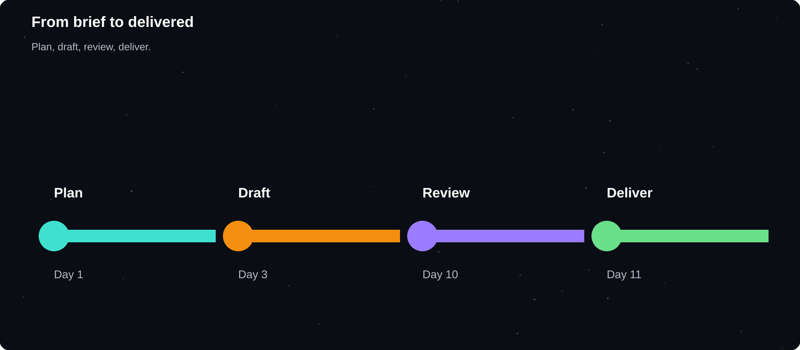
From brief to delivered
Plan, produce, review, deliver, follow up.
IN THIS CHAPTER
01 A delivery process  02 Plan your time  03 Protect quality  04 Show a draft early | 05 Deliver professionally  06 Handle revisions well  07 When you fall behind  08 Avoid overpromising | 09 Balance study and clients  10 Tools that help  11 A worked delivery timeline

A delivery process
1 Read the brief again and list every requirement
2 Break the work into small tasks
3 Set personal deadlines before the client's deadline
4 Produce a first version quickly
5 Check it against the brief
6 Deliver with a clear message
Plan your time
Estimate how long each task takes and add a buffer. Plan to finish a day or two early. Unexpected problems, other clients and study commitments will use that spare time.
Task | Estimate | Deadline
Research | 2 h | Mon
First draft | 5 h | Wed
Review | 1 h | Thu
Deliver | 1 h | Fri

Protect quality
1 Use a checklist for every project
2 Take a break, then review with fresh eyes
3 Check spelling, numbers, names and links
4 Test files on another device
5 Compare the result with the brief line by line
Show a draft early
Sharing an early version, around a third of the way through, confirms that you are on the right track. It is much cheaper to change direction early than at the end.
Deliver professionally
DELIVERY MESSAGE
Hi [Name], the [deliverable] is ready. It includes [list]. The files are attached in [formats]. Please review and tell me if anything needs adjusting. I included [number] revision rounds, so I am happy to update it. Thanks for the opportunity.

Handle revisions well
1 Ask for all feedback in one list
2 Fix what is in scope without complaint
3 Quote any new requests separately
4 Reply with a short note on what changed
5 Close the revision round clearly
When you fall behind
Tell the client early. A short honest message with a new date is far better than silence. Explain what happened, what you are doing about it and when they will have the work.
Avoid overpromising
Do not | Do instead
Promise the impossible | Offer a realistic date
Say yes to everything | Check capacity first
Work without breaks | Plan rest
Hide mistakes | Tell and fix quickly

Balance study and clients
Block your exam dates in advance. Tell clients about busy periods. Take on only as many projects as you can finish well. Missing deadlines early in your career damages your reputation.
Tools that help
Need | Tool ideas
Task list | Trello, Notion, paper
Time log | Toggl, a sheet
Review | Checklist
File sharing | Drive, platform
Reminders | Calendar alerts

A worked delivery timeline
Project: five blog posts for a start-up, due in two weeks.
Day | Task
1 | Brief, questions, outline
2 | Client approves the outline
3–4 | Draft post one, send early
5 | Feedback on post one
6–9 | Draft posts two to five
10 | Review everything
11 | Deliver, a few days early
12–13 | Revisions
14 | Final files, invoice

Notice the early draft on day four and the spare days at the end. They protect you from the unexpected and let the client see progress early.
KEEP A PROJECT LOG
Note decisions, files sent and feedback received in one place. If a question ever arises about what was agreed, you can answer in a minute.

Try it yourself
1 Create a quality checklist for your main service
2 Plan a practice project with personal deadlines
3 Write your standard delivery message
4 Block your exam weeks in your calendar
5 Decide how many projects you can handle at once
Chapter checkpoint
1 Use a repeatable process
2 Finish before the deadline
3 Check against the brief
4 Deliver with a clear message
5 Communicate early about problems

CHAPTER 15
Getting Paid and Earning Reviews
Finishing the work is not the end. You also need to get paid on time and turn each happy client into a review, a referral or a repeat order. Reviews are the currency that makes every future sale easier.
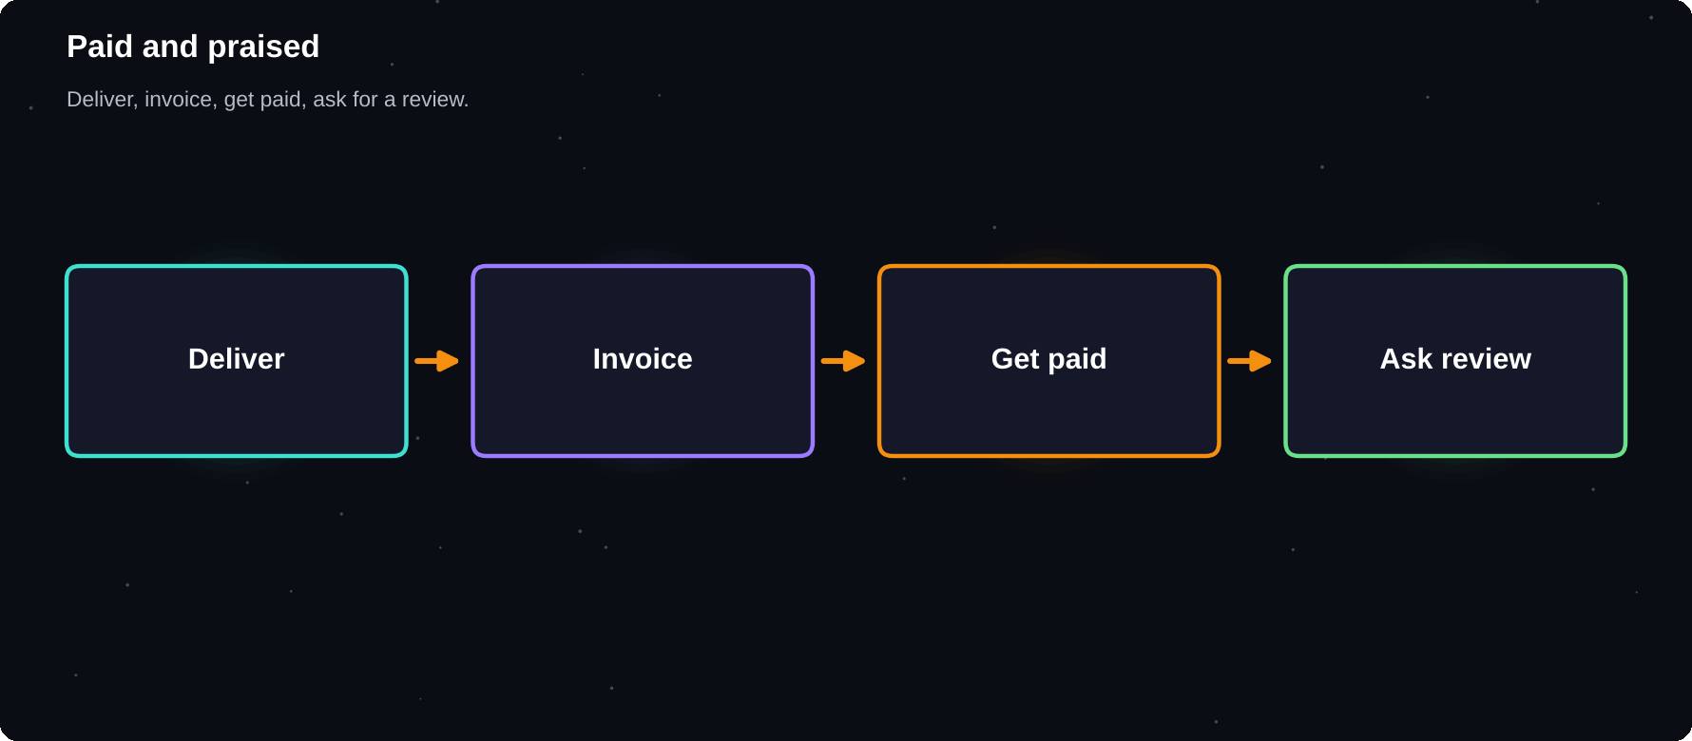
Paid and praised
Deliver, invoice, receive payment, request a review.
IN THIS CHAPTER
01 Payment on platforms  02 Payment from direct clients  03 What an invoice includes  04 Chasing late payments | 05 Withdrawals and currency  06 Ask for reviews  07 A review request message  08 Handle a bad review | 09 Collect testimonials  10 Track your money

Payment on platforms
On Upwork and Fiverr, payments are usually held by the platform and released after the client approves the work or after a set period. Know the rules: when funds become available, how withdrawals work and what fees apply.
Payment from direct clients
1 Send a clear invoice with your details
2 State the amount, dates and payment methods
3 Set a due date, such as seven or fourteen days
4 Send a polite reminder when it passes
5 Keep a copy of every invoice and receipt
What an invoice includes
Item | Details
Invoice number | Unique, in order
Dates | Issue and due date
From and to | Names, addresses
Description | Work delivered
Amount | Total, taxes if any
Payment info | Bank or method

Chasing late payments
When | Action
Due date | Friendly reminder
+7 days | Firmer message
+14 days | Call, pause work
+30 days | Formal notice, advice

PREVENT, DON'T CHASE
Deposits, milestones and platform payment protection prevent most late-payment problems. Do not hand over final files for a direct project until payment is confirmed.

Withdrawals and currency
Platforms pay in their own currency, and your bank may convert it. Fees and exchange rates affect what you receive. Compare payout options, check withdrawal limits and keep the transfer records for tax.
Ask for reviews
1 Deliver excellent work first
2 Ask once, politely, after the client says they are happy
3 Make it easy with a direct link
4 Thank them whatever they write
5 Never offer money or gifts for a review
A review request message
TEMPLATE
Thank you for working with me on [project]. I really enjoyed it. If you are happy with the result, a short review would help me a lot. I would be grateful for a line on what worked well. Thank you!

Handle a bad review
1 Pause, do not reply in anger
2 Reply once, calmly and professionally
3 Thank them, apologise if appropriate, state what you learned
4 Ask the platform to review it only if it breaks the rules
5 Use the feedback to improve
Collect testimonials
Save kind messages, with permission, for your profile and portfolio. A short real quote, with the client's name or business if allowed, is a strong proof of quality.
Track your money
Column | Record
Date | When paid
Client | Name, platform
Project | What was delivered
Gross | Before fees
Fees | Platform, bank
Net | What you received

Try it yourself
1 Create an invoice template
2 Write a late-payment reminder series
3 Prepare your review request message
4 Build your income tracking sheet
5 Read the current withdrawal rules of your platform
Chapter checkpoint
1 Know how and when you will be paid
2 Use deposits and milestones
3 Chase politely and promptly
4 Reviews power future sales
5 Track every payment

CHAPTER 16
Scams, Safety and Legal Basics
Most clients are honest, but online freelancing attracts scammers too. Learning the common tricks takes an hour and can save you money, time and stress. This chapter also covers simple legal and tax habits that every freelancer needs.
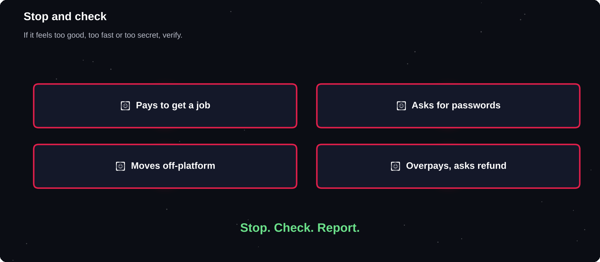
Stop and check
If an offer feels too good, too fast or too secret, pause and verify.
IN THIS CHAPTER
01 Common scams  02 Golden rules  03 Check a client | 04 Protect your accounts  05 Protect client data  06 Copyright and originality | 07 Taxes  08 Health and boundaries

Common scams
Scam | How it works
Fake cheque | Overpays, asks refund
Free sample trap | Takes full work, vanishes
Off-platform move | Avoids payment protection
Fake job fee | Asks you to pay first
Phishing link | Steals your login
Fake recruiter | Collects personal data

Golden rules
1 Never pay money to get a job
2 Never share passwords, OTPs or bank logins
3 Be careful with unknown links and files
4 Keep payments inside the platform for platform work
5 Do not accept more money than agreed and refund the difference
6 Trust your instincts and ask a trusted person
Check a client
1 Look for a verified payment method on the platform
2 Read reviews from other freelancers
3 Search the company name and website
4 Check that the email domain matches the company
5 Ask for a video call if something feels off
IF YOU ARE SCAMMED
Stop contact. Keep screenshots and messages. Report the account to the platform. Contact your bank at once if money moved. Report cybercrime to the authorities in your country. Do not feel embarrassed: it happens to experienced people too.

Protect your accounts
Habit | Why
Strong, unique passwords | Stop break-ins
Two-step login | Second barrier
Official apps and sites | Avoid fake pages
Software updates | Close security holes
Back up your files | Recover from loss

Protect client data
Clients trust you with passwords, designs and customer information. Keep it private, share only with those who need it and delete it when the project and any agreed storage period end. Respect confidentiality even if there is no written agreement.
Copyright and originality
1 Only deliver work you created or have the right to use
2 Check licences for fonts, images, music and templates
3 Never copy another person's work
4 Cite sources where needed
5 Follow the client's and platform's rules on AI tools, and be open about their use
Taxes
Freelance income is generally taxable. Keep records of income and expenses, set aside a share of each payment for tax and learn the rules of your country, such as registration, thresholds and deadlines. A qualified accountant can save you far more than they cost.
Habit | How
Record all income | Use your tracking sheet
Save for tax | Move a share aside each payment
Keep receipts | Tools, courses, fees
Know deadlines | Calendar reminders

Health and boundaries
1 Set working hours and stop on time
2 Take breaks and sleep properly
3 Do not accept every request
4 Keep one day a week free
5 Talk to someone if the pressure builds
Try it yourself
1 Turn on two-step login for every platform
2 Write your personal scam checklist
3 Learn your country's freelance tax basics
4 Create a tax savings habit
5 Set your weekly working hours
Chapter checkpoint
1 Never pay to get work
2 Keep payments and talk on the platform
3 Check every client
4 Respect copyright and confidentiality
5 Handle tax and health from the start

CHAPTER 17
Service Playbooks
Knowing the theory is useful, but you need a concrete service to sell. This chapter turns five popular beginner services into simple playbooks: what the client wants, what to put in your portfolio, a first offer, and how to deliver it well.
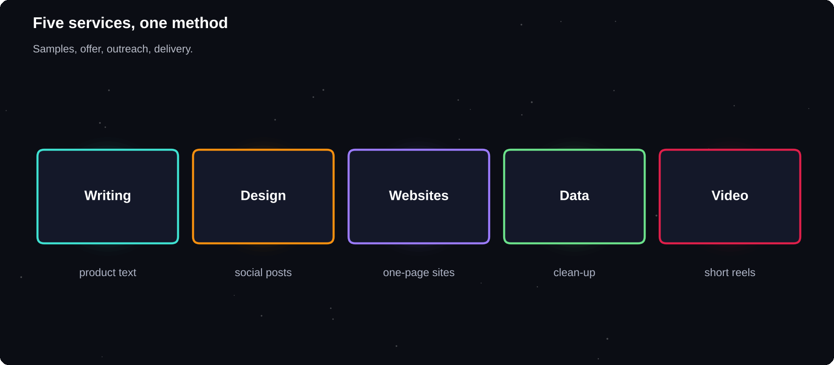
Five services, one method
Each playbook uses the same steps: sample, offer, outreach, delivery.
IN THIS CHAPTER
01 How to use a playbook  02 Playbook 1: Content writing  03 Playbook 2: Social media design | 04 Playbook 3: Simple websites  05 Playbook 4: Data entry and clean-up  06 Playbook 5: Video editing for creators | 07 Common beginner offers  08 Add a second service later

How to use a playbook
1 Pick one service that matches your skills
2 Build the listed samples
3 Create your first offer and price it with chapter 10
4 Contact the suggested buyers
5 Deliver using the checklist
Playbook 1: Content writing
Businesses need blogs, product pages, emails and captions but rarely have time to write them. Clear, accurate, friendly writing is in constant demand.
Step | Details
Samples | 2 blog posts, 1 product page, 1 email
First offer | 5 product descriptions
Buyers | Online shops, coaches, start-ups
Tools | Docs, a grammar checker
Quality check | Facts, tone, spelling, keywords

TIP
Ask the client for a style example, then write a short sample paragraph first. Agreeing the tone early avoids most revisions.

Playbook 2: Social media design
Small businesses post regularly and need a consistent look. A set of matching templates saves them hours every week.
Step | Details
Samples | A 9-post grid, 3 story templates
First offer | 12 branded posts for a month
Buyers | Cafés, salons, local shops
Tools | Canva, Figma
Quality check | Fonts, colours, spacing, spelling

Playbook 3: Simple websites
Many small businesses have no website or an outdated one. A clean, fast, mobile-friendly page with contact details is often enough.
Step | Details
Samples | 2 one-page sites, 1 redesign
First offer | One-page site in 5 days
Buyers | Clinics, tutors, local services
Tools | HTML, CSS, a website builder
Quality check | Phones, speed, links, forms

Playbook 4: Data entry and clean-up
Businesses collect messy lists: contacts, products, orders. Careful, accurate clean-up and good spreadsheet structure are valuable.
Step | Details
Samples | Before and after of a messy sheet
First offer | Clean 500 rows, remove duplicates
Buyers | Sellers, offices, researchers
Tools | Excel, Google Sheets
Quality check | Count rows, spot-check, formats

Playbook 5: Video editing for creators
Creators and small brands need many short videos. Fast, clean edits with captions are popular.
Step | Details
Samples | 3 reels with captions
First offer | Edit 4 short videos
Buyers | Creators, coaches, shops
Tools | CapCut, DaVinci Resolve
Quality check | Audio, captions, length, format

Common beginner offers
1 Start with a small, fixed offer with a clear result
2 Name the offer: “5 product descriptions in 3 days”
3 Include revisions and what is excluded
4 Add an optional extra to raise the order value
5 Test the offer with three buyers, then refine
Add a second service later
When your first service sells steadily, add a related one. A writer can add email campaigns. A designer can add presentations. A web builder can add maintenance. Related services let you sell more to the same clients.
1
service done well, at a fair price, beats ten services done halfway
Try it yourself
1 Choose one playbook
2 Build the listed samples this month
3 Write your first offer with a price
4 Find ten likely buyers
5 Send your first five messages
Chapter checkpoint
1 Pick one service and make it concrete
2 Samples first, offers second
3 A named offer is easy to buy
4 Add related services later
5 Quality beats variety

CHAPTER 18
Using AI Tools Responsibly
AI tools can help you research, draft, brainstorm and check work. They can also lead to errors, copied text and lost trust if used carelessly. Clients pay for your judgement and accountability, and no tool replaces them.
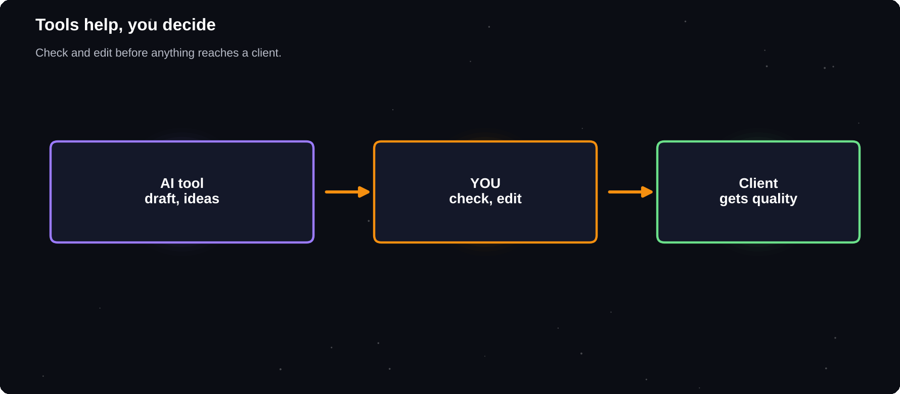
Tools help, you decide
Use AI for a first draft or a check, then apply your own judgement.
IN THIS CHAPTER
01 What AI can help with  02 What AI cannot do  03 Rules of responsible use | 04 A good workflow  05 Protect your skills  06 Competing in an AI world | 07 Using AI to learn faster  08 Be careful with images and media

What AI can help with
Task | How AI helps
Research | Summaries, questions
Ideas | Titles, angles, options
Drafts | First versions to improve
Editing | Grammar, clarity checks
Admin | Meeting notes, outlines
Learning | Explain a concept simply

What AI cannot do
1 It can state wrong facts with great confidence
2 It does not know your client's private business
3 It can repeat existing text or styles too closely
4 It cannot take responsibility for mistakes
5 It does not understand your client's real goal unless you do
Rules of responsible use
1 Check the client's and platform's rules on AI use
2 Be honest if asked how you made the work
3 Never paste confidential client data into tools that may store it
4 Verify every fact, name, number and quotation
5 Edit heavily so the work is accurate, original and in the client's voice
6 Check licences and copyright for any generated material
YOU ARE ACCOUNTABLE
If the work has an error, the client blames you, not the tool. Always read, test and fix before you deliver.

A good workflow
Step | Who does it
Understand the brief | You
Plan the approach | You
Draft or brainstorm | You and tool
Check facts | You
Edit and personalise | You
Final quality check | You

Protect your skills
If you let a tool do every step, you stop learning, and clients can do the same thing themselves. Use tools to go faster at things you understand. Keep practising the core skill so that your judgement keeps growing.
Competing in an AI world
1 Offer judgement, taste and accountability
2 Understand the client's business deeply
3 Be reliable and easy to work with
4 Specialise in a niche
5 Show your process and results
Using AI to learn faster
Ask a tool to explain a concept, quiz you or review your practice work, and then check against trusted sources. This can shorten the time it takes to reach a paying level of skill.
Be careful with images and media
1 Check the licence terms of generated images
2 Do not imitate living artists' styles to mislead
3 Never create fake reviews, certificates or identities
4 Do not deceive clients about what is real
5 Disclose generated content where the client requires it
Try it yourself
1 Read your target platform's current AI policy
2 Write your own rules for AI use
3 Choose two tasks where a tool could save you time
4 Test it on practice work, then fact-check the result
5 Prepare a short, honest answer to “Do you use AI?”
Chapter checkpoint
1 AI supports your work, it does not replace judgement
2 Verify everything before delivery
3 Respect confidentiality and copyright
4 Follow client and platform rules
5 Keep building your own skills

CHAPTER 19
Working with International Clients
Online platforms put you in front of clients across the world. That is a big opportunity, and it brings new challenges: different time zones, cultures, expectations and payment methods. A little preparation makes these differences easy to manage.
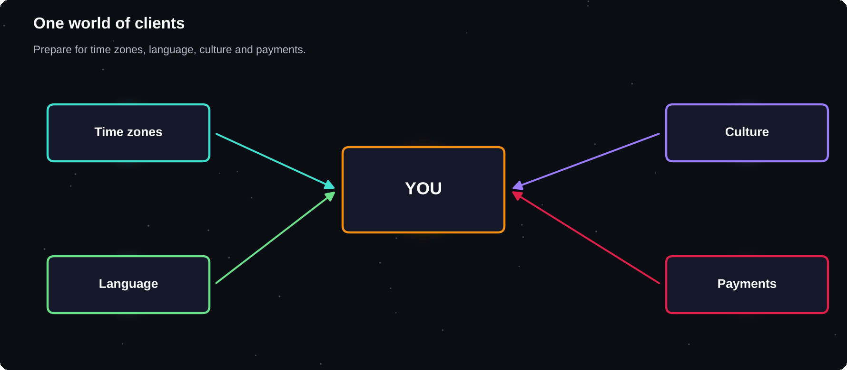
One world of clients
Clear communication matters more than accent or location.
IN THIS CHAPTER
01 Why international clients  02 Time zones  03 Language | 04 Cultural differences  05 Get paid across borders  06 Price in a currency you understand | 07 Legal and tax issues  08 Build trust remotely

Why international clients
1 More buyers for your service
2 Often a larger budget than local markets
3 Experience with global standards
4 Practice in professional English
5 A broader professional network
Time zones
Pick overlap hours with your client and stay consistent. You do not need to work at night. Many clients are happy with updates in their morning and one overlap call a week.
Tip | How
Show your time zone | In profile, messages
Use a converter | Check dates, times
Write dates clearly | 6 Nov 2026, not 6/11
Share a calendar link | Avoid back and forth
Set response hours | Tell them when you reply

Language
You do not need perfect English. You need clear English. Short sentences, simple words and polite phrases are professional in every culture. Use a spell checker and read each message aloud.
1 Avoid slang and idioms that do not translate
2 Write one idea per sentence
3 Confirm understanding by repeating the key points
4 Ask when something is unclear
5 Use bullet points for steps and lists
Cultural differences
Area | Differences to expect
Directness | Some cultures are very direct, others indirect
Hierarchy | Titles and formality vary
Deadlines | Flexible or strict, ask early
Feedback | Blunt or softened
Holidays | Different dates, plan ahead

ASK, DON'T ASSUME
When in doubt, ask the client how they prefer to work: how often they want updates, how they like feedback, and which tools they use.

Get paid across borders
Payment options depend on your country, your bank and the platform. Compare the fees, exchange rates, speed and limits of each option before you choose. Note that the amount you receive may be lower than the amount invoiced after fees and conversion.
Check | Why
Fees | Reduce what you keep
Exchange rate | Changes the amount
Speed | Cash-flow planning
Limits | Large payments
Documents | Bank and tax rules

Price in a currency you understand
Many platforms use US dollars. Work out your minimum rate in your own currency, then convert it, include fees and compare with local living costs. Do not undercharge just because local prices are lower.
Legal and tax issues
Working with foreign clients may involve special rules, for example about foreign income, registration or invoices. Ask a local accountant before the income grows, and keep all records.
Build trust remotely
1 Reply on time and keep promises
2 Share progress regularly
3 Use video calls for key discussions
4 Be clear about what you can and cannot do
5 Treat every client with respect
Try it yourself
1 Add your time zone and working hours to your profiles
2 Write a short, simple self-introduction in English
3 Compare two payout options for your country
4 Practise a five-minute video call
5 Ask an accountant about foreign income rules
Chapter checkpoint
1 Agree overlap hours and keep them
2 Clear English beats perfect English
3 Learn about cultural differences
4 Check payment fees and rules
5 Build trust with reliability

CHAPTER 20
Productivity and Mindset
Freelancing tests your discipline more than your skill. Nobody tells you when to work. Rejection is common, and results come slowly. This chapter gives you practical habits for staying consistent and calm, especially while you study.
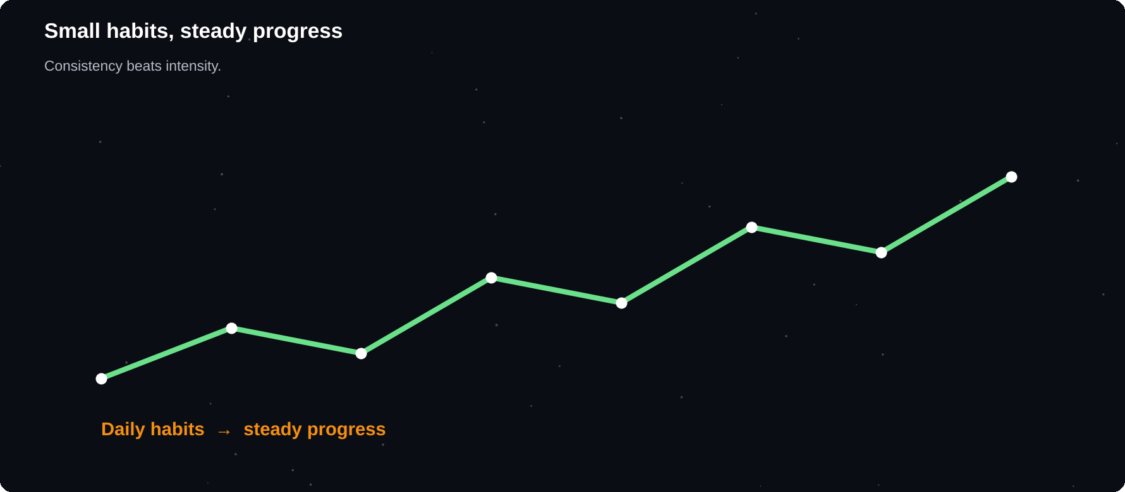
Small habits, steady progress
Consistency beats intensity.
IN THIS CHAPTER
01 Expect rejection  02 Daily and weekly routine  03 Focus techniques  04 Balance study and freelancing | 05 Procrastination  06 Impostor feelings  07 Set goals that work  08 Track progress | 09 Money habits for irregular income  10 Find support

Expect rejection
Most proposals get no reply. This is normal and says very little about you. Treat each one as a test: change one thing, measure the result and learn.
20
proposals sent with care teaches more than two read about in a book
Daily and weekly routine
When | Habit
Daily | One outreach, one skill hour
Daily | Check messages at set times
Weekly | Review leads, income, goals
Monthly | Update portfolio, prices
Quarterly | Set new goals

Focus techniques
1 Work in focused blocks of 25–50 minutes, then rest
2 Turn off notifications during deep work
3 Do the hardest task first
4 Plan tomorrow's three key tasks tonight
5 Keep a visible to-do list
Balance study and freelancing
1 Put exams and deadlines in your calendar first
2 Take on fewer projects in exam weeks
3 Tell clients about busy periods early
4 Protect sleep, meals and exercise
5 Remember that your studies come first
Procrastination
Starting is the hardest part. Use the two-minute rule: begin the task for two minutes only. Most of the time, you will continue. Break big tasks into the smallest next action.
Impostor feelings
Almost everyone feels they are not ready. Clients do not need an expert at everything. They need someone who can solve their specific problem and be honest about limits. Keep a folder of kind messages and finished work to remind yourself.
Set goals that work
Goal type | Example
Action goal | Send 5 proposals a week
Skill goal | Finish one course by month end
Result goal | Win a first paid project in 60 days
Habit goal | Practice one hour a day

Focus on goals you control, such as actions, rather than results that depend on others.
Track progress
1 Count proposals, replies and wins every week
2 Keep a log of what you learned
3 Celebrate small wins
4 Review quarterly and adjust
5 Share goals with a friend for support
Money habits for irregular income
1 Pay yourself a fixed amount from a business account
2 Save a share of every payment for tax and slow months
3 Keep a small buffer fund
4 Avoid spending income before it arrives
5 Review expenses monthly
Find support
Join a freelancer group, find a study partner or ask a mentor. Sharing wins, problems and proposals speeds learning and keeps you motivated.
Try it yourself
1 Create your weekly schedule with work blocks
2 Set one action goal for this month
3 Start a tracking sheet
4 Choose an accountability partner
5 Plan your exam-week workload
Chapter checkpoint
1 Rejection is normal and useful
2 Routines beat motivation
3 Plan around study and exams
4 Set goals you control
5 Seek support and track progress

CHAPTER 21
Three Illustrative Journeys
The stories below are fictional examples, built to show how the steps in this book can fit together in different situations. Real results vary, and none of these journeys is a promise of any income.
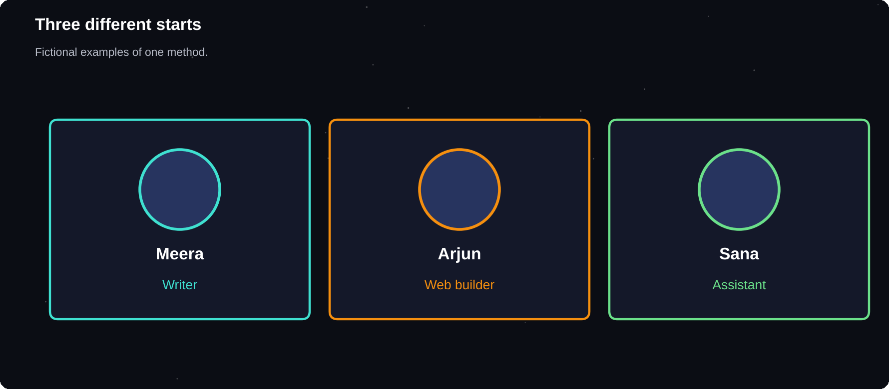
Three different starts
Different skills, same method: sample, pitch, deliver, improve.
IN THIS CHAPTER
01 Journey 1: Meera, the writer  02 Journey 2: Arjun, the web builder | 03 Journey 3: Sana, the virtual assistant  04 What the three have in common | 05 What can go wrong  06 Write your own story

FICTIONAL EXAMPLES
These characters are invented. Their numbers and outcomes illustrate a possible path. They are not data and do not show typical results.

Journey 1: Meera, the writer
Meera, a second-year commerce student, enjoys writing. She picks a niche: friendly product descriptions for small online shops.
1 Weeks 1–2: She writes four practice samples and builds a Notion portfolio
2 Week 3: She creates her profile and a Fiverr gig with three packages
3 Weeks 4–6: She sends two careful proposals a week and messages local shop owners
4 Week 7: A shop owner she met through a friend hires her for ten product descriptions
5 Week 10: Good feedback leads to a monthly arrangement
What worked: a clear niche, a small first offer and a personal contact. What she learned: proposals to strangers often failed until she added samples relevant to the shop's products.
Journey 2: Arjun, the web builder
Arjun is an IT student who can build simple websites. He worries that he has no clients.
1 Weeks 1–2: He builds three one-page sites for a club, a tutor and a relative
2 Week 3: He writes short case studies and publishes a portfolio page
3 Weeks 4–5: He visits five nearby businesses with a printed sample
4 Week 6: A tuition centre hires him
5 Months 3–4: He adds maintenance as a monthly service
What worked: local contacts and showing a finished sample on a phone. What he learned: a written scope with revision limits saved him from endless changes.
Journey 3: Sana, the virtual assistant
Sana is organised and a good communicator, but she has no specific technical skill.
1 Weeks 1–2: She learns spreadsheets, calendars and email tools
2 Week 3: She creates sample schedules, reports and a research summary
3 Weeks 4–6: She applies to small, clear Upwork jobs and tracks every result
4 Week 8: A small business owner hires her for a few hours a week
5 Month 5: She raises her rate after good reviews
What worked: sending fewer, better-matched proposals. What she learned: clear response times and weekly updates were what clients praised in reviews.
What the three have in common
Pattern | Details
Clear service | Easy to explain
Real samples | Before the first client
Small first offer | Lower risk for buyers
Warm contacts | Network before strangers
Written scope | Fewer disputes
Reviews | Raised prices later

What can go wrong
1 No replies for several weeks: improve samples and targeting
2 A client ignores the scope: use a change request
3 A late payment: remind politely, use milestones next time
4 A scam attempt: stop, report, never pay to get work
5 Burnout: reduce projects and protect your rest
Write your own story
1 Pick your service and niche
2 Decide your 30-day samples
3 Set weekly action goals
4 Note what you learn each week
5 Adjust, and keep going
Chapter checkpoint
1 Every start is different
2 The method is the same
3 Samples and small offers lower the barrier
4 Warm contacts often come first
5 Review, adjust and continue

CHAPTER 22
Grow Your Freelance Career
Your first project is a start. Your first repeat client is a business. This final chapter shows how to turn single jobs into steady work, raise your income without burning out and build a career you can sustain through study and beyond.
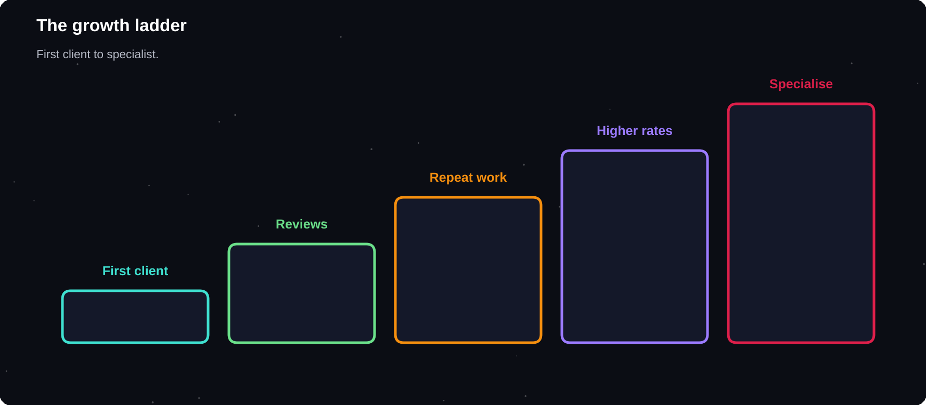
The growth ladder
First client, reviews, repeat work, higher rates, specialisation.
IN THIS CHAPTER
01 Repeat clients are gold  02 Retainers  03 Add services | 04 Raise your prices  05 Specialise  06 Build a personal brand | 07 Systems and templates  08 Teams and outsourcing  09 Freelancing and your career

Repeat clients are gold
It costs far less effort to work again for a happy client than to find a new one. After every project, stay in touch, suggest the next step and ask how the work is performing.
1 Ask if they have more work you could help with
2 Suggest an improvement they have not thought of
3 Offer a monthly package
4 Send a short thank-you note
5 Check in every few months
Retainers
A retainer is a fixed monthly fee for a set amount of work, such as four posts a month. It gives you predictable income and gives the client priority access to you.
Retainer idea | Monthly work
Social media | 12 posts, reports
Writing | 4 blog posts
Web care | Updates, fixes
Data | Weekly report update
Assistant | 10 hours of tasks

Add services
Look at what your clients already need next. A designer might add social posts and presentations. A writer might add email newsletters. Related services increase your value to each client.
Raise your prices
1 Review prices every three months
2 Increase after strong reviews or when fully booked
3 Tell existing clients in advance
4 Grandfather loyal clients for a short time if you wish
5 Do not apologise
Specialise
With experience, a clear speciality allows higher rates, because clients trust specialists. Look at which projects you enjoyed, completed fastest and received the best feedback on. Double down on those.
Build a personal brand
Habit | Result
Share lessons weekly | Visible expertise
Show finished work | Proof of skill
Help others in groups | Trust, referrals
Keep one clear message | Easy to remember

Systems and templates
1 Save proposal, scope, invoice and delivery templates
2 Keep a client checklist
3 Record your process steps
4 Use reminders for follow-ups
5 Review what wastes your time
Teams and outsourcing
When demand exceeds your time, you can partner with other freelancers for parts of a project. Be honest with clients about who does what, keep quality high and pay collaborators fairly and on time.
Freelancing and your career
Freelancing can run beside studies, a first job or a start-up. It builds skills in selling, communication, planning and delivery that employers and founders value. Whatever path you choose, the proof of real client work is a long-term advantage.
90
days is a good first cycle: build the profile, create samples, send proposals, and review what the market told you
Try it yourself
1 List three past clients and a follow-up idea for each
2 Design one retainer package
3 Set your next price review date
4 Write your 90-day freelance goal
5 Choose one habit to build your brand
Chapter checkpoint
1 Repeat clients are the easiest income
2 Retainers create stability
3 Raise prices and specialise over time
4 Build systems and a clear brand
5 Review and improve every quarter

APPENDIX A
Message Templates
Use these as starting points. Change the wording to sound like you, add real details about the client and never send a template unchanged.
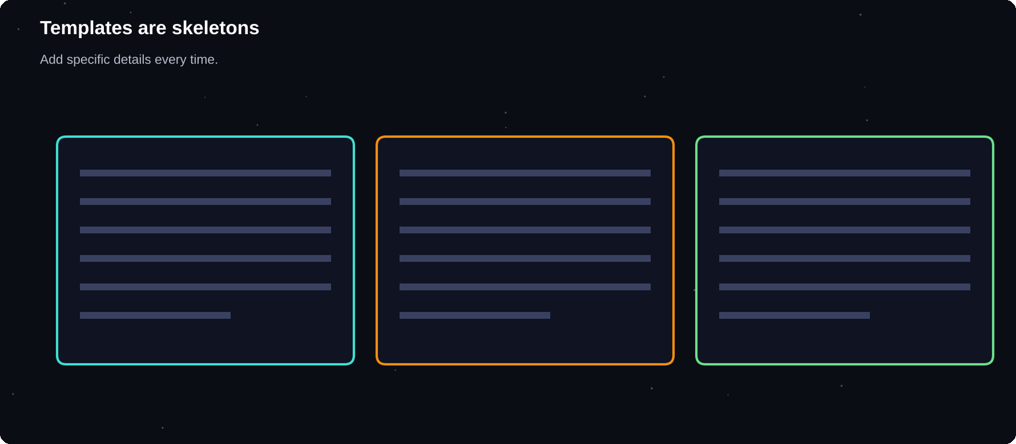
Templates are skeletons
Add specific details every time.
IN THIS CHAPTER
01 1. Reply to a new enquiry  02 2. Proposal for a marketplace job  03 3. Cold outreach  04 4. Follow-up after a proposal  05 5. Project confirmation | 06 6. Progress update  07 7. Request for information  08 8. Delivery  09 9. Scope change quote  10 10. Polite decline | 11 11. Payment reminder  12 12. Review request  13 13. Raising prices  14 14. Ending a project

1. Reply to a new enquiry
MESSAGE
Hi [Name], thank you for getting in touch. I would be glad to help with [project]. To give you an accurate quote, could you tell me [two questions]? I usually reply within a day. Thanks, [Name]

2. Proposal for a marketplace job
MESSAGE
Hi [Name], you need [goal]. I recently made [sample, link] for a similar need. My plan: 1) [step], 2) [step], 3) [step]. I can deliver by [date] for [price], including [revisions]. One question: [question]. Thanks, [Name]

3. Cold outreach
MESSAGE
Hi [Name], I noticed [specific detail]. I help [business type] with [service]. For example, I could [idea]. May I send a short sample? Thanks, [Name]

4. Follow-up after a proposal
MESSAGE
Hi [Name], I wanted to follow up on my proposal for [project]. I also thought of [quick helpful idea]. If now is not a good time, no problem. Thanks, [Name]

5. Project confirmation
MESSAGE
Thanks for choosing me. To confirm: [deliverables], [date], [price], [revisions]. I will start when the contract or deposit is in place. Please reply if anything needs changing.

6. Progress update
MESSAGE
Quick update: [part] is done and [part] is in progress. We are on track for [date]. I will send a draft on [day]. No action needed from you at the moment.

7. Request for information
MESSAGE
To continue I need [item] by [date]. If it is easier, a short call can cover it. Without it, the delivery may move to [new date].

8. Delivery
MESSAGE
The [deliverable] is ready and attached. Please review it and send all feedback together. [Number] revision rounds are included. Thank you!

9. Scope change quote
MESSAGE
That addition is outside the original scope. It would take about [time] and cost [price], moving the delivery to [date]. If you would like me to go ahead, please confirm.

10. Polite decline
MESSAGE
Thank you for thinking of me. I am not able to take this on right now because [honest reason]. I can suggest [alternative] if useful. Best wishes with the project.

11. Payment reminder
MESSAGE
Hi [Name], a friendly reminder that invoice [number] for [amount] was due on [date]. Could you let me know when I can expect payment? Thank you.

12. Review request
MESSAGE
I enjoyed working with you. If you are happy with the result, would you leave a short review? It would help me a lot. Thank you!

13. Raising prices
MESSAGE
From [date], my rate for [service] will be [new price]. For you as a current client the current rate applies until [date]. Thank you for your continued trust.

14. Ending a project
MESSAGE
The project is complete and all files are delivered. Thank you for the opportunity. If you need further help, I would be glad to work with you again.

APPENDIX B
Your 30-Day Launch Plan
Follow one task a day for a month. Each task takes thirty to ninety minutes. By day thirty you will have a profile, a portfolio, a pipeline and your first proposals sent.
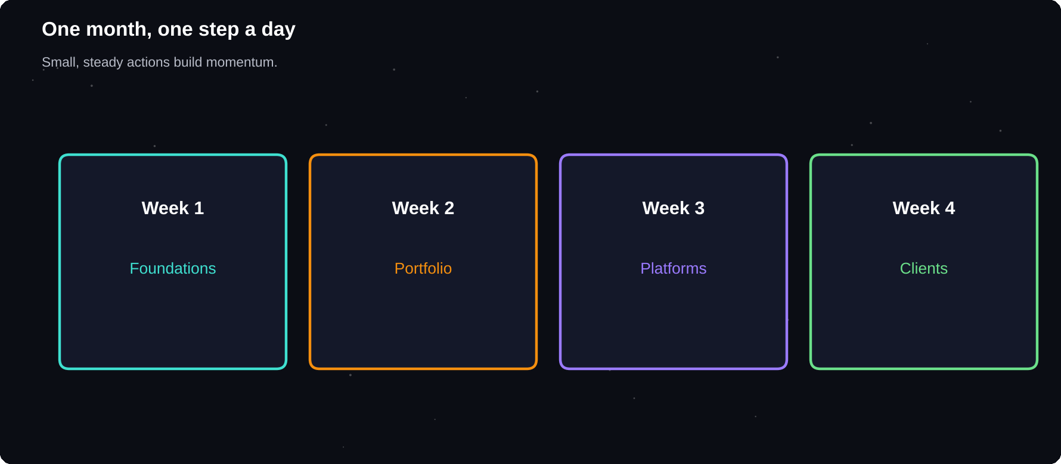
One month, one step a day
Small, steady actions build momentum.
IN THIS CHAPTER
01 Week 1: Foundations  02 Week 2: Portfolio | 03 Week 3: Platforms  04 Week 4: Clients | 05 Monthly review questions

Week 1: Foundations
Day | Task
1 | Choose your service and niche
2 | Research demand on two platforms
3 | Set up email, folders, tools
4 | Take a profile photo
5 | Write your headline and bio
6 | List your skills and gaps
7 | Rest, review the week

Week 2: Portfolio
Day | Task
8 | Plan three sample projects
9 | Create sample one
10 | Write its case study
11 | Create sample two
12 | Write its case study
13 | Create sample three
14 | Publish your portfolio page

Week 3: Platforms
Day | Task
15 | Create your Upwork profile
16 | Create your first Fiverr gig
17 | Update your LinkedIn
18 | Study 20 job posts
19 | Write your proposal template
20 | Send three proposals
21 | Review and rest

Week 4: Clients
Day | Task
22 | Message ten people you know
23 | Make a list of 20 local leads
24 | Send five outreach messages
25 | Join two communities
26 | Send three more proposals
27 | Create a pricing sheet
28 | Prepare scope, invoice templates
29 | Follow up on every lead
30 | Review results, plan next month

EXPECT SLOW STARTS
Not every plan ends in a client by day thirty. Success at this stage means a complete profile, real samples and a habit of reaching out. Keep going and adjust with what you learn.

Monthly review questions
1 How many proposals and messages did I send?
2 How many replies did I get?
3 Which message got the best response?
4 What skill held me back?
5 What will I change next month?

APPENDIX C
Service Ideas for Students
Not sure what to offer? Use this list as inspiration. Pick two ideas that match your skills, check demand and adapt them to your own niche.
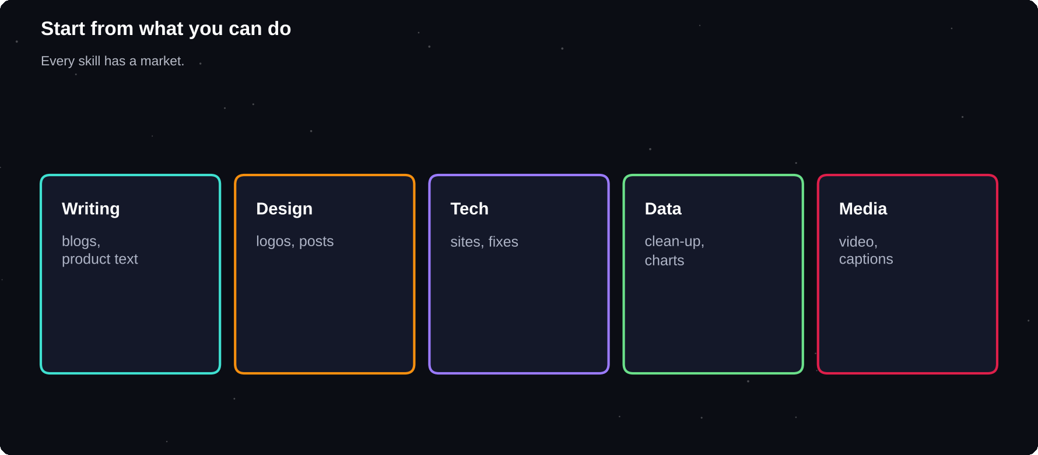
Start from what you can do
Every skill has a market. Find the buyer.
IN THIS CHAPTER
01 Writing and language  02 Design and creative | 03 Technology  04 Data and office support | 05 Media and marketing  06 Education and coaching

Writing and language
1 Blog posts for small businesses
2 Product descriptions for online shops
3 Resume and LinkedIn profile writing
4 Email newsletters
5 Proofreading and editing
6 Social media captions
7 Translation between two languages
8 Transcription of audio and video
9 Study notes and summaries for courses, where allowed
Design and creative
10 Logos for small shops
11 Social media post templates
12 Presentation design
13 Posters, flyers and invitations
14 Photo editing and background removal
15 YouTube thumbnails
16 Simple infographics
17 E-book and worksheet layouts
18 Menu and price list design
Technology
19 One-page websites
20 Website bug fixes and edits
21 WordPress setup and care
22 Landing pages
23 Chatbot and form setup
24 Automating tasks with spreadsheets or scripts
25 Basic app prototypes
26 Software testing and bug reports
27 Tutoring in programming
Data and office support
28 Data entry and clean-up
29 Excel and Google Sheets templates
30 Charts and dashboards
31 Online research and lead lists
32 Survey creation and analysis
33 Calendar and inbox management
34 Customer support replies
35 Product listing uploads
Media and marketing
36 Short video editing for reels
37 Subtitles and captions
38 Podcast editing
39 Social media management
40 Basic search engine optimisation
41 Voice-over recording
42 Local business listings setup
43 Email campaign setup
Education and coaching
44 Tutoring in school or college subjects
45 Interview and aptitude practice
46 Spoken English practice
47 Creating quizzes and worksheets
48 Course content outlines
49 Study planners
CHECK THE RULES
Some services, such as completing someone's graded assignment, break academic rules and platform terms. Offer only honest, allowed work.

APPENDIX D
Checklists
Checklists prevent small mistakes that cost clients. Print these pages or copy them into your notes app and tick them off every time.
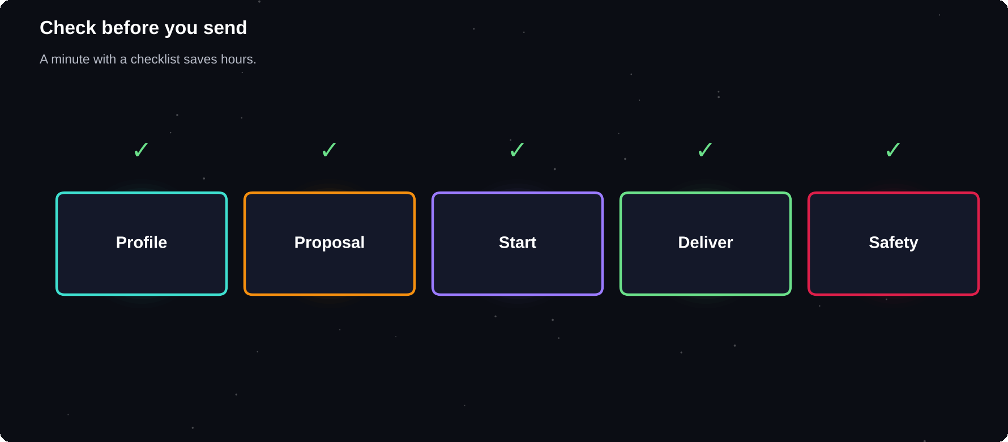
Check before you send
A minute with a checklist saves hours of repair.
IN THIS CHAPTER
01 Profile checklist  02 Proposal checklist | 03 Before starting a project  04 Before delivering | 05 After delivering  06 Safety checklist

Profile checklist
1 Clear, friendly photo
2 Headline names service and audience
3 Bio has hook, proof, process, call to action
4 Skills match what clients search for
5 3–5 portfolio samples with captions
6 No spelling errors
7 Contact and availability are clear
Proposal checklist
1 Read the whole job post twice
2 First line addresses their problem
3 One relevant sample linked
4 Plan in two or three steps
5 Price, time and scope stated
6 All questions in the post answered
7 Spelling checked
8 Closing question included
Before starting a project
1 Scope, price and deadline confirmed in writing
2 Deposit or active contract in place
3 Files and access received
4 Revision limit agreed
5 Dates set in your calendar
Before delivering
1 Checked against the brief
2 Spelling, numbers and links checked
3 Files open on another device
4 File names clear
5 Delivery message ready
6 Backup saved
After delivering
1 Payment confirmed
2 Review requested
3 Thank-you sent
4 Permission to show the work
5 Follow-up date set
6 Income recorded
Safety checklist
1 Client verified and payment method checked
2 No request to pay or share passwords
3 Communication and payment on the platform
4 Two-step login active
5 Records and screenshots saved

A TO Z
Glossary
Every term you meet on the way to your first client.

Brief
The client's description of the project and what they want.
Buffer
Extra time or money added to an estimate for the unexpected.
Case study
A short story of a project: problem, work and result.
Change request
A new task outside the agreed scope, quoted separately.
Cold outreach
Contacting a person who does not yet know you, to offer help.
Connects
Virtual credits used to send proposals on Upwork.
Deposit
Money paid before the work begins.
Escrow
A safe holding of payment until work is approved.
Fixed-price
A contract with one agreed price for the project.
Gig
A ready-made service sold on Fiverr.
Hourly rate
The price charged for each hour worked.
Invoice
A document that requests payment for work done.
Lead
A person or business that might need your service.
Milestone
A stage of a project with its own payment.
Niche
A specific group or topic you serve.
Pipeline
Your list of leads and their stage, from contact to decision.
Portfolio
A collection of your best work samples.
Proposal
A short message that pitches your service for a job.
Retainer
A monthly fee for a set amount of ongoing work.
Revision
A round of changes after the client reviews the work.
Scope
The exact work, limits and deliverables of a project.
Scope creep
The slow growth of a project beyond the agreed work.
Service fee
The percentage a platform keeps from your earnings.
Testimonial
A kind statement from a client about your work.
Value-based pricing
Pricing based on the benefit to the client, not the hours.

THE LAST WORD
Start before you feel ready
Freelancing is learned by doing. Your first profile will be imperfect and your first proposals will be ignored. Keep improving one small thing at a time, and the replies will come.

Thank you for reading. If this book helped you, please leave a review on the store where you bought it. It helps other students find it.
NOTES
Upwork Help Center
support.upwork.com (current fees, Connects and rules)
Fiverr Seller Resources
fiverr.com (current seller guidelines and fees)
Important
Platform fees, rules and tax laws change. Check the official pages and your local rules before you act. This book is general guidance, not legal, tax or financial advice, and it does not promise any level of income.

