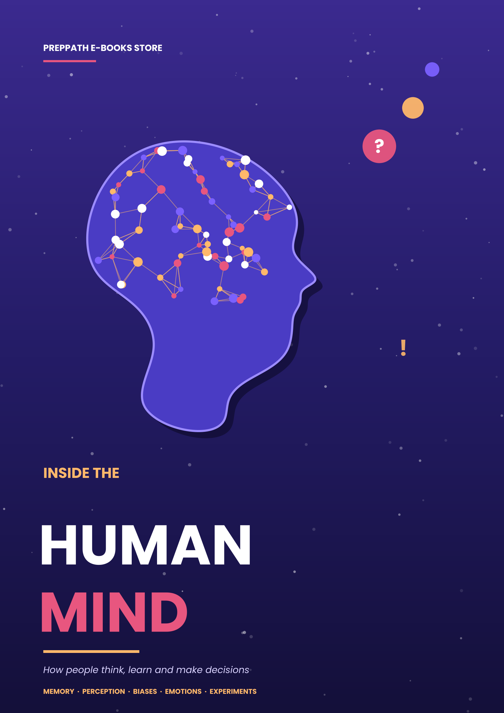

Contents

◆ Welcome to your mind 3
01 Memory 5
02 Perception 11
03 Cognitive Biases 16
04 Emotions and Decision-Making 21
05 Psychology Experiments 26
06 Everyday Behaviour 31
07 Lab Day: Try It Yourself 36
08 Mind Myths 39
09 Your Mind Toolkit 41
◆ Glossary 46
◆ Timeline 47
◆ Who's who 48
◆ My notes 49
◆ Go Deeper 50
Welcome to your mind

You have been using your mind for as long as you can remember, yet you have probably never been given the manual. Why can you recall a song from ten years ago but not where you left your keys five minutes ago? Why do two honest witnesses describe the same event differently? Why do smart people make choices they later regret?
Inside the Human Mind is a guided tour of how people think, learn and make decisions. It draws on more than a century of psychology and neuroscience, and it keeps the jargon to a minimum. Every idea is tied to a real experiment, a real example, or something you can try yourself in a few minutes.
What you will explore
Chapter | The big question
1 Memory | How are memories made, why do they fade, and why can we trust them less than we think?
2 Perception | How does the brain build your experience of the world from raw signals?
3 Cognitive Biases | Which mental shortcuts help us, and which quietly steer us wrong?
4 Emotions and Decisions | How do feelings shape the choices we believe are rational?
5 Psychology Experiments | What did the most famous studies show, and what have we learned since?
6 Everyday Behaviour | How do habits, social influence and attention run your ordinary day?
7 Lab Day | Five quick tests that show your own mind at work.
8 Mind Myths | Which popular beliefs about the mind do not survive the evidence?
9 Your Mind Toolkit | How can you put all of this to work in 30 days?

How to use this book
1 Read in any order. Each chapter stands alone, but the ideas link up.
2 Try the experiments. Boxes marked Try it are safe, quick and need nothing more than a pen.
3 Watch for the caveats. Psychology has had a reckoning over studies that did not replicate. Where a famous result is disputed, this book says so.
4 Use the toolkit. Chapter 7 turns the science into a 30-day plan.
WATCH OUT Education, not therapy
This book explains how minds work in general. It is not a diagnosis or a treatment. If you are struggling with your mental health, please talk to a qualified professional or someone you trust.

CHAPTER  01 | Memory  How your mind records, stores and rebuilds the past

Memory is not a video recording. It is a story your brain tells again each time you remember.

IN THIS CHAPTER YOU WILL LEARN
✓ The three stages of memory and how information moves between them
✓ Why we forget, and how to forget less
✓ Why vivid memories can still be wrong
✓ Proven techniques to learn and remember better

A three-part system
In 1968 Richard Atkinson and Richard Shiffrin proposed a model that is still the easiest way to picture memory. Information passes through three stores, and each store has a different job and a different capacity.
Store | Job | How long | How much
Sensory memory | Holds a raw snapshot of what your senses just took in | A fraction of a second to about 3 seconds | Large, but fades almost at once
Short-term / working memory | Holds and works on what you are thinking about now | Roughly 15–30 seconds without rehearsal | Small: about 4 chunks in most modern estimates
Long-term memory | Stores facts, skills and experiences | Minutes to a lifetime | Effectively unlimited

You may have heard that we hold "seven plus or minus two" items in short-term memory. That comes from George Miller's famous 1956 paper. Later work by Nelson Cowan suggests the real limit for fresh, unrehearsed material is closer to four chunks. A chunk is any unit that means something to you: the digits 1-9-4-7 are four chunks, but if you know that 1947 is the year India became independent, they are just one.
TRY IT Test your working memory
Ask a friend to read aloud the digits 7 3 9 1 5 8 2 4 6 at a steady pace, one per second, then try to repeat them. Most people manage five to seven. Now try the same digits chunked as 739-158-246. Chunking is the single most useful trick for stretching working memory.

Encoding, storage and retrieval
Every memory goes through three steps. Encoding converts an experience into a form the brain can store. Storage keeps it over time. Retrieval brings it back when needed. Forgetting can happen at any step, which is why "I forgot" can mean three very different things: it was never properly encoded, it decayed or was overwritten, or it is stored but you cannot find the way in.
Encoding is where you have the most control. In 1972 Fergus Craik and Robert Lockhart showed that how deeply you process information matters more than how long you look at it. Asked whether a word is in capital letters, people remember it poorly. Asked what the word means, or how it relates to their own life, they remember it far better. Shallow processing records the surface; deep processing builds connections, and connections are what retrieval follows.
You do not remember what you looked at. You remember what you thought about.

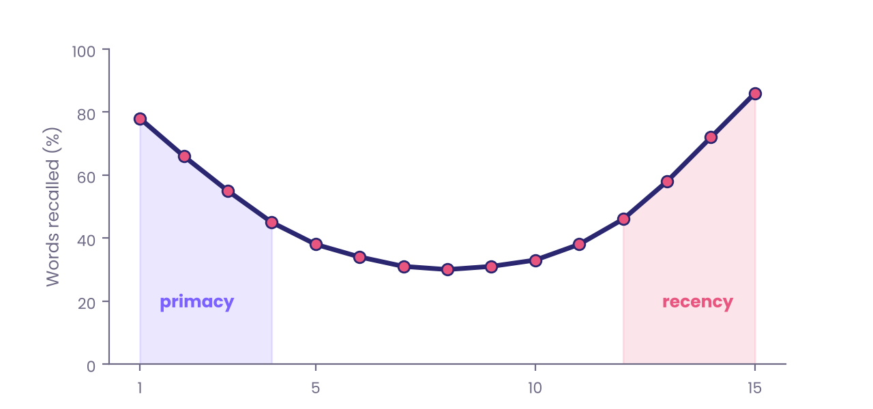
Figure 1.1 — The serial position effect: in a free-recall test, the first and last items on a list are recalled best (illustrative curve).
The curve above shows a classic result from the early 1960s, widely replicated since. When people hear a list of unrelated words and recall them in any order, they remember the first few words (the primacy effect) and the last few (the recency effect) much better than the middle. Primacy appears because early items get more rehearsal and reach long-term memory; recency appears because the latest items are still sitting in working memory.
Why we forget
In 1885 the German psychologist Hermann Ebbinghaus memorised lists of nonsense syllables such as WID and ZOF and tested himself at different delays. His results gave us the forgetting curve: memory drops steeply at first and then levels off. Without review, a large share of new material is gone within a day or two.
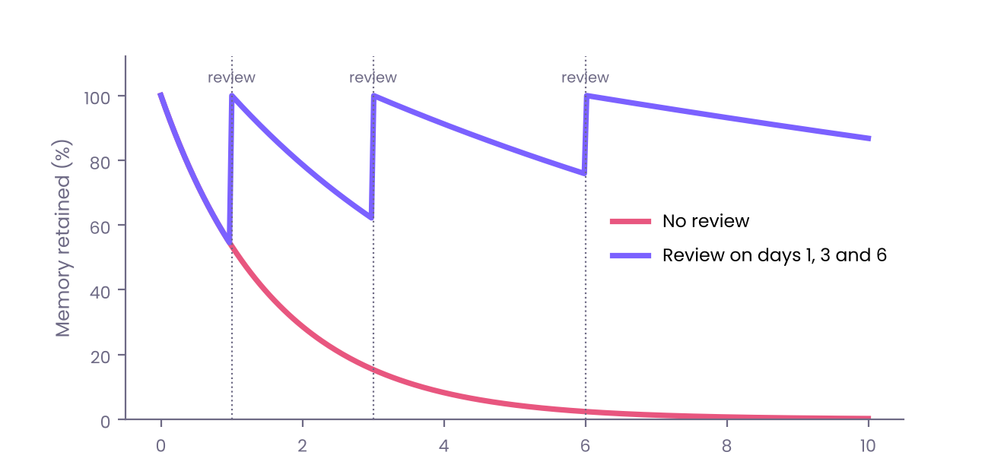
Figure 1.2 — The forgetting curve, and how spaced review flattens it (illustrative shape based on Ebbinghaus's findings).
Psychologists describe several causes of forgetting, and most real forgetting involves more than one:
• Decay — traces fade when they are not used.
• Interference — other memories get in the way. Old learning can block new learning (proactive interference), and new learning can overwrite old (retroactive interference).
• Retrieval failure — the memory is stored but the cue that would unlock it is missing. The "tip of the tongue" feeling is exactly this.
• Motivated forgetting — we sometimes push painful memories away, though how far this happens is debated.
DID YOU KNOW Context is a cue
In 1975 Duncan Godden and Alan Baddeley asked scuba divers to learn word lists either on a beach or 10 feet underwater, then recall them in the same or the opposite setting. Words were remembered best when the place of recall matched the place of learning. If you study in the room where you will be tested, or at least recall where you learned something, retrieval gets easier.

Memory is rebuilt, not replayed
The most important lesson in memory research is also the most unsettling: recalling a memory is an act of reconstruction. Your brain assembles the memory from fragments, fills the gaps with what seems plausible, and then stores the new version. Each retelling can change it a little.
THE EXPERIMENT Smashed or hit?
In 1974 Elizabeth Loftus and John Palmer showed students films of car accidents and asked how fast the cars were going when they smashed into, collided with, bumped into, hit or contacted each other. Estimates changed with the verb: about 41 mph for "smashed" against about 34 mph for "hit". A week later, people who had heard "smashed" were more than twice as likely to say they had seen broken glass, though there was none in the film (around 32% against 14%).

The study did not show that people are gullible. It showed that the question itself becomes part of the memory. Loftus's later work on the misinformation effect has reshaped how courts treat eyewitness testimony, and the way police now interview witnesses.
Flashbulb memories: vivid but not always accurate
Where were you when you heard some shocking news? Such "flashbulb" memories feel as sharp as a photograph. Yet in 1992 Ulric Neisser and Nicole Harsch asked students to write down how they heard about the Challenger space shuttle explosion the morning after it happened, then asked again two and a half years later. About a quarter of the later accounts were wrong in nearly every detail, and many students were still highly confident. Emotion makes a memory feel vivid and important; it does not guarantee that it is accurate.
WATCH OUT Confidence is not accuracy
Feeling certain about a memory tells you very little about whether it is correct. This matters for eyewitness evidence, for family arguments about "what really happened", and for your own picture of your past. When accuracy matters, look for a record: a photo, a message, a receipt.

The man who could not make new memories
In 1953 a young man known for decades only as H.M. had parts of both temporal lobes, including the hippocampus, removed in an attempt to treat severe epilepsy. The seizures eased, but he could no longer form new long-term memories of facts and events. He could hold a conversation, yet minutes later he would not remember it had happened. Brenda Milner's studies of H.M. showed two crucial things: the hippocampus is essential for forming new explicit (conscious) memories, and the brain has separate systems for implicit memory. H.M. could learn to trace a star while looking in a mirror, improving day by day, without any memory of ever practising.
Type | What it holds | Example | Needs the hippocampus?
Episodic | Personal events | Your last birthday | Yes
Semantic | General facts | Delhi is India's capital | Yes, for learning
Procedural | Skills and habits | Riding a bicycle | No
Priming | Faster response after exposure | Recognising a word you saw earlier | No

Sleep, spacing and testing: what really works
Decades of research point to a handful of techniques that reliably improve memory. Most students never use them, because they feel harder than rereading, and that difficulty is the point.
Spacing  spread study over days, not one night | Testing  quiz yourself instead of rereading | Sleep  consolidates what you learned

1 Space it out. Reviewing material at growing intervals (a day later, then three days, then a week) beats cramming for the same total time.
2 Retrieve, do not reread. In a well-known 2006 study, Henry Roediger and Jeffrey Karpicke found that students who practised recalling a passage remembered much more a week later than students who studied it again. Close the book and write down what you remember.
3 Sleep after learning. During deep sleep the brain replays and strengthens new memories. An all-nighter before an exam removes the very stage that stores your revision.
4 Make it meaningful. Connect new facts to what you already know, and explain them in your own words.
5 Use a memory palace. The ancient method of loci links items to places along a familiar route. Picture each item sitting in a different room of your home. Memory champions use it to memorise thousands of digits.
IN REAL LIFE A study session that works
Study 25 minutes. Close everything and write what you remember. Check against your notes and fix the gaps. Rest 5 minutes. Tomorrow, repeat the quiz before touching your notes. Three short quizzes spread across a week will outperform a three-hour cram.

TRY IT Check yourself
• What are the three memory stores, and which one is smallest?
• Why does a vivid memory not guarantee an accurate one?
• Give two reasons why testing yourself works better than rereading.

Chapter 1 in a nutshell

IN REAL LIFE Key takeaways: Memory
• Memory has three stores: sensory, working (about four chunks) and long-term.
• Deep, meaningful processing beats repetition; connections drive retrieval.
• Recall is reconstruction, so confident memories can still be wrong.
• Spacing, self-testing and sleep are the best-supported study methods.
• The hippocampus builds new explicit memories; skills use separate systems.

Quick quiz
1 Roughly how many chunks can working memory hold in modern estimates?
A) 2 B) 4 C) 9
2 Which method beat rereading in Roediger and Karpicke's 2006 study?
A) Highlighting B) Cramming C) Practising recall
3 In Loftus and Palmer's study, which verb produced the highest speed estimates?
A) Hit B) Bumped C) Smashed
4 The serial position effect describes better recall of...
A) Middle items B) First and last items C) Longest words
5 Which type of memory did H.M. keep, learning mirror drawing?
A) Procedural B) Episodic C) Semantic
TRY IT Answers
B, C, C, B, A

Reflect
Which idea from this chapter surprised you most, and where will you notice it this week?

CHAPTER  02 | Perception  How the brain builds your world from raw signals

You do not see the world as it is. You see the world your brain predicts is there.

IN THIS CHAPTER YOU WILL LEARN
✓ Why seeing is an active, constructive process
✓ How attention can make you miss the obvious
✓ How illusions reveal the rules your brain follows
✓ Why two people can perceive the same thing differently

Sensation versus perception
Sensation is the raw detection of energy: light hitting the retina, sound waves moving the eardrum, pressure on the skin. Perception is the process of organising and interpreting those signals so they mean something: a face, a song, a hot cup. The signals themselves are meagre and ambiguous. The retina delivers a flat, upside-down, constantly shifting image, and the brain turns it into a stable three-dimensional world full of objects.
Psychologists describe two flows that work together. Bottom-up processing starts with the raw data and builds up to recognition. Top-down processing starts with your expectations, memories and goals and shapes how the data is read. Most of what you notice is a blend of the two. That blend is usually helpful and sometimes misleading.
MIND TRICK Read this
Look at the phrase PARIS IN THE THE SPRING. Many readers miss the repeated word on first reading because the brain, expecting a familiar phrase, fills in what it predicts. Top-down expectation beats the actual letters on the page.

The brain as a prediction machine
A modern view, often called predictive processing, proposes that the brain does not wait to be told what is out there. It constantly generates a best guess about the world and compares it with incoming signals. When the guess matches, little attention is needed. When it does not, an error signal draws attention and updates the guess. This helps explain why familiar scenes feel effortless, why a sudden mismatch makes you jump, and why illusions work: they are cases where the brain's best guess is systematically wrong.
Gestalt: the whole is different from the parts
In the early 20th century, German psychologists Max Wertheimer, Wolfgang Köhler and Kurt Koffka argued that we perceive organised wholes, not scattered parts. Their Gestalt principles describe the automatic rules the visual system uses to group things.
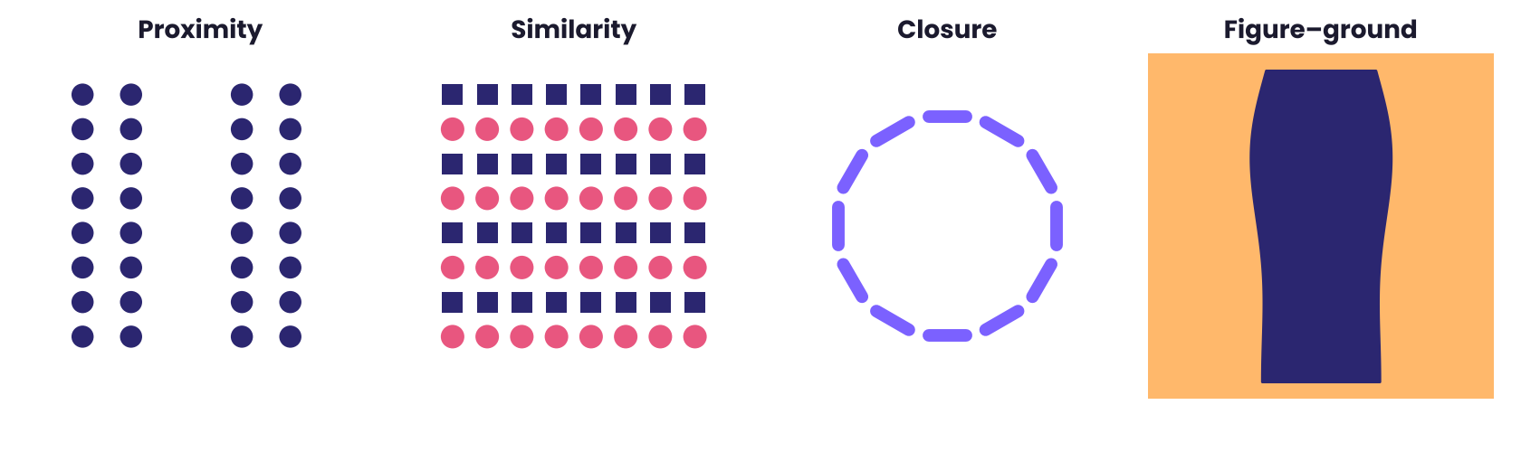
Figure 2.1 — Four Gestalt principles: proximity, similarity, closure and figure-ground.
Principle | Rule | Everyday example
Proximity | Things close together belong together | Words on a page read as lines of text
Similarity | Things that look alike belong together | Players in the same kit form a team
Closure | We complete incomplete shapes | A dotted circle still looks like a circle
Figure–ground | We split a scene into object and background | A vase that is also two faces

When attention fails: the invisible gorilla
THE EXPERIMENT Count the passes
In 1999 Daniel Simons and Christopher Chabris asked people to watch a short video of two teams passing basketballs and to count the passes made by one team. Halfway through, a person in a gorilla suit walked into the middle of the scene, thumped their chest and walked off, visible for about nine seconds. Roughly half of the viewers never noticed the gorilla.

This is inattentional blindness: when attention is occupied, we can fail to see something in plain sight. The finding is not about poor eyesight or carelessness; the people who missed the gorilla were doing the task well. It has real consequences. Drivers on phone calls can look at a pedestrian and not register them, and radiologists focused on one kind of abnormality can miss another in the same scan.
A cousin of this effect is change blindness. In a 1998 field study by Daniel Simons and Daniel Levin, an experimenter stopped a pedestrian to ask for directions. While they talked, workers carrying a door passed between them, and a second person swapped places with the experimenter. About half of the pedestrians did not notice they were now talking to a different person.
DID YOU KNOW The cocktail party effect
In 1953 Colin Cherry showed that in a noisy room you can tune in to one voice and filter the rest, yet you still catch your own name from a conversation you were ignoring. Attention filters strongly but not completely, and what slips through is whatever is personally important.

Illusions: the brain's rules on show
Visual illusions are not tricks played on a broken system. They are windows into the assumptions a well-working system makes. Take the Müller-Lyer illusion, published in 1889: two lines of identical length look unequal when one ends in outward fins and the other in inward fins. One explanation is that the brain reads the fins as the corners of rooms, and treats the line that seems farther away as longer. The effect is weaker in people who grew up with fewer right-angled buildings, which suggests that perception is shaped by experience.
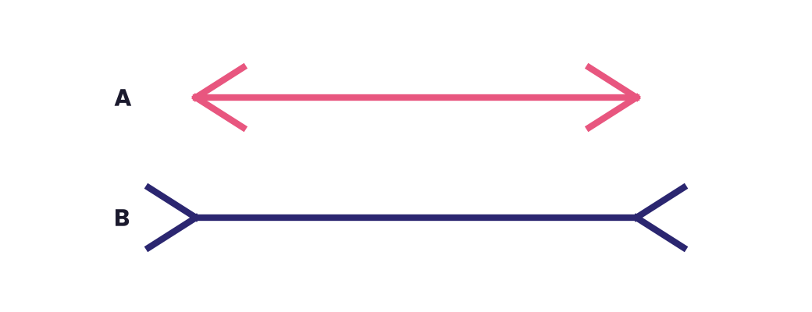
Figure 2.2 — Müller-Lyer illusion: the two horizontal lines are exactly the same length.
Other illusions work on other assumptions. Colour constancy lets you see a white shirt as white in both sunlight and lamplight, because the brain discounts the lighting. In 2015 a photograph of a striped dress went viral because some people saw it as blue and black and others as white and gold. Differences in how each brain assumed the lighting is the most widely accepted explanation.
Perception is multisensory
The senses do not work in separate boxes. In the McGurk effect (1976), a video of a person saying "ga" is paired with the sound "ba". Most people hear a third sound, "da". The eyes alter what the ears report. Cover the face and the sound returns to "ba". The rubber hand illusion (Botvinick and Cohen, 1998) goes further: when a hidden real hand and a visible fake hand are stroked at the same time, many people begin to feel the fake hand is their own. Your sense of body ownership is a conclusion the brain draws from matching signals, not a given.
Why two people perceive differently
A perceptual set is a readiness to perceive things in a particular way, set up by expectations, culture, motivation and mood. Hungry people notice food cues faster. Fans from rival teams often disagree honestly about the same foul. Two people looking at the same ambiguous scene can see different things, and each feels sure the other is wrong. Knowing this should make us a little more generous in arguments.
IN REAL LIFE Three habits for better perception
• Slow down on important details. When attention is divided, assume you are missing something.
• Ask for another view. A different position or experience may catch what yours cannot.
• Separate observation from interpretation. "The door slammed" is an observation; "he was angry" is a guess.

TRY IT Check yourself
• What is the difference between sensation and perception?
• What is inattentional blindness, and why is it not a sign of carelessness?
• How does the McGurk effect show that senses work together?

Chapter 2 in a nutshell

IN REAL LIFE Key takeaways: Perception
• Perception is constructive: the brain predicts and checks, rather than recording.
• Top-down expectations and bottom-up data blend in everything we see.
• Attention is limited; we can miss visible things (inattentional blindness).
• Illusions reveal the assumptions a well-working visual system makes.
• Senses combine: sound, sight and touch shape each other.

Quick quiz
1 What did about half of viewers miss in Simons and Chabris's video?
A) A ball B) A gorilla C) A change of colour
2 Which principle says close things are grouped?
A) Closure B) Proximity C) Similarity
3 In the McGurk effect, the eyes change what we...
A) Hear B) Smell C) Remember
4 Top-down processing starts with...
A) Raw signals B) Expectations C) Reflexes
5 Change blindness was shown when a person swapped during a...
A) Phone call B) Direction request C) Test
TRY IT Answers
B, B, A, B, B

Reflect
Which idea from this chapter surprised you most, and where will you notice it this week?

CHAPTER  03 | Cognitive Biases  The mental shortcuts that save time and sometimes mislead

We are not irrational by accident. We are efficient by design, and efficiency has a price.

IN THIS CHAPTER YOU WILL LEARN
✓ Why the brain relies on heuristics
✓ Ten common biases and how to spot them
✓ How framing and anchors change our choices
✓ Practical ways to reduce bias in your own thinking

Thinking fast and thinking slow
Your brain faces a flood of decisions with limited time and energy. To cope, it uses heuristics: quick rules of thumb that give a good-enough answer most of the time. In the 1970s Daniel Kahneman and Amos Tversky began cataloguing these shortcuts and the predictable errors they produce. Their work launched the field of behavioural economics, and in 2002 Kahneman shared the Nobel Memorial Prize in Economic Sciences for it. (Tversky had died in 1996.)
Kahneman later popularised a useful way to describe two modes of thought, which he called System 1 and System 2. These are labels for tendencies, not two separate brain regions.
 | System 1 (fast) | System 2 (slow)
Speed | Automatic, immediate | Deliberate, effortful
Effort | Almost none | Uses attention and energy
Good at | Faces, habits, gut feelings, familiar skills | Maths, planning, checking, new situations
Typical error | Jumping to conclusions | Laziness: accepting System 1's answer

TRY IT The bat and the ball
A bat and a ball cost ₹110 together. The bat costs ₹100 more than the ball. How much is the ball? The quick answer is ₹10. It is wrong: if the ball were ₹10 the bat would be ₹110 and the total ₹120. The ball costs ₹5. Many university students give the fast answer, which shows that intelligence does not switch the bias off.

Ten biases worth knowing
1. Anchoring
The first number you hear pulls your estimate toward it, even when it is irrelevant. In a 1974 experiment Tversky and Kahneman spun a rigged wheel that landed on 10 or 65, then asked people to estimate the percentage of African countries in the United Nations. Those who saw 10 guessed a median of 25%; those who saw 65 guessed 45%. A random number moved their answers by twenty points. Negotiators, sellers and salaries all feel the pull of the first figure on the table.
2. Availability
We judge how likely something is by how easily examples come to mind. Plane crashes make headlines, so flying feels riskier than driving, though per kilometre travelled driving is far more dangerous. Whatever is vivid, recent or emotional is overweighted.
3. Confirmation bias
We look for, notice and remember information that supports what we already believe. In 1960 Peter Wason gave people the sequence 2-4-6 and asked them to discover the rule by proposing other triples. Most tested only sequences that fitted their first guess (such as "numbers going up by two") and rarely tried one that could prove it wrong. The real rule was simply "any increasing numbers". Testing only what you expect to be true makes you feel right without making you correct.
4. Hindsight bias
After an outcome is known, it seems to have been obvious all along. In 1975 Baruch Fischhoff showed that people told that an event had happened rated it as far more predictable than people who were not told. "I knew it" is often a trick of memory.
5. The sunk cost fallacy
We keep investing in something because of what we have already spent, not because of what it will return. Sitting through a bad film because you paid for the ticket is the classic example. The money is gone either way; the only real question is how to spend the next hour.
6. Loss aversion and the endowment effect
Losses hurt roughly twice as much as equal gains please. Closely related is the endowment effect: we value what we own more than what we do not. In a 1990 study by Kahneman, Knetsch and Thaler, students given a coffee mug asked on average around $7 to sell it, while students without one offered only about $3 to buy the identical mug.
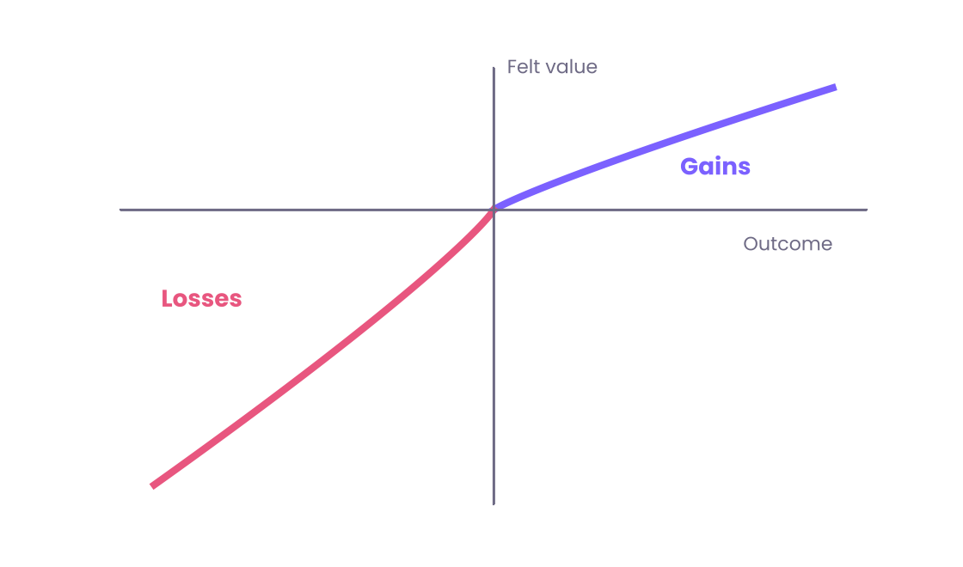
Figure 3.1 — Loss aversion: the pain of losing (left) is steeper than the pleasure of an equal gain (right).
7. Framing
The same facts, described differently, produce different choices. In the famous "Asian disease" problem (1981), people imagined a disease expected to kill 600. Offered a certain saving of 200 lives versus a one-third chance of saving all 600, about 72% chose the sure option. Offered the same options described as 400 people dying for sure versus a two-thirds chance that all 600 die, only about 22% chose the sure option, though the outcomes are identical. Wording the choice as a gain or a loss flipped the answer.
8. The fundamental attribution error
When others slip, we blame their character; when we slip, we blame the situation. In a 1967 study by Edward Jones and Victor Harris, people read an essay praising Fidel Castro and judged the writer to be pro-Castro even when told the writer had been assigned that side. We underestimate how much circumstances shape behaviour.
9. The halo effect
One good trait colours our view of everything else. Attractive people are judged as more intelligent and kind; a well-dressed candidate seems more competent. Edward Thorndike described it in 1920 when he saw officers rate soldiers' intelligence, leadership and physique almost in lockstep.
10. The planning fallacy
We underestimate how long and how costly our own projects will be, even when we know similar projects ran late. The Sydney Opera House was estimated in 1957 to cost about A$7 million and be finished in 1963; it opened in 1973 at roughly A$102 million. The cure is the outside view: ask how long projects like yours usually take, rather than how long yours should take.
DID YOU KNOW Two biases about ourselves
The spotlight effect makes us think others notice us far more than they do. In a 2000 study by Thomas Gilovich and colleagues, students forced to wear an embarrassing T-shirt predicted about half of the room would notice; only around a quarter did. The bias blind spot is the habit of spotting biases in others far more readily than in ourselves. Reading this chapter does not make you immune.

What about Dunning-Kruger?
In 1999 David Dunning and Justin Kruger reported that people who scored lowest on tests of humour, grammar and logic tended to overestimate their performance the most. It became a popular slogan: "the less you know, the more you think you know." The honest picture is more modest. Some researchers argue that part of the pattern is a statistical artefact, because almost everyone's self-ratings are noisy and tend to drift toward "above average". A safer lesson is that we are all poor judges of our own competence when we have little feedback.
Reducing bias in practice
Awareness helps a little; changing the process of deciding helps much more. These methods have the best support.
1 Consider the opposite. Before deciding, write down the best reasons why you might be wrong. Studies by Charles Lord and colleagues in the 1980s found that this simple prompt reduces one-sided thinking.
2 Run a pre-mortem. Gary Klein's technique: imagine the project has failed a year from now and list why. It makes people say doubts that groupthink would silence.
3 Take the outside view. Look for a reference class of similar cases and their actual results.
4 Sleep on big decisions and decide when you are not hungry, angry or rushed.
5 Use checklists and criteria. Decide how you will judge options before you see them, so a charming presentation cannot rewrite the rules.
IN REAL LIFE A bias-aware decision in three questions
• What is the first number or idea I was shown, and would I think the same without it?
• What evidence would change my mind, and have I looked for it?
• If I had not already spent time or money on this, would I start it today?

TRY IT Check yourself
• Explain anchoring using the wheel-of-fortune experiment.
• Why did the Asian disease wording change people's choices?
• Name two techniques that reduce bias better than "trying harder".

Chapter 3 in a nutshell

IN REAL LIFE Key takeaways: Cognitive Biases
• Heuristics are fast shortcuts; they usually work but fail in predictable ways.
• Anchoring, availability and confirmation bias are the most pervasive.
• Framing and loss aversion change choices without changing facts.
• Outside-view thinking and pre-mortems beat 'trying to be less biased'.
• Famous claims such as Dunning-Kruger are more nuanced than slogans.

Quick quiz
1 The sunk cost fallacy means...
A) Ignoring past costs B) Continuing because of past spending C) Avoiding risk
2 Which bias makes us seek evidence that supports our view?
A) Hindsight B) Halo C) Confirmation
3 The planning fallacy is underestimating...
A) Risks only B) Time and cost of our own projects C) Others' skills
4 Losses feel roughly how much stronger than equal gains?
A) Half B) Equal C) Twice
5 A pre-mortem asks you to imagine that your project has...
A) Succeeded B) Failed C) Been cancelled
TRY IT Answers
B, C, B, C, B

Reflect
Which idea from this chapter surprised you most, and where will you notice it this week?

CHAPTER  04 | Emotions and Decision-Making  Why feelings are not the enemy of good choices

Emotion is not the opposite of reason. Without it, reason has nothing to steer by.

IN THIS CHAPTER YOU WILL LEARN
✓ What emotions are and what they are for
✓ How patients with brain damage revealed the role of feeling in choice
✓ How mood, stress and fatigue tilt decisions
✓ Skills for deciding well when emotions run high

What are emotions for?
Emotions are rapid, whole-body responses that prepare us to act: fear readies us to flee or freeze, anger to confront, disgust to avoid contamination, joy to approach and share. They combine bodily changes (heart rate, hormones, posture), a conscious feeling, and urges to act. Charles Darwin argued in 1872 that expressions of emotion evolved because they were useful. Paul Ekman's cross-cultural studies from the 1960s onward found that people in many societies recognise expressions of anger, fear, disgust, happiness, sadness and surprise at better than chance levels. How universal and how few the "basic" emotions really are remains debated, and modern researchers stress that culture and context shape how we feel and show emotion.
Where do feelings come from?
Theory | Core idea | In one line
James–Lange (1880s) | Body response comes first; the feeling is how we notice it | "I feel afraid because I tremble."
Cannon–Bard (1920s) | Body response and feeling arise together | "Both happen at once."
Schachter–Singer (1962) | Arousal plus the label we give it | "I am aroused, and the situation says it is excitement."
Appraisal theories | The meaning we give an event triggers the emotion | "What happened matters to me, and I can/cannot cope."

Today most researchers favour an appraisal-based, constructed view: the brain combines signals from the body with context and past experience to make sense of a feeling. Schachter and Singer's famous adrenaline experiment, however, has been hard to reproduce, so treat it as an early idea rather than settled fact.
Two routes to fear
Joseph LeDoux's research on rats and later on humans described two routes for threat signals. A fast, rough route goes directly to the amygdala and triggers a response in a fraction of a second, before you are consciously sure what you saw. A slower route passes through the cortex for a careful look. The fast route explains why you jump at a curved stick and only then realise it is not a snake. Wrongly jumping costs little; wrongly not jumping could cost a life.
Feelings guide decisions
THE EXPERIMENT Phineas Gage and Elliot
In 1848 a railway worker named Phineas Gage survived an iron rod passing through the front of his skull. Reports describe lasting changes in his behaviour, though accounts have been exaggerated over time. A much better documented case comes from neurologist Antonio Damasio, whose patient Elliot lost part of his ventromedial prefrontal cortex after tumour surgery. His intelligence and memory tested normally, yet his life fell apart. He could spend half an hour weighing the pros and cons of which day to book his next appointment and still not decide. Damasio concluded that without emotional signals to mark options as better or worse, rational analysis alone cannot decide.

Damasio's somatic marker hypothesis says that gut feelings, tied to past outcomes, steer us toward good options and away from bad ones before we can explain why. The hypothesis is influential, though still debated in its details. The practical message is that feelings are information. They are sometimes wrong, but ignoring them is not the same as being rational.
When emotion distorts judgement
Emotions help most when they are relevant to the decision at hand, and hurt most when they come from something unrelated and we do not notice it. Researchers call the borrowed feeling incidental emotion.
• Affect heuristic. Paul Slovic found that we judge risks and benefits by how we feel about something: if we like it, we tend to see low risk and high benefit; if we dislike it, the reverse.
• Mood and risk. Anger tends to make people more optimistic and willing to take risks, while fear makes them more cautious and pessimistic, even about unrelated choices.
• Stress. Moderate arousal sharpens performance, but too much narrows attention and favours habit over flexible thinking. This is the Yerkes–Dodson law (1908), pictured below.
• Affective forecasting. We are poor at predicting how we will feel. Daniel Gilbert and Timothy Wilson showed an impact bias: we overestimate how strongly and for how long a future event, good or bad, will affect our mood.
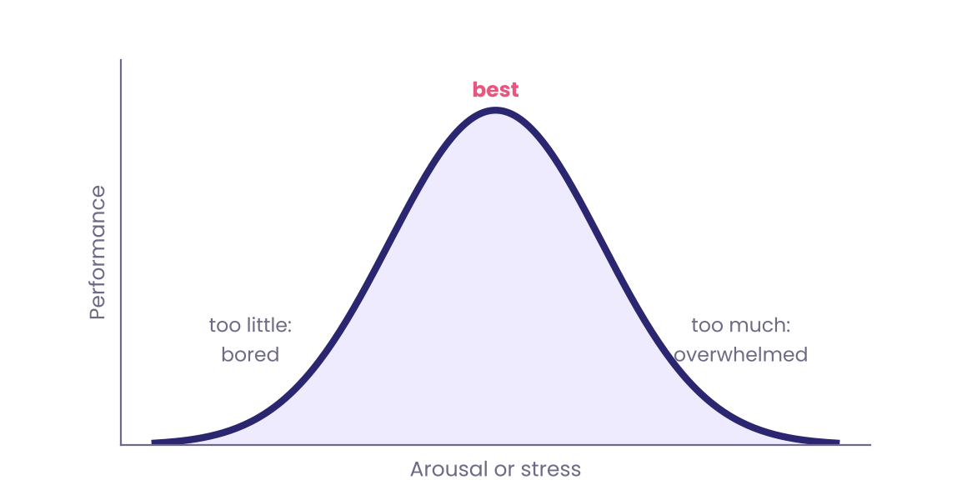
Figure 4.1 — The Yerkes–Dodson curve: performance is best at a moderate level of arousal (illustrative).
WATCH OUT Ego depletion and the "tired willpower" idea
A famous claim held that self-control is a limited fuel that runs down with use. Large, pre-registered replication attempts in the 2010s found the effect to be tiny or absent. Sleep, hunger and stress do affect decisions, but treat dramatic claims about willpower "running out" with care.

How we remember experiences
Kahneman and colleagues showed in the early 1990s that we judge an experience mostly by two moments: its most intense point and its end. This is the peak–end rule. In one experiment participants held a hand in painfully cold water for 60 seconds, and in another trial for 90 seconds, where the last 30 seconds were slightly warmer but still unpleasant. Asked which they would repeat, most chose the longer trial, because it ended better, even though it contained more total pain. The way an experience ends shapes whether we call it good, which is why a thoughtful goodbye matters.
The paradox of too much choice
In a widely cited 2000 study, Sheena Iyengar and Mark Lepper set up a jam stall in a supermarket. A display of 24 jams attracted more visitors than one of 6, but only about 3% of those who stopped at the larger display bought a jar, against about 30% at the smaller. Later research across many studies finds the effect is not universal: choice overload appears mainly when options are many, similar and hard to compare, and when people have no clear preference. Practical lesson: when choosing, narrow the field early with clear criteria.
Delaying gratification
In the late 1960s and early 1970s Walter Mischel offered preschoolers at Stanford one marshmallow now or two if they could wait about fifteen minutes. Early follow-ups suggested that children who waited longer later had better outcomes. A larger 2018 study by Tyler Watts and colleagues found the link was considerably weaker once family background and early cognitive ability were taken into account. Waiting is a skill worth building, but a single test at age four is no destiny.
Skills for deciding well
1 Name the feeling. Research by Matthew Lieberman and colleagues indicates that putting an emotion into words ("I am anxious") reduces the amygdala's response. Labelling is a quick way to turn the volume down.
2 Reappraise. James Gross found that reinterpreting a situation ("this is a challenge, not a threat") works better over time than trying to suppress the feeling.
3 Create a gap. Wait before big replies and big purchases. Even ten minutes lets the first surge pass.
4 Check the source. Ask whether the feeling is about this decision or carried in from elsewhere: a bad morning, a hungry stomach, a heated argument.
5 Decide with a rule when you are weak. If you shop angrily, set a 24-hour rule. Planning ahead beats willpower in the moment.
IN REAL LIFE The 10-10-10 rule
Before an emotional choice, ask: how will I feel about this in 10 minutes, 10 months and 10 years? It shifts attention from the surge of feeling to the long-term effect, and it takes ten seconds.

TRY IT Check yourself
• What does the case of Elliot suggest about emotion and decisions?
• What does the Yerkes–Dodson curve say about stress and performance?
• Which two moments dominate how we remember an experience?

Chapter 4 in a nutshell

IN REAL LIFE Key takeaways: Emotions and Decision-Making
• Emotions are fast, body-wide responses that prepare action and carry information.
• Patients like Elliot show that without feeling, choosing becomes almost impossible.
• Incidental mood can bias unrelated judgements; naming it helps.
• We remember experiences by their peak and their end.
• Reappraisal and pauses beat suppressing emotion.

Quick quiz
1 Which structure gives the fast route for threat?
A) Hippocampus B) Amygdala C) Cerebellum
2 The Yerkes-Dodson curve links performance to...
A) Age B) Arousal C) Sleep
3 Affective forecasting errors are the impact bias: we overestimate...
A) Emotional impact B) Memory C) Speed
4 The peak-end rule says we judge an experience by its...
A) Average B) Peak and ending C) Start
5 Which skill is supported by affect-labelling research?
A) Naming the emotion B) Ignoring it C) Shouting
TRY IT Answers
B, B, A, B, A

Reflect
Which idea from this chapter surprised you most, and where will you notice it this week?

CHAPTER  05 | Psychology Experiments  The studies that changed how we see ourselves, and what they got right and wrong

A famous result is not the same as a true one. The best psychologists keep testing their heroes.

IN THIS CHAPTER YOU WILL LEARN
✓ Eight landmark experiments and what they showed
✓ The ethical lines psychology drew after its darker studies
✓ Why the replication crisis changed the field
✓ How to read a psychology headline critically

Learning by association and consequence
Pavlov (1900s). Ivan Pavlov, studying digestion in dogs, noticed that they began to salivate at the sight of the lab assistant who fed them. He paired a neutral signal, such as a bell, with food, and soon the bell alone produced salivation. This is classical conditioning: a neutral cue becomes a trigger by being linked with something that already matters. It explains why a song can bring back a mood and why a certain smell can make you hungry.
Skinner (1930s–50s). B. F. Skinner studied operant conditioning: behaviour followed by reward tends to be repeated, and behaviour followed by punishment tends to fade. Rats pressing a lever for food showed that unpredictable rewards produce the most persistent behaviour, the same principle that makes slot machines and social media feeds hard to put down.
Bandura (1961). Albert Bandura's Bobo doll study showed that children who watched an adult punch and kick an inflatable doll were more likely to imitate that aggression than children who saw a calm adult. People learn by watching, without any reward of their own. The study sparked decades of debate about media and behaviour, and it remains a cornerstone of social learning theory.
WATCH OUT The Little Albert problem
In 1920 John Watson and Rosalie Rayner conditioned an infant to fear a white rat. The study is a staple of textbooks and a standard example of poor ethics: the child's consent was never properly sought, the fear was never undone, and later accounts of the details disagree. It helped create the rules that now protect research participants.

Conformity and obedience
THE EXPERIMENT Asch's lines (1951)
Solomon Asch showed groups a line and asked which of three comparison lines matched it. The answer was obvious. But in the group, all but one person were confederates who sometimes gave the same wrong answer. About three-quarters of participants went along with the group at least once, and overall around a third of their answers conformed. When just one confederate gave the correct answer, conformity fell sharply.

Asch showed that social pressure can make us doubt our own eyes, but also that a single ally gives us the courage to speak. In his debriefs, many conformers said they had privately doubted the group and still gone along, so social pressure acts through the wish to fit in as well as through the belief that the group knows best.
THE EXPERIMENT Milgram's shock study (1961–63)
Stanley Milgram told volunteers they were helping a study of learning and instructed them to give a "learner" (an actor) electric shocks of increasing strength for wrong answers, up to a labelled 450 volts. No shocks were real. In the best-known version, about 65% of participants went all the way to the top of the scale, many showing great distress, because an experimenter in a lab coat calmly said the experiment required them to continue.

Milgram's finding was that ordinary people can do harmful things when an authority takes responsibility. Later analyses point out that obedience dropped when the authority was absent, when the learner was nearby, or when other participants refused, and that many participants did not fully believe the shocks were real. The study remains a sobering lesson in how situations, not only character, drive behaviour. It also could not be run today.
The bystander effect
In 1964 the murder of Kitty Genovese in New York was reported, famously and inaccurately, as witnessed by 38 neighbours who did nothing. Later investigations found the story exaggerated. Still, it inspired John Darley and Bibb Latané to test how people respond to emergencies. In their 1968 study, students in separate rooms heard over an intercom what sounded like another student having a seizure. When a student believed they were the only listener, 85% reported it; with one other person present, about 62%; with four others, about 31%. The more people who could help, the less likely any single person was to act, a diffusion of responsibility. Later research shows that in clear, dangerous emergencies with direct contact, people often do help, so the effect is real but depends on the situation.
IN REAL LIFE If you need help in a crowd
Do not wait for someone else. Point at one person and say: "You in the blue jacket, call an ambulance." Giving a specific job removes the diffusion of responsibility.

Dissonance and group conflict
Festinger and Carlsmith (1959). Participants spent an hour on dull tasks, then were paid either $1 or $20 to tell the next participant that the tasks were fun. Later, those paid just $1 rated the tasks as more enjoyable than those paid $20. Festinger's explanation was cognitive dissonance: the $1 group had no good external reason for saying something false, so they relieved the discomfort by changing their attitude. We tend to adjust our beliefs to fit what we have done.
Robbers Cave (1954). Muzafer Sherif split 22 boys at a summer camp in Oklahoma into two groups, which soon developed rivalry and hostility. Friction eased only when the groups had to cooperate on shared goals, such as fixing the camp's water supply. The study suggested that conflict between groups grows from competition, and fades with common purpose.
Attachment
In the late 1950s Harry Harlow raised infant rhesus monkeys with two artificial "mothers": a bare wire frame that dispensed milk and a soft cloth-covered one without milk. The monkeys spent most of their time clinging to the cloth mother and went to the wire one only to feed. The results challenged the idea that infants bond mainly to whoever feeds them, and underlined the importance of comfort and contact. The work also raised serious animal welfare concerns that influence how research is regulated.
When famous studies fall apart
Psychology's best-known stories have not all survived scrutiny. Three examples:
• The Stanford prison experiment (1971). Philip Zimbardo assigned students to be guards or prisoners; guards soon became abusive and the study was stopped after six days. Later analysis of archives and interviews suggests the guards were coached on how to behave and that participants knew what was expected of them. It is better read as a lesson about how leaders shape behaviour than as proof that roles automatically corrupt.
• Rosenhan's "On being sane in insane places" (1973). Pseudo-patients reported hearing voices and were admitted to hospitals. A later investigation by Susannah Cahalan questioned how the study was run and reported. It reminds us to check sources, even for classics.
• Power posing (2010). An early claim that standing in a "power pose" changes hormones was not supported by larger replications. Posing may change how people feel, but the hormonal claim did not hold.
The replication crisis
In 2015 a team of 270 researchers, the Open Science Collaboration, attempted to reproduce 100 published psychology studies. Whereas about 97% of the original studies reported statistically significant results, only around 36% of the replications did, and the effects tended to be smaller. The finding did not mean psychology is worthless. It exposed weak habits: small samples, flexible analysis choices, and journals preferring exciting results. The field responded with pre-registration (declaring the plan before collecting data), larger samples, open data and registered reports.
Warning sign in a headline | Question to ask
"Scientists prove..." | How many people were studied, and has anyone repeated it?
A single, surprising result | Is it one study, or a pattern across many?
Huge claims from a small sample | Was it 20 students, or thousands of people from many places?
Correlation presented as cause | Could something else explain both?
"Everyone" or "always" | Who was left out? Most studies draw on Western university students.

The ethics that came out of it
Reaction to wartime and postwar abuses led to the Nuremberg Code (1947), which put voluntary consent at the centre of research. In the United States the Belmont Report (1979) set out three principles: respect for persons, beneficence (doing good and avoiding harm) and justice. Today most universities require an ethics board to review human studies, and participants must give informed consent, be told they can leave at any time, and be debriefed afterwards. Some of the most famous studies in this chapter could not be repeated today.
TRY IT Check yourself
• What did Asch's experiment show about conformity, and what reduced it?
• Why does the bystander effect get weaker when someone is given a specific job?
• What did the 2015 replication project find, and how did the field respond?

Chapter 5 in a nutshell

IN REAL LIFE Key takeaways: Psychology Experiments
• Conditioning, observation and social pressure shape behaviour.
• Asch, Milgram and Darley and Latane showed the power of situations.
• Several famous studies (Stanford prison, power posing) have been criticised or not replicated.
• The 2015 project replicated about 36% of 100 studies' significant results.
• Ethics: consent, debriefing and review boards now protect participants.

Quick quiz
1 In Asch's study, roughly what share conformed at least once?
A) One in ten B) About three-quarters C) Everyone
2 In Darley and Latane's study, helping was highest when the person was...
A) Alone B) With four others C) With a friend
3 Cognitive dissonance was shown when $1 participants...
A) Refused B) Rated the task more enjoyable C) Asked for more
4 Which document set out respect, beneficence and justice?
A) Belmont Report B) Nuremberg Code C) Geneva Convention
5 Pre-registration means...
A) Booking a lab B) Declaring the plan before collecting data C) Paying participants
TRY IT Answers
B, A, B, A, B

Reflect
Which idea from this chapter surprised you most, and where will you notice it this week?

CHAPTER  06 | Everyday Behaviour  The habits, influences and attention patterns that run an ordinary day

Much of what you call your life is a set of habits you did not decide to make.

IN THIS CHAPTER YOU WILL LEARN
✓ How habits form and how long they take to change
✓ How other people shape your choices without a word
✓ How attention, sleep and multitasking affect your day
✓ Small environmental changes that beat willpower

Habits: the autopilot
A 2002 diary study by Wendy Wood and colleagues found that about 43% of the everyday actions people reported were performed almost daily, in the same place, while thinking about something else. Habits are the brain's way of saving effort: once a behaviour is linked to a context, it fires automatically. A habit is not a stronger form of willpower. It is behaviour that no longer needs it.
Habits are driven by a loop that Charles Duhigg popularised in 2012 and that researchers describe as cue, routine, reward. The cue (arriving home) triggers the routine (sitting on the sofa with the phone), which delivers a reward (relief, entertainment), which strengthens the link.
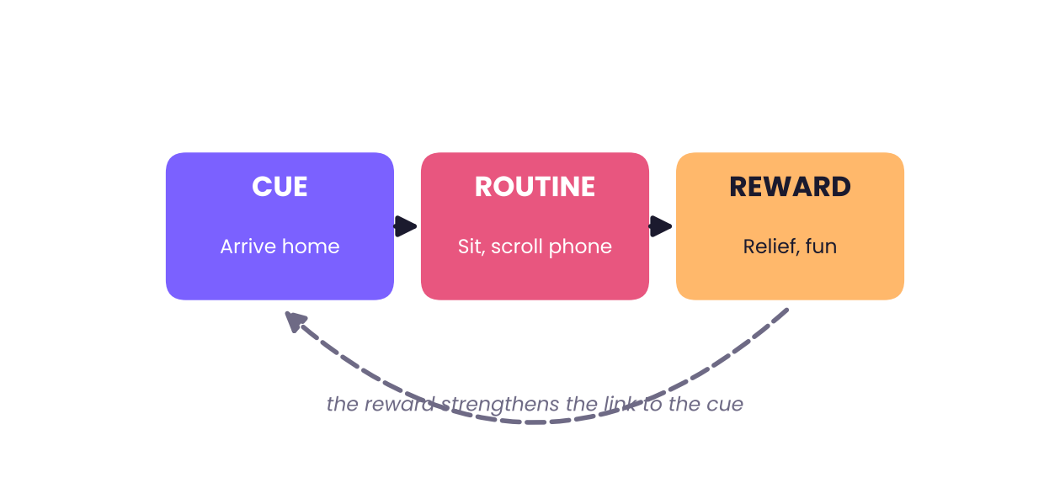
Figure 6.1 — The habit loop: cue, routine and reward. Change any link and you change the habit.
THE EXPERIMENT How long does a habit take?
The popular "21 days to form a habit" has no scientific basis. In a 2010 study led by Phillippa Lally, volunteers picked a new daily behaviour, such as drinking water after breakfast, and reported how automatic it felt. It took on average about 66 days to reach a plateau, and the range ran from 18 to 254 days. Missing a single day did not ruin progress.

Three ways to build a habit work better than motivation:
1 Anchor it to a cue you already have. "After I pour my morning tea, I will read one page." The existing routine acts as a trigger.
2 Make the first step tiny. Two minutes of study beats a plan for two hours that you never begin.
3 Make it easy. Lay out the running shoes the night before. Friction decides more than intention.
To break a habit, do not just remove the routine; change the cue or substitute a new routine that gives a similar reward. Moving the phone out of the bedroom works better than promising to scroll less.
If–then plans
Peter Gollwitzer's research on implementation intentions shows that people who turn a goal into an "if–then" plan are much more likely to follow through. A 2006 review of nearly one hundred studies found a medium-to-large benefit. "I want to exercise more" becomes "If it is 6:30 pm on a weekday, then I will walk for 20 minutes." The plan hands the decision to the situation, so you do not need to decide in the moment.
The pull of other people
We are intensely social animals, and a great deal of everyday behaviour follows what we think others do and approve of. Robert Cialdini and colleagues tested this in hotels in 2008. A card in the bathroom asking guests to reuse towels for the environment got about 35% compliance; saying that most guests reuse towels raised it to about 44%; and saying that most guests in this very room did so raised it to about 49%. The nearer and more like us the group, the stronger the effect.
Principle | What it means | Where you see it
Social proof | We copy what others do | Bestseller labels, queues, reviews
Reciprocity | We feel we should repay favours | Free samples, a small gift before a request
Commitment | We stay consistent with what we have said | Signing a pledge, public goals
Authority | We trust apparent experts | Uniforms, titles, credentials
Scarcity | Rare things seem more valuable | "Only 3 left"

First impressions. In 2006 Janine Willis and Alexander Todorov found that people formed judgements of a stranger's trustworthiness and competence from a face seen for just a tenth of a second, and longer viewing mostly made them more confident rather than more accurate. Snap judgements are fast, sticky, and not very reliable, so take a second look at people you have already sorted.
Nudges and defaults
The most powerful influence on many choices is the default. In a widely cited 2003 comparison by Eric Johnson and Daniel Goldstein, countries where citizens were registered as organ donors unless they opted out had donor consent rates of about 86% to 99%, while countries where people had to opt in sat between about 4% and 28%. Same people, same values, different form. Designing the default well, a nudge, can improve choices without banning anything.
IN REAL LIFE Use defaults on yourself
Set automatic transfers to savings on payday. Keep fruit on the table and biscuits in a high cupboard. Turn off notifications you do not need. You are changing the environment, not fighting your impulses.

Attention, multitasking and your phone
People rarely multitask; they task-switch. In studies by Joshua Rubinstein, David Meyer and Jeffrey Evans (2001), switching between tasks slowed people down and increased errors, with costs that grew for more complex tasks. Each switch brings a small delay while the brain reloads the rules for the new task. The effects are small in a single instance and large across a day.
Phones deserve a careful mention. Some studies find that even a silent phone on the desk can reduce performance on demanding tasks, but follow-up work has had mixed results, so the effect is not settled. What is clear is that frequent interruptions fragment attention. Put the phone in another room during focused work and see for yourself.
Sleep: the foundation
Most adults need seven to nine hours. Beyond memory consolidation, sleep helps regulate mood, attention and judgement. After a night of poor sleep people tend to react more strongly to negative events and are more prone to errors. Regular sleep and wake times, a dark cool room, and less late-evening screen light support better sleep. Persistent sleep problems deserve a conversation with a doctor.
Procrastination and the present self
Why do we put off tasks that we know matter? Researchers point to present bias: given a choice between a reward now and a bigger one later, we overvalue now. Studying feels costly today and the benefit arrives later, so the present self wins. Making the future reward feel nearer (small deadlines, study partners, rewards for completing a block) and making the task start smaller are the best remedies.
TRY IT A two-minute habit audit
List five things you do every morning without thinking. For each, write the cue and the reward. Pick one you want to change and write one if–then plan for it. You have just turned an unconscious loop into a design decision.

TRY IT Check yourself
• What are the three parts of the habit loop?
• Why does the hotel-towel study suggest that "most guests in this room" beats a general message?
• Why are defaults so powerful?

Chapter 6 in a nutshell

IN REAL LIFE Key takeaways: Everyday Behaviour
• Habits run on cues and rewards; a median of about 66 days to automaticity.
• If-then plans turn goals into automatic actions.
• Social proof and defaults shape choices strongly, often invisibly.
• Task-switching has a cost; protect your attention.
• Sleep supports memory, mood and judgement.

Quick quiz
1 The habit loop is cue, routine and...
A) Reward B) Reminder C) Review
2 In Lally's study, habit formation took a median of about...
A) 21 days B) 66 days C) 6 months
3 In the hotel study, which message worked best?
A) Environment appeal B) Most guests C) Most guests in this room
4 Which change often has the biggest effect on choices?
A) Defaults B) Lectures C) Colours
5 Present bias makes us overvalue...
A) The future B) The past C) Now
TRY IT Answers
A, B, C, A, C

Reflect
Which idea from this chapter surprised you most, and where will you notice it this week?

CHAPTER  07 | Lab Day: Try It Yourself  Five quick tests that show your mind at work

The best way to understand a mind is to catch your own doing something odd.

IN THIS CHAPTER YOU WILL LEARN
✓ How the Stroop effect shows automatic reading
✓ How to measure your memory span
✓ How the Cognitive Reflection Test separates fast from slow thinking
✓ How to run a simple illusion test on a friend

Test 1: The Stroop effect
In 1935 John Ridley Stroop found that naming the ink colour of a word is slower when the word spells a different colour. Reading is so automatic that it interferes. Time yourself saying the ink colour (not the word) for each card below, row by row, aloud.
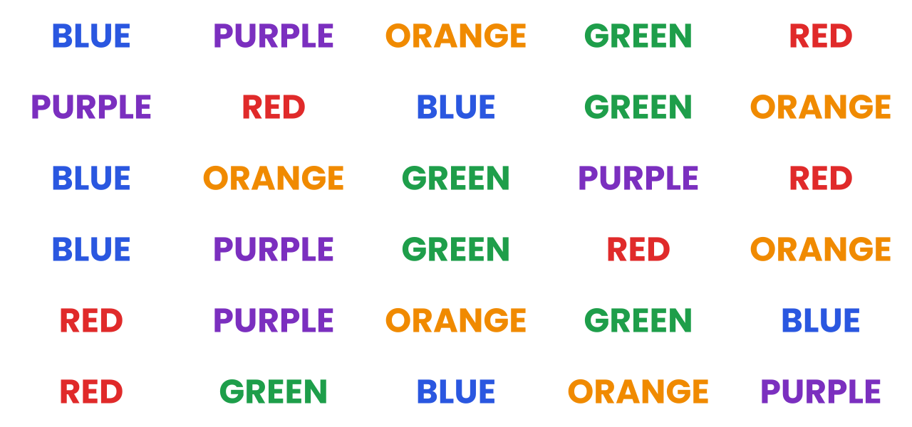
Card A — Name the ink colour. The word and the colour match.
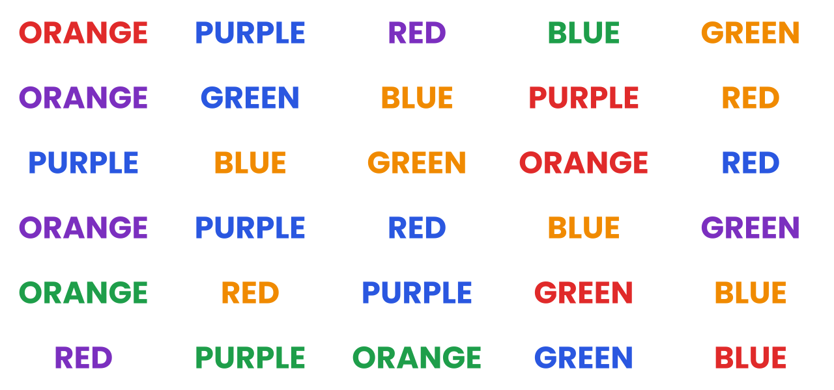
Card B — Name the ink colour. The word and the colour do not match.
THE EXPERIMENT What to expect
Almost everyone is clearly slower and makes more errors on Card B. Part of your brain wants to read; part wants to name colours. The conflict you feel is a glimpse of System 1 versus System 2.

Test 2: Memory span
Read the list below once at a steady pace (about one word per second), cover it, then write down as many words as you can in any order on a sheet of paper.
river | candle | tablet | anchor | violin
mirror | orange | ladder | pillow | tunnel
garden | bridge | pencil | button | cloud

Score yourself and check where your errors fall. Most people recall the first few and last few words best (the serial position effect). Try again after rehearsing in groups of three, or by building a story that links the words in order, and compare.
Test 3: Cognitive Reflection Test
Shane Frederick's 2005 test uses three puzzles whose quick answer is wrong. Try them before reading the answers.
1 A bat and a ball cost ₹110 in total. The bat costs ₹100 more than the ball. How much does the ball cost?
2 If it takes 5 machines 5 minutes to make 5 widgets, how long would it take 100 machines to make 100 widgets?
3 In a lake, a patch of lily pads doubles in size every day. If it takes 48 days to cover the entire lake, how long would it take to cover half of it?
TRY IT Answers
1) ₹5, not ₹10. 2) 5 minutes, not 100: each machine makes a widget in 5 minutes. 3) 47 days, not 24: on day 47 the patch is half the lake and doubles to cover it on day 48. If you gave the fast answers, you are in good company: System 1 answers first and System 2 must step in.

Test 4: Your illusion lab
Draw two lines of exactly the same length on paper, one with outward-pointing arrowheads and one with inward-pointing arrowheads (see Chapter 2). Show it to three friends and ask which is longer. Then hand them a ruler. Notice that knowing the truth does not remove the illusion: perception and belief run on separate tracks.
Test 5: The anchoring trial
Ask three people to estimate the population of a city. Before asking, ask one "Is it more than 2 million?", another "Is it more than 20 million?" and the third nothing. Compare their estimates. Write your results below.
My lab notebook
Record one line for each test you tried.
Test | What I predicted | What happened | What it shows

CHAPTER  08 | Mind Myths  Twelve popular beliefs the evidence does not support

What everybody knows about the mind is often only what everybody repeats.

IN THIS CHAPTER YOU WILL LEARN
✓ Twelve widespread myths and the evidence against them
✓ Why myths about the mind are so sticky
✓ How to check a claim before you believe it
✓ How to share what you have learned kindly

Psychology attracts myths the way a magnet attracts iron filings. A myth often contains a grain of truth, makes a simple story out of a complex one, or flatters us. Here are twelve you may have heard.
1 | MYTH We use only 10% of our brains.  FACT Brain imaging shows activity throughout the brain across a day, and damage almost anywhere has effects.
2 | MYTH People are either left-brained or right-brained.  FACT The hemispheres cooperate on nearly every task. The idea of strong personality 'sides' is not supported by evidence.
3 | MYTH Learning styles (visual, auditory, kinaesthetic) mean people learn best in their own style.  FACT Reviews find little evidence that matching teaching to a preferred style improves learning. Matching the method to the content matters more.
4 | MYTH Memory works like a video recorder.  FACT Memory is reconstructive and can change with each recall.
5 | MYTH Venting anger reduces it.  FACT Studies (e.g. by Brad Bushman) found that venting through aggression tends to keep anger high. Calming strategies work better.
6 | MYTH Opposites attract.  FACT Research finds that similarity in values and attitudes is a stronger predictor of attraction and lasting relationships.
7 | MYTH Playing Mozart makes babies smarter.  FACT The 1993 'Mozart effect' was a small, short-lived effect in adults on a spatial task, and not a lasting boost in intelligence.
8 | MYTH Lie detectors reliably detect lies.  FACT Polygraphs measure arousal, not lying, and people are generally little better than chance at spotting deceit.
9 | MYTH Hypnosis unlocks forgotten memories accurately.  FACT Hypnosis can increase confidence and create false memories; it is not a recording playback.
10 | MYTH Goldfish have a three-second memory.  FACT Fish can learn and remember for weeks to months.
11 | MYTH More choices always make us happier.  FACT Too many similar options can lead to regret and indecision.
12 | MYTH Genius and madness go together.  FACT Some creative people have mental health challenges, but most people with mental illness are not geniuses and most creative people are not ill.

IN REAL LIFE A four-step claim check
• Source: who says it, and what do they gain?
• Sample: how many people, and who?
• Repeat: has anyone else found the same thing?
• Cause: is it a correlation or an experiment?

TOOLKIT  09 | Your Mind Toolkit  Turn the science into a 30-day experiment

You cannot upgrade your mind overnight. You can run a small experiment on it every day.

IN THIS CHAPTER YOU WILL LEARN
✓ A 30-day plan with one idea per week
✓ Four self-experiments you can run at home
✓ A thought record for catching a bias in the act
✓ How to keep track of what works for you

The 30-day plan
Choose one focus each week and keep each action small. At the end of 30 days you will have practised the four most useful skills in this book.
Week | Focus | Daily action (5–10 minutes)
1 | Memory | Quiz yourself on something you learned yesterday before looking at notes. Sleep at a regular time.
2 | Attention | Do one 25-minute block of focused work with the phone in another room. Notice what pulls you away.
3 | Bias and emotion | When you make a decision of any size, name the feeling and ask: what would change my mind?
4 | Habits | Pick one habit and write an if–then plan. Track it with a tick each day.

Four self-experiments
TRY IT 1. Recall versus rereading
Pick two similar short passages. Read the first twice. Read the second once, then close the book and write what you remember. Two days later, test yourself on both. Most people recall more from the one they tested themselves on.

TRY IT 2. The anchoring test
Ask two friends to estimate the age of a monument. Before asking, give one of them a high number ("Is it older than 200 years?") and the other a low one ("Is it older than 20 years?"). Compare their answers. You will usually see the anchor's pull.

TRY IT 3. The 24-hour rule
The next time you want to buy something unplanned, write it down and wait 24 hours. Count how many items you still want the next day. The gap is the part of the wish that was impulse.

TRY IT 4. Attention audit
For one day, tally each time you switch tasks or check your phone while doing something else. At the end, estimate how many minutes it cost you. Most people are shocked by the total.

Thought record: catching a bias in the act
Fill in one row whenever you notice yourself being certain about something. The first row is an example.
Situation | What I thought or felt | Possible bias | A better question
Friend says the project will take a week | Fine, one week | Planning fallacy | How long did similar projects take?

30-day tracker
Tick each day you complete the daily action.
Week | Mon | Tue | Wed | Thu | Fri | Sat | Sun
Week 1: Memory
Week 2: Attention
Week 3: Bias & emotion
Week 4: Habits

Decision journal
Record decisions that matter. Review a week later, and look for patterns in how your predictions and feelings matched the outcome.
Decision | Options | My prediction | How I felt | What happened

Habit design sheet
Use one row per habit. Keep the first step so small that you cannot say no.
Habit I want | Cue | Tiny first step | Reward | My if-then plan

Keeping the learning
At the end of each week write three lines: What did I try? What happened? What will I keep? Treat yourself like a good scientist treats a hypothesis: curious, not defensive. A result that surprises you is more informative than one that confirms what you expected.
Glossary

Anchoring Being pulled toward the first number or idea you encounter. | Hippocampus Brain structure essential for forming new explicit memories.
Availability heuristic Judging likelihood by how easily examples come to mind. | Implementation intention An if–then plan that links a situation to an action.
Bystander effect The tendency to help less when others are present. | Inattentional blindness Failing to notice a visible object because attention is elsewhere.
Chunking Grouping items into meaningful units to hold more in working memory. | Loss aversion Feeling losses more strongly than equal gains.
Classical conditioning Learning that a neutral cue predicts something important. | Nudge A small change in how choices are presented that guides behaviour without restricting options.
Cognitive dissonance Discomfort from holding conflicting beliefs or acting against them, often resolved by changing attitudes. | Operant conditioning Learning from the consequences of behaviour.
Confirmation bias Seeking and favouring information that supports existing beliefs. | Peak–end rule Judging an experience by its peak and its ending.
Default The option that applies if a person does nothing. | Pre-registration Publicly stating a study's plan before collecting data.
Encoding Converting an experience into a form that can be stored in memory. | Replication Repeating a study to see if the result holds.
Endowment effect Valuing something more because you own it. | Retrieval Bringing a stored memory back into mind.
Framing How the presentation of a choice changes the decision. | Sunk cost Past spending that cannot be recovered and should not drive future choices.
Gestalt Principles describing how we perceive organised wholes. | System 1 / System 2 Fast, automatic thinking versus slow, deliberate thinking.
Habit Behaviour triggered automatically by a context. | Working memory The small mental workspace for information in use now.
Heuristic A mental shortcut that usually works but can mislead.

Timeline

Year | Milestone
1879 | Wilhelm Wundt opens a psychology laboratory in Leipzig
1885 | Ebbinghaus publishes his work on memory and the forgetting curve
1889 | Müller-Lyer illusion described
1908 | Yerkes and Dodson describe the arousal-performance relation
1920 | Watson and Rayner's Little Albert study; Thorndike names the halo effect
1935 | Stroop publishes the colour-word interference study
1951 | Asch's conformity experiments
1953 | H.M.'s surgery; Cherry describes the cocktail party effect
1956 | Miller's paper on the capacity of short-term memory
1959 | Festinger and Carlsmith's cognitive dissonance study
1961–63 | Bandura's Bobo doll study; Milgram's obedience experiments
1968 | Atkinson and Shiffrin's memory model; Darley and Latané's bystander study
1971 | Stanford prison experiment
1972 | Craik and Lockhart's levels of processing; Mischel's marshmallow test
1974 | Tversky and Kahneman on heuristics; Loftus and Palmer on eyewitness memory
1979 | Belmont Report on research ethics
1999 | Simons and Chabris's invisible gorilla
2002 | Kahneman shares the Nobel Prize in Economic Sciences
2015 | Open Science Collaboration replicates 100 psychology studies
2018 | Large replication of the marshmallow test

Who's who

Hermann Ebbinghaus  Pioneer of memory research; the forgetting curve. | Elizabeth Loftus  Showed how memory is shaped by later information.
Brenda Milner  Studied H.M. and revealed separate memory systems. | Daniel Kahneman  Heuristics, biases and System 1 and 2; Nobel laureate.
Amos Tversky  Kahneman's collaborator on judgement and decision-making. | Antonio Damasio  Linked emotion to rational decision-making.
Joseph LeDoux  Mapped fear circuits in the brain. | Solomon Asch  Conformity experiments.
Stanley Milgram  Obedience to authority. | Albert Bandura  Social learning theory.
Leon Festinger  Cognitive dissonance. | Daniel Simons  Invisible gorilla and change blindness.
Phillippa Lally  Habit formation timing. | Robert Cialdini  Social influence and persuasion.
My notes

Go deeper

If this book has sparked your curiosity, these accessible, well-regarded books and sources take each theme further.
Theme | Where to look
Memory | Moonwalking with Einstein (Joshua Foer); Elizabeth Loftus's papers and talks on eyewitness memory
Perception | The Invisible Gorilla (Chabris and Simons); Mind Hacks (Tom Stafford and Matt Webb)
Biases and decisions | Thinking, Fast and Slow (Daniel Kahneman); Nudge (Richard Thaler and Cass Sunstein)
Emotion | Descartes' Error (Antonio Damasio); How Emotions Are Made (Lisa Feldman Barrett)
Social psychology | The Social Animal (Elliot Aronson); Influence (Robert Cialdini)
Habits | Atomic Habits (James Clear); Good Habits, Bad Habits (Wendy Wood)
Reading research well | The Open Science Framework (osf.io) and the Many Labs replication projects

The mind is the only instrument that studies itself. Treat it with curiosity, and a little humility.

WATCH OUT A note on accuracy
Psychology is a living science. Findings are refined as new studies appear, and a few results described here are still debated. Where the evidence is mixed, the text says so. Check current sources if you rely on a specific figure.

Thank you for reading. May you notice your own thinking a little more, and trust it a little less, in exactly the right proportions.
Explore more e-books from PrepPath E-books Store. Visit our website and shop now.

