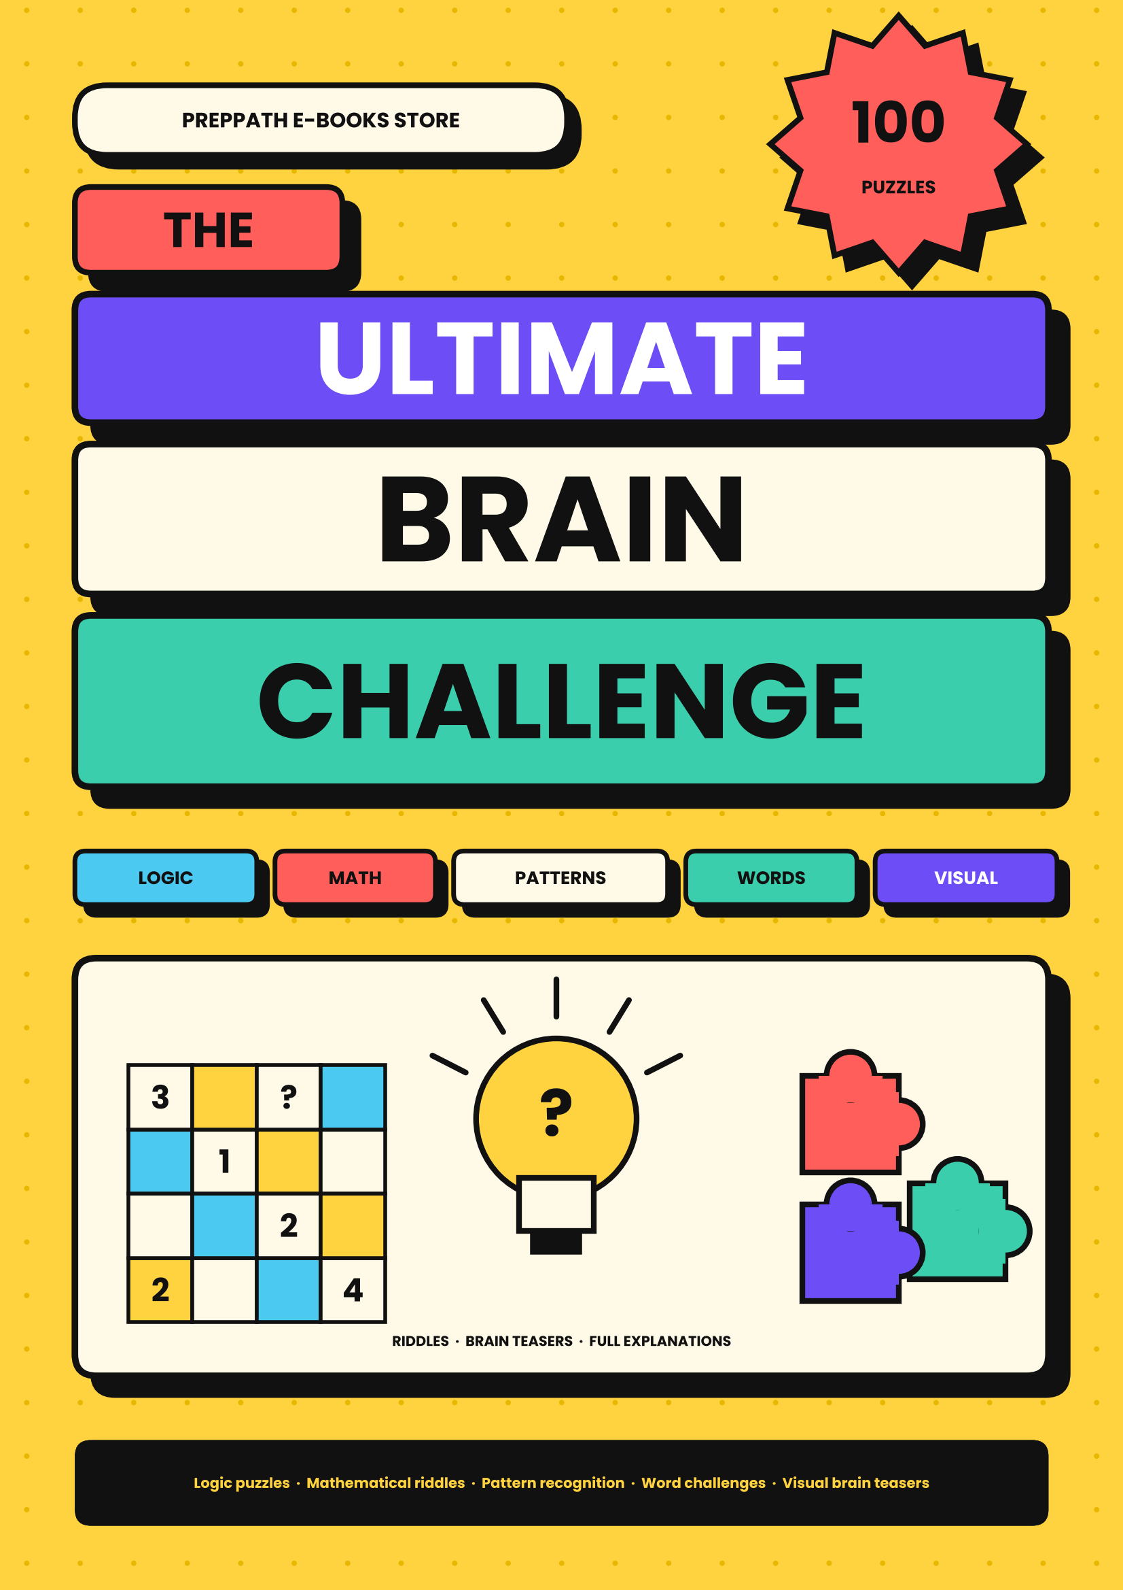

CONTENTS

 | HOW TO PLAY  Rules, scoring and golden rules | 3
 | THINKING TOOLKIT  Six tools for every solver | 4
 | LOGIC PUZZLES  Nos. 1–20 · Deduction, truth-tellers and clever reasoning. | 5
 | MATHEMATICAL RIDDLES  Nos. 21–40 · Numbers with a twist. | 12
 | PATTERN RECOGNITION  Nos. 41–56 · Find the rule hiding in the sequence, then use it to predict what comes next. | 19
 | WORD CHALLENGES  Nos. 57–74 · Riddles, ladders, codes and wordplay. | 25
 | VISUAL BRAIN TEASERS  Nos. 75–90 · Look carefully, then look again. | 32
 | THE FINAL TEN  Nos. 91–100 · The boss level. | 40
 | BONUS ROUND  Ten lightning riddles | 44
 | PUZZLE LAB  Design a puzzle of your own | 45
 | HINT VAULT  A nudge for every puzzle, with no spoilers | 46
 | ANSWER KEY AND EXPLANATIONS  Every solution, explained step by step | 48
 | SCOREBOARD  Track your points puzzle by puzzle | 54
 | BRAIN NOTES  Ruled pages for your workings | 55
 | CERTIFICATE  Your reward for finishing | 59

HOW TO PLAY | START  HERE
Welcome to the arena. Sharpen a pencil, clear a table and give your brain something worth chewing on.
1  PICK A PUZZLE  Puzzles are grouped by type, but you can jump anywhere. Each card shows the difficulty in stars. | 2  THINK, THEN WRITE  Use the scratch space. Writing out your steps is the quickest way to spot the trick. | 3  CHECK AND LEARN  Find the answer and explanation at the back. Read the why, even when you were right.

DIFFICULTY AND POINTS
LEVEL | STARS | WHAT TO EXPECT
Easy | ★☆☆ | One clear idea. Most readers solve these in a few minutes.
Medium | ★★☆ | A hidden trick or two steps of reasoning. Worth a pause.
Hard | ★★★ | Famous brain-breakers. Expect to try, fail and try again.

SCORING YOURSELF
Score each puzzle: 3 points if you solved it alone, 2 points if you needed the hint from the Hint Vault, 1 point if you solved it after reading the answer and can explain why it works. Record your points on the Scoreboard near the end. The maximum is 300.
THE GOLDEN RULES
1. Read the puzzle twice before you write anything. Many riddles hide the answer in a single word.
2. Do not peek too soon. The struggle is where the learning happens.
3. Try small cases first. Shrinking a big problem often reveals the pattern.
4. Explain your answer aloud. If you cannot explain it, you have not finished solving it.
5. Take a break. Ideas often arrive while you are doing something else.

THINKING TOOLKIT | SIX  TOOLS
Six mental tools used by good puzzle-solvers. Keep them in mind as you go.
1  WORK BACKWARDS  Start from the goal and ask what had to happen just before. Mazes, jugs and many riddles melt this way. | 2  TRY SMALL CASES  Solve the puzzle for 2, 3 or 4 first. A rule that holds for small numbers usually scales.
3  DRAW IT  A quick sketch, table or list turns a tangle of words into something you can see. | 4  ELIMINATE  Cross out what cannot be true. In logic puzzles, ruling out is faster than guessing in.
5  LOOK FOR THE INVARIANT  Ask what never changes. Colours on a chessboard or the odd-even of a count can decide everything. | 6  QUESTION THE OBVIOUS  If the answer feels too easy, re-read. Classic puzzles are built to trap the first instinct.

A QUICK EXAMPLE
A bat and a ball cost ₹110 together. The bat costs ₹100 more than the ball. How much is the ball?
The quick answer is ₹10, but then the bat costs ₹110 and the total is ₹120. Using Draw it and Question the obvious: if the ball is x, the bat is x + 100, so 2x + 100 = 110 and x = ₹5. A fast answer is not always a right one; check it against every clue.

LOGIC PUZZLES | Nos. 1–20  20 puzzles
Deduction, truth-tellers and clever reasoning. Read slowly; every word is a clue.
1 | THE MISLABELLED JARS | ★★☆ MEDIUM
Three jars hold TEA, COFFEE and MIXED powder. Every label is wrong. You may take one scoop from one jar without looking inside. Which jar do you pick, and how does one scoop label all three?
MY ANSWER: ______________________________________________
SCRATCH SPACE

2 | TWO GUARDS, TWO DOORS | ★★★ HARD
One door leads to freedom, the other to a trap. Two guards stand there: one always tells the truth, one always lies, and you do not know which is which. You may ask one question to one guard. What do you ask?
MY ANSWER: ______________________________________________
SCRATCH SPACE

3 | WHO OWNS WHAT? | ★☆☆ EASY
Arun, Bala and Chitra own one pet each: a cat, a dog and a parrot. Arun does not own the dog or the parrot. Chitra does not own the parrot. Who owns which pet?
MY ANSWER: ______________________________________________
SCRATCH SPACE

4 | RACE DAY | ★☆☆ EASY
Five runners finish in different places. Asha beat Bharat. Chitra beat Asha. Esha finished exactly one place behind Bharat. Dev finished second. Give the full order, first to last.
MY ANSWER: ______________________________________________
SCRATCH SPACE

5 | THREE SWITCHES | ★★☆ MEDIUM
Three switches outside a closed room control three bulbs inside. You may flip switches as you like but may enter the room only once. How do you work out which switch controls which bulb?
MY ANSWER: ______________________________________________
SCRATCH SPACE

6 | FOX, GOAT AND GRASS | ★★☆ MEDIUM
A farmer must take a tiger cub, a goat and a sack of grass across a river in a boat that carries only him and one item. Left alone together, the tiger eats the goat and the goat eats the grass. How does he get everything across?
MY ANSWER: ______________________________________________
SCRATCH SPACE

7 | WHO IS LYING? | ★★☆ MEDIUM
Dev says: 'Ravi is lying.' Ravi says: 'Sana is lying.' Sana says: 'Dev and Ravi are both lying.' Exactly who is telling the truth?
MY ANSWER: ______________________________________________
SCRATCH SPACE

8 | EIGHT COINS, TWO WEIGHINGS | ★★★ HARD
Eight coins look identical but one is slightly heavier. Using a balance scale only twice, how do you find it?
MY ANSWER: ______________________________________________
SCRATCH SPACE

9 | TWO ROPES | ★★★ HARD
You have two uneven ropes. Each burns in exactly 60 minutes, but burns at an uneven speed along its length. Using only matches, measure exactly 45 minutes.
MY ANSWER: ______________________________________________
SCRATCH SPACE

10 | THE JUG TRICK | ★★☆ MEDIUM
You have a 3-litre jug, a 5-litre jug and a tap. Neither jug has markings. Measure exactly 4 litres.
MY ANSWER: ______________________________________________
SCRATCH SPACE

11 | HOW MANY ARE FALSE? | ★★★ HARD
A card says:
A: 'Exactly one of these statements is false.'
B: 'Exactly two of these statements are false.'
C: 'All three of these statements are false.'
Which statements are true?
MY ANSWER: ______________________________________________
SCRATCH SPACE

12 | FOUR IN A ROW | ★★☆ MEDIUM
Four friends sit in seats 1 to 4, left to right. Mira is not at either end. Nikhil sits immediately to Mira's left. Omar is at one end. Priya sits next to Omar. What is the seating order?
MY ANSWER: ______________________________________________
SCRATCH SPACE

13 | YESTERDAY AND TOMORROW | ★☆☆ EASY
The day before yesterday was Wednesday. What day will it be the day after tomorrow?
MY ANSWER: ______________________________________________
SCRATCH SPACE

14 | FOUR CARDS | ★★★ HARD
Four cards lie on a table showing E K 4 7 (each has a number on one side and a letter on the other). Rule: 'If a card has a vowel on one side, it has an even number on the other.' Which cards must you flip to test the rule?
MY ANSWER: ______________________________________________
SCRATCH SPACE

15 | MINI SUDOKU | ★★☆ MEDIUM
Fill the 4×4 grid so that every row, every column and every 2×2 box contains the digits 1 to 4 exactly once.
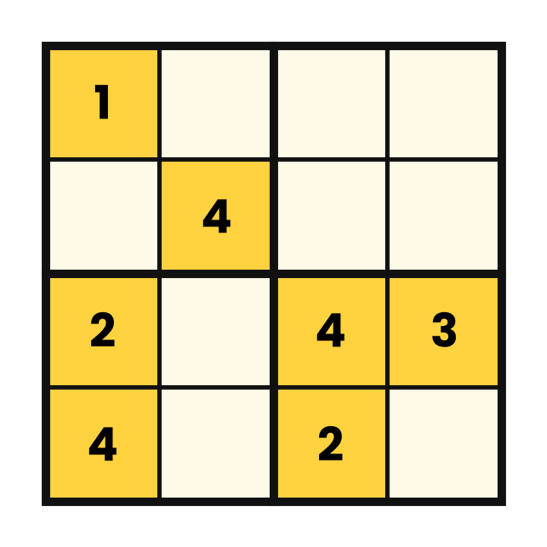
MY ANSWER: ______________________________________________
SCRATCH SPACE

16 | THE SOCK DRAWER | ★☆☆ EASY
A dark drawer holds 10 blue, 10 black and 10 white socks, all mixed up. What is the smallest number of socks you must pull out to be certain of having a matching pair?
MY ANSWER: ______________________________________________
SCRATCH SPACE

17 | SEVEN GOLD LINKS | ★★★ HARD
You hire a worker for 7 days. You pay with a 7-link gold chain, one link per day, and he returns change each day. You may cut only one link. Which link do you cut?
MY ANSWER: ______________________________________________
SCRATCH SPACE

18 | KNIGHT OR KNAVE? | ★★★ HARD
On an island, knights always tell the truth and knaves always lie. A says: 'B is a knave.' B says: 'A and I are both knights.' What are A and B?
MY ANSWER: ______________________________________________
SCRATCH SPACE

19 | AGE ORDER | ★☆☆ EASY
Ria is older than Sam. Tara is younger than Sam. Uma is older than Ria but younger than Vik. Put them in order from oldest to youngest.
MY ANSWER: ______________________________________________
SCRATCH SPACE

20 | TWENTY QUESTIONS, REALLY | ★★☆ MEDIUM
I am thinking of a whole number from 1 to 100. You may ask yes/no questions. What is the fewest questions that always guarantee you find my number?
MY ANSWER: ______________________________________________
SCRATCH SPACE

MATHEMATICAL RIDDLES | Nos. 21–40  20 puzzles
Numbers with a twist. Most have a neat trick that beats brute-force arithmetic.
21 | THE HANDSHAKE PARTY | ★☆☆ EASY
Eight guests arrive and every guest shakes hands with every other guest exactly once. How many handshakes are there?
MY ANSWER: ______________________________________________
SCRATCH SPACE

22 | NOTEBOOK AND PEN | ★☆☆ EASY
A notebook and a pen cost ₹110 together. The notebook costs ₹100 more than the pen. How much does the pen cost?
MY ANSWER: ______________________________________________
SCRATCH SPACE

23 | THE SNAIL IN THE WELL | ★★☆ MEDIUM
A snail climbs 3 metres every day and slips back 2 metres every night. The well is 10 metres deep. On which day does the snail reach the top?
MY ANSWER: ______________________________________________
SCRATCH SPACE

24 | FATHER AND SON | ★★☆ MEDIUM
A father is four times as old as his son. In 20 years he will be only twice as old. How old are they now?
MY ANSWER: ______________________________________________
SCRATCH SPACE

25 | LILY PAD LAKE | ★☆☆ EASY
A patch of lily pads doubles in size every day. It covers the whole lake on day 48. On which day did it cover half the lake?
MY ANSWER: ______________________________________________
SCRATCH SPACE

26 | GAUSS'S SHORTCUT | ★☆☆ EASY
Add all the whole numbers from 1 to 100. Can you do it without adding one by one?
MY ANSWER: ______________________________________________
SCRATCH SPACE

27 | FOUR FOURS | ★★☆ MEDIUM
Using exactly four 4s and any of + − × ÷ and brackets, make the numbers 7 and 9.
MY ANSWER: ______________________________________________
SCRATCH SPACE

28 | SMALLEST COMMON MULTIPLE | ★★★ HARD
What is the smallest positive number that can be divided exactly by every whole number from 1 to 10?
MY ANSWER: ______________________________________________
SCRATCH SPACE

29 | THE LAST DIGIT | ★★★ HARD
What is the last digit of 7 multiplied by itself 2,026 times (7 to the power 2026)?
MY ANSWER: ______________________________________________
SCRATCH SPACE

30 | THE MISSING RUPEE | ★★☆ MEDIUM
Three friends share a hotel room for ₹30 (₹10 each). The clerk realises the price is ₹25 and sends ₹5 back with a bellboy, who keeps ₹2 and gives ₹1 to each friend. Now each paid ₹9, so 3 × ₹9 = ₹27, and the bellboy has ₹2: ₹29. Where did the other rupee go?
MY ANSWER: ______________________________________________
SCRATCH SPACE

31 | CLOCK ANGLE | ★★☆ MEDIUM
What is the smaller angle between the hour and minute hands at 3:40?
MY ANSWER: ______________________________________________
SCRATCH SPACE

32 | AVERAGE SPEED | ★★☆ MEDIUM
A car drives to a town at 60 km/h and returns along the same road at 40 km/h. What is its average speed for the whole trip?
MY ANSWER: ______________________________________________
SCRATCH SPACE

33 | UP THEN DOWN | ★☆☆ EASY
A shirt's price is increased by 20%, then the new price is reduced by 20%. Is the final price the same as the original, higher or lower?
MY ANSWER: ______________________________________________
SCRATCH SPACE

34 | ONE HUNDRED LOCKERS | ★★★ HARD
A hall has 100 lockers, all closed. Person 1 toggles every locker, person 2 toggles every 2nd locker, person 3 every 3rd … up to person 100. Afterwards, how many lockers are open?
MY ANSWER: ______________________________________________
SCRATCH SPACE

35 | COIN COMBINATIONS | ★★☆ MEDIUM
In how many different ways can you pay exactly ₹10 using ₹1, ₹2 and ₹5 coins (any number of each)?
MY ANSWER: ______________________________________________
SCRATCH SPACE

36 | CONSECUTIVE SUMS | ★★★ HARD
In how many ways can 45 be written as the sum of two or more consecutive positive whole numbers? (For example 22 + 23.)
MY ANSWER: ______________________________________________
SCRATCH SPACE

37 | THE LUCKY SEVEN | ★☆☆ EASY
How many times does the digit 7 appear when you write every number from 1 to 100?
MY ANSWER: ______________________________________________
SCRATCH SPACE

38 | ONE HUNDRED DAYS | ★☆☆ EASY
Today is Sunday. What day of the week will it be exactly 100 days from now?
MY ANSWER: ______________________________________________
SCRATCH SPACE

39 | PIZZA CUTS | ★★★ HARD
What is the largest number of pieces you can cut a round pizza into using just 5 straight cuts?
MY ANSWER: ______________________________________________
SCRATCH SPACE

40 | THE MISSING DIGIT | ★☆☆ EASY
The four-digit number 4 _ 7 5 is a multiple of 9. Which digit is missing?
MY ANSWER: ______________________________________________
SCRATCH SPACE

PATTERN RECOGNITION | Nos. 41–56  16 puzzles
Find the rule hiding in the sequence, then use it to predict what comes next.
41 | GROWING GAPS | ★☆☆ EASY
2, 6, 12, 20, 30, ?
MY ANSWER: ______________________________________________
SCRATCH SPACE

42 | FAMOUS SEQUENCE | ★☆☆ EASY
1, 1, 2, 3, 5, 8, ?
MY ANSWER: ______________________________________________
SCRATCH SPACE

43 | SQUARES IN DISGUISE | ★★☆ MEDIUM
3, 6, 11, 18, 27, ?
MY ANSWER: ______________________________________________
SCRATCH SPACE

44 | SPECIAL NUMBERS | ★☆☆ EASY
2, 3, 5, 7, 11, 13, ?
MY ANSWER: ______________________________________________
SCRATCH SPACE

45 | LETTER JUMPS | ★★☆ MEDIUM
A, C, F, J, O, ?
MY ANSWER: ______________________________________________
SCRATCH SPACE

46 | BACKWARDS JUMPS | ★★☆ MEDIUM
Z, X, U, Q, L, ?
MY ANSWER: ______________________________________________
SCRATCH SPACE

47 | FACTORIAL CLIMB | ★★☆ MEDIUM
1, 2, 6, 24, 120, ?
MY ANSWER: ______________________________________________
SCRATCH SPACE

48 | TWO RULES IN ONE | ★★☆ MEDIUM
5, 10, 8, 16, 14, 28, ?
MY ANSWER: ______________________________________________
SCRATCH SPACE

49 | HIDDEN INITIALS | ★★☆ MEDIUM
O, T, T, F, F, S, S, E, N, ?
MY ANSWER: ______________________________________________
SCRATCH SPACE

50 | CALENDAR CODE | ★☆☆ EASY
J, F, M, A, M, J, J, A, S, ?
MY ANSWER: ______________________________________________
SCRATCH SPACE

51 | SAY WHAT YOU SEE | ★★★ HARD
1, 11, 21, 1211, 111221, ?
MY ANSWER: ______________________________________________
SCRATCH SPACE

52 | SQUARE AND STEP | ★★★ HARD
2, 12, 36, 80, 150, ?
MY ANSWER: ______________________________________________
SCRATCH SPACE

53 | THE NUMBER GRID | ★★☆ MEDIUM
Each row follows the same rule:
2 3 6
4 5 20
3 6 ?
MY ANSWER: ______________________________________________
SCRATCH SPACE

54 | COUNTING LIKE A COMPUTER | ★★★ HARD
1, 10, 11, 100, 101, ?
MY ANSWER: ______________________________________________
SCRATCH SPACE

55 | ARROW CLOCK | ★☆☆ EASY
An arrow points up, then right, then down. Which way does the fourth arrow point?
MY ANSWER: ______________________________________________
SCRATCH SPACE

56 | DOTS IN TRIANGLES | ★★☆ MEDIUM
Dots are stacked in triangles: 1 dot, 3 dots, 6 dots, 10 dots. How many dots are in the next triangle?
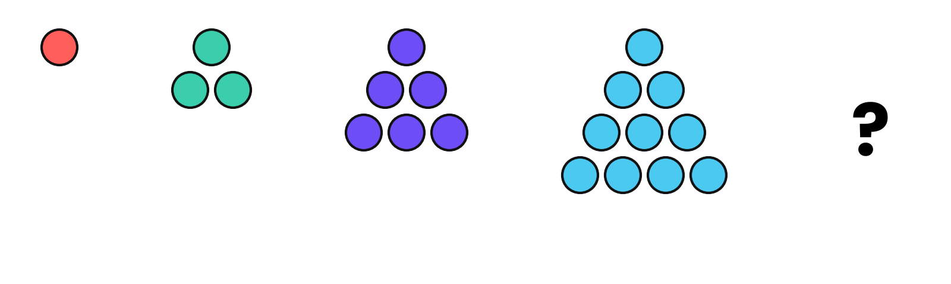
MY ANSWER: ______________________________________________
SCRATCH SPACE

WORD CHALLENGES | Nos. 57–74  18 puzzles
Riddles, ladders, codes and wordplay. Think about sounds and spellings, not only meanings.
57 | ANAGRAM ROOM | ★☆☆ EASY
Rearrange the letters of DORMITORY to make a two-word phrase describing a messy place.
MY ANSWER: ______________________________________________
SCRATCH SPACE

58 | WET BY DRYING | ★☆☆ EASY
I get wetter the more I dry. What am I?
MY ANSWER: ______________________________________________
SCRATCH SPACE

59 | HANDS, NO CLAP | ★☆☆ EASY
I have two hands but I cannot clap. I have a face but cannot smile. What am I?
MY ANSWER: ______________________________________________
SCRATCH SPACE

60 | THE TRAVELLER IN THE CORNER | ★★☆ MEDIUM
I stay in one corner, yet I travel all around the world. What am I?
MY ANSWER: ______________________________________________
SCRATCH SPACE

61 | NECK, NO HEAD | ★☆☆ EASY
I have a neck but no head, and a body of glass or plastic. What am I?
MY ANSWER: ______________________________________________
SCRATCH SPACE

62 | WORD LADDER: WARM UP | ★★☆ MEDIUM
Change COLD into WARM one letter at a time. Every step must be a real word. Use as few steps as you can.
MY ANSWER: ______________________________________________
SCRATCH SPACE

63 | WORD LADDER: HEAD TO TAIL | ★★★ HARD
Change HEAD into TAIL one letter at a time, making a real word at each step. Can you do it in five steps?
MY ANSWER: ______________________________________________
SCRATCH SPACE

64 | ODD ONE OUT | ★☆☆ EASY
Which does not belong: TIGER, LION, LEOPARD, WOLF, JAGUAR?
MY ANSWER: ______________________________________________
SCRATCH SPACE

65 | RADAR RIDDLE | ★☆☆ EASY
What five-letter word reads the same forwards and backwards, and is also a device that tracks aeroplanes?
MY ANSWER: ______________________________________________
SCRATCH SPACE

66 | PICTURE WORDS | ★★☆ MEDIUM
Each of these is a word puzzle in disguise:
1. MIND / MATTER (one above the other)
2. STAND / I (one above the other)
3. HE'S HIMSELF (side by side)
MY ANSWER: ______________________________________________
SCRATCH SPACE

67 | WORD HUNT | ★★☆ MEDIUM
Find all ten hidden words in the grid: BRAIN, LOGIC, PUZZLE, RIDDLE, PATTERN, THINK, MEMORY, FOCUS, CLUE, SOLVE. Words run across, down or diagonally, forwards or backwards.
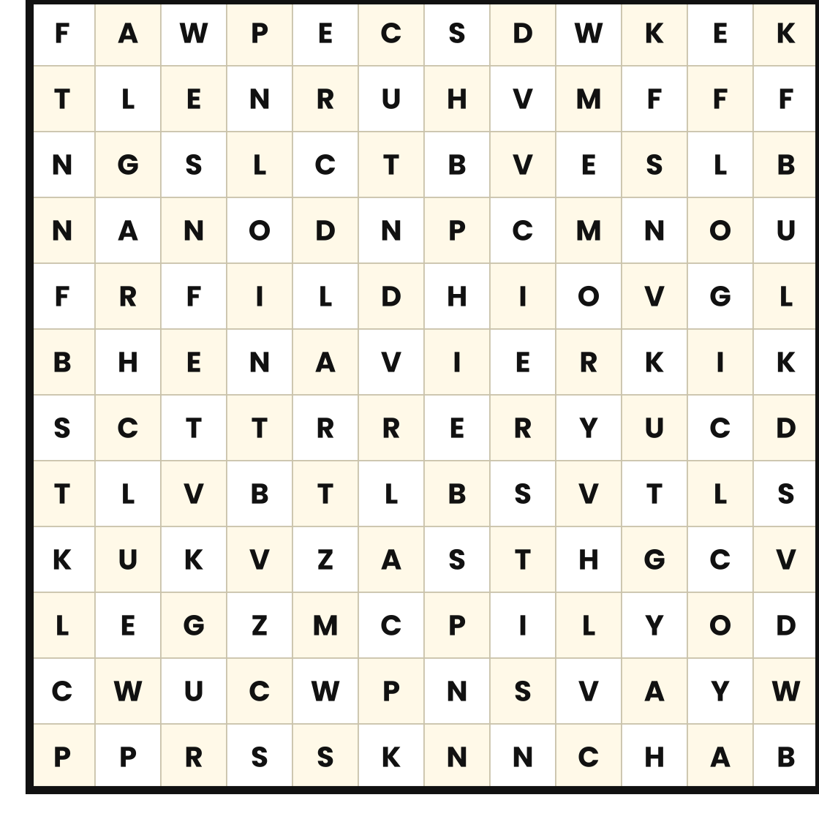
MY ANSWER: ______________________________________________

68 | SECRET MESSAGE | ★★☆ MEDIUM
A message was written by shifting every letter three places forward in the alphabet (A becomes D). Decode: WKH DQVZHU LV WZHOYH
MY ANSWER: ______________________________________________
SCRATCH SPACE

69 | THE MISSING LINK | ★★☆ MEDIUM
What one word goes with all of these: FOOT, BASKET, SNOW? And what one word completes: MOON, SUN, STAR?
MY ANSWER: ______________________________________________
SCRATCH SPACE

70 | SHRINKING WORD | ★★★ HARD
Remove one letter from STARTLING to make a new word, and keep going until one letter is left. Each step must leave a real word. Can you find the whole chain?
MY ANSWER: ______________________________________________
SCRATCH SPACE

71 | SHORTER BY ADDING | ★☆☆ EASY
Which five-letter word becomes shorter when you add two letters to it?
MY ANSWER: ______________________________________________
SCRATCH SPACE

72 | TRIPLE DOUBLE | ★★★ HARD
Which common English word has three pairs of double letters in a row?
MY ANSWER: ______________________________________________
SCRATCH SPACE

73 | MIRROR WORD | ★☆☆ EASY
What four-letter word reads the same forwards, backwards and even upside down?
MY ANSWER: ______________________________________________
SCRATCH SPACE

74 | ALWAYS WRONG | ★★☆ MEDIUM
There is one word in the English language that is always spelled 'wrong' in the dictionary. What is it?
MY ANSWER: ______________________________________________
SCRATCH SPACE

VISUAL BRAIN TEASERS | Nos. 75–90  16 puzzles
Look carefully, then look again. Trust your reasoning more than your eyes.
75 | SQUARES EVERYWHERE | ★☆☆ EASY
How many squares of any size can you find in this 4×4 grid?
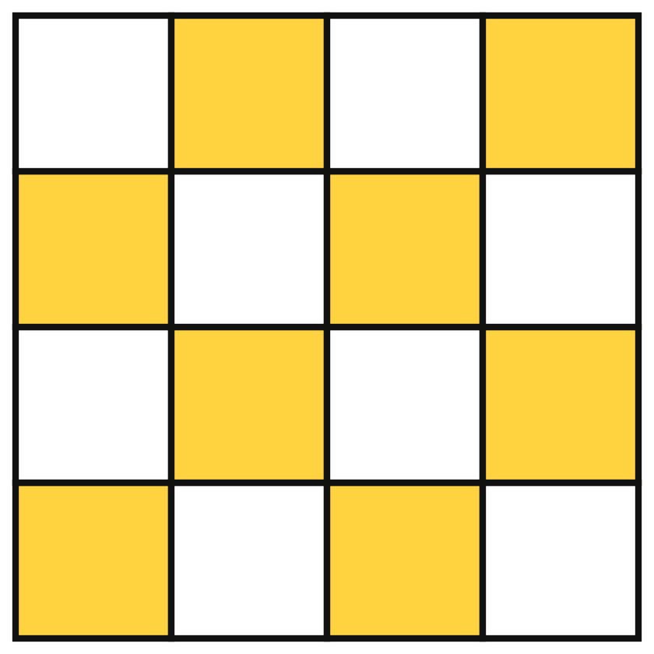
MY ANSWER: ______________________________________________
SCRATCH SPACE

76 | SLICES OF PIZZA ROOF | ★☆☆ EASY
Count every triangle in the figure, including those made of several slices.
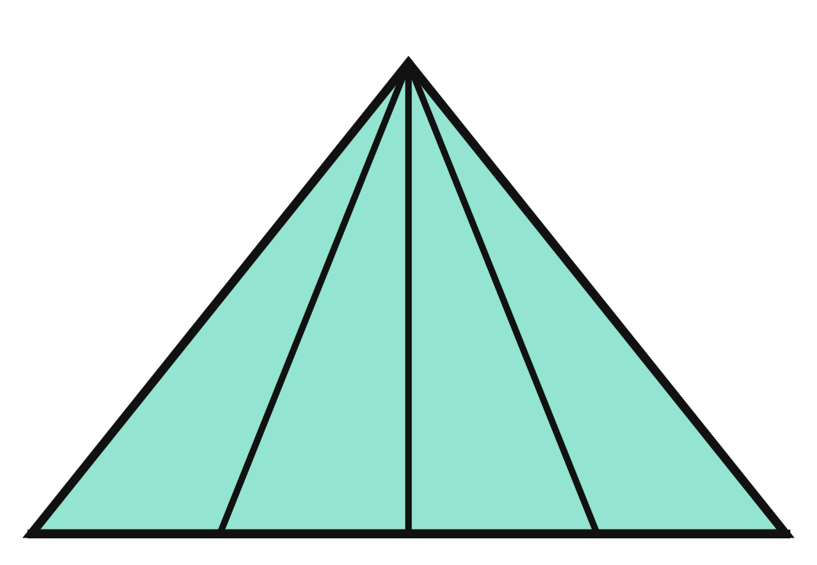
MY ANSWER: ______________________________________________
SCRATCH SPACE

77 | THE ODD F | ★★☆ MEDIUM
Five of these six tiles are the same letter F, only turned around. One has been flipped like a mirror image. Which tile number is the odd one out?
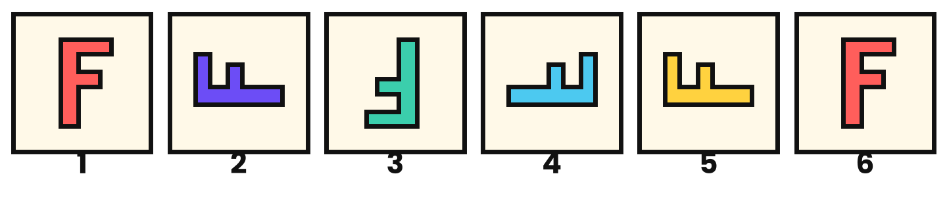
MY ANSWER: ______________________________________________
SCRATCH SPACE

78 | MISSING SHAPE | ★★☆ MEDIUM
Each row and each column contains every shape once and every colour once. What belongs in the empty square?
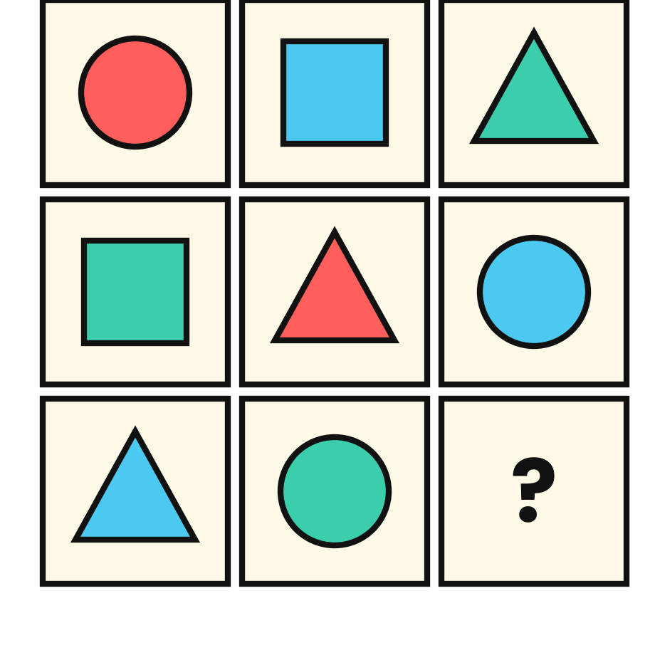
MY ANSWER: ______________________________________________
SCRATCH SPACE

79 | THE MIRROR CLOCK | ★★☆ MEDIUM
You see this clock in a mirror. What is the real time?
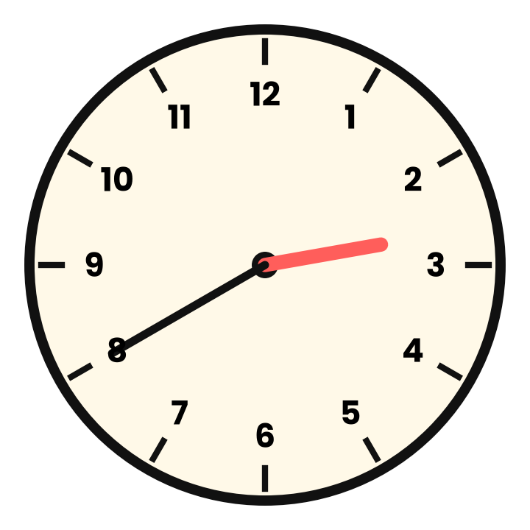
MY ANSWER: ______________________________________________
SCRATCH SPACE

80 | EXIT THE MAZE | ★★☆ MEDIUM
Find a path from START (top left) to EXIT (bottom right). There is only one route that never doubles back.
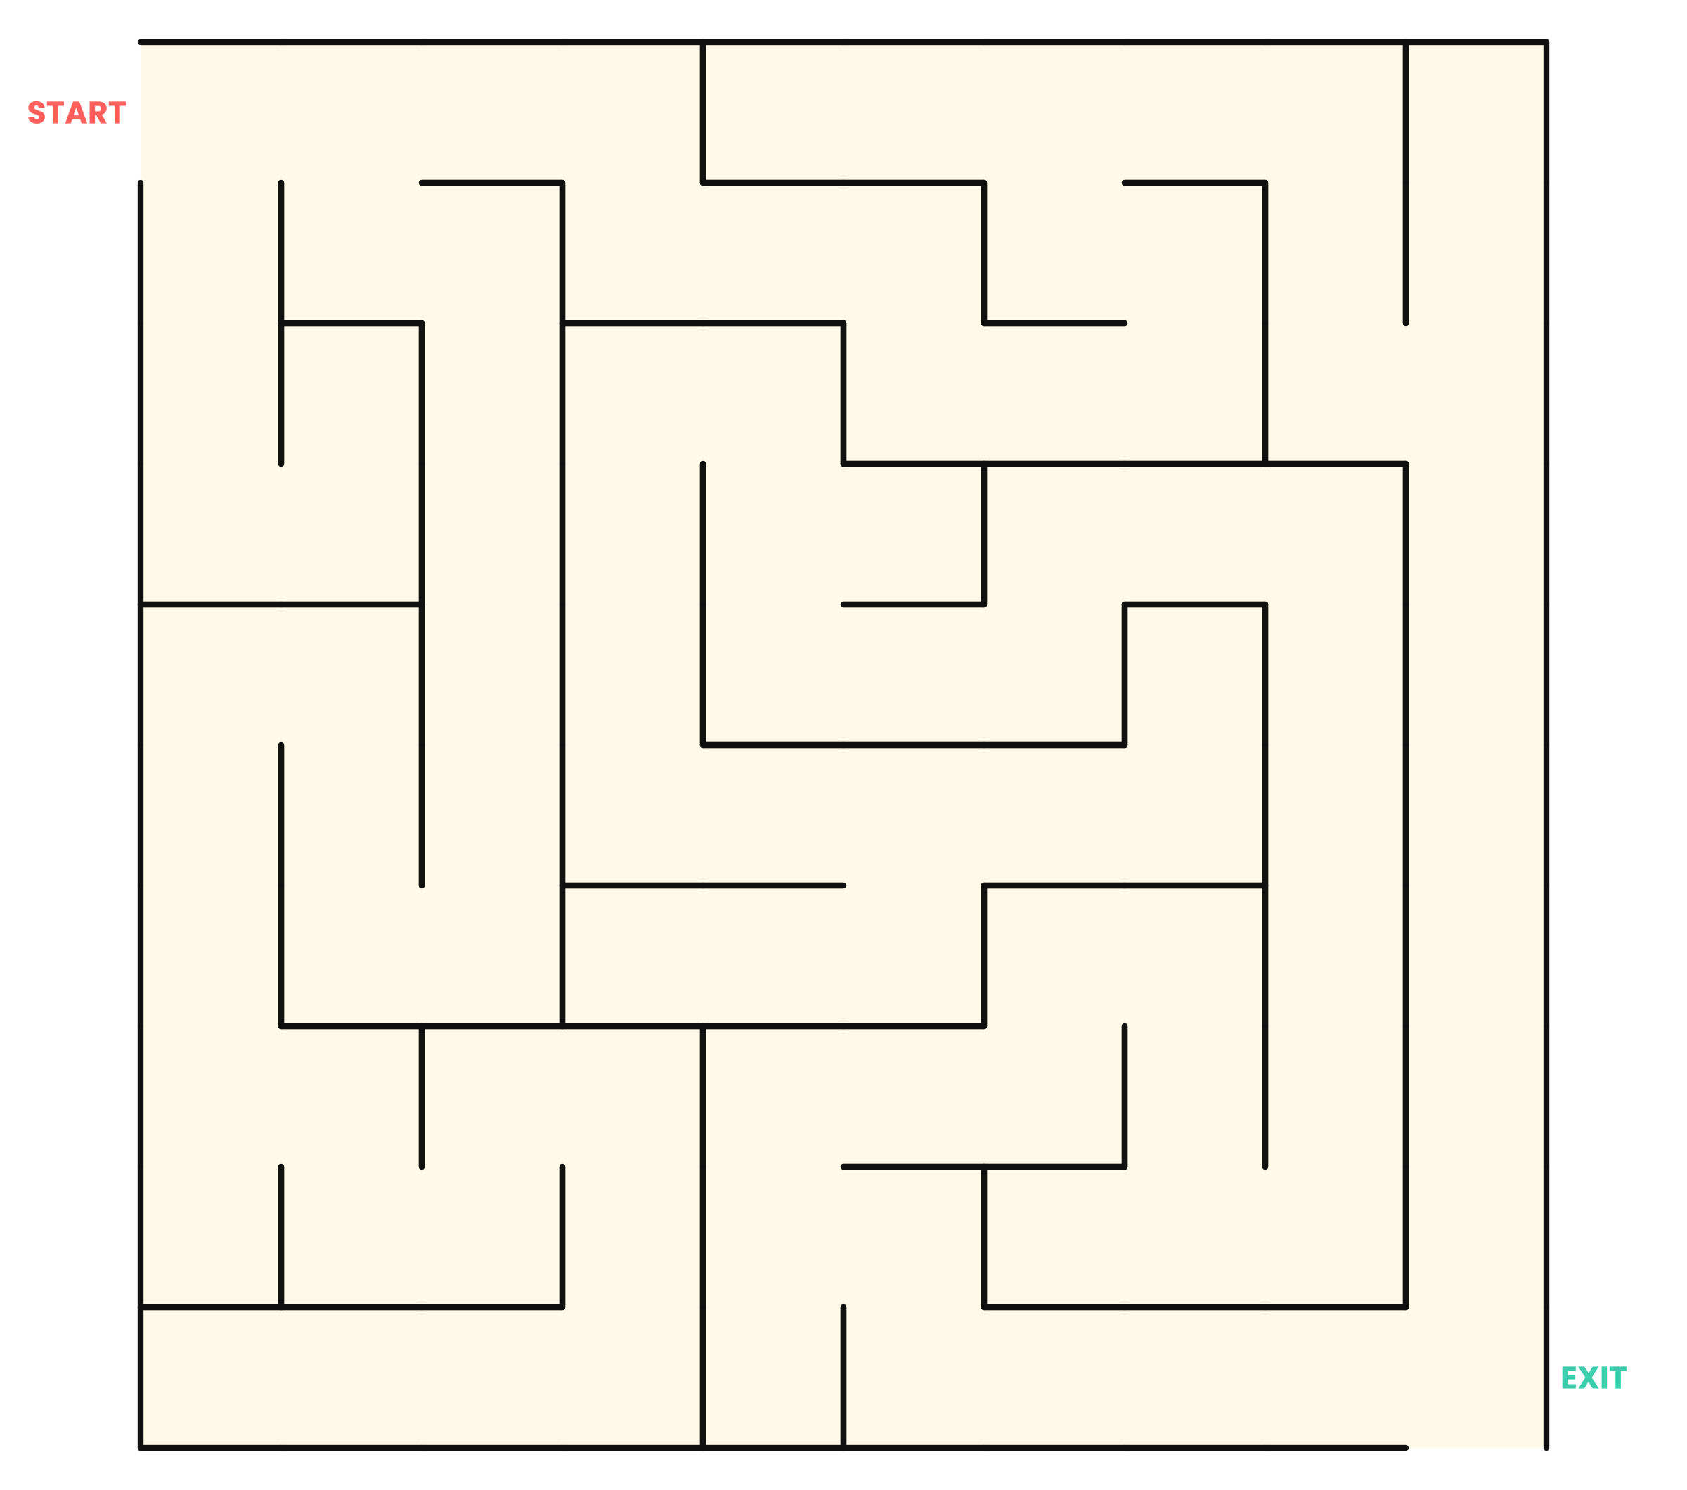
MY ANSWER: ______________________________________________

81 | THREE CIRCLES | ★☆☆ EASY
Three circles overlap as shown. Into how many separate regions do they divide the plane inside the circles?
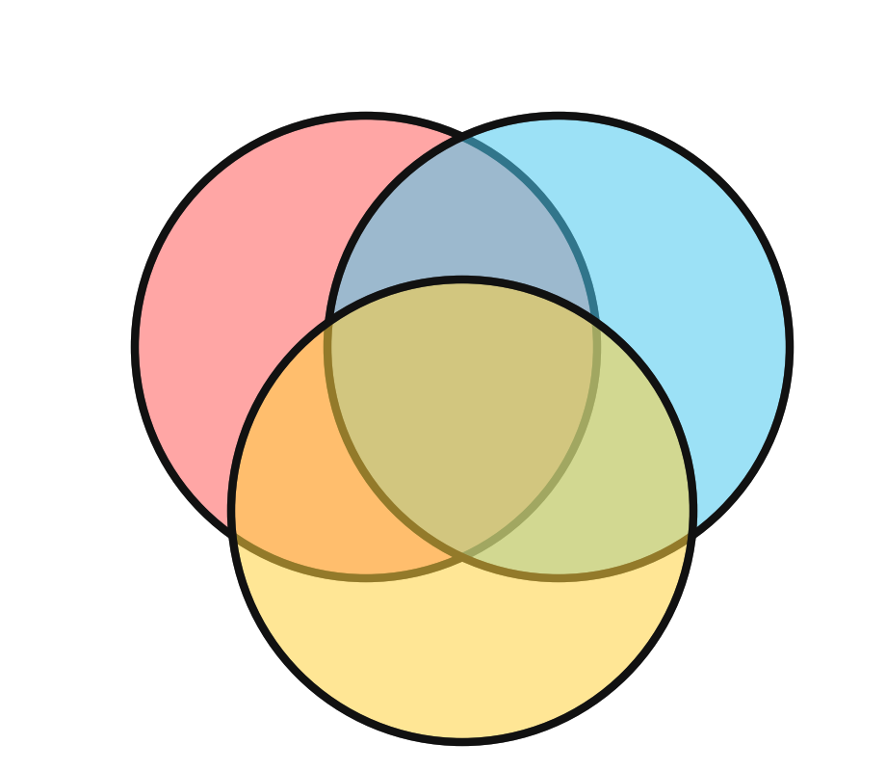
MY ANSWER: ______________________________________________
SCRATCH SPACE

82 | ONE STROKE ENVELOPE | ★★★ HARD
Can you draw this envelope without lifting your pencil and without going over any line twice? If yes, where must you start?
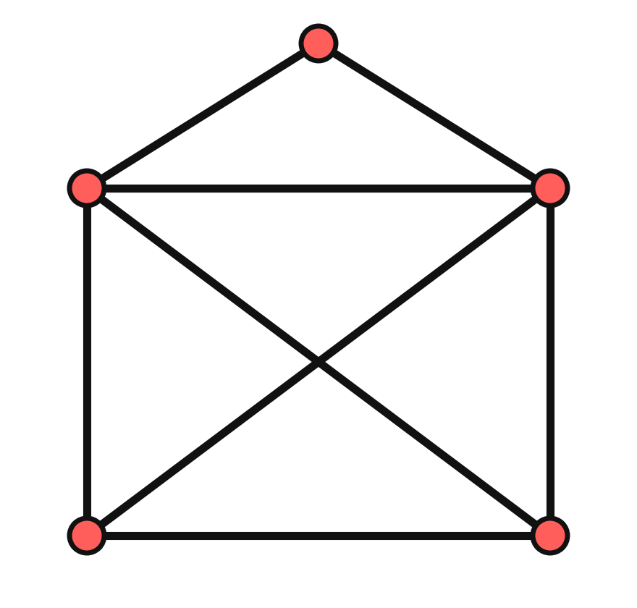
MY ANSWER: ______________________________________________
SCRATCH SPACE

83 | DOMINOES ON A CHESSBOARD | ★★★ HARD
Two opposite corners are removed from a chessboard. Can the remaining 62 squares be covered by 31 dominoes, each covering two touching squares?
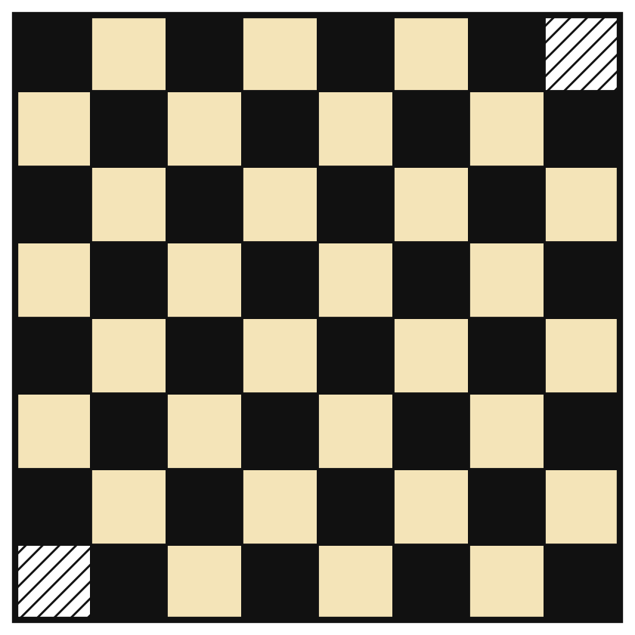
MY ANSWER: ______________________________________________
SCRATCH SPACE

84 | WHICH LINE IS LONGER? | ★☆☆ EASY
Compare line A (outward arrowheads) with line B (inward arrowheads). Which is longer?
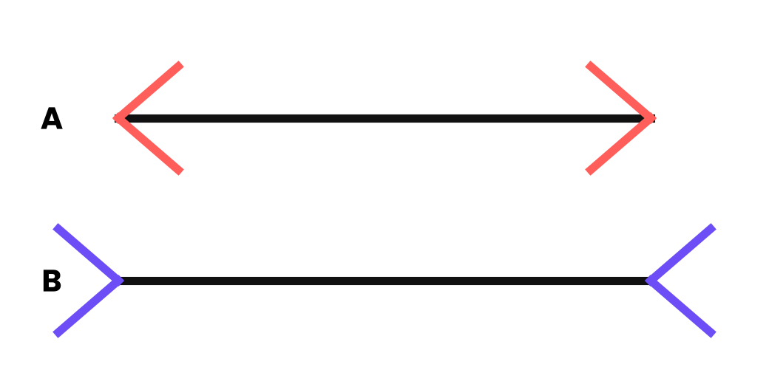
MY ANSWER: ______________________________________________
SCRATCH SPACE

85 | CUBE COUNT | ★★☆ MEDIUM
This pile of identical cubes rests on the floor with no hidden gaps. How many cubes are there in total?
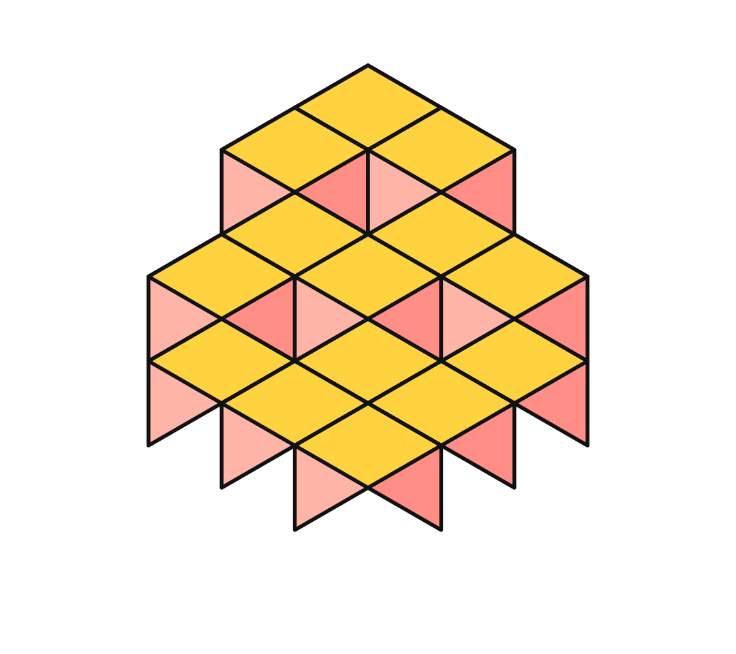
MY ANSWER: ______________________________________________
SCRATCH SPACE

86 | STAR TRIANGLES | ★★☆ MEDIUM
How many triangles of any size can you find in this six-pointed star?

MY ANSWER: ______________________________________________
SCRATCH SPACE

87 | MAGIC SQUARE | ★★☆ MEDIUM
Fill the 3×3 grid with 1 to 9, each used once, so that every row, column and long diagonal adds to 15.
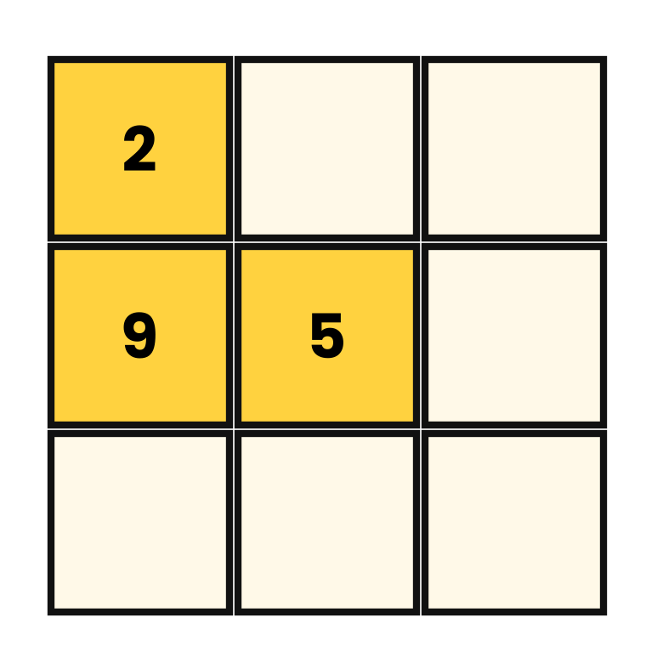
MY ANSWER: ______________________________________________
SCRATCH SPACE

88 | FLIP THE TRIANGLE | ★★★ HARD
Ten coins form a triangle pointing up. Move only three coins so that the triangle points down.
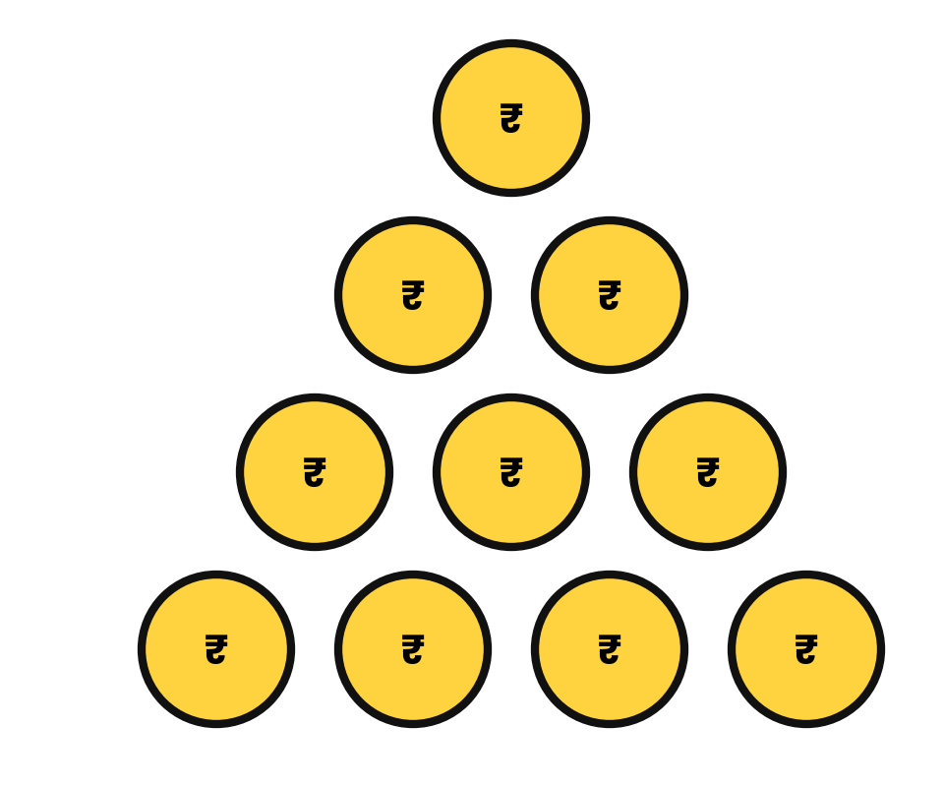
MY ANSWER: ______________________________________________
SCRATCH SPACE

89 | RECTANGLES COUNT | ★★☆ MEDIUM
How many rectangles of any size (squares count) can be traced along the lines of this 3-by-2 grid?
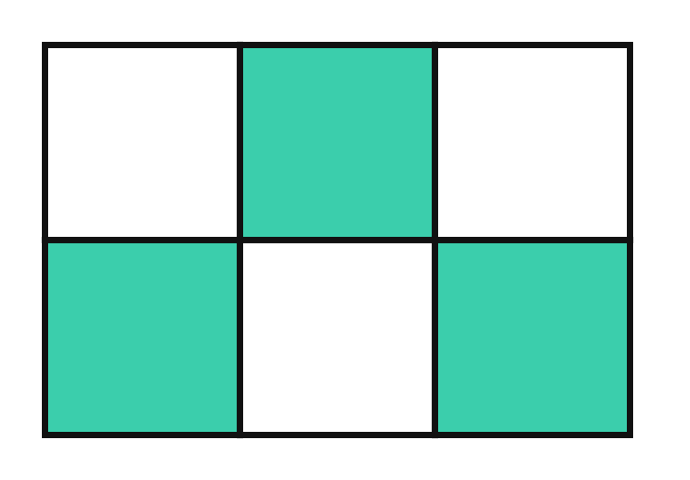
MY ANSWER: ______________________________________________
SCRATCH SPACE

90 | CITY ROUTES | ★★★ HARD
You walk from A (bottom left) to B (top right), moving only right or up along the grid lines. How many different routes are there?
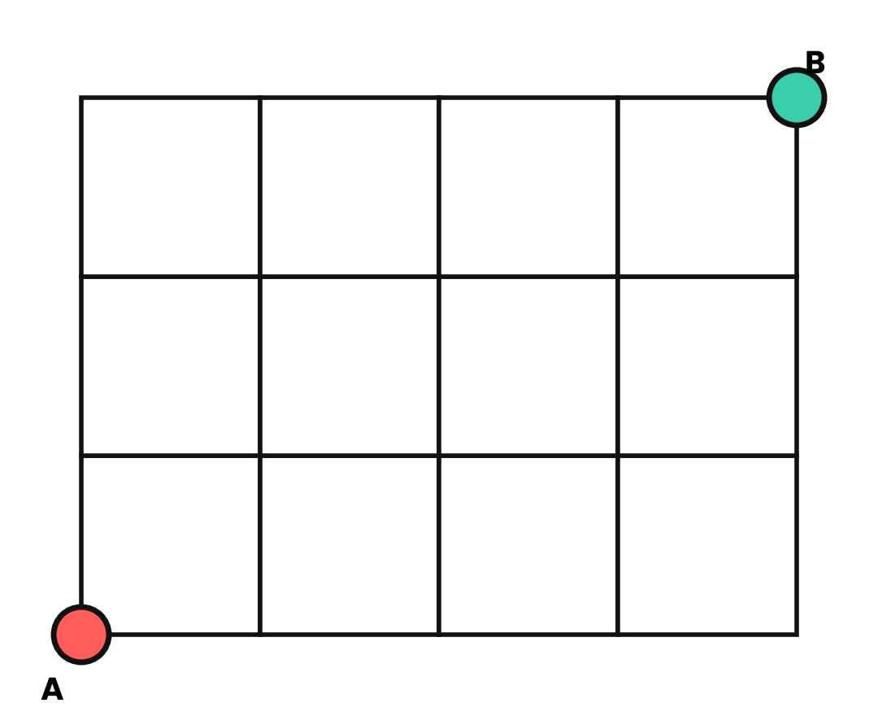
MY ANSWER: ______________________________________________
SCRATCH SPACE

THE FINAL TEN | Nos. 91–100  10 puzzles
The boss level. Famous paradoxes and classic head-scratchers, hardest of all.
91 | THE MONTY HALL DOOR | ★★★ HARD
You pick one of three doors; a car is behind one, goats behind the others. The host, who knows where the car is, opens a different door showing a goat and offers a swap. Should you swap, and what are your odds?
MY ANSWER: ______________________________________________
SCRATCH SPACE

92 | THE BIRTHDAY SURPRISE | ★★★ HARD
How many people must be in a room before it is more likely than not that two share a birthday? (Ignore leap years.)
MY ANSWER: ______________________________________________
SCRATCH SPACE

93 | TWO CHILDREN | ★★★ HARD
A family has two children. At least one is a boy. What is the probability that both are boys?
MY ANSWER: ______________________________________________
SCRATCH SPACE

94 | TWO EGGS, 100 FLOORS | ★★★ HARD
An egg breaks if dropped from floor N or higher of a 100-floor building, and survives lower drops. With only two eggs, what is the fewest drops that always finds N?
MY ANSWER: ______________________________________________
SCRATCH SPACE

95 | EIGHT SLICES | ★★☆ MEDIUM
What is the greatest number of pieces you can cut a round cake into using three straight cuts (the cake is a solid cylinder)?
MY ANSWER: ______________________________________________
SCRATCH SPACE

96 | THE CIRCLE OF FATE | ★★★ HARD
100 people stand in a circle, numbered 1 to 100. Starting with 1, every second person is removed (2, 4, 6 …) and counting continues around the circle. Who is the last person standing?
MY ANSWER: ______________________________________________
SCRATCH SPACE

97 | ROPE AROUND THE EARTH | ★★★ HARD
A rope is tied tightly around the Earth's equator (about 40,000 km). Add 1 metre to the rope and lift it evenly all around. About how high does the gap become?
MY ANSWER: ______________________________________________
SCRATCH SPACE

98 | BRIDGE IN THE DARK | ★★★ HARD
Four people must cross a bridge at night. They take 1, 2, 5 and 10 minutes. They have one torch, the bridge holds two people at a time, and a pair walks at the slower person's pace. What is the shortest total time?
MY ANSWER: ______________________________________________
SCRATCH SPACE

99 | BLINDFOLDED COINS | ★★★ HARD
In total darkness you are given 100 coins. Exactly 10 are heads up. You cannot feel or see which, but you can move and flip coins. How do you split them into two piles with the same number of heads?
MY ANSWER: ______________________________________________
SCRATCH SPACE

100 | THREE ANTS | ★★★ HARD
Three ants sit at the corners of a triangle. Each picks a direction along an edge at random and walks. What is the probability that no two ants collide?
MY ANSWER: ______________________________________________
SCRATCH SPACE

BONUS ROUND | 10  RIDDLES
Ten lightning riddles for a quick warm-up. No scoring, just fun. Answers are at the bottom of the page.
1 | What has keys but cannot open a single lock?  Answer: ____________________________
2 | What gets bigger the more you take away from it?  Answer: ____________________________
3 | I have cities but no houses, forests but no trees, and water but no fish. What am I?  Answer: ____________________________
4 | What comes once in a minute, twice in a moment, but never in a thousand years?  Answer: ____________________________
5 | What has a head and a tail but no body?  Answer: ____________________________
6 | The more of me there is, the less you can see. What am I?  Answer: ____________________________
7 | What goes up when the rain comes down?  Answer: ____________________________
8 | What has many teeth but cannot bite?  Answer: ____________________________
9 | If you have me, you want to share me. If you share me, you no longer have me. What am I?  Answer: ____________________________
10 | What is full of holes but still holds water?  Answer: ____________________________

ANSWERS: 1. A piano (or a keyboard) 2. A hole 3. A map 4. The letter M 5. A coin 6. Darkness 7. An umbrella 8. A comb 9. A secret 10. A sponge

PUZZLE LAB | YOUR  TURN
The best way to master puzzles is to invent one. Build your own and challenge a friend.
1  PICK A TRICK  Choose one idea: a pattern, a twist in wording, a counting trap or a logic chain. | 2  WRITE THE PUZZLE  Start from the answer and build backwards. Make every word necessary. | 3  TEST IT  Give it to a friend. If they solve it too fast or not at all, adjust and try again.

MY RIDDLE OR WORD PUZZLE
Puzzle:

MY NUMBER OR PATTERN PUZZLE
Puzzle:

MY ANSWER AND EXPLANATION | DIFFICULTY (CIRCLE ONE)  ★☆☆ ★★☆ ★★★

HINT VAULT | 100  HINTS
Stuck? Read only the hint for the puzzle you are on. Peeking at other hints will spoil the fun.

LOGIC PUZZLES
1. Which label tells you the most, once you know it is false?
2. Make the question about what the other guard would say.
3. Start with the person who has the most 'not' clues.
4. Chain the clues: who is ahead of whom?
5. A bulb can give you two kinds of evidence, not just light.
6. Items can travel back too.
7. Test one person's honesty and follow the chain.
8. Do not weigh four against four. Try groups of three.
9. One rope can be lit at both ends.
10. Use the 3-litre jug as a measuring spoon.
11. Count how many statements can be false at once.
12. Where can Mira sit? Then place Nikhil.
13. Step forward one day at a time from Wednesday.
14. You are looking for a card that could break the rule.
15. Find a cell where only one digit can fit.
16. Think about the worst possible luck.
17. Aim for pieces of size 1, 2 and 4.
18. Assume B is a knight and see what breaks.
19. Build one long chain of '>' signs.
20. Each question can halve the possibilities.
MATHEMATICAL RIDDLES
21. Each person shakes 7 hands, but a handshake involves two people.
22. The answer is not ₹10.
23. Look at the last day separately: it does not slip back.
24. Let the son's age be x and write both ages after 20 years.
25. Work backwards.
26. Pair the first number with the last.
27. Division of 4 by 4 gives 1.
28. Use the highest power of each prime.
29. The last digits of the powers of 7 repeat.
30. Is it right to add the bellboy's ₹2 to the ₹27?
31. The hour hand has moved past the 3.
32. Compare the times, not the speeds.
33. Take ₹1,000 as the starting price.
34. Which numbers have an odd number of factors?
35. Count by the number of ₹5 coins: 0, 1 or 2.
36. The count relates to odd divisors of 45.
37. Count units digits and tens digits separately.
38. Weeks repeat every 7 days.
39. Each new cut should cross all the old ones, at new points.
40. A number is a multiple of 9 when its digits add up to a multiple of 9.
PATTERN RECOGNITION
41. Look at the differences between neighbours.
42. Each term depends on the two before it.
43. Compare each term with a perfect square.
44. These numbers have exactly two factors.
45. Count how many letters you jump each time.
46. This time you move backwards.
47. Each term is the previous term times a growing number.
48. Two operations alternate.
49. These letters are the first letters of something you count.
50. Think of twelve things in a year.
51. Read each term out loud and describe it.
52. Each term is a square multiplied by the next whole number.
53. Compare the first two numbers with the third.
54. Computers count in base 2.
55. Which way does it turn each time?
56. Add a new row each time.
WORD CHALLENGES
57. The second word is where you might sleep.
58. You use me after a shower.
59. I tell you something important every day.
60. I am found in the top corner of an envelope.
61. You open me to drink.
62. The first change is in the middle of the word.
63. The words HEAL and TELL appear on the way.
64. Think about the animal family.
65. It begins with R.
66. Think about the position of the words.
67. Hunt for the rare letters first, such as Z.
68. Shift every letter back by three.
69. Add the same word to the end of each.
70. The first letter to go is an L.
71. Think of an adjective.
72. It describes a person who keeps accounts.
73. It describes midday.
74. The answer is hiding in the question.
VISUAL BRAIN TEASERS
75. Count by size: 1×1, 2×2, 3×3, 4×4.
76. Every triangle needs the top point and two points on the base.
77. Rotate each tile in your head until its long bar points up.
78. Do shapes and colours separately.
79. Reflect the picture left to right.
80. Work backwards from the exit.
81. Count the overlaps as well as the single parts.
82. Count how many lines meet at each dot.
83. Colour matters.
84. Do not trust your eyes. Trust a ruler.
85. Count by columns. Each column is a stack.
86. Six small points, plus two big triangles.
87. The centre of a 3×3 magic square is always 5.
88. The top coin and the two bottom corners are the ones that matter.
89. Choose two vertical and two horizontal lines.
90. Every route has 4 rights and 3 ups. Where do the ups go?
THE FINAL TEN
91. Your first pick is right only one time in three.
92. The answer is far smaller than you expect. Count pairs, not people.
93. List the equally likely combinations.
94. Make each extra drop one step shorter than the last.
95. Cuts do not have to be vertical.
96. Try small circles first and look for the power of 2.
97. The Earth's size does not matter. Use C = 2πr.
98. The two slowest should cross together.
99. Make the small pile a mirror image of what is left.
100. They avoid collision only if all walk the same way round.

ANSWER KEY | 100  ANSWERS
Every solution is explained, because the reasoning matters more than the result.

LOGIC PUZZLES
1 THE MISLABELLED JARS
Pick the jar labelled MIXED.
That label is wrong, so the jar is pure. Say the scoop is tea: then it is the TEA jar. The jar labelled COFFEE cannot be coffee (wrong label) or tea (taken), so it is MIXED, and the jar labelled TEA must be COFFEE.
2 TWO GUARDS, TWO DOORS
Ask either guard: 'Which door would the other guard say leads to freedom?' Then take the opposite door.
The truthful guard honestly reports the liar's wrong answer. The liar lies about the truthful guard's right answer. Either way you are pointed to the trap, so choose the other door.
3 WHO OWNS WHAT?
Arun: cat. Bala: parrot. Chitra: dog.
Arun has only one choice left: the cat. Chitra cannot have the parrot or the cat, so she has the dog, leaving the parrot for Bala.
4 RACE DAY
1 Chitra, 2 Dev, 3 Asha, 4 Bharat, 5 Esha.
Chitra, Asha, Bharat, Esha must appear in that order, with Esha right after Bharat. Dev takes second place, which forces the rest into places 1, 3, 4 and 5.
5 THREE SWITCHES
Switch 1 on for ten minutes, then off. Switch 2 on, then enter. The lit bulb is switch 2. The warm, dark bulb is switch 1. The cold, dark bulb is switch 3.
Light tells you about one switch; heat tells you about another. Using both gives three distinct outcomes for three bulbs.
6 FOX, GOAT AND GRASS
Take goat over. Return. Take tiger over, bring goat back. Take grass over. Return. Take goat over. (7 crossings.)
The goat is the problem item, so it must never be left with either of the others. Bringing the goat back once separates the dangerous pairs.
7 WHO IS LYING?
Only Ravi tells the truth.
If Sana were truthful, Dev and Ravi both lie, but then Dev's claim 'Ravi is lying' would be true, a contradiction. So Sana lies, which makes Ravi truthful, which makes Dev's statement false.
8 EIGHT COINS, TWO WEIGHINGS
Weigh 3 against 3. If they balance, the heavy coin is among the 2 left: weigh them against each other. If not, take the heavier 3 and weigh 1 against 1: the heavier is it, or if they balance it is the third.
Each weighing has three outcomes (left, right, balance), so two weighings distinguish up to 3 × 3 = 9 coins.
9 TWO ROPES
Light rope A at both ends and rope B at one end. When A burns out (30 min), light B's other end. B burns out 15 minutes later: 45 min.
Lighting both ends halves the time, whatever the uneven burning. At 30 minutes B has 30 minutes of burn left; lit from both ends it finishes in 15.
10 THE JUG TRICK
Fill the 5L jug, pour into the 3L jug (2L stays). Empty the 3L jug and pour the 2L into it. Fill the 5L jug again and top up the 3L jug (needs 1L). 4L remain in the 5L jug.
The key is leaving exactly 2 litres behind, then topping a jug that already holds 2 so it takes only 1 more.
11 HOW MANY ARE FALSE?
Only B is true.
Exactly one statement can be correct about the count. If A were true, one is false, but B and C would then both be false: two false. If C were true, all three would be false. Only 'two false' fits.
12 FOUR IN A ROW
Nikhil, Mira, Priya, Omar.
Mira is in seat 2 or 3. If she is in seat 3, Nikhil is in seat 2, and Omar and Priya could not be neighbours. So Mira is in seat 2, Nikhil in 1, and Priya and Omar fill seats 3 and 4.
13 YESTERDAY AND TOMORROW
Sunday.
Wednesday → yesterday is Thursday → today is Friday → tomorrow is Saturday → the day after tomorrow is Sunday.
14 FOUR CARDS
Flip E and 7.
E must be checked (an odd number behind it would break the rule). 7 must be checked (a vowel behind it would break the rule). K and 4 cannot disprove the rule.
15 MINI SUDOKU
Row 1: 1 2 3 4 Row 2: 3 4 1 2 Row 3: 2 1 4 3 Row 4: 4 3 2 1
Start with the cell that has three neighbours already filled; each placement then forces the next.
16 THE SOCK DRAWER
Four socks.
In the worst case your first three socks are three different colours. The fourth must match one of them.
17 SEVEN GOLD LINKS
Cut the third link, making pieces of 1, 2 and 4 links.
Pieces 1, 2, 4 can pay any amount from 1 to 7: day 1 give 1; day 2 give 2, take back 1; day 3 give 1; day 4 give 4, take back 1 and 2; and so on.
18 KNIGHT OR KNAVE?
A is a knight; B is a knave.
If B were a knight, both would be knights, so A's claim 'B is a knave' would be false, a contradiction. So B lies, and A's statement about B is true.
19 AGE ORDER
Vik, Uma, Ria, Sam, Tara.
Vik > Uma > Ria > Sam > Tara. Each clue gives one link of the chain.
20 TWENTY QUESTIONS, REALLY
Seven questions.
Each question at best halves the options: 100 → 50 → 25 → 13 → 7 → 4 → 2 → 1. Six questions only distinguish 64 numbers; seven distinguish 128.
MATHEMATICAL RIDDLES
21 THE HANDSHAKE PARTY
28 handshakes.
8 × 7 = 56 counts each handshake twice, so 56 ÷ 2 = 28.
22 NOTEBOOK AND PEN
₹5.
If the pen is ₹5, the notebook is ₹105 and together they cost ₹110. If the pen were ₹10, the notebook would be ₹110 and the total ₹120.
23 THE SNAIL IN THE WELL
Day 8.
Each full day-night cycle gains 1 metre, so after 7 days the snail is at 7 m. On day 8 it climbs 3 m and reaches 10 m before nightfall.
24 FATHER AND SON
Son 10, father 40.
4x + 20 = 2(x + 20) gives 2x = 20, so x = 10. In 20 years: 60 and 30.
25 LILY PAD LAKE
Day 47.
If it doubles each day, the day before the full lake it was exactly half.
26 GAUSS'S SHORTCUT
5,050.
Pair 1 + 100, 2 + 99, 3 + 98 … There are 50 pairs, each summing to 101: 50 × 101 = 5,050.
27 FOUR FOURS
7 = 4 + 4 − 4÷4. 9 = 4 + 4 + 4÷4.
4 ÷ 4 = 1, so adding or subtracting it from 4 + 4 = 8 gives 9 or 7.
28 SMALLEST COMMON MULTIPLE
2,520.
Take the largest prime powers up to 10: 2³ × 3² × 5 × 7 = 8 × 9 × 5 × 7 = 2,520.
29 THE LAST DIGIT
9.
The last digits of 7, 49, 343, 2401 … go 7, 9, 3, 1 and repeat every 4 steps. 2,026 ÷ 4 leaves remainder 2, which matches the second entry: 9.
30 THE MISSING RUPEE
Nothing is missing: the ₹2 should be subtracted, not added.
The friends paid ₹27, which already includes the ₹2 the bellboy kept: ₹25 for the room + ₹2 for the bellboy. Adding ₹2 again is the trick.
31 CLOCK ANGLE
130 degrees.
At 3:40 the minute hand is at 240°. The hour hand is at 3 × 30 + 40 × 0.5 = 110°. The difference is 130°.
32 AVERAGE SPEED
48 km/h.
For a 120 km road each way: 2 h + 3 h = 5 h for 240 km, giving 48 km/h. The slower leg takes more time, so it counts for more.
33 UP THEN DOWN
Lower: 4% lower.
₹1,000 up 20% is ₹1,200. Down 20% of ₹1,200 is ₹240, leaving ₹960. The second percentage applies to a bigger number.
34 ONE HUNDRED LOCKERS
10 lockers (numbers 1, 4, 9, …, 100).
A locker is toggled once for each of its factors. Factors come in pairs, except for perfect squares, so only squares are toggled an odd number of times: 10 squares up to 100.
35 COIN COMBINATIONS
10 ways.
With no ₹5: ₹10 from 1s and 2s gives 6 ways. With one ₹5: ₹5 remains, giving 3 ways. With two ₹5 coins: 1 way. Total 10.
36 CONSECUTIVE SUMS
5 ways: 22+23, 14+15+16, 7+8+9+10+11, 5+6+7+8+9+10, 1+2+…+9.
45 has odd divisors 1, 3, 5, 9, 15, 45. Each divisor except 1 gives a valid run of consecutive numbers, giving 5 sums of at least two terms.
37 THE LUCKY SEVEN
20 times.
Ten numbers end in 7 (7, 17 … 97) and ten have 7 as the tens digit (70 … 79). The number 77 counts twice: 10 + 10 = 20.
38 ONE HUNDRED DAYS
Tuesday.
100 = 14 × 7 + 2. After 98 days it is Sunday again, and two more days make it Tuesday.
39 PIZZA CUTS
16 pieces.
With n cuts the maximum is n(n + 1)/2 + 1. For n = 5: 15 + 1 = 16. Each new cut adds as many pieces as lines it crosses plus one.
40 THE MISSING DIGIT
2 (the number is 4,275).
4 + 7 + 5 = 16. The next multiple of 9 is 18, so the missing digit is 2. Check: 4,275 ÷ 9 = 475.
PATTERN RECOGNITION
41 GROWING GAPS
42
The gaps are 4, 6, 8, 10, so the next gap is 12: 30 + 12 = 42. (Each term is n × (n + 1).)
42 FAMOUS SEQUENCE
13
Each number is the sum of the previous two (Fibonacci): 5 + 8 = 13.
43 SQUARES IN DISGUISE
38
The terms are 1²+2, 2²+2, 3²+2, 4²+2, 5²+2, so the next is 6²+2 = 38.
44 SPECIAL NUMBERS
17
These are the prime numbers. The next prime after 13 is 17.
45 LETTER JUMPS
U
The jumps are +2, +3, +4, +5, so the next is +6: O (15) → U (21).
46 BACKWARDS JUMPS
F
The backward jumps are 2, 3, 4, 5, then 6: L (12) − 6 = 6 = F.
47 FACTORIAL CLIMB
720
The multipliers are 2, 3, 4, 5 and then 6: 120 × 6 = 720. (These are factorials.)
48 TWO RULES IN ONE
26
The rule alternates ×2 and −2: 5×2 = 10, −2 = 8, ×2 = 16, −2 = 14, ×2 = 28, −2 = 26.
49 HIDDEN INITIALS
T
They are the first letters of One, Two, Three, Four, Five, Six, Seven, Eight, Nine, so the next is Ten: T.
50 CALENDAR CODE
O
The first letters of the months: January … September, so October comes next: O.
51 SAY WHAT YOU SEE
312211
Each term describes the previous one: '111221' is three 1s, two 2s, one 1 → 312211.
52 SQUARE AND STEP
252
The terms are 1²×2, 2²×3, 3²×4, 4²×5, 5²×6, so the next is 6²×7 = 252.
53 THE NUMBER GRID
18
In each row the third number is the product of the first two: 2×3 = 6, 4×5 = 20, 3×6 = 18.
54 COUNTING LIKE A COMPUTER
110
These are 1, 2, 3, 4, 5 written in binary, so the next is 6, which is 110.
55 ARROW CLOCK
Left.
The arrow rotates a quarter turn clockwise each time: up → right → down → left.
56 DOTS IN TRIANGLES
15 dots.
Each triangle adds a new row one dot longer: 1, +2, +3, +4, so the next adds 5 dots: 10 + 5 = 15.
WORD CHALLENGES
57 ANAGRAM ROOM
DIRTY ROOM.
DORMITORY and DIRTYROOM both use the letters D, I, M, O, O, R, R, T, Y.
58 WET BY DRYING
A towel.
A towel dries you by taking the water onto itself, so it becomes wetter.
59 HANDS, NO CLAP
A clock.
A clock has an hour hand and minute hand, a face, but no body.
60 THE TRAVELLER IN THE CORNER
A postage stamp.
The stamp stays stuck in the corner of the envelope while the envelope makes the journey.
61 NECK, NO HEAD
A bottle.
A bottle has a neck and a body but no head.
62 WORD LADDER: WARM UP
COLD → CORD → CARD → WARD → WARM (4 steps).
Each word differs from the one before in exactly one letter: L→R, O→A, C→W, D→M.
63 WORD LADDER: HEAD TO TAIL
HEAD → HEAL → TEAL → TELL → TALL → TAIL.
One letter changes each time: D→L, H→T, A→L, E→A, L→I.
64 ODD ONE OUT
WOLF.
Tiger, lion, leopard and jaguar are big cats. A wolf is a member of the dog family.
65 RADAR RIDDLE
RADAR.
RADAR is a palindrome: R-A-D-A-R reads the same in both directions.
66 PICTURE WORDS
1. Mind over matter. 2. I understand. 3. He's beside himself.
In puzzle 1, MIND sits over MATTER. In 2, I is under STAND. In 3, HE'S is beside HIMSELF.
67 WORD HUNT
All ten words are listed in the explanation below, as (row, column) start and end, counting from the top left.
Positions: PATTERN (10,7) to (4,1); PUZZLE (12,2) to (7,7); RIDDLE (7,8) to (2,3); MEMORY (2,9) to (7,9); BRAIN (8,7) to (4,3); LOGIC (3,11) to (7,11); THINK (8,10) to (12,6); FOCUS (5,3) to (1,7); SOLVE (3,3) to (7,7); CLUE (7,2) to (10,2).
68 SECRET MESSAGE
THE ANSWER IS TWELVE.
This is a Caesar cipher: W→T, K→H, H→E, D→A, Q→N, V→S, Z→W, H→E, U→R, and so on.
69 THE MISSING LINK
BALL (football, basketball, snowball). LIGHT (moonlight, sunlight, starlight).
Each answer forms a new compound word when added after every word in the list.
70 SHRINKING WORD
STARTLING → STARTING → STARING → STRING → STING → SING → SIN → IN → I.
Each step deletes a single letter and keeps the others in order: L, T, A, R, T, G, S, N.
71 SHORTER BY ADDING
SHORT.
Adding ER gives SHORTER, which means more short, in the other sense of 'shorter'.
72 TRIPLE DOUBLE
BOOKKEEPER.
BOOKKEEPER has OO, KK and EE one after another.
73 MIRROR WORD
NOON.
NOON is a palindrome. Rotated 180 degrees, N and O look the same, so it still reads NOON.
74 ALWAYS WRONG
INCORRECTLY.
If you spell it correctly, you have spelled the word 'incorrectly' correctly. The riddle is a pun on the word itself.
VISUAL BRAIN TEASERS
75 SQUARES EVERYWHERE
30
16 + 9 + 4 + 1 = 30 squares (1×1, 2×2, 3×3 and 4×4).
76 SLICES OF PIZZA ROOF
10
There are 5 points on the base, giving 4 segments. Triangles = choose 2 of the 5 base points = 10.
77 THE ODD F
Tile 4.
A turned F can always be rotated back to the original. Only the mirror image cannot, no matter how you turn it. Tile 4 is the flipped one.
78 MISSING SHAPE
A red square.
Row 3 already has a triangle and a circle, so the shape is a square. Column 3 holds green and blue, so the colour is red.
79 THE MIRROR CLOCK
9:20
In a mirror the minute hand pointing at 8 (40 min) appears where 4 (20 min) would be, and the hour hand just past 2 appears just past 9. The real time is 9:20.
80 EXIT THE MAZE
See the solution picture. Route: R3 D1 R2 D1 R2 U1 L1 U1 R2 D2 R1 D7 (R = right, D = down, U = up, L = left, counted in squares).
Dead ends are easy to spot when you start from the exit: follow the only corridor that keeps going.
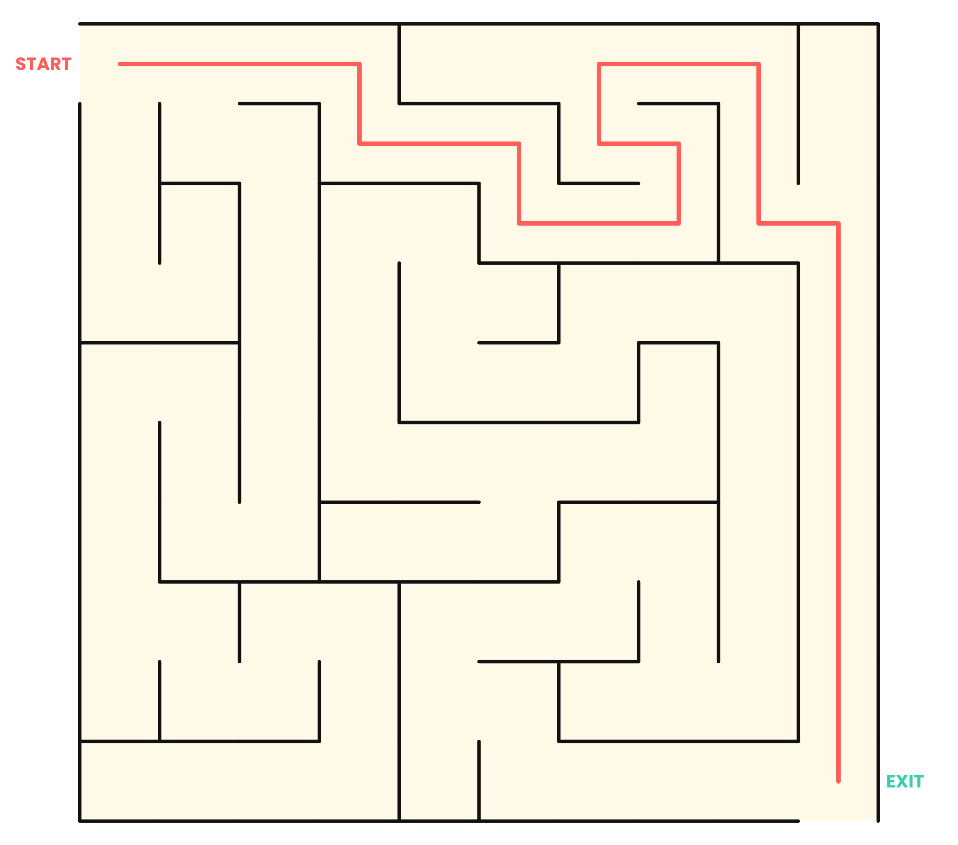
81 THREE CIRCLES
7
Three parts that belong to one circle only, three parts shared by exactly two circles, and one centre shared by all three: 3 + 3 + 1 = 7.
82 ONE STROKE ENVELOPE
Yes. Start at one of the two bottom corners and finish at the other.
A single stroke is possible only if 0 or 2 dots have an odd number of lines. Here exactly the two bottom corners have 3 lines each, so the path must begin at one and end at the other.
83 DOMINOES ON A CHESSBOARD
No.
Every domino covers one dark and one light square. Opposite corners have the same colour, so 32 squares of one colour and 30 of the other remain: a perfect cover is impossible.
84 WHICH LINE IS LONGER?
Neither: they are exactly equal.
This is the Müller-Lyer illusion. The brain reads the arrowheads as clues about depth and misjudges the length.
85 CUBE COUNT
18
The stacks, from the front, have heights 1, 1, 2 / 1, 2, 3 / 2, 3, 3. Their total is 18.
86 STAR TRIANGLES
8
The six small triangles at the points, plus the two large overlapping triangles that make up the star: 6 + 2 = 8.
87 MAGIC SQUARE
Row 1: 2 7 6. Row 2: 9 5 1. Row 3: 4 3 8.
The square must be [[2,7,6],[9,5,1],[4,3,8]]. Every row, column and diagonal adds to 15.
88 FLIP THE TRIANGLE
Move the top coin and the two bottom corner coins to the opposite side.
Keep the middle six coins. Place the top coin below them, and put the two bottom-corner coins on either side of the new bottom row. The shape is now an inverted triangle of 10.
89 RECTANGLES COUNT
18
There are 4 vertical lines and 3 horizontal lines. Rectangles = choose 2 of 4 × choose 2 of 3 = 6 × 3 = 18.
90 CITY ROUTES
35
Any route is a sequence of 4 R and 3 U moves. The number of ways to place the 3 U moves among 7 steps is C(7,3) = 35.
THE FINAL TEN
91 THE MONTY HALL DOOR
Swap. Swapping wins 2 times out of 3.
Your first choice wins 1/3 of the time. The host never reveals the car, so in the other 2/3 of cases the remaining door hides it. Swapping wins whenever your first pick was wrong.
92 THE BIRTHDAY SURPRISE
23 people (about 50.7%).
Instead of asking for a match, work out the chance of no match: 365/365 × 364/365 × … × 343/365 ≈ 0.493. So a match has probability about 50.7%. With 23 people there are 253 pairs.
93 TWO CHILDREN
1/3
Equally likely families: boy-boy, boy-girl, girl-boy, girl-girl. 'At least one boy' removes girl-girl, leaving three; only one of them is boy-boy.
94 TWO EGGS, 100 FLOORS
14 drops.
Drop first from floor 14, then 27 (+13), 39 (+12), and so on, each jump one smaller. If egg one breaks, egg two walks up one floor at a time. 14 + 13 + … + 1 = 105 ≥ 100.
95 EIGHT SLICES
8 pieces.
Two vertical cuts make 4 columns, then one horizontal cut through the middle splits each in two: 4 × 2 = 8.
96 THE CIRCLE OF FATE
Person 73.
This is the Josephus problem. For n people the survivor is 2L + 1, where L = n − 2^k and 2^k is the largest power of 2 not above n. Here 100 − 64 = 36, and 2 × 36 + 1 = 73.
97 ROPE AROUND THE EARTH
About 16 cm.
C = 2πr, so adding 1 m to C adds 1/(2π) ≈ 0.16 m to the radius. The size of the planet is irrelevant.
98 BRIDGE IN THE DARK
17 minutes.
1 and 2 cross (2). 1 returns (1). 5 and 10 cross (10). 2 returns (2). 1 and 2 cross (2). Total 2 + 1 + 10 + 2 + 2 = 17.
99 BLINDFOLDED COINS
Take any 10 coins as pile A and flip every coin in pile A.
Say pile A has h heads, so it has 10 − h tails; the other pile B has 10 − h heads. After flipping A, it has 10 − h heads, equal to B.
100 THREE ANTS
1/4
There are 2³ = 8 equally likely choices. Only 'all clockwise' and 'all anticlockwise' avoid collisions: 2/8 = 1/4.

SCOREBOARD | MAX  300
Write 3, 2 or 1 in each box. Add up each row, then the grand total.
TOTAL | 1 | 2 | 3 | 4 | 5 | 6 | 7 | 8 | 9 | 10
1–10 | 1 | 2 | 3 | 4 | 5 | 6 | 7 | 8 | 9 | 10
11–20 | 11 | 12 | 13 | 14 | 15 | 16 | 17 | 18 | 19 | 20
21–30 | 21 | 22 | 23 | 24 | 25 | 26 | 27 | 28 | 29 | 30
31–40 | 31 | 32 | 33 | 34 | 35 | 36 | 37 | 38 | 39 | 40
41–50 | 41 | 42 | 43 | 44 | 45 | 46 | 47 | 48 | 49 | 50
51–60 | 51 | 52 | 53 | 54 | 55 | 56 | 57 | 58 | 59 | 60
61–70 | 61 | 62 | 63 | 64 | 65 | 66 | 67 | 68 | 69 | 70
71–80 | 71 | 72 | 73 | 74 | 75 | 76 | 77 | 78 | 79 | 80
81–90 | 81 | 82 | 83 | 84 | 85 | 86 | 87 | 88 | 89 | 90
91–100 | 91 | 92 | 93 | 94 | 95 | 96 | 97 | 98 | 99 | 100

RANKS
SCORE | TITLE | WHAT IT MEANS
0–99 | Warm-Up Warrior | You started the engine. Keep going.
100–179 | Puzzle Apprentice | Solid thinking and growing confidence.
180–239 | Logic Knight | Sharp, patient and hard to fool.
240–285 | Mind Master | Very few puzzles escape you.
286–300 | Brain Champion | Legendary. Print the certificate.

MY TOTAL SCORE  ______________________ | DATE FINISHED  ______________________

BRAIN NOTES | NOTES
Space for workings, ideas and puzzles that deserve a second attempt.

PREPPATH E-BOOKS STORE
CERTIFICATE
OF BRILLIANCE
This certificate is proudly awarded to
__________________________________
for completing
THE ULTIMATE BRAIN CHALLENGE
100 puzzles, riddles and mind-bending challenges
SCORE: ______ / 300 TITLE: ____________________
★ ★ ★ ★ ★

KEEP YOUR BRAIN IN TRAINING
Puzzles build patience, pattern-spotting and the confidence to attack problems that look impossible. Come back to the hard ones in a week; you may be surprised how differently they look.
Explore more e-books from PrepPath E-books Store. Visit our website and shop now.

