PYLOOM Mapping Solutions
Reference block mappings for every question, drawn exactly as they are built on the canvas.
How to read the diagrams: green = Input block, blue = processing blocks, red = Output block. Arrows show the connection order. An orange number on an arrow shows the order in which that block must be connected where a block takes two inputs (for example Divide = first input ÷ second input). Settings shown inside a block (Key, Decimals, Operator, Title) are filled in through the block's gear icon.
Note: These are the reference solutions. Other combinations of the available blocks that produce the same expected output are also accepted.

Easy 1 · Voting Eligibility Checker
An election portal checks whether a person is eligible to vote. A person is eligible only if their age is 18 or above.
Input data | 20
Operation | Compare the age with the voting age limit: age >= 18
Expected output | True

Mapping diagram
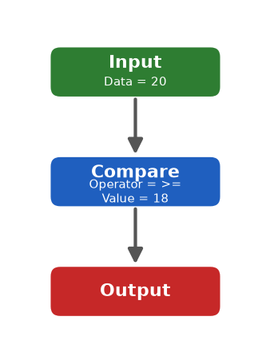

Steps
- Drag an Input node, open ⚙ and type 20 in Input Data (the person's age).
- Input → Compare. Open Compare ⚙: set Operator = >= and Value = 18 (the voting age limit). Compare answers True when the age is 18 or more, otherwise False.
- Compare → Output.
- Leave the Output format empty. Run Flow must show True (eligible to vote).

Easy 2 · BMI Calculator
A fitness app calculates a person's Body Mass Index: BMI = Weight (kg) / Height² (m), rounded to 1 decimal place.
Input data | {"weight": 70, "height": 1.75}
Operation | BMI = weight / height² (round to 1 decimal)
Expected output | 22.9

Mapping diagram
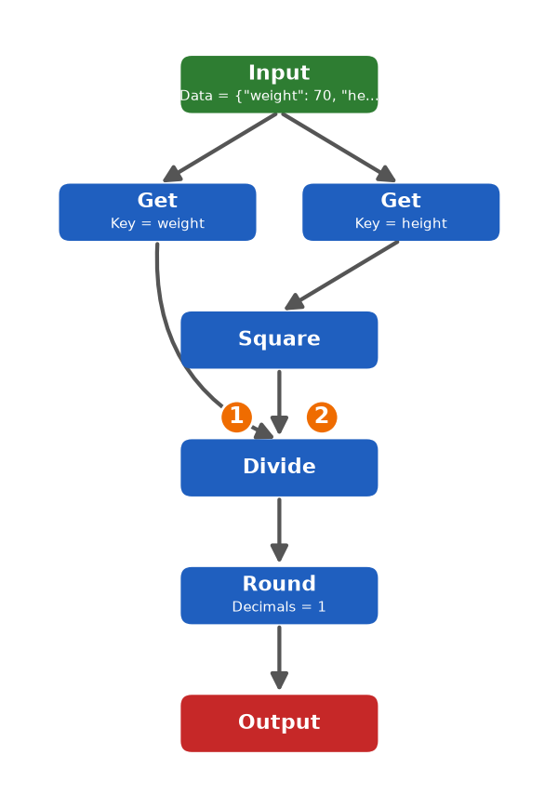

Steps
- Drag an Input node and set Input Data to {"weight": 70, "height": 1.75}.
- Input → Get #1 (Key = weight is already filled in). This picks out the weight, 70.
- Input → Get #2 (Key = height is already filled in) → Square. Square multiplies the height by itself: 1.75 × 1.75 = 3.0625.
- Now build the division IN THIS ORDER: first connect Get #1 (weight) → Divide, then connect Square → Divide. Divide always does (first input) ÷ (second input) = 70 ÷ 3.0625.
- Divide → Round (Decimals = 1 is already filled in) → Output.
- Leave the Output format empty. Run Flow must show 22.9.

Easy 3 · Palindrome String Checker
Given a word, check if it reads the same backward as forward (a palindrome).
Input data | "radar"
Operation | Check if the word is equal to its reverse
Expected output | True

Mapping diagram
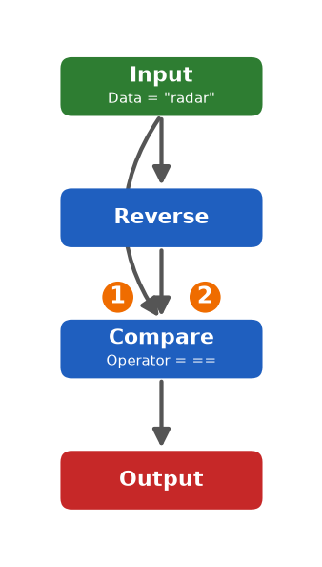

Steps
- Drag an Input node and set Input Data to radar.
- Input → Reverse. Reverse turns radar into radar backwards (here the same word).
- Input → Compare (this carries the original word straight to Compare).
- Reverse → Compare (this carries the reversed word). Open Compare ⚙ and set Operator = ==. Compare checks whether the two words are equal.
- Compare → Output.
- Leave the Output format empty. Run Flow must show True (it is a palindrome).

Easy 4 · Fahrenheit to Celsius Converter
A weather app converts a temperature reading from Fahrenheit to Celsius. Formula: C = (F - 32) × 5 / 9.
Input data | 98.6
Operation | C = (F - 32) × 5 / 9
Expected output | 37.0

Mapping diagram
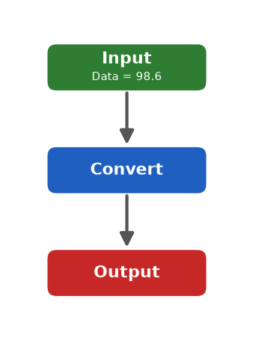

Steps
- Drag an Input node and set Input Data to 98.6 (the temperature in °F).
- Input → Convert. The Convert block already contains the formula (F - 32) × 5 / 9, so there is nothing to set.
- Convert → Output.
- Leave the Output format empty. Run Flow must show 37.0 (the temperature in °C).

Easy 5 · Average of Numbers
Given a list of numbers, calculate their average (mean) value: the sum of the numbers divided by how many numbers there are.
Input data | [10, 20, 30, 40]
Operation | Average = sum ÷ count
Expected output | 25.0

Mapping diagram
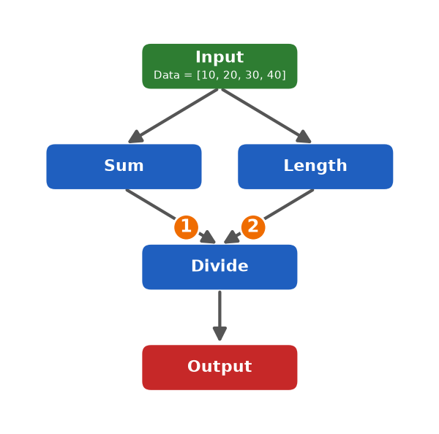

Steps
- Drag an Input node and set Input Data to [10, 20, 30, 40].
- Input → Sum. Sum adds all the numbers: 10 + 20 + 30 + 40 = 100.
- Input → Length. Length counts the numbers: 4.
- Build the division IN THIS ORDER: first connect Sum → Divide, then connect Length → Divide. Divide does (first input) ÷ (second input) = 100 ÷ 4.
- Divide → Output.
- Leave the Output format empty. Run Flow must show 25.0.

Medium 1 · Binary Search Locator
Given a sorted array and a target value, find the index of the target using Binary Search: look at the middle value and keep halving the search range.
Input data | {"array": [2, 4, 6, 8, 10, 12, 14], "target": 10}
Operation | Binary search: Midpoint → Compare → Repeat on the half that can still contain the target
Expected output | 4

Mapping diagram
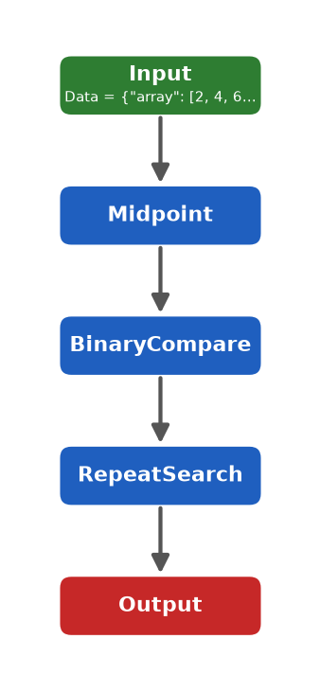

Steps
- Drag an Input node and set Input Data to {"array": [2, 4, 6, 8, 10, 12, 14], "target": 10}.
- Input → Midpoint. Midpoint picks the middle index of the search range (here index 3, the value 8).
- Midpoint → BinaryCompare. It compares the middle value with the target: equal = found; target smaller = search the left half; target larger = search the right half. (8 < 10, so the right half is next.)
- BinaryCompare → RepeatSearch. It repeats Midpoint + Compare on the narrowed range until the target is found, and returns its index (10 is at index 4). It returns -1 when the target is not in the array.
- RepeatSearch → Output.
- Leave the Output format empty. Run Flow must show 4 (the index of the value 10).

Medium 2 · Leap Year Checker
Given a year, decide whether it is a leap year. A year is a leap year if it is divisible by 4, except century years (divisible by 100), which must also be divisible by 400.
Input data | 2000
Operation | Divisible by 4? Then, if it is a century year, divisible by 400?
Expected output | True

Mapping diagram
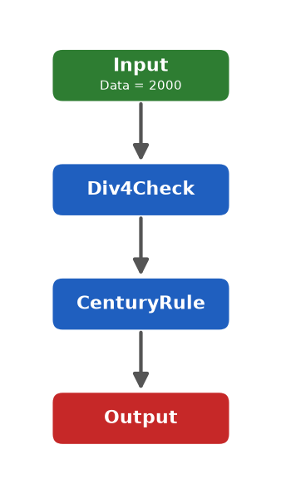

Steps
- Drag an Input node and set Input Data to 2000 (the year).
- Input → Div4Check. It checks whether the year is divisible by 4 (2000 ÷ 4 → yes).
- Div4Check → CenturyRule. If the year is a century year (divisible by 100) it must ALSO be divisible by 400 to stay a leap year (2000 ÷ 400 → yes). Years that are not centuries pass automatically.
- CenturyRule → Output.
- Leave the Output format empty. Run Flow must show True (2000 is divisible by 4, by 100 and by 400).

Medium 3 · Sorting a List of Numbers
Given an unsorted list of numbers, sort them in ascending order using Bubble Sort: repeatedly compare neighbouring numbers and swap them when the left one is greater than the right one.
Input data | [64, 25, 12, 22, 11]
Operation | Bubble sort: compare & swap neighbours, repeat the pass until no swaps are left
Expected output | [11, 12, 22, 25, 64]

Mapping diagram
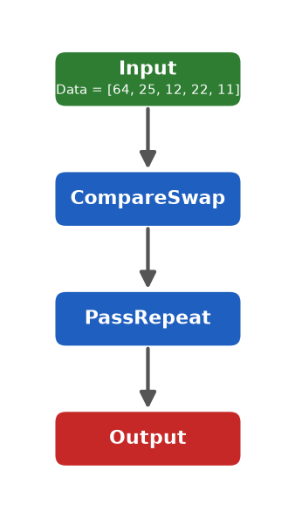

Steps
- Drag an Input node and set Input Data to [64, 25, 12, 22, 11].
- Input → CompareSwap. It makes ONE pass over the list: each pair of neighbours is compared and swapped if the left number is greater (64 bubbles to the end: [25, 12, 22, 11, 64]).
- CompareSwap → PassRepeat. It keeps repeating the pass until a full pass needs no swaps - then the list is sorted.
- PassRepeat → Output.
- Leave the Output format empty. Run Flow must show [11, 12, 22, 25, 64].

Hard 1 · Monthly Expense Pie Chart
A personal finance app records monthly expenses in 4 categories: Rent, Food, Transport and Entertainment. Calculate each category's percentage share of the total spending, then draw the result as a pie chart.
Input data | {"Rent": 12000, "Food": 6000, "Transport": 3000, "Entertainment": 3000}
Operation | Total = sum of all amounts; percentage = amount ÷ total × 100; draw a pie chart
Expected output | Rent: 50% | Food: 25% | Transport: 12.5% | Entertainment: 12.5%

Mapping diagram
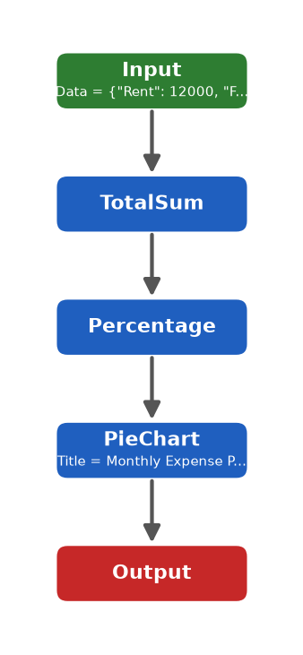

Steps
- Drag an Input node and set Input Data to {"Rent": 12000, "Food": 6000, "Transport": 3000, "Entertainment": 3000}.
- Input → TotalSum. It adds up every category (total = 24000) and passes the amounts on.
- TotalSum → Percentage. For every category it does amount ÷ total × 100 (Rent: 12000 ÷ 24000 × 100 = 50%).
- Percentage → PieChart. It draws one slice per category (the chart title is already filled in).
- PieChart → Output.
- Leave the Output format empty. Run Flow must draw the pie chart and show Rent: 50% | Food: 25% | Transport: 12.5% | Entertainment: 12.5%. The reference picture shows how the chart should look.

Hard 2 · Weekly Sales Bar Chart
A store tracks daily sales for 5 days against a fixed sales target of $200. Mark each day as "Above Target" (sales ≥ target) or "Below Target", then draw the results as a bar chart (green = Above, red = Below).
Input data | {"sales": [180, 220, 250, 150, 300], "target": 200}
Operation | For each day: sales ≥ target → Above Target, otherwise Below Target; draw a bar chart
Expected output | Mon: Below Target | Tue: Above Target | Wed: Above Target | Thu: Below Target | Fri: Above Target

Mapping diagram
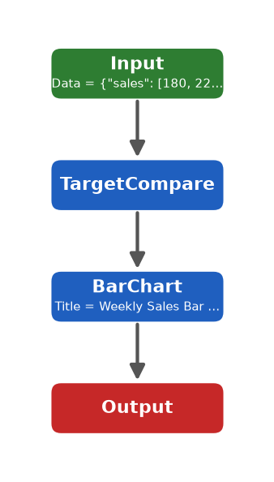

Steps
- Drag an Input node and set Input Data to {"sales": [180, 220, 250, 150, 300], "target": 200}. The days Mon-Fri are added automatically in order.
- Input → TargetCompare. For each day it checks sales ≥ target (180 → Below, 220 → Above, 250 → Above, 150 → Below, 300 → Above).
- TargetCompare → BarChart. It draws one bar per day: green for Above Target, red for Below Target (the chart title is already filled in).
- BarChart → Output.
- Leave the Output format empty. Run Flow must draw the bar chart and show Mon: Below Target | Tue: Above Target | Wed: Above Target | Thu: Below Target | Fri: Above Target.

