PYLOOM – Mapping Solutions (Image Guide)
Each question shows the block mapping as a diagram. Block names are the simple names shown in the app. Arrows show the connection order; text inside a block is the setting to enter in its ⚙ panel.
Colours: Blue = Input / Output / Get Green = Compare / If-Else / Filter Orange = Search & Sort / Text Pink = Charts & Grades Purple = Math

Easy level

Easy 1 – Voting Eligibility Checker
An election portal checks whether a person is eligible to vote. A person is eligible only if their age is 18 or above.
Input data: 20
Operation: Compare the age with the voting age limit: age >= 18
Expected output: True
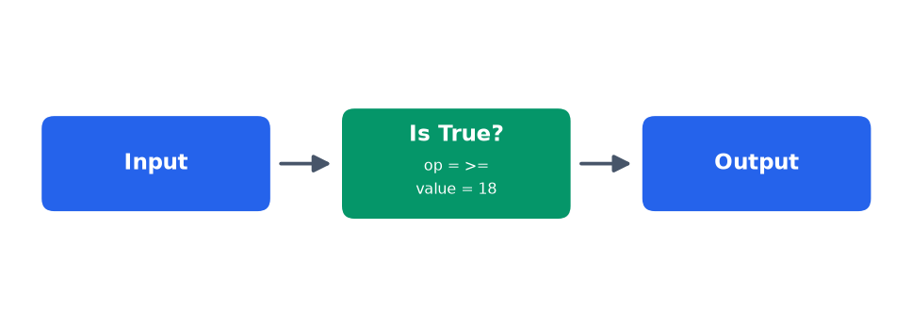
Steps
- Drag an Input node, open ⚙ and type 20 in Input Data (the person's age).
- Input → Compare. Open Compare ⚙: set Operator = >= and Value = 18 (the voting age limit). Compare answers True when the age is 18 or more, otherwise False.
- Compare → Output.
- Leave the Output format empty. Run Flow must show True (eligible to vote).

Easy 2 – BMI Calculator
A fitness app calculates a person's Body Mass Index: BMI = Weight (kg) / Height² (m), rounded to 1 decimal place.
Input data: {"weight": 70, "height": 1.75}
Operation: BMI = weight / height² (round to 1 decimal)
Expected output: 22.9
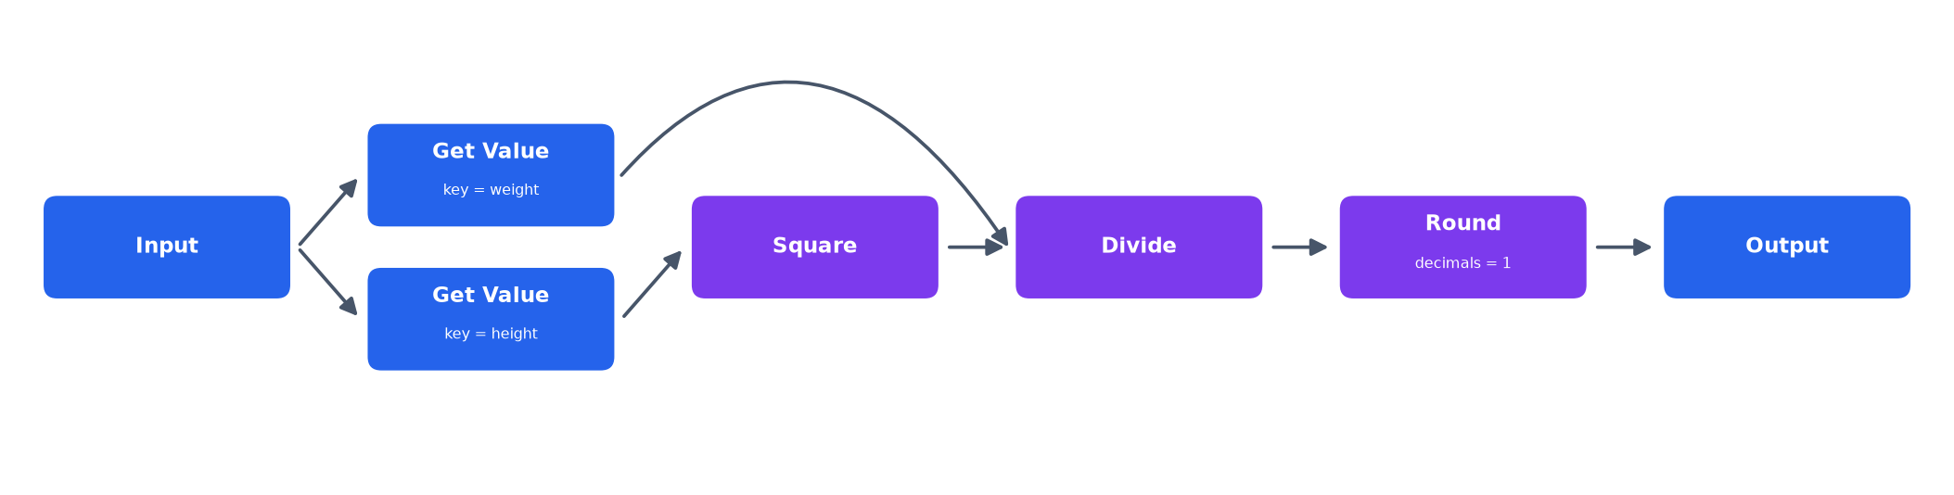
Steps
- Drag an Input node and set Input Data to {"weight": 70, "height": 1.75}.
- Input → Get #1 (Key = weight is already filled in). This picks out the weight, 70.
- Input → Get #2 (Key = height is already filled in) → Square. Square multiplies the height by itself: 1.75 × 1.75 = 3.0625.
- Now build the division IN THIS ORDER: first connect Get #1 (weight) → Divide, then connect Square → Divide. Divide always does (first input) ÷ (second input) = 70 ÷ 3.0625.
- Divide → Round (Decimals = 1 is already filled in) → Output.
- Leave the Output format empty. Run Flow must show 22.9.

Easy 3 – Palindrome String Checker
Given a word, check if it reads the same backward as forward (a palindrome).
Input data: "radar"
Operation: Check if the word is equal to its reverse
Expected output: True
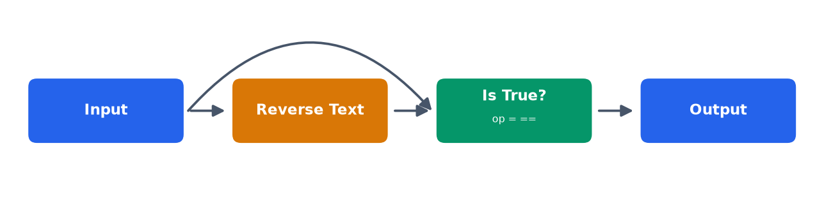
Steps
- Drag an Input node and set Input Data to radar.
- Input → Reverse. Reverse turns radar into radar backwards (here the same word).
- Input → Compare (this carries the original word straight to Compare).
- Reverse → Compare (this carries the reversed word). Open Compare ⚙ and set Operator = ==. Compare checks whether the two words are equal.
- Compare → Output.
- Leave the Output format empty. Run Flow must show True (it is a palindrome).

Easy 4 – Fahrenheit to Celsius Converter
A weather app converts a temperature reading from Fahrenheit to Celsius. Formula: C = (F - 32) × 5 / 9.
Input data: 98.6
Operation: C = (F - 32) × 5 / 9
Expected output: 37.0
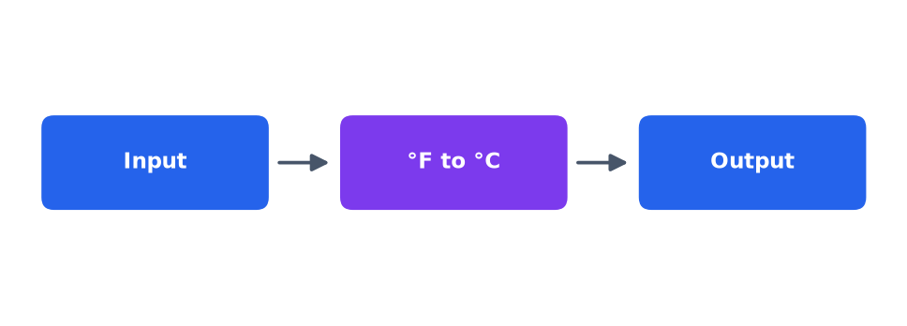
Steps
- Drag an Input node and set Input Data to 98.6 (the temperature in °F).
- Input → Convert. The Convert block already contains the formula (F - 32) × 5 / 9, so there is nothing to set.
- Convert → Output.
- Leave the Output format empty. Run Flow must show 37.0 (the temperature in °C).

Easy 5 – Average of Numbers
Given a list of numbers, calculate their average (mean) value: the sum of the numbers divided by how many numbers there are.
Input data: [10, 20, 30, 40]
Operation: Average = sum ÷ count
Expected output: 25.0
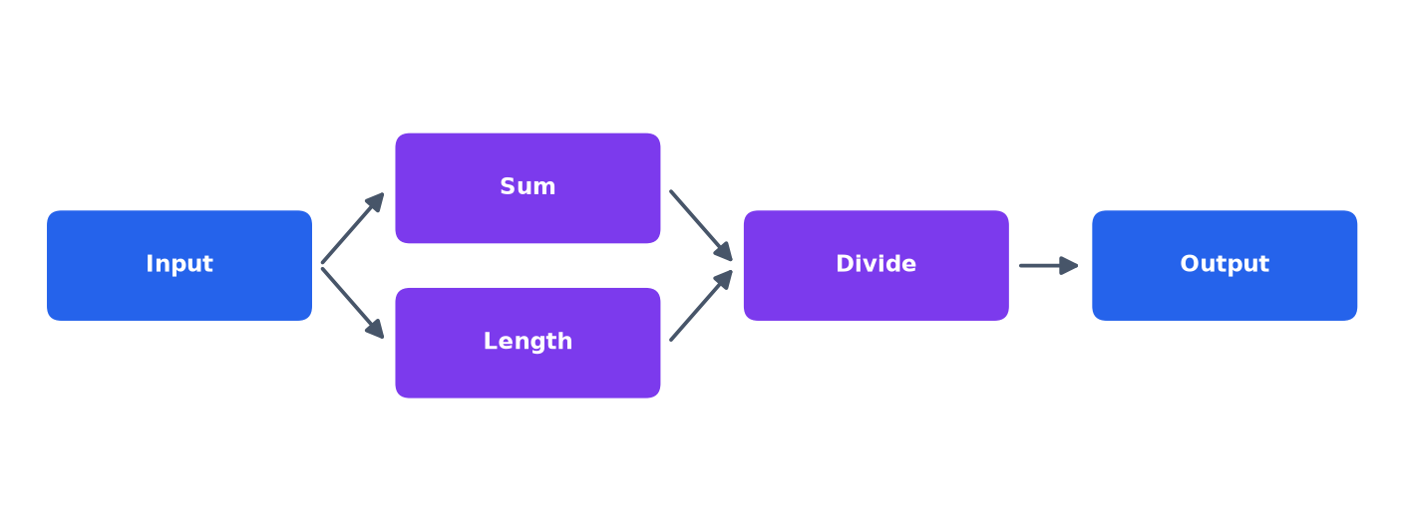
Steps
- Drag an Input node and set Input Data to [10, 20, 30, 40].
- Input → Sum. Sum adds all the numbers: 10 + 20 + 30 + 40 = 100.
- Input → Length. Length counts the numbers: 4.
- Build the division IN THIS ORDER: first connect Sum → Divide, then connect Length → Divide. Divide does (first input) ÷ (second input) = 100 ÷ 4.
- Divide → Output.
- Leave the Output format empty. Run Flow must show 25.0.

Medium level

Medium 1 – Binary Search Position Finder
Given a sorted array, find where the value 10 sits using Binary Search (look at the middle value and keep halving the range). The target is NOT in the input: you must enter it yourself. Report the position counting from 1, written as "Position: <number>" (0 when the value is missing).
Input data: {"array": [2, 4, 6, 8, 10, 12, 14]}
Operation: Set target = 10 → Midpoint → Compare → Repeat → add 1 (index → position) → format the answer as Position: <number>
Expected output: Position: 5
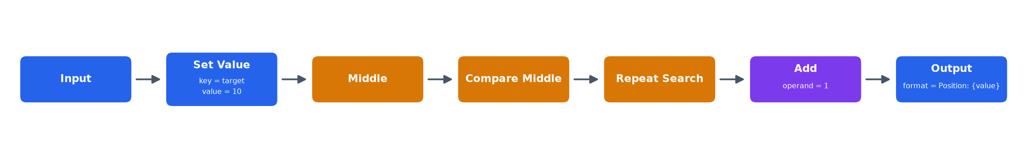
Steps
- Drag an Input node and set Input Data to {"array": [2, 4, 6, 8, 10, 12, 14]}. There is no target in it yet.
- Input → Set Value. Open ⚙ and type Key = target and Value = 10. This adds the target to the data.
- Set Value → Middle. It picks the middle index of the search range (index 3, the value 8).
- Middle → Compare Middle. Equal = found; target smaller = search the left half; larger = search the right half.
- Compare Middle → Repeat Search. It repeats Middle + Compare until the target is found and returns its INDEX (10 is at index 4; -1 when missing).
- Repeat Search → Add. Type Operand = 1 so the index becomes a position (index 4 → position 5; a missing value gives 0).
- Add → Output. Type the Output format: Position: {value}
- Run Flow must show Position: 5.

Medium 2 – Next-Year Leap Checker
Given a year, check the NEXT year (year + 1). It is a leap year if divisible by 4, except century years (divisible by 100), which must also be divisible by 400. Show the answer as "Next year: Leap Year" or "Next year: Common Year".
Input data: 1999
Operation: Year + 1 → divisible by 4? → century rule → if True then "Leap Year" else "Common Year" → format as Next year: <answer>
Expected output: Next year: Leap Year
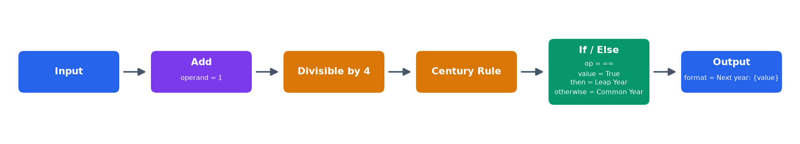
Steps
- Drag an Input node and set Input Data to 1999 (the year).
- Input → Add. Type Operand = 1 to move to the next year (1999 → 2000).
- Add → Divisible by 4. It checks whether that year is divisible by 4.
- Divisible by 4 → Century Rule. A century year must ALSO be divisible by 400 (2000 ÷ 400 → yes).
- Century Rule → If / Else. Set Operator == , Compare with True, Then Leap Year, Otherwise Common Year.
- If / Else → Output. Type the Output format: Next year: {value}
- Run Flow must show Next year: Leap Year.

Medium 3 – Valid Marks Sorter
A list of marks contains invalid values. Keep only marks from 10 to 100 (both included), then sort the valid marks in ascending order with Bubble Sort. Show them as "Sorted marks: [..]".
Input data: [64, 150, 25, 12, 5, 22, 11, 90]
Operation: Keep marks between 10 and 100 → bubble sort (compare & swap, repeat) → format as Sorted marks: <list>
Expected output: Sorted marks: [11, 12, 22, 25, 64, 90]
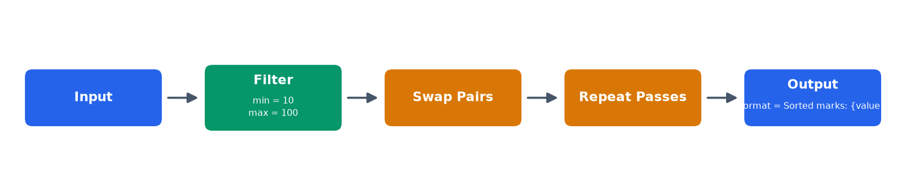
Steps
- Drag an Input node and set Input Data to [64, 150, 25, 12, 5, 22, 11, 90].
- Input → Filter. Type Min = 10 and Max = 100. The invalid marks 150 and 5 are removed: [64, 25, 12, 22, 11, 90].
- Filter → Swap Pairs. ONE pass: neighbours are compared and swapped when the left one is greater.
- Swap Pairs → Repeat Passes. It repeats the pass until no swaps are left: the list is sorted.
- Repeat Passes → Output. Type the Output format: Sorted marks: {value}
- Run Flow must show Sorted marks: [11, 12, 22, 25, 64, 90].

Hard level

Hard 1 – Monthly Budget Pie Chart
A finance app records monthly expenses in 4 categories. The person also puts 6000 into Savings, but Savings is not in the data: add it yourself as a 5th category. Calculate every category's percentage share of the total, then draw a pie chart titled "Monthly Budget Pie Chart" (type the title yourself).
Input data: {"Rent": 12000, "Food": 6000, "Transport": 3000, "Entertainment": 3000}
Operation: Add Savings = 6000 → total = sum of all amounts → percentage = amount ÷ total × 100 → pie chart with the title typed in
Expected output: Rent: 40% | Food: 20% | Transport: 10% | Entertainment: 10% | Savings: 20%
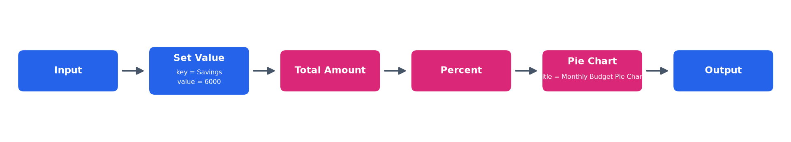
Steps
- Drag an Input node and set Input Data to {"Rent": 12000, "Food": 6000, "Transport": 3000, "Entertainment": 3000}.
- Input → Set Value. Type Key = Savings and Value = 6000. Savings becomes the 5th category.
- Set Value → Total Amount. It adds up all 5 categories (total = 30000).
- Total Amount → Percent. For each category: amount ÷ total × 100 (Rent: 12000 ÷ 30000 × 100 = 40%).
- Percent → Pie Chart. Type the Title: Monthly Budget Pie Chart.
- Pie Chart → Output.
- Leave the Output format empty. Run Flow must draw the pie chart and show Rent: 40% | Food: 20% | Transport: 10% | Entertainment: 10% | Savings: 20%.

Hard 2 – Weekly Sales Bar Chart
A store tracks daily sales for 7 days (Mon-Sun). The sales target is $200 but it is NOT in the data: enter it yourself. Mark each day "Above Target" (sales ≥ target) or "Below Target", then draw a bar chart titled "Weekly Sales Bar Chart" with the Y label "Sales ($)" (green = Above, red = Below).
Input data: {"sales": [180, 220, 250, 150, 300, 170, 260]}
Operation: Set target = 200 → each day: sales ≥ target → Above Target, otherwise Below Target → bar chart with the title and Y label typed in
Expected output: Mon: Below Target | Tue: Above Target | Wed: Above Target | Thu: Below Target | Fri: Above Target | Sat: Below Target | Sun: Above Target
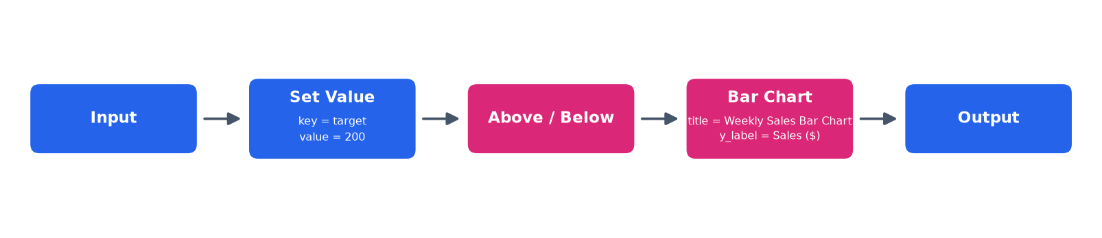
Steps
- Drag an Input node and set Input Data to {"sales": [180, 220, 250, 150, 300, 170, 260]}. The days Mon-Sun are added automatically in order.
- Input → Set Value. Type Key = target and Value = 200.
- Set Value → Above / Below. For each day it checks sales ≥ target (180 → Below, 220 → Above, ...).
- Above / Below → Bar Chart. Type Title = Weekly Sales Bar Chart and Y label = Sales ($). Bars are green for Above Target, red for Below Target.
- Bar Chart → Output.
- Leave the Output format empty. Run Flow must draw the bar chart and show Mon: Below Target | Tue: Above Target | Wed: Above Target | Thu: Below Target | Fri: Above Target | Sat: Below Target | Sun: Above Target.

