PYLOOM
Mapping Solutions
Block-by-block answers for all 11 questions
Level | Question | Score
Easy | Voting Eligibility Checker | 4 points
Easy | BMI Calculator | 4 points
Easy | Palindrome String Checker | 4 points
Easy | Fahrenheit to Celsius Converter | 4 points
Easy | Average of Numbers | 4 points
Medium | Binary Search Locator | 10 points
Medium | Leap Year Checker | 10 points
Medium | Sorting a List of Numbers | 10 points
Hard | Monthly Expense Pie Chart | 17 points
Hard | Weekly Sales Bar Chart | 17 points
Hard | Student Grade Distribution Pie Chart | 16 points

How to map a question
- Drag an Input node onto the canvas, open its ⚙ and type the question's input data yourself.
- Drag the other blocks listed in the solution and open ⚙ to fill in the settings (some are already pre-filled).
- Connect the blocks with the ports: click the output port (right side) of one block, then the input port (left side) of the next.
- Where a block has two incoming connections (Divide), connect them in the order written in the solution.
- Click Run Flow, check that the output equals the expected output, then click Submit solution.
- Scoring: 4 of 4 checks (Mapping Flow, Logic building, Output compare with sample output, Output check) = full score, 3 = ¾, 2 = ½, 1 = ¼.

Easy level

Question 1: Voting Eligibility Checker (4 points)
Problem: An election portal checks whether a person is eligible to vote. A person is eligible only if their age is 18 or above.
Input data: 20
Expected output: True
Block flow
[Input] ──► [Compare >= 18] ──► [Output]
Mapping solution
Block | Settings (⚙) | Connect from
1. Input | Input Data = 20 | —
2. Compare | Operator = >= Value = 18 | Input
3. Output | (leave format empty) | Compare
Why it works: Compare answers True when the age is 18 or more.

Question 2: BMI Calculator (4 points)
Problem: A fitness app calculates a person's Body Mass Index: BMI = Weight (kg) / Height² (m), rounded to 1 decimal place.
Input data: {"weight":70,"height":1.75}
Expected output: 22.9
Block flow
[Input] ─► [Get weight] ─────────────────────► [Divide] ─► [Round 1] ─► [Output]
└► [Get height] ─► [Square] ─────────────┘
Mapping solution
Block | Settings (⚙) | Connect from
1. Input | Input Data = {"weight": 70, "height": 1.75} | —
2. Get (weight) | Key = weight (pre-filled) | Input
3. Get (height) | Key = height (pre-filled) | Input
4. Square | no settings | Get (height)
5. Divide | no settings | FIRST Get (weight), THEN Square
6. Round | Decimals = 1 (pre-filled) | Divide
7. Output | (leave format empty) | Round
Why it works: Order matters on Divide: connect Get (weight) → Divide first, then Square → Divide. It calculates 70 ÷ 3.0625 = 22.857, rounded to 22.9.

Question 3: Palindrome String Checker (4 points)
Problem: Given a word, check if it reads the same backward as forward (a palindrome).
Input data: radar
Expected output: True
Block flow
┌─► [Reverse] ─┐
[Input] ──┤ ├─► [Compare ==] ─► [Output]
└──────────────┘
Mapping solution
Block | Settings (⚙) | Connect from
1. Input | Input Data = radar | —
2. Reverse | no settings | Input
3. Compare | Operator = == | Input, and Reverse (both connections)
4. Output | (leave format empty) | Compare
Why it works: Compare receives the original word and the reversed word; == says whether they are the same.

Question 4: Fahrenheit to Celsius Converter (4 points)
Problem: A weather app converts a temperature reading from Fahrenheit to Celsius. Formula: C = (F - 32) × 5 / 9.
Input data: 98.6
Expected output: 37.0
Block flow
[Input] ──► [Convert (F-32)×5/9] ──► [Output]
Mapping solution
Block | Settings (⚙) | Connect from
1. Input | Input Data = 98.6 | —
2. Convert | no settings (formula is built in) | Input
3. Output | (leave format empty) | Convert
Why it works: (98.6 - 32) × 5 / 9 = 37.0

Question 5: Average of Numbers (4 points)
Problem: Given a list of numbers, calculate their average (mean) value: the sum of the numbers divided by how many numbers there are.
Input data: [10,20,30,40]
Expected output: 25.0
Block flow
[Input] ─► [Sum] ──────► [Divide] ─► [Output]
└► [Length] ───┘
Mapping solution
Block | Settings (⚙) | Connect from
1. Input | Input Data = [10, 20, 30, 40] | —
2. Sum | no settings | Input
3. Length | no settings | Input
4. Divide | no settings | FIRST Sum, THEN Length
5. Output | (leave format empty) | Divide
Why it works: Sum = 100, Length = 4, so Divide gives 100 ÷ 4 = 25.0. Connect Sum to Divide first.

Medium level

Question 1: Binary Search Locator (10 points)
Problem: Given a sorted array and a target value, find the index of the target using Binary Search: look at the middle value and keep halving the search range.
Input data: {"array":[2,4,6,8,10,12,14],"target":10}
Expected output: 4
Block flow
[Input] ──► [Midpoint] ──► [BinaryCompare] ──► [RepeatSearch] ──► [Output]
Mapping solution
Block | Settings (⚙) | Connect from
1. Input | Input Data = {"array": [2, 4, 6, 8, 10, 12, 14], "target": 10} | —
2. Midpoint | no settings | Input
3. BinaryCompare | no settings | Midpoint
4. RepeatSearch | no settings | BinaryCompare
5. Output | (leave format empty) | RepeatSearch
Why it works: Round 1: middle = index 3 (8). 8 < 10, so search the right half. Round 2: middle = index 5 (12). 12 > 10, so search the left part. Round 3: middle = index 4 (10) = target, found at index 4. RepeatSearch does these repeats for you.

Question 2: Leap Year Checker (10 points)
Problem: Given a year, decide whether it is a leap year. A year is a leap year if it is divisible by 4, except century years (divisible by 100), which must also be divisible by 400.
Input data: 2000
Expected output: True
Block flow
[Input] ──► [Div4Check] ──► [CenturyRule] ──► [Output]
Mapping solution
Block | Settings (⚙) | Connect from
1. Input | Input Data = 2000 | —
2. Div4Check | no settings | Input
3. CenturyRule | no settings | Div4Check
4. Output | (leave format empty) | CenturyRule
Why it works: 2000 is divisible by 4, is a century year, and is divisible by 400, so it is a leap year (True). 1900 would give False.

Question 3: Sorting a List of Numbers (10 points)
Problem: Given an unsorted list of numbers, sort them in ascending order using Bubble Sort: repeatedly compare neighbouring numbers and swap them when the left one is greater than the right one.
Input data: [64,25,12,22,11]
Expected output: [11, 12, 22, 25, 64]
Block flow
[Input] ──► [CompareSwap] ──► [PassRepeat] ──► [Output]
Mapping solution
Block | Settings (⚙) | Connect from
1. Input | Input Data = [64, 25, 12, 22, 11] | —
2. CompareSwap | no settings (one pass) | Input
3. PassRepeat | no settings (repeats passes) | CompareSwap
4. Output | (leave format empty) | PassRepeat
Why it works: Pass 1: [25, 12, 22, 11, 64]. Pass 2: [12, 22, 11, 25, 64]. Pass 3: [12, 11, 22, 25, 64]. Pass 4: [11, 12, 22, 25, 64]. A last pass with no swap ends the sort.

Hard level

Question 1: Monthly Expense Pie Chart (17 points)
Problem: A personal finance app records monthly expenses in 4 categories: Rent, Food, Transport and Entertainment. Calculate each category's percentage share of the total spending, then draw the result as a pie chart.
Input data: {"Rent":12000,"Food":6000,"Transport":3000,"Entertainment":3000}
Expected output: Rent: 50% | Food: 25% | Transport: 12.5% | Entertainment: 12.5%
Block flow
[Input] ──► [TotalSum] ──► [Percentage] ──► [PieChart] ──► [Output]
Mapping solution
Block | Settings (⚙) | Connect from
1. Input | Input Data = {"Rent": 12000, "Food": 6000, "Transport": 3000, "Entertainment": 3000} | —
2. TotalSum | no settings (total = 24000) | Input
3. Percentage | no settings (amount ÷ total × 100) | TotalSum
4. PieChart | Title = Monthly Expense Pie Chart (pre-filled) | Percentage
5. Output | (leave format empty) | PieChart
Why it works: Result: Rent 50%, Food 25%, Transport 12.5%, Entertainment 12.5%.
Expected chart
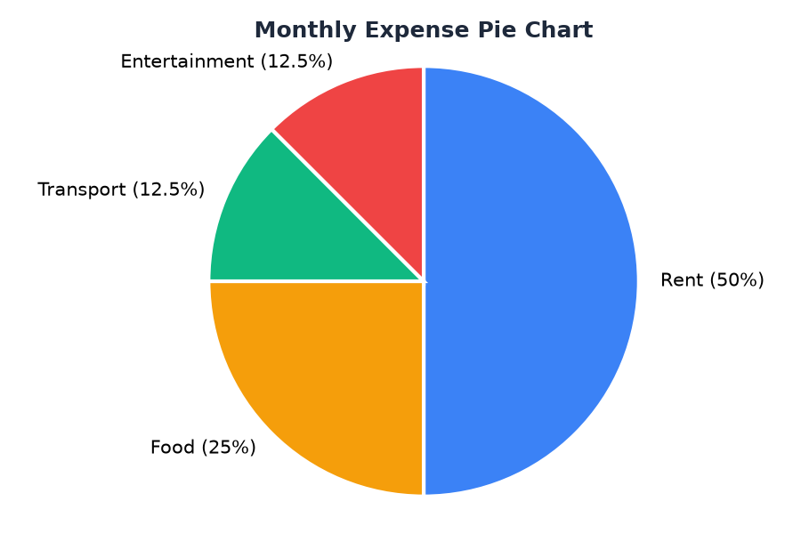

Question 2: Weekly Sales Bar Chart (17 points)
Problem: A store tracks daily sales for 5 days against a fixed sales target of $200. Mark each day as "Above Target" (sales ≥ target) or "Below Target", then draw the results as a bar chart (green = Above, red = Below).
Input data: {"sales":[180,220,250,150,300],"target":200}
Expected output: Mon: Below Target | Tue: Above Target | Wed: Above Target | Thu: Below Target | Fri: Above Target
Block flow
[Input] ──► [TargetCompare] ──► [BarChart] ──► [Output]
Mapping solution
Block | Settings (⚙) | Connect from
1. Input | Input Data = {"sales": [180, 220, 250, 150, 300], "target": 200} | —
2. TargetCompare | no settings (sales ≥ target = Above) | Input
3. BarChart | Title = Weekly Sales Bar Chart (pre-filled) | TargetCompare
4. Output | (leave format empty) | BarChart
Why it works: Days Mon–Fri are added automatically. Green bars = Above Target, red bars = Below Target.
Expected chart
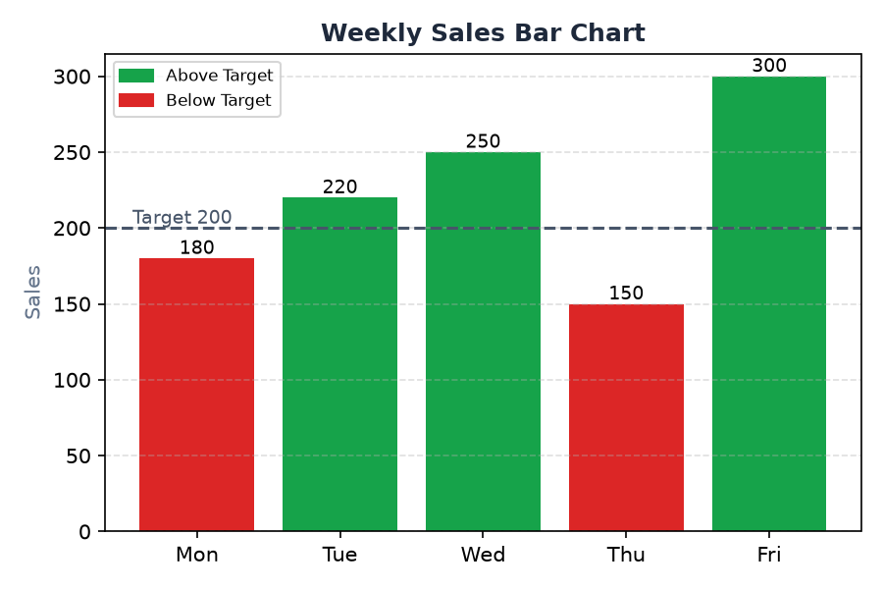

Question 3: Student Grade Distribution Pie Chart (16 points)
Problem: Given a list of student scores, give each score a grade (A: 90 or more, B: 75-89, C: 50-74, F: below 50), count how many students got each grade, and draw the distribution as a pie chart.
Input data: [95,82,67,45,88,91,60]
Expected output: A: 2 | B: 2 | C: 2 | F: 1
Block flow
[Input] ──► [GradeClassifier] ──► [CountGrades] ──► [PieChart] ──► [Output]
Mapping solution
Block | Settings (⚙) | Connect from
1. Input | Input Data = [95, 82, 67, 45, 88, 91, 60] | —
2. GradeClassifier | no settings (A ≥ 90, B 75–89, C 50–74, F < 50) | Input
3. CountGrades | no settings | GradeClassifier
4. PieChart | Title = Student Grade Distribution (pre-filled) | CountGrades
5. Output | (leave format empty) | PieChart
Why it works: Grades: 95→A, 82→B, 67→C, 45→F, 88→B, 91→A, 60→C. Counts: A 2, B 2, C 2, F 1.
Expected chart
