FINAL YEAR B.TECH PROJECT REPORT
ReadVibe
(Vibe Reader)
An AI-Powered Immersive Reading, Audiobook and Research Platform
Reader · Zen · Vibe modes | Multi-tone neural narration with word-level synchronisation | Document-grounded AI companion | Research Studio | Presentation Studio
Department of Information Technology
Anjalai Ammal Mahalingam Engineering College, Thiruvarur
Tamil Nadu, India | Academic Year 2025 – 2026
Submitted by: [Student name(s) and register number(s)]
Project guide: [Name and designation]
Live application: https://readvibe-app.vercel.app/
Report date: 1 November 2026
Contents
Each entry is a link to its section. The report contains 10 parts and 100 numbered sections; figures and tables are numbered in order of appearance.
Part 1 — Project Introduction
1. Project Title
2. Abstract
3. Introduction
4. Background of the Project
5. Problem Statement
6. Existing System
7. Limitations of Existing System
8. Proposed System
9. Objectives of the Project
10. Scope of the Project
11. Motivation Behind the Project
12. Expected Outcomes
Part 2 — Research and Literature Survey
13. Research Background
14. Literature Review
15. Review of Existing Research Papers
16. Comparison of Related Applications
17. Research Gaps Identified
18. Proposed Research Contribution
19. References and Research Resources
Part 3 — Requirements Analysis
20. Functional Requirements
21. Non-Functional Requirements
22. Hardware Requirements
23. Software Requirements
24. User Requirements
25. Use Cases and User Scenarios
Part 4 — System Architecture and Design
26. Overall System Architecture
27. High-Level Design (HLD)
28. Low-Level Design (LLD)
29. System Workflow
30. Data Flow Diagram (DFD)
31. Use Case Diagram
32. Activity Diagram
33. Sequence Diagram
34. Database Design
35. API Architecture
36. Module Description
Part 5 — Core Modules of Vibe Reader
37. User Authentication and Profile Management
38. E-book Discovery and Search
39. Document Upload and Management
40. PDF, EPUB and DOCX Processing
41. Text Extraction and Preprocessing
42. Reader Mode
43. Zen Mode
44. Vibe Reader Mode
45. Text-to-Speech Engine
46. Emotion-Aware Voice Narration
47. Audio and Text Synchronisation
48. Background Music and Audio Controls
49. AI-Based Book Summarization
50. AI-Based Concept Explanation
51. Diagram and Mind Map Generation
52. Deep Research Assistant
53. Personalized Book Recommendations
Part 6 — Technologies and Algorithms
54. Technology Stack
55. Frontend Technologies
56. Backend Technologies
57. Database Technologies
58. AI and Machine Learning Technologies
59. NLP Techniques
60. Text-to-Speech Models
61. Emotion Recognition and Classification
62. Recommendation Algorithms
63. Text Extraction Algorithms
64. Audio Processing Techniques
65. Third-Party APIs and Integrations
Part 7 — Implementation
66. Development Environment Setup
67. Project Folder Structure
68. Frontend Implementation
69. Backend Implementation
70. Database Integration
71. API Integration
72. AI Model Integration
73. TTS Integration
74. File Processing Pipeline
75. Error Handling and Security
76. Module Integration
Part 8 — Testing and Evaluation
77. Testing Methodology
78. Unit Testing
79. Integration Testing
80. Functional Testing
81. Performance Testing
82. Usability Testing
83. TTS Quality Evaluation
84. Audio Synchronization Evaluation
85. AI Output Evaluation
86. Test Cases and Results
Part 9 — Results and Discussion
87. Application Screenshots
88. Output Demonstrations
89. Experimental Results
90. Performance Analysis
91. Comparison with Existing Applications
92. Advantages of Vibe Reader
93. Current Limitations
Part 10 — Conclusion and Future Scope
94. Project Conclusion
95. Research Contributions
96. Future Enhancements
97. Commercial Applications
98. Deployment Strategy
99. Final References
100. Appendix

Part 1 — Project Introduction

1. Project Title
ReadVibe (Vibe Reader): An AI-Powered Immersive Reading, Audiobook and Research Platform
A web-based reading ecosystem that unifies three reading environments (Reader, Zen and Vibe), document-grounded AI assistance, multi-tone neural audio narration with word-level synchronisation, a collaborative audiobook studio, a research-paper drafting pipeline, a presentation generator and a personalised reading agent named Vibe. The live deployment is available at https://readvibe-app.vercel.app/.
Table 1: Project at a glance
Item | Detail
Project name | ReadVibe (research title: Vibe Reader)
Programme | Final-year B.Tech, Information Technology (2025 – 2026)
Institution | Anjalai Ammal Mahalingam Engineering College, Thiruvarur, Tamil Nadu, India
Live application | https://readvibe-app.vercel.app/
Frontend | React 19, Vite, React Router 7
Backend | Python FastAPI, SQLAlchemy 2, Pydantic 2
Data | SQLite (development) or PostgreSQL (production); file storage for originals and caches
Verified test status | 159 automated backend tests passing (run on 1 November 2026)

2. Abstract
Digital reading today is fragmented. A reader who wants to read a document, hear it narrated, understand it with the help of AI, write about it and present it normally has to move between five or six separate applications, each with its own library, its own account and its own limits. This fragmentation interrupts concentration, increases cost and leaves many readers — students with dyslexia or attention difficulties, second-language readers and learners in low-bandwidth settings — poorly served.
ReadVibe resolves this by providing one platform in which a document is uploaded once and then read, listened to, questioned, visualised, quoted in a research paper and turned into a presentation. The platform ingests PDF, EPUB, DOCX and many other formats (up to 5 GB per upload, streamed to disk), segments them into chapters, and offers three reading modes: Reader for typographic comfort and annotation, Zen for distraction-free focus with generative ambient sound and a Pomodoro timer, and Vibe for reading over music with a live audio-reactive visualiser. A multi-tone narration engine (Regular, Humor and Tough) drives neural voices with word-level timings so that the spoken word is highlighted in the text. An AI companion produces summaries at three depths, five explanation styles, mind maps, flowcharts, quizzes, flashcards and cited answers. Every AI feature has a local, network-free fallback built on BM25 retrieval and TF-IDF key-phrase extraction, so the product degrades gracefully instead of failing.
A Research Studio discovers references from Semantic Scholar, Crossref and OpenAlex, ranks them, drafts a structured paper with APA, IEEE or MLA citations and exports DOCX, PDF or Markdown. A reading agent, Vibe, adds behaviour-, cognition- and empathy-aware guidance under explicit privacy controls. The system is verified by 159 automated tests and is deployed with the frontend on Vercel and the API in a Docker container.
Keywords. Keywords: digital reading, text-to-speech, expressive narration, audio–text synchronisation, retrieval-augmented generation, BM25, reading comprehension, accessibility, affective computing, distraction-free reading.

3. Introduction
Reading remains the primary way people learn, yet the tools used to read have not kept pace with how people actually study. An e-book reader presents text; an audiobook player presents sound; a note-taking application stores thoughts; a reference manager stores citations; a slide tool produces presentations. None of them shares context with the others. When a student highlights a paragraph, the audiobook does not know about it; when a researcher cites a paper, the reader does not know where it was read.
Research in the literature reviewed for this project shows that the individual ingredients of a better solution already exist. Text-to-speech improves comprehension for readers with reading difficulties, and synchronised highlighting adds further benefit [2, 3, 4]. Expressive speech synthesis trained on audiobook data produces narration that is more natural and intelligible [1, 5]. Digital distractions measurably reduce comprehension [10, 11, 12, 16]. Affective personalisation can adapt interfaces to the user [7, 8, 17], and graph-based personalisation improves audiobook discovery [6]. What is missing is a single system that integrates these findings. ReadVibe is an engineering response to that gap.
This report documents the platform end-to-end: the problem and research background, the requirements, the architecture and design (with data-flow, sequence, use-case and activity diagrams), every core module, the technologies and algorithms used, the implementation, testing and evaluation, and the results. It is written from the working code base and the deployed application, and where earlier planning documents proposed a technology that was replaced during implementation, this is stated explicitly in Section 93.

4. Background of the Project
Three trends motivate the project. First, reading is moving onto screens, but screens are also the source of most interruptions; studies of digital reading report attentional disruptions roughly every four minutes [12] and a substantial negative effect of distraction on comprehension (Hedges’ g = −0.64 across 32 studies [10]). Second, audio has become a mainstream way to consume text, but commercial audiobooks are pre-recorded and limited to published titles, leaving the user’s own PDFs, lecture notes and papers without a narrated form. Third, large language models make document-grounded assistance practical, but cloud-only assistants raise cost, privacy and availability concerns, especially for students in India who may have limited connectivity.
ReadVibe is built for this context. It is free to use without an AI key, works with the user’s own files, supports Indian languages in extraction, translation and neural voices, and keeps working when the network or an AI provider is unavailable.
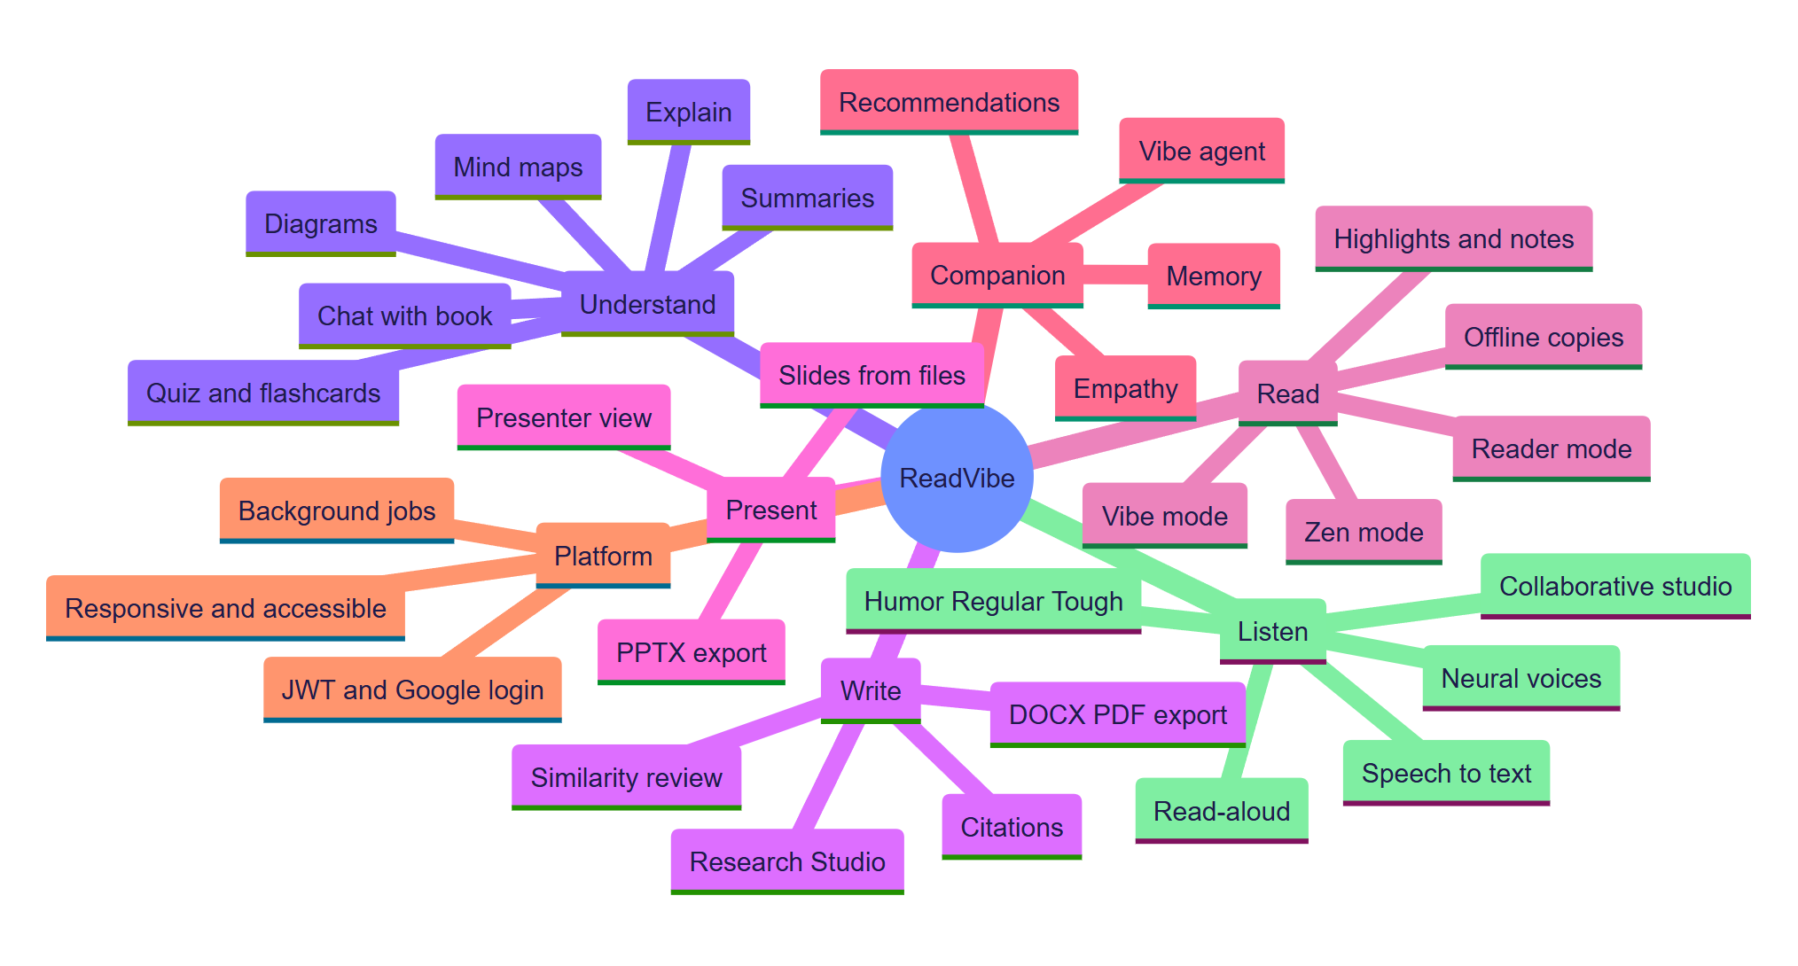
Figure 1: Overview mind map of the ReadVibe platform: seven capability families around one document library.

5. Problem Statement
Readers, students and researchers lack a single, accessible, AI-assisted environment in which a document can be read in a mode suited to their state of mind, narrated expressively with synchronised highlighting, interrogated and visualised with answers grounded in the text itself, turned into research output and slides, and adapted to the individual reader — while remaining usable offline, on a phone, and without paid AI keys.
The specific sub-problems are:
- Fragmentation — reading, listening, studying, writing and presenting require different tools with no shared context.
- Distraction — standard readers offer little protection against attentional interruption and no deliberate focus environment.
- Flat narration — most text-to-speech reads every sentence in the same neutral voice, ignoring dialogue, mood and stage directions.
- Ungrounded AI — generic chatbots invent facts; a reading assistant must answer from the document and show where.
- Accessibility and equity — dyslexia-friendly typography, read-aloud with highlighting, regional-language support and offline access are rarely combined.
- One-size-fits-all — the same interface and advice are given to a stressed student before an exam and to a relaxed reader on a weekend.

6. Existing System
Existing solutions each address one slice of the problem:
Table 2: Categories of existing systems (based on their primary public positioning)
Category | Typical examples | What they do well
E-book readers | Kindle, Google Play Books, Apple Books | Typography, store integration, progress sync
Audiobook services | Audible and similar | Professionally narrated, pre-recorded titles
Text-to-speech readers | Speechify, NaturalReader, built-in OS voices | Reading arbitrary text aloud
Reference and writing tools | Zotero, Mendeley, Google Scholar, word processors | Collecting and citing sources
General AI assistants | Chat assistants | Open-ended Q&A and summarisation
Focus applications | Ambient-sound and Pomodoro apps | Concentration support

Scope of comparison. The comparison in this report is category-level and based on each product family’s primary positioning. It is not an exhaustive feature audit of any specific commercial product, whose features change frequently.

7. Limitations of Existing System
- No shared context between reading, audio, notes and research; the user re-uploads and re-organises the same file in each tool.
- Pre-recorded audio is closed: it cannot narrate a user’s own document, cannot change tone, and offers no word-level highlight of the user’s text.
- Neutral TTS: stage directions such as “[in fright]” are either read aloud or ignored, and characters share one voice.
- Ungrounded answers: general assistants do not cite the passage an answer came from, so students cannot verify them.
- Cloud dependence: AI and neural voices usually need a paid account and a stable connection; none degrade to a local engine.
- Weak personalisation: recommendations and advice ignore how the reader actually behaves — pace, consistency, quiz results, mood.
- Limited accessibility and language reach, particularly for Indian languages and dyslexia-friendly presentation.

8. Proposed System
ReadVibe is a three-tier web platform (architecture in Section 26). A React single-page application provides the reading, audio, research and presentation interfaces. A FastAPI service exposes more than 120 REST endpoints behind JWT authentication, rate limiting and consistent error handling. Domain services implement document extraction, NLP, narration planning, neural text-to-speech, recommendation, research and slide generation. Data is stored in a relational database and a file store, with a browser-side IndexedDB cache for offline reading.
The distinguishing design decision is graceful degradation. Every network-dependent capability has a local fallback and every response states which engine produced it:
Table 3: Preferred and fallback paths
Capability | Preferred path | Fallback when unavailable
Summaries, explanations, chat, mind maps, quizzes | LLM through an OpenAI-compatible endpoint (own key, then free public endpoints) | Local extractive NLP engine (TF-IDF, BM25, clustering)
Read-aloud voice | Neural voice (Edge TTS, optionally OpenAI) with exact word timings | Browser Web Speech voices
Vibe agent | Primary model with retries, then backup model | Free LLM, then local engine
Reference discovery | Semantic Scholar + Crossref + OpenAlex | The user’s own library passages
Translation | MyMemory with permanent per-sentence cache | Clear “quota reached” message — never silent English

9. Objectives of the Project
The project defines five formal objectives, taken from the project’s objectives statement and restated here against what has been implemented:
Table 4: Project objectives and implemented outcomes
# | Objective | Implemented outcome
01 | Immersive multi-modal reading | Reader, Zen and Vibe modes with seamless switching that preserves position; offline copies; seven typefaces including OpenDyslexic and Hyperlegible
02 | AI content intelligence | Summaries (brief, standard, deep), five explanation styles, chat with citations, mind maps, flowcharts, quizzes, flashcards, visual references, concept comparison
03 | Multi-tone audio engine | Regular, Humor and Tough narration; neural voices with word timings; speed 0.5–3×; sleep timer; bookmarks; collaborative studio with microphone recording and WAV export
04 | Research paper pipeline | Discovery across three scholarly sources, ranking, outline, section drafting with versions, APA/IEEE/MLA, similarity and citation review, DOCX/PDF/Markdown export
05 | Scalable, accessible deployment | Docker image, nginx and Render configurations, Vercel frontend, JWT, rate limits, background jobs, themes, reduced-motion, responsive layouts

Two further objectives emerged during development and are also met: a presentation studio that converts any file into a themed, animated deck exportable as .pptx, and a behaviour-, cognition- and empathy-aware reading agent (Vibe).

10. Scope of the Project

In scope
- Ingestion of PDF, EPUB, DOCX, PPTX, ODT, TXT, Markdown, HTML, RTF, CSV, XML, JSON, YAML, LOG, TeX and RST files, and pasted text.
- Reader, Zen and Vibe modes; highlights in five categories, notes, bookmarks, pen sketches, in-document search.
- Document-grounded AI features, narration, audiobooks and collaborative recording, speech-to-text.
- Research Studio, Presentation Studio, Notebook, recommendations, statistics and streaks.
- Email/password and Google sign-in; data export and account deletion.

Out of scope (current release)
- A native mobile application (the web app is fully responsive instead).
- Spotify playback integration (Vibe mode uses local files and generative lo-fi).
- Kubernetes orchestration and a message broker; a thread-pool job runner is used and is designed to be swappable.
- DRM-protected e-books and a commercial book store.
- Clinical or diagnostic use of the empathy features — they are a gentle estimate, never a diagnosis.

11. Motivation Behind the Project
The motivation is both personal and evidence-based. Students routinely carry reading lists in PDF form, study late at night, and switch between a reader, a music player and a chat assistant. Evidence shows that interruptions hurt comprehension, that read-aloud with highlighting helps struggling readers, and that one-size-fits-all assistance is least effective for the readers who need it most. Building a tool that treats reading as a whole workflow — and that remains useful on a slow connection with no paid keys — responds directly to that evidence and to the needs of the project team’s own peers.

12. Expected Outcomes
- A deployed, publicly accessible application that a faculty panel can use without installation.
- A reproducible, tested code base (159 passing tests) with clear separation of routers, services and data models.
- Measurable behaviour: ingestion of multi-megabyte documents in well under a second on the local engine, interactive retrieval in tens of milliseconds (Section 90).
- A documented integration of expressive narration, synchronised reading, distraction-aware modes and personalisation — a combination that the surveyed literature treats only in isolation.
- A foundation for future work: user studies, richer expressive models and a native client.

Part 2 — Research and Literature Survey

13. Research Background
The research scope of ReadVibe combines six areas that are normally studied separately: digital document reading, text-to-speech (TTS), expressive or emotion-aware narration, synchronised audio–text reading, mood-aware personalisation, and distraction-free reading — together with personalised content discovery. The literature base consists of seventeen published works, grouped into the clusters below.
Table 5: Research areas and their application
Research area | Sources | Application in ReadVibe
Expressive TTS | [1], [5] | Tone engine (Regular / Humor / Tough), stage-direction delivery, character voices
TTS and comprehension | [2], [3], [4] | Read-aloud with synchronised word highlighting; adaptive Read + Listen
Personalised affective computing | [7], [8], [17] | Vibe agent’s empathy layer; mood-responsive scenes and interface
Digital distraction | [9] – [12], [16] | Zen mode, focus sessions, notification and pop-up minimisation
E-book usability | [13], [14], [15] | Reader typography, navigation, search, annotation, comfort
Recommendation | [6] | Interest profile and “related to what you are reading” suggestions

14. Literature Review

Expressive narration
Michel et al. [1] introduce LibriQuote, a 5.3K-hour corpus of expressive character quotations with contextual pseudo-labels describing intended delivery, and show that fine-tuning a flow-matching model on it improves expressivity and intelligibility. Charfuelan Oliva and Steiner [5] earlier showed that audiobook sentences can be grouped by acoustic voice style and controlled through EmotionML. Both support the premise that narration should depend on narrative context — dialogue, mood, speaker — rather than being uniform.

TTS and reading comprehension
A meta-analysis [4] finds a positive overall effect of TTS and read-aloud tools on comprehension for students with reading difficulties, while cautioning that effects depend on design and population. Keelor et al. [3] found that TTS, with or without highlighting, improved comprehension compared with silent reading, supporting the combination of auditory and visual presentation. Chen et al. [2] used eye-tracking and found that benefits differ by profile: TTS improved comprehension for students with ADHD-related reading difficulties, while students with dyslexia showed reduced reading time and effort without a comprehension gain. The conclusion drawn for ReadVibe is that assistance should be adaptive and optional, not one-size-fits-all.

Distraction
Shen’s meta-analysis [10] of 32 studies reports a substantial negative effect of attentional distraction on digital-reading comprehension (Hedges’ g = −0.6411). Santhosh et al. [11] found that notifications and pop-ups disrupted flow, reduced comprehension and increased frustration. A naturalistic study [12] with 74 participants found disruptions about every four minutes, concentrated early in the text. Not all findings are uniform: a study of passive on-screen distractions [9] found little effect when readers retained top-down attentional control. ReadVibe therefore treats Zen mode as an option that removes active interruptions rather than assuming all stimuli are harmful.

Personalisation and affect
Li et al. [7] organise personalised affective computing into data-level and model-level approaches (user-specific models, group models, fine-tuning, multitask learning). Medjden et al. [8] show that an interface that adapts to recognised emotion can improve usability, and Haddad et al. [17] show that physiological and behavioural signals can implicitly assess affective responses to interfaces. De Nadai et al. [6] demonstrate that graph-based personalisation can improve audiobook discovery under sparse interaction data.

E-book usability
Studies of tablet readers [13], realistic e-books [14] and e-book usability [15] show that page-turn cues, bookmarks, annotation, full-text search and attention to visual fatigue improve reading performance and preference.

15. Review of Existing Research Papers
Table 6: Summary of the seventeen reviewed works
# | Work (year) | Key finding | Used in ReadVibe for
1 | Michel et al. (2026) | LibriQuote 5.3K-hour expressive-quote corpus; flow-matching fine-tuning improves expressivity | Character- and narrative-aware narration
2 | Chen et al. (2026) | TTS benefit differs for dyslexia vs ADHD-related difficulties (eye-tracking) | Adaptive, optional Read + Listen
3 | Keelor et al. (2023) | TTS with or without highlighting beats silent reading | Synchronised word highlighting
4 | Wood et al. (2017) | Meta-analysis: positive TTS effect on comprehension | Justification for TTS as core feature
5 | Charfuelan Oliva & Steiner (2013) | Audiobook data + EmotionML for controllable expressive voice | Emotion presets and tone engine
6 | De Nadai et al. (2024) | Graph neural network audiobook recommendation (2T-HGNN) | Interest-profile recommendation
7 | Li et al. (2023) | Survey of personalised affective computing | Mood-aware personalisation design
8 | Medjden et al. (2020) | Emotion-adaptive UI, >90% recognition, better usability | Adaptive scenes and themes
9 | JCAL (see [9]) | Passive distractions had little effect when top-down control is intact | Zen mode as opt-in
10 | Shen (2025) | 32-study meta-analysis, g = −0.6411 | Evidence for focus mode
11 | Santhosh et al. (2024) | Notifications and pop-ups hurt flow and comprehension | Interruption minimisation
12 | Frontiers (2022) | Disruption about every 4 minutes; pleasure predicts comprehension | Flow-preserving interface
13 | Huang et al. (2014) | Contextual-inquiry-driven tablet reader redesign improved acceptance | Reader UI design
14 | Liesaputra & Witten (2012) | Physical-book cues plus digital search improves task efficiency | Navigation, bookmarks, search
15 | Kang et al. (2009) | Higher eye fatigue on e-books; comfort matters | Typography and page colours
16 | Liu (2021/22) | Screen reading strongly tied to multitasking | Motivation for focused modes
17 | Haddad et al. (2024) | Eye, face and EEG signals reveal affective response to GUIs | Future affective evaluation

Verification. Bibliographic details were transcribed from the project’s abstracts document. As that document itself advises, authors, venue, volume and page details should be re-verified against the publisher record before final submission; the source link for each work is given in Section 99.

16. Comparison of Related Applications
The table compares ReadVibe with the main product categories on the capabilities this project targets. “Typically” indicates the common case for the category; individual products may differ.
Table 7: Capability comparison by product category
Capability | E-book readers | Audiobook services | TTS readers | General AI chat | ReadVibe
Reads the user’s own files | Yes | No | Yes | Upload-dependent | Yes (≤ 5 GB)
Narration of own documents | Limited | No | Yes | No | Yes, three tones
Word-level highlight while speaking | Rare | No | Common | No | Yes (neural timings)
Distraction-free scene with ambient sound | No | No | No | No | Zen mode
Music-reactive reading | No | No | No | No | Vibe mode
Answers cited to the document | No | No | No | Rare | Yes
Mind maps / flowcharts from text | No | No | No | On request | Built-in, exportable
Reference discovery and paper drafting | No | No | No | Partial | Research Studio
Works without a paid AI key | n/a | n/a | Varies | Rarely | Yes (local engine)
Personalised, empathy-aware agent | No | No | No | Generic | Vibe agent

17. Research Gaps Identified
- Isolation of research threads. Expressive TTS, comprehension-oriented TTS, affective personalisation, distraction research and e-book usability are studied as separate problems [1]–[17].
- Expressive narration for arbitrary user documents. Expressive-TTS research uses curated audiobook corpora; systems that apply controllable expression to a user’s own uploaded text, including stage directions and character gender inferred from the text, are scarce.
- Adaptive rather than uniform TTS. Evidence [2] shows benefits differ by reader profile, yet commercial readers provide one mode.
- Grounded, offline-capable assistance. Most assistants are cloud-only and ungrounded; few degrade to a local extractive engine.
- Privacy-respecting personalisation. Affective personalisation research often assumes cameras or sensors [8], [17]; a text-and-behaviour-only approach that stores no message content is under-explored.

18. Proposed Research Contribution
ReadVibe contributes an integrated, working reference implementation that connects these threads in one adaptive reading environment, and several specific engineering contributions:
- A universal speech-planning contract that sanitises text, detects language runs, applies emotion, pace, energy and articulation deltas, resolves voices, and records a note whenever it substitutes anything — so fidelity to the transcript is auditable.
- Performed stage directions: bracketed directions are removed from the spoken text but converted into delivery (rate, pitch, volume) while remaining visible, dimmed, in the transcript.
- Evidence-based character casting that infers male/female speakers only from explicit textual evidence (titles, kinship, role nouns), never from names.
- Dual-engine AI with identical JSON shapes from an LLM or the local BM25/TF-IDF engine, tagged by engine so users always know which produced a result.
- Privacy-first empathy layer: a local, lexicon-and-behaviour estimate that returns a guess with confidence, stores only a mood label (never the message), and routes safety phrases to a fixed caring response without calling a model.

19. References and Research Resources
The full reference list is given in Section 99. Additional technical resources used during development include the documentation of FastAPI, SQLAlchemy, React and Vite; the Semantic Scholar, Crossref and OpenAlex APIs; Project Gutenberg and the Internet Archive for public-domain texts; Wikimedia Commons for open-licensed images; and the edge-tts package for Microsoft neural voices.

Part 3 — Requirements Analysis

20. Functional Requirements
Requirements are identified FR-xx. Each is traceable to an API router and a user interface area.
Table 8: Functional requirements
ID | Requirement | Module / router
FR-01 | Register, log in with email and password, sign in with Google, or enter a demo library | auth
FR-02 | Upload files (≤ 5 GB, streamed), paste text, or import public-domain books from Project Gutenberg and the Internet Archive | documents, catalog
FR-03 | Extract text and detect chapters from PDF, EPUB, DOCX, PPTX, ODT, TXT, MD, HTML, RTF and other text formats as a background job with progress | ingest, jobs
FR-04 | Manage the library: tags, favourites, pins, offline copies, sorting, grid/list views, search | documents
FR-05 | Read in Reader, Zen and Vibe modes with position preserved when switching | frontend reader
FR-06 | Highlight (five categories), annotate, bookmark, sketch with pen/marker, search inside the document | documents
FR-07 | Adjust typography: seven typefaces incl. OpenDyslexic, size, spacing, width, alignment, page colour | frontend, prefs
FR-08 | Read aloud with neural voices, word-level highlighting, speed 0.5–3×, skip, sleep timer, queue | tts, audio
FR-09 | Generate audiobooks in Regular, Humor or Tough tone; resume, bookmark, download script | audio
FR-10 | Collaborative studio: collaborators, chapter assignments, microphone recording, teleprompter, clean-up, stitch, WAV export | audio (collab)
FR-11 | Summarise at three depths; explain in five styles; define terms; chat with citations | ai
FR-12 | Generate mind maps and flowchart / concept / block diagrams; export PNG, SVG, HTML, Mermaid | ai
FR-13 | Create quizzes, short-answer grading and flashcards; compare concepts; show visual references | ai
FR-14 | Produce a spoken Audio Overview (conversation or narrative) in the listener’s language | ai (overview)
FR-15 | Translate chapters and scripts; support Indian-language voices | ai (translate), tts
FR-16 | Speech-to-text for dictation and recording transcription with speaker turns | transcribe
FR-17 | Discover references, curate them, outline, draft sections with versions, review similarity and citations, export DOCX/PDF/Markdown | research
FR-18 | Generate a themed presentation from any file; edit, present with presenter view, export .pptx | decks
FR-19 | Notebook of notes, highlights and saved AI outputs; flashcard study mode; Markdown export | notes
FR-20 | Recommendations, statistics, streaks, notifications, global search | documents, activity
FR-21 | Vibe agent: chat, daily briefing, mood check-in, memory management, personalisation switch | agent
FR-22 | Export all user data; delete account | auth

21. Non-Functional Requirements
Table 9: Non-functional requirements
Category | Requirement | How it is met
Performance | Interactive retrieval and local NLP responses; non-blocking ingestion | In-process LRU cache, BM25 index, background jobs; measured in Section 90
Scalability | Large files without exhausting memory | 4 MB streamed upload chunks; text capped at 32 MB; stateless API plus swappable storage and job runner
Reliability | No hard failure when an AI or voice provider is down | Provider fail-over with cool-downs; local engine; browser voices
Security | Authenticated access to user data | JWT (HS256, 7-day expiry), PBKDF2-SHA256 hashes, Google ID-token verification, per-user data scoping
Abuse control | Prevent flooding | Sliding-window rate limit: 600 requests/min general, 40/min for AI endpoints
Privacy | User controls their data | Export and delete endpoints; agent memories visible and deletable; mood label stored, not message text; personalisation can be switched off
Accessibility | Usable by readers with different needs | OpenDyslexic, adjustable size/spacing, light/dark/high-contrast themes, reduced motion, keyboard shortcuts, screen-reader labels
Usability | Works on phone, tablet and desktop | Responsive layouts, mobile reader and mobile home
Portability | Runs anywhere Docker or Python runs | Dockerfile, docker-compose, render.yaml, SQLite or PostgreSQL
Maintainability | Clear structure and tests | Routers / services / models separation; 159 automated tests
Observability | Trace and debug problems | Request IDs on every response; slow-request logging above 1.5 s; consistent JSON errors

22. Hardware Requirements
Table 10: Hardware requirements
Role | Minimum | Recommended
End-user device | Any device with a current browser, 2 GB RAM, speakers or headphones | Phone, tablet or laptop with 4 GB+ RAM; microphone for the collaborative studio
API server (basic) | 1 vCPU, 512 MB RAM, persistent disk for uploads and caches (free container tier is sufficient for demonstration) | 2 vCPU, 2 GB RAM; SSD volume sized to the library; managed PostgreSQL
Speech-to-text (optional) | Not required — feature is disabled unless a server is configured | A GPU server hosting NVIDIA Nemotron-3.5-Transcribe-30B-A4B (the configuration notes one 80 GB H100 for BF16) behind an OpenAI-compatible endpoint
Development machine | Windows, macOS or Linux with Node.js and Python | Used in this project: Windows 11, Node.js 22, Python 3.13

Note. Server sizing figures are guidance derived from the deployment configuration (Render free Docker service) and the model card note for the optional speech-to-text model; they are not results of a load test.

23. Software Requirements
Table 11: Software requirements
Layer | Software | Version / note
Browser | Chrome, Edge, Firefox, Safari (current) | Web Audio, Web Speech, IndexedDB, MediaRecorder required for full features
Frontend runtime | Node.js, npm | Node 22 used for builds
Frontend libraries | react 19, react-dom 19, react-router-dom 7, lucide-react; Vite | See package.json
Backend runtime | Python 3.13 | Docker base image python:3.13-slim
Backend libraries | fastapi, uvicorn, SQLAlchemy 2, pydantic 2, PyJWT, python-multipart, pypdf, python-docx, httpx, fpdf2, edge-tts, google-auth, psycopg 3, python-pptx, Pillow | See backend/requirements.txt
Database | SQLite or PostgreSQL | Any SQLAlchemy URL via READVIBE_DATABASE_URL
Testing | pytest | 159 tests
Deployment | Docker, docker-compose, nginx 1.27, Render Blueprint, Vercel | See Section 98

24. User Requirements
Three primary user groups were identified from the project objectives.
Table 12: User groups and needs
User group | Needs | ReadVibe features that serve them
Students and casual readers | Focus, comprehension, revision, reading on a phone at night | Zen / Vibe / Reader modes, summaries, quizzes, flashcards, Vibe agent, offline copies
Readers with reading or attention difficulties | Alternatives to dense visual text; reduced cognitive load | Read-aloud with highlight, OpenDyslexic, spacing controls, adjustable speed, reading ruler and focus line
Research scholars and postgraduates | Find, cite and draft quickly; verify sources | Research Studio, citation review, DOCX/PDF export, grounded chat with citations
Learners and book clubs | Hear a text, record parts together | Audio Studio, tones, collaborative studio
Educators and presenters | Turn material into slides | Presentation Studio with presenter view and .pptx export

25. Use Cases and User Scenarios
Three representative scenarios follow. The formal use-case diagram, with all actors and use cases, is given in Section 31.

Scenario A — A student prepares for an exam
- The student uploads a 300-page PDF. The ingest job extracts text and chapters and notifies when ready.
- They open Zen mode with rain ambience and a 25-minute focus session, reading one chapter at a time.
- They ask for a Standard summary of the chapter, generate a mind map, then take a quiz and save weak cards to the Notebook.
- Late at night they tell Vibe they feel overwhelmed. Vibe responds gently, suggests a smaller goal, remembers “preparing for exam” and logs only the label overwhelmed.

Scenario B — A reader with dyslexia reads a novel
- They choose OpenDyslexic, increase line spacing and switch the page to a warm colour.
- They press Listen; a neural voice reads each sentence while the current word is highlighted and the page scrolls.
- They slow the speed to 0.85× and pause at a bookmark; the next day playback resumes at the same sentence.

Scenario C — A scholar writes a literature review
- They enter a topic. ReadVibe queries Semantic Scholar, Crossref and OpenAlex, de-duplicates and ranks results.
- They include or exclude references, generate an outline, draft sections with the AI, and run the similarity and uncited-claim review.
- They export a DOCX with IEEE citations.

Part 4 — System Architecture and Design

26. Overall System Architecture
ReadVibe follows a four-tier architecture: a client tier, an application tier, a data tier and an optional external-services tier. The client talks to the API over HTTPS using JSON and a bearer JWT. The API never requires an external service to be present; each external dependency sits behind a service module that has a local fallback.
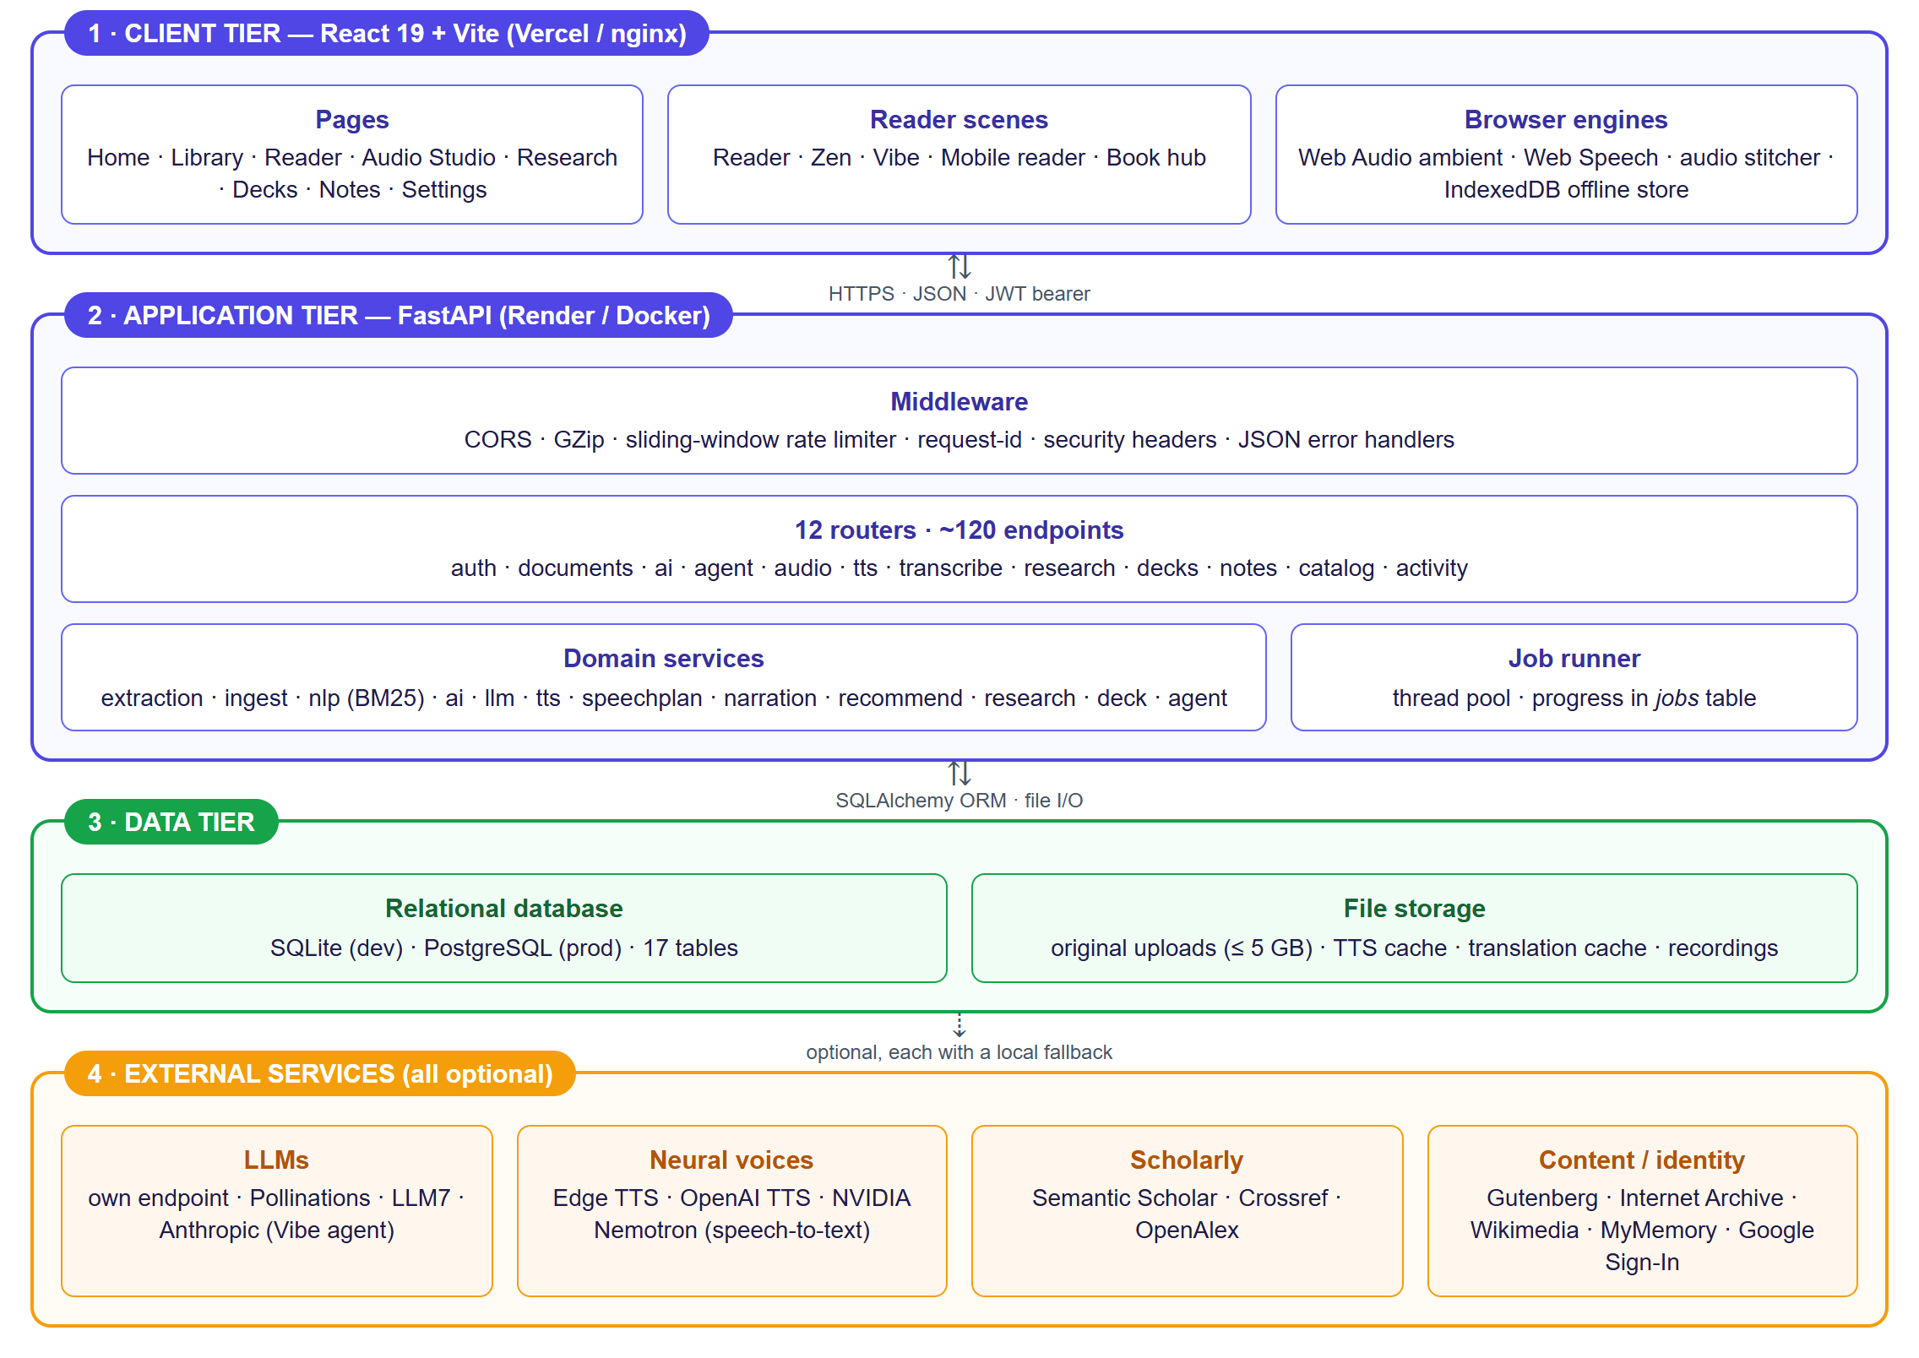
Figure 2: Overall system architecture of ReadVibe.
The application tier is a single FastAPI process organised as middleware → routers → services. Routers validate input and authorise the user; services contain all domain logic and are free of HTTP concerns, which is why the same service functions are exercised directly by unit tests and through the HTTP layer by integration tests.

Cross-cutting concerns
- Authentication: a dependency decodes the bearer JWT and loads the user; every query is scoped by owner_id.
- Rate limiting: an in-memory sliding window per client and bucket (general or AI), returning HTTP 429 with Retry-After.
- Error handling: all errors become {detail, request_id} JSON; validation errors report the first failing field.
- Observability: an X-Request-ID header on every response; slow requests are logged with the same ID.
- Background work: a thread-pool runner persists job state to the jobs table so the UI can poll progress and show notifications.

27. High-Level Design (HLD)
The high-level design divides the system into four layers and five families of domain services. The layering is strict: the presentation layer depends only on the API contract, and domain services depend on persistence and on optional external providers through narrow interfaces.
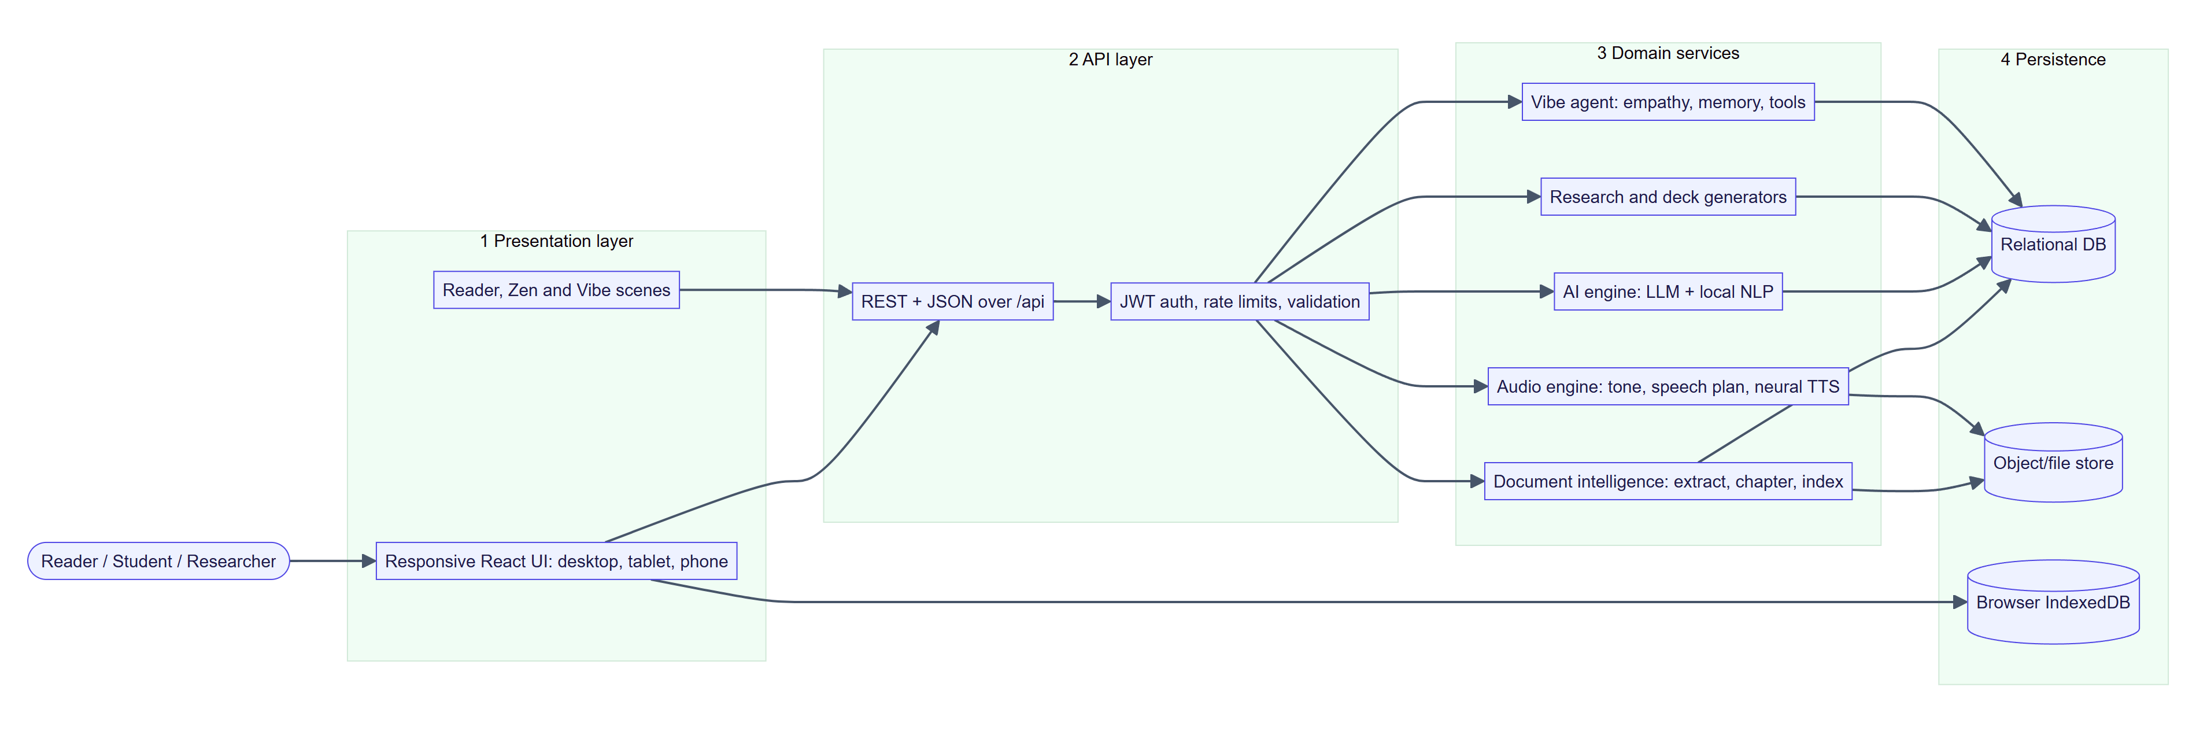
Figure 3: High-level design: layers and domain-service families.
Table 13: Service families
Service family | Responsibility | Principal modules
Document intelligence | Extract, chapter, describe, index and search documents | extraction, ingest, nlp, storage
Audio engine | Plan narration, synthesise neural speech, cache audio, transcribe speech | narration, speechplan, directions, cast, tts, transcribe, overview, translate, languages
AI engine | Provide summaries, explanations, chat, maps, diagrams and quizzes with fail-over | ai, llm, nlp
Research and decks | Discover and rank references; draft and export papers; build slide decks | research, deck, art, pptx_export
Vibe agent | Empathic, grounded, tool-using reading companion | agent/orchestrator, empathy, profile, memory, gateway, tools, briefing

28. Low-Level Design (LLD)
The following table gives the low-level responsibilities of the most important modules and the key functions in each.
Table 14: Low-level module responsibilities
Module | Key functions / classes | Detail
services/extraction.py | extract, chapter regex, TARGET_SECTION_WORDS | Format dispatch; chapter markers in English and ten Indian scripts; sections split near 2,200 words; text capped at 32 MB
services/ingest.py | write_chapters, describe | Stores chapters; builds a two-sentence description and up to three key-phrase tags
services/jobs.py | create_job, submit, JobContext.update | Thread-pool runner (4 workers by default); progress is monotonic; failure message stored on the job
services/nlp.py | key_phrases, rank_sentences, BM25Index, summarize, mind_map, diagram, quiz, flashcards, similarity_flags | Dependency-free engine; BM25 with k1 = 1.4, b = 0.75
services/llm.py | provider chain, cool-down | OpenAI-compatible calls; failed provider skipped for 90 s (120 s on rate-limit); LLMUnavailable triggers local fallback
services/ai.py | summarize, explain, chat, mind_map, diagram, quiz | Chooses LLM or local engine; thread-safe LRU cache; same JSON shape either way; result tagged with engine
services/narration.py | TONES, script builder | Tone profiles (rate, pitch, pauses), spoken intro/outro per tone
services/speechplan.py | style, sanitise, language runs, apply_glossary, resolve_voice, check_audio | Speech contract: transcript fidelity, voice substitution recorded as a note
services/tts.py | synthesize, prosody, _edge, _openai | ≤ 1,500 characters per segment; hash-keyed disk cache; word timings
services/recommend.py | categories, interest profile | 13 categories; behaviour-weighted; local only
services/research.py | discover, rank, format_citation, draft_section, export_docx/pdf/markdown | Parallel provider queries; de-duplication; APA / IEEE / MLA
services/deck.py | LAYOUTS, _normalize | 15 slide layouts; LLM or local generation both normalised
services/agent/* | orchestrator, empathy.detect, gateway.converse, tools, memory, profile | See Section 44 and 52

Example: sliding-window rate limiter
class RateLimiter:
def allow(self, key, limit, window=60.0):
now = time.monotonic()
with self.lock:
q = self.hits[key]
while q and now - q[0] > window:
q.popleft()
if len(q) >= limit:
return False, int(window - (now - q[0])) + 1 # retry-after seconds
q.append(now)
return True, 0

Example: research relevance score
score = 0.5*title_match + 0.25*abstract_match + 0.15*min(log10(citations+1)/4, 1) + 0.10*recency
relevance = round(min(0.99, 0.35 + score * 0.7), 3) # recency = max(0, 1 - age/25 years)

29. System Workflow
The end-to-end workflow below shows how a user moves from authentication to ingestion, to a reading mode, and from there to AI, audio, research or presentation features, with every artefact flowing into the Notebook and the statistics.
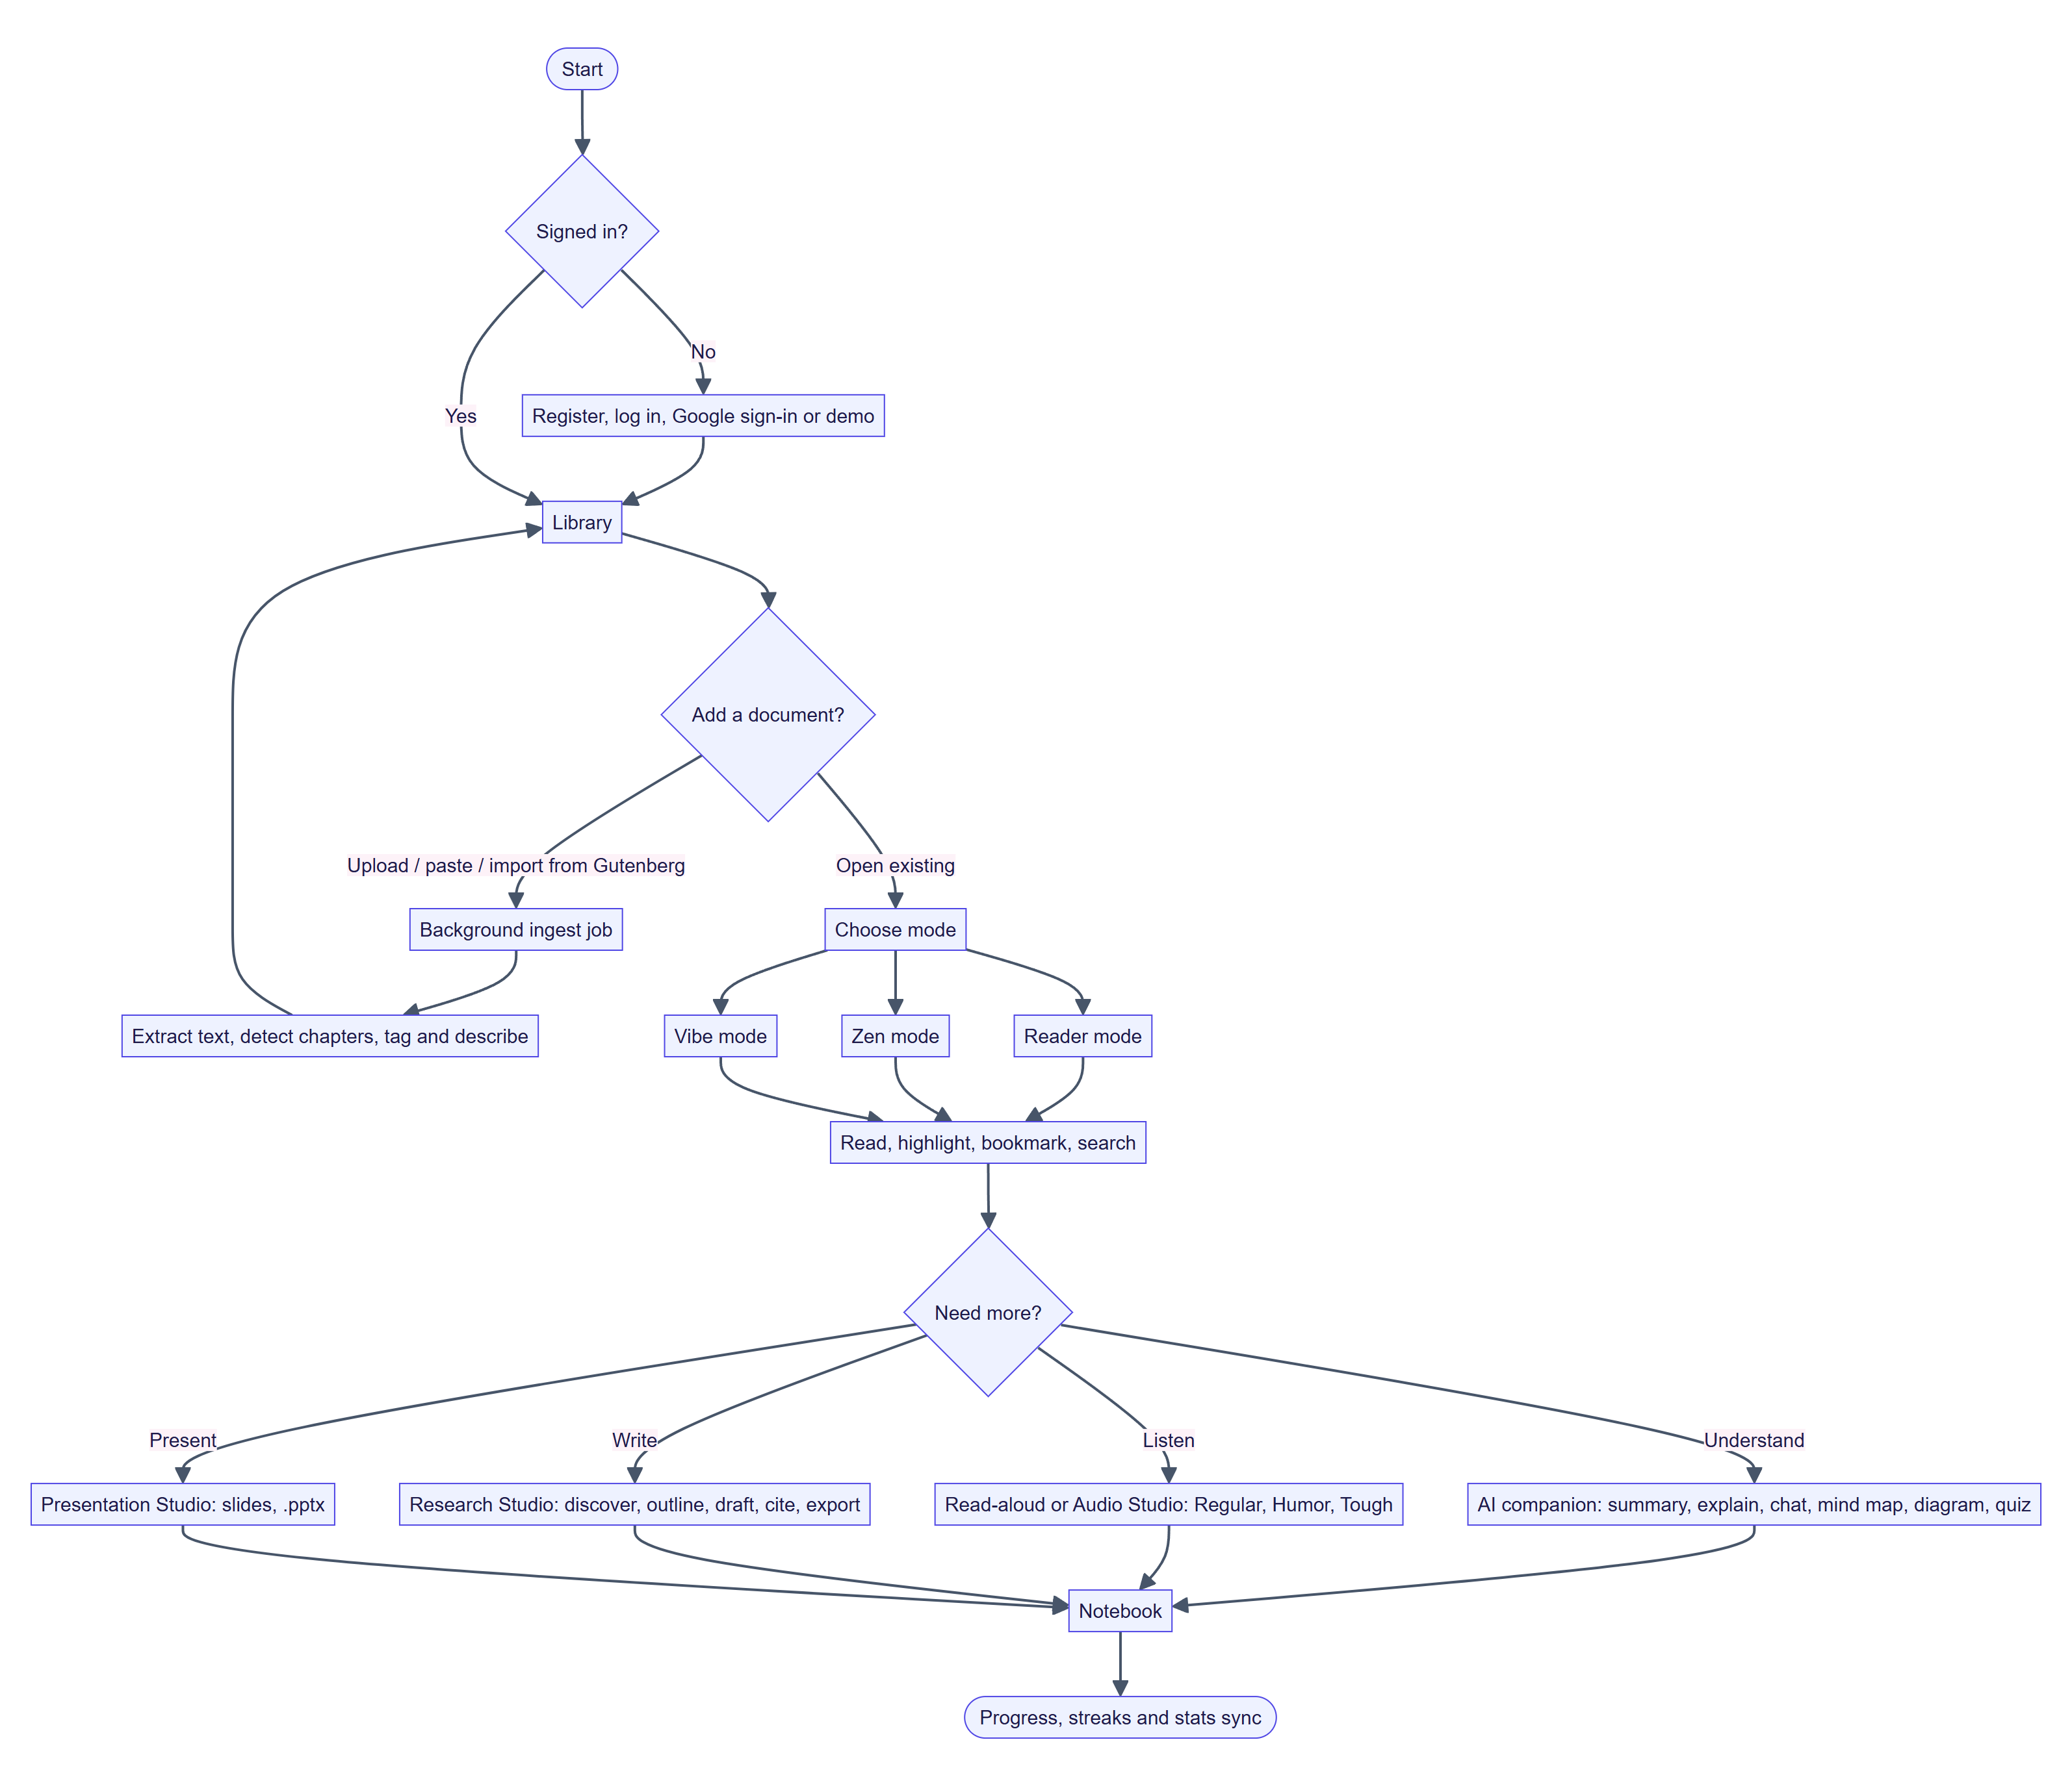
Figure 4: End-to-end system workflow (flow chart).

30. Data Flow Diagram (DFD)

Level 0 — Context diagram
At the context level ReadVibe is a single process that exchanges data with the user and with five optional external systems.
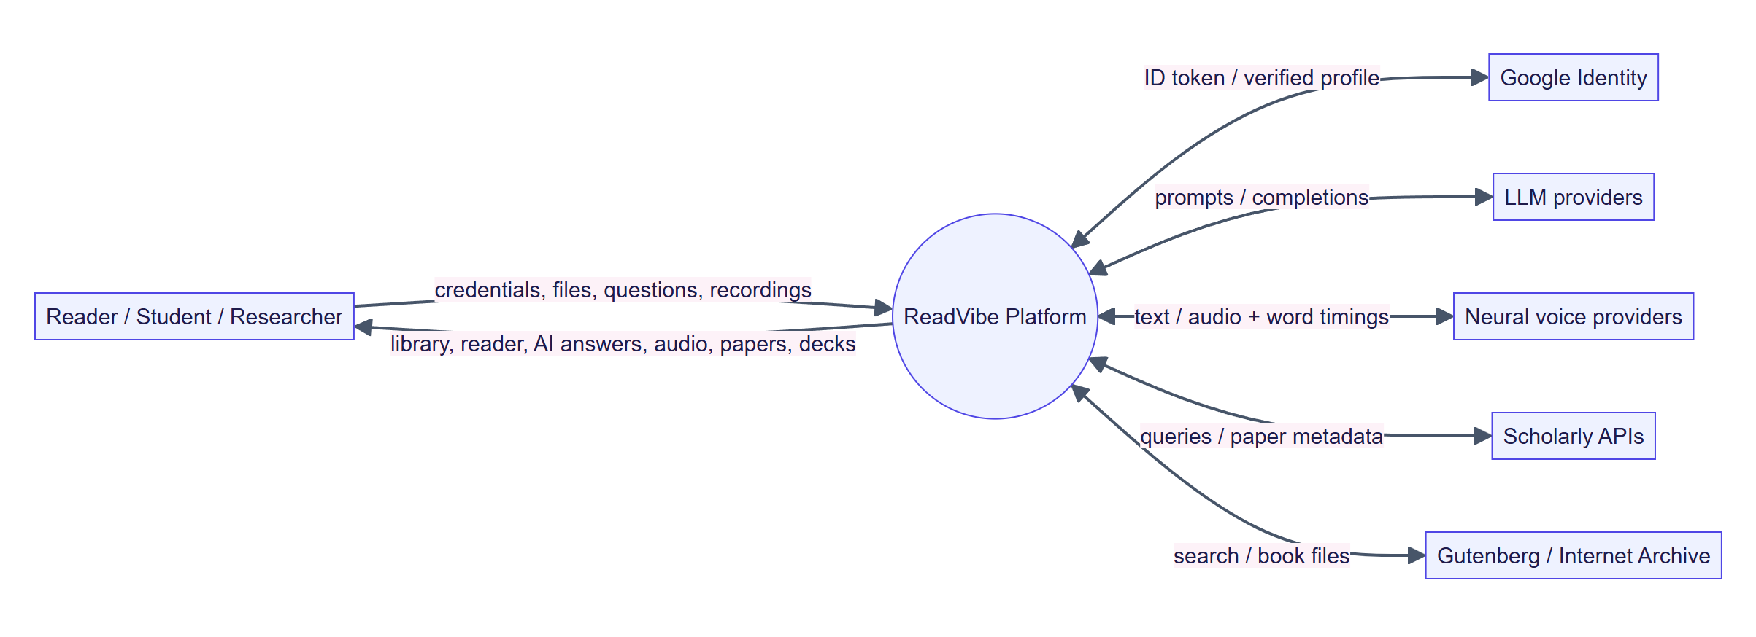
Figure 5: DFD level 0 (context diagram).

Level 1
Level 1 decomposes the system into seven processes and six data stores. Processes read and write only the stores shown.
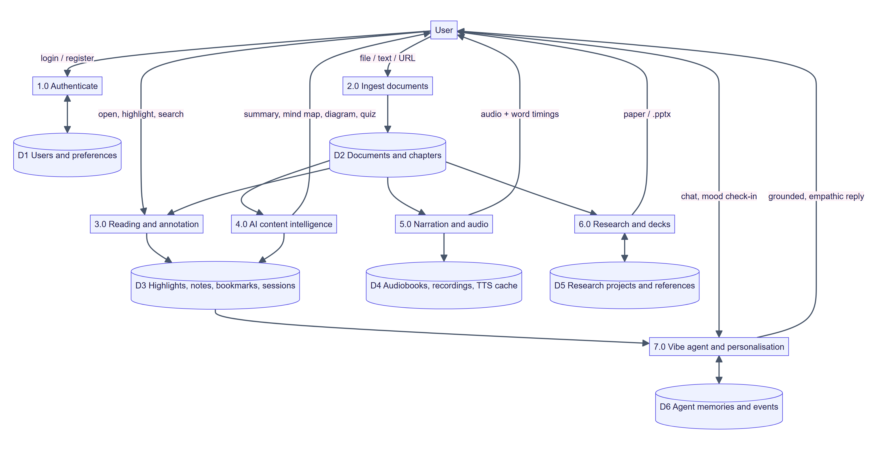
Figure 6: DFD level 1: seven processes and six data stores.

31. Use Case Diagram
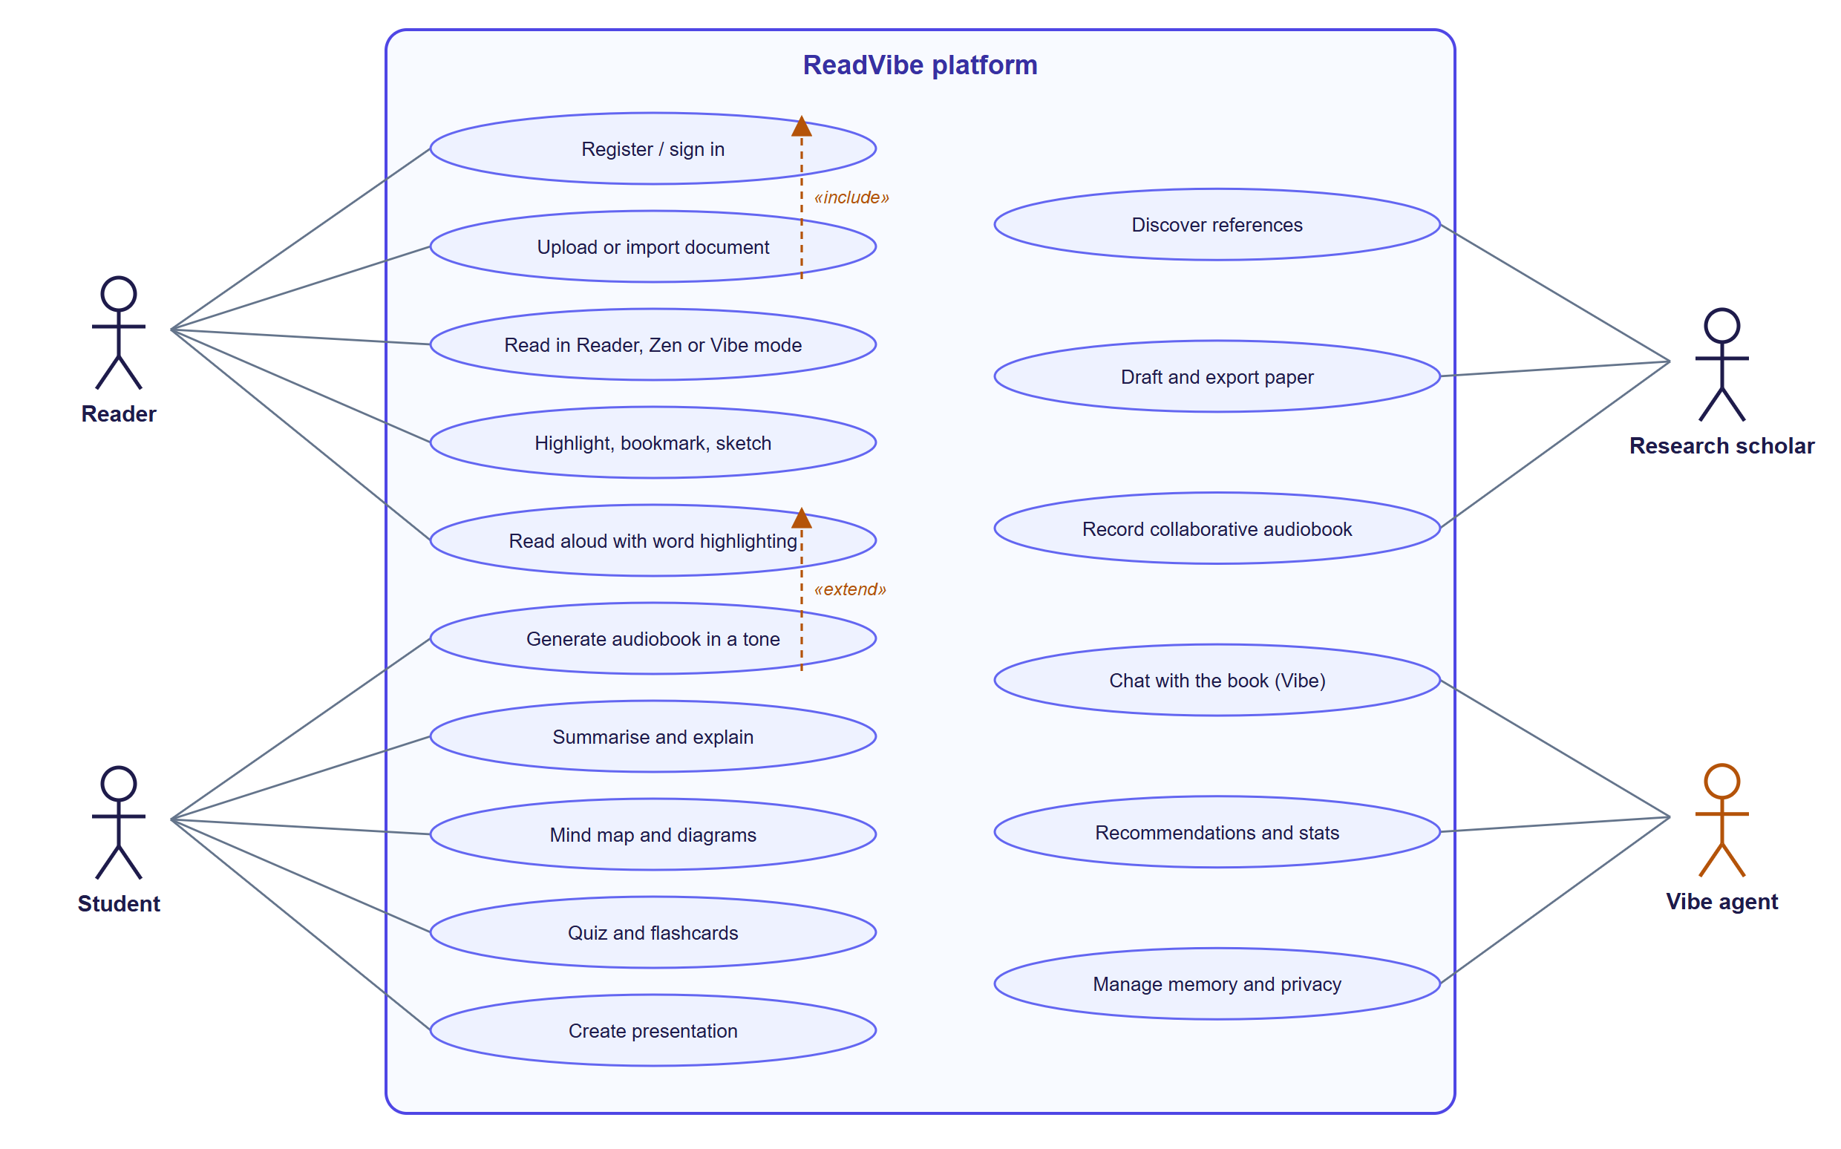
Figure 7: Use-case diagram of ReadVibe (actors: Reader, Student, Research scholar, Vibe agent).
Table 15: Selected use-case specifications
Use case | Primary actor | Pre-condition | Main outcome
Upload or import document | Reader | Signed in | Document ready with chapters, tags and description
Read in Reader / Zen / Vibe mode | Reader | Document ready | Position, mode and time recorded as a reading session
Read aloud with highlighting | Reader | Document open | Spoken audio with word highlight and auto-scroll
Generate audiobook | Student | Document ready | Audiobook with chapters, resume and download
Summarise / mind map / quiz | Student | Document open | AI output tagged with its engine; can be saved to Notebook
Discover references; draft paper | Research scholar | Project created | Ranked sources; cited draft; DOCX/PDF export
Record collaborative audiobook | Research scholar / Reader | Project with assignments | Stitched, normalised WAV
Chat with the book (Vibe) | Vibe agent | Document open | Grounded, empathic, cited answer
Manage memory and privacy | Vibe agent / User | Signed in | Memories viewed or deleted; personalisation toggled

32. Activity Diagram
The activity diagram shows the document life-cycle from selection to first use, including the validation, failure and notification branches.
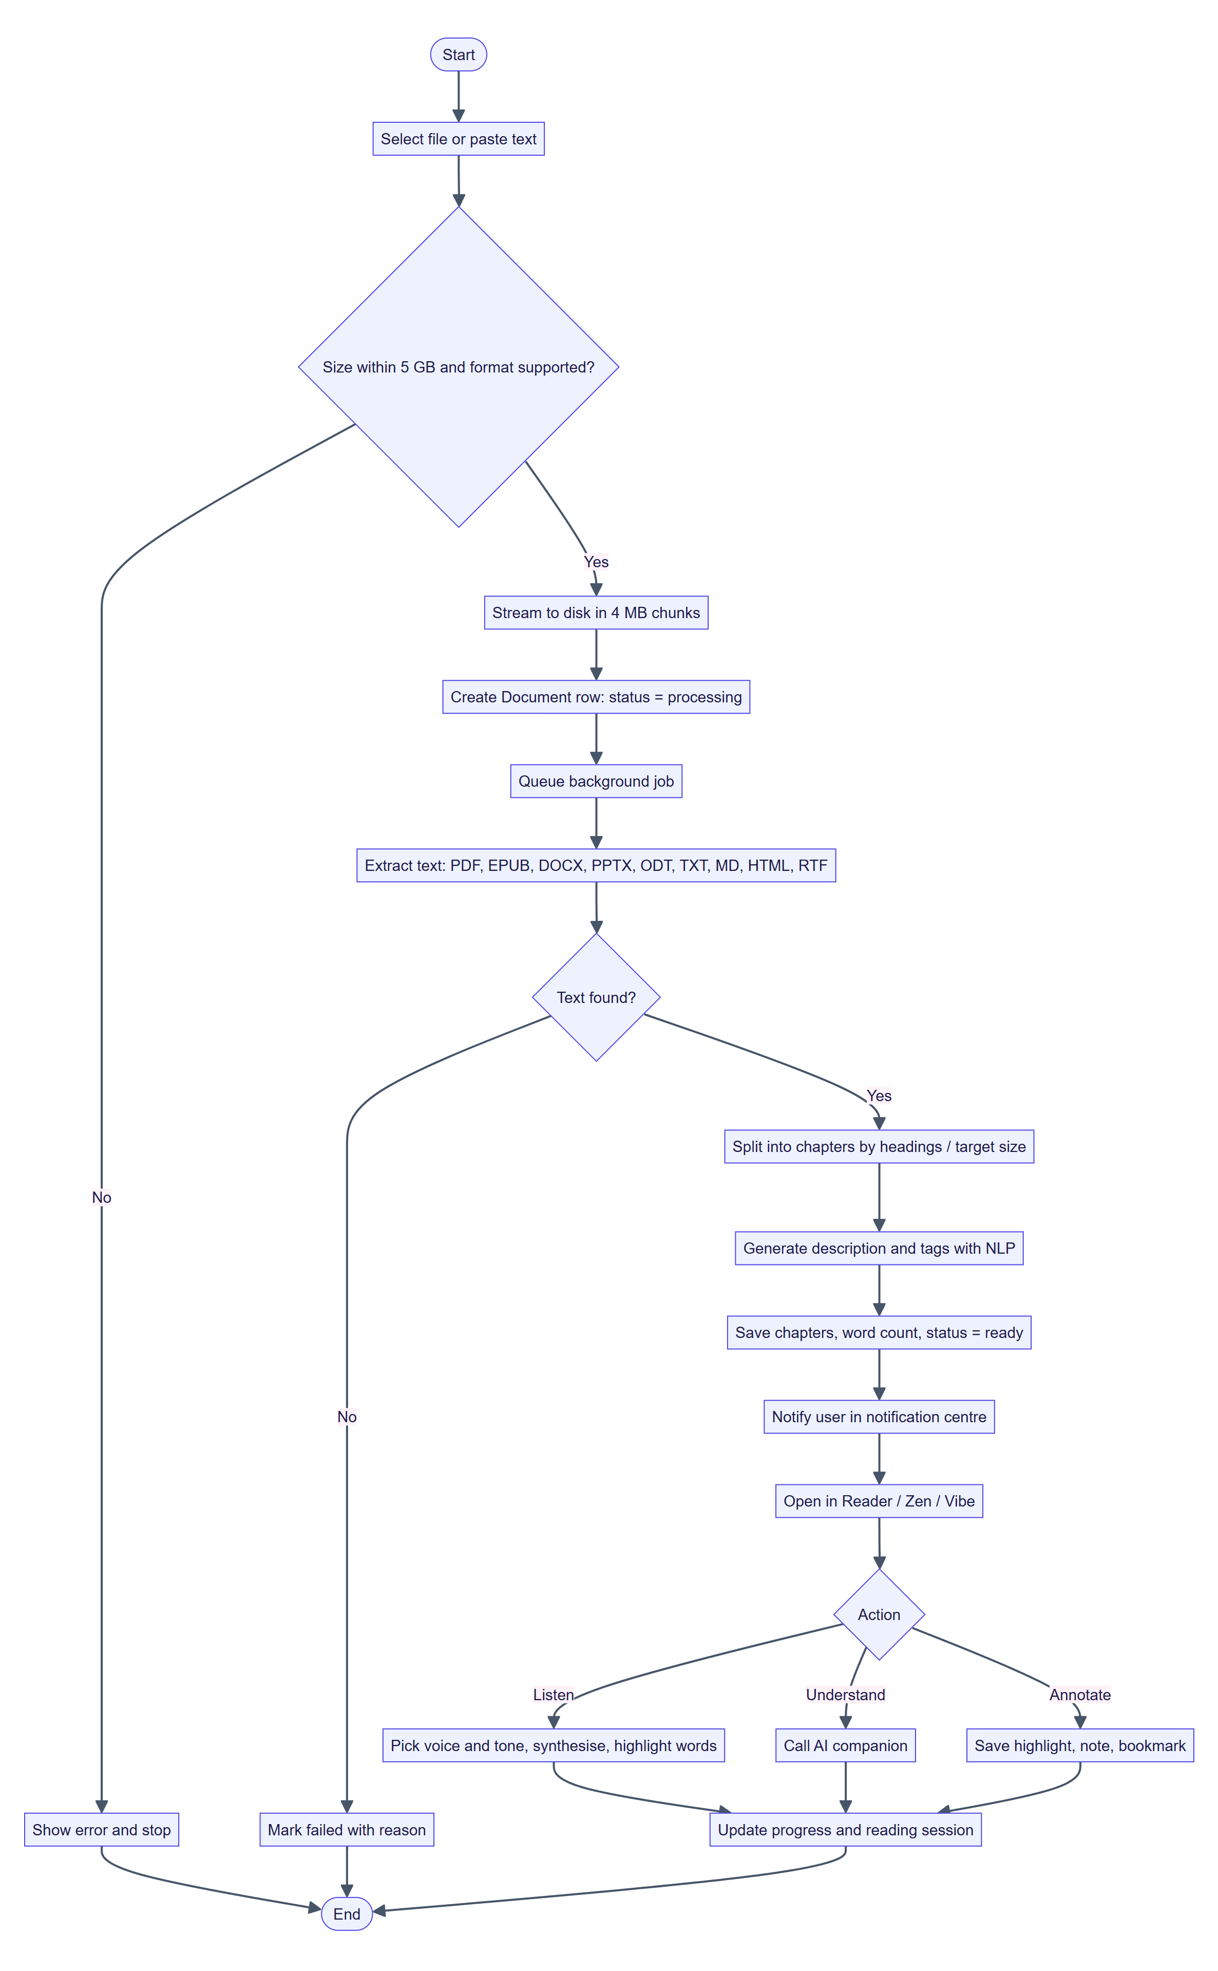
Figure 8: Activity diagram: document ingestion and first use.

33. Sequence Diagram

Upload and ingestion
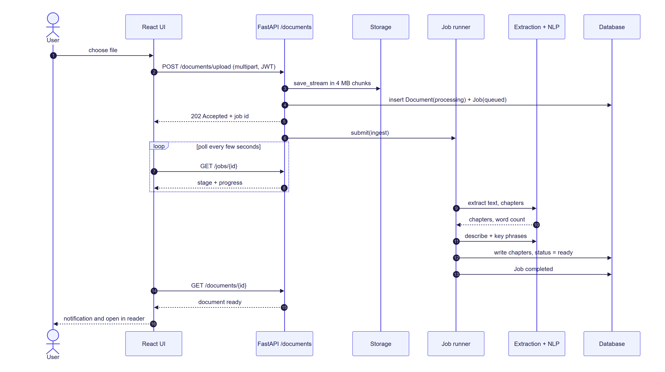
Figure 9: Sequence diagram: upload, background ingestion and notification.

Read-aloud with word synchronisation
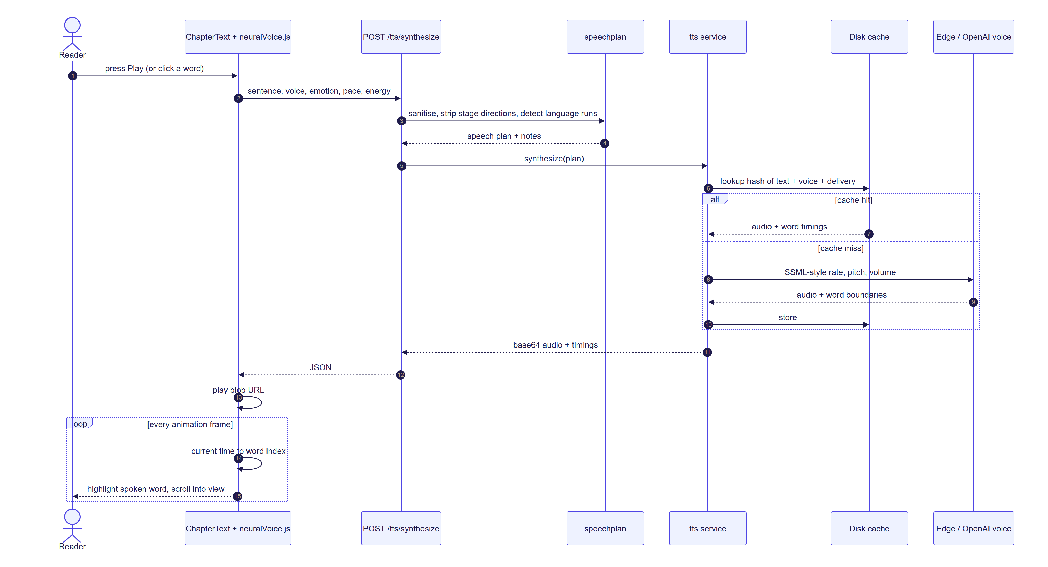
Figure 10: Sequence diagram: neural read-aloud with caching and word highlighting.

Vibe agent conversation
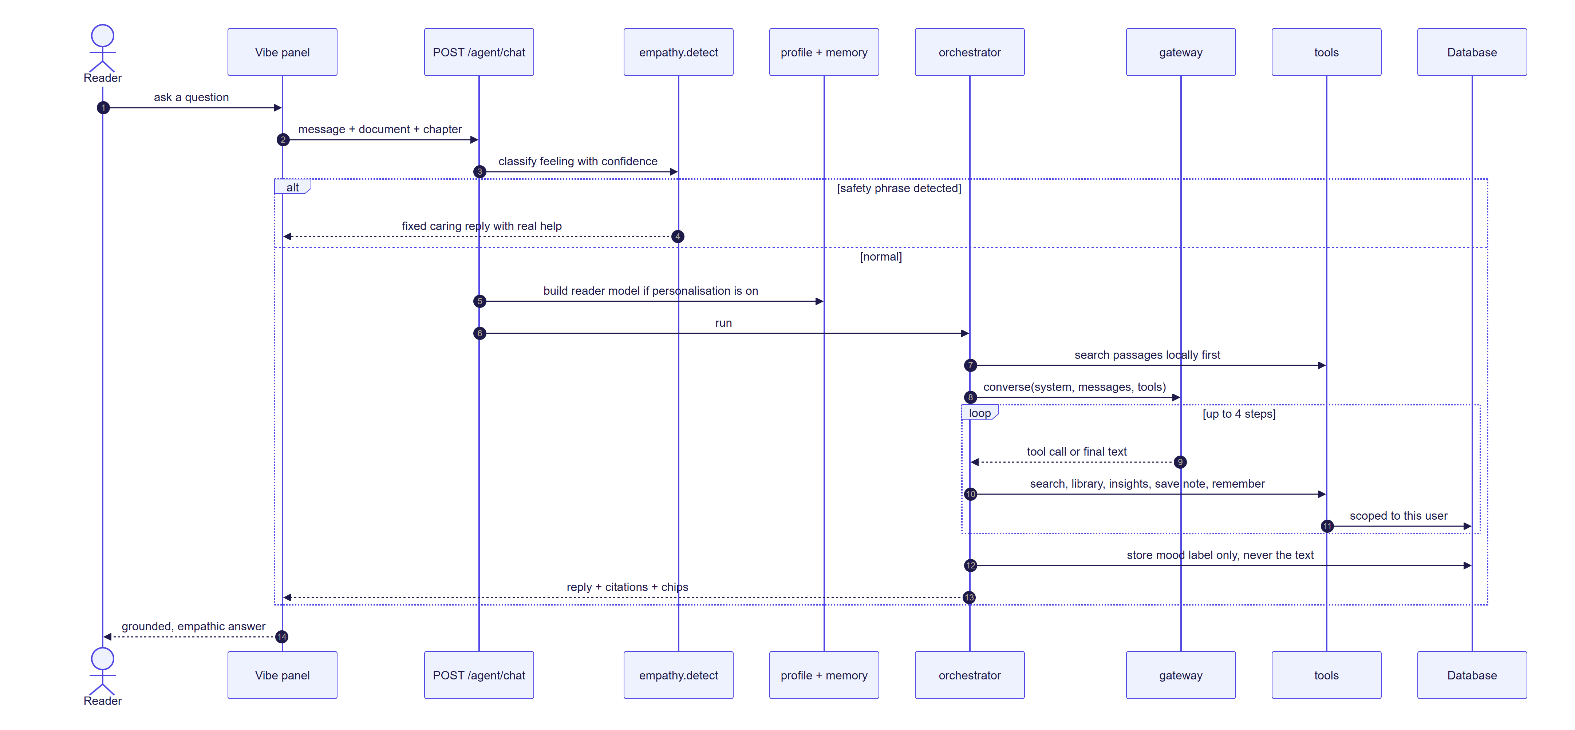
Figure 11: Sequence diagram: Vibe agent request, safety path, tool loop and learning.

Authentication
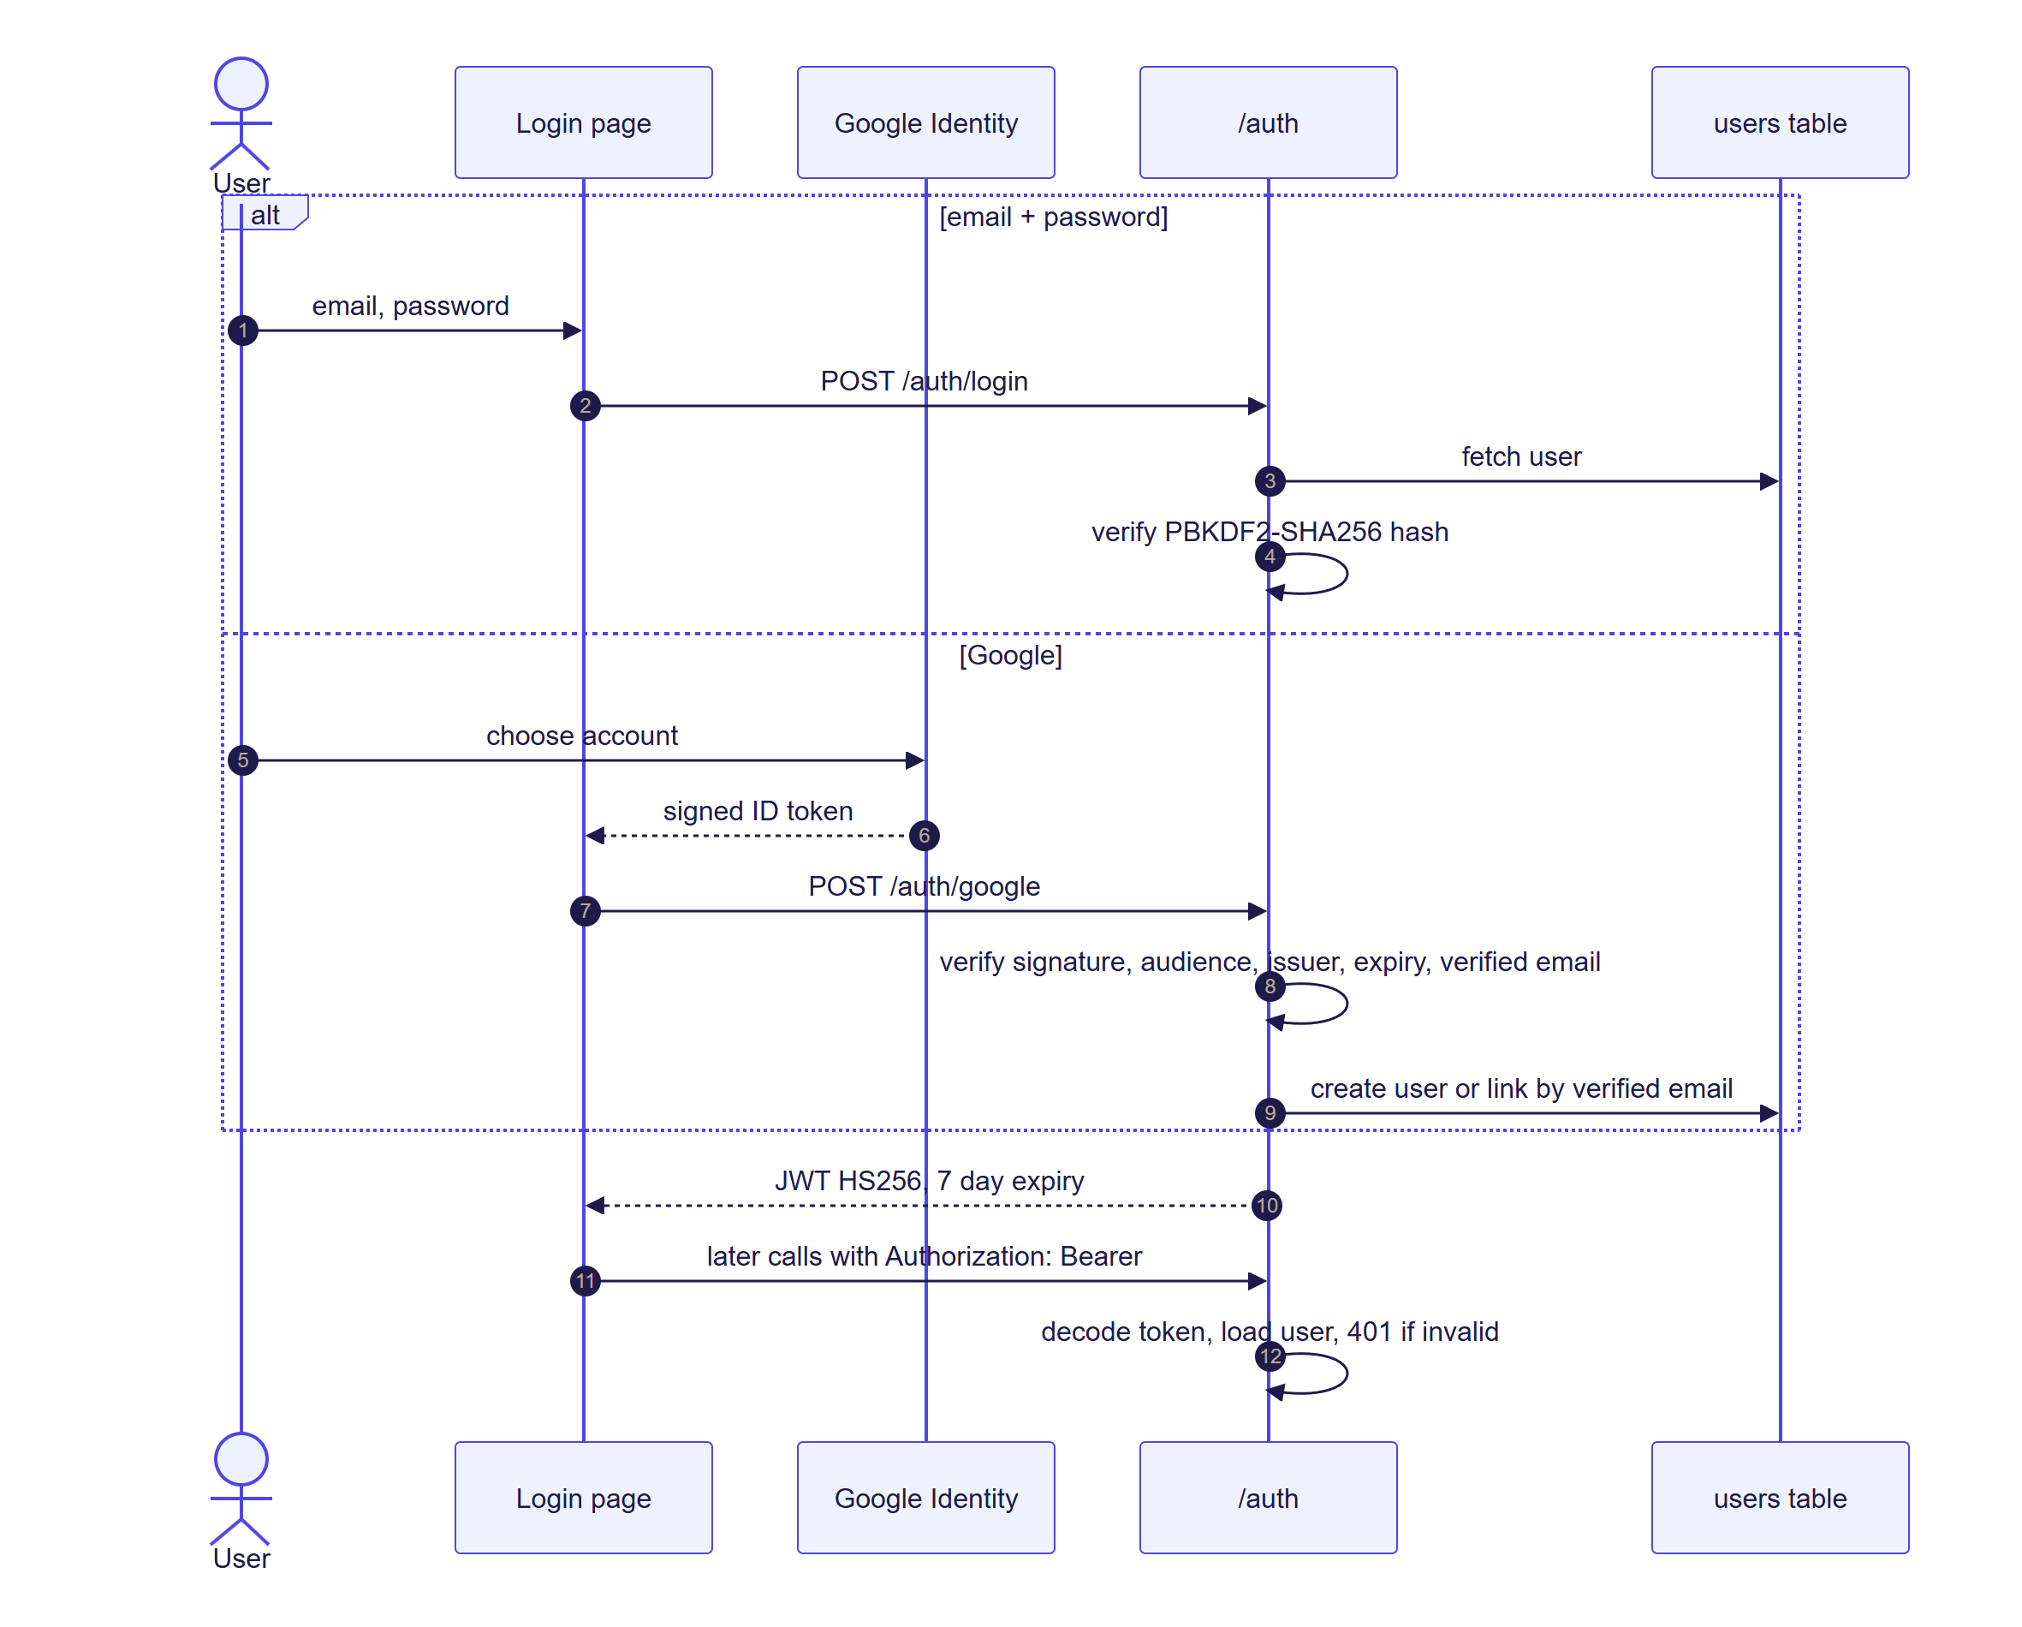
Figure 12: Sequence diagram: email/password and Google authentication.

34. Database Design
The schema has 17 tables defined with SQLAlchemy 2 declarative models. All primary keys are 32-character identifiers; all user-owned rows carry owner_id with ON DELETE CASCADE so deleting an account removes its data. Notes and decks use SET NULL for the document foreign key so that user-authored content survives deleting the source book. JSON columns hold flexible structures (preferences, tags, scripts, outlines, slides), which keeps the schema portable between SQLite and PostgreSQL.
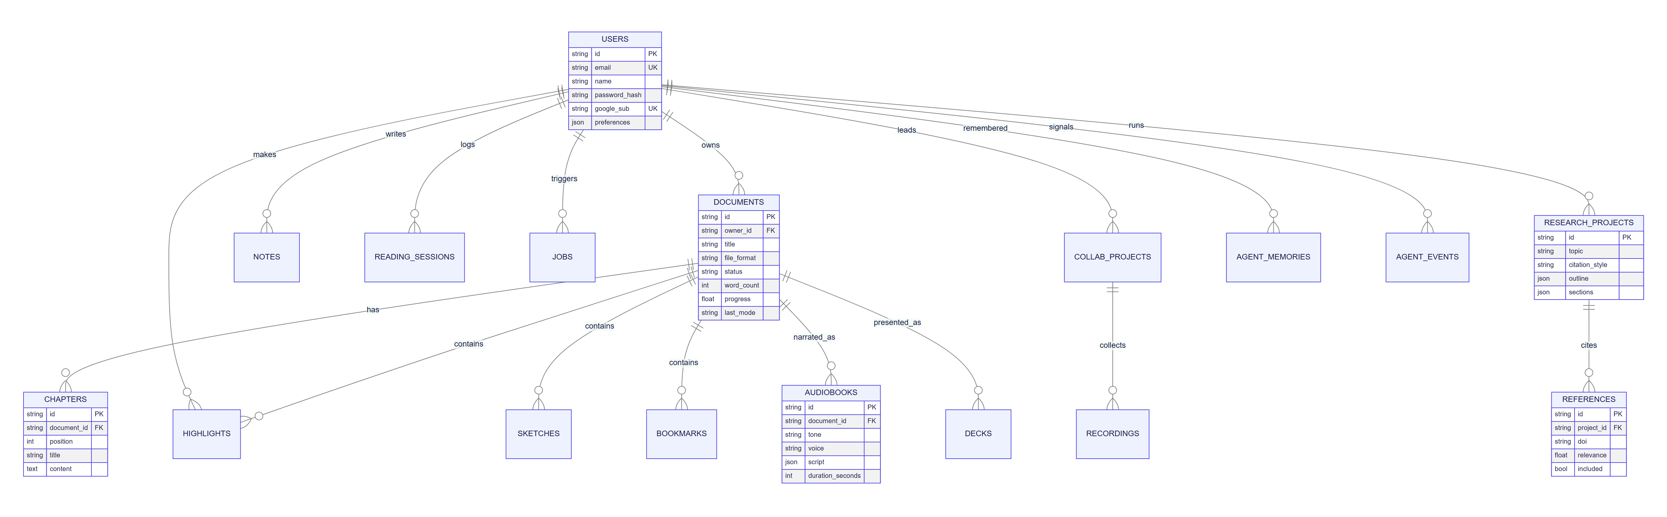
Figure 13: Entity–relationship diagram (key attributes shown).
Table 16: Table inventory
Table | Purpose | Notable columns
users | Accounts | email (unique), password_hash (“!” for Google-only), google_sub (unique), preferences (JSON)
documents | Library items | file_format, status (processing / ready / failed), word_count, progress, scroll_ratio, last_mode, favorite, pinned, offline
chapters | Segmented text | document_id, position, title, content, word_count
highlights, sketches, bookmarks | Annotations | chapter_index, category / tool / label, scroll_ratio; sketch points as [x, y, pressure]
notes | Notebook | note_type (note, highlight, ai_insight, summary, mindmap, diagram, quiz, explanation), ai_payload (JSON)
reading_sessions | Statistics | kind (reading / focus / listening), mode, seconds, started_at
jobs | Background jobs | kind, status, stage, progress, result, seen
audiobooks | Narrations | tone, voice, script (JSON), rate, pitch, position_chapter / segment, bookmarks
collab_projects, recordings | Collaborative studio | collaborators, assignments (JSON); recordings file_path, mime_type, duration
research_projects, references | Research Studio | citation_style, outline, sections with versions; references doi, relevance, included
decks | Presentations | theme, slides (JSON), meta
agent_memories, agent_events | Vibe agent | kind and text (≤ 300 chars), source; event kind and numeric payload — never message text

35. API Architecture
The API is RESTful, versioned implicitly under /api, documented automatically at /api/docs (OpenAPI), and secured with a bearer token on every route except authentication, health and configuration. There are 122 route handlers in 12 routers, plus a health check.
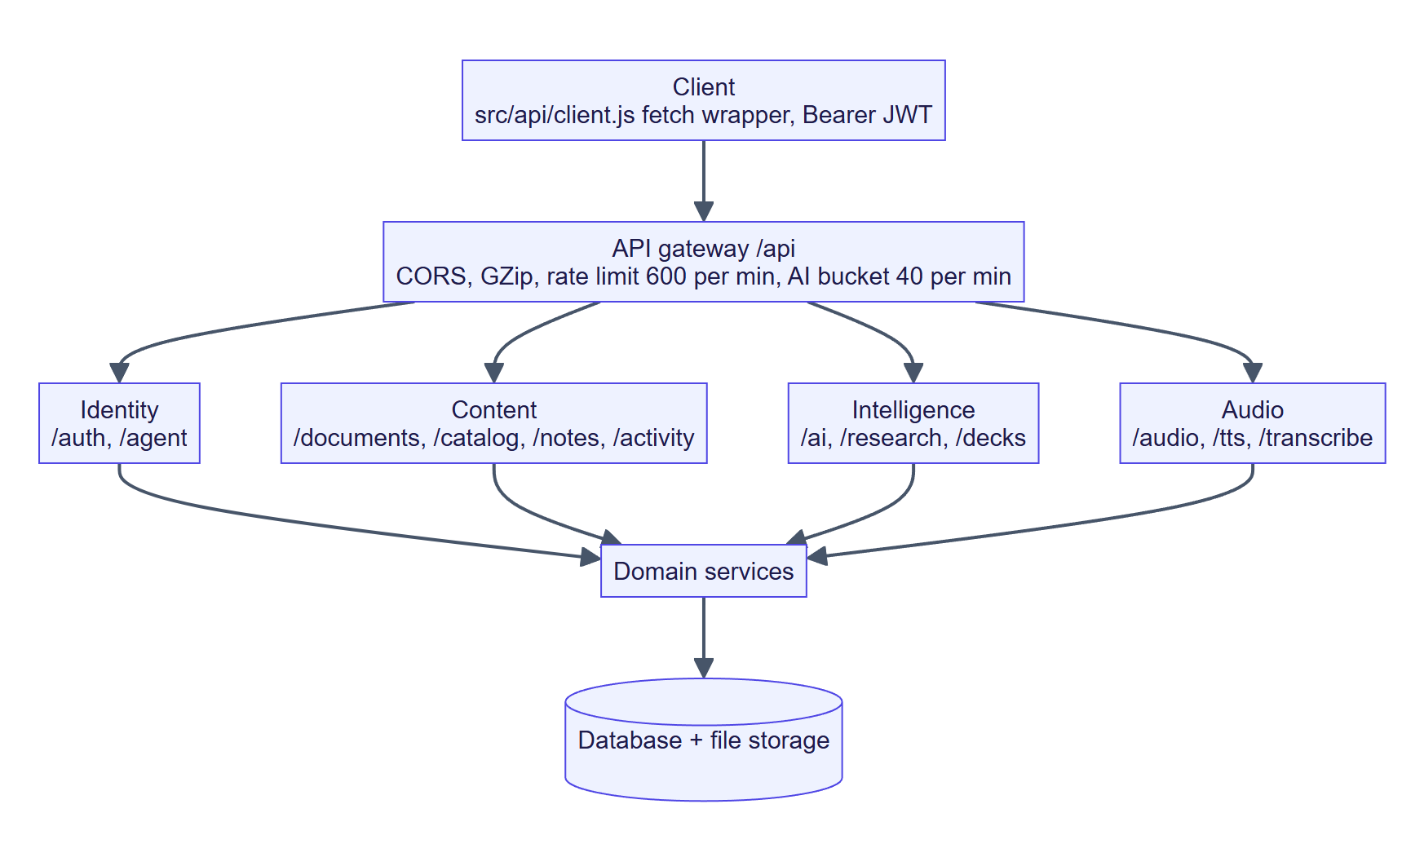
Figure 14: API architecture: gateway, router groups and services.
Table 17: Routers and handler counts
Router (prefix) | Handlers | Highlights
auth | 11 | register, login, google, demo, me, preferences, password, export, delete
documents | 26 | upload (streamed), text, chapters, package, file, progress, search, highlights, sketches, bookmarks, cast
ai | 14 | summarize, explain, define, chat, mindmap, diagram, quiz, quiz/grade, compare, visual, recommendations, overview, translate
agent | 9 | chat, briefing, checkin, events, profile, settings, memories
audio | 15 | tones, preview, audiobooks CRUD, script.txt, collaborative projects and recordings
tts | 4 | status, languages, voices, synthesize
transcribe | 3 | status, transcription job, dictate
research | 16 | projects, discover, references, citations, outline, sections (+ versions), review, export
decks | 8 | list, generate, upload, edit, art image, export.pptx
notes | 6 | list, notebook, CRUD, Markdown export
catalog | 3 | Gutenberg search, new releases, import
activity | 7 | sessions, stats, global search, jobs

Table 18: API conventions
Concern | Design
Long-running work | Endpoints return 202 Accepted with a job ID; the client polls GET /jobs/{id}
Large payloads | Multipart upload streamed to disk in 4 MB chunks; limit enforced mid-stream; partial file removed on overflow
Errors | {detail} with correct status; 401 invalid token; 422 validation; 429 with Retry-After
AI responses | Same JSON shape regardless of engine; engine field identifies LLM or local

36. Module Description
Table 19: Modules and their code locations
Module | Frontend | Backend | Description
Authentication and profile | LoginPage, GoogleSignIn, SettingsPage | auth, security, google_auth | Accounts, sessions, preferences
Discovery | DiscoverPage, Suggestions | catalog, recommend | Import free books; suggestions
Library | LibraryPage, UploadModal | documents, ingest, extraction | Upload and manage
Reader | ReaderPage, ChapterText, ReaderTools | documents | Annotated reading
Zen / Vibe scenes | ZenPanel, VibePanel, Scenes | — (browser audio) | Focus and music scenes
Audio | AudioStudioPage, ListenSheet, CollabStudio | audio, tts, narration, speechplan | Narration and recording
AI companion | AIPanel, MindMap, Diagram | ai, llm, nlp | Intelligence tools
Vibe agent | BriefingCard, CompanionSettings | agent/* | Personal reading agent
Research Studio | ResearchPage, ResearchProjectPage | research | Discover, draft, export
Presentation Studio | DecksPage, DeckEditorPage, DeckPresentPage | decks, deck, pptx_export | Slides
Notebook and activity | NotesPage, Notifications, SearchOverlay | notes, activity, jobs | Notes, stats, notifications

Part 5 — Core Modules of Vibe Reader

37. User Authentication and Profile Management
Authentication supports three entry routes: email and password, Google Sign-In, and a one-click demo library. Passwords are stored as salted PBKDF2-HMAC-SHA256 hashes with the iteration count embedded in the stored string, which allows the work factor to be raised later without invalidating old hashes. On success the API issues an HS256 JWT containing sub, iat, exp and type, valid for seven days. In production the API refuses to start if the signing secret is still the default value.
For Google Sign-In the browser obtains a Google-signed ID token. The server verifies the signature, audience, issuer, expiry and that the e-mail is verified, then signs the user in. A first-time Google user gets an account automatically; an existing account with the same verified e-mail is linked; Google-only users (stored with password hash “!”) can add a password later in Settings → Account.
- Profile: name, avatar (from Google), preferences stored as JSON (theme, reader typography, agent settings).
- Privacy rights: GET /auth/me/export returns all data; DELETE /auth/me removes the account and, through cascades, every owned row.
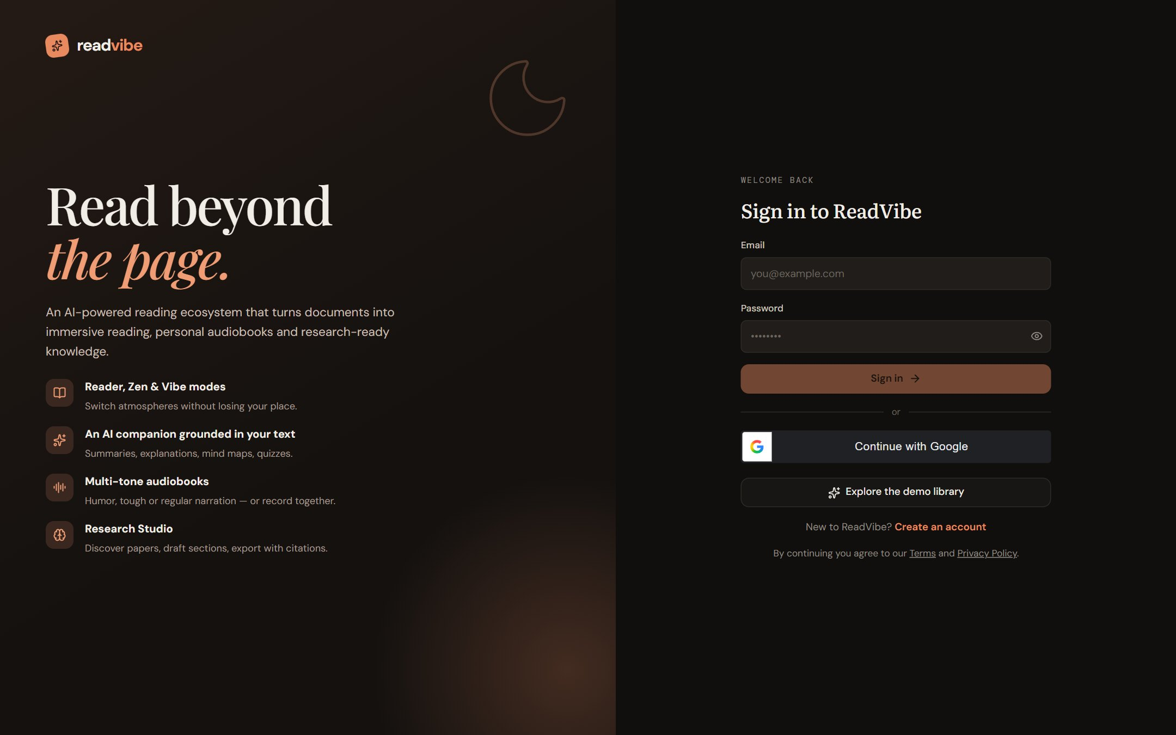
Figure 15: Sign-in page of the deployed application (https://readvibe-app.vercel.app/).

38. E-book Discovery and Search
The Discover page suggests free, openly licensed books and lets the user import them directly into the library. catalog.py queries Project Gutenberg and the Internet Archive, strips the Gutenberg licence header and footer markers, and creates a document through the same ingestion pipeline used for uploads. Suggested topics come from the recommendation engine (Section 53), so discovery reflects what the reader already engages with.
Search exists at three levels: the library filter (title, author, description, tags), in-document search within a book (GET /documents/{id}/search), and a global search overlay (Ctrl + K) across documents, notes and highlights.
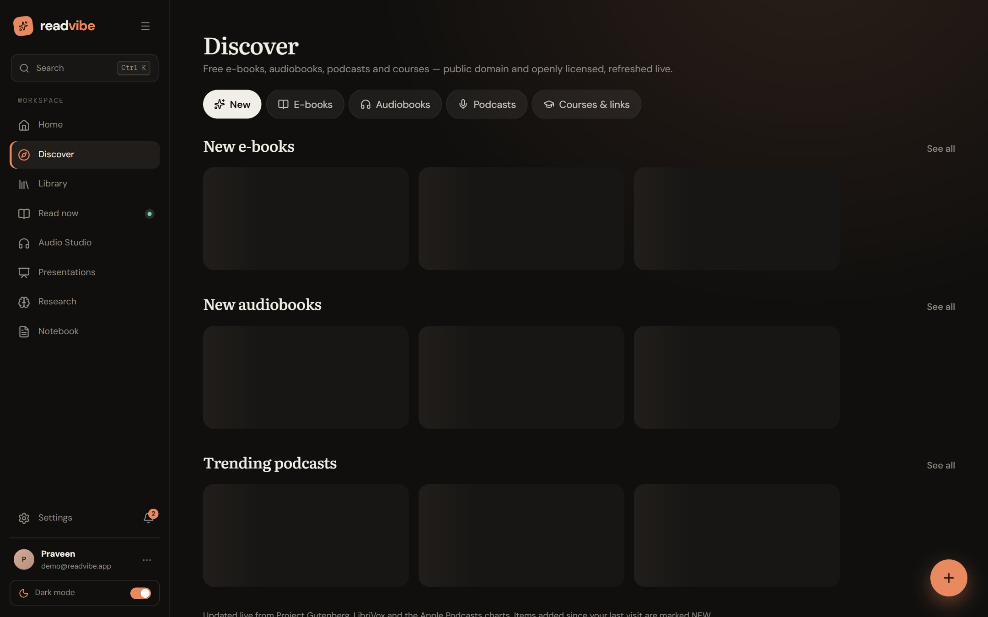
Figure 16: Discover page.

39. Document Upload and Management
Uploads are streamed to disk in 4 MB chunks so memory use stays flat for any file size; the 5 GB limit is enforced mid-stream and the partial file is deleted if it is exceeded. The request returns 202 Accepted with a job ID while ingestion continues in the background, and progress appears in the notification centre. The full original file is always kept and can be downloaded, even though only the readable text (capped at about 32 MB, roughly 5 million words) is stored as chapters.
- Library views: grid and list, sort by recently opened, filter by type (books, research papers, documents, audiobooks, favourites, downloads), tag chips.
- Organisation: favourites, pins, tags, rename, delete, last-opened mode and reading position per document.
- Offline copies: a complete reading package (chapters, highlights, bookmarks) is stored in the browser’s IndexedDB so the document remains readable without a connection.
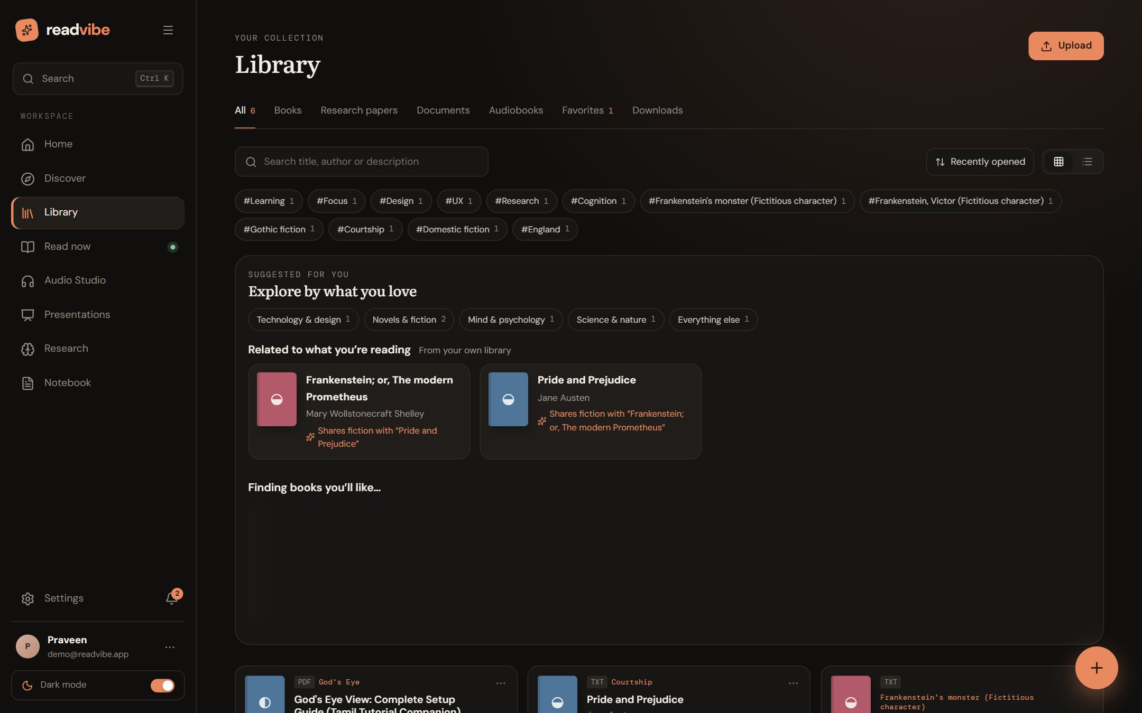
Figure 17: Library with tag filters and “Suggested for you”.

40. PDF, EPUB and DOCX Processing
extraction.extract(filename, data) dispatches by file extension. PDF text is read page by page with pypdf; EPUB is treated as a ZIP archive whose spine order and HTML content are parsed; DOCX paragraphs and heading styles are read with python-docx; PPTX and ODT are parsed from their XML parts; and plain-text, Markdown, HTML, RTF, CSV, XML, JSON, YAML, LOG, TeX and RST are decoded and cleaned. Binary readers accept either bytes or a file path so very large files are read from disk.
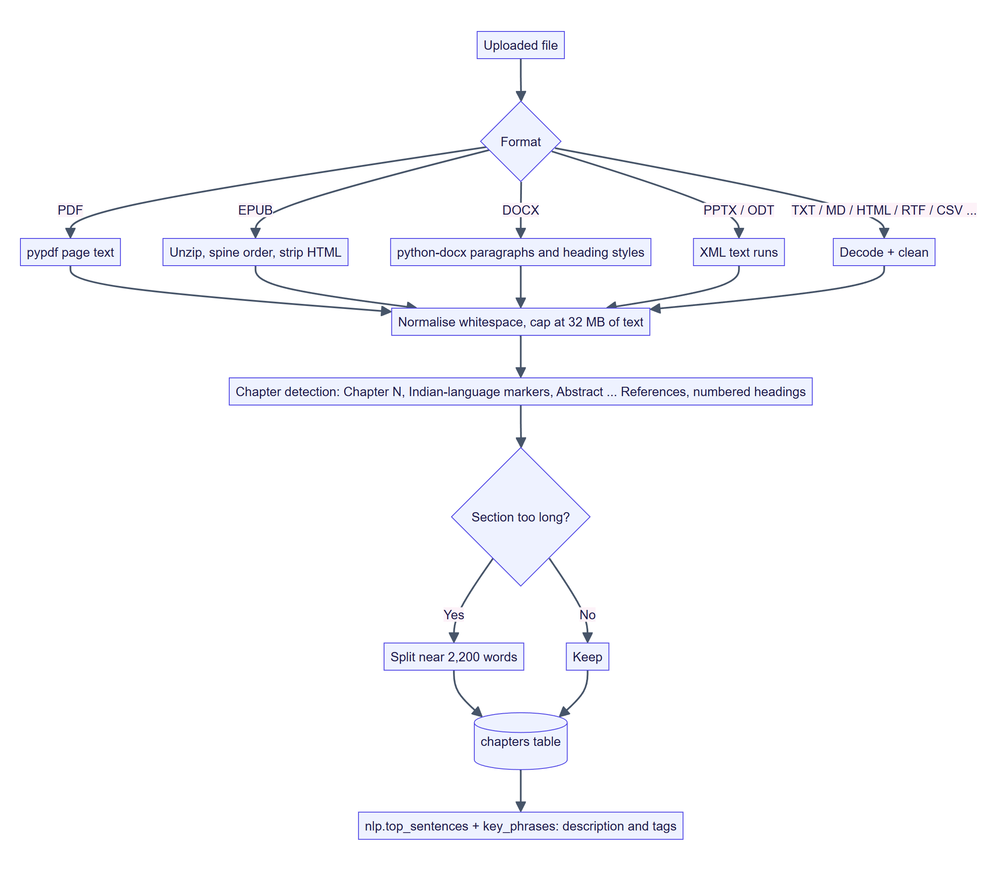
Figure 18: Extraction and chapter-segmentation pipeline.
Limitation. Scanned PDFs that contain only images have no extractable text layer, and the platform does not currently perform OCR. Such files are marked as failed with a reason (Section 93).

41. Text Extraction and Preprocessing
After extraction, text is normalised (whitespace, control characters) and segmented into chapters using a multi-pattern detector: “Chapter/Part/Book/Section N” in digits, Roman numerals or words; the same markers in Tamil, Telugu, Malayalam, Kannada, Hindi/Marathi, Bengali, Gujarati, Punjabi, Odia and Urdu; academic headings such as Abstract, Introduction, Methodology, Results, Conclusion and References; and numbered headings. Markdown # headings are also honoured. A section that grows beyond the target size is split near 2,200 words so each chapter remains comfortable to read and to process.
Ingestion then derives a two-sentence description from the most informative sentences of the first chapters and up to three short key-phrase tags from a bounded sample of the text, so even a thousand-page file remains cheap to describe. The result is written to the chapters table and the document is marked ready.

42. Reader Mode
Reader mode is the default environment: a clean page with a contents panel, a chapter navigator and a tools rail. Typography is fully adjustable — seven typefaces including OpenDyslexic, Lexend and Hyperlegible, size, line spacing, column width, alignment and page colour (Paper, Sepia, Night or High contrast). Selecting text offers five highlight categories with notes; bookmarks record the chapter and scroll ratio; pen and marker sketches are stored as normalised coordinates so they scale with the page; and a reading ruler and focus line help readers keep their place.
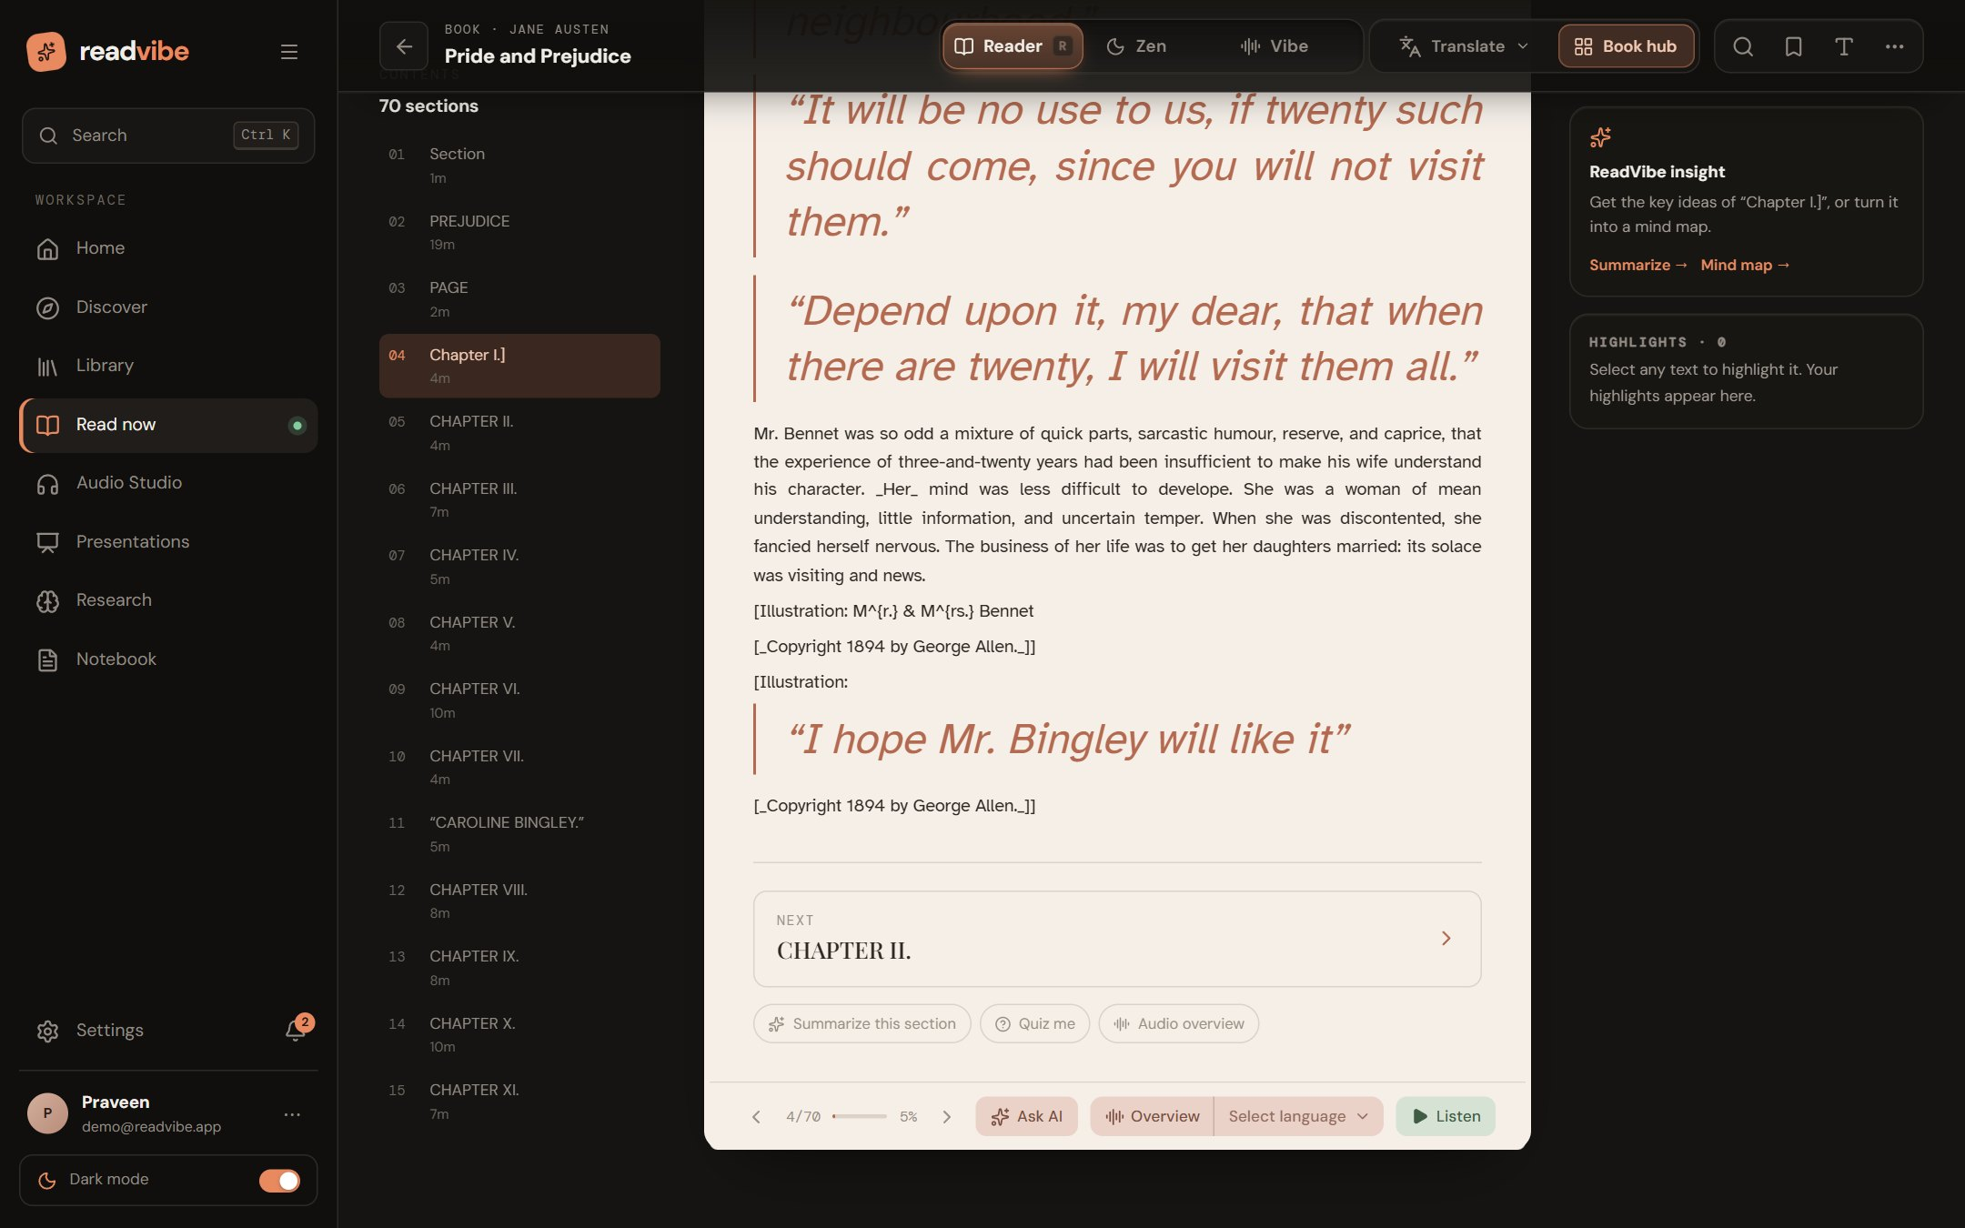
Figure 19: Reader mode: contents, chapter text, insight card and bottom action bar (Ask AI, Overview, Listen).
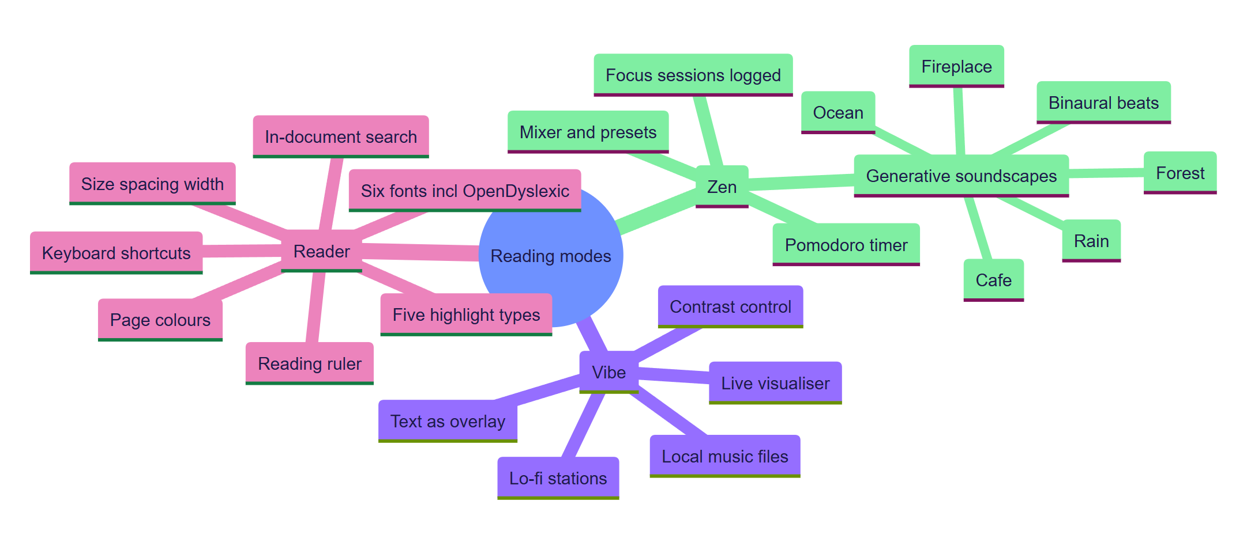
Figure 20: Mind map of the three reading modes and their features.

43. Zen Mode
Zen mode is a distraction-free environment motivated by the evidence that notifications, pop-ups and multitasking harm comprehension [10]–[12], [16]. The page sits on a calm, animated scene. Sound is generated live with the Web Audio API — rain, forest, ocean, café, fireplace and binaural focus beats — from filtered noise and low-frequency oscillators, so there are no audio files to download, loops are seamless and it works offline. A mixer controls ambience and volume, and the mode also plays a bundled set of calm tracks as an endless shuffled loop without listing their names.
A Pomodoro focus timer (default 25-minute focus and 5-minute break, adjustable) records each completed focus session in reading_sessions, feeding the statistics and streaks shown on the home page and used by the Vibe agent.
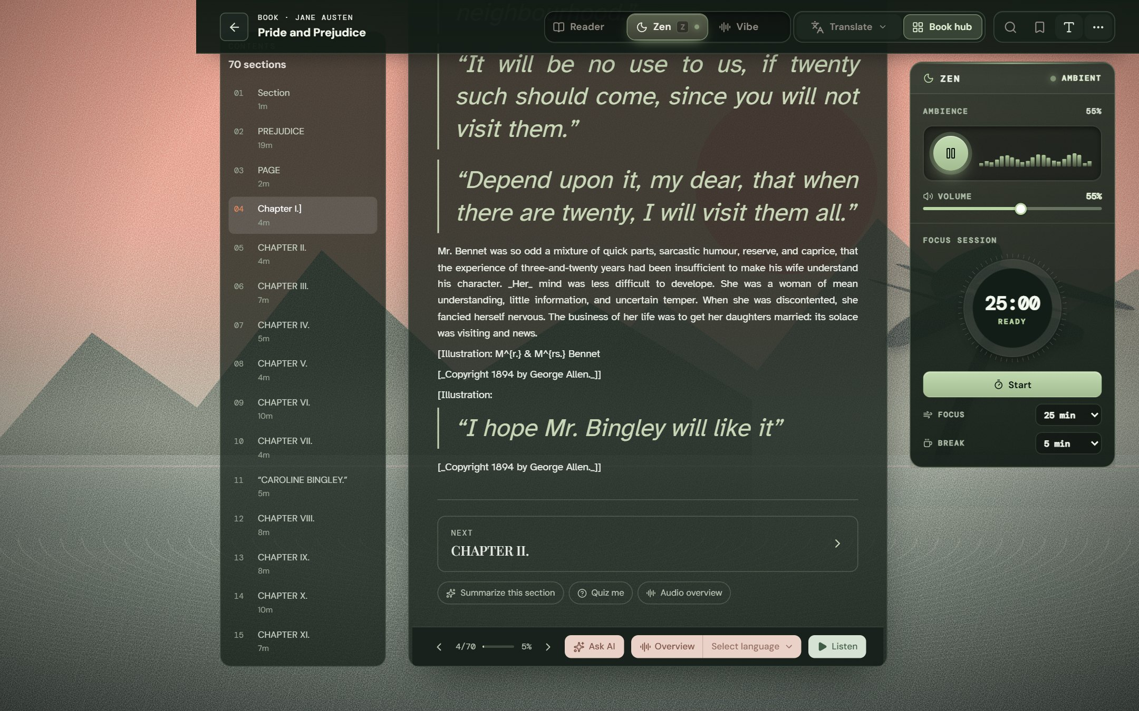
Figure 21: Zen mode: ambient scene, ambience mixer and focus-session timer.

44. Vibe Reader Mode
Vibe mode lets the reader study over music. The text is presented as a large, high-contrast overlay in place of song lyrics, with spoken-dialogue passages emphasised. Music comes from three built-in generative sources — Lo-fi study stream (72 BPM, calm), Dream pads (56 BPM, dreamy) and Night drive pulse (96 BPM, energetic) — or from the user’s local music files, which never leave the browser. An analyser node reads the live audio so the visualiser reacts to the real signal; music level and text contrast are adjustable.
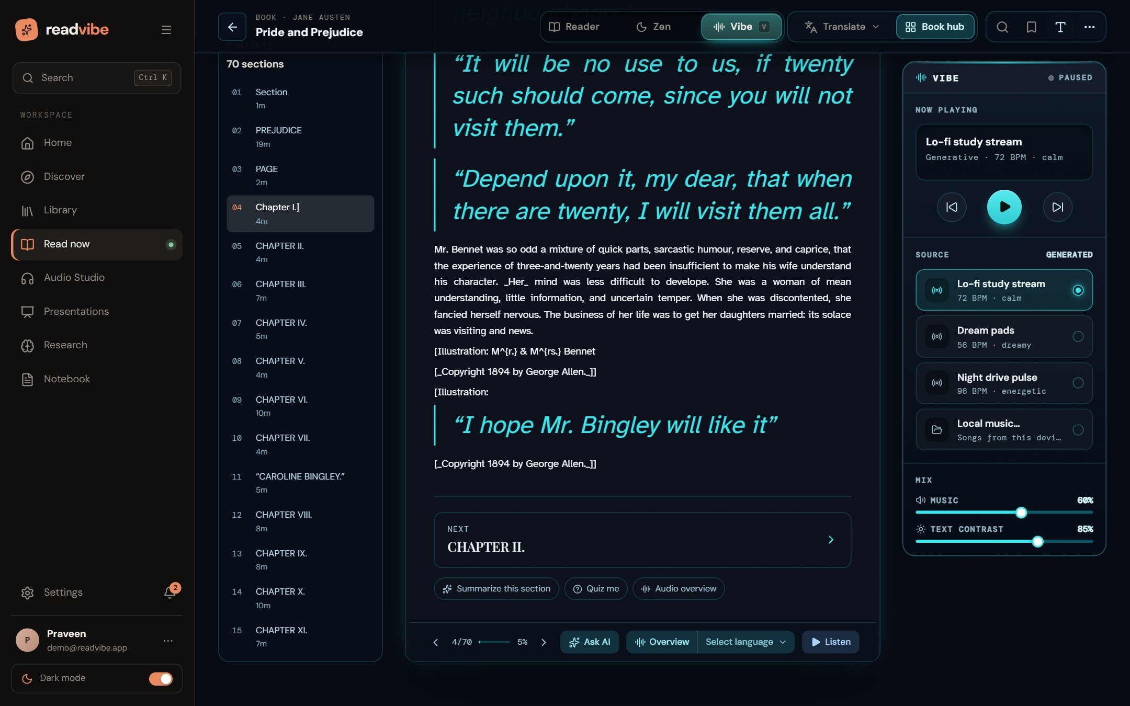
Figure 22: Vibe mode: lo-fi source selector, transport controls, music and text-contrast mix.

45. Text-to-Speech Engine
Read-aloud is served by POST /tts/synthesize. The request carries a sentence, a voice identifier of the form provider:voice, an optional emotion, a pitch shift and style deltas. Two providers are implemented: Edge (Microsoft neural voices through the edge-tts package, no API key, returns exact word boundaries) and OpenAI (gpt-4o-mini-tts, needs a key, accepts narration-style instructions; word timings are estimated from character counts). If neither is reachable the client falls back to the browser’s Web Speech voices.
- Voices: Indian English first (Neerja, Prabhat), then US, UK, Australian, Canadian and Irish English, and neural voices for Tamil, Telugu, Malayalam, Kannada, Hindi, Marathi, Bengali and Gujarati. Punjabi and Odia are supported as text but have no neural voice yet.
- Segments are limited to 1,500 characters and cached on disk by a hash of text, voice and delivery, so re-reading a passage costs nothing.
- Integrity: check_audio validates what an engine returned before it is played.
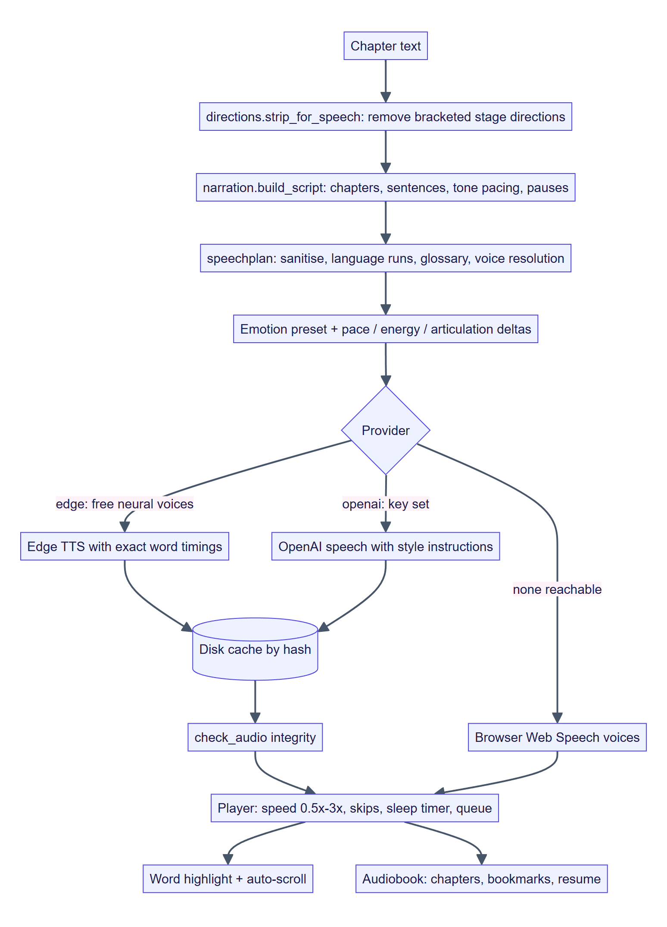
Figure 23: Text-to-speech workflow from chapter text to synchronised playback.

46. Emotion-Aware Voice Narration
Narration expression is computed, not guessed per sentence. Three layers combine to produce the final rate, pitch and volume sent to the voice:
- Document tone — Regular, Humor or Tough (Table below).
- Emotion preset — from a stage direction or caller, e.g. neutral (0, 0, 0), warm (−3 % rate, +1 Hz), excited (+8 %, +5 Hz, +5 %); aliases such as suspenseful, whispered, afraid and joyful are mapped to engine presets.
- Style deltas — pace (slow −18 %, relaxed −7 %, conversational 0, brisk +12 %), energy (low, moderate, high) and articulation (casual, balanced, precise).
Small punctuation-driven adjustments are then applied: a sentence ending in “?” gains +3 Hz of pitch; one ending in “!” gains +4 % rate and +8 % volume; sentences over 150 characters slow by 3 % “to breathe”. Results are clamped (rate ±40 %, pitch ±30 Hz, volume −50 % to +30 %).
Table 20: Tone profiles from the narration module
Tone | Rate | Pitch | Sentence pause | Paragraph pause | Intended use
Regular | 1.00 | 1.00 | 250 ms | 650 ms | Neutral, clear, everyday documents
Humor | 1.08 | 1.18 | 180 ms | 500 ms | Upbeat and engaging; light fiction and comics
Tough | 0.92 | 0.82 | 380 ms | 900 ms | Authoritative; academic and historical content

Stage directions such as “[in fright]” or “[directly to Biff]” are performed, never spoken: they are stripped from the spoken text, classified into an emotion preset, and shown dimmed in the transcript. Character casting (cast.py) assigns male or female voices to speakers only from explicit evidence in the book — titles (Mr., Miss), kinship (“his wife”), role nouns or reflexive pronouns — and leaves anyone without evidence undecided so the client gives them the less-used voice.
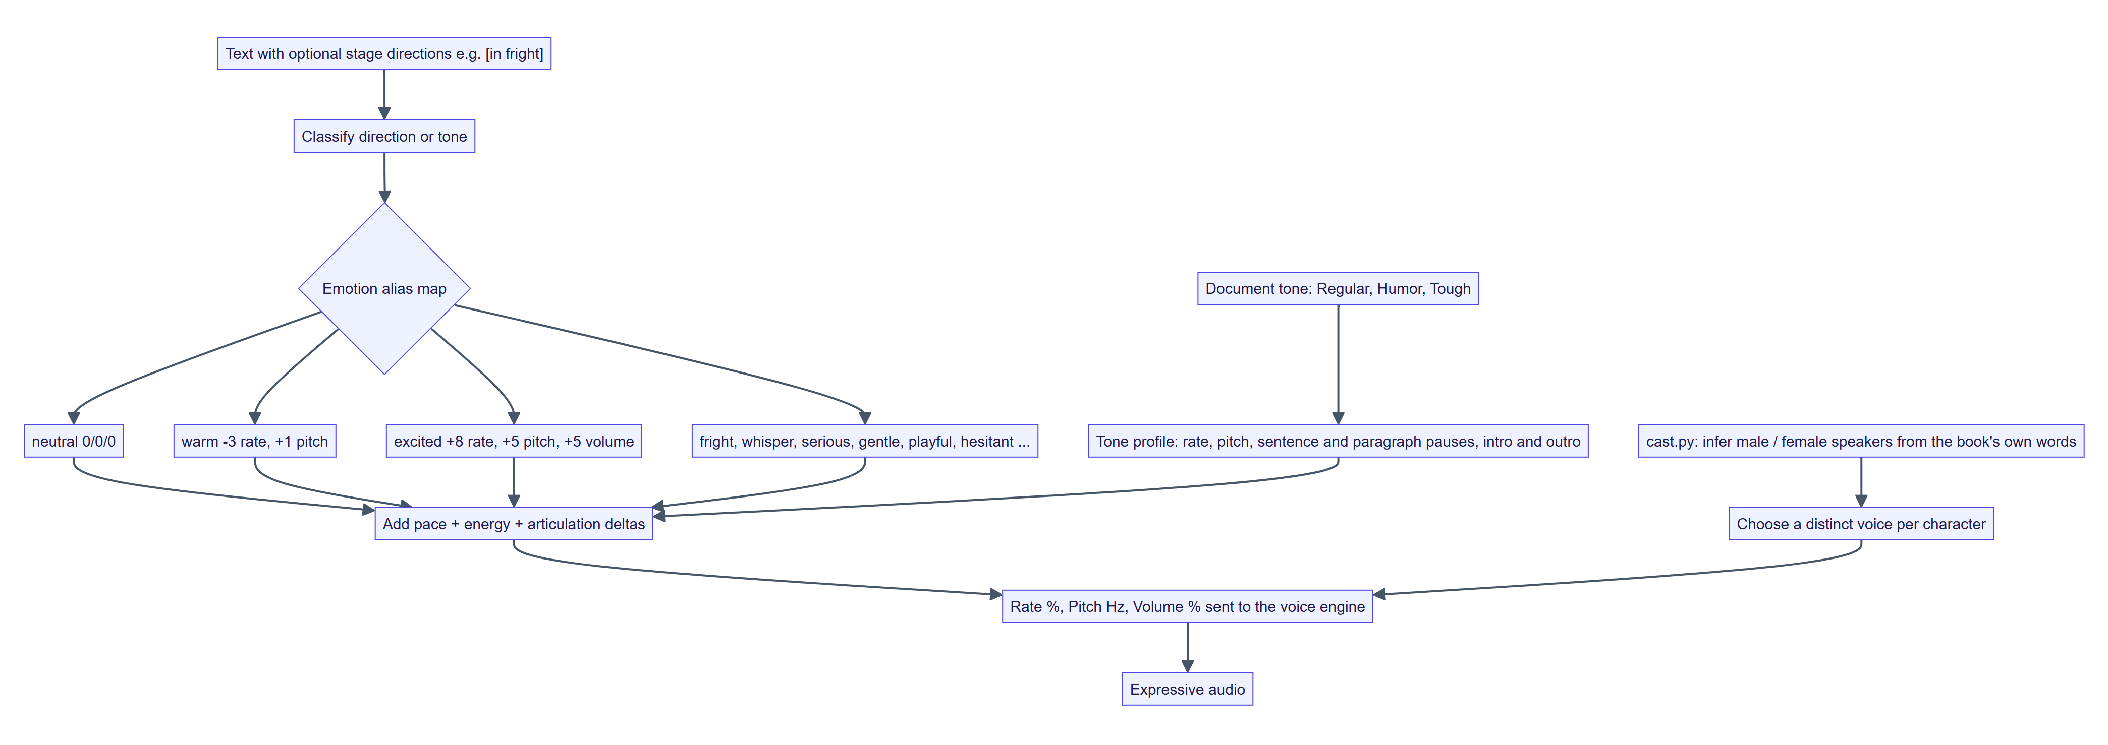
Figure 24: Emotion-aware delivery: tone, stage directions, style deltas and casting combine into engine parameters.

47. Audio and Text Synchronisation
The research on synchronised highlighting [3] motivates word-level synchronisation. The neural provider returns word boundaries (start, end, word) with each clip. During playback the client finds the word whose time interval contains the audio’s current time, converts it to character offsets within the current paragraph (paragraph elements carry a data-p attribute and offsets share the narration script’s coordinate space), builds a DOM Range over the word, and highlights it while scrolling it into view. Clicking a word does the reverse: it converts the offset to a start time and begins playback there. Where a provider gives no timings they are estimated from character counts.
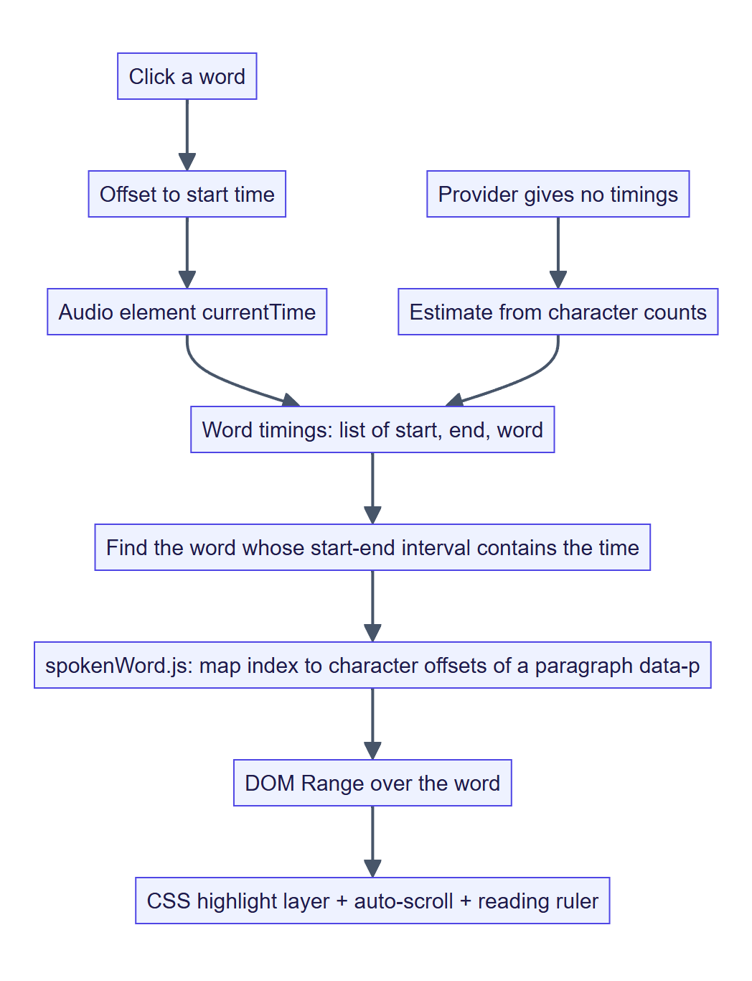
Figure 25: Audio–text synchronisation pipeline.

48. Background Music and Audio Controls
Beyond the reading scenes, the Audio Studio is a full player. Controls include play/pause, previous/next chapter, ±10-second and ±30-second skips, a waveform seek bar, playback speed from 0.5× to 3×, a sleep timer, shuffle and repeat, a queue, bookmarks that save a moment and resume from the last position, voice and language selection, translation, and download. A transcript tab follows the narration, and a Reader tab shows the text.
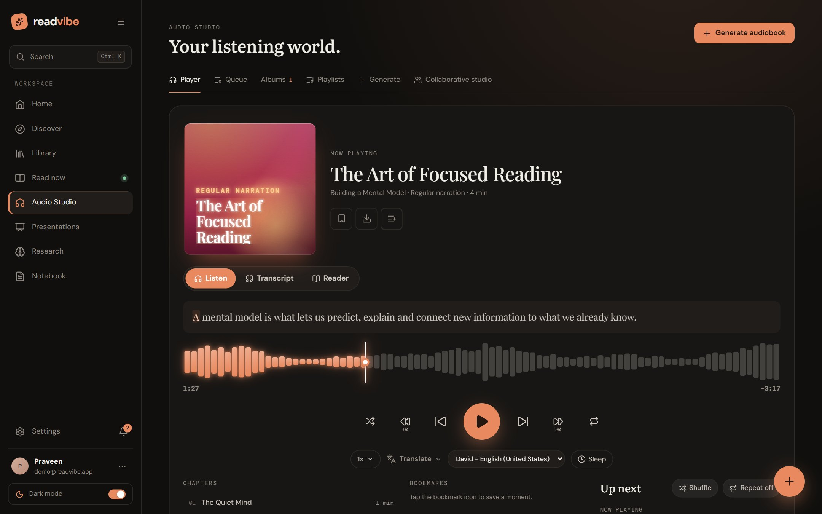
Figure 26: Audio Studio: now-playing card, waveform, transport, speed, translation, voice and sleep timer.
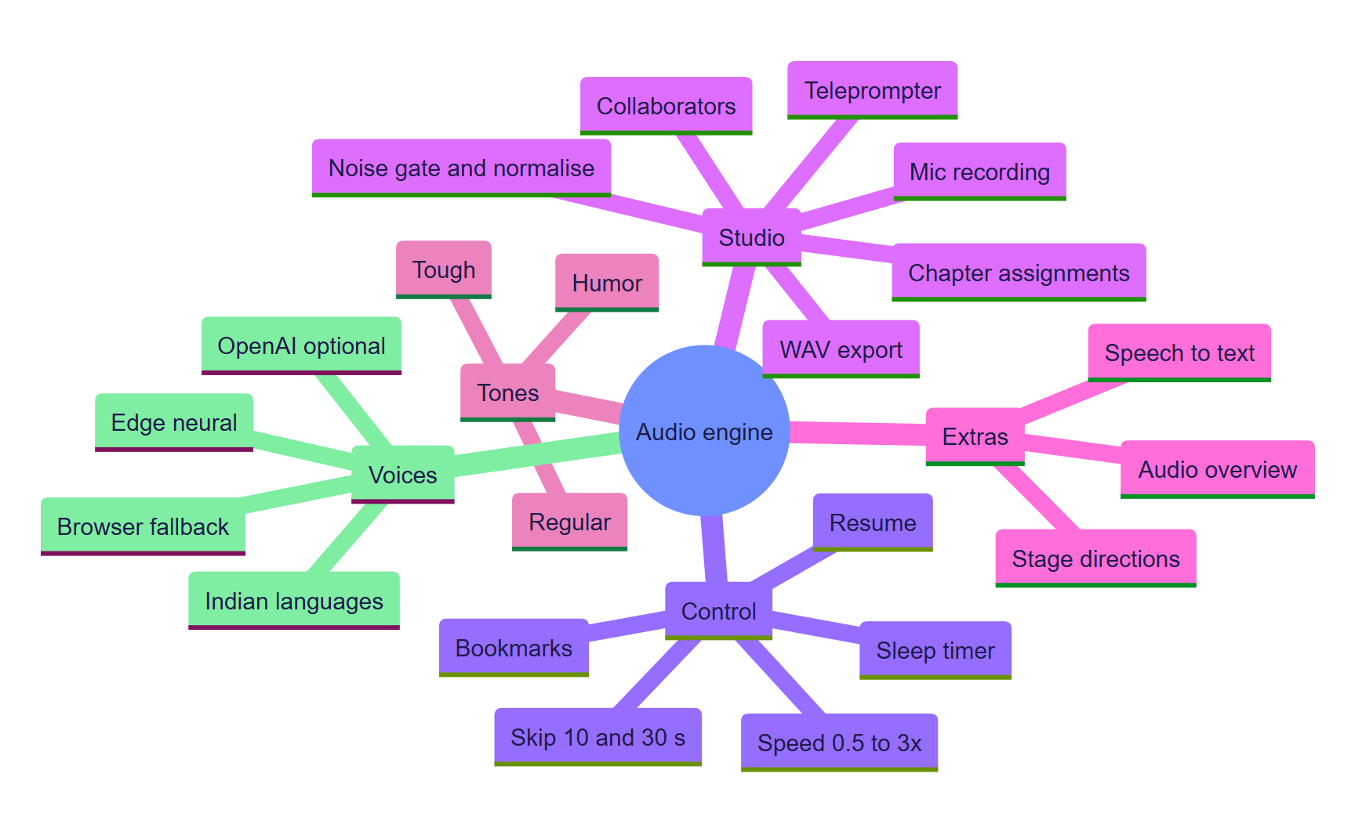
Figure 27: Mind map of the audio engine.

Collaborative audiobook studio
The collaborative studio lets a project owner add collaborators, assign chapters, and record each part through the browser’s microphone (MediaRecorder) with a teleprompter. Recordings are uploaded to the server. On the client, audioStitch.js decodes each part, trims silence, applies a gentle noise gate, peak-normalises, joins parts with short gaps and encodes a single WAV file.

49. AI-Based Book Summarization
Summaries are offered at three depths — Brief (the essentials in a minute), Standard (main concepts with context) and Deep dive (full detail for study) — for a chapter or the whole book. The request flows through the pipeline in Section 49 below: scope selection, cache lookup, BM25 passage retrieval, the LLM provider chain with a JSON-schema prompt, and a local fallback that selects the highest-ranked sentences.
Table 21: Summary depths
Depth | Content requested from the LLM | Local engine
Brief | 3 key points, 3 concepts, at most 1 example; one sentence each | Fewest top-ranked sentences
Standard | 5–7 key points, 5–8 concepts, 2–3 examples | Moderate number of sentences
Deep dive | 9–12 detailed key points, 8–12 concepts, 3–4 examples, suitable for exam study | Largest set of sentences

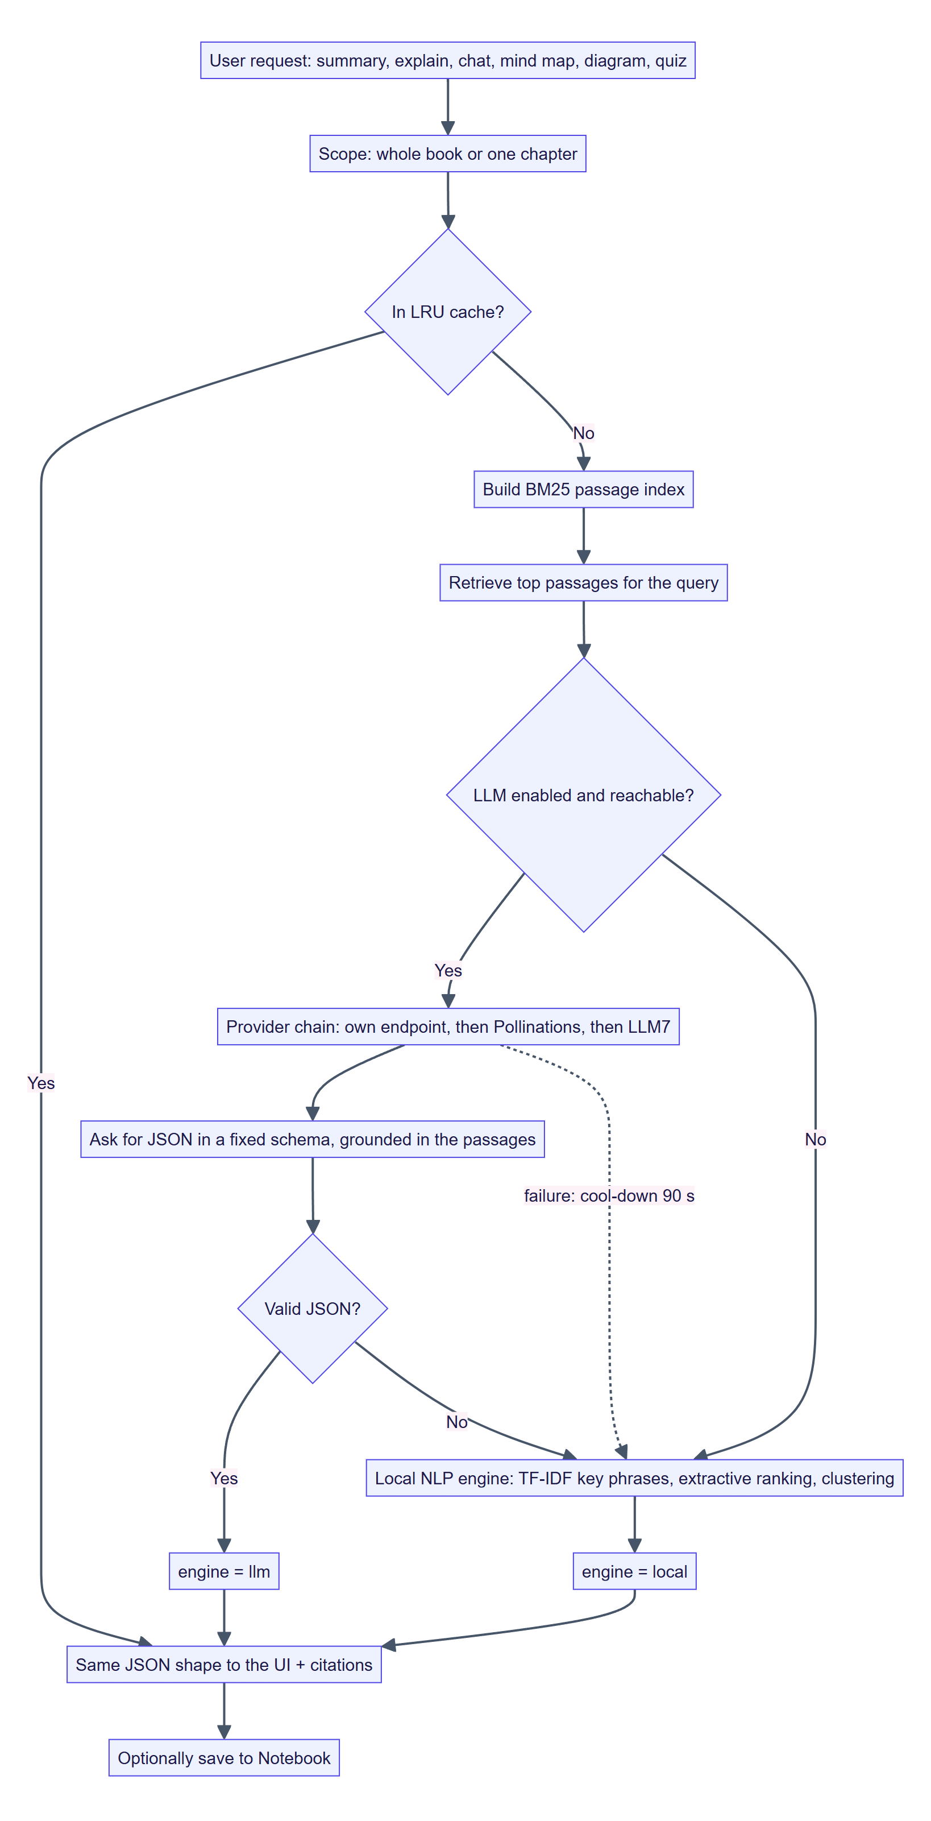
Figure 28: AI pipeline: cache, retrieval, LLM chain and local fallback converge on one response shape.

Local summarisation algorithm
- Split text into sentences and tokenise into content words (stop-words and generic words removed; light stemming).
- Score each sentence by the normalised frequency of its stemmed words divided by length^0.6, so long sentences are not favoured merely for being long.
- Apply multipliers: ×1.25 for the first three sentences (lead bias), ×1.1 for quoted sentences, ×1.15 for definitional sentences (“is”, “means”, “defined as”), ×1.2 for cue words (“therefore”, “in summary”, “the key”), and ×0.6 for sentences shorter than 7 or longer than 55 words.
- Take the best 3n candidates, skip any that share ≥ 55 % of content words with one already chosen, keep n, and return them in original document order, n depending on the depth chosen.
Because the local engine is extractive, every sentence it outputs is a sentence from the document; nothing is invented. The response carries an engine field so the interface can show whether an LLM or the local engine produced it.
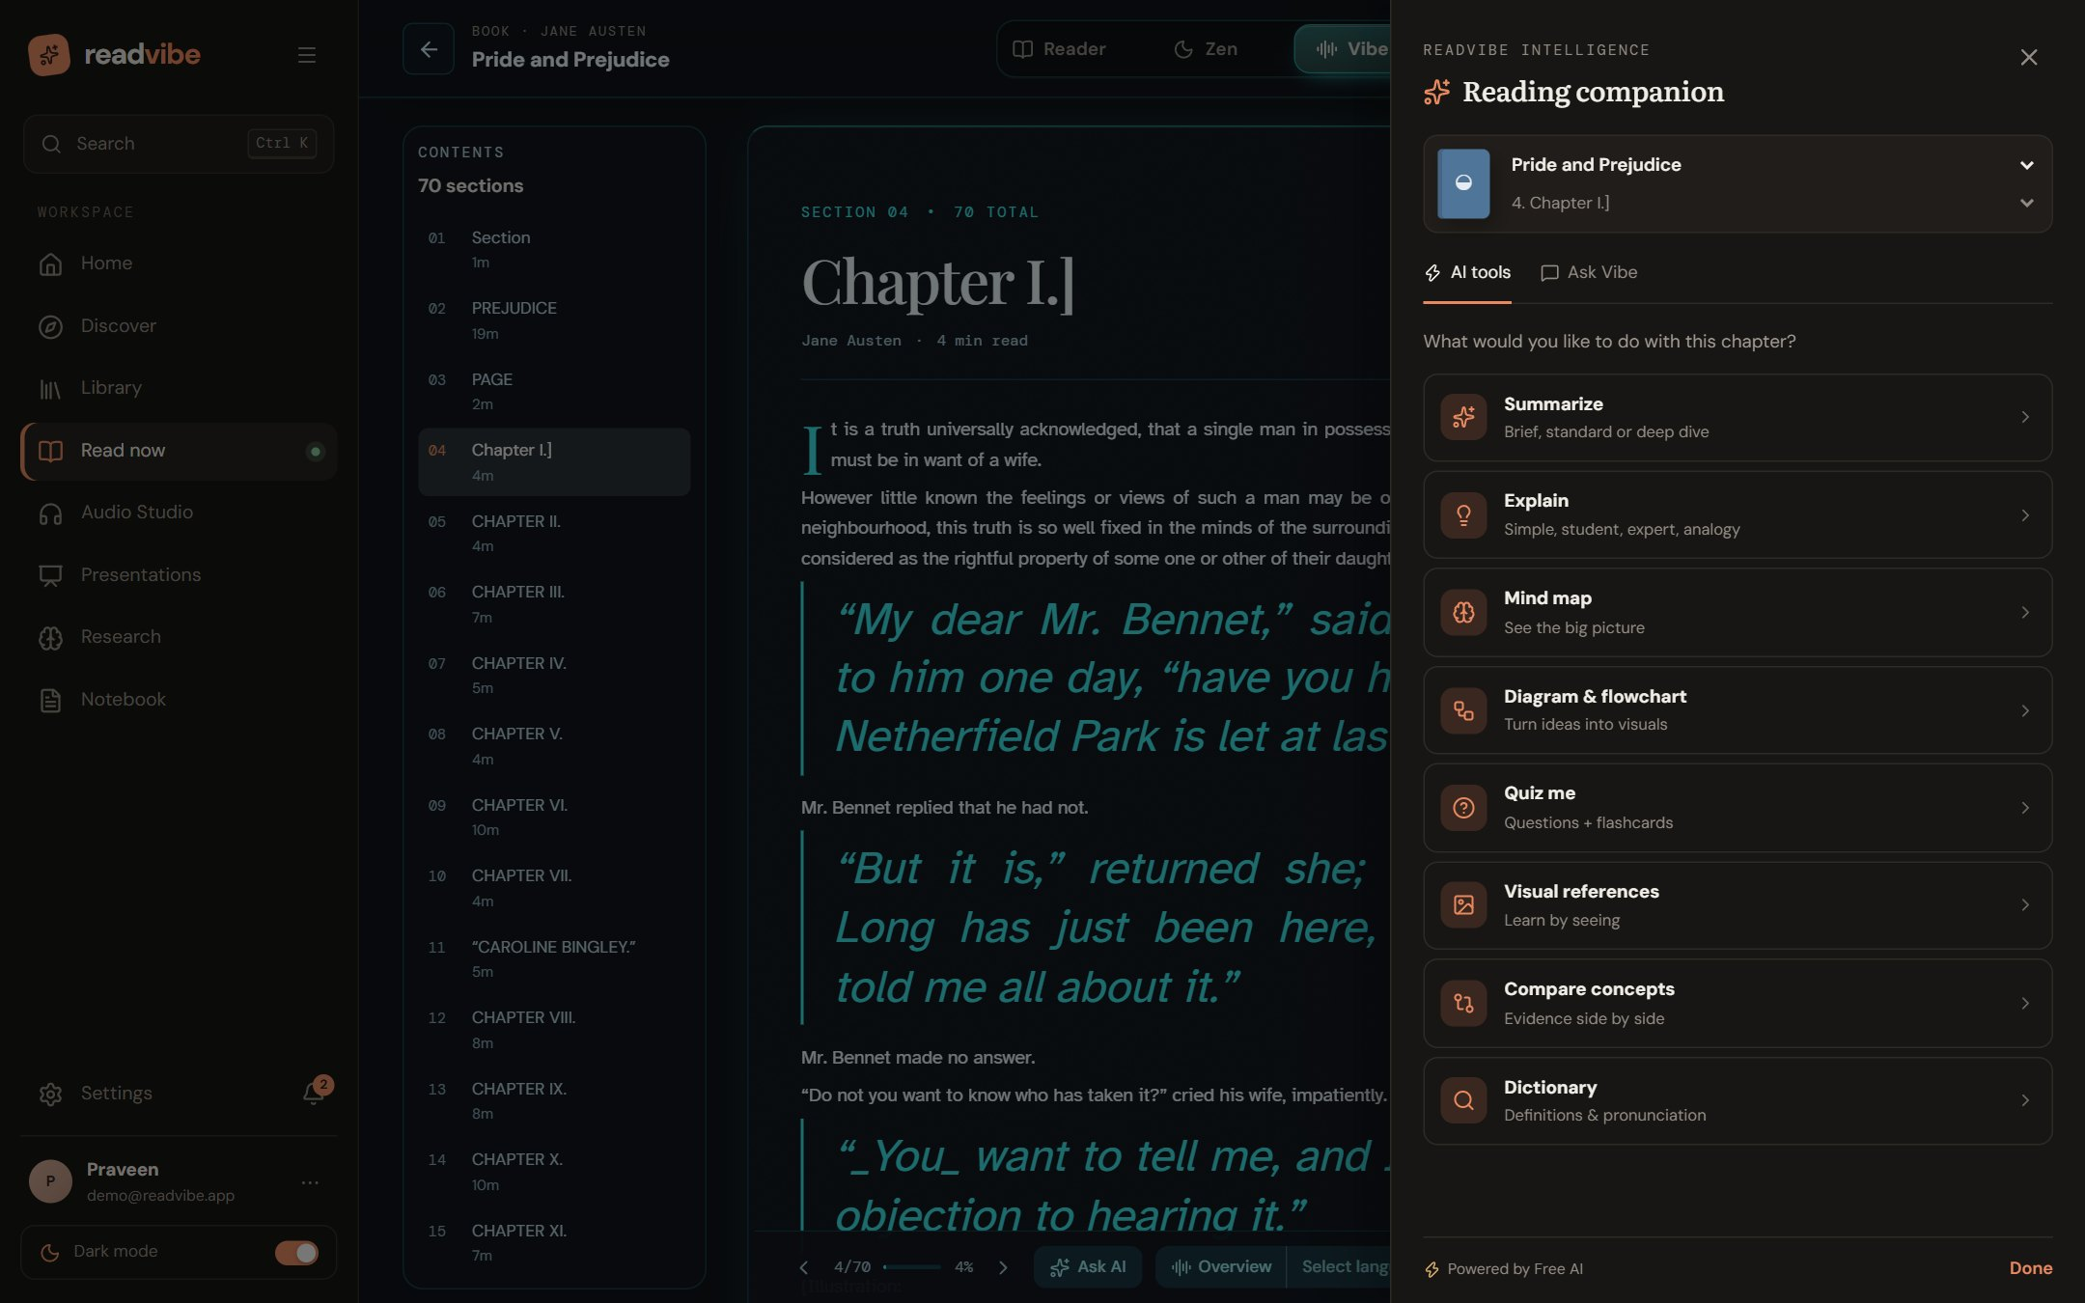
Figure 29: AI “Reading companion” panel listing the available tools for the current chapter.

50. AI-Based Concept Explanation
Selecting any passage and choosing Explain returns an explanation in one of five styles (Simple, Student, Expert, Example and Analogy), along with definitions of the key terms found in the document itself and related passages retrieved with BM25. A dictionary tool gives definitions and pronunciation, and Compare concepts presents two concepts side by side with evidence from the text.
Chat with the book answers questions strictly from retrieved passages and returns citations (chapter and passage) so the reader can verify each claim. For a more personal, conversational experience the Vibe agent (“Ask Vibe” tab) adds memory, mood awareness and tools; its loop is shown below.
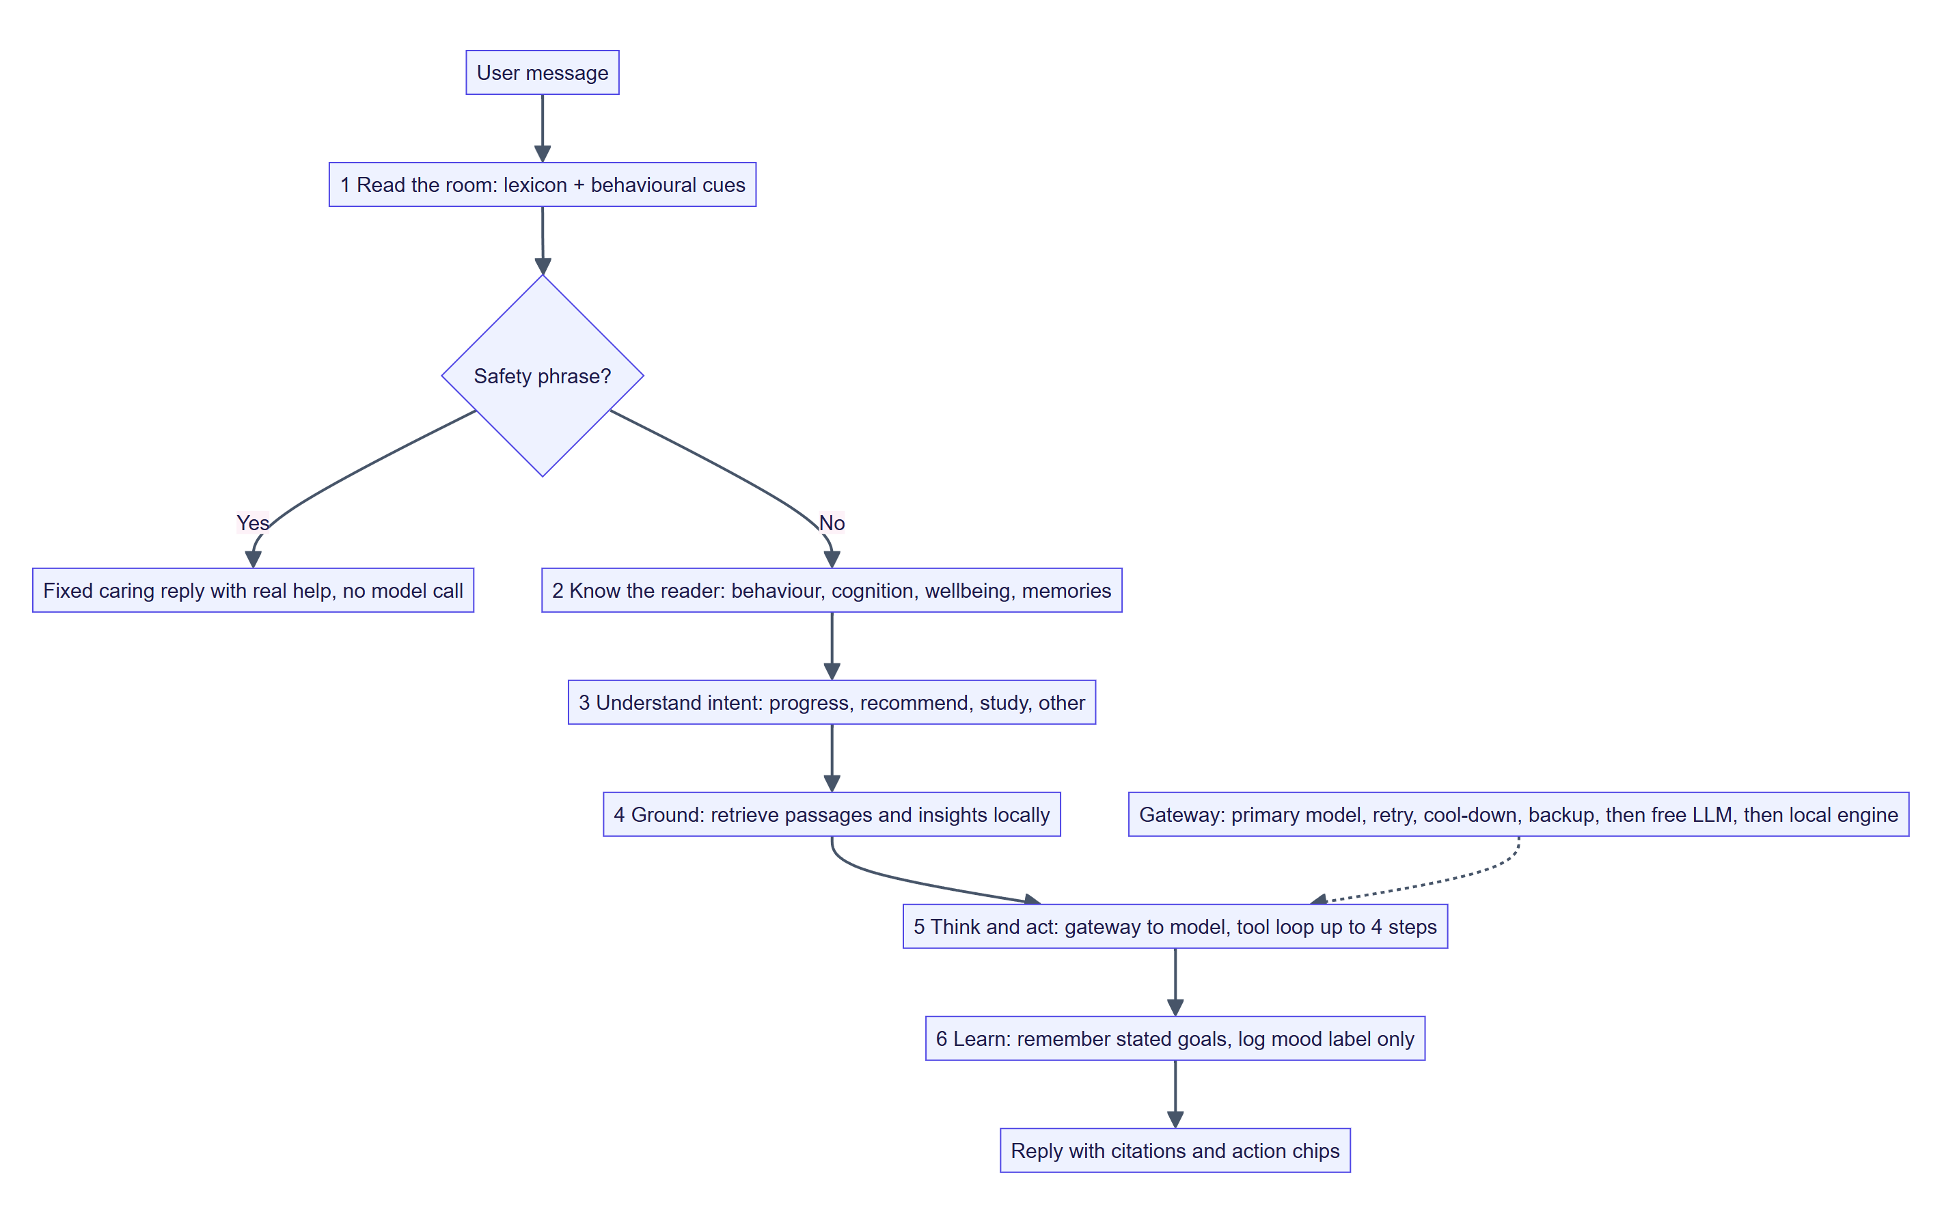
Figure 30: Vibe agent loop: read the room, know the reader, ground, think and act, learn.
Table 22: Layers of the Vibe agent
Agent layer | What it does | Safeguard
Read the room (empathy.detect) | Lexicon of states (e.g. overwhelmed, anxious, discouraged, frustrated, confused, tired, bored, excited, curious, grateful) plus behavioural cues such as very late sessions, very long sessions and repeated questions; ignores negated matches | Returns a guess with confidence, never a diagnosis; no model call; message text not stored
Know the reader (profile, memory) | Behaviour (when and how long), cognition (pace, quiz performance, scaffolding), wellbeing (late nights, check-ins) and remembered goals/preferences | Everything is listed in Settings and deletable; personalisation can be switched off
Ground (tools, ai) | Retrieves passages and insights locally before any model call; model may call tools (search document, list chapters, library, insights, what to read next) | Tool output is treated as untrusted data; only two write tools (save note, remember) exist and both touch only the user’s own account
Gateway (gateway.converse) | One primary model; same-model retries; switch only after repeated failure; notes the switch to the reader | Falls back through backup model, free LLM and local engine

Safety path. A message that suggests the reader may be in danger skips the model and receives a fixed, caring reply that points to real help. This is a safety net, not a clinical feature.

51. Diagram and Mind Map Generation
Mind maps are built from chapter headings and clustered key concepts: key phrases are extracted, clustered into about five groups, and each group becomes a branch with short labels. Diagrams come in three kinds — flowchart, concept map and block diagram — in vertical or horizontal layout and at three detail levels (simpler, standard, detailed). A flowchart extracts up to eight steps from the text; concept diagrams link key concepts with relation verbs found in the sentences. The result is a node/edge graph that is rendered as SVG in the browser, and can be exported as PNG, SVG, HTML or Mermaid text (to_mermaid). The canvas is zoomable.
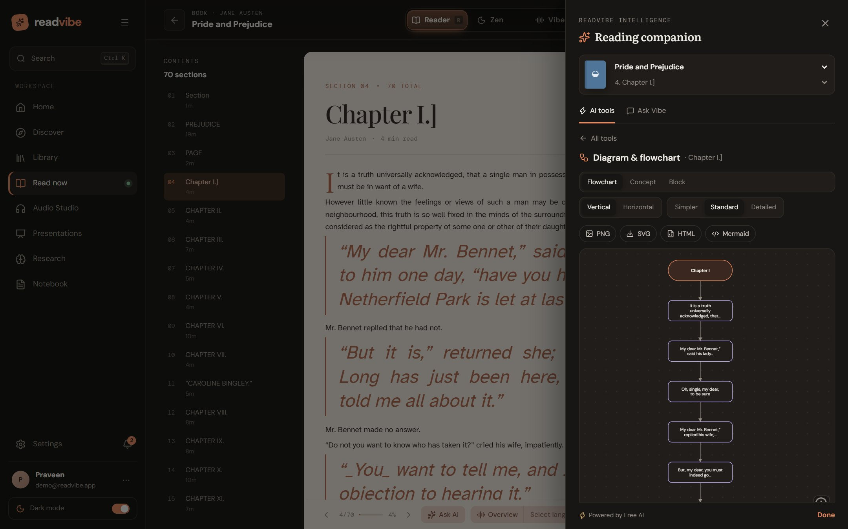
Figure 31: Diagram & flowchart tool generating a flowchart from Chapter I, with kind, layout, detail and export options.

52. Deep Research Assistant
The Research Studio takes a topic (and optionally the user’s own documents as sources) to a cited, exportable draft in seven steps: topic or sources → discover papers → include or exclude → outline → draft sections → citation and similarity review → export.
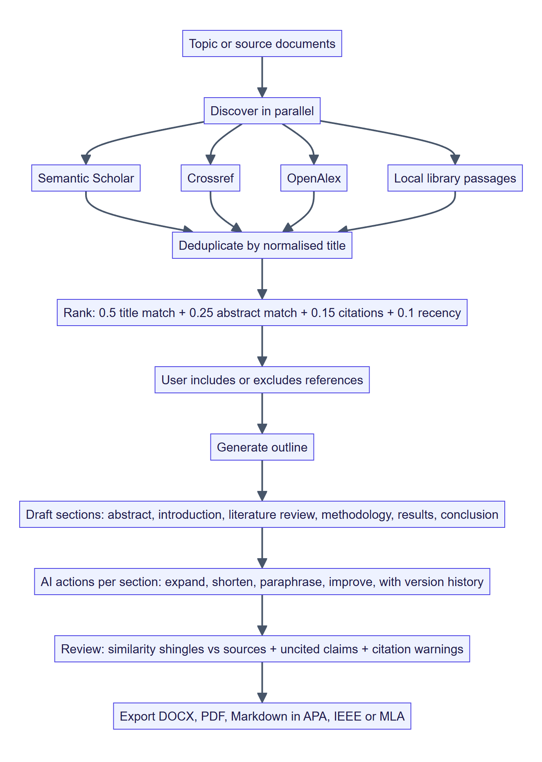
Figure 32: Research pipeline from topic to exported paper.
- Discovery queries Semantic Scholar, Crossref and OpenAlex in parallel with a short timeout, adds passages from the user’s library, de-duplicates by normalised title and ranks (formula in Section 28).
- Drafting covers Abstract, Introduction, Literature Review, Methodology, Results & Discussion and Conclusion. Each section has AI actions (generate, regenerate, expand, shorten, academic tone, cite, simplify), autosave and a version history with restore.
- Citations are formatted in APA, IEEE or MLA with in-text forms.
- Review flags passages that overlap sources using 5-word shingles (threshold 0.12) and lists claims without citations. The interface states that it never claims a text is plagiarism-free.
- Export produces DOCX, PDF or Markdown.
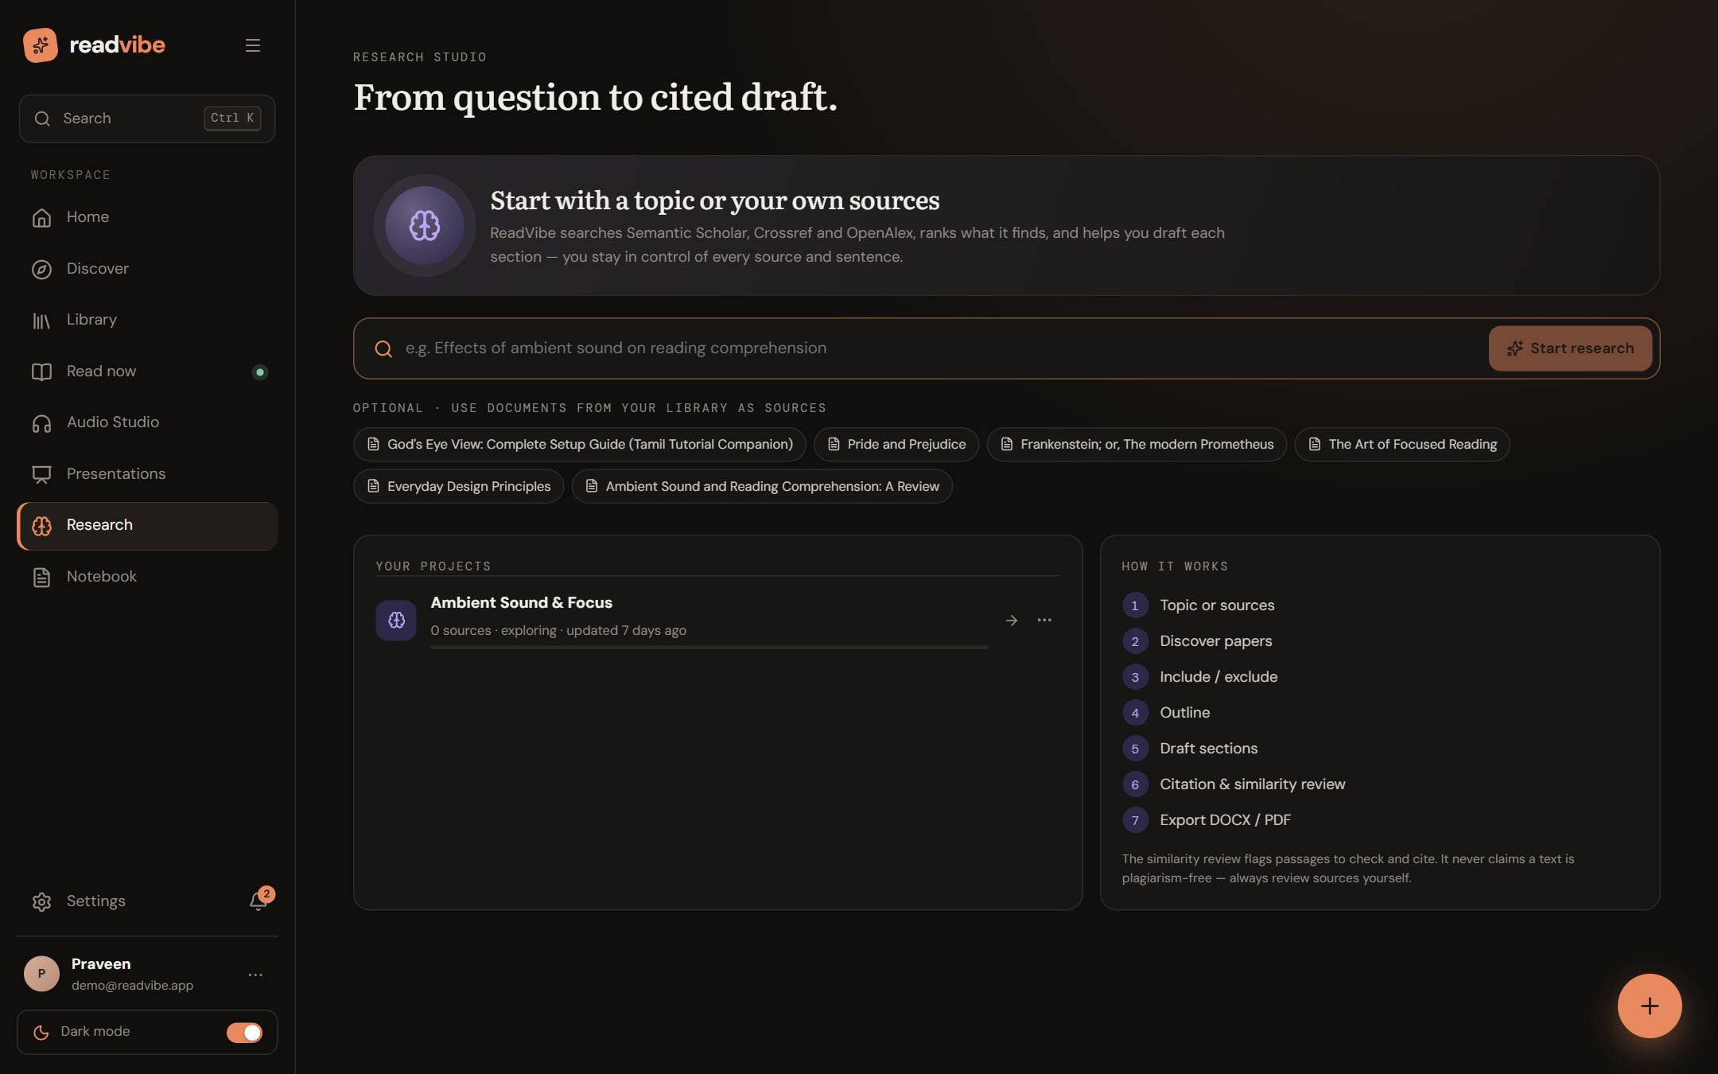
Figure 33: Research Studio home: topic search, library sources, projects and the seven-step process.

Presentation Studio
A related generator turns any file into a themed deck. The model or local engine produces layout-tagged slides from 15 layouts (title, agenda, concept, bullets, hierarchy, types, process, chart, mind map, compare, timeline, stats, quote, summary, example), in one of four styles (Executive, Academic, Creative, Technical) and four themes (Aurora, Nebula, Solar, Frost). Slides carry animations, transitions, speaker notes and generated imagery; the deck can be presented with a presenter view and exported as .pptx using python-pptx.
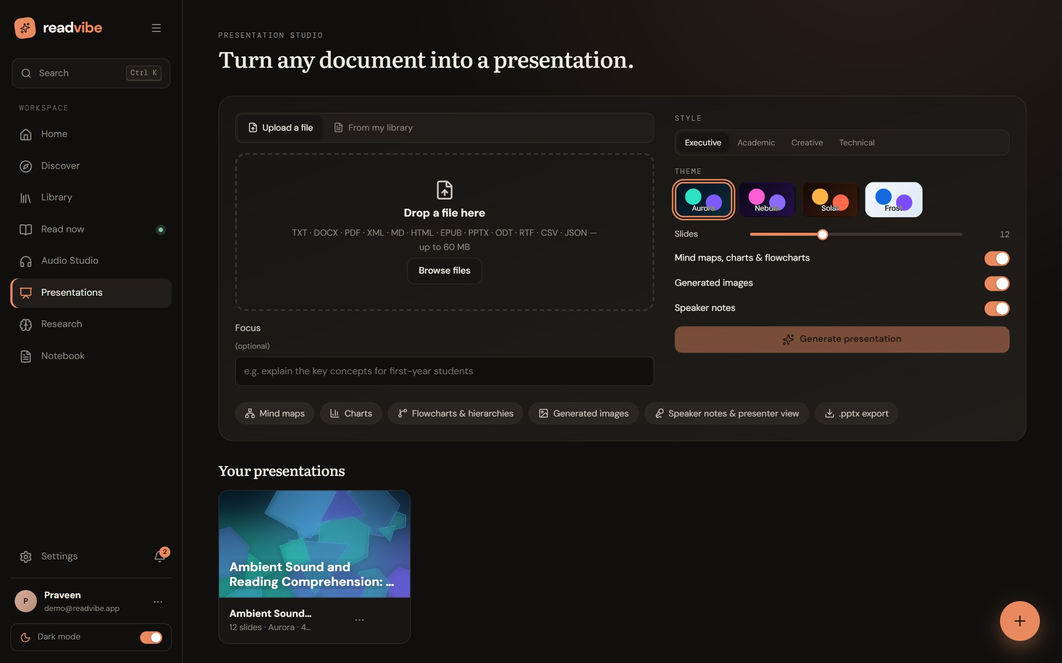
Figure 34: Presentation Studio: upload or choose from the library, set style, theme and options.

53. Personalized Book Recommendations
Recommendations are computed locally from the user’s own data, so they need no AI key and send nothing off the device. Every document is placed into one of 13 categories (novels & fiction, mystery & crime, adventure, sci-fi & fantasy, romance, story books, poetry & drama, philosophy, history & society, science & nature, technology & design, mind & psychology, business & economics) from keyword matches in its title, tags, description and author. Reading behaviour — progress, favourites, pins and recent opens — turns categories into a weighted interest profile. From that profile the engine ranks interests (each mapped to a Project Gutenberg topic the Discover page uses to suggest new books) and finds unfinished library books related to what the reader already engages with, stating why (for example “Shares fiction with Pride and Prejudice”).
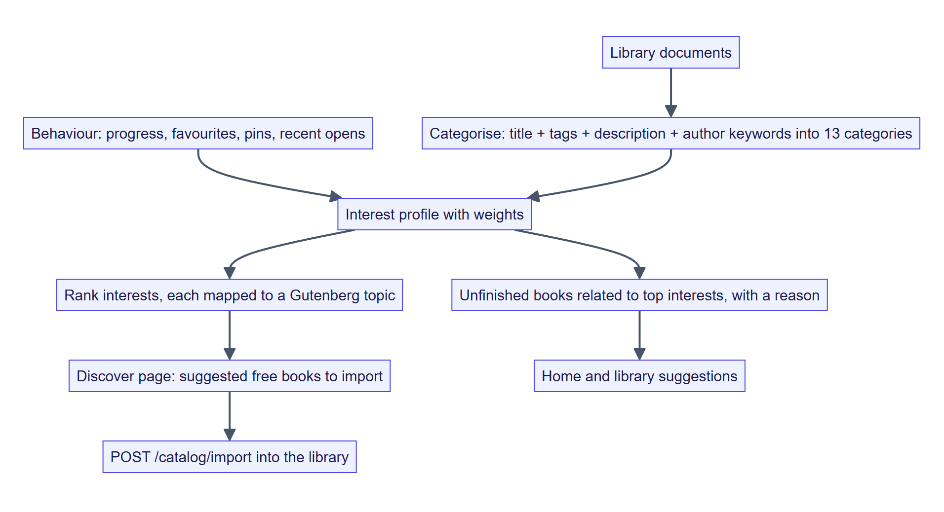
Figure 35: Recommendation flow.
This design is deliberately simpler than the graph-neural-network approach reported by De Nadai et al. [6], which requires large interaction data; the interest-profile approach works from the first book and can be explained to the user.

Part 6 — Technologies and Algorithms

54. Technology Stack
Table 23: Technology stack
Layer | Technology | Role
Presentation | React 19, React Router 7, Vite, CSS (custom design system), lucide-react icons | Single-page application, routing, build
Browser engines | Web Audio API, Web Speech API, MediaRecorder, IndexedDB, Canvas / SVG | Ambient sound, fallback speech, recording, offline store, visualisations
API | FastAPI, Uvicorn, Pydantic 2, python-multipart | REST endpoints, validation, streaming upload
Persistence | SQLAlchemy 2, SQLite, PostgreSQL (psycopg 3) | Relational storage
Document processing | pypdf, python-docx, zipfile / ElementTree, html.parser | Extraction
NLP | Custom dependency-free engine (BM25, TF-IDF, extractive ranking, shingles) | Local AI and retrieval
LLM access | httpx to OpenAI-compatible endpoints; Anthropic for the Vibe agent (optional) | Generative features
Speech | edge-tts, OpenAI speech (optional), NVIDIA Nemotron-3.5-Transcribe-30B-A4B (optional, self-hosted) | Neural TTS and speech-to-text
Export | python-docx, fpdf2, python-pptx, Pillow | DOCX, PDF, PPTX, imagery
Security | PyJWT, hashlib PBKDF2, google-auth | Tokens, hashing, Google ID-token verification
Testing | pytest, FastAPI TestClient | 159 tests
Deployment | Docker, docker-compose, nginx, Render, Vercel, GitHub Actions (keep-alive) | Hosting

55. Frontend Technologies
The frontend is a React 19 single-page application built with Vite. Routing uses React Router 7; global state (user, preferences, notifications) lives in an AppContext; data fetching is wrapped by useAsync and a small fetch client in src/api/client.js that attaches the bearer token. There is no heavyweight state library, which keeps the bundle small. Custom hooks encapsulate device and media concerns: useMediaQuery (responsive behaviour), useNaturalVoice (neural voice catalogue and per-language voice choice), useDictation (speech-to-text), useDeckPlayer (presentation playback) and useChapterTranslation.
- Design system: modular CSS files (app, reader-modes, responsive, mobile, decks, agent, overview) with CSS variables for theming; light, dark and high-contrast themes; reduced-motion support.
- Browser libraries (`src/lib`): ambient.js (generative soundscapes), vibeMusic.js and zenMusic.js (music engines), neuralVoice.js (neural clips and word timings), spokenWord.js (word ranges), audioStitch.js (WAV stitching), offline.js (IndexedDB), svgExport.js (diagram export), pageFlip.js, localStore.js, queue.js.
- Responsive layouts: a dedicated mobile reader and mobile home, tablet and landscape adaptations.

56. Backend Technologies
The backend is a FastAPI application created by an application factory with a lifespan hook that validates production settings, initialises the database and seeds demo data on a background thread so the port opens quickly. Settings come from environment variables with the READVIBE_ prefix (Pydantic settings). Services are plain Python modules without framework coupling. HTTP calls to third parties use httpx with explicit timeouts (45 s for LLM calls, 8 s for scholarly discovery).
- Concurrency: uploads and routes are asynchronous where useful; CPU-bound extraction runs in the thread-pool job runner.
- Configuration: database URL, storage directory, CORS origins, LLM endpoint, Anthropic key, OpenAI key, Google client ID, transcription server, upload limit and rate limits are all environment-driven.
- Resilience: every external call is wrapped and degrades to a local path.

57. Database Technologies
SQLAlchemy 2 provides the ORM; the default database is a SQLite file (zero set-up), and any SQLAlchemy URL — notably PostgreSQL on Supabase or Neon — can be supplied for production. A helper expands a bare password into a full connection string for convenience, and a configuration-error flag lets the API report a misconfigured database clearly instead of crashing. Because flexible structures use JSON columns, the same models run unchanged on both engines. Binary and large artefacts (original uploads, TTS audio, translations, recordings) live in a file store addressed by relative paths; the storage module is three functions and can be re-implemented for S3 or GCS.

58. AI and Machine Learning Technologies
Table 24: AI techniques used
Technique | Where used | Notes
LLM completion with JSON-schema prompts | Summaries, explanations, chat, diagrams, quizzes, drafts, overviews, decks | OpenAI-compatible protocol; own endpoint first, then Pollinations and LLM7
BM25 retrieval | Grounding for chat, explain and agent | k1 = 1.4, b = 0.75; passages of about 60–140 words
TF-IDF key-phrase extraction | Tags, mind maps, flashcards | Optional corpus from the document’s chapters
Extractive sentence ranking | Local summaries and descriptions | Multipliers described in Section 49
Cluster-based mind maps | Local mind map | Key phrases grouped into about five branches
Shingle overlap | Research similarity review | 5-word shingles, threshold 0.12
Lexicon-based affect estimate | Vibe empathy layer | Local, no model call
Neural TTS / ASR | Narration, dictation | Edge, OpenAI, NVIDIA Nemotron

Design choice. No machine-learning model is trained in this project. Learned models are consumed as services (LLMs, neural voices, speech recognition); all locally executed intelligence is classical information retrieval and heuristics, chosen so that it is fast, explainable and free of network dependence.

59. NLP Techniques
- Tokenisation and stop-word removal with a large English stop-word list plus a list of generic words that make poor key concepts.
- Light stemming to merge inflections before counting.
- Sentence segmentation that is abbreviation-aware.
- Passage building to chunk chapters into retrieval passages.
- Definition mining: pattern search for “X is …”, “X means …”, “defined as …” to find definitions of a term inside the document.
- Sentence simplification for Simple explanations.
- Step extraction from imperative and sequential sentences for flowcharts.
- Language detection by Unicode script (and common function words to separate Hindi from Marathi) so each phrase receives a voice that can speak it.
- Stage-direction and bracket handling to separate performance cues from spoken text.
- Gender inference from textual evidence (titles, kinship, role nouns, reflexives) for character casting.

BM25 scoring
score(q, d) = Σ_t idf(t) * f(t,d) * (k1 + 1) / ( f(t,d) + k1 * (1 - b + b * |d| / avgdl) )
with k1 = 1.4, b = 0.75

60. Text-to-Speech Models
Table 25: TTS providers
Provider | Model | Key needed | Word timings | Style control
Edge | Microsoft neural voices (e.g. en-US-AvaMultilingualNeural, en-IN-NeerjaNeural, Indian-language voices) | No | Exact boundaries | Rate %, pitch Hz, volume %
OpenAI | gpt-4o-mini-tts (configurable) | Yes | Estimated from character counts | Natural-language narration instructions
Browser | Web Speech voices on the device | No | Boundary events where supported | Rate and pitch

The default voice is edge:en-US-AvaMultilingualNeural; the default narration style instruction for instruction-capable models is “read aloud like a warm, expressive audiobook narrator: natural pacing, gentle emphasis on key ideas, clear diction”.

61. Emotion Recognition and Classification
Two different problems are addressed and kept separate.

Emotion in the *text* (for narration)
Stage directions and tone words are classified into emotion presets through an alias table (for example suspenseful → hesitant, amused → playful, whispered or hushed → whisper, scared or afraid → fright, joyful → excited). The preset determines rate, pitch and volume deltas (Section 46).

Emotion of the *reader* (for the agent)
empathy.detect estimates how the reader may be feeling from regular-expression lexicons with weights, adds behavioural cues (very late hour, very long session, a repeated question) and returns a guess with a confidence. A negation (“not confused”) cancels a match. The agent is instructed to respond “it sounds like…” rather than announce a detection.
Table 26: Affect lexicon (weights from the implementation; list abbreviated)
State | Example cues | Weight
discouraged | give up, hopeless, burnout, no motivation | 1.4
overwhelmed | too much, can’t keep up, falling behind | 1.3
anxious | nervous, panic, exam tomorrow, deadline | 1.2
frustrated | annoying, doesn’t work, fed up | 1.1
confused | don’t understand, makes no sense, I’m lost | 1.0
tired | exhausted, can’t focus, brain fog | 0.9
excited | love this, fascinating, can’t wait | 0.9
bored | boring, tedious, so slow | 0.8
grateful | thanks, that helped | 0.7
curious | what if, tell me more, go deeper | 0.6

Honest scope. This is not a trained classifier and has not been validated against a labelled dataset. It is a transparent heuristic and should not be presented as emotion recognition in the clinical or computer-vision sense (cf. [8], [17], which use facial and physiological sensing).

62. Recommendation Algorithms
Recommendation is a content-based, behaviour-weighted interest model computed per request from the user’s own library:
- Assign each document to a category by whole-word keyword matches over title, tags, description and author.
- Weight categories by engagement signals — reading progress, favourites, pins and recent opens (with a recency window).
- Rank categories into an interest list; each carries a Project Gutenberg topic for new-book suggestions.
- For each unfinished library book, compute relatedness to the top interests and attach a human-readable reason.
Advantages: works from the first interaction (no cold-start training), is explainable and private. Limitation: it cannot discover cross-category taste patterns that collaborative or graph-based methods such as 2T-HGNN [6] can; this is listed as future work.

63. Text Extraction Algorithms
- Dispatch by extension to a format reader; binary readers accept a path to stream from disk.
- Decode and clean (HTML tag removal, entity decoding, whitespace normalisation).
- Chapter detection with the multi-script pattern (Section 41); fall back to size-based sectioning when no headings are found.
- Split over-long sections near 2,200 words.
- Cap readable text at 32 MB while retaining the original file.

64. Audio Processing Techniques
Table 27: Audio techniques
Technique | Where | Detail
Generative noise synthesis | ambient.js | White, pink and brown noise sources through low-pass / band-pass filters with low-frequency-oscillator modulation to make rain, forest wind, ocean surf, café and fireplace layers
Binaural beats | ambient.js | Two oscillators at 200 Hz and 210 Hz routed to the left and right channels, giving a 10 Hz beat for the “focus beats” layer; a “soft noise” (white) layer is also provided
Frequency analysis | vibeMusic.js | Analyser node feeds the live visualiser
Prosody control | tts.prosody | Rate, pitch and volume deltas with clamping and punctuation lifts
Audio integrity check | speechplan.check_audio | Cheap validation of engine output
Silence trimming, noise gate, peak normalisation, joining, WAV encoding | audioStitch.js | Used to stitch collaborative recordings
Caching | tts.py | Disk cache keyed by a hash of text, voice and delivery

65. Third-Party APIs and Integrations
Table 28: Third-party integrations
Service | Used for | Key required | Failure behaviour
OpenAI-compatible LLM (own endpoint) | Generative AI features | Optional | Next provider, then local engine
Pollinations, LLM7 | Free key-less LLM access | No | 90 s cool-down, then local engine
Anthropic | Vibe agent primary and backup models | Optional | Retry, backup model, free LLM, local
Microsoft Edge neural voices (edge-tts) | Read-aloud | No | Browser voices
OpenAI speech | Alternative neural voices | Optional | Edge, then browser
NVIDIA Nemotron transcribe server | Speech-to-text | Self-hosted | Feature reports unavailable
Semantic Scholar, Crossref, OpenAlex | Reference discovery | Optional (Semantic Scholar key) | Skip failing provider; local sources
Project Gutenberg, Internet Archive | Free book import | No | Error message
Wikimedia Commons / Wikipedia | Open-licensed visual references | No | Empty result
MyMemory | Free translation (about 5,000 characters/day anonymously) | Optional contact e-mail | Clear quota message
Google Identity Services | Sign in with Google | Client ID | E-mail login still works

Part 7 — Implementation

66. Development Environment Setup
The project runs on Windows, macOS or Linux. The steps below are those used on Windows 11 with Node.js 22 and Python 3.13.

API (terminal 1)
cd backend
py -m venv .venv
.venv\Scripts\python -m pip install -r requirements.txt
.venv\Scripts\python run.py # http://localhost:5000 (docs: /api/docs)

Web (terminal 2, project root)
npm install
npm run dev # http://localhost:5173 (proxies /api to :5000)

Opening the app and choosing Explore the demo library signs in a seeded demo account with sample books, highlights, notes, reading history and an audiobook. Tests run with npm run api:test. Configuration is copied from backend/.env.example; all settings use the READVIBE_ prefix.
Table 29: Principal configuration settings
Setting | Purpose
READVIBE_JWT_SECRET | Required in production; the API refuses to start with the default
READVIBE_GOOGLE_CLIENT_ID | Enables Sign in with Google
READVIBE_LLM_BASE_URL / _API_KEY / _MODEL | Optional own OpenAI-compatible LLM, tried first
READVIBE_LLM_ENABLED | false turns off every network LLM
READVIBE_ANTHROPIC_API_KEY | Enables the Vibe agent’s primary/backup models
READVIBE_OPENAI_API_KEY | Enables OpenAI speech voices
READVIBE_DATABASE_URL | SQLite by default; any SQLAlchemy URL
READVIBE_MAX_UPLOAD_MB | Upload limit (default 5120)
READVIBE_CORS_ORIGINS | JSON list of allowed frontend origins
VITE_API_URL | Frontend: API base when it is on another origin

67. Project Folder Structure
read_vibe_codex/
├── index.html, vite.config.js, package.json
├── src/ # React frontend
│ ├── api/client.js # fetch wrapper with bearer token
│ ├── context/AppContext.jsx
│ ├── pages/ # Home, Library, Reader, AudioStudio, Research, Decks, Notes, Settings ...
│ ├── components/ # reader/, ai/, audio/, agent/, deck/, layout/, library/, upload/ ...
│ ├── hooks/ # useAsync, useNaturalVoice, useDictation, useDeckPlayer ...
│ ├── lib/ # ambient.js, vibeMusic.js, neuralVoice.js, audioStitch.js, offline.js ...
│ └── styles/ # app.css, reader-modes.css, responsive.css, mobile.css ...
├── backend/
│ ├── app/
│ │ ├── main.py # app factory, middleware, error handlers
│ │ ├── config.py, database.py, models.py, schemas.py, security.py, deps.py
│ │ ├── routers/ # auth, documents, ai, agent, audio, tts, transcribe, research, decks, notes, catalog, activity
│ │ └── services/ # extraction, ingest, nlp, ai, llm, tts, speechplan, narration, recommend, research, deck, agent/ ...
│ ├── tests/ # 12 test modules
│ ├── Dockerfile, requirements.txt, run.py
├── deploy/nginx.conf # 5 GB body limit, SPA routing
├── docker-compose.yml, render.yaml, vercel.json
└── .github/workflows/keepalive.yml

68. Frontend Implementation
The Reader page is the most complex: it owns the current chapter, the scroll position, the active mode (Reader, Zen or Vibe, switchable with the R, Z and V keys), the selection toolbar, the contents drawer and the read-aloud controller. Chapters are rendered paragraph by paragraph; each paragraph carries a data-p index so highlights, sketches, search results and the spoken-word highlight can all be addressed in the same coordinate space.
- Mode switching preserves the chapter and scroll ratio, which is saved with PUT /documents/{id}/progress and restored on the next open.
- Responsive behaviour is handled by useMediaQuery and separate mobile components (MobileReader, MobileHome).
- Theming: theme (dark, light, system, high-contrast) and typography are held in preferences and applied through CSS variables; reduced motion is respected.
- Offline: offline.js stores complete reading packages (chapters, highlights, bookmarks) in IndexedDB so downloaded documents stay readable without a connection.
- AI panel: a slide-over panel with “AI tools” and “Ask Vibe” tabs; each tool shows a mode selector, a result view and export or save-to-Notebook actions.
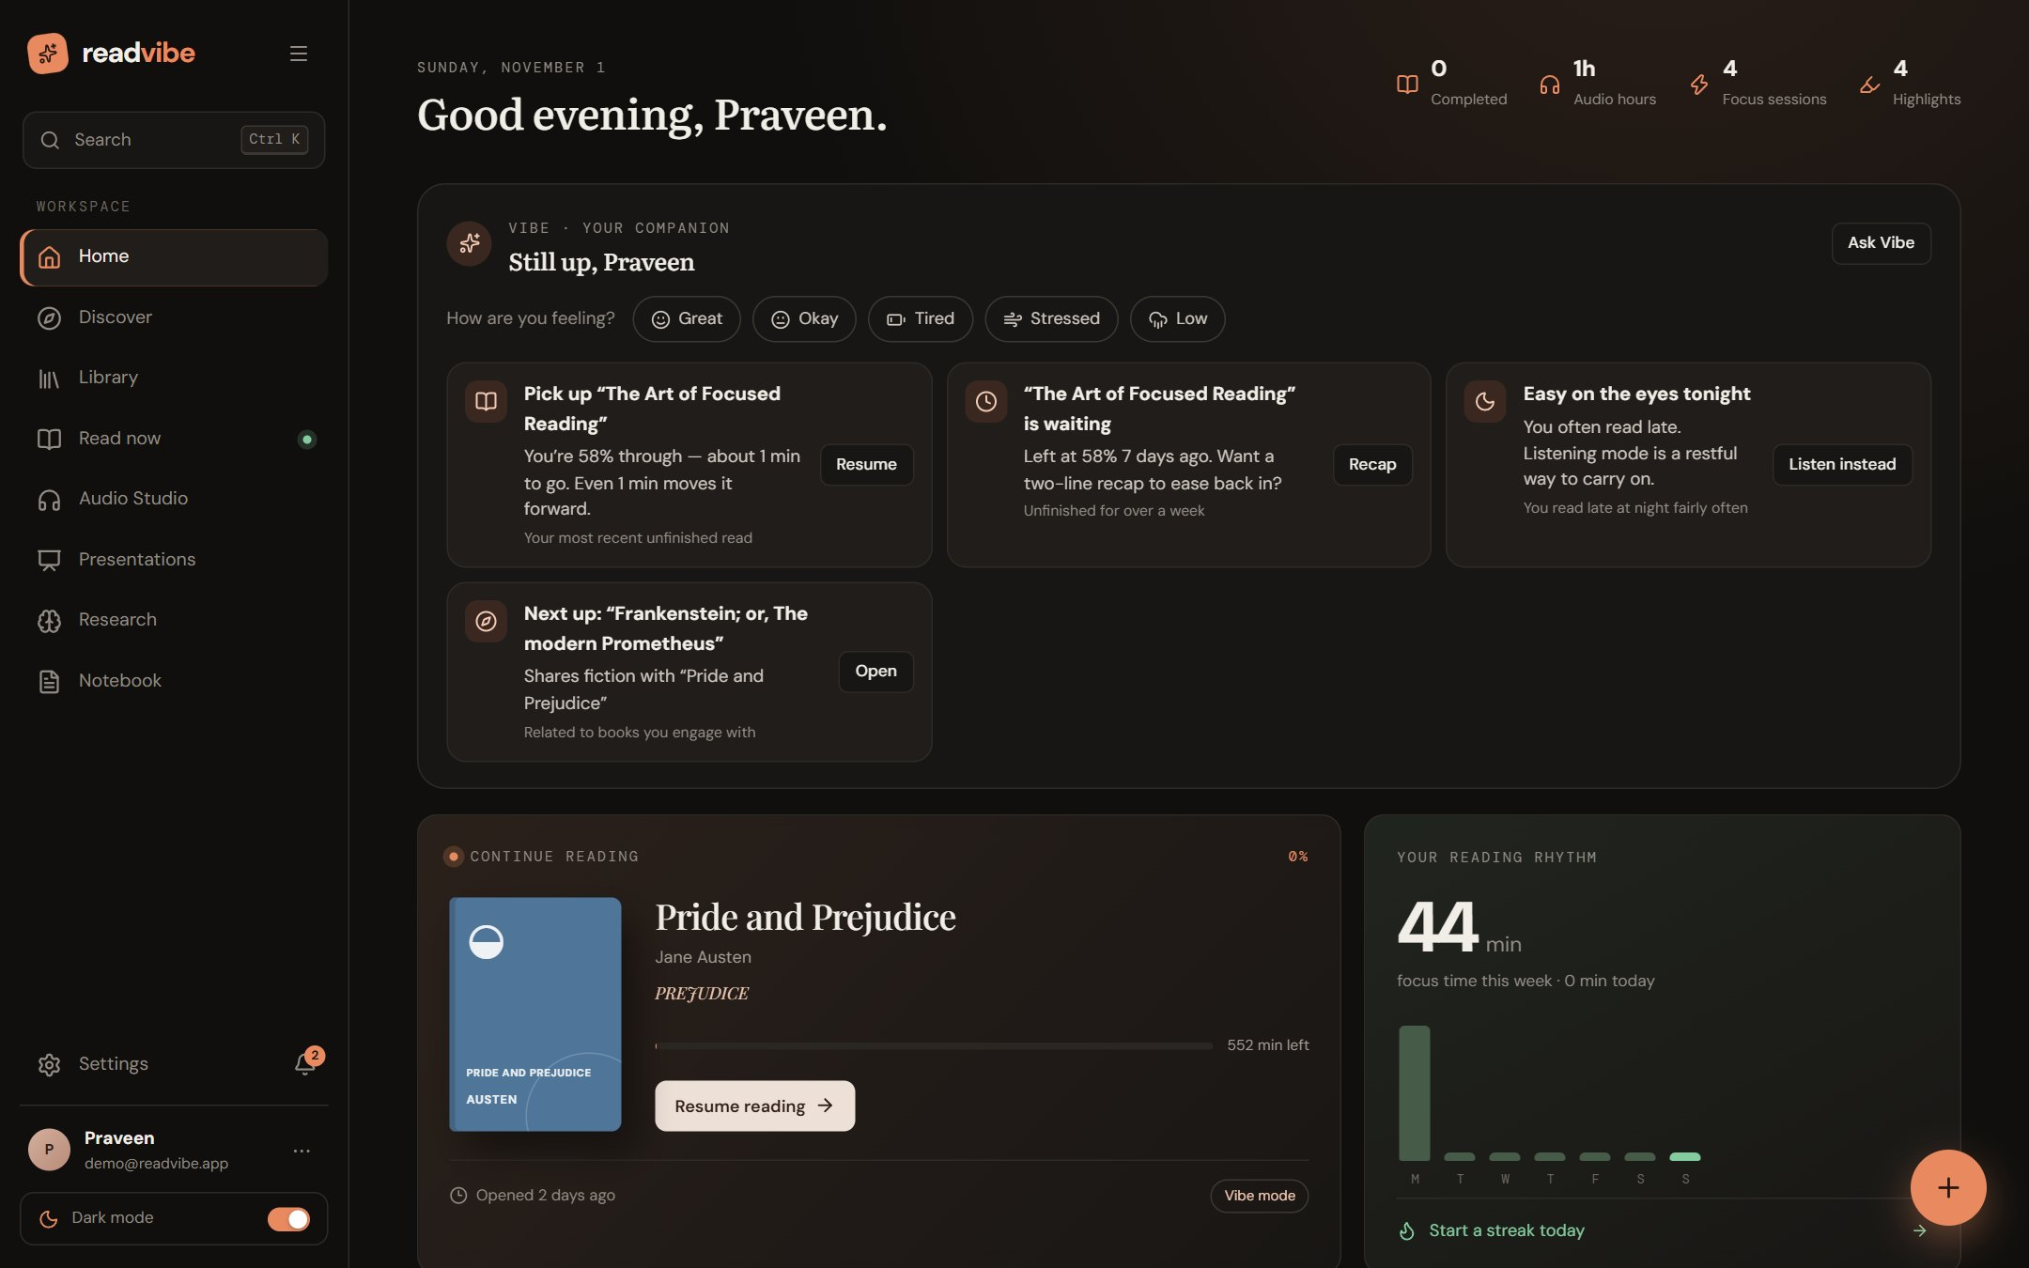
Figure 36: Home page after demo sign-in.

69. Backend Implementation
main.py builds the application, installs GZip and CORS middleware (allowing the configured origins and any *.vercel.app preview), installs the rate-limiting and request-context middleware, and registers consistent JSON handlers for HTTP errors, validation errors and uncaught exceptions. Routers are thin: they parse and validate with Pydantic schemas, check ownership through the deps module, and call services.

Background jobs
Abridged from the ingestion job: the stage names and percentages below are the ones the notification centre shows.
job = jobs.create_job(db, owner_id, "ingest", title, ref_id=doc.id) # status = queued
jobs.submit(job.id, job_fn) # 4-worker thread pool

# inside job_fn(ctx):
ctx.update("Reading file", 10)
ctx.update("Extracting text", 30)
ctx.update("Splitting into chapters", 60)
ctx.update("Analysing content", 80)
ctx.update("Building search index", 95)
# on success: status = completed, stage = "Completed", progress = 100
# on error: status = failed, error = str(exc)[:500]

Extensibility. The job runner is intentionally minimal. Its docstring notes that submit can be replaced by a Celery, RQ or RabbitMQ producer without changing job functions, which only need a job ID.

70. Database Integration
database.py creates the engine from the configured URL, supports SQLite (with a writable fallback location for any OS user) and hosted PostgreSQL URLs (normalised so common copy-paste forms work), and creates tables at start-up with init_db(). Sessions are provided per request through a dependency. A password-safe description of connection problems is exposed so that error messages never leak credentials; tests cover malformed pastes, paths with spaces and a bare password that is expanded to the pooler address. Demo seeding runs on a background thread so the port opens first.

71. API Integration
src/api/client.js wraps fetch, prefixes /api (or VITE_API_URL), attaches the bearer token, parses JSON and converts error bodies to readable messages. In development Vite proxies /api to port 5000; in production vercel.json rewrites /api/* to the API host, and deploy/nginx.conf proxies it for the Docker deployment (5 GB request bodies, unbuffered, one-hour timeouts for long uploads).

72. AI Model Integration
All generative features go through services/llm.py, which speaks the OpenAI-compatible /chat/completions protocol. The provider order is: a provider configured by the owner (Groq, OpenRouter, Gemini’s OpenAI endpoint, a local Ollama, …), then two free public endpoints that need no key (Pollinations and LLM7). A provider that fails is skipped for a cool-down (90 s; 120 s when it signals a rate limit, honouring any “retry after N s” hint) so a dead service never slows every request. Because the free models spend their reasoning from the same token budget, a minimum of 1,200 tokens is requested.
complete_json asks for a JSON object with a stated schema, tolerantly extracts JSON from the reply, validates required keys, and moves to the next provider if the schema is wrong; if all providers fail it raises LLMUnavailable, and the caller uses the local engine. The Vibe agent has its own gateway.converse, which sticks to one primary model, retries it, parks it for a cool-down only after repeated failure, and then uses the backup model; a switched_from note is returned so the reader can be told once.
Simplified from ai.summarize: cache first, then the LLM with a schema, then the local engine.
if (hit := _cache.get(key)) is not None: # thread-safe LRU
return hit
if llm.available():
try:
data = llm.complete_json(llm.READER_SYSTEM, prompt_with_document, _SUMMARY_SCHEMA)
result = _with_engine(data, llm.provider_name())
except llm.LLMUnavailable:
result = None
if result is None:
result = _with_engine(nlp.summarize(text, title, depth, corpus), "local")

73. TTS Integration
The browser requests speech sentence by sentence (neuralVoice.js), keeps each clip as a blob URL in memory with its word timings. The server plans the utterance with speechplan (sanitise, language runs, glossary, voice resolution), calls the chosen provider, validates the audio, caches it on disk and returns base64 audio with aligned words. If the neural path is not available the client switches to the browser’s Web Speech engine without interrupting the session. A silent clip is played inside the user’s tap so that mobile browsers allow later programmatic playback.

74. File Processing Pipeline
- Receive: multipart upload streamed to storage/<owner>/<folder>/<safe-name> in 4 MB chunks; filenames are sanitised.
- Register: a Document row with status = processing and a Job row are created; HTTP 202 is returned.
- Extract: the job reads the file from disk (not memory), dispatches by format and produces chapters.
- Describe: description and tags are derived from bounded samples.
- Persist: chapters are written, word count and status updated, notification raised.
- Serve: chapters are delivered on demand (/chapters/{index}) or as a single offline package (/package).

75. Error Handling and Security
Table 30: Security and error-handling measures
Area | Measure
Authentication | JWT bearer on all data routes; PBKDF2-SHA256 with per-password salt; production refuses default secret
Authorisation | Every query filtered by owner_id; a test verifies that users cannot read each other’s data (ownership_isolation)
Input validation | Pydantic schemas with length and enum limits; file type and size checks; unsafe catalogue IDs rejected
Abuse | Sliding-window rate limit; 429 with Retry-After; AI bucket stricter than general
Transport and headers | HTTPS in production; X-Content-Type-Options: nosniff; Referrer-Policy: strict-origin-when-cross-origin; CORS allow-list
Prompt injection | Document text and tool results are labelled as untrusted data in the agent’s system prompt; write tools can only add a note or a short memory to the user’s own account; a test covers an injected instruction inside a document
Privacy | Message text never stored by the agent; personalisation off stores and uses nothing; export and delete available
Errors | Uniform JSON; request IDs; exception details not leaked to the client; slow-request logging
Forged identity | Google tokens verified for signature, audience, issuer, expiry and verified e-mail; a test rejects forged tokens

76. Module Integration
Modules integrate through three shared assets: the document (chapters, progress, last mode), the Notebook (any AI output, highlight or note can be saved and later reviewed as flashcards) and the job and notification system. For example, Audio overview reads a document, asks the AI to write a conversation or narrative in the listener’s language, translates only what is necessary, assigns two voices, synthesises through the TTS service and returns a playable script; the Vibe agent uses the same AI and retrieval services as the AI panel, plus the recommendation engine and the reading-session data collected by the reader.

Part 8 — Testing and Evaluation

77. Testing Methodology
Testing combines four layers. Automated tests (pytest) exercise services directly and the HTTP API through FastAPI’s TestClient with an isolated database and inline job execution. Functional checks were performed manually on the deployed application, including a scripted browser session that signed in with the demo library, visited every main page and opened the Reader, Zen, Vibe and AI tools (the screenshots in Part 9 come from that session). Performance measurements were taken against the live deployment and locally. Evaluation protocols for subjective qualities (TTS naturalness, usability) are defined but, as stated in the relevant sections, have not yet been run with participants.
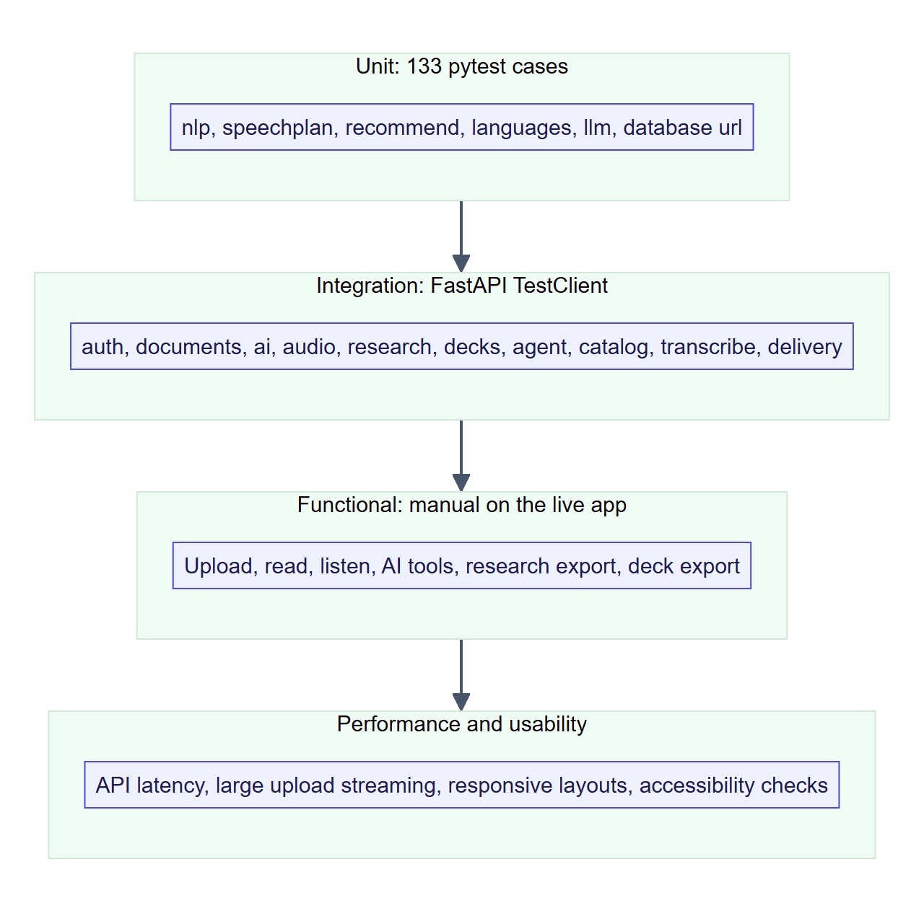
Figure 37: Testing strategy.
Reporting policy. Every result reported in this part is from a run on 1 November 2026 against the repository at that date. Where a quality has not been measured, the report says so rather than estimating.

78. Unit Testing
Unit tests target pure logic that must be exactly right:
Table 31: Unit-test coverage
Module | What is verified | Test names (abridged)
test_speechplan.py | Markup never spoken but wording kept; code-switching by language; style deltas combine and unknowns are neutral; glossary changes sound only; wrong-language voice replaced with a note; audio validation; mixed-language timings joined; symbols become pauses without changing length | 11 tests
test_llm.py | Disabled means local only; free providers work without a key; custom provider first; tolerant JSON extraction; prose rejected; schema validation; fail-over with cool-down; HTTP errors become “unavailable”; cool-down follows the retry hint | 10 tests
test_recommend.py | Categorisation, interest ranking with reasons, Indic-language grouping | 4 tests
test_languages.py | Script detection, southern languages first, NLP on Indic text, Indic chapter headings, translation caching and script verification | 10 tests
test_database_url.py | Messy pastes normalised, paths with spaces, password never in problem descriptions, fallback location writable, bare-password expansion | 8 tests
test_agent.py (part) | Affect detection, negation respected, behavioural cues, safety path never reaches a model, conservative memory extraction | —

79. Integration Testing
Integration tests run complete request flows through the API with real routers, services and a test database.
Table 32: Integration-test coverage
Flow | What is checked
Authentication | Register, log in, get profile; protected routes return 401 without a token; Google sign-in accepted for a valid token and a forged token rejected
Documents | Upload text, DOCX and PPTX (slide order with notes and tables); unsupported types rejected; 5 GB limit enforced mid-stream; streamed upload processed from disk
Annotations | Highlights, bookmarks, notes, sketches; ownership isolation between users
AI and audio | AI features respond (local engine path), audiobook generation, collaborative studio, TTS aligns words and caches, unknown provider rejected
Research | Create project, discover, curate, outline, draft, review, export
Decks | Deck from text and from a library document; edit; export .pptx; ownership; every theme renders every style; normaliser repairs model output
Catalogue | Gutenberg boilerplate stripped; unsafe IDs rejected; fallback when upstream is down or slow; stale cache served on failure
Transcription | Prompt follows the model card; speaker tags become turns; unavailable server reported plainly; size and type limits

80. Functional Testing
Functional testing verifies each functional requirement (Section 20) end-to-end. The table records the outcome for the deployed application observed on 1 November 2026.
Table 33: Functional verification
FR | Check | Method | Result
FR-01 | Demo sign-in reaches the home page | Browser session | Pass (redirect in about 1 s)
FR-04 | Library shows tabs, tag filters, suggestions and cards | Browser session | Pass
FR-05 | Reader, Zen and Vibe modes open on a 70-section book and keep the chapter | Browser session | Pass
FR-08/09 | Audio Studio player renders now-playing, waveform, speed, voice and sleep controls | Browser session | Pass (visual)
FR-11–13 | AI panel lists all tools; the Diagram tool produced a flowchart from the open chapter | Browser session | Pass
FR-17 | Research Studio shows topic search, library sources and the seven-step process | Browser session | Pass (visual)
FR-18 | Presentation Studio shows upload, style, theme and options; a generated deck is listed | Browser session | Pass (visual)
FR-02…22 | Backed by API-level tests (Sections 78–79) | pytest | Pass

Interpretation. “Pass (visual)” means the page rendered the expected controls; the underlying behaviour for those features is covered by API tests, but audio playback quality and research output were not subjectively assessed in this session.

81. Performance Testing

Live API round-trip latency
Six sequential requests per endpoint from the development machine to the deployed site (browser-equivalent route: Vercel edge → rewrite → API container). Times include network and TLS.
Table 34: Round-trip latency to the deployed API (n = 6 per endpoint)
Endpoint | Status | Min (s) | Median (s) | Max (s)
/api/health | 200 | 0.62 | 0.73 | 1.14
/api/auth/config | 200 | 0.50 | 0.60 | 0.67
/api/tts/status (no token) | 401 | 0.50 | 0.58 | 0.62
/api/ai/status (no token) | 401 | 0.49 | 0.60 | 0.67

Local engine timings
Measured on the development machine with synthetic English text (a fixed vocabulary, one chapter heading per 20 paragraphs) so that sizes are controlled.
Table 35: Local NLP and extraction timings
Operation | Input | Time
Extract and chapter plain text | 50,000 words (0.4 MB) → 36 chapters | 0.05 s
Extract and chapter plain text | 200,000 words (1.5 MB) → 143 chapters | 0.16 s
Build BM25 index | 60 chapters, 84,000 words | 0.15 s
BM25 query (top passages) | Same index | 11 ms
Local summary | One 1,400-word chapter | 13 ms
Local mind map | 10 chapters | 315 ms

Limit observed. A trial at 2,000,000 words did not finish within five minutes and was stopped, so extraction time is not claimed to scale linearly to very large texts. The platform’s defence for large files is streaming upload, a 32 MB text cap and background processing; profiling very large inputs is listed as future work.

Test-suite time
The full backend suite of 159 cases passed in 40.2 seconds.

82. Usability Testing
No formal usability study with participants has been conducted yet. The design draws on published usability findings [13]–[15], and the following evaluation plan is proposed for the next phase.
Table 36: Proposed usability evaluation
Element | Plan
Participants | 15–20 students, including at least five with self-reported dyslexia or attention difficulty
Tasks | Upload a PDF; read a chapter in each mode; summarise and generate a mind map; listen with highlighting; draft a research section
Measures | Task success and time; System Usability Scale (SUS); NASA-TLX workload; reading comprehension quiz scores in silent vs. listen-and-read conditions
Design | Within-subject, counterbalanced mode order, one week of free use with usage logs (focus sessions, streaks)
Acceptance | SUS ≥ 68 (average) and task success ≥ 90 %

Heuristic observations from the live session: mode switching is available from a single control and by keyboard (R, Z, V); the contents panel, progress and chapter controls are always visible; every AI tool shows the engine badge “Powered by Free AI” and offers save-to-Notebook and export.

83. TTS Quality Evaluation
Objective checks are automated: output audio is validated by check_audio; synthesis is deterministic and cached per text, voice and delivery; stage directions never reach the speech engine (directions_never_reach_speech); symbols become pauses without changing the transcript length; mixed-language text is voiced per language with joined timings. Subjective naturalness and expressiveness have not been rated by listeners.
Table 37: TTS evaluation protocol (to be run)
Planned measure | Method
Naturalness and expressiveness | Mean Opinion Score (1–5) by at least 15 listeners on matched passages in Regular, Humor and Tough tones against a neutral baseline
Intelligibility | Word error rate of an independent recogniser on the synthesised audio of 50 sentences
Appropriateness of tone | Forced-choice: which tone suits this passage (comic vs. historical)
Character distinction | Listeners identify speaker changes in dialogue with cast voices on and off

84. Audio Synchronization Evaluation
Synchronisation correctness is verified structurally: the Edge provider returns word boundaries, _align maps them onto the displayed text, and tests assert that words are aligned and cached (tts_aligns_words_and_caches), that engine-side pauses do not shift the timings, which stay on the original text (engine_receives_pauses_but_timings_stay_on_the_original_text), and that mixed-language segments produce a single joined timeline. The perceptual offset between the heard word and the highlighted word has not been instrumented.
Proposed measurement: record screen and audio for 20 sentences per voice, mark the onset of each word’s audio and highlight, and report the median and 95th-percentile offset; the target is ≤ 150 ms. For OpenAI voices, whose timings are estimated from character counts, the same protocol will quantify drift and decide whether forced alignment is needed.

85. AI Output Evaluation
- Groundedness by construction: the local engine is extractive — every output sentence exists in the source. LLM prompts require examples to come from the text; chat answers carry passage citations.
- Robustness verified by tests: malformed or non-JSON model output is rejected (extract_json_rejects_prose); wrong schemas move to the next provider; a dead provider is cooled down; all-models-down degrades to the local engine; a prompt injected inside a document is treated as data.
- Format stability: the same JSON shape is returned regardless of engine, with an engine field.
Table 38: AI evaluation plan (to be run)
Quality dimension | Planned metric
Summary faithfulness and coverage | Human rating on 30 chapters; ROUGE-L against reference key points; proportion of summary sentences found verbatim (local engine = 100 %)
Answer correctness and citation precision | 100 questions with known answers; fraction of citations that contain the answer
Mind-map usefulness | Learner rating and concept recall after 10 minutes of study
Quiz validity | Expert review of item correctness; difficulty distribution

86. Test Cases and Results
The complete automated suite was run with pytest -q on 1 November 2026: 159 passed, 0 failed, 0 skipped in 40.18 s. Selected cases are listed below by identifier.
Table 39: Selected automated test cases
ID | Area | Case | Expected | Result
T-01 | Auth | requires_auth | Protected routes reject missing tokens | Pass
T-02 | Auth | google_verification_rejects_forged_token | Forged ID token refused | Pass
T-03 | Upload | upload_limit_is_5gb_and_enforced_while_streaming | Stream stops and partial file removed beyond limit | Pass
T-04 | Upload | upload_pptx / extract_pptx_in_slide_order_with_notes_and_tables | Slides in order with notes and tables | Pass
T-05 | Security | ownership_isolation | User A cannot access user B’s data | Pass
T-06 | TTS | tts_aligns_words_and_caches | Word timings returned; second call served from cache | Pass
T-07 | TTS | directions_never_reach_speech | Bracketed directions never spoken | Pass
T-08 | TTS | cast_hints_come_from_the_text_never_the_name | Gender inferred only from evidence | Pass
T-09 | Speech plan | voice_for_wrong_language_is_replaced_with_a_note | Voice substituted and the change recorded | Pass
T-10 | LLM | fails_over_to_the_next_provider_and_cools_the_first_down | Second provider answers; first skipped | Pass
T-11 | LLM | extract_json_rejects_prose | Non-JSON model output rejected | Pass
T-12 | Agent | safety_path_never_reaches_a_model | Fixed caring reply; no model call | Pass
T-13 | Agent | personalisation_off_stores_and_uses_nothing | No memories or events written or used | Pass
T-14 | Agent | prompt_injection_in_a_document_is_labelled_as_data | Injected instruction not obeyed | Pass
T-15 | Agent | every_request_uses_the_same_model_and_never_names_it | No per-request model switching | Pass
T-16 | Agent | all_models_down_degrades_to_local | Local reply with citations | Pass
T-17 | Languages | indian_language_chapter_headings_split_documents | Chapters split on Tamil, Hindi … markers | Pass
T-18 | Translate | translate_caches_verifies_script_and_falls_back | Untranslated answers rejected; cache used | Pass
T-19 | Decks | every_theme_renders_every_style | All 16 theme–style combinations render | Pass
T-20 | Catalogue | slow_gutendex_hits_a_hard_deadline_then_falls_back | Deadline respected; fallback served | Pass
T-21 | Database | problem_description_never_contains_the_password | Credentials never leak in errors | Pass
T-22 | Transcribe | prompt_follows_the_model_card | Request matches the model card | Pass
T-23 | Research | research_workflow | Discover → draft → review → export succeeds | Pass
T-24 | Audio | collab_studio | Collaborators, assignments and recordings handled | Pass

Part 9 — Results and Discussion

87. Application Screenshots
All screenshots in this report were captured on 1 November 2026 from the deployed application at https://readvibe-app.vercel.app/ using the demo library (dark theme, 1440 × 900 viewport). The index below locates each screen; additional screens that appear only in this section follow.
Table 40: Screenshot index
Screen | Where shown
Sign-in | Section 37
Home | Section 68
Library | Section 39
Discover | Section 38
Reader mode; Zen mode; Vibe mode | Sections 42, 43, 44
AI companion panel; Diagram tool | Sections 49, 51
Audio Studio | Section 48
Research Studio; Presentation Studio | Section 52
Display settings; Book hub; Notebook; Settings | This section

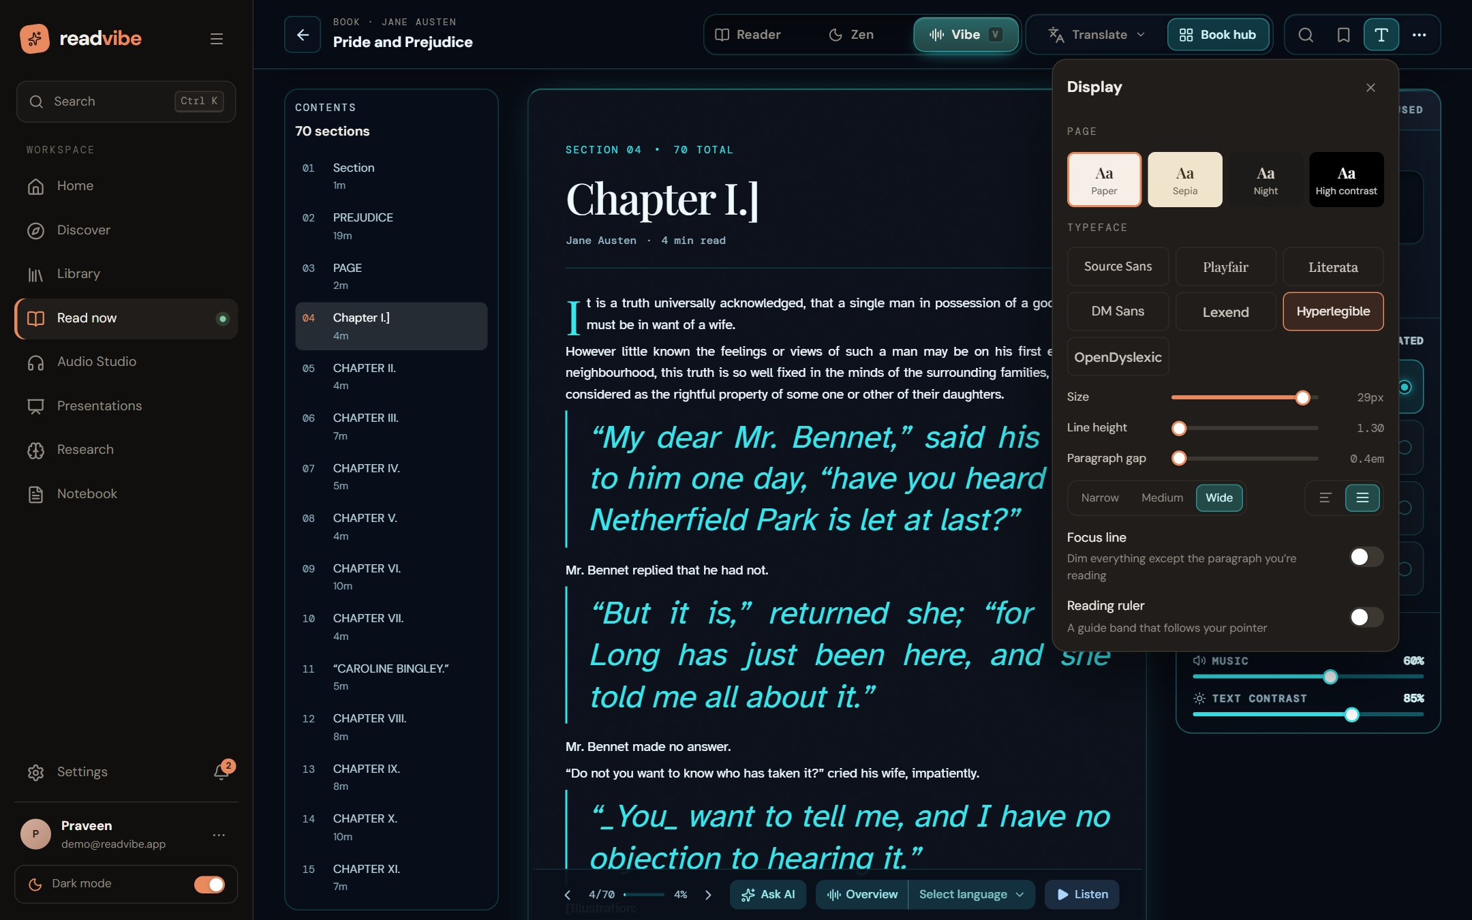
Figure 38: Reader “Display” popover: page colour (Paper, Sepia, Night, High contrast), seven typefaces including OpenDyslexic and Hyperlegible, size, line height, paragraph gap, width, alignment, focus line and reading ruler.
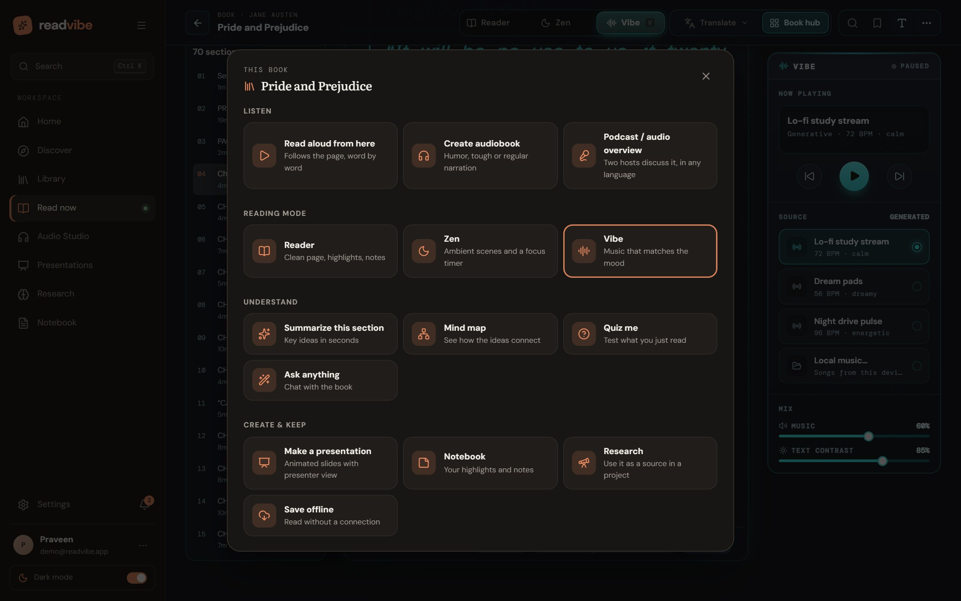
Figure 39: Book hub: every action for one book — Listen (read aloud, create audiobook, podcast-style audio overview), Reading mode, Understand, and Create & keep (presentation, notebook, research, save offline).
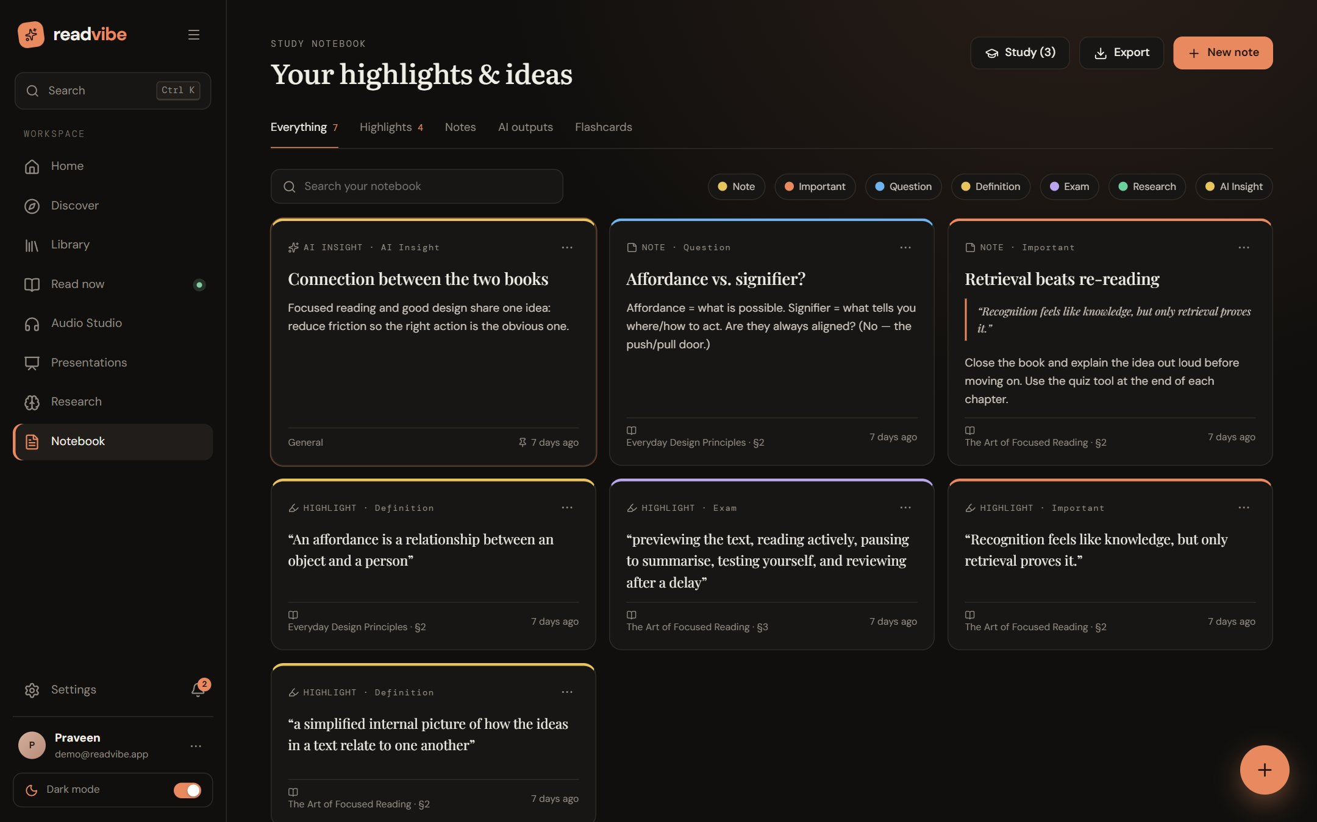
Figure 40: Study Notebook: highlights, notes and AI outputs with category filters, flashcard study and Markdown export.
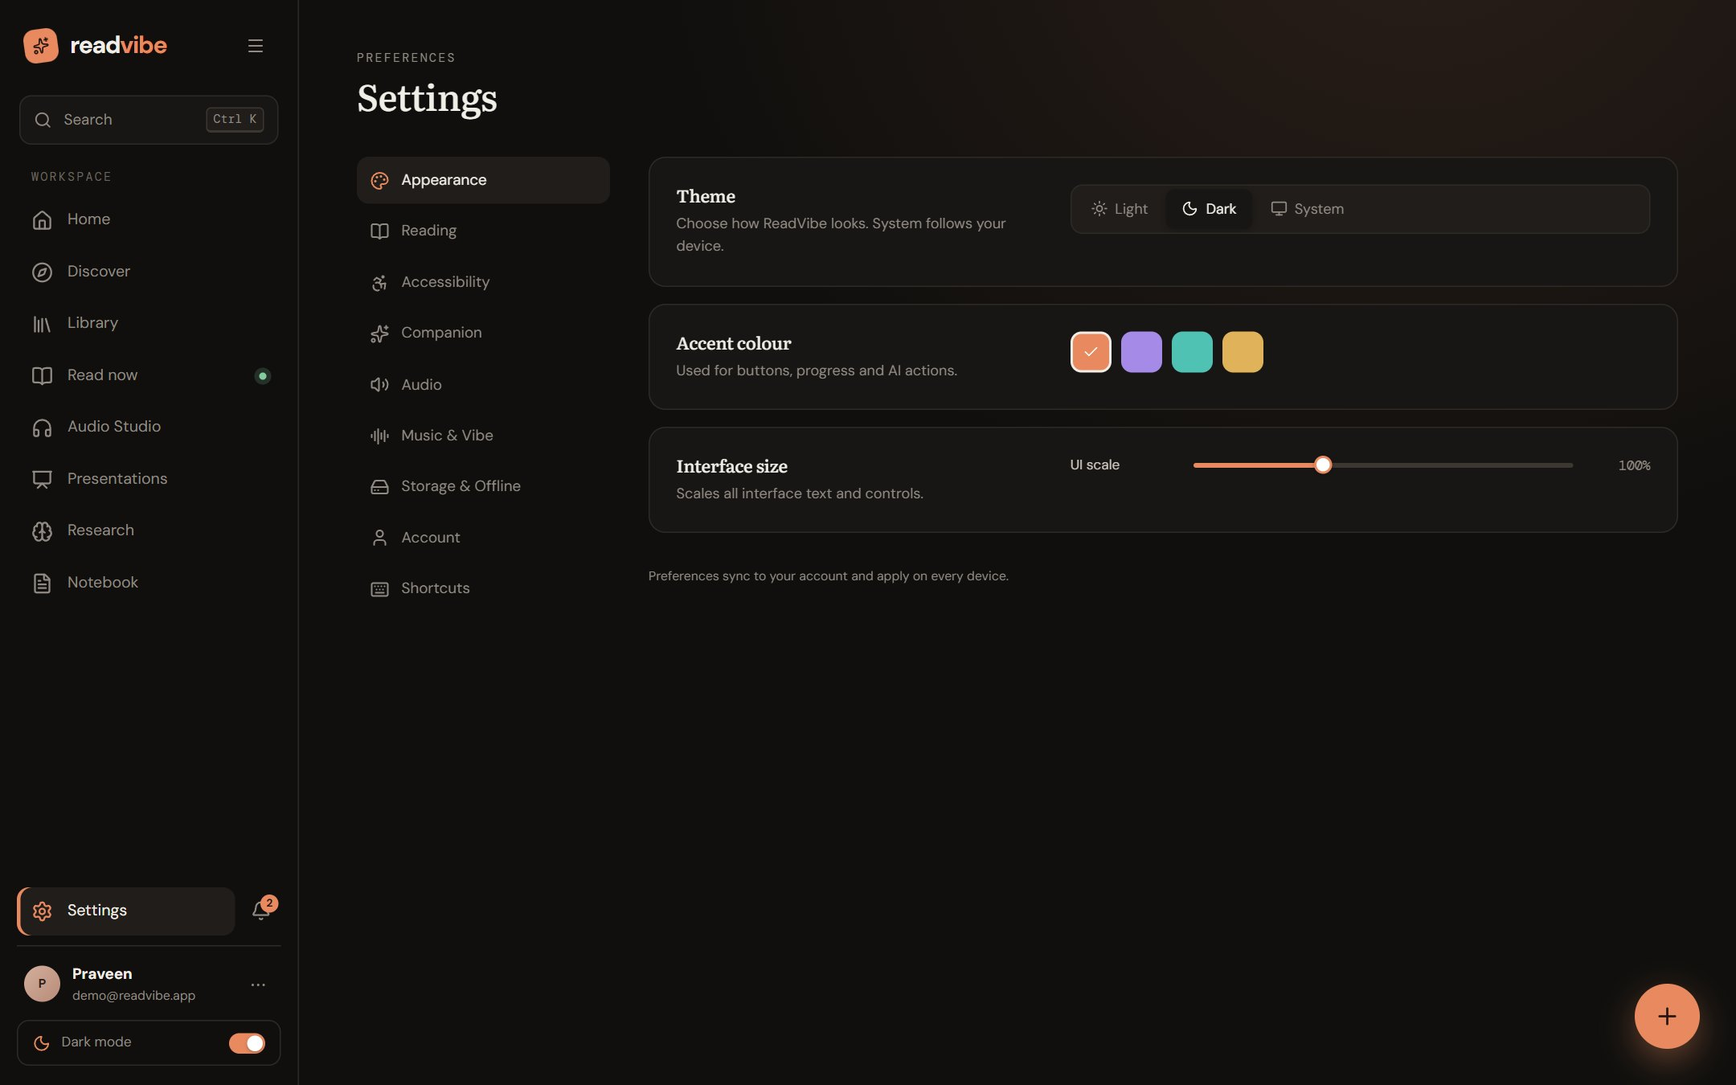
Figure 41: Settings: Appearance, Reading, Accessibility, Companion, Audio, Music & Vibe, Storage & Offline, Account and Shortcuts.

88. Output Demonstrations
The following outputs were produced by running the project’s own local engine (no network, no LLM) on the opening of Pride and Prejudice (public domain, 1813), abridged to about 330 words. They are shown unedited, including their imperfections.

Brief summary (local extractive engine)
Table 41: Local summary output
Field | Output
key_points[1] | “However little known the feelings or views of such a man may be on his first entering a neighbourhood, this truth is so well fixed in the minds of the surrounding families, that he is considered the rightful property of some one or other of their daughters.”
key_points[2] | “My dear Mr. Bennet,” said his lady to him one day, “have you heard that Netherfield Park is let at last?”
key_points[3] | “Oh, single, my dear, to be sure!
concepts | Single man · Mrs long · Large fortune · Bennet · Wife

Observation. The output illustrates the engine’s guarantee and its weakness. Every sentence is genuinely from the text, so nothing is invented; but extractive selection can choose a fragment (“Oh, single, my dear, to be sure!”) and the concept list lower-cases a surname (“Mrs long”). An LLM, when available, writes a more fluent summary; the local engine is the safety net.

Flowchart generated from the same text
The engine produced this Mermaid source, which the application renders and can export:
flowchart TD
start(["Chapter I"])
s0["It is a truth universally acknowledged, that…"]
s1["However little known the feelings or views…"]
s2["My dear Mr. Bennet,' said his lady…"]
s3["Why, my dear, you must know, Mrs.…"]
s4["Oh, single, my dear, to be sure"]
s5["A single man of large fortune; four…"]
start --> s0 --> s1 --> s2 --> s3 --> s4 --> s5

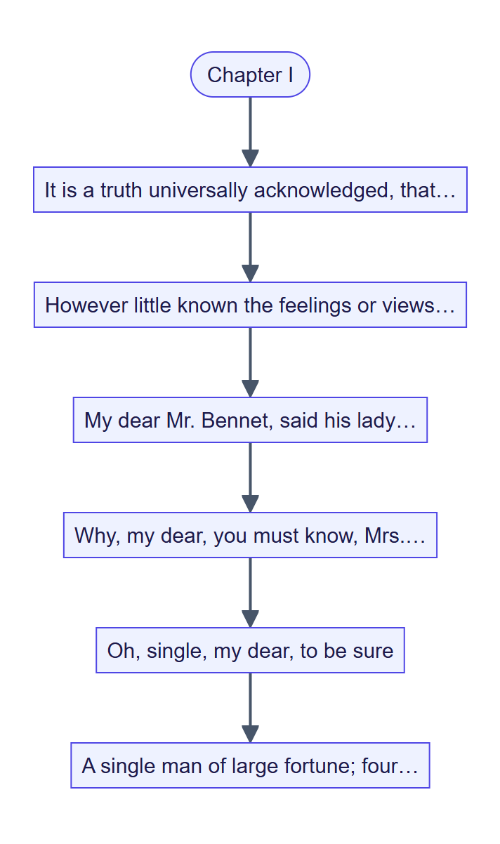
Figure 42: The generated flowchart, rendered from the Mermaid text above.

Narration scripts in three tones
Input: “It is a truth universally acknowledged… “Have you heard that Netherfield Park is let at last?” [in a hushed tone] said she. “I hope Mr. Bingley will like it!”” The bracketed direction is removed from speech in every tone; numbers are the pause (ms) that follows each segment.
Table 42: Generated narration scripts (excerpt)
Segment | Regular | Humor | Tough
Intro | “Chapter I.” (650) | “Alright, settle in — here comes Chapter I!” (500) | “Chapter I.” (900)
Sentence 1 (paragraph end) | pause 650 | pause 500 | pause 900
“Have you heard … at last?” said she. | pause 250 | pause 180 | pause 380
“I hope Mr. Bingley will like it!” | pause 650 | pause 500 | pause 900
Outro | “End of Chapter I.” (650) | “And that’s a wrap on Chapter I. Onwards!” (500) | “This concludes Chapter I.” (900)
Estimated duration of the excerpt | 17 s | 15 s | 19 s

Prosody sent to the voice engine
Table 43: Output of `tts.prosody` for sample sentences
Sentence | Neutral (rate, pitch, volume) | excited | whisper
“It is a truth.” | +0 %, +0 Hz, +0 % | +8 %, +5 Hz, +5 % | −10 %, −2 Hz, −35 %
“Have you heard?” (question) | +0 %, +3 Hz, +0 % | +8 %, +8 Hz, +5 % | −10 %, +1 Hz, −35 %
“I hope Mr. Bingley will like it!” (exclamation) | +4 %, +0 Hz, +8 % | +12 %, +5 Hz, +13 % | −6 %, −2 Hz, −27 %

The punctuation lifts are visible: the question gains +3 Hz of pitch, the exclamation gains +4 % rate and +8 % volume on top of whatever emotion preset is selected. Stage-direction removal gives: "Have you heard?" [in a hushed tone] said she. → "Have you heard?" said she.

89. Experimental Results
The table consolidates every quantitative result obtained for this report. Quantities that were not measured are marked as such.
Table 44: Consolidated results
Measure | Result | Source
Automated tests | 159 passed, 0 failed, 0 skipped, 40.18 s | pytest, 1 Nov 2026
Backend test modules | 12 | backend/tests
REST route handlers | 122 in 12 routers (+ health) | Source inspection
Database tables | 17 | models.py
Live API round trip (median) | 0.58 – 0.73 s across four endpoints | Six requests each, Section 81
Demo sign-in to home page | about 1.1 s | Browser session
Extract + chapter 1.5 MB text | 0.16 s | Local benchmark
BM25 index, 84,000 words | 0.15 s | Local benchmark
BM25 query | 11 ms | Local benchmark
Local summary, 1,400-word chapter | 13 ms | Local benchmark
Local mind map, 10 chapters | 315 ms | Local benchmark
TTS naturalness (MOS), sync offset, usability (SUS), summary faithfulness | Not measured — protocols in Sections 82–85 | —

90. Performance Analysis
- Network latency dominates user-perceived API time. Even a request that does no work (/api/health) takes about 0.7 s from the test machine through the edge rewrite to the free-tier API container, so the 0.5–1.1 s range is a property of the hosting path rather than of application code. The keep-alive workflow (a ping every five minutes) removes the cold-start delay that a sleeping free-tier container would otherwise add.
- Local intelligence is effectively instantaneous for interactive use. A BM25 query takes 11 ms and a chapter summary 13 ms; building the index for 84,000 words takes 0.15 s and is cached per document (LRU), so the cost is paid once.
- Mind-map generation is the heaviest local operation (315 ms for ten chapters) because it clusters key phrases; it is acceptable interactively and cached.
- Large inputs are handled by design, not by speed. Streaming upload keeps memory flat; background jobs keep the UI responsive; the 32 MB text cap bounds the work. A 2,000,000-word synthetic input exceeded five minutes in extraction and chaptering and was aborted, which shows that processing time is not linear for extreme inputs; this is the first item for profiling.
- Audio cost is amortised by caching. Each synthesised segment is stored under a hash of text, voice and delivery; a repeated read costs no synthesis.

91. Comparison with Existing Applications
The comparison in Section 16 is restated here with the evidence for each ReadVibe entry.
Table 45: Evidence for capability claims
Capability | ReadVibe evidence
Narrates the user’s own documents | Audio Studio and read-aloud; audiobook_generation, tts_aligns_words_and_caches tests
Word-level highlighting | Neural word boundaries and spokenWord.js; alignment tests
Distraction-free scene | Zen mode with six generative soundscapes and Pomodoro (screenshot, Section 43)
Grounded answers | BM25 retrieval, citations, chat_falls_back_to_local_engine_with_citations test
Works without paid AI keys | Local engine; disabled_means_local_only, all_models_down_degrades_to_local tests
Reference discovery and drafting | Research Studio (screenshot, Section 52); research_workflow test
Indian-language support | Script detection, chapter markers in ten scripts, neural voices for eight languages; language tests
Privacy controls | Export, delete, personalisation off, memories deletable; tests

ReadVibe does not match specialised products in every dimension: it has no commercial book store, no professionally narrated catalogue, no native mobile app and no OCR. Its advantage is integration and graceful degradation, not depth in any single category.

92. Advantages of Vibe Reader
- One platform, one document, many ways to use it — read, listen, study, write, present.
- Evidence-informed design — each major feature maps to published findings (Section 15).
- Graceful degradation — AI, voices, translation and discovery all fall back; results state which engine produced them.
- Grounded and verifiable AI — extractive local engine; cited chat; untrusted-data handling for prompt injection.
- Expressive, synchronised narration — tones, stage directions performed rather than spoken, character casting, word highlighting.
- Accessibility and equity — OpenDyslexic and Hyperlegible typefaces, high-contrast page, reduced motion, offline copies, Indian-language support, free to run.
- Privacy by design — local recommendations; message text never stored by the agent; full export and deletion.
- Tested and deployable — 159 passing tests; Docker, nginx, Render and Vercel configurations.

93. Current Limitations
- No OCR: scanned, image-only PDFs yield no text.
- No formal user studies yet: TTS naturalness, synchronisation offset, usability and AI-output quality are specified but unmeasured.
- Heuristic affect estimation: the empathy layer is a lexicon with behavioural cues, unvalidated, English-centred, and not a clinical tool.
- Extractive local summaries can be fragmentary (Section 88).
- Free-tier dependencies: public LLM endpoints and MyMemory translation have quotas (about 5,000 characters/day anonymously) and can disappear; the free-tier API container has an ephemeral disk unless a database and storage volume are configured.
- In-process job runner and rate limiter: state is per process, so scaling to several instances needs a shared queue and a shared limiter.
- No CI test pipeline: the only GitHub Actions workflow is the keep-alive ping; tests are run locally.
- Large-input scaling: extremely large texts are not yet profiled or optimised (Section 90).
- Browser dependence: Zen and Vibe sound, Web Speech fallback and microphone recording need modern browser APIs.

Planned versus implemented
The project’s earlier planning documents (the abstracts and objectives statement) described a larger technology plan. The table records what was actually built so that the report and the planning documents can be reconciled honestly.
Table 46: Planned versus implemented
Area | Planned | Implemented
Client | Flutter cross-platform mobile app | React 19 + Vite responsive web app with mobile layouts
Backend | Node.js gateway + Python FastAPI microservices on Kubernetes (AWS EKS) | Single containerised FastAPI service; Docker, nginx, Render; no Kubernetes
Databases | MongoDB Atlas, PostgreSQL, Redis, S3 | SQLAlchemy on SQLite or PostgreSQL; in-process LRU cache; file storage module (swappable for S3)
Auth | Firebase Auth | JWT + PBKDF2, Google Sign-In
LLMs | Claude, GPT-4, Gemini via LangChain | Provider-agnostic OpenAI-compatible chain with free endpoints, plus Anthropic for the Vibe agent; no LangChain
RAG | Pinecone / FAISS embeddings | In-process BM25 retrieval (no embeddings)
TTS | ElevenLabs and OpenAI TTS | Edge neural voices (key-less) and optional OpenAI; browser fallback; no ElevenLabs
Queue | RabbitMQ | Persisted-job thread pool, designed to be swapped
Collaboration | WebRTC recording and AI post-processing | MediaRecorder recording, upload, client-side stitching with noise gate and normalisation to WAV
Vibe music | Spotify Web API | Local files and generative lo-fi streams; no Spotify
Diagrams | Mermaid.js and GPT-4 Vision | Mermaid / SVG generation from text; no vision model
Reference images | Unsplash, Google Custom Search | Wikipedia / Wikimedia Commons
Plagiarism awareness | Cross-check layer | Shingle similarity vs. sources and uncited-claim detection (explicitly not a plagiarism guarantee)
CI/CD | GitHub Actions + AWS CodeDeploy | Platform auto-deploys (Vercel, Render Blueprint); keep-alive workflow only
Additions not originally planned | — | Presentation Studio (.pptx), Vibe agent, speech-to-text, Audio Overview, translation, multi-script chapter detection

Part 10 — Conclusion and Future Scope

94. Project Conclusion
ReadVibe set out to replace a fragmented set of reading, listening, studying, writing and presenting tools with one platform that treats a document as the starting point of a workflow. The delivered system does this: a document uploaded once can be read in three purpose-built environments, narrated in three tones with word-level highlighting, summarised, questioned, visualised and quizzed with grounded answers, cited in a researched paper, turned into a presentation, and discussed with a reading agent that adapts to the reader while respecting their privacy.
The engineering result is a tested, deployed full-stack application: 122 REST handlers in 12 routers, 17 database tables, 159 passing automated tests, a documented API, Docker and hosting configurations, and a live deployment. Its central design principle — graceful degradation — means that each network-dependent feature has a local fallback, so the product remains useful on a poor connection and without paid keys. Measured behaviour supports interactive use: local retrieval in about 11 ms and summaries in about 13 ms.
The report is also explicit about what remains unproven. The subjective qualities that motivated the research — narration naturalness, comprehension benefit, usability, and the value of empathy-aware guidance — are defined with evaluation protocols but have not been measured with participants. The literature supports the premises; testing the integrated system against them is the natural next step.

95. Research Contributions
- Integration of previously separate research threads — expressive narration, comprehension-oriented TTS with synchronised highlighting, distraction-aware reading, personalisation and e-book usability — in one working system.
- A speech-planning contract that guarantees transcript fidelity, records every substitution, and combines tone, emotion, pace, energy and articulation into engine parameters.
- Performed stage directions and evidence-based character casting for arbitrary user text.
- A dual-engine AI architecture with identical output shapes and explicit engine attribution, including an extractive local engine whose outputs are verifiably from the source.
- A privacy-first empathy layer that stores labels not messages, never calls a model on a safety phrase, and can be switched off entirely.
- An honest comparison of plan and delivery (Section 93) and a set of ready evaluation protocols (Sections 82–85) for follow-up studies.

96. Future Enhancements
Table 47: Future work
Area | Enhancement | Rationale
Evaluation | Run the usability, MOS, synchronisation-offset and AI-quality studies | Close the measurement gap (Sections 82–85)
Accessibility | Adaptive Read + Listen profiles (dyslexia vs ADHD-related difficulties) | Evidence that benefit differs by profile [2]
Document intake | OCR for scanned PDFs; table and figure extraction | Removes the largest current intake limitation
Retrieval | Embedding-based retrieval alongside BM25 (hybrid) | Better recall on paraphrased questions
Expressive TTS | Context-aware expressive models trained on narrative corpora [1]; forced alignment for estimated-timing voices | Higher naturalness; tighter sync
Recommendation | Graph-based personalisation when interaction data is available [6] | Cross-category discovery
Affect | Optional, consented signals (typing cadence, session patterns); validation against labelled data | Move from heuristic to validated [7], [8], [17]
Scale | Shared queue (RabbitMQ / Redis), shared rate limiter, object storage (S3), horizontal scaling | Multi-instance deployment
Collaboration | Live WebRTC co-recording; real-time shared annotations | Original plan; richer studio
Clients | Native or installable mobile app with background audio | Mobile-first reading
Integrations | Spotify playback, institutional LMS and library connectors | Original plan; adoption
Quality engineering | CI pipeline running the test suite, linting and type checks on every push | Close the CI gap
Performance | Profile and optimise extraction and chaptering for multi-million-word inputs | Section 90

97. Commercial Applications
Table 48: Potential applications
Segment | Use | Why ReadVibe fits
Education (schools, colleges) | Reading support, revision and accessibility for diverse learners | Dyslexia-friendly typography, read-aloud with highlighting, quizzes, Indian-language support, free-to-run
Research institutions | Literature review and drafting support | Multi-source discovery, citation formats, review of overlap and uncited claims
Corporate learning | Turn manuals and reports into narrated audio and slide decks | Presentation Studio, audio overview, private deployment option
Libraries and publishers | Narrated editions of public-domain or licensed text | Tone engine, collaborative studio, Gutenberg and Internet Archive import
Accessibility services | Assistive reading for people with visual or reading difficulties | Neural voices, adjustable speed, high contrast, keyboard shortcuts
Wellbeing and focus products | Study-focus sessions with ambient sound | Zen mode and Pomodoro statistics

A sustainable commercial model could keep the local-first tier free (preserving equity of access) and charge for managed hosting, higher-quality neural voices, larger storage, institutional administration and priority AI. Any commercial use of third-party voices, models and content requires checking the provider’s terms; the free endpoints currently used are suitable for demonstration and education rather than guaranteed production service.

98. Deployment Strategy
The recommended production topology keeps the static frontend on a CDN and the API in a container with a managed PostgreSQL database and persistent storage. The public deployment follows this model.
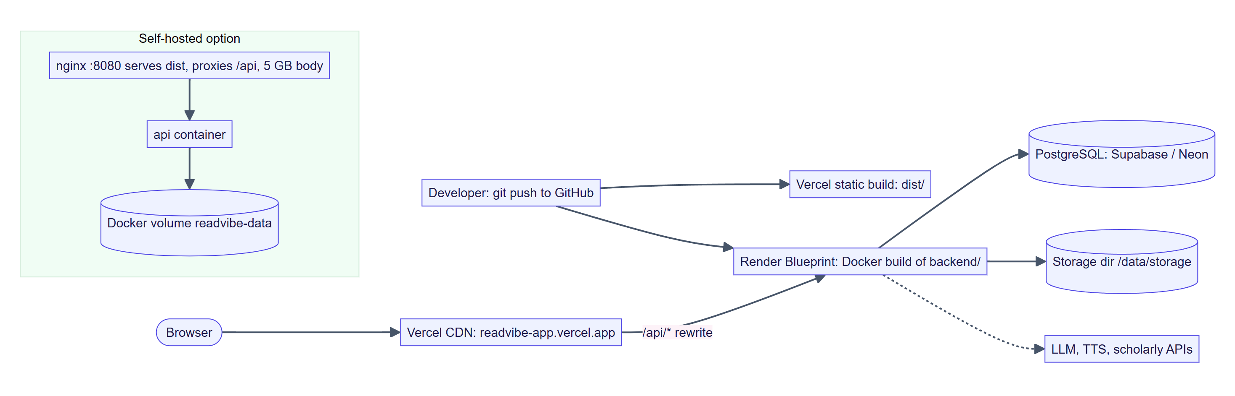
Figure 43: Deployment topology: Vercel CDN, Render container, PostgreSQL, and the self-hosted Docker alternative.
Table 49: Deployment configuration
Component | Configuration
Frontend | Vite production build (npm run build → dist/) served by Vercel; vercel.json rewrites /api/* to the API host and sets long-lived cache headers for /assets/
API | Docker image from backend/Dockerfile (python:3.13-slim, non-root user, health check on /api/health); Render Blueprint (render.yaml) with auto-deploy
Database | Managed PostgreSQL (e.g. Supabase or Neon) via READVIBE_DATABASE_URL; SQLite only for local use because free-tier disks are ephemeral
Storage | READVIBE_STORAGE_DIR on a persistent volume; the storage module is swappable for S3/GCS
Secrets | READVIBE_JWT_SECRET (generated), optional LLM, Anthropic, OpenAI and Google client settings
Origins | READVIBE_CORS_ORIGINS list plus automatic allowance for *.vercel.app previews
Self-hosting | npm run build && docker compose up --build then open http://localhost:8080 (nginx serves dist/, proxies /api, 5 GB bodies, one-hour timeouts)
Availability | GitHub Actions keep-alive workflow pings /api/health every five minutes to avoid free-tier sleep

Recommended roll-out
- Provision PostgreSQL and a persistent volume; set the JWT secret and CORS origins.
- Deploy the API; confirm /api/health; run the test suite in CI before promotion.
- Deploy the frontend; verify the /api rewrite and Google sign-in origins.
- Enable optional providers (LLM, Anthropic, OpenAI, transcription server) one at a time and confirm the engine badge in the UI.
- Monitor request IDs and slow-request logs; add a shared queue and rate limiter before running more than one API instance.

99. Final References
Citations in the text use these numbers. Entries were transcribed from the project’s abstracts document; before final submission, authors, venue, volume, issue and page ranges should be verified against each source record (links provided).
[1] G. Michel, E. V. Epure and C. Cerisara, “Computational Narrative Understanding for Expressive Text-to-Speech,” 2026. https://aclanthology.org/2026.findings-acl.308/
[2] C.-H. Chen, L.-Y. Hung and Y.-C. Jian, “The Effects of Text-to-Speech on Reading Comprehension in Junior High School Students with Reading Disabilities: An Eye-Tracking Study in Taiwan,” 2026. https://link.springer.com/article/10.1007/s11145-025-10738-5
[3] J. L. Keelor et al., “Impact of Text-to-Speech Features on the Reading Comprehension of Children with Reading and Language Difficulties,” 2023. https://doi.org/10.1007/s11881-023-00281-9
[4] Wood et al., “Does Use of Text-to-Speech and Related Read-Aloud Tools Improve Reading Comprehension for Students with Reading Disabilities? A Meta-Analysis,” 2017. https://pmc.ncbi.nlm.nih.gov/articles/PMC5494021/
[5] M. Charfuelan Oliva and I. Steiner, “Expressive Speech Synthesis in MARY TTS Using Audiobook Data and EmotionML,” 2013. https://www.dfki.de/en/web/research/projects-and-publications/publication/6840
[6] M. De Nadai et al., “Personalized Audiobook Recommendations at Spotify Through Graph Neural Networks,” 2024. https://arxiv.org/abs/2403.05185
[7] J. Li, M. Elgarf, A. Waleed and H. Salam, “Beyond One-Size-Fits-All: A Survey of Personalized Affective Computing in Human-Agent Interaction,” 2023. https://arxiv.org/abs/2304.00377
[8] S. Medjden, N. Ahmed and M. Lataifeh, “Adaptive User Interface Design and Analysis Using Emotion Recognition Through Facial Expressions and Body Posture from an RGB-D Sensor,” PLOS ONE, 2020. https://journals.plos.org/plosone/article?id=10.1371/journal.pone.0235908
[9] “Effects of Digital Reading With On-Screen Distractions: An Eye-Tracking Study,” Journal of Computer Assisted Learning (authors and year to be confirmed from the source record). https://doi.org/10.1111/jcal.13106
[10] Y. Shen, “Distractions in Digital Reading: A Meta-Analysis of Attentional Interference Effects,” 2025. https://pubmed.ncbi.nlm.nih.gov/41368163/
[11] J. Santhosh, S. Jagtap, A. Dengel and S. Ishimaru, “Digital Distractions in Reading: Investigating Impact of Cognitive Control Training on Reading Behavior and Outcomes,” 2024. https://dl.acm.org/doi/10.1145/3675094.3677591
[12] “What Breaks the Flow of Reading? A Study on Characteristics of Attentional Disruption During Digital Reading,” Frontiers in Psychology, 2022 (authors to be confirmed from the source record). https://www.frontiersin.org/journals/psychology/articles/10.3389/fpsyg.2022.987964/full
[13] K.-L. Huang, K.-H. Chen and C.-H. Ho, “Enhancement of Reading Experience: Users’ Behavior Patterns and the Interactive Interface Design of Tablet Readers,” 2014. https://doi.org/10.1108/lht-01-2014-0002
[14] V. Liesaputra and I. H. Witten, “Realistic Electronic Books,” 2012. https://www.sciencedirect.com/science/article/abs/pii/S1071581912000316
[15] Y.-Y. Kang, M.-J. J. Wang and R. Lin, “Usability Evaluation of E-books,” 2009. https://www.sciencedirect.com/science/article/abs/pii/S0141938208000826
[16] Z. Liu, “Reading in the Age of Digital Distraction,” 2021/2022. https://www.sciencedirect.com/org/science/article/abs/pii/S0022041821000011
[17] S. Haddad, K. Latifzadeh, S. Duraisamy, J. Vanderdonckt, L. A. Leiva et al., “Good GUIs, Bad GUIs: Affective Evaluation of Graphical User Interfaces,” 2024. https://orbilu.uni.lu/handle/10993/61604

Technical resources
- FastAPI, Pydantic, SQLAlchemy, Uvicorn documentation; React, React Router and Vite documentation.
- Semantic Scholar Graph API; Crossref REST API; OpenAlex API.
- Project Gutenberg and Internet Archive; Wikimedia Commons API.
- edge-tts package; OpenAI speech API; NVIDIA Nemotron-3.5-Transcribe-30B-A4B model card.
- Robertson, S. and Zaragoza, H., “The Probabilistic Relevance Framework: BM25 and Beyond,” Foundations and Trends in Information Retrieval, 2009 (BM25).

100. Appendix

Appendix A — API endpoint inventory (122 handlers)
Table 50: Endpoint inventory
Router | Endpoints
/auth (11) | POST /register, /login, /google, /demo, /me/password; GET /config, /me, /me/export; PATCH /me; PUT /me/preferences; DELETE /me
/documents (26) | GET (list), /recommendations, /tags, /{id}, /{id}/chapters/{index}, /{id}/package, /{id}/file, /{id}/search, /{id}/highlights, /{id}/sketches, /{id}/bookmarks; POST /upload, /text, /{id}/open, /{id}/highlights, /{id}/sketches, /{id}/bookmarks, /{id}/cast; PUT /{id}/progress; PATCH /{id}, /highlights/{id}; DELETE /{id}, /highlights/{id}, /{id}/sketches, /sketches/{id}, /bookmarks/{id}
/ai (14) | GET /status, /recommendations; POST /summarize, /explain, /define, /chat, /mindmap, /diagram, /quiz, /quiz/grade, /compare, /visual, /overview, /translate
/agent (9) | GET /status, /briefing, /profile; POST /chat, /checkin, /events; PUT /settings; DELETE /memories/{id}, /memories
/audio (15) | GET /tones, /audiobooks, /audiobooks/{id}, /audiobooks/{id}/script.txt, /collab, /collab/{id}/recordings/{rid}; POST /preview, /audiobooks, /collab, /collab/{id}/recordings; PATCH /audiobooks/{id}, /collab/{id}; DELETE /audiobooks/{id}, /collab/{id}, /collab/{id}/recordings/{rid}
/tts (4) | GET /status, /languages, /voices; POST /synthesize
/transcribe (3) | GET /status; POST (file job), /dictate
/research (16) | GET (list), /{id}, /{id}/citations, /{id}/review; POST (create), /{id}/discover, /{id}/references, /{id}/outline, /{id}/sections/{key}, /{id}/sections/{key}/restore/{v}, /{id}/export; PATCH /{id}, /{id}/references/{rid}; PUT /{id}/sections/{key}; DELETE /{id}, /{id}/references/{rid}
/decks (8) | GET (list), /art/image, /{id}, /{id}/export.pptx; POST (create), /upload; PATCH /{id}; DELETE /{id}
/notes (6) | GET (list), /notebook, /export/markdown; POST (create); PATCH /{id}; DELETE /{id}
/catalog (3) | GET /gutenberg, /new; POST /import
activity (7) | POST /sessions, /jobs/mark-seen; GET /stats, /search, /jobs, /jobs/{id}; DELETE /jobs

Appendix B — Glossary
Table 51: Glossary
Term | Meaning
BM25 | A ranking function that scores passages against a query using term frequency, inverse document frequency and length normalisation
TF-IDF | Term frequency–inverse document frequency weighting
Extractive | Built only from sentences that exist in the source
Shingle | A contiguous n-word window used to detect overlapping text
Prosody | Rate, pitch and volume of speech
JWT | JSON Web Token used as a bearer credential
PBKDF2 | Password-based key-derivation function used for password hashing
Pomodoro | Timed focus-and-break work technique (default 25 + 5 minutes)
MOS / SUS | Mean Opinion Score (speech quality) / System Usability Scale
Graceful degradation | Falling back to a simpler, local capability instead of failing

Appendix C — Useful commands
# API
cd backend && py -m venv .venv && .venv\Scripts\python -m pip install -r requirements.txt
.venv\Scripts\python run.py
# Web
npm install && npm run dev
# Tests
npm run api:test # or: cd backend && .venv\Scripts\python -m pytest -q
# Production build and Docker
npm run build && docker compose up --build

Appendix D — Test run record
$ pytest -q
........................................................................ [ 45%]
........................................................................ [ 90%]
............... [100%]
159 passed in 40.18s (1 November 2026, Windows 11, Python 3.13.7)

Appendix E — Reproducing the measurements
- Latency: curl -s -o /dev/null -w "%{http_code}/%{time_total}" https://readvibe-app.vercel.app/api/health, repeated six times.
- Local timings: a short Python script imports app.services.extraction and app.services.nlp, builds synthetic text of a given word count, and times extract, BM25Index, answer_question, summarize and mind_map with time.perf_counter().
- Screenshots: a scripted headless-Chrome session signs in with the demo library and captures each page at 1440 × 900.

— End of report —

