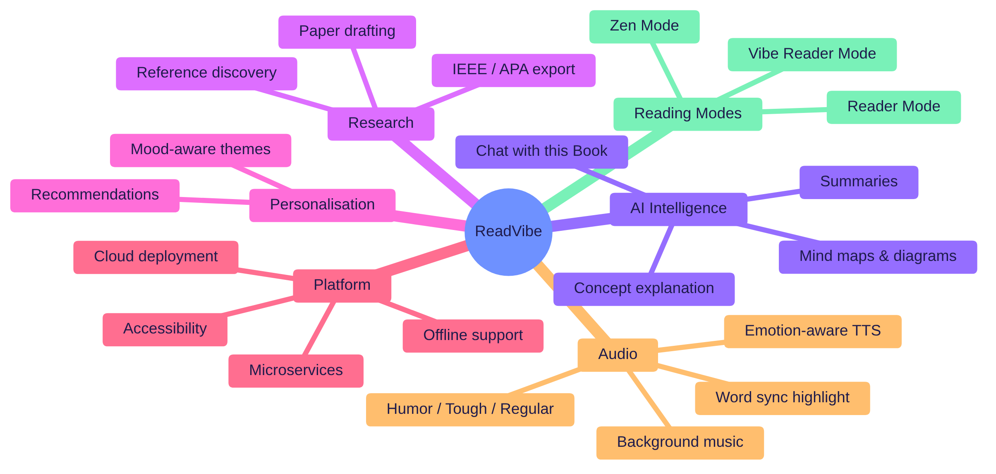
Figure 1: ReadVibe at a glance — mind map of all major features

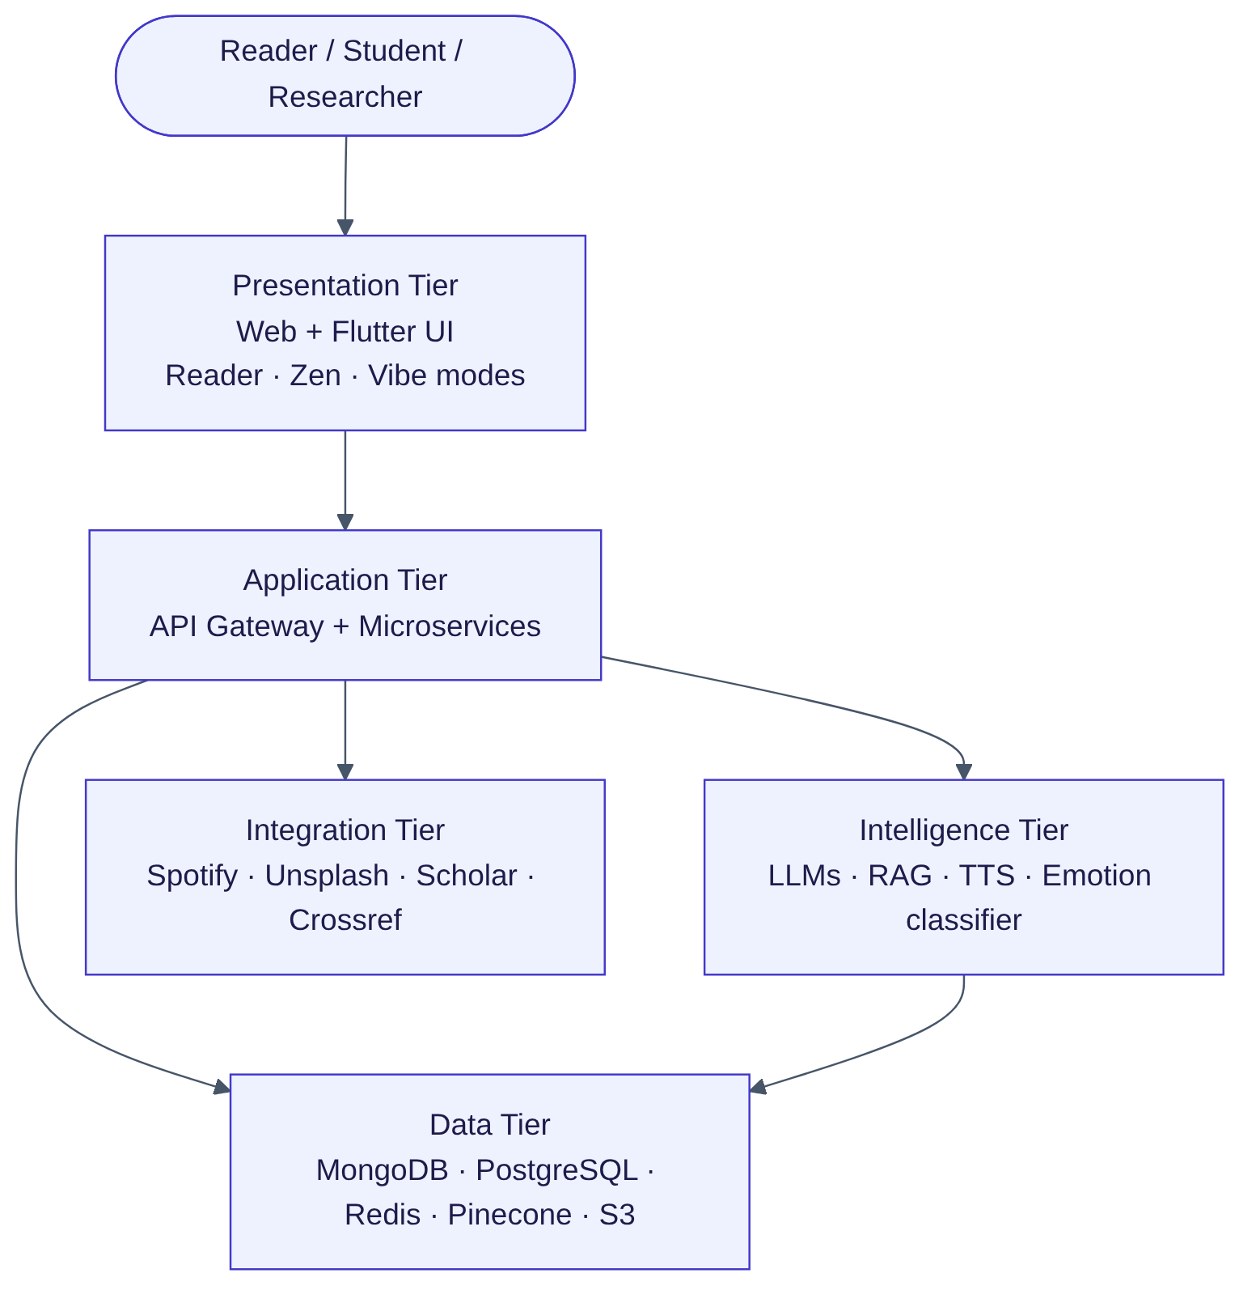
Figure 2: Proposed system — tiers of ReadVibe

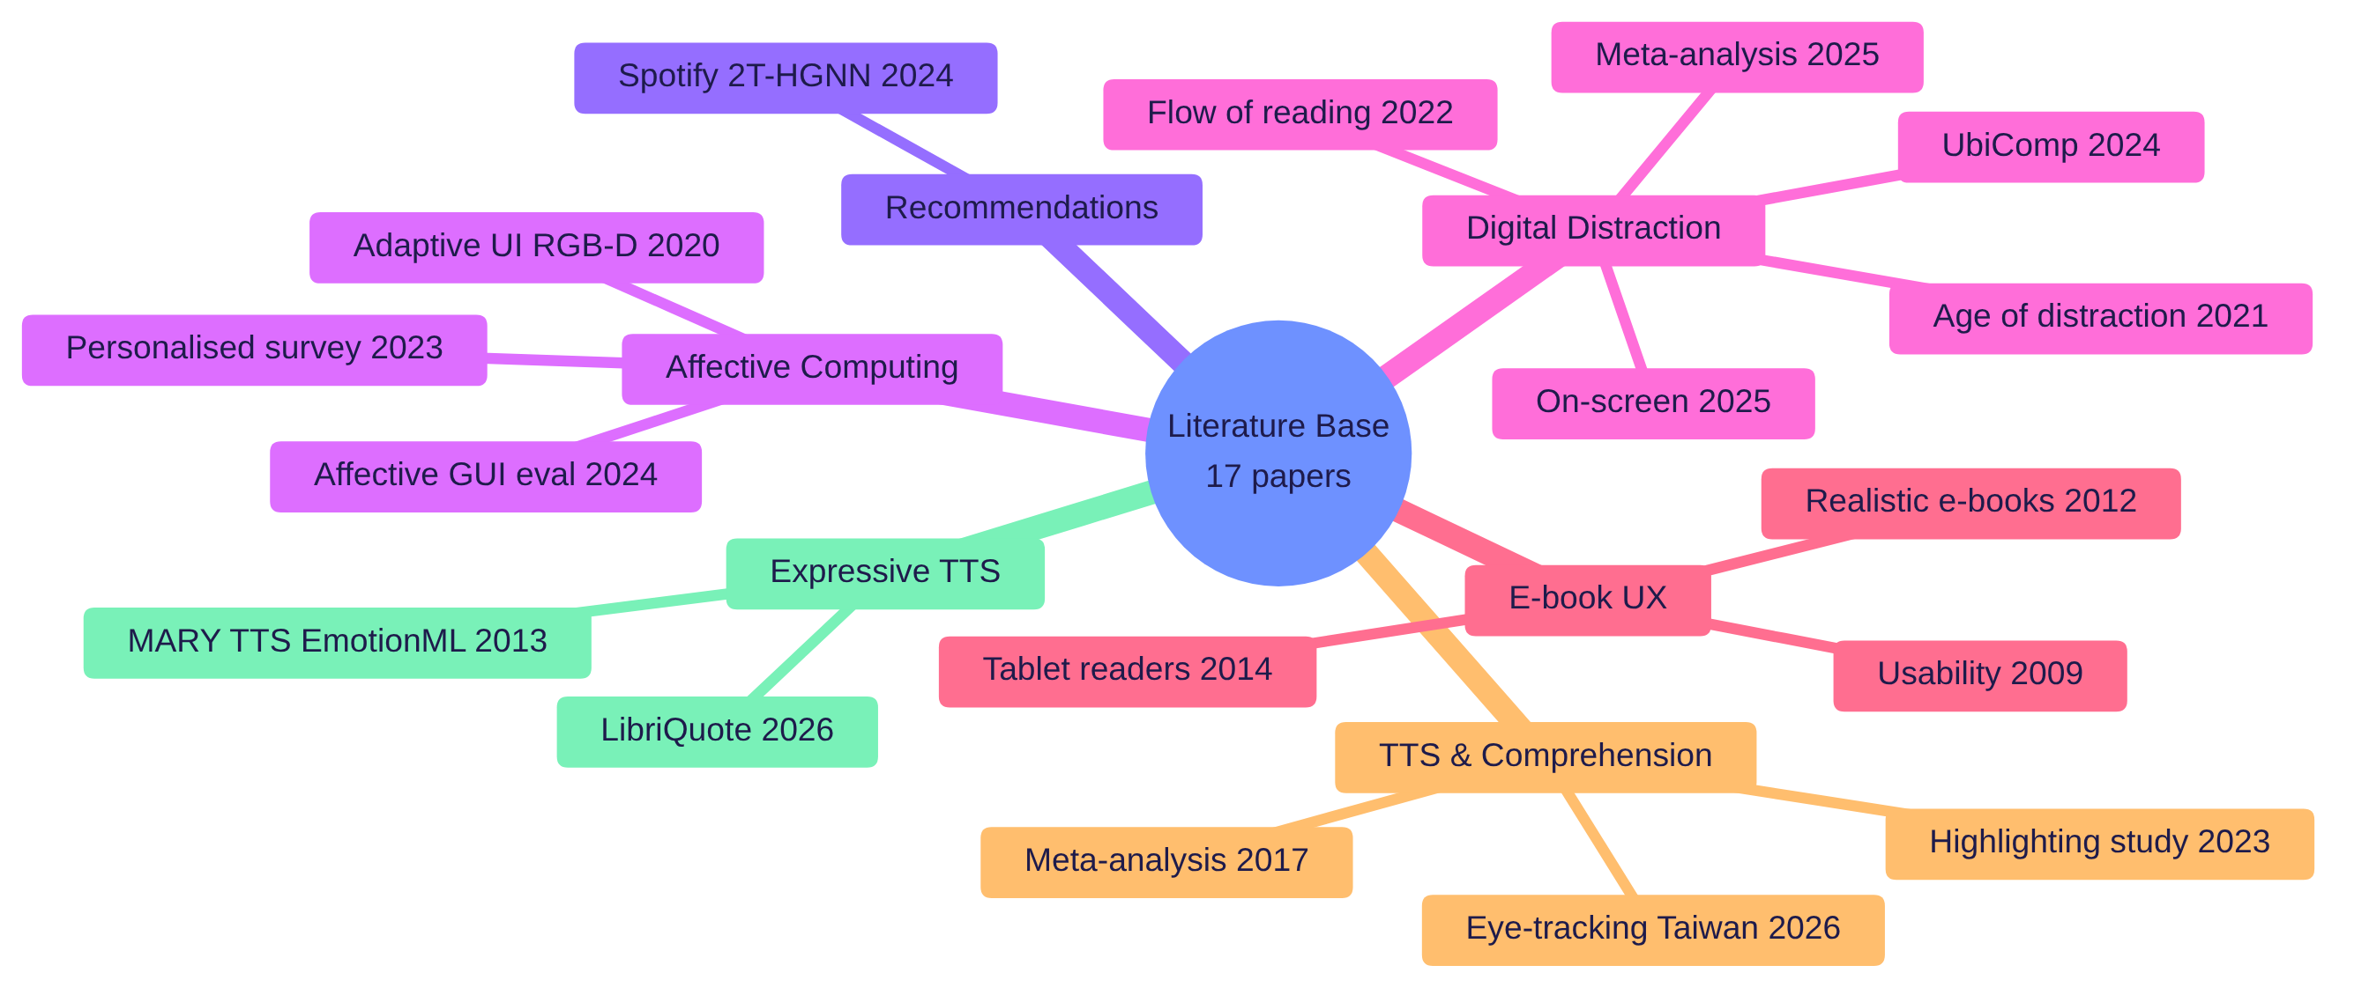
Figure 3: Mind map of the literature base (17 papers in six themes)
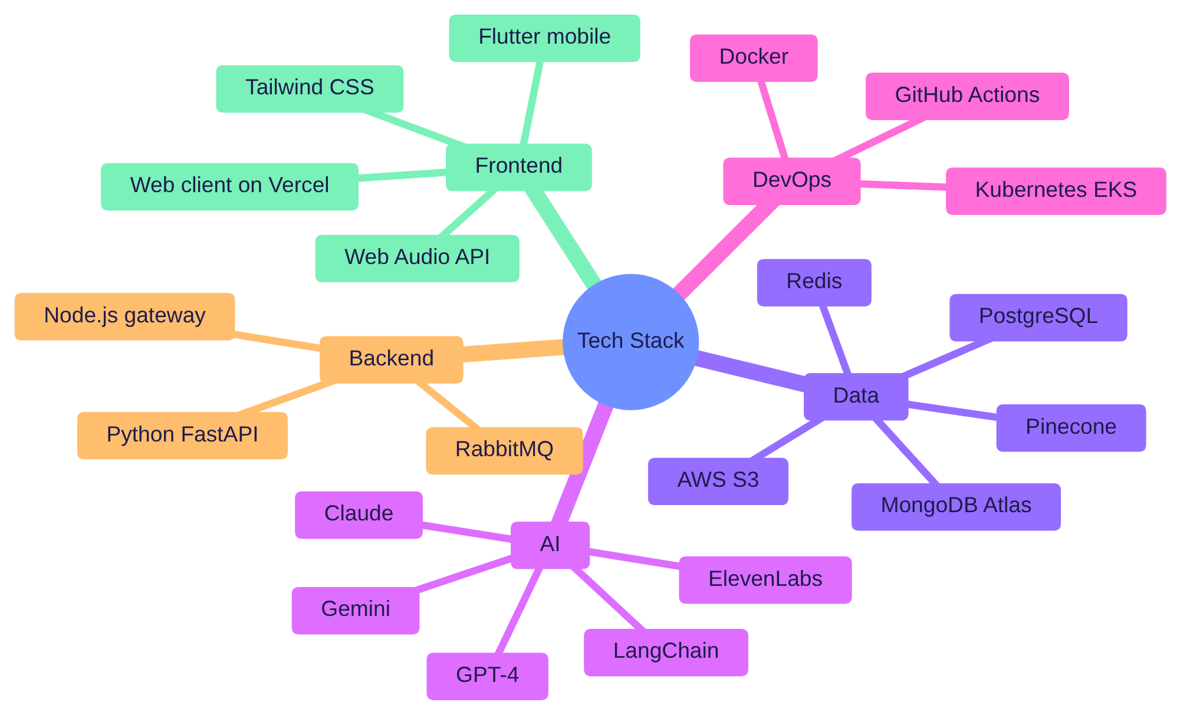
Figure 5: Technology mind map across the tiers

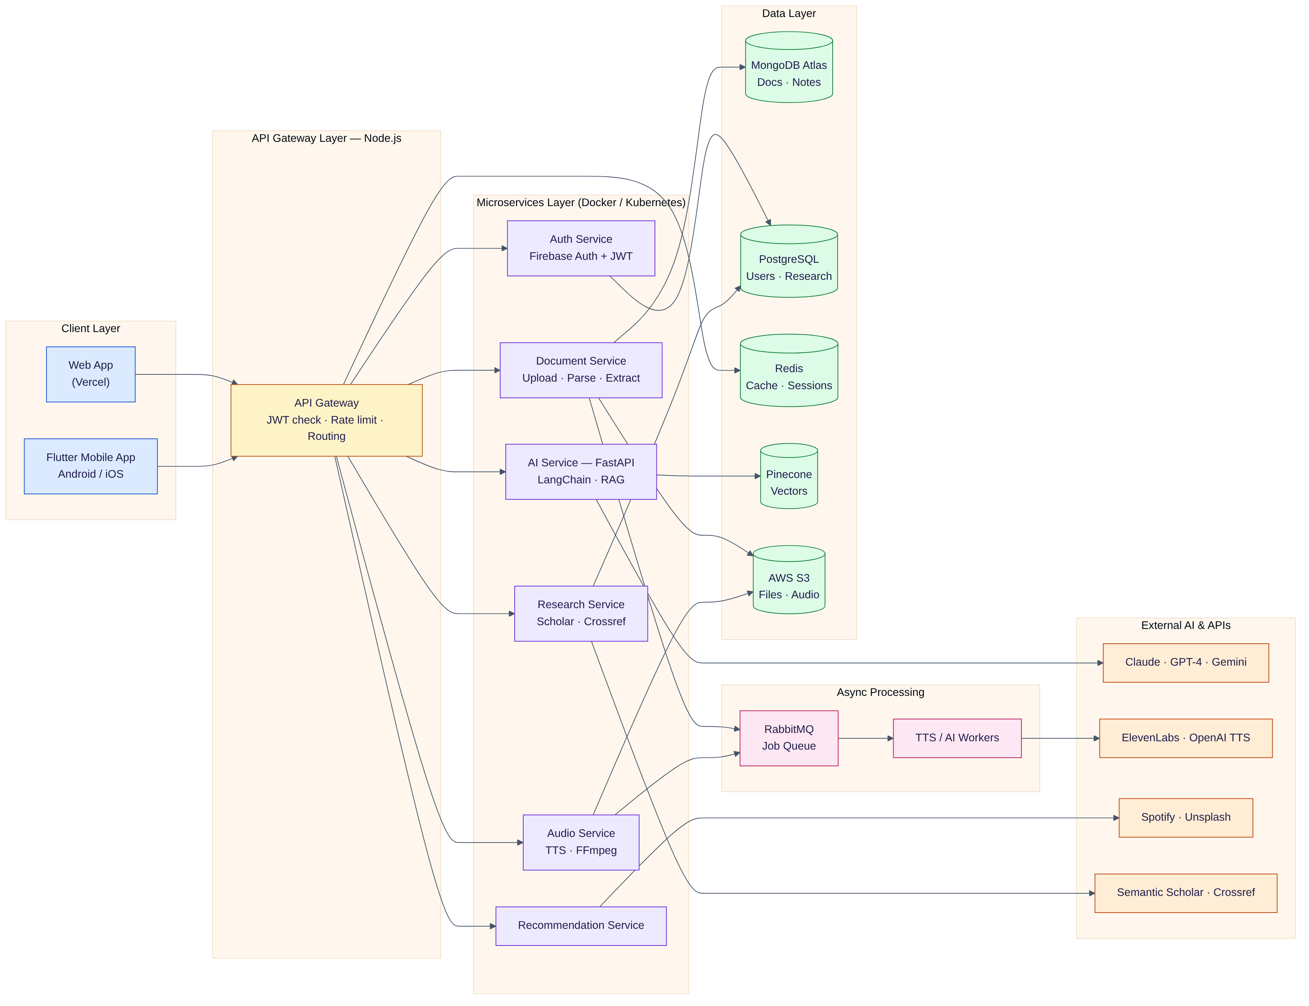
Figure 4: Overall system architecture of ReadVibe

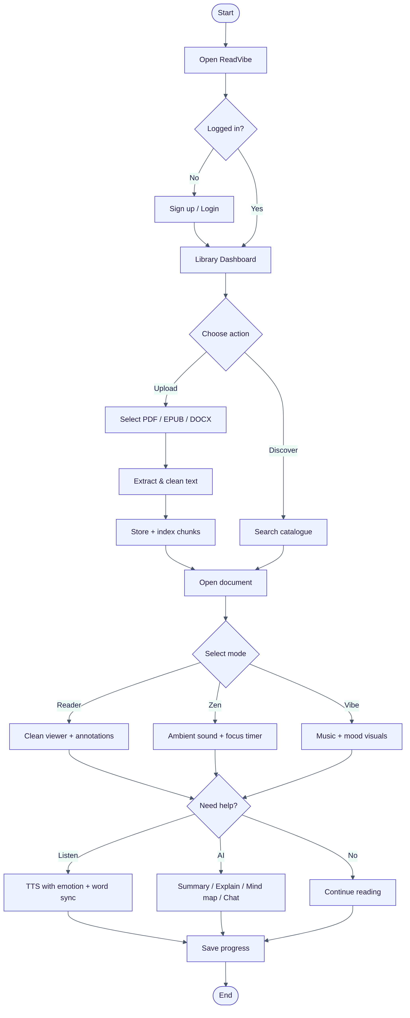
Figure 6: End-to-end system workflow (flowchart)

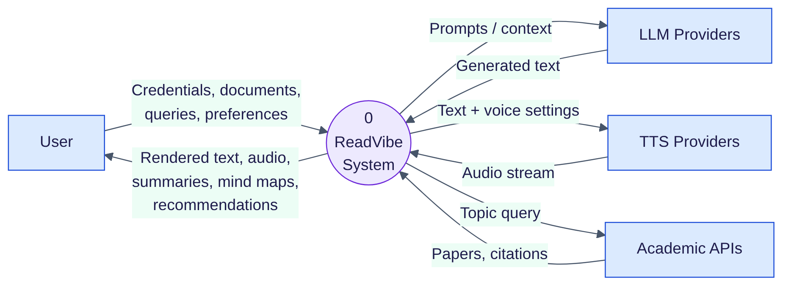
Figure 7: DFD Level 0 — context diagram

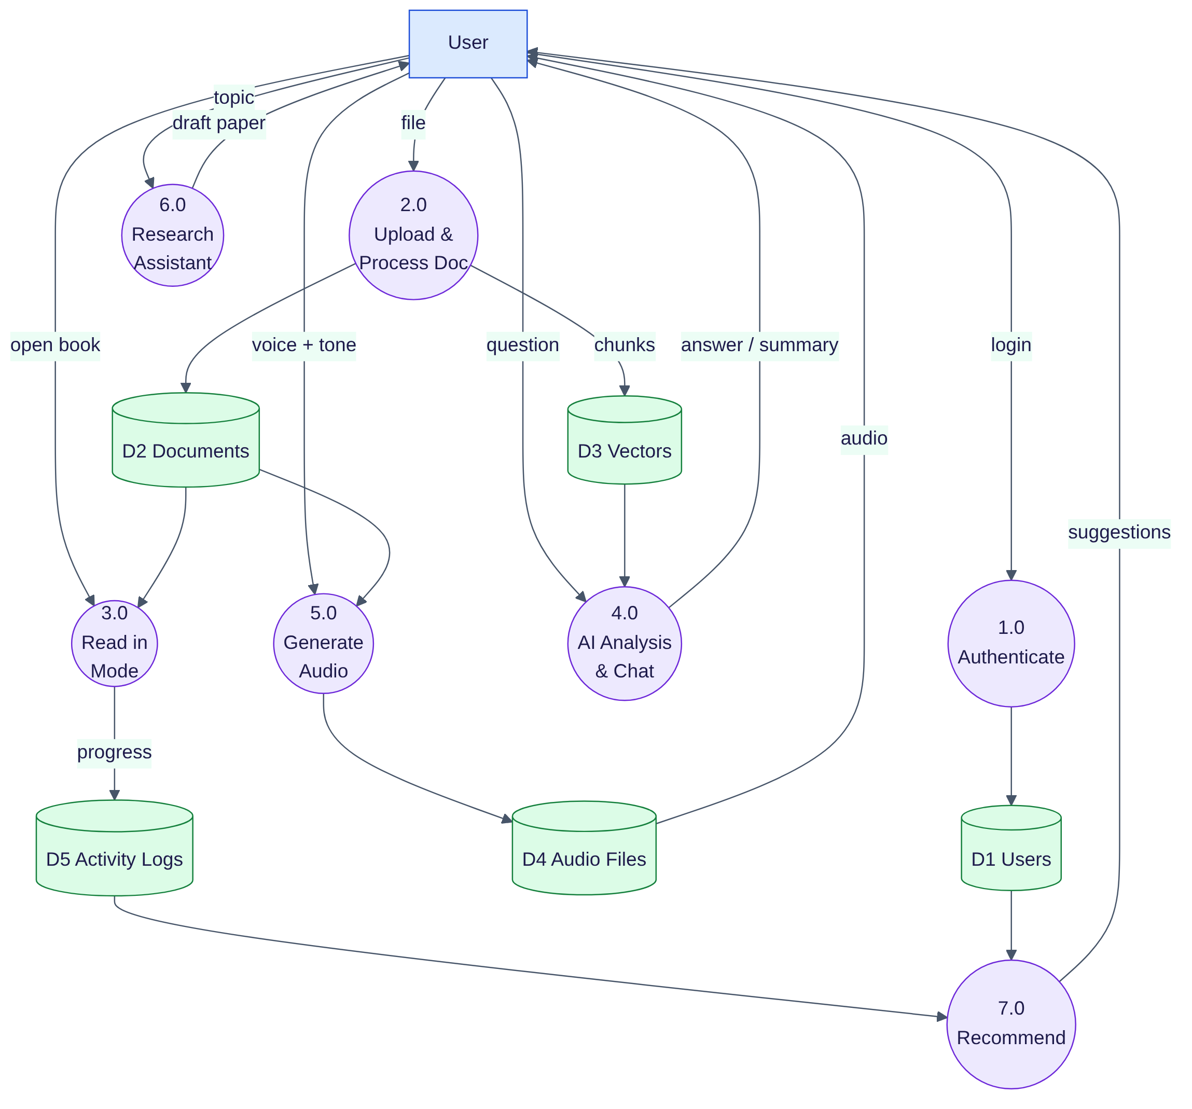
Figure 8: DFD Level 1 — processes and data stores

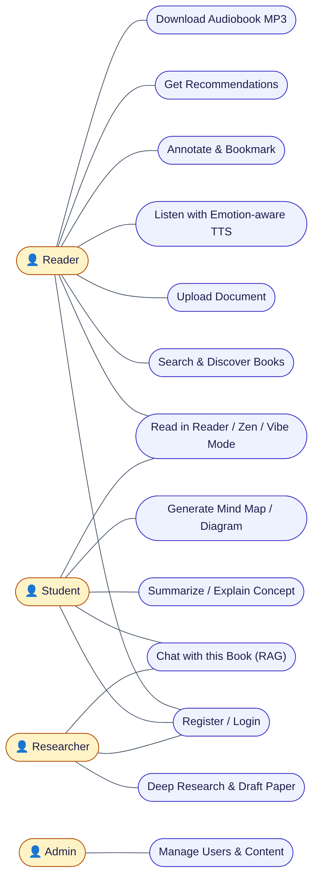

Figure 9: Use case diagram

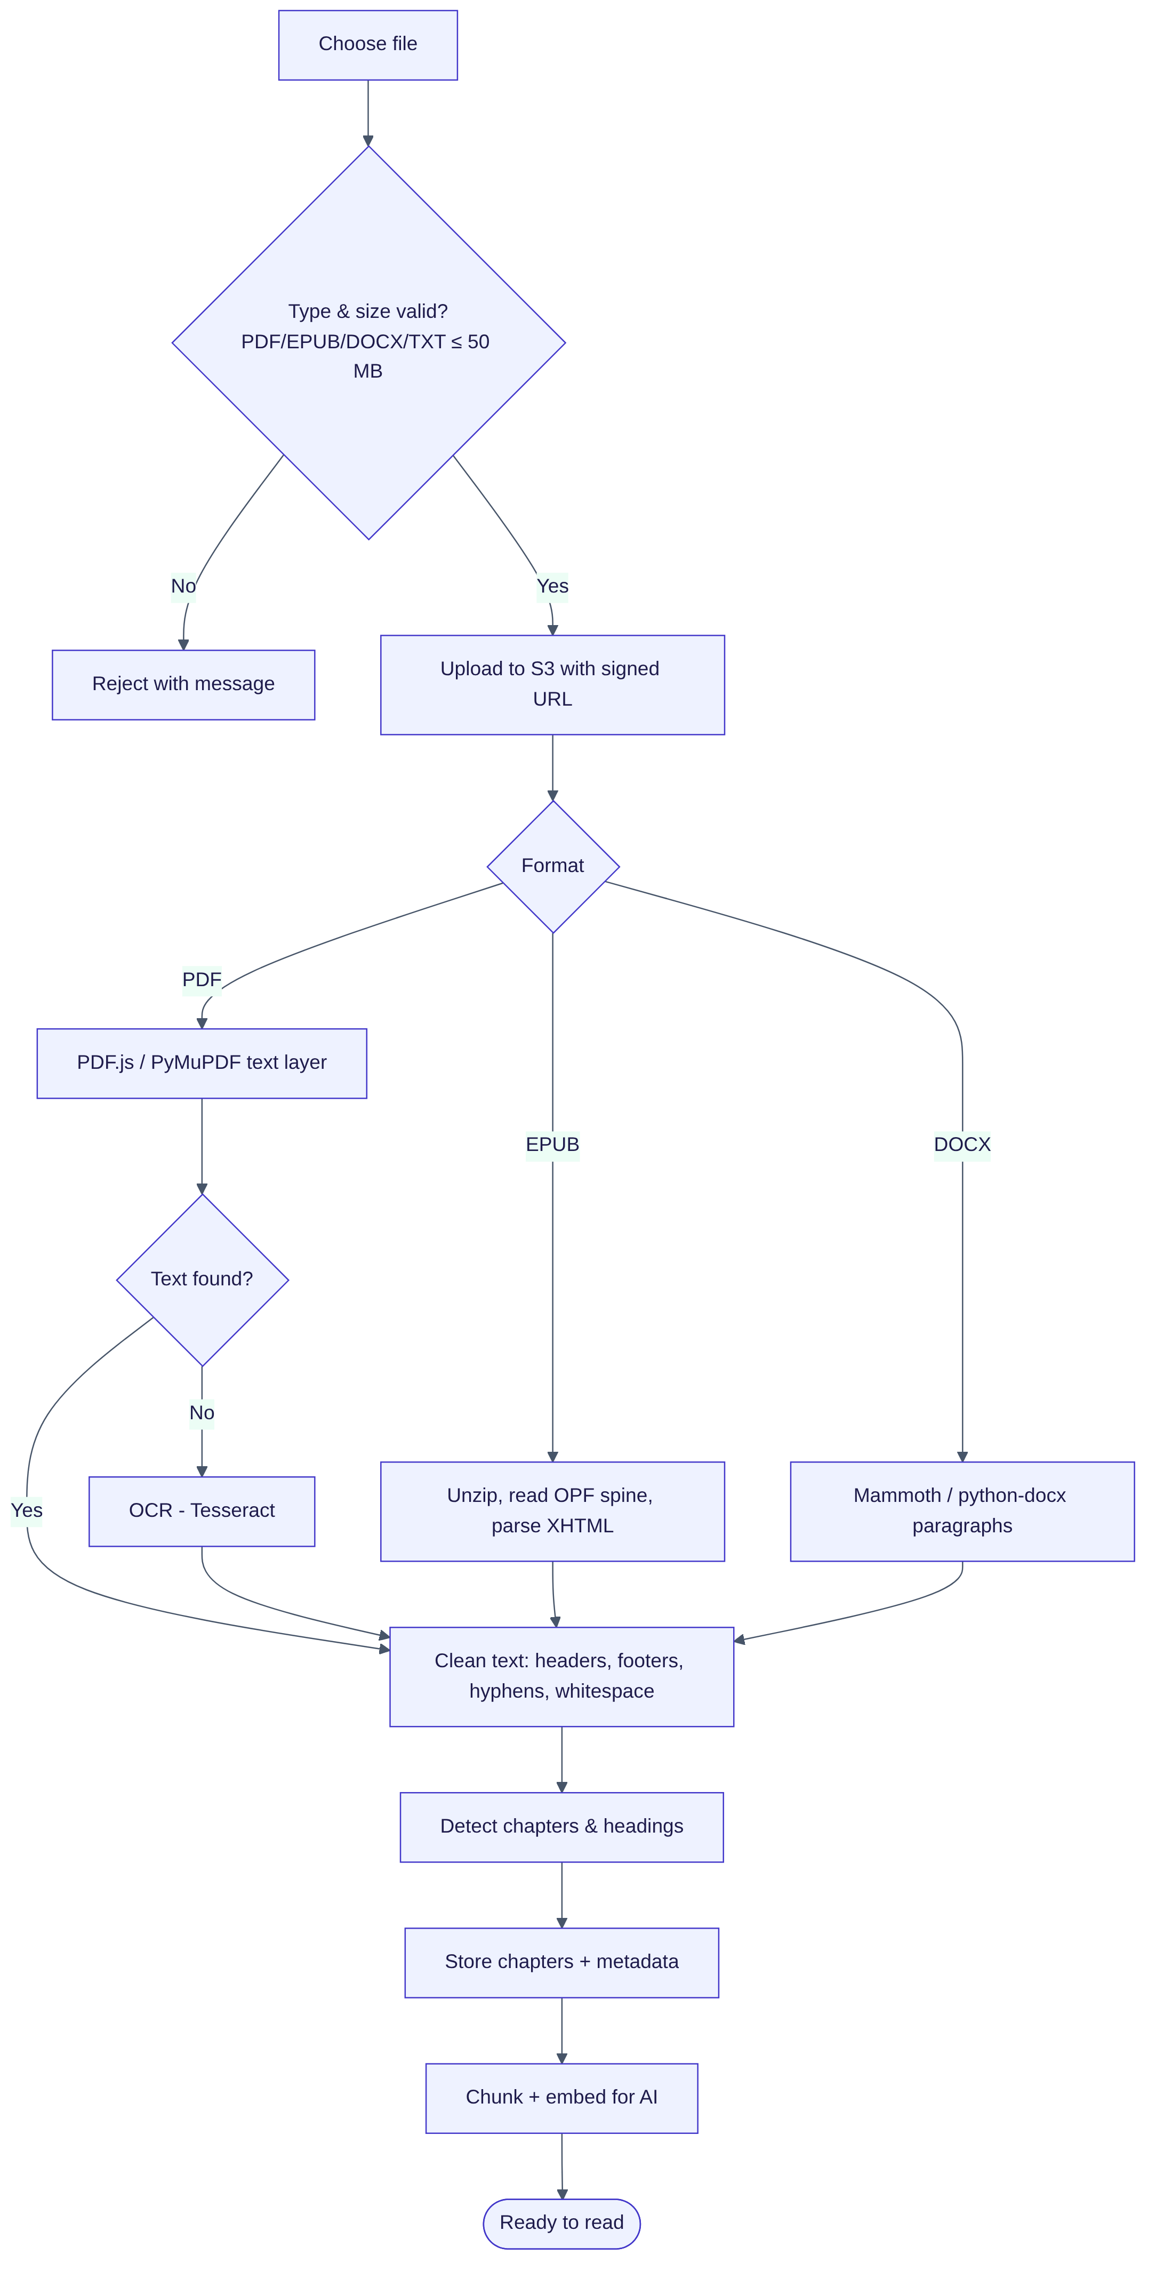
Figure 10: Activity diagram — document upload and processing
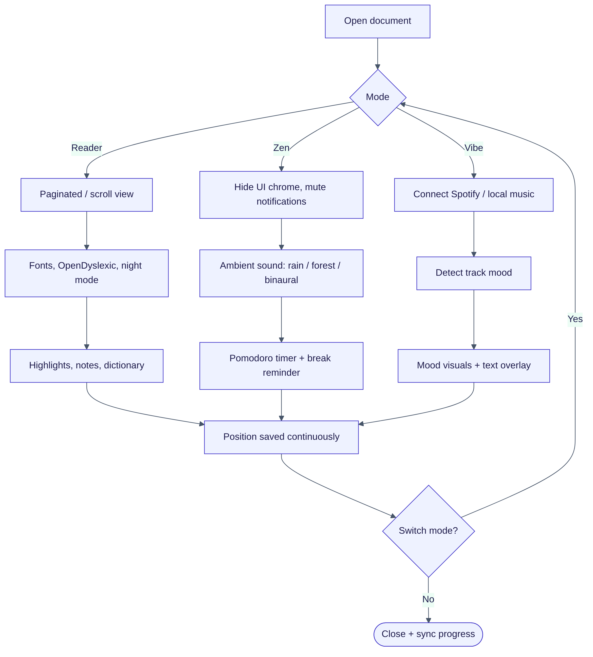
Figure 11: Activity diagram — reading in the three modes

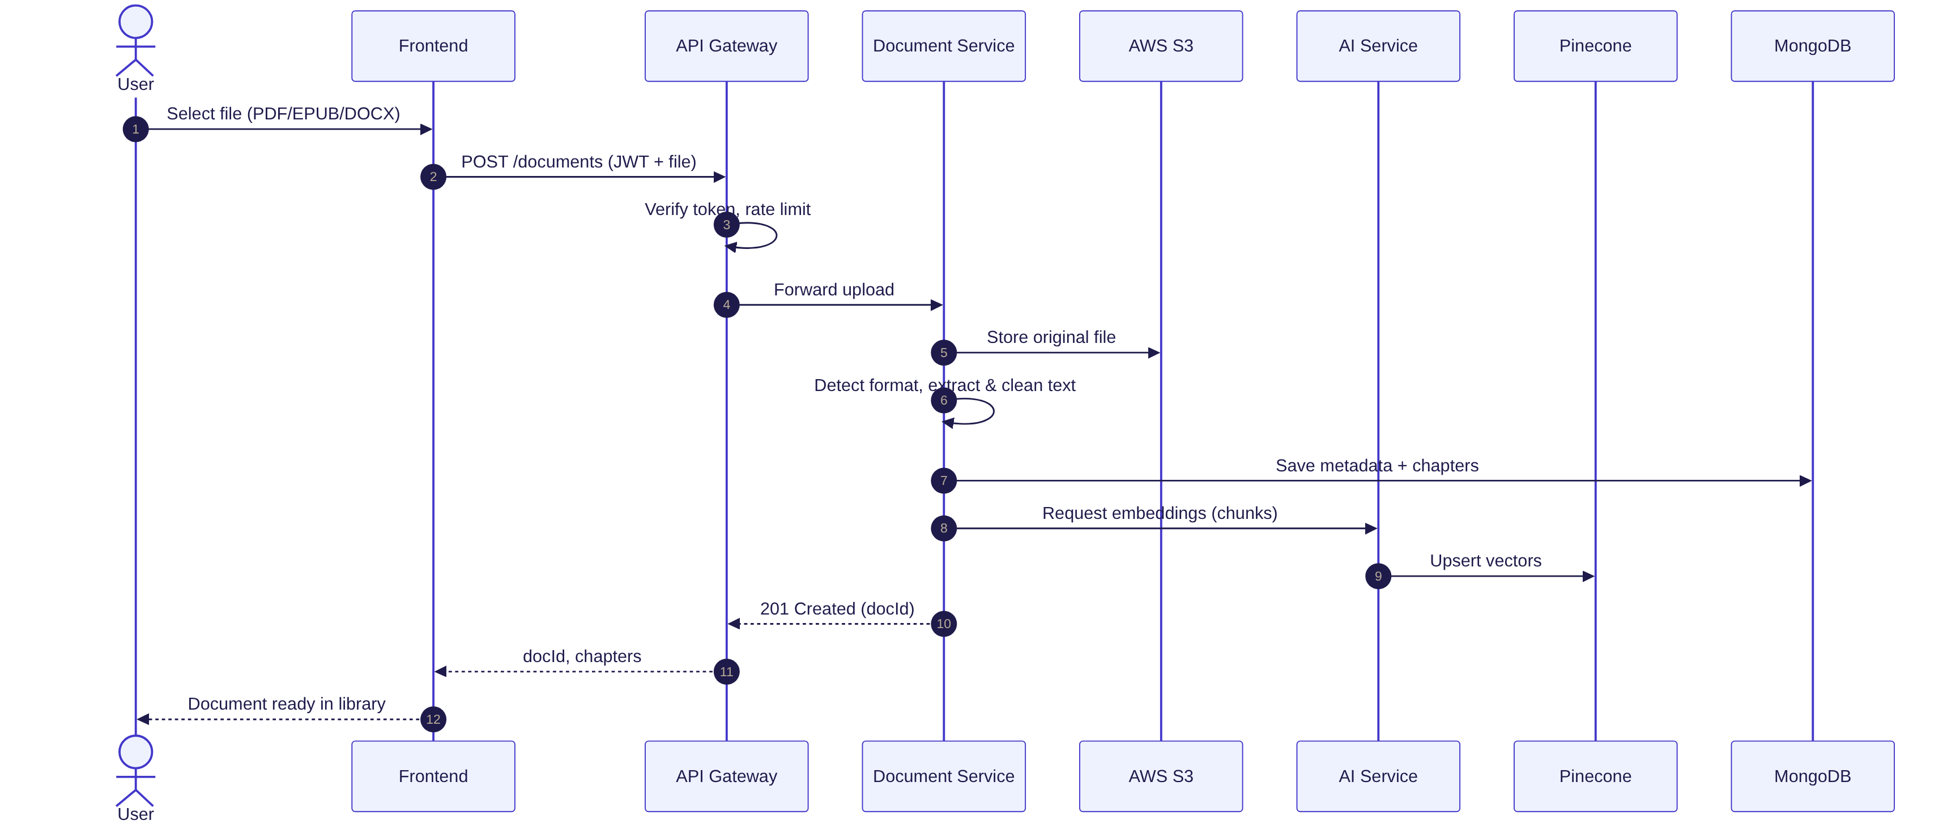

Figure 12: Sequence diagram — document upload and indexing

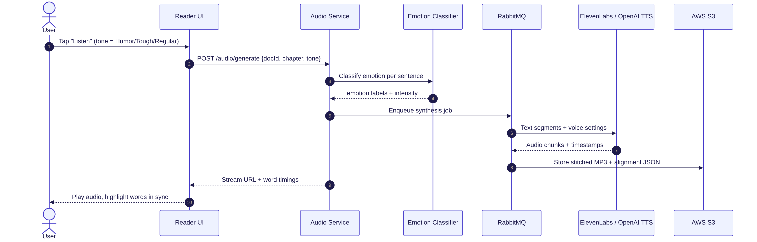

Figure 13: Sequence diagram — emotion-aware audio generation and playback

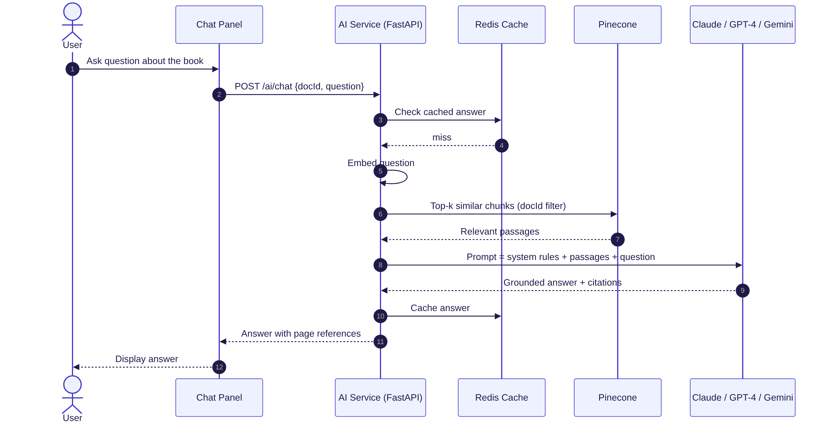
Figure 14: Sequence diagram — RAG-based question answering

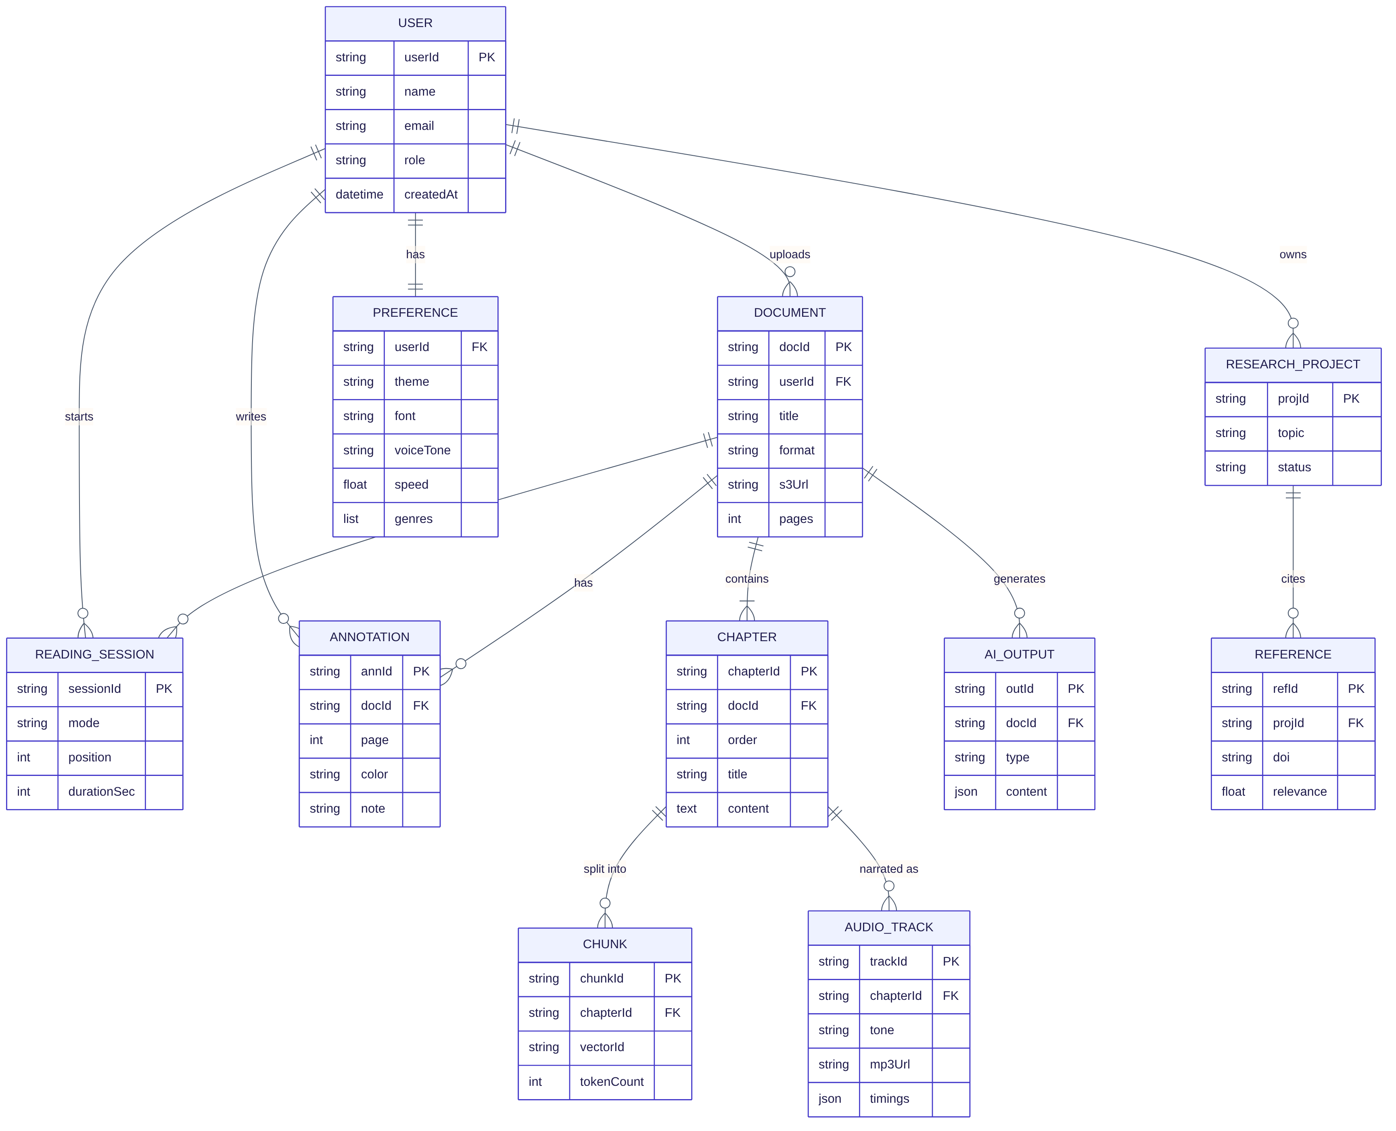
Figure 15: Entity–relationship diagram
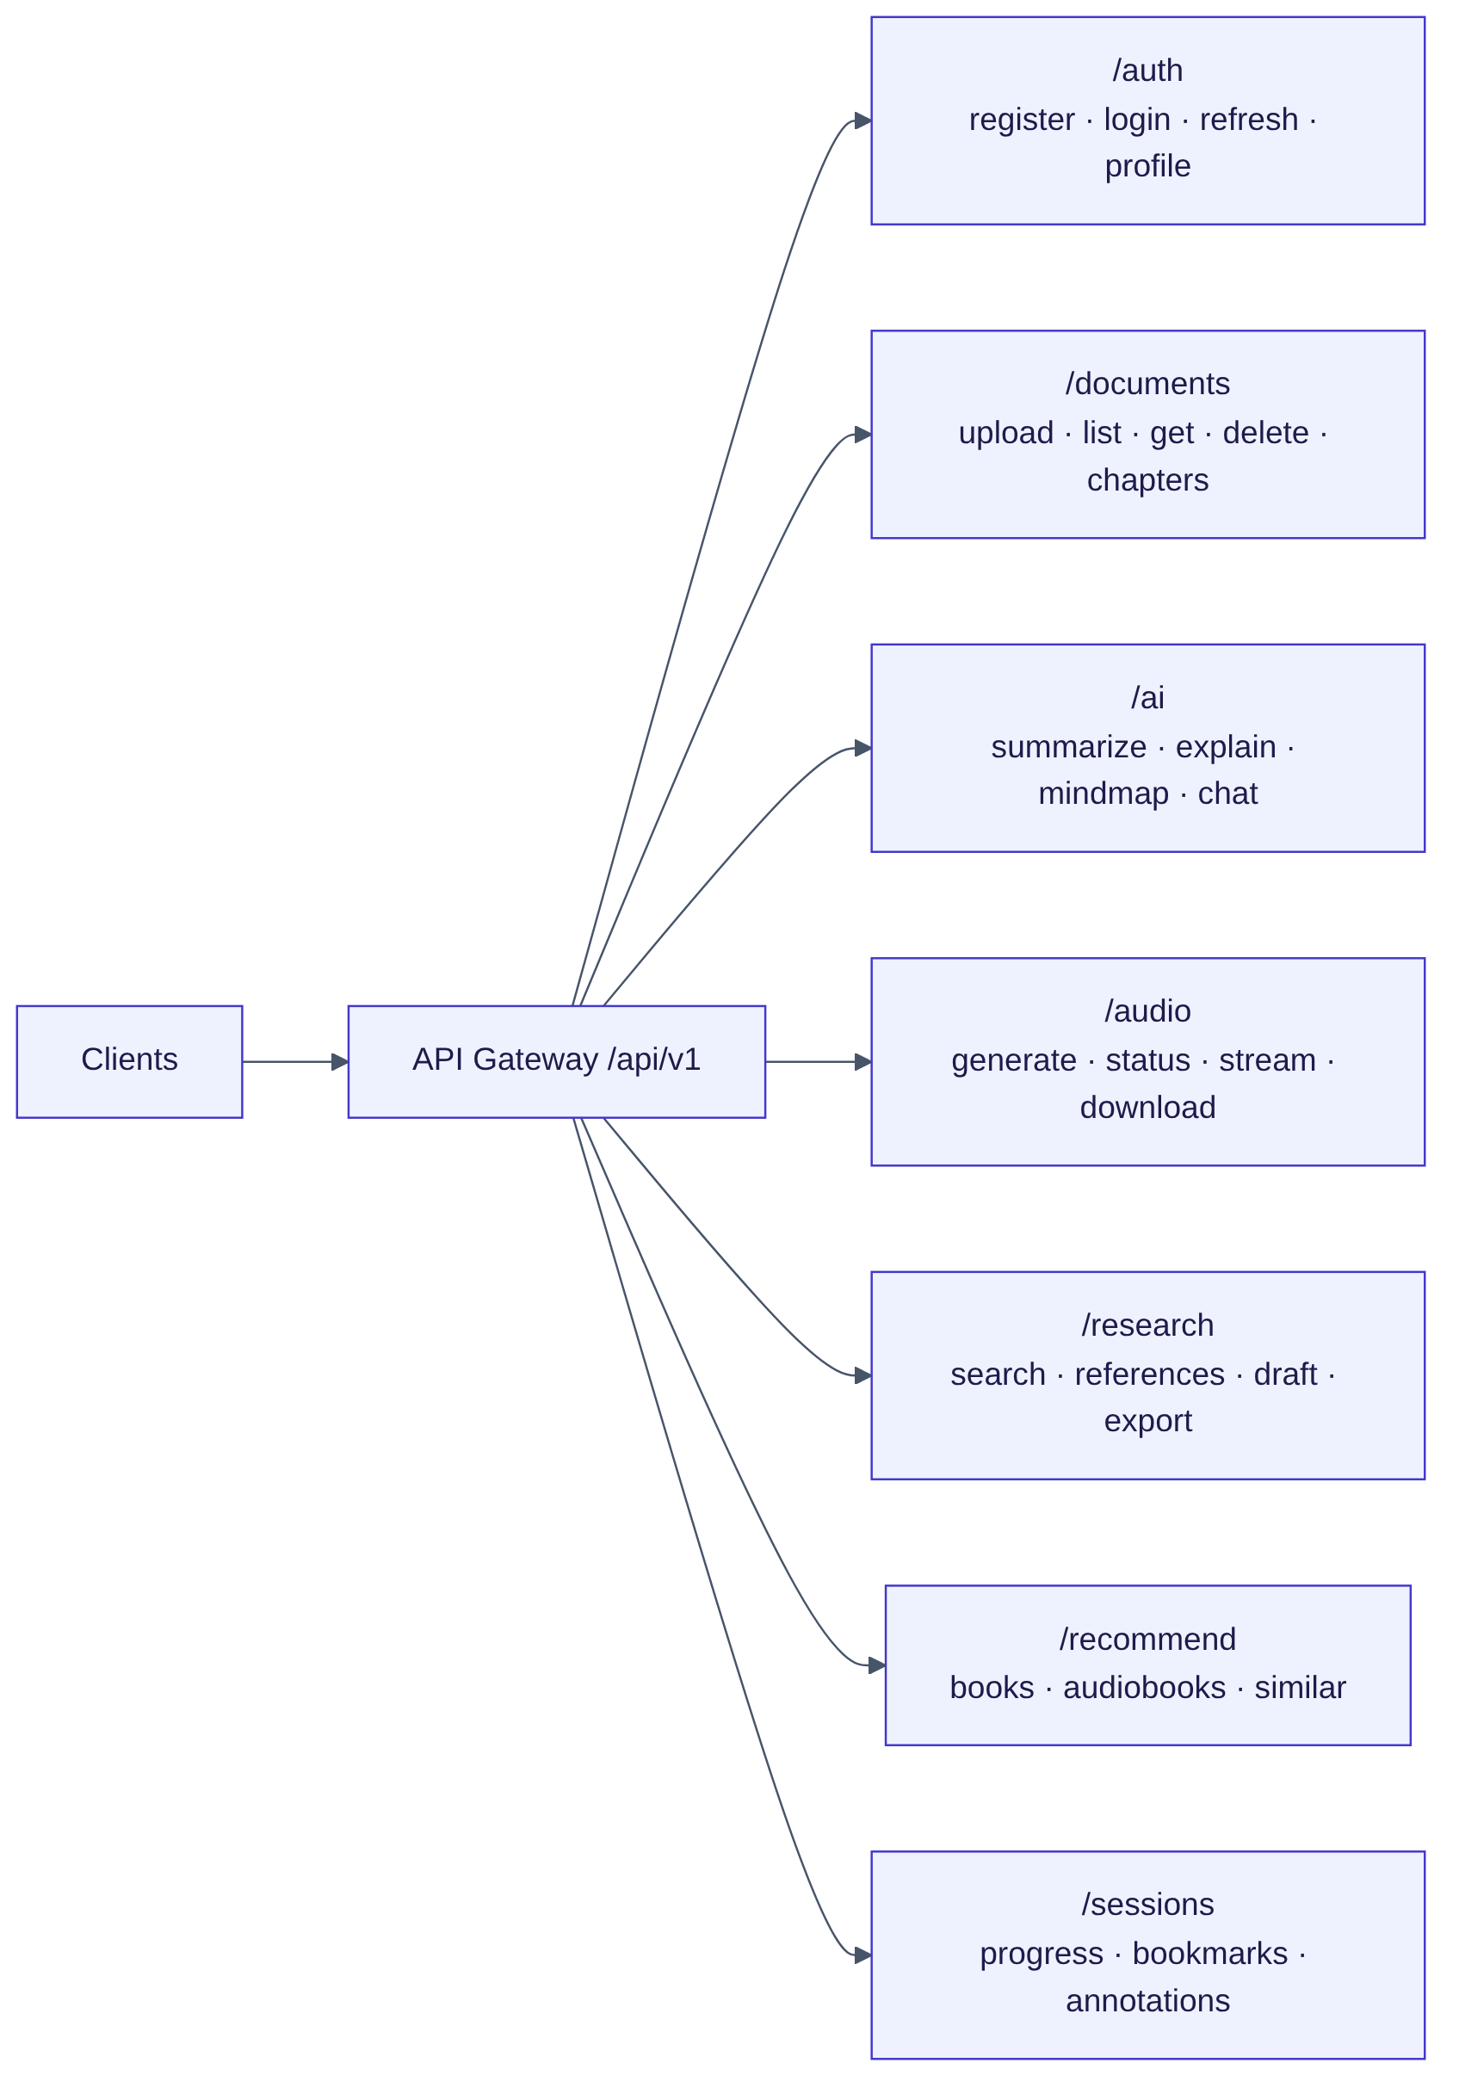
Figure 16: API architecture — route groups behind the gateway

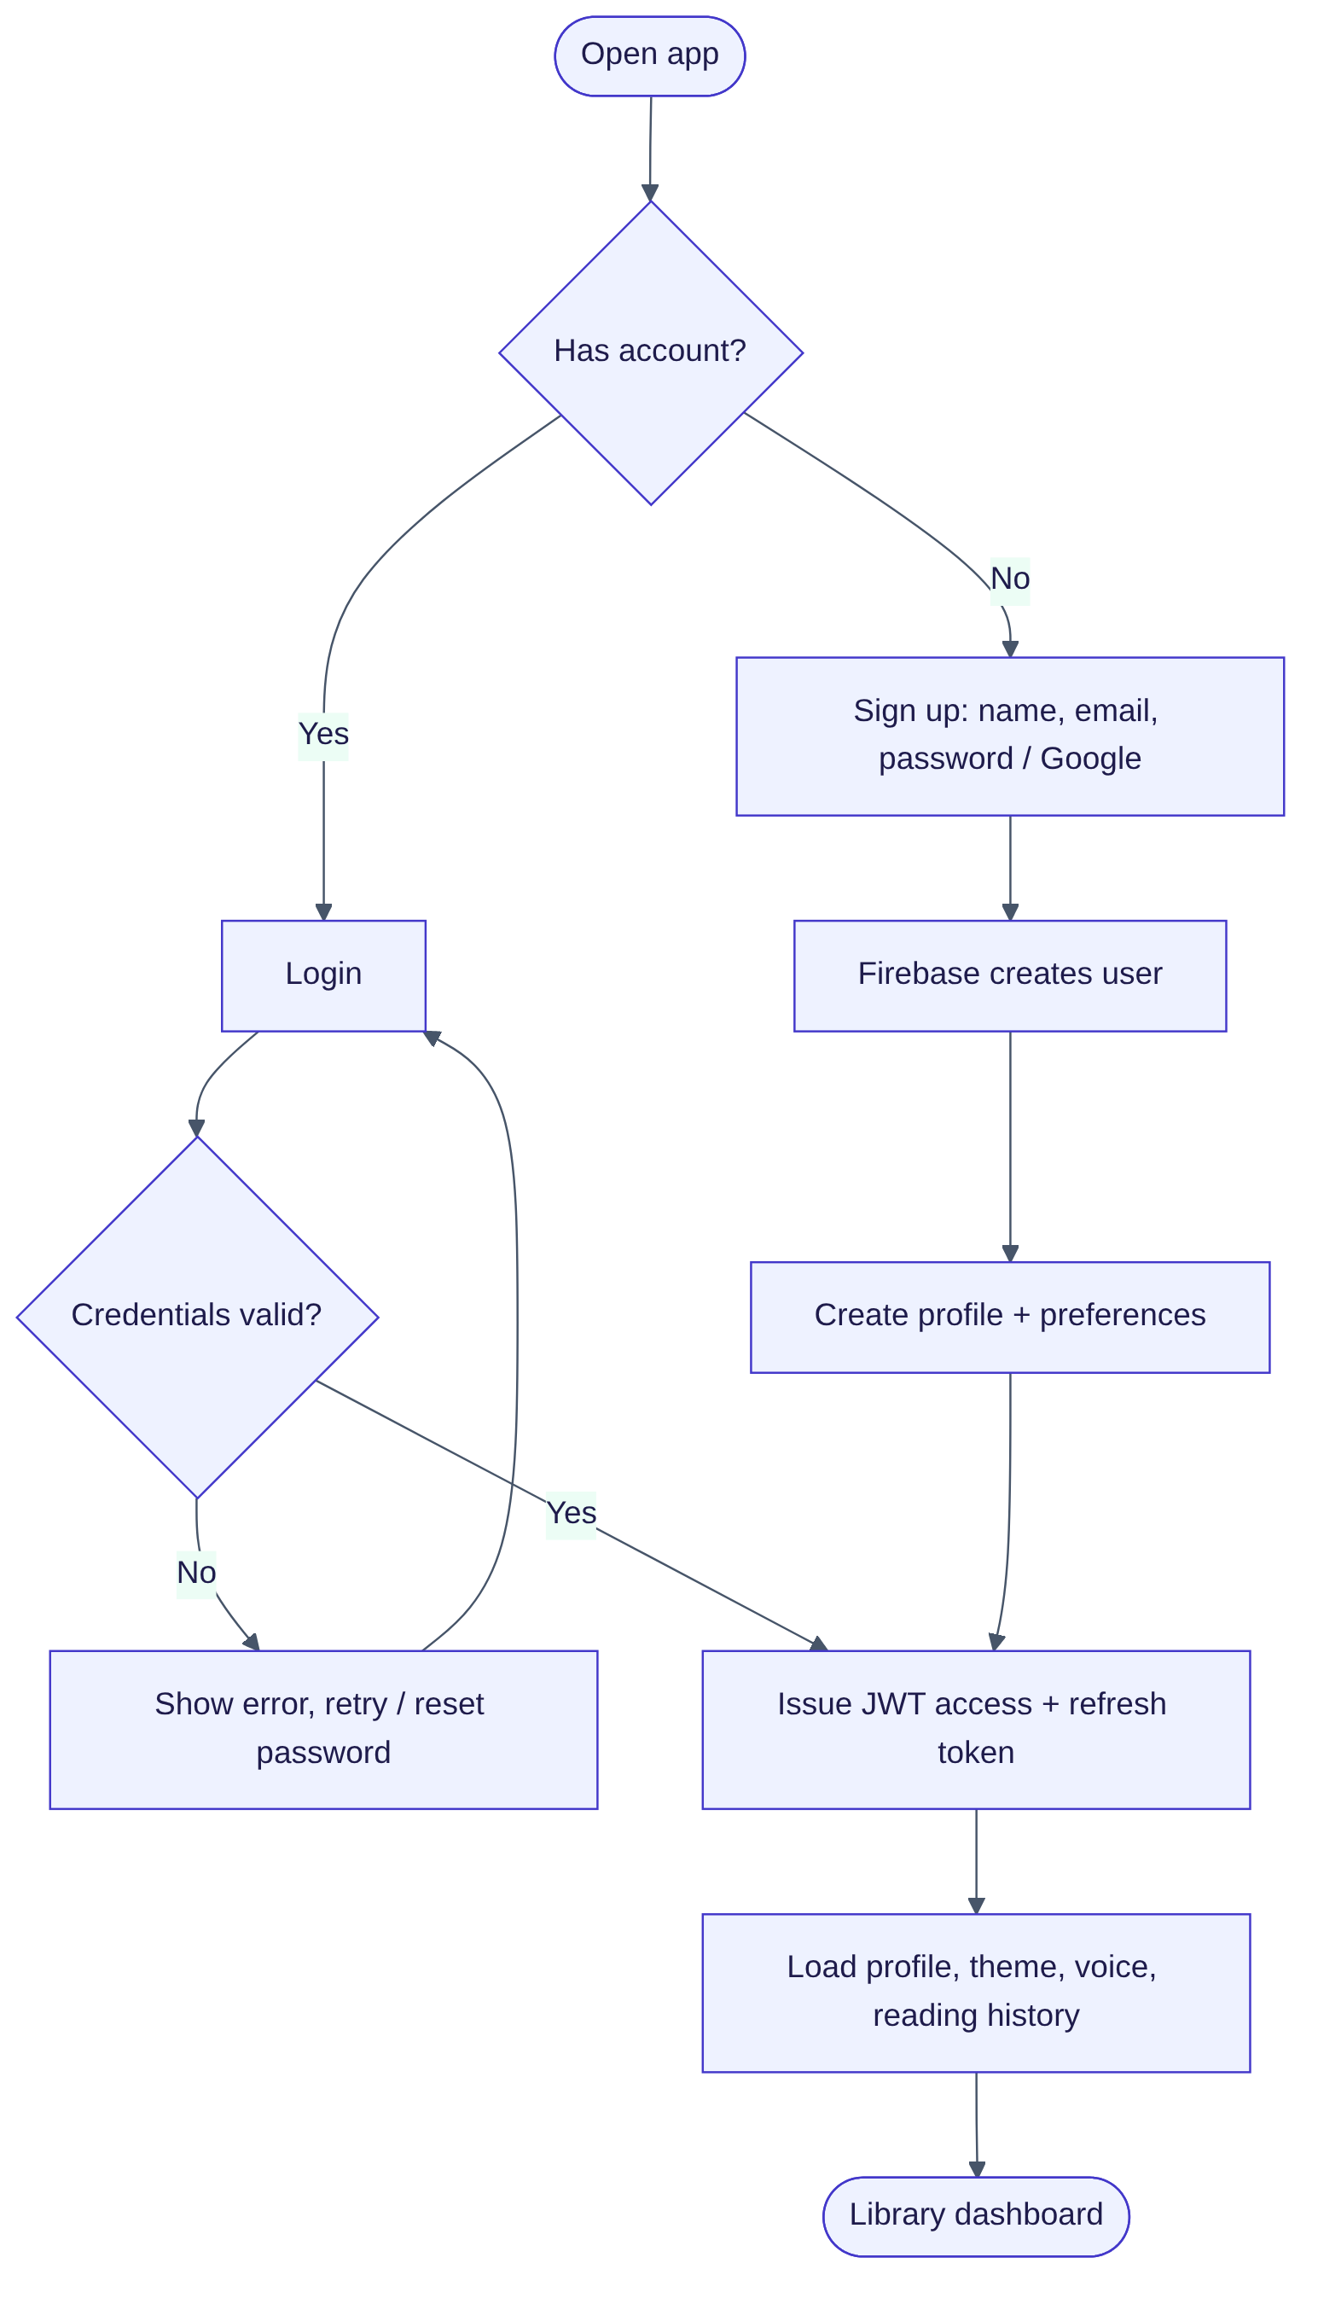
Figure 17: Flowchart — authentication and profile loading

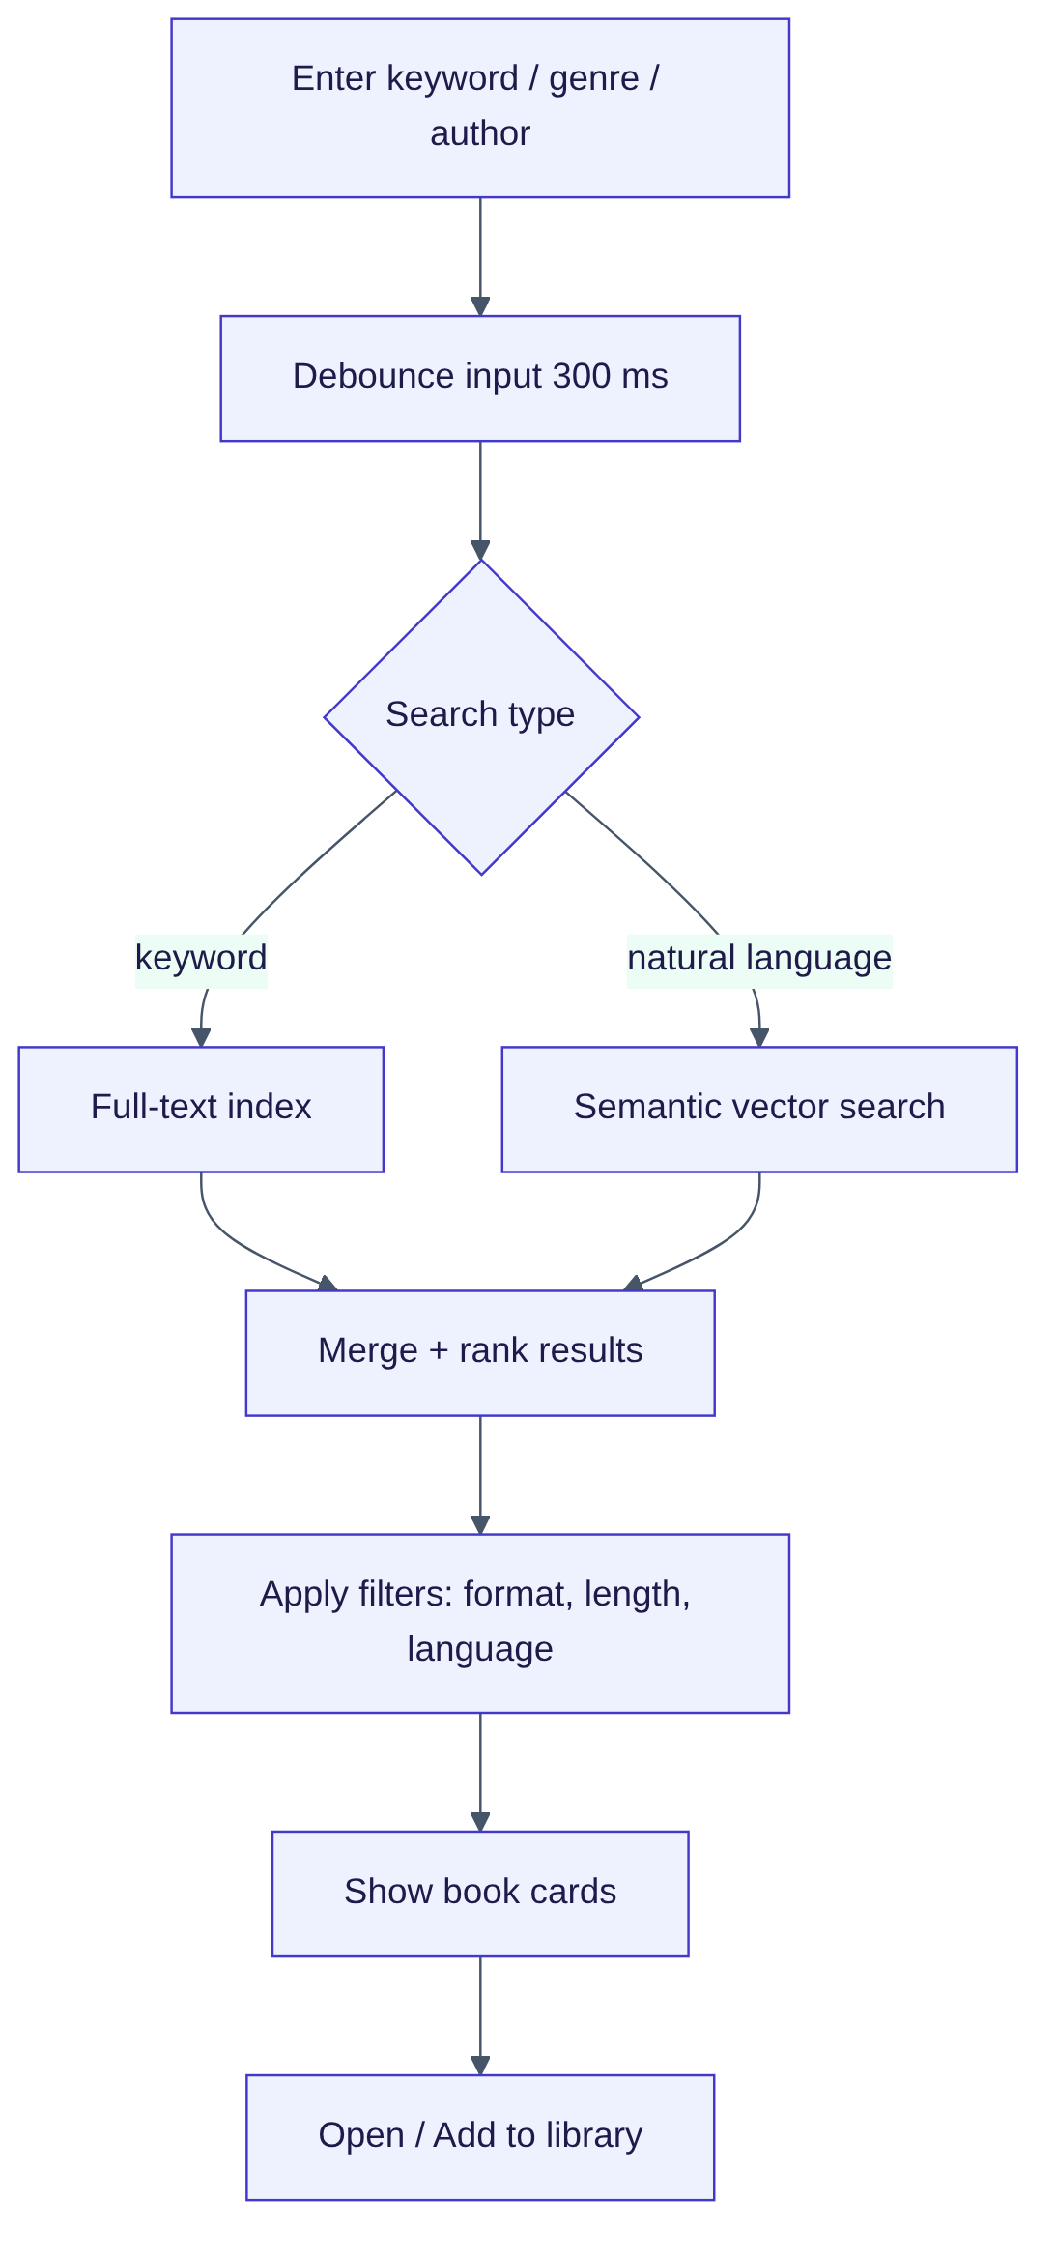

Figure 18: Flowchart — hybrid keyword + semantic search

Figure 19: How the three reading modes work and share reading position

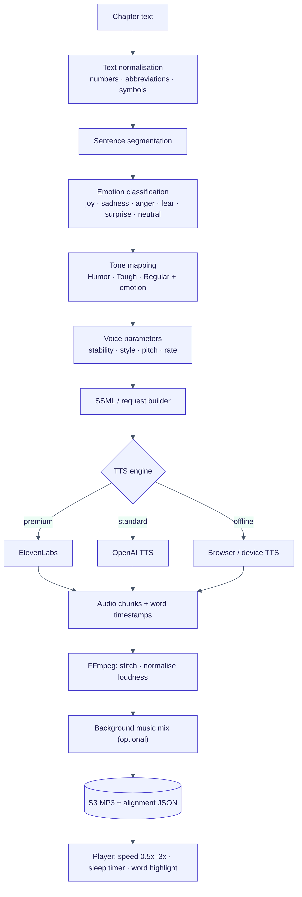
Figure 20: TTS workflow — from chapter text to synchronised playback
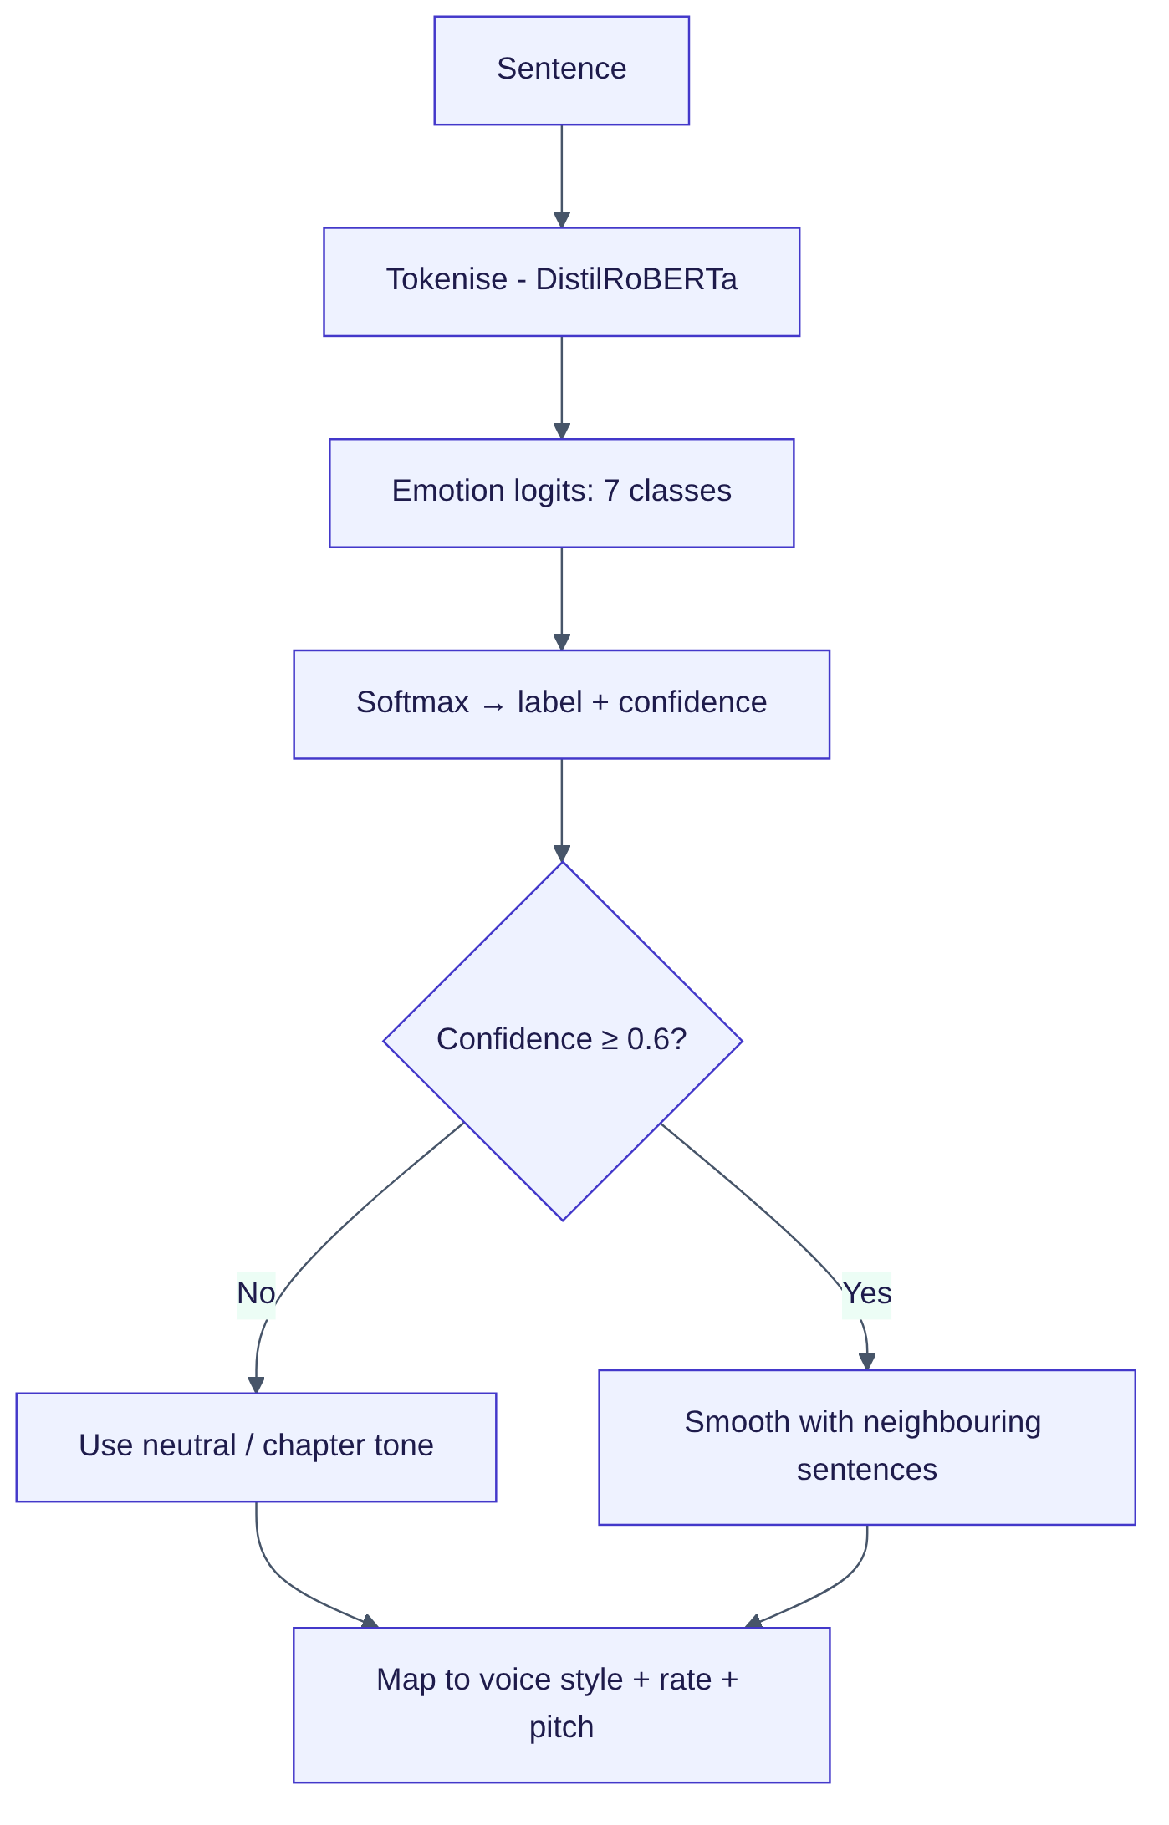
Figure 21: Emotion detection and mapping to voice parameters

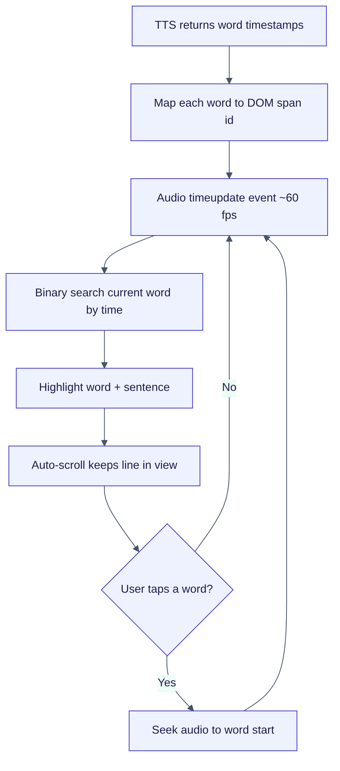
Figure 22: Audio–text synchronisation loop

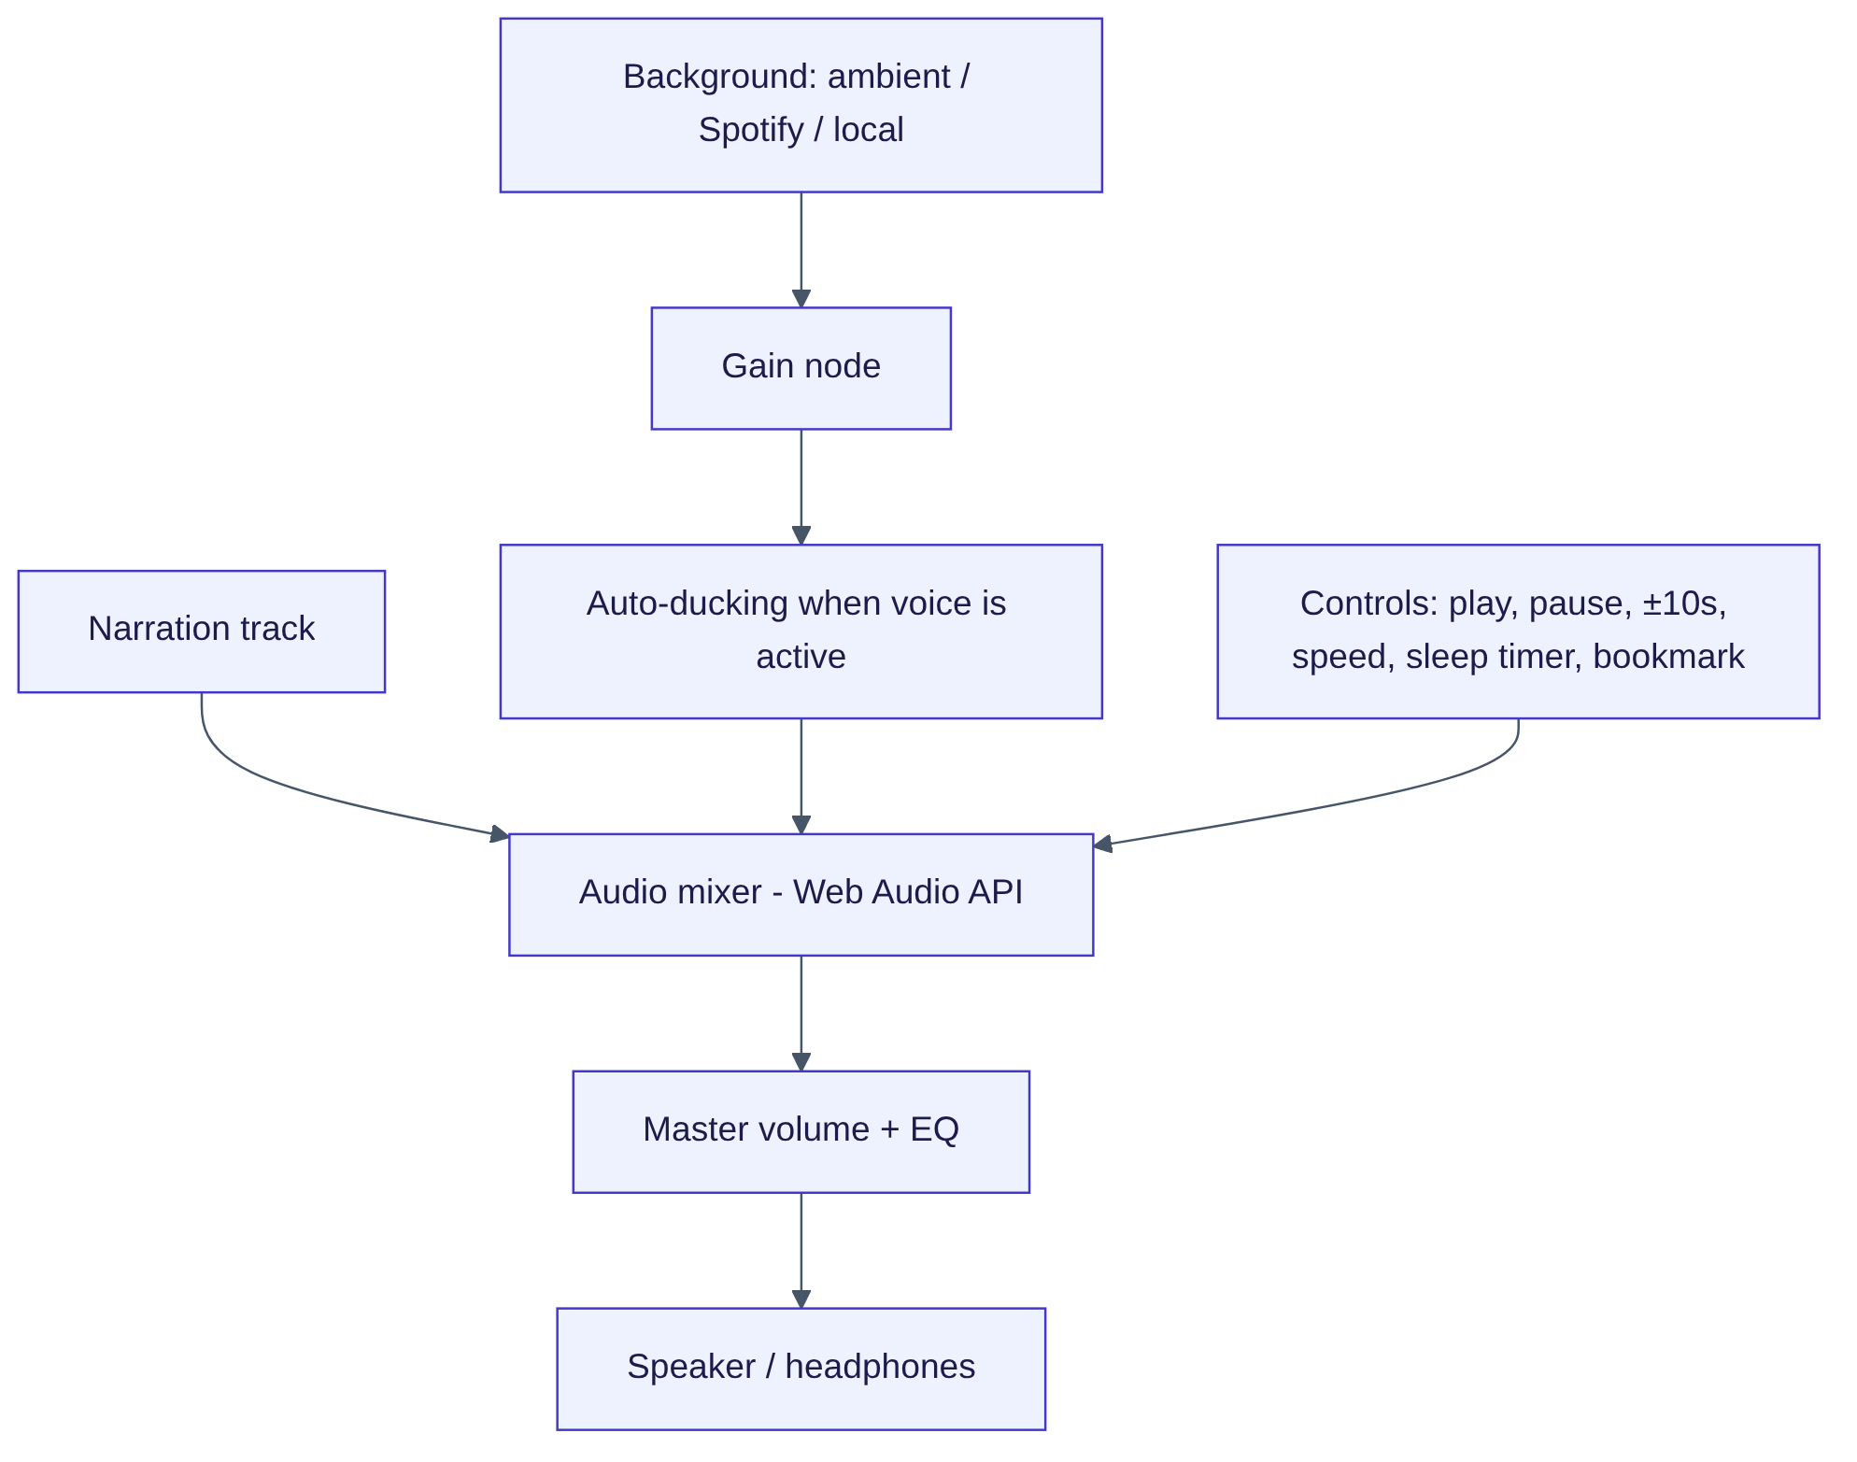
Figure 23: Audio mixing and controls

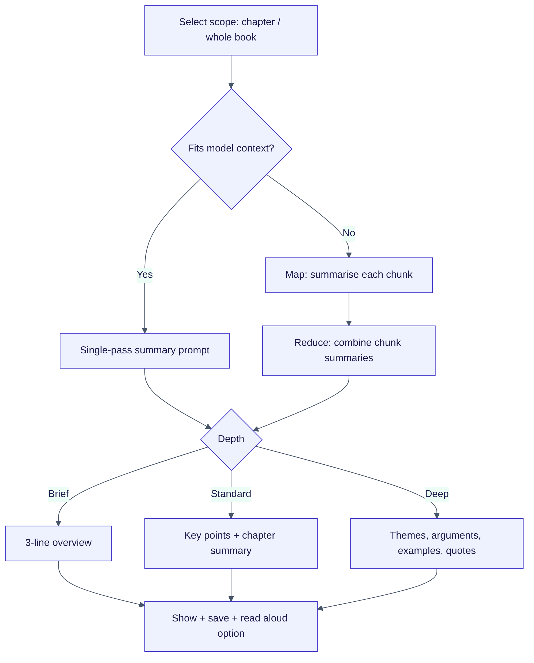
Figure 24: Summarisation flow using map-reduce for long texts

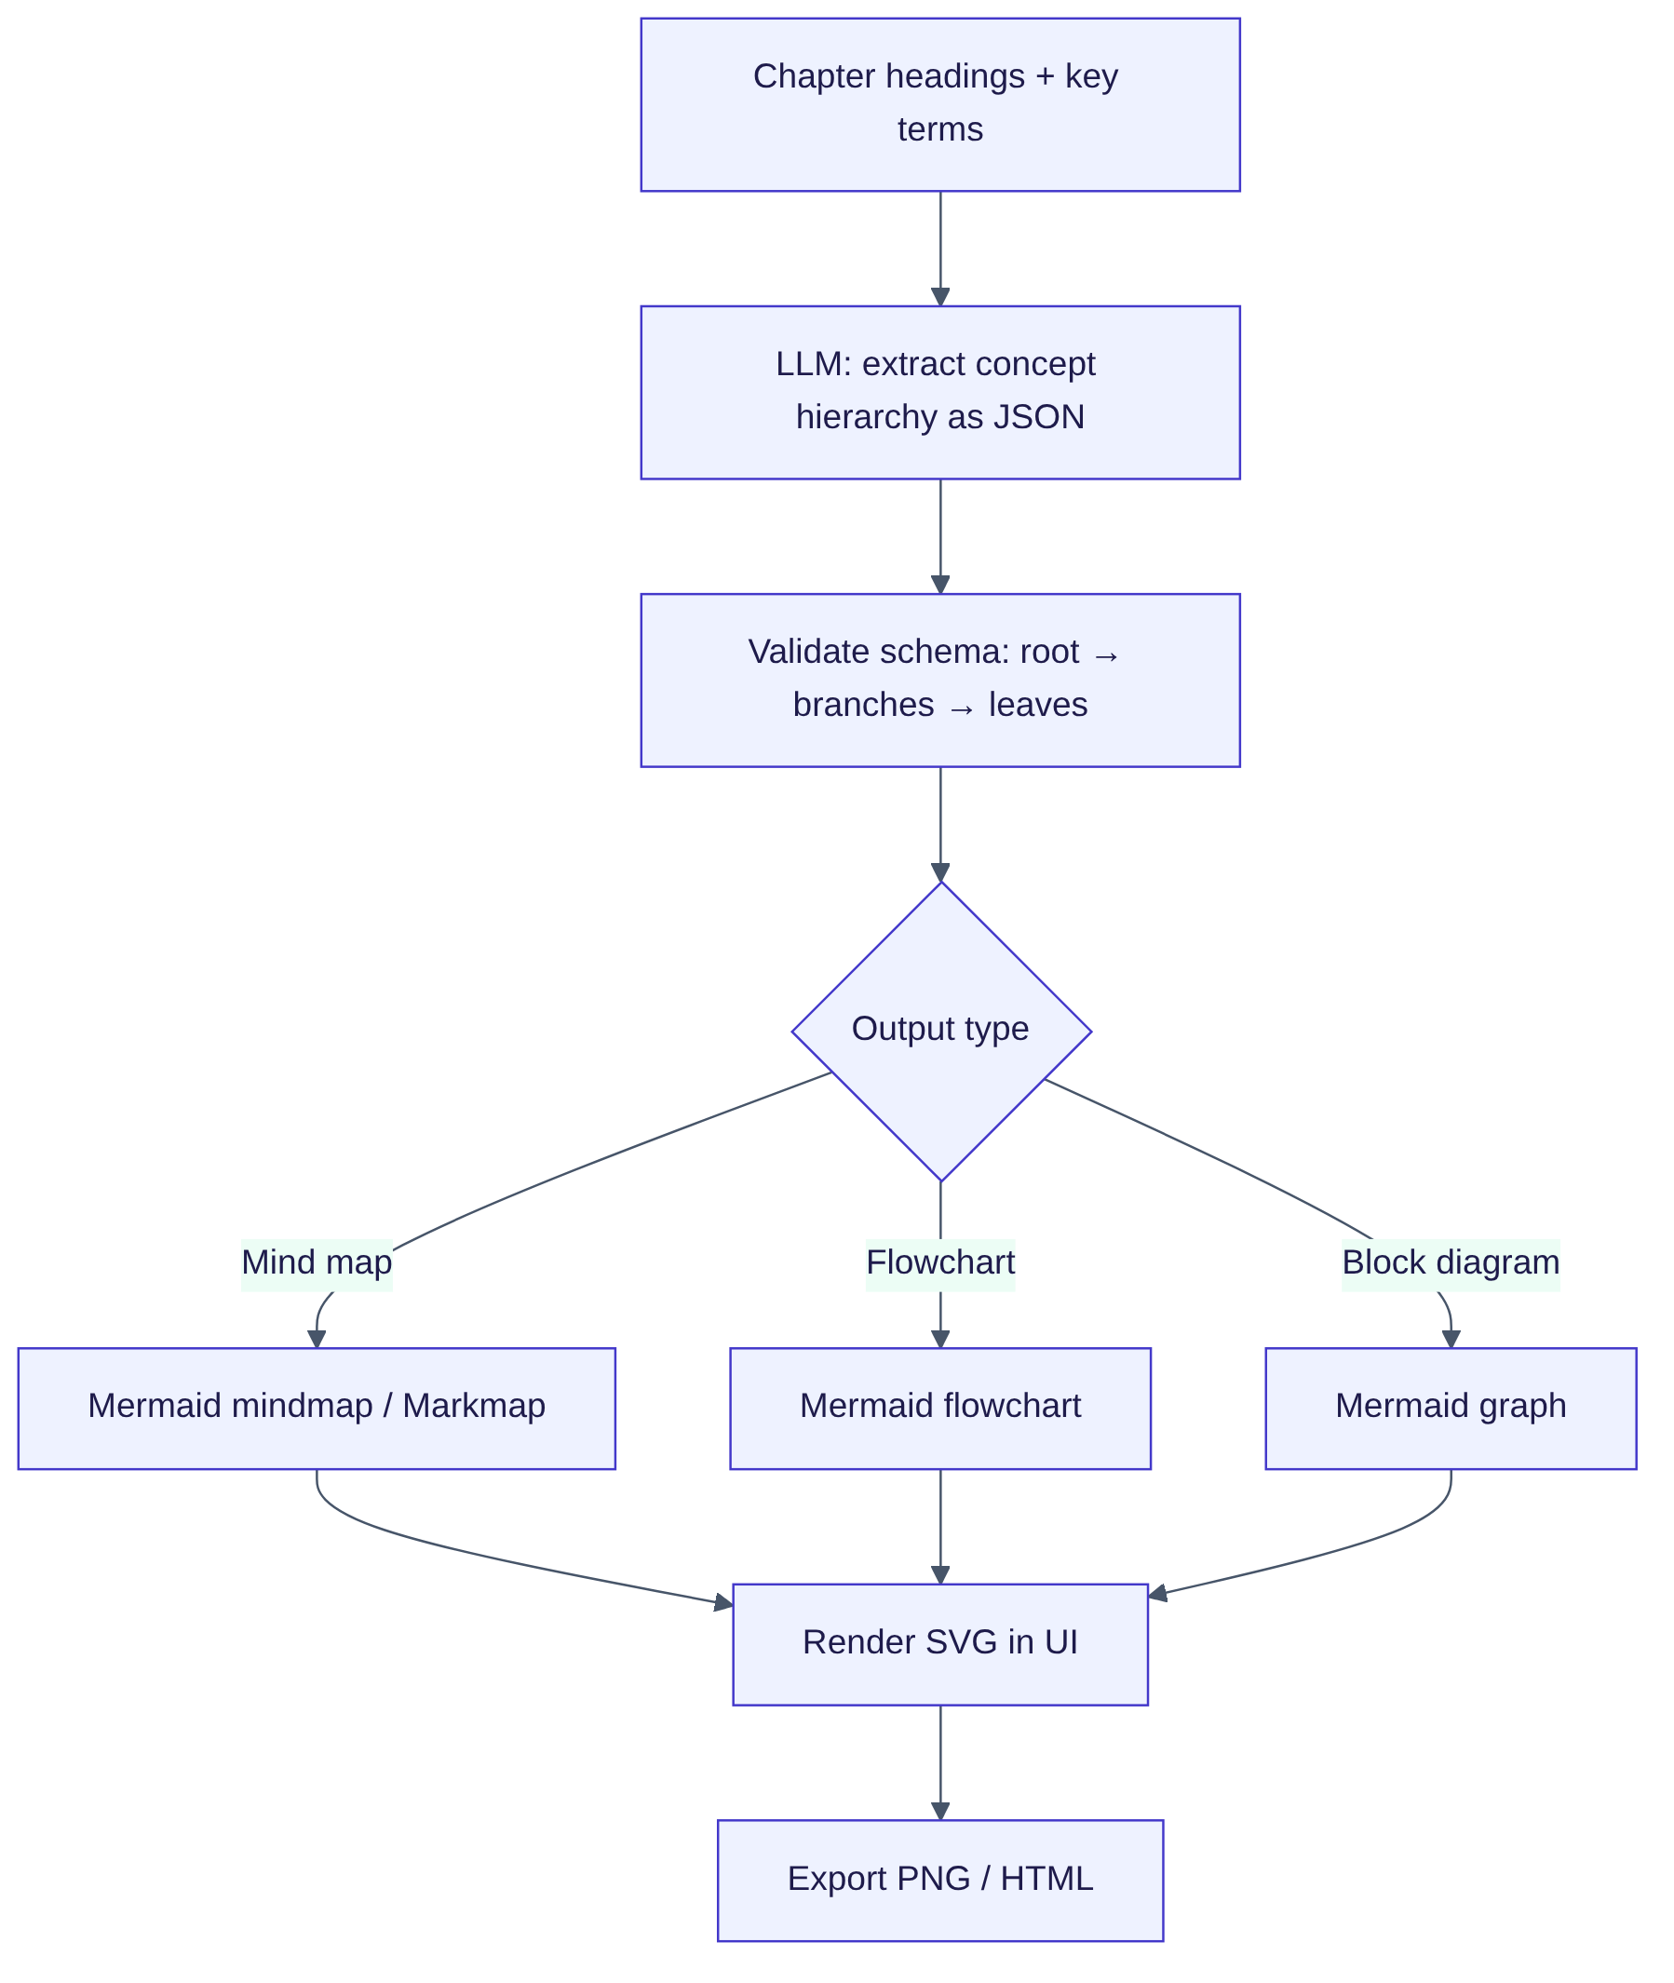
Figure 25: Generating mind maps and diagrams from text

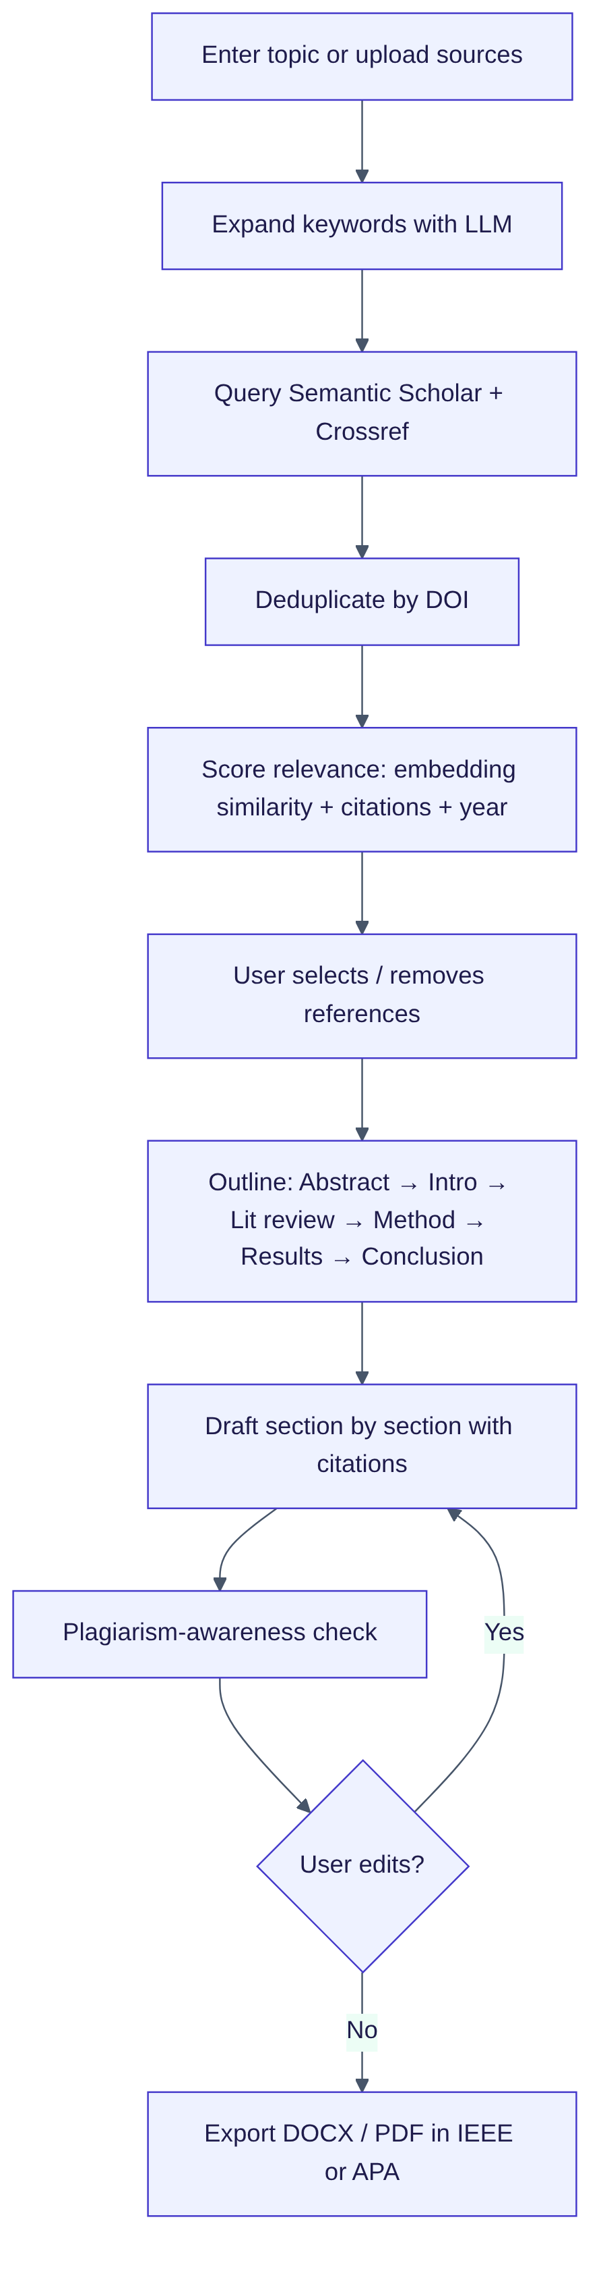
Figure 26: Deep Research Assistant pipeline
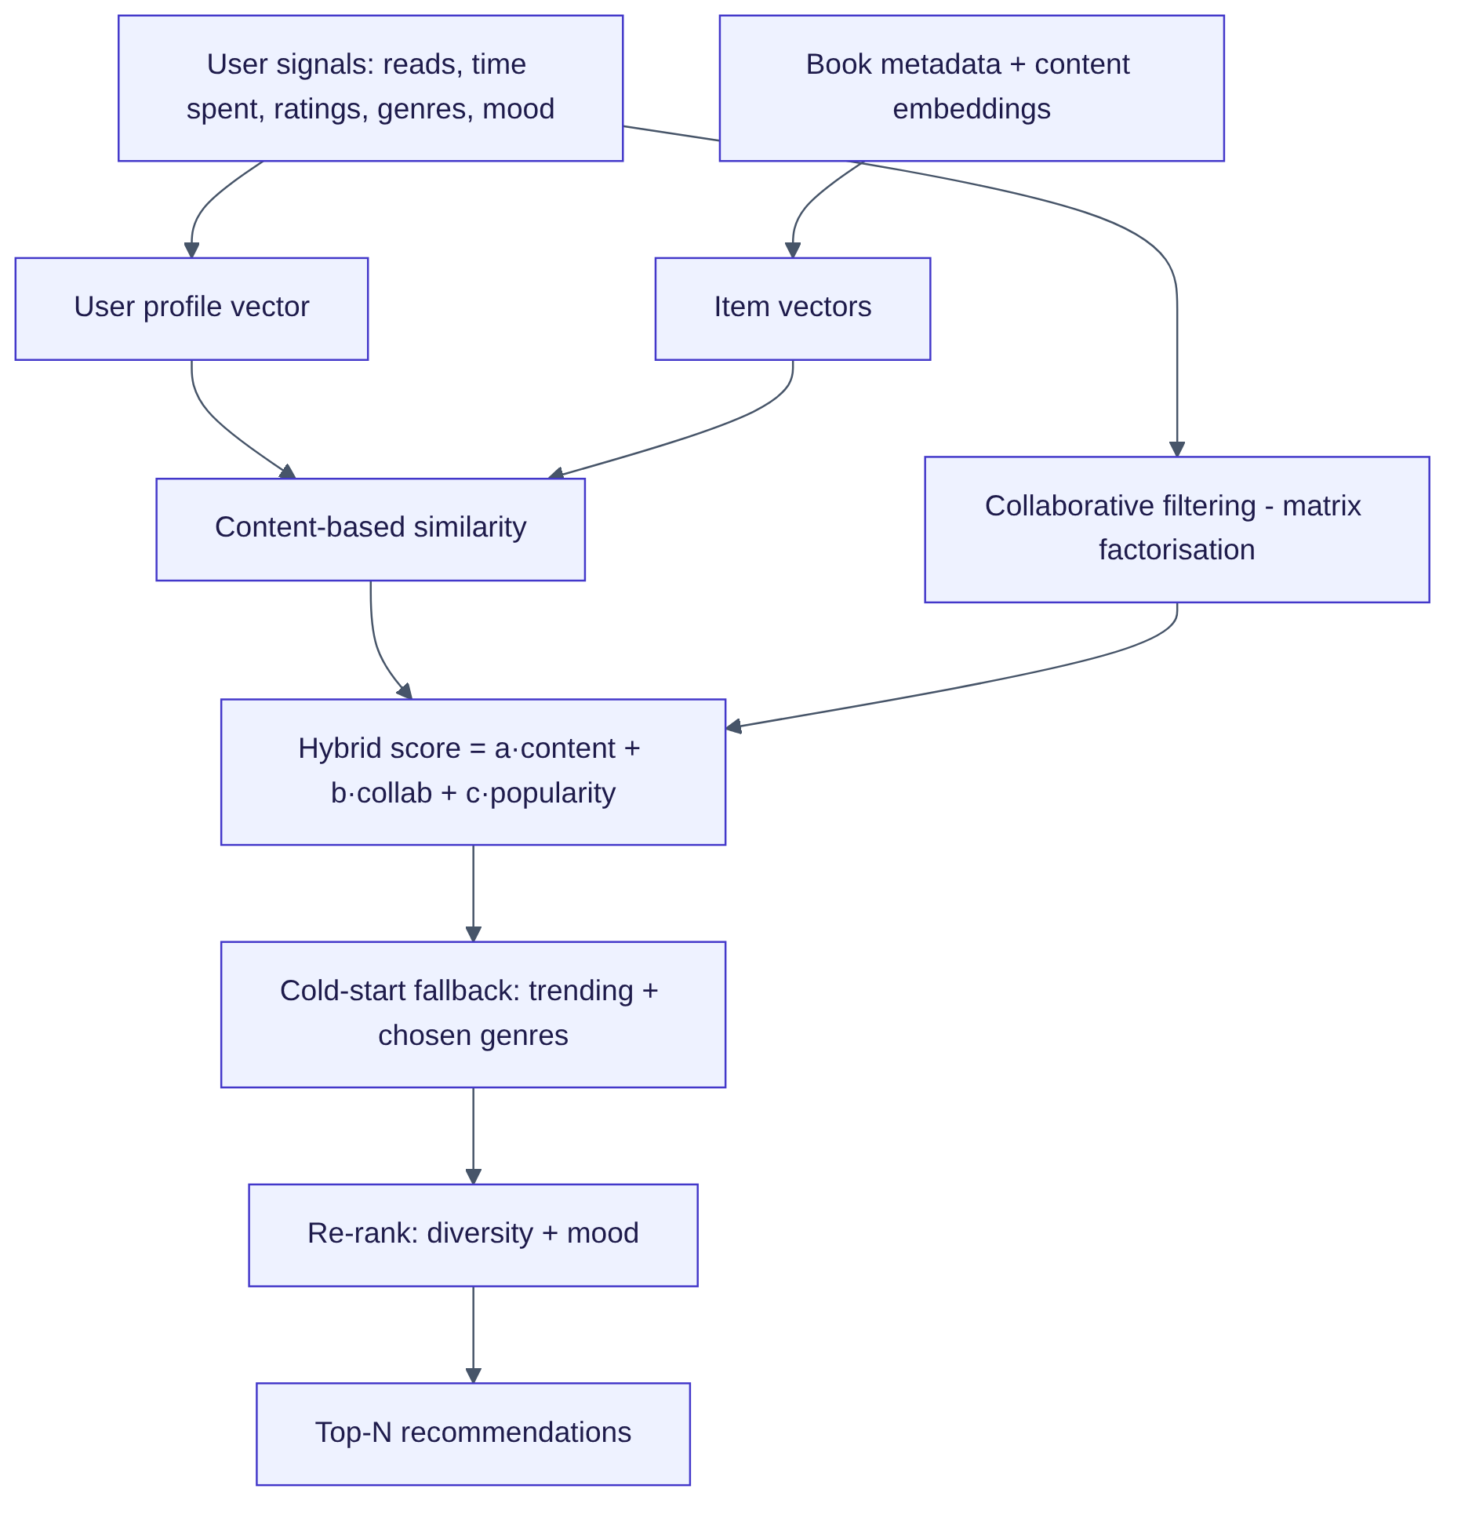

Figure 27: Hybrid recommendation pipeline

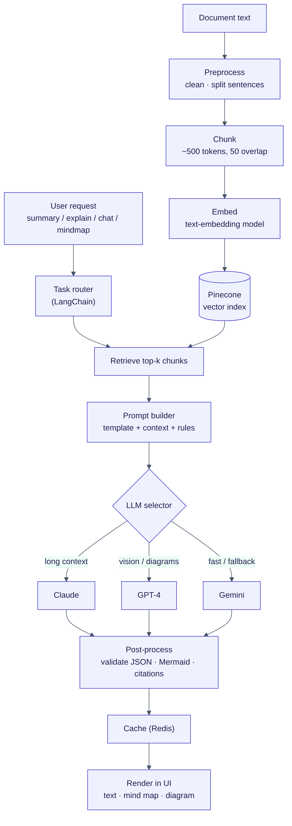
Figure 28: AI pipeline — ingestion, retrieval, model routing and rendering
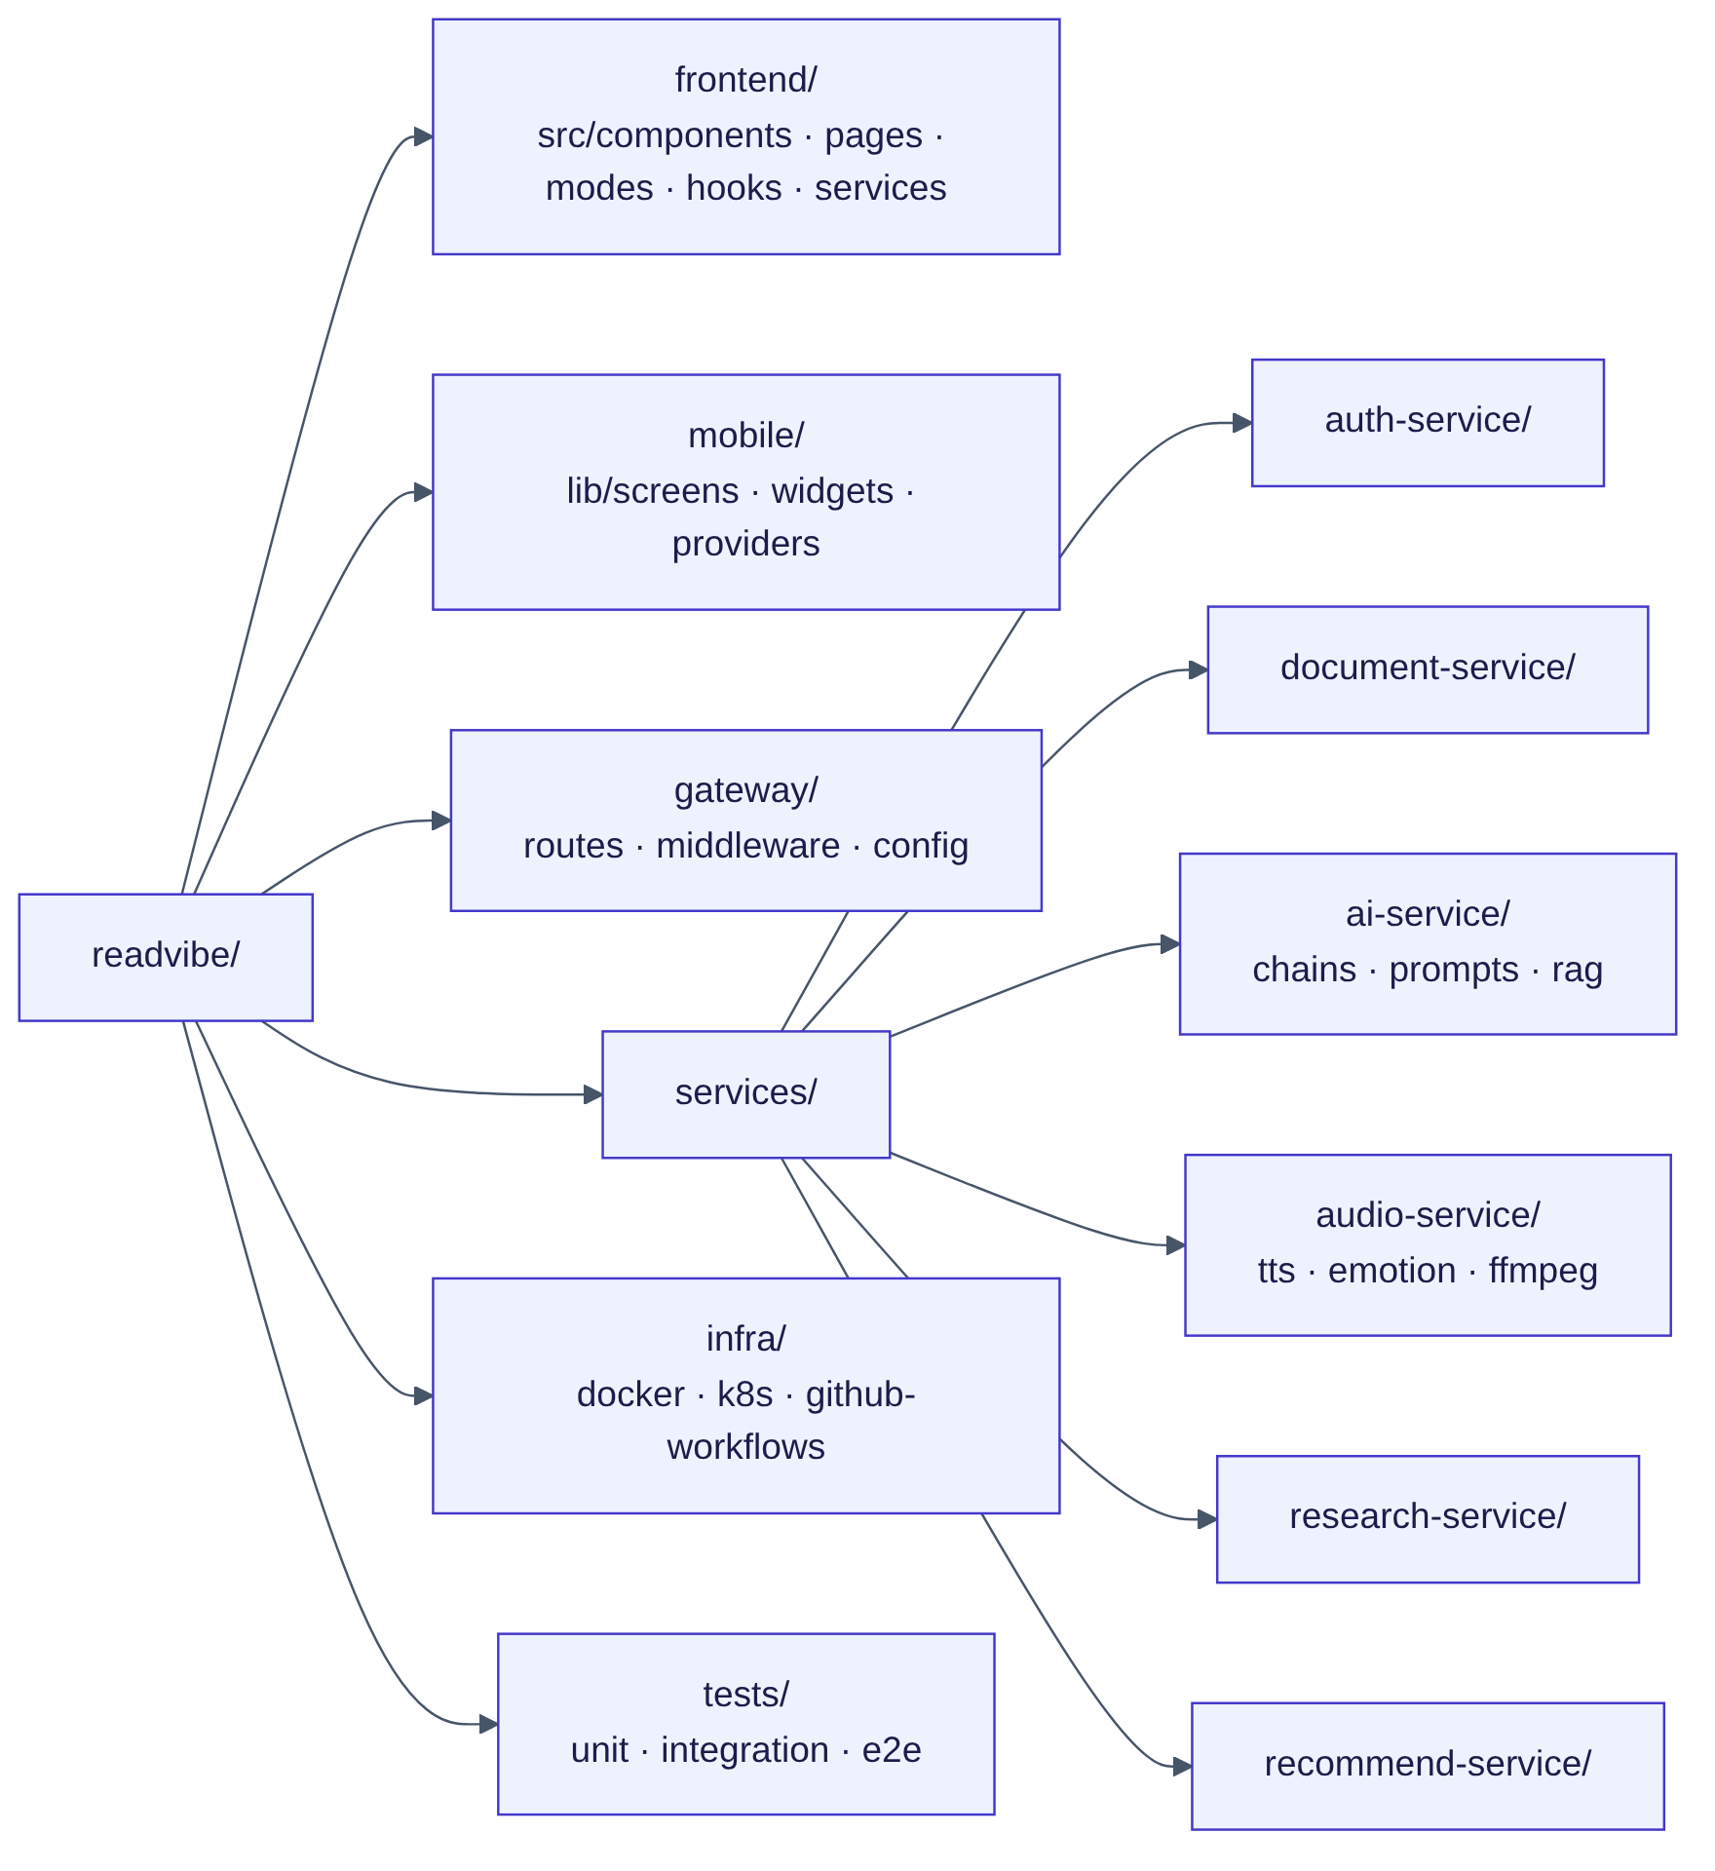
Figure 29: Project folder structure

Figure 30: File processing pipeline as a sequence of service calls

Figure 31: How modules connect around the single ReadVibe experience

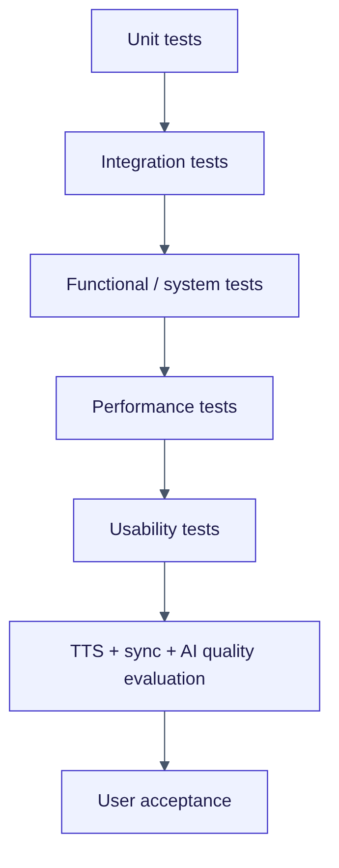
Figure 32: Testing levels used for ReadVibe
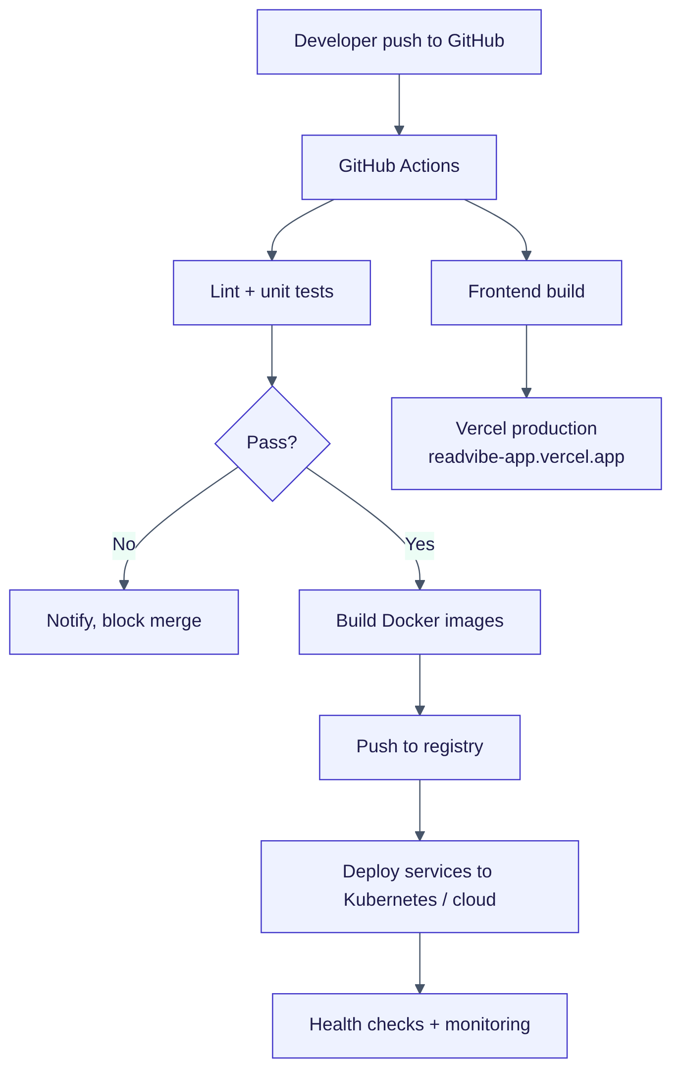
Figure 42: CI/CD and deployment pipeline

