Rare Politics
Where strategy wins election
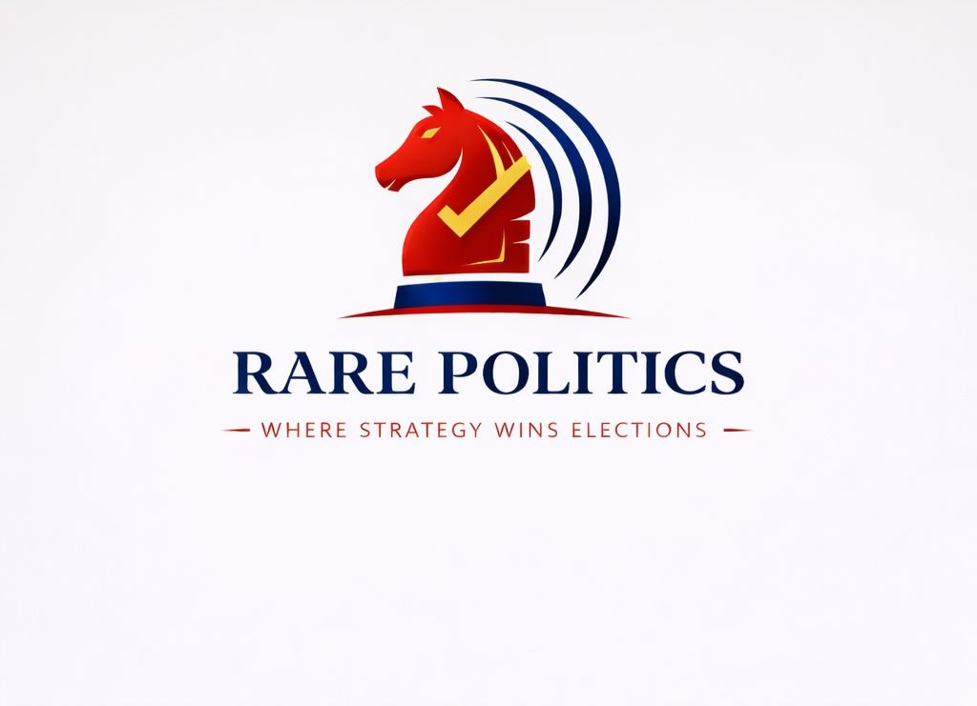

Discription
- Strategy creates momentum. Momentum wins elections.
Rare Politics makes both happen.
- No noise. No guesswork. Just winning strategy.
Rare Politics delivers data-driven campaigns that convert ground reality into votes.
This is where elections are decided.
- Elections are not fought. They are engineered.
Rare Politics builds the strategy, momentum, and execution that wins.
Clear thinking. Decisive results.

About us:
Rare Politics is a results driven political consultancy built on one core belief: elections are not won by chance, but by strategy.
With a sharp focus on data, ground intelligence, and precise execution, we design campaigns that don’t just create noise but build measurable momentum. From constituency level insights to large-scale narrative building, our approach combines research, technology, and on-ground coordination to give candidates a decisive edge.
We work closely with political leaders, independent candidates, and organizations to craft tailored strategies that reflect local realities while aligning with broader electoral goals. Every campaign we handle is treated like a high-stakes project, where planning, timing, and execution come together with clarity and discipline.
At Rare Politics, we don’t wait for waves. We build them.
Rare Politics : Where Strategy Wins Elections.

About:
The Rare Politics Edge
Why India's top candidates trust us with their political future.
- Pan-India Experience
From the hills of Himachal to the coasts of Kerala, we understand the diverse political fabric of India.
- Absolute Confidentiality
Your strategy is your weapon. We maintain the highest standards of data security and professional ethics.
- Digital First Approach
We leverage cutting-edge technology to reach voters where they spend most of their time—on their screens.

Services:
Comprehensive solutions tailored for every stage of your political career.
- Political Strategy & Advisory
Winning begins with clarity. We design sharp, data-backed strategies that define your path to victory.
- Election Roadmap & Timeline Planning
- Opponent Analysis & Counter-Strategy
- Alliance & Coalition Strategy
- Issue Mapping & Narrative Positioning

- 360° Campaign Management
End-to-end election strategy from booth level to constituency-wide mobilization.
From planning to execution, we manage every layer of your campaign with precision and discipline.
- Constituency Profiling & SWOT Analysis
- War Room Setup & Operations
- Booth Management & Panna Pramukh Training
- Voter Outreach Programs
- Election Roadmap & Timeline Planning
- Polling Day War Room
- Voter Mobilization Strategy (GOTV)
- Booth-level Turnout Tracking
- Crisis Response on Election Day

- Political Data Analytics
Scientific voter sentiment analysis and predictive modeling to drive decisions.
Decisions driven by data, validated on ground. We turn insights into winning actions.
- Opinion & Exit Polls
- Voter List Analysis
- Micro-targeting Strategies
- Sentiment Tracking
- Ground Surveys & Field Feedback Systems
- Real-time Issue Tracking
- Local Influencer Mapping

- Digital & Social Media
Building a powerful digital narrative that resonates with the modern voter.
- Social Media Management
- WhatsApp Marketing Campaigns
- Influencer Coordination
- Online Reputation Management
- Content Strategy & Narrative Design
- Candidate Image Building & Personal Branding
Elections are about perception as much as performance. We shape how leaders are seen, heard, and trusted.
• Leader Profiling & Image Makeover
• Personal Brand Strategy
• Public Speaking & Communication Coaching
• Constituency Connect Planning

- PR & Media Relations
The right message, delivered at the right time, through the right channels.
- Press Release & Media Kits
- Journalist Relations
- Crisis Management
- Speech Writing & Training

- Policy Research & Governance Support
Our role doesn’t end with elections. We help translate victory into effective governance.
• Manifesto Drafting
• Policy Research & Issue Papers
• Governance Communication Strategy
• Public Feedback Systems
• Re-election Planning

- Connect With Us
- Stay updated with our latest insights and ground reports across all platforms.

Youtube
Instagram
Facebook
Twitter

Articles
Political Insights
Deep dives into the mechanics of modern Indian politics.

Contact
Ready to Win?
Let's discuss how we can transform your political vision into a winning reality.
Email us
Call us

Founders/CEO/Director
Rahul Kumar-
Rohit-
Samiksha Shewale –
Data analytics and policy professional with a background in political science and international electoral management. Skilled in data-driven analysis, research, and documentation & system optimization, committed to strengthening institutional operations through technology and strategic engagement.
https://www.linkedin.com/in/samiksha-shewale-255438263/

(1. Political Strategy & Advisory
What it is.
A winning campaign starts with the right strategy. We design clear, data-backed political roadmaps that guide every decision from start to finish.
What we do.
- Election Roadmap & Timeline Planning – Structured planning from pre-campaign to polling day
- Opponent Analysis & Counter-Strategy – Identifying weaknesses and designing targeted responses
- Alliance & Coalition Strategy – Evaluating and structuring strategic partnerships
- Issue Mapping & Narrative Positioning – Defining the core message that connects with voters
How it helps you win.
- Eliminates guesswork and confusion
- Builds a clear, focused campaign direction
- Positions you strongly against opponents

2. 360° Campaign Management
What it is
We handle the complete execution of your campaign, ensuring every level from booth to constituency works in sync.
What we do
- Constituency Profiling & SWOT Analysis – Deep understanding of ground realities
- War Room Setup & Operations – Central command for decision-making and monitoring
- Booth Management & Panna Pramukh Training – Strengthening grassroots structure
- Voter Outreach Programs – Rallies, door-to-door, and engagement activities
- Polling Day War Room – Real-time monitoring and coordination
- Voter Mobilization (GOTV) – Ensuring supporters turn out to vote
- Booth-level Turnout Tracking – Identifying gaps and acting instantly
- Crisis Response on Election Day – Quick handling of disruptions
How it helps you win
- Strong booth level control
- Higher voter turnout in your favor
- Seamless execution without last-minute chaos

3. Political Data Analytics
What it is
We turn data into actionable insights, helping campaigns make informed and precise decisions.
What we do
- Opinion & Exit Polls – Measuring public sentiment
- Voter List Analysis – Identifying key voter segments
- Micro-targeting Strategies – Focused outreach for maximum impact
- Sentiment Tracking – Monitoring public mood continuously
- Ground Surveys & Field Feedback – Real-time grassroots inputs
- Real-time Issue Tracking – Identifying emerging concerns
- Local Influencer Mapping – Leveraging community voices
How it helps you win
- Smarter targeting of voters
- Early identification of risks and opportunities
- Data-backed decisions instead of assumptions

4. Candidate Image Building & Personal Branding
What it is
We shape how the candidate is perceived, building trust, relatability, and a strong public image.
What we do
- Leader Profiling & Image Makeover – Defining strengths and improving perception
- Personal Brand Strategy – Creating a consistent and impactful identity
- Public Speaking & Communication Coaching – Enhancing message delivery
- Constituency Connect Planning – Strengthening local engagement
How it helps you win
- Builds voter trust and connection
- Creates a strong, relatable leader image
- Improves communication and public appeal

5. Digital & Social Media
What it is
We create and manage a powerful digital presence that influences and engages modern voters.
What we do
- Social Media Management – Consistent and strategic content
- WhatsApp Campaigns – Direct voter communication at scale
- Influencer Coordination – Expanding reach through key voices
- Online Reputation Management – Handling perception and narratives
- Content Strategy & Narrative Design – Crafting impactful messaging
How it helps you win
- Expands reach beyond physical campaigning
- Builds continuous voter engagement
- Controls and shapes online narrative

6. PR & Media Relations
What it is
We ensure your message reaches the right audience through effective media planning and communication.
What we do
- Press Releases & Media Kits – Structured communication with media
- Journalist Relations – Building strong media networks
- Crisis Management – Handling negative coverage effectively
- Speech Writing & Training – Delivering impactful public messages
How it helps you win
- Strong media visibility
- Controlled and consistent messaging
- Quick recovery from negative situations

7. Policy Research & Governance Support
What it is
We go beyond elections, helping leaders deliver on promises and maintain public trust.
What we do
- Manifesto Drafting – Clear and impactful policy commitments
- Policy Research & Issue Papers – In-depth understanding of key issues
- Governance Communication Strategy – Communicating work effectively
- Public Feedback Systems – Tracking citizen response
- Performance Tracking & Re-election Planning – Preparing for the next election
How it helps you win
- Builds long term credibility
- Strengthens public trust after elections
- Creates a foundation for re-election

