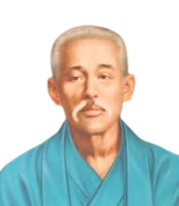

Grandmaster Kanryo Higashionna

(1853-1915)

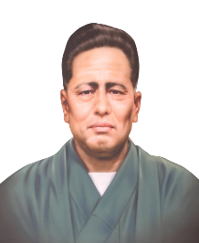

Grandmaster Hanshi Kichi Nakamoto

1931 10th DAN

Grandmaster **Chojun Miyagi** Founder GOJU RYU

(1888-1953)

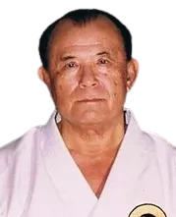 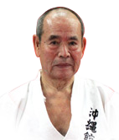

Grandmaster **Hanshi Eiichi Miyazato**

(1922-1999)

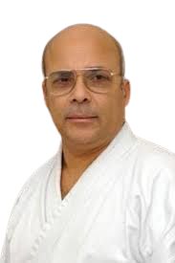

**Hanshi Jaime Pereira** 9th DAN

1949

**Shihan. Francisco Pereira**

1978 6th DAN

