CURRICULAM VITAE
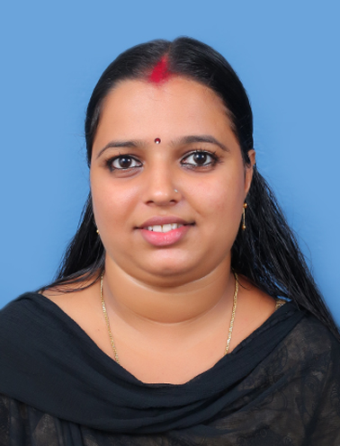
ANJU MADANAN
Kaliyampurathu (H)
Irapuram(PO)
koozhoor,Ernakulam
Kerala-683541
Email:Anjumadanan1994@gmail.com
Mob – +9539133000

OBJECTIVE
Seeking a responsible and challenging position with a progressive company, where my skills fully utilized for organization growth while providing opportunity for career growth.
AREAS OF INTEREST
- Digital electronics. & Electronics circuit
- Embedded System& Microcontroller
- Computer Hardware
ACHIEVEMENTS
- University First Rank Holder in Bsc Electronics 2018 Exam.
- PCB Training program in NTTF Bangalore
EDUCATIONAL QUALIFICATION

Examination | Discipline/  Specialization | School/College | Board/  University | Year of Passing | %
Python Django | Python Django | Avodha |  | On going
Bsc | Electronics | Ilahia college of  Arts and science | MG university | 2018 | 86%
Diploma | Mechatronics | NTTF cochin | Nettur Technical Training Foundation | 2014 | 85%
Pluse two | Biology-science | TTHSS,  Muvattupuzha | Higher Secondary Board | 2011 | 80%
X | - | St.Augestins girls HSS,Mvpa | Kerala state | 2009 | 86%

SOFTWARE & OTHER TECHNICAL SKILLS
Languages: C,C++,Visual basic , Keil , MP lab,Python Django
Operating Systems: Windows .
Other Technologies: Circuit design in circuit maker, Robot programming using teach pendent.
PREVIOUS EXPERIENCES
1Year and 4 Months work experience in THINTURE TECHNOLOGY’S PVT. LTD. Bangalore as Electronics Technician.
PROJECTS DONE
1. Project Name : Power Supply.
Description : Power supply for digital electronics lab, 5V, 500mA power supply
designed and assembled using 7805 regulator and filtering capacitors for
Accurate output.
Technologies Used : Circuit maker, 7805 regulator IC.

2. Project Name : Plant Watering Autonous Robort
Description : The mechatronics system developed using RF ID sensing module
and microcontroller.
Technologies used : RFID, PIC 16F877A

PERSONAL INFORMATION
Date of Birth : 19.06.1994
Sex : Female
Language Known : English, Malayalam
Nationality : Indian
Religion : Hindu
Marital Status : Married
Husband Name : RAKESH VENUGOPAL
Son Name : Ishan Krishna
Father Name : Madanan P M
Mother Name : Jamanthi
Interest : Reading, Music

I hereby declare that the information particulars furnished above are true and fair to my best of my knowledge and belief.

Place: Ernakulam Anju Madanan
Date: 1/12/2023

