# Introduction:

A gas detector is a device that detects the presence of gases in an area, often as part of a safety system. This type of equipment is used to detect a gas leak and interface with a control system so a process can be automatically shut down. A gas detector can sound an alarm to operator in the area where the leak is occurring, giving them the opportunity to leave. This type of device is important because there are many gases that can be harmful to organic life, such as humans or animals. Gas detectors can be used to detect combustible, flammable and toxic gases, and oxygen depletion. This type of device is used widely in industry and can be found in locations, such as on oil rigs, to monitor manufacture processes and emerging technologies such as photovoltaic. They may be used in fire fighting. In common usage, a gas leak refers to a leak of natural gas should not be present. Because natural gas may explode when exposed to flame or sparks, this situation is very dangerous to the general public. In addition to causing fire and explosion hazards, leaking flammable gases can kill vegetation, including large trees, and releases powerful greenhouse gases to the atmosphere.

Gas leak detection is the process of identifying potentially hazardous gas leaks by sensors. These sensors usually employ an audible alarm to alert people when a dangerous gas has been detected. Common sensors include point sensors, ultrasonic sensors, electrochemical gas sensors, and semiconductor sensors. More recently, infrared imaging sensors have come into use. All of these sensors are used for a wide range of applications and can be found in industrial plants, refineries, waste-water treatment facilities, vehicles, and homes.

The escape of harmful gases into the air from a closed container is called gas leakage. These leaked harmful gases may explode due to chemical reaction with other gases which results in the death of people and damage to the properties around. The gas leakage detection system will detect the harmful gases and alert the people around instantly by sounding alarm. The device is intended for use in household safety where appliances and heaters that use natural gas and liquid petroleum gas (LPG) may be a source of risk.

Gas detectors can be classified according to the operation mechanism (semiconductors, oxidation, catalytic, infrared, etc.). Gas detectors come packaged into two main form factors: portable devices and fixed gas detectors.

Portable detectors are used to monitor the atmosphere around personnel and are worn on clothing or on a belt/harness. These gas detectors are usually battery operated. They transmit warnings via audible and visible signals, such as alarms and flashing lights, when dangerous levels of gas vapors are detected. Fixed type gas detectors may be used for detection of one or more gas types. Fixed type detectors are generally mounted near the process area of a plant or control room, or an area to be protected, such as a residential bedroom. Generally, industrial sensors are installed on fixed type mild steel structures and a cable connects the detectors to a SCADA system for continuous monitoring. A tripping interlock can be activated for an emergency situation.

There are several different sensors that can be installed to detect hazardous gases in a residence. Carbon monoxide is a very dangerous, but odorless, colorless gas, making it difficult for humans to detect. Carbon monoxide detectors can be purchased for around 2000 rupees. Many local jurisdictions in the United States now require installation of carbon monoxide detectors in addition to smoke detectors in residences. Handheld flammable gas detectors can be used to trace leaks from natural gas lines, propane tanks, butane tanks, or any other combustible gas. These sensors can be purchased for around 3000 rupees. The MQ-6 sensor shown in figure 1.1 is a type of gas sensor we used in this project.

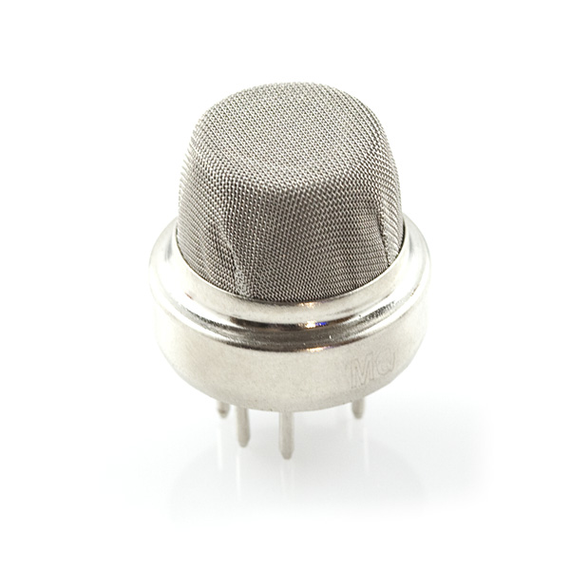

Fig 1.1 – MQ-6 gas sensor

## Gas Sensor Types

Some different types of gas sensors are:

1. **Electrochemical gas sensor:**

Electrochemical gas detector works by allowing gases to diffuse through a porous membrane to an electrode where it is either chemically oxidized or reduced. The amount of current produced is determined by how much of the gas is oxidized at the electrode, indicating the concentration of the gas. Manufactures can customize electrochemical gas detectors by changing the porous barrier to allow for the detection of a certain gas concentration range. Also, since the diffusion barrier is a physical/mechanical barrier, the detector tended to be more stable and reliable over the sensor's duration and thus required less maintenance than other early detector technologies.

However, the sensors are subject to corrosive elements or chemical contamination and may last only 1–2 years before a replacement is required. Electrochemical gas detectors are used in a wide variety of environments such as refineries, gas turbines, chemical plants, underground gas storage facilities, and more.

1. **Infrared point sensor:**

Infrared (IR) point sensors use radiation passing through a known volume of gas; energy from the sensor beam is absorbed at certain wavelengths, depending on the properties of the specific gas. For example, carbon monoxide absorbs wavelengths of about 4.2-4.5 μm. (This wavelength is approximately a factor of 10 larger than that of visible light, which ranges from 0.39 μm to 0.75 μm for most people.) The energy in this wavelength is compared to a wavelength outside of the absorption range; the difference in energy between these two wavelengths is proportional to the concentration of gas present.

This type of sensor is advantageous because it does not have to be placed into the gas to detect it and can be used for remote sensing. Infrared point sensors can be used to detect hydrocarbons and other infrared active gases such as water vapor and carbon dioxide. IR sensors are commonly found in waste-water treatment facilities, refineries, gas turbines, chemical plants, and other facilities where flammable gases are present and the possibility of an explosion exists. The remote sensing capability allows large volumes of space to be monitored.

Engine emissions are another area where IR sensors are being researched. The sensor would detect high levels of carbon monoxide or other abnormal gases in vehicle exhaust and even be integrated with vehicle electronic systems to notify drivers.

1. **Infrared imaging:**

Infrared imaging sensors include active and passive systems. For active sensing, IR imaging sensors typically scan a laser across the field of view of a scene and look for backscattered light at the absorption line wavelength of a specific target gas. Passive IR imaging sensors measure spectral changes at each pixel in an image and look for specific spectral signatures that indicate the presence of target gases. The types of compounds that can be imaged are the same as those that can be detected with infrared point detectors, but the images may be helpful in identifying the source of a gas.

1. **Semiconductor:**

Semiconductor sensors detect gases by a chemical reaction that takes place when the gas comes in direct contact with the sensor. Tin dioxide is the most common material used in semiconductor sensors, and the electrical resistance in the sensor is decreased when it comes in contact with the monitored gas. The resistance of the tin dioxide is typically around 50 kΩ in air but can drop to around 3.5 kΩ in the presence of 1% methane. This change in resistance is used to calculate the gas concentration. Semiconductor sensors are commonly used to detect hydrogen, oxygen, alcohol vapor, and harmful gases such as carbon monoxide. One of the most common uses for semiconductor sensors is in carbon monoxide sensors. They are also used in breath analyzers. Because the sensor must come in contact with the gas to detect it, semiconductor sensors work over a smaller distance than infrared point or ultrasonic detectors.

1. **Ultrasonic:**

Ultrasonic gas detectors use acoustic sensors to detect changes in the background noise of its environment. Since most high-pressure gas leaks generate sound in the ultrasonic range of 25 kHz to 10 MHz, the sensors are able to easily distinguish these frequencies from background acoustic noise which occurs in the audible range of 20 Hz to 20 kHz. The ultrasonic gas leak detector then produces an alarm when there is an ultrasonic deviation from the normal condition of background noise. Ultrasonic gas leak detectors cannot measure gas concentration, but the device is able to determine the leak rate of an escaping gas because the ultrasonic sound level depends on the gas pressure and size of the leak.

Ultrasonic gas detectors are mainly used for remote sensing in outdoor environments where weather conditions can easily dissipate escaping gas before allowing it to reach leak detectors that require contact with the gas to detect it and sound an alarm. These detectors are commonly found on offshore and onshore oil/gas platforms, gas compressor and metering stations, gas turbine power plants, and other facilities that house a lot of outdoor pipeline.

1. **Holographic:**

Holographic gas sensors use light reflection to detect changes in a polymer film matrix containing a hologram. Since holograms reflect light at certain wavelengths, a change in their composition can generate a colorful reflection indicating the presence of a gas molecule. However, holographic sensors require illumination sources such as white light or lasers, and an observer or CCD detector.

## Calibration:

All gas detectors must be calibrated on a schedule. Of the two form factors of gas detectors, portables must be calibrated more frequently due to the regular changes in environment they experience. A typical calibration schedule for a fixed system may be quarterly, bi-annually or even annually with more robust units. A typical calibration schedule for a portable gas detector is a daily "bump test" accompanied by a monthly calibration. Almost every portable gas detector requires a specific calibration gas which is available from the manufacturer. In the US, the Occupational Safety and Health Administration (OSHA) may set minimum standards for periodic recalibration.

1. **Challenge (bump) test:**

Because a gas detector is used for employee/worker safety, it is very important to make sure it is operating to manufacturer's specifications. Australian standards specify that a person operating any gas detector is strongly advised to check the gas detector's performance each day and that it is maintained and used in accordance with the manufacturer’s instructions and warnings.

A challenge test should consist of exposing the gas detector to a known concentration of gas to ensure that the gas detector will respond and that the audible and visual alarms activate. It is also important inspect the gas detector for any accidental or deliberate damage by checking that the housing and screws are intact to prevent any liquid ingress and that the filter is clean, all of which can affect the functionality of the gas detector. The basic calibration or challenge test kit will consist of calibration gas/regulator/calibration cap and hose (generally supplied with the gas detector) and a case for storage and transport. Because 1 in every 2,500 untested instruments will fail to respond to a dangerous concentration of gas, many large businesses use an automated test/calibration station for bump tests and calibrate their gas detectors daily.

1. **Oxygen concentration:**

Oxygen deficiency gas monitors are used for employee and workforce safety. Cryogenic substances such as liquid nitrogen (LN2), liquid helium (He), and liquid argon (Ar) are inert and can displace oxygen (O2) in a confined space if a leak is present. A rapid decrease of oxygen can provide a very dangerous environment for employees, who may not notice this problem before they suddenly lose consciousness. With this in mind, an oxygen gas monitor is important to have when cryogenics are present. Laboratories, MRI rooms, pharmaceutical, semiconductor, and cryogenic suppliers are typical users of oxygen monitors.

Oxygen fraction in a breathing gas is measured by elctro-galvanic fuel cell sensors. They may be used stand-alone, for example to determine the proportion of oxygen in a nitrox mixture used in scuba diving, or as part of feedback loop which maintains a constant partial pressure of oxygen in a re-breather.

1. **Hydrocarbons and VOCs:**

Detection of hydrocarbons can be based on the mixing properties of gaseous hydrocarbons – or other Volatile Organic Compounds (VOCs) – and the sensing material incorporated in the sensor. The selectivity and sensitivity depends on the molecular structure of the VOC and the concentration; however, it is difficult to design a selective sensor for a single VOC. Many VOC sensors detect using a Fuel-cell method.

VOCs in the environment or certain atmospheres can be detected based on different principles and interactions between the organic compounds and the sensor components. There are electronic devices that can detect ppm concentrations despite not being particularly selective. Others can predict with reasonable accuracy the molecular structure of the volatile organic compounds in the environment or enclosed atmospheres and could be used as accurate monitors of the chemical fingerprint and further as health monitoring devices. Solid-Phase Micro Extraction (SPME) techniques are used to collect VOCs at low concentrations for analysis.

# Literature survey:

## Introduction:

The gas leakage detection system will detect when there is a substantial leakage in the gas level in a house or an industry that may result in explosion. It will alert the surroundings by surrounding an alarm or sending a message to the required people. This is a project for the smart and safe home. he LPG or propane which is flammable mixture of hydrocarbon gases used as fuel in many applications like homes, hostels, industries, automobiles, vehicles because of its desirable properties which include high calorific value, which produce the less smoke, produces less soot, and does not cause much harm to the environment. Natural gas is another widely used fuel in homes. Both gases burns to produce clean energy, however there is a serious problem about their leakage in the air. The gases being heavier than air do not disperse easily and may lead to suffocation when inhaled also when gas leakage into the air may lead to explosion. Due to the explosion of LPG, the number of deaths has been increased in recent years. To avoid this problem there is a need for a system to detect and also prevent leakage of LPG. Gas leak detection is the process of identifying potentially hazardous gas leaks by means of various sensors. These sensors usually employ an audible alarm to alert people when a dangerous gas has been detected.

## Existing System:

The major part of gas leakage detection systems use the alarm method and most recently many systems are using the GSM Modem to deliver the alert message. But all the systems use the microcontroller to code the working of the system. Let us examine the existing system.

### 2.2.1 System using Microcontroller and Alarm:

A wireless safety device for gas leakage detection is proposed. The device is intended for use in household safety where appliances and heaters that use natural gas and liquid petroleum gas (LPG) may be a source of risk. The system also can be used for other applications in the industry or plants that depend on LPG and natural gas in their operations. The system design consists of two main modules: the detection and transmission module, and the receiving module. The detection and transmitting module detects the change of gas concentration using a special sensing circuit built for this purpose. This module checks if a change in concentration of gas(es) has exceeded a certain pre-determined threshold. If the sensor detects a change in gas concentration, it activates and audiovisual alarm and sends a signal to the receiver module. The receiver module acts as a mobile alarm device to allow the mobility within the house premises. The system was tested using LPG and the alarm was activated as a result of change in concentration.

Gas leakage is a major concern with residential, commercial premises and gas powered transportation vehicles. One of the preventive measures to avoid the danger associated with gas leakage is to install a gas leakage detector at vulnerable locations. The objective of this work is to present the design of a cost effective automatic alarming system, which can detect liquefied petroleum gas leakage in various premises. In particular, the alarming system designed has a high sensitivity for primarily butane, which is also individually sold bottled as a fuel for cooking and camping. The proposed system is designed to meet UK occupational health and safety standards. Test results are demonstrated for an USB powered gas leakage detection system and it gives early warning signals under less severe conditions and activates a high pitched alarm in case of emergency situations to safeguard the users.

Liquid petroleum gas (LPG) is commonly used in homes for central heating, hot-water, gas-fires, cooking, and in mobile heaters for leisure activities such as boats, caravans and barbecues. This energy source is primarily composed of propane and butane which are highly flammable chemical compounds. LPG leaks can happen, though rarely, inside a home, commercial premises or in gas powered vehicles. Leakage of this gas can be dangerous as it raises the risk of building fire or an explosion. The casualties caused by this hazard are still common news in the media. Since the LPG as such does not have any odour, gas companies/refineries add an odorant such as ethanethiol, thiophene or a mercaptan so that leaks can be detected easily by most people. However, some people who have a reduced sense of smell may not be able to rely upon this inherent safety mechanism. In such cases, a gas leakage detector becomes vital and helps to protect people from the dangers of gas leakage. A number of research papers have been published on gas leakage detection techniques. A wireless home safety gas leakage system has been proposed in where the alarm device provides mobility within the house premises.

Leakage detection and identifying its location is the most important task of pipeline operators in the gas industry. Flow monitoring and linear parameter varying (LPV) model based methods are widely used in the gas industry to detect gas leakage. Both these methods continuously measure the pressure at different sections of the pipeline, usually at extreme ends. However, the drawback of these techniques is that they are strongly dependent on the noise of pressure/temperature measurements. Reliability issues of gas leakage detectors were addressed in [9]. Gas leakage sounds generated from the cracks in the pipelines were analyzed in to locate the leakage. This paper provides a cost effective audio-visual solution for LPG leakage detection in homes and commercial premises and audibly alert the users of those premises in case of a hazardous situation and provide warning signals (beeps) in case of low risk scenarios – in particular, when the appliances may be left unattended in a premises or there is a risk of gas flames blowing out or being forgotten to be lit.

The proposed system ensures a continuous monitoring of the gas levels. If the gas level increases above the normal threshold level of 400ppm butane (LPG), the system starts to issue early warning alarms at 100ms interval, which implies low level gas leakage. If the leakage level increases to 575ppm of butane (LPG), the system activates high severity audio alarms at 50ms intervals warning the occupants to run to safety. To ensure the user’s/occupier’s safety, the alarm will not switch off until the level of gas reaches the normal value of 400ppm. These gas leakage levels correspond to the UK occupational safety standards.

The basic block diagram of the proposed system is shown in Figure 2.1. Any gas leak is detected by the sensor and the voltage output from the sensor is fed to the microcontroller for processing to produce an appropriate audio-visual alarm. The microcontroller receives a voltage signal proportionate to the extent of gas leak detected (low or high) and drives the alarming system connected with LEDs and buzzers. Bearing in mind the user accessibility and convenience, the system is made to produce both audio and visual alarms. LEDS represent the visual alarms, while the buzzers represent the audible alarms meant to draw the immediate attention of users.

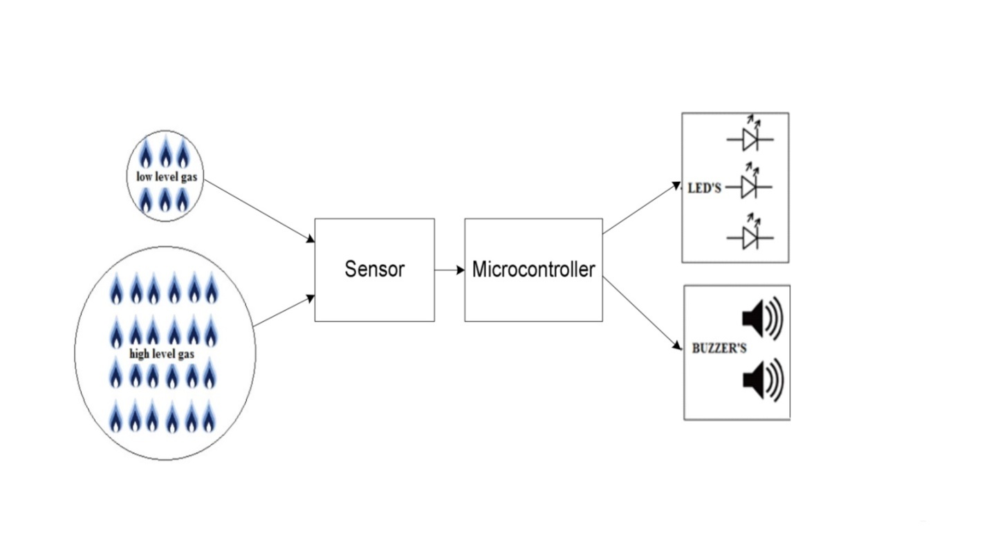

Fig 2.1 – Gas leakage detection system using alarm

The MQ-5 gas sensor has been selected as a candidate device which has the ability to sense multiple gases [16]. The sensitive material used in MQ-5 gas sensor is tin/stannic oxide (SnO2), which has lower conductivity in a clean air medium. When the target LPG leak is detected, the sensor’s conductivity rises and increases proportionately as the extent of gas leakage increases.

Using a PPM meter, the voltage ranges for butane gas concentration corresponding to various levels were measured and these are given in the table 2.1.

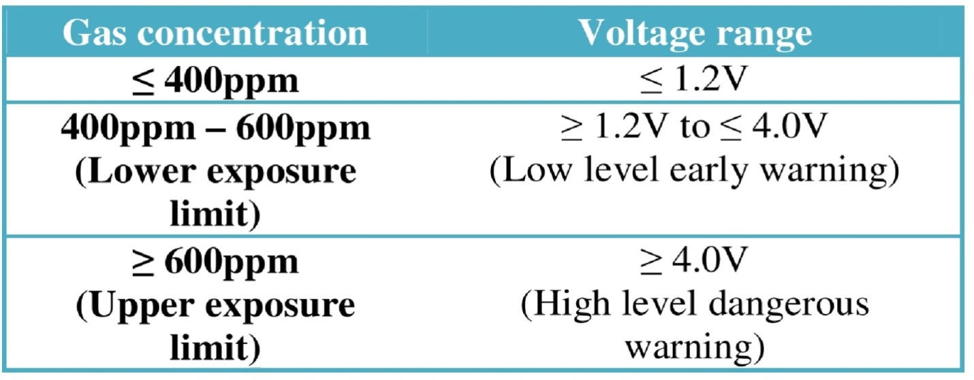

Table 2.1 – Relation between gas concentration and voltage

The PIC18F1320 microcontroller has been chosen to perform the desired task of gas leakage detection and activate the alarms when the exposure limit exceeds the acceptable values as per UK safety standards. The flowchart for the microcontroller program is shown in Figure 2.2.

When the sensor senses no gas in the air, it produces a voltage below 1.2V on the output pins which are connected to port RA0 of the microcontroller. When the sensor senses the presence of gas in the air due to a leak, the voltage rises above 1.2V. The voltage varies between 1.2V and 5V depending on the level of gas concentration detected. If the voltage is between 1.2V and 4V, the microcontroller activates a low level early warning by sending signals to ports RB1, RB2 and RB3 to turn-on the LEDs (LED_YELLOW, LED_GREEN) and the buzzer (BUZ1) respectively. The low level warning signal is then supplied for 100ms (slow mode) and then stopped. This step is constantly repeated until the voltage drops to 1.2V or below or until it rises above 4V.

If the voltage increases above 4V, then the high level dangerous warning sign is activated by sending signals to ports RB0, RB3 and RB4 to turn on the LED (LED_RED) and the buzzers (BUZ1, BUZ2) respectively. These signals are supplied for 50ms (fast mode) and then stopped. This step gets repeated until the voltage drops below 4.0V. The system remains active until the gas level is reduced below the acceptable limit of less than 400ppm.

The practical testing of the system was done using butane based lighter, which forms an ingredient of LPG. The test results confirm the efficient operation of the prototype by detecting low and high gas leakage levels and alerts the users by issuing appropriate audio-visual warning signals.

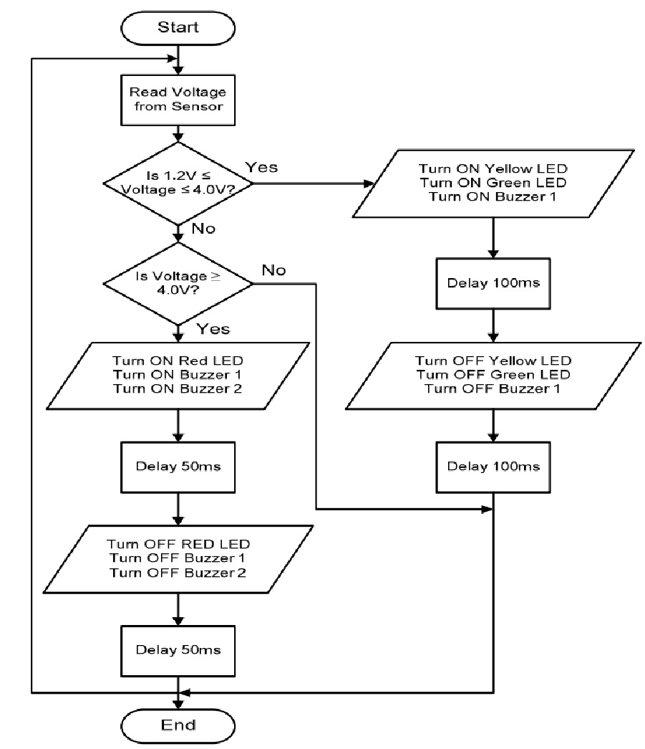

Fig 2.2 – Flowchart for the system

### 2.2.2 System using Microcontroller and GSM Modem:

The presence of dangerous LPG leakage in the cars, service station or in the storage tank environment can be detected using the Ideal Gas Sensor. This LPG gas leakage detector unit can be easily integrated into a unit that can sound an alarm or give a visual suggestion of the LPG concentration. The sensor has both admirable sensitivity and rapid response time. This sensor can also be used to sense other gases like iso-butane, propane, LNG and even cigarette smoke.

The output of the sensor goes LOW as soon as the LPG sensor senses any gas leakage from the storage. This is detected by the microcontroller and the LED & buzzer is turned ON. After the delay of few milliseconds, the exhaust fan is also turned ON for throwing the gas out and it continues sending message as ‘GAS LEAKAGE’ to a mobile number which is pre-defined.

MQ-5 semiconductor sensor is Combustible Gas Sensitive. The MQ-5 gas sensor is made up of SnO2 which has lower conductivity in clean air. A simple electro-circuit is used here which is used to convert the changing conductivity into corresponding output signal of gas concentration. Both Methane and Propane can be detected easily by MQ-5 sensor because it has high sensitivity towards Methane, Propane and Butane. It is a low cost sensor suitable for different application.

The figure 2.4 shows the design of the system. The system uses MQ-5 sensor, AVR microcontroller, LED, Buzzer, GSM module and exhaust fan. In this project we use the LPC2148 is based on 32 bit ARM7TDMI-S CPU which is the heart of the entire system controlling all processes. The control module composed of ARM7 processor, SDRAM, FLASH and related peripherals circuits. The main function of this controller is when the concentration of gas in the air exceeds the safety level then sends the message using GSM module to alert the consumer even when they are away from home. Any number of mobile numbers can be included to which SMS must be sent about the above mentioned details. This module used to activate the LED, Buzzer to alert the people at home to indicate the gas leakage and LCD display interfaced to the controller to display the message.

A GSM module assembles the GSM modem, serial communication and power supply. A GSM modem is a wireless modem looks like a mobile phone that works with the GSM network. AT commands are used to control the modem. Advantage of GSM modem is compact, low power consumption and standard AT commands interface to users and high quality SMS function.

Overall system was designed and tested by introducing the small amount of LPG near gas sensor module. The system detect the level of gas in the air if it exceeds the safety level then send a SMS to the consumer using GSM modem and activate the audio-visual alarm which includes LED, Buzzer to alert the user at home in abnormal condition and to take the necessary action.

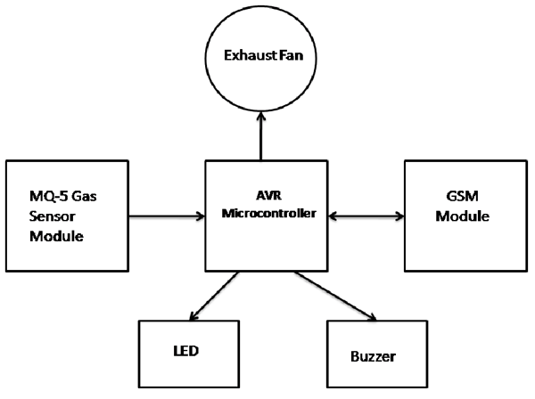

Fig 2.3 - Gas Detector using Microcontroller.

## Disadvantages of Existing System:

* Uses old model sensor.
* Less sensitive when compared to latest gas detectors.
* Microcontroller is hard to code compared to new Arduino boards.
* Exhaust fan makes the system very costly.
* Can detect only a few varieties of gases.
* Cannot support virtual pins.
* Only allows to code in assembly language.

## Proposed System:

In our gas leakage detection system using MQ-6 sensor, we connect the detection system to a mobile using Bluetooth, which notifies the people when there is a leakage in the gas system. Our system is developed mainly for elder and deaf people. We use three modules in our system, they are detection, transmission, receiving. The detection module detects the change of gas concentration using MQ-6 sensor. Transmitting module transmits the alert message using the Bluetooth in the detection system circuit. The receiving module is a mobile which receives the alert message. The outline of the proposed system will be as shown in the figure 2.5 below:

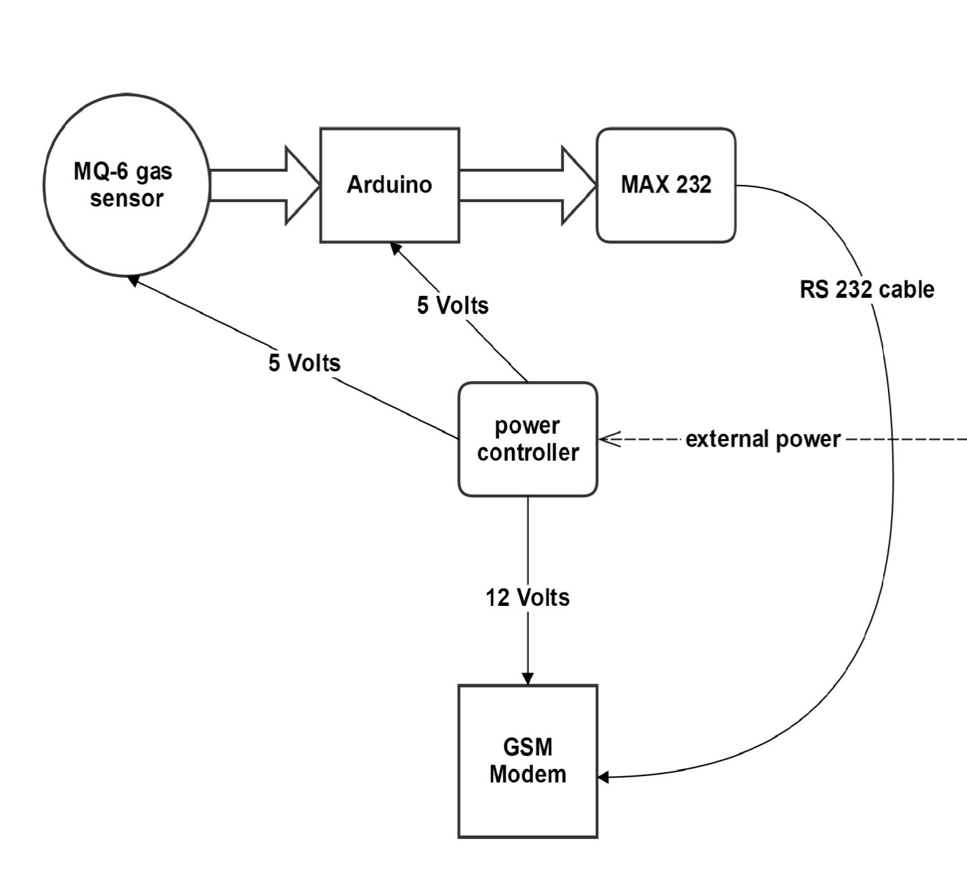

Fig 2.4 – Block diagram of proposed system

## Advantages of Proposed System:

* Uses the latest version of the gas sensor that is the MQ-6 sensor.
* Can detect more number of gases.
* Less sensitivity allows the sensor to detect even the mild leakage of the gases in the surroundings.
* Arduino board is used in the place of microcontroller, which allows us to get away from the assembly language.
* Can write the programs using C and C++ programming languages.
* Can make changes to the system easily.
* Arduino is open source and hence we can find the solutions and examples of the programs on the web.
* Allows us to create virtual pins.

# System Requirements:

The system mainly contains the hardware components and software for coding the working procedure of the system.

* 1. **Hardware Requirements:**
* MQ-6 gas sensor
* GSM-modem
* Arduino board
* Voltage regulator
* Rs-232 cable
* Max-232 translator

1. **MQ-6 gas sensor:**

The MQ series of gas sensors use a small heater inside with an electro-chemical sensor. They are sensitive for a range of gasses and are used indoors at room temperature. They can be calibrated more or less (see the section about "Load-resistor" and "Burn-in") but a known concentration of the measured gas or gasses is needed for Since there are no electronic components inside, therefore most sensors can be used with AC and DC voltages. The output is an analog signal and can be read with an analog input of the Arduino. The sensor is already shown in the figure 1.1. Let us see the wiring and details of the sensor.

The preferred wiring is to connect both 'A' pins together and both 'B' pins together. It is safer and it is assumed that is has more reliable output results. Although many schematics and datasheets show otherwise, you are advised to connect both 'A' pins together and connect both 'B' pins together.

In the picture, the heater is for +5V and is connected to both 'A' pins. This is only possible if the heater needs a fixed +5V voltage. The variable resistor in the figure 3.1 is the load-resistor and it can be used to determine a good value. A fixed resistor for the load-resistor is used in most cases. The Volt is connected to an analog input of the Arduino.

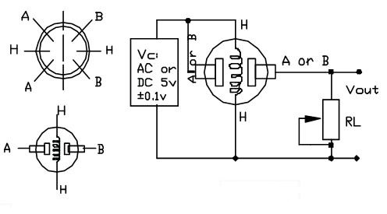

Fig 3.1 – wiring of MQ series sensors

The main features of MQ-6 sensor are:

• High Sensitivity to LPG, iso-butane, propane

• Small sensitivity to alcohol, smoke

• Detection Range: 100 - 10,000 ppm iso-butane propane

• Fast Response Time: <10s

• Simple drive circuit

• Heater Voltage: 5.0V

• Dimensions: 18mm Diameter, 17mm High excluding pins, Pins - 6mm High

1. **GSM-modem:**

A GSM modem is a specialized type of modem which accepts a SIM card, and operates over a subscription to a mobile operator, just like a mobile phone. From the mobile operator perspective, a GSM modem looks just like a mobile phone. GSM Modem comes in various interfaces, such as PCMCIA Type II, USB, and Serial. GSM Modem is However the main difference is that GSM Modem is wireless, while dial-up modem is wired. Some GSM Modems also has GPRS feature that allows tramission of data over TCP/IP (internet). To transmit data using GSM Modem, there are various methods that can be used, such as:

* SMS
* CSD or HSCSD
* GPRS / UMTS

Even though a normal mobile phone can be used as GSM Modem, it is highly recommended that a special industrial grade terminal to be used as a GSM Modem due to its stability and reliability. The GSM Modem will be as shown in figure 3.2 below:

A GSM Modem can be used to build the following applications:

* SMS Gateway to send and receive SMS
* telemetric to collect data from remote terminals
* call-back service for VOIP
* SMS application, SMS solution, or SMS program
* automatic reloading of pre-paid account with STK API
* machine to machine communication
* sending SMS from PC
* automating business process
* vehicle tracking with cell broadcast feature or with integrated GPS terminal

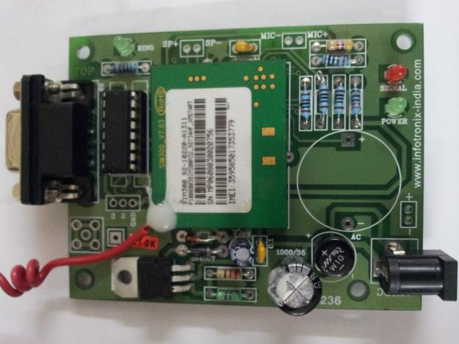

Fig 3.2 – GSM Modem

1. **Arduino Board:**

Arduino is an open-source computer hardware and software company, project and user community that designs and manufactures kits for building digital devices and interactive objects that can sense and control the physical world. Arduino boards may be purchased pre-assembled, or as do-it-yourself kits; at the same time, the hardware design information is available for those who would like to assemble an Arduino from scratch.

The project is based on a family of microcontroller board designs manufactured primarily by Smart Projects in Italy, and also by several other vendors, using various 8-bit Atmel AVR microcontrollers or 32-bit Atmel ARM processors. These systems provide sets of digital and analog I/O pins that can be interfaced to various extension boards and other circuits. The boards feature serial communications interfaces, including USB on some models, for loading programs from personal computers. For programming the microcontrollers, the Arduino platform provides an integrated development environment (IDE) based on the Processing project, which includes support for C and C++ programming languages.

The first Arduino was introduced in 2005. The project leaders sought to provide an inexpensive and easy way for hobbyists, students, and professionals to create devices that interact with their environment using sensors and actuators. Common examples for beginner hobbyists include simple robots, thermostats and motion detectors. Adafruit Industries estimated in mid-2011 that over 300,000 official Arduinos had been commercially produced, and in 2013 that 700,000 official boards were in users' hands. The Arduino board will be as shown in figure 3.3 below:

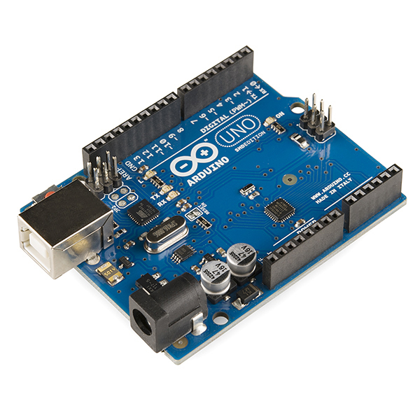

Fig 3.3 – Arduino

1. **RS-232:**

In telecommunications, RS-232 is a standard for serial communication transmission of data. It formally defines the signals connecting between a DTE (data terminal equipment) such as a computer terminal, and a DCE (data circuit-terminating equipment, originally defined as data communication equipment), such as a modem. The RS-232 standard is commonly used in computer serial ports. The standard defines the electrical characteristics and timing of signals, the meaning of signals, and the physical size and pin out of connectors. The current version of the standard is TIA-232-F Interface between Data Terminal Equipment and Data Circuit-Terminating Equipment Employing Serial Binary Data Interchange, issued in 1997.

An RS-232 serial port was once a standard feature of a personal computer, used for connections to modems, printers, mice, data storage, uninterruptible power supplies, and other peripheral devices. However, RS-232 is hampered by low transmission speed, large voltage swing, and large standard connectors. In modern personal computers, USB has displaced RS-232 from most of its peripheral interface roles. Many computers do not come equipped with RS-232 ports and must use either an external USB-to-RS-232 converter or an internal expansion card with one or more serial ports to connect to RS-232 peripherals. RS-232 devices are widely used, especially in industrial machines, networking equipment and scientific instruments. The RS 232 cable is shown in figure 3.4 below:

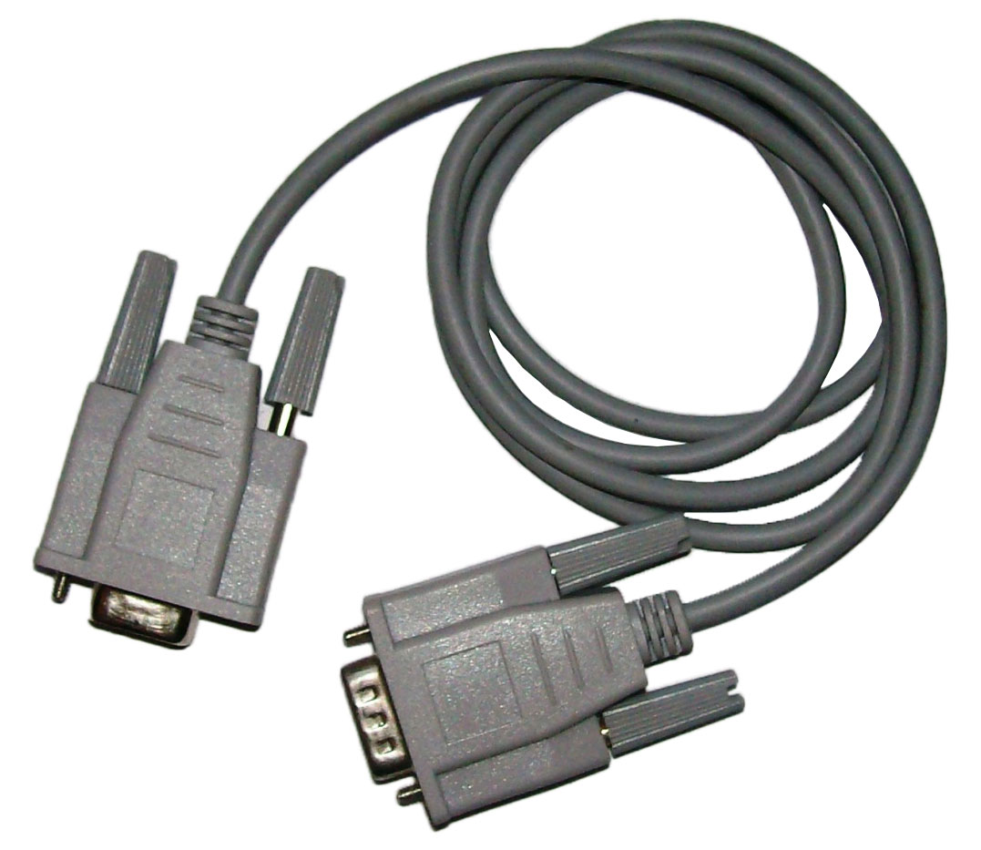

Fig 3.4 - RS 232 cable

1. **MAX 232:**

The MAX232 is an IC, first created in 1987 by Maxim Integrated Products, that converts signals from an RS-232 serial port to signals suitable for use in TTL compatible digital logic circuits. The MAX232 is a dual driver/receiver and typically converts the RX, TX, CTS and RTS signals.

The drivers provide RS-232 voltage level outputs (approx. ± 7.5 V) from a single + 5 V supply via on-chip charge pumps and external capacitors. This makes it useful for implementing RS-232 in devices that otherwise do not need any voltages outside the 0 V to + 5 V range, as power supply design does not need to be made more complicated just for driving the RS-232 in this case. The receivers reduce RS-232 inputs (which may be as high as ± 25 V), to standard 5 V TTL levels. These receivers have a typical threshold of 1.3 V, and a typical hysteresis of 0.5 V. It is helpful to understand what occurs to the voltage levels. When a MAX232 IC receives a TTL level to convert, it changes TTL logic 0 to between +3 and +15 V, and changes TTL logic 1 to between -3 to -15 V, and vice versa for converting from RS232 to TTL. This can be confusing when you realize that the RS232 data transmission voltages at a certain logic state are opposite from the RS232 control line voltages at the same logic state. The image for MAX 232 is shown in figure 3.5 below:

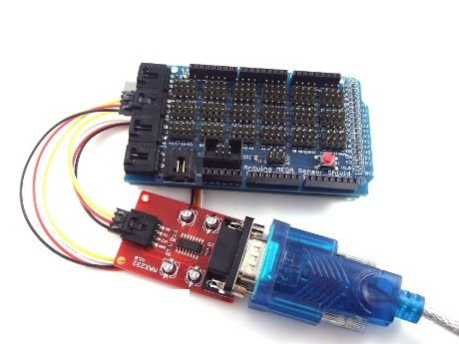

Fig 3.5 - MAX 232.

1. **Power Controller:**

In the system, the different components need different power input. The GSM Modem needs 12 volts but the remaining components need only 5 volts. So there is a need for this power controller which provides different power for different components. This device takes the power input and controls the voltage required for different components based on the circuit connections. The GSM Modem is given connection with the 12 volts and gnd. All the remaining components are given 5 volts and gnd. The power controller will be as shown in the figure 3.5.

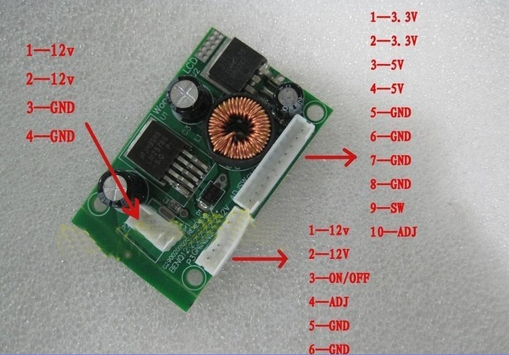

Fig 3.6 – Power controller

## Software Requirements:

The software here is used to code the working of the system. The only software we use in this system is:

* ARDUINO 1.6.0

The Arduino 1.6.0 is the latest software that is used to code the arduino board which is the main component that controls the working of the gas leakage detection system. The open-source Arduino Software (IDE) makes it easy to write code and upload it to the board. It runs on Windows, Mac OS X, and Linux. The environment is written in Java and based on Processing and other open-source software. This software can be used with any Arduino board. The logo for the Arduino software of version 1.6.0 is shown in figure 3.6 below.

The Arduino integrated development environment (IDE) is a cross-platform application written in Java, and derives from the IDE for the Processing programming language and the Wiring projects. It is designed to introduce programming to artists and other newcomers unfamiliar with software development. It includes a code editor with features such as syntax highlighting, brace matching, and automatic indentation, and is also capable of compiling and uploading programs to the board with a single click. A program or code written for Arduino is called a sketch.

Arduino programs are written in C or C++. The Arduino IDE comes with a software library called "Wiring" from the original Wiring project, which makes many common input/output operations much easier. Users only need define two functions to make a runnable cyclic executive program:

* setup(): a function run once at the start of a program that can initialize settings
* loop(): a function called repeatedly until the board powers off

A typical first program for a microcontroller simply blinks an LED on and off. In the Arduino environment, the user might write a program like this:

* #define LED_PIN 13

void setup ()

{

pinMode (LED_PIN, OUTPUT); // Enable pin 13 for digital output

}

void loop ()

{

digitalWrite (LED_PIN, HIGH); // Turn on the LED

delay (1000); // Wait one second (1000 milliseconds)

digitalWrite (LED_PIN, LOW); // Turn off the LED

delay (1000); // Wait one second

}

It is a feature of most Arduino boards that they have an LED and load resistor connected between pin 13 and ground; a convenient feature for many simple tests.[16] The previous code would not be seen by a standard C++ compiler as a valid program, so when the user clicks the "Upload to I/O board" button in the IDE, a copy of the code is written to a temporary file with an extra include header at the top and a very simple main() function at the bottom, to make it a valid C++ program.

The Arduino IDE uses the GNU toolchain and AVR Libc to compile programs, and uses avrdude to upload programs to the board. As the Arduino platform uses Atmel microcontrollers, Atmel's development environment, AVR Studio or the newer Atmel Studio, may also be used to develop software for the Arduino.

# Modules and their Functionalities:

The system is divided into some modules in order to make the process of building the system easier. The system is then implemented in modules and then combined into a single system. This method is very much suitable is group projects where the division of work needs to be done. In the gas leakage detection system, we have divided the system into 3 modules as follows:

* Detection – To detect the gas level leaked in the surroundings.
* Transmission – To send an alert message when the gas level exceeds a threshold value.
* Receiving – To receive the alert message send by the transmission module.

The modules of the system are as shown in figure 4.1.

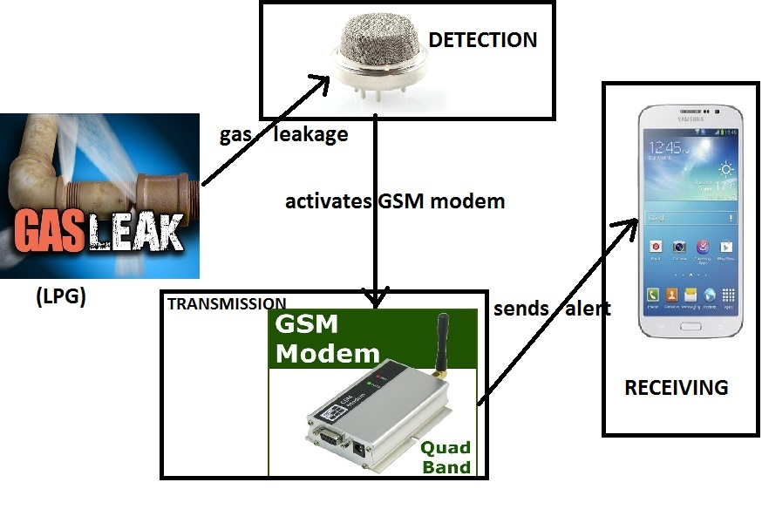

Fig 4.1 – Modules of the System

## Detection:

The process of tracing and finding out a gas is called as detection of gas. In this system one of the three modules is detection. The main purpose of this detection system is to trace the leaked gas, calculate its gas level and send analog signals to the Arduino circuit where the level checking is done. This module includes:

* Tracing the leaked gas
* Calculate its gas level
* Comparing the gas level to a pre fixed threshold value

In the detection process the leaked gas is sensed by the mq-6 sensor. The mq-6 sensor detects various gases like methane, propane, butane, LPG etc. This detection process also includes the classification of the type of gas which leaked. Then the mq-6 sensor sends analog signals to Arduino. On receiving the signals from the mq-6 sensor the Arduino will convert the analog value to a decimal value. The decimal value is compared to the threshold value or the limit we set in the code written for the Arduino.

## Transmission:

The sending of alert message to a mobile number that is set in the code written for Arduino whenever the limit exceeds is the transmission module. The main element in this module is the GSM Modem. The GSM Modem will be activated by the Arduino whenever the gas leakage level exceeds the threshold value. Then the Arduino will send the Alert message to the GSM Modem through the RS-232 cable and then it is transmitted to the owner by the GSM Modem.

## Receiving:

The main component of this module is the mobile. The main pre-requisite of this module is that the mobile should be connected to a network. The alert message that is send by the GSM Modem will be received by the mobile in this module. The system will be successful when the message is received by the mobile only when there is an ample leakage in the gas.

## 

# Software Design:

Let us see the basic idea of the system in the form of a picture as shown in the figure 5.1:

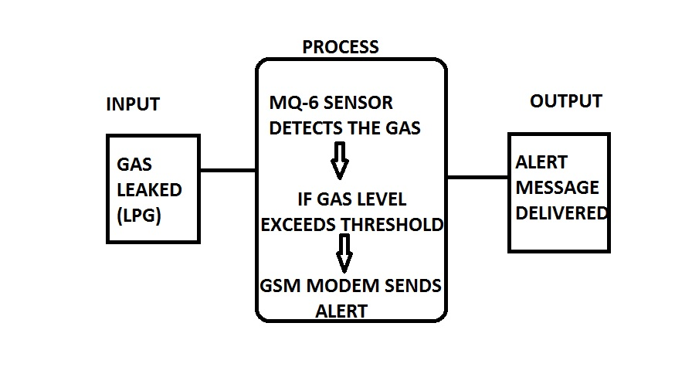

Fig 5.1 – Basic idea of the system

The system takes the gas as the input and always measures the quantity of the gas in the surroundings. Whenever the gas leakage exceeds the threshold value then the Arduino will send a signal to the GSM Modem to send an alert SMS to the pre-registered mobile number

## Activity Diagram:

Activity diagram is a graphical representation of the workflow and the sequence of activities used to describe the functioning of the system. This diagram shows the overall control flow of the system.

The Fig 5.2 is an activity diagram which shows the sequence of operations performed by the system in which it takes the gas input and waits until the gas leakage exceeds the limit. Once the gas exceeds the limit, the Arduino will activate the GSM Modem to send an SMS to the owner of the house. All these operations are clearly specified by the activity diagram below.

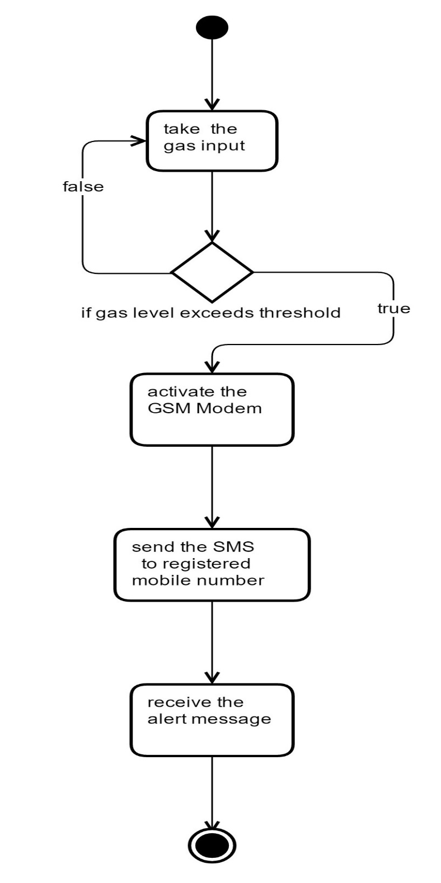

Fig 5.2 Activity Diagram

## Sequence Diagram:

Sequence diagram is an interaction diagram which shows how the processes interact with one another and in what order. It shows the object interactions arranged in time sequence. It represents the objects and classes involved in the scenario. It also shows the sequence of messages exchanged between those objects which are needed to perform different functionality of the scenario. Sequence diagrams are associated with use case realizations of the Logical View of the system. The figure 5.3 shows the Sequence diagram for the gas leakage detection system using MQ-6 sensor.

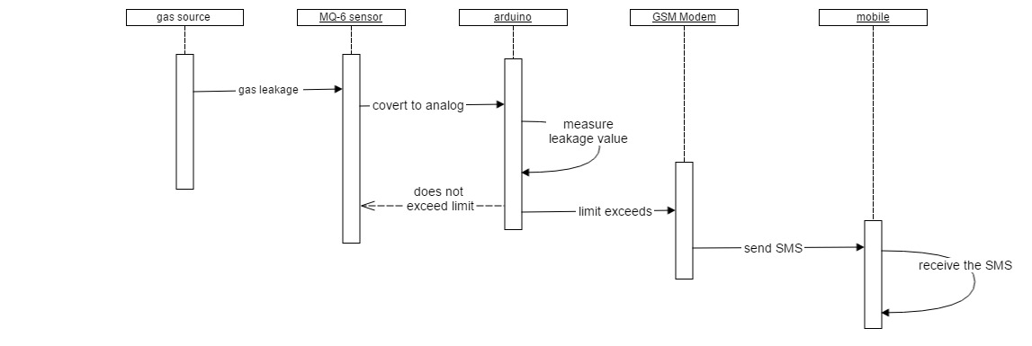

Fig 5.3 – Sequence Diagram

## Flowchart of the System:

The figure 5.4 shows the flowchart of the gas leakage detection system.

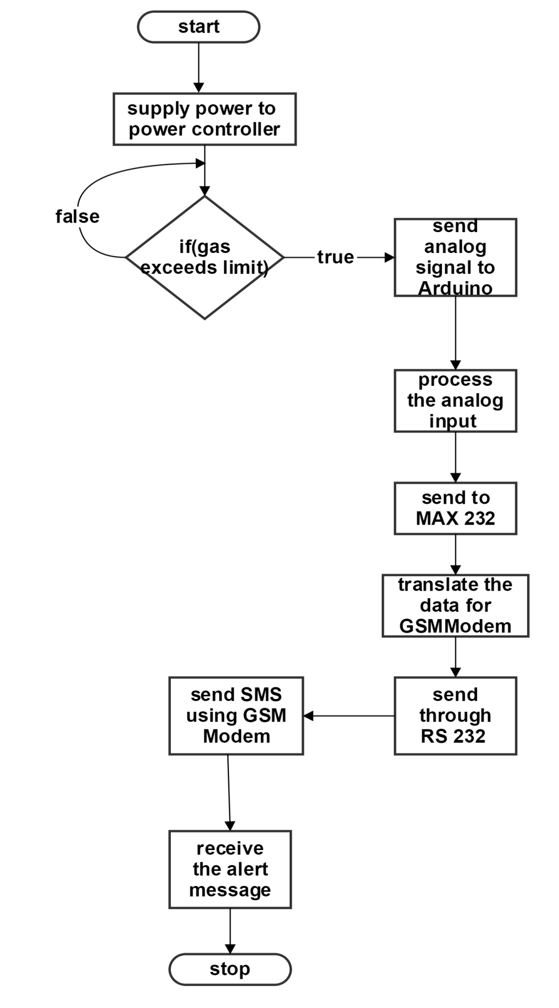

Fig 5.4 – Flowchart for the system

# CODE:

int buzzer=13;

int red=12;

int gre=11;

#include <SoftwareSerial.h>

SoftwareSerial gasSerial(2, 3);

void setup()

{

gasSerial.begin(9600);

Serial.begin(9600);

pinMode(buzzer, OUTPUT);

pinMode(red, OUTPUT);

pinMode(gre, OUTPUT);

digitalWrite(buzzer, LOW);

digitalWrite(gre,HIGH);

digitalWrite(red, LOW);

gasSerial.println("AT");

Serial.print("AT");

delay(100);

gasSerial.println("AT+CMGF=1");

Serial.println("AT+CMGF=1");

delay(100);

gasSerial.println("AT+CNMI=2,2,0,0,0");

Serial.println("AT+CNMI=2,2,0,0,0");

delay(100);

Serial.print("VR GAS SAFETY SYSTEM");

delay(5000);

}

void loop()

{

digitalWrite(buzzer,LOW);

int gasval=analogRead(A1);

Serial.println(gasval);

delay(2000);

if(gasval>100)

{

digitalWrite(buzzer,HIGH);

digitalWrite(red,HIGH);

digitalWrite(gre,LOW);

Serial.println("RED-HIGH ,GRE:LOW,BUZZER:HIGH");

delay(1000);

gasSerial.println("AT+CMGS=\"9666626425\"");

Serial.println("AT+CMGS=\"9177736542\"");

delay(1000);

gasSerial.print("GAS SAFTY SYSTEM");

gasSerial.print("Warning Gas lekage ");

Serial.print("Warning Gas lekage ");

gasSerial.write(26);

delay(5000);

digitalWrite(buzzer,LOW);

digitalWrite(red,LOW);

digitalWrite(gre,HIGH);

Serial.println("RED-LOW ,GRE:HIGH,BUZZER:LOW");

}

}

# TESTING:

A process of executing a program with the explicit intention of finding errors, that is making the program fail. Testing is the process of detecting errors. Testing performs a very critical role for quality assurance and for ensuring the reliability of software. The results of testing are used later on during maintenance also.

## Unit testing and Integrated testing:

A unit test is a test written by the programmer to verify that a relatively small piece of code is doing what it is intended to do. They are narrow in scope, they should be easy to write and execute, and their effectiveness depends on what the programmer considers to be useful. The tests are intended for the use of the programmer, they are not directly useful to anybody else, though, if they do their job, testers and users downstream should benefit from seeing fewer bugs.

Part of being a unit test is the implication that things outside the code under test are mocked or stubbed out. Unit tests shouldn't have dependencies on outside systems. They test internal consistency as opposed to proving that they play nicely with some outside system.

An integration test is done to demonstrate that different pieces of the system work together. Integration tests cover whole applications, and they require much more effort to put together. They usually require resources like database instances and hardware to be allocated for them. The integration tests do a more convincing job of demonstrating the system works (especially to non-programmers) than a set of unit tests can, at least to the extent the integration test environment resembles production.

Actually "integration test" gets used for a wide variety of things, from full-on system tests against an environment made to resemble production to any test that uses a resource (like a database or queue) that isn't mocked out.

## Unit testing:

It concentrates on each unit of the software as implemented in source code and is a white box oriented. Using the component level design description as a guide, important control paths are tested to uncover errors within the boundary of the module. In the unit testing, the steps can be conducted in parallel for multiple components. In my project we tested all the modules individually using the main component of the respective module.

As already mentioned the three modules of the system are:

* Detection
* Transmission
* Receiving

Let start the unit testing by performing the test of detection. As MQ-6 sensor is the one used for the detection purpose, this test mainly involves the testing of the MQ-6 gas sensor. The test result for the MQ-6 sensor is shown in the table 7.1 below:

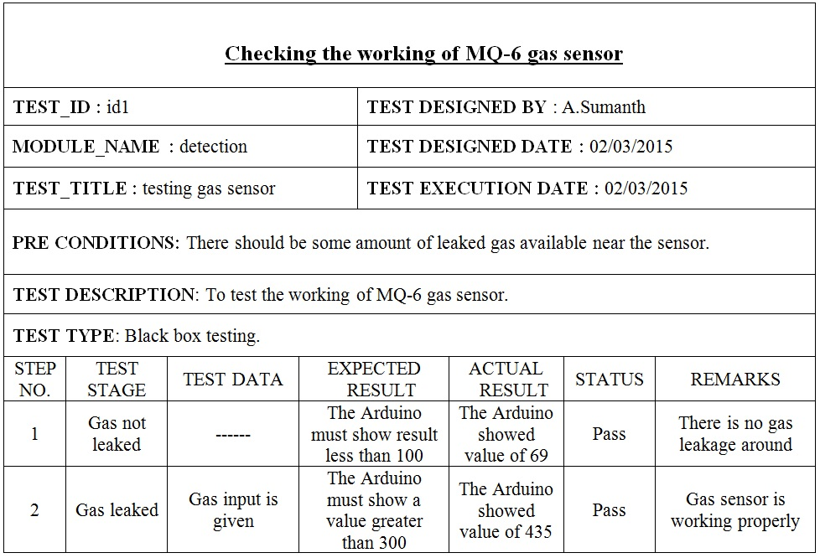

Table 7.1 – Testing the detection module

Now we will move to the next module, Transmission. The main component here is the GSM Modem. So we are going to test the working of the GSM modem individually. First we will send a signal to Arduino that there is no leakage in gas and then in the second step we will send a signal that the gas is leaking and now the GSM Modem should deliver the SMS. The test results for the Transmission module using GSM Modem is shown in table 7.2. The test is successfully completed as the message is not sent in the first case but was sent by the GSM Modem in the second case. All this can be observed from the Arduino connected to a computer.

The last module is receiving. The mobile should receive the SMS to complete the process. In the first case of no gas leakage, there is no message received by the system but in the second case the message is successfully received by the mobile. This module is tested individually by sending a general message from the GSM Modem. The message is successfully received by the mobile when we sent the message from the GSM Modem. This test case is shown in the table 7.3 below.

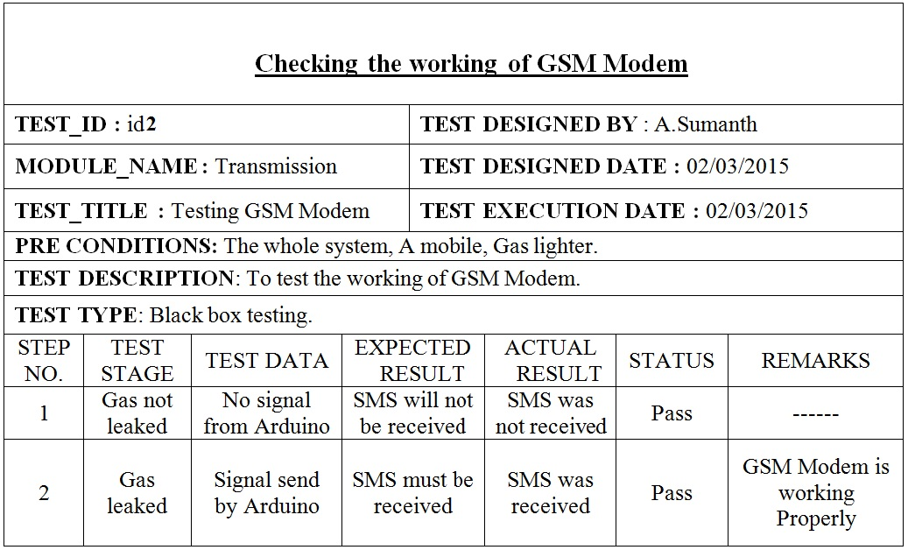

Table 7.2 – Testing the transmission module

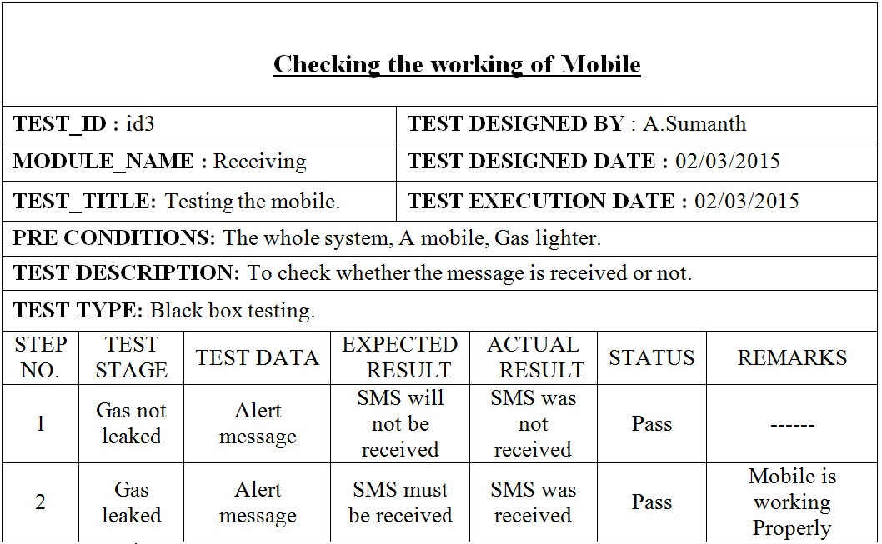

Table 7.3 – Testing the receiving module

## Integrated Testing:

The integrated testing will test the working of the whole system. In this test the whole system is taken into consideration and the testing is done by comparing the final output of the system to the desired result for which we have built the system. Now coming to the system, there will be no output that is a message will not be received in the case of normal surroundings and the system is switched on. Then we will leak the gas using a lighter which leaks butane gas. Then the system must send an SMS. We have tested this using path testing. The results of the path testing are as follows:

# Output Screens:

## Power not given:

The figure 8.1 shows the system while the power is not given. The system is ideal and will not detect any gases until the power is given to the power controller.

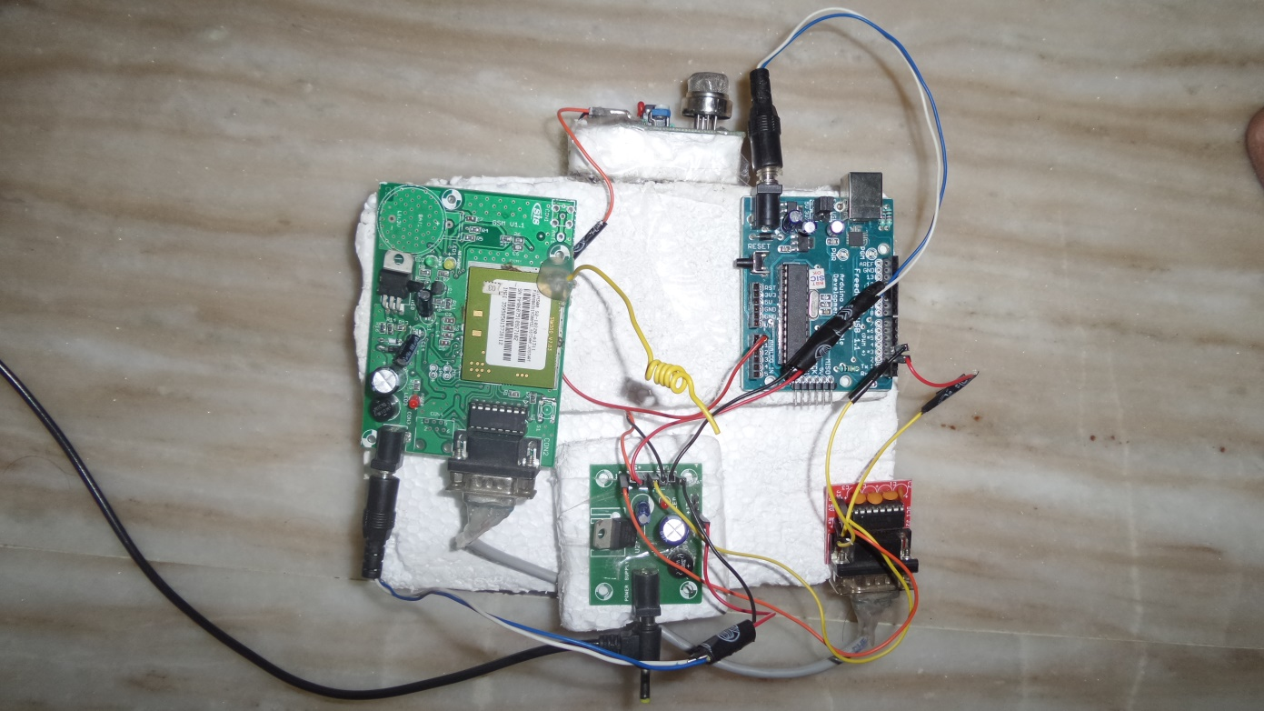

Fig 8.1 – System with no power

## Power switched on:

Now the power controller will divide and supply the required power to the required components. This will be as shown in figure 8.2:

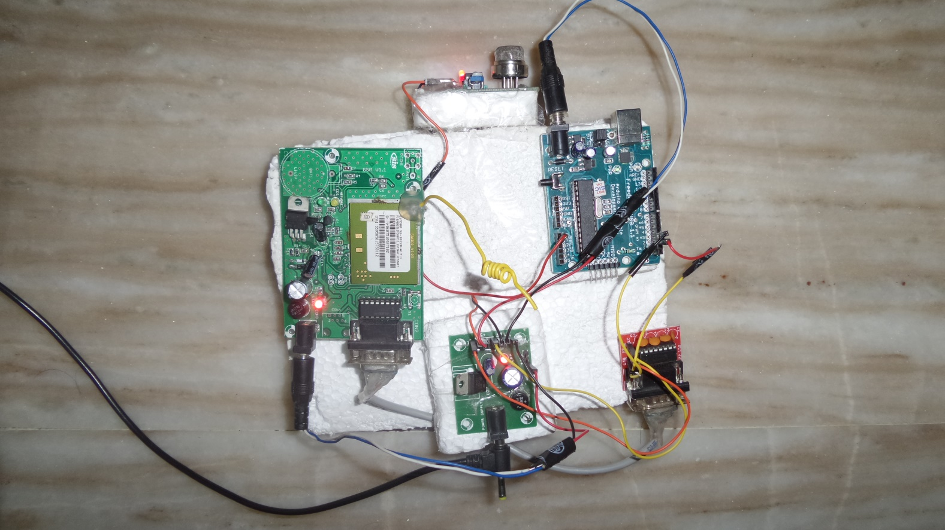

Fig 8.2 – System with power switched on

## Checking the SIM card in GSM Modem:

A call is made to the SIM inserted in the GSM Modem. Then the green light will lit as shown in the figure 8.3:

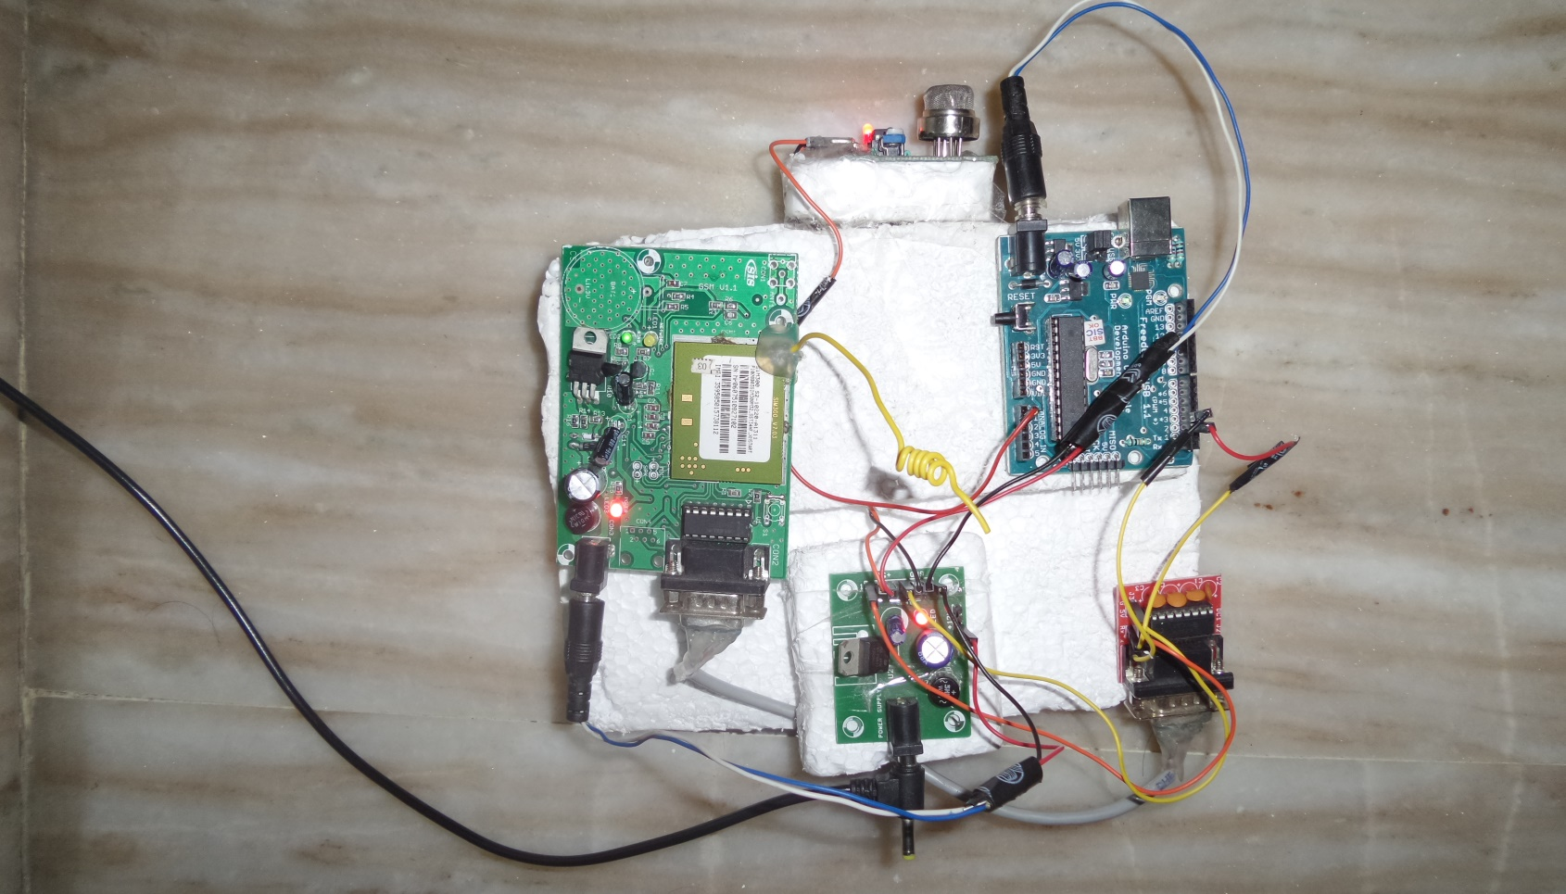

Fig 8.3 – checking the GSM Modem

## Leaking the gas:

A gas lighter which leaks butane gas is used to leak some gas near the gas sensor. This will be as shown in figure 8.4:

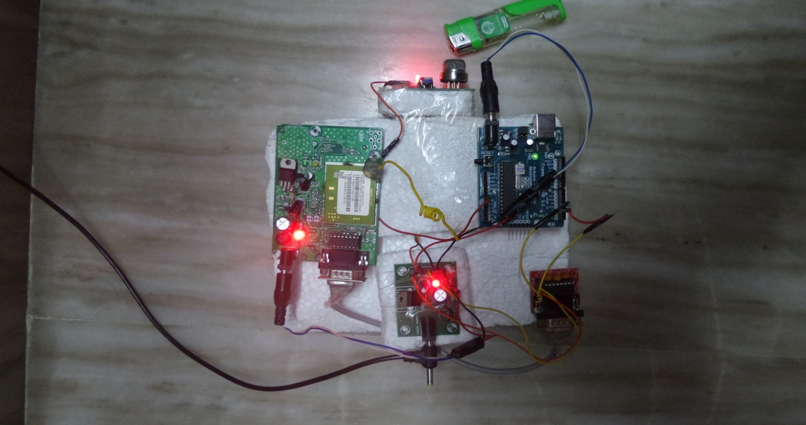

Fig 8.4 – Gas leakage using lighter

## Message received to the house owner:

The message will be delivered to the mobile of the house owner whose number is used in the code written for the Arduino. The message will be received by the owner and it will be as shown in figure 8.5:

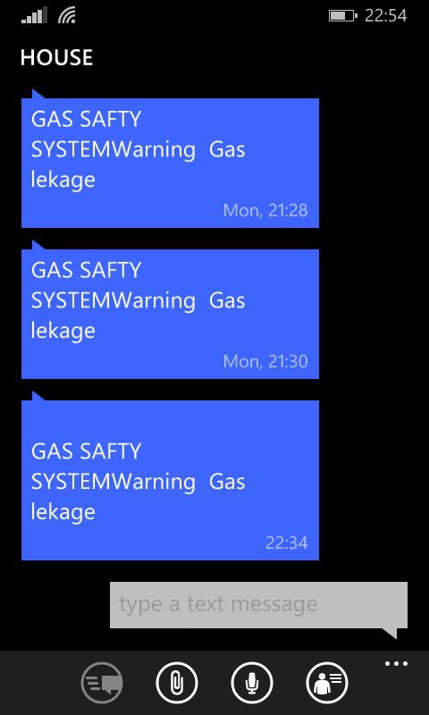

Fig 8.5 – Received message

# Conclusion and Future work:

## Conclusion:

The system which we opt to build is successfully implemented. The system we built now can deliver message at any time when there is a leakage of gas in the surroundings. The message is getting delivered in less than 10 seconds to the house owner when the mobile phone of the owner is connected to the network. All the elements are successfully tested individually and also integrated testing is performed to check all the working of the components combined to form the system. The system made can also be used in industries as the system can detect more harmful gases along with the LPG for which the system is primarily made.

## Future work:

The main idea in extending this system is to automatically switch off the gas source whenever the gas leakage is detected. This extension will be more helpful as there is no need for the house owner to reach the house or even there is no danger when he is the house too. This future work will surely make the project a big step towards the smart home and will definitely reduce the number of fire accidents drastically.

# References:

[1]. GSM:”Architecture, protocols and services” by JorgEberspacher, Christian, Hansjoergvogel, Christian Hartmann, John Wiley Son Ltd, 2009.

[2]. LuayFriwan, KhaldonLweesy, AyaBani-Salma, Nour Mani , “AWireless Home Safety Gas Leakage Detection System”, IEEE 2011.

[3]. Hanwei Electronics Co. Ltd, MQ 6 sensor Datasheet.

[4]. W. Chung, and D. Lee, "Real time multi-channel gas leak monitoring system using CPLD chip," Sensors and Actuators B, Vol. 77, pp. 186-189, 2001.

[5]. Rajkamal, ”Embedded Systems: Architecture, Programming and Design”, Tata McGraw-Hill Education.

[6]. AshishShrivastava, Rahul Verma,―2nd National Conference in Intelligent Computing & Communication‖ Dept. of IT, GCET, Greater Noida, INDIA.

[7]. [14] Bˆarsan N and Weimar U 2001 Conduction model of metal oxide gas sensors J. Electroceramics, 143–67.

[8]. Barsan N, Schweizer-Berberich M and G¨opel W 1999 Fundamentals and practical applications to designnanoscaled SnO2 gas sensors: a status report Fresenius J. Anal. Chem, 287–304.

[9]. T. Murugan, A. Periasamy and S. Muruganand, ―Embedded Based Industrial temperature monitoring system using GSM,‖International Journal of computer application, vol. 58, no. 19, Nov. 2012.