How to install VirtualBox, Vagrant and a Virtual Machine in Windows 10

1. First Download the virtual box from official website for windows.

<https://www.virtualbox.org/wiki/Downloads>

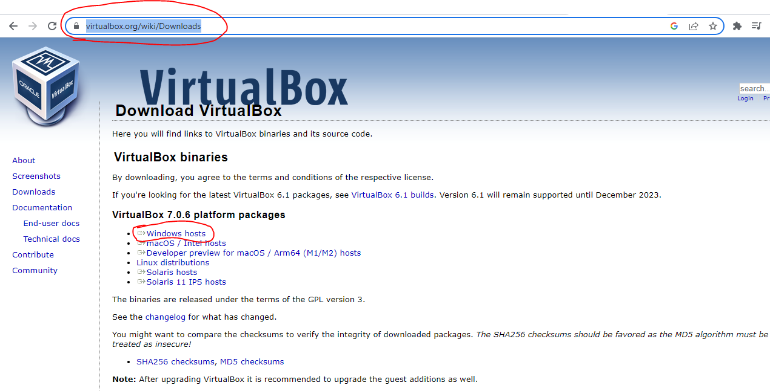

1. Install Virtual Box with default setting next -next button.

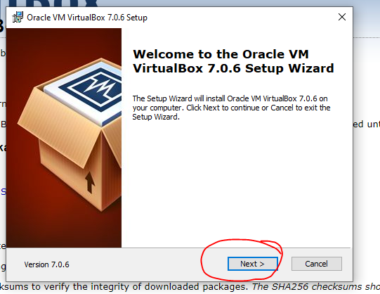

## 3.Download Vagrant from official site for windows according to os type.

## <https://developer.hashicorp.com/vagrant/downloads>

## 

## 4.Install the Vagrant by just clicking next button.

## 

## 5. After installation of both, Restart the system.

## 6. Open command prompt .

## (Windows + r and type cmd then Enter)

## 7. create one folder and enter that folder .

## mkdir VirtualBox

## cd VirtualBox

## 

## 8. Create another folder in this directory and enter that folder.

## mkdir ubuntu14

## cd ubuntu14

## 

## 9. now download ubuntu iso using command

## vagrant box add ubuntu/trusty64

## 

## 10. After successfully add initialize iso using command.

## vagrant init ubuntu/trusty64

## 

## 11. After that install vagrant plugin using command

## vagrant plugin install vagrant-vbguest

## 

## 12. Now run the command vagrant up , it start the virtual machine in virtual box in backend.

## vagrant up

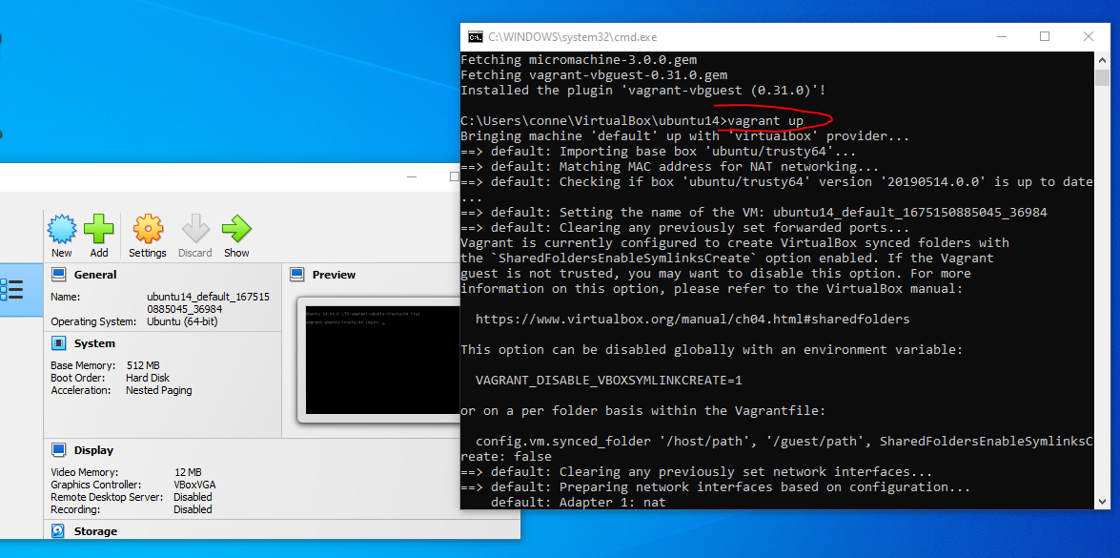

13. Now login to virtual machine using command

vagrant ssh

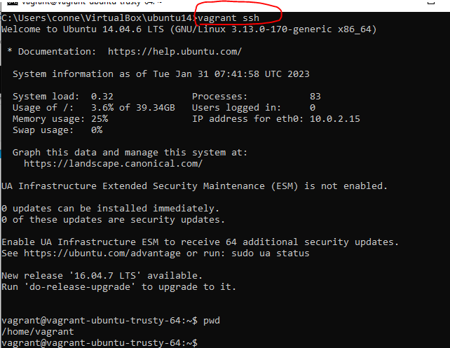

14. Now you are login successfully. For checking type any linux command like pwd , ls.

15. for logout type exit and for poweroff type vagrant halt

