1.ONLINE VOTING – USE CASE DIAGRAM.

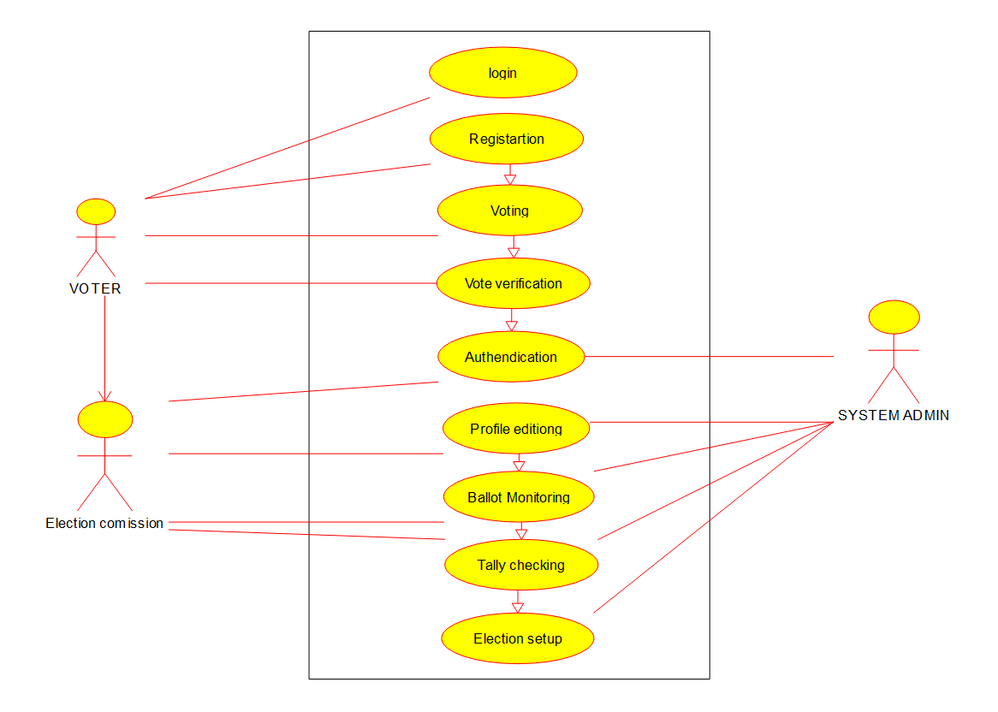

2.LIBRARY MANAGEMENT – USE CASE

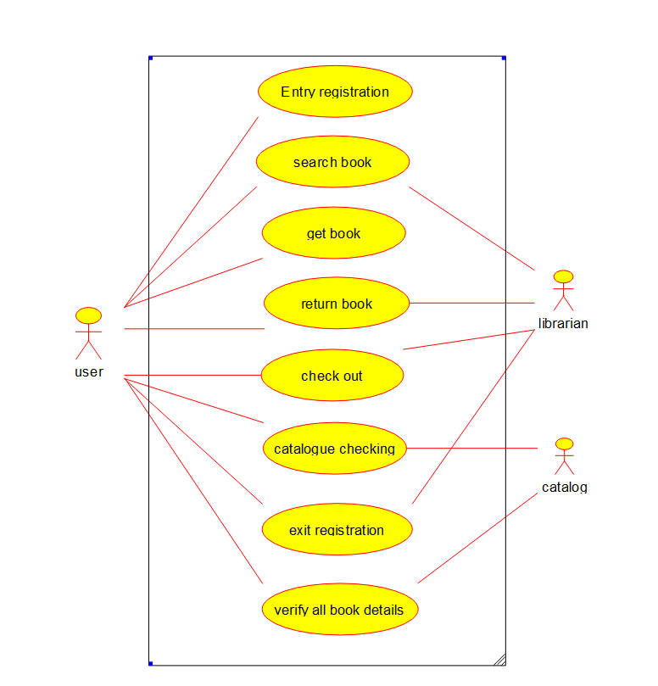

3.QUOTIENT AND REMAINDER – FLOW CHART

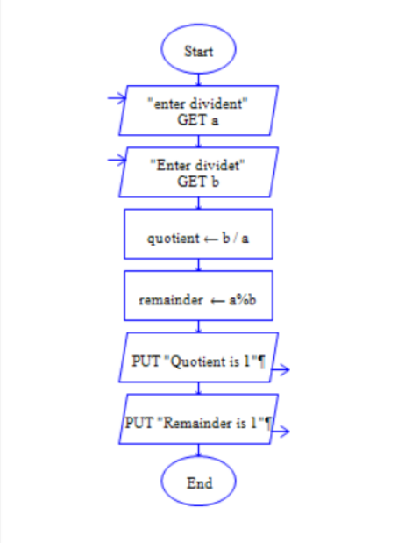

4.ONLINE SHOPPING

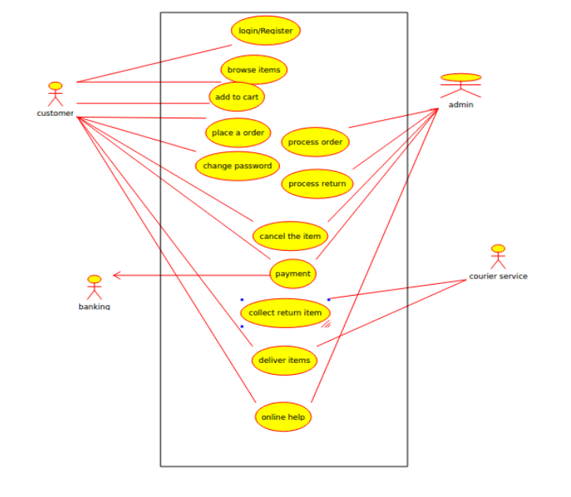

5.RAILWAY RESEERVATION SYSTEM – USE CASE

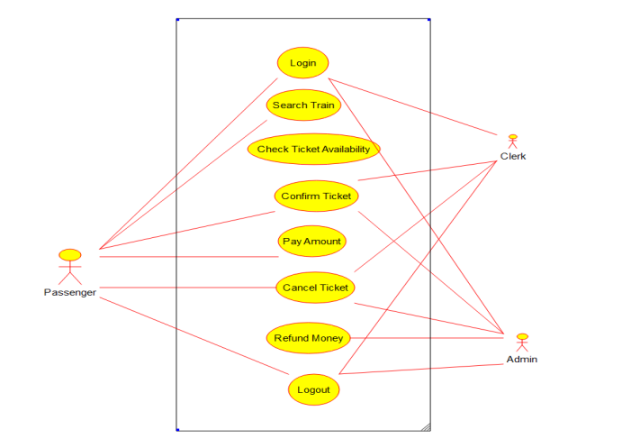

6.HOSPITAL MANAGEMENT SYSTEM-USE CASE

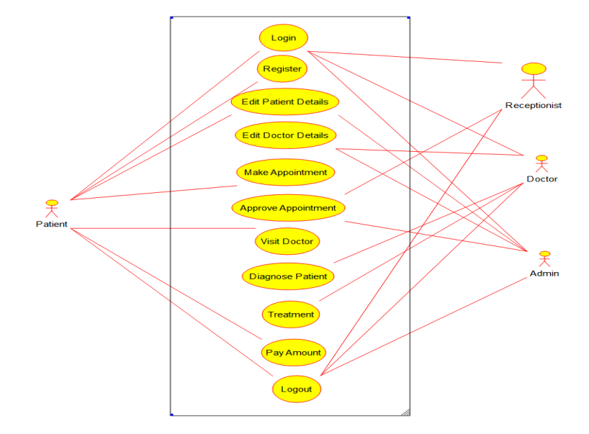

7.ATM SYSTEM – USE CASE



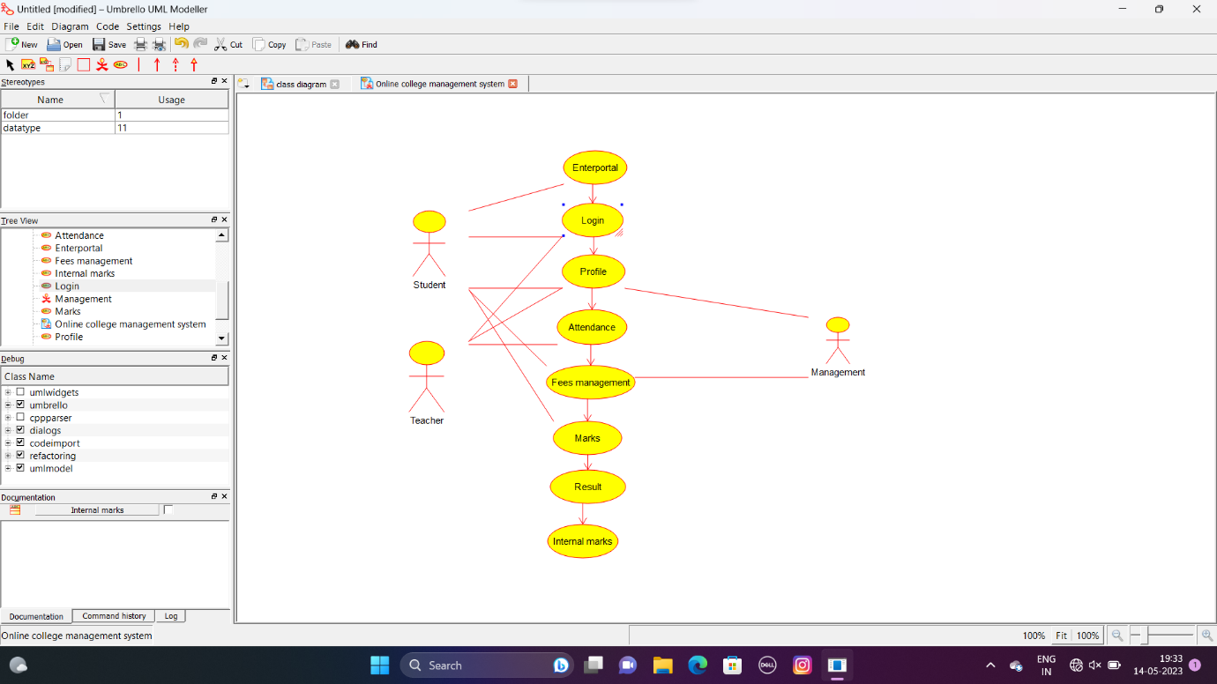8.ONLINE COLLEGE MANAGEMENT SYSTEM – USE CASE

9.ONLINE AIRLINE RESERVATION – USE CASE

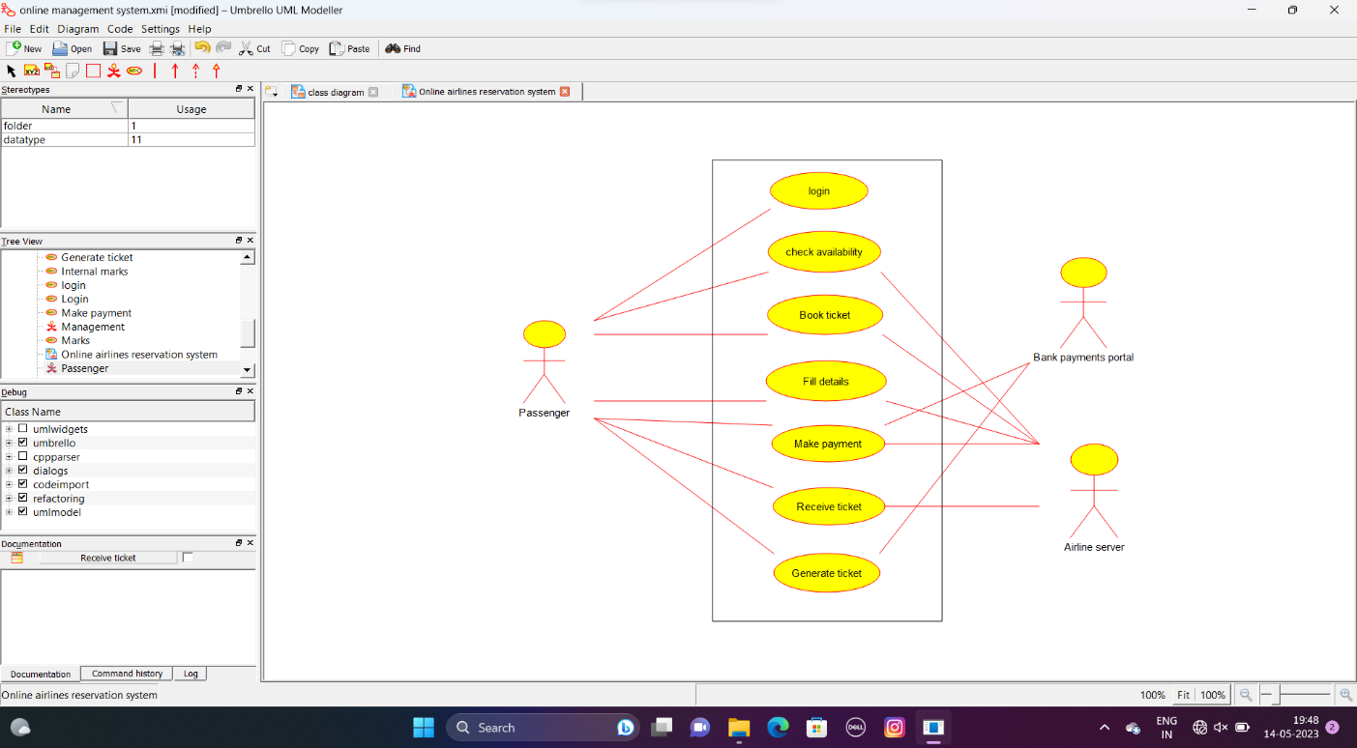

10.ONLINE AIRLANE RESERVATION SYSTEM – CLASS DIAGRAM

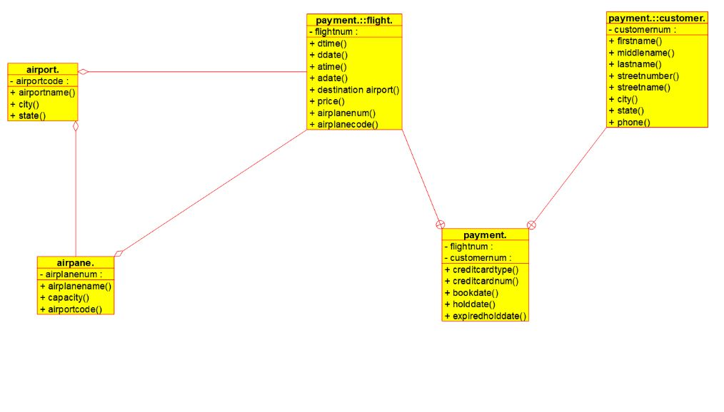

11.ONLINE VOTING SYSTEM – CLASS DIAGRAM

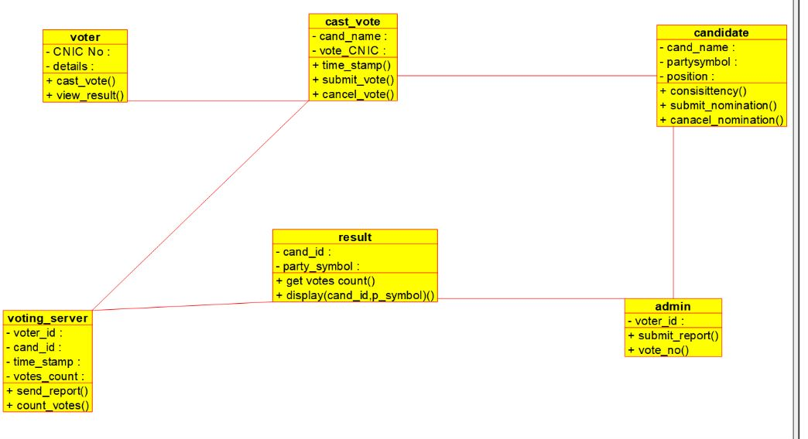

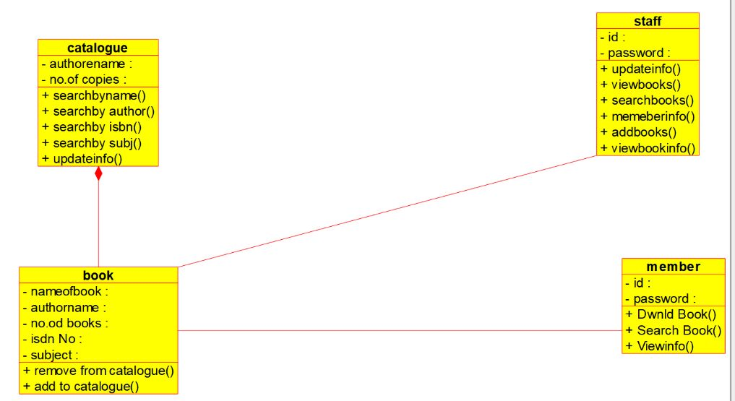12.LIBRARY MANAGEMENT SYSTEM – CLASS DIAGRAM

13. ONLINE VOTING SYSTEM – ACTIVITY DIAGRAM

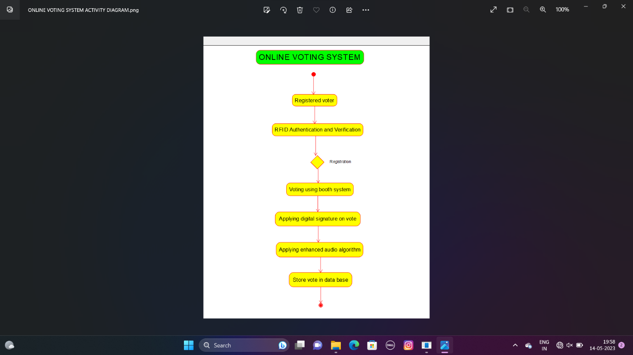

14.LIBRARY MANAGEMENT SYSTEM – USE CASE

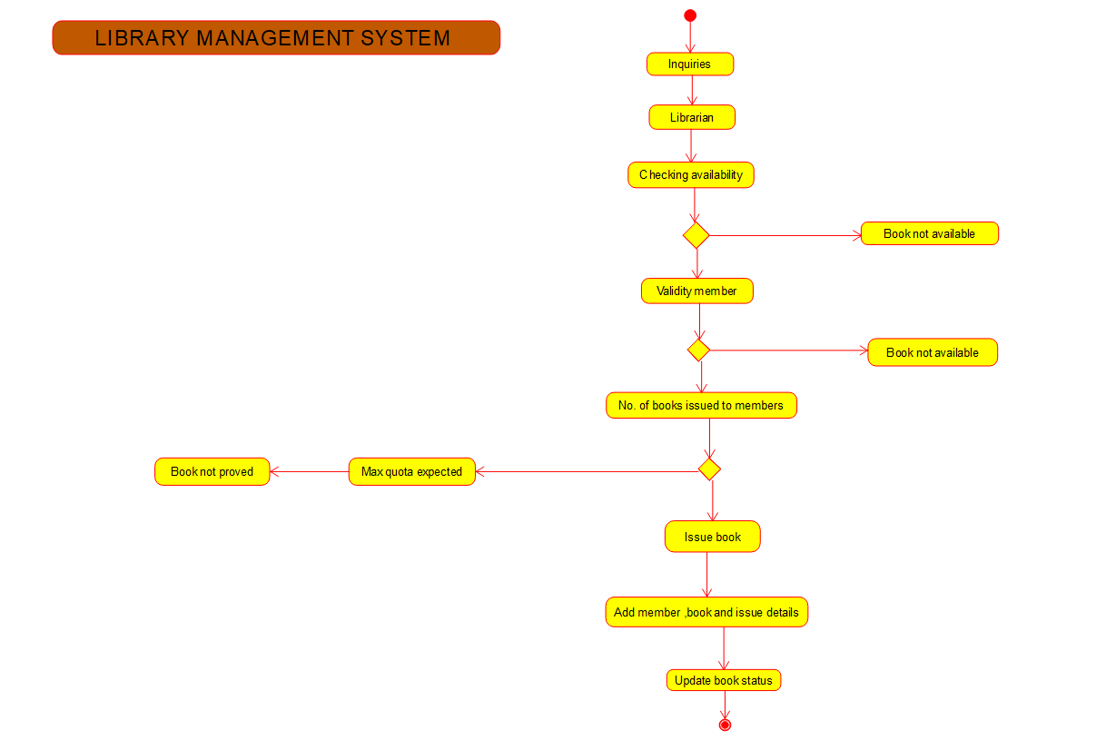

15. ONLINE SHOPPING SYSTEM – ACTIVITY DIAGRAM

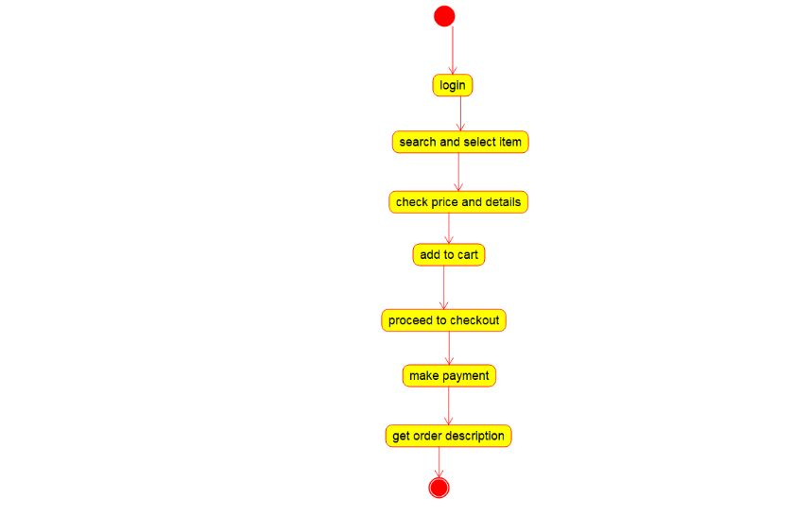

16. ONLINE RAILWAY RESERVATION – ACTIVITY DIAGRAM

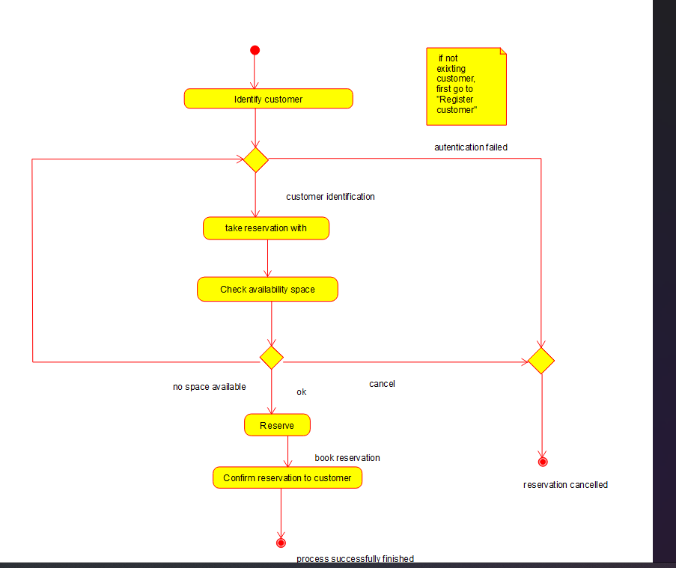

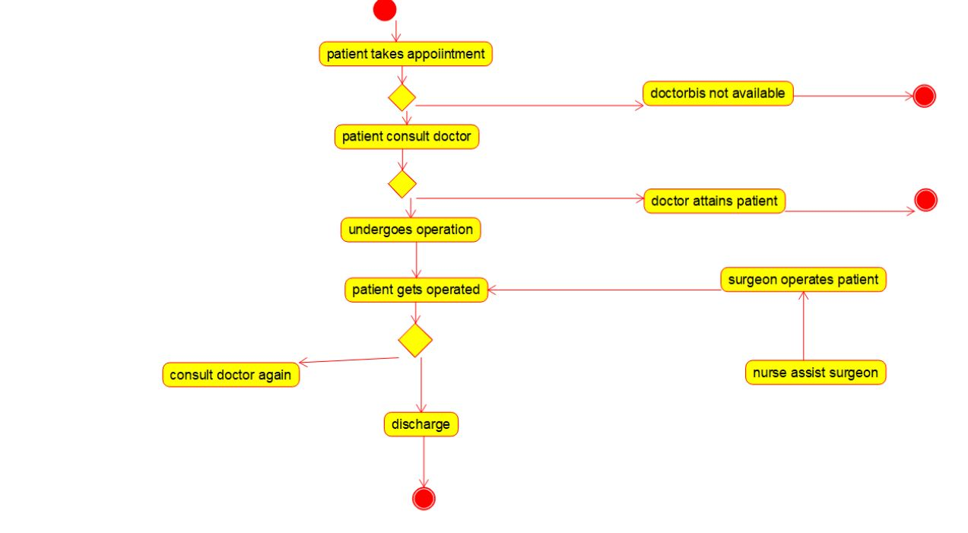17.HOSPITAL MANAGEMENT SYSTEM – ACTIVITY DIAGRAM

18.PALINDROME – FLOW CHART

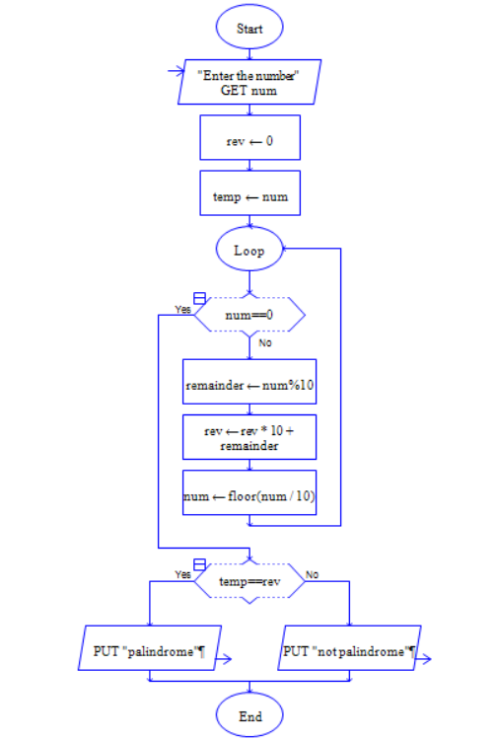

19

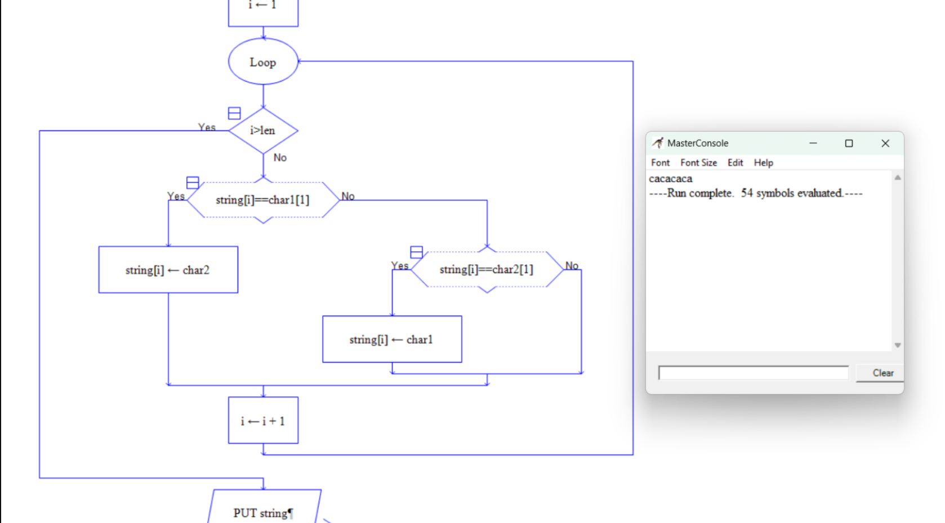

20. NUMBER OF CHARACTER IN A STRING

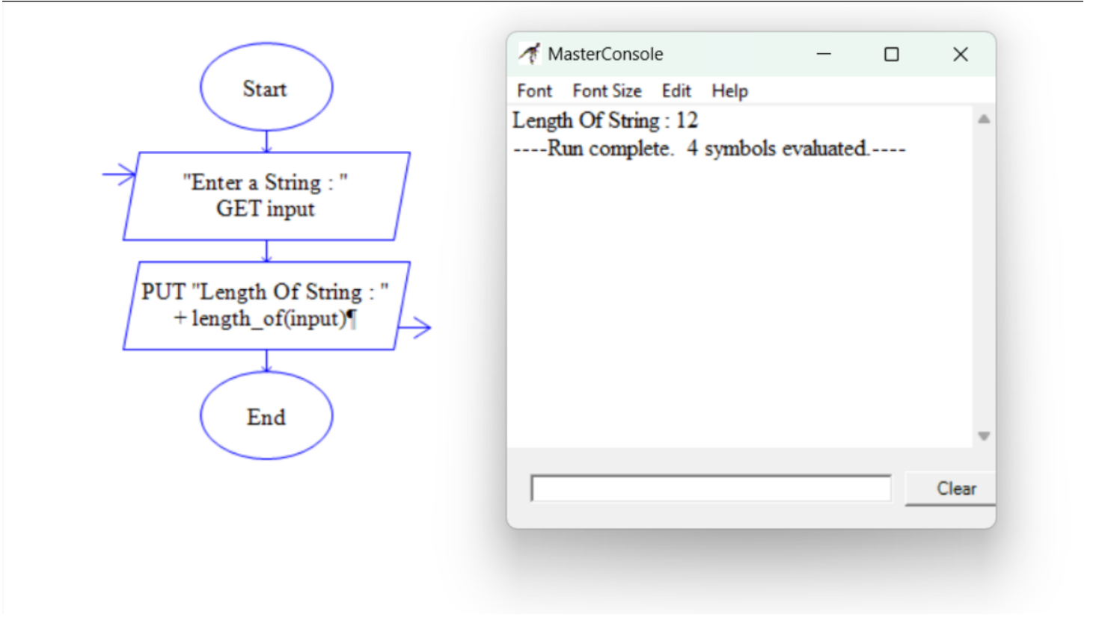

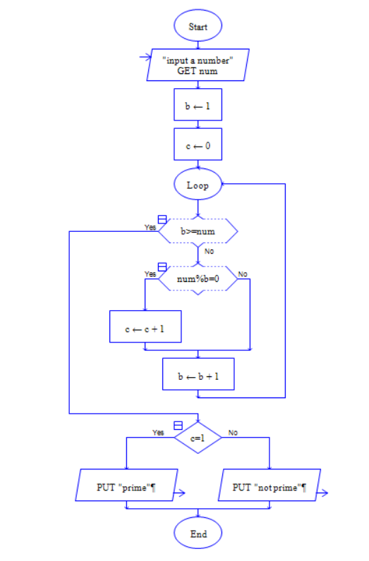21.PRIME OR NOT – FLOW CHART

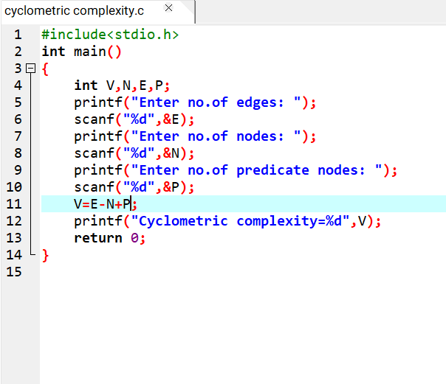22.CYCLOMETRIC COMPLEXITY CALCULATION

23.ACTIVITY DIAGRAM FOR AUTOMATED ONLINE BAMKING SYSTEM

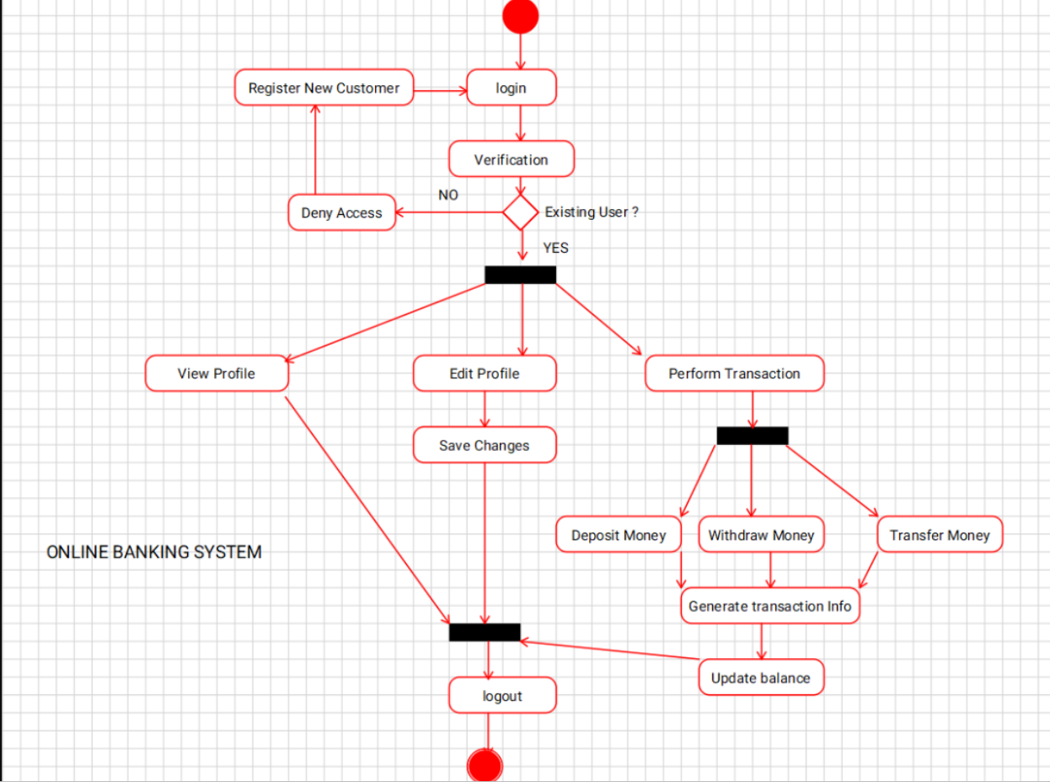

24.ACTIVITY DIAGRAM FOR E-LIBRARYONLINE PUBLINE ACCESS CATALOGUE

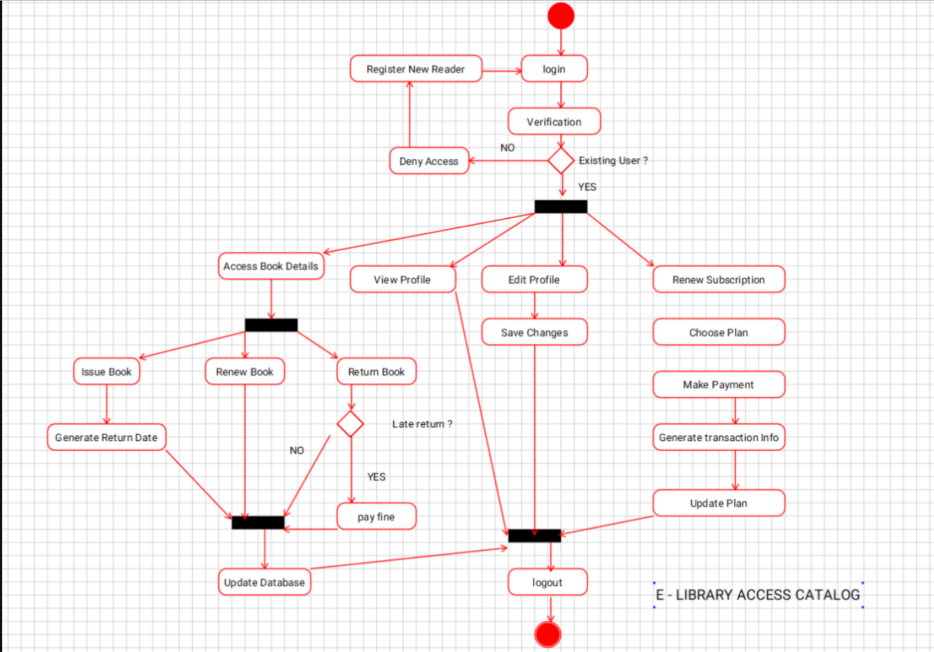

25.E-LIBRARY ONLINE PUBLIC ACCESS – CLASS DIAGRAM

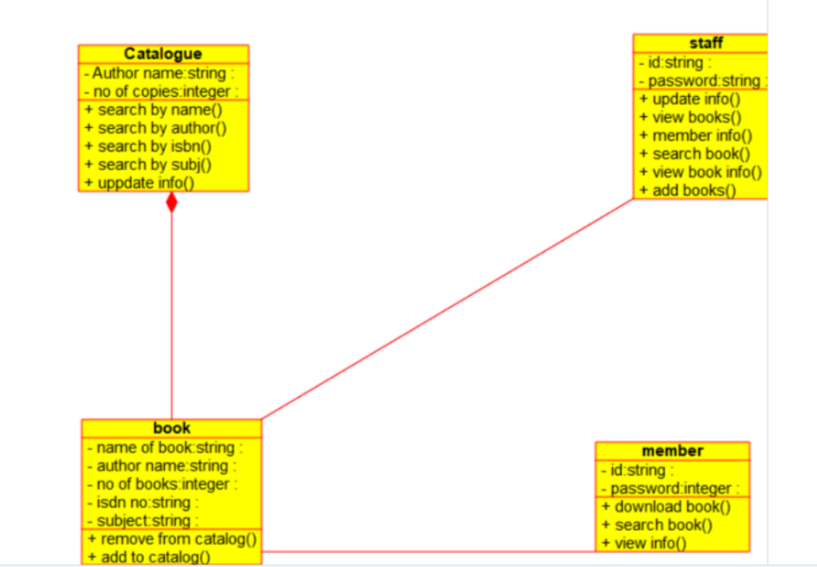

26.RESTAURANT SYSTEM – USE CASE

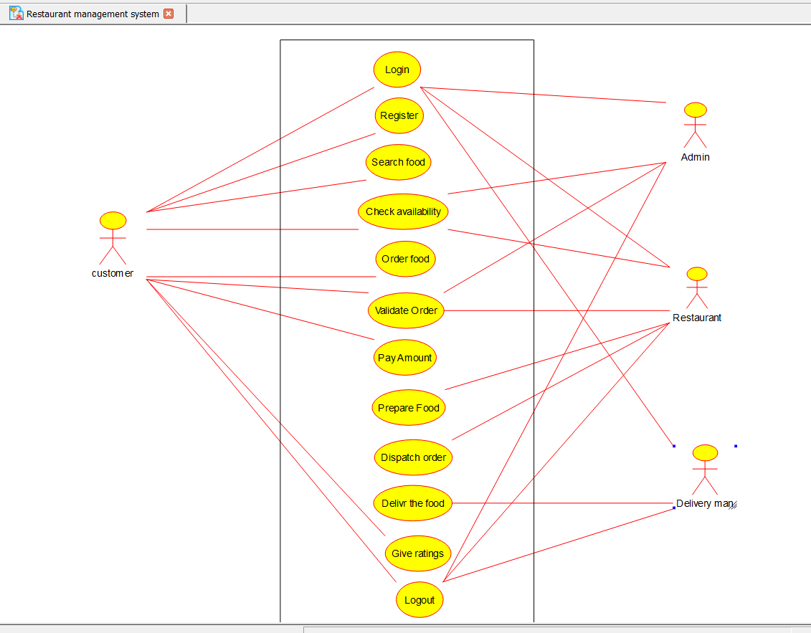

27. RESTAURANT SYSTEM – CLASS DIAGRAM

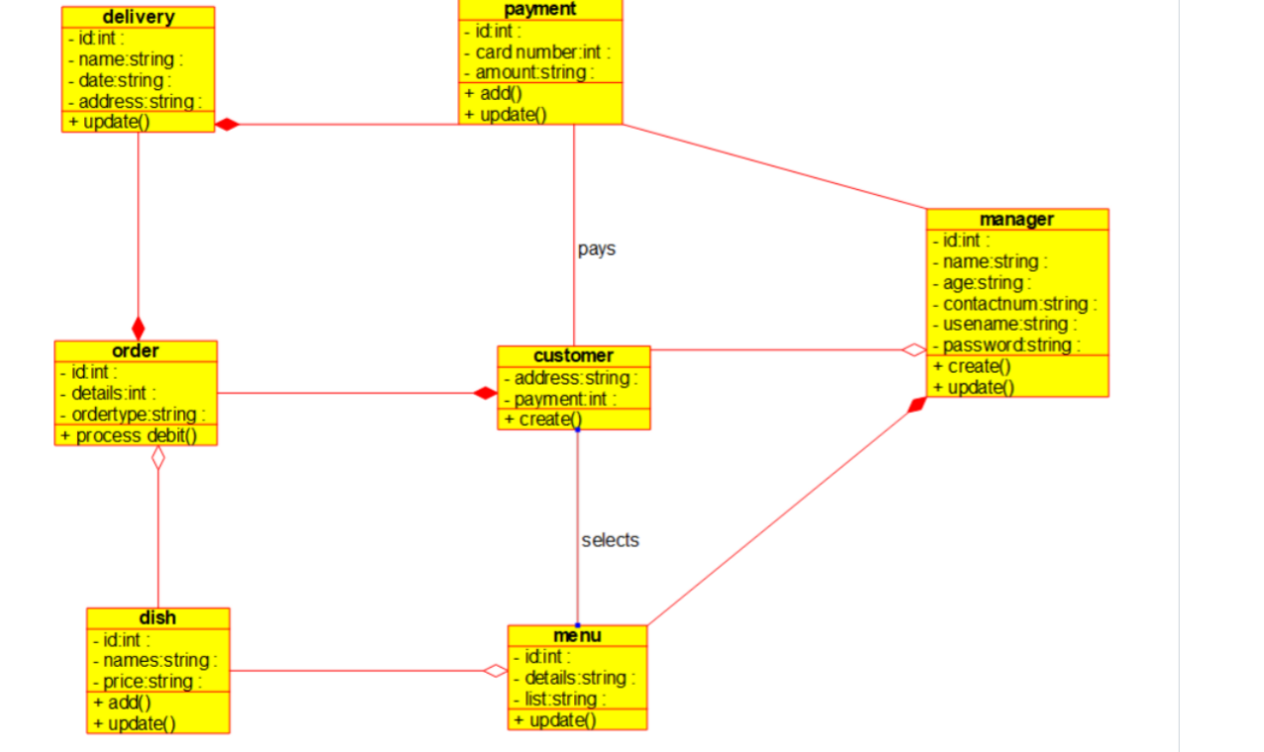

28.QUIZ SYSTEM – CLASS DIAGRAM

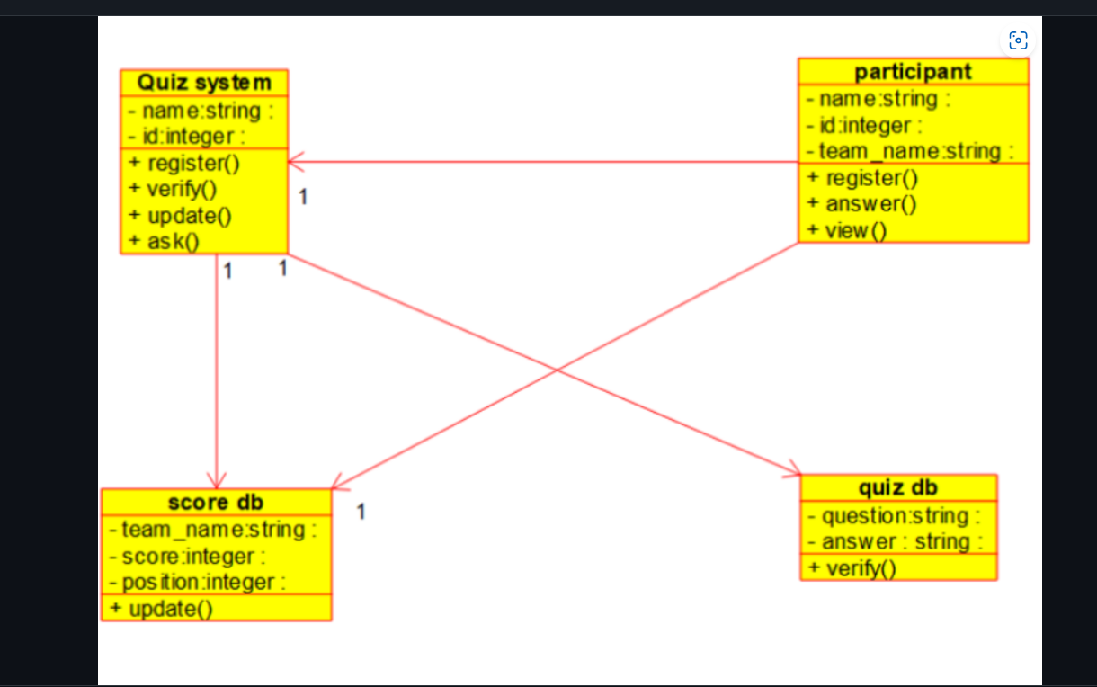

29.QUIZ SYSTEM - USE CASE

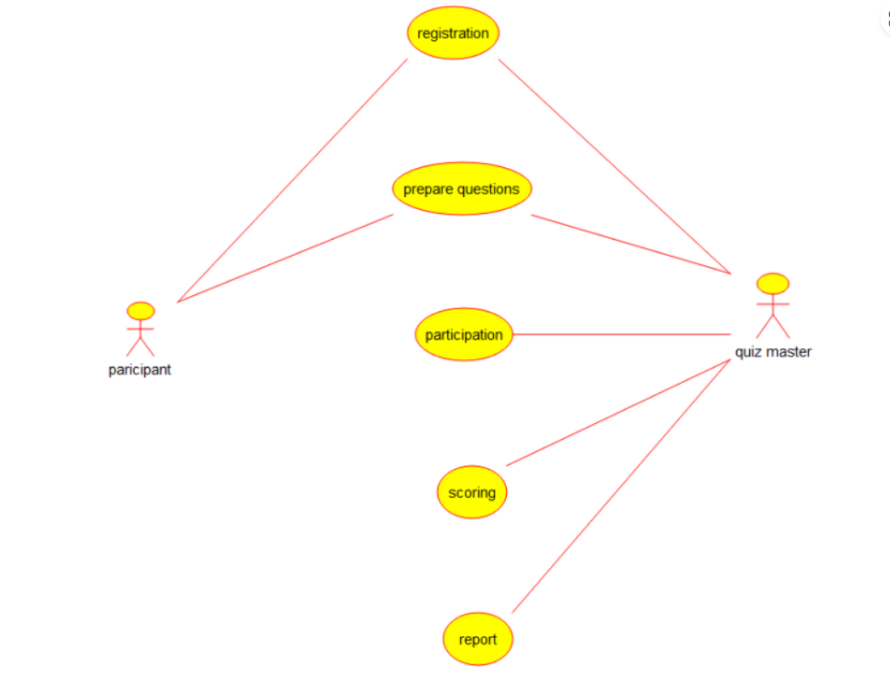

30.FACTORIAL – FLOW CHART

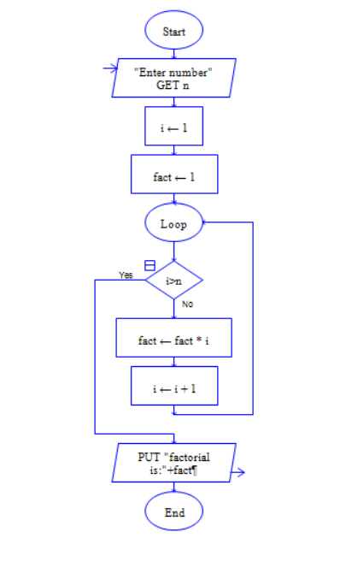

31.EVEN NUMBER SERIES – RAPTOR

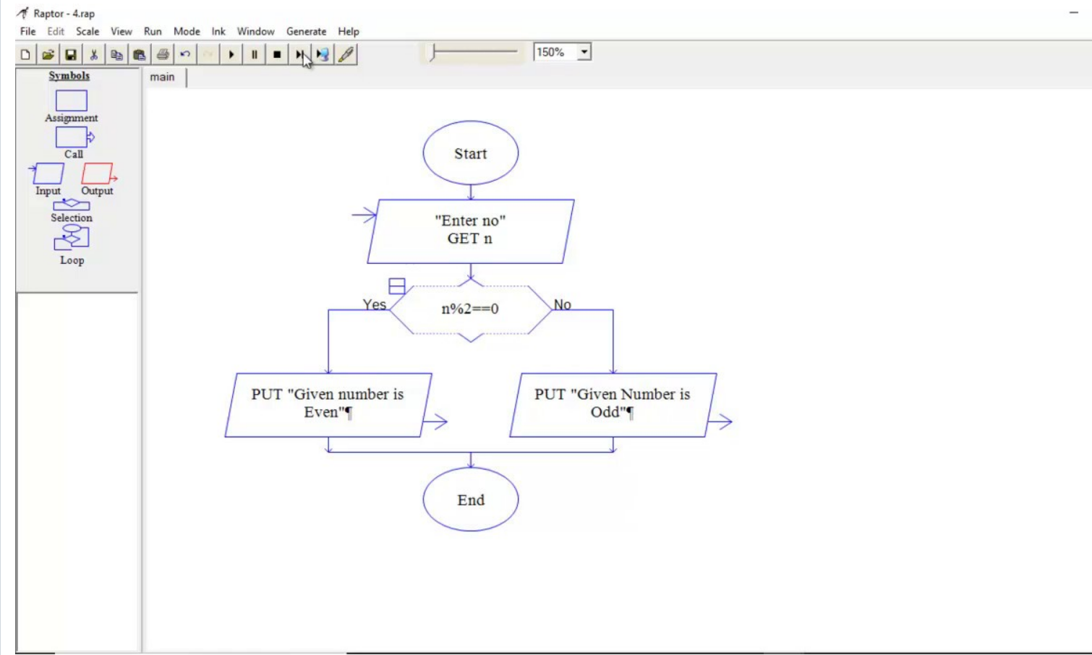

32.REVERSE A STRING – FLOW CHART

