Software Requirements Specification   
–

Document ID: ASP-CMS-SRS-02.doc

Author(s): PRAVEENKUMAR R

Version: 0.2

Date: November 3, 2022

1. Objective and Scope 3

2. Product perspective 3

3. Features 4

3.1 Login to the system 4

3.2 Withdraw / Deposit 4

3.3 Balance enquiry 4

3.4 Edit phone number 5

3.5 Print receipt 5

3.6 Exit from process 6

4. Diagrams 6

4.1 usecase diagram 6

4.2 class diagram 7

4.3 ER diagram 8

# Objective and Scope

The objective and the scope of the project is to build a ATM Management System that is capable of withdraw, deposit the money, balance enquiry, user details change, etc… The scope of the product includes the following basic features:

* The automated teller machine (ATM ) is an automatic banking machine which allows the user to complete basic transactions without any help of bank representatives
* The ATM System is the project which is used to access their bank accounts in order to make cash withdrawals. Whenever user want to make withdrawals, they can enter their ATM card and verified PIN ,then user select the withdrawal option and enter the withdrawal amounts you want.
* The user also able to perform one or more transactions . This system will provide for secure connections between users and the bank servers. The whole process will be automated right from PIN validation to transaction completion.
* The card details and PIN database will be secure module that will not be open to routine maintenance after each process. ATM Simulation System will enable two important features of an ATM, reduction of human error in the banking system and the possibility of24 hour personal banking.
* There are two types of automated teller machine. The basic one allows the customer to only draw cash and receive a report of the account balance. Another one is a more complex machine which accepts the deposit, provides credit card payment facilities and reports account information.
* In earlier years all the transactions were to be done manually, still done but very rarely, as it is very difficult task. so now banks use this to give their customers to have easy and faster transactions. This make transactions faster with less time period and customer friendly.

# Product Perspective

* The ATM always connected to the bank’s main server for database and the memory of software requires 20GB
* Some of hardware components like memory drives, card reader, printer for printing receipts, switches, console, networking port
* It perform many features like login,deposit, change phone number, withdraw, print receipt, check balance, language selection, transfer funds, exit .

# Features

## Login to the system

Each and every user should be authenticated with a User Name and 4 digit Pin to login into the system.

Validations for User Name and Password.

User Name: It accepts only Alphabets, Numbers, Dot (.) symbol and Underscore (_) symbol.

Password: It can be four digit numbers only.

## Withdraw / Deposit

The software allows the user to select the kind of operation to be performed i.e. whether he wants to withdraw or deposit the money.The amount to be withdrawn or deposited is then mentioned by the user from his account.

## Balance

Balance enquiry for any account linked to the card.the amount after all the transitions and its shown up balance in the console page.

## Change phone number

The customer is able to change his phone number with the option . on clicking the option he can enter the old phone number and also the new phone number .

## Print receipt

Any transaction shall be recorded in the form of a receipt and the same would be dispensed to the customer. The billing procedures are handled by the billing module that enable user to choose whether he wants the printed statement of the transaction or just the updation in his account. It includes all the transcations with account no, customer name, date,etc…

BANK NAME

BRANCH

DATE :

ACCOUNT NO : XXXXXXXXXXXX

CUSTOMER NAME : YYYYYY

DATE                     TYPE                   ACCOUNT                 AMOUNT

1.

2.

                                                                                      BALANCE

………………………………THANK YOU! VISIT AGAIN ...........................

## EXIT

The customer shall cancel a transaction with the press of a Cancel key. For example on entering a wrong depositing amount. In addition the user can also cancel the entire session by pressing the abort key and can start a fresh session all over again.

# Diagrams

## Usecase

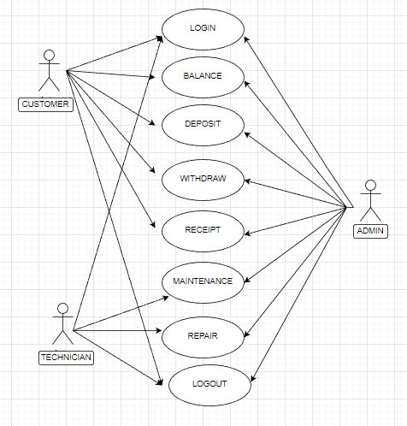

## 4.2 Class diagram

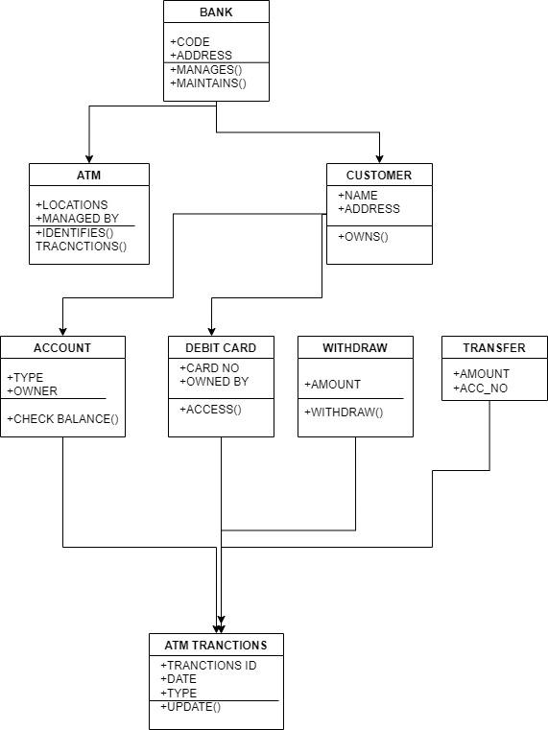

## 4.3 ER diagram

