Faster R-CNN: Towards Real-Time Object Detection with Region Proposal Networks

**Introduction:** In this project we have used Region Proposal Network (RPN) to get full image convolutional features with the detection network, which enables nearly cost-free region proposals. An RPN is a fully convolutional network that simultaneously predicts object bounds and objectness scores at each position. The RPN is trained end-to-end to generate high-quality region proposals, which are used by Fast R-CNN for detection. We further merge RPN and Fast R-CNN into a single network by sharing their convolutional features—using the recently popular terminology of neural networks with “attention” mechanisms, the RPN component tells the unified network where to look.

**DATASET PREPARATION:** We have used Visual Object Classes Challenge 2012 (VOC2012) dataset for this project.

<http://host.robots.ox.ac.uk/pascal/VOC/voc2012/#data>

* In this dataset we have mainly concentrated on 2 main folders JPEGImages – which have actual images and Annotations – which have convolutional features about data.
* We merge the images and the information of the image available in Annotations folders into a single panda’s data frame.
* After loading the data looks as below screenshot

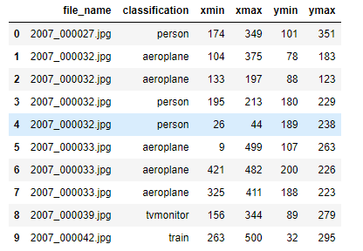

* From the data set above we took dataset that has single object per image for simplicity
* Unique classes we have for processing is shown in below screenshot.

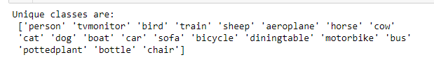

* From which we have come down to 2 classes Sofa and pottedplants as these to have almost equal number of images for training and testing and considering these two will be easy while computing.
* With the selected classes images and its annotation data we have plotted the annotation Xmin, Ymin, Xmax, Ymax details on the images, respectively. The same is show in below screenshots.

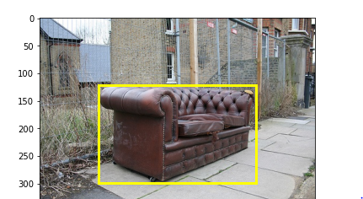

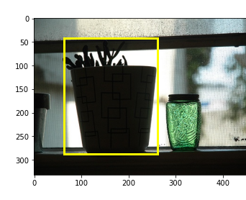

* We have subset the data of 2 classes into new folders Training_dataset and Annotations for future processing.
* Data is reformatted to required format to implement YOLO algorithm. Which can be seen in below screenshot.

