Sri Lanka Institute of Information

Technology

# **Data warehousing and Business Intelligence (IT3021)**

Continuous Assignment 2 – 2025, 3rd Year Semester 2

## **Final Report**



**Praveen J - IT22154262**

**Y3.S2.WE.DS.01.02**

Table of Contents

**Data warehousing and Business Intelligence (IT3021)** 1

**Final Report** 1

**1.Data Source** 3

**Overview** 3

**Star Schema Description** 3

Dimensions: 3

Fact Table: 3

**ER Diagram:** 5

**2. SSAS Cube implementation** 6

Creating the SSAS Project 6

Defining the Data Source 7

Creating the Data Source View (DSV) 7

Building the Cube 7

Designing Dimensions and Hierarchies 7

Configuring Keys and Relationships 8

Deploying and Processing the Cube 8

Validating the Cube 8

**3.** Excel Operations 8

**1. Roll-up / Drill-down** 9

**2. Slice** 10

**3. Pivot** 10

**3. Dice** 11

**4.Data Warehouse Design & Development** 11

**Prepare Data in Power BI** 11

**Data Sources** 11

**Creating Required Reports** 12

Report 1: 12

Report 2: 12

Report 3: 12

Report 4: 12

**Reference** 14

**Chatgpt,youtube** 14

# 1.Data Source

## **Overview**

The data set used in this project is a hotel booking transactions data set, which can be used in hospitality data warehousing and analytics. It captures detailed information about hotel bookings, room occupancy, and guest information, supporting both operational and analytical needs in the hotel management industry.

## **Star Schema Description**

**Star Schema:** Centralized fact_booking table linked to dimension tables, optimized for querying large datasets and performing analytical operations.

## Dimensions:

**dim_guest:**

* Contains guest personal information (name, email, phone)
* Includes geographical hierarchy (country → state/province → city)
* Implemented as Type 1 SCD for contact detail updates

**dim_room:**

* Stores room details (room_id, room_type, price)
* Includes room attributes (amenities, capacity)
* Contains price history and availability information

**dim_payment_method:**

* Payment method details (cash, credit card, online banking)
* Simple dimension with payment categorization

**dim_date:**

* Comprehensive date hierarchy (year → quarter → month → day)
* Includes time-related attributes (day_name, is_weekend, is_holiday)
* Supports temporal analysis of booking patterns and seasonality

## Fact Table:

**fact_booking:**

* Contains measures like total_amount, stay_days
* Includes foreign keys to all dimension tables
* Records booking transaction details
* Contains accumulating fact attributes (transaction create/complete times)

This star schema design facilitates comprehensive analysis of hotel booking data, allowing slicing and dicing across multiple dimensions while maintaining a straightforward, denormalized structu**Data Source Description for Hotel Booking Data Warehouse**

Overview

The data set used in this project is a hotel booking transactions data set, which can be used in hospitality data warehousing and analytics. It captures detailed information about hotel bookings, room occupancy, and guest information, supporting both operational and analytical needs in the hotel management industry.

Star Schema Description

**Star Schema:** Centralized fact_booking table linked to dimension tables, optimized for querying large datasets and performing analytical operations.

**Dimensions:**

**dim_guest:**

* Contains guest personal information (name, email, phone)
* Includes geographical hierarchy (country → state/province → city)
* Implemented as Type 1 SCD for contact detail updates

**dim_room:**

* Stores room details (room_id, room_type, price)
* Includes room attributes (amenities, capacity)
* Contains price history and availability information

**dim_payment_method:**

* Payment method details (cash, credit card, online banking)
* Simple dimension with payment categorization

**dim_date:**

* Comprehensive date hierarchy (year → quarter → month → day)
* Includes time-related attributes (day_name, is_weekend, is_holiday)
* Supports temporal analysis of booking patterns and seasonality

**Fact Table:**

**fact_booking:**

* Contains measures like total_amount, stay_days
* Includes foreign keys to all dimension tables
* Records booking transaction details
* Contains accumulating fact attributes (transaction create/complete times)

This star schema design facilitates comprehensive analysis of hotel booking data, allowing slicing and dicing across multiple dimensions while maintaining a straightforward, denormalized structure for efficient querying and reporting.

re for efficient querying and reporting.

## **ER Diagram:**

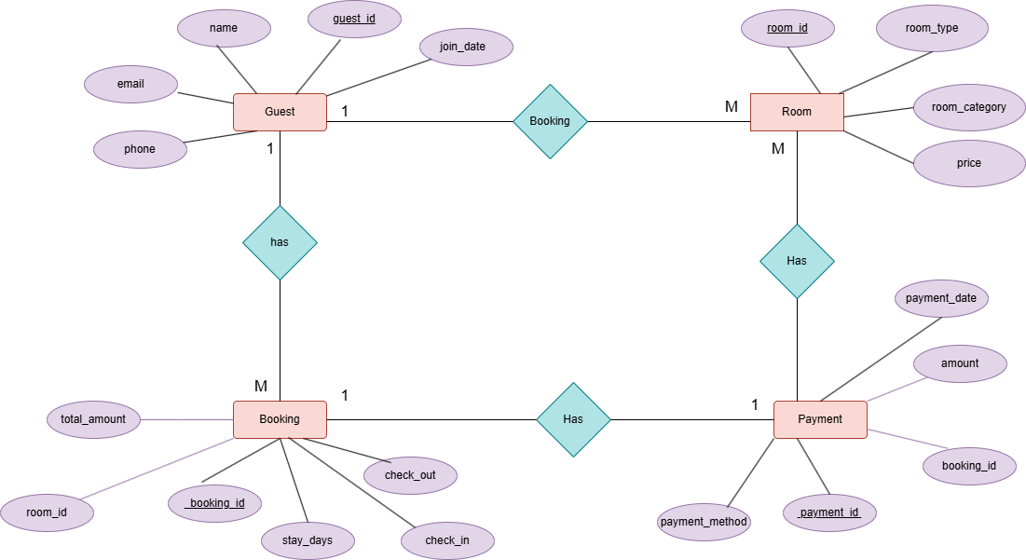

# **2. SSAS Cube implementation**

Creating the SSAS Project

* Opened Visual Studio (SQL Server Data Tools) as Administrator
* Created a new Analysis ServicCreating the SSAS Project
* Opened Visual Studio (SQL Server Data Tools) as Administrator
* Created a new Analysis Services Multidimensional project named "HotelCube"
* Defining the Data Source
* Added a new data source connecting to the hotel data warehouse
* Selected "Microsoft OLE DB Driver for SQL Server" as the provider
* Connected using Windows Authentication (WIN-7CS513LLFF7\sivaa)
* Named the data source "HotelDW"
* Creating the Data Source View (DSV)
* Created a new Data Source View
* Included fact_booking and all dimension tables (dim_guest, dim_room, dim_payment_method, dim_date)
* Verified and configured relationships between fact and dimension tables
* Named the view "HotelDW"
* Building the Cube
* Used the Cube Wizard to create the cube structure
* Selected fact_booking as the measure group source
* Added measures including total_amount and stay_days
* Added all dimensions (guest, room, payment method, date)
* Named the cube "HotelCube"
* Designing Dimensions and Hierarchies
* Configured appropriate attributes for each dimension
* Created a date hierarchy (Year → Quarter → Month → Day) in dim_date
* Ensured descriptive fields were available for analysis
* Configuring Keys and Relationships
* Set surrogate keys (guest_key, room_key, etc.) as key attributes
* Verified dimension-to-fact relationships in the Dimension Usage tab
* Resolved duplicate key issues for price attributes
* Deploying and Processing the Cube
* Configured the deployment server (localhost)
* Deployed the cube to the SSAS instance
* Processed the cube to populate it with data
* Validating the Cube
* Connected to Analysis Services in SSMS
* Browsed the cube to validate measures and dimensions
* Confirmed that hierarchies and aggregations worked correctly
* The SSAS cube now provides a multidimensional view of the hotel booking data warehouse, enabling effective analytics across guest, room, payment, and time dimensions.
* es Multidimensional project named "HotelCube"

Defining the Data Source

* Added a new data source connecting to the hotel data warehouse
* Selected "Microsoft OLE DB Driver for SQL Server" as the provider
* Connected using Windows Authentication (WIN-7CS513LLFF7\sivaa)
* Named the data source "HotelDW"

Creating the Data Source View (DSV)

* Created a new Data Source View
* Included fact_booking and all dimension tables (dim_guest, dim_room, dim_payment_method, dim_date)
* Verified and configured relationships between fact and dimension tables
* Named the view "HotelDW"

Building the Cube

* Used the Cube Wizard to create the cube structure
* Selected fact_booking as the measure group source
* Added measures including total_amount and stay_days
* Added all dimensions (guest, room, payment method, date)
* Named the cube "HotelCube"

Designing Dimensions and Hierarchies

* Configured appropriate attributes for each dimension
* Created a date hierarchy (Year → Quarter → Month → Day) in dim_date
* Ensured descriptive fields were available for analysis

Configuring Keys and Relationships

* Set surrogate keys (guest_key, room_key, etc.) as key attributes
* Verified dimension-to-fact relationships in the Dimension Usage tab
* Resolved duplicate key issues for price attributes

Deploying and Processing the Cube

* Configured the deployment server (localhost)
* Deployed the cube to the SSAS instance
* Processed the cube to populate it with data

Validating the Cube

* Connected to Analysis Services in SSMS**Excel Operations**
* Used the Data tab in Excel to import the HotelCube data into a pivot table in Excel
* 1. Roll-up / Drill-down
* **Roll-up:** Collapse detail to see higher-level summary (e.g., see total booking amount by Year).
* **Drill-down:** Expand to see more detail (e.g., see Months under a Year).
* **Process:**
* In my PivotTable, I made sure I have the Date Hierarchy in the Rows area.
* Click the "+" next to a year (e.g., 2024) to drill down and see quarters, then months, then days.
* Click the "-" next to a year or month to roll up and collapse the details.
* This allowed me to analyze booking patterns at different time granularities, from yearly summaries down to daily booking details.
* Browsed the cube to validate measures and dimensions
* Confirmed that hierarchies and aggregations worked correctly

The SSAS cube now provides a multidimensional view of the hotel booking data warehouse, enabling effective analytics across guest, room, payment, and time dimensions.

# **3.** **Excel Operations**

Used the Data tab in Excel to import the HotelCube data into a pivot table in Excel

## **1. Roll-up / Drill-down**

**Roll-up:** Collapse detail to see higher-level summary (e.g., see total booking amount by Year).

**Drill-down:** Expand to see more detail (e.g., see Months under a Year).

**Process:**

* In my PivotTable, I made sure I have the Date Hierarchy in the Rows area.
* Click the "+" next to a year (e.g., 2024) to drill down and see quarters, then months, then days.
* Click the "-" next to a year or month to roll up and collapse the details.

This allowed me to analyze booking patterns at different time granularities, from yearly summaries down to daily booking details.

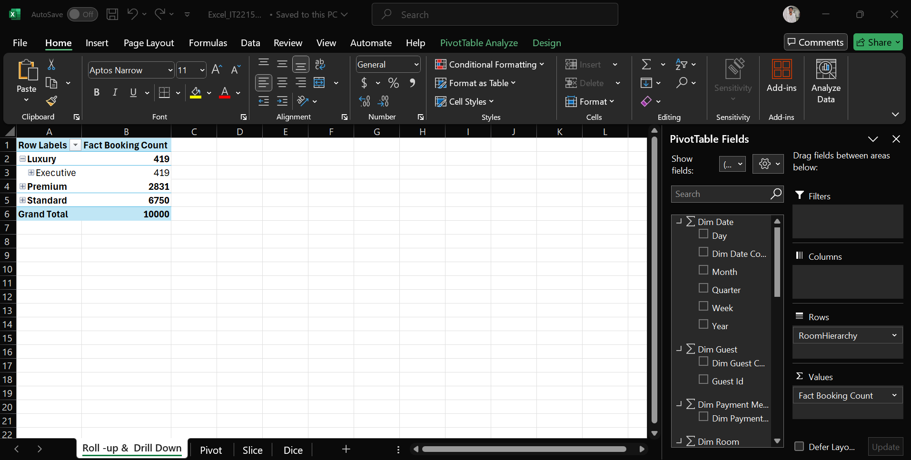

## **2. Slice**

## **3. Pivot**

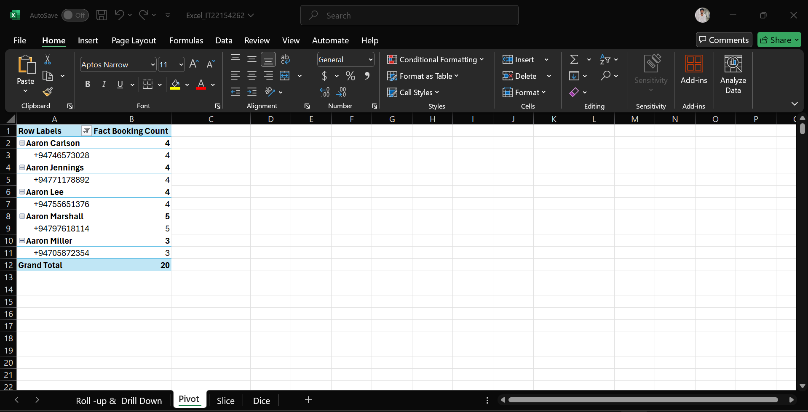

## **3. Dice**

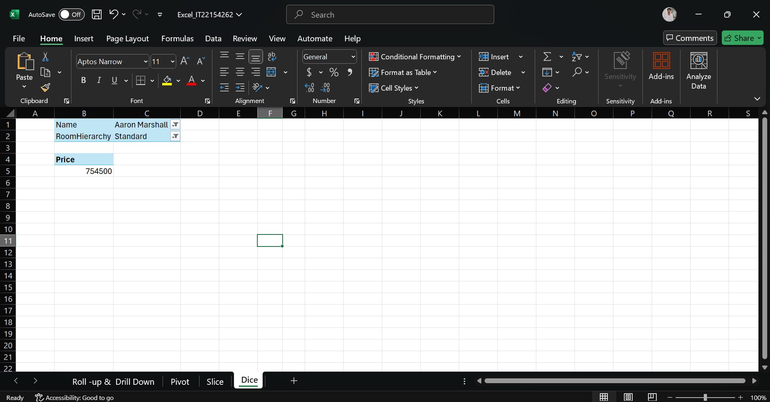

TEXT::

:

# **4.Data Warehouse Design & Development**

## **Prepare Data in Power BI**

Opened Power BI Desktop then clicked Import data from SQL server. Entered my server and database name, then loaded my fact and dimension tables.

## **Data Sources**

Source: SQL Server database (HotelCube).  
Tables Loaded:

* Fact Table: fact_booking
* Dimension Tables: dim_date, dim_guest, dim_room, dim_payment_method

## **Creating Required Reports**

## Report 1:

Added a Matrix visual with row and column groupings. Dragged Room Type from dim_room as rows and Guest Country from dim_guest as columns, with total_amount as the values. This creates a comprehensive view of booking revenue by room type and guest origin.

## Report 2:

Added multiple slicers (Room Type and Guest Country) with cascading filters.

* First slicer filters Room Type
* Second slicer (Guest Country) dynamically updates based on first selection  
  Added bar charts and pie charts to visualize booking patterns based on slicer selections.

## Report 3:

Created a bar chart showing total_amount by date hierarchy (Year → Quarter → Month → Day).  
Enabled the drill-down feature in the visualization pane.  
Users can click to drill down from yearly booking totals to specific days.

## Report 4:

Added a drill-through page showing detailed booking information.  
Added booking_id to the drill-through filters pane.  
From the main dashboard, users can right-click on any data point to see comprehensive details about specific bookings.

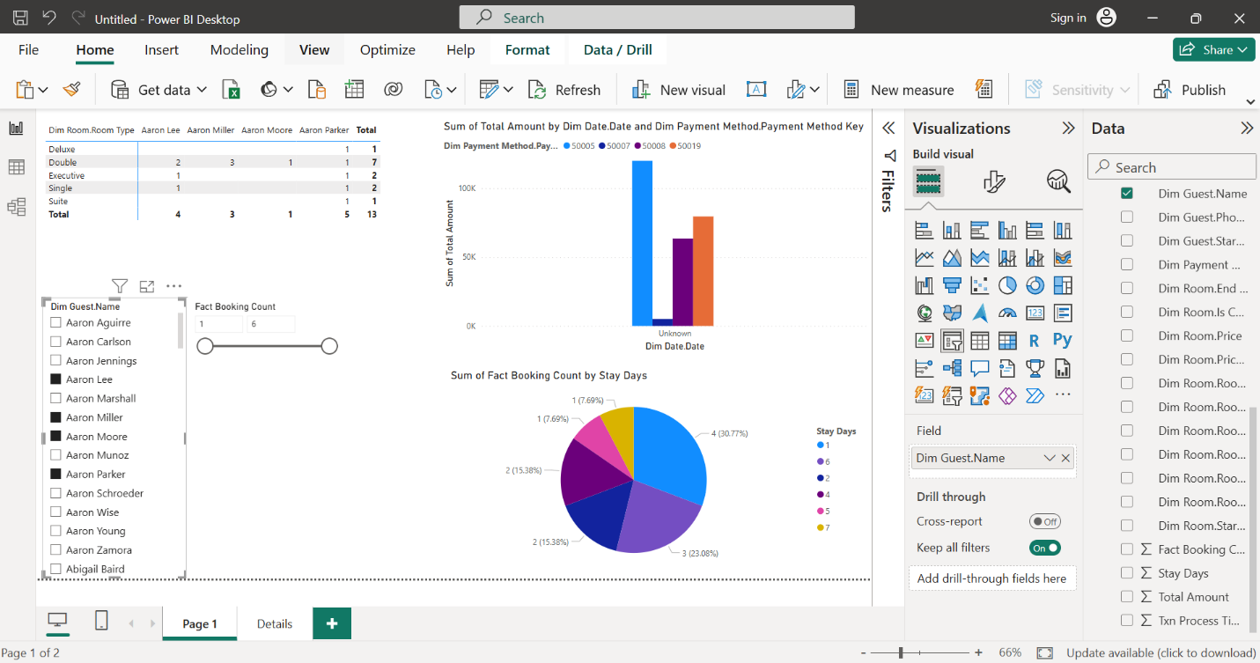

**Publish to Power BI Service**

* Clicked Publish and sign in to Power BI. Selected my workspace and published now I can open Power BI Service in my browser to demonstrate the reports
* Link- https://app.powerbi.com/groups/me/reports/5a96dd54-13a2-4262-9a79-48d79dd8f658/ReportSection?experience=power-bi

# **Reference**

# **Chatgpt,youtube**