BUSINESS REQUIREMENTS DOCUMENT
One Finance UX
Event-Driven Business Outcome Platform
From “Is SAP ready?” to “Can I produce the 15C3 report?”. Requirements, notification design, POC evidence and the one fix plan.
Document | BRD and One Fix Plan, with Spring Boot proof of concept
Version | 0.1 (draft for review)
Date | September 10, 2026
Prepared by | Praveen, VP Engineering, Finance Technology
Source | One Finance UX: Event Driven Business Outcome Platform (vision document, onefinuxreview.html)
Companion artefacts | onefinux-poc source code (hub and source simulator), README, event contract JSON schema, sample HTTP requests
Status | For review by Finance Technology architecture, FOBO Controllers, US Regulatory Reporting and Product Control

Contents
1. Executive summary
2. Problem statement
3. Vision and guiding principles
4. Scope
5. Stakeholders and personas
6. Review of the vision document
7. Target architecture
8. Business requirements
9. Functional requirements
10. Event catalogue and contract
11. Business outcome definitions
12. Outcome lifecycle
13. Notification requirements
14. Workflow and control rules
15. Non-functional requirements
16. Proof of concept
17. One fix plan
18. Success criteria and KPIs
19. Assumptions, dependencies and constraints
20. Risks
21. Open questions
22. RACI
Appendix A. API reference
Appendix B. Traceability
Appendix C. Glossary

1. Executive summary
Month-end close, PnL reporting, 15C3 regulatory reporting and FOBO analysis all depend on work finishing in Motif, GMIS, RAM, SAP, Axiom and several other systems. Each of those systems reports its own status in its own way. Nobody can see, in one place, whether a business process can start, so controllers and operations teams chase readiness through email, spreadsheets and Teams calls.
One Finance UX is an orchestration layer that sits above those systems without replacing them. Source systems publish events when work completes, fails or is restated. The platform turns those events into the status of business outcomes, and it tells the accountable people what has changed and why. When an outcome is ready, it triggers the next step itself. The question people ask changes from “Is SAP ready?” to “Can I produce the 15C3 report, and if not, what exactly is missing and when will it be ready?”
What the proof of concept demonstrated
FOBO / Helix. 300 master-book events arrived. At 300 of 300 the platform triggered Helix without human monitoring, received the result (breaks found, breaks above materiality) and notified FOBO Controllers.
15C3. 20 inputs arrived from SAP, US Castle, Finance Store and Axiom. A failed US Castle batch blocked the outcome, named the failed batch and alerted US Regulatory Reporting. When the batch recovered, Axiom generated the report automatically.
PnL. The platform warned the owner before the deadline, and it recorded the SLA breach as an auditable event.
Restatement. SAP withdrew a trial balance. Readiness was pulled back from the dependent 15C3 report, and the report re-ran under a new run id. Late results from the superseded run were ignored.
Resilience. After a restart, the platform rebuilt identical state from its event store (331 events, SLA breaches included) without re-sending notifications. All 7 engine unit tests pass.

Recommendation and decisions requested
Approve a Phase 1 MVP that takes 15C3 and FOBO/Helix live for AMRS on the enterprise event bus. It would use Oracle 19c for persistence, the Central Enterprise Entitlement System for access control, and email, Teams and ServiceNow for notifications. The indicative duration is 12 to 14 weeks, to be sized in planning. The steering group is asked to decide on four items:
- Endorse the business outcome model and the event contract (section 10) as the standard for Finance source systems.
- Nominate business owners for the 15C3 and FOBO/Helix outcome definitions, including expected input counts and cut-off times.
- Confirm the production event bus and the adapter approach for systems that cannot publish events.
- Resolve the open questions in section 21, particularly the 15C3 report variant and the override approval policy.

2. Problem statement

2.1 Current state
Finance processes span Motif, GMIS, RAM, SAP and Axiom, with US Castle, Finance Store and Helix in the critical path for specific outcomes. Each application maintains its own status, workflow, reporting and entitlements. Readiness is a question people answer by hand.
Pain point | Effect today | Who feels it
No unified view of readiness | Controllers check several applications, or ask each support team, before starting a process | FOBO Controllers, Regulatory Reporting, Product Control
Manual chasing | Email chains, spreadsheets and Teams calls every close cycle; knowledge sits with individuals | Operations, source support teams
Dependencies are implicit | Which inputs a report needs lives in people's heads and runbooks, not in a system | New joiners, cover staff, audit
Late discovery of problems | A failed batch is found when someone looks, often close to the deadline | Report owners, management
Restatements are invisible | When an input is re-run after a report was produced, dependants are not told reliably | Regulatory Reporting, Control
No predictability | No ETA, so completion commitments are estimates | Finance managers, business heads
Waiting instead of working | FOBO analysis waits until someone confirms all 300 master books are ready | FOBO Controllers

2.2 Why existing approaches fail
Approach | What it gives | Why it is not enough
Dashboard aggregation | A screen that shows each system's status side by side | A dashboard of dashboards. It shows visibility without intelligence: users must still work out what the statuses mean for their process, and it cannot act.
Polling source systems | A central component that asks each system for status on a timer | Constant calls across infrastructure and wasted compute. It scales poorly, adds latency equal to the poll interval, makes wait states hard to manage, and couples the platform to every system's internals.

3. Vision and guiding principles
The platform is a central finance operations hub that converts events into business outcomes, workflow execution, predictive insights and management visibility. The central shift is from system status to business outcome status.
System status question (today) | Business outcome question (target)
Is Motif complete for all 300 master books? | Can I execute FOBO analysis?
Is SAP trial balance done? Has US Castle finished? Has Axiom received data? | Can I produce the 15C3 report?
Has GMIS finished? Is RAM ready? | Can I run PnL reporting?
Are all upstream closes complete? | Can I begin month-end close?

Guiding principles
- Orchestrate, do not replace. Source applications keep their workflows. The platform only listens, interprets and coordinates.
- Push, not poll. Sources publish events. Where a system cannot publish, a thin adapter at the edge converts its status into events, so any polling stays inside that adapter.
- Outcomes are metadata. An outcome's inputs, owners, deadlines and follow-on actions live in a governed registry. Adding one should not need a code release.
- Every state change is an event. This includes the platform's own decisions (action triggered, override, SLA breach). The audit trail and a restart then see the same truth.
- Count facts, not messages. Readiness counts distinct inputs, so re-sent events are harmless and restatements can withdraw readiness precisely.
- The core is deterministic and AI advises. The outcome engine is a pure, testable fold over events. AI agents (Phase 3) predict and recommend, but they do not decide readiness.
- Humans stay in control. Overrides and re-runs need a reason and are audited. Regulatory outcomes add maker-checker.
- Notify on meaning, not on noise. People are told about business-relevant changes, never about each of 300 master-book events.

4. Scope
Area | POC (complete) | Phase 1 MVP | Later phases
Outcomes | FOBO/Helix, 15C3, PnL | 15C3 and FOBO/Helix live in AMRS | PnL, Month End Close, regulatory reporting, other regions
Sources | Simulated Motif, SAP, GMIS, RAM, US Castle, Finance Store, Axiom | Real Motif, SAP, US Castle, Finance Store, Axiom via event bus or adapters | GMIS, RAM and others
Downstream actions | Mock Helix and Axiom | Real Helix and Axiom triggers | Further consumers, including AOF agents
Notifications | In-app live, simulated email, Teams webhook (optional) | Corporate email, Teams, ServiceNow; subscriptions and severity routing | Digest, mobile push
Workflow | Override, re-run, SLA monitor | Plus entitlement checks on actions | Maker-checker, attestations, exception resolution
Persistence and platform | H2 file DB, single instance | Oracle 19c, event bus, HA deployment | Multi-region active/active
Security | None (local demo) | SSO and Central Enterprise Entitlement System | Fine-grained data entitlements
Intelligence | Arrival-rate ETA | Same, with history captured | Predictive ETA, bottleneck detection, AI assistance

Out of scope
- Replacing or changing the internal workflows of any source application.
- Changing source batch schedules or cut-offs. The platform observes them and reports against them.
- Producing report content. Axiom still generates the 15C3 report and Helix still performs the analysis.
- Reconciliation logic, which stays in Helix or the Agent One Finance (AOF) platform.

5. Stakeholders and personas
Persona | Primary question | What they need | Notifications
FOBO Controller | Can I execute FOBO analysis? | Master-book progress, automatic Helix trigger, break summary | Started, milestones, ready, done, at risk
US Regulatory Reporting analyst | Can I produce the 15C3 report? | Which inputs are missing, blocked batches, restatement alerts | All transitions; critical alerts for blocked, breach, revoked
Product Control | Can I run PnL reporting? | Readiness across GMIS, RAM and SAP; ETA versus deadline | At risk, breach, ready
Source support team (SAP, US Castle, Motif and others) | Which of my feeds is holding up the business? | Failures and late inputs attributed to their system | Blocked and at risk, when they own the slowest input
Finance manager or business head | Will we make today's deadlines? | Roll-up across outcomes and regions with ETAs | Breach and revoked, plus an optional daily digest
Executive (CFO office) | Are critical deliverables on track? | One-line status per critical outcome | Breach on regulatory outcomes
Platform support | Is the platform healthy? | Event lag, dead letters, dispatch failures | Action failed, adapter silence
Audit and Compliance | Who did what, when, and why? | Immutable event and override history, replayable state | None (they query)

6. Review of the vision document
The vision document sets the right direction. Building the POC surfaced ten points it does not yet settle. Each would cause defects or rework in production if left open, so this BRD resolves them or raises them as open questions.
# | Observation | Risk if left open | Resolution
1 | Outcomes are named without a scope (for example, “15C3 Report”) | Today's and yesterday's runs, or AMRS and EMEA, would overwrite each other | Every outcome instance is keyed by (outcome, COB date, region). Implemented in the POC.
2 | Event names are inconsistent (SAP_TB_COMPLETED and SAP_TB_COMPLETE both appear) | Producers and consumers silently miss each other | Governed event catalogue and naming rule (section 10). Decision required on the final names.
3 | The 15C3 example lists 4 dependencies but shows 15 completed and 5 pending events | “Ready” is undefined unless the expected count of each input is known | Each dependency carries an expected count (5 of each in the POC). In production these come from reference data, not constants.
4 | Only success events are shown | Failures and re-runs leave stale “ready” states that mislead users | Statuses STARTED, COMPLETED, FAILED and REVOKED. FAILED blocks the outcome and REVOKED withdraws readiness. Implemented.
5 | The Event Hub is given an “Orchestrate” responsibility | Business logic spreads into the transport layer and becomes untestable | The hub is a pipe (validate, de-duplicate, persist, route, replay). Orchestration lives in the outcome engine and workflow layer.
6 | Assumes every source can publish events | Legacy systems stall the programme | Edge adapters (CDC on status tables, MQ bridges) turn state into events. Polling is confined to the adapter.
7 | Manual overrides are mentioned without controls | An unapproved override on a regulatory report is a control failure | A reason is mandatory and every override is stored as an event. Maker-checker for regulatory outcomes in Phase 2. Overrides of already-complete inputs are rejected.
8 | “15C3” is not specified further | Rule 15c3-1 (net capital) and Rule 15c3-3 (customer protection) have different inputs and deadlines | Open question for US Regulatory Reporting (section 21).
9 | Notifications are implied but not designed (who, when, which channel) | Either silence or alert fatigue | Notification matrix, routing and noise controls (section 13). Implemented in the POC.
10 | Success criteria are qualitative | No way to prove value or stop the programme | Measurable KPIs with a baseline period (section 18).

7. Target architecture
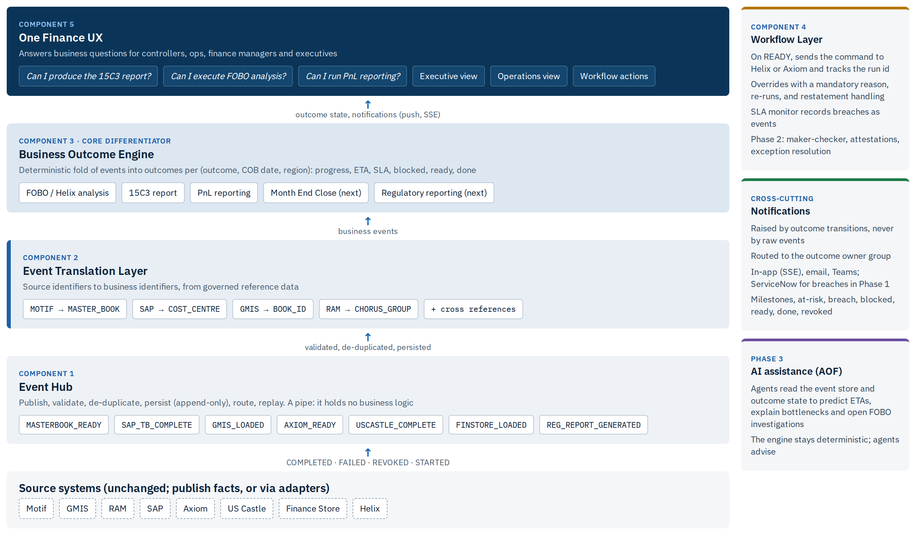
Figure 1. One Finance UX target architecture (the POC implements every box except AI assistance)

End-to-end event flow
- A source system (for example Motif) publishes MASTERBOOK_READY for master book MB042, COB date and region, status COMPLETED.
- The Event Hub validates the event against the contract and de-duplicates it by event id or natural key. It then appends the event to the event store.
- The Translation Layer maps the source identifier to a business identifier (Motif MB042 to MASTER_BOOK) and adds cross-references such as the cost centre.
- The Outcome Engine applies the event to every outcome instance that depends on it. It recomputes progress, ETA, risk and status.
- If the status or a milestone changed, the engine raises a transition. Transitions drive notifications, live UX updates and the workflow layer.
- On READY, the workflow layer sends a command (with correlation id and run id) to Helix or Axiom and records WORKFLOW_ACTION_TRIGGERED.
- The downstream system publishes its completion event (such as HELIX_ANALYSIS_COMPLETE) with the same run id, and the outcome becomes DONE. Completions carrying an older run id are ignored.
Design decision: why the engine is a fold over the event stream
Outcome state is always derived from the stored events, never edited directly. That gives three properties the regulator and the audit team care about. The state at any time can be reproduced. A restart cannot lose or invent state. And a bug fix can be applied by replaying the events.

8. Business requirements
Priority uses MoSCoW. The POC column shows what the Spring Boot POC demonstrates today.
ID | Requirement | Priority | POC
BR-01 | Provide a single view of readiness for each business outcome, per COB date and region | Must | Proven
BR-02 | Answer each business question in plain language (Not yet, Blocked, Yes, Done) and state what is missing | Must | Proven
BR-03 | Receive status by events pushed from sources; the platform must not poll source applications | Must | Proven with simulated sources
BR-04 | Notify the accountable group proactively when an outcome changes in a way that matters | Must | Proven
BR-05 | Trigger the downstream process automatically when an outcome becomes ready | Must | Proven with mock Helix and Axiom
BR-06 | Track ETA against deadline and warn before an SLA is missed | Must | Proven (arrival-rate ETA)
BR-07 | Handle failures, re-runs and restatements correctly, and never show stale readiness | Must | Proven
BR-08 | Allow human override and re-run with a mandatory reason, fully audited | Must | Proven (maker-checker in Phase 2)
BR-09 | Keep a complete audit trail from which state can be reproduced | Must | Proven by replay; point-in-time query in Phase 1
BR-10 | Add new outcomes by configuration, not code | Should | Proven (YAML); governed registry in Phase 1
BR-11 | Restrict visibility and actions by entitlement | Must | Phase 1
BR-12 | Provide management roll-up across outcomes and regions | Should | Partial (single board)
BR-13 | Predict completion, detect bottlenecks and recommend actions using AI | Could | Phase 3

9. Functional requirements

9.1 Event Hub
ID | Requirement | Acceptance criterion | POC
FR-EH-01 | Accept events by REST (single and batch) that conform to contract v1 | A missing sourceKey returns 400 with an RFC 7807 body naming the field | Yes
FR-EH-02 | Idempotent ingest by eventId, or by a natural key when no id is supplied | A re-sent event returns 200 DUPLICATE and progress does not change | Yes
FR-EH-03 | Append-only store of all accepted events, including platform WORKFLOW_* events | No update or delete path exists outside the demo reset | Yes
FR-EH-04 | Rebuild all outcome state from the store on start-up, without notifications | After a restart, state is identical and no alerts are re-sent | Yes
FR-EH-05 | Support the statuses STARTED, COMPLETED, FAILED and REVOKED | Each status has the effect defined in section 12 | Yes
FR-EH-06 | Consume from the enterprise event bus, partitioned by (COB date, region), with a dead-letter queue | An invalid message lands in the DLQ with its reason; per-partition order is preserved | Phase 1
FR-EH-07 | Provide edge adapters for systems that cannot publish (CDC, MQ bridge) | An adapter emits events within 60 seconds of a source state change | Phase 1

9.2 Event Translation Layer
ID | Requirement | Acceptance criterion | POC
FR-TR-01 | Map each source identifier to its business identifier type | A Motif key becomes MASTER_BOOK and a SAP key becomes COST_CENTRE | Yes
FR-TR-02 | Enrich events with cross-references (master book to cost centre to account) | MB001 carries CC-4410 and GL-100200 | Yes (static)
FR-TR-03 | Load mappings from effective-dated reference data; flag unmapped identifiers rather than drop them | An unmapped key appears on a data-quality list and is still counted | Phase 1

9.3 Business Outcome Engine
ID | Requirement | Acceptance criterion | POC
FR-OE-01 | Define outcomes as metadata: question, regions, owner group, dependencies with expected counts, SLA, on-ready action, completion event | A new outcome needs a configuration change only | Yes
FR-OE-02 | Track each outcome per (outcome, COB date, region) | Two COB dates run independently | Yes
FR-OE-03 | Count readiness on distinct source keys with COMPLETED status | 300 events for 300 distinct books reach 100%; duplicates do not | Yes (tested)
FR-OE-04 | Let one event satisfy every outcome that depends on it | A SAP TB event advances both 15C3 and PnL | Yes (tested)
FR-OE-05 | Block the outcome on FAILED, naming the keys; clear the block when the same key later completes | BATCH-03 failure shows Blocked, and recovery resumes | Yes (tested)
FR-OE-06 | On REVOKED, withdraw readiness from every dependent outcome; the next action run gets a new run id | A restated SAP TB takes 15C3 from Done back to In progress, then it re-runs | Yes (tested)
FR-OE-07 | Compute ETA from the observed arrival rate; flag at risk when ETA passes the deadline, naming the slowest input | PnL warns before its deadline and names GMIS books | Yes
FR-OE-08 | Support deadlines as a cut-off time with day offset, or as a window from the first input | 07:30 on COB+1 can be configured | Yes
FR-OE-09 | Source expected counts from reference data (for example, the active master-book list for the COB) | Adding a book raises the expected count without a code or config release | Phase 1
FR-OE-10 | Allow outcomes to depend on other outcomes | Month End Close waits for PnL READY | Phase 2

9.4 Workflow Layer
ID | Requirement | Acceptance criterion | POC
FR-WF-01 | On READY, send the configured command with correlation id and run id | Helix receives one command per run | Yes
FR-WF-02 | Accept a completion only when its run id matches the current run | A late result from a superseded run is ignored | Yes (tested)
FR-WF-03 | Record dispatch failures as events and show ACTION_FAILED | An unreachable Axiom raises a critical alert | Yes
FR-WF-04 | Allow override of a pending or failed input with reason and requester; reject overrides of complete inputs | Overriding a complete input returns 409 | Yes
FR-WF-05 | Allow manual re-run of the action for a READY or DONE outcome; reject it otherwise | Re-running a not-ready outcome returns 400 | Yes
FR-WF-06 | Record SLA breaches as events | The breach survives a restart | Yes
FR-WF-07 | Require maker-checker for overrides on regulatory outcomes; support attestations | An override needs a second approver before it takes effect | Phase 2

9.5 Notifications
ID | Requirement | Acceptance criterion | POC
FR-NT-01 | Generate notifications only from notifiable outcome transitions, never from raw events | 300 master-book events produce about 5 notifications, not 300 | Yes
FR-NT-02 | Persist each notification once, then fan it out to channels | An inbox record exists even if a channel fails | Yes
FR-NT-03 | Deliver to in-app (live), email and Teams channels | All three receive a BLOCKED alert | Yes (email simulated)
FR-NT-04 | Write messages that state the business impact, what is missing and the ETA or deadline | See the examples in section 13 | Yes
FR-NT-05 | Make progress milestones configurable | Defaults are 50% and 90% | Yes
FR-NT-06 | Never notify during replay | A restart sends nothing | Yes
FR-NT-07 | Route by severity and by user or group subscription; digest INFO notifications | An executive receives only critical alerts for regulatory outcomes | Phase 1
FR-NT-08 | Raise a ServiceNow incident for breaches and blocks on regulatory outcomes | An incident is created with the outcome and missing inputs | Phase 1
FR-NT-09 | Track delivery and retry external channels | A failed Teams post is retried and reported | Phase 1

9.6 Unified Finance UX
ID | Requirement | Acceptance criterion | POC
FR-UX-01 | Show one card per outcome with the question, answer, progress, facts and per-input meters | The board shows three outcomes | Yes
FR-UX-02 | Update live without refresh | Cards move as events arrive | Yes (SSE)
FR-UX-03 | Show a master-book grid for FOBO | 300 cells, each turning green when its book arrives | Yes
FR-UX-04 | Provide a notification inbox and an incoming-event tape | Both visible on the board | Yes
FR-UX-05 | Offer override and re-run from the UI | Forms validate their input and show the result | Yes
FR-UX-06 | Provide an executive roll-up and COB history | A region-by-outcome matrix is available | Phase 1/2
FR-UX-07 | Drill through to the evidence behind a status (event payloads, source links) | Clicking an input shows its events | Phase 1

10. Event catalogue and contract

10.1 Event contract v1
The JSON schema contracts/business-event.schema.json is the governed contract. Producers state facts about their own identifiers. The platform decides what those facts mean.
Field | Required | Description
eventId | No | Producer-assigned unique id. Re-sending it is a no-op. If absent, the platform derives a deterministic id from the natural key.
eventType | Yes | Governed name from the catalogue below
sourceSystem | Yes | MOTIF, GMIS, RAM, SAP, AXIOM, USCASTLE, FINSTORE, HELIX
sourceKey | Yes | The source's own id for the unit of work (master book, cost centre, batch, feed, schedule, run)
cobDate | Yes | The close-of-business date the fact belongs to, not the send date
region | Yes | AMRS, EMEA, APAC or GLOBAL
status | Yes | STARTED, COMPLETED, FAILED or REVOKED
occurredAt | No | When the fact happened at source (UTC). Defaults to the receipt time.
attributes | No | Context. Downstream completions must echo correlationId and runId.

10.2 Event catalogue
Event type | Source | Source key | Business identifier | Consumed by
MASTERBOOK_READY | Motif | Master book MB001 to MB300 | MASTER_BOOK | FOBO_HELIX
SAP_TB_COMPLETE | SAP | Cost centre | COST_CENTRE | REPORT_15C3, PNL_REPORTING
USCASTLE_COMPLETE | US Castle | Processing batch | PROCESSING_BATCH | REPORT_15C3
FINSTORE_LOADED | Finance Store | Feed | FEED | REPORT_15C3
AXIOM_READY | Axiom | Schedule | REPORT_SCHEDULE | REPORT_15C3
GMIS_LOADED | GMIS | Book | BOOK_ID | PNL_REPORTING
RAM_CHORUS_READY | RAM | Chorus group | CHORUS_GROUP | PNL_REPORTING
HELIX_ANALYSIS_COMPLETE | Helix | Run id | ANALYSIS_RUN | FOBO_HELIX (completion)
REG_REPORT_GENERATED | Axiom | Run id | REPORT_SCHEDULE | REPORT_15C3 (completion)
WORKFLOW_ACTION_TRIGGERED, WORKFLOW_ACTION_FAILED, WORKFLOW_OVERRIDE, WORKFLOW_SLA_BREACHED | One Finance UX | Run id, dependency or outcome | WORKFLOW | Audit and replay

Naming rule (proposed)
Use the form SUBJECT_STATE in upper snake case, with the state as an adjective (COMPLETE, READY, LOADED, GENERATED). The vision document's SAP_TB_COMPLETED becomes SAP_TB_COMPLETE. Success, failure and restatement are expressed through the status field, never through separate event names such as SAP_TB_FAILED.

11. Business outcome definitions
These are the definitions used in the POC. Expected counts and deadlines are illustrative and must be confirmed by each outcome's business owner. Demo deadlines are short windows so that alerts can be shown live; production uses cut-offs such as 07:30 on COB+1.

11.1 FOBO_HELIX: Can I execute FOBO analysis?
Scope | GLOBAL, per COB date
Owner group | FOBO Controllers
Inputs | 300 × MASTERBOOK_READY from Motif (one per master book)
When ready | Send an HTTP command to Helix with correlation id and run id; notify “Helix analysis started”
Done when | HELIX_ANALYSIS_COMPLETE arrives with the current run id; the summary (breaks, breaks above materiality) is shown and notified
Deadline | Demo: 5 minutes from the first input. Production: to be confirmed.
Vision reference | Example 7. Replaces waiting for 300 master books and monitoring them manually.

11.2 REPORT_15C3: Can I produce the 15C3 report?
Scope | AMRS, per COB date
Owner group | US Regulatory Reporting
Inputs | 5 × SAP_TB_COMPLETE (SAP trial balance)  5 × USCASTLE_COMPLETE (US Castle batches)  5 × FINSTORE_LOADED (Finance Store feeds)  5 × AXIOM_READY (Axiom schedules)
When ready | Send a command to Axiom to generate the 15C3 report
Done when | REG_REPORT_GENERATED arrives with the current run id; the report id is shown
Deadline | Demo: 5 minutes. Production: regulatory cut-off to be confirmed.
Controls | Any REVOKED input withdraws readiness and raises a critical alert. Overrides require maker-checker (Phase 2).
Vision reference | Example 8 (progress, completed and pending counts, ETA)

11.3 PNL_REPORTING: Can I run PnL reporting?
Scope | AMRS, per COB date
Owner group | Product Control
Inputs | 3 × GMIS_LOADED, 2 × RAM_CHORUS_READY, and 5 × SAP_TB_COMPLETE (shared with 15C3: published once, consumed by both)
When ready | Notify only (no downstream trigger in the POC)
Deadline | Demo: 1 minute, so the at-risk and breach alerts can be shown

12. Outcome lifecycle
State | Meaning | Answer shown to users
NOT_STARTED | No inputs received for this COB date and region | Not yet
IN_PROGRESS | Some inputs complete; none failed | Not yet, with %, what is missing and the ETA
BLOCKED | At least one input failed and has not recovered | Blocked, naming the failed keys and the owner
READY | All expected inputs complete (or overridden) | Yes; the action starts automatically if one is configured
ACTION_RUNNING | The downstream command was sent; waiting for completion | Yes, with the running action and run id
ACTION_FAILED | The downstream action could not start or reported failure | Blocked on the action; re-run is available
COMPLETED | The downstream completion was received for the current run | Done, with the result summary

Two flags sit alongside the state. At risk means the projected ETA is after the deadline. Breached means the deadline passed before READY; it is recorded as an event and remains visible after completion (“Missed the deadline by 4 min”).

How each event status affects an outcome
- COMPLETED adds the key to the input's completed set. It is idempotent per key.
- FAILED adds the key to the failed set and moves the outcome to BLOCKED. A later COMPLETED for the same key clears it.
- REVOKED removes the key from the completed set. If the outcome was READY or later, it drops back to IN_PROGRESS, and the next READY starts a new run.
- STARTED is informational and does not change readiness.

13. Notification requirements
Notifications are raised by outcome transitions. Every message answers three things: what changed for the business, what is missing, and when it will be resolved. The example text below is taken verbatim from the POC run.
Transition | Trigger | Severity | Audience | Example (from the POC)
STARTED | First input for the COB date and region | Info | Owner group | 15C3 report has started. First input arrived: US Castle batches BATCH-02 complete.
MILESTONE | Progress crosses a configured milestone (50%, 90%) | Info | Owner group | 15C3 report: 90% complete. 18 of 20 inputs in. ETA 18:31. Still waiting on US Castle batches 4 of 5, Axiom schedules 4 of 5.
AT_RISK | Projected ETA is later than the deadline | Warning | Owner group, slowest input's support team | PnL reporting may miss its deadline. Projected ready at 18:32, deadline 18:32. Slowest input: GMIS books.
BLOCKED | An input reports FAILED | Critical | Owner group, source support | 15C3 report is blocked. US Castle batches failed: BATCH-03. Owner: US Regulatory Reporting.
UNBLOCKED | A failed key later completes | Info | Owner group, source support | 15C3 report is moving again. US Castle batches BATCH-03 complete.
READY | All inputs complete or overridden | Success | Owner group | 15C3 report is ready. All 20 inputs are complete. Starting 15C3 report generation.
ACTION_TRIGGERED | Downstream command sent | Info | Owner group | 15C3 report generation started. Run RUN-0BF16928 was triggered automatically.
ACTION_FAILED | Command rejected or the target unreachable | Critical | Owner group, platform support | Helix analysis could not start. Target unreachable; re-run available.
COMPLETED | Downstream completion with the current run id | Success | Owner group | 15C3 report is done. 15C3 report RPT-47B873 generated from 20 inputs and is ready for review.
SLA_BREACHED | Deadline passes before READY | Critical | Owner group, manager | PnL reporting missed its deadline. Deadline was 18:32. Still waiting on GMIS books 0 of 3, RAM chorus groups 0 of 2.
REVOKED | A completed input is restated after READY | Critical | Owner group, downstream consumers | 15C3 report: readiness withdrawn. SAP trial balance CC-4430 restated. Anything produced since 18:31 may need to be re-run.
OVERRIDDEN | Manual override accepted | Warning | Owner group, audit | US Castle batches overridden by controller.jsmith: Batch verified manually, INC0042.

13.1 Channel routing (Phase 1 target)
Severity | In-app | Email | Teams | ServiceNow
Info | Yes | Optional daily digest | No | No
Success | Yes | Yes (subscribers) | Optional | No
Warning | Yes | Yes | Yes (owner channel) | No
Critical | Yes | Yes | Yes | Incident, for regulatory outcomes

In the POC, every notification goes to every enabled channel and the audience is the outcome's owner group. Severity routing and subscriptions are Phase 1 requirements (FR-NT-07).

13.2 Noise controls
- Raw events never notify. The 300 master-book events for FOBO produce about five notifications in total.
- Each transition notifies once per outcome instance. Repeated conditions (for example, still at risk) do not re-alert.
- Once an outcome has breached, at-risk warnings stop, because the breach alert is the message.
- Replays and restarts never notify.
- Milestones are configurable per outcome. Phase 1 adds quiet hours and digests for Info.

14. Workflow and control rules
Rule | Requirement
Override | Allowed only for an input that is pending or failed. Needs a reason and a requester, and is stored as WORKFLOW_OVERRIDE. An override of a complete input is rejected (409). Regulatory outcomes require a second approver (Phase 2).
Re-run | Allowed only when the outcome is READY, ACTION_FAILED or COMPLETED. Each run gets a new run id, and results from earlier runs are discarded.
Restatement | A REVOKED input withdraws readiness from every dependent outcome and alerts the owners. When the input is re-published, the outcome becomes READY again and the action re-runs automatically.
SLA | The SLA monitor checks deadlines every 10 seconds after start-up replay completes. A breach is recorded once, as an event, so it is auditable and survives a restart.
Audit | Every accepted event, including overrides and platform decisions, is immutable and replayable. Phase 1 adds point-in-time queries (“what did the board show at 18:30?”).
Human-in-the-loop (Phase 2) | Attestations before regulatory submission, exception resolution tasks, and FOBO investigation actions linked to AOF agent recommendations.

15. Non-functional requirements
The targets below are proposals for Phase 1, to be confirmed with the business owners and platform engineering.
Category | Requirement | Phase 1 target (proposed)
Latency | Time from event acceptance to board update and notification | Under 2 seconds at p95
Throughput | Sustained and burst event rate at COB peaks | 200 events/s sustained; 2,000 events/s burst
Availability | Service availability during COB processing windows | 99.9%, with no single point of failure
Durability | No loss of accepted events | RPO 0 for accepted events; at-least-once delivery with idempotent ingest
Recovery | Time to restore service | RTO 15 minutes; state rebuilt by replay
Retention | Events, overrides and notifications | Per Barclays records retention policy for regulatory evidence (to be confirmed with Records Management)
Security | User and producer authentication; authorisation | Enterprise SSO for users; OAuth2 client credentials or mTLS for producers; entitlements through the Central Enterprise Entitlement System
Data | Event payload content | Identifiers and status only; no client PII or position values in events
Auditability | Who did what, when and why | Every override and re-run is attributable and immutable
Observability | Platform health | Metrics for event lag, DLQ depth, dispatch failures and adapter silence; distributed tracing; dashboards and alerts
Scalability | Growth to more outcomes and regions | Engine consumers scale horizontally by (COB date, region) partition
Accessibility | UX standard | WCAG 2.1 AA

16. Proof of concept

16.1 What was built
Stack | Java 21, Spring Boot 3.5, Spring Data JPA, H2 (file), Server-Sent Events, virtual threads for action dispatch
onefinux-hub (port 8080) | Event Hub, Translation Layer, Outcome Engine, Workflow (dispatcher, override, re-run, SLA monitor), Notifications (in-app, simulated email, Teams webhook) and the live board
source-simulator (port 8081) | Simulated Motif, SAP, GMIS, RAM, US Castle, Finance Store and Axiom. Mock Helix and Axiom endpoints that accept commands and publish completions back with the run id.
Configuration | Three outcomes, translation mappings, action targets and milestones in application.yml
Tests | OutcomeEngineTest: 7 of 7 pass (distinct counting, shared input, block and unblock, restatement, stale run, override, silent replay)
Run | scripts/run.sh (macOS/Linux) or scripts\run.cmd (Windows), then open http://localhost:8080

16.2 Scenarios and results
Scenario | Expected | Observed | Result
Helix: 300 master books over 45 s | Milestones at 50% and 90%; Helix triggered at 300 of 300; done with summary | As expected. Helix reported breaks and materiality; FOBO Controllers notified at each step. | Pass
15C3 with a US Castle failure | Blocked naming BATCH-03; recovers; Axiom triggered; done | As expected. Report RPT id shown; critical alert to US Regulatory Reporting. | Pass
PnL slow sources | At-risk warning before the deadline, then a breach | As expected. The breach is stored as WORKFLOW_SLA_BREACHED. | Pass
SAP trial balance restatement | 15C3 falls back from Done; re-runs with a new run id | Went from Done to In progress at 95% (19 of 20); re-ran as a new run with a new report id | Pass
Duplicate event | No double count | First send 202 ACCEPTED; second 200 DUPLICATE | Pass
Invalid event | Rejected with field errors | 400 naming sourceKey and region | Pass
Override | Accepted with reason; rejected for a complete input | Accepted and announced; complete input returns 409 | Pass
Re-run | New run for a ready or done outcome; rejected otherwise | Helix re-ran with a new run id; not-ready outcome returns 400 | Pass
Restart | Identical state, breaches kept, no notifications | Rebuilt from 331 events; breach retained; no alerts sent | Pass

16.3 Screens
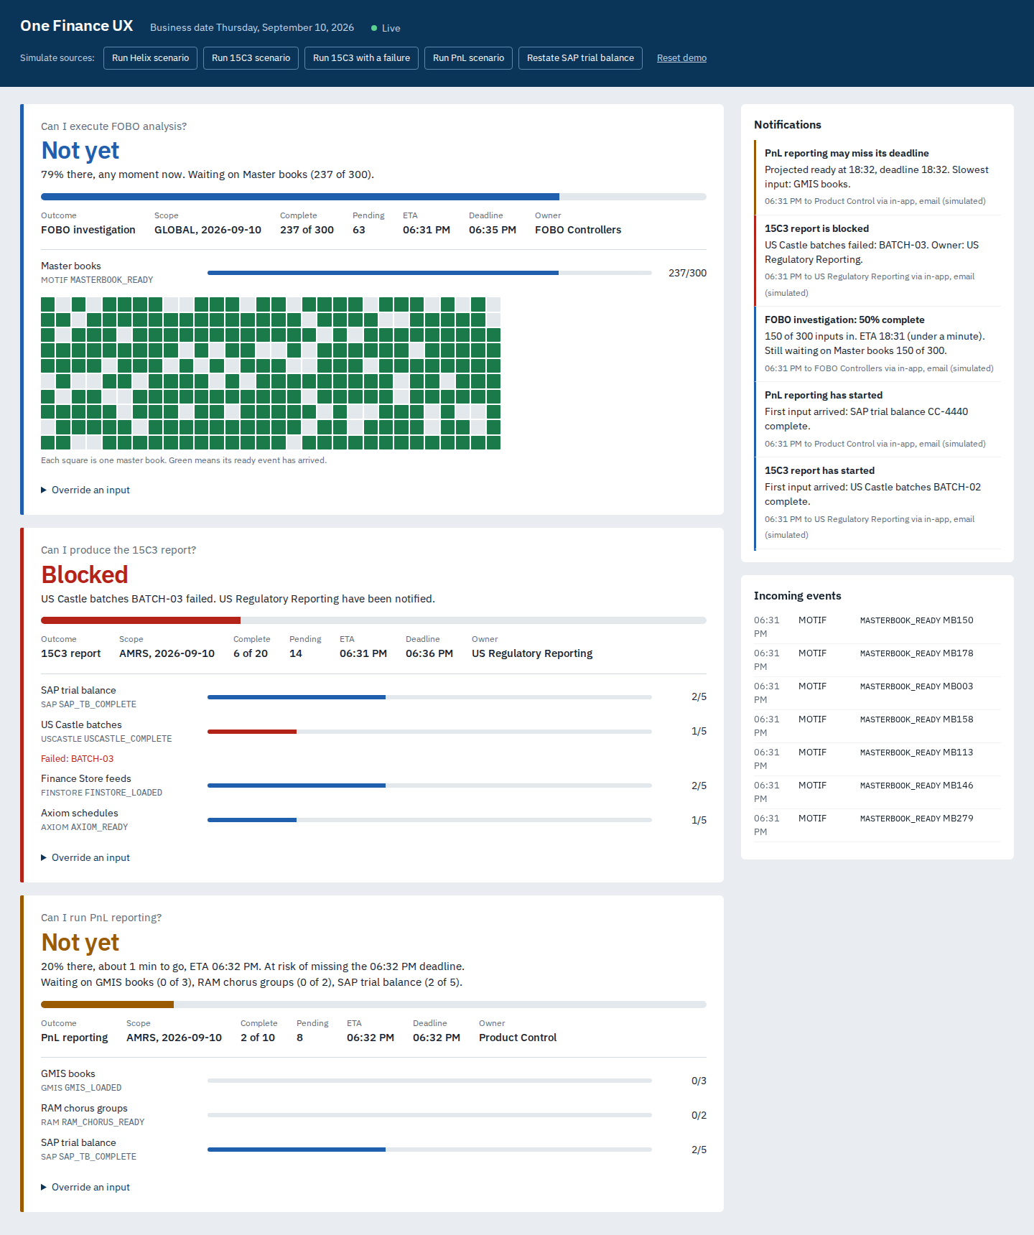
Figure 2. Mid-run: FOBO at 79% with the master-book grid, 15C3 blocked on BATCH-03, PnL at risk
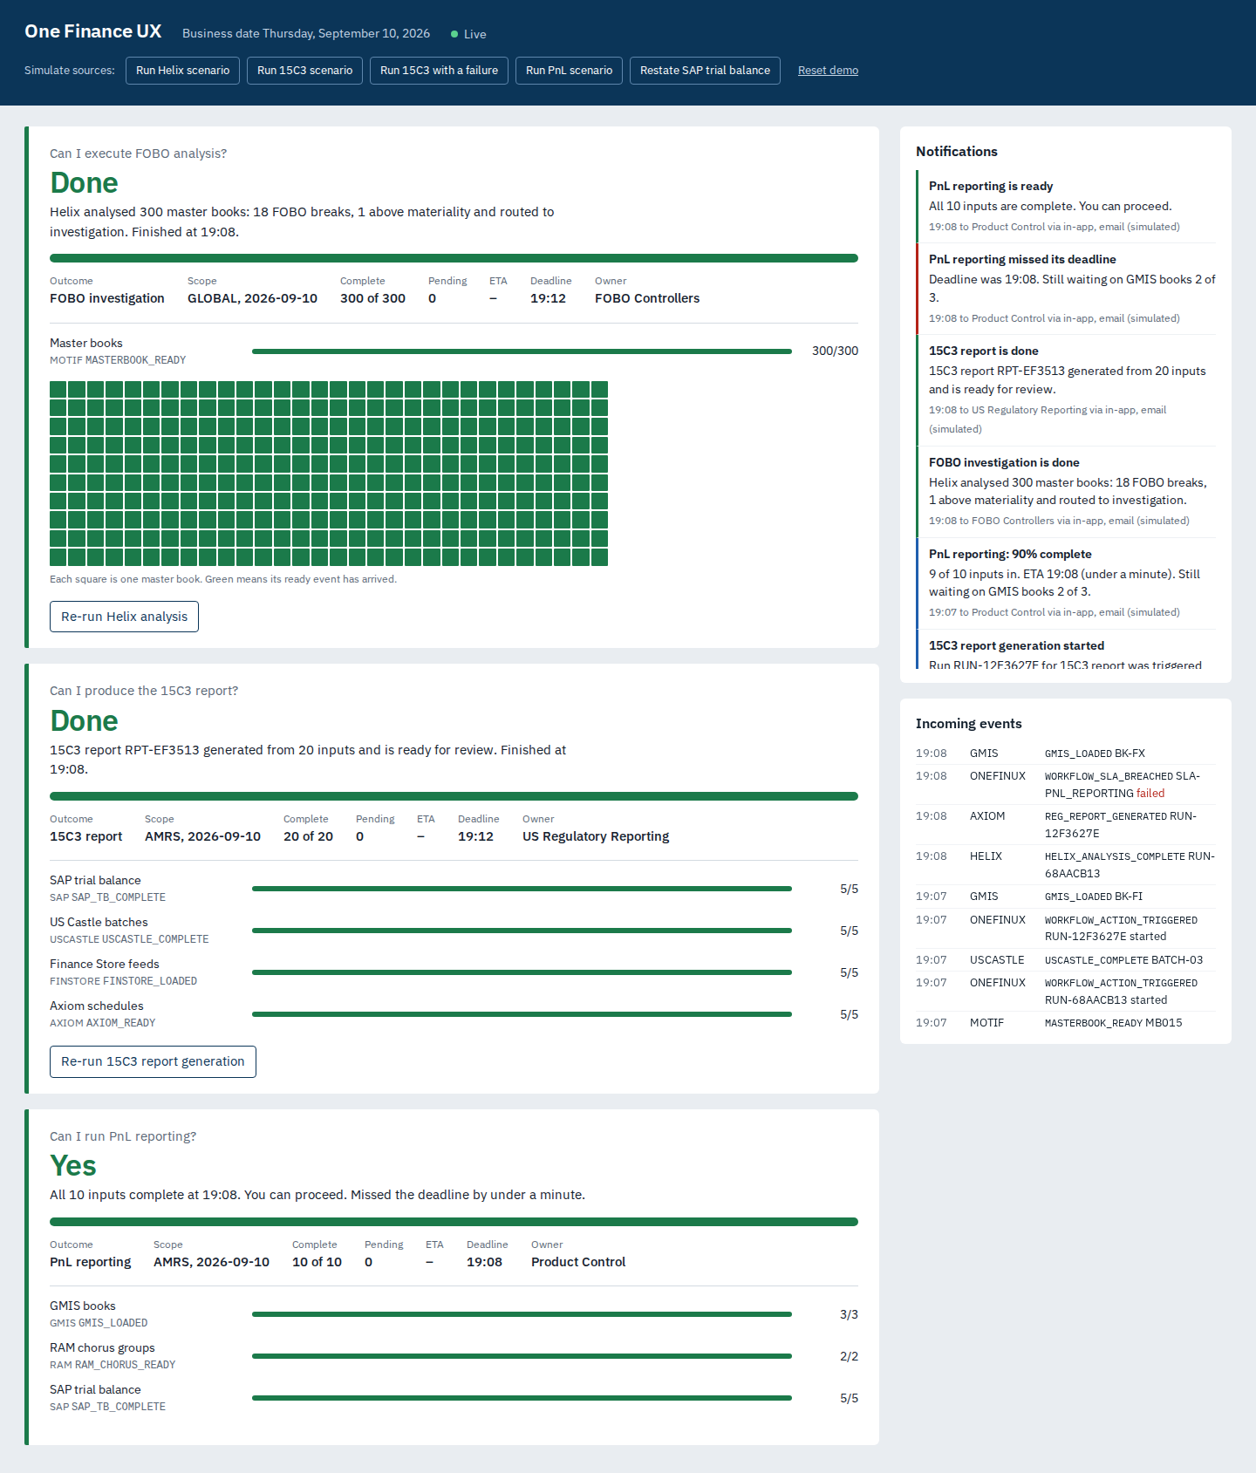
Figure 3. End state: FOBO and 15C3 done with results from Helix and Axiom; PnL ready but late

16.4 What the POC does not prove
- Throughput and availability at production scale (single instance, H2 database).
- Integration with real source systems, the event bus or real Helix and Axiom interfaces.
- Authentication, entitlements and maker-checker.
- Predictive ETA. The POC uses the current arrival rate, which is accurate for steady arrivals but not for batch schedules with gaps.
- Real email, Teams delivery tracking and ServiceNow integration.

17. One fix plan
The plan applies one fix to every pain point in section 2: move readiness from people to events, and move the answer from systems to outcomes. It then delivers that fix in phases, so that value arrives with the first two outcomes rather than at the end.

17.1 Pain point to fix
Pain point | Fix | Phase
No unified view of readiness | One board per business outcome, per COB date and region | 1
Manual chasing | Proactive, owner-routed notifications with what is missing | 1
Implicit dependencies | Outcome definitions in a governed registry | 1
Late discovery of failures | FAILED events block the outcome immediately and alert the source team | 1
Invisible restatements | REVOKED withdraws readiness and triggers re-runs | 1
No predictability | Arrival-rate ETA now; historical prediction in Phase 3 | 1, then 3
Waiting instead of working | Automatic trigger of Helix or Axiom on READY | 1
Polling and dashboard sprawl | Event contract plus edge adapters; one platform replaces status dashboards | 1 and 2

17.2 Phased roadmap
Phase | Scope | Exit criteria | Indicative duration
0. POC | Spring Boot hub and simulator; three outcomes; notifications | Scenarios in section 16 pass; stakeholder demo complete | Complete (September 2026)
1. MVP | 15C3 and FOBO/Helix live for AMRS. Event bus integration; adapters for Motif, SAP, US Castle, Finance Store, Axiom; Oracle 19c; outcome registry; SSO and entitlements; email, Teams, ServiceNow; HA deployment | Two outcomes used for 20 consecutive COB dates; KPI baseline and first targets met; controls sign-off | 12 to 14 weeks
2. Scale | PnL, Month End Close, regulatory reporting; EMEA and APAC; outcome-on-outcome dependencies; maker-checker and attestations; executive roll-up; COB history | Eight or more outcomes live; manual status checks retired for them | Two quarters
3. Intelligence | AOF agents over the event store: predictive ETA from history, bottleneck detection, recommended actions, automatic FOBO investigation, conversational “why is 15C3 late?” | ETA within ±15 minutes for 90% of runs; agent recommendations accepted at an agreed rate | Follows Phase 2; aligns with the AOF roadmap

17.3 POC to production mapping
Concern | POC | Production
Event transport | REST into an in-process publisher | Enterprise event bus (for example Kafka), partitioned by (COB date, region), with a DLQ; REST gateway for simple producers
Sources that cannot publish | Simulator | CDC on status tables or MQ bridges, owned by the platform team
Event store and state | H2 file database | Oracle 19c: append-only event table, outcome snapshot table, notifications; partitioned by COB date
Outcome definitions | application.yml | Outcome registry tables with maker-checker and versioning; expected counts from reference data
Engine | Single instance, synchronized | Consumers per partition; snapshots plus replay; idempotent apply
Notifications | In-app, log email, optional webhook | SSE through the API gateway; corporate SMTP relay; Teams; ServiceNow; delivery tracking
Security | None | SSO; Central Enterprise Entitlement System for views and actions; producer credentials
Observability | Logs | Metrics, tracing, dashboards; event-lag and adapter-silence alerts

17.4 First 30 days of Phase 1
- Confirm the 15C3 variant, input lists, expected counts and cut-offs with US Regulatory Reporting; do the same for FOBO/Helix with FOBO Controllers.
- Agree the event contract and catalogue with the Motif, SAP, US Castle, Finance Store and Axiom teams, and decide who publishes natively and who needs an adapter.
- Stand up event bus topics, Oracle schema and the CI/CD pipeline; port the engine with its tests unchanged.
- Integrate entitlements and SSO; run the first adapter end-to-end in a lower environment.
- Start capturing KPI baselines (section 18) from current manual processes.

18. Success criteria and KPIs
Baselines are measured during the first four weeks of Phase 1, before go-live. Targets apply to outcomes that are live.
Vision success criterion | KPI | Phase 1 target
Single view of operations | Share of in-scope outcomes whose readiness is visible on the platform | 100% of live outcomes
Reduced manual tracking | Status-chasing emails and calls per COB for live outcomes (sampled) | At least 70% reduction from baseline
Real-time monitoring | Latency from source completion to board update | Under 2 seconds at p95 (under 60 seconds through adapters)
Predictable completion | ETA accuracy at 50% progress | Within ±30 minutes for 80% of runs (±15 minutes in Phase 3)
Earlier problem detection | Time from input failure to owner alert | Under 1 minute
Workflow orchestration | Downstream runs triggered automatically rather than by hand | At least 90% for FOBO/Helix and 15C3
Business outcome visibility | Time for a controller to answer “can I start?” | Under 1 minute, from several minutes to hours today
Enterprise scalability | Effort to add a new outcome | Configuration only, under 5 days including sign-off

19. Assumptions, dependencies and constraints

Assumptions
- Source teams can publish events natively, or allow read access to status data for an adapter.
- Input lists and expected counts for each outcome can be derived from reference data owned by Finance.
- Helix and Axiom can accept an API or message trigger and publish a completion event that echoes the run id.
- An enterprise event bus is available to Finance Technology.

Dependencies
- Central Enterprise Entitlement System for roles and action permissions.
- Reference data services for master books, cost centres, chorus groups and account hierarchies.
- Corporate email relay, Teams and ServiceNow integration approvals.
- Architecture Review Board approval of the target design.

Constraints
- No change to source application workflows or schedules in Phase 1.
- Regulatory evidence retention and data residency rules apply to stored events.

20. Risks
Risk | Likelihood | Impact | Mitigation
Source teams cannot prioritise event publishing | High | High | Platform-owned adapters; publishing is a small, well-defined contract
Expected counts are wrong, so “Ready” is wrong | Medium | High | Counts from reference data; data-quality alerts for unexpected keys; business sign-off of each definition
Users distrust the board and keep chasing | Medium | High | Run in parallel for 20 COB dates; drill-through evidence; publish accuracy
Alert fatigue | Medium | Medium | Transition-only notifications, severity routing, digests, a per-outcome milestone policy
Overrides bypass controls on regulatory outputs | Low | High | Mandatory reason and audit now; maker-checker in Phase 2
Scope creeps into re-building source workflows | Medium | Medium | The “orchestrate, don't replace” principle is enforced at design review
Event bus or adapter outage hides readiness | Low | High | Adapter-silence alerts; board shows data freshness; idempotent catch-up replay

21. Open questions
# | Question | Owner | Needed by
Q1 | Which 15C3 report is in scope: Rule 15c3-1 net capital, Rule 15c3-3 reserve computation, or both? What are their inputs and cut-offs? | US Regulatory Reporting | Phase 1 week 2
Q2 | What are the final event names (for example SAP_TB_COMPLETE), and who governs the catalogue? | Finance Technology architecture | Phase 1 week 2
Q3 | Is the 300 master-book count fixed, or is it the active book list per COB? Where is it sourced? | FOBO Controllers, reference data | Phase 1 week 3
Q4 | What override policy applies (who may override, which outcomes need a second approver)? | Risk and Compliance | Phase 1 week 4
Q5 | Which event bus is used, and what are the topic ownership and partitioning standards? | Platform engineering | Phase 1 week 2
Q6 | Can Helix and Axiom accept an automated trigger in production, and through which interface? | Helix and Axiom owners | Phase 1 week 3
Q7 | Which notification channels are approved for which severities? | Operations leadership | Phase 1 week 4
Q8 | What retention period applies to events and overrides used as regulatory evidence? | Records Management | Phase 1 week 6

22. RACI
R = responsible, A = accountable, C = consulted, I = informed.
Activity | Finance sponsor | Product owner | Finance Tech platform | Source app teams | Outcome owners | Risk and Compliance | Architecture
Approve BRD and roadmap | A | R | C | I | C | C | C
Define outcome (inputs, counts, deadline) | I | A | C | C | R | C | I
Event contract and catalogue | I | C | A | R | I | I | C
Publish events or support adapters | I | I | C | R | I | I | A
Build and run the platform | I | C | A/R | C | I | I | C
Notification policy | I | A | R | I | C | C | I
Override and control policy | C | C | R | I | C | A | I
Go-live readiness sign-off | A | R | R | C | R | C | C

Appendix A. API reference (POC)
Method | Path | Purpose
POST | /api/events | Publish one event (202 accepted, 200 duplicate, 400 invalid)
POST | /api/events/batch | Publish several events
GET | /api/events?limit= | Event tape
GET | /api/outcomes | All outcome instances
GET | /api/outcomes/{id}/{cobDate}/{region} | One outcome in detail
POST | /api/outcomes/{id}/{cobDate}/{region}/override | Override an input: {dependency, reason, requestedBy}
POST | /api/outcomes/{id}/{cobDate}/{region}/run | Re-run the downstream action: {requestedBy}
GET | /api/notifications?limit= | Notification inbox
GET | /api/stream | Server-Sent Events: outcome, notification, event
GET | /api/config | Loaded outcomes, mappings and targets
POST | /api/admin/reset | Clear all data (demo only)
POST | :8081/sim/scenarios/{helix | 15c3 | pnl | restate | all | cancel} | Drive the source simulator

Appendix B. Traceability
Business requirement | Functional requirements | POC implementation
BR-01, BR-02 | FR-OE-01, FR-OE-02, FR-UX-01, FR-UX-02 | outcome.OutcomeEngine, OutcomeInstance; static/index.html
BR-03 | FR-EH-01 to FR-EH-05 | event.EventHubService, api.EventController
BR-04 | FR-NT-01 to FR-NT-06 | notification.NotificationService and its channels
BR-05 | FR-WF-01 to FR-WF-03 | workflow.ActionDispatcher; source-simulator DownstreamMocks
BR-06 | FR-OE-07, FR-OE-08, FR-WF-06 | OutcomeInstance ETA; workflow.SlaMonitor
BR-07 | FR-OE-05, FR-OE-06, FR-WF-02 | OutcomeEngine apply rules; OutcomeEngineTest
BR-08 | FR-WF-04, FR-WF-05, FR-UX-05 | workflow.WorkflowController
BR-09 | FR-EH-03, FR-EH-04 | event.EventRecord (append-only); api.StartupReplay
BR-10 | FR-OE-01 | config.OneFinUxProperties; application.yml

Appendix C. Glossary
Term | Meaning
Business outcome | A business deliverable whose readiness depends on inputs from several systems (for example, the 15C3 report)
Outcome instance | One outcome for one COB date and region
COB | Close of business; the business date a fact belongs to
FOBO | Front office to back office reconciliation
Helix | Analysis engine that runs FOBO analysis over master books
15C3 | US SEC broker-dealer rules: 15c3-1 (net capital) and 15c3-3 (customer protection reserve)
Restatement | A re-run or correction that withdraws a previously completed input (status REVOKED)
Run id | Identifier for one execution of a downstream action; used to discard results from superseded runs
Replay | Rebuilding state by re-applying stored events in order
SSE | Server-Sent Events; a one-way live stream from server to browser
AOF | Agent One Finance, the Finance AI agent platform

