**A**

**DISSERATATION PROJECT**

**ON**

**“NAME OF THE PROJECT ”**

**IN THE REQUIREMENT OF AWARD DEGREE OF**

**BACHLOER OF COMPUTER APPLICATION (BCA)**

**UNDER THE GUIDANCE OF**

**<<GUIDE NAME>>**

**SUBMITTED BY**

**<<NAME OF STUDENT>>**

**<<ENROLLMENT NO.>>**

**BATCH- 2022-25**

**SUBMITTED TO**

**MIT COLLEGE OF MANAGEMENT, PUNE**

**2024-2025**

**Certificate from Company ( if applicable)**



**MIT ADT University, Pune**

**MIT College of Management, Pune**

**Program: Bachelor of Computer Application**

**CERTIFICATE (Individual Project)**

This is to certify that Mr/Miss ­­­_______________________________has submitted a Project Report on _________________________________________________ to MIT-ADT University, Pune, for the requirement of an award degree of Bachelor in Computer Application (Data Science/ Cloud Computing) submitted during the academic year 2024-25.

We further certify that to the best of our knowledge and belief, the matter presented in this project has not been submitted for any degree or diploma course.

***PRN No:***

Dr. Ashwin Tomar Dr. Sangita Phunde, Dr. Dipti Tulpule Prof. Dr. Sunita Kara

**HOD, BCA** **Principal**  **UG HEAD**  **Director**

**Internal Examiner** **Sign of Examiners:**

**1.______________________**  **__________________**

**External Examiner** **Sign of Examiners:**

**2.______________________**  ***__________________***



**MIT ADT University, Pune**

**MIT College of Management, Pune**

**Program: Bachelor of Computer Applications**

**DECLARATION**

I hereby declare that the project work entitled “_____________________________” submitted to the MIT - ADT University, Pune, is a record of an original work done by me under the guidance of Prof._____________________, and this project work is submitted in the requirements for the award of the degree of Bachelor of Computer Application. The project work in this report has not been submitted to any other University or Institute for the award of any degree or diploma. This is my own and original work.

Name of the student

Date: Signature



**MIT ADT University, Pune**

**MIT College of Management, Pune**

**Program: Bachelor of Computer Application**

**DECLARATION (Group Project)**

We hereby declare that the project work entitled “____________________________” submitted to the MIT–ADT University, Pune, is a record of an original work done by us and this project work is submitted in the partial fulfillment of the requirements for the award of the degree of Bachelor of Computer Application. The project work in this report has not been submitted to any other University or Institute for the award of any degree or diploma.

As authors of this Group Project report, entitled [project name]…………………………….…..…. our signatures on the document signify our joint responsibility in this project.

|  |  |  |  |
| --- | --- | --- | --- |
| **Sr. No.** | **Seat No /PRN No** | **Name of Student** | **Functionality/ Module** |
| 1 |  |  |  |
| 2 |  |  |  |

Sign._________________________ Sign.___________________________

Name of Student 1 Name of Student 2

This Group Project Report is authored by MIT College of Management Pune students and has been reviewed and approved by:

Sign__________________________ Sign __________________________



**MIT ADT University, Pune**

**MIT College of Management, Pune**

**Program : Bachelor of Computer Application**

**CERTIFICATE OF THE GUIDE**

This is to certify that, Mr/Miss ___________________________________ of B.C.A Course (Data Science/Cloud Computing) have/ has successfully completed his/her Project Work Titled “________________________________________________________”, under my guidance during the Academic Year 2024-2025.

Date:

Project Guide name & Signature



**MIT ADT University, Pune**

**MIT College of Management, Pune**

**Program: Bachelor of Computer Application**

**ACKNOWLEDGEMENT**

I would like to express my sincere gratitude to all those who have been instrumental in the development of the project. I am greatly thankful to Honorable **Dr.** **Prof. Sunita Karad**, Executive Director of MITCOM, for all her timely support.

I express my gratitude to the UG Head, Dr**.** Dipti Tulpule & Principal **Dr. Sangita Phunde** and Head of BCA Department **Dr. Ashwin Tomar** who helped me in my extreme solutions.

I am also thankful to ***………………………………………….*** my internal project guide, for his/her invaluable guidance, help and great support during the project work.

I am greatly thankful to the staff of MITCOM, Pune for helping me through the entire course.

**Student Name & Signature:**

**Date:**

**Place: MITCOM, MIT-ADT University, Pune**

|  |  |
| --- | --- |
| **Sr. NO** | **Content** |
| 1 | Title of Project |
| 2 | Introduction of the Project |
| 3 | Problem Statement |
| 4 | Scope of the Project   * Existing System * Proposed System. |
| 5 | Objectives |
| 6. | Feasibility Study |
| 7. | ER (diagram with explanation) |
| 8. | Technology Used (power bi excel Sheets, google Collab) |
| 9. | Python Codes |
| 10. | Dashboards1 |
| 11. | Conclusion |
| 12. | Plagiarism |

**Introduction:**

The Indian Premier League (IPL) stands as a groundbreaking phenomenon in the world of sports, blending cricket with entertainment to create a global spectacle. Since its inception in 2008, IPL has redefined the dynamics of cricket, introducing a franchise-based model that brings together international players, local talent, and passionate fans. The league's innovative format, featuring fast-paced Twenty20 matches, has captivated audiences worldwide, making it one of the most-watched sporting events.

Beyond the game, IPL has emerged as a powerful platform for economic growth, generating significant revenue through sponsorships, broadcasting rights, and merchandise sales. It has also revolutionized sports marketing, leveraging social media and digital platforms to engage fans and build brand loyalty. The league's emphasis on data analytics and technology has further enhanced player performance, team strategies, and fan experiences.

This project delves into the multifaceted aspects of IPL, exploring its structure, economic impact, technological advancements, and cultural significance. By analyzing the league's success, the study aims to uncover insights into how IPL has transformed cricket into a global entertainment powerhouse while fostering innovation and collaboration in the sports industry

IPL is not just about cricket; it is a celebration of culture, innovation, and economic growth. The league has pioneered advancements in sports marketing, leveraging digital platforms and social media to engage fans and build brand loyalty. It has also become a significant contributor to the economy, generating substantial revenue through sponsorships, broadcasting rights, and merchandise sales. The integration of data analytics and technology has further enhanced player performance, team strategies, and fan experiences, making IPL a case study in modern sports management.

Problem Statement:

The Indian Premier League (IPL) has revolutionized cricket by blending sports and entertainment, creating a global phenomenon. However, the league faces several challenges that require innovative solutions to sustain its growth and impact. Key issues include optimizing team performance through data-driven strategies, enhancing fan engagement in an increasingly digital world, and addressing the economic disparities among franchises. Additionally, the league must navigate ethical concerns such as player workload management, transparency in auctions, and the environmental impact of large-scale events.

This project aims to address these challenges by leveraging advanced technologies, such as data analytics and machine learning, to develop actionable insights for teams and organizers. It also explores innovative fan engagement strategies, including augmented reality (AR) and virtual reality (VR) experiences, to enhance the viewing experience. Furthermore, the project emphasizes sustainability and ethical practices, proposing solutions to minimize the league's environmental footprint and ensure fair play. By tackling these multifaceted issues, the project seeks to contribute to the IPL's continued success as a global leader in sports and entertainment.

**Scope of the IPL Project\***

* The Indian Premier League (IPL) project encompasses a comprehensive analysis of the league's multifaceted aspects, focusing on its structure, operations, and impact. The scope includes:
* Data Analysis and Visualization:
  + Examination of historical IPL data, including player statistics, match outcomes, and team performance.
  + Visualization of trends and patterns using tools like Python, Pandas, and Matplotlib.
* Technological Integration:
  + Exploration of advanced technologies such as machine learning and data analytics to predict match outcomes and player performance.
  + Development of algorithms for team strategy optimization and fan engagement.
* Economic Impact:
  + Analysis of revenue streams, including sponsorships, broadcasting rights, and merchandise sales.
  + Evaluation of the financial disparities among franchises and their implications.
* Fan Engagement:
  + Study of innovative methods to enhance fan experiences, such as augmented reality (AR) and virtual reality (VR).
  + Assessment of social media strategies and their effectiveness in building brand loyalty.
* Ethical and Environmental Considerations:
  + Addressing ethical concerns like player workload management and transparency in auctions.
  + Proposing sustainable practices to minimize the environmental footprint of IPL events.
* Cultural Significance:
  + Exploration of IPL's role in fostering international camaraderie and promoting cricket as a global sport.
  + Analysis of its influence on emerging talent and grassroots cricket development.
* Scalability and Future Prospects:
  + Identifying opportunities for expansion, including new franchises and international collaborations.
  + Evaluating the potential for technological advancements to shape the future of IPL.

**Existing System\***

* Data Utilization: Limited use of advanced analytics for team strategies and fan engagement.
* Fan Interaction: Primarily reliant on traditional methods like social media and live broadcasts.
* Revenue Model: Focused on sponsorships, broadcasting rights, and merchandise sales, with financial disparities among franchises.
* Technological Integration: Basic use of data visualization tools, with minimal adoption of advanced technologies like AR/VR.
* Ethical and Environmental Concerns: Limited initiatives addressing player workload, auction transparency, and sustainability.

### Proposed System

* Advanced Analytics: Implement machine learning models to predict match outcomes, player performance, and optimize team strategies.
* Innovative Fan Engagement: Introduce AR/VR experiences, such as virtual stadium tours and real-time match simulations, to enhance fan interaction.
* Equitable Revenue Sharing: Develop models to address financial disparities among franchises, ensuring sustainable growth.
* Enhanced Technological Integration: Utilize tools like Power BI, Python, and Google Collab for data analysis and visualization.
* Ethical and Sustainable Practices: Propose solutions for player workload management, auction transparency, and eco-friendly event practices.
* Scalability: Explore opportunities for new franchises, international collaborations, and integration of emerging technologies.

**Objectives:**

The primary objective of this project is to analyze and enhance the multifaceted aspects of the Indian Premier League (IPL), focusing on its operational efficiency, technological integration, and overall impact. The project aims to:

1. Optimize Team Performance:
   1. Utilize advanced data analytics and machine learning techniques to predict match outcomes, player performance, and team strategies.
2. Enhance Fan Engagement:
   1. Develop innovative methods such as augmented reality (AR) and virtual reality (VR) experiences to elevate the viewing experience.
   2. Explore social media strategies to strengthen fan loyalty and interaction.
3. Evaluate Economic Impact:
   1. Assess revenue streams, including sponsorships, broadcasting rights, and merchandise sales.
   2. Address financial disparities among franchises and propose solutions for equitable growth.
4. Promote Ethical Practices:
   1. Ensure transparency in player auctions and team management.
   2. Address concerns related to player workload and environmental sustainability.
5. Foster Cultural and Global Significance:
   1. Highlight IPL’s role in promoting international camaraderie and grassroots cricket development.
   2. Analyze its influence on emerging talent and its contribution to the global sports ecosystem.
6. Explore Scalability and Future Prospects:
   1. Identify opportunities for expansion, including new franchises and international collaborations.
   2. Investigate the potential for technological advancements to shape the future of IPL.

**TEST CASES:**

Test cases for an IPL-related project should focus on diverse aspects like data analysis, fan engagement, performance tracking, and technological integrations, depending on your specific goals. Here are some tailored suggestions:

### **1. Functional Test Cases**

* Team Statistics Dashboard: Verify that the dashboard displays accurate team and player statistics like runs, wickets, and strike rates.
* Match Scheduling: Ensure the match schedules and fixtures are correctly displayed and updated dynamically.
* Live Score Updates: Check that live scores are updated in real-time without delays.
* Player Performance Analysis: Validate data visualization for player performance comparisons (e.g., graphs for batting and bowling averages).
* Fan Engagement Features: Test features like polls, trivia quizzes, and real-time fan interactions.
* User Authentication: Confirm secure login for fans, analysts, and administrators with appropriate access levels.

### **2. Data Analytics Test Cases**

* Predictive Analytics: Verify the accuracy of predictions for match outcomes, player performances, or audience trends.
* Historical Data Access: Ensure users can retrieve and analyze historical IPL data.
* Trend Identification: Validate the system's ability to identify trends like emerging players, top scorers, and team weaknesses.

### **3. AR/VR Integration Test Cases (if applicable)**

* Virtual Stadium Experience: Test the rendering quality and responsiveness of AR/VR features simulating a stadium environment.
* Replay Features: Check playback controls for replays and highlights in an immersive VR setup.
* Interactive Features: Verify user engagement with interactive elements, such as viewing statistics through AR while watching matches.

### 4**. Performance Test Cases**

* Load Testing: Simulate high traffic scenarios during live matches to assess system reliability.
* Streaming Performance: Test video and audio quality under varying network conditions.
* Latency Check: Measure system response time for user actions like voting in polls or viewing player stats.

### 5. **Security Test Cases**

* Data Integrity: Ensure the integrity of critical data, such as scores and player stats, is maintained without manipulation.
* Payment Security: Validate secure transactions for ticket bookings or merchandise purchases.
* Privacy Compliance: Confirm adherence to data privacy laws for user information collected through fan engagement features.

### 6. **Scalability Test Cases**

* High Traffic Scenarios: Assess system performance as the number of concurrent users grows (e.g., during playoffs or finals).
* Database Scaling: Verify that the system can handle a growing database of historical IPL data and user records.

**Feasibility Study of IPL Project:**

#### **1. Technical Feasibility**

* Data Analytics and Tools: Evaluate the availability and compatibility of tools like Python, Power BI, and machine learning frameworks for analyzing IPL data.
* Technological Infrastructure: Assess the infrastructure required for implementing advanced technologies like augmented reality (AR), virtual reality (VR), and predictive analytics.
* Scalability: Ensure the system can handle large datasets, real-time updates, and future expansions.

#### **2. Operational Feasibility**

* Stakeholder Engagement: Analyze the involvement of IPL franchises, players, and fans in adopting new technologies or strategies.
* Workflow Integration: Assess how proposed solutions, such as fan engagement platforms or performance analytics, integrate into existing IPL operations.
* User Accessibility: Ensure that the solutions are user-friendly and accessible across diverse demographics.

#### **3. Economic Feasibility**

* Cost Analysis: Estimate the costs associated with developing and implementing the project, including software, hardware, and personnel.
* Revenue Potential: Evaluate potential revenue streams, such as sponsorships, merchandise sales, and enhanced fan engagement platforms.
* Return on Investment (ROI): Calculate the expected ROI to determine the financial viability of the project.

#### **4. Legal and Ethical Feasibility**

* Compliance: Ensure adherence to legal regulations, such as intellectual property rights and data privacy laws.
* Ethical Considerations: Address concerns related to player workload, transparency in auctions, and environmental sustainability.

#### **5. Environmental Feasibility**

* Sustainability: Propose eco-friendly practices to minimize the environmental impact of IPL events, such as reducing carbon footprints and promoting waste management.
* Community Impact: Assess the social and environmental benefits of the project for local communities.

#### **6. Market Feasibility**

* Audience Analysis: Study the demographics and preferences of IPL fans to tailor solutions for maximum engagement.
* Competitor Analysis: Evaluate similar initiatives in other sports leagues to identify unique opportunities for IPL.

#### **7. Risk Assessment**

* Technical Risks: Identify potential challenges in implementing advanced technologies and propose mitigation strategies.
* Operational Risks: Address risks related to stakeholder resistance or integration issues.
* Financial Risks: Analyze the impact of budget overruns or lower-than-expected revenue generation.

**Entities:**

Entity-Relationship (ER) diagram focusing on the IPL components: Individual Score, Player, Venue, Match, Team, and *Owner*.

**Entities in the ER Diagram**

**1. Player**

* Represents the cricketers playing for various IPL teams.
* Attributes:
  + Player ID: Unique identifier for each player.
  + Name: Full name of the player.
  + Role: The player's position (e.g., batsman, bowler, all-rounder).
  + Nationality: The country the player represents.

**2. Team**

* Represents the IPL franchises.
* Attributes:
  + Team ID: Unique identifier for each team.
  + Name: The name of the team.
  + Logo: Team's logo image.

**3. Owner**

* Represents the individual or organization that owns the team.
* Attributes:
  + Owner ID: Unique identifier for each owner.
  + Name: Owner's name.
  + Contact Info: Email or phone for communication.

**4. Match**

* Represents an IPL match scheduled between teams.
* Attributes:
  + MatchI D: Unique identifier for each match.
  + Date: Scheduled date of the match.
  + Time: Scheduled start time.
  + Format: The match format (e.g., T20).

**5. Venue**

* Represents the stadiums where IPL matches take place.
* Attributes:
  + Venue ID: Unique identifier for each venue.
  + Name: Venue name (e.g., Wankhede Stadium).
  + City: The city where the venue is located.
  + Capacity: Maximum seating capacity.

#### **6. Individual Score**

* Represents performance data for players in a match.
* Attributes:
  + Scored: Unique identifier for the score record.
  + Runs: Number of runs scored by the player.
  + Wickets: Number of wickets taken by the player.
  + Overs: Number of overs bowled by the player.

### **Relationships**

1. *Player and Team: A team recruits multiple players, and each player belongs to only one team during the season. *(1-to-Many)
2. *Owner and Team: Each team is owned by one entity, but an owner can own multiple teams. *(1-to-Many)
3. *Team and Match: Matches are contested between two teams. *(Many-to-Many)
4. *Venue and Match: Each match is played at a specific venue, and venues host multiple matches. *(Many-to-One)
5. *Player and Individual Score: Each player's performance in every match is tracked through an individual score. *(1-to-Many)

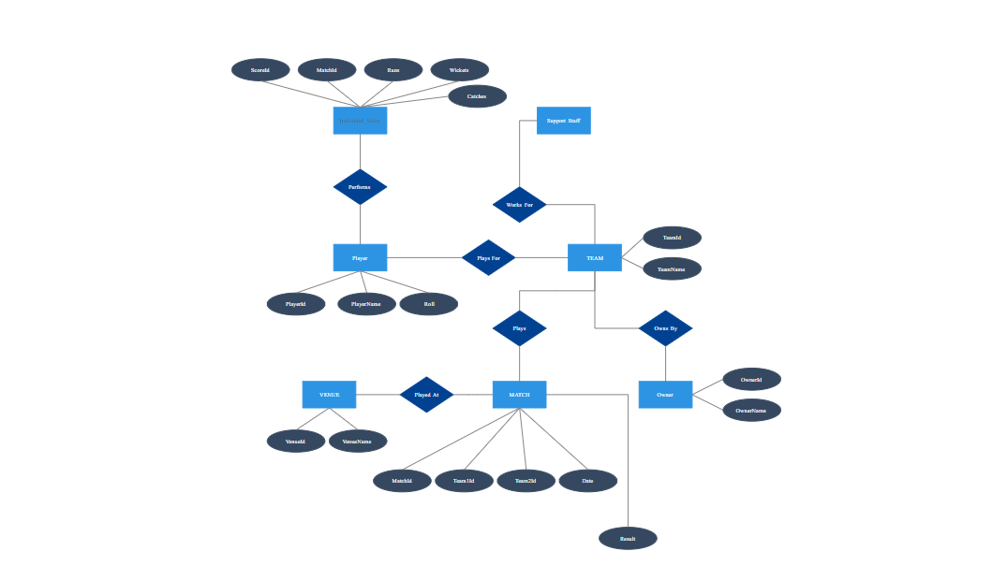

**Technologies used:**

1.**Excel*:**

•Data cleaning and preprocessing using formulas and functions.

•Creating interactive dashboards with Pivot Tables, Slicers, and Charts to visualize team performance, player statistics, and match outcomes.

2.. **Google Collab**\*:

* Performing advanced data analysis using Python libraries like Pandas, NumPy, and Matplotlib.
* Implementing machine learning models to predict match outcomes and player performance.

3.**Power BI*:**

- Building dynamic and interactive dashboards for IPL data analysis.

- Visualizing trends like Orange Cap and Purple Cap winners, tournament statistics, and team

performance over the years.

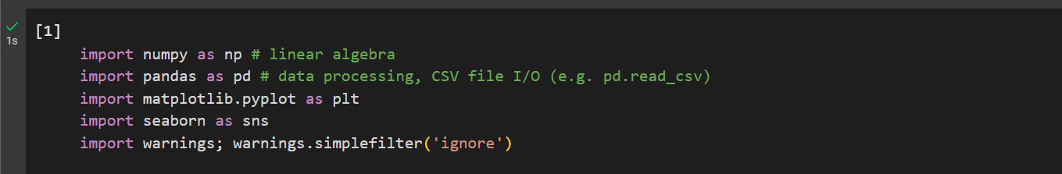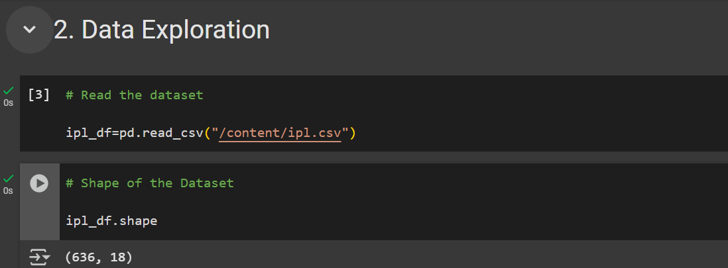

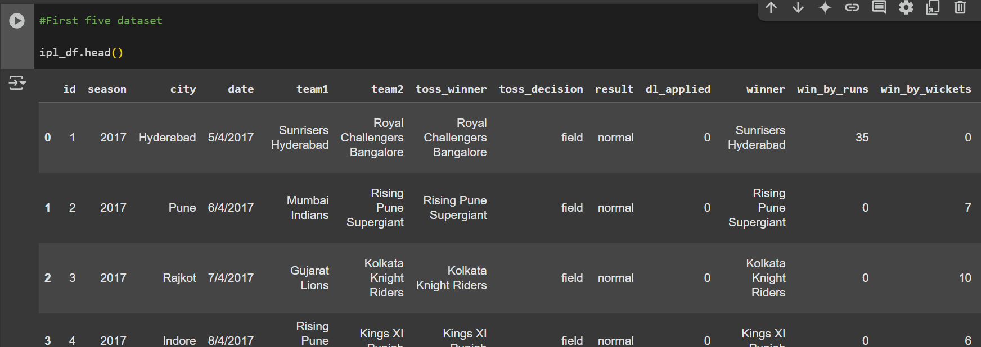

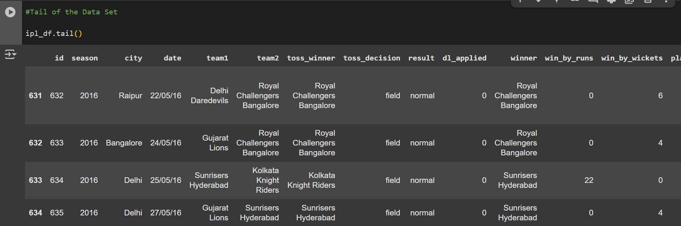

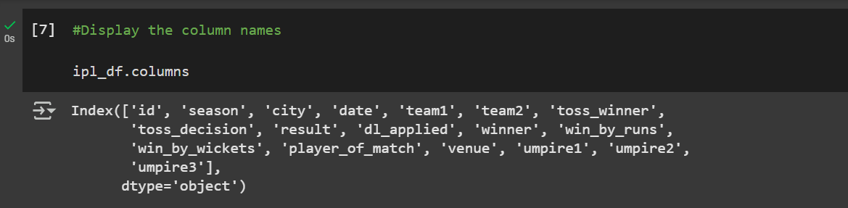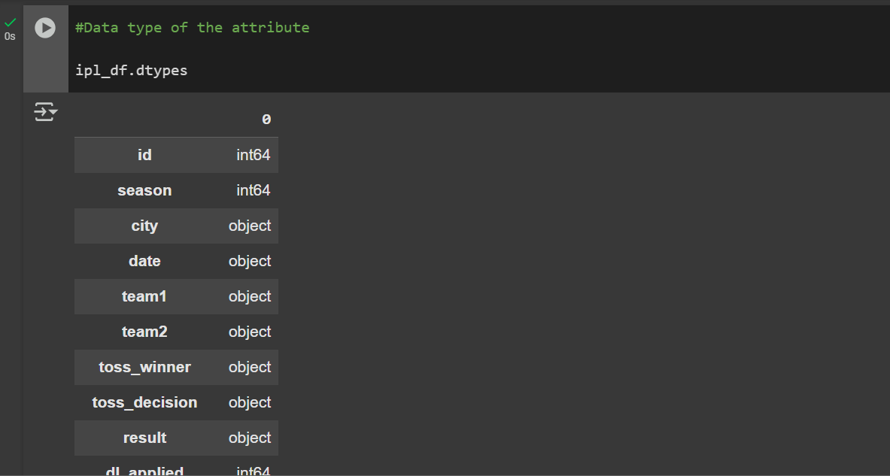



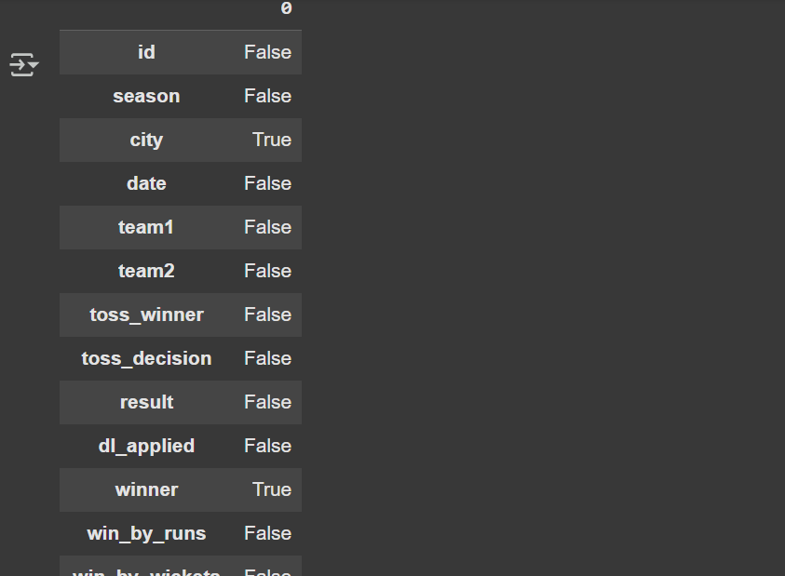

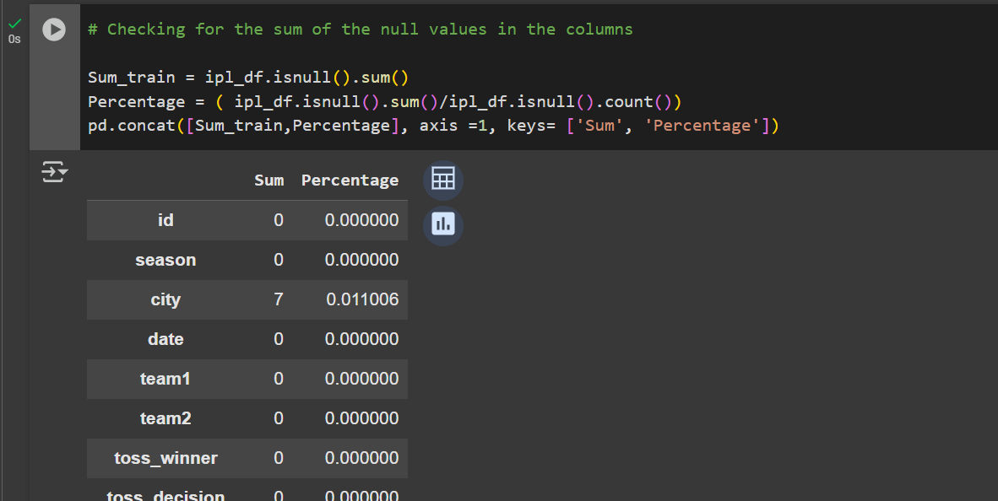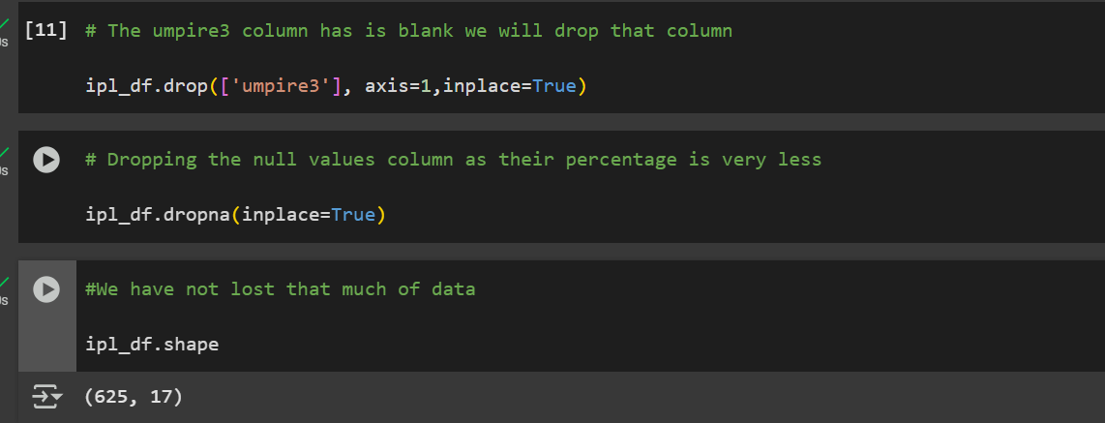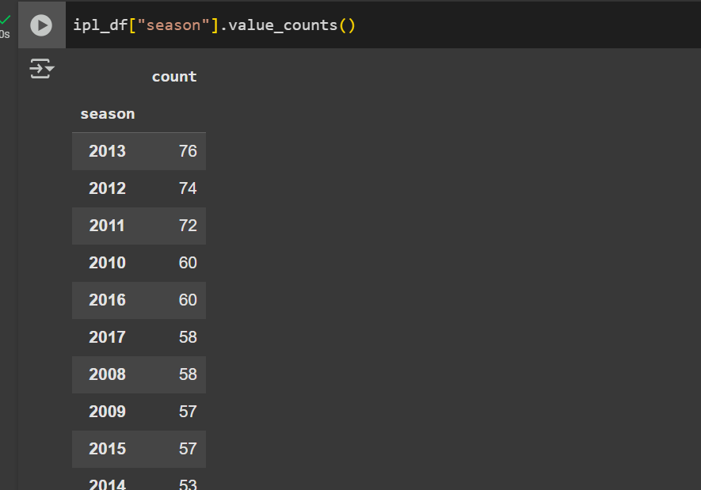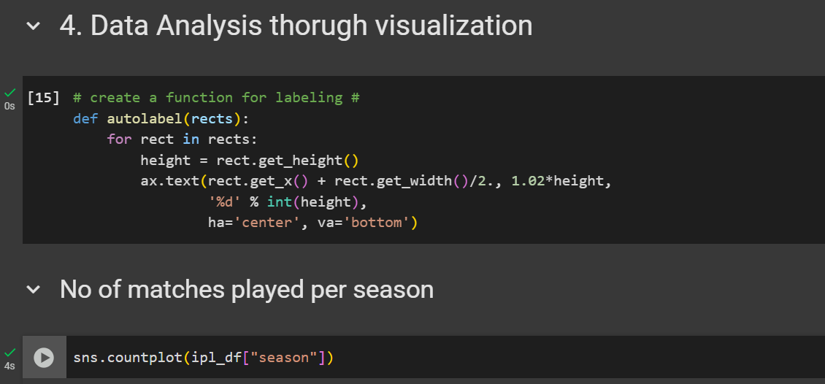

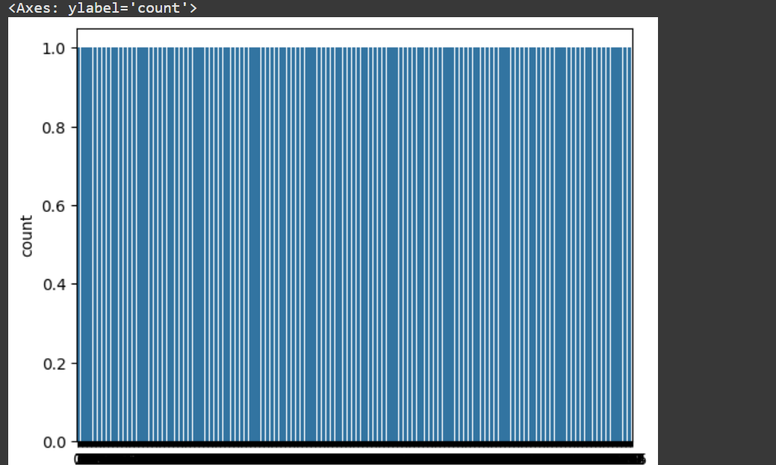

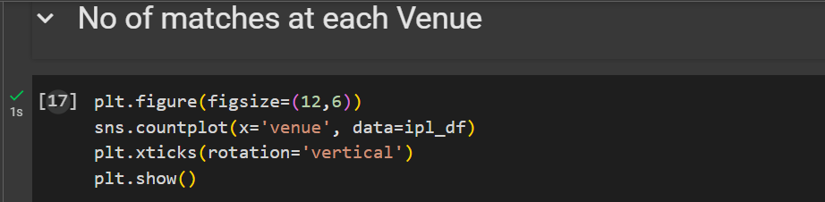

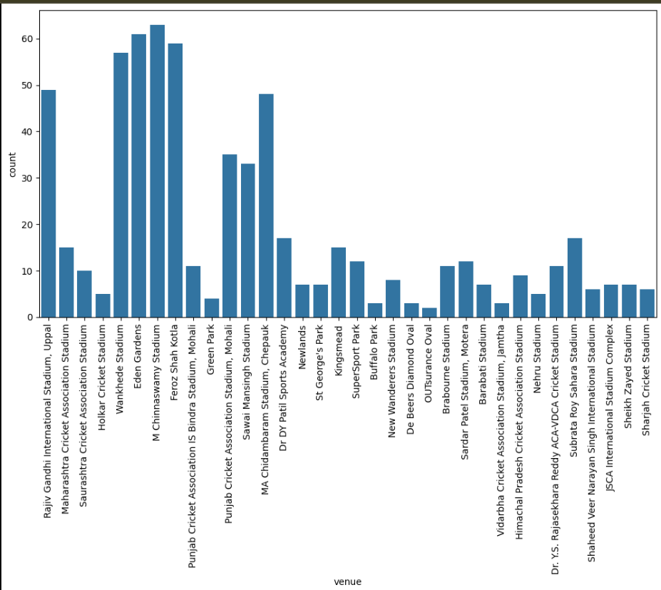

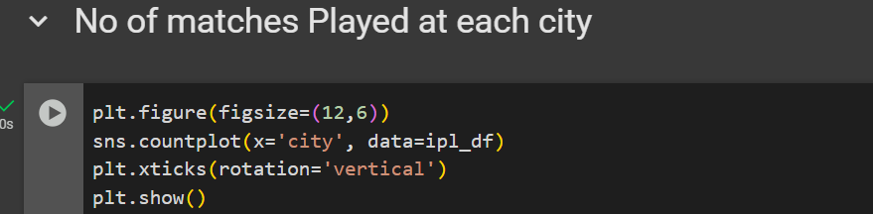

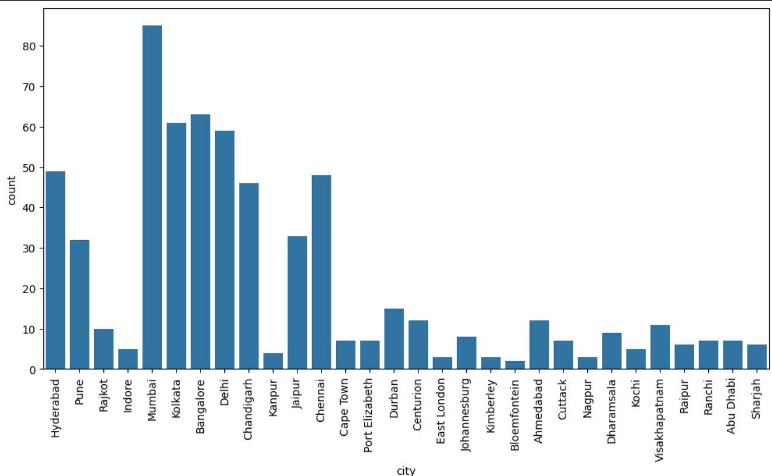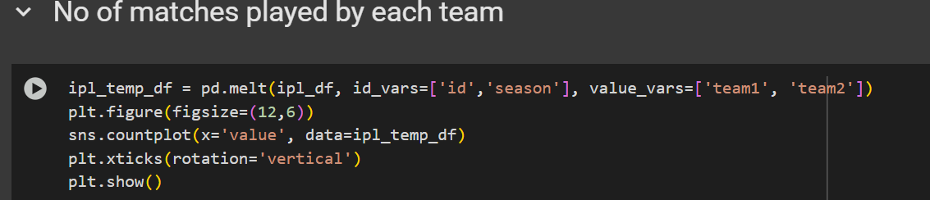

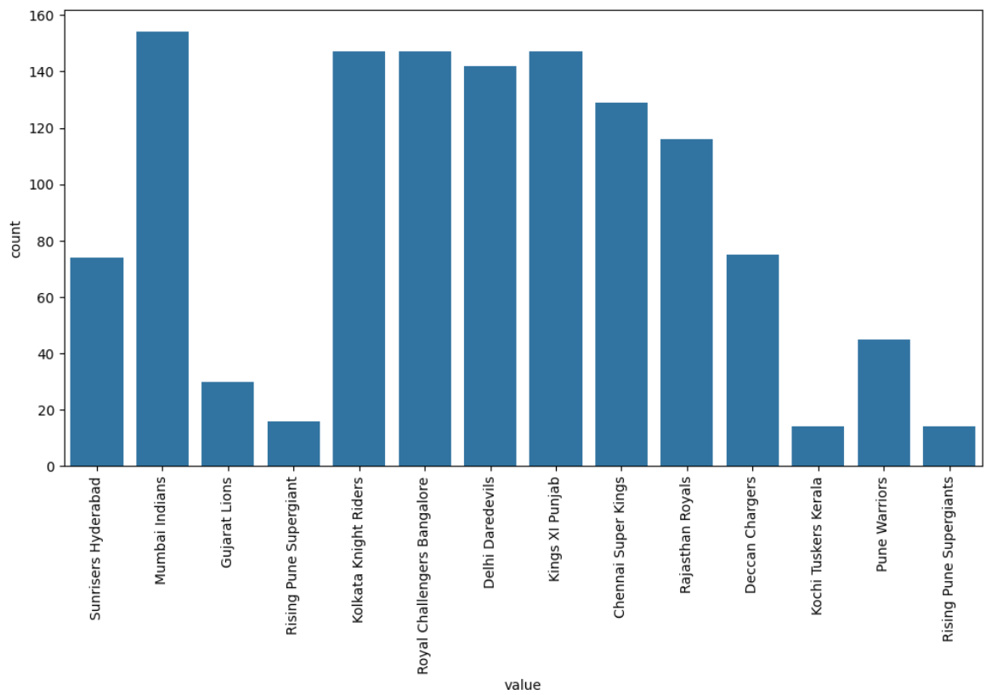

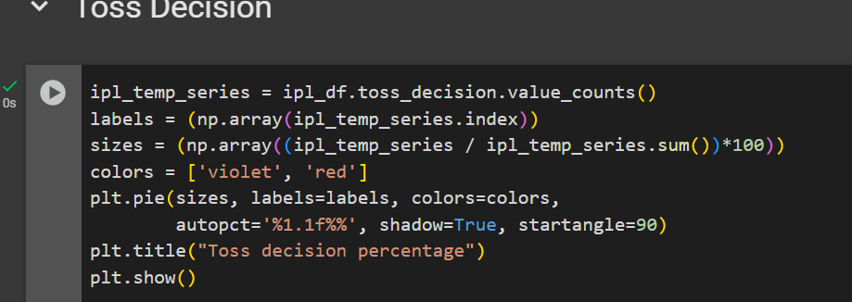

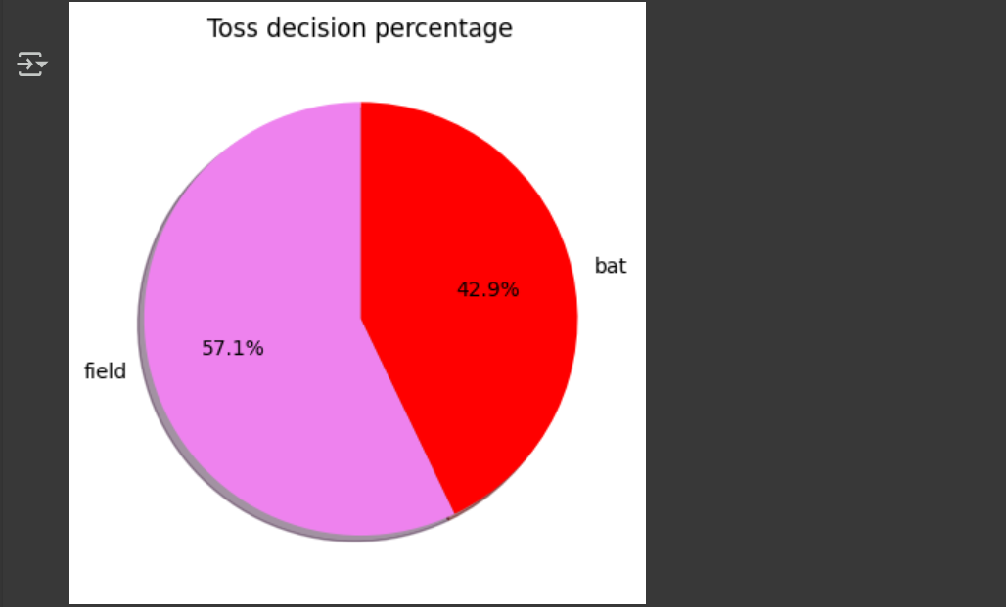

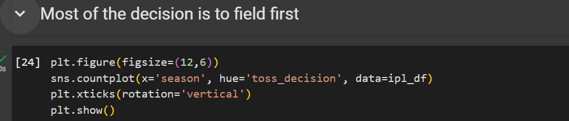

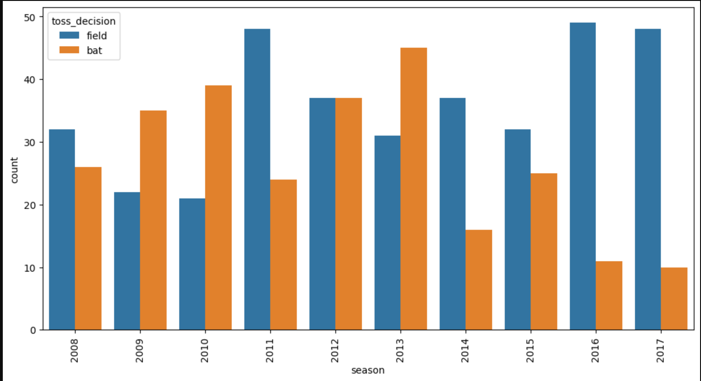

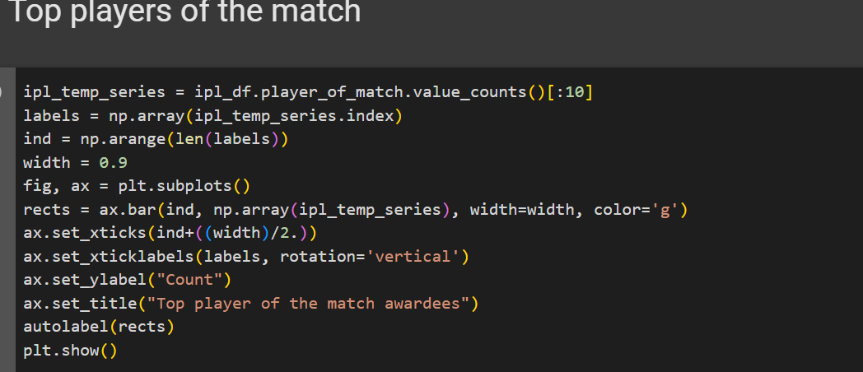

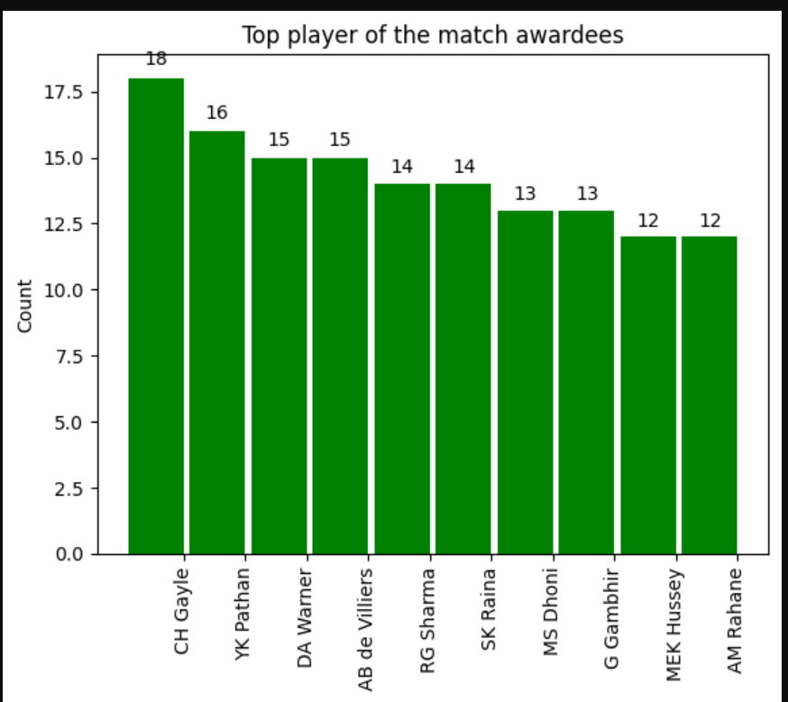

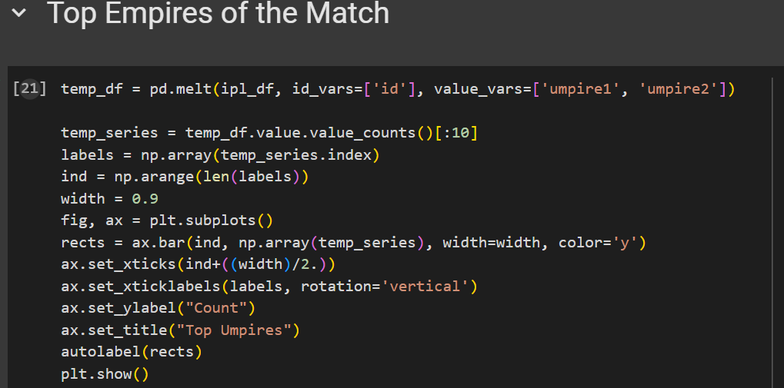

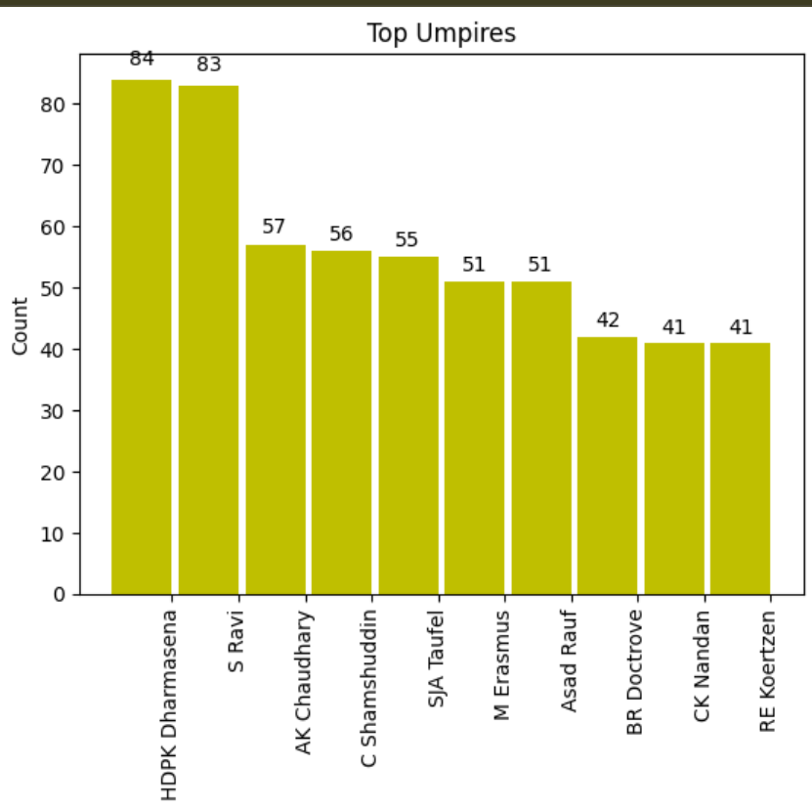

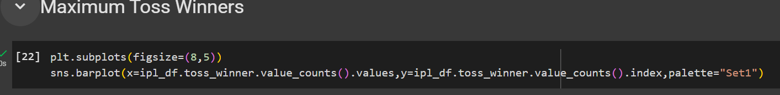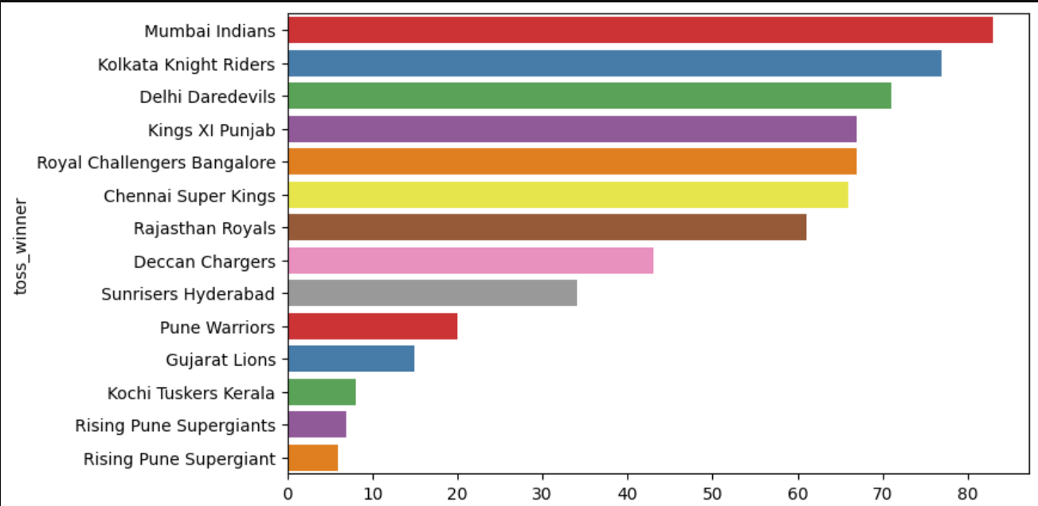

**Dashboards**

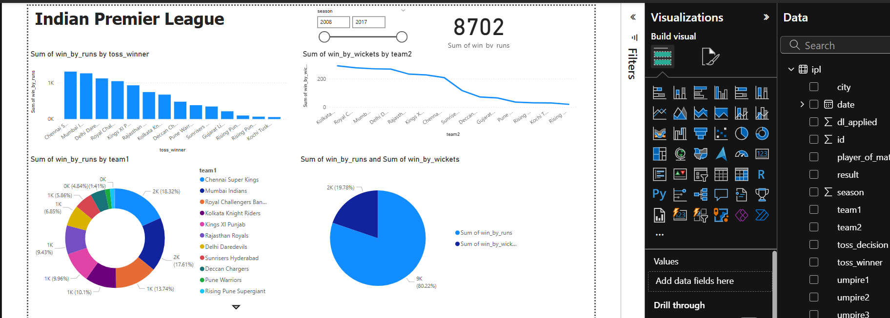

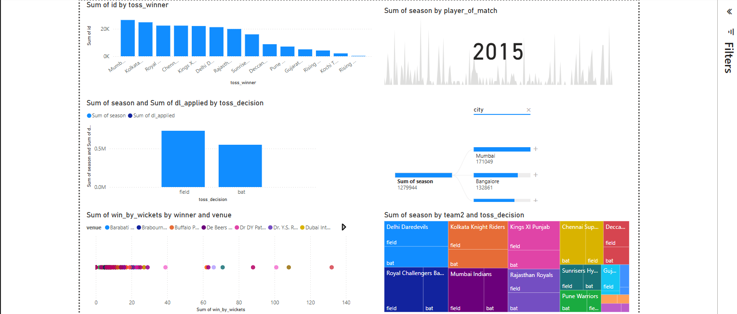

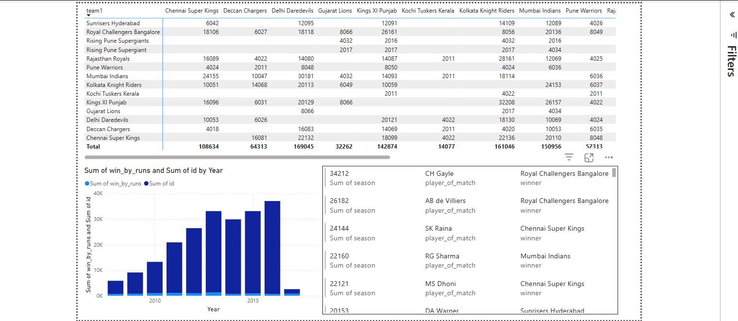

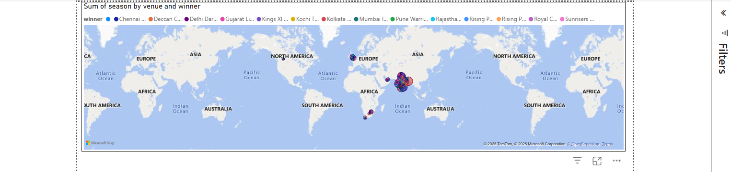

**Conclusion**:

The Indian Premier League (IPL) has established itself as a global phenomenon, blending cricket with entertainment and innovation. Through this project, we have explored the multifaceted aspects of IPL, including its structure, technological advancements, economic impact, and cultural significance. The analysis highlights how IPL has revolutionized cricket by introducing a franchise-based model, leveraging data analytics, and fostering international camaraderie.

The integration of technologies such as machine learning, augmented reality (AR), and virtual reality (VR) has enhanced fan engagement and team performance, setting new benchmarks in sports management. Furthermore, the league's emphasis on ethical practices and sustainability demonstrates its commitment to addressing modern challenges, such as player workload and environmental impact.

By examining IPL's scalability and future prospects, this project underscores the league's potential for continued growth and innovation. The insights gained from this study contribute to a deeper understanding of IPL's role in shaping the sports industry and its ability to inspire global audiences. Ultimately, IPL serves as a testament to the power of sports in driving economic, cultural, and technological progress.