Please verify elastic search is running - <http://localhost:9200/>

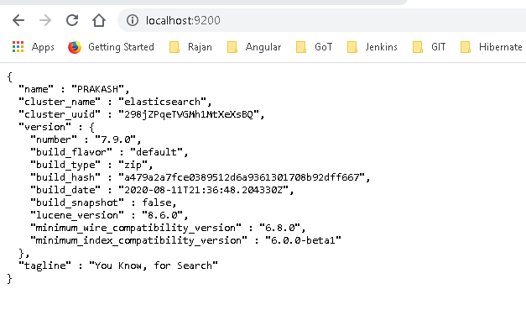

**Creating index API**

<https://www.elastic.co/guide/en/elasticsearch/reference/current/indices-create-index.html>

Cmd:

PUT /<index>

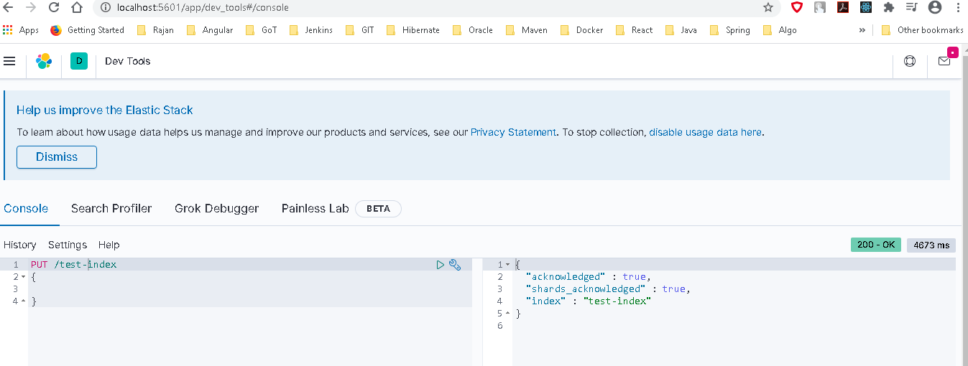

**Cat API**

<https://www.elastic.co/guide/en/elasticsearch/reference/current/cat.html>

cat APIs are only intended for human consumption using the Kibana console or command line. They are not intended for use by applications. For application consumption, we recommend using a corresponding JSON API.

