




TABLE OF CONTENTS
1. Abstract
2. Introduction
3. System Analysis
4. Database Design
5. ER Diagram
6. Relational Schema
7. Table Design
8. Normalization
9. SQL Implementation
10. SQL Queries and Outputs
11. Conclusion
12. Future Enhancements
13. References
LIST OF FIGURE
Figure 1. ER representation of the Courier Management System

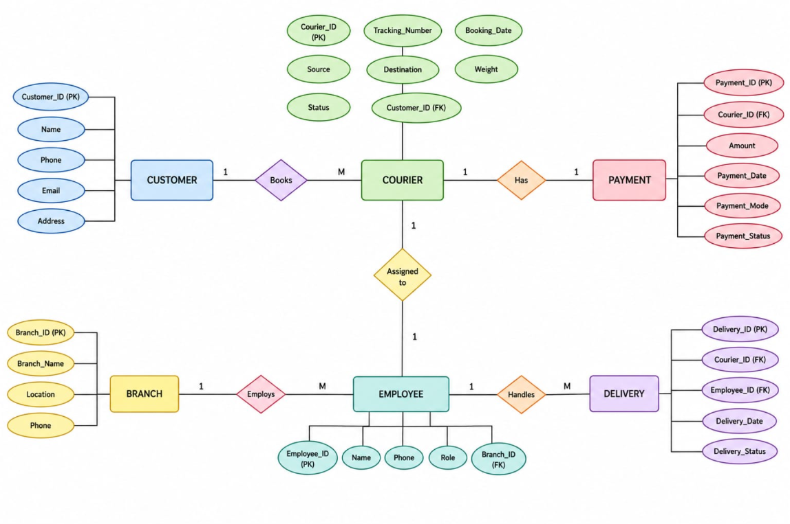

List of tables

Table 1. Major functional modules and requirements
Table 2. Major entities and their purposes
Table 3. Relationships and cardinalities
Table 4. Relational schema
Table 5. CUSTOMER table structure
Table 6. COURIER table structure
Table 7. BRANCH table structure
Table 8. EMPLOYEE table structure
Table 9. PAYMENT table structure
Table 10. DELIVERY table structure
Table 11. Constraints used
Table 12. Normalization stages and decomposition
Table 13. Anomalies addressed through normalization
Table 14. Sample record counts
Table 15. Key SQL outputs

ACRONYMS
DBMS — Database Management System
ER — Entity Relationship
SQL — Structured Query Language
DDL — Data Definition Language
DML — Data Manipulation Language
DQL — Data Query Language
PK — Primary Key
FK — Foreign Key
1NF — First Normal Form
2NF — Second Normal Form
3NF — Third Normal Form
CRUD — Create, Read, Update, Delete
ID — Identification
UPI — Unified Payments Interface

1. ABSTRACT
1. Abstract
The Courier Management System is a database management system designed to manage courier bookings, customers, branches, employees, payments, and deliveries in an organized manner. The system provides a centralized database where courier-related information can be stored, updated, retrieved, and analyzed efficiently.
Traditional manual courier management can lead to duplicate records, inconsistent information, difficulty in tracking shipments, and delays in generating reports. The proposed system solves these problems by maintaining all important information in a structured relational database.
The system consists of six major entities: Customer, Courier, Branch, Employee, Payment, and Delivery. Relationships between these entities are maintained using primary keys and foreign keys. SQL queries are used to retrieve information, perform calculations, analyze courier status, manage payments, and generate useful reports.
The database is also normalized up to Third Normal Form (3NF) to reduce redundancy and avoid insertion, deletion, and update anomalies.
Keywords: Courier Management System, DBMS, SQL, Relational Database, Courier Tracking, Customer Management, Payment Management, Delivery Management, Normalization, 3NF.

2. Introduction
Courier services involve managing a large amount of information related to customers, shipments, employees, branches, payments, and deliveries. Managing this information manually can become difficult when the number of courier bookings increases.
The Courier Management System provides a centralized database to store and manage all courier-related information. It allows courier staff and administrators to access accurate information quickly.
The system focuses on:
- Customer management
- Courier booking
- Shipment tracking
- Branch management
- Employee management
- Payment management
- Delivery management
- Report generation
The database uses a relational structure where different tables are connected through primary and foreign keys.

3. System Analysis
3.1 Problem Statement
A traditional courier management process may depend on manual records and separate files. This can result in:
- Duplicate customer records
- Incorrect or inconsistent data
- Difficulty tracking courier status
- Delays in retrieving shipment information
- Difficulty managing employees and branches
- Problems maintaining payment records
- Difficulty preparing reports
Therefore, a centralized database is required to manage courier operations efficiently.
3.2 Proposed Solution
The proposed Courier Management System uses a centralized relational database to store courier information.
The system provides:
- A single source of courier information
- Faster access to shipment records
- Better data accuracy
- Reduced data redundancy
- Easier shipment tracking
- Organized payment and delivery records
- Efficient report generation
The project specifically identifies centralized storage, faster tracking, accurate data, easy access, and management of customers, bookings, shipments, branches, employees, payments, deliveries, and reports as major objectives. Courier_Management_System_Revie…

4. Users and Requirements
4.1 End Users
The system is intended for:
- Customers
- Courier Staff / Employees
- Admin / Branch Manager
4.2 Functional Requirements
The system should support:
- Customer management
- Courier booking
- Shipment tracking
- Employee management
- Branch management
- Payment management
- Delivery management
- Report generation
4.3 Non-Functional Requirements
The system should provide:
- Security
- Performance
- Reliability
- Usability
- Scalability
These user and requirement categories are included in the uploaded project material. Courier_Management_System_Revie…

5. Database Entities
The Courier Management System contains six major entities:
Entity | Description
CUSTOMER | Stores customer information
COURIER | Stores booking and shipment information
BRANCH | Represents courier operating locations
EMPLOYEE | Stores courier staff and branch employee information
PAYMENT | Stores payment details
DELIVERY | Stores delivery assignment and completion details
These six entities are explicitly defined in your project material. Courier_Management_System_Revie…

6. Entities and Attributes
CUSTOMER
- Customer_ID — Primary Key
- Name
- Phone
- Email
- Address
COURIER
- Courier_ID — Primary Key
- Tracking_Number
- Booking_Date
- Source
- Destination
- Weight
- Status
- Customer_ID — Foreign Key
BRANCH
- Branch_ID — Primary Key
- Branch_Name
- Location
- Phone
EMPLOYEE
- Employee_ID — Primary Key
- Name
- Phone
- Role
- Branch_ID — Foreign Key
PAYMENT
- Payment_ID — Primary Key
- Courier_ID — Foreign Key
- Amount
- Payment_Date
- Payment_Mode
- Payment_Status
DELIVERY
- Delivery_ID — Primary Key
- Courier_ID — Foreign Key
- Employee_ID — Foreign Key
- Delivery_Date
- Delivery_Status
The uploaded project defines these entities and attributes with PK/FK relationships. Courier_Management_System_Revie…

7. Relationships and Cardinality
The major relationships are:
Relationship | Cardinality | Description
Customer → Courier | 1:M | One customer can book many couriers
Branch → Employee | 1:M | One branch can have many employees
Courier → Payment | 1:1 | Each courier has one payment record
Courier → Delivery | 1:1 | Each courier has one delivery record
Employee → Delivery | 1:M | One employee can handle many deliveries
These cardinalities are directly specified in your uploaded ER design. Courier_Management_System_Revie…

8. ER Diagram Explanation
An Entity–Relationship Diagram (ER Diagram) represents the entities in the database and the relationships between them.
The ER diagram represents the database structure of the Courier Management System and shows how customers, couriers, payments, branches, employees, and deliveries are connected.
- Customer – Stores customer details such as Customer ID, Name, Phone, Email, and Address.
- Courier – Stores courier information including Courier ID, Tracking Number, Booking Date, Source, Destination, Weight, Status, and Customer ID.
- Payment – Records payment details such as Payment ID, Courier ID, Amount, Payment Date, Payment Mode, and Payment Status.
- Branch – Contains Branch ID, Branch Name, Location, and Phone.
- Employee – Stores Employee ID, Name, Phone, Role, and Branch ID.
- Delivery – Maintains Delivery ID, Courier ID, Employee ID, Delivery Date, and Delivery Status.
9. Relational Schema
The relational schema of the project is:
CUSTOMER
CUSTOMER(Customer_ID, Name, Phone, Email, Address)
COURIER
COURIER(Courier_ID, Tracking_Number, Booking_Date, Source,
Destination, Weight, Status, Customer_ID)
BRANCH
BRANCH(Branch_ID, Branch_Name, Location, Phone)
EMPLOYEE
EMPLOYEE(Employee_ID, Name, Phone, Role, Branch_ID)
PAYMENT
PAYMENT(Payment_ID, Courier_ID, Amount, Payment_Date, Payment_Mode, Payment_Status)
DELIVERY
DELIVERY(Delivery_ID, Courier_ID, Employee_ID, Delivery_Date, Delivery_Status)

10. Database Design
The database uses:
- Primary Keys
- Foreign Keys
- NOT NULL constraints
- UNIQUE constraints
- CHECK constraints
- DEFAULT values
These constraints help maintain data integrity and prevent invalid records.
For example, the Courier table restricts the courier status to:
- Booked
- In Transit
- Out for Delivery
- Delivered
Similarly, delivery status is restricted to:
- Pending
- Assigned
- Out for Delivery
- Delivered

11. Normalization
Normalization is the process of organizing data into tables to reduce redundancy and avoid database anomalies.
The Courier Management System is normalized up to 3NF.
11.1 First Normal Form – 1NF
A table is in 1NF when:
- All values are atomic.
- There are no repeating groups.
- Each record can be uniquely identified.
In the Courier Management System, courier information is stored as individual records and Courier_ID is used as the primary key.
Therefore, the database satisfies 1NF.
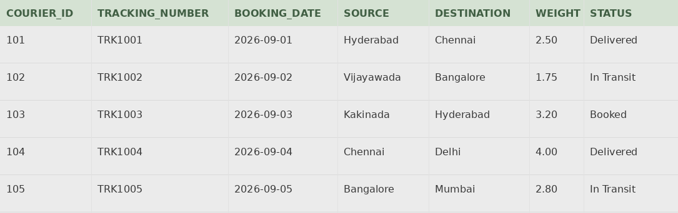

11.2 Second Normal Form – 2NF
A relation is in 2NF when:
- It is already in 1NF.
- There is no partial dependency.
The COURIER table uses a single-column primary key, Courier_ID. Therefore, partial dependency cannot occur.
The functional dependency is:
Courier_ID → Customer_ID, Tracking_Number, Booking_Date, Source, Destination, Weight, Status
Every non-key attribute depends on the complete primary key. Courier_Management_System_Revie…
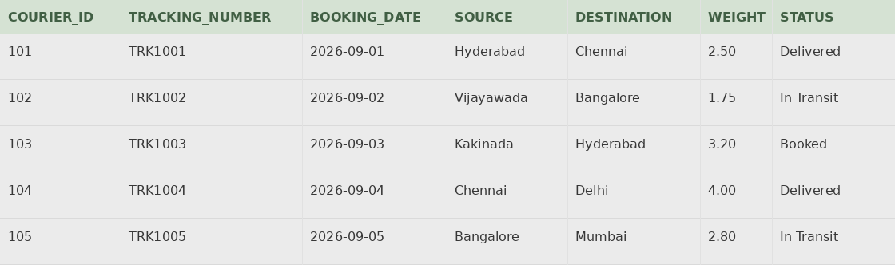

11.3 2NF Decomposition
The database is divided into separate relations:
- CUSTOMER
- COURIER
- BRANCH
- EMPLOYEE
- PAYMENT
- DELIVERY
Foreign keys maintain the relationships between these tables. Courier_Management_System_Revie…
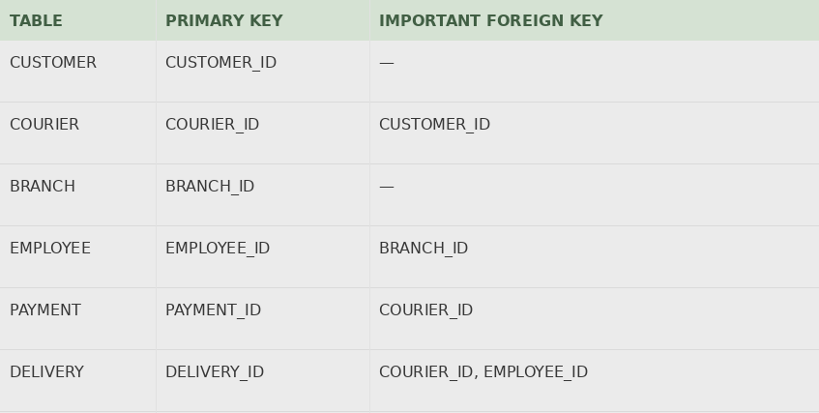

11.4 Third Normal Form – 3NF
A relation is in 3NF when:
- It is in 2NF.
- It does not contain transitive dependencies.
Important dependencies include:
Courier_ID → Customer_ID
Customer_ID → Customer_Name, Customer_Phone
Employee_ID → Branch_ID
Branch_ID → Branch_Name
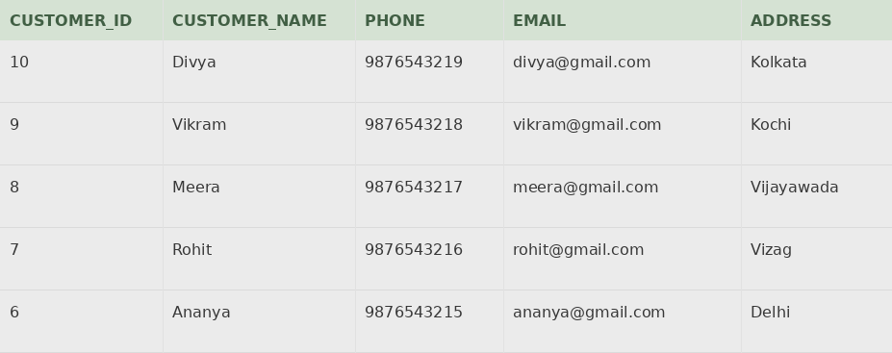
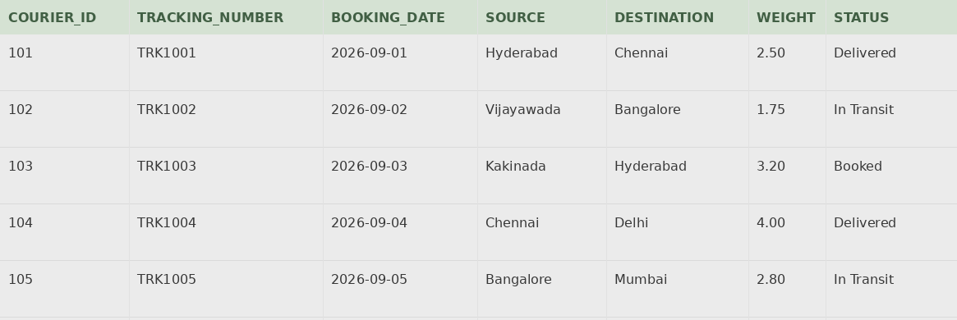

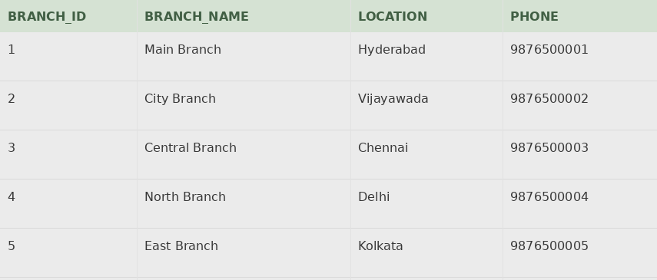
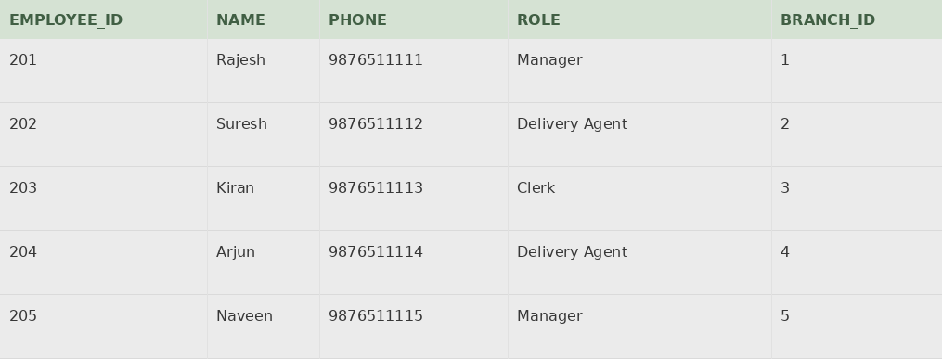
Transitive dependencies are separated into appropriate tables.
This reduces:
- Data redundancy
- Update anomalies
- Insertion anomalies
- Deletion anomalies

12. SQL Implementation
The database can be implemented using SQL CREATE TABLE commands.
For example:
CREATE TABLE CUSTOMER (
Customer_ID NUMBER(6) PRIMARY KEY,
Name VARCHAR2(80) NOT NULL,
Phone VARCHAR2(15) NOT NULL UNIQUE,
Email VARCHAR2(100) NOT NULL UNIQUE,
Address VARCHAR2(200) NOT NULL
);
Courier table:
CREATE TABLE COURIER (
Courier_ID NUMBER(6) PRIMARY KEY,
Tracking_Number VARCHAR2(20) NOT NULL UNIQUE,
Booking_Date DATE NOT NULL,
Source VARCHAR2(50) NOT NULL,
Destination VARCHAR2(50) NOT NULL,
Weight NUMBER(6,2) NOT NULL CHECK (Weight > 0),
Status VARCHAR2(20) DEFAULT 'Booked' NOT NULL,
Customer_ID NUMBER(6) NOT NULL,
FOREIGN KEY (Customer_ID)
REFERENCES CUSTOMER(Customer_ID)
);

13. SQL Queries
Query 1 – Display all customers
SELECT * FROM CUSTOMER;
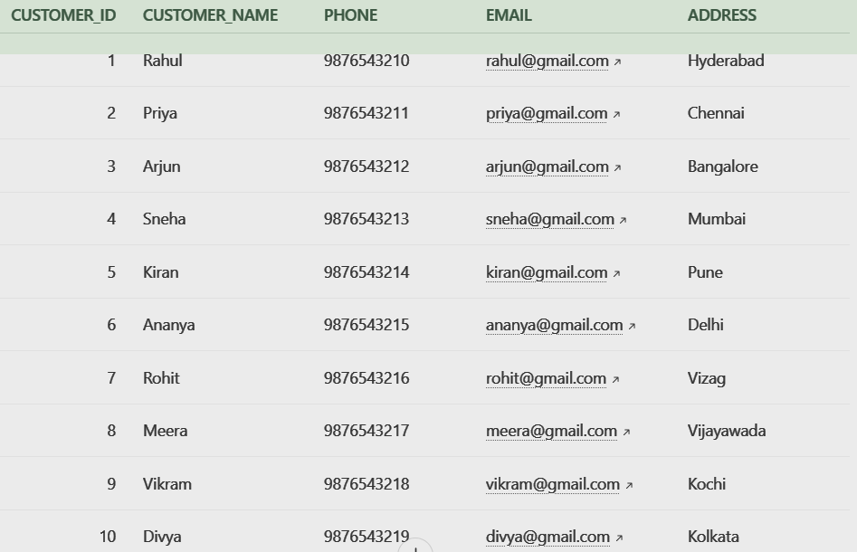
Query 2 – Display branch names and locations
SELECT Branch_Name, Location
FROM BRANCH;
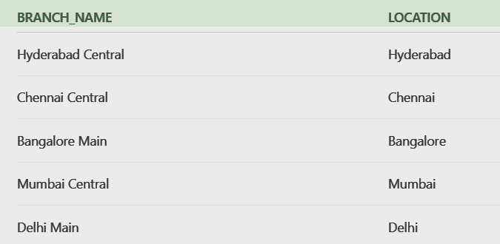
Query 3 – Couriers weighing more than 5 kg
SELECT *
FROM COURIER
WHERE Weight > 5;
Query 4 – Couriers in transit
SELECT *
FROM COURIER
WHERE Status = 'In Transit';
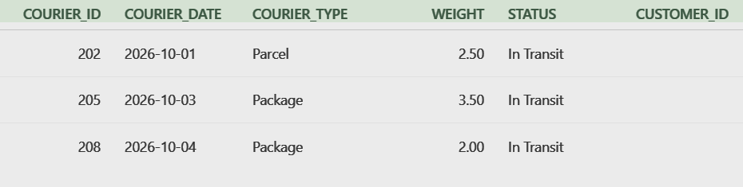
Query 5 – Pending payments
SELECT *
FROM PAYMENT
WHERE Payment_Status = 'Pending';
Query 6 – Delivery agents
SELECT Employee_ID, Name, Role
FROM EMPLOYEE
WHERE Role = 'Delivery Agent';
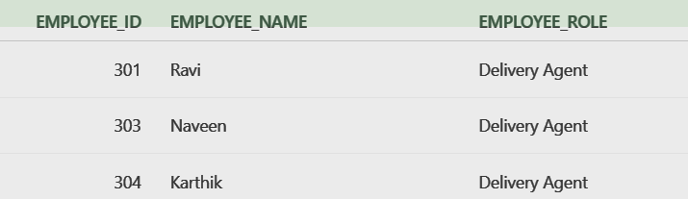
Query 7 – Count couriers by status
SELECT Status, COUNT(*)
FROM COURIER
GROUP BY Status;
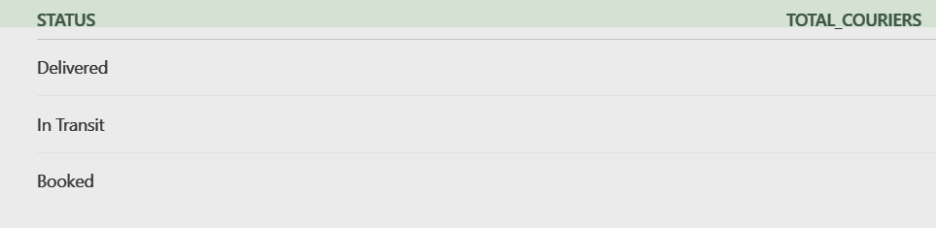
Query 8 – Customer and courier details
SELECT c.Name,
c.Phone,
cr.Tracking_Number,
cr.Destination,
cr.Status
FROM CUSTOMER c
JOIN COURIER cr
ON c.Customer_ID = cr.Customer_ID;
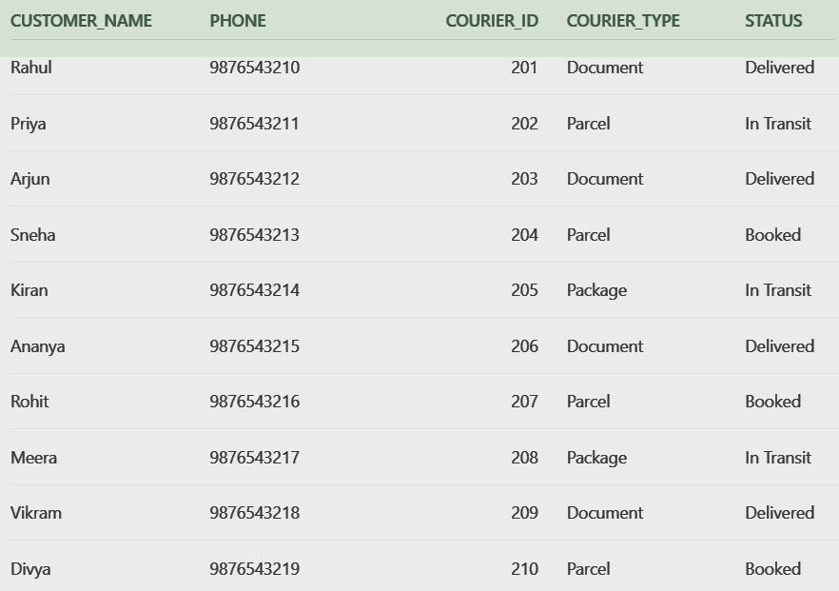
Query 9 – Couriers with payment details
SELECT cr.Courier_ID,
cr.Tracking_Number,
p.Amount,
p.Payment_Mode,
p.Payment_Status
FROM COURIER cr
JOIN PAYMENT p
ON cr.Courier_ID = p.Courier_ID;
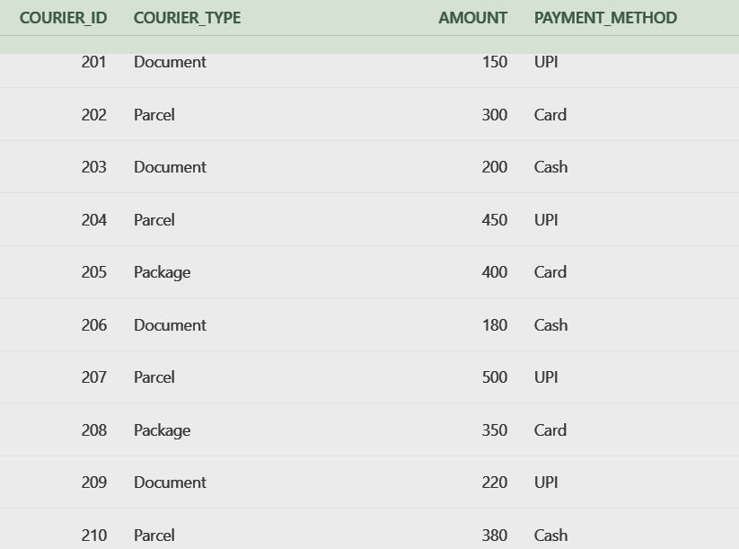
Query 10 – Delivery details
SELECT d.Delivery_ID,
cr.Tracking_Number,
e.Name,
d.Delivery_Status
FROM DELIVERY d
JOIN COURIER cr
ON d.Courier_ID = cr.Courier_ID
JOIN EMPLOYEE e
ON d.Employee_ID = e.Employee_ID;
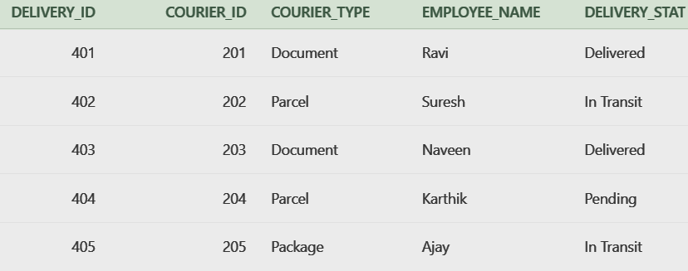

14. Advanced SQL Queries
Employees in each branch
SELECT b.branch_name,
e.employee_name,
e.employee_role
FROM BRANCH b
JOIN EMPLOYEE e
ON b.branch_id = e.branch_id;
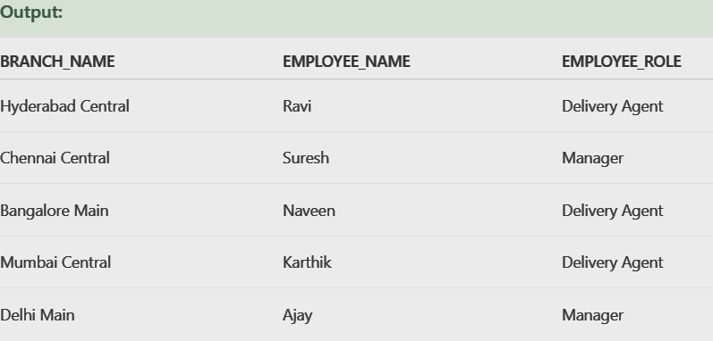
Total payment amount by payment mode
SELECT Payment_Mode, SUM(Amount)
FROM PAYMENT
GROUP BY Payment_Mode;
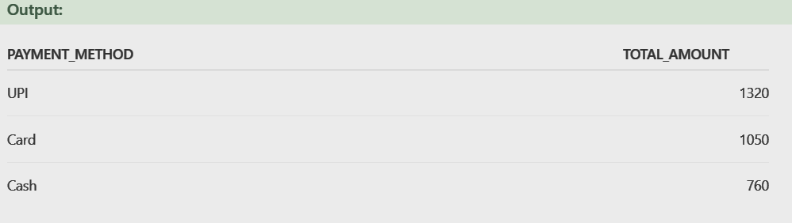
Customers with courier count
SELECT c.Name, COUNT(cr.Courier_ID)
FROM CUSTOMER c
LEFT JOIN COURIER cr
ON c.Customer_ID = cr.Customer_ID
GROUP BY c.Name;
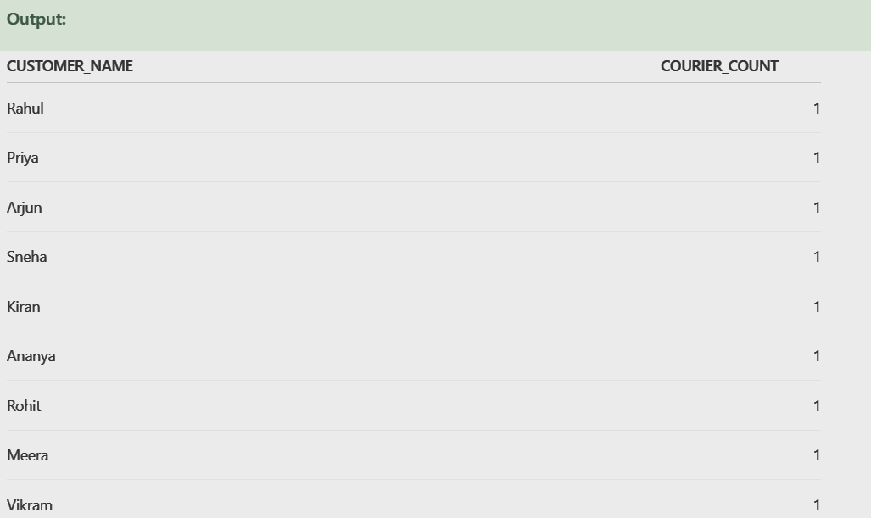
Couriers heavier than average weight
SELECT *
FROM COURIER
WHERE Weight >
(SELECT AVG(Weight)
FROM COURIER);
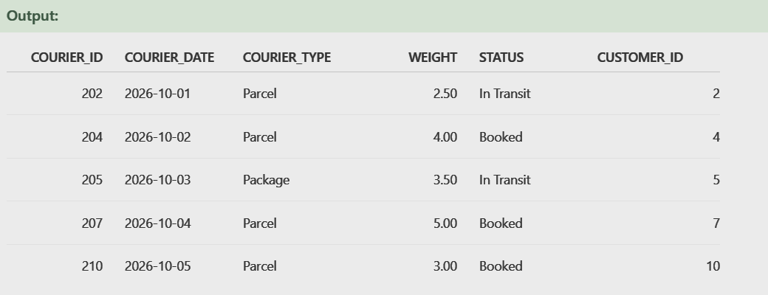
Heaviest courier
SELECT *
FROM COURIER
WHERE Weight =
(SELECT MAX(Weight)
FROM COURIER);
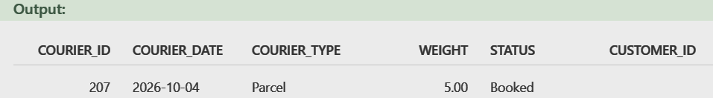

15. Conclusion
The Courier Management System provides an organized and efficient database solution for managing courier operations. The system brings customer, courier, branch, employee, payment, and delivery information together in a centralized relational database.
The use of primary keys, foreign keys, constraints, SQL queries, relationships, and normalization helps maintain accurate and consistent information.
The system also demonstrates how SQL can be used to retrieve information, track courier status, analyze payments, manage deliveries, and generate useful reports.
Normalization up to 3NF reduces redundancy and prevents common database anomalies.
Overall, the Courier Management System provides a reliable foundation for managing courier operations and can be further enhanced with real-time tracking, notifications, online payments, and advanced reporting.

16. Future Enhancements
Possible future improvements include:
- Real-time GPS courier tracking
- Customer online tracking
- SMS notifications
- Email notifications
- WhatsApp notifications
- Online payment integration
- Mobile application
- Admin dashboard
- Advanced analytics
- Automatic report generation
- Backup and recovery
- Role-based access control
- Delivery performance analysis

