Step to merge Trunk to Branch

1. Right Click branch project and select TourtiseSVN ->Merge
2. Select Merge Type and click Next

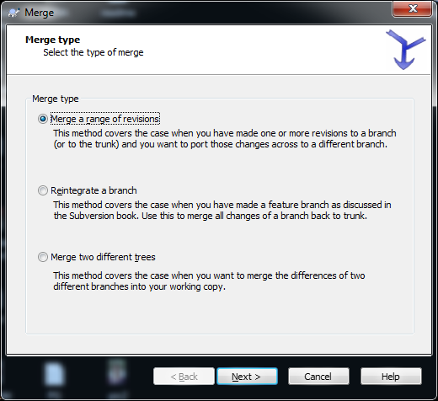

Select trunk project url to merge from.

Select Revision Range from where to Create the Branch to Head.

Eg: Branch created at Revision 6

Then Revision Range to merge: ***6-Head***

***Click Next***





Test Merge and Merge.

Once It is Done successfully then follow below steps

1. Checkout Trunk project .

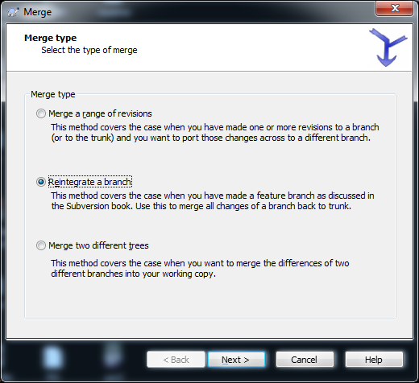

Give Branch url

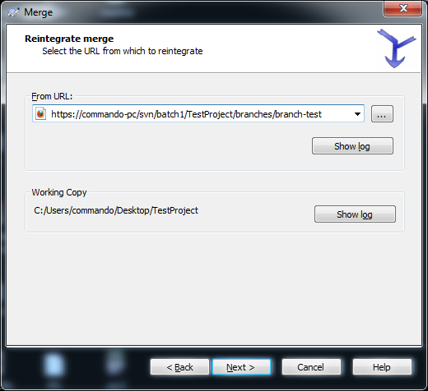



Test Merge.