1. Create an abstract class called Book with title as an instance variable, setTitle() as an abstract method and a concrete method getTitle().Create a MyBook class such that it produces the following output.

**Sample Input**

A tale of two cities

**Sample Output**

The title is: A tale of two cities

1. Create an Animal class with walk() method that prints “I am walking”.

Create a Bird class that also has a fly() method that prints “I am flying”.

Create a Bird object that can fly and walk.Now, add a sing() method to the Bird class, and write the main() method so that the code prints the following lines.

**Sample Output**

I am walking

I am flying

I am singing

1. Write the following code in your editor:

1. A class named **Arithmetic** with a method named add that takes 2 integers as parameters and returns an integer denoting their sum.

2. A class named **Adder** that inherits from a superclass named Arithmetic.

**Input Format**

Test your code by calling the add method on an Adder object and passing it 2 integer parameters.

**Output Format**

Your add method must return the sum of its 2 parameters.

**Sample Output**

My superclass is: Arithmetic

42 13 20(3 method calls)

1. Write an interface **AdvancedArithmetic** which contains a method signature int divisor_sum(int n). You need to write a class called MyCalculator which implements the interface. divisorSum function just takes an integer as input and return the sum of all its divisors.

**For example**

divisors of 6 are 1, 2, 3 and 6, so divisor_sum should return 12.

The value of n will be at most 1000.

**Sample Input**

6

**Sample Output**

I implemented: AdvancedArithmetic

12

**Explanation**

Divisors of 6 are 1,2,3 and 6. 1+2+3+6=12.

1. Create a class BiCycle that defines a method called define_me() which returns a String called “a vehicle with pedals.”.Now, create a sub class called MotorCycle to BiCycle such that it overrides define_me() and returns a String “a cycle with an engine.”

**Extend the code so that the code prints the following text:**

Hello I am a motorcycle, I am a cycle with an engine.

My ancestor is a cycle who is a vehicle with pedals.

1. Create the class Add and the required methods so that the code prints the sum of the

numbers passed to the function add.

**Input Format**

There are six lines of input, each containing an integer.

**Output Format**

There will be only four lines of output. Each line contains the sum of the integers passed as the parameters to add in the main method.

**Sample Input**

1

2

3

4

5

6

**Sample Output**

1+2=3

1+2+3=6

1+2+3+4+5=15

1+2+3+4+5+6=21.

1. Implement the classes and methods detailed in the diagram below:

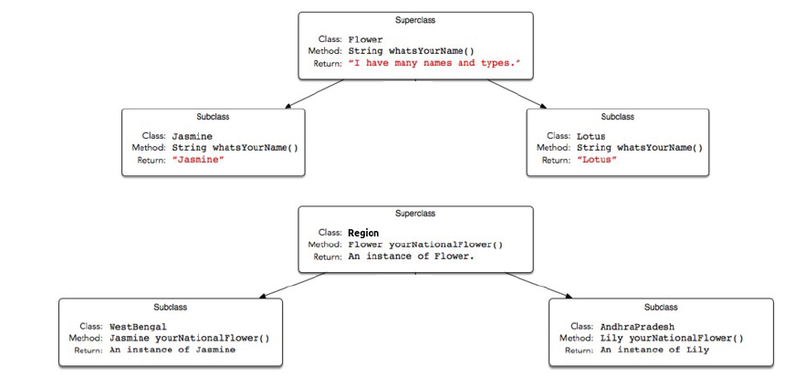

Write a codewhere the main method takes the name of a state (i.e., WestBengal , or AndhraPradesh ) and prints the national flower of that state using the classes

and methods written.

**Input Format**

Your code should read a single string denoting the name of a subclass of State (i.e., WestBengal ,Karnataka , or AndhraPradesh ), then tests the methods associated with that subclass.

**Output Format**

Creates the object corresponding to the input string's class name and then prints the name returned by that class' national flower's whatsYourName method.

**Sample Input 0**

AndhraPradesh

**Sample Output 0**

Lily

**Explanation 0**

An AndhraPradesh object's yourNationalFlower method returns an instance of the Lily class, and the Lily class' whatsYourName method returns Lily .