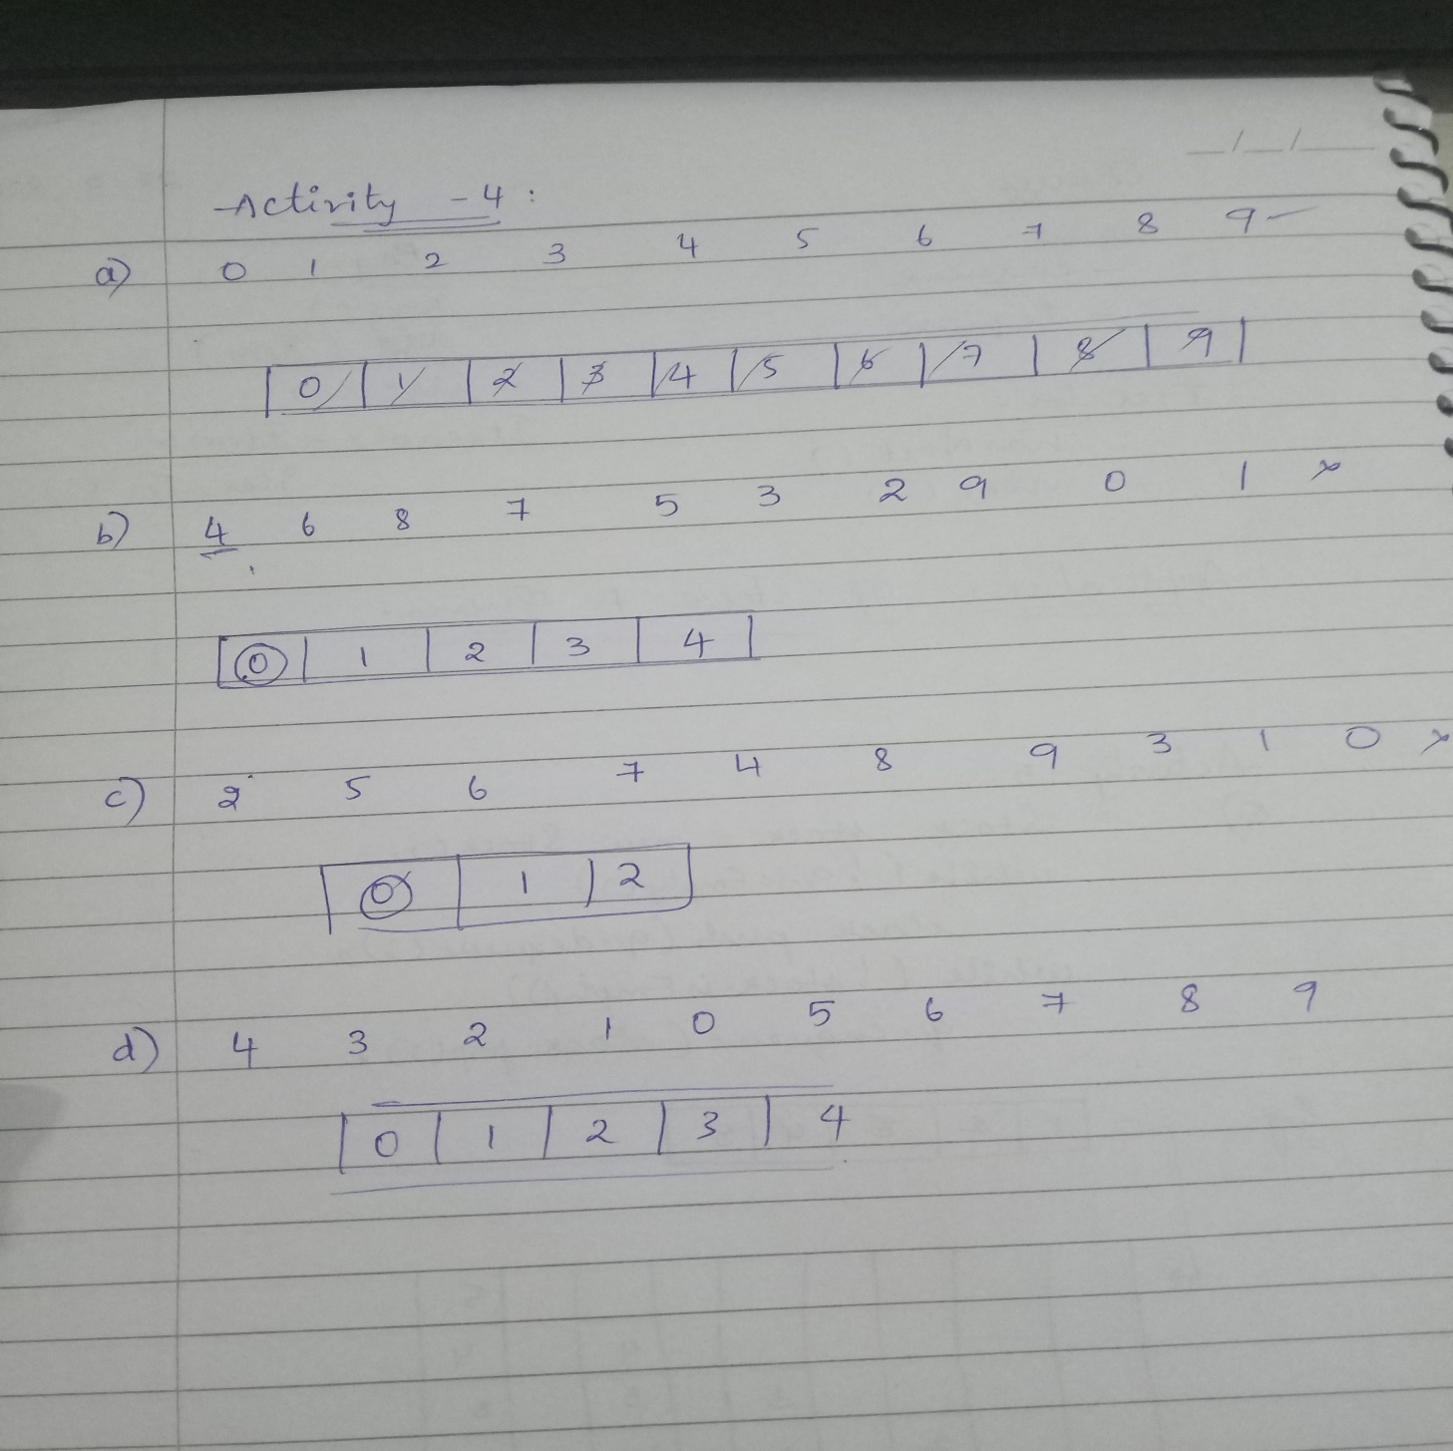

Sequences b, c, d cannot occur.