|  |  |  |  |  |
| --- | --- | --- | --- | --- |
| **Name** | **Function1** | **Function2** | **Advantages** | **Disadvantages** |
| Smart Thermostat | Adjust Room temperature | Manage Air-conditioning systems automatically using custom mode | Can be paired with computer, smart phone or Fios TV | Not compatible with all heating and cooling systems. |
| Appliance Switches | Report real time energy consumption | Turn connected appliances on /off remotely | Can be used with different appliances to find which one is using much electricity |  |
| Engage Efergy (App) | Report energy consumption online |  | Energy consumption will be reported instantly to our engage account. | Our information is stored in third party servers which is a safety concern. |
| Meter Plug | Gauge energy usage of single or multiple appliances | Calculate electricity costs for different times of the day. | - Has built in memory to record information for later use.  - Alert or auto-off system if a device usage cost goes beyond preselected amount. | The device range is limited to 100 feet. |
| TED Pro spyder | Monitor overall electricity usage of building in real time and project monthly bills. | Export data in csv format to analyze trends | - Gives us breaker level detail s in energy usage. | Professional installation is recommended |
| Energy reader | Report real time energy usage over a period of time. | Display effect of turning down power hungry AC’s or installing power strips that let you turn cut off the electricity to devices that you don’t need. | - Low cost energy meter |  |
| Wi-Fi Home energy monitor | Break electricity bill down by each appliance. | Report the usage instantaneously using app, API and cloud service. | - Stores a year of data logging to ensure data isn’t lost when your power or Wi-Fi goes down.  - Future plan to offer social features to the device so users can share and compare their energy usage data with one another. |  |
| In-Wall paddle switch dimmer | Wireless control of On/Off and dimming functions of hard-wired incandescent lighting. | Replaces our current light switch, uses our existing wiring, and provides wireless and manual control of overhead lighting. | - Dimmer switch includes an LED indicator light to easily locate the switch in a dark room. | Professional installation is recommended for the In-Wall Paddle Switch if we are unfamiliar with installing electrical devices. |
| Real-time Web Based Household Power Usage Monitor | Measure electrical current on the main lines entering home with AC clamps. | Chart the data with Google Charts as it is measured and make kilowatt-hour calculations in real-time. | - Takes care of feeding the data to the internet without the need to host a power hungry home web server. |  |
| Whole House Power Monitors | Track electricity use for entire home by attaching to home’s E-meter. | Track the usage history and predict next month bill. | - Helps to save energy and make savings. | - Usually doesn’t link up with utilities. |
| Smart meter | Communicate with energy supplier and make accurate meter reading. | Report data through wireless mobile phone technology. | - More accurate bills.  - Better oversight and management of your energy use with a real-time data display in your home | - Won’t itself save you money but offers much insight into how to lower your bills. |
| SG6200NXL Smart energy gate way | Provide real time power management and secured wireless internet access | Push recorded data to power tracker website so users can remotely monitor consumption | - Can communicate wirelessly with all power tracker devices. | - Connectivity is limited to 10 appliances. |
| Energy saver  (App) | Analyze present usage and estimate future energy consumption appliance wise. | Find out which appliances are using the most energy, and the ones that have phantom loads. | - Can select some pre-populated energy rates and analyze the energy *consumption of* our appliances to find out how to optimize our house for the most efficient and cheapest energy use to save both power and money. | - Only compatible with iPhone and android platforms. |
| Open energy monitor (project) | Develop open-source energy monitoring tools to help us relate to our use of energy, our energy systems and the challenge of sustainable energy. |  | - It’s a complete open source hardware and software energy monitoring platform.  - Gives idea of diverting surplus P.V energy to domestic hot water. | - Need to get a deep insight into the project and must have sufficient technical knowledge to do that. |
| iMeter Solo - INSTEON Power Meter (Plug-In) | Measure power consumption of an appliance | Store energy usage data in csv file to analyze further. | - Can be connected to hardware/software to track and create graphs for consumption. | - Only compatible with INSTEON hw/sw devices. |
| Energy monitoring socket 2.0 – Efergy | Connect to appliances and assess how efficient they are. | Provide multiple displays to show combinations of multiple data. | - Programmable to our own energy unit cost.  - Precision accuracy to within 2 %.  - Low power consumption. |  |
| Watt vision Power Monitor | Track our electricity use and send readings to Wattvision’s site. |  | - Simple to use. | - Expensive. |
| Clipsal CENT-A-METER Energy Monitoring Device | Display the cost of electricity being used on a portable, easy-to-read LCD monitor inside your home. | Computes the approximate power use, energy cost and greenhouse gas generation. | - Installation is easy and has several display modes. | - Limited to monitor individual circuits of metered premises to estimate their share of power use. |
| Current Cost - ENVI | Measure whole house or individual appliance power usage. | Forecast daily, weekly and monthly usage and cost. | - Ability to measure single and 3 phase electricity.  - XML data output for analysis. | - Connectivity is limited to 9 appliances. |
| Wattson Classic Energy Meter | Displays instantaneous energy usage and allows entering your tariff details ensuring accurate cost analysis. | Connects to computer to spot trends in usage. | - Glows red if energy usage is high, purple if average and blue if your energy usage is lower than normal.  - Allows you to enter your specific electricity tariff details providing you with incredibly accurate information | - Works only within 30 m distance from transmitter. |

**Narrative Description**

**Smart Thermostat**

|  |
| --- |
| The Smart Thermostat allows you to manage your home's heating and air-conditioning systems from your computer, compatible smartphone or FiOS TV. From your computer, set up custom "modes" that automatically adjust your home's temperature or turn off your HVAC completely.The Smart Thermostat is not compatible with all heating and cooling systems. |

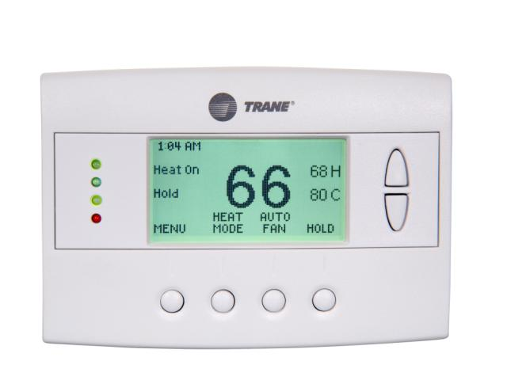

**Appliance Switches**

|  |
| --- |
| The Appliance Switch reports real-time energy consumption. Appliance Switches can also be used to turn connected appliances on/off remotely – such as turning a lamp on so it looks like someone is home. Or, rotate it to a different appliance each week to discover which ones are using the most electricity. |

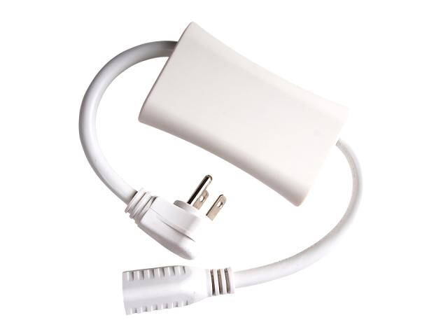

**Engage Efergy**

To view your energy consumption online through the engage portal you will need:

1. An energy sensor that measures the energy being consumed in your home. This picks up the consumption data from your fuse box or meter.
2. A transmitter attached to the sensor sends the energy information wirelessly to the engage hub. Your energy information is stored on our servers. We follow high security standards, respecting your privacy and confidentiality.
3. The engage hub receives the information sent from the transmitter and pushes it instantly to your engage account via your internet router. To enable the information to be sent to the internet, you will also require a broadband connection.
4. A PC, Mac, smartphone or tablet, to allow you to view the information in real-time.

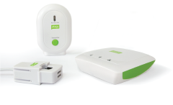

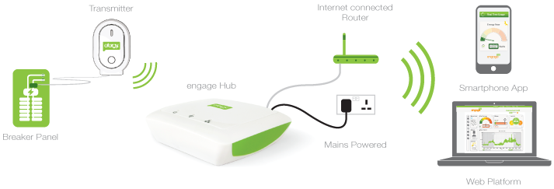

**Meterplug**

MeterPlug is a new home energy monitoring device that brings a mix of simplicity and sophistication to the equation when it comes to keeping track of how much energy various home appliances use. Placed between the appliance and the AC outlet, the MeterPlug sends precise information on energy usage to iOS and Android devices via Bluetooth 4.0 and incorporates a range of power saving features to help curb excessive consumption.

MeterPlug can be used to gauge how much energy a single appliance is using or connected through a power strip to monitor multiple appliances. It is also capable of calculating electricity costs for different times of the day and if you are running several MeterPlug's on different devices, the app can be used to connect to them simultaneously.

The device has a wireless range of about 100 feet (30 m) and transmits real-time information on energy costs in your local currency as well as a historical breakdown – last day, last week etc. Its built-in memory also allows it to measure and record information for a later download when the user is not home.

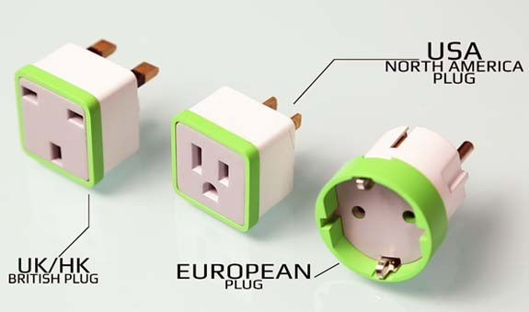

**TED Pro Spyder**

  TED Pro Spyder is a **NEW** add-on compatible with only TED Pro systems.   The Spyder is a monitoring unit that comes with **eight (8) Current Transformers**.   These CTs are designed to go around individual circuit conductors inside your breaker panel.   The Spyder will log data for individual circuits/appliances/systems/motors.   Every TED Pro MTU comes with a built-in Spyder connection, so if you have an existing TED Pro-series MTU, you will NOT need to purchase an additional MTU to use TED Spyder.

As the ultimate monitoring tool that gives you breaker-level detail, the Spyder monitors your refrigeration units, computer equipment, lighting, individual offices, and thousands of other possibilities! This add-on is the perfect way to take your TED Pro to the next level of monitoring and saving!

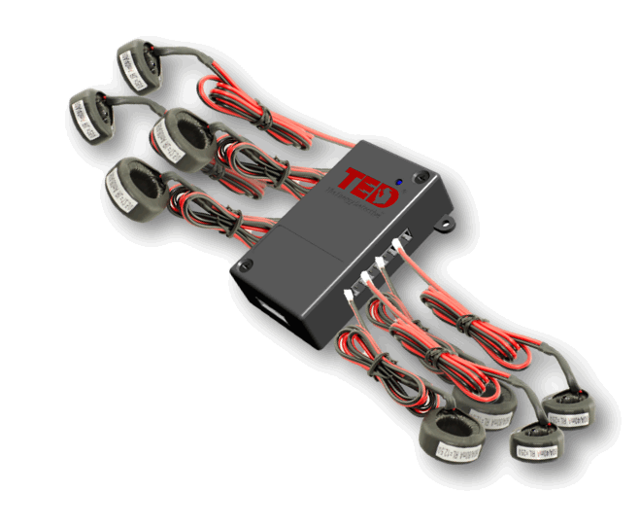

**Wi-Fi home energy meter**

**Neurio** is a new home energy monitoring system that uses a sensor installed directly inside of your home's breaker panel in combination with an app, API, and cloud service to help you keep a real-time tab on your home's electrical appliance usage.  
  
Started by **Janice Cheam** and her Vancouver-based **Energy Aware team**, the WiFi enabled system can break your electricity bill down by each appliance, detect the biggest energy guzzlers (According to the company about 8 or 9 common home appliances are responsible for over 80% of the energy consumption.), and take action on household events based on personalized rules.

A text message can be sent to you when your laundry has finished or when you have forgotten to turn the stove off before leaving the house. More complex custom triggers like having the lights in your home switch on as you pull the car into the garage after work can be setup using the cloud service and the service's mobile app nicknamed "Wattson".

Inside your breaker panel the Neurio sensor uses **Current Transformers** (CT’s) to measure the flow of electricity and a REST API to transmit your home's energy use data to their cloud service. This removes the need to install sensors on every outlet using a **smart plug**, or have any device be "smart" at all, Letting the centralized Neurio and its algorithms track household behavior over time to provide personalized tips to cut down on electricity usage based on actual activity patterns.

Additional features of the system include:

* The sensor device stores a year of data logging to ensure data isn’t lost when your power or WiFi goes down.
* A developer API and triggering script that works well with IFTTT, Android and the Raspberry Pi.
* Future plans to offer social features to the device so users can share and compare their energy usage data with one another.