**PHP**

**1: what would be the output of the following code**

**$str = “0011110000bsts11100”;**

**Echo trim($str,’010s’);**

**2:which of the following valid mysqli configration options**

**3: which function can be use to determine if a file exists**

**4: which function is use to destroy a variable and object**

**5: which MIME type needs to use to send an attachment to mail**

**6:which of the following statements is incurrect which respect to inheritance in php**

**7: you can extend the exception class, but can not override any of the precending methods becouse they are declared as**

**8: in which order are methods called in the below php code**

**$object->method1()->method2()->method3()**

**9: what will be the output of the following code**

**$arr = array(“THEN”,”WE”, array(“I”, “YOU”), “YOUR”);**

**echo(count($arr, 1));**

**10: the PDO_MYSQL data source Name (DNS) is the composed of the following elements**

**11: which of the following file modes is use to write into the file at the end of the existing content, and the creatre the file if the file does note exist**

**12: which of the following would show an error in php**

**13: which of the correct way to send an SMTP email using php**

**14:which of the following is note correct way to create an empty object in php**

**15: which of the following will print out of the php call stack**

**16: which method is use to tweak an object cloning behavior**

**17:what is the output of the following code**

**Class foo{**

**Private $foo;**

**Protected $bar;**

**Publice $test;**

**Public function _construct(){**

**$this->foo = 1;**

**$this->bar = 2;**

**$this->test = 3;**

**}**

**}**

**print_r((array) new foo);**

**18: after the following query is executed in php, whic function can be used to count the number of rows returned**

**Select * from students**

**19:choose the correct option to force redirect from http and https**

**20: what will be the output of the below code**

**$tmp =”Dragon%%Ball%%z%”;**

**$arr = explode(‘%’,trim($tmp));**

**echo count($arr);**

**21: what is the correct syntax of the mail() function php**

**22:**

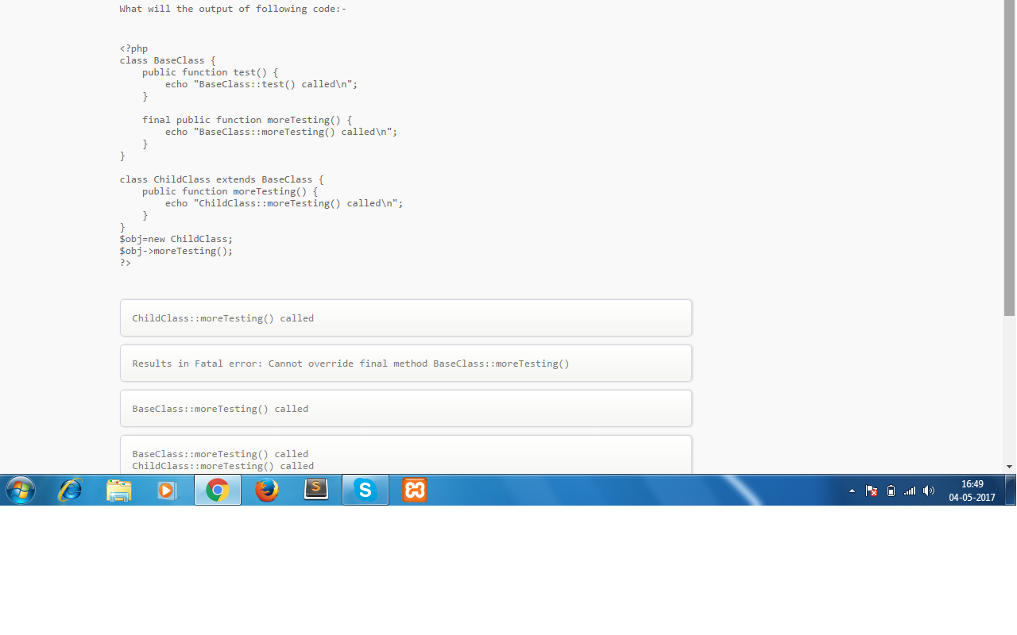

**23:what will happen if fatal error was thrown in your php program**

**24: which statement is not currect**

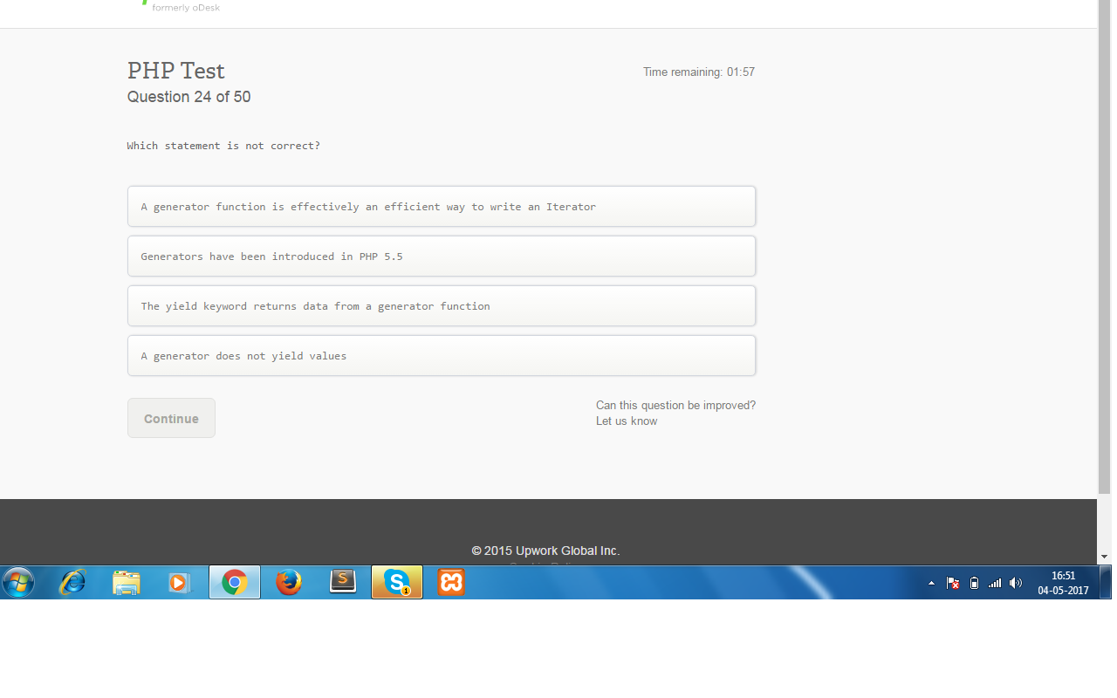

**25:which expresion is return true**

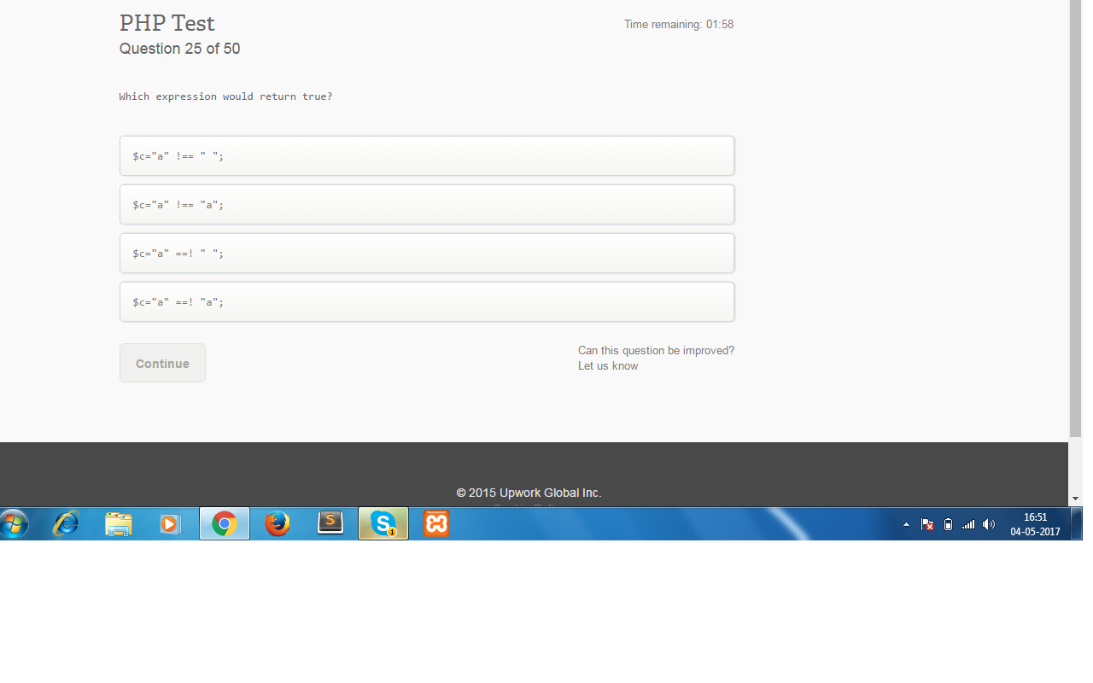

**26: how do you access result set meta data**

**27:which function use to read a file removing the html and php tags in it**

**28:what would be the output of the 1 and 2 sample code**

1. **$a = array();**

**$b =$a;**

**$b[‘foo’] = 42;**

**echo $a[‘foo’];**

1. **$a = new StdClass();**

**$b =$a;**

**$b->foo = 42;**

**echo $a->foo;**

**29:** 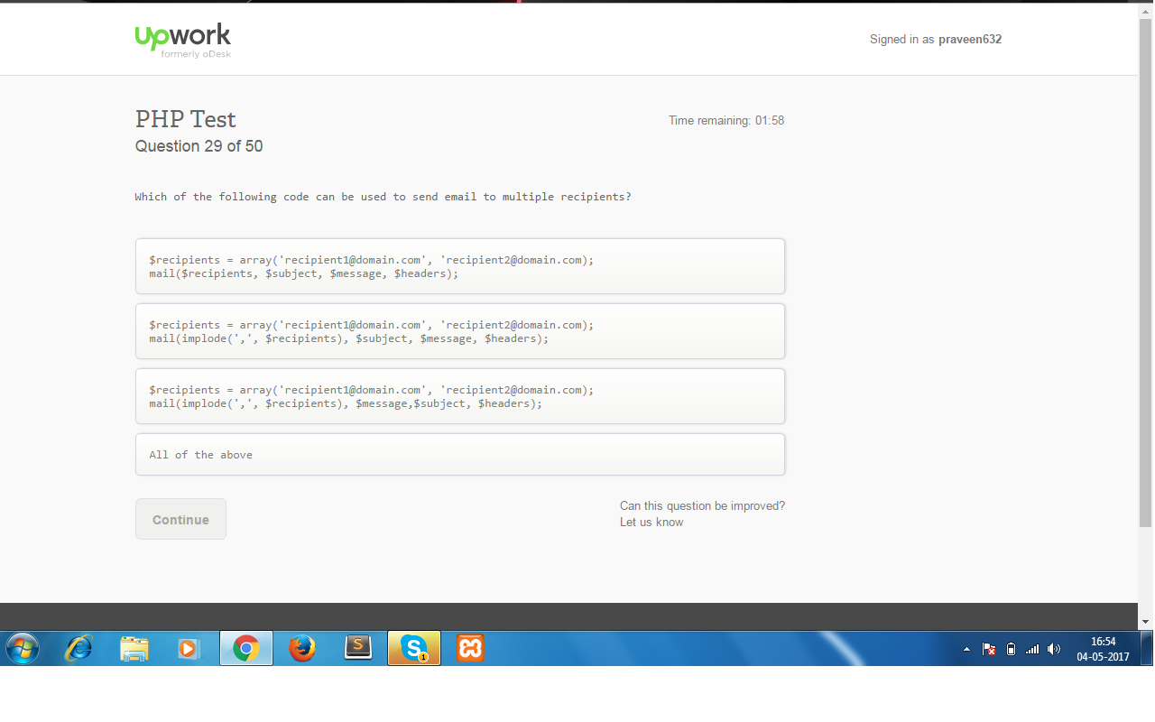

**30:** 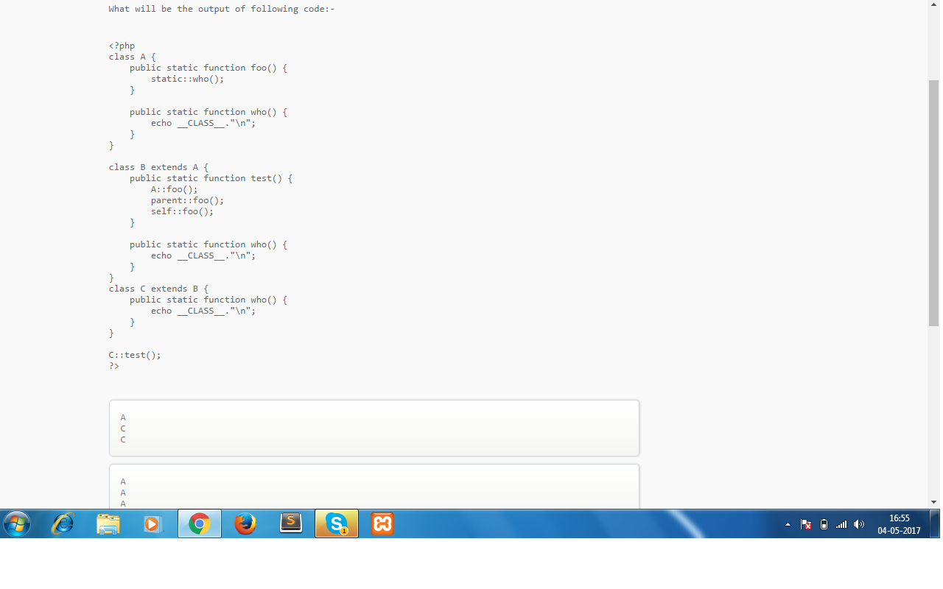

**31:** 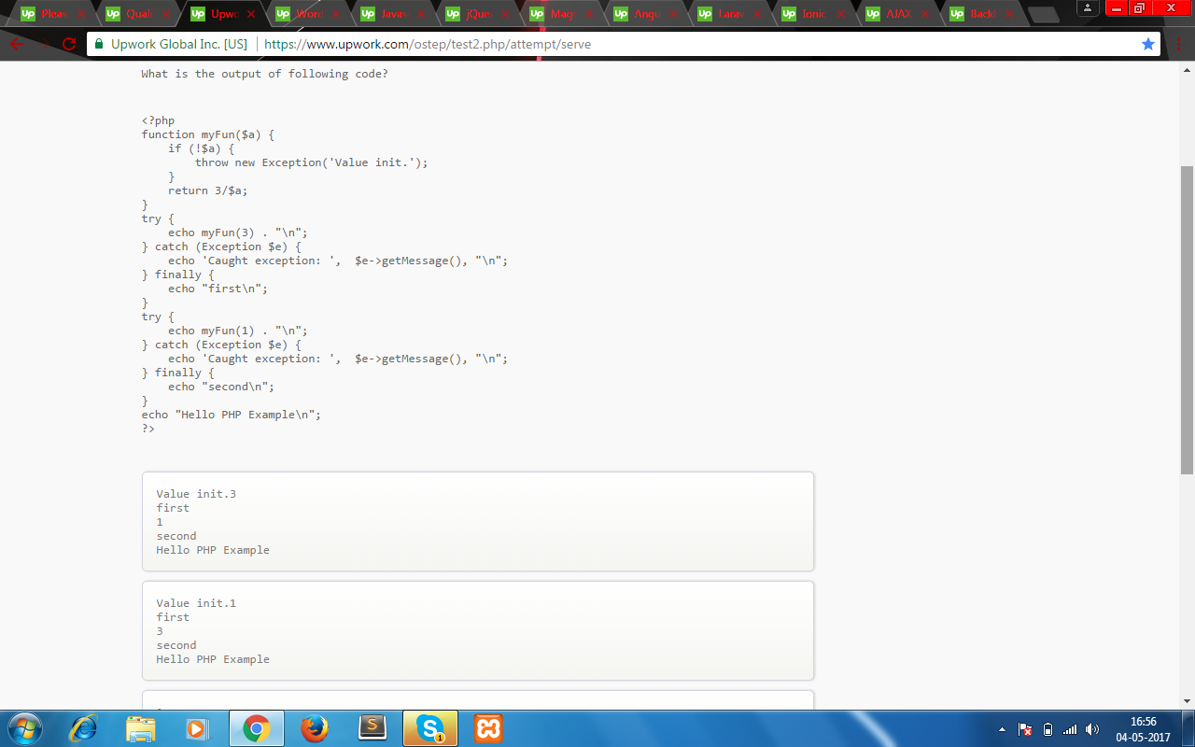

32:

**32:which of the following function is not related to garbage collection in php**

**33:** 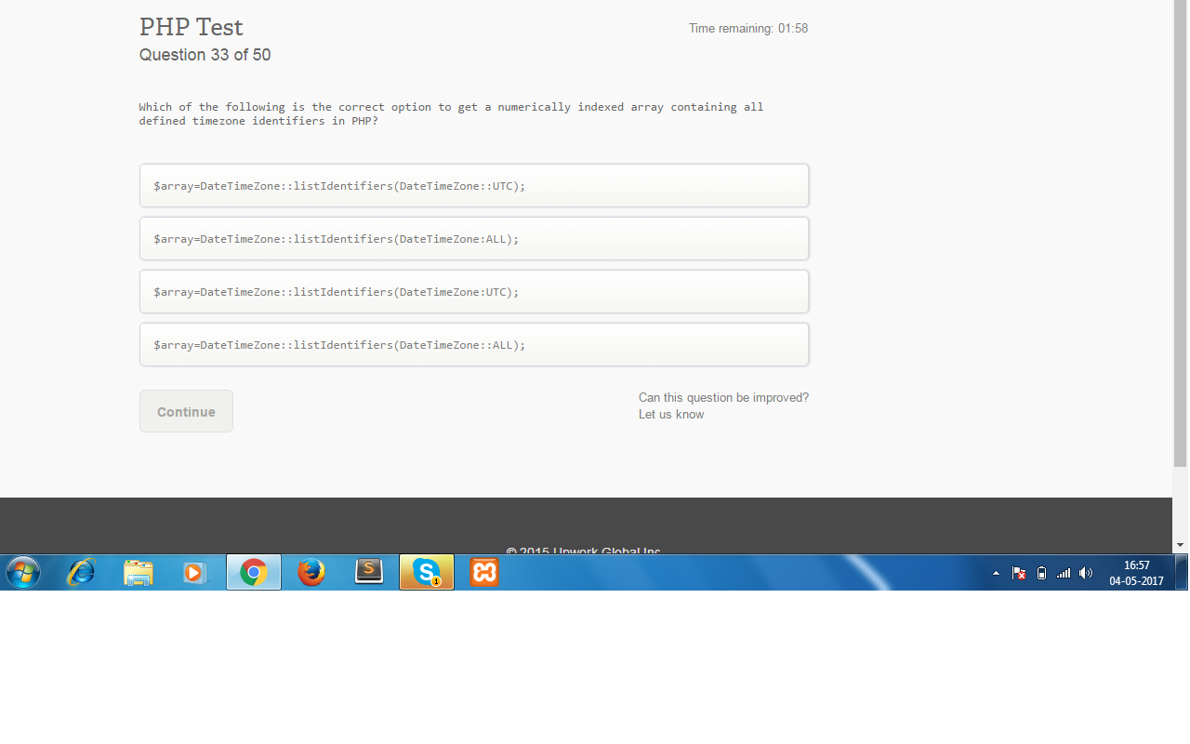

**34:what is the best practice for running MySql queries in php? Consider the risk of the injection**

**35:Xdebug is a php ______,the information which Xdebug provides is about stack and functions with full parameter for user derfined functions, memory allocation and support for infinite recursions**