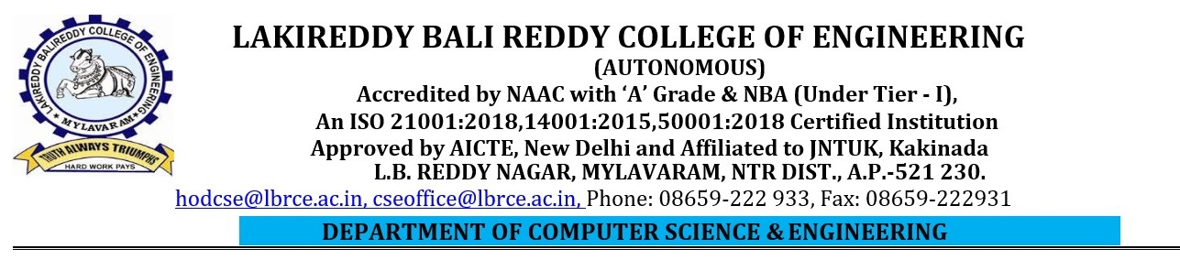
Lab External Examinations, April-2025
Lab Name: Server-Side Scripting Lab Code: 20CS63
Q1) Develop a PHP web application which demonstrates the following operations by Applying Cookies

Create Book_details form (bid, btitle, branch, version, author, publisher, price)
- Insert multiple records
- View specific book details using “bid”
- View all the books based on “branch” / “author” / “publisher”
- Create admin login & logout

Q2) Develop a PHP web application which demonstrates the following operations by Applying Cookies
- Create Doctor Registration (drId,drname,gender,specialisation,email, password, mobile)
- Insert multiple records
- View all the doctor’s data
- Create doctor login
- View doctor profile

Q3) Develop a PHP Online Ticket Reservation System web application which
demonstrates the following operations by Applying Cookies
- User Registration Form(UID,uname,gen,dob,age,email,mobile,password,address)
- Login form
- Ticket reservation form(UID,Tdate,from,to,cost)
- View travel details
- Update travel details
- Logout

Q4) Develop a PHP web application which demonstrates the following operations by Applying Cookies
- Create PatientRegistration form (pid, pname, gen, age, disease, drname, pmobile, paddress)
- Insert multiple records
- View specific patient record using “pid”
- View all the patient records
- View patient profile

Q5) Develop a PHP RESULTS web application which demonstrates the following operations by Applying Cookies
- Create Marks Entry form (rno, branch,
subcode1, subname1, grade1, gradeValue1,
subcode2, subname2, grade2, gradeValue2,
subcode3, subname3, grade3, gradeValue3, S.G.P.A)
- Insert multiple records
- Display all records
- Display Specific Student Record
- Display branch wise Records

Q6) Develop a PHP GYM web application which demonstrates the following operations by Applying Cookies
- Create Registration form (uid, uname, gen, age, jdate, slot, email, mobile, address)
- Insert multiple records
- Create User login
- Create gym allocation(uid,age,gymEx)
- View all users’ details
- Log out
Q7) Develop a PHP web application which demonstrates the following operations by Applying Cookies
- Create Disease form(pid, pname, disid, disease_name, drid, drname)
- View all the Patient records based on “disease” Or “disid”;
- View all the Doctor records based on “disease” Or “disid”;
- Update doctor details using “disid”
- Delete Patient details using “pid”

Q8) Develop a PHP web application which demonstrates the following operations by Applying Cookies
- Create Book_issue form(sid,sname,branch,year,sem,bid,title,issuedate);
- Display sid,sname,bid,btitle based on issuedate
- Update bid & btitle using sid & issuedate.
- View all the records
- View all the books based on “branch” / “author” / “publisher”
- Create admin login & logout

Q9) Develop a PHP web application which demonstrates the following operations by Applying Cookies
- Create Doctor Registration(drId,drname,gender,specialisation,email, password, mobile)
- Insert multiple records
- Update doctor mobile number & email Id using “drid”
- View updated doctor details
- Delete Doctor record using “drid”
- Create admin login & logout

Q10) Develop a PHP Online Food Order web application which
demonstrates the following operations by Applying Cookies
- User Registration Form
- Login form
- Food Order form
- View Order details
- Update Order details
- Logout

Q11) Develop a PHP web application which demonstrates the following operations by Applying Cookies
- Create PatientRegistration form (pid, pname, gen, age, disease, drname, pmobile, paddress)
- Insert multiple records
- Update patient age & address using “pid”
- Delete patient record using “pid”
- Create admin login & logout

Q12) Develop a PHP STUDENT web application which demonstrates the following operations by Applying Cookies
- Create Registration form (sid,sname, gen, dob, brach, year, sem, email, mobile, address)
- Insert multiple records
- Create Student login
- Display all student records
- Update student details using “uid”
- Specific student record view
- Update all student records
- Log out

Internal Examiner External Examiner

