INDIAN INSTITUTE OF TECHNOLOGY ROORKEE
ROORKEE – 247 667
Data Structures (MA 568)

Surprise Quiz 4 Max. Marks: 10
Spring Semester 2004-05 Time: 15 Mts.
Instructions:
- Those who are writing the quiz will get 2 marks (to distinguish from absentees).
- All answers should be written in the space or revise side of the question paper.

- AVL tree was introduced in ______________ by _____________________________

- Write a C++ fragment for finding balance factor in a BST.

- The following items are inserted into a BST: 3, 6, 5, 2, 4, 7, 1. Which node is the deepest.

- Make the following Binary search tree into AVL search tree.
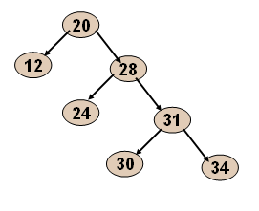
- Which sorting algorithm requires the most extra space, on average, when implementation as in the text.

- Is every AVL tree is AVL search tree? Why or why not?

- Sachin Tendulkar scored 4, 2, 6, 123, 1 and 9 against Pakistan in the recently concluded One-day series. Construct an AVL search tree from Sachin’s scores and what is the rank of node 9 in the resulting tree.

(P.T.O)
- Consider the following code fragment. Let us assume that the arrays f, m and x are already defined.

G = 6.67e-11;
for (i = 0; i < N; i++) {
f[i] = 0.0;
for (j = 0; j < N; j++)
if (i != j)
f[i] += G * m[i] * m[j] / ((x[i] - x[j]) * (x[i] - x[j]));
}

Suppose it takes 1 minute to solve a problem of size N. Estimate how many minutes it will take to solve a problem of size 10N.

