INDIAN INSTITUTE OF TECHNOLOGY ROORKEE
ROORKEE – 247 667
Data Structures (MA 568)

Test 2 Max. Marks: 25
Spring Semester 2004-05 Time: 1 hour

Each question carries FIVE marks

- Construct a C++ structure for a point 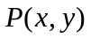that defined in a Euclidean plane. A line segment is a join of two points say 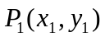 and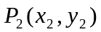 whose Euclidean distance is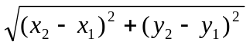. Assume that the linked lists store the information of several line segments. Write a C++ program to calculate the sum of the squares of all the distances of the line segments and find the positions (linked list positions) of larger and smaller line segments.

  - Write a C++ function/template function to calculate the number of leaves in a Binary tree.
  - Is every extended binary tree is a full binary tree? Why or why not?
(3+2) Marks

- I. Consider the following C++ fragment
line 1: for (i=0; i<n; i++)
line 2: for (j=0; j<i; j++)
line 3: for (k=i; k<j; k++)
line 4: sum+=1;
line 5: for (p=0; p<n*n; p++)
line 6: for (q=0; q<p; q++)
line 7: sum-=1;

- How many times is statement in line 4 executed (in terms of n)?
- How many times is statement in line 7 executed (in terms of n)?
- What is the running time of this fragment?

II. Describe a case where quicksort will result in quadratic behavior.
(3+2) Marks

- Recall the function void intravmod(NODEPTR tree) that we have seen in the class using right-in threaded binary trees (without stacks). Compute the Inorder traversal of the following tree (shown in the next page) using the pointer p and the auxiliary pointer q. Display the values of the pointers p and q as well as the inorder expressions in each step of the above function. What is the breath-first traversal of the tree?

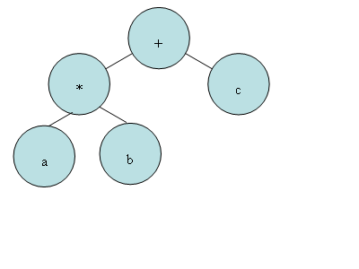
(4+1) Marks

  - Give the result of partitioning the keys

T H E Q U I C K L A Z Y D O G

during the first stage of the standard quicksort implementation (Use the last element G as pivot). In the last step, exchange the final lower bound element with the pivot. What is the average case complexity of this modified algorithm?

  - Prove that if 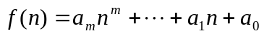 and 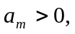 then 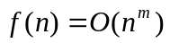.
(4+1) Marks

------End------

