INDIAN INSTITUTE OF TECHNOLOGY ROORKEE
ROORKEE – 247 667

Spring Semester 2005 – 06 Test 2
Data Structures (MA 568/CA 506) Max. Marks: 25

- Here are the results of an inorder, preorder, and postorder traversal of a given binary tree (NULL nodes are omitted). Unfortunately, a few of the keys are unreadable and the tree is no longer available. Reconstruct the 9 missing letters.

inorder: A B C D E F G H I J
preorder: F C B A ? ? ? ? ? ?
postorder: A ? E D ? G H J I ? (5 Marks)

Draw the resultant binary tree and also write its level order.

- (a) Consider the following code fragment. Let us assume that the arrays f, m and x are already defined.

G = 6.67e-11;
for (i = 0; i < N; i++) {
f[i] = 0.0;
for (j = 0; j < N; j++)
if (i != j)
f[i] += G * m[i] * m[j] / ((x[i] - x[j]) * (x[i] - x[j]));
}

Suppose it takes 1 minute to solve a problem of size N. Estimate how many minutes it will take to solve a problem of size 10N.

(b) Write a c++ function that deletes all leaves of a binary tree that have their key equal to a given value. (2+3 Marks)

- (i) Consider the following definition:
F₀ = F₁ = 1 and F_{n} = F_{n-1} + F_{n-2} if n >1
- Consider the following two implementations to compute F_{n}
int fibrec(int n) { if (n<2) return 1; else return f(n-1) + f(n-2); }
int fibiter(int n)
{ int f1=f2=1; for (j=2; j<=n; j++) { f2= f2+f1; f1=f2-f1; } return f2; }
Compute the time complexities of fibrec and fibiter.
- Which one of the above functions will you prefer to compute F_{n} in terms of complexity?

(ii) Under what circumstances, if any, can the inorder and postorder traversals produce the same result?

(iii) Under what circumstances, if any, can the preorder and postorder traversals produce the same result? (3+1+1 Marks)
- (a) What is the maximum number of nodes in a binary tree that has m-leaves?

(b) For the AVL tree shown below, perform the necessary rotations to balance the tree assuming a new node containing 35 is inserted into the tree. For each rotation that is required, identify the type of rotation, i.e., right, left, or double. Show the balance factors at every node before and after the rotation. Draw the resulting AVL tree. How many rotations will you perform and what is the rank of the resultant root node?
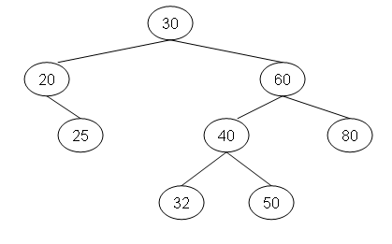
(c) For the AVL tree shown below, perform the necessary rotations to balance the tree assuming the node containing 60 is deleted from the tree. For each rotation that is required, identify the type of rotation, i.e., right, left, or double. Show the balance factors at every node before and after the rotation. . Draw the resulting AVL tree. How many rotations will you perform and what is the rank of the resultant root node?
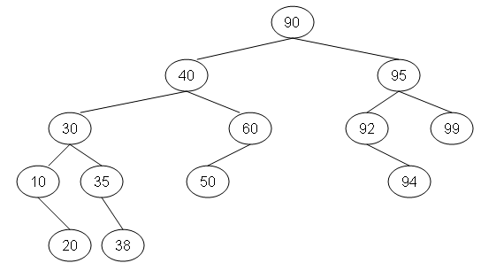 (1+2+2 Marks)

5 (a) Give the result of partitioning the keys
T H I S C O U R S E I S F I N E
during the first stage of quicksort. Write each steps of the first stage (do not write the result directly)

(b) How do you say Quick sort is better than Merge sort.

- An algorithm takes 6 seconds to solve a problem of size 100 and ten minutes to solve a problem of size 1000. What is the complexity of this algorithm?
(3+1+1 Marks)

END

