INDIAN INSTITUTE OF TECHNOLOGY ROORKEE
ROORKEE – 247 667

Spring Semester 2006 – 07 Test 2
Data Structures (MA 568/CA 506) Max. Marks: 25

Answer any FIVE questions. Question 6 is compulsory. Each question carries FIVE marks.

- (a) Give the binary search tree that results when the keys

I N D I A N I N S T I T U T E O F T E C H N O L O G Y R O O R K E E

are inserted in that order into an initially empty tree.

(b) Prove the following:
If x and y are real numbers such that 0 < x < y then 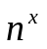is O(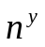) but is not O().

(3+2)

- Recall the function void intravmod(NODEPTR tree) that we have seen in the class using right-in threaded binary trees (without stacks). Compute the Inorder traversal of the following tree (shown in the next page) using the pointer p and the auxiliary pointer q. Display the values of the pointers p and q as well as the inorder expressions in each step of the above function. What is the breath-first traversal of this tree?
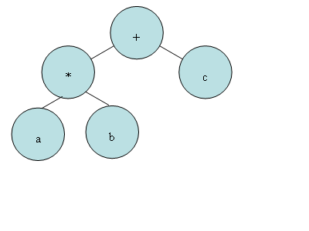
- Given a Doubly linked list of integers sorted from largest (at the head end) to smallest, and a left pointer and a right pointer to a single node containing an integer, insert the node in the doubly linked list so that it remains sorted. Write a C++ program/function.
P.T.O
- (a) The following recurrence relation occurs in the analysis of a variant of binary search (quaternary-search). Unfold this recurrence relation to obtain a closed-form expression for T(N). Assume that N is a power of 4.
T(N) = T(N/4) + 2, T(1) = 1.

(b) A 3-way mergesort on an array with N elements works as follows:
1. Divide the array into 3 subarrays of size N/3 ;
2. Recursively sort the 3 subarrays;
3. merge the 3 subarrays together.
Find the time complexity of 3-way mergesort. You may assume that N is a power of 3.

(2+3)

- (a) Given a binary search tree containing n floating point values and having a height that is O(log n) (i.e. it is balanced), write an efficient algorithm to count the number of nodes storing values greater than x0 and less than x1. What is the running time of your algorithm?

(b) How many different trees can be constructed using n nodes?
(4+1)

- (a) Consider the trigonometric equation:
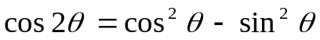

Construct the expression tree and postfix expression, the operators which you may use are: cos, sin, *, = , - and ^ where = is a binary operator along with *, - and ^, while cos and sin are unary operators. While constructing expression tree you should only have two
types of leaves, 2 and ; furthermore, unary operators should act on their left children.

(b) How do you say Merge sort is better than Quick sort.

(c ) An algorithm takes 30 seconds for an input of size100. If the algorithm is cubic, i.e. 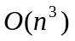, how large a problem can be solved in 13 minutes and 30 seconds?
(2+1+2)

END

