INDIAN INSTITUTE OF TECHNOLOGY ROORKEE
ROORKEE – 247 667
Data Structures (MA 568/CA 506)

End Semester Examination Max. Marks: 50
Spring Semester 2006-07 Time: 3 hours
Total No. of Pages: 3
Answer any TEN questions. Each question carries FIVE marks

- Write the packed adjacency list representation of the following two graphs
(a) (b)
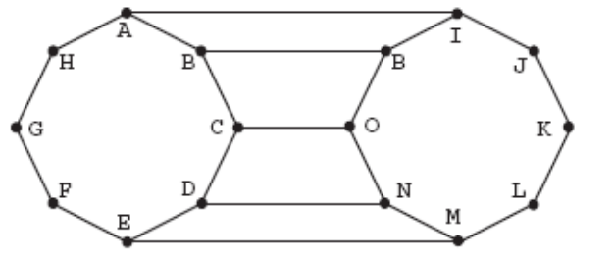
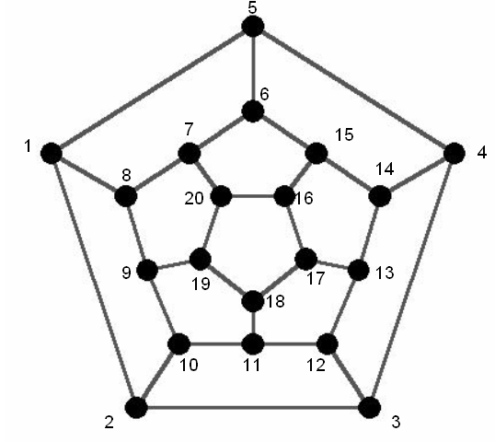

(c ) Every connected graph is complete. Why or Why not?

(d) Prove with the usual notation 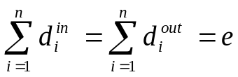 and 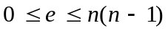

- (a) Insert the following numbers into what is originally an empty B-tree of order 4:

4, 6, 12, 15, 3, 5, 10, 8, 11, 13, 14, 17 (The first three numbers get inserted in the same node).

(b) Let T be a binary tree.
If T has seven nodes, what is its minimum height? What is its maximum height? Draw two trees with seven nodes that achieve the minimum and maximum height, respectively.

- Recall Max. heap sorting algorithm that we had seen in the class. Using Min heap sorting algorithm, sort the following elements in the descending order. Draw each heap trees clearly and what is the complexity of the algorithm? 39 10 70 63 12 31 20 57 42 23 44 30 45 27 49.

- (a) Australin skipper Ricky Ponting scored 113, 23, 91, 35, 86, 66, 66, 22, 37 in the recently concluded world cup cricket matches. Construct an AVL search tree from Punter’s scores and what is the rank of node 66 in the resulting tree.
-P.T.O
(b) Assume a binary tree T has N nodes, where 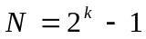 for some positive integer k. If h(N) denotes the minimum height of T, then h(N) = h((N − 1)/2) + 1 and h(1) = 0. Also, if H(N) denotes the maximum height of T, then H(N) = H(N − 2) + 1 and H(1) = 0. Explain the logic behind these recurrence equations (i.e., why does h(N) = h((N − 1)/2) + 1 and why does H(N) = H(N − 2) + 1?). In addition, solve them explicitly.

- Using Dijkstra’s algorithm, for the following diagram, find the shortest path between node 13 {} to every other node by constructing a spanning tree. What is the shortest path between node 1 to node 11 (if you choose node 1 as {}) and also find the total cost between these two nodes.

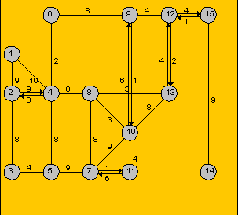

- Consider the “mystery function" foo, which is given below with comments removed.
foo(int a[],int l,int r,int k)
{ int i;
i = partition(a,l,r);
if (i == k) return a[k];
else if (i < k) return foo(a,i+1,r,k);
else return foo(a,l,i-1,k); }

partition(int a[],int l,int r)
/* let v=a[r]; this function rearranges the subarray a[l] through a[r] such that the elements less than or equal to v precede the remaining elements, and returns index i such that a[i]=v */
{int v,t,i,j;
v = a[r]; i = l - 1; j = r;
while (1)
{ while (a[++i] < v);
while (a[--j] > v && j >= l);
if (i >= j) break;
t = a[i]; a[i] = a[j]; a[j] = t; }
t = a[i]; a[i] = a[r]; a[r] = t;
return i; }
Let a be an array of size N of integers, and 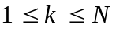
a. What will foo(a,1,N,k) return?
b. What is the worst-case time complexity of foo(a,1,N,k), and when does it occur?
c. What is the average-time complexity of foo(a,1,N,k)?

- (a) Suppose we are given a set of segments and we want to find out all the groups of parallel segments. Give an efficient algorithm for this problem and determine its time complexity. (Assume that arithmetic computations can be done with arbitrary precision.).

(b) A hash table of size M stores N integer keys. Collisions are handled by linear open addressing and the hash function is h(K) = K mod M.
1. What is the worst-case search time? Give an example of a set of keys that achieves the worst-case search time.
2. Would you use this hash table for a time-critical application (e.g., air-traffic control)?

- (a) Let A and B be two programs that perform the same task. Let 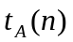 and 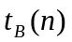, respectively, denote their run times. For each of the following pairs, find the range of n values for which program A is faster than program B.
  - 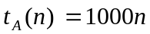, 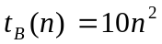
  - 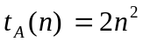, 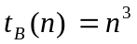
  - 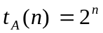, 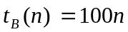
  - 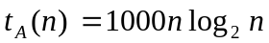, 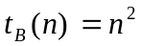

(b) The solution 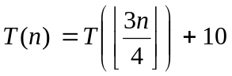 with 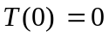 is most accurately given interms of big oh notation __________________?

- M is Tridiagonal Matrix iff 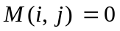 for 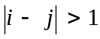. Create a C++ class by adding public members to input, output, add, subtract and transpose tridiagonal matrices. Overload C++ operators where appropriate.

- (a) Consider the following induction “Justification” that all sheep in a flock are the same color:
Base case: One Sheep. It is clearly the same color as itself.
Induction step: A flock of n sheep. Take a sheep, X, out of the flock. The remaining 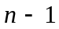are all the same color by induction. Now put sheep X back in the flock, and take out a different sheep, Y. By induction, the sheep (now with X in their group) are all the same color as all the other sheep; hence, all the sheep in the flock are the same color.
What is wrong with the “justification”?

(b) Demonstrate your understanding of recursion by giving a recursive algorithm using C++ function for the generation of Fibonacci Series of n numbers, where n is user defined. The recursive formula satisfies the boundary (starting) conditions fib(0)=0 and fib(1)=1. (Fibonacci series is 0, 1, 1, 2, 3, 5, 8, ….)
(c ) Based on the above recursion formula, prove by induction 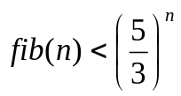

- A deque is an ordered list to/from which we can make additions and deletions at/from either end. Therefore, we can call it a double-ended queue.
Using the following equation
location(i)=(location(1)+i-1)%MaxSize

to represent deque. Develop a C++ class Deque that corresponds to the ADT Deque and write code for the class members Create, IsEmpty, Isfull, Left, Right, AddRight, DeleteLeft and DeleteRight

- (a) Let T be tree with n nodes. Define the Lowest common ancestor (LCA) between two nodes v and w as the lowest node in T that has both v and w as descendents (where we allow a node to be a descendent of itself). Given two nodes v and w, describe an efficient algorithm for finding the LCA of v and w.

(b) Give a recursive algorithm to compute the product of two positive integers m and n using only addition.

-BEST OF LUCK-

