INDIAN INSTITUTE OF TECHNOLOGY ROORKEE
ROORKEE – 247 667
Data Structures (MA 568/CA 506)

End Semester Examination Max. Marks: 50
Spring Semester 2007-08 Time: 3 hours
Total No. of Pages: 3
Answer any TEN questions. Each question carries FIVE marks

- Using Max heap sort algorithm, sort the following elements in the ascending order. Draw each heap trees clearly and what is the complexity of the algorithm? 390 100 700 630 120 310 200 570 420 230 440 300 450 270 490.

- Using Dijkstra’s algorithm, for the following diagram, find the shortest path between node 14 {} to every other node by constructing a spanning tree. What is the shortest path between node 1 to node 16 (if you choose node 1 as {}) and also find the total cost between these two nodes.
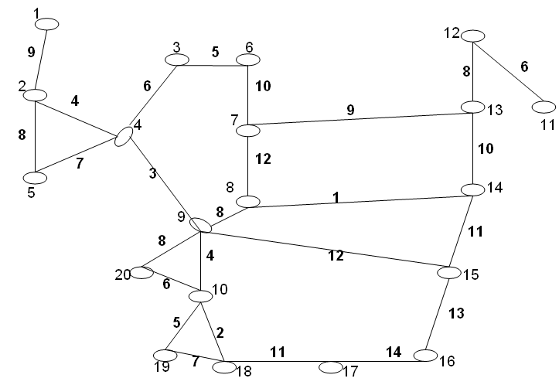

- (a) Write a C++ program / Pseudo code for a binary search algorithm that calculates the middle using 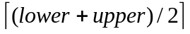. Also use lower=middle+1; and upper=middle-1;
(b) Describe Horner’s algorithm to evaluate the polynomial expression. What is its advantage over the usual brute-force computation? [3+2]

- Convert the following post fix operation to prefix operation using operand and operator stack. Determine its value (No integer Division).

4 9 160 * 12 8 2 $ / 4096 * - 2 * +
- (a) What is the linked representation of the following graph?
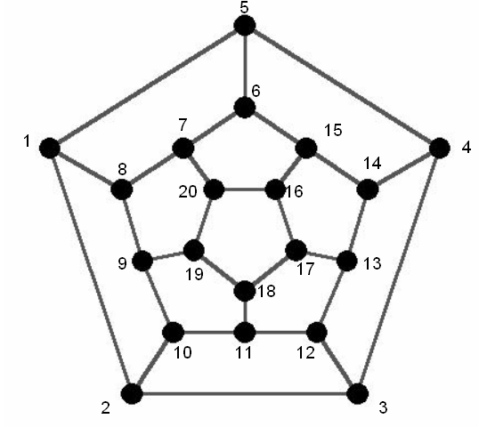
(b) What is complete bipartite graph? Give an example.
(c ) Let G be an undirected graph. Show that the number of vertices with odd degrees is even.
[2+1+1]

- Assume that a single doubly linked list node consists of two integers. Given n doubly linked list and each consists of two information (integers). Write a C++ program/Pseudo code to find whether the node contains the two integers is relatively prime or not. In a same program or in a different program write a program to delete this relatively prime node.
Note: Two numbers are relatively prime when their greatest common divisor is 1.

- In an C- Matrix, all terms other than those in row 1, row n and column 1 are zero.
    - Give a sample 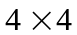 matrix.
    - At the most how many non-zero elements will be there in this matrix? Prove.
    - Write a C++ program or function to perform matrix subtraction using the above question 7(b)(ii). [1+2+2]

- (a) Let T be binary search tree with n nodes. Let v and w be the nodes in it. Write a C++ Program/function to find which node is at the lowest level in a Tree.
(b) State the difference between B-Trees and B*-Trees. Give examples. [3+2]

- (a) Prove that height of an AVL tree that contains n nodes is 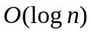
(b)Start with an empty AVL search tree and insert the following keys in the given order:
40, 50, 70, 30, 20, 45, 25, 10, 5, 22, 1, 35 [2+3]

- Write the Output of the following Programs:
  - void main()
{
int a[]={100,200,300,400,500};
int j;
for (j=0; j<5; j++)
{
cout<<a;
a++;
}
}

  - #include <iostream.h>
#include <string.h>
void main()
{
char s[]=”IITROORKEE!”;
cout<<*(s+strlen(s));
}

  - void main()
{
int t[3][2][4]={
{
2, 4, 3, 6,
1, 6, 7, 9
},
{
8, 2, 1, 1,
2, 3, 7, 3
},
{
1, 6, 2, 4,
0, 7, 9, 5
}
};
cout << t[2][1][3]<<*(*(*(t+2)+1)+2)); [2+1+2]
}
- (a) Give an example for a collision resolution technique in Hash search
(b) An algorithm takes 6 seconds to solve a problem of size 100 and ten minutes to solve a problem of size1000.What is the likely running time of the algorithm?
(c ) A heap sort algorithm takes 10 seconds for an input size of 256. How long does it take in minutes to solve a problem of size 8192? [1+2+2]

- (a) Prof. Dean Jones claims that in a B-tree of Order 4 storing a set of items will always have the same structure, regardless of the order in which the items are inserted. Is Prof. Dean Jones’s statement right or wrong? Explain.
(b) Draw the Order - 7 B-tree resulting from inserting the following keys (in this order) into an initially empty tree T.
(4, 40, 23, 50, 11, 34, 62, 78, 66, 22, 90, 59, 25, 72, 64, 77, 39,12).
(c ) Show the B-tree of order 4 that results when deleting A, then deleting V and then deleting P from the following B-tree.
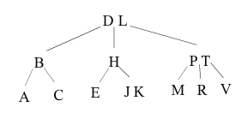 [2+1+2]
END

