INDIAN INSTITUTE OF TECHNOLOGY ROORKEE
ROORKEE – 247 667
Data Structures (MA 568/ CA 506)

Quiz 3 Max. Marks: 10
Spring Semester 2007-08 Time: 15 Mts.
Instructions:
- Those who are writing quiz will get 2 marks (to distinguish from absentees).
- Write your answers in the space or revise side of the question paper. Attach extra sheet if necessary

- Quick sort is invented by _______________________________
- Draw 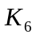 Complete graph.

- Insert 74 in the following B-Tree of order 4

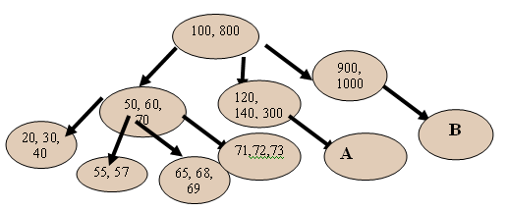
where A and B are sub trees that have 4 and 3 internal nodes respectively.

4 Insert the following letters into the given B-tree of order 5.

H E K Q M F W L T Z D P R X Y S

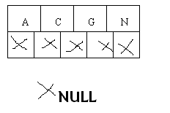
Initial B-Tree

