INDIAN INSTITUTE OF TECHNOLOGY ROORKEE
ROORKEE – 247 667

Spring Semester 2008 – 09 Test I
Data Structures (MA 568/CA 506) Max. Marks: 25
Answer any FIVE questions. Question 1 is compulsory. Each question carries FIVE marks.

- (a) Write the output of the following program
#include <iostream.h>
void main()
{
char str[]={73,0,73,0,84,0,82};
char *s;
int i;
s=str;
for (i=0; i<=6; i++)
{
if (*s)
cout<<*s;
s++;
}
}

(b) In an 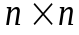 a-matrix, all terms other than those in row 1, column 1, column n and diagonal (not main diagonal) are zero. For example, a 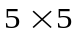 a-matrix is given by 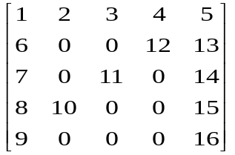
    - how many non-zero elements can you find in the a-matrix.
    - Given two O-matrices A and B find its sum using C++ with the help of 1(b)(i). In a usual matrix addition you require 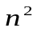 steps. How many steps do you require to add two a-matrices.

(2+3)

- Convert the following post fix operation to prefix operation using operand and operator stack. Determine its value (No integer Division).

4 9 160 * 12 8 2 $ / 4096 * - 2 * +

- (a) BIFO stands for ____________ and which Data Structure? Give an example.
(b) Suppose that B[] is an array of 100 elements, with all entries initialized to 0, and A[] is an array of N elements, each of which is an integer between 0 and 99. What is the effect of the following loop?
for (j = 0; j < N; j++)
B[A[j]]++; (3+2)

- Find the output of the following program which uses the recursion function:

#include <iostream.h>
void mystery(int N)
{
if (N < 1) return;
cout<<N;
mystery(N-1);
mystery(N-2);
cout<<N;
}

void main()
{
mystery(6);
}

- Given a linked list of positive integers. Assume that there are n nodes. Few nodes contain the number which is a power of 2, namely PowersOfTwo nodes. Write a C++ program/function to find the position/index of PowersOfTwo nodes. (For example 1, 2, 4, 8, 16, 32, 64, 128, …… are power of 2). Write a separate function for finding a number which is power of 2 in the program and do not use any inbuilt function.

- Assume that the circular linked list consists of positive integers. Create a circular linked list with header node. Write a C++ program or function to find the number of nodes that contain a prime number.

All the Best

