## ** 1. Overview **

Input Variables:

* **fixed acidity:**  most acids involved with wine or fixed or nonvolatile
* **volatile acidity:**  the amount of acetic acid in wine
* **citric acid:**  found in small quantities, citric acid can add 'freshness' and flavor to wines
* **residual sugar:**  the amount of sugar remaining after fermentation stops
* **chlorides:**  the amount of salt in the wine
* **free sulfur dioxide:**  the free form of SO2 exists in equilibrium between molecular SO2 (as a dissolved gas) and bisulfite ion
* **total sulfur dioxide:**  amount of free and bound forms of S02
* **density:**  the density of water is close to that of water depending on the percent alcohol and sugar content
* **pH:**  describes how acidic or basic a wine is on a scale from 0 (very acidic) to 14 (very basic)
* **sulphates:**  a wine additive which can contribute to sulfur dioxide gas (S02) levels
* **alcohol:**  the percent alcohol content of the wine

Output Variable:

* **quality:**  output variable (based on sensory data, score between 0 and 10)

## ** 2. Importing Libraries and Reading the Dataset **

import numpy as np  
import pandas as pd  
import matplotlib.pyplot as plt  
import seaborn as sns  
from sklearn.metrics import accuracy_score  
from sklearn.metrics import mean_squared_error  
from sklearn.model_selection import cross_val_score  
from sklearn.metrics import confusion_matrix  
from collections import Counter  
from IPython.core.display import display, HTML  
sns.set_style('darkgrid')

dataset = pd.read_csv('wine_quality.csv')  
dataset.head()

fixed acidity volatile acidity citric acid residual sugar chlorides \  
0 7.4 0.70 0.00 1.9 0.076   
1 7.8 0.88 0.00 2.6 0.098   
2 7.8 0.76 0.04 2.3 0.092   
3 11.2 0.28 0.56 1.9 0.075   
4 7.4 0.70 0.00 1.9 0.076   
  
 free sulfur dioxide total sulfur dioxide density pH sulphates \  
0 11.0 34.0 0.9978 3.51 0.56   
1 25.0 67.0 0.9968 3.20 0.68   
2 15.0 54.0 0.9970 3.26 0.65   
3 17.0 60.0 0.9980 3.16 0.58   
4 11.0 34.0 0.9978 3.51 0.56   
  
 alcohol quality   
0 9.4 5   
1 9.8 5   
2 9.8 5   
3 9.8 6   
4 9.4 5

## ** 3. Data Visualization and Preprocessing **

dataset.isnull().sum()

fixed acidity 0  
volatile acidity 0  
citric acid 0  
residual sugar 0  
chlorides 0  
free sulfur dioxide 0  
total sulfur dioxide 0  
density 0  
pH 0  
sulphates 0  
alcohol 0  
quality 0  
dtype: int64

bins = (2, 6.5, 8)  
labels = ['bad', 'good']  
dataset['quality'] = pd.cut(x = dataset['quality'], bins = bins, labels = labels)

dataset['quality'].value_counts()

bad 1382  
good 217  
Name: quality, dtype: int64

Not bad! I mean the result :)

from sklearn.preprocessing import LabelEncoder  
labelencoder_y = LabelEncoder()  
dataset['quality'] = labelencoder_y.fit_transform(dataset['quality'])

dataset.head()

fixed acidity volatile acidity citric acid residual sugar chlorides \  
0 7.4 0.70 0.00 1.9 0.076   
1 7.8 0.88 0.00 2.6 0.098   
2 7.8 0.76 0.04 2.3 0.092   
3 11.2 0.28 0.56 1.9 0.075   
4 7.4 0.70 0.00 1.9 0.076   
  
 free sulfur dioxide total sulfur dioxide density pH sulphates \  
0 11.0 34.0 0.9978 3.51 0.56   
1 25.0 67.0 0.9968 3.20 0.68   
2 15.0 54.0 0.9970 3.26 0.65   
3 17.0 60.0 0.9980 3.16 0.58   
4 11.0 34.0 0.9978 3.51 0.56   
  
 alcohol quality   
0 9.4 0   
1 9.8 0   
2 9.8 0   
3 9.8 0   
4 9.4 0

corr = dataset.corr()  
#Plot figsize  
fig, ax = plt.subplots(figsize=(10, 8))  
#Generate Heat Map, allow annotations and place floats in map  
sns.heatmap(corr, cmap='coolwarm', annot=True, fmt=".2f")  
#Apply xticks  
plt.xticks(range(len(corr.columns)), corr.columns);  
#Apply yticks  
plt.yticks(range(len(corr.columns)), corr.columns)  
#show plot  
plt.show()

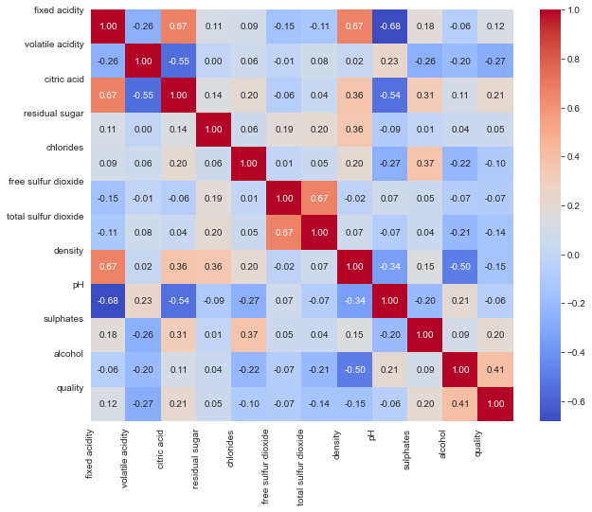

f, axes = plt.subplots(1,2,figsize=(14,4))  
  
sns.distplot(dataset['fixed acidity'], ax = axes[0])  
axes[0].set_xlabel('Fixed Acidity', fontsize=14)  
axes[0].set_ylabel('Count', fontsize=14)  
axes[0].yaxis.tick_left()  
  
sns.violinplot(x = 'quality', y = 'fixed acidity', data = dataset, hue = 'quality',ax = axes[1])  
axes[1].set_xlabel('Quality', fontsize=14)  
axes[1].set_ylabel('Fixed Acidity', fontsize=14)  
axes[1].yaxis.set_label_position("right")  
axes[1].yaxis.tick_right()  
  
plt.show()

D:\anaconda3\lib\site-packages\seaborn\distributions.py:2557: FutureWarning: `distplot` is a deprecated function and will be removed in a future version. Please adapt your code to use either `displot` (a figure-level function with similar flexibility) or `histplot` (an axes-level function for histograms).  
 warnings.warn(msg, FutureWarning)

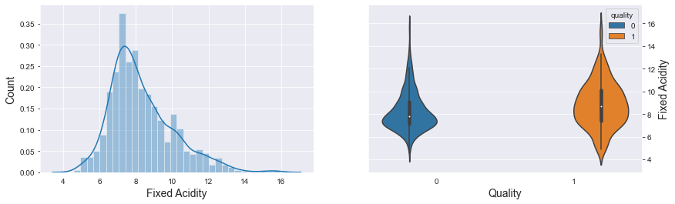

f, axes = plt.subplots(1,2,figsize=(14,4))  
  
sns.distplot(dataset['volatile acidity'], ax = axes[0])  
axes[0].set_xlabel('Volatile Acidity', fontsize=14)  
axes[0].set_ylabel('Count', fontsize=14)  
axes[0].yaxis.tick_left()  
  
sns.violinplot(x = 'quality', y = 'volatile acidity', data = dataset, hue = 'quality',ax = axes[1])  
axes[1].set_xlabel('Quality', fontsize=14)  
axes[1].set_ylabel('Volatile Acidity', fontsize=14)  
axes[1].yaxis.set_label_position("right")  
axes[1].yaxis.tick_right()  
  
plt.show()

D:\anaconda3\lib\site-packages\seaborn\distributions.py:2557: FutureWarning: `distplot` is a deprecated function and will be removed in a future version. Please adapt your code to use either `displot` (a figure-level function with similar flexibility) or `histplot` (an axes-level function for histograms).  
 warnings.warn(msg, FutureWarning)

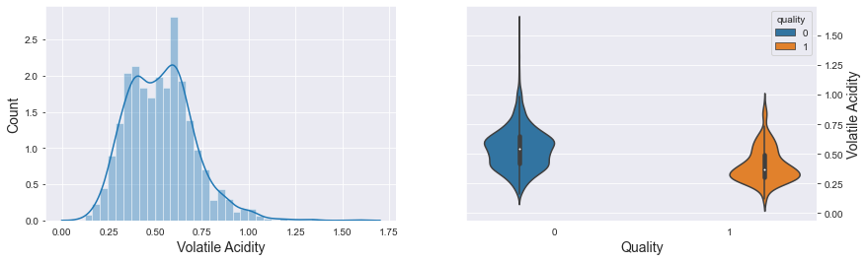

f, axes = plt.subplots(1,2,figsize=(14,4))  
  
sns.distplot(dataset['citric acid'], ax = axes[0])  
axes[0].set_xlabel('Citric Acid', fontsize=14)  
axes[0].set_ylabel('Count', fontsize=14)  
axes[0].yaxis.tick_left()  
  
sns.boxenplot(x = 'quality', y = 'citric acid', data = dataset, hue = 'quality',ax = axes[1])  
axes[1].set_xlabel('Quality', fontsize=14)  
axes[1].set_ylabel('Citric Acid', fontsize=14)  
axes[1].yaxis.set_label_position("right")  
axes[1].yaxis.tick_right()  
  
plt.show()

D:\anaconda3\lib\site-packages\seaborn\distributions.py:2557: FutureWarning: `distplot` is a deprecated function and will be removed in a future version. Please adapt your code to use either `displot` (a figure-level function with similar flexibility) or `histplot` (an axes-level function for histograms).  
 warnings.warn(msg, FutureWarning)

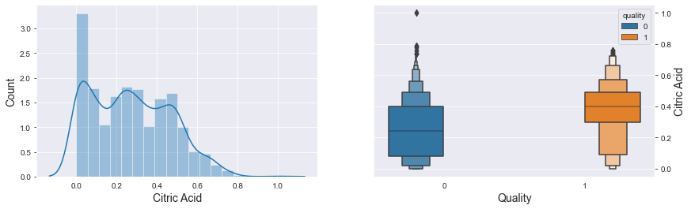

f, axes = plt.subplots(1,2,figsize=(14,4))  
  
sns.distplot(dataset['residual sugar'], ax = axes[0])  
axes[0].set_xlabel('Residual Sugar', fontsize=14)  
axes[0].set_ylabel('Count', fontsize=14)  
axes[0].yaxis.tick_left()  
  
sns.violinplot(x = 'quality', y = 'residual sugar', data = dataset, hue = 'quality',ax = axes[1])  
axes[1].set_xlabel('Quality', fontsize=14)  
axes[1].set_ylabel('Residual Sugar', fontsize=14)  
axes[1].yaxis.set_label_position("right")  
axes[1].yaxis.tick_right()  
  
plt.show()

D:\anaconda3\lib\site-packages\seaborn\distributions.py:2557: FutureWarning: `distplot` is a deprecated function and will be removed in a future version. Please adapt your code to use either `displot` (a figure-level function with similar flexibility) or `histplot` (an axes-level function for histograms).  
 warnings.warn(msg, FutureWarning)

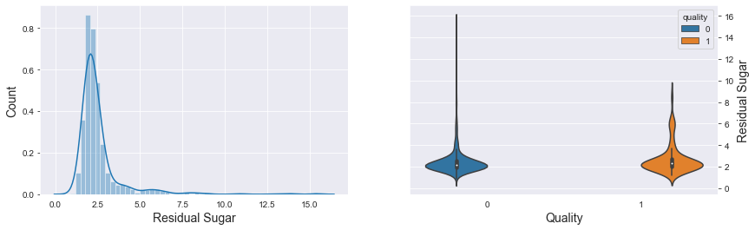

f, axes = plt.subplots(1,2,figsize=(14,4))  
  
sns.distplot(dataset['chlorides'], ax = axes[0])  
axes[0].set_xlabel('Chlorides', fontsize=14)  
axes[0].set_ylabel('Count', fontsize=14)  
axes[0].yaxis.tick_left()  
  
sns.violinplot(x = 'quality', y = 'chlorides', data = dataset, hue = 'quality',ax = axes[1])  
axes[1].set_xlabel('Quality', fontsize=14)  
axes[1].set_ylabel('Chlorides', fontsize=14)  
axes[1].yaxis.set_label_position("right")  
axes[1].yaxis.tick_right()  
  
plt.show()

D:\anaconda3\lib\site-packages\seaborn\distributions.py:2557: FutureWarning: `distplot` is a deprecated function and will be removed in a future version. Please adapt your code to use either `displot` (a figure-level function with similar flexibility) or `histplot` (an axes-level function for histograms).  
 warnings.warn(msg, FutureWarning)

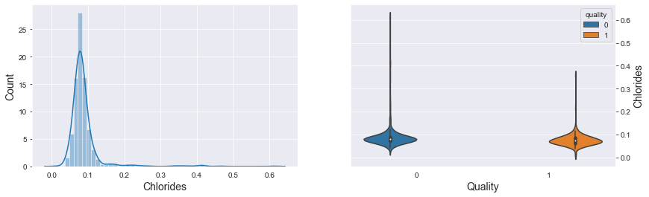

f, axes = plt.subplots(2,2,figsize=(14,8))  
  
sns.distplot(dataset['free sulfur dioxide'], ax = axes[0,0])  
axes[0,0].set_xlabel('Free Sulfur Dioxide', fontsize=14)  
axes[0,0].set_ylabel('Count', fontsize=14)  
axes[0,0].yaxis.tick_left()  
  
sns.boxenplot(x = 'quality', y = 'free sulfur dioxide', data = dataset, hue = 'quality',ax = axes[0,1])  
axes[0,1].set_xlabel('Quality', fontsize=14)  
axes[0,1].set_ylabel('Free Sulfur Dioxide', fontsize=14)  
axes[0,1].yaxis.set_label_position("right")  
axes[0,1].yaxis.tick_right()  
  
sns.distplot(dataset['total sulfur dioxide'], ax = axes[1,0])  
axes[1,0].set_xlabel('Total Sulfur Dioxide', fontsize=14)  
axes[1,0].set_ylabel('Count', fontsize=14)  
axes[1,0].yaxis.tick_left()  
  
sns.boxenplot(x = 'quality', y = 'total sulfur dioxide', data = dataset, hue = 'quality',ax = axes[1,1])  
axes[1,1].set_xlabel('Quality', fontsize=14)  
axes[1,1].set_ylabel('Total Sulfur Dioxide', fontsize=14)  
axes[1,1].yaxis.set_label_position("right")  
axes[1,1].yaxis.tick_right()  
  
plt.show()

D:\anaconda3\lib\site-packages\seaborn\distributions.py:2557: FutureWarning: `distplot` is a deprecated function and will be removed in a future version. Please adapt your code to use either `displot` (a figure-level function with similar flexibility) or `histplot` (an axes-level function for histograms).  
 warnings.warn(msg, FutureWarning)  
D:\anaconda3\lib\site-packages\seaborn\distributions.py:2557: FutureWarning: `distplot` is a deprecated function and will be removed in a future version. Please adapt your code to use either `displot` (a figure-level function with similar flexibility) or `histplot` (an axes-level function for histograms).  
 warnings.warn(msg, FutureWarning)

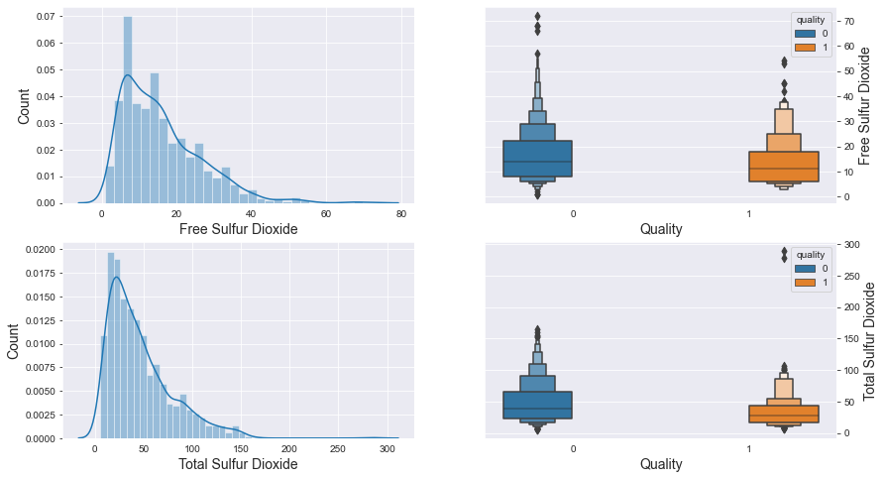

f, axes = plt.subplots(1,2,figsize=(14,4))  
  
sns.distplot(dataset['density'], ax = axes[0])  
axes[0].set_xlabel('Density', fontsize=14)  
axes[0].set_ylabel('Count', fontsize=14)  
axes[0].yaxis.tick_left()  
  
sns.violinplot(x = 'quality', y = 'density', data = dataset, hue = 'quality',ax = axes[1])  
axes[1].set_xlabel('Quality', fontsize=14)  
axes[1].set_ylabel('Density', fontsize=14)  
axes[1].yaxis.set_label_position("right")  
axes[1].yaxis.tick_right()  
  
plt.show()

D:\anaconda3\lib\site-packages\seaborn\distributions.py:2557: FutureWarning: `distplot` is a deprecated function and will be removed in a future version. Please adapt your code to use either `displot` (a figure-level function with similar flexibility) or `histplot` (an axes-level function for histograms).  
 warnings.warn(msg, FutureWarning)

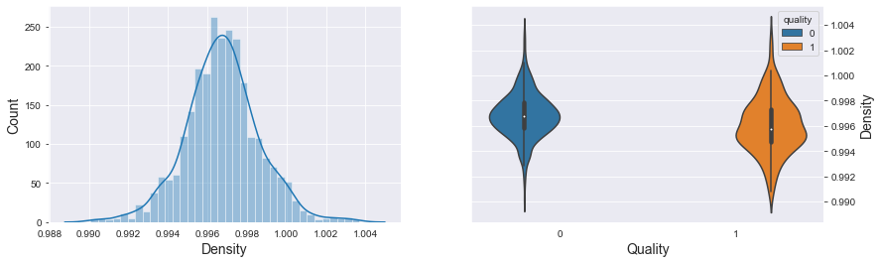

f, axes = plt.subplots(1,2,figsize=(14,4))  
  
sns.distplot(dataset['pH'], ax = axes[0])  
axes[0].set_xlabel('pH', fontsize=14)  
axes[0].set_ylabel('Count', fontsize=14)  
axes[0].yaxis.tick_left()  
  
sns.violinplot(x = 'quality', y = 'pH', data = dataset, hue = 'quality',ax = axes[1])  
axes[1].set_xlabel('Quality', fontsize=14)  
axes[1].set_ylabel('pH', fontsize=14)  
axes[1].yaxis.set_label_position("right")  
axes[1].yaxis.tick_right()  
  
plt.show()

D:\anaconda3\lib\site-packages\seaborn\distributions.py:2557: FutureWarning: `distplot` is a deprecated function and will be removed in a future version. Please adapt your code to use either `displot` (a figure-level function with similar flexibility) or `histplot` (an axes-level function for histograms).  
 warnings.warn(msg, FutureWarning)

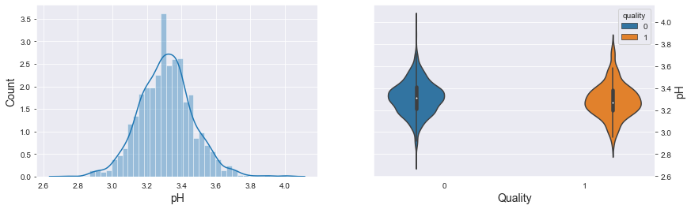

f, axes = plt.subplots(1,2,figsize=(14,4))  
  
sns.distplot(dataset['sulphates'], ax = axes[0])  
axes[0].set_xlabel('Sulphates', fontsize=14)  
axes[0].set_ylabel('Count', fontsize=14)  
axes[0].yaxis.tick_left()  
  
sns.violinplot(x = 'quality', y = 'sulphates', data = dataset, hue = 'quality',ax = axes[1])  
axes[1].set_xlabel('Quality', fontsize=14)  
axes[1].set_ylabel('Sulphates', fontsize=14)  
axes[1].yaxis.set_label_position("right")  
axes[1].yaxis.tick_right()  
  
plt.show()

D:\anaconda3\lib\site-packages\seaborn\distributions.py:2557: FutureWarning: `distplot` is a deprecated function and will be removed in a future version. Please adapt your code to use either `displot` (a figure-level function with similar flexibility) or `histplot` (an axes-level function for histograms).  
 warnings.warn(msg, FutureWarning)

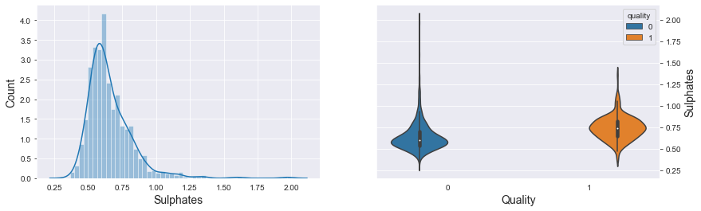

f, axes = plt.subplots(1,2,figsize=(14,4))  
  
sns.distplot(dataset['alcohol'], ax = axes[0])  
axes[0].set_xlabel('Alcohol', fontsize=14)  
axes[0].set_ylabel('Count', fontsize=14)  
axes[0].yaxis.tick_left()  
  
sns.violinplot(x = 'quality', y = 'alcohol', data = dataset, hue = 'quality',ax = axes[1])  
axes[1].set_xlabel('Quality', fontsize=14)  
axes[1].set_ylabel('Alcohol', fontsize=14)  
axes[1].yaxis.set_label_position("right")  
axes[1].yaxis.tick_right()  
  
plt.show()

D:\anaconda3\lib\site-packages\seaborn\distributions.py:2557: FutureWarning: `distplot` is a deprecated function and will be removed in a future version. Please adapt your code to use either `displot` (a figure-level function with similar flexibility) or `histplot` (an axes-level function for histograms).  
 warnings.warn(msg, FutureWarning)

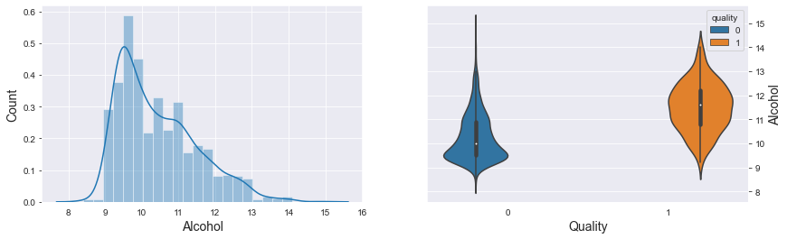

dataset['quality'].value_counts()

0 1382  
1 217  
Name: quality, dtype: int64

X = dataset.drop('quality', axis = 1).values  
y = dataset['quality'].values.reshape(-1,1)

# Splitting the dataset into the Training set and Test set  
from sklearn.model_selection import train_test_split  
X_train, X_test, y_train, y_test = train_test_split(X, y, test_size = 0.2, random_state = 42)

print("Shape of X_train: ",X_train.shape)  
print("Shape of X_test: ", X_test.shape)  
print("Shape of y_train: ",y_train.shape)  
print("Shape of y_test",y_test.shape)

Shape of X_train: (1279, 11)  
Shape of X_test: (320, 11)  
Shape of y_train: (1279, 1)  
Shape of y_test (320, 1)

## ** 4. Classification Models **

# Feature Scaling  
from sklearn.preprocessing import StandardScaler  
sc = StandardScaler()  
X_train_scaled = sc.fit_transform(X_train)  
X_test_scaled = sc.transform(X_test)

### ** Logistic Regression **

# Fitting Logistic Regression to the Training set  
from sklearn.linear_model import LogisticRegression  
classifier_lr = LogisticRegression(C=1, fit_intercept=True, max_iter=1000, penalty = 'l2', solver='liblinear')  
classifier_lr.fit(X_train_scaled, y_train.ravel())

LogisticRegression(C=1, max_iter=1000, solver='liblinear')

# Predicting Cross Validation Score  
cv_lr = cross_val_score(estimator = classifier_lr, X = X_train_scaled, y = y_train.ravel(), cv = 10)  
print("CV: ", cv_lr.mean())  
  
y_pred_lr_train = classifier_lr.predict(X_train_scaled)  
accuracy_lr_train = accuracy_score(y_train, y_pred_lr_train)  
print("Training set: ", accuracy_lr_train)  
  
y_pred_lr_test = classifier_lr.predict(X_test_scaled)  
accuracy_lr_test = accuracy_score(y_test, y_pred_lr_test)  
print("Test set: ", accuracy_lr_test)

CV: 0.885857529527559  
Training set: 0.8858483189992181  
Test set: 0.865625

confusion_matrix(y_test, y_pred_lr_test)

array([[264, 9],  
 [ 34, 13]], dtype=int64)

tp_lr = confusion_matrix(y_test, y_pred_lr_test)[0,0]  
fp_lr = confusion_matrix(y_test, y_pred_lr_test)[0,1]  
tn_lr = confusion_matrix(y_test, y_pred_lr_test)[1,1]  
fn_lr = confusion_matrix(y_test, y_pred_lr_test)[1,0]

### ** K-Nearest Neighbors (K-NN) **

# Fitting classifier to the Training set  
from sklearn.neighbors import KNeighborsClassifier  
classifier_knn = KNeighborsClassifier(leaf_size = 1, metric = 'minkowski', n_neighbors = 32, weights = 'distance')  
classifier_knn.fit(X_train_scaled, y_train.ravel())

KNeighborsClassifier(leaf_size=1, n_neighbors=32, weights='distance')

# Predicting Cross Validation Score  
cv_knn = cross_val_score(estimator = classifier_knn, X = X_train_scaled, y = y_train.ravel(), cv = 10)  
print("CV: ", cv_knn.mean())  
  
y_pred_knn_train = classifier_knn.predict(X_train_scaled)  
accuracy_knn_train = accuracy_score(y_train, y_pred_knn_train)  
print("Training set: ", accuracy_knn_train)  
  
y_pred_knn_test = classifier_knn.predict(X_test_scaled)  
accuracy_knn_test = accuracy_score(y_test, y_pred_knn_test)  
print("Test set: ", accuracy_knn_test)

CV: 0.9022699311023622  
Training set: 1.0  
Test set: 0.89375

confusion_matrix(y_test, y_pred_knn_test)

array([[264, 9],  
 [ 25, 22]], dtype=int64)

tp_knn = confusion_matrix(y_test, y_pred_knn_test)[0,0]  
fp_knn = confusion_matrix(y_test, y_pred_knn_test)[0,1]  
tn_knn = confusion_matrix(y_test, y_pred_knn_test)[1,1]  
fn_knn = confusion_matrix(y_test, y_pred_knn_test)[1,0]

### ** Support Vector Machine (SVM - Linear) **

# Fitting classifier to the Training set  
from sklearn.svm import SVC  
classifier_svm_linear = SVC(kernel = 'linear')  
classifier_svm_linear.fit(X_train_scaled, y_train.ravel())

SVC(kernel='linear')

# Predicting Cross Validation Score  
cv_svm_linear = cross_val_score(estimator = classifier_svm_linear, X = X_train_scaled, y = y_train.ravel(), cv = 10)  
print("CV: ", cv_svm_linear.mean())  
  
y_pred_svm_linear_train = classifier_svm_linear.predict(X_train_scaled)  
accuracy_svm_linear_train = accuracy_score(y_train, y_pred_svm_linear_train)  
print("Training set: ", accuracy_svm_linear_train)  
  
y_pred_svm_linear_test = classifier_svm_linear.predict(X_test_scaled)  
accuracy_svm_linear_test = accuracy_score(y_test, y_pred_svm_linear_test)  
print("Test set: ", accuracy_svm_linear_test)

CV: 0.8670829232283465  
Training set: 0.8670836591086787  
Test set: 0.853125

confusion_matrix(y_test, y_pred_svm_linear_test)

array([[273, 0],  
 [ 47, 0]], dtype=int64)

tp_svm_linear = confusion_matrix(y_test, y_pred_svm_linear_test)[0,0]  
fp_svm_linear = confusion_matrix(y_test, y_pred_svm_linear_test)[0,1]  
tn_svm_linear = confusion_matrix(y_test, y_pred_svm_linear_test)[1,1]  
fn_svm_linear = confusion_matrix(y_test, y_pred_svm_linear_test)[1,0]

### ** Support Vector Machine (SVM - Kernel) **

# Fitting classifier to the Training set  
from sklearn.svm import SVC  
classifier_svm_kernel = SVC(kernel = 'rbf', C = 10, tol = 0.001, gamma = 'scale')  
classifier_svm_kernel.fit(X_train_scaled, y_train.ravel())

SVC(C=10)

# Predicting Cross Validation Score  
cv_svm_kernel = cross_val_score(estimator = classifier_svm_kernel, X = X_train_scaled, y = y_train.ravel(), cv = 10)  
print("CV: ", cv_svm_kernel.mean())  
  
y_pred_svm_kernel_train = classifier_svm_kernel.predict(X_train_scaled)  
accuracy_svm_kernel_train = accuracy_score(y_train, y_pred_svm_kernel_train)  
print("Training set: ", accuracy_svm_kernel_train)  
  
y_pred_svm_kernel_test = classifier_svm_kernel.predict(X_test_scaled)  
accuracy_svm_kernel_test = accuracy_score(y_test, y_pred_svm_kernel_test)  
print("Test set: ", accuracy_svm_kernel_test)

CV: 0.8999261811023622  
Training set: 0.9421422986708365  
Test set: 0.89375

confusion_matrix(y_test, y_pred_svm_kernel_test)

array([[261, 12],  
 [ 22, 25]], dtype=int64)

tp_svm_kernel = confusion_matrix(y_test, y_pred_svm_kernel_test)[0,0]  
fp_svm_kernel = confusion_matrix(y_test, y_pred_svm_kernel_test)[0,1]  
tn_svm_kernel = confusion_matrix(y_test, y_pred_svm_kernel_test)[1,1]  
fn_svm_kernel = confusion_matrix(y_test, y_pred_svm_kernel_test)[1,0]

### ** Naive Bayes **

# Fitting classifier to the Training set  
from sklearn.naive_bayes import GaussianNB  
classifier_nb = GaussianNB()  
classifier_nb.fit(X_train_scaled, y_train.ravel())

GaussianNB()

# Predicting Cross Validation Score  
cv_nb = cross_val_score(estimator = classifier_nb, X = X_train_scaled, y = y_train.ravel(), cv = 10)  
print("CV: ", cv_nb.mean())  
  
y_pred_nb_train = classifier_nb.predict(X_train_scaled)  
accuracy_nb_train = accuracy_score(y_train, y_pred_nb_train)  
print("Training set: ", accuracy_nb_train)  
  
y_pred_nb_test = classifier_nb.predict(X_test_scaled)  
accuracy_nb_test = accuracy_score(y_test, y_pred_nb_test)  
print("Test set: ", accuracy_nb_test)

CV: 0.8373462106299213  
Training set: 0.8389366692728695  
Test set: 0.846875

confusion_matrix(y_test, y_pred_nb_test)

array([[234, 39],  
 [ 10, 37]], dtype=int64)

tp_nb = confusion_matrix(y_test, y_pred_nb_test)[0,0]  
fp_nb = confusion_matrix(y_test, y_pred_nb_test)[0,1]  
tn_nb = confusion_matrix(y_test, y_pred_nb_test)[1,1]  
fn_nb = confusion_matrix(y_test, y_pred_nb_test)[1,0]

### ** Decision Tree Classification **

# Fitting classifier to the Training set  
from sklearn.tree import DecisionTreeClassifier  
classifier_dt = DecisionTreeClassifier(criterion = 'gini', max_features=6, max_leaf_nodes=400, random_state = 33)  
classifier_dt.fit(X_train_scaled, y_train.ravel())

DecisionTreeClassifier(max_features=6, max_leaf_nodes=400, random_state=33)

# Predicting Cross Validation Score  
cv_dt = cross_val_score(estimator = classifier_dt, X = X_train_scaled, y = y_train.ravel(), cv = 10)  
print("CV: ", cv_dt.mean())  
  
y_pred_dt_train = classifier_dt.predict(X_train_scaled)  
accuracy_dt_train = accuracy_score(y_train, y_pred_dt_train)  
print("Training set: ", accuracy_dt_train)  
  
y_pred_dt_test = classifier_dt.predict(X_test_scaled)  
accuracy_dt_test = accuracy_score(y_test, y_pred_dt_test)  
print("Test set: ", accuracy_dt_test)

CV: 0.8960014763779528  
Training set: 1.0  
Test set: 0.878125

confusion_matrix(y_test, y_pred_dt_test)

array([[252, 21],  
 [ 18, 29]], dtype=int64)

tp_dt = confusion_matrix(y_test, y_pred_dt_test)[0,0]  
fp_dt = confusion_matrix(y_test, y_pred_dt_test)[0,1]  
tn_dt = confusion_matrix(y_test, y_pred_dt_test)[1,1]  
fn_dt = confusion_matrix(y_test, y_pred_dt_test)[1,0]

### ** Random Forest Classification **

# Fitting Random Forest Classification to the Training set  
from sklearn.ensemble import RandomForestClassifier  
classifier_rf = RandomForestClassifier(criterion = 'entropy', max_features = 4, n_estimators = 800, random_state=33)  
classifier_rf.fit(X_train_scaled, y_train.ravel())

RandomForestClassifier(criterion='entropy', max_features=4, n_estimators=800,  
 random_state=33)

# Predicting Cross Validation Score  
cv_rf = cross_val_score(estimator = classifier_rf, X = X_train_scaled, y = y_train.ravel(), cv = 10)  
print("CV: ", cv_rf.mean())  
  
y_pred_rf_train = classifier_rf.predict(X_train_scaled)  
accuracy_rf_train = accuracy_score(y_train, y_pred_rf_train)  
print("Training set: ", accuracy_rf_train)  
  
y_pred_rf_test = classifier_rf.predict(X_test_scaled)  
accuracy_rf_test = accuracy_score(y_test, y_pred_rf_test)  
print("Test set: ", accuracy_rf_test)

CV: 0.9140194389763779  
Training set: 1.0  
Test set: 0.9125

confusion_matrix(y_test, y_pred_rf_test)

array([[267, 6],  
 [ 22, 25]], dtype=int64)

tp_rf = confusion_matrix(y_test, y_pred_rf_test)[0,0]  
fp_rf = confusion_matrix(y_test, y_pred_rf_test)[0,1]  
tn_rf = confusion_matrix(y_test, y_pred_rf_test)[1,1]  
fn_rf = confusion_matrix(y_test, y_pred_rf_test)[1,0]

## ** 6. Measuring The Error **

models = [('Logistic Regression', tp_lr, fp_lr, tn_lr, fn_lr, accuracy_lr_train, accuracy_lr_test, cv_lr.mean()),  
 ('K-Nearest Neighbors (KNN)', tp_knn, fp_knn, tn_knn, fn_knn, accuracy_knn_train, accuracy_knn_test, cv_knn.mean()),  
 ('SVM (Linear)', tp_svm_linear, fp_svm_linear, tn_svm_linear, fn_svm_linear, accuracy_svm_linear_train, accuracy_svm_linear_test, cv_svm_linear.mean()),  
 ('SVM (Kernel)', tp_svm_kernel, fp_svm_kernel, tn_svm_kernel, fn_svm_kernel, accuracy_svm_kernel_train, accuracy_svm_kernel_test, cv_svm_kernel.mean()),  
 ('Naive Bayes', tp_nb, fp_nb, tn_nb, fn_nb, accuracy_nb_train, accuracy_nb_test, cv_nb.mean()),  
 ('Decision Tree Classification', tp_dt, fp_dt, tn_dt, fn_dt, accuracy_dt_train, accuracy_dt_test, cv_dt.mean()),  
 ('Random Forest Tree Classification', tp_rf, fp_rf, tn_rf, fn_rf, accuracy_rf_train, accuracy_rf_test, cv_rf.mean())  
 ]

predict = pd.DataFrame(data = models, columns=['Model', 'True Positive', 'False Positive', 'True Negative',  
 'False Negative', 'Accuracy(training)', 'Accuracy(test)',  
 'Cross-Validation'])  
predict

Model True Positive False Positive \  
0 Logistic Regression 264 9   
1 K-Nearest Neighbors (KNN) 264 9   
2 SVM (Linear) 273 0   
3 SVM (Kernel) 261 12   
4 Naive Bayes 234 39   
5 Decision Tree Classification 252 21   
6 Random Forest Tree Classification 267 6   
  
 True Negative False Negative Accuracy(training) Accuracy(test) \  
0 13 34 0.885848 0.865625   
1 22 25 1.000000 0.893750   
2 0 47 0.867084 0.853125   
3 25 22 0.942142 0.893750   
4 37 10 0.838937 0.846875   
5 29 18 1.000000 0.878125   
6 25 22 1.000000 0.912500   
  
 Cross-Validation   
0 0.885858   
1 0.902270   
2 0.867083   
3 0.899926   
4 0.837346   
5 0.896001   
6 0.914019

### ** Visualizing Models Performance **

f, axe = plt.subplots(1,1, figsize=(18,6))  
  
predict.sort_values(by=['Cross-Validation'], ascending=False, inplace=True)  
  
sns.barplot(x='Cross-Validation', y='Model', data = predict, ax = axe)  
#axes[0].set(xlabel='Region', ylabel='Charges')  
axe.set_xlabel('Cross-Validaton Score', size=16)  
axe.set_ylabel('Model')  
axe.set_xlim(0,1.0)  
axe.set_xticks(np.arange(0, 1.1, 0.1))  
plt.show()

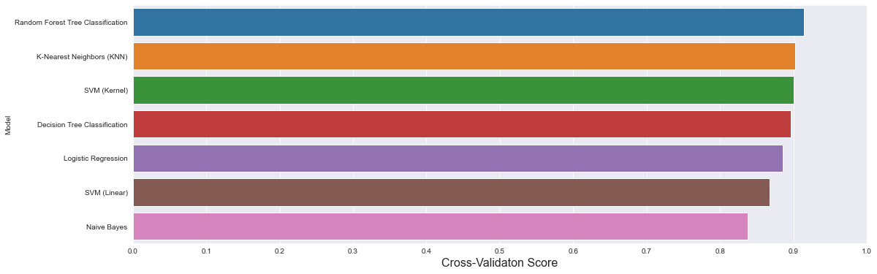

f, axes = plt.subplots(2,1, figsize=(14,10))  
  
predict.sort_values(by=['Accuracy(training)'], ascending=False, inplace=True)  
  
sns.barplot(x='Accuracy(training)', y='Model', data = predict, palette='Blues_d', ax = axes[0])  
#axes[0].set(xlabel='Region', ylabel='Charges')  
axes[0].set_xlabel('Accuracy (Training)', size=16)  
axes[0].set_ylabel('Model')  
axes[0].set_xlim(0,1.0)  
axes[0].set_xticks(np.arange(0, 1.1, 0.1))  
  
predict.sort_values(by=['Accuracy(test)'], ascending=False, inplace=True)  
  
sns.barplot(x='Accuracy(test)', y='Model', data = predict, palette='Reds_d', ax = axes[1])  
#axes[0].set(xlabel='Region', ylabel='Charges')  
axes[1].set_xlabel('Accuracy (Test)', size=16)  
axes[1].set_ylabel('Model')  
axes[1].set_xlim(0,1.0)  
axes[1].set_xticks(np.arange(0, 1.1, 0.1))  
  
plt.show()

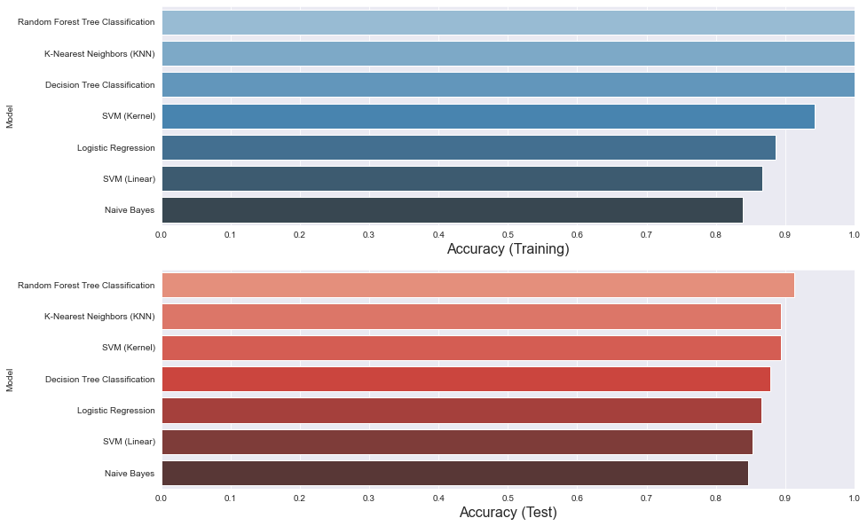

predict.sort_values(by=(['Accuracy(test)']), ascending=True, inplace=True)  
  
f, axe = plt.subplots(1,1, figsize=(24,8))  
sns.barplot(x = predict['Model'], y=predict['False Positive'] + predict['False Negative'], ax = axe)  
axe.set_xlabel('Model', size=20)  
axe.set_ylabel('False Observations', size=20)  
  
plt.show()

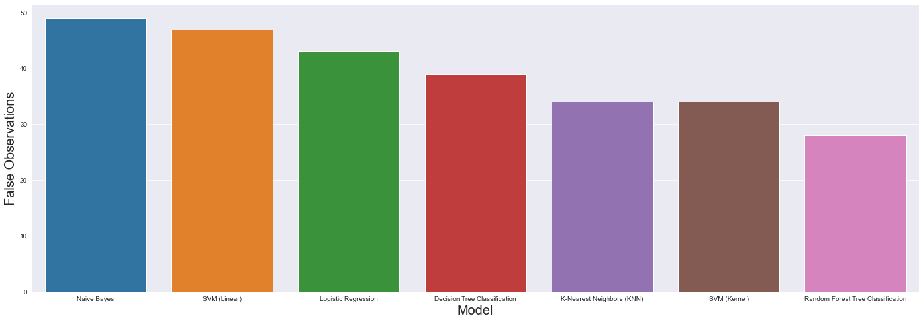

y_pred_rf_test

array([0, 0, 0, 0, 0, 0, 0, 0, 0, 0, 1, 0, 0, 0, 0, 0, 0, 0, 1, 0, 0, 0,  
 0, 0, 0, 0, 1, 0, 0, 0, 0, 0, 0, 0, 0, 0, 0, 0, 0, 0, 0, 0, 0, 0,  
 0, 0, 0, 0, 0, 0, 0, 0, 0, 1, 0, 0, 0, 0, 0, 0, 0, 0, 0, 0, 1, 0,  
 1, 0, 1, 0, 0, 0, 0, 0, 0, 0, 1, 0, 0, 0, 0, 1, 0, 0, 0, 0, 0, 0,  
 0, 0, 0, 0, 0, 0, 0, 0, 0, 0, 0, 0, 0, 0, 0, 1, 0, 1, 0, 0, 0, 0,  
 1, 0, 1, 0, 0, 0, 0, 0, 0, 0, 0, 0, 0, 0, 0, 0, 0, 0, 0, 0, 0, 0,  
 0, 0, 0, 0, 0, 0, 0, 0, 1, 0, 1, 0, 0, 0, 0, 0, 0, 0, 0, 0, 0, 0,  
 0, 0, 0, 0, 0, 0, 0, 0, 0, 0, 0, 0, 0, 0, 0, 0, 0, 0, 1, 0, 1, 0,  
 0, 0, 0, 0, 0, 0, 0, 0, 0, 0, 0, 0, 1, 0, 0, 0, 0, 0, 0, 0, 0, 0,  
 0, 1, 0, 0, 0, 0, 1, 0, 0, 0, 0, 0, 1, 0, 0, 0, 0, 0, 0, 0, 0, 0,  
 0, 0, 0, 0, 0, 0, 0, 1, 0, 0, 0, 0, 1, 0, 0, 1, 0, 0, 0, 0, 0, 0,  
 0, 1, 0, 1, 0, 0, 0, 0, 0, 0, 0, 0, 0, 0, 0, 0, 0, 0, 0, 0, 0, 0,  
 0, 0, 0, 0, 0, 0, 0, 0, 0, 0, 0, 0, 0, 0, 0, 0, 1, 0, 0, 0, 0, 1,  
 0, 0, 0, 0, 0, 1, 0, 0, 0, 0, 0, 1, 0, 0, 0, 0, 0, 0, 0, 0, 0, 0,  
 0, 1, 0, 0, 0, 0, 0, 0, 0, 0, 0, 0])

#Let us take a random testcase and predict using random forests

classifier_rf.predict([[7.4,0.76,0,4.4,0.106,15,67,0.99,3.7,0.5,9.3]])

array([0])

#This test case indicates the wine is of bad quality

# The End